[Egyptian Informatics Journal 22 (2021) 439–445](https://doi.org/10.1016/j.eij.2021.01.003)

Contents lists available at [ScienceDirect](http://www.sciencedirect.com/science/journal/11108665)

Egyptian Informatics Journal

journal homepage: [www.sciencedirect.com](http://www.sciencedirect.com/)

[](http://crossmark.crossref.org/dialog/?doi=10.1016/j.eij.2021.01.003&domain=pdf)An improved energy-efficient head election protocol for clustering techniques of wireless sensor network (June 2020)

Safa’a S. Saleh a,⇑, Tamer F. Mabrouk a, Rana A. Tarabishi b

a *Information System Department, Alexandria Academy for Management and Accounting-EIA, Alexandria, Egypt*

b *Computer Science Department, Taibah University, KSA, Saudi Arabia*

# a r t i c l e i n f o

*Article history:*

Received 8 June 2020

Revised 22 November 2020

Accepted 20 January 2021

Available online 4 February 2021

*Keywords:* WSN LEACH

Clustering Head election

# a b s t r a c t

Although wireless sensor networks (WSNs) have been utilized for over one decade, it is now heavily used by many modern applications such as medical observance, disaster management and environmental monitoring. This type of network suffers from limited energy and a short lifetime in addition to the low channel bandwidth. Bandwidth represents the major challenges of such systems due to the great impact of communication cost on the consumption of nodes power. Clustering has been proven to be one of the best techniques to conserve the energy of WSNs. LEACH (low energy adaptive clustering hier- archy) protocol is one of the most fundamental works of WSN clustering. However, this protocol suffers from some drawbacks, especially in the setup phase where CH is selected randomly. This work aims to enhance LEACH by identifying a cluster head according to the lowest degree of consuming energy. The results clarify the ability of this work to enhance LEACH while prolonging the lifetime and improving the performance of WSN.

© 2021 THE AUTHORS. Published by Elsevier BV. on behalf of Faculty of Computers and Artificial Intel-

ligence, Cairo University. This is an open access article under the CC BY-NC-ND license ([http://creative-](http://creativecommons.org/licenses/by-nc-nd/4.0/)

[commons.org/licenses/by-nc-nd/4.0/](http://creativecommons.org/licenses/by-nc-nd/4.0/)).

1. Introduction

CONTINUOUS technological progress works to convert the dis- tributed systems from large to small and tiny scales are known as Wireless Sensor Networks (WSNs) [1]. WSNs are gigantic sys- tems composed of a large number of miniaturized, distributed and limited-energy sensor nodes. These nodes are usually spread over a certain region in order to collect various types of environ- mental data [2]. Many recent applications depend on WSN such as medical observance, disaster management and environmental monitoring. The collected data are always sent to a base station (called sink) for processing and analysis. This type of network suf- fers from limited energy and a short lifetime due to the limited non-rechargeable power of the small batteries in sensor nodes. The network lifetime is defined by the round when all nodes have died, and the sensor node is defined as dead when its energy is out [1]. The limited lifetime and low channel bandwidth are the major challenges of such systems due to the great impact of communica-

* Corresponding author.

*E-mail addresses:* [Safaa34@hotmail.com](mailto:Safaa34@hotmail.com) (S.S. Saleh), [tamer_fm@yahoo.com](mailto:tamer_fm@yahoo.com) (T.F. Mabrouk), [rana.tarabishi@hotmail.com](mailto:rana.tarabishi@hotmail.com) (R.A. Tarabishi).

Peer review under responsibility of Faculty of Computers and Artificial Intelligence, Cairo University.

tion on the consumption of the power energy of nodes. Therefore, the efficient use of energy to face these challenges and to prolong the network lifetime is the most critical issue in WSNs [3].

Clustering as a reduction technique has been proven to be one of the good techniques to conserve the energy of WSNs. With clus- tering, sensor nodes are grouped into an optimized number of clus- ters with a lower number of nodes. As such, each cluster must have at least one node acting as a cluster header, which is often abbre- viated as CH, which is responsible for receiving and aggregating the sensed data, then forwarding them to the base station. Conse- quently, the packets sent to the base station are reduced and the communication bandwidth is conserved as a result. The most important target is to reduce the energy used to receive and send more sensed data [4].

Several exertions with many strategies are introduced to cluster WSN for power reduction and extension network lifetime. LEACH

[5] is the most fundamental protocol for clustering WSN. It groups the sensor nodes into several small-sized clusters. Each round of LEACH consists of two phases: (1) setup phase where the clusters are formed and the cluster-head of each cluster is elected. (2) steady state phase where the sensed data is sent to the base station via CHs. Randomly, LEACH elects one node to be CH for a round; each node selects a random number between 0 and 1. If that num- ber is less than or equal to the threshold (T(n)), it becomes CH;

<https://doi.org/10.1016/j.eij.2021.01.003>

1110-8665/© 2021 THE AUTHORS. Published by Elsevier BV. on behalf of Faculty of Computers and Artificial Intelligence, Cairo University. This is an open access article under the CC BY-NC-ND license (<http://creativecommons.org/licenses/by-nc-nd/4.0/>).

Notation:

N: number of nodes; BS: a base stationS0: Maximum size of cluster thresholdETci: Energy of transmission cost from ni to BSH0 = Capability thresholdXi, Yi : Latitude & Longitude of nid0 : distance thresholdRei: Residual Energy of niK: the size of sensing packet

Table 1

The Simulation Settings.

Parameter Default value

Monitoring area 100 m × 100 *m*

Number of nodes- N 45–85

Packet size 6400 bit

Ei 0.5

BS location (50,50)

*R* 50 × 10-9/ packet

*e*

*i*

*A* 5 × 10-9/ bit

*e*

*i*

*S* 50 × 10-9 /bit

*e*

*i*

otherwise, a node will remain regular. The threshold is set as in equation (1): [5]

authors used shortest distance as the clustering criteria in order to decrease energy consumption by CHs [6,7,8,9], while others added the residual energy to the clustering criteria in an attempt to achieve more accurate results [10,11,12,13].

The communication cost is the major consumer of WSN energy. There are many factors other than distance that can affect the com- munication cost as stated by [14].; the present work decides to use the communication cost as the main criteria in the election of CHs instead of using any indirect factors that impact the communica- tion cost.

The current work addresses the problem of a random election of CHs, which causes the dissipation of energy among sensor nodes. The first contribution of this work is to enhance LEACH by modifying the setup phase to elect CHs based on four param- eters: communication cost with BS, residual energy, location and network size. In order to be more accurate and closer to reality, the selection process is not based on the highest energy as in [4] or the shortest distance as in [15]. Cluster heads are identified in this work according to the adequacy of residual energy to cover the needed communication cost in each round. So, we can effec- tively conserve the energy of the elected CHs and maintain the entire system’s performance. Another source of the dissipation the energy of WSNs is the power that consumption holds in for- warding redundant information to BS by multiple CHs. The redundant information is produced due to the overlapped CHs in the same monitoring area where the distance between any two or more CHs overlay each other. The second contribution

of this work is enhancing LEACH to avoid forwarding this redun-

( *p* 1

*if n* ∈ *G*

dant information by identifying one or more vices for each CH.

*T*(*n*) =

1—*p*\*(*rmodp*)

0 *otherwise*

(1)

The goal here is to find the set of headers that can compete each header (cover the same monitoring area). This work is based on

Where *p* is the probability of the current node (*r*) to be CH, *G* is the set of nodes that were not CH before. The remaining nodes in the cluster collect their targets and forward them to CH, which it is responsible to aggregate ~~for~~ and compress the received data before forwarding it to the base station. According to LEACH, each node has the same chance to be a header. As the node successes to become a CH, it broadcasts an invitation message to join its clus- ters. The target nodes then decide to join the cluster of sending a CH based on the strength of the signal by sending an acknowledge- ment message. Subsequently, the CH assigns each node a time slot in which it can transmit the sensed data according to a schedule. The node cannot be chosen as a CH more than once for the current round [5].

On the other hand, LEACH suffers from many defects due to the random selection of CHs. First, a low powered node has the same chance to be a CH as a high powered node, which can be the main source of energy depletion. Second, LEACH was not clear enough about any constraint on the number of CHs in the network. Finally, although all CHs must have the ability to immediately link to the base station (BS), LEACH did not consider any clustering features such as location, energy, communication cost, etc. between itself and the BS [6].

Based on the fact that the consumed energy increased due to the long distance, several efforts were introduced to enhance LEACH by eliminating the random election of CHs and identifying them according to suitable features. These efforts attempted to reduce the high energy consumption of nodes. However, most

Table 2

Cluster Lifetime Of The Proposed Work And Most Related Works.

Average IE2-LEACH E-LEACH LEACH

Number of Heads/Cluster 4 1 1

Cluster density of 6.5 18 28

Number of rounds/ CH 125 15 13

the memetic algorithm [16] to define vices set for each header. The presence of the defined vices of the cluster header (candi- date headers) drives this work to the third contribution of the scheduling mechanism to arrange the defined CH with its vices in the correct order. This work tries to achieve an efficient energy consumption of WSNs using the waking-sleeping scheduling mechanism for managing which head must wake- up to perform all tasks of receiving the collected data, aggregat- ing them and sending them to BS.

The remaining part of this paper is organized as follows: Sec- tion 2 briefly reviews the previous related works to the present work. The proposed IE2-LEACH protocol is presented in Section 3. In Section 4, the simulation results are revealed. Finally, Section 5 concludes the work and highlights future directions for other aspects of improvement in WSN.

1. Related work

Clustering protocols plays a significant role in prolonging the lifetime of WSNs. The LEACH protocol is introduced by [5] to reduce global communications among WSN by grouping the nodes into a number of small-sized clusters. The random election of CHs represents one of the main weak points of LEACH, the problem that this work tries to address. Consequently, many strategies have been introduced to face this problem.

Similar to this work, the following efforts are introduced to improve the setup phase of LEACH protocol using different strate- gies to enhance LEACH during the main task of the setup phase (to select CHs).

The work of [7] introduces the HEED approach, which selects the nodes with high residual energy to be the CHs through an iter- ation of CH election scheme, according to the current and the ini- tial battery levels. The work of [8] proposed FLEC to improve LEACH employing the high energy nodes to become a cluster

header and combine the data of their cluster aspects and transmit it BS. In order to support LEACH for minimizing the consumed time and energy for selecting a new cluster head when one is damaged [9], a new mechanism should be introduced to assign each cluster with a vice cluster head.

The work by [17] elaborates LEACH with a fixed count of the cluster (LEACH-F) protocol by a centralized cluster representation. This protocol has a difficult drawback as it has no flexibility for adding or removing nodes once clusters are formed, and nodes cannot modify their activity on node damaging.

Furthermore, the work of [18] showed that an energy- balanced clustering algorithm based on the LEACH protocol relies on the remaining energy and distance agents, which improve the strategies of selection and not the selection of the cluster head.

In addition, [19] proposed K-LEACH using k-medoids. They par- tially elected CHs randomly only after almost 50% of round opera- tions of the network, instead of totally random CHs election in LEACH.

The work of [6] uses the distance of the node from BS to the cluster LEACH protocol in prolonging the lifetime of the network. Moreover, for reduction, other transferences are conducted in the current LEACH protocol.

The works of [20] and [21] both address the energy consump- tion problem and present clustering by considering the energy and distance. In order to select the CHs in the setup phase, the first work calculates the distances between all the nodes. A node with the minimal distance and higher residual energy is designated as CH. The node is considered as a high power node if the calculated residual energy is higher than the threshold. In the second work, the CH selection is based on the optimal number of clusters con- firmed by the lower energy dissipation.

As all clustering works in WSN, [15] aimed to reduce the power consumption in cluster head nodes and prolong the lifetime of the whole network. They introduced an enhanced LEACH protocol by randomly identifying a CH according to the shortest distance from BS.

In order to balance the energy consumption of WSN, the work by [16] introduced ESACC scheduling mechanism which monitors the network performance to ensure that only some redundant nodes are scheduled to work while the others sleep. Sleeping nodes are awakened to replace the dead nodes and maintain network performance. Their main objective is to find a minimum set of working nodes that succeed to reduce the consumption of power and maintain the coverage area.

The work of [22] is most related to the present work because of the common primary objective of improving the cluster head selec- tion of LEACH. They have introduced an Improved Energy Efficient Cluster Head Selection protocol (IEECHS-WSN) by selecting dual cluster heads in a separated cluster based on the distance. The first CH transfers the information to the sink node, and sink node then accepts the data and that sent via the second CH. As such, the energy usage for connection with the sink is distributed between the dual CHs.

In the context of scheduling, we benefit from the work by [23], which introduces a novel cluster based task scheduling method called Algorithmic Critical Path Formulation (ACPF) to minimize the execution energy by separating task requests into clusters based on a set of defined parameters in order to apply the appro- priate load balancing upon them.

1. The proposed improvement of LEACH

As previously stated, LEACH is a most popular clustering proto- col, which, in WSN, has many weak points due to the random

selection of cluster heads. The proposed work tries to address the main problems of LEACH in the setup phase including the sources of energy depletion:

1. The random selection gives an equal chance for lower- powered nodes and high-powered nodes to be cluster heads. This increases the probability of decreasing the lifetime of the network.
2. The physical properties of the connection with BS are ignored during the selection of cluster heads.
3. There is no constraint to avoid the selection of overlapping or competitive CHs.

The main contribution of this work is to introduce IE2-LEACH as an effective selection algorithm for cluster headers to overcome the previously mentioned problems. Although IE2-LEACH is intro- duced to maintain the properties of LEACH, it is designed mainly to prolong the lifetime network; therefore, it can be adapted to any other clustering technique that includes a step of CH election. The proposed algorithm (IE2-LEACH) introduces a new method for identifying the cluster heads instead of selecting them ran- domly in LEACH. Moreover, identifying CHs according to the accu- rate bases is one contribution of IE2-LEACH for power saving. As proved before in [24], the transmission cost is the biggest con- sumer of the WSN power. Many factors can impact the transmis- sion cost between two points. The work by [14] lists these factors as the number of transmitted packets, the properties of transmission medium, physical distance, the number of nodes in the transmission path, etc. The identifying CHs based on some of these factors (with their indirect effect on consuming power) to achieve power saving is not accurate. We see that the usage of the factors that have a direct effect on power consumption can be more suitable. Therefore, using the distance as a parameter in cluster head selection as in LEACH may not be enough. There are many factors other than distance that can affect the transmission cost, which is the main energy consumer and impact the role of

distance itself.

In order to prolong the lifetime of CHs, IE2-LEACH avoids selecting theredundant CHs(headersthatareveryclosetoeachother, coverthe same monitoring area and expected to be overlapped in their roles) and defining them as vices of CH. Therefore, the geographic location of each header is considered as a parameter by IE2-LEACH in order toidentifythevicesof CHs. Subsequently, asleeping-wakingschedul- ing mechanism is used to decreases the death probability of CHs and optimize the energy consumption by minimizing the redundant information that have to be forward to BS.

* 1. *Network model*

The IE2-LEACH protocol suits WSNs under the following suppositions:

* + - All nodes are randomly distributed to collect data about envi- ronmental parameters
    - The physical location of each node is fixed; therefore, the dis- tance of any node and BS can be calculated
    - The packet size of collected data from each node is equal
    - Each node may act as a sensing node or a cluster head but not both in each round
    - All sensing nodes are responsible for only collecting data and forwarding them to their corresponding cluster header
    - CHs are responsible for receiving data from sensing nodes, aggregating them and forwarding to BS
    - BS is responsible for performing all calculations in each round, and it is power-equipped enough for this task
    - Each node uses the same level energy, and it is possible to cal- culate the residual energy of each node at BS using power trans-

ferring and the transmission cost

* + - As in LEACH, the cluster-head node is responsible for the cre- ation of Time-Division Multiple Access (TDMA) schedule, which

determines when the sensor nodes can transmit each time slot.

* 1. *Energy model*

The energy model of the proposed protocol is similar to the first order energy model of LEACH. The energy needed to send data through the cluster head is formulated as follows:

Each sensor node (*SNi*) in IE2-LEACH has a set of periodic tasks =

the power consumption by CHs and prolong their lifetime. The for- mation of the cluster in the second phase is expected to be as in LEACH by distributing the remaining nodes on the suitable selected CHs.

Module1: Cluster Header Selection for the Setup Phase

In order to identify all nodes that can act as CHs without exhausting energy for at least one round, the Weight Decision Value (WDV) in Eq. (5) is used. These nodes are then divided into two groups: strong and weak candidate CHs, which are calculated by the Headers Decision Value (HDV) in Eq. (6). Eq. (7) is used to identify all vices. The pseudo code for manipulating the process of the last three steps of the proposed setup method is presented below in algorithm 1:

*i*

{*C*i, *S*i} where *C*i is the collecting data, and *S*i is sending them to CH

WDV Ni 1*Zi* ≥ 1

*i*∈*N* 5

(sink). While the cluster head node (CHi) also has a set of periodic tasks = {*R*i, *G*i, *S*i} where Ri is the receiving data from sensor nodes,

## ( ) 0*Z* < 1 ; Λ ( )

Gi is the aggregating of the received data, Si is sending the received data to BS.

Let *ec*(k), *eg* (k) denote the energy consumption by collecting and

*i*

*i*

{*PDVj HWj* ≥ *H*0

{*PDVj* *HWj* < *H*0

HDV(Nj)(

## ; Λ*j*∈*w*; wisthesizeofHW (6)

aggregating respectively, while *es*(k, Tc) denotes the energy con- sumption by sending the number of data units (k) with the trans-

*i*

## CDV(Si; Si + 1)

*viceofHeadi*; *loc*(*Si*; *S*

*i*+1

) ≥ *d*0

(7)

mission cost (Tc) between the sensing node and CH or between CH and BS. Moreover, *er*(k) is the energy consumption by receiving the number of data units (k).

*i*

Thus, the residual energy *Ei* at any node *ni* can be obtained by Eq. (2) if it is a sensor node, or by Eq. (3) if the node acts as cluster head.

*ESN* = *Ei* — (*ec* + *es*) (2)

*i i* *i*

*ECH* = *Ei* — (*er* + *eg* + *es*) (3)

*i i i* *i*

where, *ESN* is the residual energy of sensor node and *ECH* is the

*clusterHeader*; *loc*(*Si*; *Si*+1) < *d*0

Algorithm 1:. *Cluster Header Selection for the Setup Phase*

1. Number of clusters M = N/S0
2. For each Node i
3. Exchange a message with size = k announcing itself to BS
4. Calculate *ETci*, *Rei*, *Xi* and *Yi*
5. Calculate the number of possible rounds Zi = *Rei*, /*ETc*i
6. If (Zi >1), then add ni to {HW}, //{HW} is set of High weight nodes

*i*

residual energy of cluster header node.

*i*

1. End for
2. For each Node n in {HW}

( *k* × *E* ; *Tcn*2*CH* > *Th forSn* i

*es* =

*Tc*

*E*

0

(4)

9. If (*HWj* ≥ H0) then

*i k* × *ETc*; *TcCH*2*BS* > *Th*0*forCH*

*E*

where, *ETc* is the dissipated energy for each data unit that

depends on many factors such as the characters of signal (digital coding, modulation and spreading), the distance, etc. as mentioned in previous sections.

According to Eq. (4), the dissipated energy of cluster header can be minimized; therefore, maximizing the network lifetime by min- imizing the energy of aggregating (*ea*), receiving (*er*) and sending (*es*). Moreover, (*ea*) and (*er*) are already reduced by reducing the number of communicating nodes as a result of clustering. In order to minimize (*es*), the communication cost between CH and BS must be minimized.

*i*

*i* *i*

*i i* *i*

* 1. *Proposed algorithm description*

The method of this work is the same as of LEACH, in that it con- sists of two phases: setup and steady state. The significant differ- ence from LEACH occurs at the setup phase as this work tries to face the problem of CHs selection randomly. In our setup phase, the CHs are selected and their vices are identified. In order to determine whether or not any sensor node can be a CH with min- imum threats on its lifetime, IE2-LEACH introduces a header selec- tion method that considers the impact of the transmission cost between that node and BS on its residual energy during the selec- tion decision.

Since the much closed neighboring nodes collect the same data (redundant data), the geographic information about the location of the CH is needed to determine the vices of the selected CH in preparation to apply the sleep-wake technique in order to save

1. add ni to {{}, C is set of strong candidate CH
2. else add ni to {{}, {is set of weak candidate CH
3. End if
4. End for
5. For each node ni in {{}
6. Queue {H[i]}.push(*C*i), Create new header queue for each

cluster

1. For j = i + 1 to length(*C*)-1 do
2. If(Xi|Yi – Xj|Yj ≤ d0) then {*C*}.pop(nj)

P

{H[i]}.push(nj), add nj to c vices s of CH[i]

1. If( *C* < M) then {*C*}.push({{}.pop()), first node of{C} to end of{{}.}
2. End if
3. End if
4. End for
5. End for

Module2: Select the Sleeping and Waking Cluster Headers

Due to unknown events, some nodes are gradually depleted of energy. Therefore, this work introduces a wake-up-sleep scheme to coordinate the work of each CH with its vices so that only the most efficient-powered header is awakened while others remain asleep. The ability of the residual energy of the current CH to cover required tasks is assessed at the beginning of each round. If it does not have enough energy, it will be removed from the header set and converted to a normal sensor node. It will be replaced by the first candidate in the vices queue (the highest in the residual energy). Fig. 1 shows the flowchart of Algorithm 2 and the wake- sleep scheduling mechanism of each round divided to two stages. The decision-making stage is responsible for monitoring the power

level in the working head and evaluating its ability to cover the needed energy for the next round. In the processing stage, the selected CH performs all tasks of receiving the collected data from sensing nodes (R), aggregating them (A) and forwarding them to BS (S).

Algorithm 2:. *Selection of Waking and Sleeping Headers*

Inputs: Queue of CHs set sorted in descending order by *Rei*

1. Sleep All;
2. Current CH = CHs.peek(); // choose the first node
3. Wake up Current CH
4. For each round r
5. Do while (*Ecurrent* > *Eneeded*)
6. Perform all round activities
7. Loop
8. Sleep Current CH
9. Current CH = CHs.next(); // choose the Highest power
10. Loop r
11. Simulation and results

The present approach is introduced mainly to enhance the LEACH protocol with three contributions. Since being a cluster- head drains the battery of that node [5], the first contribution is to introduce a novel selection method for the capable nodes (that can be CHs). In the second contribution, we proposed an efficient method to define the vices of each CH to avoid sending redundant information. The third contribution aims to balance the energy usage among the vices of each header. The objectives of these con- tributions are to prolong the lifetime of WSN, while improving its ability to transfer and extend.

In this section, we evaluate the performance of IE2-LEACH by comparing it with the mentioned related work. We investigate the LEACH protocol [5] as the main related work in addition to the work by [15], which we referred to as E-LEACH for the first con- tribution. Furthermore, the IEECHS-WSN protocol by [22], which

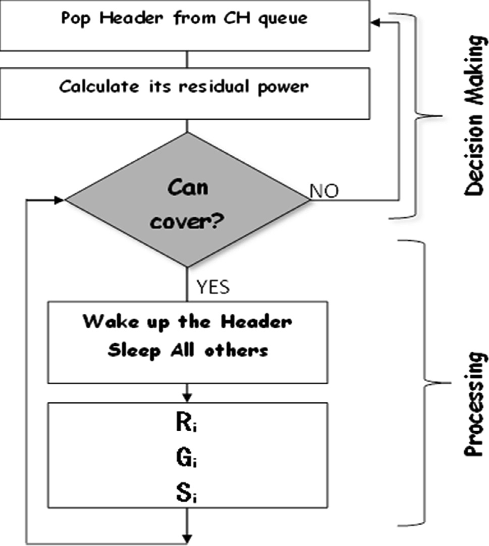

Fig. 1. Header wake-sleep mechanism flowchart.

already outperforms the work of [9] is investigated for the second contribution and the ESACC algorithm [16] and ECH protocol [21] for the third contribution.

For the sake of comparison, we consider the survivability and transfer capability to evaluate the proposed protocol with its men- tioned related works.

To make the results from the experiments more objective, we use the same environment and parameters as the related works. Table 1 summarizes the set of parameters and the baseline settings for the simulation. The used simulation is MATLAB Environment guided by the simulation by the works of [25] and [26]. We evalu- ated the performance of the proposed IE2-LEACH through exten- sive simulation tests.

* 1. *The survivability*

We use the following metrics to evaluate the survivability of the proposed approach compared to the related works.

* Energy depletion: measures the consumed energy during HNA
* Network Lifetime: measures the number of rounds until the end (all nodes are dead)
  + 1. *Energy depletion*

In order to evaluate and compare the performance of the pro- posed work with its related works, the network lifetime metric is used in the form of the number of rounds. Fig. 2 shows the compar- ison of the network lifetimes with three algorithms: LEACH [5], E- LEACH [15], IEECHS-WSN [22]. As seen in the figure below, in terms of average network lifetime, the IE2-LEACH outperforms the others; it is 20–45% better.

* + 1. *Energy dissipation*

Fig. 3 reveals the average power consumption compared at dif- ferent times for various nodes in 8 rounds. Fig. 3 depicts the result of energy depletion in CHs in LEACH, E-LEACH compared to energy depletion in the proposed approach (IE2-LEACH). The simulation results show the outperformance of the proposed approach over the related works, especially with the higher number of nodes. In other words, the proposed approach consumes less power than its related work. This minimization of power consumption is due to the selection of CHs according to the lowest power cost where the extra transmission is omitted.

* 1. *The transfer capability*

We use the clustering lifetime as a metric to evaluate the trans- fer capability of the proposed approach compared to the related works. We measure the number of rounds covered by each CH and its vices

Toward more accurate results, we investigate the impact of the second and third contributions by the number of rounds covered by each CH and the vices as indicators about the cluster age. Table 2 and Fig. 4 reflect the light on the outperformance of the introduced work IE2-LEACH and its ability to reduce the energy dissipation from CHs, as well as conserve the cluster alive. This can enhance the entire system’s lifetime.

From Table 2, it can be easily to notice that the number of CHs of the present work is greater than that of the other protocols in the experiments. In detail, when running approximately 500 rounds, E-LEACH outperforms LEACH. This demonstrates that the present work can maintain better information transmission performance.

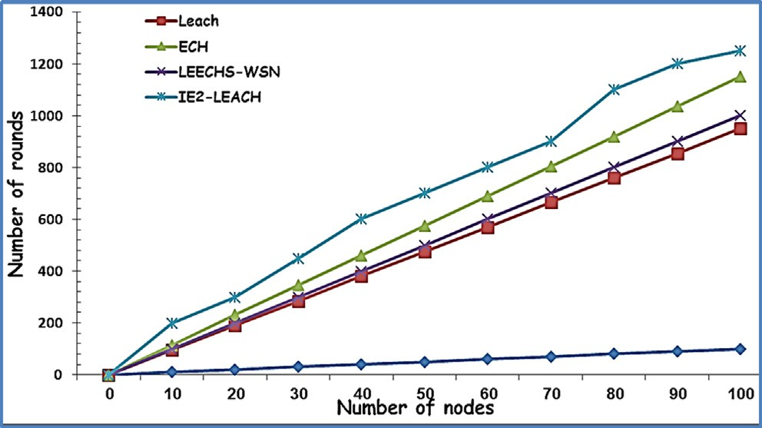

Fig. 2. The energy lifetime by LEACH, E-LEACH, IEECHS-WSN and IE2-LEACH.

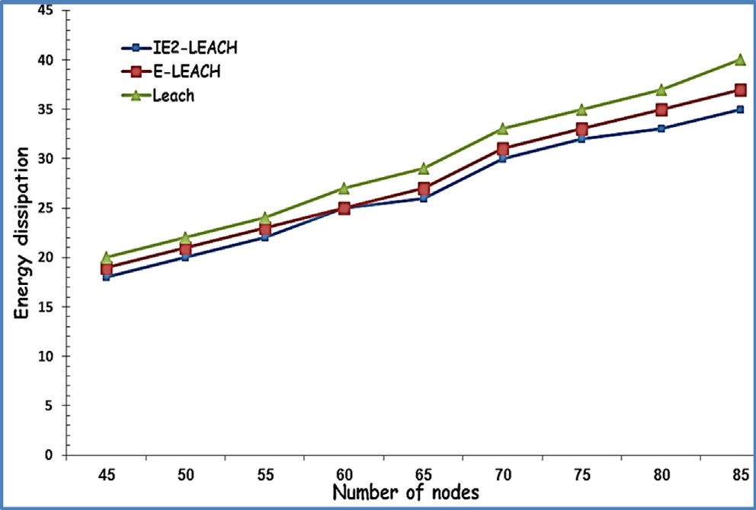

Fig. 3. The energy dissipation by cluster head in LEACH, E-LEACH and IE2-LEACH.

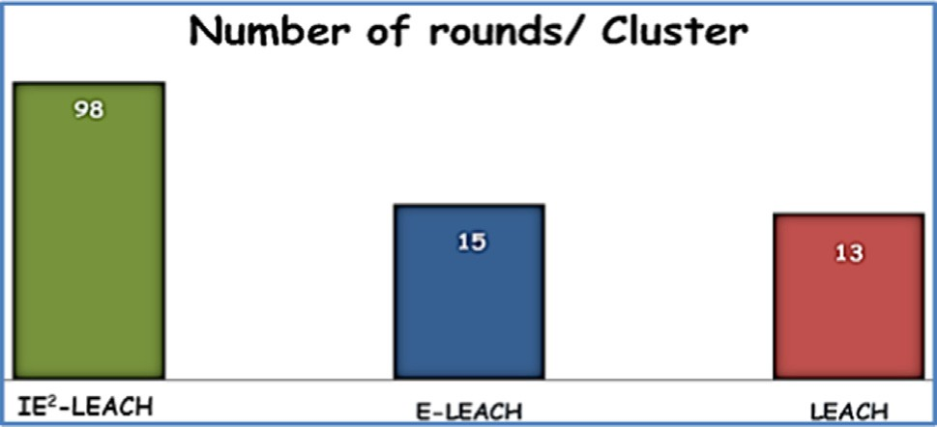

Fig. 4. The cluster lifetime of proposed work and related works.

1. Conclusions and future work

The LEACH protocol is fundamental for WSN clustering. How- ever, it suffers from some drawbacks, especially in the setup phase where the selection of CH is random. In a trial to recruit the clus- tering techniques to confront these drawbacks, this work intro- duced an enhanced energy efficient cluster head identifying method in WSN according to the lowest degree of energy con- sumption. This work is introduced as an improvement on the LEACH protocol as we modify the method of CH selection in LEACH. The head selection is based on balancing between the communica- tion cost and the residual energy. In addition, this work defines the vices of each CH to avoid sending redundant information. The present work also proposes a sleeping-waking up scheduling algo- rithm to conserve the power consumption. The simulation results show a better performance of IE2-LEACH compared to many

related works in terms of minimizing power consumption and maximizing network lifetime. In future, the proposed clustering technique should be extended to include the steady state phase.

References

1. [Xu L, Collier R, O’Hare GMP. A survey of clustering techniques in WSNs and](http://refhub.elsevier.com/S1110-8665(21)00003-7/h0005) [consideration of the challenges of applying such to 5G IoT scenarios. IEEE](http://refhub.elsevier.com/S1110-8665(21)00003-7/h0005) [Internet Things J Oct. 2017;4(5):1229–49](http://refhub.elsevier.com/S1110-8665(21)00003-7/h0005).
2. Jairam B, Ashoka DV, Multiple Mobile Elements Based Energy Efficient Data Gathering Technique in Wireless Sensor Networks, in Digital Business; Lecture Notes on Data Engineering and Communications Technologies, Springer, vol. 21, July 2019.
3. [Guo X, Chen Z, Hu X, Li X. Multi-source localization using time of arrival self-](http://refhub.elsevier.com/S1110-8665(21)00003-7/h0015) [clustering method in wireless sensor networks. IEEE Access June](http://refhub.elsevier.com/S1110-8665(21)00003-7/h0015) [2019;7:82110–21](http://refhub.elsevier.com/S1110-8665(21)00003-7/h0015).
4. [Zhang Y, Liu M, Liu Q. An energy-balanced clustering protocol based on an](http://refhub.elsevier.com/S1110-8665(21)00003-7/h0020) [improved CFSFDP algorithm for wireless sensor networks. Sensors March](http://refhub.elsevier.com/S1110-8665(21)00003-7/h0020) [2018;18(3):881](http://refhub.elsevier.com/S1110-8665(21)00003-7/h0020).
5. Heinzelman WR, Chandrakasan A, Balakrishnan H, ‘‘Energy-efficient communication protocol for wireless microsensor networks,” Proceedings of the 33rd Annual Hawaii International Conference on System Sciences, Maui, HI, USA, 2000, pp. 10 pp. vol.2.
6. Aza A, Shekhar P, Mishra AK, Pandey RC, ‘‘An Approach To Optimize H-Leach For Efficient Clustering In WSN,” 2019 9th International Conference on Advances in Computing and Communication (ICACC), Kochi, India, 2019, pp. 11-16.
7. [Younis O, Fahmy S. HEED: a hybrid, energy-efficient, distributed clustering](http://refhub.elsevier.com/S1110-8665(21)00003-7/h0035) [approach for ad hoc sensor networks. IEEE Trans Mob Comput Oct. 2004;3](http://refhub.elsevier.com/S1110-8665(21)00003-7/h0035) [(4):366–79](http://refhub.elsevier.com/S1110-8665(21)00003-7/h0035).
8. [Verma A, Kumar S, Gautam P, Rashid T, Kumar A. Fuzzy logic based effective](http://refhub.elsevier.com/S1110-8665(21)00003-7/h0040) [clustering of homogeneous wireless sensor networks for mobile sink. IEEE Sens](http://refhub.elsevier.com/S1110-8665(21)00003-7/h0040) [J Jan. 2020;20(10):5615–23](http://refhub.elsevier.com/S1110-8665(21)00003-7/h0040).
9. I. Daanoune, A. Baghdad and A. Balllouk, ‘‘BRE-LEACH: A New Approach to Extend the Lifetime Of Wireless Sensor Network,” 2019 Third International Conference on Intelligent Computing in Data Sciences (ICDS), Marrakech, Morocco, 2019, pp. 1-6.
10. Yuvaraj P. and K. V. L. Narayana, ‘‘EESCA: Energy efficient structured clustering algorithm for wireless sensor networks,” 2016 International Conference on Computing, Analytics and Security Trends (CAST), Pune, 2016, pp. 523-527.
11. [Sharma R, Mishra N, Srivastava S. A proposed Energy Efficient Distance Based](http://refhub.elsevier.com/S1110-8665(21)00003-7/h0055) [Cluster Head (DBCH) algorithm: an improvement over LEACH. Proc Comput Sci](http://refhub.elsevier.com/S1110-8665(21)00003-7/h0055) [ELSEVIER 2015;57:807–14](http://refhub.elsevier.com/S1110-8665(21)00003-7/h0055).
12. [Mohapatra H, Rath A. Fault tolerance in WSN through PE-LEACH protocol. IET](http://refhub.elsevier.com/S1110-8665(21)00003-7/h0060) [Wireless Sens Syst Nov. 2019;9(6):358–65](http://refhub.elsevier.com/S1110-8665(21)00003-7/h0060).
13. M. S. Ali, T. Dey and R. Biswas, ‘‘ALEACH: Advanced LEACH routing protocol for wireless microsensor networks,” 2008 International Conference on Electrical and Computer Engineering, Dhaka, 2008, pp. 909-914.
14. [Duche RN, Sarwade N. Round trip delay time as a linear function of distance](http://refhub.elsevier.com/S1110-8665(21)00003-7/h0070) [between the sensor nodes in wireless sensor network. Int. J. Eng. Sci. Emerg.](http://refhub.elsevier.com/S1110-8665(21)00003-7/h0070) [Technol. 2012;1(2):20–6](http://refhub.elsevier.com/S1110-8665(21)00003-7/h0070).
15. [Abu Salem A, Shudifat N. Enhanced LEACH protocol for increasing a lifetime of](http://refhub.elsevier.com/S1110-8665(21)00003-7/h0075) [WSNs. Pers Ubiquit Comput 2019;23(5–6):901–7](http://refhub.elsevier.com/S1110-8665(21)00003-7/h0075).
16. [Wang H, Li Y, Chang T, Chang S. An Effective Scheduling Algorithm for](http://refhub.elsevier.com/S1110-8665(21)00003-7/h0080) [Coverage Control in Underwater Acoustic Sensor Network. Sensors 2018;18](http://refhub.elsevier.com/S1110-8665(21)00003-7/h0080) [(8):2512](http://refhub.elsevier.com/S1110-8665(21)00003-7/h0080).
17. [Nayak P, Devulapalli A. A Fuzzy Logic-Based Clustering Algorithm for WSN to](http://refhub.elsevier.com/S1110-8665(21)00003-7/h0085) [Extend the Network Lifetime. IEEE Sens J 2016;16(1):137–44](http://refhub.elsevier.com/S1110-8665(21)00003-7/h0085).
18. Liao Q, Zhu , ‘‘An Energy-Balanced Clustering Algorithm Based on LEACH Protocol”, in ICSEM-13 - 2nd International Conference on Systems Engineering and Modeling, 2013, vol. 5, no. 3, pp. 90-95
19. Rajpoot P, Dwivedi P, Dubey K, ‘‘Power Balanced Efficient Clustering Algorithm for WSN,” 2019 International Conference on Communication and Electronics Systems (ICCES), Coimbatore, India, 2019, pp. 585-589.
20. Kirsan AS., Udin Harun Al Rasyid M, Syarif I, Efficient Energy for Cluster Head Selection using New LEACH-based routing protocol in Wireless Sensor Network 2019 International Electronics Symposium (IES), Surabaya, Indonesia, 2019, pp. 70-75.
21. [El Alami H, Najid A. ECH: an enhanced clustering hierarchy approach to](http://refhub.elsevier.com/S1110-8665(21)00003-7/h0105) [maximize lifetime of wireless sensor networks. IEEE Access Aug.](http://refhub.elsevier.com/S1110-8665(21)00003-7/h0105) [2019;7:107142–53](http://refhub.elsevier.com/S1110-8665(21)00003-7/h0105).
22. [Jesudurai S, Senthilkumar A. An improved energy efficient cluster head](http://refhub.elsevier.com/S1110-8665(21)00003-7/h0110) [selection protocol using the double cluster heads and data fusion methods for](http://refhub.elsevier.com/S1110-8665(21)00003-7/h0110) [IoT applications. Cog. Syst. Res. Elsevier Oct. 2019;57:101–6](http://refhub.elsevier.com/S1110-8665(21)00003-7/h0110).
23. Widodo DHK, Kurniawan A, Arifianto MS, ‘‘Improving Topology of LEACH Cluster Using Reinforcement Learning Method,” 2019 IEEE International Conference on Sensors and Nanotechnology, Penang, Malaysia, 2019, pp. 1-4.
24. [Kim S, Kim B, Kim K, Kim K. Opportunistic multipath routing in long-hop](http://refhub.elsevier.com/S1110-8665(21)00003-7/h0120) [wireless sensor networks. Sensors Sep. 2019;19(19):4072](http://refhub.elsevier.com/S1110-8665(21)00003-7/h0120).
25. [Deng Y et al. Simulation study on ASCMP protocol in utility tunnel WSN. IEEE](http://refhub.elsevier.com/S1110-8665(21)00003-7/h0125) [Access Nov. 2019;7:168141–50](http://refhub.elsevier.com/S1110-8665(21)00003-7/h0125).
26. Amin Nazari (2019). Wireless Sensor Networks Simulation (https:// [www.mathworks.com/matlabcentral/fileexchange/69778-wireless-sensor-](http://www.mathworks.com/matlabcentral/fileexchange/69778-wireless-sensor-) networks-simulation), MATLAB Central File Exchange.

Safa’a S. Saleh received B.Sc. from Alexandria University in 1991. She awarded High Diploma, M.Sc. (by research) in information systems -College of Computing and Information Technology, Arab Academy for Science & Technology and Maritime Transport (AASTMT), Alexandria 2005 and 2008 respectively. Ph.D. degree in Information System, Menoufia University, Egypt with a title of Intelligent Replication for Distributed Active Real-Time Databases Systems. She has contributed papers in the areas of Data mining, Distributed Real- time Database Systems, Digital Libraries and Bioinfor- matics. Currently, she is an Assistant Professor in the

Information Systems Department, Egyptian Institute of Alexandria Academy for Management and Accounting.

Tamer F. Mabrouk received the B.Sc. in Computer Engineering from Arab Academy for Science & Tech- nology and Maritime Transport (AASTMT) in 1997. He held the M.Sc. degree in Information Technology from the Institute of Graduate Studies and Research (IGSR), Department of Information Technology, Alexandria University in 2004. He received his Ph.D. degree from Alexandria University for a thesis in Multi-Agent System and Business Intelligence in 2009. His present research interests are currently focused on Database Manage- ment, Cloud Computing and Artificial Intelligence. He has published in journals and conferences and severed

as TPC of many international conferences. He has been an Assistant Professor in the Department of Computer engineering, Alexandria Higher Institute of Engineering &

Technology, AIET from Decemeber, 2010 till August, 2018. Since September, 2018, He has been an Assistant Professor in the Department of Management Information Systems, Egyptian Institute of Alexnadria Academy for Management and Account- ing.

Rana A. Tarabishi received a B.Sc. in Computer Science from Taibah University, Saudi Arabia, in 2010. The graduate project was - Microarray Data Mining for Predicting Gene Function Using Gene Ontology – also earned the ‘‘Best Project” distinction in a competition organized by previous Taibah University Graduates. She worked as a Teaching Assistant in the Department of Computer Science - Col- lege of Computer Science and Engineering - at Taibah University in 2011. She received M.Sc. in Artificial Intelligence from the School of Computer Science and Engineering in UNSW, Sydney, Australia in 2015. She is interested in bioinformatics and the analysis of health information using data mining techniques, computer vision, and the ethical/social issues of Internet of Things and smart cities. She also received the badge of Big Data Engineer (Mastery Award for Educators) from IBM, 2019. Since 2015, she is working as a lecturer in the Department of Computer Science - College of Computer Science and Engineering (Taibah University, KSA).