[Egyptian Informatics Journal 23 (2022) 13–19](https://doi.org/10.1016/j.eij.2021.05.001)

Contents lists available at [ScienceDirect](http://www.sciencedirect.com/science/journal/11108665)

Egyptian Informatics Journal

journal homepage: [www.sciencedirect.com](http://www.sciencedirect.com/)

[](http://crossmark.crossref.org/dialog/?doi=10.1016/j.eij.2021.05.001&domain=pdf)An optimal configuration-based trading scheme for profit optimization in wireless networks

Ayoub Alsarhan

*Department of Computer Information System, Hashemite University, P.O. Box 150459, Zarqa 13115, Jordan*

# a r t i c l e i n f o

*Article history:*

Received 23 June 2020

Revised 26 February 2021

Accepted 3 May 2021

Available online 19 May 2021

*Keywords:*

Cognitive radio Primary user Secondary user

Dynamic spectrum allocation Spectrum utilization Spectrum trading

# a b s t r a c t

Over the last few years, we have seen dramatic increase in the demand for radio spectrum in the world due to rapid growth in wireless services and applications. In order to meet the growing demand for radio spectrum, new schemes should be developed for utilizing free spectrum effectively. Cognitive radio (CR) is promising technology that enables solving spectrum scarcity problem effectively. Thus, in this paper, we propose two schemes to motivate primary user (PU) to share spectrum with secondary users (SUs). The key concern of the proposed schemes is maximizing PU’s profit by hiring free spectrum to wealthy SUs. In the eviction scheme, SUs with less profit are expelled from service to serve wealthy SUs. The fold- ing scheme reconfigures spectrum request to serve it. It reduces the size of request if the available size is not sufficient for the request. The simulation results demonstrate that the ability of new schemes to max- imize PU’s profit. Apparently, the results confirm the ability of the proposed schemes to utilize the free spectrum efficiently.

© 2022 THE AUTHORS. Published by Elsevier B.V. on behalf of Faculty of Computers and Information,

Cairo University. This is an open access article under the CC BY-NC-ND license ([http://creativecommons.](http://creativecommons.org/licenses/by-nc-nd/4.0/)

[org/licenses/by-nc-nd/4.0/](http://creativecommons.org/licenses/by-nc-nd/4.0/)).

1. Introduction

Wireless services and applications have been growing exponen- tially [1,2]. This is due to the emergence of new wireless technolo- gies and networking paradigms. Hence, radio spectrum has become congested due to its inability to accommodate this grow- ing demand [1–4]. CR enables PUs to utilize spectrum for generat- ing extra money and serving more SUs. Furthermore, CR contributes to solve the spectrum scarcity problem that results from fixed spectrum allocation policies [1]. However, these policies fail to meet high bandwidth demand. In addition, many studies have shown that significant amount of spectrum is unutilized (spectrum opportunity). Therefore, it is necessary to reconsider developing new schemes for utilizing unused spectrum.

A new communication paradigm is called dynamic spectrum allocation (DSA) has emerged to enable spectrum allocation

*E-mail address:* [ayoubm@hu.edu.jo](mailto:ayoubm@hu.edu.jo)

Peer review under responsibility of Faculty of Computers and Information, Cairo University.

**Production and hosting by Elsevier**

dynamically. In DSA, the spectrum is allocated dynamically by PU. CR enables DSA and makes it a reality [2,5–8]. The spectrum can be hired to SUs using CR. In this spectrum sharing model, SUs can access free spectrum provided that they pay for spectrum usage [3]. An access point located at any public place is an example for spectrum trading where users have to pay for accessing internet.

In spectrum trading market, PUs temporarily transfer the right of accessing their free spectrum to SUs using spectrum trading scheme. The spectrum is leased according to the SU based on the objectives and goals of spectrum owner. In our work, PU offers renting his free spectrum. After that, he receives spectrum requests. Then, the requests are sorted based on the offered prices. PU tries to maximize the profit as much as possible by serving the wealthiest SUs and utilizing spectrum efficiently.

In order to maximize PUs’ profit, it is important to reconfigure spectrum requests based on the status of the market. Request attri- butes determine the profit of PU. Attributes are essentially values that are associated with a particular service request. These values include: reported profit, spectrum price, rental period, size of required spectrum (i.e. number of required spectrum units). This analysis enables the PU to maximize his own profit.

In our eviction policy, PU tries to serve the new requests if the entire spectrum is busy and the newcomer offers more service price than in-service clients. In order to maximize profit by serving

<https://doi.org/10.1016/j.eij.2021.05.001>

1110-8665/© 2022 THE AUTHORS. Published by Elsevier B.V. on behalf of Faculty of Computers and Information, Cairo University. This is an open access article under the CC BY-NC-ND license (<http://creativecommons.org/licenses/by-nc-nd/4.0/>).

wealthy users, PU attempts to expel in-services users whom reported profits are lowest. The evicted users are compensated to encourage them to release their channels. Furthermore, we pro- pose another scheme (folding scheme) that attempts to utilize the entire free spectrum for serving SUs by configuring spectrum requests. PU may reduce the size of request if the request size of spectrum is greater than the size of the free spectrum. In order to motivate SUs to accept new configuration, PU offers a lower price for the new configuration. The contributions of this paper are summarized as follows:

1. We study the the problem of determining the optimal admission of spectrum requests. Our schemes prioritize serving the requests which maximize PU’s profit and enable PU to utilize the spectrum efficiently.
2. A new scheme is proposed for request configuration. The proposed scheme takes into account the size of free spec- trum and the required number of spectrum units. It tries to reduce the requested size for utilizing the small size of available spectrum.
3. A novel scheme is suggested for evicting some users in- service to utilize their spectrum for serving wealthy clients. To the best our knowledge, this is the first attempt to max- imize PU’s profit by jointly optimize admission and eviction controls with dynamic size of free spectrum.
4. Extensive performance analysis is carried out for these schemes. The results showed that PU can maximize the profit by configuring some requests and optimizing the admission and eviction controls.

This paper is organized as follows. We show related works in Section 2. Next, we describe the system model in Section 3. We for- mulate the problem in Section 4 and then we describe our scheme. We evaluate the performance of the proposed scheme in Section 5. Finally, the paper is concluded and future research directions are given.

1. Related work

Over the past decades, many wireless services have emerged, resulting in a dramatic increase in spectrum demand [1,2]. The frequency spectrum is the scarcest natural resource nowadays [2]. Traditional spectrum management policies fail to meet the growing demand for radio spectrum resources. PUs have exclu- sive right to access their spectrum using these policies. These policies prevent access to free spectrum from SUs. Unfortunately, many studies reported that significant portions of spectrum are underutilized [1–3]. In spectrum trading, CR is adopted to resolves or at least to mitigate the spectrum scarcity problem by allowing SUs to access free provided that they pay for the spectrum usage [25–27].

In [1,6], authors proposed DSA to utilize unused spectrum. DSA enables CR technology that allows SUs to detect free chan- nels and access them without interfering with PUs. Although some schemes [9–11,26,27] improve spectrum utilization signifi- cantly, they are not acceptable these days since they allow SUs to access the licensed bands without paying any usage charge to PUs. However, PUs pay to get the exclusive rights for accessing spectrum.

In [12], authors proposed a new spectrum pricing strategy based on game theory. The spectrum was traded to SUs. A sealed-bid knapsack auction mechanism was used to trade free spectrum. However, the scheme did not consider utilizing the entire spectrum since it did not try reconfiguring spectrum request to utilize small size of free spectrum. Furthermore, it did not attempt to evict poor in-service requests to serve wealthy SUs.

Authors proposed using game theory for spectrum allocation in [2]. They discussed several aspects of using game theory for spec- trum trading such as analysis of SUs behavior, and design of effi- cient trading scheme.

In [13,14], authors proposed a new scheme for maximizing the profit of PU by preempting in-service SUs to allow the PU to access his spectrum. The main concern of the proposed scheme is protect- ing the PU and allowing him to access his spectrum anytime. The scheme preempts SU if all of the channels are occupied and it could not find free channels to serve PU. Dynamic programming was applied to find the optimal admission control policy that maximize the long run average profit. The results showed that the perfor- mance of the proposed scheme depends only on the total number of SUs in the market. In [15], a wireless service provider (WSP) leases free spectrum for PUs via auction technique. Then, PUs rent the free spectrum to SUs. SUs must release channels as soon as PU needs these channels. PU compensates the evicted SUs by the fixed amount of cash. Linear programming is used to find the optimal control policy. Authors studied the economical perspective of trad- ing Wi-Fi service in [16]. In the proposed spectrum market, WSP rents free spectrum to SUs in order to maximize profit. The pro- posed scheme considers the main factors that affect the profit of WSP. These factors include:

* Channel cost.
* Quality of service (QoS) constraints.
* Protecting PU from unlicensed access to his spectrum.

In [17], authors studied the QoS for SUs. In the proposed

scheme, SUs release channels upon detecting PU’s signal. There- fore, the QoS for SUs degraded significantly because of PUs activi- ties. Furthermore, new scheme was proposed to rank channels based on its attributes. These attributes include: bandwidth, inter- ference, and channel error rate. In [18,19], authors studied profit maximization for PU. Free spectrum is used to serve multiple classes of SUs. In this spectrum market, PUs are given priority to access free spectrum over SUs. The scheme preempts SUs upon arrivals of PU. In [20], PUs may rent free spectrum to SUs for gen- erating extra money. The main concern of the proposed scheme is maximizing the PUs profit and meeting the requirements con- straints of SUs.

Reinforcement learning model (RL) was used to extract the opti- mal control policy that is used to lease spectrum for a set of SUs. The main goal of the proposed scheme is maximizing the total profit and utilizing free spectrum efficiently. In [21], authors pro- posed new trading scheme where PU serves a set of SUs by renting free spectrum. Buyer/seller paradigm was used to characterize the interaction between PUs and SUs. PU sets the prices of the spec- trum to maximize his profit. In [22], the main concern of the pro- posed scheme is maximizing the profit and serving SUs requests based on the ranks. SUs’ requests are ranked based on the spec- trum price. Unfortunately, some of these schemes did not consider maximizing total profit of PUs by preempting SUs in-service to serve wealthy requests. Furthermore, they neglected utilizing the whole spectrum by configuring spectrum request to reduce the delay time of SUs in the queue. Furthermore, some of them [23,24] did not consider the limited amount of spectrum. They assumed the spectrum is free all the time and PUs cannot preempt SUs for generating extra money. However, none of these schemes consider the following:

1. Maximizing total profit of PUs by preempting SUs in- service to serve wealthy requests.
2. Utilizing the entire spectrum by configuring new requests.
3. Reducing delay time of SUs in the queue by offering less sizes of spectrum with lower prices.
4. System model

As illustrated in Fig. 1, we model a channel in our work as an 1/0

K*q*|*s* = (*q* : *qi* ≥ 0;

*w*

X*i*=1

*si* ≤ *W*)

(6)

alternating renewal process. 1(0) period implies the channel is occupied (free) and cannot be traded. We assume that 1/0 transi- tions can be detected by the spectrum sensing but that is not our concern of this paper. The following condition for specifying the state of the channel is used:

The set of possible sub state *s* is given as:

K*s* = {*s* : *si* ∈ {0; 1} (7)

Each SU knows about his request but does not has knowledge

about other SUs requests. We assume *C* is the cost of spectrum. The spectrum market state is defined as follows:

*S* = 1; *p* > *T*

*i*

0; *p* < *T*

## (1) (

where *p* is the received power at the receiver, and *T* is interference threshold.

}

*H* = (*s*; *q*) =

*s* = {*s*1; *s*2; ·· · ; *sW* }

(8)

1/0 states are independent of each other. We assume states are

exponentially-distribution for 1 and 0 period with mean 1 and 1 .

*q* = *q*1; *q*2 ; ·· · ; *qN*

As illustrated in Fig. 2, spectrum market made up of *N* SUs and a

PU who trade his spectrum.

l1 l0

In spectrum market, we consider *N* set of SUs compete for *W* spec- trum units (i.e., number of idle channels). The pool of spectrum is represented as follows:

*W* = {*s*1; *s*2; *s*3; ·· · ; *sw*} (2)

The set of possible sub state *q* for a given channel state *s* is

determined as:

1. Spectrum allocation schemes for profit maximization

The profit maximization for a PU is a unique challenge due to time-varying spectrum availability and dynamic nature for spec- trum market. Many attributes for spectrum market change over time. These changes include: demand, spectrum cost, and supply. Therefore, PU must jointly consider SUs admission and eviction

K*q*|*s* = (*q* : *qi* ≥ 0;

*w*

X*i*=1

*si* ≤ *W*)

(3)

controls to optimize his profit subject to some constraints. These constraints include:

The set of possible sub state S is given as:

K*s* = {*s* : *si* ∈ {0; 1} (4)

We assume the arrival request rate follows the Poisson distribu-

tion and each request has an arrival rate k. Service time for each request l is assumed to be exponentially distributed. Each SU sub- mits his request at the beginning of each session. The request for *ith* client *Ei*can be expressed follows:

*Ei* = *qi* ; *ri*;*ti* (5)

}

where *qi* is the spectrum size (i.e. number of channels), *ri* is the bid,

and *ti* is the rental period for spectrum. The set of possible sub state

*q* for a given channel state *s* is determined as:

* Capacity constraint where each PU has finite amount of this

commodity. This condition can be expressed as follows:

*si* ≤ *W* (9)

X

*T*→∞

where *T* is the time horizon.

* Budget constraint where SU has limit amount of cash. This con- dition can be expressed as follows:

*ri* ≤ *B* (10)

where *B* is the maximum cash that *ith S*U can pay. For each new

request, PU has to decide whether to serve the request or reject it using the trading scheme. The action taken by PU will change the market state accordingly. The action space can be defined as follows:

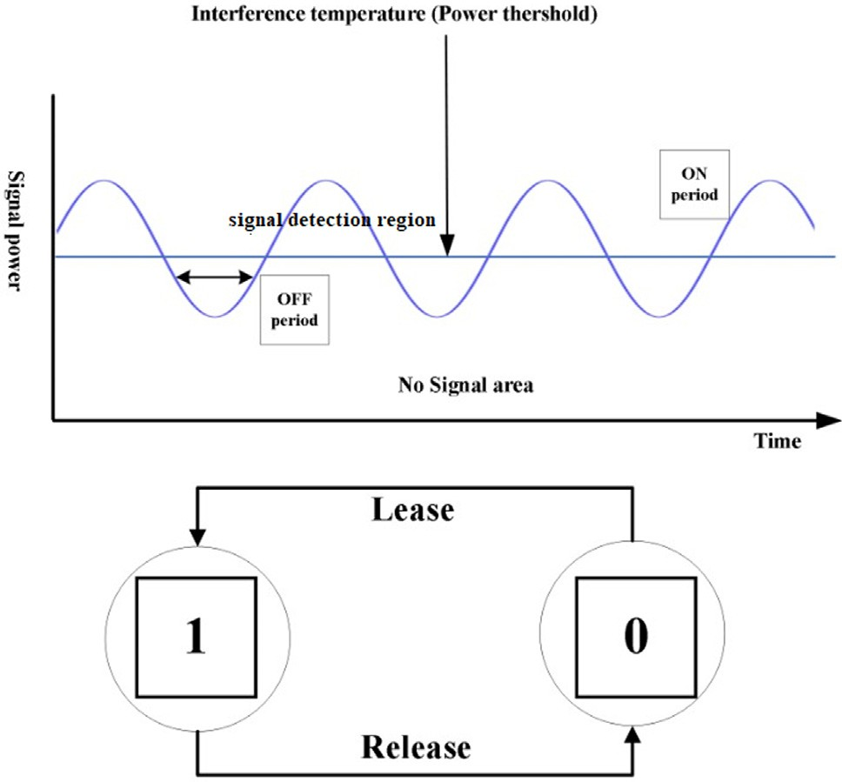 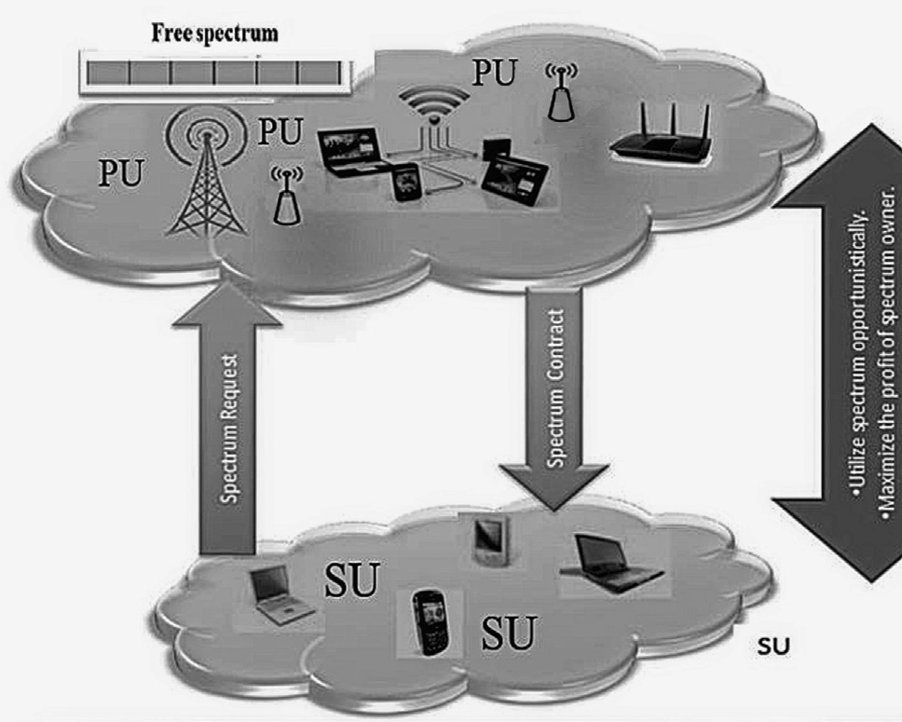

Fig. 1. Spectrum status: alternating busy (1) and free (states). Fig. 2. Spectrum market*.*

*A* = *a* = {*a*1; *a*2; ··· ; *an* }

*E* = {*E*1; *E*2; ·· · ; *En* }

The action *ai* for request *Ei* is represented as follows:

( ;

### 0 *rejecttheithrequest*

*a* =

## (11)

(12)

The key concern of eviction scheme is maximizing PU’s profit by prioritizing wealthy clients. Some requests are evicted immedi- ately if new request arrives with more reward and the amount of free spectrum is not adequate to serve the request. Evicted SUs are compensated with amount *Rc* which is computed as follows:

### *i* 1; *admittheithrequest*

*R* = X *I* * *ti* * £

## (15)

The generated reward after serving SUs is computed as follows:

*i*∈*V c i r* *i*

*n*

*R* = *qi* * *ri* * *ti*\**ai* (13)

X

*i*=1

We formulate the trading policy as follows:

arg max *qi* * *ri* * *ti* * *ai* (14)

*ai* ∈*A*

where *Ii*is fixed amount of money paid *ith* SU for releasing a channel, *V* is the set of evicted SUs, and £iis the number of released channels from *ith* SU, and *ti* is the the remaining time of rental period. The

remaining time of rental period *ti* is computed as follows:

*r*

*ti* = *tc* — *ts* (16)

*r*

*r*

where *ts* is the starting time of service, and *tc* is the current time.

s.t.

*si* ≤ *W*

X

*i*∈*Z*

*ri* ≤ *B*

where *Z* is the set of in-service SUs. Next, we present our schemes to

maximize PU’s profit if the total size of the requested spectrum is larger than the available spectrum (i.e. *W*). Our trading scheme (configuration-based scheme) sort all requests based on reward in descending order. Then, it starts serving theme. However, if the size of request is larger than the size of free spectrum, configuration- based scheme calls folding policy for spectrum allocation. Contrary, if all spectrum units are busy, then eviction policy is called. The configuration-based scheme is given as follows:

The eviction scheme is given as follows:

Variable Definition

*compensate(l) Method for compensating lth SU using Eq.* *(13)* *evict(l) Method for evicting lth SU*

*assign(sl,i) Method for allocating ith SU spectrum for lth SU*

Algorithm 2: Eviction scheme

*1: Sort(E);*

*2:Ei* = *Red New Requst*();

*3: l* = min *rj*;

*j*∈*Z*

*4:x* = max *rj*;

*j*∈*iZ*

5: g = 0;

6: while *(g <qi && qi <W && rl* < *ri) 7: {*

|  |  |  |  |
| --- | --- | --- | --- |
| Variable | Variable | *10:* | *compensate(l);* |
| Sort | Method for sorting requests in queue | *11:* | *evict(l);* |
| Z | Set of requests in service | *12:* | *if (ql < (qi* — *g))* |
| F | Available size of spectrum | *13:* | *{* |

Algorithm 1: Configuration-based scheme

*1: While (is-not-EmptyQueu())*

*2: {*

*3: Sort(E);*

*4: i = pop();*

*5: if (qi < f)*

*6: ServRequest(Ej*)*;*

*7: else if (qi > f)*

*8: {*

*9: x* = min *rj*;

*j*∈*Z*

*10: if (ri > rx)*

*11: EvictionScheme(i);*

*12: if (ri < rx)*

*11: FoldingScheme(i);*

12: }

13: }

* 1. *Eviction scheme*

The reward is the amount of money that paid to PU in return for accessing PU’s spectrum. The proposed scheme evicts the requests in-service if new request arrives and the reward of this request is more than the reward of all SUs in a queue and some of SUs in- service. It evicts SUs solely when the whole spectrum is busy.

*14: g = g+ ql;*

*15: assign(ql,i);*

*16: l* = min *rj*;

*j*∈*Z*

16: }

17: else

18: {

19: *g = g+* (*ql* — *qi*)*;*

*20: assign(ql* — *qi,i);*

*21: f ree* = *f ree* + (*ql* — *q*);

*22: }*

*23: }*

* 1. *Folding scheme*

The request is served if the size of free spectrum is greater than the required size. Folding scheme tries to utilize the entire spec- trum and to eliminate spectrum whole (i.e. unused spectrum). It attempts to serve the request even if its size is larger than number of available size. It configures the request by changing the service price and the size of request. The new size for *ith* SU is determined as follows:

*qi* = *f* (17)

‘

where *f* is the size of free spectrum. The new reward *r*‘ for *ith* SU is

*i*

Firstly, the scheme sorts all spectrum requests in descending order

according based on reward. After that, it starts serving the requests on the queue. The request is served if the free spectrum is sufficient to serve it.

computed as follows:

*r*‘ = *ri* * *f*

*i qi*

## (18)

In addition to maximize PU’s profit, folding policy tries to reduce the turnaround time of service by utilizing the spectrum efficiently. Turnaround time *Tt* for *ith* request is computed as follows:

*Tt* = *Yt* + l (19)

where *Yt* is the amount of time that *ith* request waits for service. The

folding scheme is given as follows:

Variable Definition

*Algorithm 3: Folding scheme 1: Sort(E);*

*2: i* =*pop();*

*3: if (qi* < *f )*

*4:* {

5: assign(*qi,i*);

6: *f* = *f* -*qi*;

*7: Go to 2;*

*11: }*

*12: else*

*13: {*

*14: qi* = *f ;*

‘

*15: r*‘ = *ri* \**f ;*



Table 1

Simulation parameters.

Parameter Value

Number of SUs 50

Number of requests per clients random

Number of channels per a PU 20

Number of messages per client random

k 2

|  |  |  |
| --- | --- | --- |
| Simulation device | Core | I5 |
|  | CPU | 2.5 GHz |
|  | Operating system Installed memory (RAM) | Windows 7 64 bit  6 GB |





*i qi*

‘

*16: assign*(*qi*; *i*);

16: *Go to 2;*

17: }

1. Performance evaluation

In this section, the performance of the proposed schemes is evaluated. The proposed schemes are implemented in the C lan- guage. Requests are served based on the offered price and the size of the required spectrum. the key performance measure of interest in the simulations is the reward of PU which is computed using Eq.

(3). For comparison purpose, the greedy scheme [22] is also simulated.

For the greedy scheme, spectrum are leased based on reward. PU does not try to configure requests to maximize his profit and utilize the entire free spectrum efficiently. However, in our work, PU utilizes the whole spectrum and serves wealthy clients to max- imize his profit. We consider an urban scenario where nodes are

distributed randomly over 200 × 200 *m*2. The parameters chosen

for evaluating the algorithm and the methodology for the simula-

tion are shown in Table 1.

* 1. *Simulation results*

Fig. 3 shows the reward comparison of configuration-based scheme with greedy scheme. The figure shows that the reward increases as the demand for spectrum increases (i.e. arrival rate). More arrival rate means serving more users. Serving more users generates more reward. As the figure illustrates, our scheme out- performs the greedy scheme. The configuration-based policy evicts some in-service SUs who pay less money if there is SU who pays more for service. This scheme prioritizes wealthiest SUs even if they are waiting in queue.

Serving wealthy SUs enables PU to maximize his reward. Fur- thermore, configuration-based scheme configures the request by reducing its size for utilizing the whole spectrum. It serves SUs even if the available number of spectrum units is inadequate to serve the request in the queue provided that SU accept to pay less amount of cash for the new size of spectrum. This action reduces



Fig. 3. PU’s reward under different spectrum demand.

the delay time for request and generates extra cash for PU by uti- lizing the available smaller number of channels. PU offers less money for service as compensation in return of the small size that is allocated for SU. Clearly, the service time for the SU will increase. We analyze the ability of our scheme to utilize the entire spec- trum to serve SUs. We simulate spectrum market where various sizes of requests arrive to PU. Fig. 4 shows that the utilization of configuration-based scheme is higher than the greedy scheme. Greedy scheme does not serve the user in the head of queue unless the free spectrum is adequate to serve the request. However, if the size of available spectrum less than the requested size of the spec- trum, the greedy scheme does not search the queue for a request that can be served using the available spectrum. Furthermore, it does not attempt to serve the request with less size of available spectrum. The figure depicts that as the arrival rate increases the utilization increases since more users are served. Our scheme uti-

lizes the whole spectrum to serve SUs.

Our scheme provides good service for SUs in terms of turn- around time. Fig. 5 shows a comparison of turnaround time of configuration-based scheme with the priority scheme. Our policy takes advantage of available spectrum that is inadequate to serve the request. It evicts SUs who pays less and utilizes the available spectrum to serve wealthy requests. Sometimes, the policy evicts users in service and serve the client in queue that needs more spec- trum. It is clear from the figure the eviction scheme outperforms the priority for all spectrum demands in terms of turnaround time. Since our scheme utilizes the whole spectrum, it serves users quickly. However, greedy scheme stuck with the user in the head who request size of spectrum greater than the available number of the spectrum. Some of the clients are not willing to wait in the queue. Usually, these users pay more money for service. There- fore, our scheme prefers to serve these users to generate extra money.

System capacity refers to the number of channels that PU can offer to the SUs. Fig. 6 shows the reward comparison of the two

nels increases. Increasing number of channels means serving more number of clients resulting in generating extra money. Clearly, serving more clients helps PU to increase his profit. Our scheme preempts poor users who pay less and utilize the entire spectrum for serving PU by reducing the size of request. The likelihood of serving more SUs’ requests and generating more money increases when the request is configured to make it suitable for service.





1. Conclusion

 



Fig. 4. Spectrum utilization under different values of spectrum demand.





Fig. 5. Spectrum turnaround under different spectrum demand.





Fig. 6. Reward under different values of spectrum supply.

schemes under different system capacities. The result shows that our scheme outperforms greedy scheme in terms of the reward. The figure shows that the reward increases as the number of chan-

In this paper, we address the problem of spectrum trading in secondary spectrum market where a PU trades the spectrum to make extra revenue. We have presented a business model for max- imizing the PU’s profit, while serving more SUs in the queue and utilizing the entire free spectrum. The main concern of our model is prioritizing wealthiest SUs in the queue. Furthermore, our policy tries to serve SUs by configuring the spectrum size and service price if the available spectrum is inadequate to serve them. The future work includes extension of the trading schemes and consid- ering the competition among PUs in the spectrum market.

References

1. [Akyildiz IF, Lee W-Y, Vuran MC, Mohanty S. NeXt generation/dynamic](http://refhub.elsevier.com/S1110-8665(21)00027-X/h0005) [spectrum access/cognitive radio wireless networks: a survey. Comput Netw](http://refhub.elsevier.com/S1110-8665(21)00027-X/h0005) [2006;50(13):2127–59](http://refhub.elsevier.com/S1110-8665(21)00027-X/h0005).
2. [Ji Z, Liu KJ. Cognitive radios for dynamic spectrum access-dynamic spectrum](http://refhub.elsevier.com/S1110-8665(21)00027-X/h0010) [sharing: a game theoretical overview. IEEE Commun Mag 2007;45(5):88–94](http://refhub.elsevier.com/S1110-8665(21)00027-X/h0010).
3. [Niyato D, Hossain E. Spectrum trading in cognitive radio networks: a market-](http://refhub.elsevier.com/S1110-8665(21)00027-X/h0015) [equilibrium-based approach. IEEE Wirel Commun 2008;15(6):71–80](http://refhub.elsevier.com/S1110-8665(21)00027-X/h0015).
4. Meghanathan N, Reddy Y. B. Cognitive radio technology applications for wireless and mobile Ad Hoc networks; 2013.
5. [Jia J, Zhang Q, Zhang Q, Liu M. Revenue generation for truthful spectrum](http://refhub.elsevier.com/S1110-8665(21)00027-X/h0025) [auction in dynamic spectrum access. In: In: Proceedings of the tenth ACM](http://refhub.elsevier.com/S1110-8665(21)00027-X/h0025) [international symposium on Mobile ad hoc networking and computing. p.](http://refhub.elsevier.com/S1110-8665(21)00027-X/h0025) [3–12](http://refhub.elsevier.com/S1110-8665(21)00027-X/h0025).
6. [Hossain E, Niyato D, Han Z. Dynamic spectrum access and management in](http://refhub.elsevier.com/S1110-8665(21)00027-X/h0030) [cognitive radio networks. Cambridge University Press; 2009](http://refhub.elsevier.com/S1110-8665(21)00027-X/h0030).
7. [Alsarhan A, Agarwal A. Channel assignment in cognitive wireless mesh](http://refhub.elsevier.com/S1110-8665(21)00027-X/h0035) [networks. In: In: Proceedings of 3rd International Symposium on Advanced](http://refhub.elsevier.com/S1110-8665(21)00027-X/h0035) [Networks and Telecommunication Systems (ANTS). p. 1–3](http://refhub.elsevier.com/S1110-8665(21)00027-X/h0035).
8. [McHenry MA, Tenhula PA, McCloskey D, Roberson DA, Hood CS. Chicago](http://refhub.elsevier.com/S1110-8665(21)00027-X/h0040) [spectrum occupancy measurements & analysis and a long-term studies](http://refhub.elsevier.com/S1110-8665(21)00027-X/h0040) [proposal. In: In: Proceedings of the first international workshop on](http://refhub.elsevier.com/S1110-8665(21)00027-X/h0040) [Technology and policy for accessing spectrum. p. 1-es.](http://refhub.elsevier.com/S1110-8665(21)00027-X/h0040).
9. [Buddhikot M. Understanding dynamic spectrum access: Models, taxonomy](http://refhub.elsevier.com/S1110-8665(21)00027-X/h0045) [and challenges. In: In: Proceedings of the 2nd IEEE International Symposium](http://refhub.elsevier.com/S1110-8665(21)00027-X/h0045) [on New Frontiers in Dynamic Spectrum Access Networks. p. 649–63](http://refhub.elsevier.com/S1110-8665(21)00027-X/h0045).
10. [Wang B, Ji Z, Liu KR. Primary-prioritized Markov approach for dynamic](http://refhub.elsevier.com/S1110-8665(21)00027-X/h0050) [spectrum access. In: In: Proceedings of the 2nd IEEE International Symposium](http://refhub.elsevier.com/S1110-8665(21)00027-X/h0050) [on New Frontiers in Dynamic Spectrum Access Networks. p. 507–15](http://refhub.elsevier.com/S1110-8665(21)00027-X/h0050).
11. [Kim H, Shin KG. Efficient discovery of spectrum opportunities with MAC-layer](http://refhub.elsevier.com/S1110-8665(21)00027-X/h0055) [sensing in cognitive radio networks. IEEE Trans Mob Comput 2008;7](http://refhub.elsevier.com/S1110-8665(21)00027-X/h0055) [(5):533–45](http://refhub.elsevier.com/S1110-8665(21)00027-X/h0055).
12. Sengupta S, Chatterjee M, Ganguly S. An economic framework for spectrum allocation and service pricing with competitive wireless service providers. In: Proceedings of 2nd IEEE International Symposium on New Frontiers in Dynamic Spectrum Access Networks 2007; pp. 89-98.
13. Turhan A, Alanyali M, Starobinski D. Optimal admission control of secondary users in preemptive cognitive radio networks. In: Proceedings of 10th International Symposium on Modeling and Optimization in Mobile, Ad Hoc and Wireless Networks (WiOpt), Paderborn; 2012, pp. 138-144.
14. [Zhao Z, Weber S, de Oliveira JC. Admission control and preemption policy](http://refhub.elsevier.com/S1110-8665(21)00027-X/h0070) [design of multi-class computer networks. In: In: Proceedings of 4th Annual](http://refhub.elsevier.com/S1110-8665(21)00027-X/h0070) [Conference on Information Sciences and Systems (CISS). p. 1–6](http://refhub.elsevier.com/S1110-8665(21)00027-X/h0070).
15. [Kim H, Shin KG. Optimal admission and eviction control of secondary users at](http://refhub.elsevier.com/S1110-8665(21)00027-X/h0075) [cognitive radio hotspots. In: In: Proceedings of 6th Annual IEEE](http://refhub.elsevier.com/S1110-8665(21)00027-X/h0075) [Communications Society Conference on Sensor, Mesh and Ad Hoc](http://refhub.elsevier.com/S1110-8665(21)00027-X/h0075) [Communications and Networks. p. 1–9](http://refhub.elsevier.com/S1110-8665(21)00027-X/h0075).
16. [Kim H, Shin KG. Understanding wi-fi 2.0: From the economical perspective of](http://refhub.elsevier.com/S1110-8665(21)00027-X/h0080) [wireless service providers [dynamic spectrum management]. IEEE Wirel](http://refhub.elsevier.com/S1110-8665(21)00027-X/h0080) [Commun 2010;17(4):41–6](http://refhub.elsevier.com/S1110-8665(21)00027-X/h0080).
17. [Guo T, Moessner K. Optimal strategy for QoS provision under spectrum](http://refhub.elsevier.com/S1110-8665(21)00027-X/h0085) [mobility in cognitive radio networks. Proc IEEE Vehicular Technol Conf (VTC](http://refhub.elsevier.com/S1110-8665(21)00027-X/h0085) [Fall) 2012:1–5](http://refhub.elsevier.com/S1110-8665(21)00027-X/h0085).
18. [Turhan A, Alanyali M, Kavurmacioglu E, Starobinski D. Dynamic pricing of](http://refhub.elsevier.com/S1110-8665(21)00027-X/h0090) [preemptive service for secondary demand. IEEE Trans Cognit Commun Netw](http://refhub.elsevier.com/S1110-8665(21)00027-X/h0090) [2016;2(2):208–22](http://refhub.elsevier.com/S1110-8665(21)00027-X/h0090).
19. [Ulukus MY, Güllü R, Örmeci L. Admission and termination control of a two](http://refhub.elsevier.com/S1110-8665(21)00027-X/h0095) [class loss system. Stochastic Models 2011;27(1):2–25](http://refhub.elsevier.com/S1110-8665(21)00027-X/h0095).
20. [Alsarhan A, Agarwal A. Optimizing spectrum trading in cognitive mesh](http://refhub.elsevier.com/S1110-8665(21)00027-X/h0100) [network using machine learning. J Electr Comput Eng 2012;2012(1):1–12](http://refhub.elsevier.com/S1110-8665(21)00027-X/h0100).
21. Ren S, van der Schaar M. Revenue maximization and distributed power allocation in cognitive radio networks. In: Proceedings of 2009 ACM workshop on Cognitive radio networks; pp. 43-48.
22. [Vickrey W. Counter speculation, auctions, and competitive sealed tenders. J](http://refhub.elsevier.com/S1110-8665(21)00027-X/h0110) [Finance 1961;16(1):8–37](http://refhub.elsevier.com/S1110-8665(21)00027-X/h0110).
23. [Jiang T, Wang H, Vasilakos AV. QoE-driven channel allocation schemes for](http://refhub.elsevier.com/S1110-8665(21)00027-X/h0115) [multimedia transmission of priority-based secondary users over cognitive](http://refhub.elsevier.com/S1110-8665(21)00027-X/h0115) [radio networks. IEEE J Sel Areas Commun 2012;30(7):1215–24](http://refhub.elsevier.com/S1110-8665(21)00027-X/h0115).
24. [Cordeiro C, Challapali K, Birru D, Shankar S. IEEE 802.22: the first worldwide](http://refhub.elsevier.com/S1110-8665(21)00027-X/h0120) [wireless standard based on cognitive radios. In: In: Proceedings of the First](http://refhub.elsevier.com/S1110-8665(21)00027-X/h0120) [IEEE International Symposium on New Frontiers in Dynamic Spectrum Access](http://refhub.elsevier.com/S1110-8665(21)00027-X/h0120) [Networks. p. 328–37](http://refhub.elsevier.com/S1110-8665(21)00027-X/h0120).
25. [Miller BL. A queueing reward system with several customer classes. Manage](http://refhub.elsevier.com/S1110-8665(21)00027-X/h0125) [Sci 1969;16(3):234–45](http://refhub.elsevier.com/S1110-8665(21)00027-X/h0125).
26. [Alsarhan A, Agarwal A. Profit optimization in multi-service cognitive mesh](http://refhub.elsevier.com/S1110-8665(21)00027-X/h0130) [network using machine learning. EURASIP J Wireless Commun Netw](http://refhub.elsevier.com/S1110-8665(21)00027-X/h0130) [2011;2011(36):1–14](http://refhub.elsevier.com/S1110-8665(21)00027-X/h0130).
27. [Alsarhan A, Agarwal A. Spectrum sharing in multi-service cognitive network](http://refhub.elsevier.com/S1110-8665(21)00027-X/h0135) [using reinforcement learning. In: In: Proceedings of : First UK-India](http://refhub.elsevier.com/S1110-8665(21)00027-X/h0135) [International Workshop on Cognitive Wireless Systems (UKIWCWS). p. 1–5](http://refhub.elsevier.com/S1110-8665(21)00027-X/h0135).

Ayoub Alsarhan received his Ph.D. degree in Electrical and Computer Engineering from Concordia University, Canada in 2011, his M.Sc. Degree in Computer Science from Al-Bayt University, Jordan in 2001, and B.E. degree in Computer Science from the Yarmouk University, Jordan in 1997. He is currently an Associate Professor at the Computer Information System Department of the Hashemite University, Zarqa, Jordan. His research interests include Cognitive Networks, Parallel Process- ing, Cloud Computing, Machine Learning, and Real Time Multimedia Communication over Internet.