Available online at [www.sciencedirect.com](http://www.sciencedirect.com/)



[Electronic Notes in Theoretical Computer Science 277 (2011) 65–76](http://dx.doi.org/10.1016/j.entcs.2011.09.036)

[www.elsevier.com/locate/entcs](http://www.elsevier.com/locate/entcs)

Analysis of Calcium Spiking in Plant Root Epidermis through CWC Modeling *?*

Eva Sciaccaa*,*1 Salvatore Spinellaa*,*1 Andrea Genreb*,*2 Cristina Calcagnoa*,*b*,*2

a *Dipartimento di Informatica, Universita` di Torino*

b *Dipartimento di Biologia Vegetale, Universita` di Torino*

**Abstract**

The purpose of this study is to explore the possibility to mimic, in silico, biological experiments. From the formulation of a biological model using a formal calculus, the corresponding stochastic simulations are statistically compared with measured experimental data in terms of its qualitative behavior. The result of this comparison is indicative of the possible integration of laboratory experiments with computational simulations. The biological case study concerns calcium as a second messenger which transmit external signals to intracellular targets by oscillations of its concentration in the nucleus. The experimental data refers to recent experiments of calcium responses to endosymbiotic Arbuscular Mycorrhizal (AM) fungi in the host plant root epidermis. The employed formal tool is the Calculus of Wrapped Compartments (CWC) which combines the simplicity of notation of rewrite systems with the advantage of compositionality.

*Keywords:* rewriting systems, calcium oscillations, statistical analysis

# Introduction

Many processes in living organisms are oscillatory. Besides well known examples such as the beating of the heart or lung respiration, there are many instances of biological oscillators on a microscopic scale, such as the cell cycle or the glycolytic oscillations. Calcium oscillations had been known for a long time in heart cells and neurons. Later, they have also been found in many other animal cells as well as in plant cells. Calcium (*Ca*2+) is an ubiquitous second messenger 3 in all eukaryotes. An outstanding question is how this cation serves as a messenger for numerous

٨ This research is funded by the BioBITs Project (Converging Technologies 2007, area: Biotechnology-ICT), Regione Piemonte

1 Email: *{*sciacca,spinella*}*@di.unito.it

2 Email: *{*andrea.genre,cristina.calcagno*}*@unito.it

3 Second messengers are molecules that relay signals from receptors to target molecules inside a cell and cause some kind of change in the activity of the cell

1571-0661 © 2011 Elsevier B.V. Open access under [CC BY-NC-ND license](http://creativecommons.org/licenses/by-nc-nd/3.0/).

[doi:10.1016/j.entcs.2011.09.036](http://dx.doi.org/10.1016/j.entcs.2011.09.036)

signals and confers specific cellular responses. Recent studies have established a concept termed “*Ca*2+ signature” that specifies *Ca*2+ changes triggered by each signal. These changes may proceed as single calcium transients, oscillations, or repeated spikes with specific subcellular location, lag time, amplitude and frequency. Moreover, the same signal induces different calcium signatures depending on the organ, the tissue, or the cell type in a tissue. Other studies in both animal and plant cells suggest that a *Ca*2+ signal is presented not only by the concentration of *Ca*2+ but also by its spatial and temporal information [1,10].

The information transmitted by these signals arrives as a stimulus at the plasma membrane and is translated into intracellular *Ca*2+ oscillations. *Ca*2+ release from storage compartments is controlled by channels. *Ca*2+ is accurately regulated by the coordination of: passive fluxes (*Ca*2+ channels); active transport (*Ca*2+-ATPases and *Ca*2+-antiporters) across the plasma membrane and/or endomembranes; and the buffering capacity of the cytosol. *Ca*2+-dependent signalling processes are broadly conserved in plants and animals.

These variations in calcium level were observed in plants in response to external stimuli such as the interaction with Arbuscular Mycorrhizal (AM) fungi. These microorganisms form mutualistic endosymbiotic interaction with the roots of the most land plants [2]. The mutualism of the AM symbiosis is witnessed by bidi- rectional nutrient exchanges: the fungus is nourished by plant photosynthates that are essential for the completion of its life cycle and, in turn, it provides the host plant mineral nutrients. The contribution of this symbiosis to plant productivity is of enormous importance for the major crops that humans rely on for nutrition. Additionally, the symbiosis plays a key role in nutrient cycling in natural ecosystems and contributes to sustain plant diversity.

The first aim of this study was to analyze the experimental data taken from

[6] where *Ca*2+ responses to AM fungi were measured in *Medicago truncatula* root epidermal cells treated with exudates obtained from germinating spores of the AM fungus *Gigaspora margarita*. This paper expounds how internal properties of the experimental data can be determined from global observations. We show that nu- clear *Ca*2+ oscillations exhibit inter spike intervals (ISI) [24] with an exponential distribution in relation to their waiting time. This lead us to analyze the data with respect to the information content of spike trains using entropy as measure for information transfer.

The second aim was to develop a computational model using a formal calculus endowed with a stochastic quantitative semantics to simulate the dynamics of cal- cium in the plant cell nuclei in order to extend the statistical data analysis in a computational framework. In computer science, several modeling languages for the representation and simulation of biological systems behavior have been proposed. Rewrite systems can describe regulatory networks by notations that can be easily understood by biologists. The Calculus of Wrapped Compartments [9,8] (CWC) is a modeling language that combines the simplicity of notation of rewrite systems with the advantage of a form of compositionality allowing the component-wise study of the behavior of a network including topological structures such as the membranes.

# The Calculus of Wrapped Compartments

Like most modeling languages based on term rewriting, a CWC biological model consists of a term, representing the system and a set of rewrite rules which model the transformations determining the system’s evolution. Terms are defined from a set of atomic elements (representing DNA strands, genes, proteins or other bio- chemical molecules) via an operator of compartment construction. Compartments are enriched with a nominal type, represented as a label, which identifies the set of rewrite rules that may be applied to them.

An example of a term is *t* = 2*a* 3*b* (*c d ♩ e ƒ* )l representing a multiset consist- ing of two atoms of species *a* and three of species *b* and an *l*-type compartment (*c d ♩ e ƒ* )l which, in turn, consists of a wrap (a membrane) with two atoms *c* and *d* on its surface, and containing the atoms *e* and *ƒ* . The term representing the whole system is always a single compartment labelled *T* with an empty wrap, i.e., all systems are represented by a term of the shape (*•♩ t*)*T*, which is also written as *t* for simplicity.

The changes of the system are defined by rewriting rules. A rewrite rule *l* : *P '−→ O* is defined as a label *l*, denoting the compartment, and a pair of terms (*P, O*), possibly containing variables, which represent the patterns along which the system transformations are defined. The choice of defining rules at the level of com- partments allows to simplify the formal treatment, restoring a uniform presentation of the system semantics.

A quantitative operational semantics for CWC associates to each rewriting rule *R* a kinetic rate *k ∈* R*≥*0. This rate is related to the chemical and biological attitude of the species involved that interact according to *R*. To calculate the probability that a reaction will take place in a given compartment other parameters are considered depending on the content of the compartment, like the number of the reactants contained in it.

A (standard) quantitative simulation methods for CWC is based on Gillespie’s stochastic simulation algorithm [12]. The quantitative approaches associate a rate to each chemical reaction, i.e. to each application of a reduction rule to a specific compartment. Such a rate, which is related to the probability that the reaction takes places, is obtained by multiplying the kinetic constant of the reaction rule *R* representing the reaction by an activity factor which depends on the number and kind of the elements present in the compartment.

In CWC the activity factor is defined as a function on the occurrences of the reactants in the subterm representing the content of the compartment or wrap in which the reaction takes place. This allows to tailor the reaction rates on the specific characteristics of the system, as for instance when representing nonlinear reactions as it happens for Michaelis–Menten or Hill kinetics. From the reaction rate an ex- ponential distribution probability of the moment in which the next *R*-reaction will take place is calculated. This approach has been applied, for instance, to define the quantitative semantics of the stochastic *π*-calculus [20,21]. The use of the exponen- tial distribution to characterize the time spent between two occurrences of chem-

ical reactions allows to describe the system as a Continuous Time Markov Chain (CTMC), and consequently allows verifying properties of the described system an- alytically and by means of stochastic model checkers. The stochastic quantitative semantics of CWC has been implemented into a simulator 4 which has been used for experiments with several biological models.

# The Biological Case Study

Arbuscular Mycorrhizal symbiosis is one of the most ancient and widespread sym- biotic associations formed between fungi and the roots of most of the land plants. The colonization of the host plant requires the accomplishment of two main events:

1. signalling and partner recognition, ii) the colonization of root tissues and the development of intraradical fungal structures which lead to a functional symbiosis. Here we focus on the early stages of the interaction before the contact between the plant and the fungus in which a molecular dialogue mediated by diffusible molecules occurs [15]. The external signal released by these fungi is perceived by a receptor on the plant plasma membrane and is transduced into the cell with the activation of a symbiotic signalling pathway that lead to the colonization process. Evidence for a role for *Ca*2+ signalling during the early stages of the AM association has come from a study in *M. truncatula* showing that cytoplasmic *Ca*2+ spiking can be observed in a percentage of root hairs in the vicinity of ramifying AM fungal hyphae [15]. Based on the results of [15] and our observation that *Ca*2+ responses are not limited to contacted epidermal root cells, we then asked whether exudates of germinated AM spores (*G. margarita*), known to contain bioactive molecules [18], could also induce *Ca*2+ spiking in the *M. truncatula* root epidermis. We found that the application of a 10 times concentrated fungal exudate induces pronounced nuclear localized *Ca*2+ spiking in the majority of non root hair epidermal cells (atrichoblasts). Water con- trols failed to elicit any spiking. From the biological experiments performed in [6], and from other studies (e.g. in [5]) we can derive that plant cell nuclei constitute a closed system, i.e. there are no calcium exchanges with the external medium (see Figure 1). Cell nuclei respond to mechanical stimulation depending on an external signal. A rapid increase of the free calcium concentration in the nucleoplasm are explained by the opening of channels located on the inner nuclear membrane which induce a calcium influx from the nuclear envelope. The slow decreasing phase of the process, which took up to 1-2 minutes to return to the initial calcium level, cannot be explained in such a simple way. We can suppose there is a mechanism by which calcium ions are transported actively from the nucleoplasm to the nuclear envelope, in order to restore the resting level after stimulation by so far hypothetical transporters.

Data of nuclear fluorescence were statistically analyzed in order to claim an hy-

pothesis about the information carried by the calcium spiking. This phenomenon is considered as a signal embedded into a more complex biological pathway, therefore its understanding is fundamental. A CWC model to simulate the dynamics of cal-

4 Available at <http://cwcsimulator.sourceforge.net/>

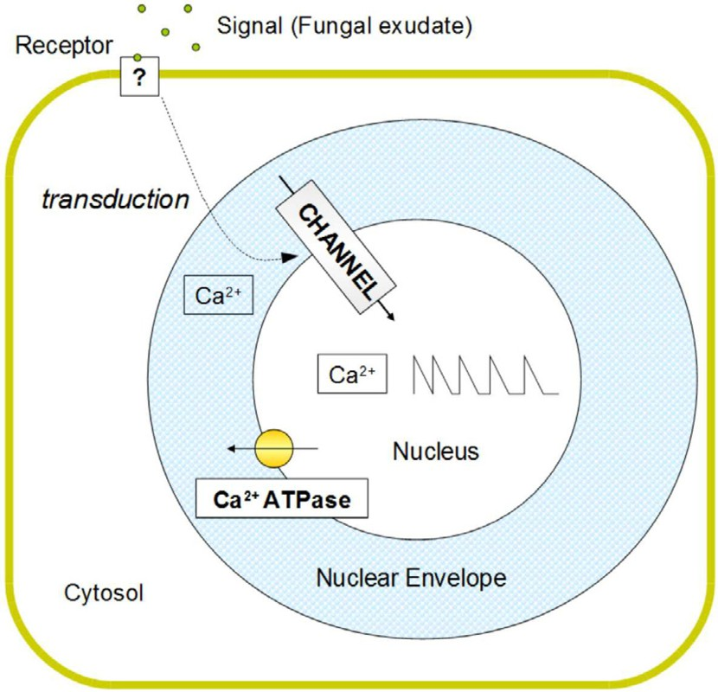

Fig. 1. Calcium nuclear spiking schematic model

cium in cell nuclei was developed in order to extend the analysis in a computational framework.

# Statistical Analysis

* 1. *Experimental Methods*

In [6] nuclear *Ca*2+ spiking was measured in 60 root epidermal cells of *Med- icago truncatula* treated with fungal exudates of *Gigaspora margarita* germinat- ing spores. Variation of calcium concentration was observed by using a nuclear- targeted “cameleon” calcium reporter (35S:NupYC2.1) expressed in root organ cul- tures (ROCs) of *M. truncatula*. The NupYC2.1 reporter is a fusion between the nuclear protein nucleoplasmin and the cameleon YC2.1, and has recently been used to demonstrate rhizobial NF-elicited *Ca*2+ spiking within root hair nuclei of *M. truncatula* roots. Confocal microscopy was used for all the fluorescence resonance energy transfer (FRET)-based experiments. The detection and plotting of relative changes in nuclear *Ca*2+ levels over time correspond to FRET-based ratio imaging of yellow fluorescent protein (YFP) over cyan fluorescent protein (CFP). A scanning resolution of 512 *×* 512 pixels was chosen to allow rapid imaging, and frames were collected every 5 seconds.

1.4

original data filtered data peak function

1.2

1

0.8

Calcium Data

Filtering

4.5

4

3.5

3

2.5

P(**)

0.6 2

0.4

0.2

0

0 5 10 15 20 25 30 35 40

Time (min)

* 1. Experimental data of one root epidermal cell and its respective filtering and peak function

1.5

1

0.5

0

0 0.2 0.4 0.6 0.8 1

**

* 1. Distribution of peak waiting time

Fig. 2. Peak series detection and statistical distribution of waiting time

* 1. *Numerical Methods*

In order to identify the oscillation dynamics into the fluorescent data, a Savitzky- Golay filter [22] was employed to remove noise. This filter performs a local poly- nomial regression on a series of values to determine the smoothed value for each point. It calculates the first up to the fifth derivatives with reliable accuracy and tends to preserve features of the signal such as relative maxima, minima and width, which are usually “flattened” by other adjacent averaging techniques (like moving averages, for example).

Starting from data filtered by the procedure *ƒ* expressed as *x*i = *ƒ* ([*Ca*2+](*t*i)), we define a function *p*α(*t*) performing a numerical peak detection exploiting the in- terpolation of the first and second derivatives given by filtering. The peak detection function is composed by three factors: the magnitude of first derivative, mapped to *∼* 1 where *xj* is small; the sign of second derivative, mapped to *∼* 1 where *x*i is concave; the magnitude of data.

i

Since the value of peak function must be related to the analytical criterion of local maxima, the above factors are combined as follow:

i

(1)

j

*p*α(*t*i)= max

( 1 *−*

*|xj |*

maxj *{|xj |}*

*—* min *{xjj,* 0*}*

*·*

i

maxj *{−* min *{xjj,* 0*}}*

j

*· x*i*, α*

where the parameter *α* allows to neglect insignificant peaks. The height of the peaks of *p*α(*t*) is an indicator of the sharpness of the peaks in the filtered data. Figure 2(a) shows the result of the application of Savitzky-Golay filter and the peak function *p*0.15(*t*) on the experimental data of one root epidermal cell. In our computations we performed a 5th order polynomial regression filter on a set of 21 points.

The statistics takes into account the relative waiting time *τ*i given by the ratio between the waiting time of the *i*-th spike *t*i *− t*i*—*1 (also known as Inter Spike Interval) and the time elapsed since the beginning of the experiment to the spike

at time *t*i*—*1 :

*τ* = *t*i *− t*i*—*1 *.*

i *t*i*—*1

This analysis covers the surveys of the 60 cells involved in the spiking phe- nomenon and, under the Kolmogorov-Smirnov [17] test (at a 5% significance level), the hypothesis of exponential distribution of *τ* was not rejected. Hence the distri- bution is taken as:

(2)

1 *τ*

*P* (*τ* )= *e λ*

*—*

*λ*

where *λ* is the expected value of *τ* (see Figure 2(b)).

* 1. *Information Theory*

A key measure of information is known as entropy, which quantifies the uncertainty involved in predicting the value of a system state. In Bayesian probability, the exponential distribution best represents the current state of knowledge because it is the one with largest entropy (principle of maximum entropy [13]).

An interpretation of the spiking phenomenon is related to the information trans- mission and its energetic and metabolic costs. The signals based on nuclear cal- cium release need ATPase pumps (energy consuming) to balance its concentrations to avoid toxicity. Thus, the temporal structure of the spiking should limit their number over time in order to maximize information transfer. The exponential dis- tribution of relative waiting times of the spike, according to the statistical principle of maximum entropy, maximize the information transmitted within the cell given a fixed internal energy to be dissipated.

# CWC Modeling and Results

Experimental investigations of calcium oscillations almost from their beginning have been accompanied by mathematical modelling and a wide range of models based on ordinary differential equations have been developed [11,23,3]. Recently, some formal language approaches have been proposed to model calcium oscillations in theoretical models (e.g. using Bio-PEPA [7]) or in realistic examples involved in presynaptic transmission using process calculi [4].

In this section we show how the basic dynamical characteristics of the experimen- tal data analyzed as discussed in Section 4 are captured in a CWC model following the schema introduced in Section 3. All the simulations are performed using the CWC simulator. The model, exploits the calculus as formal grounds, enjoying the nice compositional properties, has a direct computational implementation that sup- ports simulation trials, and, to our knowledge, represents the first rewrite system based model of a plant nuclear *Ca*2+ spiking system.

250

Simulation Result

250

Simulation Result

200 200

150 150

Nuclear Ca

Nuclear Ca

100 100

50 50

0

0 50 100 150 200 250 300

Time (s)

0

0 5 10 15 20 25 30 35 40

Time (min)

1. Channel/Pump activity
2. Channel regulation by a stationary signal trans- duction activity

Fig. 3. Results of the simulation of the CWC model for the Channel/Pump activity and for the Channel regulation by the signal transduction activity of the Calcium Spiking system

* 1. *Channel/Pump Activity*

First the rules for the channel and pump activities were built up. The set of adopted rules are the following:

K

(*R*1) *T* : 250 *× Ca*(*OCh ♩ X*)

η *NE*

η *H*

f

*'—→* (*Ch ♩* 250 *× Ca X*)η

(*R*2)

*T* : (*x ♩ Ca X*)

*'—→ Ca*(*x ♩ X*)η

where the nuclear envelope is referred as the *T* compartment while *η* is the label used for the nucleoplasm. Rule (*R*1) represents the channel activity which releases *Ca*2+ from the nuclear envelope to the nucleus with kinetic rate *K*NE; as it has been observed from the experiments, the calcium influx is almost instantaneous and only happens if the channel is open. For this reason the atom *OCh*, representing the open channel, is modeled on the membrane and it is closed (atom *Ch*) after the calcium influx. Since the nuclear *Ca*2+ increases at a 2*.*5% level of the *Ca*2+ in the nuclear envelope, if we consider 10000 atoms of *Ca* in the nuclear envelope, 250 are moved to the nucleoplasm. Rule (*R*2) describes the calcium uptake from the nucleoplasm to the nuclear envelope. A simple Hill function as rate is assumed, such that:

(3)

*Ca*p *ƒ*H = *V K*p + *Ca*p

This function has often been used to model *Ca*2+ pumps [14,5] either in the plasma membrane or in the endoplasmic reticulum membrane.

Figure 3(a) shows the results of the simulation given the initial term *T* = 10000*× Ca* (*OCh ♩ •*)η. The instantaneous nuclear calcium increase is due to rule (*R*1) where *K*NE was set to 5 *·* 10*—*6. The calcium decreasing in the nucleoplasm depends on the parameter chosen for equation 3. Here we used the following values: *V* = 5, *K* = 40, *p* = 2.

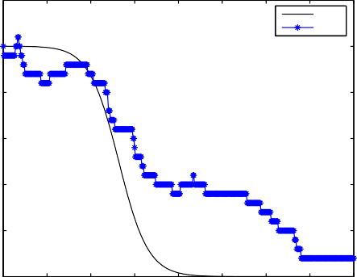30

ODE CWC

25

20

15

S

10

5

0

0 5 10 15 20 25 30 35 40

Time (min)

300

250

200

Nuclear Ca

150

100

50

0

Simulation Result

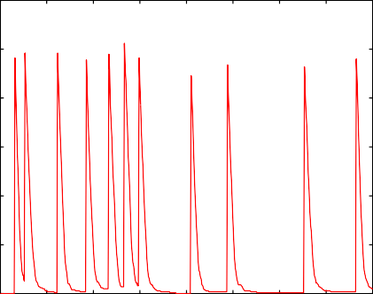

0 5 10 15 20 25 30 35 40

Time (min)

* + 1. ODE and CWC Simulation of Signal transduc- (b) CWC Simulation of Calcium Spiking model us-

tion decay

ing rules (R1 - R5)

Fig. 4. Results of the simulation of the CWC model for the Channel regulated by the decaying signal transduction in the Calcium Spiking system

* 1. *Channel Regulation by a Stationary Signal Transduction*

The signal transduction (here represented with atom *S*) induces a transient opening of *Ca*2+-channels, resulting in a rapid and transient influx of calcium in the nucle- oplasm from the nuclear envelope by the rule (*R*1). This condition can be modeled in CWC using the following rule:

η *S*

K

(*R*3) *T* : *S*(*Ch ♩ X*)

*'—→* (*OCh ♩ X*)η

Figure 3(b) shows the results of the simulation given the initial term *T* = 10000 *× Ca S* (*Ch ♩ •*)η. The calcium spikes frequency depends on the rate given by the kinetic parameter *K*S. In the simulation in Figure 3(b) we have chosen *K*S = 4*·*10*—*3.

* 1. *Channel Regulation by a Decaying Signal Transduction*

The evidence from the experimental data is that the frequency of the calcium spikes decreases as the time goes by. We can distinguish the simulation in three phases: the first one with high frequency spikes, the second one of transition and the last one with low frequent spikes. This frequency decay is probably due to the fungal signal which is given as a pulse of molecules that progressively are scavenged by the receptors which are internalized in the cell and degradated. To model this hypothetical phenomena we propose a sigmoidal signal transduction decay given by the following Ordinary Differential Equation: dS = *k*2*S*2 *— k*1*S* , corresponding to

dt

the following two rules:

K1 K2

(*R*4)*T* : *S '—→ •* (*R*5)*T* :2 *∗ S '—→* 3 *∗ S*

According to the Gillespie simulation schema, the decreasing of *S* will select the rule for channel opening (*R*3) less frequently resulting in a frequency decrease of calcium spikes. Figure 4(b) shows the results of the simulation given the initial term *T* = 10000 *× Ca* 25 *× S* (*Ch ♩ •*)η. The parameter values used in this simulation are: *K*S =2 *·* 10*—*4, *K*1 = 6*.*25 *·* 10*—*4, and *K*2 = 2*.*5 *·* 10*—*5.

3.5

3

2.5

2

P(**)

1.5

1

0.5

0

0 0.2 0.4 0.6 0.8 1

**

Fig. 5. Distribution of peak waiting time of the CWC Calcium Spiking model

We performed 60 runs of the stochastic CWC simulations and analyzed the data as discussed in Section 4.2. The calculated distribution of *τ* is shown in Figure 5. For this model *τ* matches an exponential distribution under the Kolmogorov-Smirnov test, at the 5% significance level.

# Conclusions

Calcium spiking is a fundamental phenomenon of cellular signalling. *Ca*2+ concen- tration in plant cells nuclei fluctuates in response to external stimuli such as the interaction with mycorrhizal fungi, serving as a messenger for triggering changes inside the cell. New formalisms and computational tools are mandatory in order to deeply understand the cellular messages underneath calcium spiking.

Experimental data [6] of nuclear *Ca*2+ responses in plant root epidermal cells to exudates of Arbuscular Mycorrhizal (AM) fungi were analyzed with respect to the information content of the spike trains using an entropy hypothesis regarding the information transfer. Then we have explored the possibility to mimic, in silico, these experimental data using a CWC formal model to describe calcium home- ostasis process in plant cell nuclei. This model is based upon the assumption that nucleoplasmic calcium is regulated by the balance between *Ca*2+-channel and *Ca*2+- transporter activities, both located on the inner nuclear membrane of the nuclear envelope.

The numerical simulations suggest that the proposed model well captures the nuclear calcium dynamics in statistical terms. This represent a first step towards a more complete model to describe and verify the biological hypothesis on the main calcium processes involved during the AM symbiosis focusing the attention on the information content of the spikes rather than on the exact matching of the experimental data.

Future work will attempt to dissect the model into stochastic and deterministic portions using the hybrid semantics of CWC [8]. This will lead us to determine whether our system under study exhibit the stochastic/deterministic nature of other intracellular calcium oscillations well studied using mathematical approaches

(e.g. in [19,16]).

**Acknowledgements**. The authors gratefully thank Professor Mario Coppo for the extensive discussions on the arguments of this work and for his careful review.

# References

1. Allen, G., S. Chu, C. Harrington, K. Schumacher, T. Hoffmann, Y. Tang, E. Grill and J. Schroeder, *A* *defined range of guard cell calcium oscillation parameters encodes stomatal movements*, Nature **411** (2001), pp. 1053–1057.
2. Bonfante, P. and A. Genre, *Mechanisms underlying beneficial plant–fungus interactions in mycorrhizal symbiosis*, Nature Communications **1** (2010), pp. 1–11.
3. Borghans, J. et al., *Complex intracellular calcium oscillations A theoretical exploration of possible* *mechanisms*, Biophysical chemistry **66** (1997), pp. 25–41.
4. Bracciali, A., M. Brunelli, E. Cataldo and P. Degano, *Expressive models for synaptic plasticity*, in:

*Computational Methods in Systems Biology*, Springer, 2007, pp. 152–167.

1. Bri`ere, C., T. Xiong, C. Mazars and R. Ranjeva, *Autonomous regulation of free Ca2+ concentrations* *in isolated plant cell nuclei: A mathematical analysis*, Cell calcium **39** (2006), pp. 293–303.
2. Chabaud, M., A. Genre, B. Sieberer, A. Faccio, J. Fournier, M. Novero, D. Barker and P. Bonfante, *Arbuscular mycorrhizal hyphopodia and germinated spore exudates trigger Ca2+ spiking in the legume and nonlegume root epidermis*, New Phytologist **189** (January 2011), pp. 347–355.
3. Ciocchetta, F. and M. Guerriero, *Modelling biological compartments in bio-pepa*, Electronic Notes in Theoretical Computer Science **227** (2009), pp. 77–95.
4. Coppo, M., F. Damiani, M. Drocco, E. Grassi, E. Sciacca, S. Spinella and A. Troina, *Hybrid Calculus of* *Wrapped Compartments*, Membrane Computing and Biologically Inspired Process Calculi 2010 (2010).
5. Coppo, M., F. Damiani, M. Drocco, E. Grassi and A. Troina, *Stochastic Calculus of Wrapped* *Compartments*, Quantitative Aspects of Programming Languages 2010 (2010).
6. Dolmetsch, R., K. Xu and R. Lewis, *Calcium oscillations increase the efficiency and specificity of gene expression*, Nature **392** (1998), pp. 933–935.
7. Dupont, G. and A. Goldbeter, *One-pool model for Ca2+ oscillations involving Ca2+ and inositol 1, 4, 5-trisphosphate as co-agonists for Ca2+ release*, Cell Calcium **14** (1993), pp. 311–322.
8. Gillespie, D., *Exact stochastic simulation of coupled chemical reactions*, J. Phys. Chem. **81** (1977),

pp. 2340–2361.

1. Jaynes, E. T., *Information theory and statistical mechanics*, Phys. Rev. **106** (1957), pp. 620–630.
2. Kargacin, G., *Responses of Ca2+-binding proteins to localized, transient changes in intracellular [Ca2+]*, Journal of Theoretical Biology **221** (2003), pp. 245–258.
3. Kosuta, S., S. Hazledine, J. Sun, H. Miwa, R. Morris, J. Downie and G. Oldroyd, *Differential and chaotic calcium signatures in the symbiosis signaling pathway of legumes*, Proceedings of the National Academy of Sciences **105** (2008), p. 9823.
4. Kummer, U., B. Krajnc, J. Pahle, A. Green, C. Dixon and M. Marhl, *Transition from stochastic to deterministic behavior in calcium oscillations*, Biophysical journal **89** (2005), pp. 1603–1611.
5. Massey Jr, F., *The Kolmogorov-Smirnov test for goodness of fit*, Journal of the American Statistical Association **46** (1951), pp. 68–78.
6. Navazio, L., R. Moscatiello, A. Genre, M. Novero, B. Baldan, P. Bonfante and P. Mariani, *A diffusible signal from arbuscular mycorrhizal fungi elicits a transient cytosolic calcium elevation in host plant cells*, Plant physiology **144** (2007), p. 673.
7. Perc, M., A. Green, C. Dixon and M. Marhl, *Establishing the stochastic nature of intracellular calcium oscillations from experimental data*, Biophysical chemistry **132** (2008), pp. 33–38.
8. Priami, C., *Stochastic pi-calculus*, Comput. J. **38** (1995), pp. 578–589.
9. Priami, C., A. Regev, E. Y. Shapiro and W. Silverman, *Application of a stochastic name-passing calculus to representation and simulation of molecular processes*, Inf. Process. Lett. **80** (2001), pp. 25– 31.
10. Savitzky, A. and M. Golay, *Smoothing and differentiation of data by simplified least squares procedures.*, Analytical chemistry **36** (1964), pp. 1627–1639.
11. Schuster, S., M. Marhl and T. H¨ofer, *Modelling of simple and complex calcium oscillations*, European Journal of Biochemistry **269** (2002), pp. 1333–1355.
12. Skupin, A. and M. Falcke, *Statistical properties and information content of calcium oscillations*, Genome Inf **18** (2008), pp. 44–53.