Available online at [www.sciencedirect.com](http://www.sciencedirect.com/)



[Electronic Notes in Theoretical Computer Science 275 (2011) 143–158](http://dx.doi.org/10.1016/j.entcs.2011.09.010)

[www.elsevier.com/locate/entcs](http://www.elsevier.com/locate/entcs)

Analysis of the Expected Number of Hops in Mobile Ad Hoc Networks with Random Waypoint Mobility

Osama Younes1 and Nigel Thomas2

*School of Computing Science Newcastle University*

*UK*

**Abstract**

The number of hops between the source and destination nodes is a key parameter in studying multi-hop ad hoc networks analytically. To the best of our known, there is no analytical work that considers the hop count of paths in MANETs in a random mobility environment. This paper presents a theoretical study for the expected number of hops between any random source-destination pair in multi-hop ad hoc networks where nodes move according to the random waypoint mobility model. The effects of network parameters such as node density, size of the network area, and node transmission range are studied. Simulation experiments for different network parameters have been conducted to validate the proposed analytical approach.

*Keywords:* Mobile Ad Hoc Networks, hop count, Random Waypoint Mobility, greedy routing.

# Introduction

A mobile ad hoc network (MANET) is a collection of wireless mobile nodes, moving with unpredictable mobility pattern, which dynamically form a network without any infrastructure elements. MANETs are self organizing and self configurable networks where the network is formed as soon as one of the nodes wants to send data to one or more of the other nodes. They are multi-hop wireless networks because the destination node is usually out of the transmission range of the source node. Therefore, the packets reach the destination after some hops on the intermediate nodes between the source and destination. As a result, the mobile nodes work as both sources and routers for other mobile nodes in the network. MANETs were initially designed to be used in the military and emergency relief applications.

1 Email: [Osama.Younes@ncl.ac.uk](mailto:Osama.Younes@ncl.ac.uk)

2 Email: [Nigel.Thomas@ncl.ac.uk](mailto:Nigel.Thomas@ncl.ac.uk)

1571-0661 © 2011 Elsevier B.V. Open access under [CC BY-NC-ND license](http://creativecommons.org/licenses/by-nc-nd/3.0/).

[doi:10.1016/j.entcs.2011.09.010](http://dx.doi.org/10.1016/j.entcs.2011.09.010)

Lately, they have attracted researchers because of the need for flexible and efficient networks, so they have been utilised in many other applications [1].

In MANETs, the route or path is the sequence of mobile nodes which data packets pass through in order to reach the intended destination node from a given source node. Due to the mobility of nodes, mobile ad hoc networks have inher- ently dynamic topologies. Therefore the routes are prone to frequent breaks which reduce the throughput of the network compared to wired or cellular networks. Con- sequently, the route followed by packets to reach the destination varies frequently. This is a crucial factor that affects the performance of the network.

The hop count specifies the number of hops on the path between source and destination nodes. The analysis of the hop count in multi-hop networks is very important because it can provide design guidelines for ad hoc networks. It can be used in many applications such as, 1) estimation of the delivery ratio of packets, 2) with per hop delay, the end to end delay can be estimated, 3) with the number of simultaneous communications in the network, the network traffic can be estimated,

4) performance comparison between different multi-hop routing protocols, 5) eval- uating the flooding cost and search latency for on-demand routing protocols and determining the optimal flooding strategy [2], 6) studying of connectivity and esti- mation of the capacity of the network. In addition, the hop count is a key parameter for performance analysis of multi-hop ad hoc networks using analytical methods.

Many studies have been issued to analyze how the performance of MANETs is affected by the hop count of paths [3-5]. The impact of hop count on searching cost and delay in ad hoc routing protocols has been investigated in [3]. Li et al. have simulated the impact of different traffic patterns on the scalability of per node throughput. They showed that the network throughput deteriorates when the number of hops of the path increases due to interference between nodes. In [5], Gamal et al introduced a scheme to analyze the impact of the transmission range, degree of node mobility and number of hops on the trade-off between the delay and throughput in fixed and mobile ad hoc networks.

Although the impacts of the hop count of multi-hop paths on the performance of MANETs have been well recognized, there have been a very limited number of studies that focussed on the theoretical analysis of the expected number of hops in multi-hop paths in MANETs [6-9]. In [6], Jia-Chun and Wanjiun modelled the be- haviour of packet forwarding on a multi-hop path for mobile ad hoc networks with high node density as circles centred at the initial location of the destination node. However, the results are not accurate because it is assumed that the progress per hop is equal to the transmission range. The relation between source-to-destination Euclidean distance and the hop count has been examined in [7]. The authors con- sidered a greedy routing approach called Least Remaining Distance (LRD) which attempts to minimize the remaining distance to the destination in each hop. An analytical model for LRD and bounds on the number of hops for a given Euclidean distance between source and destination has been developed. Unfortunately, the accuracy of LRD approach is good only when the node density is very high.

In [8] an analytical model describing the hop count distribution for each source

destination pair in multi-hop wireless networks has been developed. Also, the trade- off between flooding cost and search latency for target location discovery, used in most ad hoc routing protocols, has been evaluated. The drawback of this work is that it supposed that the distance between the source and destination nodes is uniformly distributed, and the impact of the size of the simulated network area is neglected. A mathematical model for the expected number of hops based on a Poisson randomly distributed network has been presented in [9]. The probability of n-hop count is derived and used to compute the expected number of hops. Un- fortunately, all of these previous studies suppose that the nodes are stationary (no mobility) and are either uniformly or exponentially distributed over the network area.

Random mobility models, such as Random Way Point, Random Walk (random direction), Free Way, and Manhattan, play an important role in simulation of mo- bile ad hoc networks. To the best of our knowledge, there is no analytical work that computes the expected hop count of paths in MANETs in a random mobility environment. This is the motivation for our work, in which we develop a simple closed form analytical approach to estimate the expected number of hops between any source-destination pair in MANETs where the nodes are scattered in a square area and move according to the random waypoint mobility model (RWPMM). The RWPMM is selected because it is one of the most commonly used mobility models in MANETs studies. The hop count of paths for other mobility models can be investigated using the proposed approach.

For a given distance between the source and destination, to analytically com- pute the expected hop count, we need a packet forwarding algorithm which uses an optimization criteria to choose a relay node from neighbour nodes that minimizes the number of hops a packet has to traverse in order to reach the destination. We proposed a new packet forwarding strategy called Maximum Hop Distance (MHD) that attempts to minimize the number of hops needed for a packet to reach its des- tination by forwarding the packet to a neighbour node with the maximum forward distance in the direction of the destination.

To calculate the average number of hops analytically using MHD without the need to run time-consuming simulations, the probability density function of the distance between the source (or a relay node) and its neighbour nodes is derived using geometric probability. Then, it is used to compute the expected value for the maximum forward distance toward the destination which is essential to compute the expected value for the remaining distance to the destination. By recursive computing for remaining distance to the destination, the expected hop counts can be computed.

The number of hops between the source and destination in multi-hop ad hoc networks is jointly affected by many network factors, such as the node density, transmission range of nodes, mobility pattern, and the size of the simulated net- work area. The proposed approach is used to analyze the effect of these factors on the expected number of hops of paths in MANET. The main contribution of our work is twofold: (1) For the first time, an expression for the expected Euclidean

distance between any source and destination nodes moving according to the random waypoint mobility model is driven, (2) A novel analytical approach called Maximum Hop Distance (MHD) is proposed to compute the expected hop count for a given Euclidian distance between a source and destination.

MHD approach is a greedy routing approach which is inspired by LRD approach introduced in [7], but it is simpler and more accurate, as clear from the comparison between the two approaches in Section 4. In addition, MHD can be used for networks with low nodes density. The proposed process that uses the MHD approach to analytically compute the expected hop count between source and destination nodes moving according to the RWPMM can be summarized as follows:

1. With a given network size, the expected distance between any source-destination pair is computed
2. Compute the maximum expected distance (maximum forward distance) be- tween any two nodes in the route for a given transmission range
3. With a given node density, the per-hop progress is calculated
4. By recursive computation, the expected number of hops for each packet to traverse from a source to a destination is derived

The rest of this paper is organized as follows. In Section 2 we drive an expression for the expected Euclidean distance between any random source and destination nodes moving according to RWPMM. Theoretical analysis of per hop progress and hop count is presented in Section 3. In Section 4, the proposed approach is validated via simulation. Finally, the paper is concluded in Section 5.

# Euclidean Distance Between the Source and Destina- tion Nodes

This section drives an expression for the expected Euclidean distance between any random source and destination nodes moving according to RWPMM. First, we drive it for one dimension and then consider the square area.

* 1. *Expected Distance on One Dimension*

We first consider the distance between two nodes in a line segment. Suppose that two random points *X*1 and *X*2 are located in a line segment with length *L*. The distance between *X*1 and *X*2 is *S*. *X*1 and *X*2 are independent identically distributed random variables. According to [10], for the Random Waypoint Mobility Model the distribution of *X*1 or *X*2 is non-uniform at the long run. The probability distribution function of the location of a point *Xn* moving on a line with length *L* according to the RWPMM is [10]

*fX* (*xn*)= 6 *xn* + 6 *x*2 0 *≤ xn ≤ L*

*n*

*L*2

*L*3

*n*

Because *X*1 and *X*2 are i.i.d, the probability distribution function (pdf) of the location of the two points is

*fX*1*X*2 (*x*1*, x*2)= *fX*1 (*x*1) *· fX*2 (*x*2) 0 *≤ x*1 *≤ L*, 0 *≤ x*2 *≤ L*

The cumulative distribution function (CDF) of the distance *S* = *|x*2 *− x*1*|* be- tween the two points (The probability that *S* is smaller than a given value *d*) can be obtained by integration of *fX*1*X*2 (*x*1*, x*2) over the bounds of *S* as follows:

*P* (*s ≤ d*)= ∫ ∫ *fX*1*X*2 (*x*1*, x*2) *dx*2*dx*1 = ∫ ∫ *fX*1 (*x*1)*fX*2 (*x*2) *dx*2*dx*1

*d d*+*x*1

∫ ∫

= *fX*1 (*x*1)*fX*2 (*x*2) *dx*2*dx*1 +

*L*∫*−d d*+∫*x*1

*fX*1 (*x*1)*fX*2 (*x*2) *dx*2*dx*1 +

0 0

∫*L* ∫*L*

*d x*1*−d*

*fX*1 (*x*1)*fX*2 (*x*2) *dx*2*dx*1

*L−d x*1*−d*

The integrations in the last equation can be evaluated yielding the following result:

12*d*

4*d*3

3*d*4 2*d*6

(1)

*P* (*S ≤ d*)= 5*L −*

*L*3 +

*L*4 *−* 5*L*6

By definition the probability density function *f* (*d*) of *d* is given by the derivative of the Equation 1.

*f* (*d*)= 12 *−* 12*d*2 + 12*d*3 *−* 12*d*5

5*L*

*L*3

*L*4

5*L*6

* 1. *Expected Distance on Two Dimension*

Now, consider two random points *X*1 and *X*2 located in a square area of size *L × L* with coordinates (*x*1*, y*1) and (*x*2*, y*2), respectively. If *d* is the distance between *X*1 and *X*2, *d* is given by

*d* = (*x*1 *− x*2)2 + (*y*1 *− y*2)2

If *fdx* and *fdy* are the pdf of the events (*x*1 *− x*2)2 and (*y*1 *− y*2)2, respectively. Then, the pdf of the distance *d* is given by the convolution of *fdx* and *fdy* as follows:

(2) *fxy*(*d*)= ∫ *fdx*(*z*) *· fdy*(*d − z*) *dz*

2

Let (*x*1 *− x*2) = *d√x* , then the CDF of *dx* can be obtained by using Equation 1

by substituting *d* by *dx*. We get the following:

*F* (*dx*)=

12*√dx* 5*L −*

4*√dx*3

*L*3 +

3*dx*3

*L*4

2*dx*32 5*L*6

The pdf of *dx* is obtained as follows:

*—*

*∂F* (*dx*)

6*dx*

6*dx*2 6 6*√dx*

(3)

*f* (*dx*)=

=

*∂dx*

*L*4 *−*

5*L*6 + 5*L√dx − L*3

In the same way, *f* (*dy*) can be obtained.

Because the domain of *d* is divided in two parts, 0 *< d ≤ L*2 and *L*2 *< d ≤* 2*L*2, there are two cases for Equation 2 which are

⎧⎪ ∫*d* 2

(4)

0

∫

*fxy*(*d*)=

⎪⎨ *I*1(*d*)=

⎪

⎩

*I*2(*d*)=

*d−L*2

*fdx*(*z*) *· fdy*(*d − z*) *L*

*< d ≤* 2*L*

*fdx*(*z*) *· fdy*(*d − z*) 0 *< d ≤ L*

*L*2

2 2

By substituting Equation 3 into Equation 4, the integrals (*I*1) and (*I*2) in Equation 4 can be evaluated and with some simplification and reduction of their terms, we obtain the following

6*d*3

6*d*4

6*d*5

96*√d*3

1584*√d*5

36*π*

*I*1(*d*)= *L*8 *−* 5*L*10 + 125*L*12 +

5*L*5 *−*

125*L*7 + 25*L*2

(5)

192*d*2*√d*3

+ 175*L*9 *−*

36*πd* 5*L*4 *−*

48*d√d*3 5*L*7 +

9*πd*2 2*L*6

312*d*

1104

12*d*2

6*d*3

6*d*4

6*d*5

*I*2(*d*)= 25*L*4 *−* 875*L*2 *−*

5*L*6 *−*

*L*8 + 5*L*10 *−* 125*L*12

9 4 2 2

*L*2 *− d*

+ (8*L −* 40*L d* + 25*d* ) arctan(

*√* 2 )

25*L*6

*− −* √ *−*

*L d − L*2

(6)

6 (165*L*4 232*L*2*d* + 32*d*2) (*d L*2)3

175*L*9

*− −* √ *−*

6 (407*L*6 + 1936*L*4*d* 1768*L*2*d*2 + 160*d*3) *d L*2

875*L*9

Because *d* is the square distance between *X*1 and *X*2, the expected distance between the two nodes *E*(*δ*) is given by

2*L*2

∫

*E*(*δ*)=

0

∫

*L*2

*√d fxy*(*d*) *dd* =

∫

0

2*L*2

*√d I*1(*d*) *dd* +

∫

*L*2

*√d I*2(*d*) *dd*

(7)

*√*2*L*

=

0

*L*

2*δ*2 *fxy*(*δ*) *dδ* =

∫

0

2*δ*2 *I*1(*δ*) *dδ* +

*√*2*L*

*L*

∫

2*δ*2 *I*2(*δ*) *dδ*

where *δ*= *√d* and *dd* = 2*δ dδ*. The expected distance between the two nodes can

be evaluated by plugging Equation 5 and 6 into Equation 7 which yields

350

750750

375375

(8)

*E*(*δ*)= 11

ln(*√*2 + 1) + 28083 *√*2+ 19064 *· L*

For uniformly distributed nodes in a square area of size *L×L*, the expected distance between two random nodes is [11]

*E*(*δ*)= 0*.*5214054 *L*

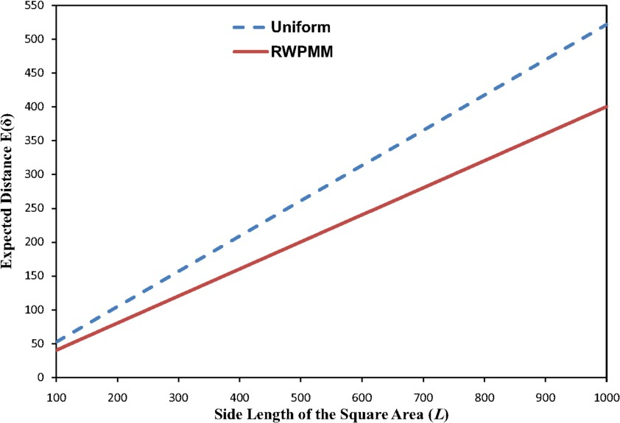

Fig. 1. The expected Euclidian distance between any random source and destination nodes

Figure 1 shows the expected Euclidian distance between any random source and destination nodes (*E*(*δ*)) that are uniformly scattered or moving according to the RWPMM in a square area, plotted against different values of the side length of the square area (*L*). It is clear that the expected distance between the two nodes in the case of the RWPMM is much less than uniform distributed nodes, especially for large value of *L*. This is because the spatial distribution of nodes moving according to the RWPMM at long run is non-uniform, since the probability that a node is located at the centre of the square area is high, and it reaches zero at the border of the area [12].

# Expected Hop Count

To analyze the expected hop count in MANETs where nodes move according to the RWPMM, we consider any source node *S* that tries to send its packet to a destination node *D*, as shown in Figure 2, where the circle with radius *R* around any node indicates the transmission area. The expected distance between any source and destination nodes is *d*. If *d* is greater than the transmission range *R*, which is equal for all nodes in the network, the source uses the intermediate nodes to forward the packets to the destination through two or more hops. The routing protocol searches all routes to the destination and chooses the shortest one. If the source has *Nh* neighbour nodes (the nodes within the transmission range), the

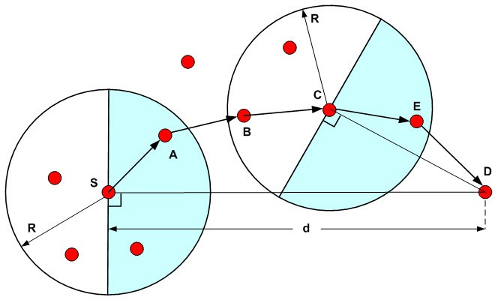

Fig. 2. Packet forwarding in a multi-hop path

routing protocol in *S* will choose the closest neighbour node to the destination (e.g. the node *A* in Figure 2) to work as the next relaying node to forward the packet in the path. The number of hops in the path depends on the distance between the source and destination nodes (*d*) and the remaining distance to the destination per hop (per hop progress).

To compute the expected hop count analytically without the need to run time- consuming simulations, a greedy routing approach called Maximum Hop Distance (MHD) is proposed. MHD is a packet forwarding algorithm that uses the maximum forward distance toward the destination as the optimization criterion to choose the relay node from neighbour nodes that minimizes the number of hops a packet has to traverse in order to reach the destination. The geometric probability is used to drive the pdf of the distance between the source (or a relay node) and its neighbour nodes which is used to compute the expected value for the maximum forward distance toward the destination. Also, the expected remaining distance to the destination, which is used to calculate the expected hop count, is computed using the geometric probability.

MHD approach succeeds if at least one router is located towards the destination (shaded regions shown in Figure 2) in each hop to prevent back forwarding of packets. Otherwise it fails. For example, as shown in Figure 2, for node *S* and *C*, node *A* and *E* are located in the grey half circle towards the destination *D* to forward the packets from *S* and *C*, respectively, to the destination. Intuitively, to keep the connectivity of the route, each node needs at least two neighbour nodes; one is for the previous hop and the other is for the next hop. Therefore, the node density must exceed a certain threshold to ensure the route and network connectivity. In [13] and [14], the authors showed that the average number of neighbour nodes required to ensure one-connectivity is eight. Hence, in all validation scenarios, introduced in Section 4, the total number of nodes in the network (*N* ) and size of the network area are chosen to make the number of neighbour nodes is eight.

Let *M* be the potential router that used to forward the packets from *S* to *D*

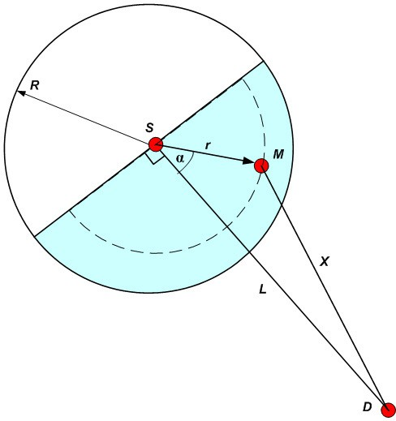

Fig. 3. Least remaining distance for the first hop

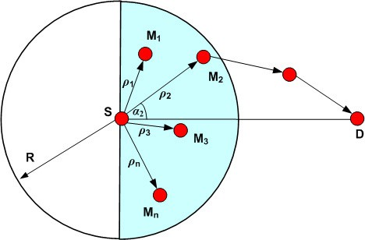

Fig. 4. The distances between S and neighbour nodes

for the first hop, as shown in Figure 3. Also, let *r* and *X* be the distance between the source and the router *M* (the maximum forward distance) and the remaining distance from *M* to *D*, respectively. The pdf and expected value for *r* and *X* must be derived to compute the expected hop count.

First, we drive the pdf of the maximum forward distance *r* that is used by MHD approach as the optimization criterion to minimize the hop count. suppose that there are *n* forwarding neighbour nodes (*M*1,. ,*Mn*) distributed over the half circle

towards of the destination *D*. The distances and angles from the source *S* to the neighbour nodes are *ρi* and *αi*, where *i* = 1,. ,*n*, as shown in Figure 4. For simplicity

of the analysis the neighbour nodes are assumed to be uniformly distributed around

*S*. So, the expected value of *n* equals to the half of the expected number of neighbour nodes (*Nh*). The value of *Nh* for the RWPMM can be computed using the methods introduced in [15]. The pdf of the distance (*ρ*) between *S* and the neighbour nodes is

*fρα*(*ρ, α*)= 2*ρ*

*πR*2

where 0 *≤ ρ ≤ R* and *−π ≤ α ≤ π* . Integrating the last Equation over *α* gives the

pdf of *ρ* as

2 2

*fρ*(*ρ*)= 2*ρ*

*R*2

To minimize the hop count to the destination, the neighbour node with the maximum distance (*ρmax*) from the source *S* is chosen to forward the packets. According to [16], because *ρ*1, .. , *ρn* are i.i.d random variables each with pdf *fρ*(*ρ*), the pdf of *ρmax* is

*f* (*ρ*)= *n* (*F* (*ρ*))*n f* (*ρ*)= 2*n ρ*2*n−*1

*ρmax*

*ρ ρ R*2*n*

Where *Fρ*(*ρ*) is the CDF of *ρ*. By definition, the expected value of *ρmax* is

*R*

∫

*E*(*ρmax*)=

0

*ρ fρ* (*ρ*) *dρ* = 2*n R*

Therefore, the expected distance *r* between the source *S* and router *M* , shown in Figure 3, is given by

*max* 2*n* + 1

(9)

2*n*

*r* = *E*(*ρmax*)= *R*

2*n* +1

The resulting function for *r* for a given *R* = 250 or 220 and increasing values of *n* is shown in Figure 5. Clearly, for a given transmission range *R*, for small values of *n*, *r* increases rapidly. For large values of *n*, *r* may reach *R*. Therefore, increasing the node density decreases the expected hop count, but it increases the interference between neighbour nodes. Equation 9 can be used for analysis of the distance between the source and other nodes in the path which is important to study the survivability of the path.

RWPMM significantly increases the average number of neighbour nodes com- pared to uniformly distributed nodes [15]. As shown in Figure 5, an increase in the number of neighbour nodes (*n*) increases the maximum forward distance (*r*) which decreases the expected hop count. Therefore, the expected number of hops for nodes moving according to RWPMM is less than that for uniform distributed nodes.

To drive an expression for the remaining distance, we consider that the router *M* may be located at any point on the circumference of a half circle with a radius *r* (the dashed half circle shown in Figure 3) computed using Equation 9, as shown in

Figure 3. Let *M* is located at random angle *α*. So, the domain of *α* is *−π ≤ α ≤ π* .

2 2

The remaining distance *X* can be described using a pdf as follows

*fα*(*α*)= 1

*π*

*— π ≤ α ≤ π*

The probability that *α* is smaller than a given value *a* can be computed by the integral of the last equation as

2

2

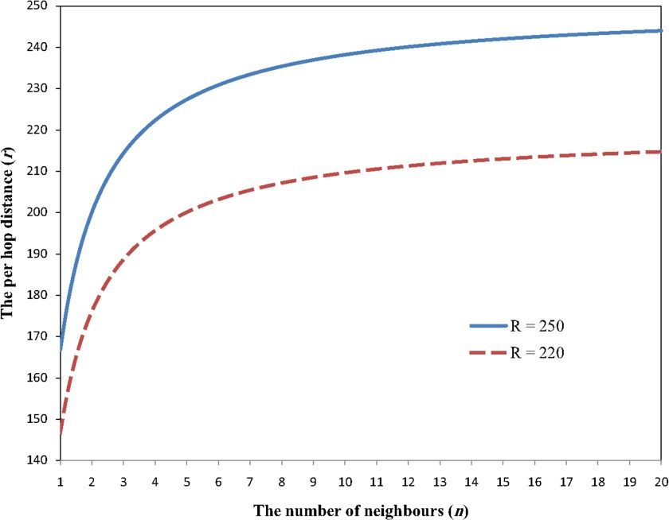

Fig. 5. The per hop distance for different values for *n* and *R*

*a*

∫

1. *P* (*α* *≤ a*)=

2

*fα*(*α*) *dα* = *π a*

*−a*

From geometry, *d*2 + *r*2 *−* 2*Xr* cos *a* = *X*2. Therefore, by substitution in Equation 10, we get CDF of *X* as

*F* (*X*)= *P*

*X*

*x*

(*X ≤ x*)= 2 arccos( *d*2 + *r*2 *− X*2 )

The last equation is differentiated to get its pdf of *X* as

*π*

2 *d r*

2*X*

1. *fX* (*X*)=

*π d r*

1 *−* (

*d*2+*r*2 *X*2 2

2 *d r*

*—* )

By definition, the expected value of *X* can be deduced form Equation 11 as follows

*√d*2+*r*2

1. *Xr* = *E*(*X*)=

∫

*d−r*

*X · fX* (*X*) *dX*

The last equation can be easily evaluated numerically.

After getting the remaining distance *Xr* from the router *M* to the destination for the first hop, to get the expected number of hops, the current distance to the destination *d* in the next hop is replaced by the remaining distance *Xr* obtained using Equation 12. Then, the process is repeated and the hops are counted until *Xr* falls below the transmission range *R*. The following procedure summarizes this process:

**Step 1:** Set the inputs *N* , *R*, and *L*

**Step 2:** Set the number of hop count to *hop count* = 0

**Step 3:** Compute the expected distance between the source and destination (*d*) using Equation 7

**Step 4:** If *d ≤ R*, then hop count = *d*

*R*

**Step 5:** Set hop count = hop count+1

, go to the End

**Step 6:** The remaining distance between the router and destination (*Xr*) is com- puted using Equation 12

**Step 7:** If *Xr ≤ R*, then *hop count* = *hop count* + *Xr* **Step 8:** If *Xr > R*, then set *d* = *Xr* and go to step 6 **Step 9:** End

*R*

# Validation

In this section, the proposed approach is validated by comparing the theoretical and simulation results. We first validate the theoretical analysis of the expected Euclidean distance between any random source and destination nodes, introduced in Section 2, by network simulation. For this validation we used the MobiSim tool [17] that uses topological characteristics to analyze and manage the mobility scenarios for ad hoc networks. We consider a simulation scenario consists of a square system area of a side length *L* that varies from 400 to 1000 m. A set of 200 nodes are uniformly scattered in the square area and move according to the RWPMM. Every node moves towards the destination point with a velocity chosen uniformly from 0 to maximum speed (*V max*). When it reaches the destination it chooses and moves towards a new destination in a similar manner. The maximum moving speed is set to 20 m/s. A zero pause time was chosen to make the nodes move all the time. All nodes have a radio range of 250m.

For each mobility scenario, the expected distance between any source-destination pair is computed by taking the average of the distances between every pair of nodes. Many different mobility scenarios (with different random seeds) have been generated until the expected distance between nodes is within 95% confidence interval with 1% relative error. Figure 6 shows simulation and analysis results for the expected distance between any two nodes for varying values of the side length of the square area. The comparison between analytical and simulation results shows the accuracy of the proposed analysis.

To validate the proposed theoretical analysis and procedure to compute the expected number of hops for a packet transmission in ad hoc networks, we performed a series of simulation tests using NS-2 [18]. The simulation settings consist of a network with a square area. The side length of the square area varies from 700 to 1600m. The maximum speed of a node is set to 20 m/s. The simulation time is set to 1500 seconds. To be sure that the average number of neighbour nodes is greater than or equals 8 nodes, the node density is varied depending on the size of the system

area. To illustrate its effect on the expected number of hops, the transmission range is considered to be 200 or 250m. The RWP mobility patterns used in all simulation tests are generated using setdest tool which is a node movement generator tool implemented by the current ns-2 version.

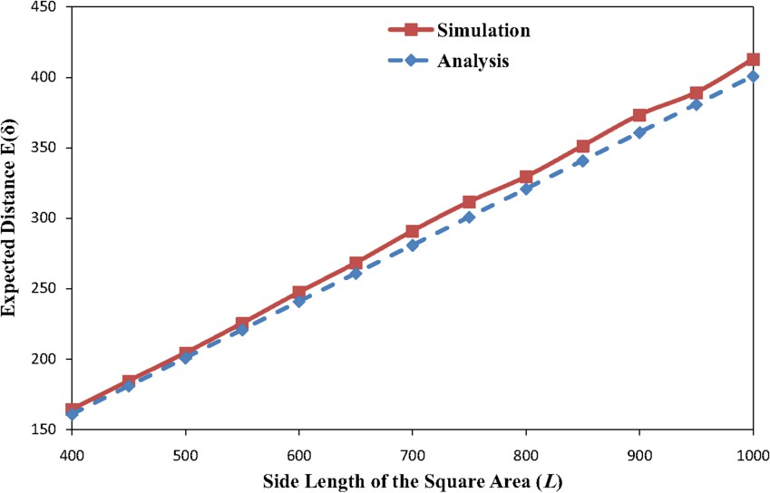

Fig. 6. Expected distance for different sizes of the network area *n* and *R*

The number of hops between nodes can be computed on the fly during simulation runs. But this method consumes a long time (may be days) especially with a large number of nodes and network area size. Alternatively, we used an object called General Operations Director (GOD) which is implemented with setdest tool and used to mange the shortest path information between nodes. For the whole simulation period, GOD is aware of any changes in mobile wireless network topology. GOD is an omniscient observer, where it is used to store global information about the topology of the network. This global information is not totally available to any node, but partial information is provided to each node when needed. GOD is used to store an array of the optimal path length in hops between every pair of nodes. This information is used to analyze and develop ad hoc network routing protocols. For the same network settings, the expected number of hops is computed by averaging the number of hops between every pair of nodes. We generated many mobility patterns for the same network settings and computed the expected number of hops with a confidence level of 95% and a relative error threshold of 2%. Table 1 shows the simulation and theoretical results for the expected number of hops for two different values of transmission range (*R* = 200 or 250) and increasing values for side length of the square area of the simulated network. As shown in Table 1, for a given transmission range, the expected number of hops increases significantly as the network size increases because of increasing the expected distance between the source and destination. In addition, as expected, the expected number of hops decreases with increasing of the transmission range because of increasing of the per hop progress. As can be seen in Table 1, the theoretical results are accurate

compared to simulation results.

Table 1

Analytical and simulation results for expected hop count for increasing values for the side length of the network area where *R* = 200 or 250m

|  |  |  |  |  |
| --- | --- | --- | --- | --- |
| *L* | Expected Number of Hops | | | |
| *R* = 200 | | *R* = 250 | |
| Sim | Ana | Sim | Ana |
| 700 | 2.61 | 2.73 | 2.01 | 1.82 |
| 800 | 2.93 | 2.84 | 2.14 | 1.91 |
| 900 | 3.19 | 2.97 | 2.69 | 2.75 |
| 1000 | 3.65 | 3.8 | 2.94 | 2.83 |
| 1100 | 4.10 | 3.92 | 3.18 | 2.93 |
| 1200 | 4.58 | 4.76 | 3.57 | 3.76 |
| 1300 | 4.93 | 4.86 | 3.86 | 3.83 |
| 1400 | 5.28 | 4.99 | 4.16 | 3.92 |
| 1500 | 5.79 | 5.82 | 4.52 | 4.75 |
| 1600 | 6.19 | 5.93 | 4.63 | 4.81 |

To compare the LRD and MHD approaches, Table 2 shows the expected number of hops computed using the two approaches and simulation for the same network settings used to validate the MHD approach where *R* = 150. Compared with simulation results, it is clear that the accuracy of the MHD approach is much better than LRD approach, as shown in Table 2. The expected number of hops computed using the LRD approach is much less than simulation especially for long routes. This is because the LRD approach supposes that the routers with the minimum remaining distance to the destination constitute the shortest path to the destination which is only true when the node density is very high.

Compared to simulation results, the computation time required for theoretical analysis is trivial. For example, in the case of *N* = 250, *R* = 150, *L* = 1600, simulation time = 1500s, for 95% confidence interval and 2% relative error, the time required for generating the mobility patterns and computing the expected hop count is about 28.2 hours, whereas the time required for theoretical analysis is less than 2 seconds, where the simulation and theoretical analysis was conducted on desktop workstation equipped with 2.6GHz (Intel Q9400 Core 2 Quad) processor, 4 GB of RAM and Ubuntu Linux version 8.10.

# Conclusion

In this paper, we presented a theoretical analysis for the expected number of hops in mobile ad hoc networks where nodes move according to random waypoint mobility model. The proposed approach can be used to analyze the hop count for other mobility models. It depends on computing the expected distance between source

Table 2

Comparison between simulation and LRD and MHD results for expected hop count for increasing values for *L* where *R* = 150

|  |  |  |  |
| --- | --- | --- | --- |
| L | Sim | LRD | MHD |
| 700 | 3.37 | 2.39 | 3.74 |
| 800 | 3.83 | 2.62 | 3.86 |
| 900 | 4.40 | 2.86 | 4.75 |
| 1000 | 4.84 | 3.40 | 4.86 |
| 1100 | 5.42 | 3.63 | 5.75 |
| 1200 | 5.83 | 3.88 | 5.86 |
| 1300 | 6.35 | 4.4 | 6.74 |
| 1400 | 6.72 | 4.64 | 6.85 |
| 1500 | 7.06 | 4.89 | 6.99 |
| 1600 | 7.35 | 5.42 | 7.83 |

and destination nodes, per hop distance, and per hop progress which are used to compute the expected hop count. The proposed approach has been validated using network simulation for different network parameters. The impacts of the transmission range, node density, and size of network area on the hop count have been investigated. Compared to other methods in the literature, the accuracy of the proposed approach is much better.

# References

1. Sarkar, S. K., C. Puttamadappa, and T. G. Basavaraju, ”Ad Hoc Mobile Wireless Networks Principles, Protocols and Applications,” *Auerbach Publications*, 2008.
2. Nicholas, C., and L. Mingyan, ”Revisiting the TTL-based controlled flooding search: optimality and randomization,” *Proceedings of the 10th annual international conference on Mobile computing and* *networking*, ACM, 2004.
3. Zhao, C., and B. H. Wendi, ”Flooding strategy for target discovery in wireless networks,” *Wirel. Netw.*, 5, 2005, pp. 607-618.
4. Jinyang, L., B. Charles, S. J. D. C. Douglas et al., ”Capacity of Ad Hoc wireless networks,” *Proceedings* *of the 7th annual international conference on Mobile computing and networking*, ACM, 2001.
5. Gamal, A. E., J. Mammen, B. Prabhakar et al., ”Throughput-delay trade-off in wireless networks,” INFOCOM 2004. *Twenty-third AnnualJoint Conference of the IEEE Computer and Communications* *Societies*, 2004, p. 475.
6. Jia-Chun, K., and L. Wanjiun, ”Modeling the behavior of flooding on target location discovery in mobile ad hoc networks,” *IEEE International Conference on Communications*, 2005, pp. 3015-3019 Vol. 5.
7. De, S., ”On hop count and euclidean distance in greedy forwarding in wireless ad hoc networks,”

*Communications Letters, IEEE*, 11, 2005, pp. 1000-1002.

1. Jia-Chun, K., and L. Wanjiun, ”Hop Count Distribution of Multihop Paths in Wireless Networks With Arbitrary Node Density: Modeling and Its Applications,” *IEEE Transactions on Vehicular Technology*, 4, 2007, pp. 2321-2331.
2. Shadi, M. H., and M. Janise, ”Analytical Study of the Expected Number of Hops in Wireless Ad Hoc Network,” *Proceedings of the Third International Conference on Wireless Algorithms, Systems, and Applications*, Springer-Verlag, 2008.
3. Bettstetter, C., G. Resta, and P. Santi, ”The node distribution of the random waypoint mobility model for wireless ad hoc networks,” *IEEE Transactions on Mobile Computing*, 3, 2003, pp. 257-269.
4. Santalo, L. A., ”Integral geometry and geometric probability,” *Addison-Wesley*, 1976.
5. Christian, B., and W. Christian, ”The Spatial Node Distribution of the Random Waypoint Mobility Model,” *In Proceedings of the 1st German Workshop on Mobile Ad hoc Networks (WMAN)*, 2002, pp. 41-58.
6. Takagi, H., and L. Kleinrock, ”Optimal Transmission Ranges for Randomly Distributed Packet Radio Terminals,” *IEEE Transactions on Communications*, 3, 1984, pp. 246-257.
7. Royer, E. M., P. M. Melliar-Smith, and L. E. Moser, ”An analysis of the optimum node density for ad hoc mobile networks,” *IEEE International Conference on Communications*, 2001, vol.3, pp. 857-861.
8. Bettstetter, C., ”On the Connectivity of Ad Hoc Networks,” *The Computer Journal*, 4, 2004, pp. 432-447.
9. Ewens, W., and G. Grant, ”Statistical Methods in Bioinformatics: An Introduction (Statistics for Biology and Health),” *Springer*, 2004.
10. Mousavi, S. M., H. R. Rabiee, M. Moshref et al., ”MobiSim: A Framework for Simulation of Mobility Models in Mobile Ad-Hoc Networks,” *IEEE International Conference on Wireless and Mobile Computing, Networking and Communications*, 2007, pp. 82-82.
11. ”The Network Simulator ns2,” version 2.34, <http://www.isi.edu/nsnam/ns/>.