

Cairo University

Egyptian Informatics Journal

[www.elsevier.com/locate/eij](http://www.elsevier.com/locate/eij) [www.sciencedirect.com](http://www.sciencedirect.com/science/journal/11108665)



FULL-LENGTH ARTICLE

Analysis of wavelength reservation based quality of service differentiation in optical burst switching networks using Markov model



Ravi Sankar Barpanda *, Ashok Kumar Turuk, Bibhudatta Sahoo

*Department of Computer Science & Engineering, National Institute of Technology, Rourkela 769008, India*

Received 15 December 2015; revised 17 April 2016; accepted 19 June 2016

Available online 20 September 2016

Abstract With the increased usage of time-critical applications, the need for differentiation among service classes has become a major goal in research communities. Optical burst switching (OBS) is one of the most promising switching technologies to cope with heavy traffic diversity. To satisfy the bandwidth requirement in OBS networks, the recent literature suggests two efficient techniques: one is based on offset time and the other is on wavelength reservation. In this paper, we analyze the wavelength reservation based technique to support a given number of service classes. We describe a Markov model to estimate the blocking probabilities of various service classes. Simulation is con- ducted at one of the output ports of a core node to validate the model.

© 2021 THE AUTHORS. Published by Elsevier BV on behalf of Faculty of Computers and Artificial

KEYWORDS

Service differentiation; Optical burst switching; Offset time;

Wavelength reservation; Markov model

Intelligence, Cairo University. This is an open access article under the CC BY-NC-ND license (http://

creativecommons.org/licenses/by-nc-nd/4.0/).

1. Introduction

Since the last few years, the Internet is experiencing an expo- nential growth in IP traffic [1]. With the increased usage of bandwidth sensitive applications such as video conferencing, voice-on-demand and other multimedia applications, this growing trend is expected to continue for many years to come [2]. To meet this overwhelming demand for bandwidth, wave-

* Corresponding author.

E-mail addresses: [ravi.barpanda@gmail.com](mailto:ravi.barpanda@gmail.com) (R.S. Barpanda), [akturuk@gmail.com](mailto:%20%20%20%20%20%20%20akturuk@gmail.com) (A.K. Turuk), [bibhudatta.sahoo@gmail.com](mailto:bibhudatta.sahoo@gmail.com) (B. Sahoo).

Peer review under responsibility of Faculty of Computers and Information, Cairo University.

length division multiplexing (WDM) technology [3] has become an effective choice for the backbone networks. OBS [4,5] is a promising switching paradigm to carry IP traffic over WDM networks. In the context of OBS, the unit of transmis- sion is a burst. The transmission of each burst is preceded by the transmission of a burst header packet (BHP) to reserve wavelength resources for the upcoming data burst. The BHP undergoes O/E/O conversion at intermediate nodes while the data burst is transmitted all-optically. Unlike circuit switching, a source node does not wait for confirmation that an end-to- end connection has been established; instead, it starts transmit- ting the burst after a delay referred to as offset, following the transmission of the BHP [6]. The value of the offset time should be greater than or at least equal to the total processing delay encountered by the BHP.

<http://dx.doi.org/10.1016/j.eij.2016.06.006>

1110-8665 © 2021 THE AUTHORS. Published by Elsevier BV on behalf of Faculty of Computers and Artificial Intelligence, Cairo University. This is an open access article under the CC BY-NC-ND license [(http://creativecommons.org/licenses/by-nc-nd/4.0/).](http://creativecommons.org/licenses/by-nc-nd/4.0/))

The rest of the paper is structured as follows: In Section 2,

P

*B*(q, *W*)=

(q)*k*/*k*!

(1)

we provide a brief overview of the signaling and scheduling

protocols in OBS networks. In Section 3, Quality-of-Service

*c*=1 *k*

(q)*c*/*c*!

(QoS) differentiation mechanisms to satisfy the burst loss probability (BLP) requirements of various service classes are studied. The analytical models for a single class system as well as its generalization to a 2-class and a k-class scenario are presented in Section 4. Analytical results validating the models are given in Section 5. In Section 6, we conclude the paper.

1. Signaling protocols in OBS networks

Signaling specifies the protocol used for handling traffic requests, and its operation determines whether or not the bandwidth resource is efficiently utilized [7]. Several signal- ing protocols have been proposed for OBS networks. Among these, two most widely used protocols in the litera- ture are Just-Enough-Time (JET) and Just-In-Time (JIT) protocols, both of which use the offset-based signaling tech- nique [8].

Based on the duration of reservation on the wavelength channel, signaling techniques can be categorized as immediate reservation or delayed reservation [9]. In the immediate reser- vation technique, the channel on which the data burst is due to arrive is reserved immediately after the BHP is processed. On the other hand, in the delayed reservation technique, the chan- nel is reserved only for the duration of the data burst. When the BHP arrives on the control wavelength, it informs the core node about the upcoming burst length, arrival time, and the wavelength used [10]. For example, JIT signaling protocol uses immediate reservation, while the JET signaling protocol adopts delayed reservation. Since the bandwidth is reserved even when there is no burst, the utilization in JIT protocol is poorer compared to JET protocol. JET protocol outperforms JIT protocol in terms of bandwidth utilization and BLP at the expense of increased computational complexity at the core nodes.

In OBS networks with multiple wavelength channels per link, a scheduling algorithm must be implemented to select the channel on which a burst should be forwarded. In general, wavelength scheduling algorithms can be divided into two dis- tinct categories: non-void filling and void filling algorithms. The non-void filling algorithm maintains the latest available unscheduled time on each wavelength and when a new burst arrives it is scheduled on a wavelength such that the void size is minimized. Examples of algorithms in this category include FFUC (First Fit Unscheduled Channel) [11] and LAUC (Lat- est Available Unscheduled Channel) [12].

On the other hand, void filling algorithms keep track of all the voids on the wavelengths and try to schedule a burst in one of the voids whenever possible. Examples of this category of algorithms are LAUC-VF (Latest Available Unused Channel with Void Filling) [12], PLAUC-VF (Preemptive Latest Avail- able Unused Channel with Void Filling) [13].

The signaling protocol used in an OBS network plays a prominent role in determining the blocking probability for data bursts in that network [14]. For the JIT protocol, the blocking probability can be calculated by modeling the output

port as a *M*/*G*/*k*/*k* queue, and using the well-known Erlang’s

B formula for the loss probability:

offered load. For the JIT protocol, the offered load is k(*b* + *a*), In this equation, *k* is the number of wavelengths, and q is the where k is the mean burst arrival rate, *a* is the burst offset-time

in time units, and *b* is the burst duration in time units. Erlang’s B formula has also been used to approximate the blocking probability for the JET protocol by treating the output port as a traditional loss system with an offered load of k*b*.

1. QoS differentiation in OBS networks

Burst loss due to contention is a major concern in OBS net- works. Such contention losses can heavily degrade the perfor- mance of OBS networks. Contention occurs when two or more bursts intend to take the same output port, on the same wave- length, at the same time. OBS is a buffer-less technology and OBS networks belong to the class of loss networks [15,16]. The lack of efficient optical buffers makes the task of designing QoS differentiation mechanisms for OBS networks even more important when contention for resources leads to burst loss. The key idea of QoS differentiation mechanism is to allocate more resources to higher priority classes compared to lower priority classes. The wavelength reservation based QoS differ- entiation mechanism is studied in the literature under the fol- lowing two alternatives.

* 1. *Offset time based approach*

The logical explanation of this approach [17,18] is that if the offset time is relatively large, then bandwidth will be reserved before other bursts have a chance to make a reservation. To achieve a certain degree of isolation from lower-priority bursts, an additional offset time is provided to bursts belonging to higher priority classes. A big advantage of this approach is that it is implemented only at the OBS ingress edge nodes and no modifications in the core of the network are required.

To make a tractable analysis, we consider a system with a single switch and a single output port. For instance, we con- sider two classes of traffic, namely *class 1 (higher priority traf- fic)*, and *class 0 (lower priority traffic)*. To ensure a higher priority for wavelength reservation, an additional offset time, denoted by *Toffset* is given to class 1 traffic. We denote by *tai* and *tsi* the arrival time and the service time for class *i* (*i* = 0, 1) traffic respectively. Let *li* denote the average burst length of class *i* (*i* = 0, 1) traffic. We refer to Fig. 1 where a burst request from class 0 arrives, followed by a burst request

from class 1 traffic. Though *ta*1 < *ts*0 + *l*0, the blocking of class

the condition *ta*1 + *Toffset* > *ts*0 + *l*0 holds. Thus, *Toffset* needs to 1 request can be avoided by selecting a proper *Toffset* such that be larger than the average burst length of class 0 traffic to

avoid blocking of a class 1 burst by a class 0 burst.

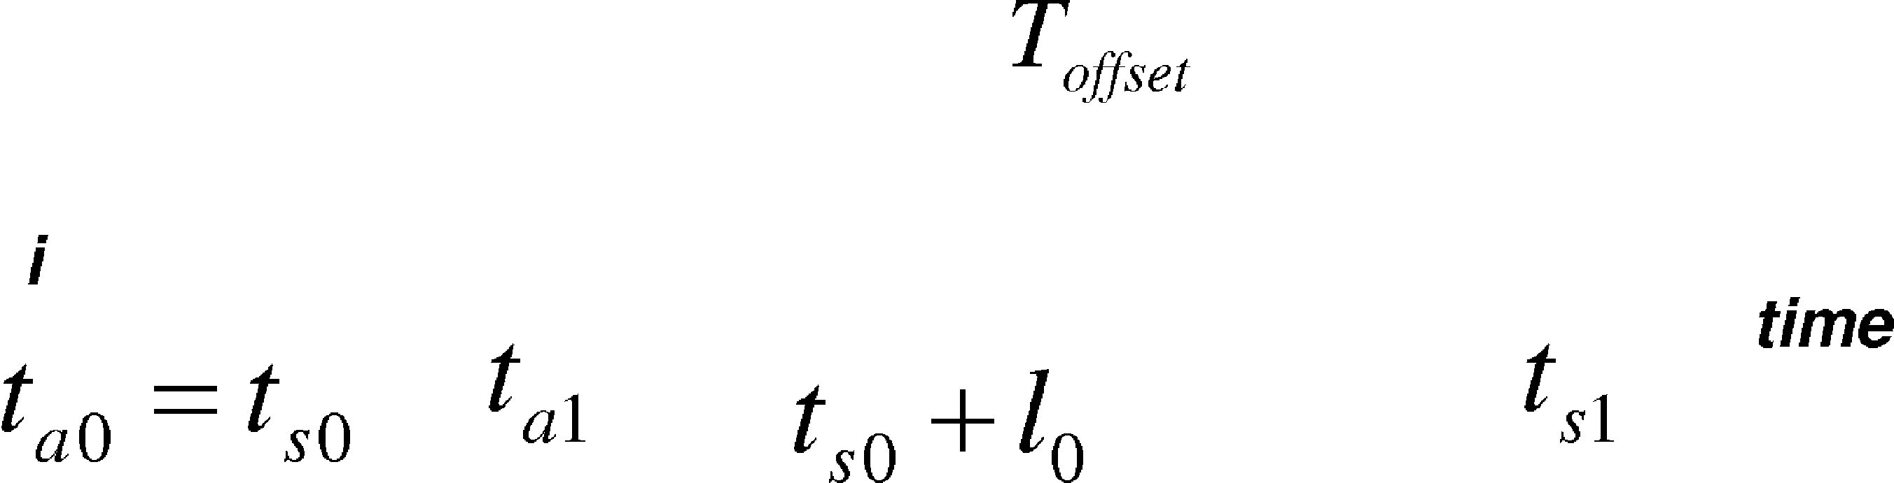

Figure 1 Additional offset time for class 1 traffic.

Consider Fig. 1 when the condition *ta*1 ﬃ *ts*0 holds. Assum- ing the burst length is exponentially distributed with an aver-

age of *l*0, the probability *P* that a burst in class 1 avoids being blocked by a class 0 burst is given by the following:

*Toffset*

*Wmin* = 0; *Wmax* = *W*; *i* = 1, 2, 3, ... *P* (3)

In case of a wavelength partitioning (WP) policy, the wave-

*i* *i*

length space is partitioned among the *P* traffic classes and each class has a dedicated access to a subset of *W* wavelengths [22].

*P*(*l*0

*offset*

6 *Toffset*

)= 1 — *e*— *l*0 ⇒ *T*

= —*l*0

ln(1 — *P*) (2)

Thus, the wavelength bounds for the traffic classes are stated

as follows:

We plot the above stated probability distribution function

0 < *Wmax* = *Wmin* = *W* < *W*; *i* = 1, 2, 3, ... *P*

(PDF) denoted by *P* against the ratio of *Toffset* over *l*0 in Fig. 2. From the plot it is observed that an additional offset time equal to five times the average burst length of the lower class ensures over 99% of class isolation.

*i* *i*

*P*

X

*i*=1

*i*

*Wi* = *W* (4)

* 1. *Wavelength reservation based approach*

In this approach [19], more wavelength resources are allocated to higher priority bursts compared to the lower priority bursts according to a threshold parameter. In a 2-class system, the lower priority bursts are discarded when the occupancy of

At last, the family of generalized wavelength sharing

(GWS) policies are examined. GWS not only reserves *Wmin* number of wavelengths to be used exclusively by class *i* bursts, but also restricts the number of wavelengths that can be occu- pied simultaneously by class *i* bursts to *Wmax*. The wavelength lower and upper bounds for each class are defined as follows:

*i*

*i*

0 6 *Wmin* < *Wmax* 6 *W*; *i* = 1, 2, 3, ... *P* (5)

*i* *i*

associated resources exceeds the threshold whereas the higher

priority bursts are admitted as long as one of the wavelengths is free.

*i*; *i* = 1, 2, 3, ... *P* is characterized by a worst-case end-to-end In general, in a multi class system, each traffic class BLP guarantee denoted by *Be*2*e*. The higher class bursts have

*i*

To facilitate sharing of wavelengths among the traffic

classes, the following constraints are imposed on the wave- length lower and upper bounds:

*P*

X

*Wmin* < *W*

*i*

more stringent BLP requirements than lower class bursts. In

order to attain this objective, the network nodes need to employ appropriate policies to allocate wavelength resources

*i*=1

*P*

X

*Wmax* > *W* (6)

*i*

to bursts of each class based on its load and worst-case end-

to-end BLP requirement [20,21].

*i*=1

Let a new class *i* burst arrives the output port at state

For the purpose of analysis, we assume that the output port of an optical switch consists of *W* parallel wavelengths, and carries *P* classes of bursts. The wavelength allocation policy imposes a pair of bounds to each class *i*, denoted by

(*Wmax*, *Wmin*) where *Wmax* is referred to as wavelength upper

(*n*1, *n*2, ... , *nP*) where *ni* is the number of wavelengths busy in

serving class *i* bursts. Then, the new class *i* burst can be accom-

modated on any free wavelength if the following condition holds the following:

* + 1. *i i* ( )

*min*

bound for class *i* and *Wi* is referred to as wavelength lower

*i*

*i*

*k*–*i*

*k*

*k*

bound for class *i* respectively. In a complete wavelength shar-

ing policy, the wavelength bounds for the traffic classes are sta-

*n* < min *Wmax*, *W* — X max{*n* , *Wmin*}

(7)

ted as follows:

else the burst is dropped.

1

0.95

Probability Distribution Function (PDF)

0.9

0.85

0.8

0.75

0.7

0.65

Exponential Distribution of PDF

1. Analytical model

Markov Decision Processes (MDP) are the fundamental aspects to analyze stochastic systems [23]. In this section, we present a Markov model for a single class OBS system that employs wavelength reservation based QoS mechanism as shown in Fig. 3. We consider a single switch and one of its out- put ports that carries *W* wavelengths. Further, we assume that there is no use of fiber delay lines (FDLs).

dom variable *X*(*t*) that defines the number of wavelengths busy For the above depicted Markov model, we denote a ran- in serving class *k* bursts at time instant *t*. Let k*k* and l*k* denote

the arrival and the service rate of traffic class *k*. The above con- tinuous time Markov model is a one dimensional birth and death process, and follows the following postulates:

*Pij*(*t*)= *P*{*X*(*t* + *h*)= *j*|*X*(*h*)= *i*}

1 2 3 4 5 6 7 8 9 10

Ratio of offset time over mean burst length of Class 0 traffic

*Pi*(*i*+1)

(*h*) = k*kh* + *o*(*h*); *h* → 0

Figure 2 Exponential distribution of PDF.

*Pi*(*i*—1)(*h*)= *i*l*kh* + *o*(*h*); *h* → 0

*Pii*(*h*)= 1 — (k*k* + *i*l*k*)*h* + *o*(*h*); *h* → 0

According to the above postulates, we can state that:

*Pij*(*t* + *h*) = *P*{*X*(*t* + *h* + *u*)= *j*|*X*(*u*)= *i*}

= *P*{*X*(*t* + *h* + *u*)= *j*, *X*(*t* + *u*)= *c*; *c* = 0, 1, ... , *W*|*X*(*u*)= *i*}

=

X*W*

*c*=0 *W*

X

=

*c*=0 *W*

X

=

*c*=0 *W*

X

=

*c*=0

*P*{*X*(*t* + *h* + *u*)= *j*, *X*(*t* + *u*)= *c*|*X*(*u*)= *i*}

*P*{ *X*(*t* + *u*)= *c*|*X*(*u*)= *i*} *P*{*X*(*t* + *h* + *u*)= *j*| *X*(*t* + *u*)= *c*, *X*(*u*)= *i*}

*P*{ *X*(*t* + *u*)= *c*|*X*(*u*)= *i*} *P*{*X*(*t* + *h* + *u*)= *j*| *X*(*t* + *u*)= *c*}

*Pic*(*t*)*Pcj*(*h*)

= *Pi*(*j*—1)(*t*)*P*(*j*—1)*j*(*h*)+ *Pij*(*t*)*Pjj*(*h*)+ *Pi*(*j*+1)(*t*)*P*(*j*+1)*j*(*h*)+ X *Pic*(*t*)*Pcj*(*h*)

*c*–*j*,*j*—1,*j*+1

= *Pi*(*j*—1)(*t*)[k*kh* + *o*(*h*)] + *Pij*(*t*)[1 — (k*k* + *j*l*k*)*h* + *o*(*h*)] + *Pi*(*j*+1)(*t*)[(*j* + 1)l*kh* + *o*(*h*)] + *o*(*h*)

= k*khPi*(*j*—1)(*t*)+ *Pij*(*t*)— (k*k* + *j*l*k*)*hPij*(*t*)+ (*j* + 1)l*khPi*(*j*+1)(*t*)+ *o*(*h*)

⇒ *Pij*(*t* + *h*)— *Pij*(*t*)= k*khPi*(*j*—1)(*t*)— (k*k* + *j*l*k*)*hPij*(*t*)+ (*j* + 1)l*khPi*(*j*+1)(*t*)+ *o*(*h*)

⇒ *Pij*(*t* + *h*)— *Pij*(*t*) = k *P*

(*t*) — (k

+ *j*l )*P* (*t*)+ (*j* + 1)l *P*

(*t*) + *o*(*h*)

*h k i*(*j*—1)

*k k ij*

*k i*(*j*+1) *h*

⇒ *P*' (*t*)= k*kPi*(*j*—1)(*t*)— (k*k* + *j*l*k*)*Pij*(*t*)+ (*j* + 1)l*kPi*(*j*+1)(*t*); *h* → 0

*ij*

⇒ *P*' (*t*)= —k*kPi*0(*t*)+ l*kPi*1(*t*)

*i*0

At steady state, lim*t*→∞*Pij*(*t*)= *Pj* and lim*t*→∞*P*' (*t*)= 0.

*ij*

Hence, at steady state the above derivation can be restated

as follows:

— k*kP*0 + l*kP*1 = 0

From Eq. (10), we observe that the probability of being in state 0 denoted by *P*0 decreases with the increase in traffic intensity.

The numerical results are verified with *W* = 8, 16, 24 and 32

respectively as shown in Fig. 4.

⇒ *P*1 =

k*k* q1

 *P*0 = *k P*0

l*k* 1!

(8)

0.14

where q*k*

is the traffic intensity of class *k*.

0.12

k*kPj*—1 — (k*k* + *j*l*k*)*Pj* + (*j* + 1)l*kPj*+1 = 0; *j* P 1 (9)

From Eqs. (8) and (9), it can be derived that:

q2

*P*2 = *k P*0

2!

q3

*P*3 = *k P*0

3!

0.1

0.08

**P0**

0.06

q*W*

In general, *PW* = *k P*0.

*W*!

It is intuitive that the probabilities of all possible states of

the above Markov model sum up to 1. Hence,

*W*

*PW* = 1

X

0.04

0.02

0

2 4 6 8 10 12 14 16 18 20 22 24 26 28 30 32 34 36 38 40

W=32 W=16 W=8 W=24

*s*=0

1

⇒ *P*0 = q0 q1 q2 q*W*

(10)

**Traffic Intensity**

Figure 4 Validation of Eq. (10).

*k* + *k* +

*k* + ··· + *k*

0! 1! 2! *W*!



Figure 3 The Markov model for a single class OBS system.

0.9

0.8

0.7

0.6

0.5

**PW**

0.4

0.3

0.2

0.1

0

W=32 W=16 W=8 W=24

2 4 6 8 10 12 14 16 18 20 22 24 26 28 30 32 34 36 38 40

**Traffic Intensity**

Figure 5 Blocking probability of burst.

* + 1. *Assumptions*
       - There are two traffic classes namely Low (*L*) and High (*H*) with burst arrival rates k1 and k2 respectively.
       - Each output port consists of *W* wavelengths where bursts from class *L* traffic are allowed to use at most *W S* wave-

lengths at any given time. Accordingly, the pair of wave- length lower and upper bounds for class *L* traffic is

(0, *W S*) and for class *H* traffic is (0, *W* ) respectively.

Without loss of generality, the aforementioned assumptions

can be used to model a two dimensional birth and death pro- cess as shown in Fig. 6. A state of the system at time instant *t*

can be characterized by the pair (*n*1, *n*2) where *n*1 and *n*2 are the

number of wavelengths assigned to the bursts of classes *L* and

*H* respectively. According to the above assumptions, *n*1 6 *WS*

and *n*1 + *n*2 6 *W*.

Let *Pij* denotes the steady state probability of assigning *i*

and *j* wavelengths to the bursts of class *L* and class *H* respec- tively and is stated as below:

q*i* q *j*

A forthcoming burst will be blocked when all the wave-

*Pij* = 1 2 *P*00; 0 6 *i* 6 *WS*, 0 6 *j* 6 *W* — *i* (11)

lengths are busy and its blocking probability is calculated by the probability of being in state *W*, denoted by *PW*. The block- ing probability of a burst increases with the increase in traffic intensity for a given *W* as shown in Fig. 5. *PW* increases with

*i*! *j*!

where

1

*P*00 = *i j*

*WS W*—*i* 1 2

(12)

the decrease in *W* for a given traffic intensity because the out-

put port saturates early for a lower *W*.

* 1. *The 2-class model*

q = k*k* l*k*

*i*=0

*j*=0

*i*! *j*!

(13)

A preliminary version of the 2-class Markov model is pre- sented in [1]. However, in this paper, the description of the model has been improved through hand traced examples used to substantiate the stated mathematical equations.

*k*

P P q q

traffic class *k* = 1, 2. k*k* and l*k* respectively denote the arrival and the service rate of

A burst from class *H* is lost when it finds all wavelengths

are busy in serving the already scheduled bursts. Let *PH*

denotes the BLP associated with class *H* and is stated as below:

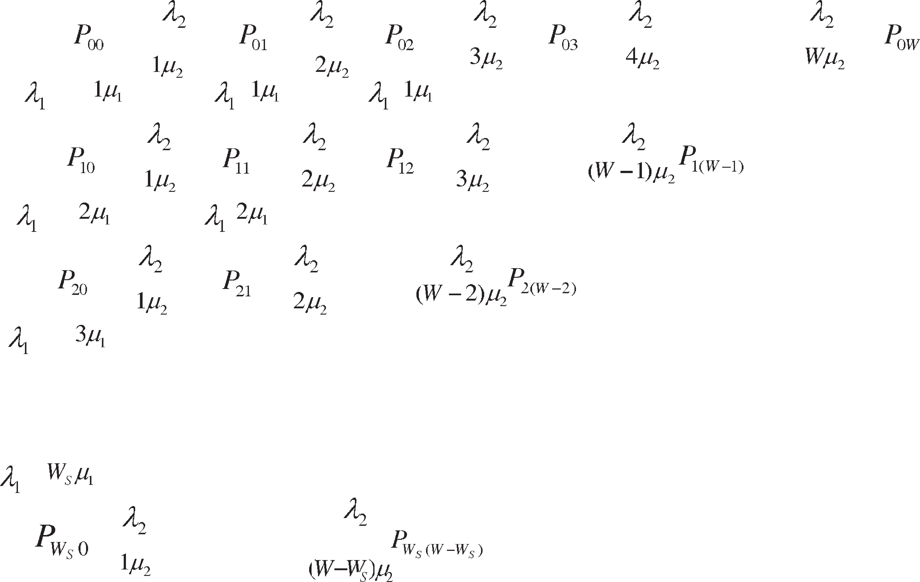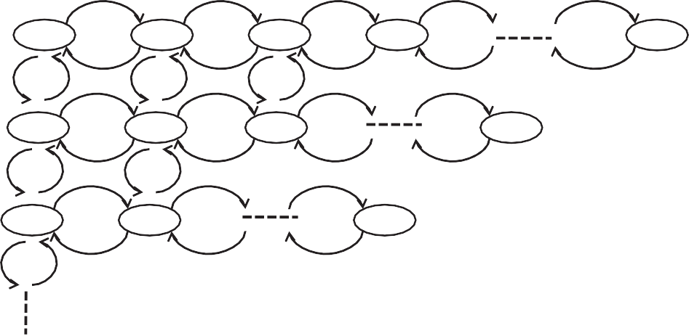

Figure 6 The 2-class Markov model.

*PH* =

*P*00 X*W*

*W*—*j*

1

q

q *j P*00 X*W*

*W* q*W*—*j* q *j*

To examine the above formulas, we consider an exemplary

2-class Markov model as shown in Fig. 7. Let *W* = 5 and

*W*! *j*=*W*—*Ws*

*W*!

2 =

1 2

(*W* — *j*)! *j*!

*W*! *j*=*W*—*WS j*

*WS* = 2. In this 2-class exemplary model, the steady state

(14)

tized, i.e. *WS* = *W*, Eq. (14) can be restated as below: Considering the case where both classes are equally priori-

blocking probabilities of bursts from both the classes are esti- mated in Eqs. (18) and (19) respectively:

*PH* = *Pij* = *P*05 + *P*14

X

*i*+*j*6*W*

*i*6*WS*

2

1 .

0!

1 +

5!

1 .

1!

1 +

4!

1 .

2!

1

3!

*P* = (q

q

*Shared*

1

=

5!

2 =

+ q )*W P*00

(15)

q0 q5

q1 q4

q2 q3

A burst from class *L* is lost not only when all the wave-

*W*!

+ *P*23 = *P*00

1 2

*P*00 X5

5—*j j* X5 5

1 q *P*00

q5—*j* q *j*

(18)

lengths are busy in serving the already scheduled bursts but also when the bursts of class *L* scheduled in the system have

5! *j*=3

(5 — *j*)! *j*!

5! *j*=3 *j*

reached the threshold limit i.e. *WS*. Let *PL* denotes the BLP *PL* = *P*05 + *P*14 + *P*23 + *P*20 + *P*21 + *P*22

associated with class *L* and is stated as below:

5 5—*j j*

2 2 *j*

= *P*00 X*W*! q1 q2 + *P*

00

q1 X q2

(19)

" 1 X*W*

*PL* = *P*00

q*W*—*j* q *j* +

1

2

(16)

*W*

q*Ws W*—X*WS* —1 q *j* #

*W*! *j*=3

(5 — *j*)! *j*!

2! *j*=0 *j*!

*W*! *j*=*W*—*WS j*

1 2 *WS*!

*j*=0 *j*!

Given

1

*P*00 = *i j*

*i*=0

*j*=0 *i*!

*j*!

(20)

Let *PT* denotes the overall BLP of both the classes at the

*H*

output port and is stated as below:

P2 P5—*i* q1 q2

k1

*P* = k + k *P*

*T*

*L*

1 2

1 2

k2

+ k + k *P*

(17)

In the case of a classless system as modeled in Fig. 8, the

bursts from both the classes are equally prioritized. The steady state blocking probability of a burst in such a system is esti- mated in Eq. (21)

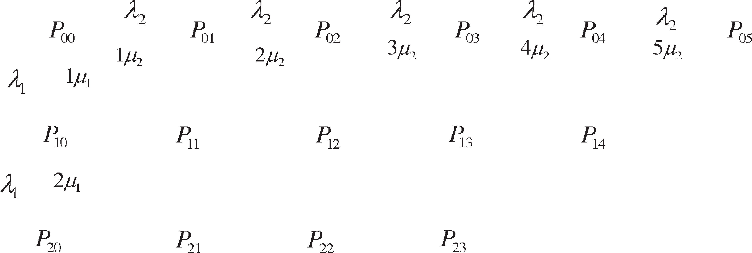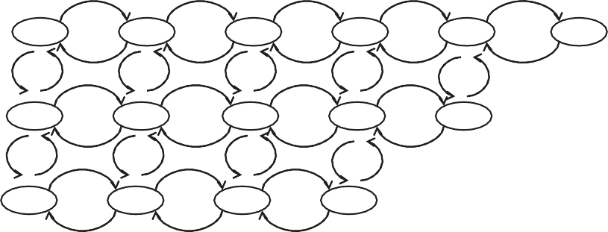

Figure 7 An exemplary 2-class model.

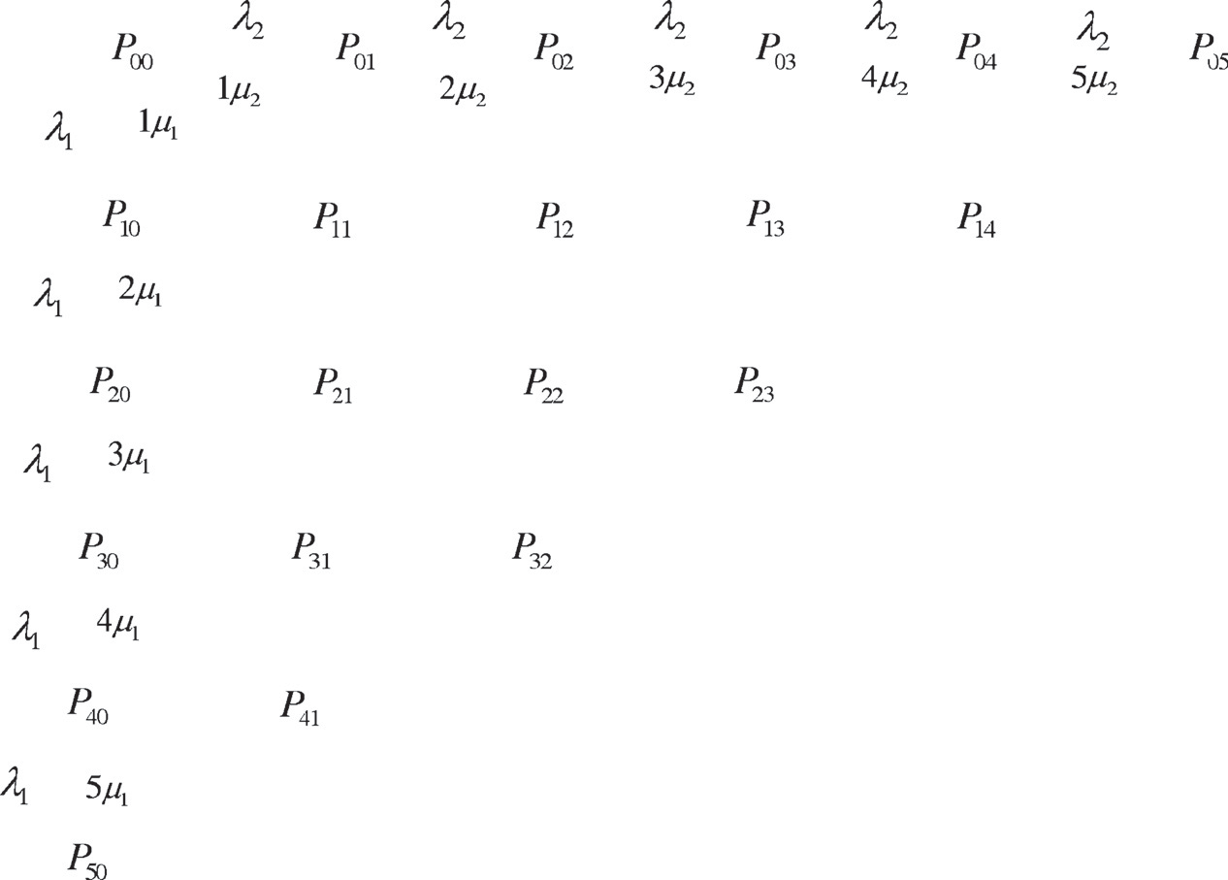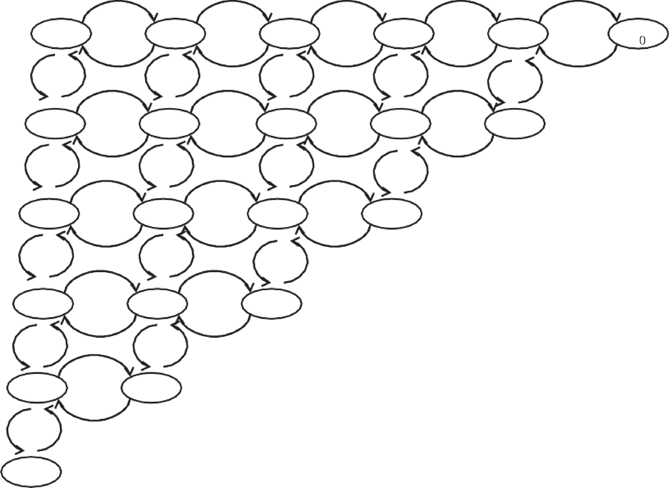

Figure 8 An exemplary classless model.

*PShared* = *P*05 + *P*14 + *P*23 + *P*32 + *P*41 + *P*50

2 + 5!

2 + 5!

2 + 5!

1

2

**W=32, WS=4, and** **1= 5 Erlangs**

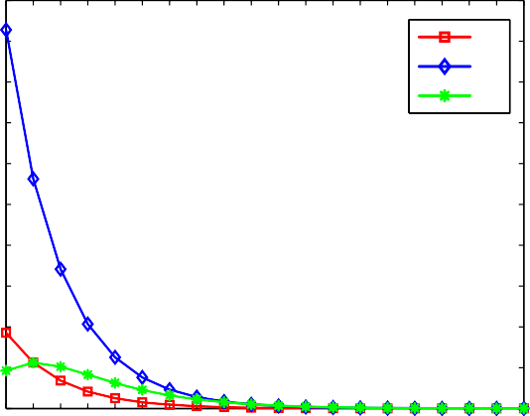

P00 P10 P01

*P*00

=

5!

q0 q5



q1 q4



q2 q3



q3 q2



0.05

5! 0! 5!

1

1

1

q4 q1

+5!

1

2 + 5!



1! 4!

q5 q0

1

2

5! 0!



2! 3!

3! 2!

0.045

0.04

**Estimation of P00, P10, and P01**

= *P*00 5 q0q5 + 5 q1q4 + 5 q2q3 + 5 q3q2

4! 1!

5!

0

1

2

1

1

2

2

1

2

3

1

2

0.035

0.03

5 4 1

5 5 0

*P*00 5

0.025

+ 4 q1 q2 +

5 q1q2

= 5! (q1 + q2)

(21)

0.02

0.015

* 1. *Generalization to k-class model*

In this section, we generalize the 2-class model to support an arbitrary number of service classes (*k* P 2). Let k*i* and l*i* denote, respectively, the arrival and service rate of bursts of

some class *i* (0 6 *i* 6 *k* — 1). Without loss of generality, the

0.01

0.005

0

0.5 1 1.5 2 2.5 3 3.5 4 4.5 5 5.5 6 6.5 7 7.5 8 8.5 9 9.5 10

**Traffic Intensity of Higher Class**

Figure 11 Validation of Eq. (11).

0.025

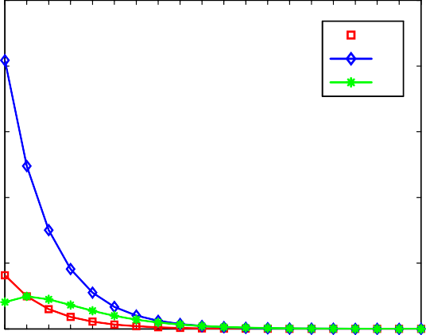

P00

P10 P01

0.02

**Estimation of P00, P10, and P01**

0.015

**W=32, WS=16, and** **1=5 Erlangs**

0.14

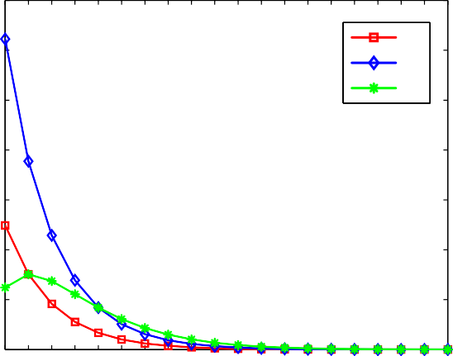

P00 P10 P01

0.12

**Estimation of P00, P10, and P01**

0.1

0.08

**W=32, WS=16, and** **1=2.5 Erlangs**

0.01

0.06

0.005

0

0.5 1 1.5 2 2.5 3 3.5 4 4.5 5 5.5 6 6.5 7 7.5 8 8.5 9 9.5 10

**Traffic Intensity of Higher Class**

Figure 9 Validation of Eq. (11).

0.04

0.02

0

0.5 1 1.5 2 2.5 3 3.5 4 4.5 5 5.5 6 6.5 7 7.5 8 8.5 9 9.5 10

**Traffic Intensity of Higher Class**

Figure 12 Validation of Eq. (11).

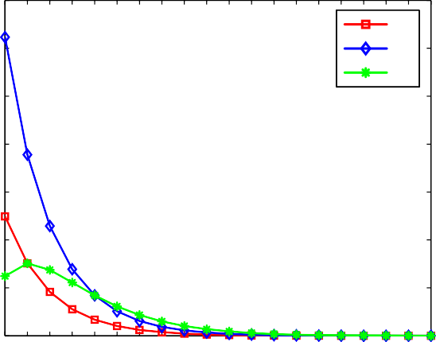

P00 P10 P01

0.025

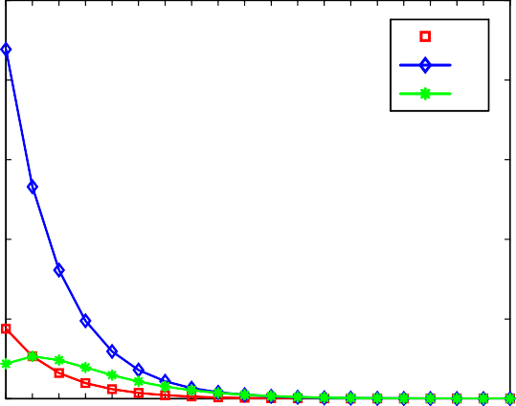

P00

P10 P01

0.02

**Estimation of P00, P10 and P01**

0.015

**W=32, WS=8, and** **1=5 Erlangs**

0.14

0.12

**Estimation of P00, P10, and P01**

0.1

0.08

**W=32, WS=8, and** **1=2.5 Erlangs**

0.01

0.005

0.06

0.04

0.02

0

0.5 1 1.5 2 2.5 3 3.5 4 4.5 5 5.5 6 6.5 7 7.5 8 8.5 9 9.5 10

**Traffic Intensity of Higher Class**

0

0.5 1 1.5 2 2.5 3 3.5 4 4.5 5 5.5 6 6.5 7 7.5 8 8.5 9 9.5 10

**Traffic Intensity of Higher Class**

Figure 10 Validation of Eq. (11). Figure 13 Validation of Eq. (11).

*k*—1 *nj*

Y

steady state probability of the *k*-tuple (*n*0, *n*1, *n*2, .. . , *nk*—1) is

given by the following:

*Pj* = X

(q*j* ) *P*

*n* !

*j*

*j*

(00 0...*k times*)

(24)

P*k*—1 *n* =*L*

*j*=0 *j*

*k*—1

|*n* =*L j*=0 *j*

*P* = Y (q*j* ) *P*

*k*—1

*nj*

*k*—1

; *n* 6 *L* , X*n* 6 *L*

*n*0 *n*1 *n*2 ,...,*nk*—1

*j*=0



*nj*!

(00 0...*k times*) *j*

* + 1. *j*

*j*=0

*k*—1

(22)

1. Numerical results & discussion

where *Lj* is the maximal number of wavelengths allocated to

class *j*.

In this section, we present the analytical results to validate the formulas stated in the preceding section. A single optical

c0 c1

(00 0...*k times*)

*n*0 =0*n*1 =0

*nk*—1 =0 *j*=0

*nj*!

*j*

*j*

c*k*—1 *k*—1 *nj*

switch with one output port and Poisson traffic arrival is con-

*P* = XX ... ... X Y (q*j*) ; 0 6 c 6 *L* (23)

sidered for different traffic loads. The simulation is verified in a

Pentium(R) 4 CPU with a clock cycle of 3.2 GHz and a 2 GB

A burst of class *Sj* fails to get a free wavelength if it either

finds, at the instant of arrival, all wavelengths are busy or the maximal number of wavelengths allocated to class *Sj* has already reached the threshold *Lj*. Hence, the associated prob- ability is stated as follows:

**W=32, WS=4, and** **1= 2.5 Erlangs**

0.14

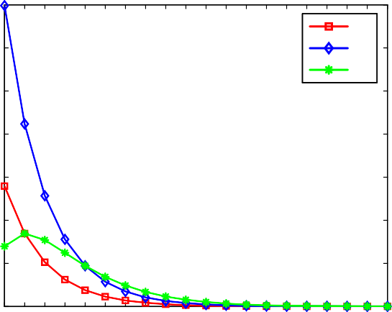

P00 P10 P01

0.12

**Estimation of P00, P10, and P01**

0.1

0.08

0.06

0.04

0.02

0

0.5 1 1.5 2 2.5 3 3.5 4 4.5 5 5.5 6 6.5 7 7.5 8 8.5 9 9.5 10

**Traffic Intensity of Higher Class**

of RAM. The simulator used is MATLAB 7.0.1. In our simu-

lation, the traffic intensity of the shared system is equal to the

**W=16, WS=4, and** **1=5**

0.45

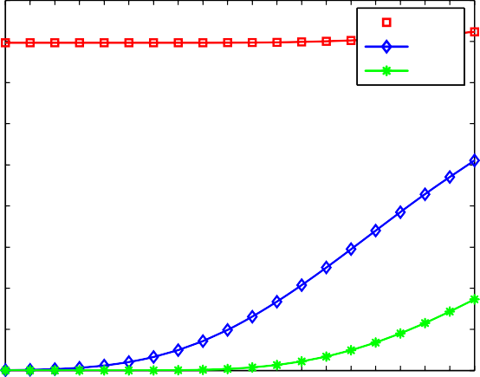

PL

PShared PH

0.4

0.35

**Blocking Probability**

0.3

0.25

0.2

0.15

0.1

0.05

0

0.5 1 1.5 2 2.5 3 3.5 4 4.5 5 5.5 6 6.5 7 7.5 8 8.5 9 9.5 10

**Traffic Intensity of Higher Class**

Figure 16 BLP comparison of class *L*, class *H*, and shared systems.

Figure 14 Validation of Eq. (11).

**W=16, W =8, and**  **=5**

**W=32, WS=16, and** **1=10**

0.18 **S 1**

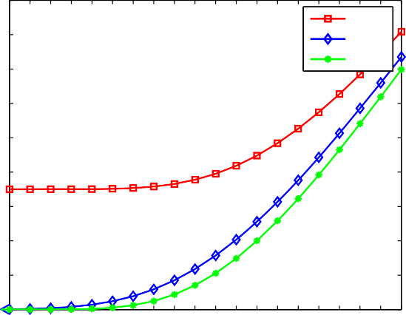

PL

PShared PH

0.16

0.14

**Blocking Probability**

0.12

0.1

0.08

0.06

0.04

0.02

0.12

0.1

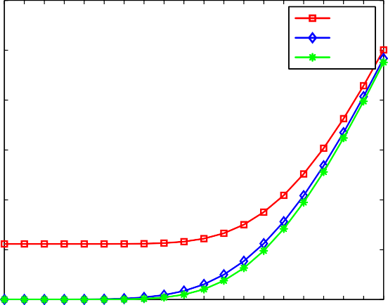

PL

PShared PH

**Blocking Probability**

0.08

0.06

0.04

0.02

0

0.5 1 1.5 2 2.5 3 3.5 4 4.5 5 5.5 6 6.5 7 7.5 8 8.5 9 9.5 10

**Traffic Intensity of Higher Class**

0

1 2 3 4 5 6 7 8 9 10 11 12 13 14 15 16 17 18 19 20

**Traffic Intensity fo Higher Class**

Figure 15 BLP comparison of class *L*, class *H*, and shared systems.

Figure 17 BLP comparison of class *L*, class *H*, and shared systems.

q = q1 + q2 and the whole wavelength space is allocated to this sum of the traffic intensities of both class *L* and class *H*, i.e. traffic intensity.

Figs. 9–14 validate Eq. (11) for a given *W*, *WS* and q1. It is observed that with increase in higher class traffic intensity q2,

the probability of being in state (1, 0) decreases.

In Figs. 15–18, we study the effect of increasing the traffic

intensity of class *H* on the BLP of both class *L* and the shared system for a given *W*, *WS* and q1. It is observed that class *H* bursts suffer lesser loss compared to class *L* bursts. Blocking probabilities of both class *L* and class *H* increase as q2

increases. In order to demonstrate service class isolation, *PShared* is also depicted as a function of q2. It is observed that *PShared* lies between *PH* and *PL*, implying that bursts of class *H* are prioritized to those of class *L*.

In Figs. 19 and 20, we have studied the impact of increasing the traffic intensity of class *L* on the BLP of class H for a given *W* and *WS* respectively. It is observed that the blocking prob- ability of class *H* bursts increases with the increase in q1. It is because a class *H* burst has a lower chance of using the spared wavelengths from the pool of wavelengths allocated to class *L* when q1 is sufficiently large.

In Figs. 21 and 22, we have studied the impact of *WS* on the BLP of class *H* for a given *W* and q1 respectively. It is observed that the blocking probability of class *H* bursts increases with the increase in *WS*. When class *L* is privileged with more num- ber of wavelengths and with the increase in class *L* traffic, a burst from class *H* lessens its chance of getting a free wavelength.

0.35

PL

PShared PH

0.3

0.25

**Blocking Probability**

0.2

0.15

0.1

0.05

**W=32, WS=8, and** **1=10**

0.1

0.09

0.08

0.07

0.06

0.05

**PH**

0.04

0.03

0.02

0.01

**W=32, WS=16**

0

1 2 3 4 5 6 7 8 9 10 11 12 13 14 15 16 17 18 19 20

**Traffic Intensity of Higher Class**

0

1 2 3 4 5 6 7 8 9 10 11 12 13 14 15 16 17 18 19 20

**Traffic Intensity fo Higher Class**

Figure 18 BLP comparison of class *L*, class *H*, and shared systems.

1= 10 Erlangs

1= 5 Erlangs

Figure 20 BLP of class *H* traffic.

0.09

1= 5 Erlangs

1= 2.5 Erlangs

0.08

0.07

0.06

0.05

**PH**

0.04

0.03

0.02

0.01

0

**W=16, WS=4**

0.14

0.12

0.1

0.08

**PH**

0.06

0.04

0.02

0

**W=16,** **1= 5 Erlangs**

0.5 1 1.5 2 2.5 3 3.5 4 4.5 5 5.5 6 6.5 7 7.5 8 8.5 9 9.5 10

**Traffic Intensity of Higher Class**

0.5 1 1.5 2 2.5 3 3.5 4 4.5 5 5.5 6 6.5 7 7.5 8 8.5 9 9.5 10

**Traffic Intensity of Higher Class**

Figure 19 BLP of class *H* traffic. Figure 21 BLP of class *H* traffic.

WS=8

WS=4

0.1

0.09

0.08

0.07

0.06

0.05

**PH**

0.04

0.03

0.02

0.01

0

**W=32,** **1= 10 Erlangs**

WS=16

WS=8

1 2 3 4 5 6 7 8 9 10 11 12 13 14 15 16 17 18 19 20

**Traffic Intensity of Higher Class**

Figure 22 BLP of class *H* traffic.

1. [Choudhury S, Nair V, Mal AK. Routing scheme for OBS](http://refhub.elsevier.com/S1110-8665(16)30032-9/h0030) [networks. IEEE/OSA J Opt Commun Netw 2012;4(10):799–811](http://refhub.elsevier.com/S1110-8665(16)30032-9/h0030).
2. A´ lvaro de Mascarenhas Pereira do Nascimento de Lima Barradas.

Quality of Service in Optical Burst Switching Networks; 2009.

<<http://hdl.handle.net/10400.1/343>>.

1. Jue JP, Yang WH, Kim YC, Zhang Q. Optical packet and burst switched networks: a review. IET Commun 2009;3(3):334–52. http://dx.doi.org/10.1049/iet-com:20070606.
2. [Tintor V, Matavulj P, Radunovic J. Analysis of blocking](http://refhub.elsevier.com/S1110-8665(16)30032-9/h0045) [probability in optical burst switched networks. Photonic Netw](http://refhub.elsevier.com/S1110-8665(16)30032-9/h0045) [Commun 2008;15(3):227–36](http://refhub.elsevier.com/S1110-8665(16)30032-9/h0045).
3. Venkatesh T, Siva Ram Murthy C. An analytical approach to optical burst switched networks. Springer; 2010. [http://dx.doi.org/](http://dx.doi.org/10.1007/978-1-4419-1510-8) [10.1007/978-1-4419-1510-8](http://dx.doi.org/10.1007/978-1-4419-1510-8).
4. [Sivaramamuthy C, Guruswamy M. WDM optical networks-](http://refhub.elsevier.com/S1110-8665(16)30032-9/h0055) [concepts, design and algorithms. Prentice Hall; 2002, ISBN: 0-13-](http://refhub.elsevier.com/S1110-8665(16)30032-9/h0055) [060637-5](http://refhub.elsevier.com/S1110-8665(16)30032-9/h0055).
5. [Xiong Yijun, Vandenhoute Marc, Cankaya Hakki C. Control](http://refhub.elsevier.com/S1110-8665(16)30032-9/h0060) [architecture in optical burst-switched WDM networks. IEEE J Sel](http://refhub.elsevier.com/S1110-8665(16)30032-9/h0060) [Areas Commun 2000;18(10):1838–51](http://refhub.elsevier.com/S1110-8665(16)30032-9/h0060).
6. [Kaheel Ayman, Alnuweiri Hussein. A strict priority scheme for](http://refhub.elsevier.com/S1110-8665(16)30032-9/h0065) [quality-of-service provisioning in optical burst switching net-](http://refhub.elsevier.com/S1110-8665(16)30032-9/h0065) [works. In: Eighth IEEE international symposium on computers](http://refhub.elsevier.com/S1110-8665(16)30032-9/h0065) [and communication, 2003(ISCC 2003). p. 16–21](http://refhub.elsevier.com/S1110-8665(16)30032-9/h0065).
7. Conclusion

In this paper, we presented an analytical model for the wave- length reservation based QoS differentiation mechanism in OBS networks. The model is studied in depth for a single class system and then generalized to a k-class service system. Through simulation, we examined the impact of higher prior- ity traffic classes on the performance of lower priority classes in terms of blocking probability. During simulation, a shared traffic system is also examined to exhibit the QoS differentia- tion among multiple traffic classes. Through the numerical results, it is concluded that service classes with more allocated wavelengths experience lesser BLP compared to classless sys- tems, while those with lesser wavelengths suffer heavy burst losses.

References

1. [Rajabi A, Dadlani A, Kianrad A, Khonsari A, Varaminian F.](http://refhub.elsevier.com/S1110-8665(16)30032-9/h0005) [Mathematical analysis of wavelength-based QoS management in](http://refhub.elsevier.com/S1110-8665(16)30032-9/h0005) [optical burst switched networks. In: Third Asia international](http://refhub.elsevier.com/S1110-8665(16)30032-9/h0005) [conference on modelling & simulation. AMS’09. IEEE; 2009. p.](http://refhub.elsevier.com/S1110-8665(16)30032-9/h0005) [655–60](http://refhub.elsevier.com/S1110-8665(16)30032-9/h0005).
2. Shuo Li. Analysis and synthesis of optical burst switched networks. PhD thesis. City University of Hong Kong; February 2014.
3. [Brackett Charles A. Dense wavelength division multiplexing](http://refhub.elsevier.com/S1110-8665(16)30032-9/h0015) [networks: principles and applications. IEEE J Sel Areas Commun](http://refhub.elsevier.com/S1110-8665(16)30032-9/h0015) [1990;8(6):948–64](http://refhub.elsevier.com/S1110-8665(16)30032-9/h0015).
4. [Qiao Chunming, Yoo Myungsik. Optical burst switching](http://refhub.elsevier.com/S1110-8665(16)30032-9/h0020) [(OBS) – a new paradigm for an optical Internet. J High Speed](http://refhub.elsevier.com/S1110-8665(16)30032-9/h0020) [Netw 1999;8(1):69–84](http://refhub.elsevier.com/S1110-8665(16)30032-9/h0020).
5. [Chen Yang, Qiao Chunming, Yu Xiang. Optical burst](http://refhub.elsevier.com/S1110-8665(16)30032-9/h0025) [switching: a new area in optical networking research. IEEE Netw](http://refhub.elsevier.com/S1110-8665(16)30032-9/h0025) [2004;18(3):16–23](http://refhub.elsevier.com/S1110-8665(16)30032-9/h0025).
6. [Kaheel Ayman Malek, Alnuweiri Hussein, Gebali Fayez. A New](http://refhub.elsevier.com/S1110-8665(16)30032-9/h0070) [analytical model for computing blocking probability in](http://refhub.elsevier.com/S1110-8665(16)30032-9/h0070) [optical burst switching networks. IEEE J Sel Areas Commun](http://refhub.elsevier.com/S1110-8665(16)30032-9/h0070) [2006;24(12):120–8](http://refhub.elsevier.com/S1110-8665(16)30032-9/h0070).
7. [Rosberg Zvi, Le Vu Hai, Zukerman Moshe, White Jolyon.](http://refhub.elsevier.com/S1110-8665(16)30032-9/h0075) [Performance analyses of optical burst-switching networks. IEEE J](http://refhub.elsevier.com/S1110-8665(16)30032-9/h0075) [Sel Areas Commun 2003;21(7):1187–97](http://refhub.elsevier.com/S1110-8665(16)30032-9/h0075).
8. [Rosberg Zvi, Le Vu Hai, Zukerman Moshe, White Jolyon.](http://refhub.elsevier.com/S1110-8665(16)30032-9/h0080) [Blocking probabilities of optical burst switching networks based](http://refhub.elsevier.com/S1110-8665(16)30032-9/h0080) [on reduced load fixed point approximations. In: Twenty-second](http://refhub.elsevier.com/S1110-8665(16)30032-9/h0080) [annual joint conference of the IEEE computer and communica-](http://refhub.elsevier.com/S1110-8665(16)30032-9/h0080) [tions. INFOCOM 2003. IEEE; 2003. p. 2008–18](http://refhub.elsevier.com/S1110-8665(16)30032-9/h0080).
9. [Yoo Myungsik, Qiao Chunming, Dixit Sudhir. QoS performance](http://refhub.elsevier.com/S1110-8665(16)30032-9/h0085) [of optical burst switching in IP-over-WDM networks. IEEE J Sel](http://refhub.elsevier.com/S1110-8665(16)30032-9/h0085) [Areas Commun 2000;18(10):2062–71](http://refhub.elsevier.com/S1110-8665(16)30032-9/h0085).
10. [Yoo Myungsik, Qiao Chunming, Dixit Sudhir. Optical burst](http://refhub.elsevier.com/S1110-8665(16)30032-9/h0090) [switching for service differentiation in the next-generation optical](http://refhub.elsevier.com/S1110-8665(16)30032-9/h0090) [Internet. IEEE Commun Mag 2001;39(2):98–104](http://refhub.elsevier.com/S1110-8665(16)30032-9/h0090).
11. [Akar Nail, Karasan Ezhan, Vlachos Kyriakos G, Varvarigos](http://refhub.elsevier.com/S1110-8665(16)30032-9/h0095) [Emmanouel A, Careglio Davide, Klinkowski Miroslaw, et al. A](http://refhub.elsevier.com/S1110-8665(16)30032-9/h0095) [survey of quality of service differentiation mechanisms for optical](http://refhub.elsevier.com/S1110-8665(16)30032-9/h0095) [burst switching networks. Opt Switching Netw 2010;7(1):1–11](http://refhub.elsevier.com/S1110-8665(16)30032-9/h0095).
12. [Yang Li, Rouskas George N. Generalized wavelength sharing](http://refhub.elsevier.com/S1110-8665(16)30032-9/h0100) [policies for absolute QoS guarantees in OBS networks. IEEE J Sel](http://refhub.elsevier.com/S1110-8665(16)30032-9/h0100) [Areas Commun 2007;25(3):93–104](http://refhub.elsevier.com/S1110-8665(16)30032-9/h0100).
13. [Yang Li, Rouskas George N. Optimal wavelength sharing policies](http://refhub.elsevier.com/S1110-8665(16)30032-9/h0105) [in OBS networks subject to QoS constraints. IEEE J Sel Areas](http://refhub.elsevier.com/S1110-8665(16)30032-9/h0105) [Commun 2007;25(9):40–9](http://refhub.elsevier.com/S1110-8665(16)30032-9/h0105).
14. [Liao Wanjiun, Loi Chi-Hong. Providing service differentiation](http://refhub.elsevier.com/S1110-8665(16)30032-9/h0110) [for optical-burst-switched networks. J Lightwave Technol](http://refhub.elsevier.com/S1110-8665(16)30032-9/h0110) [2004;22(7):1651–60](http://refhub.elsevier.com/S1110-8665(16)30032-9/h0110).
15. Hyytia Esa. Resource allocation and performance analysis prob- lems in optical networks. PhD thesis. Department of Electrical and Communications Engineering, Helsinki University of Tech- nology; December 2004.