[Computers](https://doi.org/10.1016/j.cexr.2023.100021) & [Education: X Reality 2 (2023) 100021](https://doi.org/10.1016/j.cexr.2023.100021)

 

Contents lists available at [ScienceDirect](http://www.sciencedirect.com/science/journal/29496780)

Computers & Education: X Reality

journal homepage: [www.journals.elsevier.com/computers-and-education-x-reality](http://www.journals.elsevier.com/computers-and-education-x-reality)

[](http://crossmark.crossref.org/dialog/?doi=10.1016/j.cexr.2023.100021&domain=pdf)Augmented reality and worked examples: Targeting organic chemistry competence

Daniel Elford *, Simon J. Lancaster **, Garth A. Jones

*School of Chemistry, University of East Anglia, Norwich Research Park, NR4 7TJ, United Kingdom*

A R T I C L E I N F O

*Keywords:*

Augmented reality Worked examples

Electrophilic aromatic substitution Undergraduate

Problem solving Interactive visualisation

A B S T R A C T

Instructional guidance, provided using worked examples, helps the inexperienced learner cope with complex information, that may be difficult to process in limited capacity working memory. For students of chemistry, such complex information can pertain to the visualisation of structural changes in molecules throughout chemical reactions. This can be alleviated through the affordances of augmented reality (AR) technology. 3D structures are important as they have a crucial impact on the chemical and physical properties of molecules. Within a framework of Cognitive Load Theory, this study illustrates how AR-supported worked examples may enhance learning of electrophilic aromatic substitution. The participant cohort were FHEQ level 5 undergraduate students studying a module of organic chemistry. In addition, the achievement motivation of learner's was also explored, and how this may be impacted by the provision of AR technology and worked examples. The control group was provided with a copy of our worked examples that contained 2D reaction mechanism drawings. Data was collected using a combination of quantitative instruments and qualitative surveys/interviews. For this cohort of students, signifi- cant intragroup improvements, and greater normalised change values, in conceptual understanding were observed in the AR group. This was not observed in the control group. No significant intergroup differences in reported cognitive load or achievement motivation of students were found. This was unaffected when introducing prior relevant chemistry experience as a covariate. Student feedback and subsequent thematic analysis show not only the positive impacts on student engagement, but also how students convey their understanding of electro- philic aromatic substitution principles.

1. Worked examples and augmented reality

Worked examples feature regularly where problem solving is a prominent goal and are a widely studied approach to reducing cognitive load (Booth, McGinn, Young, & Barbieri, 2015; Paas, Van Gog, & Sweller, 2010; Sweller, 1988). Whereas a conventional problem contains only a stimulus (the description) and a stem (the problem statement), a worked example additionally outlines the solution steps required to reach the correct answer. This reduces or eliminates random problem-solving at- tempts (Sweller, Ayres, & Kalyuga, 2011). As such, worked examples are an empirical demonstration of the borrowing and reorganising principle (see Chen, Woolcott, & Sweller, 2017). Typically, a worked example is composed of two parts:

1. A worked solution to a problem with each step explained
2. Follow-up problems, completed by students to foster understanding of the subject content.

The sequence in which these two parts occur has been shown to be important. Whereas a worked solution, followed by a problem, most benefits individuals with lower relevant prior knowledge, a problem, followed by a worked solution demonstrates better learning outcomes for students with higher domain-specific knowledge (Reisslein, Atkinson, Seeling, & Reisslein, 2006). This is a clear example of an expertise reversal effect (see Kalyuga & Renkl, 2010). In fact, Paas, Renkl, and Sweller (2003) have shown that most, if not all cognitive load effects, reverse themselves when learners with a higher level of relevant prior knowledge are considered. It is noteworthy at this point to introduce the concept of elements. An element is anything that needs to be, or has been learned, such as a concept or procedure (Chen, Kalyuga, & Sweller, 2015). The more elements that interact, and thus cannot be learned in

* Corresponding author.

** Corresponding author.

*E-mail addresses:* [d.elford@uea.ac.uk](mailto:d.elford@uea.ac.uk) (D. Elford), [s.lancaster@uea.ac.uk](mailto:s.lancaster@uea.ac.uk) (S.J. Lancaster), [garth.jones@uea.ac.uk](mailto:garth.jones@uea.ac.uk) (G.A. Jones).

<https://doi.org/10.1016/j.cexr.2023.100021>

Received 5 November 2022; Received in revised form 14 April 2023; Accepted 15 April 2023

2949-6780/© 2023 The Authors. Published by Elsevier Ltd. This is an open access article under the CC BY-NC-ND license ([http://creativecommons.org/licenses/by-](http://creativecommons.org/licenses/by-nc-nd/4.0/) [nc-nd/4.0/](http://creativecommons.org/licenses/by-nc-nd/4.0/)).

isolation to achieve understanding, the greater the working memory load. This level of interaction is defined as element interactivity and is also influenced by learners’ level of expertise (Chen, Kalyuga, and Sweller, 2017).

The topic of organic chemistry where our worked examples were applied was electrophilic aromatic substitution (SEAr). Understanding SEAr requires underlying knowledge of principles of organic chemistry and can therefore be assumed to be of higher element interactivity. Re- sources for visualising chemical reactions (Fig. 1) are largely limited to isometric representations, static physical models, and pre-programmed animations. AR is a technique that imposes computer-assisted contex- tual information onto the physical world (Milgram, Takemura, Utsumi, & Kishino, 1994), obviating the reliance of using static 2D representations of 3D molecules. Further, visualising the structural changes that occur to the molecules throughout the reaction can be a challenging, but crucial, cognitive skill to the novice chemist. We hope to alleviate this through the coupling of AR with the pedagogical approach of worked examples. No longer does an educator need to make arbitrary judgements about the most effective representation to carry the learning objective. The uti- lisation of AR liberates from the two-dimensional constraints of a rep- resentation, and places control into the fingertips of the individual student, promoting active learning in the affective and cognitive domains (An & Holme, 2021; Keller, Rumann, & Habig, 2021).

2. Cognitive load and achievement motivation

When incorporated into Cognitive Load Theory (CLT), it can be pre- dicted that for the fledgling chemist, learning via worked examples should be superior to learning via problem solving alone. Within the context of worked examples, instruction imposes three types of cognitive load on learners’ limited capacity working memory (Paas et al., 2010):

1. Intrinsic Cognitive Load (ICL), concerned with the natural complexity of any information must be understood. This is not associated with instructional issues and can only be altered by changing the nature of what is to be learned.
2. Extraneous Cognitive Load (ECL), concerned with instructional issues.
3. Germane Cognitive Load (GCL), which consists of working memory resources used to handle element interactivity associated with ICL.

CLT is primarily concerned with techniques designed to reduce ECL. If the level of element interactivity can be reduced without altering what is learned, the load is extraneous, otherwise, the load is intrinsic. As such, if ICL is high and ECL is low, due to organised instruction, GCL will be maximised because the learner must devote a large proportion of work- ing memory resources to dealing with the essential learning components. However, when considering the expertise reversal effect, elements critical for the novice become redundant for a chemist with greater relevant prior knowledge. This introduces ECL and weakens the worked example effect. Prompting students to self-explain the rationale behind worked-out solution steps may increase GCL, if students can provide adequate explanations (Richey & Nokes-Malach, 2013). Yet, students may lack the prior domain knowledge necessary to do so, especially very early in training. When this is the case, self-explanations are likely to

induce ECL.

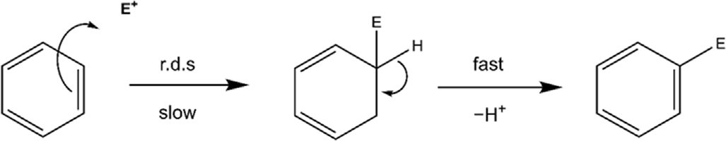

Fig. 1. General mechanism of the electrophilic aromatic substitution reaction (Hughes-Ingold mechanistic symbol: SEAr).

In addition to the cognitive load perspective is the affective perspective, which identified the relationships between learners' moti- vation, their cognitive load, and their prior knowledge. Previous works have reported a significant correlation between GCL and measures of individuals’ motivation (Um, Plass, Hayward, & Homer, 2012). As such, measures of motivation may influence the amount of cognitive resource an individual chooses to invest in a learning activity. Those learners who are self-regulated, may be able to employ more learning strategies to expand upon their effective cognitive capacity (Moreno & Park, 2010). This supports the hypothesis that higher levels of motivation can lead to greater persistence and mental effort throughout a task (Schnotz, 2010). Within this study, we are interested in the concept of current achievement motivation (CAM). CAM can be defined as the instigation and aim of competence-relevant behaviour (Atkinson, 1957; Rheinberg, Vollmeyer, & Burns, 2001). In other words, why does an individual strive towards competence and away from incompetence? Rheinberg et al. (2001) offer a model of CAM that differentiates four distinct factors: anxiety, challenge, interest, and probability of success. Historically, a significant number of studies regarding achievement motivation have been conducted in business environments (Smith & Karaman, 2019) consisting mainly of managers and business professionals (McClelland, 1961). The findings of these studies supported the hypothesis of achievement motivation as a significant predictor of success within the business environments where the research was conducted (McClelland, 1961). In comparison, a lower volume of work has been reported on the topic of achievement motivation within an educational setting and have produced mixed results when assessing achievement motivation as a predictor of performance (Awan, Noureen, & Naz, 2011; Kolb, 1965;

Lazowski & Hulleman, 2016; Singh, 2011; Smith & Troth, 1975).

The goal of achievement-oriented tasks is to improve an individual's capabilities in relation to a standard of competency (Heckhausen, 1977) to avoid demonstrating a lack of ability (Tanaka & Yamauchi, 2001). In this way, CAM is like self-efficacy, in that an individual's belief in their own ability can lead to positive or negative learning outcomes. CAM is also known to be impacted by situational task characteristics; just as self-efficacy is considered an individual's self-perception of their capa- bilities to accomplish a task under certain conditions (Bandura, 1977). Students will differ in their strength of motive to achieve, and educa- tional activities will differ in the challenge that they pose. If an individual and the task characteristics display a good fit, CAM should influence task-related behaviour in a performance situation (Bipp, Steinmayr, & Spinath, 2008; Richardson & Abraham, 2009).

1. Research questions

This study attempts to explore how coupling the pedagogical approach of worked examples with AR technology impacts students' conceptual understanding of electrophilic aromatic substitution. Further, we are interested in the interactions between students’ current achievement motivation, cognitive load, and cognitive information pro- cessing. Qualitative data collection was also undertaken. The research questions investigated were as follows:

Research question 1. How do cognitive load measures of partici- pants correlate with measures of current achievement motivation? Research Question 2. How is relevant chemistry experience impacted by the presentation of the worked examples?

Research Question 3. Is there an expertise reversal effect signifying interactions between the mode of representation, relevant chemistry experience, cognitive load, and current activity motivation?

Research Question 4. What are the participants' perceptions to the use of worked examples, and how do participants convey their un- derstanding of electrophilic aromatic substitution in conversation?

1. Methods
   1. *Test instruments*

The following test instruments were employed throughout this study. Cognitive Load Scale. Students’ cognitive load was measured via an adapted version of the Cognitive Load Scale (CLS, Leppink et al., 2013). The CLS is a previously validated three-component psychometric in- strument considered capable of distinguishing between ICL, ECL, and GCL (Hadie & Yusoff, 2016). The scale was adapted to the context of our electrophilic aromatic substitution worked example activity (see sup-

porting information).

Questionnaire on Current Motivation. An 18-item instrument designed to measure the four distinct factors of current achievement motivation in specific performance situations. The Questionnaire on Current Motivation (QCM) utilises a 7-point Likert scale and has been previously shown to be a predictor of performance in a variety of com- plex problem-solving tasks (Freund, Kuhn and Holling., 2011; Rheinberg et al., 2001; Vollmeyer & Rheinberg, 2006). Previous validity and reli- ability analysis of the QCM has been undertaken (Vollmeyer & Rhein- berg, 2006), and evidence for the absence of measurement bias on the instrument has also been provided (Freund, Kuhn and Holling., 2011).

SEAr Test Instrument. A 9-item multiple choice assessment of elec- trophilic aromatic substitution chemistry achievement, developed by the authors. The assessment was administered during the pre- and post-test phases of the study. A dichotomous scoring approach is used for each item. A correct response yields a score of 10, whereas an incorrect response yields a score of 0. A two-step validation approach (internal and external) was employed to ensure that the items on the instrument were

appropriate to gauge students’ conceptual understanding.

ChemFord. A free AR mobile and tablet application available on Apple iOS (11.0 or later) and Android (4.4 and up) platforms (Elford, Lancaster & Jones, 2021, 2022).

* 1. *Participants and procedures*

This study was conducted throughout the academic year of 2021/ 2022 as part of a UK Higher Education module of organic chemistry study at the University of East Anglia. The participant cohort identified for this research were second-year undergraduate students. Research on the worked example effect has been criticized for using problem solving without instructional support as a control condition (Koedinger & Aleven, 2007). Within this study, we examine alternate-format worked example study coupled with the same faded problems. A faded problem is one that omits steps, but retains much of the guidance provided by the context of a solved example. A pre-test/post-test experimental design (Fig. 2) was employed, and participants were randomly assigned to one of two groups to avoid bias and confounding variables as follows:

1. Control group: The worked example activity incorporated 2D drawings of electrophilic aromatic substitution reaction mechanisms.
2. AR group: The worked example activity incorporated an interactable electrophilic aromatic substitution reaction mechanism afforded through the use of AR.

To ensure the feasibility and safety of the selected research topic and recruited participants, ethical guidelines and regulations were consid- ered prior to commencing research to ensure sound research practices.

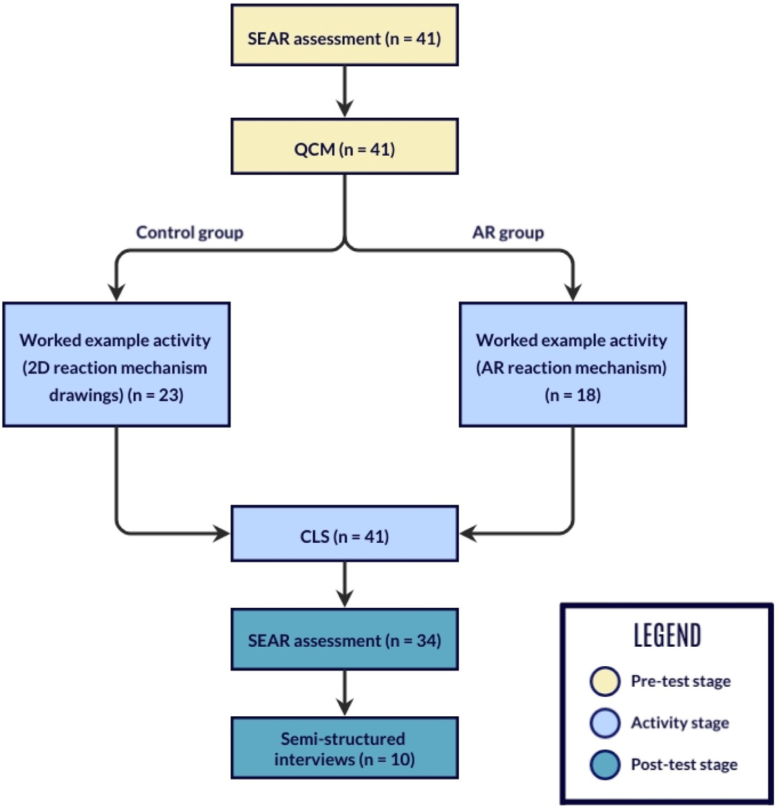

Fig. 2. Experimental design utilized for this study, including details of participant engagement.

Ethical clearance was obtained under the regulations of UEA's School of Science Research Ethics Committee, a sub-committee of the UEA Research Ethics Committee. The principle of informed consent involves researchers providing sufficient information and assurances regarding the research project to allow individuals to fully understand the impli- cations of participation, to reach a fully informed and freely given deci- sion (DuBois, 2002). This was obtained via a consent form (included as part of the participant information statement). Participants were made aware of their right to withdraw from the study, at any part of the research phase, without declaring a reason. Throughout the research period, participants were assured of data anonymity and confidentiality. Identifying information was irrevocably stripped from data documenta- tion, and study codes utilized in their place. All collected information was used only for the purposes outlined in the participant information statement. Data management was ensured through strict following of data protection principles, outlined under the Data Protection Act 2018, the United Kingdom's (UK) implementation of the General Data Protec- tion Regulation (GDPR).

Throughout the study, each group participated in only one worked example activity to eliminate carryover effects. The pre-test stage of the study was carried out in week 2 of the academic semester and consisted of the SEAr test instrument and the QCM. In week 3, a synchronous teaching session was conducted with the entire student cohort prior to the activity which introduced concepts pertaining to electrophilic aro- matic substitution. The activity was conducted in week 4, in which stu- dents also completed the CLS. At the post-test stage (in week 5), students completed the SEAr test instrument for the second time, in addition to also completing semi-structured interviews. Throughout the qualitative data collection stage, we conducted discussions with participants on topics relating to electrophilic aromatic substitution. This proved critical to evaluating whether students demonstrated a deep understanding of the topic material. Details of this can be found in the interview schedule (see supporting information).

* 1. *Activity design and AR SEAr mechanism*

The vision for our educational intervention draws on the coupling of worked examples with faded practice problems to elicit interaction, an approach that has been shown to yield greater learning outcomes than the use of either approach independently (Atkinson, Renkl, & Merrill, 2003; Crippen & Brooks, 2009; Jones & Fleischman, 2001; Sweller, van Merri€enboer, and Paas, 1998). Progressive fading can direct students' attention to important steps (Hilbert, Renkl, Kessler, & Reiss, 2008), and allow for gradual adaptation of support in response to student's increase in knowledge, thus removing redundant information (Low, Jin, & Sweller, 2011). With reference to CAM, we are interested in the inter- action of our activity, as the situational stimulus, with students'

underlying motives. Thus, at the beginning of the session, we introduced the activity and the ChemFord application. This was to ensure students understood the cognitive demands and requirements beforehand. Stu- dents were instructed to study the worked example prior to attempting the faded practice problems.

The design of our activity draws on the principles of Cognitive Load Theory. To be effective, our learning resources were designed to optimise ICL, that is, to be at the appropriate level of complexity. Thus, it is essential to design instruction in a format that reduces working memory load to manageable proportions. To accomplish this, principles of the Cognitive Theory of Multimedia Learning (CTML; Mayer and Fiorella, 2014) also guided the design of the learning material. We aimed to minimise ECL by eliminating split attention and redundancy conditions wherever possible.

Our learning resource is composed of 8 sections. Firstly, drawing on the segmenting principle (Clark & Mayer, 2016), sequential chunks of information on the fundamental aspects of electrophilic aromatic sub- stitution are provided. These include directing effects (Fig. 3), activating and deactivating groups, and regioselectivity.

Based on learner characteristics, and the representation of educa- tional content, previous research has reported that diagrams are more effective than textual representations (Ainsworth & ThLoizou, 2003). Hence, the representation of the worked examples was mainly graphical. In addition, previous work has also found positive impacts for textual explanations (Atkinson, Derry, Renkl, & Wortham, 2000). With consid- eration to the spatial and temporal contiguity principle, words and pic- tures should be presented simultaneously, and near one another.

Secondly, full worked examples of the electrophilic aromatic substi- tution reaction mechanism are provided. Addressing research question 2, we sought to investigate the impact of the AR as a visualisation aid on students’ ECL. We hypothesise that students using the AR tool will report lower measures of ECL, and thus can dedicate more working memory resources to GCL.

Throughout the facilitation of this activity, we considered two addi- tional points. Firstly, to provide autonomy to students, we did not impose an individual or group setting. On performance measures, no superior effects have previously been found for group work compared with indi- vidual study when utilising worked examples (Kasuma and Retnowati, 2021). In addition, instructional explanations were provided. Previous work has found instructional explanations, and even no explanations, to be superior to self-explanations (Renkl, Atkinson, & Groβe, 2004). The novice chemist is likely to be unable to accurately diagnose their own performance deficiencies, an ability that seems to be related to an in- dividual's knowledge of the task (Dunning, Johnson, Erlinger, & Kruger, 2003).

One of the primary challenges of conducting this study was the development of an interactive AR electrophilic aromatic substitution

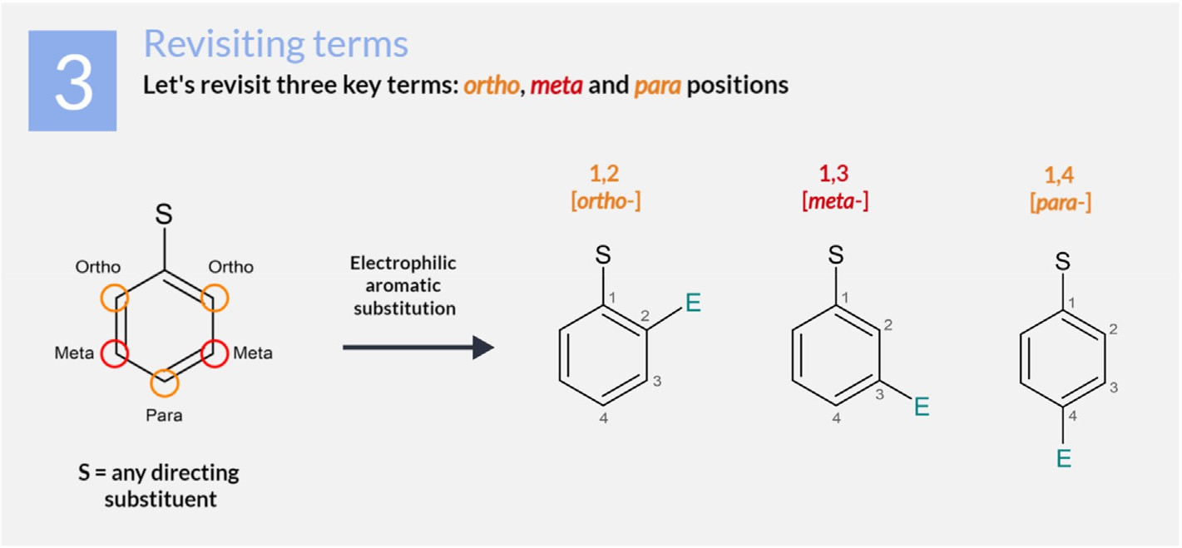

Fig. 3. Section 3 of the worked example activity, displaying directing effects.

reaction mechanism which could be used to support the learning of participants in the AR experimental group. We present a short overview of the development of the AR mechanism which explores the virtual

Table 1

SEAr conceptual knowledge scores and cognitive load measures.

Variable Control group AR group

objects created and the underlying C# components driving the func- tionality (see supporting information). Components were added allowing

objects to be rescaled, moved, and rotated when manipulated by a user,

Median (25th/75th Percentile)

Median (25th/75th Percentile)

in addition to reacting when brought into proximity of one another. Within the Unity Editor, which served as the environment where the AR

SEAr knowledge test score

*0 (low) to 90 (high)*

n ¼ 22 n ¼ 12

experience was developed, classes of code were written using Visual Studio IDE 2019 (2022). Molecules were created using Blender v.2.9 (Foundation, 2022), an open-source computer graphics software toolset. For this study, the developed AR SEAr reaction is the Friedel-Crafts Alkylation, presented in Fig. 4.

1. Results and discussion

Descriptive statistics concerning the measured variables of cognitive load, conceptual understanding, and motivational measures are sum- marised in Tables 1 and 2. Following data collection, the Shapiro-Wilk test was used to check for normality. 34 students completed the SEAr

Pre-test 40.00 (30.0/50.0) 40.00 (20.0/55.6)

Post-test 50.00 (40.0/80.0) 50.00 (40.0/70.0)

CLS responses *(11-point scale)* n ¼ 23 Mean (SD) n ¼ 18 Mean (SD)

ICL 5.91 (1.51) 6.36 (1.65)

ECL 3.41 (2.22) 3.58 (1.56)

GCL 6.44 (1.48) 6.26 (1.72)

Table 2

Median and interquartile range for CAM measures.

Variable Control group AR group

assessment at both pre- and post-test stages. Data pertaining to concep- tual knowledge was found to be nonnormally distributed for both pre-

Median (interquartile range)

Median (interquartile range)

and post-test stages. Thus, intergroup comparisons of conceptual un-

derstanding were conducted using the Mann-Whitney *U* test. No signif- icant differences in pre-test scores, *p* ¼ 0.579, or post-test scores, *p* ¼ 0.514, were observed. Cohen's *d* for post-test SEAr scores was 0.14,

suggesting negligible differences between groups. For this cohort of students, the introduction of AR technology, as a mode of representation for the worked example, resulted in significant intragroup improvement

|  |  |  |
| --- | --- | --- |
| Anxiety | 3.20 (1.60) | 3.50 (1.80) |
| Challenge | 4.25 (1.25) | 4.50 (1.25) |
| Interest | 4.60 (1.40) | 4.50 (1.80) |
| Probability of success | 4.50 (1.25) | 4.50 (1.00) |

QCM responses*(7-point Likert scale)*

n ¼ 23 n ¼ 18

in performance on the SEAr instrument. *5.1. CLS and QCM data*

A total of 41 students completed the CLS instrument. Prior to data

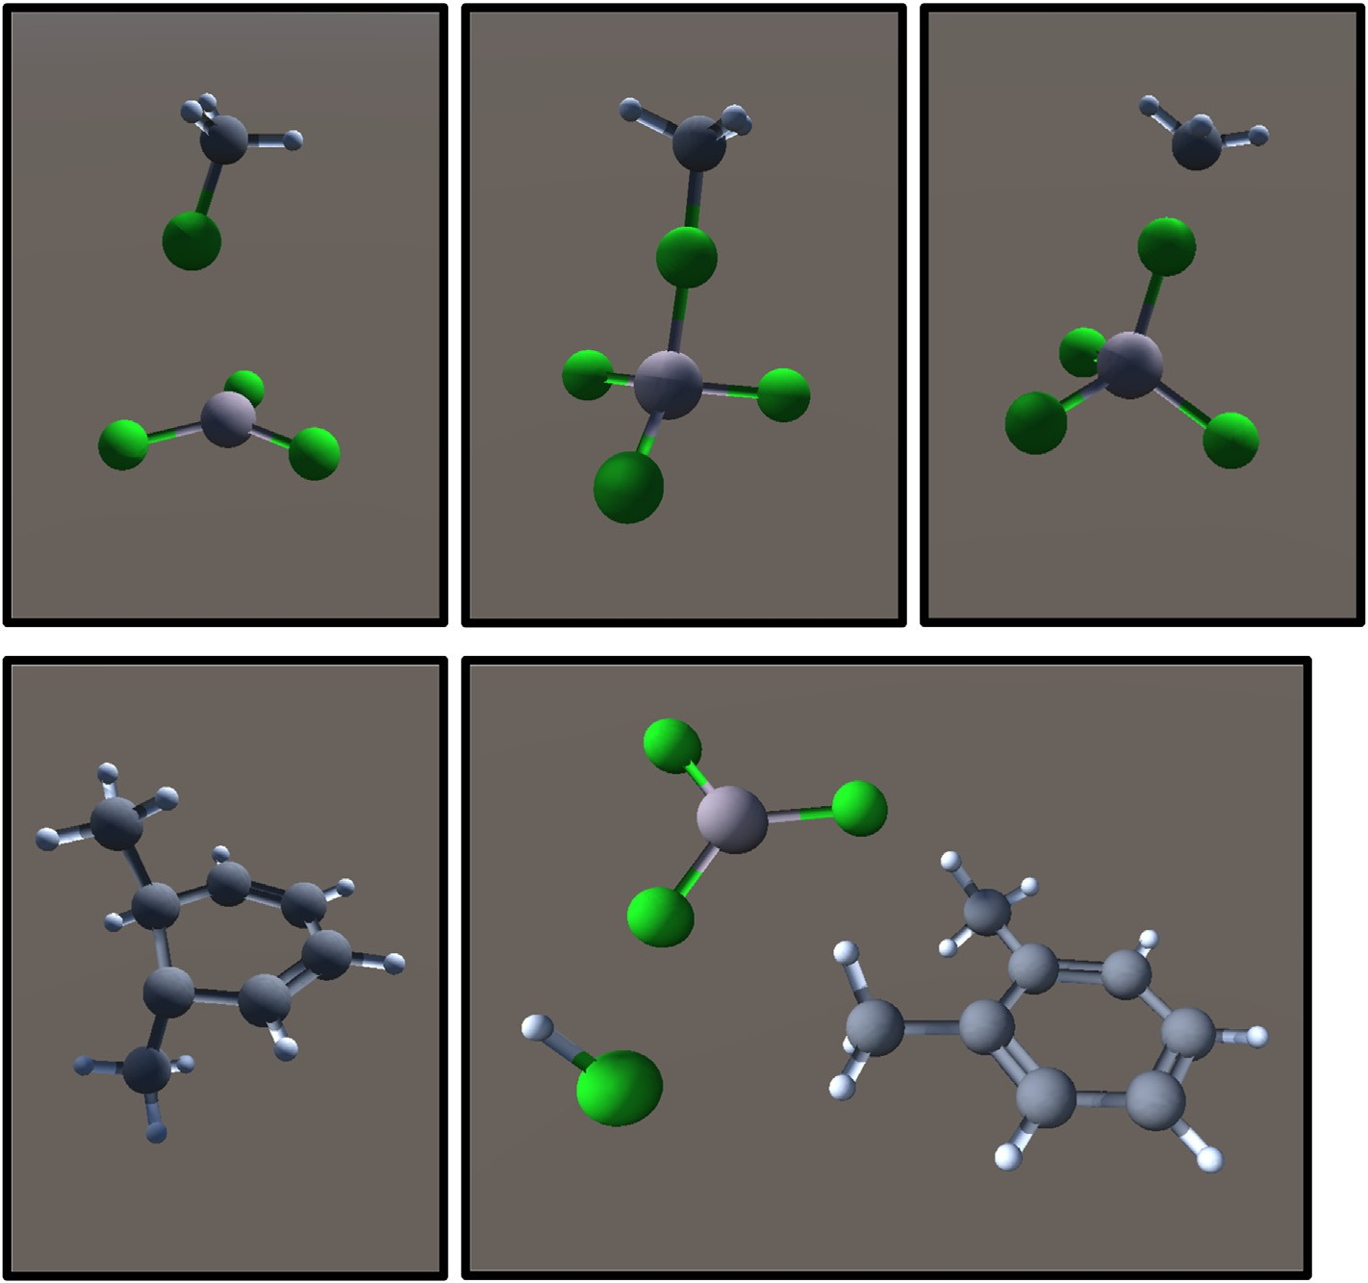

Fig. 4. The Friedel-Crafts alkylation of toluene represented using the ChemFord AR tool.

analysis, the existence of normality and equality of variances was confirmed through the use of the Shapiro-Wilk test and Bartlett's test. We conducted intergroup comparisons for each component of cognitive load

by carrying out two-tailed independent sample *t*-tests. No significant differences were detected for ICL, *t* (39) = 0.903, *p* = 0.372, ECL, *t* (39) = 0.292, *p* = 0.772, or GCL, *t* (39) = 0.361, *p* = 0.720. We expected the

introduction of AR would assist students' mental visualisation, thus reducing reported measures of ECL, whilst achieving similar or improved conceptual understanding in the post-test stage. As ECL decreases, more working memory resources are available to deal with ICL, and hence the generation of GCL. To account for participants' prior knowledge, a one-

way ANCOVA was employed, introducing the pre-test SEAr scores of participants as a covariate. For ICL, *F* (1,29) = 0.112, *p* = 0.741, and ECL, *F* (1,29) = 0.989, *p* = 0.329, tests of between-subject effects showed no

significant differences in cognitive load. GCL approaches significance

with Bonferroni post hoc comparisons showing higher levels of GCL in the AR group, *p* = 0.098.

Cronbach's alpha values show very good internal consistency on the CLS instrument: ICL = 0.92, ECL = 0.89, and GCL = 0.92. As predicted, measures of ECL negatively corelated with measures of GCL. As extra-

neous load, imposed by suboptimal instructional design increases, effective learning decreases. This relationship, *r* (41) = —0.600, calcu- lated using Pearson's correlation, was significant at *p* = 0.01. Internal

consistency measures for the four sub-scales of the QCM indicated acceptable Cronbach's alpha values of 0.59 (challenge), 0.77 (interest), 0.754 (probability of success), and 0.719 (anxiety).

Through Spearman's correlation, we observed that dimensions of in- terest, challenge, and probability of success all positively correlated with

GCL. This was significant at *p* = 0.01 (Table 3). Interest has previously

been shown to be an important predictor of test performance (Freund,

Kuhn, & Holling, 2011). In addition, ECL was moderately negatively correlated with interest, *r* (41) = —0.482, and challenge, *r* (41) =

—0.492. This was again significant at *p* = 0.01. Lastly, probability of success was negatively correlated with ICL, *r* (41) = —0.297. This was close to reaching significance at *p* = 0.05. For anxiety, interest, and

probability of success, a one-way ANCOVA showed that pre-test scores

were not related to these measures. However, for the challenge measure, Bonferroni post hoc pairwise comparisons approach significance, *p* =

0.082, with higher values for the AR group. Thus, students in the AR group may have perceived the learning task as easier when utilising AR technology, and were therefore more motivated towards completing the challenging tasks.

* 1. *Cognitive, affective and performance measures*

Normalised change (*c*) calculations were conducted as a measure of the learning gain of students between the pre- and post-test stages. The higher the normalised change, the greater the learning gain. For this study, the ranges defined by Hake (1998) for normalised gain are

adopted: low (*c* < 0.3), medium (0.3 ≤ *c* ≤ 0.7); and high (0.7 ≤ *c*). Firstly, for the two different modes of representation, *c* = 0.12 for the control group, who utilized 2D worked examples, and *c* = 0.22, for the

AR group. In addition, the extreme group method was used to differen- tiate between students of low and high prior conceptual knowledge. Groups were partitioned by the top and bottom 27% (Preacher, 2015).

For students with lower relevant chemistry experience, *c* = 0.30. For students displaying higher relevant chemistry experience, *c* = 0.10. In

Table 3

Relationship between GCL and QCM measures.

|  |  |  |  |  |  |
| --- | --- | --- | --- | --- | --- |
| Measure | rs |  | | | |
|  | Challenge | Interest | Probability of success | Anxiety |  |
| GCL | 0.517a | 0.548a | 0.336a | 0.008 |  |

a Correlation is significant at the 0.01 level (2-tailed).

particular, AR-related learning outcomes report higher performance while reducing cognitive load in comparison to other teaching ap- proaches, evident by works such as Bellucci, Ruiz, Díaz, and Aedo (2018) and Polvi et al. (2018) who report higher performance and lower cognitive load in their AR experimental groups, compared to control conditions.

To investigate the possibility of an expertise reversal effect (the reversal of the effectiveness of instructional techniques on learners with differing levels of prior knowledge; Kalyuga & Renkl, 2010) ECL mea- sures for students of low and high relevant chemistry experience were compared to their calculated normalised change. For participants

exhibiting lower prior conceptual knowledge, the mean value of ECL =

2.94, whereas for participants with higher prior conceptual knowledge, the mean value of ECL = 4.40. This difference was not shown to be statistically significant, *p* = 0.095, yet it does potentially indicate the

presence of an expertise reversal effect as participants with higher prior conceptual knowledge process more redundant elements in the learning material that do not directly contribute to learning. Comparison of nor- malised change between groups shows no significant difference. How- ever, a medium effect size was calculated, with the average learning gain of students with lower prior conceptual knowledge being 0.53 standard deviations greater than the students of higher prior conceptual knowl- edge. Previous findings support this view: that example-problem pairs may be more effective for learners with lower prior knowledge (Reisslein et al., 2006; Van Gog, Kester, & Paas, 2011).

In terms of motivational measures, no significant differences were found for the four sub-scales of the QCM between participants demon- strating low and high scores on prior conceptual knowledge. In addition, no significant differences were found between groups when introducing pre-test conceptual knowledge as a covariate. The association between reported ECL, and the four sub-scales of the QCM, for students of lower and higher prior conceptual knowledge, is shown in Table 4. This was calculated using Spearman's correlation. The two groups were again partitioned by the top and bottom 27%.

For participants with lower prior conceptual knowledge, anxiety was found to be positively correlated with probability of success, *p* = 0.05. In addition, probability of success was found to be strongly positively correlated with measures of challenge, *p* = 0.01. ECL was found to be negatively correlated with measures of interest. This correlation was approaching significance, *p* = 0.056. For participants of higher prior conceptual knowledge, ECL was strongly negatively correlated with both

challenge and interest. Measures of challenge were strongly positively correlated with interest, *p* = 0.01, and approaching significance for a moderate positive correlation with measures of probability of success, *p*

= 0.068.

* 1. *Qualitative data analysis*

We recruited 10 students in total, from both experimental groups, to participate in semi-structured interviews. The interview schedule covered two topic areas: (i) perception and satisfaction in response to completing our worked example learning activity; (ii) a discussion around the topic of electrophilic aromatic substitution.

Qualitative analysis of the participant interviews was completed through latent thematic analysis using the approach of Braun and Clarke (2006). Data was recorded, and transcribed verbatim, prior to being

Table 4

Relationship between ECL and QCM measures for participant groups of low and high prior conceptual knowledge.

|  |  |  |  |  |  |  |
| --- | --- | --- | --- | --- | --- | --- |
| Measure | rs |  | | | | |
|  | Group | Challenge | Interest | Probability of success | Anxiety |  |
| ECL | Low High | —0.312  —0.815a | —0.564  —0.824a | —0.294  —0.262 | 0.332  —0.091 |  |

a Correlation is significant at the 0.01 level (2-tailed).

subjected to analysis for commonly occurring themes. The initial broad themes were constructed based on frequency and similarity of responses. Redundancy was eliminated and closely related major themes were merged. In this paper we focus on 2 predominant themes found in student discussions: (i) designing effective worked examples; and (ii) students’ understanding of SEAr.

We sought to ensure reliability in our analysis through the use of negotiated agreement. The extent of agreement between coders was measured using Krippendorff's alpha. Two of the authors independently coded the full set of interview transcripts and then negotiated in how they applied the codes. Differences were discussed and where there was a consistent disagreement, a common approach was agreed. Krippendorff's alpha is a commonly used chance-corrected reliability measure that avoids many of the limitations described for Cohen's kappa, such as its suitability to smaller samples sizes (Krippendorff, 2018). Krippendorff's

alpha has ranges between —1.00 and 1.00, with positive values indi-

cating agreement beyond chance. Values above 0.66 are acceptable for tentative conclusions (Krippendorff, 2018). The Krippendorff's alpha calculated for this study was 0.82.

* 1. *Designing effective worked examples*

In their accounts, participants highlighted their views of, and expe- riences with, our worked examples. To avoid confounding the potential benefits afforded by our AR tool, and to minimise sources of ECL, design principles of the CTML were employed. Our quantitative data suggests that interest is strongly negatively correlated with measures of ECL. This is in line with work published by Habig (2020) who reports the potential benefit of AR representations as meaningful supplements for 2D re- sources. This was reflected in participants’ responses, in terms of positive student satisfaction:

“*I really like the booklet, the collection of examples. The step-by-step layout in which it was given. I really liked it, I wanted to take it with me after that session*” (interviewee B); and in terms of our worked ex- amples supporting the learning process:

“*It's really good to fall back to for reference if I ever forget any of the steps or any of the core ideas*” (interviewee A).

“*The fact that it's step by step, that it's broken up into steps* … *So, first the mechanism, then the substituents etc. The fact that it's structured in a way that you can follow easily* …” (interviewee C).

Regarding the design of visual elements within our worked examples, evidence of CTML principles were noted in students' accounts: “*Breaking it down into smaller chunks is a lot easier*” (segmenting principle; inter- viewee A); “… the description at the start is just really concise. It's down to the point” (coherence principle; interviewee D); “*It made it very visually easy to read. It wasn't just, you know, blocks of text* …” (multimedia prin- ciple; interviewee F); and “… *that's really clear. Right next to it is the activating and deactivating groups. I find this table really handy*” (spatial contiguity principle; interviewee E). The integration of our AR tool was also very positively perceived. Participants commented that the visual- isation affordance of the technology supported their learning: “*The actual model of it, though, I thought was really good. I thought it was brilliant to be fair, importing the chemicals, and seeing the 3D view in front of you*” (interviewee D).

In an attempt to both enhance learning and improve comprehension, we used colour to direct attention and associate information. Students’ responses indicated that this assisted retrieval practice when answering the faded problems. This is a finding consistent with previous studies (Dzulkifli & Mustafar, 2013).

“… *the colour coding helped understand it. It was well laid out*” (inter- viewee G).

In contrast, a minority of participants noted that the use of colours

may be a possible source of distraction, and hence ECL, potentially diminishing the generation GCL. “*There are quite a few different font col- ours. I think some people find that quite distracting* …” (interviewee A). However, the psychology of colour, and its impact on the visual elements embedded within our learning activity, is outside the scope of this study. Regarding element interactivity, participants implied that mentally processing a worked example, containing all steps of an electrophilic aromatic substitution reaction, may overwhelm their working memory. “*I think maybe if it had been broken up a bit more, so maybe a bit of infor- mation and then a question about the information. Then more information followed by another question*” (interviewee C). Interlinking smaller worked examples for each step, paired with faded problems, that sub- sequently lead to a larger faded problem that encapsulates multiple steps may be a more effective approach for tasks considered to be of higher element interactivity. Lastly, the inclusion of an introduction to electro- philic aromatic substitution theory, provided by the facilitator prior to participants attempting the worked examples, was noted as an important step to this pedagogical approach. “*I would rather be taught a chunk of material and then given this to reinforce it, you know, to really drive home, the*

*mechanisms and stuff like that*” (interviewee J).

* 1. *Students*’ *understanding of SEAr*

Participants’ understanding of the concepts underlying SEAr, in response to completing our worked examples, and faded problems, were explored. Students could identify examples of both activating and deac- tivating groups: “*I could quite easily go for methyl [substituents] being activating and nitro [substituents] being deactivating*” (interviewee A); “*Ester groups are deactivating*” (interviewee H). In addition, students demonstrated sound understanding of what constitutes activating and deactivating groups:

“*Activating groups are able to donate electron density into the pi orbitals above and below the aromatic ring. That will be things like amine groups* … *Deactivating is when they pull electron density away from the ring struc- ture. So, that will be cyanide groups and nitro groups*” (interviewee E).

We expanded our discussions to analyse how students convey the effects activating and deactivating groups have on the SEAr reaction. Regarding the rate of reaction, participants could explain that activating groups “… *are going to increase the rate*” (interviewee H); “*It increases it [the rate of reactivity]*” (interviewee J). In addition, interlinking the in- fluence of activating and deactivating groups on substitution position, students recalled that: “*So, activating groups tend to be ortho/para, and deactivating groups tend to be meta*” (interviewee C), but also provided evidence of deeper understanding:

“*So, I know, if it's electron donating, it's more like to be ortho/para. And if it's electron withdrawing, it's more likely to be meta*” (interviewee I). In terms of regioselectivity, students exclaimed that substitution posi- tion will be a result of “… *the groups attached to it [the ring] and where the charge ends up.*” (Interviewee A).

Moreover, we extended our discussion, on the influence of attached functional groups on substitution position, to include disubstituted aro- matic molecules. Throughout our accounts with students, three common responses were apparent:

1. The more activating group will control the position of substitution: “*It would be the more activating group. It would be the methyl group*” (interviewee H)
2. Steric effects will primarily dictate the position of substitution: “*The nitro group? It's bulkier. Right?*” (Interviewee B)
3. The group that is more activating or deactivating will control the position of substitution: “*I feel like it will be the nitro group because the nitro group is more strongly deactivating than the methyl group is acti- vating.*” (Interviewee G).

Next, our discussions shifted to focus on the SEAr reaction mecha- nism, in which we focused on three distinct areas: (i) changes in aromaticity, (ii) role of the Lewis acid, and (iii) the rate determining step. To start, we asked students to comment on whether any changes in aromaticity occur throughout the SEAr reaction, and, if so, at what point(s). A majority of participants could accurately explain that a loss of aromaticity is initially observed on the ring system as a result of the bonding of the electrophile: “*You'd lose the aromaticity of the ring.*” (Interviewee F), and that the aromaticity is regenerated through depro- tonation: “*When the intermediates form, technically it's lost, but I mean, it regains it*” (interviewee D).

Regarding, areas (ii) and (iii), a majority of students conveyed reasonable understanding. Participants could correctly identify the role of the Lewis acid catalyst: “… *it's deprotonating*” (interviewee A); “… *you end up with a positive charge and AlCl4 which attacks the hydrogen to take it away*” (interviewee C). In addition, a majority of students could suc- cessfully recognise the rate determining step: “*It will be the formation of the intermediate*” (interviewee E); “*It's the original breaking of the aroma- ticity to form the tetrahedral carbon*” (interviewee I).

Following on, the discussion transitioned from SEAr concepts to specific examples of SEAr reactions. Students could identify both the Friedel-Crafts alkylation and acylation, in addition to examples such as: “*I remember the nitration. So, sulfonation and nitration* …” (interviewee D); “… *chlorination and bromination* …” (interviewee E); and “*I think the Vilsmeier-Haak mechanism was mentioned*” (interviewee G). Remaining on the topic of Friedel-Crafts alkylation, we captured discussion points regarding: (i) carbocation rearrangement, and (ii) unwanted supple- mental activity. Most students recognised that carbocation rearrange- ment occurred within alkylation reactions, but only a minority of students were able to disclose the reason why: “… *it rearranges to be* … *it would prefer to be secondary or tertiary, it's more stable*” (interviewee E); and that “*with acylation, it will always be primary, as [it's] an acyl chloride*” (Interviewee H). Further, only a small number of participants demon- strated understanding of the limitations of polyalkylation: “*So, with regards to alkylation, [methyl] groups increase the electron density and thus increases the reactivity towards electrophiles*” (interviewee D). A common misconception was that this reactivity was caused by interactions with the Lewis acid catalyst: “*It could be a problem because it could potentially react with the AlCl4?*” (Interviewee H).

Finally, we presented students with two visual elements containing three molecules (Table 5). For each example, we asked the following questions:

1. Which molecule will be acting as the nucleophile, the electrophile and the Lewis acid catalyst in a SEAr reaction?
2. What is the name of the SEAr reaction being displayed?
3. Where will the new group be substituted, with respect to the aromatic starting reagent.

Table 5

Examples 1 and 2 shown to participants throughout the semi-structured interviews.

Molecule 1 Molecule 2 Molecule 3

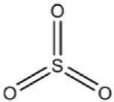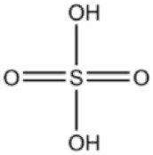Interview example 1

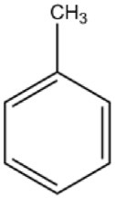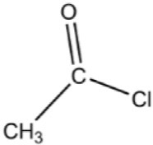

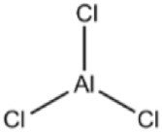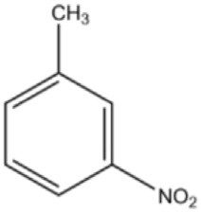Interview example 2

Example 1 was answered well by a majority of participants, who were able to distinguish that this reaction was a sulfonation, and that the major product observed would be substitution at positions ortho/para to the methyl group of toluene. In contrast, when discussing example 2, stu- dents would commonly attribute it as a chlorination reaction. From further probing, it was apparent that participants were not able to identify that an acyl chloride functional group was present. We corrected for this, and a majority of students revaluated that the reaction was in fact a Friedel-Crafts Acylation. Most participants could correctly assign the substitution position of the incoming electrophile for example 2: “*It's going to be at positions one and three*” (interviewee J); “… *NO2 is deacti- vating, and the methyl group is activating* … *So, it's going to be ortho and para to the CH3 group*” (interviewee E).

1. Study limitations

Some limitations of this study must be acknowledged. Firstly, a major limitation is the relatively small sample size that the data analysis was based upon. The sample size was the result of modest enrolment com- pounded by participant disengagement between the pre- and post-test stages. For instrument reliability analysis using approaches such as CTT, larger sample sizes are preferable where possible. In addition, we must acknowledge the possibility of self-selection bias from participants (Heckman, 1990). Students who volunteer for interviews may be different from the rest of the population regarding their communication ability or reasoning levels. Lastly, the absence of a delayed post-test, for conceptual understanding, prevents the evaluation of long-term retention.

1. Conclusions

Instructional guidance, such as that provided by worked examples, helps the novice learner deal with complex information, that may be difficult to process in limited capacity working memory. This study il- lustrates how worked examples, adopting the affordances of AR tech- nology, may support learning of electrophilic aromatic substitution. Referring to research question 1, regarding measures of cognitive load and achievement motivation, no significant differences were observed between groups. This was unaffected when introducing prior relevant chemistry experience as a covariate. QCM measures of challenge, inter- est, and probability of success were found to correlate positively with reported GCL. Reported ECL negatively correlated with reported GCL, in addition to measures of challenge and interest. Measures of challenge and interest demonstrated a stronger negative correlation with ECL for students displaying higher prior relevant chemistry experience.

Regarding research question 2, no significant differences were observed between groups for conceptual understanding, demonstrated by the scores achieved on our SEAr instrument, at both the pre- and post- test stages. Yet, significant intragroup improvement and greater nor- malised change values were observed for the AR group. No significant intragroup improvement was found in the control group for conceptual understanding. Initial reliability analysis for the SEAr instrument was conducted using CTT and IRT. Items 1–4 are generally at the lower es- timate of individuals’ ability, whereas items 5–9 demonstrate difficulty values around the mean of the population distribution of the latent trait. In an attempt to answer research question 3, we found that partici- pants displaying higher prior conceptual knowledge also reported higher measures of ECL, alongside lower normalised change values. As learner expertise increases, a shift to a heavier emphasis on problem solving may be beneficial. For learners with lower relevant chemistry experience, challenge was strongly correlated with probability of success. Com- menting on research question 4, student feedback and subsequent the- matic analysis showed that our developed worked examples, alongside implementation of our AR tool, were positively perceived by students. Commenting on research question 4, our qualitative data suggests how CTML design principles may have supported learning, as well as how

participants conveyed their understanding of SEAr concepts following our intervention.

Data availability statement

The datasets generated and analysed that support the findings of this study are available from the corresponding author upon request.

Statements on open data and ethics

Students must have provided explicit informed consent to participate, and were informed that their involvement within any aspect of this research was completely voluntary. In addition, participants were made aware of their right to withdraw from the study, at any part of the research phase, without declaring a reason. Identifying information was irrevocably stripped from data documentation, and study codes utilized in their place.

Compliance with ethical standards

All procedures performed in studies involving human participants were in accordance with the ethical standards of the institutional research committee. Informed consent was obtained from all individual participants included in the study. The authors declare that they have no conflict of interest.

Funding information

This research did not receive any financial assistance from funding agencies in the public, commercial, or not-for-profit sectors.

Declaration of competing interest

The authors declare that they have no known competing financial interests or personal relationships that could have appeared to influence the work reported in this paper.

Acknowledgements

The study team would like to express thanks to all the students who participated in this study.

Appendix A. Supplementary data

Supplementary data to this article can be found online at [https://do](https://doi.org/10.1016/j.cexr.2023.100021) [i.org/10.1016/j.cexr.2023.100021](https://doi.org/10.1016/j.cexr.2023.100021).

References

[Ainsworth, S., & Th Loizou, A. (2003). The effects of self-explaining when learning with](http://refhub.elsevier.com/S2949-6780(23)00015-6/sref1) [text or diagrams. *Cognitive Science, 27*(4), 669](http://refhub.elsevier.com/S2949-6780(23)00015-6/sref1)–[681](http://refhub.elsevier.com/S2949-6780(23)00015-6/sref1).

[An, J., & Holme, T. (2021). Evaluation of augmented reality application usage and](http://refhub.elsevier.com/S2949-6780(23)00015-6/sref2) [measuring students' attitudes toward instrumentation. *Journal of Chemical Education,*](http://refhub.elsevier.com/S2949-6780(23)00015-6/sref2)[*98*(4), 1458](http://refhub.elsevier.com/S2949-6780(23)00015-6/sref2)–[1464](http://refhub.elsevier.com/S2949-6780(23)00015-6/sref2).

[Atkinson, J. W. (1957). Motivational determinants of risk-taking behavior. *Psychological*](http://refhub.elsevier.com/S2949-6780(23)00015-6/sref3)[*Review, 64*(6p1), 359](http://refhub.elsevier.com/S2949-6780(23)00015-6/sref3).

[Atkinson, R. K., Derry, S. J., Renkl, A., & Wortham, D. (2000). Learning from examples:](http://refhub.elsevier.com/S2949-6780(23)00015-6/sref4) [Instructional principles from the worked examples research. *Review of Educational*](http://refhub.elsevier.com/S2949-6780(23)00015-6/sref4)[*Research, 70*(2), 181](http://refhub.elsevier.com/S2949-6780(23)00015-6/sref4)–[214](http://refhub.elsevier.com/S2949-6780(23)00015-6/sref4).

[Atkinson, R. K., Renkl, A., & Merrill, M. M. (2003). Transitioning from studying examples](http://refhub.elsevier.com/S2949-6780(23)00015-6/sref5) [to solving problems: Effects of self-explanation prompts and fading worked-out steps.](http://refhub.elsevier.com/S2949-6780(23)00015-6/sref5) [*Journal of Educational Psychology, 95*(4), 774](http://refhub.elsevier.com/S2949-6780(23)00015-6/sref5).

[Awan, R. U. N., Noureen, G., & Naz, A. (2011). A study of relationship between](http://refhub.elsevier.com/S2949-6780(23)00015-6/sref6) [achievement motivation, self concept and achievement in English and mathematics at](http://refhub.elsevier.com/S2949-6780(23)00015-6/sref6) [secondary level. *International Education Studies, 4*(3), 72](http://refhub.elsevier.com/S2949-6780(23)00015-6/sref6)–[79](http://refhub.elsevier.com/S2949-6780(23)00015-6/sref6).

[Bandura, A. (1977). Self-efficacy: Toward a unifying theory of behavioral change.](http://refhub.elsevier.com/S2949-6780(23)00015-6/sref7)

[*Psychological Review, 84*(2), 191](http://refhub.elsevier.com/S2949-6780(23)00015-6/sref7).

[Bellucci, A., Ruiz, A., Díaz, P., & Aedo, I. (2018). Investigating augmented reality support](http://refhub.elsevier.com/S2949-6780(23)00015-6/sref8) [for novice users in circuit prototyping. In *Proceedings of the 2018 international*](http://refhub.elsevier.com/S2949-6780(23)00015-6/sref8)[*conference on advanced visual interfaces*](http://refhub.elsevier.com/S2949-6780(23)00015-6/sref8).

[Bipp, T., Steinmayr, R., & Spinath, B. (2008). Personality and achievement motivation:](http://refhub.elsevier.com/S2949-6780(23)00015-6/sref9) [Relationship among Big Five domain and facet scales, achievement goals, and](http://refhub.elsevier.com/S2949-6780(23)00015-6/sref9) [intelligence. *Personality and Individual Differences, 44*(7), 1454](http://refhub.elsevier.com/S2949-6780(23)00015-6/sref9)–[1464](http://refhub.elsevier.com/S2949-6780(23)00015-6/sref9).

[Booth, J. L., McGinn, K. M., Young, L. K., & Barbieri, C. (2015). Simple practice doesn't](http://refhub.elsevier.com/S2949-6780(23)00015-6/sref10) [always make perfect: Evidence from the worked example effect. *Policy Insights from*](http://refhub.elsevier.com/S2949-6780(23)00015-6/sref10)[*the Behavioral and Brain Sciences, 2*(1), 24](http://refhub.elsevier.com/S2949-6780(23)00015-6/sref10)–[32](http://refhub.elsevier.com/S2949-6780(23)00015-6/sref10).

[Braun, V., & Clarke, V. (2006). Using thematic analysis in psychology. *Qualitative Research*](http://refhub.elsevier.com/S2949-6780(23)00015-6/sref11)[*in Psychology, 3*(2), 77](http://refhub.elsevier.com/S2949-6780(23)00015-6/sref11)–[101](http://refhub.elsevier.com/S2949-6780(23)00015-6/sref11).

[Chen, O., Kalyuga, S., & Sweller, J. (2015). The worked example effect, the generation](http://refhub.elsevier.com/S2949-6780(23)00015-6/sref12) [effect, and element interactivity. *Journal of Educational Psychology, 107*(3), 689](http://refhub.elsevier.com/S2949-6780(23)00015-6/sref12).

[Chen, O., Woolcott, G., & Sweller, J. (2017). Using cognitive load theory to structure](http://refhub.elsevier.com/S2949-6780(23)00015-6/sref13) [computer-based learning including MOOCs. *Journal of Computer Assisted Learning,*](http://refhub.elsevier.com/S2949-6780(23)00015-6/sref13)[*33*(4), 293](http://refhub.elsevier.com/S2949-6780(23)00015-6/sref13)–[305](http://refhub.elsevier.com/S2949-6780(23)00015-6/sref13).

[Clark, R. C., & Mayer, R. E. (2016). *E-learning and the science of instruction: Proven guidelines*](http://refhub.elsevier.com/S2949-6780(23)00015-6/sref14)[*for consumers and designers of multimedia learning*. john Wiley](http://refhub.elsevier.com/S2949-6780(23)00015-6/sref14) & [sons](http://refhub.elsevier.com/S2949-6780(23)00015-6/sref14).

[Crippen, K. J., & Brooks, D. W. (2009). Applying cognitive theory to chemistry](http://refhub.elsevier.com/S2949-6780(23)00015-6/sref15) [instruction: The case for worked examples. *Chemistry Education: Research and Practice,*](http://refhub.elsevier.com/S2949-6780(23)00015-6/sref15)[*10*(1), 35](http://refhub.elsevier.com/S2949-6780(23)00015-6/sref15)–[41](http://refhub.elsevier.com/S2949-6780(23)00015-6/sref15).

[DuBois, J. (2002). When is informed consent appropriate in educational research?:](http://refhub.elsevier.com/S2949-6780(23)00015-6/sref16) [Regulatory and ethical issues. *IRB: Ethics and Human Research, 24*(1), 1](http://refhub.elsevier.com/S2949-6780(23)00015-6/sref16).

[Dunning, D., Johnson, K., Erlinger, J., & Kruger, J. (2003). Why people fail to recognize](http://refhub.elsevier.com/S2949-6780(23)00015-6/sref17) [their own incompetence. *Current Directions in Psychological Science, 12*, 83](http://refhub.elsevier.com/S2949-6780(23)00015-6/sref17)–[87](http://refhub.elsevier.com/S2949-6780(23)00015-6/sref17).

[Dzulkifli, M. A., & Mustafar, M. F. (2013). The influence of colour on memory](http://refhub.elsevier.com/S2949-6780(23)00015-6/sref18) [performance: A review. *Malaysian Journal of Medical Sciences: MJMS, 20*(2), 3](http://refhub.elsevier.com/S2949-6780(23)00015-6/sref18).

[Elford, D., Lancaster, S., & Jones, G. (2021). Stereoisomers, not stereo enigmas: A](http://refhub.elsevier.com/S2949-6780(23)00015-6/sref19) [stereochemistry escape activity incorporating augmented and immersive virtual](http://refhub.elsevier.com/S2949-6780(23)00015-6/sref19) [reality. *Journal of Chemical Education, 98*(5), 1691](http://refhub.elsevier.com/S2949-6780(23)00015-6/sref19)–[1704](http://refhub.elsevier.com/S2949-6780(23)00015-6/sref19).

[Elford, D., Lancaster, S., & Jones, G. (2022). Exploring the effect of augmented reality on](http://refhub.elsevier.com/S2949-6780(23)00015-6/sref20) [cognitive load, attitude, spatial ability, and stereochemical perception. *Journal of*](http://refhub.elsevier.com/S2949-6780(23)00015-6/sref20)[*Science Education and Technology, 31*(3), 322](http://refhub.elsevier.com/S2949-6780(23)00015-6/sref20)–[339](http://refhub.elsevier.com/S2949-6780(23)00015-6/sref20).

Foundation, B. (2022). *blender.org - home of the blender project - free and open 3D creation software*. [online] blender.org. Available at <https://www.blender.org/>. (Accessed 5 September 2022).

[Freund, P. A., Kuhn, J. T., & Holling, H. (2011). Measuring current achievement](http://refhub.elsevier.com/S2949-6780(23)00015-6/sref22) [motivation with the QCM: Short form development and investigation of](http://refhub.elsevier.com/S2949-6780(23)00015-6/sref22) [measurement invariance. *Personality and Individual Differences, 51*(5), 629](http://refhub.elsevier.com/S2949-6780(23)00015-6/sref22)–[634](http://refhub.elsevier.com/S2949-6780(23)00015-6/sref22).

[Habig, S. (2020). Who can bene](http://refhub.elsevier.com/S2949-6780(23)00015-6/sref23)fi[t from augmented reality in chemistry? Sex differences](http://refhub.elsevier.com/S2949-6780(23)00015-6/sref23) [in solving stereochemistry problems using augmented reality. *British Journal of*](http://refhub.elsevier.com/S2949-6780(23)00015-6/sref23)[*Educational Technology, 51*(3), 629](http://refhub.elsevier.com/S2949-6780(23)00015-6/sref23)–[644](http://refhub.elsevier.com/S2949-6780(23)00015-6/sref23).

[Hadie, S. N., & Yusoff, M. S. (2016). Assessing the validity of the cognitive load scale in a](http://refhub.elsevier.com/S2949-6780(23)00015-6/sref24) [problem-based learning setting. *Journal of Taibah University Medical Sciences, 11*(3),](http://refhub.elsevier.com/S2949-6780(23)00015-6/sref24) [194](http://refhub.elsevier.com/S2949-6780(23)00015-6/sref24)–[202](http://refhub.elsevier.com/S2949-6780(23)00015-6/sref24).

[Hake, R. (1998). Interactive-engagement versus traditional methods: A six-thousand-](http://refhub.elsevier.com/S2949-6780(23)00015-6/sref25) [student survey of mechanics test data for introductory physics courses. *American*](http://refhub.elsevier.com/S2949-6780(23)00015-6/sref25)[*Journal of Physics, 66*(1), 64](http://refhub.elsevier.com/S2949-6780(23)00015-6/sref25)–[74](http://refhub.elsevier.com/S2949-6780(23)00015-6/sref25).

[Heckhausen, H. (1977). Achievement motivation and its constructs: A cognitive model.](http://refhub.elsevier.com/S2949-6780(23)00015-6/sref26)

[*Motivation and Emotion, 1*(4), 283](http://refhub.elsevier.com/S2949-6780(23)00015-6/sref26)–[329](http://refhub.elsevier.com/S2949-6780(23)00015-6/sref26).

[Heckman, J. J. (1990). Selection bias and self-selection. In *Econometrics* (pp. 201](http://refhub.elsevier.com/S2949-6780(23)00015-6/sref27)–[224).](http://refhub.elsevier.com/S2949-6780(23)00015-6/sref27)

[London: Palgrave Macmillan](http://refhub.elsevier.com/S2949-6780(23)00015-6/sref27).

[Hilbert, T. S., Renkl, A., Kessler, S., & Reiss, K. (2008). Learning to prove in geometry:](http://refhub.elsevier.com/S2949-6780(23)00015-6/sref28) [Learning from heuristic examples and how it can be supported. *Learning and*](http://refhub.elsevier.com/S2949-6780(23)00015-6/sref28)[*Instruction, 18*(1), 54](http://refhub.elsevier.com/S2949-6780(23)00015-6/sref28)–[65](http://refhub.elsevier.com/S2949-6780(23)00015-6/sref28).

[Jones, R. M., & Fleischman, E. S. (2001). CASCADE explains and informs the utility of](http://refhub.elsevier.com/S2949-6780(23)00015-6/sref29) [fading examples to problems. In *Proceedings of the 23rd annual conference of the*](http://refhub.elsevier.com/S2949-6780(23)00015-6/sref29)[*cognitive science society* (pp. 459](http://refhub.elsevier.com/S2949-6780(23)00015-6/sref29)–[464)](http://refhub.elsevier.com/S2949-6780(23)00015-6/sref29).

[Kalyuga, S., & Renkl, A. (2010). Expertise reversal effect and its instructional](http://refhub.elsevier.com/S2949-6780(23)00015-6/sref30) [implications: Introduction to the special issue. *Instructional Science, 38*(3), 209](http://refhub.elsevier.com/S2949-6780(23)00015-6/sref30)–[215](http://refhub.elsevier.com/S2949-6780(23)00015-6/sref30).

[Keller, S., Rumann, S., & Habig, S. (2021). Cognitive load implications for augmented](http://refhub.elsevier.com/S2949-6780(23)00015-6/sref31) [reality supported chemistry learning. *Information, 12*(3), 96](http://refhub.elsevier.com/S2949-6780(23)00015-6/sref31).

[Koedinger, K. R., & Aleven, V. (2007). Exploring the assistance dilemma in experiments](http://refhub.elsevier.com/S2949-6780(23)00015-6/sref32) [with cognitive tutors. *Educational Psychology Review, 19*(3), 239](http://refhub.elsevier.com/S2949-6780(23)00015-6/sref32)–[264](http://refhub.elsevier.com/S2949-6780(23)00015-6/sref32).

[Kolb, D. A. (1965). Achievement motivation training for underachieving high-school](http://refhub.elsevier.com/S2949-6780(23)00015-6/sref33) [boys. Journal of. *Personality and Social Psychology, 2*(6), 783](http://refhub.elsevier.com/S2949-6780(23)00015-6/sref33).

[Krippendorff, K. (2018). *Content analysis: An introduction to its methodology* (4th ed.). SAGE](http://refhub.elsevier.com/S2949-6780(23)00015-6/sref34) [Publications](http://refhub.elsevier.com/S2949-6780(23)00015-6/sref34).

[Kusuma, I. A., & Retnowati, E. (2021). Faded-example effects in individual or group work](http://refhub.elsevier.com/S2949-6780(23)00015-6/sref35) [settings. In *2021 10th international conference on Educational and information*](http://refhub.elsevier.com/S2949-6780(23)00015-6/sref35)[*technology (ICEIT)* (pp. 204](http://refhub.elsevier.com/S2949-6780(23)00015-6/sref35)–[208). IEEE](http://refhub.elsevier.com/S2949-6780(23)00015-6/sref35).

[Lazowski, R. A., & Hulleman, C. S. (2016). Motivation interventions in education: A meta-](http://refhub.elsevier.com/S2949-6780(23)00015-6/sref36) [analytic review. *Review of Educational Research, 86*(2), 602](http://refhub.elsevier.com/S2949-6780(23)00015-6/sref36)–[640](http://refhub.elsevier.com/S2949-6780(23)00015-6/sref36).

[Leppink, J., Paas, F., Van der Vleuten, C. P., Van Gog, T., & Van Merri€enboer, J. J. (2013).](http://refhub.elsevier.com/S2949-6780(23)00015-6/sref37)

[Development of an instrument for measuring different types of cognitive load.](http://refhub.elsevier.com/S2949-6780(23)00015-6/sref37)

[*Behavior Research Methods, 45*(4), 1058](http://refhub.elsevier.com/S2949-6780(23)00015-6/sref37)–[1072](http://refhub.elsevier.com/S2949-6780(23)00015-6/sref37).

[Low, R. C., Jin, P. C., & Sweller, J. C. (2011). *Cognitive load theory, attentional processes and*](http://refhub.elsevier.com/S2949-6780(23)00015-6/sref38)[*optimized learning outcomes in a digital environment*. Cambridge University Press](http://refhub.elsevier.com/S2949-6780(23)00015-6/sref38).

[Mayer, R. E., & Fiorella, L. (2014). 12 principles for reducing extraneous processing in](http://refhub.elsevier.com/S2949-6780(23)00015-6/sref39) [multimedia learning: Coherence, signaling, redundancy, spatial contiguity, and](http://refhub.elsevier.com/S2949-6780(23)00015-6/sref39) [temporal contiguity principles. In *The Cambridge handbook of multimedia learning,*](http://refhub.elsevier.com/S2949-6780(23)00015-6/sref39)[*279*New York, NY: Cambridge University Press](http://refhub.elsevier.com/S2949-6780(23)00015-6/sref39).

[McClelland, D. (1961). *The achieving society*](http://refhub.elsevier.com/S2949-6780(23)00015-6/sref40).

[Milgram, P., Takemura, H., Utsumi, A., & Kishino, F. (1994). Augmented reality: A class of](http://refhub.elsevier.com/S2949-6780(23)00015-6/sref41) [displays on the reality-virtuality continuum. *SPIE Proceedings, 2351*, 282](http://refhub.elsevier.com/S2949-6780(23)00015-6/sref41)–[292](http://refhub.elsevier.com/S2949-6780(23)00015-6/sref41).

[Moreno, R. E., & Park, B. (2010). *Cognitive load theory: Historical development and relation*](http://refhub.elsevier.com/S2949-6780(23)00015-6/sref42)[*to other theories*](http://refhub.elsevier.com/S2949-6780(23)00015-6/sref42).

[Paas, F., Renkl, A., & Sweller, J. (2003). Cognitive load theory and instructional design:](http://refhub.elsevier.com/S2949-6780(23)00015-6/sref43) [Recent developments. *Educational Psychologist, 38*(1), 1](http://refhub.elsevier.com/S2949-6780(23)00015-6/sref43)–[4](http://refhub.elsevier.com/S2949-6780(23)00015-6/sref43).

[Paas, F., Van Gog, T., & Sweller, J. (2010). Cognitive load theory: New](http://refhub.elsevier.com/S2949-6780(23)00015-6/sref44) [conceptualizations, specifications, and integrated research perspectives. *Educational*](http://refhub.elsevier.com/S2949-6780(23)00015-6/sref44)[*Psychology Review, 22*(2), 115](http://refhub.elsevier.com/S2949-6780(23)00015-6/sref44)–[121](http://refhub.elsevier.com/S2949-6780(23)00015-6/sref44).

[Polvi, J., Taketomi, T., Noteki, A., Yoshitake, T., Fukuoka, T., Yamamoto, G., et al. (2018).](http://refhub.elsevier.com/S2949-6780(23)00015-6/sref45)

[Handheld guides in inspection tasks: Augmented reality versus picture. *IEEE*](http://refhub.elsevier.com/S2949-6780(23)00015-6/sref45)[*Transactions on Visualization and Computer Graphics, 24*(7)](http://refhub.elsevier.com/S2949-6780(23)00015-6/sref45).

[Preacher, K. J. (2015). Extreme groups designs. *The Encyclopedia of Clinical Psychology, 2*,](http://refhub.elsevier.com/S2949-6780(23)00015-6/optI1kgE05SxQ) [1189](http://refhub.elsevier.com/S2949-6780(23)00015-6/optI1kgE05SxQ)–[1192](http://refhub.elsevier.com/S2949-6780(23)00015-6/optI1kgE05SxQ).

[Reisslein, J., Atkinson, R. K., Seeling, P., & Reisslein, M. (2006). Encountering the](http://refhub.elsevier.com/S2949-6780(23)00015-6/sref46) [expertise reversal effect with a computer-based environment on electrical circuit](http://refhub.elsevier.com/S2949-6780(23)00015-6/sref46) [analysis. *Learning and Instruction, 16*(2), 92](http://refhub.elsevier.com/S2949-6780(23)00015-6/sref46)–[103](http://refhub.elsevier.com/S2949-6780(23)00015-6/sref46).

[Renkl, A., Atkinson, R. K., & Große, C. S. (2004). How fading worked solution steps](http://refhub.elsevier.com/S2949-6780(23)00015-6/sref47) [works](http://refhub.elsevier.com/S2949-6780(23)00015-6/sref47)–[a cognitive load perspective. *Instructional Science, 32*(1), 59](http://refhub.elsevier.com/S2949-6780(23)00015-6/sref47)–[82](http://refhub.elsevier.com/S2949-6780(23)00015-6/sref47).

[Rheinberg, F., Vollmeyer, R., & Burns, B. D. (2001). Fam: Ein Fragebogen zur Erfassung](http://refhub.elsevier.com/S2949-6780(23)00015-6/sref48) [aktueller Motivation in Lern-und Leistungssituationen (Langversion, 2001).](http://refhub.elsevier.com/S2949-6780(23)00015-6/sref48)

[*Diagnostica, 2*, 57](http://refhub.elsevier.com/S2949-6780(23)00015-6/sref48)–[66](http://refhub.elsevier.com/S2949-6780(23)00015-6/sref48).

[Richardson, M., & Abraham, C. (2009). Conscientiousness and achievement motivation](http://refhub.elsevier.com/S2949-6780(23)00015-6/sref49) [predict performance. *European Journal of Personality, 23*(7), 589](http://refhub.elsevier.com/S2949-6780(23)00015-6/sref49)–[605](http://refhub.elsevier.com/S2949-6780(23)00015-6/sref49).

[Richey, J. E., & Nokes-Malach, T. J. (2013). How much is too much? Learning and](http://refhub.elsevier.com/S2949-6780(23)00015-6/sref50) [motivation effects of adding instructional explanations to worked examples. *Learning*](http://refhub.elsevier.com/S2949-6780(23)00015-6/sref50)[*and Instruction, 25*, 104](http://refhub.elsevier.com/S2949-6780(23)00015-6/sref50)–[124](http://refhub.elsevier.com/S2949-6780(23)00015-6/sref50).

[Schnotz, W. (2010). Reanalyzing the expertise reversal effect. *Instructional Science, 38*(3),](http://refhub.elsevier.com/S2949-6780(23)00015-6/sref51) [315](http://refhub.elsevier.com/S2949-6780(23)00015-6/sref51)–[323](http://refhub.elsevier.com/S2949-6780(23)00015-6/sref51).

[Singh, K. (2011). Study of achievement motivation in relation to academic achievement](http://refhub.elsevier.com/S2949-6780(23)00015-6/sref52) [of students. *International Journal of Educational Planning*](http://refhub.elsevier.com/S2949-6780(23)00015-6/sref52)& [*Administration, 1*(2),](http://refhub.elsevier.com/S2949-6780(23)00015-6/sref52) [161](http://refhub.elsevier.com/S2949-6780(23)00015-6/sref52)–[171](http://refhub.elsevier.com/S2949-6780(23)00015-6/sref52).

[Smith, R., & Karaman, M. A. (2019). Development and validation of the contextual](http://refhub.elsevier.com/S2949-6780(23)00015-6/sref53) [achievement motivation measure. *International Journal of Psychology and Educational*](http://refhub.elsevier.com/S2949-6780(23)00015-6/sref53)[*Studies, 6*(3), 16](http://refhub.elsevier.com/S2949-6780(23)00015-6/sref53)–[26](http://refhub.elsevier.com/S2949-6780(23)00015-6/sref53).

[Smith, R. L., & Troth, W. A. (1975). Achievement motivation: A rational approach to](http://refhub.elsevier.com/S2949-6780(23)00015-6/sref54) [psychological education. *Journal of Counseling Psychology, 22*(6), 500](http://refhub.elsevier.com/S2949-6780(23)00015-6/sref54).

Visual Studio. (2022). *Visual Studio: IDE and code editor for software developers and teams*. [online] Available at [https://visualstudio.microsoft.com](https://visualstudio.microsoft.com/). (Accessed 11 September 2022).

[Sweller, J. (1988). Cognitive load during problem solving: Effects on learning. *Cognitive*](http://refhub.elsevier.com/S2949-6780(23)00015-6/sref56)[*Science, 12*(2), 257](http://refhub.elsevier.com/S2949-6780(23)00015-6/sref56)–[285](http://refhub.elsevier.com/S2949-6780(23)00015-6/sref56).

[Sweller, J., Ayres, P., & Kalyuga, S. (2011). Amassing information: The information store](http://refhub.elsevier.com/S2949-6780(23)00015-6/sref58) [principle. In *Cognitive load theory* (pp. 17](http://refhub.elsevier.com/S2949-6780(23)00015-6/sref58)–[25). New York, NY: Springer](http://refhub.elsevier.com/S2949-6780(23)00015-6/sref58).

[Sweller, J., Van Merri€enboer, J. J., & Paas, F. G. (1998). Cognitive architecture and](http://refhub.elsevier.com/S2949-6780(23)00015-6/sref59)

[instructional design. *Educational Psychology Review, 10*(3), 251](http://refhub.elsevier.com/S2949-6780(23)00015-6/sref59)–[296](http://refhub.elsevier.com/S2949-6780(23)00015-6/sref59).

[Tanaka, A., & Yamauchi, H. (2001). A model for achievement motives, goal orientations,](http://refhub.elsevier.com/S2949-6780(23)00015-6/sref60) [intrinsic interest, and academic achievement. *Psychological Reports, 88*(1), 123](http://refhub.elsevier.com/S2949-6780(23)00015-6/sref60)–[135](http://refhub.elsevier.com/S2949-6780(23)00015-6/sref60).

[Um, E., Plass, J. L., Hayward, E. O., & Homer, B. D. (2012). Emotional design in](http://refhub.elsevier.com/S2949-6780(23)00015-6/sref61) [multimedia learning. *Journal of Educational Psychology, 104*(2), 485](http://refhub.elsevier.com/S2949-6780(23)00015-6/sref61).

[Van Gog, T., Kester, L., & Paas, F. (2011). Effects of worked examples, example-problem,](http://refhub.elsevier.com/S2949-6780(23)00015-6/sref62) [and problem-example pairs on novices' learning. *Contemporary Educational*](http://refhub.elsevier.com/S2949-6780(23)00015-6/sref62)[*Psychology, 36*(3), 212](http://refhub.elsevier.com/S2949-6780(23)00015-6/sref62)–[218](http://refhub.elsevier.com/S2949-6780(23)00015-6/sref62).

[Vollmeyer, R., & Rheinberg, F. (2006). Motivational effects on self-regulated learning](http://refhub.elsevier.com/S2949-6780(23)00015-6/sref63) [with different tasks. *Educational Psychology Review, 18*(3), 239](http://refhub.elsevier.com/S2949-6780(23)00015-6/sref63)–[253](http://refhub.elsevier.com/S2949-6780(23)00015-6/sref63).