[Egyptian Informatics Journal 23 (2022) 83–93](https://doi.org/10.1016/j.eij.2021.07.001)

Contents lists available at [ScienceDirect](http://www.sciencedirect.com/science/journal/11108665)

Egyptian Informatics Journal

journal homepage: [www.sciencedirect.com](http://www.sciencedirect.com/)

[](http://crossmark.crossref.org/dialog/?doi=10.1016/j.eij.2021.07.001&domain=pdf)Authentication scheme for Unmanned Aerial Vehicles based Internet of Vehicles networks

Kashif Naseer Qureshi a, Muhammad Arslan Saleem Sandila a, Ibrahim Tariq Javed b, Tiziana Margaria c,

Laeeq Aslam d

a *Department of Computer Science, Bahria University, Islamabad, Pakistan*

b *Lero-The Irish Software Research Centre, University of Limerick, Limerick V94 T9PX, Ireland*

c *Lero –Science Foundation Ireland Research Centre for Software, University of Limerick, V94 T9PX Limerick, Ireland*

d *Punjab University College of lnformation Technology (PUCIT), University of the Punjab, 54000, Lahore, Pakistan*

a r t i c l e i n f o

*Article history:*

Received 26 March 2021

Revised 19 June 2021

Accepted 3 July 2021

Available online 29 July 2021

*Keywords:*

UAV

IoV Network Security

Authentication Privacy

RSU

Attack Safety

a b s t r a c t

New and advanced technologies have introduced amazing areas like the Internet of Vehicles (IoV) and Unmanned Aerial Vehicle (UAV). These two technologies are emerged to facilitate the ground users by providing more fast and convenient data communication services. Due to the open nature of these net- works, security and user privacy is always a serious concern. Different types of security attacks have been noticed in these networks like jamming attacks, global positioning system jamming, signal jamming, and data jamming. The existing solutions have been designed to resolve and tackle security issues such as authenticity, insurance of data integrity, provision of correct message authentication, and removal of redundant authentication. However, existing schemes have some limitations in terms of computational costs and efficiency and do not provide security at all levels. This paper proposes an Efficient Authentication Scheme for Safety Applications for Internet of Vehicles (EASSAIV) for message authenti- cation. The proposed scheme can gather, process, and verify the information delivered to roadside units, UAVs, or to the vehicles and authenticate the received messages. Proposed scheme achieved better per- formance as compared to state of the art scheme in terms of safety, packet loss, delay and computational cost.

© 2022 Published by Elsevier B.V. on behalf of Faculty of Computers and Information, Cairo University.

This is an open access article under the CC BY license (<http://creativecommons.org/licenses/by/4.0/>).

1. Introduction

Internet of Vehicles (IoV) is deemed as a promising research field with huge potential of benefits. It shall streamline global trav- eling practices. The IoV is a network of internet-connected vehicles with a fleet of sensors installed onboard to gather process and for- ward the data for further decision [1–3]. The IoV is based on advanced technologies including Internet, cloud, and edge, fast 5G services where the information is disseminated over the Inter- net by nearby vehicles, pedestrians via handheld devices, roadside

Peer review under responsibility of Faculty of Computers and Information, Cairo University.

**Production and hosting by Elsevier**

*E-mail addresses:* [knaseer.buic@bahria.edu.pk](mailto:knaseer.buic@bahria.edu.pk) (K.N. Qureshi), arslansandila@ gmail.com (M.A.S. Sandila), [Ibrahimtariq.javed@lero.ie](mailto:Ibrahimtariq.javed@lero.ie) (I.T. Javed), [Tiziana.](mailto:Tiziana.Margaria@lero.ie) [Margaria@lero.ie](mailto:Tiziana.Margaria@lero.ie) (T. Margaria), [laeeq.aslam@pucit.edu.pk](mailto:laeeq.aslam@pucit.edu.pk) (L. Aslam)

infrastructure, and other transport management systems [4]. Con- sequently, IoV enabled environment ensures a better traveling experience with safe navigation and road safety. However, chal- lenges in the implementation of IoVs remain with routing resource allocation, disruption/disconnection of network services, process- ing of big data, message authentication, broadcast of the secure channel, and high-cost impact. To facilitate the IoV network, the Unmanned Aerial Vehicle (UAV) has introduced which are drones or aircrafts used for private and public applications [5,6]. Drone communication services can be used for different purposes such as delivery, monitoring, military usage for security [4,7]. To control the drones, some interfaces are used like the computer, remote control, smart devices, and other software applications [8–10]. The updates among nodes are initiated by using a short beacon or Hello messages which are periodically broadcasted in the networks and the network suffered from high overhead [11]. Routing is the main factor of communication between the UAVs and the IoV network which provides the communication services. The integration of UAV technology with IoV technology has pre- sented several routing and security challenges [12].

<https://doi.org/10.1016/j.eij.2021.07.001>

1110-8665/© 2022 Published by Elsevier B.V. on behalf of Faculty of Computers and Information, Cairo University. This is an open access article under the CC BY license (<http://creativecommons.org/licenses/by/4.0/>).

Ensuring security and maintaining privacy at the same time is an additional challenge that needs to be addressed alongside issues related to mobility and reliability. Lack of open standards for intra- vehicle communication and interoperability is a big hurdle in accelerating adoption [1,13]. Some of the major challenges in UAV-based IoV networks are privacy, real-time response, dynamic support, data validation, and jamming [11,14]. Privacy is undoubt- edly being one of the prime concerns, to accurately determine dif- ferent situations like an accident, the vehicle needs to accurately report its identity to the UAV but this identity can be used/ex- ploited by unwanted users. Accurate validation of data is very important as it can play a crucial role in keeping roadside units away from garbage data processing and flooding of spam mes- sages. IoV is also prone to jamming attacks e.g. GPS jamming, sig- nal jamming, and even data jamming. These attacks can lead to the collapse of the whole concept of autonomous vehicles. Researchers divided these threats into inter-vehicle security threats and intra- vehicle security threats. Researchers also explained different types of attacks that can encounter ranging from the physical layer up to the application layer. These attacks include Illusion and GPS spoof- ing attacks using sensor tempering. This attack results in providing false information to the On-Board Units (OBU) of the vehicle by compromising the sensors. Consequently, resulting in the broad- casting of wrong information into the network regarding different measurements of the vehicle including speed and location, and ultimately results in creating the illusion of incidents that have not happened. In addition to this, other attacks that need sheer focus to be resolved include Denial of Service (DoS) attack in which resources are being choked to provide services, Sybil attack is used to send incorrect information about traffic congestion and road conditions, replay attack enables retransmission of the previous message to create confusion, black hole attack, and passive eaves- dropping attack [15,16]. Fig. 1 shows the complete architecture for the UAV-based IoV networks.

To cater to all such issues, researchers have provided a lot of solutions to deal with message authentication. In a study [17], researchers proposed an efficient authentication scheme that deals with problems associated with certificate distribution and certificate revocation list CRLs. Primarily in pseudonym and

group-based message authentication schemes, vehicles need to store a valid certificate generated by the management center and before message authentication, the receiver has to check the CRL. These CRLs have data in bulk and require heavy compu- tational resources and storage capacity. Additionally, the Trusted Authority (TA) involvement fails in such schemes in the real- world. Subsequently, the scheme proposed in this study is using the certificate-less signature in a semi-trusted authority environ- ment with a self-healing key distribution method. This enables the receiver to authenticate the message without the need to query the CRL. In this way, storage space and communication resources are saved thus increasing the efficiency of message authentication. The IoV applications and different security threats that might come across Vehicular Ad Hoc Networks (VANETs) implementation and thoroughly deliberate that existing security solutions use conventional cryptographic techniques. Most of these require high bandwidths and ultra-fast networks, so this study proposed a lightweight authentication protocol based on Radio-Frequency Identification Devices (RFID) [18]. The existing solutions are designed to resolve different problems such as reduction of time and cost, genuine authenticity, insurance of data integrity, provision of correct message authentication, and removal of chances for redundant authentication, and so on. However, existing schemes have some limitations concerning computational costs and efficiency and these do not provide secu- rity at all levels. Hence, the proposed Efficient Authentication Scheme for Safety Applications for Internet of Vehicles (EASSAIV) scheme explicitly focused on safety applications for UAV-based IoV networks to overcome the authenticity issues. The main objectives of this paper are as follows:

* Design a scheme that can quickly gather, process, and verify the information delivered to RSU, UAV, or vehicles to authenticate

the received messages.

* Proposed scheme tackles the authenticity, insurance of data integrity, provision of correct message authentication, and

removal of redundant authentication.

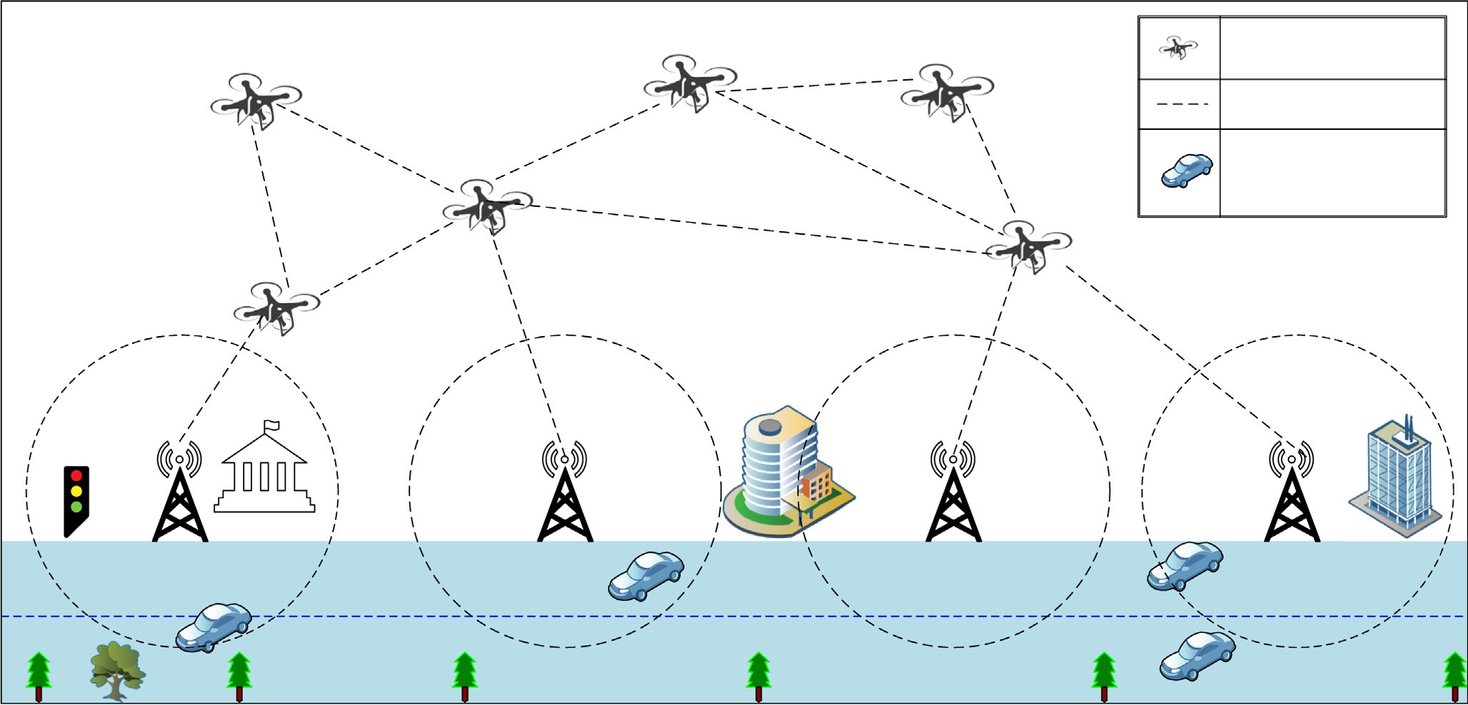

**UAV**

**UAV and IoV Connection**

**Vehicle Node**

Fig. 1. UAV-based IoV Network.

* Proposed scheme validates in security tool to check the safety and working process scenically in safety applications concern-

ing UAV-based IoV and to decrease the overheads in the network.

This paper is organized as follows: Section 2 presents the over- view of related studies and research articles, which are related to the proposed research work. Section 3 explains the proposed mechanism in detail with all its working, security model, and authentication protocol. Section 4 presents the results, analysis. The last section concludes the paper with future direction.

1. Related work

In [19], authors proposed a Secure Authentication Scheme for VANETs with Batch Verification (SAS-VANET) based on three phases including key generation and pre-distribution, pseudo- identity generation and message signing, message verification. The first phase uses system parameters for the vehicles and RSUs. In the second phase, the vehicle uses its unique identity and runs the pseudo-identity generation process. In the last phase, the mes- sage is verified and accepted. The RSU is also verifying the message by using batch verification. The proposed scheme is evaluated in terms of average delay and lost packet rate. The results indicated the better performance of the proposed scheme is compared to the previous scheme. However, this scheme is not feasible for high mobility nodes and dynamic topological changes like in vehicular ad hoc networks.

In [20], the authors explained the infrastructure authentication scheme and discussed two types of infrastructure elements. OBUs are mounted on vehicles, and Road Side Units (RSUs) are deployed at the roadside as an infrastructure. These infrastructures commu- nicate usually with the help of the TA for the integration of regis- tration and provision of authentication services. The proposed scheme consists of four phases including system initialization, key generation, signing stage, and verification stage, and then these phases are technically explained. Afterward, the security analysis is conducted and lastly, performance evaluation is done. Authors claimed that results where the proposed scheme contained costs

1.050 ms and 3.683 ms in terms of signing and verification respec- tively. In this scheme, the helper is assumed as a fully trusted device and the private key of the vehicle is generated by its helper. Subsequently, this work is extendable, and designing an efficient threshold key insulated authentication scheme is the way forward which aims to achieve feasible secure V2I communication. How- ever, this work is based on assumption where authors discussed that all devices are trustworthy and private key generated by its helper. Usually this phenomenon is not well suited for high mobil- ity based and open networks.

In [21], the authors proposed a privacy-preserving sensory data sharing scheme and addressed location privacy preservation, sen- sory data acquisition, and collection issues of IoV networks. This data collection and distribution is collected by sensor nodes and onboard devices installed in vehicles. Researchers modified the pallier cryptosystem with the structuring of multi-dimensional sensory data that is recorded at different locations. The modified pallier cryptosystem helps in achieving privacy-preserving sensory data aggregation for location. In the second phase, data acquisition is performed. In this phase, the proxy re-encryption technique is used to achieve results related to location privacy preservation of data querying at the network edge. This implies location privacy preservation without the involvement of a trusted central entity. It is expressed that during data aggregation, the location-based data queries may violate the location privacy of vehicles. Existing schemes are mostly designed for cloud environments that are out-

sourced with typically fixed storage. The proposed scheme also maintains data integrity and collision attack resistance. The results showed that the proposed scheme largely reduced the computa- tional overhead and communication cost in comparison with exist- ing OT and data aggregation protocols. However, vehicle nodes mobility is one of the important factor to design any kind of secu- rity solution for IoV network.

In [22], the authors discussed routing, quality of service, broad- casting, and security in issues for vehicular ad hoc networks. These networks have life-threatening and life-crucial scenarios therefore security being the primary most factor and need top priority. Therefore, this paper discusses different possible attacks including DoS, broadcast tempering, malware spamming, and black hole attacks. Similarly, the authors discussed threats involved in authenticity, this includes threats about message or identity mas- querading, replay attacks, and GPS spoofing. The authors pointed out tunneling, position faking, and message tampering as potential threats that can hamper authenticity. Subsequently, message sup- pression and key/certificate replication are also discussed. How- ever, this type of solutions suffered with real-time constraint, and limited computing resources.

In [23], authors discussed an efficient message authentication with revocation transparency using Blockchain for vehicular net- works to address the main concerning issues of security and pri- vacy. The proposed scheme is based on pairing-free online/offline certificate with less signature with efficient revocation. The authors used the cuckoo filter to enhance efficiency, this allows RSUs to assist nearby vehicles in the verification of signatures. The proposed study enlightens the revocation handling by key gen- eration center updating time keys of non-revoked users. A node selection algorithm is used for the reduction of the workload of the key generation center. This paper uses Blockchain technology to store the revocation list. This strategy enhanced the trans- parency of user revocation where vehicles are independent to check the revocation lists from validated Blockchain concept. Sub- sequently, an efficient signature scheme is proposed with pairing a free certificate online/offline system. The complexity is logarithmic to the number of users and conducted through a public channel. Lastly, the authors conducted security and efficiency analysis, and a comparison with existing solutions where the proposed sig- nature scheme meets all the security and privacy requirements of vehicular networks. However, the workload of the key generation centre, and verification of certificates consumed more resources and computational power.

In another study [24], the authors discussed secure authentica- tion and privacy-preserving techniques in vehicular ad hoc net- works. The authors explained that the privacy of vehicles should be maintained by keeping the vehicle’s identity and location infor- mation. But along with privacy, the message sent from the vehicle needs to be verified and no one except relevant authorities should be able to determine the identity or location of the vehicle from the message from the vehicle. Authentication is divided into two parts including node authentication and message authentication. This research promises to fill the gap created in the last decade and pro- tocols discussed in the research paper are classified into different categories based on the problems addressed as well as tools and techniques used to provide solutions. The authors claimed that this work would also serve as a suitable reference for researchers work- ing on privacy, authentication, and secure message dissemination in VANETs. However, this study still suffered with privacy, and secure message dissemination issues.

In [25], the authors discussed an enhanced anonymity resilience security protocol for vehicular ad hoc networks. This work is an enhancement and refinement of an earlier proposed protocol. The authors proposed a robust protocol that ensures security protection on existing security attacks. Also, it protects all related

possible attacks. The authors also performed simulations through Scyther and confirm that all the private information is protected while developing the common key. The proposed solution has five distinct phases including system setup, user registration, system login, mutual authentication, and data authentication. Subse- quently, formal security verification is done using a broadly accepted Scyther tool. It is to formally analyze security protocols and potential vulnerabilities. The results show better performance in terms of computation and communication overheads. However, road safety measures, multimedia data transfer, and vehicle perfor- mance data are some important factors which need attention.

Many researchers have been proposed various authentication models involving different cryptographic techniques including Elliptic Curve Cryptography. Where these schemes may fulfill the purpose to some extent, on the other hand, they are not meaning- ful in the real-time scenario as of IoV limitations of fast-moving vehicles and very little time available for authentication and vali- dation. The idea of smooth implementation of UAV-based IoV is not simple as it comes with a lot of constraints that possess serious life threats if not handled properly. Different studies concerning message authentication are thoroughly deliberated and grey areas are figured out [26,27]. These involve the high computational costs, communication overheads, redundant authentication, false authentication, prone to attack authentications, eavesdropping, and timely authentication failures. After studying deeper, it is revealed that research done in message authentication for explicit safety applications is very limited thus requires to be explored more. This research is focused on an efficient message authentica- tion scheme for safety applications for UAV-based IoV. Table 1 shows the existing studies comparison.

1. Proposed scheme

The UAV-based IoV networks are using communication between different vehicle nodes and drones where message authentication is a core factor for security provision. This commu- nication process involves several phases including the authentica- tion phase, key exchange phase, and the data transfer phase. Several message authentication schemes have been introduced to overcome these issues but most of these schemes suffer in the pro-

vision of complete security at all stages of message authentication. To address the aforementioned issues in this research, an Efficient EASSAIV is proposed. This proposed scheme secures the informa- tion between the imparting vehicles utilizing asymmetric encryp- tion procedures for example using the public key and private key encryption and decoding. This encryption-decoding measure is uti- lized to trade information between the vehicles and with drones securely. The proposed scheme is based on three main phases including the initial deployment phase, implementation phase, and operational phase. The first phase is relatively brief and the lat- ter two phases are more comprehensive. These phases are the core of the entire model and the complete concept is explained thor- oughly in these phases.

* 1. *Initial deployment phase*

The initial deployment phase initiates at the manufacturer’s site before the vehicles are shipped to the owner. In this phase, the manufacturer shall preinstall these vehicles with requisite data and cryptographic subtleties relating to correspondence/associa- tion with the cloud server. This makes a believed correspondence connect between the manufacturer and vehicles. All onboard sen- sors are also equipped into vehicles during this phase. This shall also be useful to execute remote procedures like updating new software patches or downloading the new and latest version of firmware in vehicles without the requirement of bringing the vehi- cles to some service center physically. Also, every vehicle is equipped with a personal user device for the owner of the vehicle for the establishment of communication between vehicles and gateway. This also serves as an extra layer of security and prevents unauthorized access of the vehicle to the gateway. The controller in the distant server produces the vehicle identification, *ID1*, and uti- lizing an RNG, it figures the vehicle’s private and public key. It like- wise produces a one-time access secret key or password (OT). The one time secret key or password provides a mechanism for logging on to the network or service using unique password which is used once. This method prevents the second time usage of vehicle pass- word and ensures strong authentication mechanism. These public and private keys of vehicle *V1*, the vehicle’s ID worth, and access secret key are stacked into the vehicle’s memory over a protected

Table 1

Existing Studies Comparison.

Proposed Scheme Technique & Remarks Performance Limitations

Secure Authentication Scheme for VANETs with Batch Verification (SAS-VANET) [19]

Uses key generation and pre-distribution, pseudo- identity generation and message signing, message verification

Better in term of average delay, and lost packet rate Dynamic topologies

and high mobility are not considered.

An Efficient V2I Authentication Scheme for VANETs [20]

A privacy-preserving sensory data sharing scheme [21]

Edge computing-based Security and Privacy Scheme [22]

Efficient Message Authentication with Revocation Transparency Using Blockchain for Vehicular Networks [23]

Secure authentication and privacy- preserving techniques in Vehicular Ad-hoc Networks (VANETs) [24]

An enhanced anonymity resilience security protocol [25]

An efficient vehicle to infrastructure authentication scheme specific for VANETs. It is explained that in vehicular ad hoc networks.

This scheme is used for data sharing with collision resistance in IoV networks for data collection and distribution.

A novel edge computing-based message authentication scheme. It can serve multiple mobile devices in intelligent connected vehicles. An efficient message authentication with revocation transparency using Blockchain for vehicular networks to address the main concerning issues of security and privacy.

A thorough and well-deliberated Review on Secure authentication and privacy-preserving techniques of last decade in vehicular ad hoc networks.

An enhanced anonymity resilience security protocol for the vehicular ad hoc networks. This work is an enhancement and refinement of an earlier proposed protocol.

The performance evaluation shows the proposed scheme costs 1.050 ms and 3.683 ms in terms of signing and verification respectively.

This scheme enhanced and validated the security properties and improve the computation and communication efficiency

The secure scheme in the random oracle model and can resist two types of adversaries under certificate less public key encryption.

Analysis of revocable signature scheme by comparison of computation time and signature size of the proposed scheme with existing schemes results in better performance.

A comparative analysis is done on basis of different classifications of papers.

Scyther is used to perform simulations to confirm all private information protection during the establishment of the common key.

Dynamic topologies and high mobility are not considered.

Vehicle nodes mobility is not considered

Real-time constraint, limited computing resources

The workload of the key generation center, verification of certificates.

Privacy, Authentication, Secure Message Dissemination.

Road safety measures, Multimedia data transfer, Vehicle performance data.

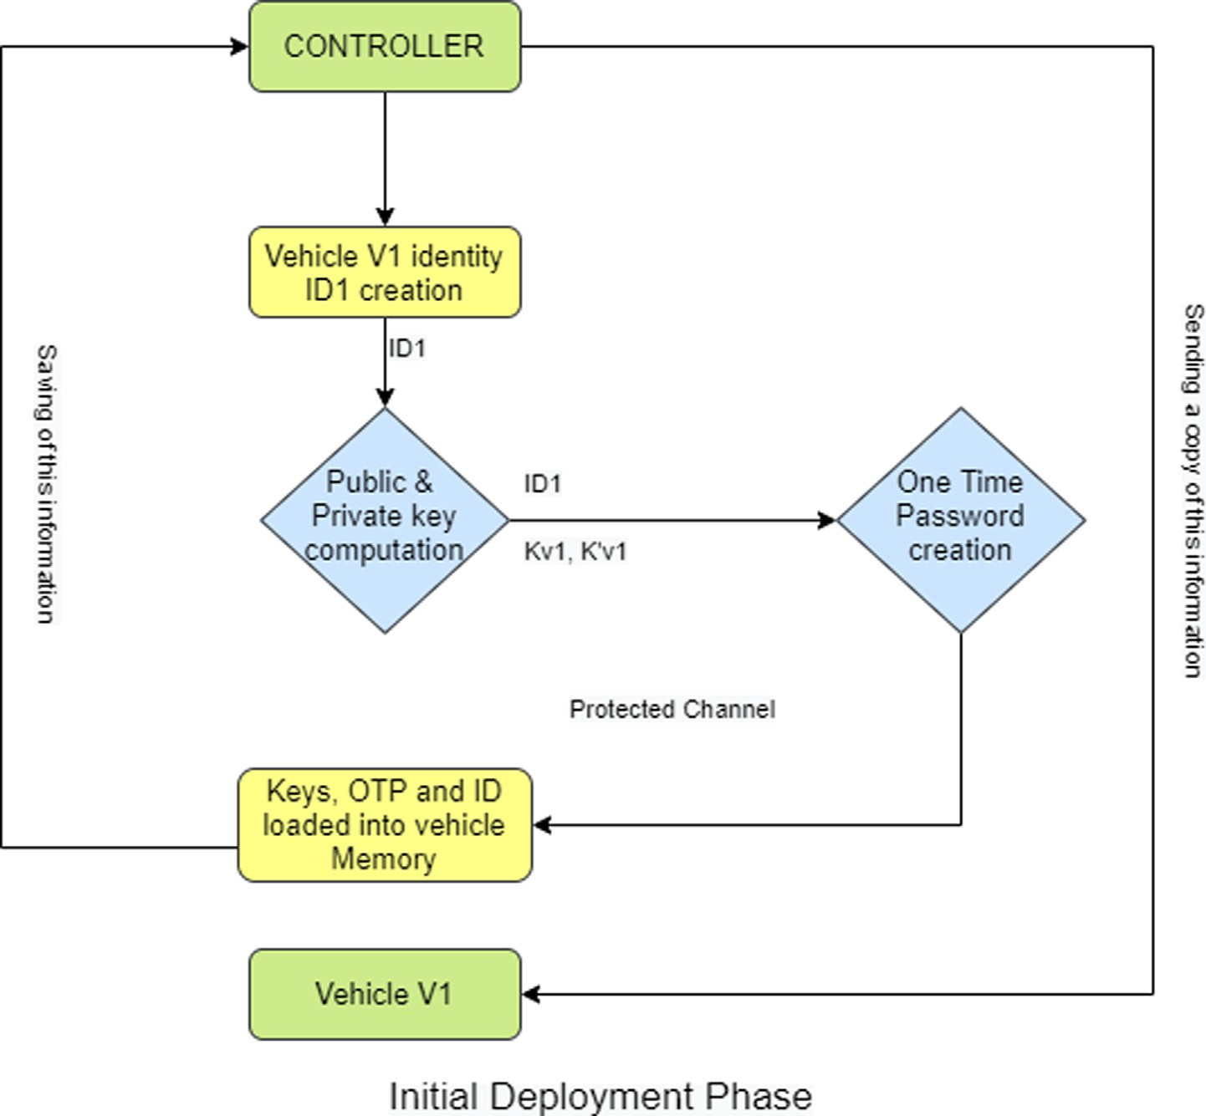

Fig. 2. Initial Deployment Phase.

channel, for example, one that is impervious to altering and catch- ing, accomplished through the cryptographic conventions exe- cuted by the maker. The regulator in the distant worker spares these in its information base and sends the vehicle *ID*, *ID1*, and the one-time access secret word, *P1* to the vehicle *V1* as shown in Equation 1:

*C* → *V* 1 : *En* *ID*1; *P*1; *Kv*1; *K*' } (1)

*v*1

*where En{} implies encryption of data inside the supports as shows

in Fig. 2.

Fig. 2 shows the initial deployment phase.

* 1. *Implementation phase*

At this point when the owner gets the IoV vehicle, *V1*, a solicita- tion for verification data from the cloud server is produced with the goal that the holder can get to the sensors installed vehicle. The cloud server’s controller sends the holder One Time Password (OTP), which when gone into the IoV *V1*, will give the holder admit- tance to it and its administrations. Fig. 3 shows the implementa- tion phase.

When the owner accesses IoV *V1*, the vehicle can associate with the network server through smart gateway *G*. The owner’s device (accompanied by vehicle by the maker) sends the identity of the

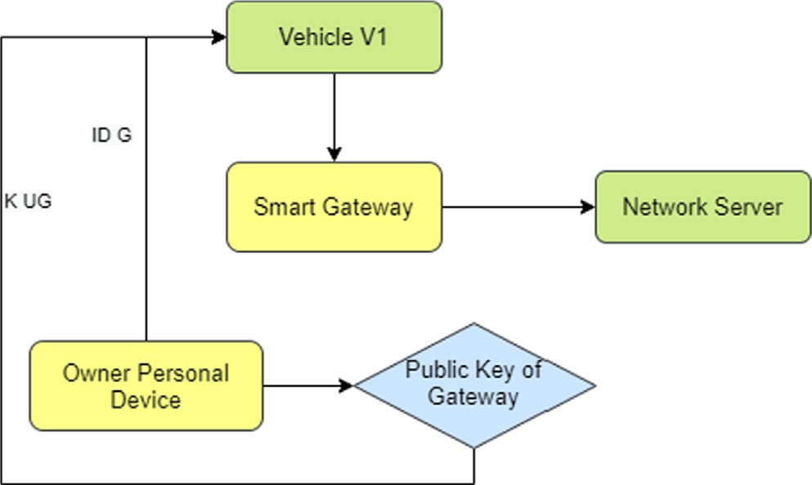

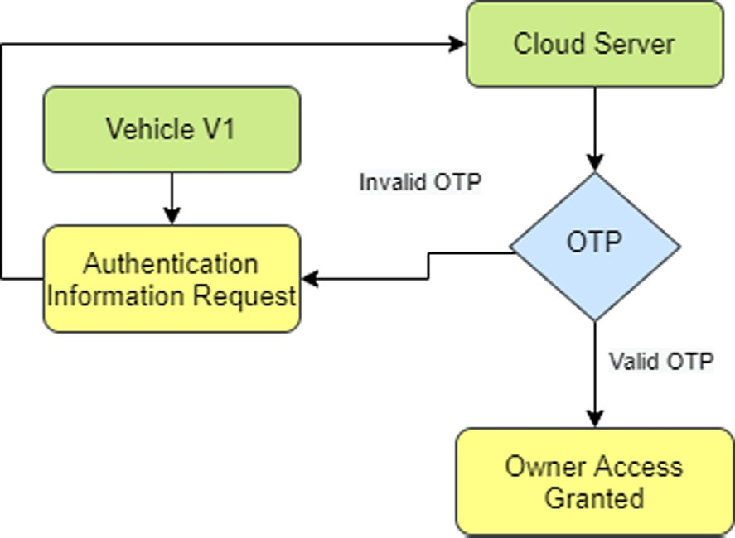*UD 1 : IDG, KuG*

Fig. 3. Implementation Phase. Fig. 4. Public Key Exchange.

*V1 c} KuG, {ID1} H1 (IDG, Tc)*

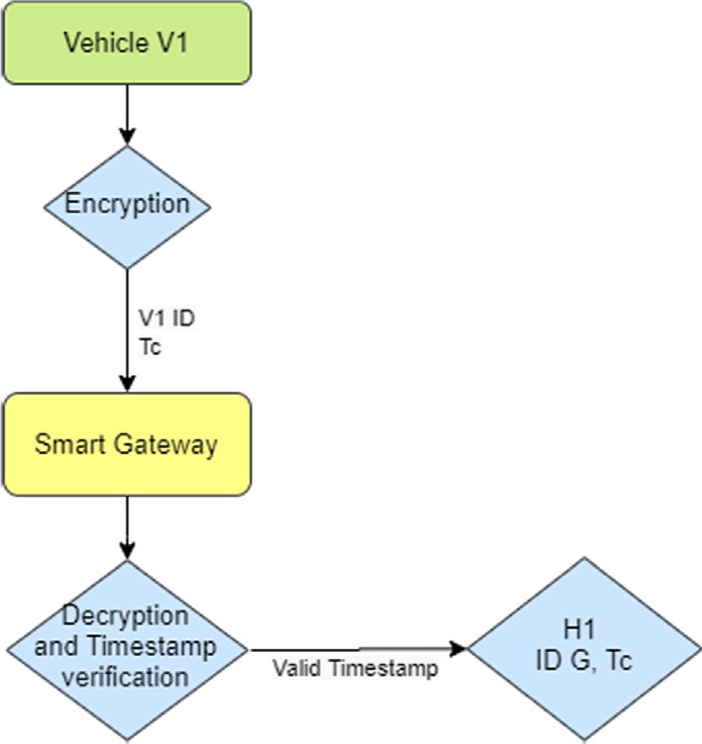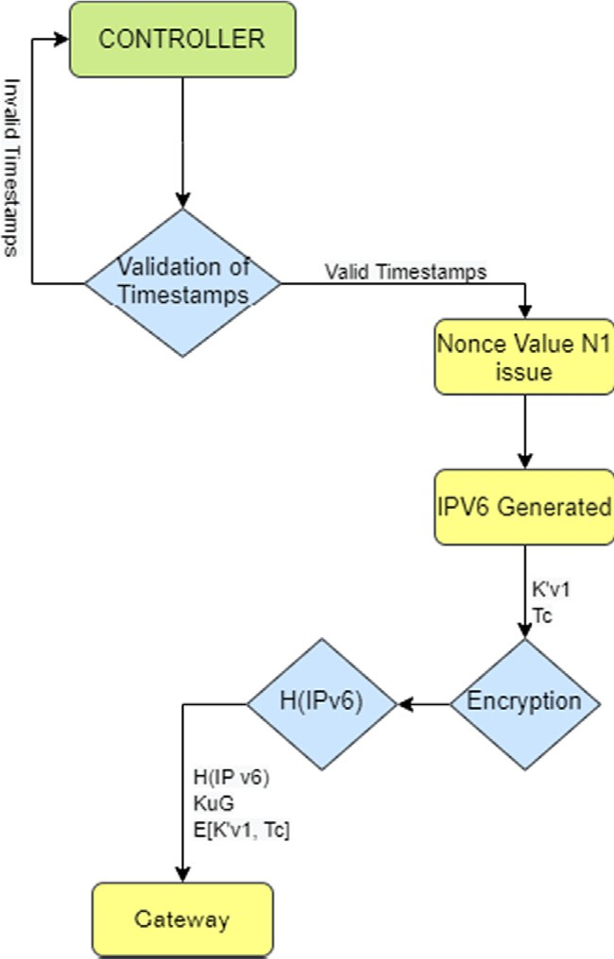

(*IPv6*)*,* {{ *KuG*} *K’v1, Tc*} *KuG*

\**where Tc is the current timestamp*

Fig. 5. Encryption Process.

smart gateway, *IDG*, and its public key, *K’uG*, to *V1*. Fig. 4 shows the public key exchange process.

*UD* → *V* 1 : *IDG*; *KuG*

The vehicle, *V1*, scrambles and sends to the gateway its ID

alongside the current timestamp to the smart passage to be enlisted in the system. On accepting the information from V1, the passage will unscramble the collected message and check the timestamp. If authentic, it will enumerate *H1 (IDG, Tc)* which was the encryption key used to encrypt the ID of *V1*. Fig. 5 shows the encryption process.

*V* 1 → *G* : {*Tc*} *KuG*; {*ID*1} *H*1(*IDG*; *Tc*)

*where Tc is the current timestamp

Once only the gateway accesses the vehicle identification proof, it advances three limitations to the regulator in the remote server for example the vehicle character, the current timestamp, and a nonce N1, all scrambled properly as appeared in the condition beneath. Fig. 6 shows the encryption process on the gateway side.

*G* → *C* : *Tc*; {*ID*1; *N*1}*K*' }*Kuc*

*uc*

Fig. 7. Gateway Authentication Timestamp Process.

The timestamp expresses facts about the occurring of an event, on the other hand, the nonce is an assessment value that is utilized just a single time and is utilized to recognize one case of the pro- tocol from the other. The selection of nonce value and timestamps also helps in the provision of deterrence against a replay attack. The controller ensures if the nonce value is not issued prior, it is done by comparing and validating the received timestamp with the current timestamp. The vehicle ID is obtained and the con- troller creates a virtual identity for *V1* and stores the ID in the data- base. The controller now sends the concatenated values of the virtual identity of *V1*, and encrypted values of Vehicle *V1* private

*c, {ID1, N1}K’uc}Kuc*

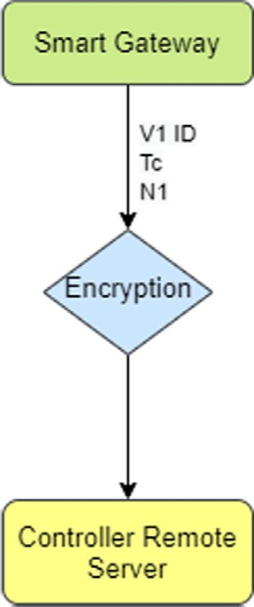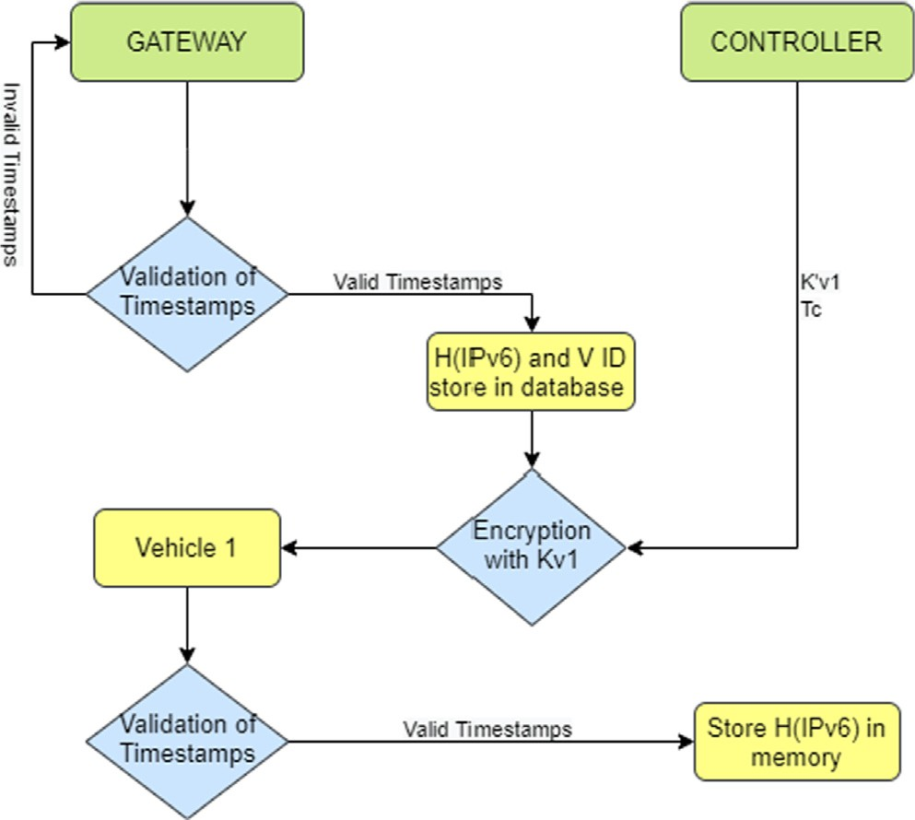

*1 : H*(*IPv6*)*,* {{ *KuG*} *K'v1, Tc*} *Kv1*

Fig. 6. Encryption Process. Fig. 8. Gateway and Controller Process.

key with Gateway *G* public key along with a current timestamp and send it to the gateway. Fig. 7 shows the gateway authentica- tion timestamp process.

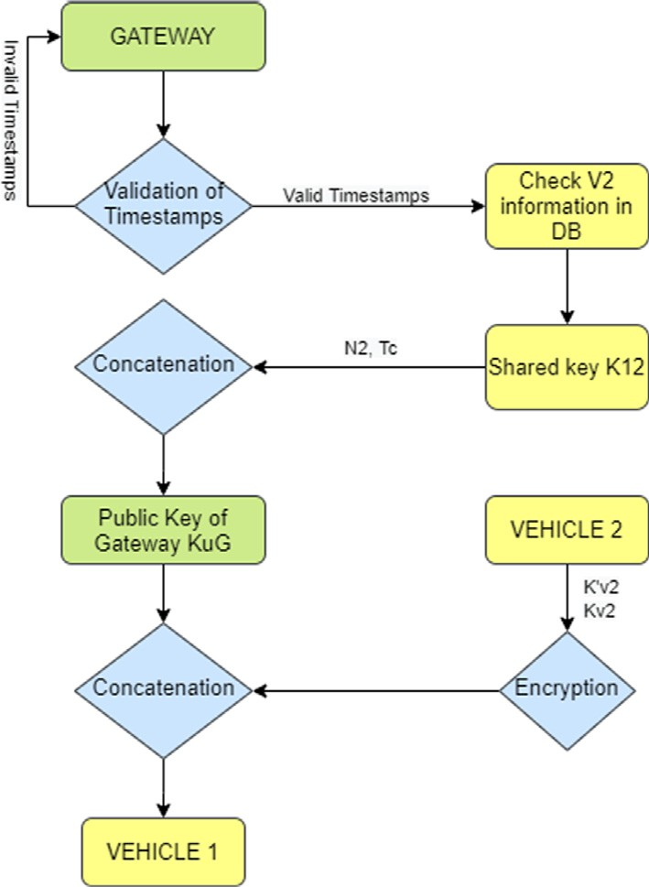

*1 :* {{{*KuG, K12*}*K’v2*}*, Tc, N2, K12*}*Kv1*

*C* → *G* : *H*(*IPv*6); {*KuG*}*K*'

*v*1

; *Tc* }*KuG*

After performing this, the gateway authenticates the timestamp and saves the hash of virtual identity IPv6 along with the respective vehicle ID in the database. Now the gateway shall forward the hash value and its public key encrypted with the vehicle’s private key that is received from the controller and timestamp. Fig. 8 shows the gateway and controller process. This complete information is then encrypted by Vehicle 1 private key. *V1* now checks the times- tamp and upon validation, the hash value is stored in the memory of *V1* as follows:

*G* → *V* 1 : *H*(*IPv*6); {*KuG*}*K*'

*v*1

; *Tc* }*Kv*1

The gateway and controller process is proposed in this research based on the concept of having its local database. This database is utilized by all the vehicles in the network to access the requisite information. The network also uses the gateway database when required. The gateway is also responsible for communication with roadside infrastructure. The information stored in the database of the gateway is uploaded and updated to the cloud server periodi- cally. The cloud server has information regarding all networks and all vehicles that are connected with these networks. Instead, the gateway only has information about the vehicles connected within its network.

* 1. *Operational phase*

The operation phase of this proposed scheme explains the basis of vehicle-to-vehicle communication during the regular working of vehicles within a network. If a vehicle *V1* wants communication to another vehicle *V2* to perform some task, *V1* needs to forward a request to the gateway first by sending information like hash value, current timestamp, and *V1* own public key. Fig. 9 shows the vehicle and gateway process.

*V* 1 → *G* : *H*(*IPv*6); {*Tc*; *V* 2}*KuG*

Validation of timestamp is performed by the gateway; upon

successful validation, the gateway checks its database for informa- tion about *V2*. After this gateway sends *K12* to Vehicle 1. This is a shared key for establishing communication between Vehicle 1 and Vehicle 2. Along with the shared key, the gateway sends a sec- ond nonce value *N2* after concatenation with the current times-

Fig. 10. Complete Process.

tamp. The gateway public key *KuG* is concatenated with shared key *K12.* Now the gateway performs encryption by vehicle 2 private key and vehicle 1 public key. Fig. 10 shows the complete process.

*G* → *V* 1 : {*KuG*; *K*12}*K*'*v*2}; *Tc*; *N*2; *K*12}*Kv*1

The information received by Vehicle 1 by the gateway is to be

forwarded to Vehicle 2. This shall assure that the key is shared by its gateway. After performing validation on timestamp vehicle 1 (if the timestamp is validated) gets the shared key. Now, vehicle 1 forwards the public key of Gateway and shared key encrypted with the private key of Vehicle 2 with third nonce value *N3* to vehi- cle 2. It also sends the current timestamp after concatenation and encryption. Fig. 11 shows the validation process.

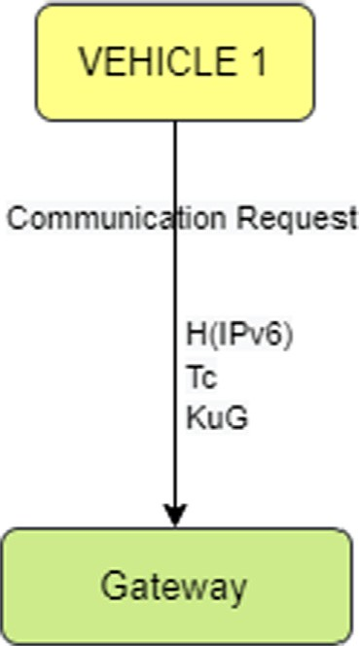

*V1 *(*IPv6*)*,* { *Tc, V2*} *KuG*

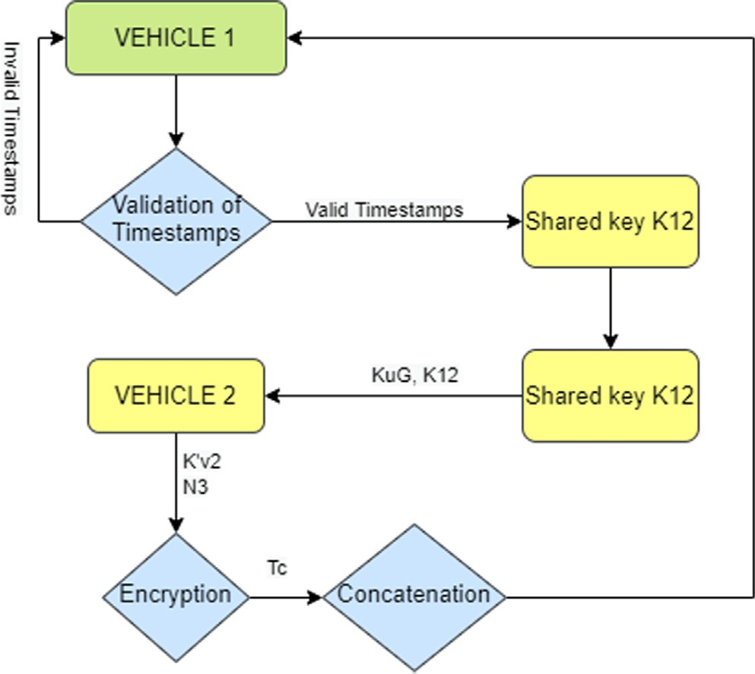

*V1 2 :* {{ *KuG, K12*}b *K’v2,* { *N3*} *K12, H1*(*K12, Tc*)} *Kv2*

Fig. 9. Vehicle and Gateway Process. Fig. 11. Validation Process.

*V* 1 → *V* 2 : {{*KuG*; *K*12}*bK*'*v*2; {*N*3}*K*12; *H*1(*K*12; *Tc*)}*Kv*2

Vehicle 2 decrypts the message that it has received and gets a

shared key from the public key of the gateway and shared key con- catenation with the private key of vehicle 2. This assures vehicle 2 that it has been provided by the gateway. After performing decryp- tion, vehicle 2 gets a third nonce value using the shared key. As vehicle 2 know the hash function and shared key it can now get and perform validation on timestamp. Now, vehicle 2 responds to vehicle 1 with the fourth nonce value *N4* after concatenating it with received *N3* and valid timestamp. This shall be encrypted by a shared key. This authenticates Vehicle 2 to Vehicle 1. Lastly, vehi- cle 1 responds with a fourth nonce value encrypted by a shared key which is only known by Vehicle 1 and Vehicle 2, this shall authen- ticate Vehicle 1 to Vehicle 2.

* 1. *Design and validation of proposed scheme*

This section explains the implementation of the proposed scheme, and the architecture of Automated Validation of Internet Security Protocol and Applications (AVISPA). This section also breaks down the security properties that AVISPA checks. The exe- cution of the proposed protocol is done in High-Level Protocol Specification Language (HLPSL). It is also exhibited the theoretical reenactment of the proposed scheme. The proposed scheme is designed for the aspects provided in AVISPA. This is an online tool used for verification of internet security-sensitive protocols. This tool performs automated validations and is a role-oriented lan- guage. In this tool, each agent that is participating plays a different role during protocol execution. Moreover, each role is purely inde- pendent of the other role. An expressive formal language is used in a modular approach for the specification of security properties of the protocol. AVISPA has the integration of different backend set- ups that are used for analysis techniques for invalidation of the protocol by finding an attack on input. Verification methods used are abstraction-based for finite as well as infinite sessions. Dolev Yao model gives attackers full control over the network, that’s why AVISPA uses this model for verifying the strength of the designed protocol. It also verifies the security properties of the specific protocol including authentication, non-repudiation, confi- dentiality, integrity, and anonymity, and data origin key manage- ment. AVISPA is a platform-independent and web-based solution for the verification of designed protocols. The threat model used in this tool is Dolev Yao, it is considered to be the most powerful model that simulates attackers over the network and gives the attacker immense powers over the network for testing out the pro- tocol. It is believed that during testing if the protocol is secure against this model then the protocol is considered to be secure against real-world attacks. Dolev Yao threat model has many capa- bilities over other threat models:

* + - The secret data is thought to be indissoluble an attacker doesn’t exploit fractional messages. The message is viewed as a secret

message except if it is undermined completely.

* + - The regular role of principals or agents can be assigned to the intruder.
    - Messages can be forwarded even if an attacker cannot read them.
    - Without the key, decryption cannot be performed.
    - The attacker can generate new messages and delete existing messages.
    - This is an interactive model where the attacker runs to learn information which can later be used in verification of other

protocol.

This tool cannot perform cryptanalysis despite having complete control over the network due to the assumption that the crypto- graphic primitives used are perfect. This tool uses HLPSL which is a formal language based on a modular approach for modeling com- munication and security protocols. This is an expressive language that is role-based. AVISPA allows the user to interact by submitting a security problem that can occur and the protocol under verifica- tion needs to be tested. The specifications are then translated into Intermediate Format at a lower abstraction level. Foregoing in view, these translations are then served as inputs to the AVISPA backend for verification of the communication and security protocol.

For mathematical processing, this tool uses the following four back-ends which are the primary source of provision for falsifica- tion of protocol and bounded unbounded verification:

1. TA4SP: is based on Tree Automata, it is dependent on Automatic Approximations for the Analysis of Security Protocols (TA4SP). This back-end indicates the vulnerability in the protocol by careful estimations of intruder capabilities.
2. CL-AtSe: stands for Constraint-Logic-based Attack Searcher. It is used to find the possible attacks on a given protocol by translat- ing the specifications into a set of constraints.
3. OFMC: stands for On-the-fly Model-Checker. It is utilized for specific protocols with requirements of algebraic properties of cryptographic functions. This back-end is utilized for fast detec- tion of attacks and verification.
4. SATMC: is an SAT-based Model-Checker. It generates a proposi- tional formula by taking the transitional state from Intermedi- ate Format to indicate a violation of security properties in a given communication and security protocol.

This tool shows the flaw in a given protocol for a specific secrecy property or strength estimation of the protocol against cer- tain security attacks by computing over-approximation value or under approximation value. The engineering of the AVISPA Tool is portrayed in Fig. 12.

1. Results and discussion

This section explains the results and analysis and explained the- oretical analysis and simulation results. The tool AVISPA is used for verification of the proposed protocol. In this section, out of four AVISPA back-ends, OFMC and CL-AtSe back-ends are used which are highly accepted back-ends for this specific purpose. After mod- eling the proposed protocol in HLPSL protocol specification, SPAN is used as a security protocol animator to symbolically execute the HLPSL protocol specification. Attackers or intruders are not assigned any role during the simulation. In this process, message sequence charts can be generated using SPAN as per specifications written in HLPSL. The tool AVISPA automatically verifies if the designed protocol that is being verified and tested using the same tool satisfies the security properties. This tool is different from other protocol testing tools because it not only gives the assurance that protocol is safe or not but additionally if it finds out that the protocol is unsafe it also gives a trace of the attack found. The secu- rity properties of Authentication, Secrecy, and integrity are being verified. Authentication is one of the key property which is based upon authentication property. It is a process of validating a vehi- cle’s identity by other vehicles in communication and vice versa. This ensures the origin and reliability of communication and vali- dates that communication is being done with a legitimate and desirable vehicle. In this proposed protocol, mutual vehicle-to- vehicle authentication is established from a shared session key. This shared key is generated by the gateway and this is transmitted

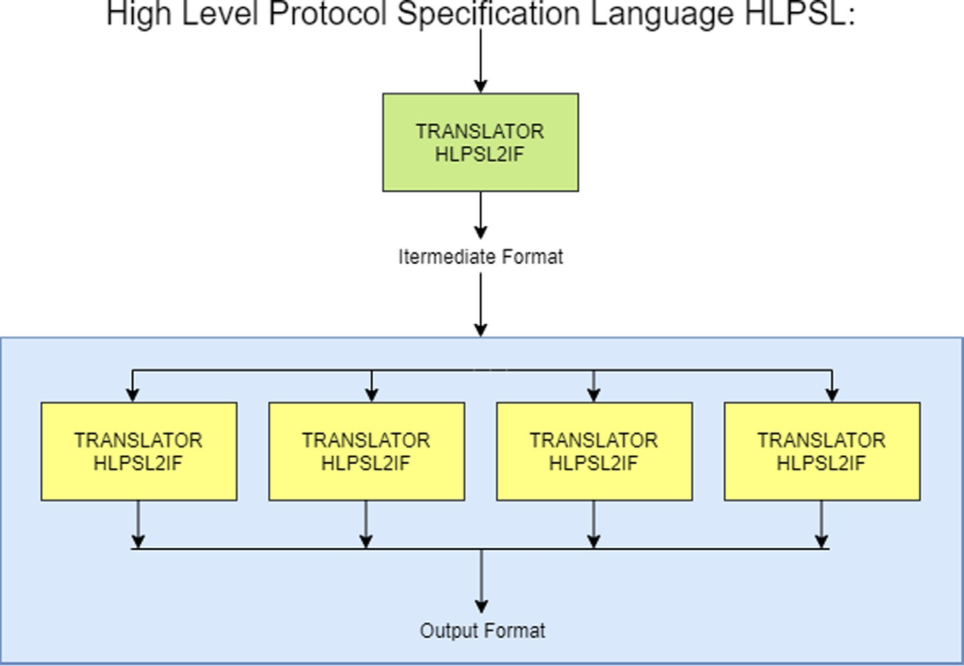

Fig. 12. AVISPA Architecture.

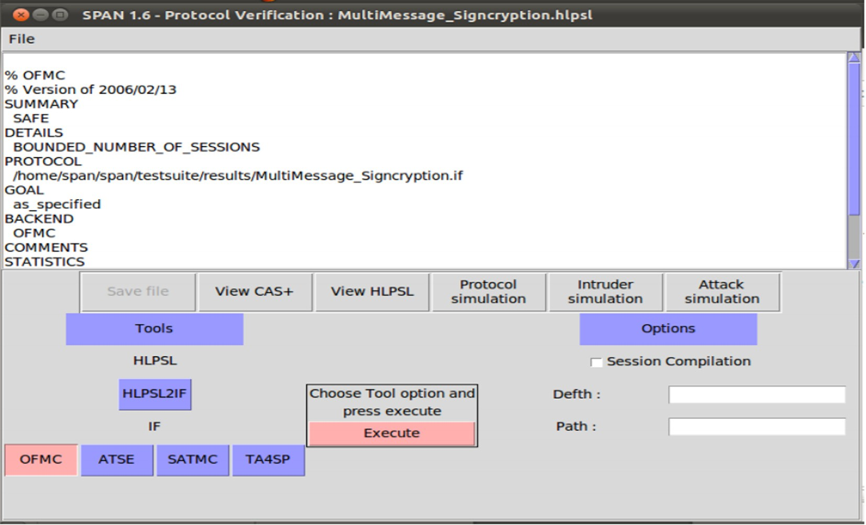

Fig. 13. Protocol verification screenshot.

secretly to only those vehicles who are intended to communicate. Vehicle 1 and vehicle exchange nonce values to authentication themselves to each other. Encryption is done using a private key to ensure the prevention of data breaches.

The property of secrecy ensures the unauthorized access of data/ information for anyone. In other words, the information should only be accessible to those for whom it is intended. This proposed protocol ensures the property of secrecy by keeping all nonce values encrypted and secret during communication. Only intended receivers can decrypt the nonce values and similarly the shared key is also kept secret between communicating parties. The property of integrity implies that the information when

received is not been altered or tempered during communication. If this property is maintained, the data received must be in original form from the sender. This proposed protocol is designed keeping in mind the property of integrity by using hash values of the shared session key. Upon receiving, the receiver verifies the hash by using the same algorithm, and in this way, data integrity is ensured.

* 1. *Simulation and verification of results*

The simulation is performed online using the AVISPA tool after modeling protocol specifications in HLPSL. Afterward, message sequence charts are produced online on a web interface using

1

0.8

**PACKET LOST RATE (%)**

0.6

0.4

0.2

0

17.5

**AVERAGE DELAY (CENTISECONDS)**

15

12.5

10

7.5

5

2.5

0

SAS-VANET

0 2 4 6 8 10 12 14 16 18

EASSAIV

**NO OF VEHICLES**

Fig. 14. Packet Loss Rate.

 SAS-VANET

EASSAIV

0 2 4 6 8 10 12 14 16 18

**THE PENETRATION RATE (NO OF VEHICLES %)**

Fig. 15. Average Delay.

sive attacks. It also indicates that there is no authentication or secrecy attack on the protocol and it is also safe against man in the middle and replays attacks. The shared session key is found safe by having no attack by the intruder. Authentication of partic- ipating entities is being done by initiating the exchange of nonce values. Message transmission and secrecy are also found to be intact after the communication. The back-end confirms the absence of any possible attack and found the proposed protocol to be safe. Hash functions are proved to maintain the integrity of communication.

Afterward, the informal security analysis is conducted to evalu- ate the strength of the proposed protocol against Replay attack, Password Guessing Attack, Multiprotocol Attack, and Reflection Attack. CL-AtSe backend of AVISPA tool is used for detection of Replay and DoS attacks. As discussed above, the proposed protocol is declared safe against these attacks by CL-AtSe. During replay attack, timestamps are used for prevention but additionally use of random nonce values ensure the freshness of the message even if clock synchronization is not in order. Similarly, in Password Guessing Attack, an attacker cannot obtain credentials because of fact the password is not dependent on any credentials. Therefore, the probability of guessing a password is so negligible practically that chance of password guessing compromise is ruled out. Also, various tests are performed to check the performance indexes of the proposed scheme including packet lost rate, average delay, and average data delivery. The results are compared with SAS- VANET [19]. The results of these tests showed promising indicators concerning better efficiency and more productiveness of our pro- posed scheme in comparison with SAS-VANET. The proposed scheme is validated by using well-known security tool AVISAP. Fig. 13 shows that the proposed scheme is safe and in working condition.

In this regard, the packet loss rate percentage is calculated in comparison with SAS-VANET as shown in Fig. 14. The results showed that the proposed scheme ESSAIV has a steep lower packet lost percentage with a lower number of connected vehicles with a greater difference. With increased vehicles connected at one time showed almost consistent results of EASSAIV with SAS-VANET.

Similarly, during the average packet delay test as shown in

SPAN. After this for verifying the model, back-ends are used which are provided in this tool and an active intruder is introduced. OFCM and CL-AtSe back-ends show verification results by confirming the safety of the protocol under both back-ends. This simulation also ensures that the proposed protocol is secure against active or pas-

Fig. 15, EASSAIV again proved to be a more efficient scheme when compared with SAS-VANET. This test shows the average delay in comparison with the penetration rate among several vehicles in percentage. The results show that throughout the increasing per- centage of vehicles (the penetration rate) the average packet delay

17.5

**AVERAGE DATA DELIVERY**

15

12.5

10

7.5

5

2.5

0

 SAS-VANET



EASSAIV

0 2 4 6 8 10 12 14 16 18

**THE PENETRATION RATE (NO OF VEHICLES %)**

Fig. 16. Average Data Delivery.

of EASSAIV is less than the SAS-VANET scheme. When 18 vehicles are connected using ESSAIV the average delay is 12 cent seconds as compared to 15 cent seconds in SAS-VANET with the same number of connected vehicles.

Subsequently, to further support the proposed scheme, the Average Data Delivery as shown in Fig. 16 test is also performed in comparison with SAS-VANET. The parameters for measuring the said is to compare average data delivery with several con- nected vehicles. In this test proposed scheme EASSAIV performed better than SAS-VANET by providing a greater data delivery rate with an increased number of connected vehicles in comparison with SAS-VANET. The results show that with 18 vehicles con- nected, EASSAIV average data delivery rate is 14.5 in comparison with 12 of SAS-VANET with the same number of vehicles.

These results show the efficiency of the proposed scheme over an existing scheme and thus this protocol to be practically usable in real-world scenarios with great potential of expansion possibil- ities in the future in terms of more efficiency and harnessing of even better results.

1. Conclusion

In this paper, a scheme is introduced for UAV and IoV networks and provide more secure data communication by using authentica- tion mechanism. The proposed EASSAIV is using a mutual message authentication mechanism between drones and vehicles nodes to ensure the security in IoV networks. Most of the existing message authentication schemes do not work on the mutual authentication between nodes. The proposed scheme ensured mutual authentica- tion between vehicle-to-vehicle. The proposed scheme is verified using the AVISPA tool and modeled in SPAN using HLPSL for more practical demonstrations and theoretical evaluations of the results. Simulation results showed the better performance of the proposed scheme compared to the state of the art scheme. This work is also extendible in the future especially for highway environments where the distance between vehicles is another challenge for an authentication mechanism.

Acknowledgment

This work is partly supported with the financial support of the Science Foundation Ireland grant 13/RC/2094\_P2 and partly funded from the European Union’s Horizon 2020 research and innovation programme under the Marie Skłodowska-Curie grant agreement No 754489.

References

1. [Qureshi KN, Din S, Jeon G, Piccialli F. Internet of vehicles: key technologies,](http://refhub.elsevier.com/S1110-8665(21)00044-X/h0005) [network model, solutions and challenges with future aspects. IEEE Trans Intell](http://refhub.elsevier.com/S1110-8665(21)00044-X/h0005) [Transp Syst 2021;22(3):1777–86](http://refhub.elsevier.com/S1110-8665(21)00044-X/h0005).
2. [Qureshi KN, Idrees MM, Lloret J, Bosch I. Self-assessment based clustering data](http://refhub.elsevier.com/S1110-8665(21)00044-X/h0010) [dissemination for sparse and dense traffic conditions for internet of vehicles.](http://refhub.elsevier.com/S1110-8665(21)00044-X/h0010) [IEEE Access 2020;8:10363–72](http://refhub.elsevier.com/S1110-8665(21)00044-X/h0010).
3. [Duan W, Gu J, Wen M, Zhang G, Ji Y, Mumtaz S. Emerging technologies for 5G-](http://refhub.elsevier.com/S1110-8665(21)00044-X/h0015) [IoV networks: applications, trends and opportunities. IEEE Network 2020;34](http://refhub.elsevier.com/S1110-8665(21)00044-X/h0015) [(5):283–9](http://refhub.elsevier.com/S1110-8665(21)00044-X/h0015).
4. [Qureshi KN, Din S, Jeon G, Piccialli F. Link quality and energy utilization based](http://refhub.elsevier.com/S1110-8665(21)00044-X/h0020) [preferable next hop selection routing for wireless body area networks. Comput](http://refhub.elsevier.com/S1110-8665(21)00044-X/h0020) [Commun 2020;149:382–92](http://refhub.elsevier.com/S1110-8665(21)00044-X/h0020).
5. [Qureshi KN, Abdullah AH, Lloret J, Altameem A. Road-aware routing strategies](http://refhub.elsevier.com/S1110-8665(21)00044-X/h0025) [for vehicular ad hoc networks: characteristics and comparisons. Int J Distrib](http://refhub.elsevier.com/S1110-8665(21)00044-X/h0025) [Sens Netw 2016;12(3):1605734](http://refhub.elsevier.com/S1110-8665(21)00044-X/h0025).
6. [Angurala M, Bala M, Bamber SS. Wireless battery recharging through UAV in](http://refhub.elsevier.com/S1110-8665(21)00044-X/h0030) [wireless sensor networks. Egyptian Inf J 2021](http://refhub.elsevier.com/S1110-8665(21)00044-X/h0030).
7. [Islam S. Security property validation of the sensor network encryption protocol](http://refhub.elsevier.com/S1110-8665(21)00044-X/h0035) [(snep). Computers 2015;4(3):215–33](http://refhub.elsevier.com/S1110-8665(21)00044-X/h0035).
8. [Alwateer M, Loke SW, Fernando N. Enabling drone services: drone](http://refhub.elsevier.com/S1110-8665(21)00044-X/h0040) [crowdsourcing and drone scripting. IEEE Access 2019;7:110035–49](http://refhub.elsevier.com/S1110-8665(21)00044-X/h0040).
9. [Qureshi KN, Abdullah AH, Yusof R. Position-based routing protocols of](http://refhub.elsevier.com/S1110-8665(21)00044-X/h0045) [vehicular Ad hoc networks & applicability in typical road situation. Life Sci J](http://refhub.elsevier.com/S1110-8665(21)00044-X/h0045) [2013;10(4):905–13](http://refhub.elsevier.com/S1110-8665(21)00044-X/h0045).
10. [Qureshi KN, Abdullah H. Topology based routing protocols for vanet and their](http://refhub.elsevier.com/S1110-8665(21)00044-X/h0050) [comparison with manet. J Theoretical Appl Inf Technol 2013;58(3):707–15](http://refhub.elsevier.com/S1110-8665(21)00044-X/h0050).
11. [Qureshi KN, Bashir F, Abdullah AH. Distance and signal quality aware next hop](http://refhub.elsevier.com/S1110-8665(21)00044-X/h0055) [selection routing protocol for vehicular ad hoc networks. Neural Comput](http://refhub.elsevier.com/S1110-8665(21)00044-X/h0055) [Applications 2020;32(7):2351–64](http://refhub.elsevier.com/S1110-8665(21)00044-X/h0055).
12. [Sakiz F, Sen S. A survey of attacks and detection mechanisms on intelligent](http://refhub.elsevier.com/S1110-8665(21)00044-X/h0060) [transportation systems: VANETs and IoV. Ad Hoc Netw 2017;61:33–50](http://refhub.elsevier.com/S1110-8665(21)00044-X/h0060).
13. [Kang J, Xiong Z, Niyato D, Ye D, Kim DI, Zhao J. Toward secure blockchain-](http://refhub.elsevier.com/S1110-8665(21)00044-X/h0065) [enabled Internet of Vehicles: optimizing consensus management using](http://refhub.elsevier.com/S1110-8665(21)00044-X/h0065) [reputation and contract theory. IEEE Trans Veh Technol 2019;68(3):2906–20](http://refhub.elsevier.com/S1110-8665(21)00044-X/h0065).
14. [Qureshi KN, Iftikhar A, Bhatti SN, Piccialli F, Giampaolo F, Jeon G. Trust](http://refhub.elsevier.com/S1110-8665(21)00044-X/h0070) [management and evaluation for edge intelligence in the internet of things. Eng](http://refhub.elsevier.com/S1110-8665(21)00044-X/h0070) [Appl Artif Intell 2020;94:103756](http://refhub.elsevier.com/S1110-8665(21)00044-X/h0070).
15. [Sun G, Sun S, Sun J, Yu H, Du X, Guizani M. Security and privacy preservation in](http://refhub.elsevier.com/S1110-8665(21)00044-X/h0075) [fog-based crowd sensing on the internet of vehicles. J Network Comp Appl](http://refhub.elsevier.com/S1110-8665(21)00044-X/h0075) [2019;134:89–99](http://refhub.elsevier.com/S1110-8665(21)00044-X/h0075).
16. [Chen C-M, Xiang B, Liu Y, Wang K-H. A secure authentication protocol for](http://refhub.elsevier.com/S1110-8665(21)00044-X/h0080) [internet of vehicles. IEEE Access 2019;7:12047–57](http://refhub.elsevier.com/S1110-8665(21)00044-X/h0080).
17. [Li F, Zhang H, Gao L, Wang J, Sanin C, Szczerbicki E. A set of experience-based](http://refhub.elsevier.com/S1110-8665(21)00044-X/h0085) [smart synergy security mechanism in internet of vehicles. Cybernet Syst](http://refhub.elsevier.com/S1110-8665(21)00044-X/h0085) [2019;50(2):230–7](http://refhub.elsevier.com/S1110-8665(21)00044-X/h0085).
18. [Wazid M, Bagga P, Das AK, Shetty S, Rodrigues JJ, Park YH. AKM-IoV:](http://refhub.elsevier.com/S1110-8665(21)00044-X/h0090) [authenticated key management protocol in fog computing-based Internet of](http://refhub.elsevier.com/S1110-8665(21)00044-X/h0090) [vehicles deployment. IEEE Internet Things J 2019;6(5):8804–17](http://refhub.elsevier.com/S1110-8665(21)00044-X/h0090).
19. [Bayat M, Barmshoory M, Rahimi M, Aref MR. A secure authentication scheme](http://refhub.elsevier.com/S1110-8665(21)00044-X/h0095) [for VANETs with batch verification. Wireless Netw 2015;21(5):1733–43](http://refhub.elsevier.com/S1110-8665(21)00044-X/h0095).
20. [Zhou Y, Liu S, Xiao M, Deng S, Wang X. An efficient V2I authentication scheme](http://refhub.elsevier.com/S1110-8665(21)00044-X/h0100) [for VANETs. Mobile Inf Syst 2018;2018:1–11](http://refhub.elsevier.com/S1110-8665(21)00044-X/h0100).
21. [Kong Q, Lu R, Ma M, Bao H. A privacy-preserving sensory data sharing scheme](http://refhub.elsevier.com/S1110-8665(21)00044-X/h0105) [in Internet of Vehicles. Future Generat Comp Syst 2019;92:644–55](http://refhub.elsevier.com/S1110-8665(21)00044-X/h0105).
22. [Onieva JA, Rios R, Roman R, Lopez J. Edge-assisted vehicular networks security.](http://refhub.elsevier.com/S1110-8665(21)00044-X/h0110) [IEEE Internet Things J 2019;6(5):8038–45](http://refhub.elsevier.com/S1110-8665(21)00044-X/h0110).
23. [Li K, Lau WF, Au MH, Ho I-W-H, Wang Y. Efficient Message authentication with](http://refhub.elsevier.com/S1110-8665(21)00044-X/h0115) [revocation transparency using blockchain for vehicular networks. Comput](http://refhub.elsevier.com/S1110-8665(21)00044-X/h0115) [Electr Eng 2020;86:106721](http://refhub.elsevier.com/S1110-8665(21)00044-X/h0115).
24. [Manivannan D, Moni SS, Zeadally S. Secure authentication and privacy-](http://refhub.elsevier.com/S1110-8665(21)00044-X/h0120) [preserving techniques in Vehicular Ad-hoc NETworks (VANETs). Vehicular](http://refhub.elsevier.com/S1110-8665(21)00044-X/h0120) [Commun 2020:100247](http://refhub.elsevier.com/S1110-8665(21)00044-X/h0120).
25. [Amin R, Lohani P, Ekka M, Chourasia S, Vollala S. An enhanced anonymity](http://refhub.elsevier.com/S1110-8665(21)00044-X/h0125) [resilience security protocol for vehicular ad-hoc network with Scyther](http://refhub.elsevier.com/S1110-8665(21)00044-X/h0125) [simulation. Comput Electr Eng 2020;82:106554](http://refhub.elsevier.com/S1110-8665(21)00044-X/h0125).
26. [Qureshi KN, Bashir F, Abdullah AH. Provision of security in vehicular Ad hoc](http://refhub.elsevier.com/S1110-8665(21)00044-X/h0130) [networks through an intelligent secure routing scheme. In: 2017 International](http://refhub.elsevier.com/S1110-8665(21)00044-X/h0130) [Conference on Frontiers of Information Technology (FIT). IEEE; 2017. p. 200–5](http://refhub.elsevier.com/S1110-8665(21)00044-X/h0130).
27. [Alouache L, Nguyen N, Aliouat M, Chelouah R. Survey on IoV routing protocols:](http://refhub.elsevier.com/S1110-8665(21)00044-X/h0135) [security and network architecture. Int J Commun Syst 2019;32(2):e3849](http://refhub.elsevier.com/S1110-8665(21)00044-X/h0135).