

Electronic Notes in Theoretical Computer Science 250 (2009) 123–136

[www.elsevier.com/locate/entcs](http://www.elsevier.com/locate/entcs)

Automated Security Verification for Crypto Protocol Implementations:

Verifying the Jessie Project

# Jan Ju¨rjens1

*Computing Department Open University*

*UK*

Abstract

An important missing link in the construction of secure systems is finding a practical way to establish a correspondence between a software specification and its implementation. We address this problem for the case of crypto-based Java implementations (such as crypto protocols) with an approach using automated theorem provers for first-order logic, by linking the implementation to a specification model. In this paper, we present details on an application of this approach to the open-source Java implementation Jessie of the SSL protocol. We also shortly comment on how these results can be transferred to the standard Java Secure Sockets Extension (JSSE) library that was recently open-sourced by Sun.

*Keywords:* Automated security verification, crypto protocol implementations, Java Secure Sockets Extension (JSSE)

# Introduction

Many security incidents at the software level have been reported, sometimes with potentially quite severe consequences. Any support to aid secure systems develop- ment is thus dearly needed. With respect to crypto-based software (such as crypto protocols or software using cryptographic signatures), a lot of very successful work has been done to formally analyze abstract specifications of these protocols for se- curity design weaknesses, including [14,15,1,16] (cf. [18,10] for overviews). More recently, there has been some work towards verifying implementations of security- critical software in general [8], and also in particular of crypto protocols [13,7,12,4]. While the approaches reported in [7,4,6] aim to verify implementations written by the research groups themselves (and [8] does not address crypto protocols), the line

1 <http://www.jurjens.de/jan> . This work was partially funded by the Royal Society within the project Modelbased Formal Security Analysis of Crypto Protocol Implementations.

1571-0661 © 2009 Elsevier B.V. Open access under [CC BY-NC-ND license.](http://creativecommons.org/licenses/by-nc-nd/3.0/)

doi:10.1016/j.entcs.2009.08.009

of work reported in the current paper (which was started in [13,12]) is targeted to legacy implementations of crypto protocols. It is motivated by the fact that so far, crypto-based software is usually not generated automatically from formal specifi- cations, or even created in ways under control of the security analyst. Thus, even where the corresponding specifications are formally verified, the implementations may still contain vulnerabilities related to the insecure use of cryptographic algo- rithms. An example for a crypto protocol whose design had been formally verified for security and whose implementation was later found to contain a weakness with respect to its use of cryptographic algorithms can be found in [17].

The current paper uses an approach for analyzing crypto-based implementations for security requirements using automated theorem provers (ATPs) for first-order logic (FOL), which is based on earlier work reported in [11]. Security requirements can be formalized straightforwardly in FOL, and the ATPs offer efficient derivation algorithms. The Java code is linked to a specification model in which the crypto- graphic operations are represented as abstract functions, and which is translated to formulas in FOL with equality. Together with a logical formalization of the security requirements, they are then given as input into any ATP supporting the TPTP input notation (which is a standard for formulating FOL formulas for ATPs), such as e-SETHEO [19] or SPASS [20]. The approach supports a modular security anal- ysis by using assertions in the source code. Where a verification fails because the implementation contains a security flaw, one can use a Prolog engine to generate the corresponding attack trace.

Our goal is not to provide a full formal verification of Java code but to increase understanding of the security properties enforced by crypto protocol implementa- tions in a way which is as automated as possible. For the moment, we assume that the cryptographic algorithms called in the crypto protocol implementations have been implemented correctly (and our goal is to verify that they are used correctly in the crypto protocol). Also, because of the abstractions introduced for efficiency reasons (as explained below, for example abstracting from the identity of the sender of a message), the approach may produce false alarms (which however have not surfaced yet in practical examples).

The goal of the current paper is to report on an application of the approach to the open-source Java implementation Jessie of the SSL protocol. We also shortly indicate how these results can be transferred to the standard Java Secure Sockets Extension (JSSE) library that was recently open-sourced by Sun.

# Code Analysis

The analysis approach used here works with the well-known Dolev-Yao adversary model for security analysis. The idea is that an adversary can read messages sent over the network and collect them in his knowledge set. The adversary can merge and extract messages in the knowledge set and can delete or insert messages on the communication links. The security requirements can then be formalized using this adversary model. For example, a data value remains secret from the adversary if it

* + enc(*E, K*) (encryption)



data flow

"uses"

Java Annota− Code

code tions

with Assert’s

Text Report

Attack Trace

Assertion Generator

Control Flow Graph

JavaSec Suite

generator

Formula

FOL Prolog

fmla prog.

Attack generator

Automated Theorem Prover

CFG

Generator

Analyzer

Java editor

* + dec(*E, K*) (decryption)
  + hash(*E*) (hashing)
  + sign(*E, K*) (signing)
  + ver(*E, K, E*') (verification of signature)
  + kgen(*E*) (key generation)
  + inv(*E*)

'

(inverse key)

* + conc(*E, E* ) (concatenation)
  + head(*E*) and tail(*E*) (head and tail of concat.)

Fig. 1. a) Tool-flow of the JavaSec suite; b) Abstract crypto operations

never appears in the knowledge set of the adversary.

We explain how to link the Java program to the specification model and how to generate the FOL formulas, which are given as input to the ATP. The corre- sponding tool-flow is shown in Fig. 1a). Because of space limitations, we can not explain all steps required for linking the Java code to the specification model in every technical detail. We restrict our explanation to the analysis for secrecy of data. The idea here is to use a predicate knows which defines a bound on the knowledge an adversary may obtain by reading, deleting and inserting messages on vulnerable communication lines (such as the Internet) in interaction with the protocol participants. Precisely, knows(*E*) means that the adversary may get to know *E* during the execution of the protocol. For any data value *s* supposed to remain confidential, one thus has to check whether one can derive knows(*s*). From a logical point of view, this means that one considers a term algebra generated from data such as variables, keys, nonces and other data using symbolic opera-

tions including the ones in Fig. 1b). There, the symbols *E*, *E*', and *K* denote terms inductively constructed in this way. For example, the term ver(*E, K, E*') denotes the boolean value which signifies whether the verification of the signa- ture E against the plain text E' using the key K is successful. These symbolic operations are the abstract versions of the cryptographic algorithms defined in the Java*TM* Cryptography Architecture (JCA) [9]. Note that the cryptographic functions in the JCA are implemented as several methods, including an object creation and possibly initialization. Relevant for our analysis are the actual cryp- tographic computations performed by the digest(), sign(), verify(), generatePublic(),

generatePrivate(), nextBytes(), and doFinal() methods (together with the arguments that are given beforehand, possibly using the update() method), so the others are essentially abstracted away. Note also that the key and random generation methods generatePublic(), generatePrivate(), and nextBytes() are not part of the crypto term algebra in Fig. 1b) but are formalized implicitly in the logical formula by introduc- ing new constants representing the keys and random values (and making use of the inv(*K*) operation in the case of generateKeyPair()). In that term algebra, one defines the equations dec(enc(E*,* K)*,* inv(K)) = E and ver(sign(E*,* inv(K))*,* K*,* E)= true for all terms E*,* K, and the usual laws regarding concatenation, head(), and tail() to hold.

input_formula(construct_message_1,axiom,(

! [E1,E2]: ((knows(E1) & knows(E2))

=> (knows(conc(E1,E2)) & knows(enc(E1,E2)) & knows(sign(E1,E2)))))). input_formula(construct_message_2,axiom,(

! [E1,E2]: (knows(conc(E1,E2)) => (knows(E1) & knows(E2))))).

Fig. 2. Some general crypto axioms

See [10] for more details on this.

The predicates defined to hold for a given system are defined as follows. For each publicly known expression E, the statement knows(E) is given. To model the fact that the adversary may enlarge his set of knowledge by constructing new expressions from the ones he knows, including the use of cryptographic operations, formulas are generated for these operations for which some examples are given in Fig. 2. We use the TPTP notation for the FOL formulas, which is the input notation for many ATPs including the one we use (e-SETHEO [19]). Here & means logical conjunction and ![E1*,* E2] forall-quantification over E1, E2.

We explain how a Java program can be linked to a specification model which gives rise to a logical formula characterizing the interaction between the adversary and the protocol participants (the bottom left part of Fig. 1a). We explain the translation first for a simplified fragment of Java without loops and concurrency. Also, to simplify the treatment of variables and their assignment, we first use stan- dard transformations to simplify the translation from the program to logic. They are necessary, because in programming languages, program variables have state, while in classical logic variables are stateless.

side effects Side effects from method calls are flattened by traversing into the method definition. Where this becomes infeasible, one may add annotations to the method declaration that abstractly capture the computation of a method (and its side effects).

static single assignment The program is transformed to the *static single assign- ment (SSA)* format as usual.

Below, setting a variable a to a value v will be formalized as the logical constraint a = v on the models (which any valid model of the axioms will have to fulfill, whereby it amounts to an assignment). Getting the value from the variable a is modeled by just using that variable. We may ignore variable data definitions since they are not necessary in the TPTP input notation for the ATP. Similarly, we can treat variable initialization as assignment. In the case of local redefinitions of global variables, we assume a suitable renaming is used to avoid confusion.

To get the FOL formula for the program, we first construct the specification model capturing the abstract behaviour of the program. This can for example be done with the help of tools for generating control flows graphs (such as Code Logic), or by constructing it manually from the textual specification of the protocol. The model we construct is a state machine with transitions carrying labels of the form *await message e – check condition g – output message e’*. A state machine transition is executed if a message conforming to its input pattern arrives (or if the input pattern is empty) and if its condition is satisfied. When the transition

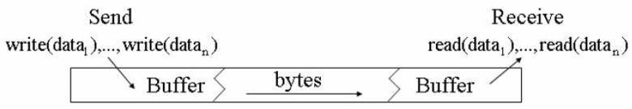

Fig. 3. Communication in crypto protocols such as SSL

is executed, its action will be executed and then the next transition in the state machine evaluated. In the label *await message e*, the expression *e* consists of a message name msg and a list of variables which will be assigned values when a message with name msg is received over the network. Similarly, an *output message e’* pattern consists of a message name msg and a list of expressions, that are at run-time evaluated to values which are sent on the network as arguments of the message msg.

To determine the data sent and received, we first deal with the mechanisms which implement a send or a receipt procedure. We assume that each message is represented by a message class. It stores the data to be written in the communica- tion buffer. Conversely, this class can also read messages from the communication buffer (this communication principle is visualized in Figure 3). We found that this mechanism is often (and in particular in the Jessie project discussed in Sect. 3) im- plemented using methods write() (for sending messages), and read() (for receiving them). Furthermore, the occurrences of the method write() (resp. read()) which are called at the class java.io.OutputStream (resp. java.io.InputStream) is used to identify the individual message parts within the communication procedure in the form of parameters that are delivered or the assignments made. In more detail, commu- nication is implemented as follows: With the method call msg*.*write(dout*,* version), the message msg is written into the output buffer dout. Each occurrence of such a method call can be identified and associated with the abstract function send(msg) in the specification model. The method call dout*.*flush later flushes the buffer. The assignment msg = Handshake*.*read reads a message from the buffer during the hand- shake part of the protocol. As an example, the code fragment for initializing and sending the ClientHello message is given in Figure 4.

Lastly, we map each assignment assgmt of an expression to a variable in Java to a logical predicate passgmt on the corresponding logical variable. The list of arguments of the message *e* may be empty and the condition *g* equal to true where they are not needed.

For the mapping from the state machine defined above to a FOL formula, we map the Boolean expression in Java syntax to logical syntax in the TPTP format,

e.g. by replacing the equality test == by the binary Boolean function equal() and

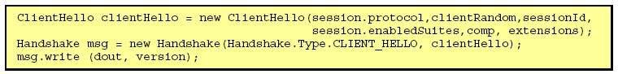

Fig. 4. Initializing and sending the ClientHello message

PRED(*l*)= ∀*exp*1*,. .. , expn.*“knows(*exp*1 ) ∧ *.. .* ∧ knows(*expn*) ∧ *cond* (*exp*1 *,.. ., expn*)

⇒ knows(*exp*(*exp*1 *,.. ., exp*n ) ∧ PRED(*l*')”

Fig. 5. Transition predicate

similarly for the other Boolean connectives.

Suppose now that we are given a transition *l* = (source(*l*)*,* event(*l*)*,* guard(*l*)*,*

msg(*l*)*,* target(*l*)) with guard(*l*) ≡ *cond* (*arg* 1*,... , arg n*), and msg(*l*) ≡ *exp*(*arg1 ,*

*... ,argn* ), where the parameters *arg i* of the guard and the message are variables which store the data values exchanged during the course of the protocol. Suppose that the transition *l*' is the next transition in the state machine. For each such tran- sition *l*, we define a predicate PRED(*l*) as in Fig. 5. If a next transition *l*' does not exist, PRED(*l*) is defined by substituting PRED(*l*') with true in Fig. 5. The formula formalizes the fact that, if the adversary knows expressions *exp*1*,... , expn* validating the condition *cond* (*exp*1*,... , expn*), then he can send them to one of the protocol participants to receive the message *exp*(*exp1 ,... , expn* ) in exchange, and then the protocol continues. With this formalization, a data value *s* is said to be kept secret if it is not possible to derive knows(*s*) from the formulas defined by a protocol. To construct the recursive definition above, we assume that the state machine is finite and cycle-free. The construction can be refined to allow loops (by using infinite

arrays for the variables updated in the loop), recursion, and concurrent threads.

For each object *O* in the system to be analyzed, this gives a predicate PRED(*O*)= PRED(*l*) where *l* is the first transition in the state machine of *O*. The axioms in the overall FOL formula for a given protocol are then the conjunction of the for- mulas representing the publicly known expressions, the formula in Fig. 2, and the conjunction of the formulas PRED(*O*) for each object *O* in the protocol.

The formulas defined above are written into the TPTP file as axioms. The security requirement to be checked is written into the TPTP file as a conjecture (for example, knows(secret) in case the secrecy of the value secret is to be checked). The ATP will then check whether the conjecture is derivable from the axioms. In the case of secrecy, the result is interpreted as follows: If knows(secret) can be derived from the axioms, this means that the adversary may potentially get to know secret. If the ATP returns that it is not possible to derive knows(secret) from the axioms, this means that the adversary will not get the data represented by secret (relative to our system and adversary model).

# The Example Application: The SSL project JESSIE

We apply the approach sketched above to the implementation of the Internet secu- rity protocol SSL in the project Jessie, which is an open-source implementation of the Java Secure Sockets Extension (JSSE).

SSL is the de facto standard for securing http connections, which however has been the source of several significant security vulnerabilities in the past [2] and is therefore an interesting target for a security analysis. In this paper, we concentrate

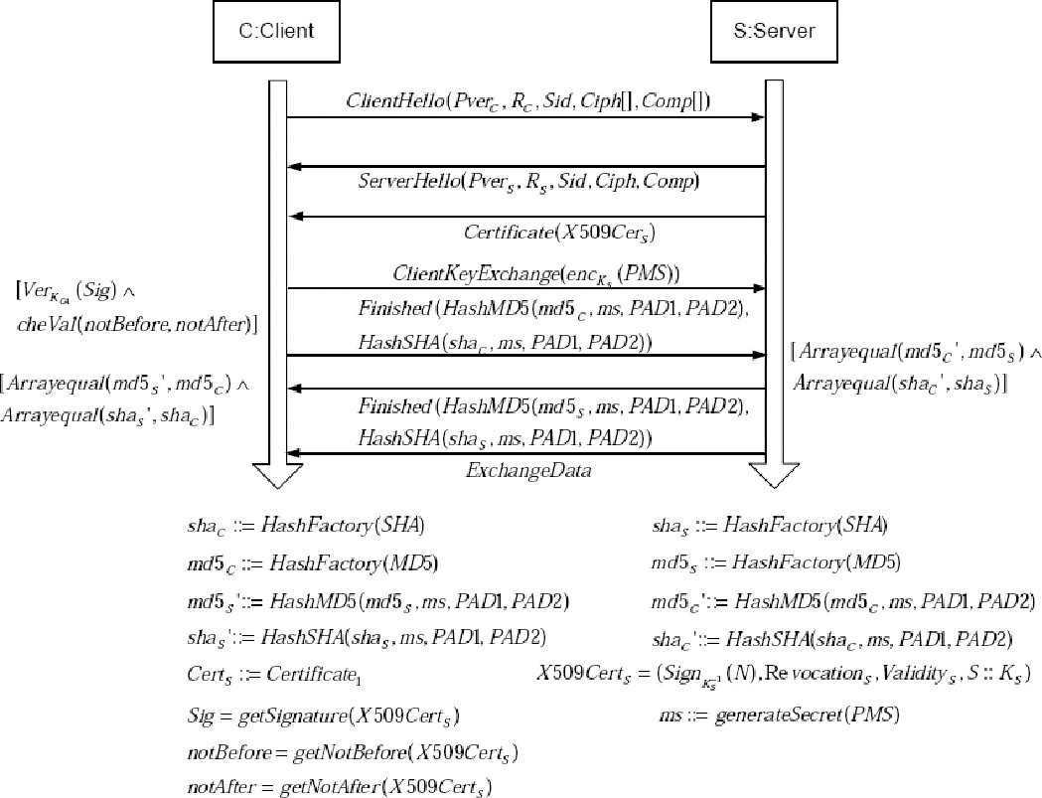

Fig. 6. The cryptographic protocol implemented in SSLSocket.java

on the fragment of SSL that uses RSA as the cryptographic algorithm and provides server authentication (cf. Fig. 6).

The whole Jessie project currently consists of about 5 MB of code, but the part directly relevant to SSL consists of less than 700 KB in about 70 classes. Therefore it is challenging, but manageable for formal analysis.

To link the code to the specification in Fig. 6, we firstly explain how important elements at the model level are implemented at the implementation level. This is done in the following three steps:

* Step 1: Identification of the data transmitted in the send and receipt procedures at the implementation level.
* Step 2: Interpretation of the transferred data and comparison with the sequence diagram.
* Step 3: Identification and analysis of the cryptographic guards at the implemen- tation level.

In step 1, the communication at the implementation level is examined and de- termined how the data that is sent and received can be found in the source code. Afterwards, in step 2, a meaning is assigned to the data. The interpreted data ele- ments of the individual messages are then compared with the appropriate elements

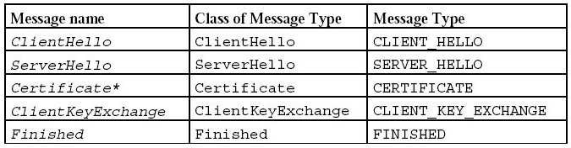

Fig. 7. Data for the Handshake message

in the model. In step 3, it is described how one can identify the guards from the model in the source code.

Step 1: In our particular protocol, setting up the connection is done by two methods: doClientHandshake() on the client side and doServerHandshake() on the server side, which are part of the SSLsocket class in jessie − 1*.*0*.*1*/*org*/* metastatic*/*jessie*/*provider. After some initializations and parameter checking, both methods perform the interaction between client and server that is specified in Fig- ure 6. Each of the messages is implemented by a class, whose main methods are called by the doClientHandshake() rp. doServerHandshake() methods. The associated data is given in Figure 7.

Step 2: In order to be able to make a comparison of the implementation with the abstract model, we must first determine for the individual data how it is im- plemented on the code level, to then be able to verify that this is done correctly. We explain this exemplarily for the variable randomBytes written by the method ClientHello to the message buffer. By inspecting the location at which the variable is written (the method write(randomBytes) in the class Random), we can see that the value of randomBytes is determined by the second parameter of the constructor of this class (see Figure 8).

Therefore the contents of the variable depends on the initialization of the cur- rent random object and thus also on the program state. Thus we need to trace back the initialization of the object. In the current program state, the random object was passed on to the ClientHello object by the constructor. This again was delivered at the initialization of the Handshake object in SSLSocket. doClien- tHandshake() to the constructor of Handshake. Here (within doClientHandshake()), we can find the initialization of the Random object that was passed on. The second parameter is generateSeed() of the class SecureRandom from the package java.security. This call determines the value of randomBytes in the current program state. Thus the value randomBytes is mapped to the model element *RC* in the mes-

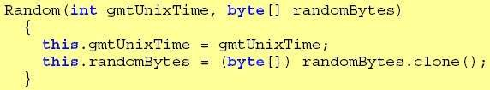

Fig. 8. Constructor for random

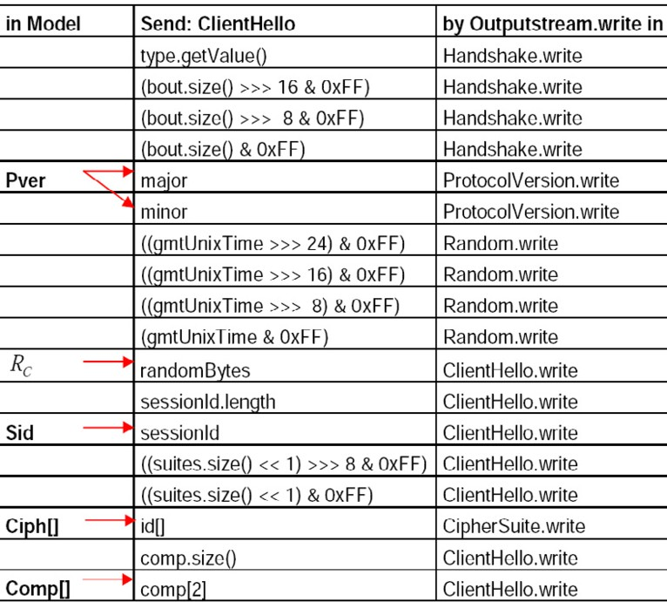

Fig. 9. Data in ClientHello message

sage ClientHello on the model level. For this, the method java.security.SecureRandom. generateSeed() must be correctly implemented. To increase our confidence in this assumption of an agreement of the implementation with the model (although a full formal verification is not the goal of this paper), all data that is sent and re- ceived must be investigated. In Figure 9, the elements of the message ClientHello of the model are listed. Here it is shown which data elements of the first message communication are assigned to which elements in the doClientHandshake() method. As an example, the following assertion for the verification of a hash at the client side in the Jessie doClientHandshake() method is inserted just before the handshake

phase is finished successfully:

assert Arrays*.*equals(finis*.*getMD5Hash()*,* verify*.*getMD5Hash()) &&

Arrays*.*equals(finis*.*getSHAHash()*,* verify*.*getSHAHash())

Note that the check that the type of the message received is actually correct is also generated as an assertion as follows, although this is only implicitly contained in our abstract specification.

assert msg*.*getType() = Handshake*.*Type*.*SERVER HELLO

Step 3: We now explain at the hand of an example how the guards from the SSL specification in Figure 6 can be identified on the code level and how it can be checked that these are in fact correctly implemented. To explain the idea, we concentrate on the Check Certificate guard from Figure 6. By manually inspecting the source code, one can find the call of a checkServerTrusted method directly after the point where

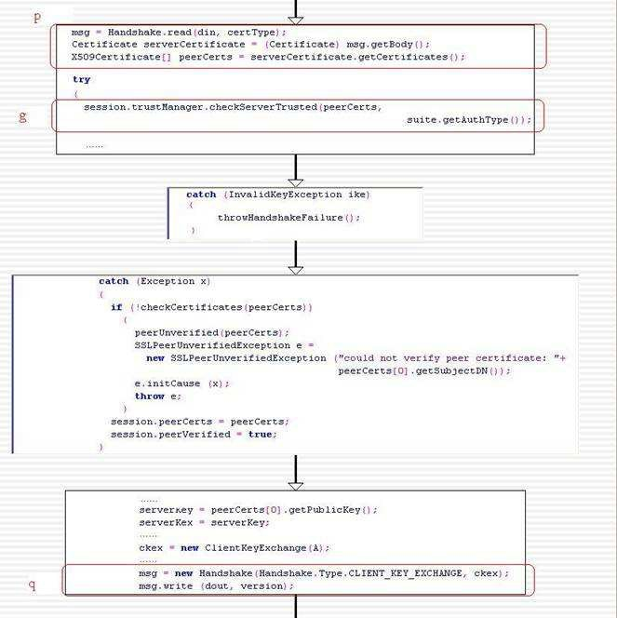

Fig. 10. Call of the checkServerTrusted method

the messages Certificate and Finished are received, which corresponds to the position of the

Check Certificate guard in the model (see Figure 10 for an excerpt of the relevant program fragment). For the Check Certificate guard we now explain how one can establish that it corresponds to the guard ver(cert*S*) on the semantic level and that it is reached within each program run. The investigation, represented in Figure 11, shows that first the validity of the individual certificates of the certificate chain peerCerts is queried. Subsequently, each certificate with the key of the predecessor in the certificate chain is verified, until the root is reached. For these it is examined whether it is referred to by one thrust ancor. If not, a CertificateException is thrown, which leads to abort the handshake dialogue. The function doVerify (Signature sig, PublicKey key) is used for verifying a certificate.

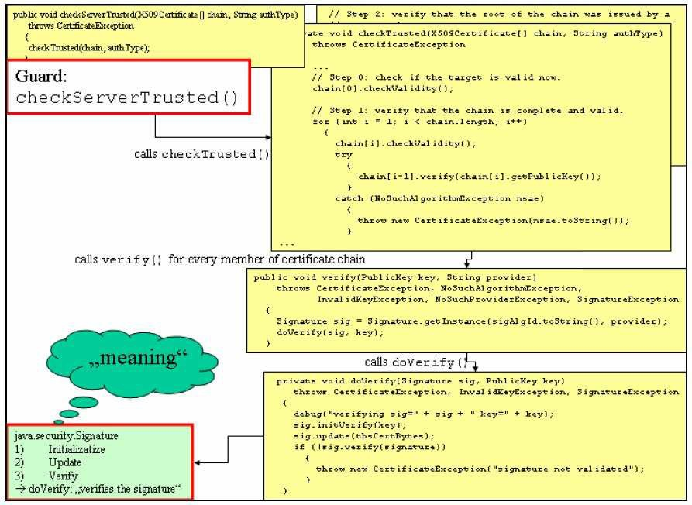

Fig. 11. Determine execution of the checkServerTrusted method

We will now explain how the tool automatically verifies, using the annotations defined above, that the code enforces the checks that have to be performed according to the protocol specification. Again, let p be the program point where a protocol message is received and q the point where the next message is sent out. Let g be the condition that according to the specification has to be checked between the program points p and q. Then the tool verifies that the condition g is enforced by the program between the execution points p and q. To verify this, our tool inspects the conditionals and exceptions between p and q to find out whether g is enforced, based on a control flow analysis using control flow graphs, where all paths between the nodes representing the program points p and q have to be examined to see whether they enforce g. As an example, we consider the guard g = ver(certS) that is performed by the client according to the specification in Fig. 6. We explain in detail how our tool automatically verifies that the Jessie implementation correctly enforces this guard. The tool makes use of the control flow graph which can be generated from the source code using tools available for this purpose (in our case using the tool CodeLogic) and which is visualized in Fig. 12.

According to the annotations defined based on the textual specifications, the check g is implemented by the method call session.trustManager. checkServerTrusted(peerCerts*,* suite*.*getAuthType()) (which throws an exception if the check fails). By tracking the various write and read calls, the tool also determines where the program points p resp. q are located, where the last message is received

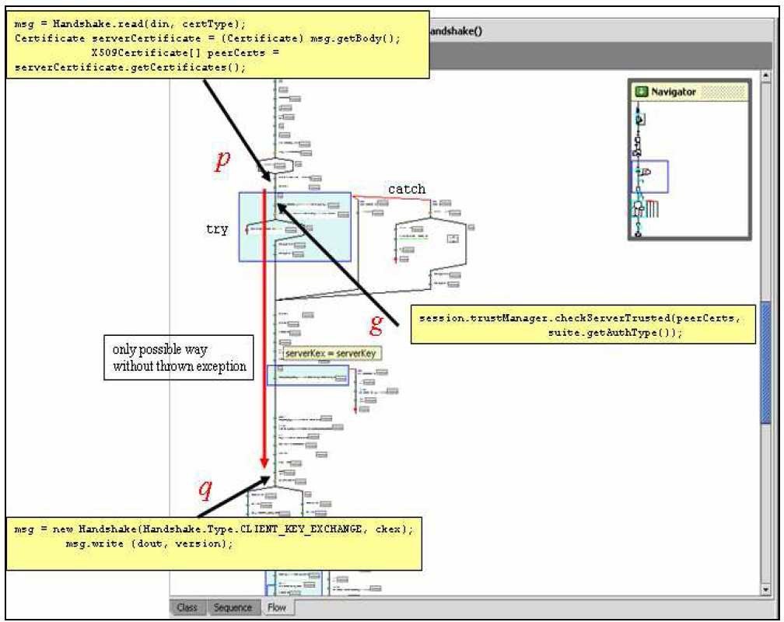

Fig. 12. Control Flow Graph for Verifying checkServerTrusted

resp. the next message is sent out. In this case, the last message before the guard should be checked is received using the command msg = Handshake*.*read(din*,* certType) at the program point marked p in Fig. 12. This cor- responds to the point where the message Certificate(X509CertS) is received at the Client side in the sequence diagram in Fig. 6. The next message after the guard should be checked is sent out using the command msg*.*write(dout*,* version) at the program point q in Fig. 12. This corresponds to the point where the message ClientKeyExchange(encKS (PMS)) is sent at the Client side in the sequence diagram in Fig. 6. Thus the tool has to check that for each execution of the program, the method call session.trustManager.checkServerTrusted(peerCerts,suite.getAuthType() will be executed between the program points p and q. The tool proves this for- mally by making use of program reasoning rules. Informally, in this simple example one can see that this is indeed the case by inspecting the control flow graph in Fig. 12, where one can see that there is no path from p to q except the one where g is checked, since the jump into the catch-block leads to a termination of the program. We then verified the abstracted control flow graph against the relevant security requirements such as secrecy and authenticity using our tools. In each case, the properties were proved within less than a minute. For example, the verification of the secrecy of the master secret communicated in the SSL protocol took 2 seconds

and was achieved by the eprover contained in the e-SETHEO suite.

# The Java Secure Sockets Extension (JSSE)

Having studied one implementation of the cryptographic protocol in Jessie 1.0.1, we aim at reusing our verification work in the reference implementation of the same pro- tocol in Jsse, which is a library in the standard JDK since version 1.4. Fortunately, Sun has released the JDK 1.6+ implementation as an open-source project called OpenJDK. The source code of the latest Jsse library can be checked out from the fol- lowing Subversion repository: https://openjdk.dev.java.net/source/browse/openjdk/ jdk*/*trunk*/*jdk*/*src*/*share*/*classes*/*sun*/*security*/*ssl. To assess transferability of our re- sults from Jessie to JSSE, we have compared Jessie with Jsse for their imple- mentations of the handshake protocol. Although implemented differently in Jsse, we were able to determine the corresponding implementations for all the symbols in our model of the handshake protocol. The doHandshake protocol is mainly im- plemented in the class org.metastatic.jessie.provider.SSLSocket of the Jessie 1.0.1 library, whereas in the Jsse library in the OpenJDK 1.6 the protocol is mainly im- plemented in the class sun.security.ssl.HandshakeMessage. Nevertheless, the naming of the symbols can be traced into the implementation. We plan to exploit these similarities in future work on verifying the Jsse library.

# Conclusion

We presented the details about an application of automated theorem provers for first order logic in an approach to verify the open-source Java implementation Jessie of the SSL protocol. We also explained how to transfer the results to the newly open-sourced JSSE library.

Although our approach is not completely automatic and requires some effort for inserting the assertions into the source code, it turned out to be applicable with reasonable effort even in software projects in industrial use, as demonstrated at the hand of the JSSE implementation. We are planning to make the approach more automatic using a pattern recognition approach for recurring functionality such as sending and receiving messages.

Future work includes plans to investigate the use of compositional verification techniques based on algorithmic game semantics [3,5].

# Acknowledgement

Help from David Kirscheneder, Haoyang Lin, and Chang Li with the implementation details of Jessie is gratefully acknowledged, as well as constructive comments from the reviewers on the presentation.

# References

1. Abadi, M. and A. Gordon, *A calculus for cryptographic protocols: The spi calculus*, Information and Computation 148 (1999), pp. 1–70.
2. Abadi, M. and R. Needham, *Prudent engineering practice for cryptographic protocols*, IEEE Transactions on Software Engineering 22 (1996), pp. 6–15.
3. Abramsky, S., D. Ghica, A. Murawski and C. Ong, *Applying game semantics to compositional software* *modeling and verification*, in: *TACAS*, Lecture Notes in Computer Science 2988, 2004, pp. 421–435.
4. Bhargavan, K., C. Fournet, A. D. Gordon and S. Tse, *Verified interoperable implementations of security* *protocols.*, in: *CSFW* (2006), pp. 139–152.
5. Dimovski, A., D. Ghica and R. Lazic, *A counterexample-guided refinement tool for open procedural* *programs.*, in: *SPIN*, Lecture Notes in Computer Science 3925, 2006, pp. 288–292.
6. Gordon, A. D., *Provable implementations of security protocols.*, in: *LICS* (2006), pp. 345–346.
7. Goubault-Larrecq, J. and F. Parrennes, *Cryptographic protocol analysis on real C code*, in: *VMCAI’05*, Lecture Notes in Computer Science (2005), pp. 363–379.
8. Heitmeyer, C., M. Archer, E. Leonard and J. McLean, *Formal specification and verification of data separation in a separation kernel for an embedded system*, in: *CCS* (2006), pp. 346–355.
9. *JavaTM cryptography architecture*, <http://java.sun.com/j2se/1.5.0/docs/guide/security/> CryptoSpec.html.
10. Ju¨rjens, J., “Secure Systems Development with UML,” Springer-Verlag, 2004.
11. Ju¨rjens, J., *Sound methods and effective tools for model-based security engineering with UML*, in: *27th International Conference on Software Engineering (ICSE 2005)*, IEEE Computer Society, 2005, pp. 322–331.
12. Ju¨rjens, J., *Security analysis of crypto-based Java programs using automated theorem provers*, in:

S. Easterbrook and S. Uchitel, editors, *21st IEEE/ACM International Conference on Automated* *Software Engineering (ASE 2006)*, ACM, 2006, pp. 167–176.

1. Ju¨rjens, J. and M. Yampolskiy, *Code security analysis with assertions.*, in: D. Redmiles, T. Ellman and

A. Zisman, editors, *20th IEEE/ACM International Conference on Automated Software Engineering (ASE 2005)*, ACM, 2005, pp. 392–395.

1. Lowe, G., *Breaking and fixing the Needham-Schroeder public-key protocol using FDR*, Software Concepts and Tools 17 (1996), pp. 93–102.
2. Lowe, G. and B. Roscoe, *Using CSP to detect errors in the TMN protocol*, IEEE Transactions on Software Engineering 23 (1997), pp. 659–669.
3. Paulson, L., *The inductive approach to verifying cryptographic protocols*, Journal of Computer Security

6 (1998), pp. 85–128.

1. Ryan, P. and S. Schneider, *An attack on a recursive authentication protocol*, Information Processing Letters 65 (1998), pp. 7–10.
2. Ryan, P., S. Schneider, M. Goldsmith, G. Lowe and B. Roscoe, “The Modelling and Analysis of Security Protocols: the CSP Approach,” Addison-Wesley, Reading, MA, 2001.
3. Stenz, G. and A. Wolf, *E-SETHEO: An automated*3 *theorem prover*, in: R. Dyckhoff, editor, *Automated Reasoning with Analytic Tableaux and Related Methods (TABLEAUX 2000)*, Lecture Notes in Computer Science 1847 (2000), pp. 436–440.
4. Weidenbach, C., U. Brahm, T. Hillenbrand, E. Keen, C. Theobald and D. Topi´c, *Spass version 2.0*, in: *18th International Conference on Automated Deduction (CADE-18)*, Lecture Notes in Computer Science 2392 (2002), pp. 275–279.