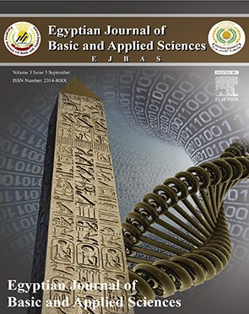 HOSTE D BY

Available online at [www.sciencedirect.com](http://www.sciencedirect.com/science/journal/2314808X)

**ScienceDirect**

journal homepage: [http://ees.elsevier.com/ejbas/default.asp](http://http//ees.elsevier.com/ejbas/default.asp)

**Full Length Article**

**Biosorption of toxic heavy metals from aqueous solution by *Ulva lactuca* activated carbon**



***Wael M. Ibrahim*** ***a******,******\*******, Asad F. Hassan*** ***b******,******c******, Yahia A. Azab*** ***d***

a *Botany Department, Faculty of Science, Damanhour University, Damanhour, Egypt*

b *Chemistry Department, Faculty of Science, Damanhour University, Damanhour, Egypt*

c *Institute of Organic Chemistry and Technology, University of Pardubice, Pardubice, Czech Republic*

d *Botany Department, Faculty of Science, Mansoura University, Mansoura, Egypt*

A R T I C L E I N F O A B S T R A C T

*Article history:*

Received 14 May 2016

Received in revised form 25 June 2016

Accepted 14 July 2016

Available online 19 July 2016

*Keywords:* Marine algae Activated carbon Heavy metals Sorption Isotherm models

Pollution with heavy metals is one of the most severe environmental problems in the world. In this study, the batch adsorption of toxic Cu+2, Cr+3, Cd+2 and Pb+2 ions using marine macroalga *Ulva lactuca* (AP) and its activated carbon (AAC) were examined. The adsorption mecha-

nism of heavy metal ions on AP and AAC was studied using various analytical techniques. The effect of several parameters such as contact time, algal dose, effect of pH, and initial concentration of metal ions on the adsorption process was estimated. The optimum ad- sorption was found to occur at pH 5.0, contact time 60 min, adsorbent dose 0.8 g/L, and initial concentration 60 mg/L. The maximum removal efficiency values of AP and AAC for heavy

metal ions were 64.5 and 84.7 mg/g for Cu+2, 62.5 and 84.6 mg/g for Cd+2, 60.9 and 82 mg/g

for Cr+3, and 68.9 and 83.3 mg/g for Pb+2. This work confirms the potential use of green macroalga *U. lactuca* and its activated carbon for the removal of heavy metals from con-

taminated water.

© 2016 Mansoura University. Production and hosting by Elsevier B.V. This is an open access article under the CC BY-NC-ND license (<http://creativecommons.org/licenses/by->

nc-nd/4.0/).

## Introduction

Heavy metal pollution is a severe environmental issue and rep- resents a threat to human beings and ecosystem [1,2]. Unlike organic contaminants, heavy metals such as chromium, cadmium, copper and lead are main pollutants of freshwater

[3] due to their carcinogenic and persistent nature [4].

The main sources of these heavy metals into the ecosys- tem through wastewater streams are electroplating, smelting,

paint pigments, batteries, mining operations and agriculture sector [5,6]. Because of their toxic nature, most heavy metals cause several health problems like kidney damage, brain func- tion disorders and nervous system deteriorations [7,8]. Their poisonous symptoms are insomnia, irritability, anemia, dizzi- ness and muscles weakness [9].

A number of techniques have been developed for the ad- sorption of heavy metals from wastewater. These techniques include ion exchange, evaporation, chemical precipitation and membrane filtration [10,11]. Activated carbon has obviously been

* Corresponding author.

*E-mail address:* [wms01@fayoum.edu.eg](mailto:wms01@fayoum.edu.eg) (W.M. Ibrahim). <http://dx.doi.org/10.1016/j.ejbas.2016.07.005>

2314-808X/© 2016 Mansoura University. Production and hosting by Elsevier B.V. This is an open access article under the CC BY-NC-ND license ([http://creativecommons.org/licenses/by-nc-nd/4.0/).](http://creativecommons.org/licenses/by-nc-nd/4.0/))

the greatest and widely used material for treatment of waste- water pollution. However, materials used for preparation of higher quality activated carbon cost greater [12]. Searching for low cost activated carbon resources is of great importance in the removal of heavy metals from wastewater [13–15].

Marine algae possess good metal biosorption capabilities due to the existence of active functional groups on the surface of their cell walls. The application of marine macroalgae as ac- tivated carbon materials has numerous advantages including low cost, extensive availability and high metal binding effi- ciency [16].

The aim of this work is to estimate the adsorption perfor- mance of *Ulva lactuca* for the removal of heavy metals from wastewater. Furthermore, this is the first study to determine the biosorption efficiency of KOH-activated carbon based on

locally marine macroalga *U. lactuca* for toxic Cu+2, Cd+2, Cr+3 and Pb+2 ions and to identify the major parameters affecting its

biosorption. In addition, Langmuir isotherm equation was em- ployed to quantify the biosorption equilibrium.

## Materials and methods

### *Preparation of adsorbents*

#### *Metal ion solutions*

Stock solutions (1000 mg/L) of tested heavy metals were pre- pared by dissolving CuSO4.5H2O, Cd(NO3)2.4H2O, Cr(NO3)3.9H2O and Pb(NO3)2 (analytical grade) in deionized water. The working solution was prepared by diluting stock solution to appropri- ate volumes.

#### *Preparation of algal powder (AP)*

The marine alga *U. lactuca* was collected from the Mediterra- nean Sea coast (Fig. 1a), Egypt, during spring season (April, 2014). The alga was washed with tap water and distilled water. The washed alga was oven dried at 60 °C for 24 h. The dried algal materials were ground using a Retsch ZM200 titanium mill. The powdered materials were used as adsorbents after sieving to obtain 0.1–0.2 mm particles.

#### *Textural characterization*

Total pore volume (mL/g), total surface area (m2/g) and pore radius (Å) were performed via nitrogen adsorption at −196 °C for AP and AAC using Quantachrome gas sorption analyzer (NOVA2000, USA).

#### *FTIR spectroscopy*

Fourier transform infrared spectra (FTIR) were recorded for AP and AAC on a Mattson 5000 FTIR spectrometer (UK).

### *Adsorption procedure*

#### *Effect of pH*

During the study of pH effect, the parameters of initial metal concentration, algal dosage, and shaking time were fixed at 10 mg/L, 0.1 g and 120 min, respectively. Effects of pH were tested at pH value 2, 3, 4, 5, 6, 7 and 8.

#### *Effect of biomass dosage*

This experiment was achieved to verify the effect of biomass weight on the sorption process. Different weights of biomass (0.2, 0.4, 0.6, 0.8 and 1.0 g/L) were mixed and shaken with a so- lution of 10 mg/L at pH 5 for 120 min.

#### *Effect of contact time*

Constant weights of AP and AAC (0.4g) were added to 10 mg/L heavy metal solution. Contact times were fixed at t = 5, 10, 20, 60 and 120 min. The solutions were filtered after each contact time and analyzed by atomic absorption spectrophotometer.

#### *Effect of initial heavy metal ions concentration*

In order to assess the effect of initial metal concentration on the adsorption, different metal concentrations of 5, 10, 20, 30,

40, 50, 60, 70 and 80 mg/L were examined at constant param- eters; pH 5 with 0.6 g/L of biosorbent for 60 min.

#### *Metal removal efficiency*

Biosorption capacity (qe), the amount of metal adsorbed per gram of biosorbent, can be calculated in mg/g as follows:

#### *Preparation of algal activated carbon (AAC)*

The dried algal material was carbonized at 600 °C for 3 h in a

qe  Co  Ce  Vm

(1)

stainless steel reactor tube (40 × 600 mm). The sample was soaked in potassium hydroxide for 48 h (potassium hydrox- ide: carbonized sample in ratio of 3:1). The sample was calcined at 800 °C for 3 h. The produced activated carbon was washed several times with distilled water until a neutral filtrate was obtained. The washed samples were stored for adsorption

where C0 is the initial metal ions concentration (mg/L), Ce is the equilibrium concentration of metal ions (mg/L), V is the volume of solution (L) and m is the mass of biosorbent (g). Per- centage of metal removal can also be displayed by the percentage of metal removal as follows:

studies after drying at 110 °C [17].

### *Characterization methods*

#### *Scanning electron microscopy (SEM)*

Scanning electron micrographs of AP and AAC were obtained using Quanta 250 FEG (USA). The sample was dried at 110 °C for 4 h then coated by thin layer of gold for charge dissipation.

Metal removal %  100 Co  Ce Co

## Results and discussion

### *Characterization of solid adsorbents*

#### *Scanning electron microscopy (SEM)*

(2)

#### *Thermal gravimetric analysis (TGA)*

TGAs were achieved for AP and AAC by differential thermal ana- lyzer (ShimadzuDTA-50, Japan) up to 800 °C.

Surface morphologies for AP and AAC are shown in Fig. 1. It displays asymmetrical size cavities and the wide distribution of pore size may be due to the drastic effect of KOH at 800 °C

**95**

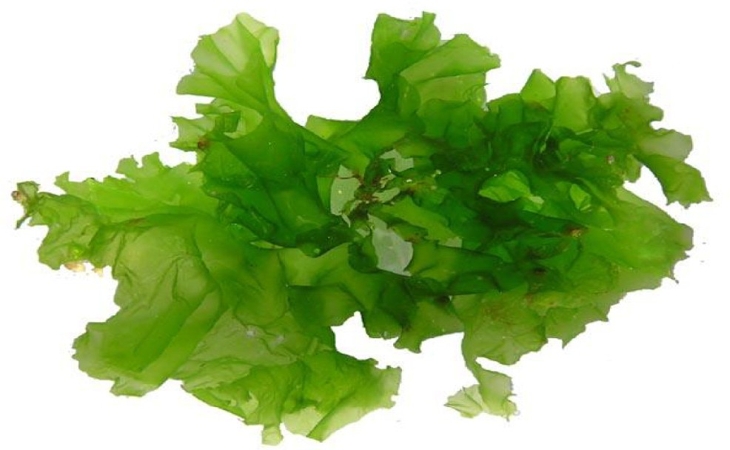

**a**

**AP AAC**

**Weight (%)**

**75**

**55**

**35**

**0 200 400 600 800**

**Temp. oC**

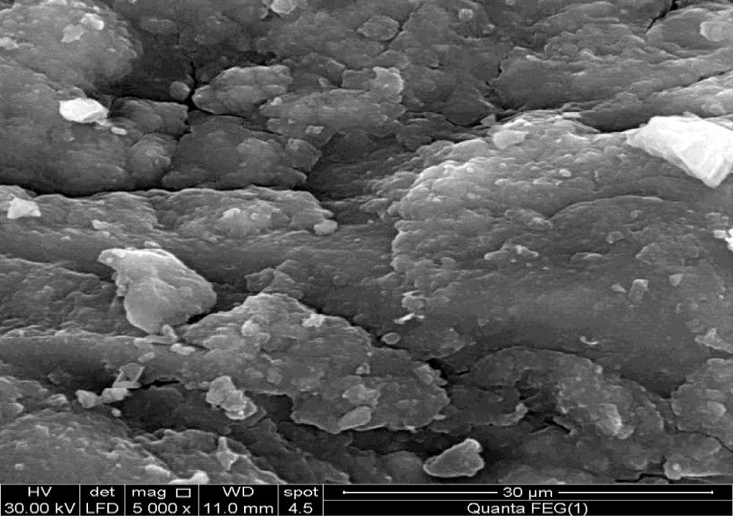**Fig. 2 – Thermogarvimetric analysis of algal powder (AP) and its activated carbon (AAC).**

and incondensable gas (CO2, CH4, H2O, H2) [18,19]. The tem- perature curve over 700 °C showed weight constant at this stage, indicating residual carbon atoms with the ash content of AP.

* + - 1. TGA curve for AAC exhibits high thermal stability com- pared to AP because it was carbonized at higher temperature.
      2. Weight loss at 110 °C due to moisture (7.9%) is higher com- pared with AP (3.6%), indicating the presence of more surface hydrophilic function groups on AAC and its higher surface area accepted by activation [20].

**b**

#### *3.1.3. Nitrogen adsorption parameters*

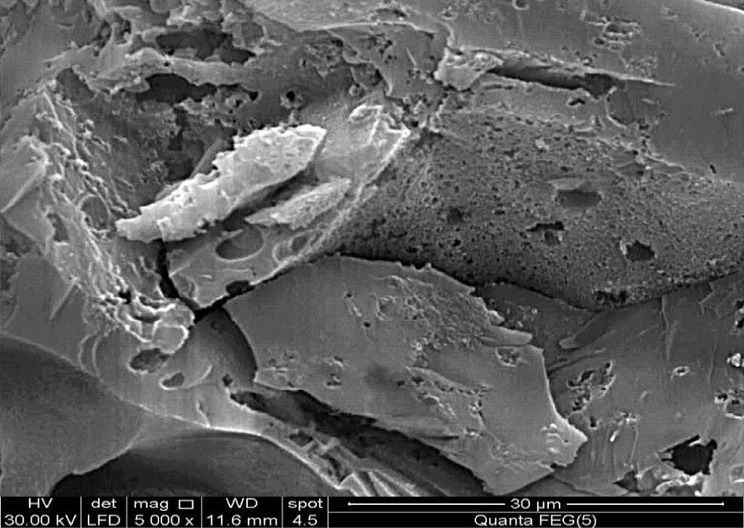Adsorption capacity for algal adsorbent materials is affected directly by surface area and porosity. Table 1 lists the ob- tained data using nitrogen adsorption isotherm at −196 °C [21,22]. Upon inspection of Table 1, it was found that the (i) surface area of AAC (345.4 m2/g) is about 1.8 times more than the surface area of AP (193.9 m2/g), which is related to the in- fluence of KOH as activating agent in the creation of internal surface area due to the formed micropores and the (ii) total pore volume for AAC (0.320 mL/g) is about 2.2 times than that calculated for AP due to the effect of activating agent (KOH), which can create new pores based on the following equation:

2C  6KOH  2K  2K2CO3  3H2

**c**

(3)

**Fig. 1 – Collected marine alga *Ulva lactuca* (a), SEM of dried powder (b) and SEM of KOH-activated carbon (c).**

on AP surface during activation. SEM image for AP exhibits the absence of pores which reflects the small surface area for AP.

#### *Thermogravimetric analysis*

Fig. 2 shows thermogravimetric analysis (TGA) for AP and AAC samples. It indicates that: (i) At lower temperatures (up to 110 °C) for AP as a raw material, the mass loss (≈3.6%) is due to mois- ture removal. The loss of AP weight at higher temperatures (245– 410 °C) may be due to the decomposition of algal organic compounds into condensable gas (methanol and acetic acid)

Equation (3) indicates the production of potassium element, which can mix into the algal powder surface and support the development of high porosity [23].

#### *3.1.4. Surface function groups*

Adsorption capacity of solid adsorbents not only depends on surface area but also on chemical surface function groups.

|  |  |  |  |  |
| --- | --- | --- | --- | --- |
| **Table 1 – Surface area, pore volume and pore radius of**  ***Ulva lactuca* powder (AP) and its activated carbon (AAC).** | | | | |
| Adsorbents | Surface area (m2/g) | Pore volume (mL/g) | Pore radius (Å) | R2 |
| AP | 193.90 | 0.108 | 11.13 | 0.997 |
| AAC | 345.40 | 0.320 | 18.50 | 0.999 |

3425 cm−1 exhibited by AP and AAC, respectively, are due to O—H of phenolic groups. In case of AP, the band located at around 1100 cm−1 is attributed to sulfate group, while the band at 3300– 3500 cm−1 is due to amine N—H stretching and the band around 2500–3000 cm−1 is due to carboxylic acid O—H stretching. In case of AAC, the band located at around 1640 cm−1 could be attrib- uted to C=C stretching for unsaturated aliphatic structures [25]. The band located at 1610–1386 cm−1 is attributed to C=O (ketone, aldehyde and carboxyl). The band located at 2930 cm−1 which is observed with AAC denotes the attendance of methy- lene group [26]. Band at 864 cm−1 was ascribed to alkenes vibrations [27]. From the latter, it is observed that AAC due to activation with KOH is rich with C—O surface function groups compared with the original AP.

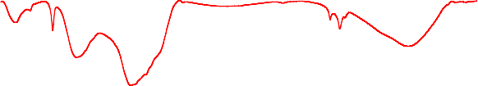

**AP**

**AAC**

**% Transmittance (a.u.)**

**864**

**1035**

**1445**

**1150**

**1430**

**1640**

**2930**

**3425**

**3439**

**500 1000 1500 2000 2500 3000 3500**

**Wave number (cm−1)**

**Fig. 3 – FTIR for *Ulva* powder (AP) and its activated carbon (AAC).**

Infrared is considered as the most useful technique to char- acterize the surface functions of activated carbons [24]. Fig. 3 shows FTIR for AP and AAC. The broad bands at 3439 cm−1 and

### *Adsorption of heavy metals*

#### *Effect of pH*

The algal biomasses contain different groups of amino, hy- droxyl, carboxyl and sulfate on the cell wall, which are affected by changes in the solution pH [28]. The influence of solution pH on the metal ions adsorption capacity was examined at various pH values (2.0 to 8.0) as displayed in Fig. 4. The maximum adsorption of Cd+2 was obtained at pH 4.5, while Cr+3 and Cu+2 exhibited the maximum adsorption capacity at pH

**90 90**



**(Cu+2 )**

**AP**

**AAC**

**(Pb+2 )**

**AP**

**AAC**

**70 70**

**Removal (%)**

**Removal (%)**

**50 50**

**30 30**

**10**

**1 2 3 4 5 6 7 8**

## PH

**10**

**1 2 3 4 5 6 7 8**

## PH

**90 90**



**(Cr+3)**

**AP**

**AAC**

**(Cd+2 )**

**AP**

**AAC**

**70 70**



**Removal (%)**

**Removal (%)**

**50 50**

**30 30**

**10**

**1 2 3 4 5 6 7 8**

## PH

**10**

**1 2 3 4 5 6 7 8**

## PH

**Fig. 4 – Effect of pH on heavy metal biosorption efficiency by *Ulva* powder (AP) and its activated carbon (AAC).**

**12**



**(Cu+2 )**

**AP**

**AAC**

**10**

**8**

**qe (mg/g)**

**6**

**4**

**2**

**0**

**0 0.2 0.4 0.6 0.8 1**

## Algal dosage (g/L)

**12**

**10**



**(Pb+2 )**

**AP**

**AAC**

**8**

**qe (mg/g)**

**6**

**4**

**2**

**0**

**0 0.2 0.4 0.6 0.8 1**

## Algal dosage (g/L)

**12**

**10**

**8**

**qe (mg/g)**

**6**

**4**

**2**

**0**

**0 0.2 0.4 0.6 0.8 1**

## Algal dosage (g/L)

**12**

**10**



**(Cr+3)**

**AP**

**AAC**



**(Cd+2 )**

**AP**

**AAC**

**8**

**qe (mg/g)**

**6**

**4**

**2**

**0**

**0 0.2 0.4 0.6 0.8 1**

## Algal dosage (g/L)

**Fig. 5 – Effect of algal dosage on heavy metal biosorption efficiency by *Ulva* powder (AP) and its activated carbon (AAC).**

5. In case of Pb+2 the removal efficiency was reached to a maximum at pH 6.

At pH value ranging from 2.0 to 4.0, the poor biosorption

of metal ions may be due to the competition with H3O+ ions on active sites for both AP and AAC. At higher solution pH (5.0–

6.0), the electrostatic repulsions between the surface of adsorbents and the positively charged metal ions are de- pressed, which increase the % of metal removal [27,29,30]. The decrease in the adsorption capacity at pH values (6.0–8.0) could be related to the repulsion between the negative charge of anionic species in solution and negative surface charge of the sorbents [31–33].

#### *Effect of adsorbent dosage*

In this work, various quantities of AP and AAC (0.2–1.0 g/L) were contacted with a fixed solution pH 6.0 and initial metal con- centration at 10 mg/L. The amount of metal adsorption qe (mg/ g) against the algal dosage (g/L) is revealed in Fig. 5. For adsorption of metal ions onto AAC, increase adsorbent dosage

from 0.2 to 0.8 g/L is accompanied by an increase in qe (mg/g) from 1.3 to 9.2, 1.5 to 9.3, 1.0 to 8.7 and 0.7 to 7.6 mg/g for Cr+3, Cu+2, Pb+2 and Cd+2, which is comparable to an increase in ad- sorption percentage by 520, 770, 607 and 985%, respectively. The

same trend was observed in case of AP but with lower adsorp- tion percentage due to the higher biosorption efficiency of AAC compared to AP.

The maximum metal adsorption at a higher adsorbent dosage (0.8 g/L) may be due to the higher active sites for AP and AAC which enhance the metal ions uptake [13,34]. With increasing adsorbent load than 0.8 g/L, the quantity of most heavy metal ions adsorbed on the adsorbent qe (mg/g) is more or less constant. High adsorbent amounts are known to cause agglomeration and a consequent reduction in intercellular dis- tance, leading to the protection of binding sites from metal ions [35].

#### *Effects of contact time and adsorption kinetics*

Contact time is the most important factor affecting the efficiency of biosorption. Fig. 6 shows the adsorption of Cu+2, Pb+2, Cr+3 and Cd+2 ions by *U. lactuca* powder (AP) and its activated carbon (AAC) with different contact times (5– 120 min). The adsorption efficiency increases with rise in contact time up to 60 min, after which it is more or less constant. However, the majority of adsorption onto adsorbents was achieved after the first 60 min in case of AP and AAC. Therefore, the optimum contact time was selected as 60 min for further experiments. The higher biosorption at the initial contact time could be related to the driving force of heavy metal ions into the surfaces of AP and AAC and the abundance of active sites on the adsorbent [36,37]. The slow removal capacity with the subsequent time may be due to the diffusion of heavy metal ions into the

**10**



**(Cu+2 )**

**AP**

**AAC**

**8**

**qe (mg/g)**

**6**

**4**

**2**

**0**

**0 20 40 60 80 100 120**

# Contact time (min)

**10**



**(Cr+3 )**

**AAC**

**AP**

**8**

**10**

**8**



**(Pb+2 )**

**AP**

**AAC**

**qe (mg/g)**

**6**

**4**

**2**

**0**

**0 20 40 60 80 100 120**

# Contact time (min)

**10**



**(Cd+2 )**

**AP**

**AAC**

**8**

**6 6**

**qe (mg/g)**

**qe (mg/g)**

**4 4**

**2 2**

**0**

**0 20 40 60 80 100 120**

# Contact time (min)

**0**

**0 20 40 60 80 100 120**

# Contact time (min)

**Fig. 6 – Effect of contact time on heavy metal biosorption efficiency by *Ulva* powder (AP) and its activated carbon (AAC).**

surface of AP and AAC and fewer remaining binding sites [38].

#### *Effect of metal ion concentration on adsorption*

Initial metal ion concentration strongly influences the metal uptake in the adsorption of metal ions. The results in Fig. 7 showed that the biosorption of different metal ions increased at the beginning and reached the maximum of 87.5% and 100% at 60 mg/L for AP and AAC, respectively. After that, with in-

where Ce (mg/L) is the equilibrium concentration, b (L/mg) is Langmuir constant, qe (mg/g) is the amount of algal material, and qm (mg/g) represents the maximum adsorption capacity. A plot of Ce/qe against Ce (Fig. 8) gives a straight line with slope 1/qm and intercept 1/bqm. From the Langmuir equation, the con- stants are calculated in Table 2. Upon inspection of Table 2 the

(i) qm for AAC adsorbent is greater than AP, which is related to the presence of microporosity on the surface of AAC as

creasing metal concentration, the adsorption capacity remained unchanged. This behavior was attributed to the fact that all

|  |  |  |  |
| --- | --- | --- | --- |
| **Table 2 – Langmuir constants for adsorption of heavy metal ions onto algal powder (AP) and its activated carbon (AAC).** | | | |
|  | qe (mg/g) | b (L/mg) | R2 |
| AP |  |  |  |
| Cu+2 | 64.51 | 0.0629 | 0.958 |
| Cd+2 | 62.5 | 0.0330 | 0.897 |
| Cr+3 | 60.91 | 0.0394 | 0.887 |
| Pb+2 | 68.92 | 0.0364 | 0.926 |
| AAC |  |  |  |
| Cu+2 | 84.77 | 0.0513 | 0.959 |
| Cd+2 | 84.61 | 0.0523 | 0.967 |
| Cr+3 | 81.97 | 0.0539 | 0.966 |
| Pb+2 | 83.34 | 0.0535 | 0.968 |

active sites on the surface of algal materials were vacant, re- sulting in high metal adsorption at the beginning. Thereafter, with increasing metal concentration, the removal of metal was decreased due to a few binding sites that were available on the surface of AP and AAC.

The Langmuir adsorption model is the most applied ad- sorption isotherm. A basic assumption of the Langmuir theory is that adsorption takes place at specific homogeneous sites within the adsorbent. Langmuir isotherm was used to char-

acterize the relation between C /q and C (mg/L) according to

the following equation.

*Ce*  1   *Ce*

e e e

(4)

*qe bqm qm*

**80**



**(Cu+2 )**

**AP**

**AAC**

**70**

**60**

**50**

**qe (mg/g)**

**40**

**30**

**20**

**10**

**0**

**0 20 40 60 80**

# Ce (ppm)

**80**

**70**



**(Pb+2 )**

**AP**

**AAC**

**60**

**50**

**qe (mg/g)**

**40**

**30**

**20**

**10**

**0**

**0 20 40 60 80**

# Ce (ppm)

**80**



**(Cr+3)**

**AP**

**AAC**

**70**

**60**

**50**

**qe (mg/g)**

**40**

**30**

**20**

**10**

**0**

**0 20 40 60 80**

# Ce (ppm)

**80**

**70**



**(Cd+2 )**

**AP**

**AAC**

**60**

**50**

**qe (mg/g)**

**40**

**30**

**20**

**10**

**0**

**0 20 40 60 80**

# Ce (ppm)

**Fig. 7 – Effect of metal ion concentration on heavy metal biosorption efficiency by *Ulva* powder (AP) and its activated carbon (AAC).**

indicated by SEM image; and the (ii) correlation coefficient (R2) of AAC ranged from 0.959 to 0.968, indicating the applicabil- ity of Langmuir equation. When the qm values for KOH- activated carbon based *U. lactuca* are compared with previous

work (Table 3), the higher efficiency of KOH-activated carbon to remove about 4.2 times for Cd+2, 3.8 times for Pb+2, 4.5 times

for Cu+2 and 27.1 times for Cr+3 are indicated. This compari-

son demonstrated that activated carbon of macroalga *U. lactuca*

is a potential biosorbent for different heavy metals because of its high maximum adsorption capacity.

## Conclusion

*U. lactuca* powder (AP) and its KOH-activated carbon (AAC) were prepared and characterized for sorption of Cd+2, Cu+2, Cr+3 and

|  |  |  |  |  |  |
| --- | --- | --- | --- | --- | --- |
| **Table 3 – Comparison of adsorption capacity of *Ulva lactuca* for heavy metal ions with different biomasses and other activated carbon.** | | | | | |
| Biosorbent | Cd+2 | Adsorption capacity (mg/g) Pb+2 Cr+3 | | Cu+2 | Reference |
| *Pinus sylvesteris* | 19.1 | 22.2 – | | – | [39] |
| Coconut shell | 7.19 | – | – | – | [40] |
| Oak wood | – | – | 3.03 | – | [41] |
| *Phaseolus* hulls activated carbon | 15.7 | 21.8 – | | 19.5 | [42] |
| Grape lex activated carbon | 58.2 | – | – | – | [43] |
| Bamboo activated carbon | 0.19 | 0.67 | 0.32 | 0.58 | [44] |
| Commercial activated carbon | 25.1 | – | – | – | [45] |
| Granular activated carbon | – | – | 0.99 | – | [46] |
| *Ulva lactuca* (AP) | 62.5 | 68.9 | 60.9 | 64.5 | Present study |
| *Ulva lactuca* (AAC) | 84.6 | 83.3 | 81.9 | 84.7 | Present study |

**1.8**

**1.6**

**1.4**

**1.2**

**Ce /qe**

**1**

**0.8**

**0.6**

**0.4**

**0.2**

**0**



**(Cu+2 )**

**AP AAC**

**Linear (AP)**

**Linear (AAC)**

**0 10 20 30 40 50 60 70 80 90**

## Ce (ppm)

**1.8**

**1.6**

**1.4**

**1.2**

**Ce /qe**

**1**

**0.8**

**0.6**

**0.4**

**0.2**

**0**



**AP**

**(Pb+2 ) AAC**

**Linear (AP) Linear (AAC)**

**0 10 20 30 40 50 60 70 80 90**

## Ce (ppm)

**2**

**1.8**

**1.6**

**1.4**

**1.2**

**Ce /qe**

**1**

**0.8**

**0.6**

**0.4**

**0.2**

**0**



**AP**

**(Cr+3) AAC**

**Linear (AP) Linear (AAC)**

**0 10 20 30 40 50 60 70 80 90**

## Ce (ppm)

**2**

**1.8**

**1.6**

**1.4**

**1.2**

**Ce /qe**

**1**

**0.8**

**0.6**

**0.4**

**0.2**

**0**



**AP**

**(Cd+2 ) AAC**

**Linear (AP) Linear (AAC)**

**0 10 20 30 40 50 60 70 80 90**

## Ce (ppm)

**Fig. 8 – Langmuir adsorption isotherm of heavy metal on *Ulva* powder (AP) and its activated carbon (AAC).**

Pb+2 ions. SEM and nitrogen adsorption indicated the pres- ence of porosity on KOH-activated carbon more than its precursor powder. TGA exhibited thermal instability in the case of *U. lactuca* when compared with KOH-activated carbon and the presence of chemical function groups on both adsorbents was illustrated by FTIR. The optimum adsorption condition was found to occur at around pH 5.0, contact time 60 min, adsor- bent dose 0.8 g/L, and initial concentration 60 mg/L. KOH- activated carbon was found to be more efficient than algal powder in removing heavy metal. Finally, it was concluded that KOH-activated carbon based *U. lactuca* can be used as an ef- fective technology for removal of metal ions from contaminated environment.

R E F E R E N C E S

1. [Aneja RK, Chaudhary G, Ahluwalia SS, Goyal D. Biosorption](http://refhub.elsevier.com/S2314-808X(16)30023-9/sr0010) [of Pb2+ and Zn2+ by non-living biomass of *Spirulina* sp. Indian](http://refhub.elsevier.com/S2314-808X(16)30023-9/sr0010) [J Microbiol 2010;50:438–42.](http://refhub.elsevier.com/S2314-808X(16)30023-9/sr0010)
2. [Nowrouzi M, Mansouri B, Nabizadeh S, Pourkhabbaz A.](http://refhub.elsevier.com/S2314-808X(16)30023-9/sr0015) [Analysis of heavy metals concentration in water and](http://refhub.elsevier.com/S2314-808X(16)30023-9/sr0015) [sediment in the Hara biosphere reserve, southern Iran.](http://refhub.elsevier.com/S2314-808X(16)30023-9/sr0015) [Toxicol Ind Health 2014;30(1):64–72.](http://refhub.elsevier.com/S2314-808X(16)30023-9/sr0015)
3. [Babarinde NAA, Babalola JO, Sanni RA. Biosorption of lead](http://refhub.elsevier.com/S2314-808X(16)30023-9/sr0020) [ions from aqueous solution by maize leaf. Int J Phys Sci](http://refhub.elsevier.com/S2314-808X(16)30023-9/sr0020) [2006;1:23–8.](http://refhub.elsevier.com/S2314-808X(16)30023-9/sr0020)
4. [Bilal M, Shah JA, Ashfaq T, Gardazi SMH, Tahir AA, Pervez A,](http://refhub.elsevier.com/S2314-808X(16)30023-9/sr0025) [et al. Waste biomass adsorbents for copper removal from](http://refhub.elsevier.com/S2314-808X(16)30023-9/sr0025)

[industrial wastewater – a review. J Hazard Mater](http://refhub.elsevier.com/S2314-808X(16)30023-9/sr0025) [2013;263:322–9.](http://refhub.elsevier.com/S2314-808X(16)30023-9/sr0025)

1. [Mousavi HZ, Seyedi SR. Nettle ash as a low cost adsorbent](http://refhub.elsevier.com/S2314-808X(16)30023-9/sr0030) [for the removal of nickel and cadmium from wastewater. Int](http://refhub.elsevier.com/S2314-808X(16)30023-9/sr0030) [J Environ Sci Technol 2011;8(1):195–202.](http://refhub.elsevier.com/S2314-808X(16)30023-9/sr0030)
2. [Ibrahim WM, Mutawie HH. Bioremoval of heavy metals from](http://refhub.elsevier.com/S2314-808X(16)30023-9/sr0035) [industrial effluent by fixed-bed column of red macroalgae.](http://refhub.elsevier.com/S2314-808X(16)30023-9/sr0035) [Toxicol Ind Health 2013;29(1):38–42.](http://refhub.elsevier.com/S2314-808X(16)30023-9/sr0035)
3. [Lee JC, Son YO, Pratheeshkumar P, Shi XL. Oxidative stress](http://refhub.elsevier.com/S2314-808X(16)30023-9/sr0040) [and metal carcinogenesis. Free Radic Biol Med J 2012;53:742–](http://refhub.elsevier.com/S2314-808X(16)30023-9/sr0040) [57.](http://refhub.elsevier.com/S2314-808X(16)30023-9/sr0040)
4. [Lung S, Li H, Bondy SC, Campbell A. Low concentrations of](http://refhub.elsevier.com/S2314-808X(16)30023-9/sr0045) [copper in drinking water increase AP-1 binding in the brain.](http://refhub.elsevier.com/S2314-808X(16)30023-9/sr0045) [Toxicol Ind Health 2015;31:1178–84.](http://refhub.elsevier.com/S2314-808X(16)30023-9/sr0045)
5. [Fu F, Wang Q. Removal of heavy metal ions from](http://refhub.elsevier.com/S2314-808X(16)30023-9/sr0050) [wastewaters: a review. J Environ Manage 2011;92:407–18.](http://refhub.elsevier.com/S2314-808X(16)30023-9/sr0050)
6. [Xu Y, Chen Y. Leaching heavy metals in municipal solid](http://refhub.elsevier.com/S2314-808X(16)30023-9/sr0055) [waste incinerator fly ash with chelator/biosurfactant mixed](http://refhub.elsevier.com/S2314-808X(16)30023-9/sr0055) [solution. Waste Manag Res 2015;33(7):652–61.](http://refhub.elsevier.com/S2314-808X(16)30023-9/sr0055)
7. [Zhang S, Zhang X, Xiong Y, Wang G, Zheng N. Effective](http://refhub.elsevier.com/S2314-808X(16)30023-9/sr0060) [solidification/stabilisation of mercury-contaminated wastes](http://refhub.elsevier.com/S2314-808X(16)30023-9/sr0060) [using zeolites and chemically bonded phosphate ceramics.](http://refhub.elsevier.com/S2314-808X(16)30023-9/sr0060) [Waste Manag Res 2015;33(2):183–90.](http://refhub.elsevier.com/S2314-808X(16)30023-9/sr0060)
8. [Babel S, Kurmiawan TA. Low-cost adsorbents for heavy](http://refhub.elsevier.com/S2314-808X(16)30023-9/sr0065) [metals uptake from contaminated water: a review. J Hazard](http://refhub.elsevier.com/S2314-808X(16)30023-9/sr0065) [Mater 2003;B97:219–43.](http://refhub.elsevier.com/S2314-808X(16)30023-9/sr0065)
9. [El-Sikaily A, El Nemr A, Khaled A, Abdelwehab O. Removal of](http://refhub.elsevier.com/S2314-808X(16)30023-9/sr0070) [toxic chromium from wastewater using green alga *Ulva*](http://refhub.elsevier.com/S2314-808X(16)30023-9/sr0070)[*lactuca* and its activated carbon. J Hazard Mater](http://refhub.elsevier.com/S2314-808X(16)30023-9/sr0070) [2007;148:216–28.](http://refhub.elsevier.com/S2314-808X(16)30023-9/sr0070)
10. [Johari K, Alias AS, Saman N, Song ST, Mat H. Removal](http://refhub.elsevier.com/S2314-808X(16)30023-9/sr0075) [performance of elemental mercury by low-cost adsorbents](http://refhub.elsevier.com/S2314-808X(16)30023-9/sr0075)

prepared through facile methods of carbonization and activation of coconut husk. Waste Manag Res 2015;33(1):81– [8.](http://refhub.elsevier.com/S2314-808X(16)30023-9/sr0075)

1. [Kim K, Lee H, Kim BS, Hwang S, Kwac L, An K, et al.](http://refhub.elsevier.com/S2314-808X(16)30023-9/sr0080) [Preparation and thermal properties of polyethylene-based](http://refhub.elsevier.com/S2314-808X(16)30023-9/sr0080) [carbonized fibers. Carbon Lett 2015;16(1):62–6.](http://refhub.elsevier.com/S2314-808X(16)30023-9/sr0080)
2. [Apiratikul R, Pavasant P. Batch and column studies of](http://refhub.elsevier.com/S2314-808X(16)30023-9/sr0085) [biosorption of heavy metals by *Caulerpa lentillifera*. Bioresour](http://refhub.elsevier.com/S2314-808X(16)30023-9/sr0085) [Technol 2008;99:2766–77.](http://refhub.elsevier.com/S2314-808X(16)30023-9/sr0085)
3. [Ibrahim WM, Salim EH, Azab YA, Ismail AM. Monitoring and](http://refhub.elsevier.com/S2314-808X(16)30023-9/sr0090) [removal of cyanobacterial toxins from drinking water by](http://refhub.elsevier.com/S2314-808X(16)30023-9/sr0090) [algal-activated carbon. Toxicol Ind Health 2015;doi:10.1177/](http://refhub.elsevier.com/S2314-808X(16)30023-9/sr0090) [0748233715583203.](http://refhub.elsevier.com/S2314-808X(16)30023-9/sr0090)
4. [Kang S, Jian CJ. Preparation and characterization of activated](http://refhub.elsevier.com/S2314-808X(16)30023-9/sr0095) [carbon from rubber-seed shell by physical activation with](http://refhub.elsevier.com/S2314-808X(16)30023-9/sr0095) [steam. Biomass Bioenergy 2010;34:539–44.](http://refhub.elsevier.com/S2314-808X(16)30023-9/sr0095)
5. [Hassan AF, Youssef AM. Preparation and characterization of](http://refhub.elsevier.com/S2314-808X(16)30023-9/sr0100) [microporous NaOH-activated carbons from hydrofluoric acid](http://refhub.elsevier.com/S2314-808X(16)30023-9/sr0100) [leached rice husk and its application for lead(II) adsorption.](http://refhub.elsevier.com/S2314-808X(16)30023-9/sr0100) [Carbon Lett 2014;15(1):57–67.](http://refhub.elsevier.com/S2314-808X(16)30023-9/sr0100)
6. [Hui TS, Zaini MAA. Potassium hydroxide activation of](http://refhub.elsevier.com/S2314-808X(16)30023-9/sr0105) [activated carbon: a commentary. Carbon Lett 2015;16(4):275–](http://refhub.elsevier.com/S2314-808X(16)30023-9/sr0105) [80.](http://refhub.elsevier.com/S2314-808X(16)30023-9/sr0105)
7. [Brunauer S, Deming LS, Deming WE, Teller E. J Am Chem Soc](http://refhub.elsevier.com/S2314-808X(16)30023-9/sr0110) [1940;62:1723–32.](http://refhub.elsevier.com/S2314-808X(16)30023-9/sr0110)
8. [Hassan AF, Youssef AM, Priecel P. Removal of deltamethrin](http://refhub.elsevier.com/S2314-808X(16)30023-9/sr0115) [insecticide over highly porous activated carbon prepared](http://refhub.elsevier.com/S2314-808X(16)30023-9/sr0115) [from pistachio nutshells. Carbon Lett 2013;14(4):234–42.](http://refhub.elsevier.com/S2314-808X(16)30023-9/sr0115)
9. [Castello DL, Carlo JM, Amoros DC, Solano AL. Carbon](http://refhub.elsevier.com/S2314-808X(16)30023-9/sr0120) [activation with KOH as explored by temperature](http://refhub.elsevier.com/S2314-808X(16)30023-9/sr0120) [programmed techniques, and the effect of hydrogen. Carbon](http://refhub.elsevier.com/S2314-808X(16)30023-9/sr0120) [2007;45:25–9.](http://refhub.elsevier.com/S2314-808X(16)30023-9/sr0120)
10. [Yang T, Lua AC. Characteristics of activated carbons](http://refhub.elsevier.com/S2314-808X(16)30023-9/sr0125) [prepared from pistachio-nut shells by physical activation. J](http://refhub.elsevier.com/S2314-808X(16)30023-9/sr0125) [Colloid Interface Sci 2003;267:408–17.](http://refhub.elsevier.com/S2314-808X(16)30023-9/sr0125)
11. [Shindo A, Izumino K. Structural variation during pyrolysis of](http://refhub.elsevier.com/S2314-808X(16)30023-9/sr0130) [furfuryl alcohol and furfural-furfuryl alcohol resins. Carbon](http://refhub.elsevier.com/S2314-808X(16)30023-9/sr0130) [1994;32(7):1233–43.](http://refhub.elsevier.com/S2314-808X(16)30023-9/sr0130)
12. [El Nemr A, El-Sikaily A, Khaled A, Abdelwahab O. Removal of](http://refhub.elsevier.com/S2314-808X(16)30023-9/sr0135) [toxic chromium from aqueous solution, wastewater and](http://refhub.elsevier.com/S2314-808X(16)30023-9/sr0135) [saline water by marine red alga *Pterocladia capillacea* and its](http://refhub.elsevier.com/S2314-808X(16)30023-9/sr0135) [activated carbon. Arabian J Chem 2015;8:105–16.](http://refhub.elsevier.com/S2314-808X(16)30023-9/sr0135)
13. [Hassan AF, Abdel-Mohsen AM, Fouda MMG. Comparative](http://refhub.elsevier.com/S2314-808X(16)30023-9/sr0140) [study of calcium alginate, activated carbon, and their](http://refhub.elsevier.com/S2314-808X(16)30023-9/sr0140) [composite beads on methylene blue adsorption. Carbohydr](http://refhub.elsevier.com/S2314-808X(16)30023-9/sr0140) [Polym 2014;102:192–8.](http://refhub.elsevier.com/S2314-808X(16)30023-9/sr0140)
14. [Sari A, Tuzen M. Biosorption of Pb(II) and Cd(II) from](http://refhub.elsevier.com/S2314-808X(16)30023-9/sr0145) [aqueous solution using green alga (*Ulva lactuca*) biomass. J](http://refhub.elsevier.com/S2314-808X(16)30023-9/sr0145) [Hazard Mater 2008;152:302–8.](http://refhub.elsevier.com/S2314-808X(16)30023-9/sr0145)
15. [Ibrahim WM. Biosorption of heavy metal ions from aqueous](http://refhub.elsevier.com/S2314-808X(16)30023-9/sr0150) [solution by red macroalgae. J Hazard Mater 2011;192:1827–](http://refhub.elsevier.com/S2314-808X(16)30023-9/sr0150) [35.](http://refhub.elsevier.com/S2314-808X(16)30023-9/sr0150)
16. [Momcˇilovic´ M, Purenovic´ M, Bojic´ A, Zarubica A, Rand¯elovic´](http://refhub.elsevier.com/S2314-808X(16)30023-9/sr0155)

[M. Removal of lead(II) ions from aqueous solutions by](http://refhub.elsevier.com/S2314-808X(16)30023-9/sr0155) [adsorption onto pine cone activated carbon. Desalination](http://refhub.elsevier.com/S2314-808X(16)30023-9/sr0155) [2011;276(53):doi:10.1016/j.desal.2011.03.013.](http://refhub.elsevier.com/S2314-808X(16)30023-9/sr0155)

1. [Kumar YP, King P, Prasad VSRK. Removal of copper from](http://refhub.elsevier.com/S2314-808X(16)30023-9/sr0160) [aqueous solution using *Ulva fasciata* sp. A marine green](http://refhub.elsevier.com/S2314-808X(16)30023-9/sr0160) [algae. J Hazard Mater 2006;137:367–73.](http://refhub.elsevier.com/S2314-808X(16)30023-9/sr0160)
2. [Escudero C, Fiol N, Villaescusa I, Bollinger JC. Arsenic](http://refhub.elsevier.com/S2314-808X(16)30023-9/sr0165) [removal by a waste metal (hydr)oxide entrapped into](http://refhub.elsevier.com/S2314-808X(16)30023-9/sr0165) [calcium alginate beads. J Hazard Mater 2009;164(2–3):](http://refhub.elsevier.com/S2314-808X(16)30023-9/sr0165) [533–41.](http://refhub.elsevier.com/S2314-808X(16)30023-9/sr0165)
3. [Esmaeili A, Beni AA. Biosorption of nickel and cobalt from](http://refhub.elsevier.com/S2314-808X(16)30023-9/sr0170) [plant effluent by *Sargassum glaucescens* nanoparticles at new](http://refhub.elsevier.com/S2314-808X(16)30023-9/sr0170) [membrane reactor. Int J Environ Sci Technol 2015;12:2055–64.](http://refhub.elsevier.com/S2314-808X(16)30023-9/sr0170)
4. [Aravindhan R, Fathima NN, Rao JR, Nair BU. Equilibrium and](http://refhub.elsevier.com/S2314-808X(16)30023-9/sr0175) [thermodynamic studies on the removal of basic black dye](http://refhub.elsevier.com/S2314-808X(16)30023-9/sr0175) [using calcium alginate beads. Colloids Surf A 2007;299:232.](http://refhub.elsevier.com/S2314-808X(16)30023-9/sr0175)
5. [El-Sikaily A, El Nemer A, Khaled A. Copper sorption onto](http://refhub.elsevier.com/S2314-808X(16)30023-9/sr0180) [dried red alga *Pterocladia capillacea* and its activated carbon.](http://refhub.elsevier.com/S2314-808X(16)30023-9/sr0180) [Chem Eng J 2011;168:707–14.](http://refhub.elsevier.com/S2314-808X(16)30023-9/sr0180)
6. [Aroua MK, Leong SPP, Teo LY, Yin CY, Daud WMAW. Real-](http://refhub.elsevier.com/S2314-808X(16)30023-9/sr0185) [time determination of kinetics of adsorption of lead(II) onto](http://refhub.elsevier.com/S2314-808X(16)30023-9/sr0185) [palm shell-based activated carbon using ion selective](http://refhub.elsevier.com/S2314-808X(16)30023-9/sr0185) [electrode. Bioresour Technol 2008;99:5786.](http://refhub.elsevier.com/S2314-808X(16)30023-9/sr0185)
7. [Wu Y, Zhang S, Guo X, Huang H. Adsorption of chromium(III)](http://refhub.elsevier.com/S2314-808X(16)30023-9/sr0190) [on lignin. Bioresour Technol 2008;99:7709.](http://refhub.elsevier.com/S2314-808X(16)30023-9/sr0190)
8. [Li Y, Du Q, Wang X, Zhang P, Wang D, Wang Z, et al. Removal](http://refhub.elsevier.com/S2314-808X(16)30023-9/sr0195) [of lead from aqueous solution by activated carbon prepared](http://refhub.elsevier.com/S2314-808X(16)30023-9/sr0195) [from *Enteromorpha prolifera* by zinc chloride activation. J](http://refhub.elsevier.com/S2314-808X(16)30023-9/sr0195) [Hazard Mater 2010;183:583.](http://refhub.elsevier.com/S2314-808X(16)30023-9/sr0195)
9. [Costodes VCT, Fauduet H, Porte C, Delacroix A. Removal of](http://refhub.elsevier.com/S2314-808X(16)30023-9/sr0200) [Cd(II) and Pb(II) ions from aqueous solutions by adsorption](http://refhub.elsevier.com/S2314-808X(16)30023-9/sr0200) [onto sawdust of *Pinus sylvestris*. J Hazard Mater 2003;105:121–](http://refhub.elsevier.com/S2314-808X(16)30023-9/sr0200) [42.](http://refhub.elsevier.com/S2314-808X(16)30023-9/sr0200)
10. [Vázquez G, Sonia Freire M, González-Álvarez J, Antorrena G.](http://refhub.elsevier.com/S2314-808X(16)30023-9/sr0205) [Equilibrium and kinetic modelling of the adsorption of Cd2+](http://refhub.elsevier.com/S2314-808X(16)30023-9/sr0205) [ions onto chestnut shell. Desalination 2009;249:855–60.](http://refhub.elsevier.com/S2314-808X(16)30023-9/sr0205)
11. [Mohan D, Rajput S, Singh VK, Steele PH, Pittman CU.](http://refhub.elsevier.com/S2314-808X(16)30023-9/sr0210) [Modeling and evaluation of chromium remediation from](http://refhub.elsevier.com/S2314-808X(16)30023-9/sr0210) [water using low cost bio-char, a green adsorbent. J Hazard](http://refhub.elsevier.com/S2314-808X(16)30023-9/sr0210) [Mater 2011;188(1–3):319–33.](http://refhub.elsevier.com/S2314-808X(16)30023-9/sr0210)
12. [Rao MM, Ramana DK, Seshaiah K, Wang MC, Chien SW.](http://refhub.elsevier.com/S2314-808X(16)30023-9/sr0215) [Removal of some metal ions by activated carbon prepared](http://refhub.elsevier.com/S2314-808X(16)30023-9/sr0215) [from *Phaseolus aureus* hulls. J Hazard Mater 2009;166(2–](http://refhub.elsevier.com/S2314-808X(16)30023-9/sr0215) [3):1006–13.](http://refhub.elsevier.com/S2314-808X(16)30023-9/sr0215)
13. [Sardella F, Gimenez M, Navas C, Morandi C, Deiana C, Sapag](http://refhub.elsevier.com/S2314-808X(16)30023-9/sr0220)

[K. Conversion of viticultural industry wastes into activated](http://refhub.elsevier.com/S2314-808X(16)30023-9/sr0220) [carbons for removal of lead and cadmium. J Environ Chem](http://refhub.elsevier.com/S2314-808X(16)30023-9/sr0220) Eng 2014;<<http://dx.doi.org/10.1016/j.jece.2014.06.026>>.

1. [Lo SF, Wang SY, Tsai MJ, Lin LD. Adsorption capacity and](http://refhub.elsevier.com/S2314-808X(16)30023-9/sr0225)

[removal efficiency of heavy metal ions by Moso and Ma](http://refhub.elsevier.com/S2314-808X(16)30023-9/sr0225) [bamboo activated carbons. Chem Eng Res Des 2012;90:1397–](http://refhub.elsevier.com/S2314-808X(16)30023-9/sr0225) [406.](http://refhub.elsevier.com/S2314-808X(16)30023-9/sr0225)

1. [Bian Y, Bian Z, Zhang J, Ding A, Liu S, Zheng L, et al.](http://refhub.elsevier.com/S2314-808X(16)30023-9/sr0230) [Adsorption of cadmium ions from aqueous solutions by](http://refhub.elsevier.com/S2314-808X(16)30023-9/sr0230) [activated carbon with oxygen-containing functional groups.](http://refhub.elsevier.com/S2314-808X(16)30023-9/sr0230) [Chin J Chem Eng 2015;23:1705–11.](http://refhub.elsevier.com/S2314-808X(16)30023-9/sr0230)
2. [Choi HD, Cho JM, Baek K, Yang JS, Lee JY. Influence of](http://refhub.elsevier.com/S2314-808X(16)30023-9/sr0235) [cationic surfactant on adsorption of Cr onto activated](http://refhub.elsevier.com/S2314-808X(16)30023-9/sr0235) [carbon. J Hazard Mater 2009;161(2–3):1565–8.](http://refhub.elsevier.com/S2314-808X(16)30023-9/sr0235)