

[Electronic Notes in Theoretical Computer Science 268 (2010) 17–29](http://dx.doi.org/10.1016/j.entcs.2010.12.003)

[www.elsevier.com/locate/entcs](http://www.elsevier.com/locate/entcs)

Bone Remodelling in BioShape

F. Buti, D. Cacciagrano, F. Corradini, E. Merelli, L. Tesei1*,*2

*School of Science and Technology University of Camerino*

*Via Madonna delle Carceri 9, 62032 Camerino, Italy*

M. Pani3

*Laboratory of Medical Technology Rizzoli Orthopaedic Institute*

*Via Di Barbiano 1/10, 40136 Bologna, Italy*

**Abstract**

Many biological phenomena are inherently multiscale, i.e. they are characterised by interactions involving different scales at the same time. This is the case of bone remodelling, where macroscopic behaviour (at organ and tissue scale) and microstructure (at cell scale) strongly influence each other. Consequently, several approaches have been defined to model such a process at different spatial and temporal levels and, in particular, in terms of continuum properties, abstracting in this way from a realistic - and more complex

- cellular scenario. While a large amount of information is available to validate such models separately, more work is needed to integrate all levels fully in a faithful multiscale model.

In this scenario, we propose the use of BioShape, a 3D particle-based, scale-independent, geometry and space oriented simulator. It is used to define and integrate a cell and tissue scale model for bone remodelling in terms of shapes equipped with perception, interaction and movement capabilities. Their in-silico simu- lation allows for tuning continuum-based tissutal and cellular models, as well as for better understanding - both in qualitative and in quantitative terms - the blurry synergy between mechanical and metabolic factors triggering bone remodelling.

*Keywords:* Particle-based models, Multiscale modelling, Simulation of biological systems, Bone remodelling

# Introduction

Nowadays, it is possible to observe biological systems in great detail: with a light microscope one can distinguish the compartments of a human cell, and with an electron microscope one can even see very small details such as proteins. At the

1 We are very grateful to Marco Viceconti, whose suggestions and discussions have had a lot of influence on this work. This work was partially supported by the Italian FIRB-MIUR LITBIO: *Laboratory for Interdisciplinary Technologies in Bioinformatics*.

2 Email: *{*federico.buti,diletta.cacciagrano,flavio.corradini,emanuela.merelli,luca.tesei*}*

@unicam.it

3 Email: [pani@tecno.ior.it](mailto:pani@tecno.ior.it)

1571-0661 © 2010 Elsevier B.V. Open access under [CC BY-NC-ND license.](http://creativecommons.org/licenses/by-nc-nd/3.0/)

[doi:10.1016/j.entcs.2010.12.003](http://dx.doi.org/10.1016/j.entcs.2010.12.003)

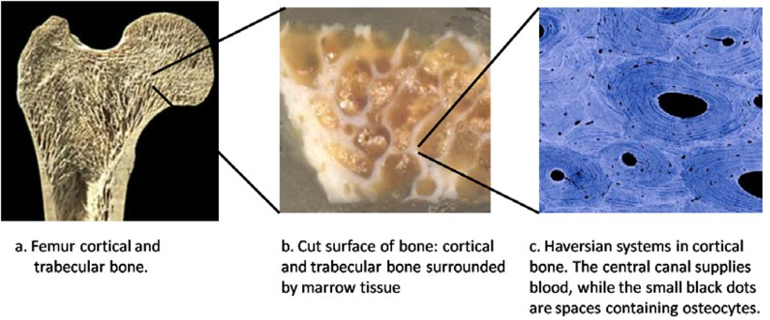

Fig. 1. Multiscale view of a human femur.

same time, models for describing and simulating biological systems have comparable resolution regimes and work on different spatial and temporal scales: in the micro- scopic approach, molecular dynamics and Monte Carlo methods describe systems at the level of atoms or proteins while, in the macroscopic regime, continuum-based simulations model complete biological assemblies (but do not contain any explicit molecular information). Actually, a characteristic of biological complexity is the intimate connection that exists between different length and time scales - from the fast nanometre-length scale of molecules to the slow highly structured meter scale of the whole human body. For instance, subtle changes in molecular structure as a consequence of a single gene mutation can lead to catastrophic failure at the or- gan level, such as heart failure from re-entrant arrhythmias that lead to ventricular fibrillation. But information flows equally in the reverse direction: mechanorecep- tors at the cell level sense the mechanical load on the musculoskeletal system and influence gene expression via signal transduction pathways [21].

* 1. *A case study: the bone remodelling process*

Bone tissue, forming the skeleton, is a remarkable material. Two macroscopically different types are distinguished. The first is *cortical* or compact bone, which is a rather dense tissue although it is penetrated by blood vessels through a network of canaliculi: it is primarily found in the shaft of long bones. The second type is *trabecular* or cancellous bone: it is porous and primarily found near joint surfaces, at the end of long bones and within vertebrae.

Old bone is continuously replaced by new tissue. This ensures that the me- chanical integrity of the bone is maintained, but it causes no global changes in morphology: Frost defined this as *remodelling* [17]. Such a phenomenon can be considered “multiscale” since macroscopic behaviour and microstructure strongly influence each other. Figure 1 highlights such a vision, showing a multiscale view of a human femur.

**Bone remodelling at tissutal scale.** On a macroscopic level, remodelling might be regulated by mechanical loading, allowing bone to adapt its structure in response to the mechanical demands. It is well-known that trabeculae tend to align with maximum stresses in many bones and greatly increase their load-carrying

capacity without increasing mass, thus improving structural efficiency; mechanical stress also improves bone strength by influencing collagen alignment as new bone is being formed [17]. Cortical bone tissue located in regions subject to predominantly tensile stresses has a higher percentage of collagen fibers aligned along the bone long axis. In regions of predominant compressive stresses, fibers are more likely to be aligned transverse to the long axis.

**Bone remodelling at cellular scale** 4 **.** Two main kinds of cells, namely *osteoclasts* (O*c*) and *osteoblasts* (O*b*), closely collaborate in the remodelling process in what is called a *Basic Multicellular Unit* (BMU). The organization of the BMUs in cortical and trabecular bone differs, but these differences are mainly morphological rather than biological.

The remodelling process begins at a quiescent bone surface (either cortical or trabecular) with the appearance of O*c*s, which attach to the bone tissue matrix, form a ruffled border, create an isolated microenvironment, acidify it and dissolve the organic and inorganic matrices of the bone.

Briefly after this resorptive process stops, O*b*s appear at the same surface site, deposit osteoid and mineralize it. Some O*b*s are encapsulated in the osteoid matrix and differentiate to *osteocytes* (O*y*). Remaining O*b*s continue to synthesize bone un- til they eventually stop and transform to quiescent *lining cells* (L*c*) that completely cover the newly formed bone surface and connect with the O*y*s in the bone matrix through a network of canaliculi.

* 1. *The need of homogeneity, space and geometry in multiscale models for bone remodelling*

Bone remodelling was always subject of extensive studies in many fields of research. Much of this research to obtain insight in bone cell biology is based on reduction, i.e. isolating the various components to unravel their individual (and often very com- plex) behaviour, without taking into account how mechanical forces are translated to structural adaptation of the internal cellular architecture [6,18,29,25].

Others approaches completely abstract from the underlying cellular processes, but relate density changes in bone directly to local strain magnitudes: these models are capable of predicting density distributions in the bone as an effect of mechanical loads, ignoring morphology and metabolic activity [32,12,13,20].

Being bone remodelling an inherently multiscale process, it is ascertained that a multiscale modelling approach [21,2,19,30,15] - i.e. a modelling approach link- ing phenomena, models and information between various scales - could be more “faithful” and suitable for an efficient simulation, prediction and control of such a phenomenon.

Indeed, it is well-known that a multiscale model can be more or less “faith- ful” according to what “single-scale” models are taken into account (for each scale) and how they are “homogenized” (i.e. integrated). In particular, homogenization is a very delicate and not so “obvious” task: either when “single-scale” models are

4 For a more detailed description, see <http://courses.washington.edu/bonephys/physremod.html>.

heterogeneous (and, as a consequence, transformation functions between scales are defined as concretions and abstractions, with consequent loss of information), or when the biological systems to model admit different homogenization techniques. From this, it follows that the “faithfulness” of a multiscale model for bone remod- elling depends on the homogeneity level of its “single-scale” models.

Also geometry and space are known to be fundamental when considering some biological scenarios and, hence, could add “faithfulness” to biological models (not only multiscale). Cytoplasm and enzymes are an excellent example. The first contains many distinct compartments, each with its own specific protein set, where localization of molecules can be influenced in many different ways (anchoring to structures like the plasma membrane or the cytoskeleton). The latter, acting in the same pathway, are often found co-localised; as the product of one reaction is the substrate for the next reaction along the pathway, this co-localisation increases substrate availability and concomitantly enhances catalytic activity, by giving rise to increased local concentration of substrates.

# Contribution of the paper: a uniform, particle-based, space and geometry oriented approach for bone re- modelling

Even if quite detailed, the actual knowledge about bone remodelling shows several gaps at different resolution degrees:

* At the tissue level, there are some questions as to whether the orientation of collagen fibers in bone occurs through functional adaptation as the bone is being remodelled or is under genetic influence during development.
* At the cell level, BMU existence indicates that a coupling mechanism must exist between formation and resorption. However the nature of this coupling mecha- nism is not known.
* At inter-scale level, it is not so clear how mechanical forces can be expressed in cell activities and whether mechanical forces are enough to explain remodelling. The pathways by which mechanical forces are expressed in O*b* and O*c* activity is currently one of the main unresolved issues in bone mechanobiology. The current concept is that the bone architecture is controlled by a local regulatory mechanism by local regulators and hormones, such as insulin-like growth factors (IGFs), cytokines interleukin-1 (IL-1), interleukin-6 (IL-6) and RANKL (RANK- ligand). However, this theory does not specify the cellular level mechanisms behind the remodelling process. In other words, it does not describe how local mechanical signals are detected, nor how they are translated to bone formation and resorption.

O*y*s may play an important role here. Several studies revealed that these cells

respond to mechanical stimulation [22]. Together with the L*c*s, they form a system that seems well equipped for signal transduction [14]. It could be that mechanically induced O*y* signals are transferred through the canaliculi to the bone

surface where they control O*b* and O*c* activity [8]. Whether this is true remains to be proven.

Our investigation tries to fill and clarify the above knowledge gaps, taking into account the above observations about the homogeneity, space and geometry rel- evance in multiscale modelling approaches. At this end, our study fully pivots on BioShape [9], a spatial 3D simulator which has been engineered in the per- spective to be a *uniform*, *particle-based*, *space-* and *geometry-oriented* multiscale modelling and simulation environment (see Sec. 3). A derived and important fea- ture of BioShape’s modelling approach is the *scale-independence* property: this is a consequence of the uniform way biological entities of any size are treated, i.e. as geometric *shapes*, equipped with perception, interaction and movement capabilities. All BioShape’s properties, both primary and derived, are crucial to face the objectives of our study: shapes allows us to define two models - one for the tis- sutal and one for the cellular scale - only based on particles; space and geometry permit to faithful enrich both models; scale-independence enables the definition of transformation functions linking such models without information loss, being them homogeneous representations at different granularity (i.e. zoom resolution) of the

same biological system (see Sec. 4).

To improve the predictiveness of the cellular and tissutal models we propose, we plan to tune and validate them taking into account experimental data as well as those produced by some available continuum-based descriptions of bone remod- elling [6,18,29,25,32,12,13,20]. We also plan to realize such tuning and validation procedures in the opposite direction, i.e. using the more detailed description level of our particle-based cellular model to validate only continuum-based tissutal models [32,12,13,20].

The tuning will mainly rely on dynamic parameter estimation, largely based on experimental datasets. More in details, the parameter estimation will be conducted by using animal datasets at cellular level, while the model validation will be relied on human clinical observations at tissutal level.

Our believe is that particle-based tissutal and cellular views of bone remodelling turn to be helpful (i) to better understand the blurry synergy between mechani- cal and metabolic factors triggering bone remodelling, both in qualitative and in quantitative terms, and (ii) to develop a coherent theory for the phenomenon as modulated by mechanical forces and metabolic factors in a uniform way.

# A short introduction to BioShape

A complete description of BioShape can be found in [9]. In the following, we only give a short description about its conceptual and architectural features.

BioShape is a spatial 3D simulator which has been engineered in the perspective to be a *uniform*, *particle-based*, *space-* and *geometry-oriented* multiscale modelling environment. Such properties result from well-defined conceptual choices already present in [16] and in [23], where respectively decomposing biological systems into a hierarchical aggregation of uniform “single-scale” models is shown to be a good

methodology to bypass homogenization problems (in [16]), and where particle-based approaches are proved to be “equivalent” to continuum-based ones, in some cases more faithful, more suitable to scale on different granularity levels and to be enriched with geometric and spatial information (in [23]).

BioShape is *scale-independent*, since it treats biological entities of any size

simply as geometric *shapes*, equipped with perception, interaction and movement capabilities. In detail, every element involved in the simulated process is defined as a 3D element with a series of information defining its structure and its spatial position; complex entities as well as simple ones can be modelled on the basis of common geometrical forms, so that all the possible biological actors can be introduced in the simulated environment (from ions to molecules, cellular organelles and so on, up to higher spatial scales).

Every entity has associated its physical movement law; this feature is particu- larly important as different are the inter-scale effects that can occur in a biological environment an so different are the physical forces involved in biological processes. Most of all this approach guarantees granularity in entities management as everyone is treated independently from the other ones.

The behaviour of every entity, i.e. the way it interacts with other entities and with the environment, is formally defined through a process algebra approach: namely, the *Shape Calculus* [3], a formal language for representing shape struc- ture and behaviour in a given 3D environment. Such a language can be considered the core “assembly” language of the simulator. It defines, among the other things, the way entities bind and react. As a consequence, a two-phase collision detection algorithm is defined in order to establish whether shapes collide in order to possibly interact and bind to construct new shapes.

Since BioShape is suited to describe any scale at different spatial granularity, transformation functions between (homogeneous) particle-based representations re- duce to mappings between different granularity instances of the same model. These mappings can be viewed as projections at different dimensional zooms (i.e. resolu- tions) of the whole system (for example, zooming from tissue into cell or vice versa); the consistency of the whole layered system is preserved providing, for each scale, an automata-based representation of the behaviour of the corresponding model and correlating “relevant” 5 states belonging to contiguous scale automata.

The BioShape software architecture has been engineered from the perspective of supporting *cluster* and *distributed* computational approaches, so that satisfying the great computational power demand in simulating complex systems in term of geometrical shapes and interactions. The current version is based on the UNICAM agent-based Java framework Hermes [11], a middleware supporting distributed ap- plications and mobile computing. Currently, a porting on a Multiple Instruction Multiple Data (MIMD) architecture with message passing is under development.

The prototype has been already exploited to test some standard biological path- ways such as the glycolysis and, in particular, the first reaction of this pathway.

5 According to some observational criteria which we consider relevant w.r.t. the scale taken into account.

Some simulation outcomes are visible on the BioShape Project Web page 6 for a simulation environment of 6 molecules of glucose (GLC), 54 molecules of ATP and 30 of Hexokinase (HEX).

# Multiscale model of trabecular bone remodelling in BioShape

We show how a multiscale model of our case-study can be defined only using the primitive concepts embodied in the BioShape simulator, i.e. shapes, perception, movement, collision-driven interaction, communication, internal calculus, aggrega- tion of shapes and disaggregation of shapes, as well as shape formation and death.

* 1. *Tissue scale: bone represented by aggregated shapes*

Accurate 3D modelling is the key to fully understand and monitor the behaviour of a trabecular bone over time. For simplicity we present the tissue model in 2D. The whole 2D trabecular tissue body is modeled as a grid of square shapes in the fully mineralised part of the bone and in the fully fluid part (resp. full/green squares and void/black squares in Fig. 2 (B)). The bone *surface* can be represented also by squares, but decomposed using five basic shapes, grouped into six element families and able to “discretize” the trabecular surface (see Fig. 2 (C)). Allowing for rotations and mirror images of these groups, only twenty-nine stiffness matrices need to be defined, thus we can always find a good representation of the border avoiding the need of a re-shaping primitive, which is not yet available in the current version of the simulator.

Each void/full/surface shape in the model has a density (of mineralisation) asso- ciated. For each shape, a Meshless Cells Method-based system [15] calculates how a tensor field applied to the tissue modifies density over time. The density values are also modified according to those ones computed by a lower cellular model, which takes into account not only the mechanical stimulus but also internal systemic fac- tors, as osteoblastic and osteoclastic activity, grown factor values, apoptosis and replication ratio. The dynamics of each shape in the tissutal model (and, hence, of the whole grid) depends on the new density values, which trigger the replacement of each shape with another void/full/surface shape - that one associated with the new density value.

We are currently using CUDA 7 , a promising general purpose parallel computing architecture that exploits nVidia graphics processing units (GPUs), to efficiently apply a continuum-based model of remodelling to every shape in the tissue grid. However, in the following section we present a more promising alternative to this approach.

6 <http://cosy.cs.unicam.it/bioshape>

7 Compute Unified Device Architecture, <http://www.nvidia.co.uk/object/cuda_what_is_uk.html>.

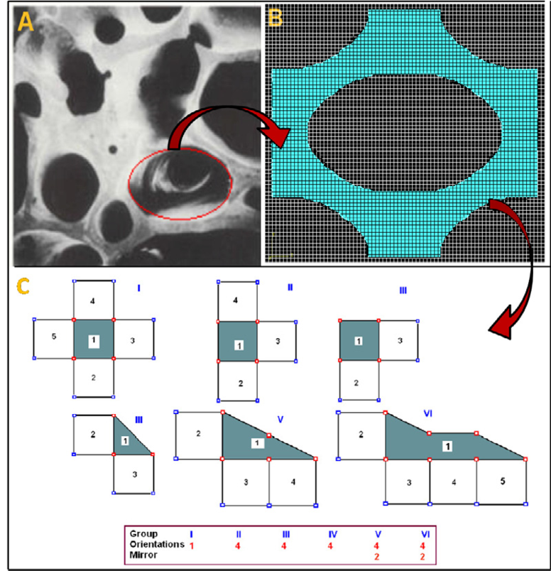

Fig. 2. 2D grid (B) for representation of the tissue (A). Six element substructures used in 2D solution (C).

* 1. *Cell scale: BMU model*

The BMU model is defined, for simplicity in 2D, as a rectangular compartment with a plane cutting it initially in half (see Fig. 3). On the left side we have the mineralized extracellular matrix that can be represented by a regular lattice; every cell of this structure can contain an O*y* (represented with a big dot inside) that is connected to its neighbours with a given geometry. O*y*s exchange biochemical signals through their interconnected network. Such signals propagate through the left part until they reach the surface. They may be influenced by the deformation tensor field of the tissue that is obtained from the continuous model defined at the upper scale. The nodes on the surface are L*c*s. The messengers that eventually reach them are used to activate the production or to define an attraction field for cells that are loose in the fluid section on the right side.

These cells can be precursors of O*b*s (P*b*) and of O*c*s (P*c*), either generated or present in the marrow and/or the blood flow. In the model they appear in the connection space on the right side when in the environment the proper conditions,

e.g. appearance of biochemical signals, occur. The signals can be released either by the surface L*c*s (represented with crossed boxes) or by cells from the fluid section. They are treated in our model as a multi-scalar field overlapped to the fluid section. Every scalar value represents a concentration of a specific messenger, in the specific point at a given time. In the fluid section we can also find macrophage, water and

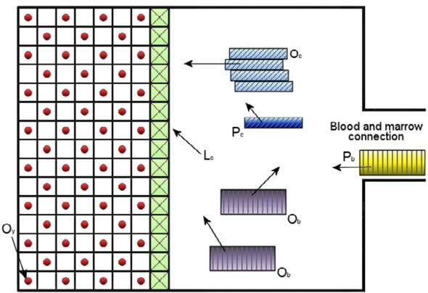 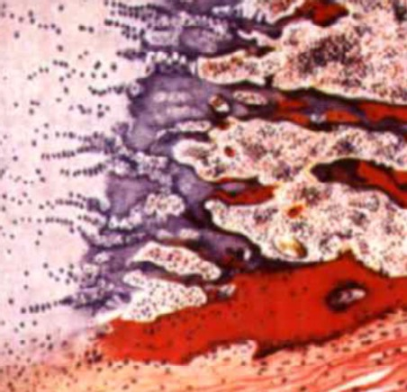

Fig. 3. BMU shape-based scenario on the left. A real BMU on the right.

some other simple elements, but we do not explicitly represent them in the model. In case of activation of remodelling, one of the hypotheses is that with no or weak tensor field the O*y*s begin to suffer and send on the surface the messengers corresponding to their status. Arrival of these, attracts P*c*s and P*b*s in the fluid section. Every P*b* emits some other messengers that favour the creation of O*c* cells from an arbitrary number k of P*c* cells. Obviously this process, which is called coalescence, is possible only where a sufficient number of P*c* cells are available and closer to each other. Mature O*c*s are the bigger cells in the model, they are attracted to the surface of the mineralized matrix by the biochemical signals produced there and eventually they reach it. Once on the splitting plane, they anchor to it and create a really acid environment between themselves and the mineralised surface. Through this environment they erode the bone structure releasing specific molecular messengers that activate the production of O*b*s from P*b*s. The O*c*s’ lifetime is limited (apoptosis process) and eventually they die. The mature O*b*s are then attracted to the remaining surface to create new bone tissue. Some of the O*b*s remain inside the new formed bone becoming new O*y*s, that will rebuild the interconnection network

with their neighbours.

Depending on the quantity and type of messengers released by O*y*s and of the dynamics in the O*c*s and O*b*s formation and activity, the whole process will end up into a positive, negative or null remodelling, which means that the final amount of bone is greater, less or equal to the original one. The implementation of this model in the BioShape simulator is quite natural, as it involves shapes (see Fig. 3) that either move possibly attracted by biochemical signals or stand still. Also the composition of O*c*s from P*c*s is a primitive supported by the simulator. Varying all the size and time parameters as well as the rules defining the behaviours of all the shapes involved, several in-silico experiments can be designed. The simulator can then be used for hypothesis testing or, whenever quantitative biological information is available from in-vivo or in-vitro experiments, for the validation of the model.

* 1. *Transformation functions and dynamics*

We can relate the two levels of zoom defined above within BioShape as they are defined with the same basic concepts of the simulator. The map simply associates every grid shape at the tissue level with a certain BMU. The dynamics of the coupled-level system works by successive steps. Each step is as follows:

* + - for each shape at the tissue scale there is a mineralization density value, which determines if the shape is on the surface, that is to say it is a possible place in which remodelling occurs. The tissue model also fixes for each shape the mechanical charge stimulus;
    - each activated shape for remodelling (randomly chosen or determined by the model of forces) is simulated with the systemic factors personalised for that shape;
    - at the end of the simulation, the new value for the density is calculated from the results and this is passed to the tissue model that updates the border surfaces of the remodelled shape (by shape replacement);
    - finally, we re-apply the tissue model to the new data to determine how the changes of density modified the mechanical stimuli.

Note that the time scale is different at the two levels: cell events occurs at a pace of days while tissue timing is in the order of months. Thus, the simulator basic time step is in the order of a (simulated) day, and when a (simulated) month elapsed also a step of the tissue level is performed.

# Related works

Several ODE-based packages, with NAMD [26], CHARMM [7] and GROMACS [4] among the most popular, are available for molecular modelling. Many particle-based approaches, such as MCell [31], Smoldyn [1] and ChemCell [27], are derivatives of the Smoluchowski model 8 and, as a consequence, can faithfully describe only reaction- diffusion systems, where particles are simple spheres and can be moved altogether only in according to Brownian motion laws (differently from BioShape, where each shape can be singularly linked to any motion law).

Differently from the above frameworks and similarly to BioShape, the particle- based and single-scale approaches proposed in Meredys 9 and in [5] also allow par- ticle geometric information to be incorporated. In detail, the mesoscopic simulator proposed in Meredys represents biological entities as single particles, spheres or cylinders, or as compound objects formed from the two. Every basic particle can have a number of binding sites associated with it. Particles and compound objects diffuse through the simulation volume using a 3D random walk algorithm. Bonds between particles are broken and created as determined by the user-defined rules. A collision detection algorithm establishes whether particles come sufficiently close to

8 This model describes a solution of interacting chemical particles as spheres moving by Brownian motion until two spheres come within a certain distance of each other causing them to react.

9 <http://www.ebi.ac.uk/compneur-srv/meredys.html>

allow bond formation. The stochastic simulator in [5] handles spatial locality, very low particle concentrations and collision between particles using a discrete 3D grid. Particles move within discrete volumes in discrete time steps. An integer-addressed 3D grid avoids floating-point computation and distance calculations for enabling highly parallel, large-scale simulations using custom hardware.

We conclude our (non-exhaustive) bird’s eye view with BlenX4Bio [28] and Bio- PEPA Workbench [10] which, differently from all the previous approaches, heavily rely on process algebra. In detail, BlenX4Bio is a high-level tabular interface for the programming language BlenX, allowing biologists to write BlenX programs without having any programming skills. A BlenX4Bio model consists of a number of tables

* describing the most important static and dynamic aspects of biological systems
* which can then be automatically mapped to BlenX programs for simulation and analysis. The Bio-PEPA Workbench allows modellers to write models for biochem- ical networks as Bio-PEPA terms. Such models are then animated using StochKit

[24] - a C++-written software for discrete stochastic and multiscale simulation of chemically reacting systems, including some important stochastic algorithms.

# Conclusions and future work

We have addressed all the issues related to the specification of two models of bone remodelling: at tissue scale and at cell scale. Both models are defined in terms of shapes and interactions between them and are implementable within the general framework of the BioShape simulator. What remains to be done is to instantiate the general shape entities of BioShape into all the entities involved in bone re- modelling in the two models, coding their behaviours and interactions according to the specifications given in Sec. 4.1 and Sec. 4.2. We are currently working on this implementation. Then we will define proper in-silico experiments for performing testing of hypotheses formulated by biologists and/or validate/refine our models using the available quantitative biological information. The in-silico experiments will be also coupled with in-vitro or in-vivo experiments designed to get specific quantitative information in the bone remodelling scenario. A parallel line of work will be the formalisation of the two models into more abstract specifications using the Shape Calculus [3]. Moreover, we will formally specify qualitative and quanti- tative properties of the models in order to perform verification.

# References

1. Andrews, S. S. and D. Bray, *Stochastic simulation of chemical reactions with spatial resolution and single molecule detail*, Phys. Biol. **1** (2004), pp. 137–151.
2. Ayton, G., W. Noid and G. Voth, *Multiscale modeling of biomolecular systems: in serial and in parallel*, Current Opinion in Structural Biology **17** (2007), pp. 192–198.
3. Bartocci, E., F. Corradini, M. R. Di Berardini, E. Merelli and L. Tesei, *Shape Calculus. A spatial calculus for 3D colliding shapes*, Technical Report 6, Department of Mathematics and Computer Science, University of Camerino (2010), Accepted for publication in the *Scientific Annals of Computer Science*. To appear in 2010. Available at <http://s1report.cs.unicam.it/6/>.
4. Berendsen, H., *GROMACS: A message-passing parallel molecular dynamics implementation*, Computer Physics Communications **91** (1995), pp. 43–56.
5. Boulianne, L., S. Assaad, M. Dumontier and W. Gross, *GridCell: a stochastic particle-based biological system simulator*, BMC Systems Biology **2** (2008).
6. Boyle, W., W. Simonet and D. Lacey, *Osteoclast differentiation and activation*, Nature **423** (2003),

pp. 337–342.

1. Brooks, B., R. Bruccoleri, B. Olafson, D. States, S. Swaminathan and M. Karplus, *CHARMM: A program for macromolecular energy, minimization, and dynamics calculations*, Journal of Computational Chemistry **4** (1983), pp. 187–217.
2. Burger, E. and J. Klein-Nulend, *Mechanosensory transduction in bone role of the lacuno-canalicular network*, FASEB J **13** (1999), pp. 101–112.
3. Buti, F., D. Cacciagrano, F. Corradini, E. Merelli and L. Tesei, *BioShape: a spatial shape-based scale- independent simulation environment for biological systems*, in: *ICCS 2010: Proceedings of Simulation* *of Multiphysics Multiscale Systems, 7th International Workshop*, 2010, downloadable at [http://cosy.](http://cosy.cs.unicam.it/bioshape/iccs2010.pdf) [cs.unicam.it/bioshape/iccs2010.pdf](http://cosy.cs.unicam.it/bioshape/iccs2010.pdf).
4. Ciocchetta, F., A. Duguid, S. Gilmore, M. L. Guerriero and J. Hillston, *The Bio-PEPA tool suite*, International Conference on Quantitative Evaluation of Systems **0** (2009), pp. 309–310.
5. Corradini, F. and E. Merelli, *Hermes: agent-base middleware for mobile computing*, in: *Mobile Computing*, LNCS **3465**, 2005 pp. 234–270.
6. Cowin, C. and D. Hegedus, *Bone remodeling i: A theory of adaptive elasticity*, Journal of Elasticity **6**

(1976), pp. 313–326.

1. Cowin, C. and D. Hegedus, *Bone remodeling ii: small strain adaptive elasticity*, Journal of Elasticity

**6** (1976), pp. 337–352.

1. Cowin, S., L. Moss-Salentijn and M. Moss, *Candidates for the mechanosensory system in bone*, J Biomech Eng **113** (1991), pp. 191–197.
2. Cristofolini, L., F. Taddei, M. Baleani, F. Baruffaldi, S. Stea and M. Viceconti, *Multiscale investigation of the functional properties of the human femur*, Philos Transact A Math Phys Eng Sci **366** (2008),

pp. 3319–3341.

1. Evans, D., P. Lawford, J. Gunn, D. Walker, D. Hose, R. Smallwood, B. Chopard, M. Krafczyk,

J. Bernsdorf and A. Hoekstra, *The application of multiscale modelling to the process of development and* *prevention of stenosis in a stented coronary artery*, Phil. Trans. R. Soc. A **366** (2008), pp. 3343–3360.

1. Frost, H., *Skeletal structural adaptations to mechanical usage (SATMU): 2. Redefining Wolffs Law:* *the remodeling problem*, Anat. Rec. **226** (1990), pp. 414–422.
2. Harada, S. and G. Rodan, *Control of osteoblast function and regulation of bone mass*, Nature **423**

(2003), pp. 349–355.

1. Hu, Z., J. Mellor, J. Wu, M. Kanehisa, J. Stuart and C. DeLisi, *Towards zoomable multidimensional* *maps of the cell*, Nature Biotechnology **25** (2007), pp. 547–554.
2. Huiskes, R., R. Ruimerman, G. V. Lenthe and J. Janssen, *Effects of mechanical forces on maintenance* *and adaptation of form in trabecular bone*, Nature **405** (2000), pp. 704–706.
3. Hunter, P., W. Li, A. McCulloch and D. Noble, *Multiscale modeling: Physiome project standards, tools,* *and databases*, Computer **39** (2006), pp. 48–54.
4. Klein-Nulend, J., A. van der Plas, C. Semeins, N. Ajubi, J. Frangos, P. Nijweide and E. Burger,

*Sensitivity of osteocytes to biomechanical stress in vitro*, FASEB J **9** (1995), pp. 441–445.

1. Koumoutsakos, P., *Multiscale flow simulations using particles*, Annu. Rev. Fluid Mech. **37** (2005),

pp. 457–487.

1. Li, H., Y. Cao and L. Petzold, *StochKit, a new stochastic simulation toolkit*, in: *Proceedings of the Sixth International Conference on Systems Biology*, 2005.
2. Nauman, E., R. Satcher, T. Keaveny, B. Halloran and D. Bikle, *Osteoblasts respond to pulsatile fluid flow with short-term increases in pge (2) but no change in mineralization*, Journal of Applied Physiology **90** (2001), pp. 1849–1854.
3. Phillips, J., R. Braun, W. Wang, J. Gumbart, E. Tajkhorshid, E. Villa, C. Chipot, R. Skeel, L. Kal´e and K. Schulten, *Scalable molecular dynamics with NAMD*, Journal of Computational Chemistry **26** (2005), pp. 1781–1802.
4. Plimpton, S. J. and A. Slepoy, *Microbial cell modeling via reacting diffusive particles*, Journal of Physics: Conference Series **16** (2005), pp. 305+.
5. Priami, C., P. Ballarini and P. Quaglia, *BlenX4Bio — BlenX for biologists*, in: *CMSB ’09: Proceedings of the 7th International Conference on Computational Methods in Systems Biology*, 2009, pp. 26–51.
6. Rouhi, G., M. Epstein, L. Sudak and W. Herzog, *Modeling bone resorption using mixture theory with chemical reactions*, Journal of Mechanics of Materials and Structures **2** (2007), pp. 1141–1156.
7. Sloot, P. and A. Hoekstra, *Multi-scale modelling in computational biomedicine*, Brief. Bioinform. (2009).
8. Stiles, J. R. and T. M. Bartol, *Monte Carlo methods for simulating realistic synaptic microphysiology using MCell*, in: E. D. Schutter, editor, *Computational Neuroscience: Realistic Modeling for Experimentalists*, CRC Press, 2001 pp. 87–127.
9. Turner, C., *Toward a mathematical description of bone biology: the principle of cellular accommodation*, Calcified Tissue International **65** (1999), pp. 466–471.