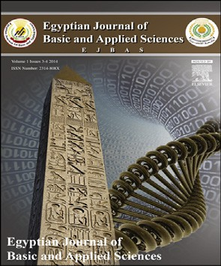 HOSTE D BY

Available online at [www.sciencedirect.com](http://www.sciencedirect.com/science/journal/2314808X)

**ScienceDirect**

journal homepage: [http://ees.elsevier.com/ejbas/default.asp](http://http//ees.elsevier.com/ejbas/default.asp)

**Full Length Article**

**Cardioameliorative effect of punicalagin against streptozotocin-induced apoptosis, redox imbalance, metabolic changes and inflammation**



***Mohamed A. El-Missiry*** ***a******,******\*******, Maher A. Amer*** ***a******, Faried A.E. Hemieda*** ***a******,***

***Azza I. Othman*** ***a******, Doaa A. Sakr*** ***a******, Haitham L. Abdulhadi*** ***b***

a *Zoology Department, Faculty of Science, Mansoura University, Mansoura, Egypt*

b *Biology department, Pure Science Education Collage, Al-Anbar University, Al-Anbar, Iraq*

A R T I C L E I N F O A B S T R A C T

*Article history:*

Received 27 July 2015

Received in revised form 30 August 2015

Accepted 8 September 2015

Available online 25 September 2015

*Keywords:* Polyphenols Cardiomyopathy Lipids Streptozotocin Heart

The effect of punicalagin on metabolic risks, oxidative stress, inflammation, cardiac apopto- sis and histopathological alterations in experimentally induced diabetes was addressed. Diabetes was induced in male rats by a single injection of streptozotocin (STZ; 40 mg/kg, i.p.), and then punicalagin (1 mg/kg) was i.p. administered every other day for 15 days. The diabetic rats treated

with punicalagin exhibited ameliorated hyperglycemia and HbA1c; improved insulin levels, HOMA-IR levels and lipid profiles; and normalized levels of IL-1b, IL-6 and TNF-α. Punicalagin also reduced the increase in the MDA and H2O2 levels; normalized the levels of GSH, SOD and

CAT in the heart; and improved serum markers of heart function including the levels of tro- ponin T level and CK-MB and LDH activities. Histopathological examinations of heart sections match these results, confirming the beneficial effect of punicalagin. It also modulated cardiomyocyte apoptosis via enhanced Bcl-2 expression; blocked the increases in P53, Bax and caspases-3, 8 and 9; and ameliorated DNA damage in the heart. The current results suggest that punicalagin protected the heart against apoptosis, necrosis, inflammation and DNA damage by improving the redox state, suppressing caspases and P53 and increasing Bcl-2. In conclu- sion, punicalagin possesses strong therapeutic potential in treating and regulating diabetes and attenuating its associated complications in the heart.

© 2015 Mansoura University. Production and hosting by Elsevier B.V. This is an open access article under the CC BY-NC-ND license (<http://creativecommons.org/licenses/by->

nc-nd/4.0/).

# Introduction

The prevalence of the diabetic heart has markedly increased in the past few years and is now considered the main cause of sick- ness and death among the diabetic and obese population. Diabetic cardiomyopathy is associated with increased oxida- tive stress that stimulates cellular injury and contributes to the

* *Corresponding author*. Tel.: +201000964040.

*E-mail address:* [maelmissiry@yahoo.com](mailto:maelmissiry@yahoo.com) (M.A. El-Missiry). <http://dx.doi.org/10.1016/j.ejbas.2015.09.004>

development and progression of complications associated with diabetes [1]. Apoptosis is a key process in diabetic cardiac dis- eases derived from poor glycemic control. A number of studies have documented an increased occurrence of apoptosis in the cardiomyocytes of diabetic patients and experimentally induced diabetic animals [2,3]. It is mediated, at least in part, by the ac- tivation of the mitochondrial pathway, which is often triggered by reactive oxygen species (ROS).

2314-808X/© 2015 Mansoura University. Production and hosting by Elsevier B.V. This is an open access article under the CC BY-NC-ND license ([http://creativecommons.org/licenses/by-nc-nd/4.0/).](http://creativecommons.org/licenses/by-nc-nd/4.0/))

There is evidence from experimental and clinical settings on the benefits of antioxidant therapies in the prevention and man- agement of diabetic complications [4–6]. Pomegranate (*Punica granatum* L. Punicaceae) juice has been shown to contain the highest antioxidant capacity compared to other polyphenol- rich beverages [7,8]. Clinical studies showed positive effects of pomegranate juice consumption on diabetic patients’ blood dia- betic and oxidative stress parameters [9]. Furthermore, it is documented that pomegranate juice supplementation showed a protective effect against isoperiotinaol-induced cardiac ne- crosis in rats [10]. The efficient antioxidant potential of the pomegranate is attributed to its major antioxidant polyphenol, punicalagin [11]. A primary mechanism by which pomegran- ate fractions exert their beneficial effects on the disease condition is by reducing oxidative stress and lipid peroxidation. This re- duction may occur by directly neutralizing the generated ROS, enhancing the activities of specific antioxidant enzymes, prompt- ing metal chelation activity, and inhibiting or activating certain transcriptional factors, such as nuclear factor kappaB and per- oxisome proliferator-activated receptor gamma [12].

Punicalagin is a bioactive ellagitannin, a type of phenolic compound isolated from pomegranate and exhibits high an- tioxidant and free radical scavenging activities [13], with several health benefits [14]. It demonstrated a marked outcome in pa- tients with metabolic syndromes, such as hyperlipidemia, non- alcoholic fatty liver disease, and coronary heart disease [12,15–17]. Punicalagin inhibits the formation of advanced glycation end-products [18] and fructose-mediated non- enzymatic protein glycation by scavenging reactive carbonyl species [19]. Good results in terms of fat loss [20] and inhibi- tion of oxidized LDL uptake in macrophages [21] have been demonstrated using punicalagin. In addition to its antioxi- dant, anti-diabetic and anti-atherosclerotic actions [12,14], punicalagin also exhibited anti-inflammatory activity in cell culture and animal studies [22,23]. It is worth mentioning that repeated oral administration with punicalagin for five weeks is not toxic to rats [24].

Because diabetes is associated with high frequency of heart failure, a better understanding of its pathophysiology is es- sential for testing of new bioactive compounds and the development of treatment strategies for diabetes-associated cardiac dysfunction. To date, no studies regarding the effect of punicalagin on diabetic cardiac apoptosis and injury have been conducted. The present study hypothesized that punicalagin can counteract oxidative stress and, in turn, ame- liorate cellular damage and reduce the development and progression of diabetic complications. Therefore, the current study was designed to investigate the potential beneficial effect of punicalagin against diabetes-induced cardiac injury and apoptosis in connection with its anti-lipid peroxidation and anti-hyperlipidemic actions.

## *Induction of diabetes*

Diabetes was induced in rats by single intraperitoneal (i.p.) in- jections of freshly prepared STZ (40 mg/kg body weight) in

0.01 M citrate buffer, pH 4.5 [25]. The blood glucose level was assayed 48 h after STZ injection using a glucose monitor set (Elegance, CT-X10, Convergent Technologies GmbH & Co. KG, Marburg, Germany). The rats with a blood glucose level above 250 mg/dl were considered diabetic and were used for the experiments.

## *Punicalagin treatment*

Punicalagin is supplied in water soluble dark-yellow powder. Applied dose of 1 mg/kg dissolved in 0.2 ml saline solution was daily i.p. administered for 15 days [26].

## *Experimental work*

Male Wister rats weighing 280–300 g were provided by the Bio- logical Products & Vaccines (VACSERA) of Cairo, Egypt, and were housed in cages with free access to food and drinking water. The animals were acclimated to laboratory conditions of 22– 24 °C with a 12-h light/dark cycle for two weeks before experimentation. The current study was approved by Mansoura University, and all experiments were performed in accor- dance with the standards accepted by the regional experimental animal ethics panel. The rats were divided randomly into four groups of seven rats each. The first group served as a control, the second group received a daily dose of punicalagin (1 mg/kg, i.p.) for 15 days, the third group received a single i.p. injec- tion of 40 mg/kg STZ, and the fourth group received a single injection of STZ (40 mg/kg, i.p.) followed by punicalagin (1 mg/kg, i.p.) every other day for two weeks. After 15 days of treat- ment, blood was obtained by cardiac puncture after overnight fasting. Serum and heart ventricle were kept in refrigerator for the following investigations.

## *Biochemical investigations*

The glucose and insulin levels in serum and the HbA1c levels in blood were determined using kits supplied by Spinreact (St. Esteve d’en Bas Girona, Spain), Abcam (Cambridge, MA, USA) and BioSystems (Barcelona, Spain), respectively. The lipid pro- files in serum, including total lipids, triglyceride, total cholesterol, high-density lipoprotein (HDL), low-density lipo- protein (LDL) and very low-density lipoproteins (VLDL), were assayed according to the manufacturer’s instructions (Spinreact, St. Esteve d’en Bas Girona, Spain). Interleukin 6 (IL-6), interleukin 1 beta (IL-1b), tumor necrosis factor alpha (TNF-α) and tropo- nin T in serum were assessed using kits provided by R&D Systems (Minneapolis, MN, USA) and Bioscience (San Diego, CA,

USA). Creatine kinase (CK-MB) and lactic dehydrogenase (LDH)

# Materials and methods

## *Chemicals*

Streptozotocin (STZ) and punicalagin (PU) were purchased from Sigma Chemical (St. Louis, MO). All other chemicals were of the highest grade.

activities in the serum were determined using kits pur- chased from Elitech (Puteaux, France). Lipid peroxidation was assessed by determining the amount of malondialdehyde (MDA). The hydrogen peroxide (H2O2) concentrations were es- timated according to the manufacturer’s instructions (Dokki- Giza, Egypt). The superoxide dismutase (SOD) and catalase (CAT) activities and the glutathione (GSH) concentration were assayed

using kits provided by Biodiagnostic (Dokki-Giza, Egypt). The protein concentrations were assayed as previously described [27].

## *Flow cytometry study*

### *Determination of apoptosis*

For flow cytometry, samples from the heart were prepared as previously described [28]. The cells were suspended in PBS with BSA, divided into aliquots and stored at 4 °C for analysis. The flow cytometry analyses were performed on a FACSCalibur™ cytometer (BD Biosciences, San Jose, CA) using CellQuest Pro software (Becton Dickinson) for data acquisition and analysis [29].

### *Annexin V/PI staining*

Apoptosis was assessed using the fluorescein isothiocyanate- conjugated annexin V/PI, ApoAlert kit from Clontech (Palo Alto, CA) according to the manufacturer’s instructions.

### *Bcl-2, Bax, P53 and CD95*

The cell suspensions were prepared in a PBS/BSA buffer and were then incubated for 30 min with anti-Bcl-2 [100/D5] anti- body (ab692) and anti-Bax [6A7] antibody (ab5714) for flow cytometry analysis of Bcl-2 and Bax, respectively. A mouse anti- P53 “aa20-25” FITC, Clone: DO-1, was used for P53 analysis by flow cytometry. A monoclonal anti-Fas (CD95/Apo-1) anti- body was used for CD95 determination. After 30-min incubation at room temperature, the cells were washed with PBA/BSA, centrifuged at 400 × g for 5 min, re-suspended in 0.5% paraform- aldehyde in PBS/BSA and analyzed using flow cytometry.

### *Caspases-3, -8 & -9*

In case of caspases-3, -8 and - 9: FITC rabbit anti-active caspase-3 (CPP32; Yama; Apopain, BD Bioscience), anti-caspase-8 (E6) antibody (Abcam) or rabbit monoclonal anti-caspase-9 (E23) antibody (ab32539) were used respectively.

## *Single cell gel electrophoresis (Comet assay)*

DNA damage in the heart samples was assessed using the single-cell gel electrophoresis (comet assay) method, a well-validated technique developed for measuring DNA strand breaks in individual cells, as described previously [30,31]. The quantification of the DNA strand breaks in the obtained images was performed with CASP software to directly obtain the percent of DNA in the tail, the tail length and the tail moment.

## *Histopathological examination*

The ventricle was excised and fixed in 4% buffered paraform- aldehyde, dehydrated in ascending grades of ethyl alcohol, cleared in xylene and mounted in molten paraplast 58–62C. Four micron histological section were cut, stained with he- matoxylin and eosin and examined under bright field light microscopy and photographed.

## *Statistical analysis*

The data were presented as the mean ± SEM. The statistical analyses were performed by one-way ANOVA followed by Stu- dents Newman–Keul’s post hoc test.

# Results

The administration of punicalagin alone every other day for two weeks did not affect the body weight, the concentration of glucose, insulin or the lipid profile. Similarly, punicalagin treatment did not affect the levels of IL-1b and IL-6. Further- more, the activities of SOD and CAT and the lipid peroxidation product (TBARS) in the heart did not change after punicalagin treatment. Conversely, significant increases were demon- strated in the HDL level in the serum and the GSH level in the heart.

## *Body weight*

The body weight of the STZ-treated rats significantly and gradu- ally decreased compared to that of the normal rats. The diabetic rats treated with punicalagin (1 mg/kg; every other day) showed a significant increase in body weight during the experimen- tal period compared with the diabetic group (Fig. 1a); however, they remained significantly lower than the control group.

## *Blood sugar, insulin and HbA-1c levels*

The blood glucose of the diabetic rats was significantly in- creased during the experimental period compared to that of the control group. The diabetic rats treated with punicalagin exhibited a marked amelioration over the experimental period (Fig. 1b) and at the end of the experimental period (Table 1) compared with the diabetic group, but the level was signifi- cantly lower than that of the control group.

The STZ injection significantly elevated the serum glucose and HbA-1c levels two weeks after diabetic induction (Table 1). In addition these rats had significantly lower insulin levels and higher HOMA-IR than the controls (Table 1). Punicalagin treat- ment for 15 days after diabetic induction significantly ameliorated the serum glucose and HbA-1c levels compared to the STZ-treated rats. The diabetic rats treated with punicalagin exhibited a significant increase in the insulin levels and a decrease in the HOMA-IR values compared to the dia- betic rats, but the results were similar to the control levels.

## *Biochemical observations*

### *Serum lipid profiles*

The lipid profile, including total lipids, TG, total cholesterol, LDL and VLDL, were significantly higher and HDL was significantly lower in the STZ-treated rats than in the control rats. Punicalagin treatment significantly ameliorated these lipid frac- tions at 15 days after diabetic induction in the rats (Fig. 2).

### *Serum markers of heart function*

The concentration of troponin T and the activity of CK-MB and LDH in heart were significantly increased in STZ-induced dia- betes compared to the normal control animals (Table 2). When diabetic rats were treated with punicalagin, the activity of both enzymes and troponin T level was normalized to a level com- parable to that of the control rats and was significantly lower than that of the diabetic animals.

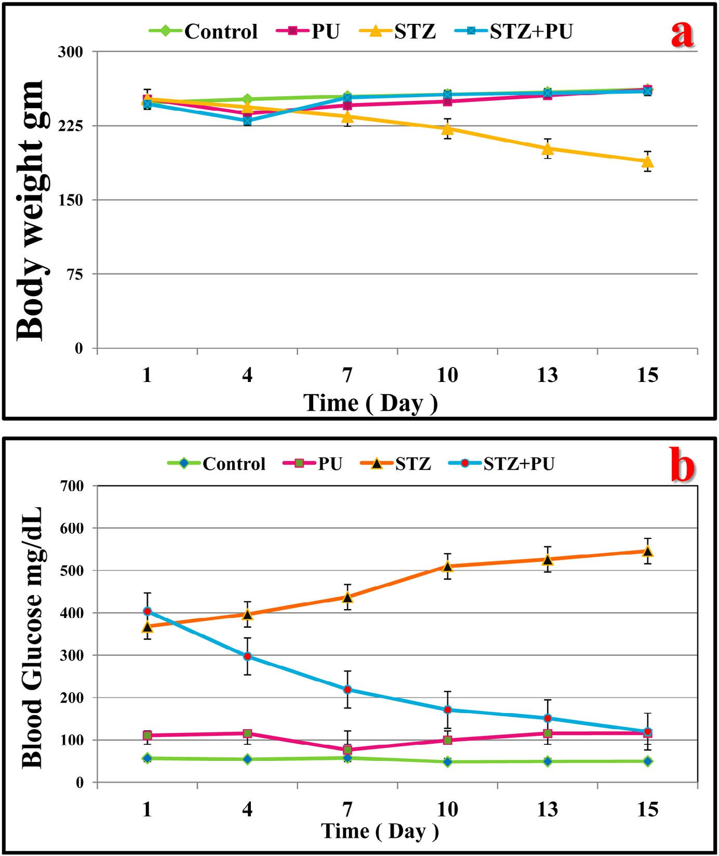

**Fig. 1 – Effects of streptozotocin (STZ) and punicalagin (PU) on blood glucose and body weights in rats in different groups** **during the experimental period. The values are expressed as the means ± SEM. (n = 7).**

### *Oxidative stress and antioxidants*

The levels of the lipid peroxidation product and H2O2 were sig- nificantly increased in the hearts of the STZ-induced diabetic rats (Fig. 3). In addition, significant decreases were demon- strated in the SOD and CAT activities and the GSH content in the hearts of STZ-treated rats. These changes appeared similar to control levels when punicalagin was administered for 15 days after diabetic induction and were significantly better than those of the diabetic rats (Fig. 3).

### *Proinflammatory cytokines*

The ability of punicalagin to influence the production of IL- 1b, IL-6, TNF-α was measured in the serum of the different rat groups using enzyme immunoassays. Animals that received STZ had significantly higher levels of IL-1b, IL-6 and TNF-α com- pared to the control values (Table 3). Punicalagin administration after diabetic induction ameliorated the increase in these in- flammatory proteins in the serum and displayed insignificant changes when compared to the diabetic rats.

|  |  |  |  |  |
| --- | --- | --- | --- | --- |
| **Table 1 – Effects of streptozotocin (STZ) and punicalagin (PU) on the serum glucose (mg/dl) and insulin (pg/ml) levels and the percentages of HbA1c and HOMA-IR in rats in different groups at the end of the experimental period.** | | | | |
|  | Control | PU | STZ | STZ + PU |
| Glucose | 82.1 ± 11.98 | 104.9 ± 10.71 | 577.8 ± 18.6*** | 115.2 ± 15.4### |
| Insulin | 99.19 ± 3.42 | 108.7 ± 11.8 | 38.44 ± 2.14*** | 110.7 ± 11.3### |
| HbA-1c | 1.39 ± 0.12 | 1.13 ± 0.11 | 5.16 ± 0.19*** | 1.66 ± 0.13### |
| HOMA-IR | 20.31 ± 3.45 | 22.45 ± 2.03 | 52.53 ± 5.56** | 23.7 ± 3.0## |
| The values are expressed as the means ± SEM. (n = 7). *, # Significant at P < 0.05, **, ## significant at P < 0.01, and ***, ### significant at P < 0.001. *, **,  *** indicate comparisons with respect to the control group. #, ##, ### indicate comparisons with respect to the diabetic group. | | | | |

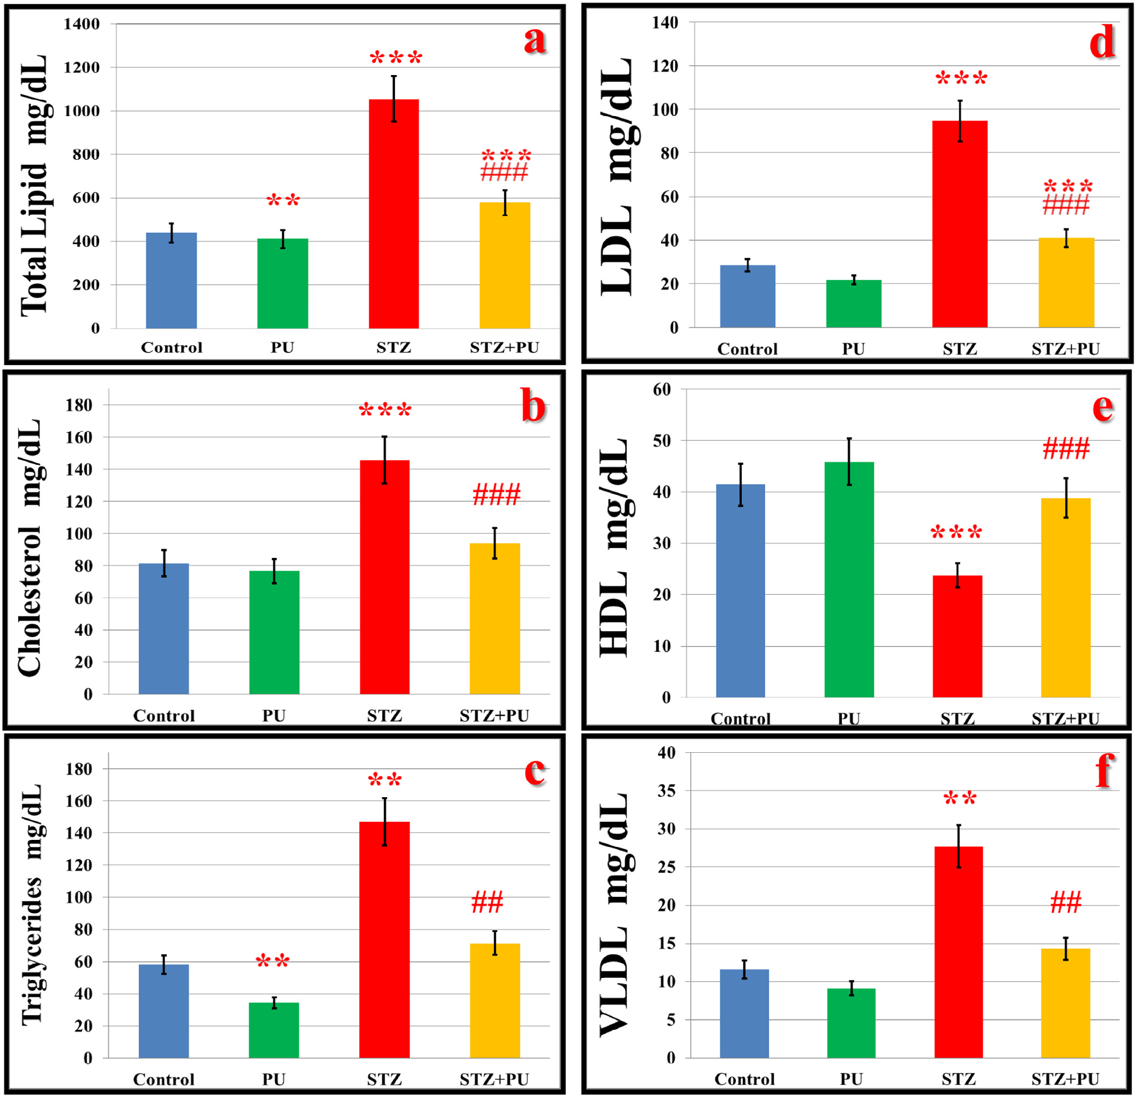

**Fig. 2 – Effect of streptozotocin (STZ) and punicalagin (PU) on the lipid profile [total lipids (a), cholesterol (b), triglycerides (c), low-density lipoprotein (d), high-density lipoprotein (e), and very-low-density lipoprotein (f)] expressed as mg/dl in the serum in rats in different groups. The values are expressed as the means ± SEM. (n = 7). *, # Significant at P < 0.05, **, ## significant at P < 0.01, and ***, ### significant at P < 0.001. *, **, *** indicate comparisons with respect to the control group. #, ##,** **### indicate comparisons with respect to the diabetic group.**

## *Flow cytometry of apoptosis and apoptotic proteins*

### *Annexin V/PI*

Flow cytometry was used to assess apoptosis in the heart using Annexin V-FITC staining (Fig. 4). The percentages of early and late apoptotic cells and necrotic cells were significantly higher in the hearts of diabetic rats than in those of the controls. The punicalagin therapy considerably

minimized the number of apoptotic cells compared to the dia- betic rats.

### *CD95 and P53*

Similarly, CD95 and P53 expressions were significantly in- creased in the hearts of STZ-treated rats (Fig. 5a,b). Punicalagin administration after diabetic induction significantly ameliorated the increase in CD95 and P53 in the heart compared to the

|  |  |  |  |  |
| --- | --- | --- | --- | --- |
| **Table 2 – Effects of streptozotocin (STZ) and punicalagin (PU) on the serum troponin T concentration (pg/ml) and CK-MB and LDH activities (U/ml) rats in different groups.** | | | | |
|  | Control | PU | STZ | STZ + PU |
| Troponin T | 104 ± 7.5 | 103 ± 4.97 | 171 ± 9.99*** | 99 ± 6.15### |
| CK-MB | 171.6 ± 6.9 | 143 ± 18.8 | 396 ± 20.4*** | 216 ± 20.5### |
| LDH | 153 ± 10.8 | 129 ± 36.1 | 361 ± 14.8*** | 194 ± 18.9### |
| The values are expressed as the means ± SEM. (n = 7). *, # Signifi- cant at P < 0.05, **, ## significant at P < 0.01, and ***, ### significant at P < 0.001. *, **, *** indicate comparisons with respect to the control group. #, ##, ### indicate comparisons with respect to the diabetic group. | | | | |

|  |  |  |  |  |
| --- | --- | --- | --- | --- |
| **Table 3 – Effect of streptozotocin (STZ) and punicalagin (PU) on the serum IL-6, IL-1b, and TNF-α levels, expressed as pg/ml, in rats in different groups.** | | | | |
|  | Control | PU | STZ | STZ + PU |
| IL-6 | 50.3 ± 2.42 | 44.2 ± 1.34 | 72.7 ± 1.98*** | 45.9 ± 2.27### |
| IL-1b | 72.9 ± 4.6 | 61.3 ± 2.72 | 124.9 ± 4.44*** | 75.7 ± 2.09### |
| TNF-α | 35.6 ± 0.81 | 33.0 ± 1.61 | 63.8 ± 2.75*** | 37.3 ± 0.42*, ### |
| The values are expressed as the means ± SEM. (n = 7). *, # Signifi- cant at P < 0.05, **, ## significant at P < 0.01, and ***, ### significant at P < 0.001. *, **, *** indicate comparisons with respect to the control group. #, ##, ### indicate comparisons with respect to the diabetic group. | | | | |

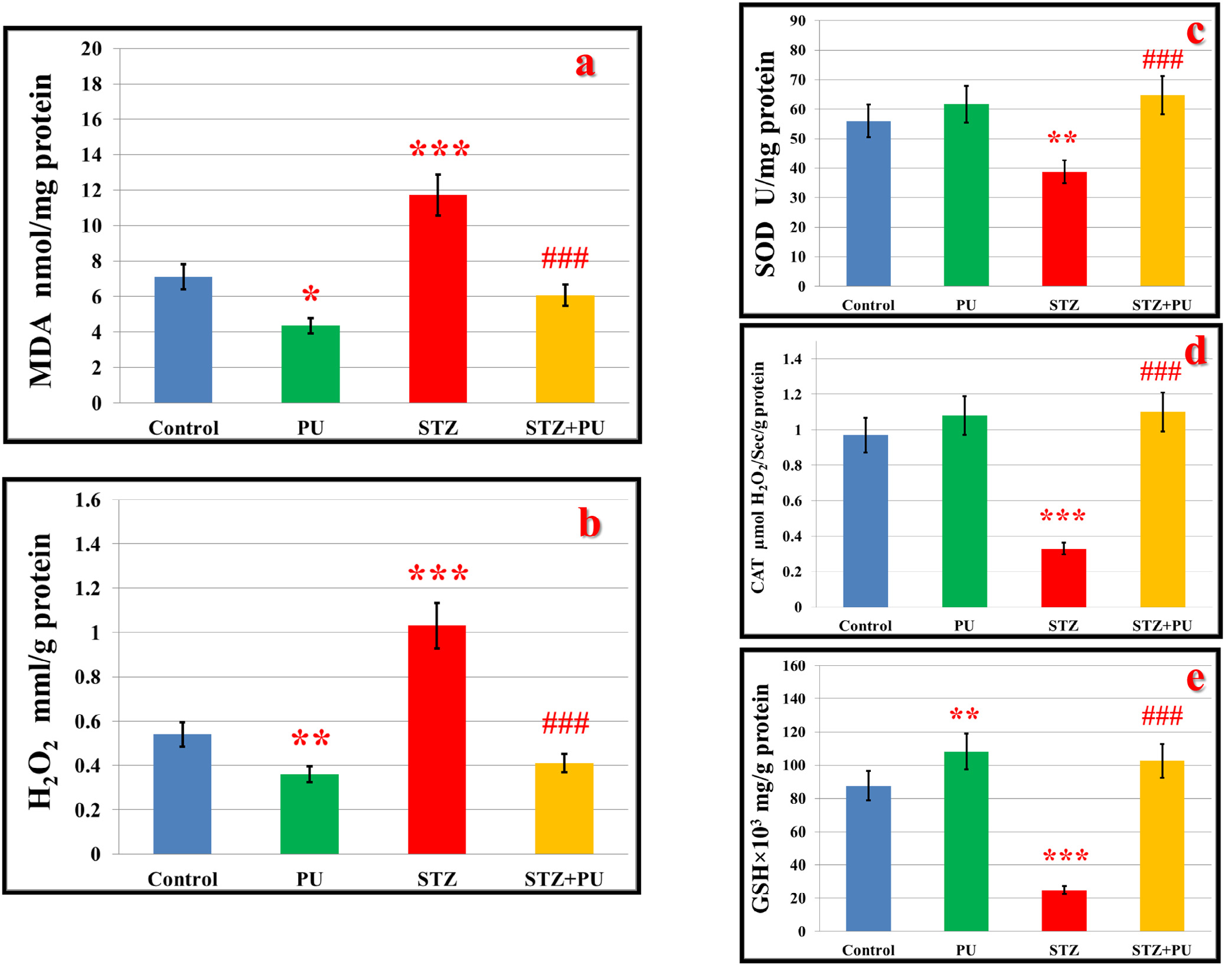

**Fig. 3 – Effect of streptozotocin (STZ) and punicalagin (PU) on the levels of the lipid peroxidation product MDA (nmol/mg protein) (a), hydrogen peroxide (H2O2)(mmol/g protein) (b), superoxide dismutase (SOD; U/mg protein) (c), and catalase (CAT; gmol H2O2/Sec/g protein) (d), glutathione (GSH; mg/g protein) (e) in the hearts of rats in different groups. The values are expressed as the means ± SEM. (n = 7). *, # Significant at P < 0.05, **, ## significant at P < 0.01, and ***, ### significant at P < 0.001.**

**\*, **, *** indicate comparisons with respect to the control group. #, ##, ### indicate comparisons with respect to the diabetic group.**

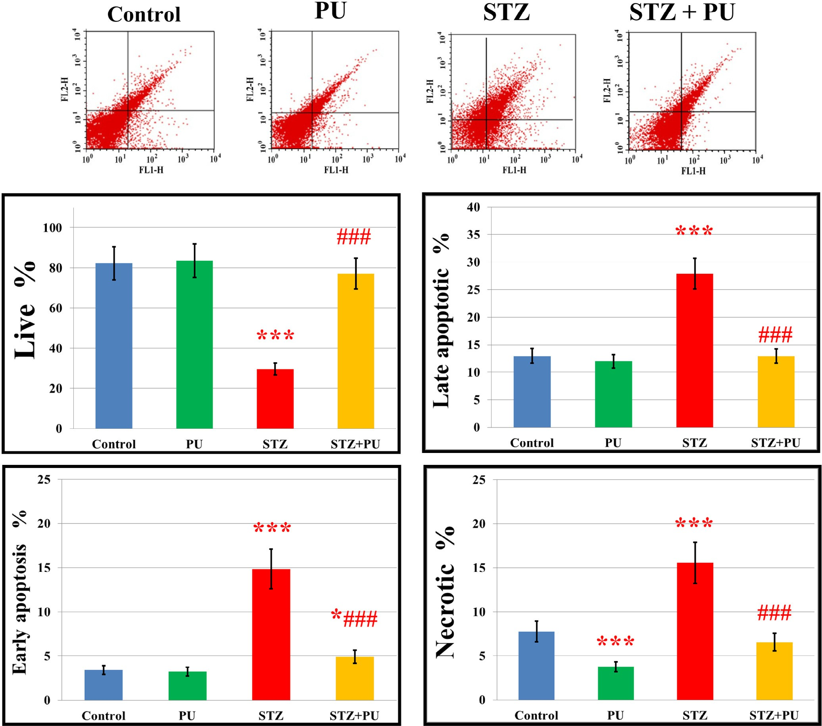

**Fig. 4 – Effects of streptozotocin (STZ) and punicalagin (PU) on the percentage of apoptosis in rats in different groups. Flow cytometry results showing examples of the data generated by FACS are at the top of each histogram. The values are expressed as the means ± SEM. (n = 7). *, # Significant at P < 0.05, **, ## significant at P < 0.01, and ***, ### significant at P < 0.001.**

**\*, **, *** indicate comparisons with respect to the control group. #, ##, ### indicate comparisons with respect to the diabetic group.**

diabetic rats. The effects of punicalagin along with diabetes for particular apoptotic proteins have been evaluated.

### *Bcl-2 and Bax*

The analysis of the flow cytometry data revealed that the anti- apoptotic protein Bcl-2 was significantly reduced, while the apoptotic protein Bax was augmented in the hearts of STZ- induced diabetic rats (Fig. 6a,b). Punicalagin treatment considerably normalized the STZ-induced changes in the ex- pression of these proteins.

### *Caspases-3, 8 and 9*

In Fig. 7, the expression levels of caspases-3, 8 and 9 were sig- nificantly up-regulated in the hearts of the STZ-induced diabetic

rats. Punicalagin administration significantly normalized these apoptotic proteins (Figs. 6c,7a,b).

## *Comet assay*

The changes in the levels of the comet parameters are displayed in Fig. 8. The STZ-treated rats showed an increase in the levels of all comet attributes, inclu- ding percent DNA in tail, tail length and tail moment, suggesting that DNA damage occurred in the diabetic rats. Meanwhile, the treatment of diabetic rats with punicalagin significantly repressed the increase in the comet parameters.

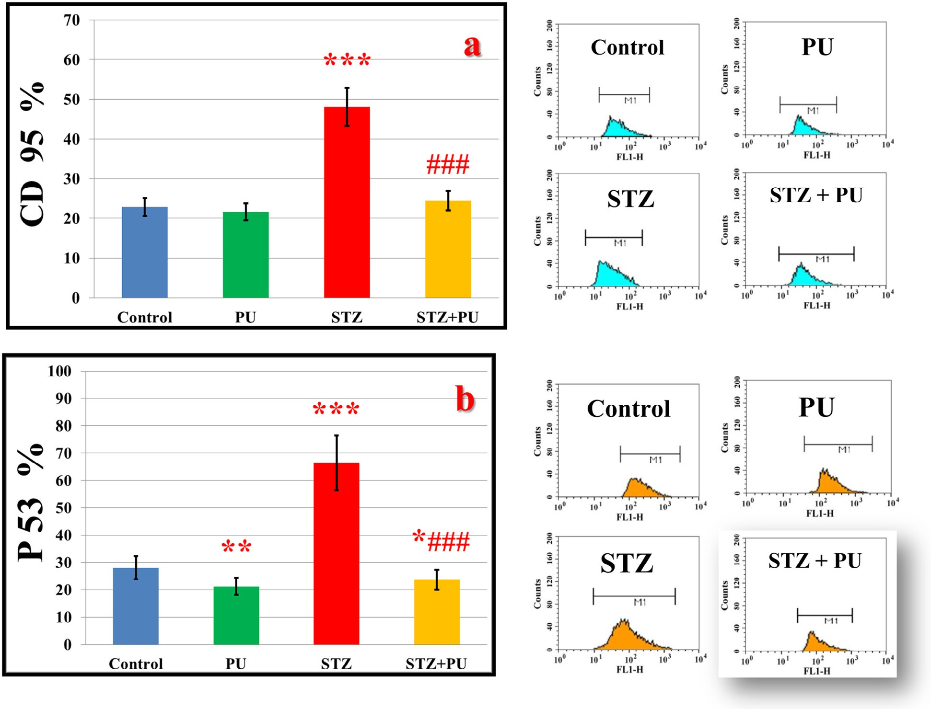

**Fig. 5 – Effects of streptozotocin (STZ) and punicalagin (PU) on the percentage of CD95 (a) and P53 (b) in rats in different groups. Flow cytometry results showing examples of the data generated by FACS are at the side of each histogram. The values are expressed as the means ± SEM. (n = 7). *, # Significant at P < 0.05, **, ## significant at P < 0.01, and ***, ### significant at P < 0.001. *, **, *** indicate comparisons with respect to the control group. #, ##, ### indicate comparisons with respect to the** **diabetic group.**

## *Histological observations*

The histological examination of heart sections from the control and punicalagin-treated animals demonstrated the uniform size and regular arrangement of the cardiac muscle fibers, with cen- trally located round or oval nuclei. The heart sections of STZ- diabetic rats showed a disorganized array of the myocardial structure, myofibrillar discontinuation, myocyte degenera- tion, and pyknotic nuclei. Punicalagin treatment of STZ- induced diabetic rats reduced these changes in the STZ- injected rat hearts and revealed markedly less disorganization of the architecture of most of the cardiac muscle fibers, with centrally located vesicular nuclei (Fig. 9).

# Discussion

The actual prevention and management of diabetic cardio- myopathy continues to be an essential health issue. To our

knowledge, this is the first study demonstrating that punicalagin has cardioprotective effects in STZ-induced diabetes and that punicalagin reduces the risk of diabetes-induced cardiac apoptosis. Oxidative stress is a core player in the cardiac patho- physiology of hyperglycemia-induced cardiac injury; therefore, it is hypothesized that treatment with bioactive antioxidants is a promising approach to block the pathological changes and protect the heart function.

In the diabetic rats, the body weights were significantly de- creased, which may be attributed to increased metabolism of the muscle tissue, fats and proteins [32]. In punicalagin- treated diabetic rats, the body weights were markedly maintained within control levels, indicating a role of punicalagin in protecting against muscle damage, possibly by influencing disturbed muscle protein turnover and the subsequent loss of muscle mass after diabetic induction.

Punicalagin treatment significantly lowered fasting serum glucose, HbA1c and HOMA-IR levels and increased the insulin level in STZ-treated rats at the end of the experimental period. The mechanism underlying the glucose-lowering effect

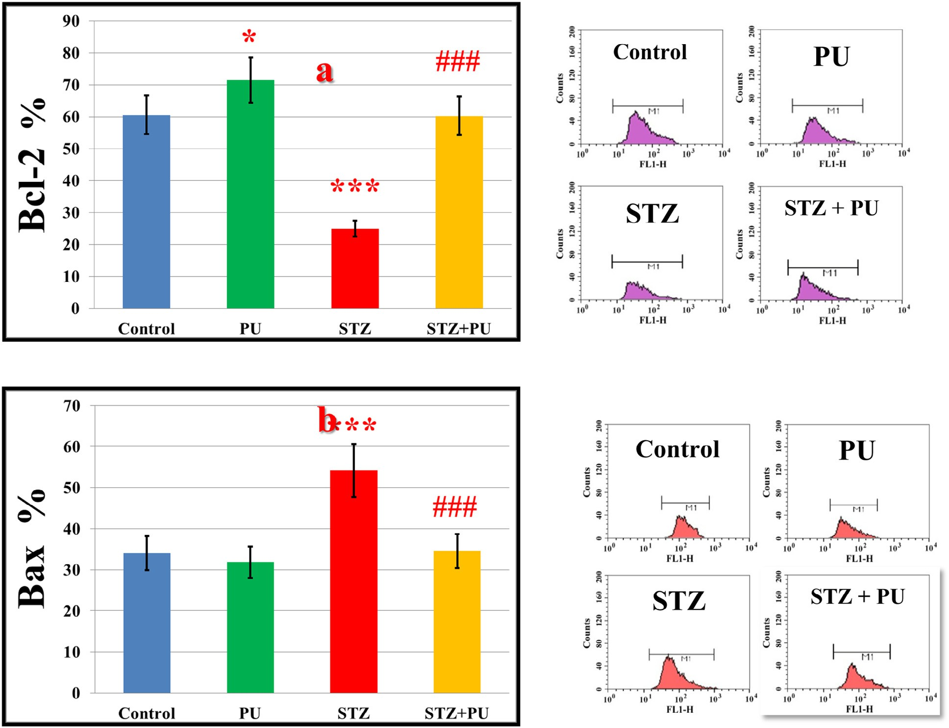

**Fig. 6 – Effects of streptozotocin (STZ) and punicalagin (PU) on the percentage of Bcl-2 (a) and Bax (b) in rats in different groups. Flow cytometry results showing examples of the data generated by FACS are at the side of each histogram. The values are expressed as the means ± SEM. (n = 7). *, # Significant at P < 0.05, **, ## significant at P < 0.01, and ***, ### significant at P < 0.001. *, **, *** indicate comparisons with respect to the control group. #, ##, ### indicate comparisons with respect to the diabetic group.**

of punicalagin may be due to increased insulin release from the protected and/or remaining β-cells, restored insulin sen- sitivity [33], changes in the absorption of dietary carbohydrates in the small intestine and facilitated utilization of glucose by the peripheral tissues that is mediated by an insulin-dependent glucose transporter [34]. The present results are consistent with findings from cell culture and animal studies as well as clini- cal human research that pomegranates rich in punicalagin exhibited anti-diabetic effect [12]. A pomegranate seed metha- nol extract that is rich in punicalagin showed hypoglycemic activity in STZ-induced diabetes and improved insulin sensi- tivity in rodent animals [35].

It is well known that maintaining normal serum lipid levels through nutrition programs is an effective approach to de- crease the major risk of cardiovascular disease and related disease complications [36]. In the current study, the total cho- lesterol, LDL-cholesterol, VLDL-cholesterol and triglyceride levels in the serum were significantly reduced after diabetic rats were treated with punicalagin, indicating its beneficial effect on the lipid profile. In Zucker fatty diabetic rats, the pomegranate extract improved abnormal cardiac lipid metabolism by

activating peroxisome proliferator-activated receptor-alpha (PPAR-α), thereby decreasing the circulating lipid levels and in- hibiting their cardiac uptake [37]. PPAR-α is a cardiac transcription factor involved in myocardial energy produc- tion via fatty acid uptake and oxidation. The augmented fatty acid oxidation improves insulin sensitivity by reducing lipid accumulation in the heart [38]. The beneficial effect of punicalagin on the lipid profile in the present study explains the clinical study in diabetic patients with hyperlipidemia [16,39]. The authors claimed that pomegranate reduced cho- lesterol absorption, increased cholesterol excretion in feces, exerted positive effects on cholesterol metabolizing enzymes, markedly decreased total and LDL-cholesterol and improved the total/HDL and LDL/HDL-cholesterol ratios [16]. Moreover, the pomegranate-mediated reduction of oxidized-LDL cellu- lar uptake and cellular cholesterol biosynthesis was associated with a significant reduction in cellular oxidative stress [40] [41]. In accord with these results, PPARγ modulation by punicalagin resulted in reduced oxidative stress in macrophages *in vitro* [42]. Thus, punicalagin treatment reduces lipid risk factors, con- firming its anti-hyperlipidemic effects in diabetic rats.

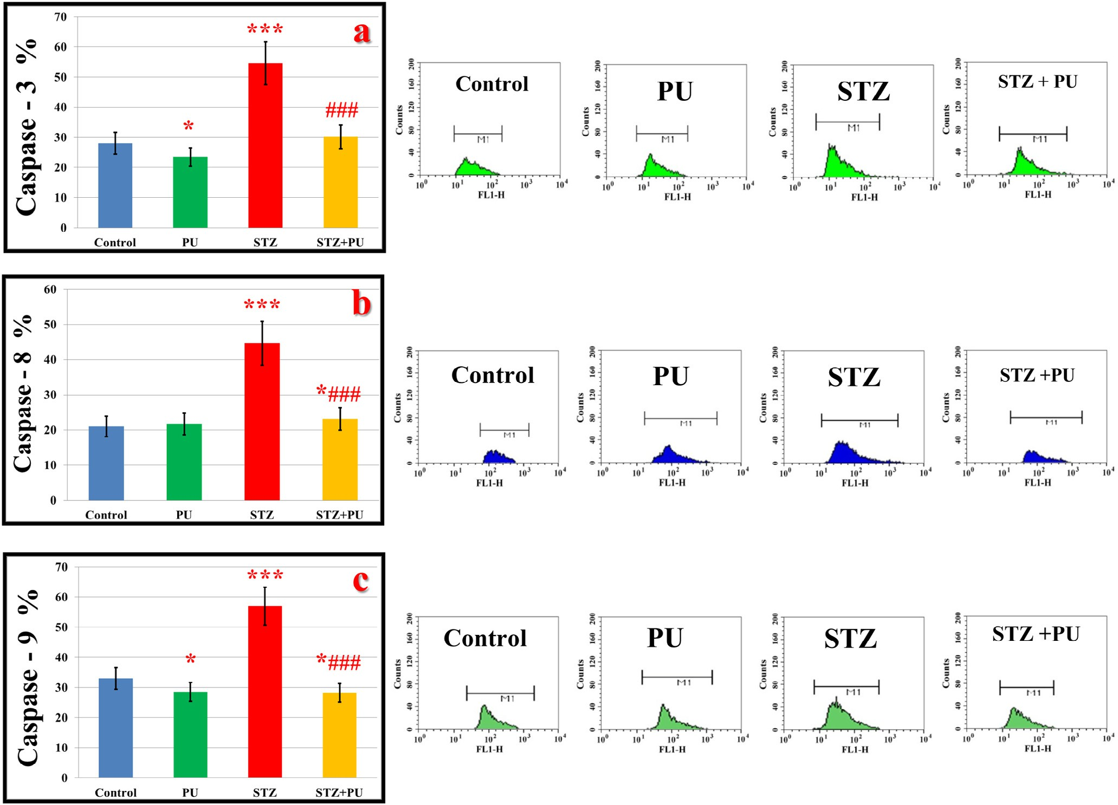

**Fig. 7 – Effects of streptozotocin (STZ) and punicalagin (PU) on caspases 3 (a), 8 (b) and 9 (c) expressions in rat hearts in rats in different groups. Flow cytometry data showing examples of the data generated by FACS are at the side of each histogram. The values are expressed as the means ± SEM. (n = 7). *, # Significant at P < 0.05, **, ## significant at P < 0.01, and**

**\*\*\*, ### significant at P < 0.001. *, **, *** indicate comparisons with respect to the control group. #, ##, ### indicate comparisons with respect to the diabetic group.**

A number of publications have reported the involvement of lipid peroxidation in the pathogenesis of diabetes- induced cardiac injury. The increased levels of H2O2 and MDA with decreased levels of SOD, CAT and GSH established ex- cessive oxidative stress in STZ-induced diabetic rats. The increase in oxidative stress in diabetic rats is a consequence of higher ROS generation, which are produced by metabolic dis- turbances [1,43]. Punicalagin treatment significantly decreased the oxidative stress parameters, increased the GSH levels and normalized the activities of antioxidant enzymes in the hearts of STZ-treated rats, demonstrating the anti-peroxidation effect of punicalagin. It is worth mentioning that punicalagin treat- ment significantly augmented the GSH levels in the rat heart, revealing its potential ability to improve the antioxidant mecha- nisms in the heart. Similarly, there was a significant increase in the GSH content in the heart of the pomegranate-treated rats compared to the doxorubicin-treated group, indicating an antioxidant effect against doxorubicin-induced oxidative cardiotoxicity in rats [44]. These results indicate that punicalagin possesses potent antioxidant capacity that is responsible for cardioprotection against oxidative stress.

Moreover, punicalagin administration significantly amelio- rated the elevated levels of troponin T levels and LDH and CK- MB activities toward normal levels, indicating that punicalagin is an efficient cardioprotectant in diabetic conditions and can protect cardiomyocyte membrane integrity. Histopathologi- cal examination of the heart confirmed this finding and showed that punicalagin effectively prevented STZ-induced cardiac damage. The current data coincide with the ability of the punicalagin-rich pomegranate to protect against I/R injury, doxo- rubicin and isoproterenol-induced cardiotoxicity in rats, likely because of its actions in enhancing oxygen free radical scav- enging activity and decreasing lipid peroxidative damage [10,44,45]. These results indicate that punicalagin can defend the heart against oxidative stress and the associated pathol- ogy and dysfunction.

The increase in ROS resulting from sustained hyperglyce- mia can lead to myocardial inflammation, which is characterized by the production of large number of cytokines [46]. Previous studies reported that the levels of proinflammatory cytokines and ROS were markedly increased and were asso- ciated with impaired glucose tolerance [47,48]. Therefore, it has

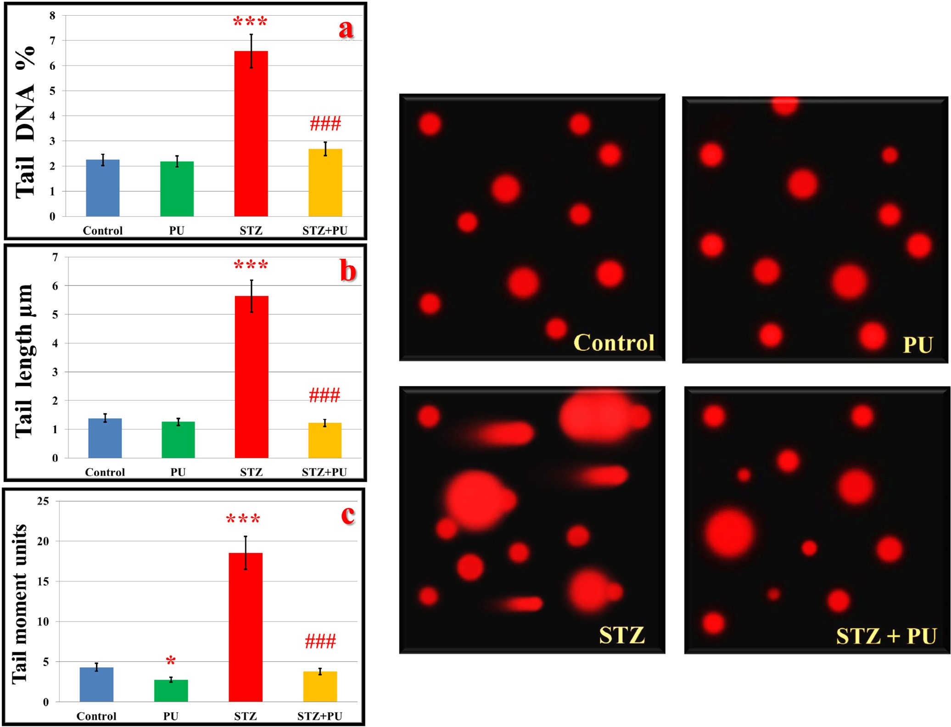

**Fig. 8 – Effect of streptozotocin (STZ) and punicalagin (PU) on the percentage of DNA damage in hearts of rats in different groups using the alkali comet assay that detects DNA single-strand breaks. (a) Percent of tail DNA, (b) tail length, and (c) tail moment. The appearance of the microscopic images of representative comets for the different groups is shown. The values are expressed as the means ± SEM. (n = 7). *, # Significant at P < 0.05, **, ## significant at P < 0.01, and ***, ### significant at**

**P < 0.001. *, **, *** indicate comparisons with respect to the control group. #, ##, ### indicate comparisons with respect to the diabetic group.**

been hypothesized that punicalagin can modulate cellular ac- tivity during inflammation due to its antioxidant properties. The current study demonstrated that punicalagin attenuated IL-1b, IL-6 and TNF-α in STZ-induced diabetes in rats. Several recent experimental studies suggest anti-inflammatory effects of pomegranate polyphenols in other settings that are char- acterized by increased oxidative stress. It has been reported that punicalagin treatment attenuated the elevation of TNF- alpha, IL-6 and IL-1b after LPS-induced acute respiratory distress syndrome in mice [49], in rat primary microglia [22], in cere- bral I/R in rats [50] and in an in vitro model of human intestinal epithelium [51]. These data suggest that punicalagin could be an interesting nutritional source that contributes to prevent- ing myocardial inflammation in diseases characterized by excessive oxidative stress, such as diabetes.

To understand the mechanism underlying the cardioprotective action of punicalagin on cardiac apoptosis in diabetes, we investigated the involvement of the STZ-mediated

extrinsic and intrinsic apoptotic cell death pathway in cardiac tissues. Flow cytometry analysis demonstrated that punicalagin treatment ameliorated STZ-induced programmed cell death in cardiac tissues by regulating pro-apoptotic proteins, such as CD95; caspases-3, 8, and 9; Bax; and P53, and anti-apoptotic proteins, such as Bcl-2. These results indicate a marked modu- lation of both mitochondrial and death receptor apoptotic pathways in the hearts of punicalagin-treated diabetic rats and provide evidence that punicalagin has the ability to modu- late apoptotic pathways in diabetes. Punicalagin significantly decreased trophoblast death as shown by the reduced levels of cleaved-PARP and LDH release [52]. Punicalagin-rich pome- granate peel extract protected the liver and kidneys by stimulating antioxidant activities and elevating the anti- apoptotic protein Bcl-2 [53]. Punicalagin reduced cerebral ischemia-reperfusion effects via attenuation of proinflammatory cytokines, up-regulation of Bcl-2 and down-regulation of Bax and caspase-3 [50]. In contrast to the induction of apoptosis

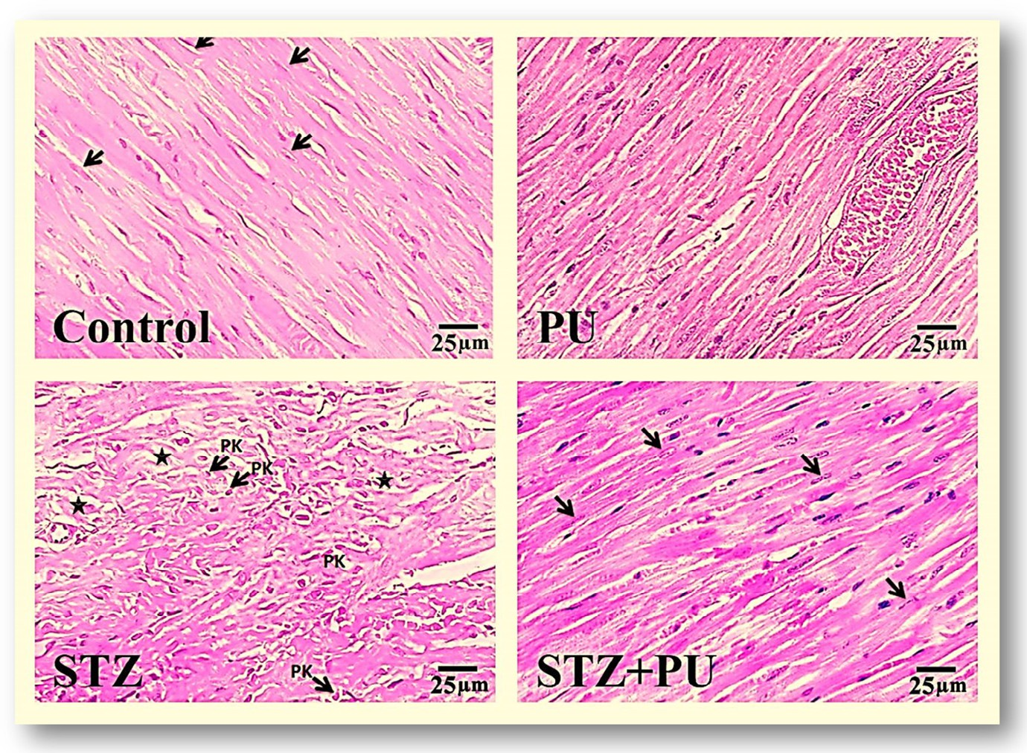

**Fig. 9 – Hematoxylin and eosin-stained heart sections of (a) control rat illustrating the regular arrangement of myocardial fibers with oval nuclei (arrows); (b) punicalagin-treated (PU) rat showing no remarkable changes; (c) streptozotocin-induced diabetic rats (STZ) illustrating the disorganized arrangement of the myocardial structure, myocyte degeneration (*) and pyknotic nuclei (Pk); and (d) streptozotocin + punicalagin-treated (STZ + PU) animals displaying an improvement in most of the cardiac muscle fibers with centrally located nuclei (arrows) (Scale bar is 25 gm).**

reported in cancer cells [54], punicalagin protects against heart cell death in STZ-induced diabetes, reflecting the cell type- specific nature of the responses to punicalagin.

In addition, STZ-induced cardiac apoptosis was also evident from the DNA damage. A significant correlation between oxi- dative DNA damage and hyperglycemia was previously reported [55]. Punicalagin treatment protected cardiac tissue from STZ- induced DNA damage, as evidenced by the inhibition of the increase of comet parameters compared to the diabetic rats. This implies that punicalagin prevented DNA strand breaks and maintained its supercoiled loops in an appropriately firm status. The precise mechanism is unidentified. However, this may be attributed to the effective antioxidant capacity of punicalagin.

induction and up-regulating Bcl-2, which is related to the en- hanced GSH and antioxidant levels in the heart. It also seems that punicalagin decreases apoptosis by blocking DNA damage via the suppression of caspases and pro-inflammatory cytokines that may be related to its anti-glycemic and anti-hyperlipidemic actions.

In conclusion, the underlying mechanisms of punicalagin- induced protection against diabetic cardiomyopathy are pleiotropic and include anti-hyperglycemic, anti-hyperlipidemic, antioxidant and anti-inflammatory activities. It can play an im- portant role in the modulation of inflammatory and apoptotic cell signaling in the diabetic heart.

Therefore, punicalagin can decrease the DNA damage by scav-

enging the ROS in diabetic cases.

Significantly, the current results display, for the first time, that punicalagin has biological activities in addition to being an antioxidant in the diabetic heart. Punicalagin showed anti- apoptotic effects and protected DNA. It can trigger a variety of anti-apoptotic pathways due to its inherited antioxidant prop- erty. Punicalagin treatment effectively down-regulates P53 and

# Acknowledgments

The facilities provided by the Faculty of Science, Mansoura Uni- versity, Egypt, are greatly acknowledged and appreciated.

R E F E R E N C E S

up-regulates Bcl-2 and intracellular GSH levels in the STZ- treated rats. P53 and its regulated genes can be activated by

hyperglycemia, leading to cardiomyocyte death [56]. It is re- ported that P53 has the ability to induce apoptosis by an ROS- dependent pathway [57,58]. In contrast, Bcl-2 exhibits an anti- apoptotic and anti-necrotic influence via its antioxidant effect on intracellular ROS [43,59]. Bcl-2 can decrease lipid peroxidation by increasing cell resistance to ROS and blocking ROS produc- tion [58]. Accordingly, it is suggested that the anti-apoptotic effect of punicalagin may occur via down-regulating P53

1. [Fiorentino TV, Prioletta A, Zuo P, Folli F. Hyperglycemia-](http://refhub.elsevier.com/S2314-808X(15)00066-4/sr0010) [induced oxidative stress and its role in diabetes mellitus](http://refhub.elsevier.com/S2314-808X(15)00066-4/sr0010) [related cardiovascular diseases. Curr Pharm Des](http://refhub.elsevier.com/S2314-808X(15)00066-4/sr0010) [2013;19:5695–703.](http://refhub.elsevier.com/S2314-808X(15)00066-4/sr0010)
2. [Chowdhry MF, Vohra HA, Galinanes M. Diabetes increases](http://refhub.elsevier.com/S2314-808X(15)00066-4/sr0015) [apoptosis and necrosis in both ischemic and nonischemic](http://refhub.elsevier.com/S2314-808X(15)00066-4/sr0015) [human myocardium: role of caspases and poly-adenosine](http://refhub.elsevier.com/S2314-808X(15)00066-4/sr0015) [diphosphate-ribose polymerase. J Thorac Cardiovasc Surg](http://refhub.elsevier.com/S2314-808X(15)00066-4/sr0015) [2007;134:124–31, 131 e121–3.](http://refhub.elsevier.com/S2314-808X(15)00066-4/sr0015)
3. [Wu TG, Li WH, Lin ZQ, Wang LX. Effects of folic acid on](http://refhub.elsevier.com/S2314-808X(15)00066-4/sr0020) [cardiac myocyte apoptosis in rats with streptozotocin-](http://refhub.elsevier.com/S2314-808X(15)00066-4/sr0020) [induced diabetes mellitus. Cardiovasc Drugs Ther](http://refhub.elsevier.com/S2314-808X(15)00066-4/sr0020) [2008;22:299–304.](http://refhub.elsevier.com/S2314-808X(15)00066-4/sr0020)
4. [Du Y, Guo H, Lou H. Grape seed polyphenols protect](http://refhub.elsevier.com/S2314-808X(15)00066-4/sr0025) [cardiac cells from apoptosis via induction of endogenous](http://refhub.elsevier.com/S2314-808X(15)00066-4/sr0025) [antioxidant enzymes. J Agric Food Chem 2007;55:1695–701.](http://refhub.elsevier.com/S2314-808X(15)00066-4/sr0025)
5. [Peuchant E, Brun JL, Rigalleau V, Dubourg L, Thomas MJ,](http://refhub.elsevier.com/S2314-808X(15)00066-4/sr0030) [Daniel JY, et al. Oxidative and antioxidative status in](http://refhub.elsevier.com/S2314-808X(15)00066-4/sr0030) [pregnant women with either gestational or type 1 diabetes.](http://refhub.elsevier.com/S2314-808X(15)00066-4/sr0030) [Clin Biochem 2004;37:293–8.](http://refhub.elsevier.com/S2314-808X(15)00066-4/sr0030)
6. [El-Missiry MA. Enhanced testicular antioxidant system by](http://refhub.elsevier.com/S2314-808X(15)00066-4/sr0035) [ascorbic acid in alloxan diabetic rats. Comp Biochem Physiol](http://refhub.elsevier.com/S2314-808X(15)00066-4/sr0035) [C Pharmacol Toxicol Endocrinol 1999;124:233–7.](http://refhub.elsevier.com/S2314-808X(15)00066-4/sr0035)
7. [Gil MI, Tomas-Barberan FA, Hess-Pierce B, Holcroft DM,](http://refhub.elsevier.com/S2314-808X(15)00066-4/sr0040) [Kader AA. Antioxidant activity of pomegranate juice and its](http://refhub.elsevier.com/S2314-808X(15)00066-4/sr0040) [relationship with phenolic composition and processing. J](http://refhub.elsevier.com/S2314-808X(15)00066-4/sr0040) [Agric Food Chem 2000;48:4581–9.](http://refhub.elsevier.com/S2314-808X(15)00066-4/sr0040)
8. [Matthaiou CM, Goutzourelas N, Stagos D, Sarafoglou E,](http://refhub.elsevier.com/S2314-808X(15)00066-4/sr0045) [Jamurtas A, Koulocheri SD, et al. Pomegranate juice](http://refhub.elsevier.com/S2314-808X(15)00066-4/sr0045) [consumption increases GSH levels and reduces lipid and](http://refhub.elsevier.com/S2314-808X(15)00066-4/sr0045) [protein oxidation in human blood. Food Chem Toxicol](http://refhub.elsevier.com/S2314-808X(15)00066-4/sr0045) [2014;73:1–6.](http://refhub.elsevier.com/S2314-808X(15)00066-4/sr0045)
9. [Gozlekci S, Saracoglu O, Onursal E, Ozgen M. Total phenolic](http://refhub.elsevier.com/S2314-808X(15)00066-4/sr0050) [distribution of juice, peel, and seed extracts of four](http://refhub.elsevier.com/S2314-808X(15)00066-4/sr0050) [pomegranate cultivars. Pharmacogn Mag 2011;7:161–4.](http://refhub.elsevier.com/S2314-808X(15)00066-4/sr0050)
10. [Jadeja RN, Thounaojam MC, Patel DK, Devkar RV,](http://refhub.elsevier.com/S2314-808X(15)00066-4/sr0055) [Ramachandran AV. Pomegranate (Punica granatum L.) juice](http://refhub.elsevier.com/S2314-808X(15)00066-4/sr0055) [supplementation attenuates isoproterenol-induced cardiac](http://refhub.elsevier.com/S2314-808X(15)00066-4/sr0055) [necrosis in rats. Cardiovasc Toxicol 2010;10:174–80.](http://refhub.elsevier.com/S2314-808X(15)00066-4/sr0055)
11. [Seeram NP, Adams LS, Henning SM, Niu Y, Zhang Y, Nair](http://refhub.elsevier.com/S2314-808X(15)00066-4/sr0060) [MG, et al. In vitro antiproliferative, apoptotic and](http://refhub.elsevier.com/S2314-808X(15)00066-4/sr0060) [antioxidant activities of punicalagin, ellagic acid and a total](http://refhub.elsevier.com/S2314-808X(15)00066-4/sr0060) [pomegranate tannin extract are enhanced in combination](http://refhub.elsevier.com/S2314-808X(15)00066-4/sr0060) [with other polyphenols as found in pomegranate juice. J](http://refhub.elsevier.com/S2314-808X(15)00066-4/sr0060) [Nutr Biochem 2005;16:360–7.](http://refhub.elsevier.com/S2314-808X(15)00066-4/sr0060)
12. [Banihani S, Swedan S, Alguraan Z. Pomegranate and type 2](http://refhub.elsevier.com/S2314-808X(15)00066-4/sr0065) [diabetes. Nutr Res 2013;33:341–8.](http://refhub.elsevier.com/S2314-808X(15)00066-4/sr0065)
13. [Middha SK, Usha T, Pande V. HPLC evaluation of phenolic](http://refhub.elsevier.com/S2314-808X(15)00066-4/sr0070) [profile, nutritive content, and antioxidant capacity of](http://refhub.elsevier.com/S2314-808X(15)00066-4/sr0070) [extracts obtained from Punica granatum fruit peel. Adv](http://refhub.elsevier.com/S2314-808X(15)00066-4/sr0070) [Pharmacol Sci 2013;2013:296236.](http://refhub.elsevier.com/S2314-808X(15)00066-4/sr0070)
14. [Basu A, Penugonda K. Pomegranate juice: a heart-healthy](http://refhub.elsevier.com/S2314-808X(15)00066-4/sr0075) [fruit juice. Nutr Rev 2009;67:49–56.](http://refhub.elsevier.com/S2314-808X(15)00066-4/sr0075)
15. [Hashemi M, Kelishadi R, Hashemipour M, Zakerameli A,](http://refhub.elsevier.com/S2314-808X(15)00066-4/sr0080) [Khavarian N, Ghatrehsamani S, et al. Acute and long-term](http://refhub.elsevier.com/S2314-808X(15)00066-4/sr0080) [effects of grape and pomegranate juice consumption on](http://refhub.elsevier.com/S2314-808X(15)00066-4/sr0080) [vascular reactivity in paediatric metabolic syndrome.](http://refhub.elsevier.com/S2314-808X(15)00066-4/sr0080) [Cardiol Young 2010;20:73–7.](http://refhub.elsevier.com/S2314-808X(15)00066-4/sr0080)
16. [Esmaillzadeh A, Tahbaz F, Gaieni I, Alavi-Majd H, Azadbakht](http://refhub.elsevier.com/S2314-808X(15)00066-4/sr0085)

[L. Cholesterol-lowering effect of concentrated pomegranate](http://refhub.elsevier.com/S2314-808X(15)00066-4/sr0085) [juice consumption in type II diabetic patients with](http://refhub.elsevier.com/S2314-808X(15)00066-4/sr0085) [hyperlipidemia. Int J Vitam Nutr Res 2006;76:147–51.](http://refhub.elsevier.com/S2314-808X(15)00066-4/sr0085)

1. [Zou X, Yan C, Shi Y, Cao K, Xu J, Wang X, et al. Mitochondrial](http://refhub.elsevier.com/S2314-808X(15)00066-4/sr0090) [dysfunction in obesity-associated nonalcoholic fatty liver](http://refhub.elsevier.com/S2314-808X(15)00066-4/sr0090) [disease: the protective effects of pomegranate with its active](http://refhub.elsevier.com/S2314-808X(15)00066-4/sr0090) [component punicalagin. Antioxid Redox Signal](http://refhub.elsevier.com/S2314-808X(15)00066-4/sr0090) [2014;21:1557–70.](http://refhub.elsevier.com/S2314-808X(15)00066-4/sr0090)
2. [Liu W, Ma H, Frost L, Yuan T, Dain JA, Seeram NP.](http://refhub.elsevier.com/S2314-808X(15)00066-4/sr0095) [Pomegranate phenolics inhibit formation of advanced](http://refhub.elsevier.com/S2314-808X(15)00066-4/sr0095) [glycation endproducts by scavenging reactive carbonyl](http://refhub.elsevier.com/S2314-808X(15)00066-4/sr0095) [species. Food Funct 2014;5:2996–3004.](http://refhub.elsevier.com/S2314-808X(15)00066-4/sr0095)
3. [Dorsey PG, Greenspan P. Inhibition of nonenzymatic protein](http://refhub.elsevier.com/S2314-808X(15)00066-4/sr0100) [glycation by pomegranate and other fruit juices. J Med Food](http://refhub.elsevier.com/S2314-808X(15)00066-4/sr0100) [2014;17:447–54.](http://refhub.elsevier.com/S2314-808X(15)00066-4/sr0100)
4. [Al-Muammar MN, Khan F. Obesity: the preventive role](http://refhub.elsevier.com/S2314-808X(15)00066-4/sr0105) [of the pomegranate (Punica granatum). Nutrition](http://refhub.elsevier.com/S2314-808X(15)00066-4/sr0105) [2012;28:595–604.](http://refhub.elsevier.com/S2314-808X(15)00066-4/sr0105)
5. [Rosenblat M, Volkova N, Roqueta-Rivera M, Nakamura MT,](http://refhub.elsevier.com/S2314-808X(15)00066-4/sr0110) [Aviram M. Increased macrophage cholesterol biosynthesis](http://refhub.elsevier.com/S2314-808X(15)00066-4/sr0110) [and decreased cellular paraoxonase 2 (PON2) expression in](http://refhub.elsevier.com/S2314-808X(15)00066-4/sr0110) [Delta6-desaturase knockout (6-DS KO) mice: beneficial](http://refhub.elsevier.com/S2314-808X(15)00066-4/sr0110) [effects of arachidonic acid. Atherosclerosis 2010;210:414–21.](http://refhub.elsevier.com/S2314-808X(15)00066-4/sr0110)
6. [Olajide OA, Kumar A, Velagapudi R, Okorji UP, Fiebich BL.](http://refhub.elsevier.com/S2314-808X(15)00066-4/sr0115) [Punicalagin inhibits neuroinflammation in LPS-activated rat](http://refhub.elsevier.com/S2314-808X(15)00066-4/sr0115) [primary microglia. Mol Nutr Food Res 2014;58:1843–51.](http://refhub.elsevier.com/S2314-808X(15)00066-4/sr0115)
7. [Yaidikar L, Byna B, Thakur SR. Neuroprotective effect of](http://refhub.elsevier.com/S2314-808X(15)00066-4/sr0120) [punicalagin against cerebral ischemia reperfusion-induced](http://refhub.elsevier.com/S2314-808X(15)00066-4/sr0120) [oxidative brain injury in rats. J Stroke Cerebrovasc Dis](http://refhub.elsevier.com/S2314-808X(15)00066-4/sr0120) [2014;23:2869–78.](http://refhub.elsevier.com/S2314-808X(15)00066-4/sr0120)
8. [Cerda B, Ceron JJ, Tomas-Barberan FA, Espin JC. Repeated](http://refhub.elsevier.com/S2314-808X(15)00066-4/sr0125) [oral administration of high doses of the pomegranate](http://refhub.elsevier.com/S2314-808X(15)00066-4/sr0125) [ellagitannin punicalagin to rats for 37 days is not toxic. J](http://refhub.elsevier.com/S2314-808X(15)00066-4/sr0125) [Agric Food Chem 2003;51:3493–501.](http://refhub.elsevier.com/S2314-808X(15)00066-4/sr0125)
9. [Ramesh B, Pugalendi KV. Antihyperglycemic effect of](http://refhub.elsevier.com/S2314-808X(15)00066-4/sr0130) [umbelliferone in streptozotocin-diabetic rats. J Med Food](http://refhub.elsevier.com/S2314-808X(15)00066-4/sr0130) [2006;9:562–6.](http://refhub.elsevier.com/S2314-808X(15)00066-4/sr0130)
10. [Yang Y, Xiu J, Zhang L, Qin C, Liu J. Antiviral activity of](http://refhub.elsevier.com/S2314-808X(15)00066-4/sr0135) [punicalagin toward human enterovirus 71 in vitro and in](http://refhub.elsevier.com/S2314-808X(15)00066-4/sr0135) [vivo. Phytomedicine 2012;20:67–70.](http://refhub.elsevier.com/S2314-808X(15)00066-4/sr0135)
11. [Lowry OH, Rosebrough NJ, Farr AL, Randall RJ. Protein](http://refhub.elsevier.com/S2314-808X(15)00066-4/sr0140) [measurement with the Folin phenol reagent. J Biol Chem](http://refhub.elsevier.com/S2314-808X(15)00066-4/sr0140) [1951;193:265–75.](http://refhub.elsevier.com/S2314-808X(15)00066-4/sr0140)
12. [Gong J, Qian L, Kong X, Yang R, Zhou L, Sheng Y, et al.](http://refhub.elsevier.com/S2314-808X(15)00066-4/sr0145) [Cardiomyocyte apoptosis in the right auricle of patients](http://refhub.elsevier.com/S2314-808X(15)00066-4/sr0145) [with ostium secundum atrial septal defect diseases. Life Sci](http://refhub.elsevier.com/S2314-808X(15)00066-4/sr0145) [2007;80:1143–51.](http://refhub.elsevier.com/S2314-808X(15)00066-4/sr0145)
13. [Juan WS, Lin HW, Chen YH, Chen HY, Hung YC, Tai SH, et al.](http://refhub.elsevier.com/S2314-808X(15)00066-4/sr0150) [Optimal Percoll concentration facilitates flow cytometric](http://refhub.elsevier.com/S2314-808X(15)00066-4/sr0150) [analysis for annexin V/propidium iodine-stained ischemic](http://refhub.elsevier.com/S2314-808X(15)00066-4/sr0150) [brain tissues. Cytometry A 2012;81:400–8.](http://refhub.elsevier.com/S2314-808X(15)00066-4/sr0150)
14. [Singh NP, McCoy MT, Tice RR, Schneider EL. A simple](http://refhub.elsevier.com/S2314-808X(15)00066-4/sr0155) [technique for quantitation of low levels of DNA damage in](http://refhub.elsevier.com/S2314-808X(15)00066-4/sr0155) [individual cells. Exp Cell Res 1988;175:184–91.](http://refhub.elsevier.com/S2314-808X(15)00066-4/sr0155)
15. [Tice RR, Andrews PW, Singh NP. The single cell gel assay: a](http://refhub.elsevier.com/S2314-808X(15)00066-4/sr0160) [sensitive technique for evaluating intercellular differences](http://refhub.elsevier.com/S2314-808X(15)00066-4/sr0160) [in DNA damage and repair. Basic Life Sci 1990;53:291–301.](http://refhub.elsevier.com/S2314-808X(15)00066-4/sr0160)
16. [Das J, Vasan V, Sil PC. Taurine exerts hypoglycemic effect in](http://refhub.elsevier.com/S2314-808X(15)00066-4/sr0165) [alloxan-induced diabetic rats, improves insulin-mediated](http://refhub.elsevier.com/S2314-808X(15)00066-4/sr0165) [glucose transport signaling pathway in heart and](http://refhub.elsevier.com/S2314-808X(15)00066-4/sr0165) [ameliorates cardiac oxidative stress and apoptosis. Toxicol](http://refhub.elsevier.com/S2314-808X(15)00066-4/sr0165) [Appl Pharmacol 2012;258:296–308.](http://refhub.elsevier.com/S2314-808X(15)00066-4/sr0165)
17. [Jelodar G, Mohsen M, Shahram S. Effect of walnut leaf,](http://refhub.elsevier.com/S2314-808X(15)00066-4/sr0170) [coriander and pomegranate on blood glucose and](http://refhub.elsevier.com/S2314-808X(15)00066-4/sr0170) [histopathology of pancreas of alloxan induced diabetic rats.](http://refhub.elsevier.com/S2314-808X(15)00066-4/sr0170) [Afr J Tradit Complement Altern Med 2007;4:299–305.](http://refhub.elsevier.com/S2314-808X(15)00066-4/sr0170)
18. [Del Rio D, Rodriguez-Mateos A, Spencer JP, Tognolini M,](http://refhub.elsevier.com/S2314-808X(15)00066-4/sr0175) [Borges G, Crozier A. Dietary (poly)phenolics in human](http://refhub.elsevier.com/S2314-808X(15)00066-4/sr0175) [health: structures, bioavailability, and evidence of protective](http://refhub.elsevier.com/S2314-808X(15)00066-4/sr0175) [effects against chronic diseases. Antioxid Redox Signal](http://refhub.elsevier.com/S2314-808X(15)00066-4/sr0175) [2013;18:1818–92.](http://refhub.elsevier.com/S2314-808X(15)00066-4/sr0175)
19. [Viladomiu M, Hontecillas R, Lu P, Bassaganya-Riera J.](http://refhub.elsevier.com/S2314-808X(15)00066-4/sr0180) [Preventive and prophylactic mechanisms of action of](http://refhub.elsevier.com/S2314-808X(15)00066-4/sr0180) [pomegranate bioactive constituents. Evid Based](http://refhub.elsevier.com/S2314-808X(15)00066-4/sr0180) [Complement Alternat Med 2013;2013:789764.](http://refhub.elsevier.com/S2314-808X(15)00066-4/sr0180)
20. [Tan BK, Tan CH, Pushparaj PN. Anti-diabetic activity of the](http://refhub.elsevier.com/S2314-808X(15)00066-4/sr0185) [semi-purified fractions of Averrhoa bilimbi in high fat diet](http://refhub.elsevier.com/S2314-808X(15)00066-4/sr0185) [fed-streptozotocin-induced diabetic rats. Life Sci](http://refhub.elsevier.com/S2314-808X(15)00066-4/sr0185) [2005;76:2827–39.](http://refhub.elsevier.com/S2314-808X(15)00066-4/sr0185)
21. [Huang TH, Peng G, Kota BP, Li GQ, Yamahara J, Roufogalis](http://refhub.elsevier.com/S2314-808X(15)00066-4/sr0190) [BD, et al. Pomegranate flower improves cardiac lipid](http://refhub.elsevier.com/S2314-808X(15)00066-4/sr0190) [metabolism in a diabetic rat model: role of lowering](http://refhub.elsevier.com/S2314-808X(15)00066-4/sr0190) [circulating lipids. Br J Pharmacol 2005;145:767–74.](http://refhub.elsevier.com/S2314-808X(15)00066-4/sr0190)
22. [Ferre P. The biology of peroxisome proliferator-activated](http://refhub.elsevier.com/S2314-808X(15)00066-4/sr0195) [receptors: relationship with lipid metabolism and insulin](http://refhub.elsevier.com/S2314-808X(15)00066-4/sr0195) [sensitivity. Diabetes 2004;53(Suppl. 1):S43–50.](http://refhub.elsevier.com/S2314-808X(15)00066-4/sr0195)
23. [Esmaillzadeh A, Tahbaz F, Gaieni I, Alavi-Majd H, Azadbakht](http://refhub.elsevier.com/S2314-808X(15)00066-4/sr0200)

[L. Concentrated pomegranate juice improves lipid profiles in](http://refhub.elsevier.com/S2314-808X(15)00066-4/sr0200) [diabetic patients with hyperlipidemia. J Med Food](http://refhub.elsevier.com/S2314-808X(15)00066-4/sr0200) [2004;7:305–8.](http://refhub.elsevier.com/S2314-808X(15)00066-4/sr0200)

1. [Cerda B, Llorach R, Ceron JJ, Espin JC, Tomas-Barberan FA.](http://refhub.elsevier.com/S2314-808X(15)00066-4/sr0205) [Evaluation of the bioavailability and metabolism in the rat](http://refhub.elsevier.com/S2314-808X(15)00066-4/sr0205) [of punicalagin, an antioxidant polyphenol from](http://refhub.elsevier.com/S2314-808X(15)00066-4/sr0205) [pomegranate juice. Eur J Nutr 2003;42:18–28.](http://refhub.elsevier.com/S2314-808X(15)00066-4/sr0205)
2. [Rosenblat M, Volkova N, Aviram M. Pomegranate juice (PJ)](http://refhub.elsevier.com/S2314-808X(15)00066-4/sr0210) [consumption antioxidative properties on mouse](http://refhub.elsevier.com/S2314-808X(15)00066-4/sr0210) [macrophages, but not PJ beneficial effects on macrophage](http://refhub.elsevier.com/S2314-808X(15)00066-4/sr0210) [cholesterol and triglyceride metabolism, are mediated via](http://refhub.elsevier.com/S2314-808X(15)00066-4/sr0210) [PJ-induced stimulation of macrophage PON2.](http://refhub.elsevier.com/S2314-808X(15)00066-4/sr0210) [Atherosclerosis 2010;212:86–92.](http://refhub.elsevier.com/S2314-808X(15)00066-4/sr0210)
3. [Shiner M, Fuhrman B, Aviram M. Macrophage paraoxonase 2](http://refhub.elsevier.com/S2314-808X(15)00066-4/sr0215) [(PON2) expression is up-regulated by pomegranate juice](http://refhub.elsevier.com/S2314-808X(15)00066-4/sr0215) [phenolic anti-oxidants via PPAR gamma and AP-1 pathway](http://refhub.elsevier.com/S2314-808X(15)00066-4/sr0215) [activation. Atherosclerosis 2007;195:313–21.](http://refhub.elsevier.com/S2314-808X(15)00066-4/sr0215)
4. [Amin AH, El-Missiry MA, Othman AI. Melatonin ameliorates](http://refhub.elsevier.com/S2314-808X(15)00066-4/sr0220) [metabolic risk factors, modulates apoptotic proteins, and](http://refhub.elsevier.com/S2314-808X(15)00066-4/sr0220) [protects the rat heart against diabetes-induced apoptosis.](http://refhub.elsevier.com/S2314-808X(15)00066-4/sr0220) [Eur J Pharmacol 2015;747:166–73.](http://refhub.elsevier.com/S2314-808X(15)00066-4/sr0220)
5. [Hassanpour Fard M, Ghule AE, Bodhankar SL, Dikshit M.](http://refhub.elsevier.com/S2314-808X(15)00066-4/sr0225) [Cardioprotective effect of whole fruit extract of](http://refhub.elsevier.com/S2314-808X(15)00066-4/sr0225) [pomegranate on doxorubicin-induced toxicity in rat. Pharm](http://refhub.elsevier.com/S2314-808X(15)00066-4/sr0225) [Biol 2011;49:377–82.](http://refhub.elsevier.com/S2314-808X(15)00066-4/sr0225)
6. [Dong S, Tong X, Liu H, Gao Q. Protective effects of](http://refhub.elsevier.com/S2314-808X(15)00066-4/sr0230) [pomegranate polyphenols on cardiac function in rats with](http://refhub.elsevier.com/S2314-808X(15)00066-4/sr0230) [myocardial ischemia/reperfusion injury]. Nan Fang Yi Ke Da](http://refhub.elsevier.com/S2314-808X(15)00066-4/sr0230) [Xue Xue Bao 2012;32:924–7.](http://refhub.elsevier.com/S2314-808X(15)00066-4/sr0230)
7. [Hayat SA, Patel B, Khattar RS, Malik RA. Diabetic](http://refhub.elsevier.com/S2314-808X(15)00066-4/sr0235) [cardiomyopathy: mechanisms, diagnosis and treatment.](http://refhub.elsevier.com/S2314-808X(15)00066-4/sr0235) [Clin Sci (Lond) 2004;107:539–57.](http://refhub.elsevier.com/S2314-808X(15)00066-4/sr0235)
8. [Khurana S, Venkataraman K, Hollingsworth A, Piche M, Tai](http://refhub.elsevier.com/S2314-808X(15)00066-4/sr0240) [TC. Polyphenols: benefits to the cardiovascular system in](http://refhub.elsevier.com/S2314-808X(15)00066-4/sr0240) [health and in aging. Nutrients 2013;5:3779–827.](http://refhub.elsevier.com/S2314-808X(15)00066-4/sr0240)
9. [Khurana S, Piche M, Hollingsworth A, Venkataraman K, Tai](http://refhub.elsevier.com/S2314-808X(15)00066-4/sr0245) [TC. Oxidative stress and cardiovascular health: therapeutic](http://refhub.elsevier.com/S2314-808X(15)00066-4/sr0245) [potential of polyphenols. Can J Physiol Pharmacol](http://refhub.elsevier.com/S2314-808X(15)00066-4/sr0245) [2013;91:198–212.](http://refhub.elsevier.com/S2314-808X(15)00066-4/sr0245)
10. [Peng J, Wei D, Fu Z, Li D, Tan Y, Xu T, et al. Punicalagin](http://refhub.elsevier.com/S2314-808X(15)00066-4/sr0250) [ameliorates lipopolysaccharide-induced acute respiratory](http://refhub.elsevier.com/S2314-808X(15)00066-4/sr0250) [distress syndrome in mice. Inflammation 2015;38:493–9.](http://refhub.elsevier.com/S2314-808X(15)00066-4/sr0250)
11. [Yaidikar L, Thakur S. Punicalagin attenuated cerebral](http://refhub.elsevier.com/S2314-808X(15)00066-4/sr0255) [ischemia-reperfusion insult via inhibition of](http://refhub.elsevier.com/S2314-808X(15)00066-4/sr0255) [proinflammatory cytokines, up-regulation of Bcl-2, down-](http://refhub.elsevier.com/S2314-808X(15)00066-4/sr0255) [regulation of Bax, and caspase-3. Mol Cell Biochem](http://refhub.elsevier.com/S2314-808X(15)00066-4/sr0255) [2015;402:141–8.](http://refhub.elsevier.com/S2314-808X(15)00066-4/sr0255)
12. [Hollebeeck S, Winand J, Herent MF, During A, Leclercq J,](http://refhub.elsevier.com/S2314-808X(15)00066-4/sr0260) [Larondelle Y, et al. Anti-inflammatory effects of](http://refhub.elsevier.com/S2314-808X(15)00066-4/sr0260) [pomegranate (Punica granatum L.) husk ellagitannins in](http://refhub.elsevier.com/S2314-808X(15)00066-4/sr0260) [Caco-2 cells, an in vitro model of human intestine. Food](http://refhub.elsevier.com/S2314-808X(15)00066-4/sr0260) [Funct 2012;3:875–85.](http://refhub.elsevier.com/S2314-808X(15)00066-4/sr0260)
13. [Chen B, Tuuli MG, Longtine MS, Shin JS, Lawrence R, Inder T,](http://refhub.elsevier.com/S2314-808X(15)00066-4/sr0265) [et al. Pomegranate juice and punicalagin attenuate oxidative](http://refhub.elsevier.com/S2314-808X(15)00066-4/sr0265) [stress and apoptosis in human placenta and in human](http://refhub.elsevier.com/S2314-808X(15)00066-4/sr0265) [placental trophoblasts. Am J Physiol Endocrinol Metab](http://refhub.elsevier.com/S2314-808X(15)00066-4/sr0265) [2012;302:E1142–52.](http://refhub.elsevier.com/S2314-808X(15)00066-4/sr0265)
14. [Abdel Moneim AE, Othman MS, Mohmoud SM, El-Deib KM.](http://refhub.elsevier.com/S2314-808X(15)00066-4/sr0270) [Pomegranate peel attenuates aluminum-induced](http://refhub.elsevier.com/S2314-808X(15)00066-4/sr0270) [hepatorenal toxicity. Toxicol Mech Methods 2013;23:624–33.](http://refhub.elsevier.com/S2314-808X(15)00066-4/sr0270)
15. [Wang SG, Huang MH, Li JH, Lai FI, Lee HM, Hsu YN.](http://refhub.elsevier.com/S2314-808X(15)00066-4/sr0275) [Punicalagin induces apoptotic and autophagic cell death in](http://refhub.elsevier.com/S2314-808X(15)00066-4/sr0275) [human U87MG glioma cells. Acta Pharmacol Sin](http://refhub.elsevier.com/S2314-808X(15)00066-4/sr0275) [2013;34:1411–19.](http://refhub.elsevier.com/S2314-808X(15)00066-4/sr0275)
16. [Song F, Jia W, Yao Y, Hu Y, Lei L, Lin J, et al. Oxidative stress,](http://refhub.elsevier.com/S2314-808X(15)00066-4/sr0280) [antioxidant status and DNA damage in patients with](http://refhub.elsevier.com/S2314-808X(15)00066-4/sr0280) [impaired glucose regulation and newly diagnosed Type 2](http://refhub.elsevier.com/S2314-808X(15)00066-4/sr0280) [diabetes. Clin Sci (Lond) 2007;112:599–606.](http://refhub.elsevier.com/S2314-808X(15)00066-4/sr0280)
17. [Fiordaliso F, Leri A, Cesselli D, Limana F, Safai B, Nadal-](http://refhub.elsevier.com/S2314-808X(15)00066-4/sr0285) [Ginard B, et al. Hyperglycemia activates p53 and p53-](http://refhub.elsevier.com/S2314-808X(15)00066-4/sr0285) [regulated genes leading to myocyte cell death. Diabetes](http://refhub.elsevier.com/S2314-808X(15)00066-4/sr0285) [2001;50:2363–75.](http://refhub.elsevier.com/S2314-808X(15)00066-4/sr0285)
18. [Cesselli D, Jakoniuk I, Barlucchi L, Beltrami AP, Hintze TH,](http://refhub.elsevier.com/S2314-808X(15)00066-4/sr0290) [Nadal-Ginard B, et al. Oxidative stress-mediated cardiac cell](http://refhub.elsevier.com/S2314-808X(15)00066-4/sr0290) [death is a major determinant of ventricular dysfunction and](http://refhub.elsevier.com/S2314-808X(15)00066-4/sr0290) [failure in dog dilated cardiomyopathy. Circ Res 2001;89:279–](http://refhub.elsevier.com/S2314-808X(15)00066-4/sr0290) [86.](http://refhub.elsevier.com/S2314-808X(15)00066-4/sr0290)
19. [Sheng R, Gu ZL, Xie ML, Zhou WX, Guo CY. EGCG inhibits](http://refhub.elsevier.com/S2314-808X(15)00066-4/sr0295) [cardiomyocyte apoptosis in pressure overload-induced](http://refhub.elsevier.com/S2314-808X(15)00066-4/sr0295) [cardiac hypertrophy and protects cardiomyocytes from](http://refhub.elsevier.com/S2314-808X(15)00066-4/sr0295) [oxidative stress in rats. Acta Pharmacol Sin 2007;28:191–](http://refhub.elsevier.com/S2314-808X(15)00066-4/sr0295) [201.](http://refhub.elsevier.com/S2314-808X(15)00066-4/sr0295)
20. [Kowaltowski AJ, Fiskum G. Redox mechanisms of](http://refhub.elsevier.com/S2314-808X(15)00066-4/sr0300) [cytoprotection by Bcl-2. Antioxid Redox Signal 2005;7:508–](http://refhub.elsevier.com/S2314-808X(15)00066-4/sr0300) [14.](http://refhub.elsevier.com/S2314-808X(15)00066-4/sr0300)