[Egyptian Journal of Basic and Applied Sciences 5 (2018) 298–302](https://doi.org/10.1016/j.ejbas.2018.08.001)



Contents lists available at [ScienceDirect](http://www.sciencedirect.com/science/journal/2314808X)

Egyptian Journal of Basic and Applied Sciences

journal homepage: [www.elsevier.com/locate/ejbas](http://www.elsevier.com/locate/ejbas)

Full Length Article

[](http://crossmark.crossref.org/dialog/?doi=10.1016/j.ejbas.2018.08.001&domain=pdf)Changes in the dielectric properties of rat lung tissue following x-irradiation

Abdelrazek B. Abdelrazzak a,⇑,1, Ahmad M. Labeeb b,1, Gamal S. El-Bahy a

a *Spectroscopy Department, Physics Research Division, National Research Centre, Cairo 12622, Egypt*

b *Microwave Physics and Dielectrics Department, Physics Research Division, National Research Centre, Cairo 12622, Egypt*

# a r t i c l e i n f o

*Article history:*

Received 14 June 2018

Received in revised form 15 August 2018 Accepted 20 August 2018

Available online 29 August 2018

*Keywords:*

Ionizing radiation Dielectric relaxation Electric modulus FTIR spectroscopy Lung tissue

# a b s t r a c t

The Dielectric and Fourier Transform Infrared (FTIR) spectroscopy have been used to investigate the effect

of low dose (10 cGy) and high dose (2 Gy) X-rays on the lung of whole-body irradiated rats. The dielectric permittivity e', dielectric loss e'', electric modulus *M*' and the imaginary part of the electric modulus *M*'' measured show changes in the molecular dynamics of the cellular membrane following 10 cGy and

2 Gy-irradiation, reflecting change in the fluidity of the cellular membrane following irradiation, with the most significant change recorded following 2 Gy-irradiation. The FTIR data further illustrate an increase in the fluidity cellular membrane following 10 cGy and 2 Gy-irradiations as marked by the shift and broadening of the CH2 asymmetric stretching vibration band. However, our findings show that 2 Gy-irradiation effects on the cellular membrane were much higher than 10 cGy but they also highlight the considerable effect of radiation dose as low as 10 cGy and its associated risk.

© 2018 Mansoura University. Production and hosting by Elsevier B.V. This is an open access article under

the CC BY-NC-ND license (<http://creativecommons.org/licenses/by-nc-nd/4.0/>).

1. Introduction

Exposure to ionizing radiation has been proven to cause variety of cellular effects [1]. Of the most deleterious cellular effects of ion- izing radiation comes the cell membrane damage. The fluidity of the cell membrane bilayer plays an important role in its function- ality. Thus, damage in the cell membrane affects its functionality and the whole cell integrity [2]. Investigation of the cellular mem- brane damage is crucial when studying the cellular effects of ion- izing radiation. The delectability of the radiation-induced damages relies essentially on the degree of the damage and the sensitivity of the detection techniques. Various physical techniques have been proven to be powerful, sensitive, and non-destructive techniques to investigate the radiation-induced damages at the cellular and molecular levels. Two of these techniques were used in this study, Dielectric spectroscopy and FTIR Spectroscopy.

Dielectric spectroscopy has widely been used to investigate molecular changes in biological tissue [3–6]. The dielectric proper- ties of biological tissue arise from the interaction of electromag- netic radiation with the constituents of the biological tissue. The molecular dynamic at different applied radio-frequencies RF can be tracked and well determined using dielectric characterizations

* Corresponding author.

*E-mail address:* [ab.abdelrazzak@nrc.sci.eg](mailto:ab.abdelrazzak@nrc.sci.eg) (A.B. Abdelrazzak).

1 Authors equally contributed to the work.

[7–10]. The application of RF around 1 MHz due to their interaction with biological tissues dates back to 1950s [11,12].

Dielectric complex permittivity e* and its reciprocal as complex

Electric Modulus *M*\* = 1/e* are useful tools in the study of biolog- ical tissues for basic and applied science applications [10,13]. The complex permittivity e* = e' — e'' parameters as dielectric constant

e' and losses e'' are always measured by parallel plate separated by

the sample as capacitor upto 100 MHz. On the other hand, the complex electric modulus *M*\* = *M*' + *iM*'' is a calculus method used for eliminate the interfacial electrode polarization that might cover any of the main relaxation processes in dielectric loss plots. Through the permittivity parameters measurements, the influence of different doses of radiation will be investigated for lung tissues of irradiated rats.

In this paper, the radio frequency RF (100 Hz–10 MHz) was used to investigate the effect of low- and high-dose whole-body irradia- tion on the molecular dynamics of the cellular membrane of the lung tissue of rats. The range 100 Hz–10 MHz is known to be the site of b dispersion. The b dispersion site arises from a polarization mecha- nism known as Maxwell-Wagner effect. In this region, the interface represents a barrier for ionic charge flow and hence leads to polar- ization and subsequent relaxation. The b dispersion in tissues often occurs at the cell membrane. Thus, any alterations in the structure of the cell membrane would markedly affect this region [14]. Addition- ally, the radiation-induced damage in the phospholipid membrane bilayer was further investigated using FTIR spectroscopy. FTIR is a

<https://doi.org/10.1016/j.ejbas.2018.08.001>

2314-808X/© 2018 Mansoura University. Production and hosting by Elsevier B.V.

This is an open access article under the CC BY-NC-ND license (<http://creativecommons.org/licenses/by-nc-nd/4.0/>).

non-destructive technique that provides in depth information about the molecular changes in the cell membrane [15–17] through pro- viding a fingerprint of all molecules in the cells [18].

1. Materials and methods
   1. *Experimental animals*

Experimental animals, twenty male Sprague-Dawley rats approximately 4 months old weighing 160 ± 20 g, were maintained under the standard conditions of 22–24 °C and 12-h light/dark cycle with free access to food and water. The experimental proce- dures were approved by the animal care and ethics committee at

the authors’ institute (approval no:17-018). The animals were divided into 3 groups each containing 5 rats; The Sham-

A is area of electrode, and e*o* is permittivity of vacuum (8.8543 × 10—12 F/m). Calculation of the permittivity in case of

using parallel plates as a capacitor is performed by dividing the capacitance of the cell with dielectric material *C* to capacitance of

empty cell *Co* where its permittivity value for air e'= 1 and the

capacitance is equal

*Co* = e*oA*/*d*

e'= *C*/*Co*

The complex electric modulus is used to shift up the frequencies of the relaxation peak and suppress the electrode polarization effect. The reciprocal values of complex permittivity as dielectric constant

e' and dielectric loss e'' determine the complex values of real and

imaginary parts of electric modulus [19]

irradiated group (0 Gy), the animals were kept unirradiated con- trol. The 2 Gy-irradiated group; Animals were 2 Gy whole-body

irradiated (dose rate 4 Gy/min). The 10 cGy-irradiated group; Ani-

*M*\* = 1

e*

= *M*' + *iM*''

e'

= e'2 + e''2

e''

+ *i* e'2 + e''2

mals were 10 cGy whole-body irradiated (dose rate 4 Gy/min).

* 1. *Irradiation*

Rats were irradiated with x-rays using a 6 MV linear accelerator (Precise Linear Accelerator; Elekta, Stockholm, Sweden) at the oncology and nuclear medicine center at Mansoura University hos- pital, Mansoura, Egypt.

Before irradiation, the animals were anesthetized by intraperi- toneal injection of Ketamine and Xylazine cocktail (75 mg/kg and 5 mg/Kg, respectively). In average, the animals were under anes- thesia for 60 min during which the animals were kept at room temperature (20–25 °C). During irradiation, the animals were restrained in the sternal recumbent position on the irradiation table and the animals were centered in the radiation field.

* 1. *Samples collection*

At the end of the experimental period, all animals were anes- thetized with halothane and sacrificed and sections from the lung were collected. All samples were then freeze-dried and stored until use.

* 1. *The dielectric measurements*

The dielectric permittivity parameters of lung tissues were measured in low frequencies from 100 Hz to 100 KHz by Ando AG-4311 LCR meter (United State). The capacitance C and dielectric loss tangent D were measured directly. Then, frequencies from 100 KHz to 120 MHz were applied by Hioki LCR 3535-Hi Tester meter (Hioki Co., Japan). The former LCR hi tester is upgraded using 9700 head amplifier unit by the manufacturer to minimize the effect of the measuring leads. The experiments were carried out using 9699 SMD test fixture which has two electrodes to be fitted with sample object sizes as width: 1.0 mm length: 4.0 mm and height: less than 1.5 mm. This test fixture has the operating fre- quency range from DC to 120 MHZ.

Both e' and e'' are calculated based on equations

e' = *Cd*/e*oA*

and dielectric loss

e'' = r*dc* /e*o* x

tan d(*D*)= e''/e'

where *C* is capacitance of the sample placed in between two elec- trodes as dielectrics, and d is thickness which is less than 1.5 mm.

The dc Conductivity r*dc* which is depending on the dielectric loss e'' and angular frequency x represent the electric charge mobility car-

ries inside the sample matrix or network of the sample. Thus, the dissipated energy could be used in driving charges carriers under applied electric field as shown in the following equation

r*dc* = r*s* + e'' e*o* x

Moreover, the dielectric properties refer to the electric charge and their carries inside the tissues regarding to an external electric field. The dc conductivity of the tissues represents their free charge movement forced by the external field. Therefore, dielectric response of biological materials is always frequency dependent. Thus, a linear response means that the dielectric properties are independent of the external field strength, which is true when the external electric field is not very strong.

* 1. *FTIR spectroscopy*

All FTIR measurements of freeze-dried samples were performed at room temperature in the energy range 4000–400 cm—1 using a Bruker Vertex 70 Fourier transform spectrometer in combination with diamond ATR unit at 4 cm—1 spectral resolution.

1. Results and discussion

Dielectric spectroscopy has been an important physical tool for the modeling and evaluating the energy deposition in tissue exposed to radio-waves [20]. The dielectric properties of the lung tissue of the sham, 10 cGy and 2 Gy-irradiated rats are represented in this section. Fig. 1 shows the permittivity as dielectric constants

e' versus the applied frequency at room temperature. Both complex

permittivity parameters as dielectric constants e' and dielectric loss e'' were measured from 100 Hz to 10 MHz. The value of per- mittivity e' of sham-irradiated group starts at 88 and decrease

rapidly over the frequency range 102 Hz–104 Hz. On the other hand, the permittivity value at the high frequency ranges

105 Hz–107 Hz, known as infinity dielectric constant e∞, was 41.

The reason for lower values of e*s* could be the due to freeze drying

the samples which removed the water content from the tissues leaving behind the non-liquid components of the tissue including cell membrane and lipids. The difference between these values (88 and 41) refers to the dielectric strength of the intra-

molecular dynamic process De = e*s* — e∞ [9]. This is in agreement

with data reported for bone tissue, whose dielectric properties were measured by Gabriel et al. in 1996 [3]. However, other organs that have large content of water recorded very high permittivity values (order of 105–107) at low RF frequencies [3]. Although the 10 cGy irradiated samples show lower permittivity values of 45

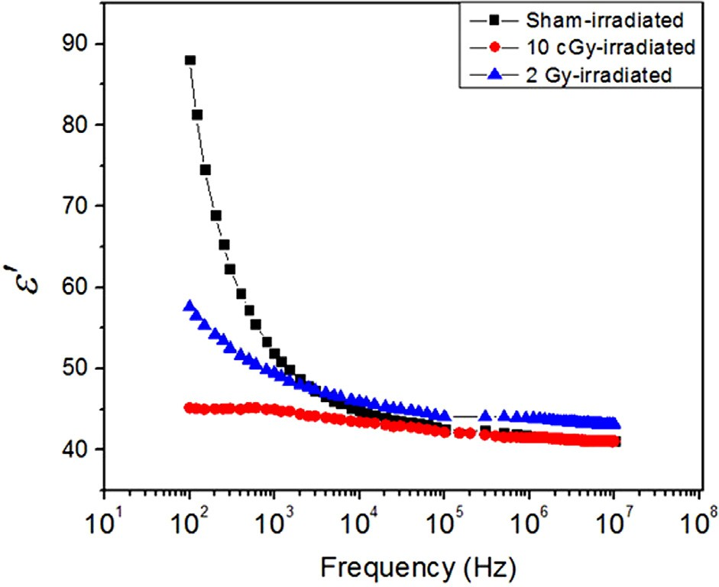 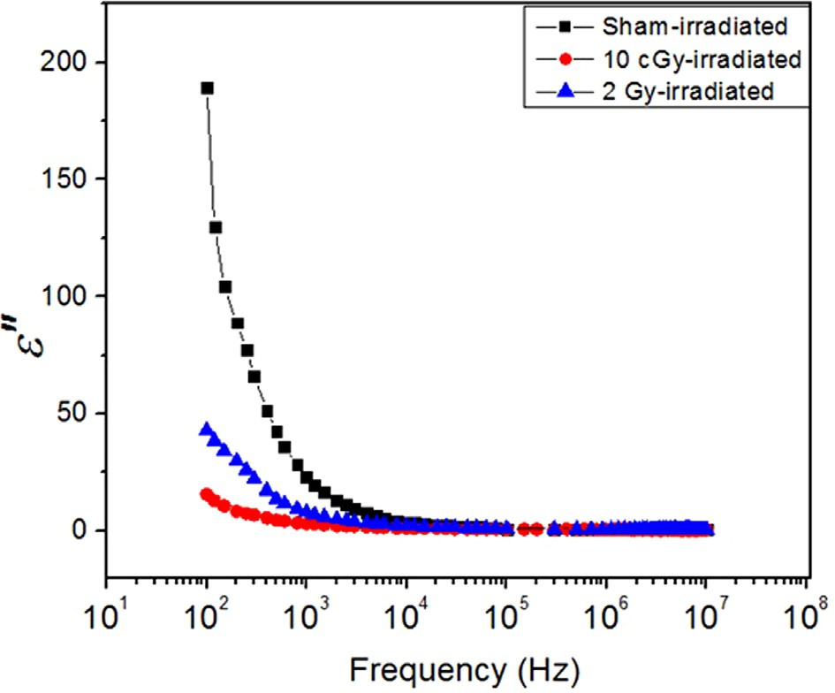

Fig. 1. The dielectric permittivity (e'). Changes in the permittivity (e') of the sham, 10 cGy and 2 Gy-irradiated groups as a function of frequency.

Fig. 2. The dielectric loss (e''). Changes in the dielectric loss (e'') of the sham, 10 cGy and 2 Gy-irradiated groups as a function of frequency.

at low frequencies, at high frequencies there is a slight decrease to

41. The 2 Gy-irradiated samples show different trend with higher permittivity value of 57.6 at the low frequencies, followed by sig- nificant decrease down to 43 at the higher frequencies.

The internal dynamic processes of the molecular structure resulting from the applied electric field can be investigated by

measuring dielectric loss (e''). Fig. 2 shows the dielectric loss e''

for the sham, low- and high-dose irradiated groups. As shown in the figure, part of the relaxation processes appears at low RF fre- quencies for the samples with contribution of the interfacial or electrode polarizations especially in the sham and high-dose irra- diated groups. Whereas, the low-dose irradiated group does not show any relaxation process. The overall trend shows the relax- ation processes to be shifted towards the lower frequencies. Due to the interference of electrode polarization, it is hard to determine the relaxation processes at low RF region [21]. Therefore, the elec- tric modulus *M*' was used to eliminate the effect of electrode polar- ization as it is considered a useful correlation to get the molecular dynamics and their related relaxation processes clearly and easily as shown in Figs. 3 and 4.

As shown in Fig. 3, in the low-dose irradiated group, the real part of the electric modulus *M*' slightly increases from 0.020 to

0.024 as a result of its high shift towards the low frequency region. However, the electric modulus *M*' of the sham-irradiated group shows a dramatic increase from 0.002 to 0.022 before reaching the plateau level. This typical behavior of complete relaxation pro- cess reflects the changes in the molecular dynamics of the macro- molecules and is attributed to the flexibility of the structure and enlarge the free volume in the texture [14]. The electric modulus

*M*' of the high-dose irradiated group shows a shift starting from

0.0111 and reaching the plateau from 0.0214 to 0.0232 over the frequency range 103–107 Hz.

Thus, the imaginary part of electric modulus *M*'' is useful to

show the relaxation processes without any contribution of the AC conductivity due electrode polarization. Fig. 4 shows the imag- inary electric modulus *M*'' full relaxation process for the sham- irradiated group while the 2 Gy-irradiated group shows an inter- mediate relaxation process peak. This is an evidence of little shift in the main relaxation of the lung tissue cellular membrane as a result of 2 Gy-irradiation. However, for the 10 cGy-irradiation, shift towards very low frequencies was observed. These data clearly show the influence of ionizing radiation on the fluidity of the cel- lular membrane.

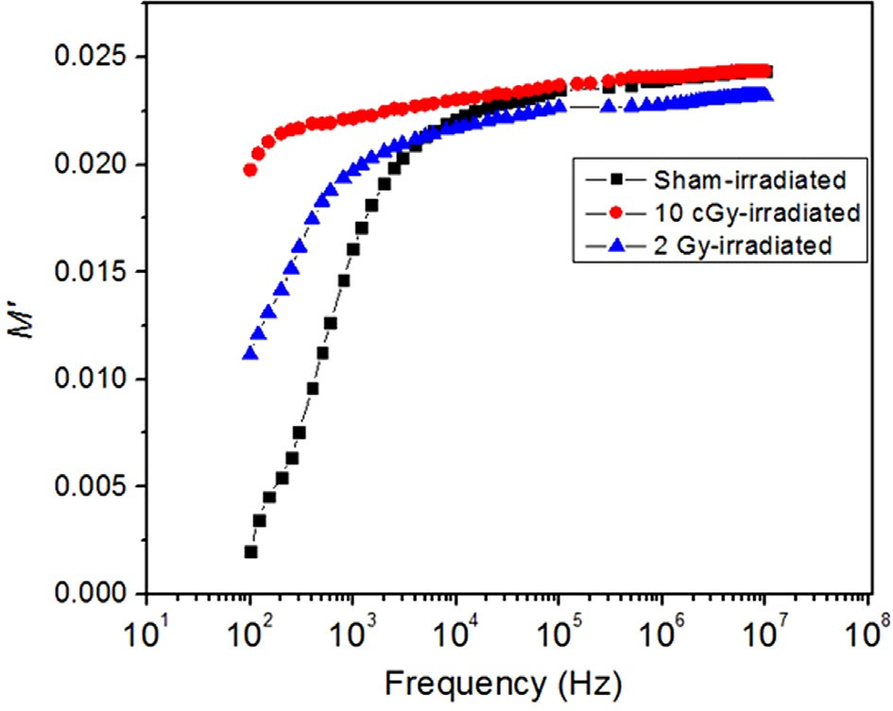

Fig. 3. The real part of the electric modulus (*M*'). Changes in the real part of the electric modulus M' of the sham, 10 cGy and 2 Gy-irradiated groups as a function of frequency.

The free volume distribution depends on the temperature and frequency, and affects the relaxation peak frequency [22]. Our results show 10 cGy-irradiation lead to greater shift in the relax- ation peak towards low frequencies than the 2 Gy-irradiation. This implies that 10 cGy-irradiation leads to increased rigidity in the cell membrane as compared with 2 Gy-irradiation.

The dielectric relaxation process in the linear systems refers to the time delay needed by the molecule to regain its original state before applying the electric [23]. The relaxation time of the 10 cGy-irradiated group is high as a result of the shift of the relax- ation peak towards low frequencies. The more rigid the molecule is, the less free volume the molecule has and hence the more the time the relaxation process takes. Thus more shifts toward lower frequencies is observed [22]. Changes in the temperature remark- ably affect the dielectric relaxation process [23]. In this study, all samples were measured at room temperature. Thus, the tempera- ture had negligible effect on our results which indicates that the shift in the dielectric relaxation process to lower frequencies was solely due to the effect ionizing radiation on the macromolecules in the samples.

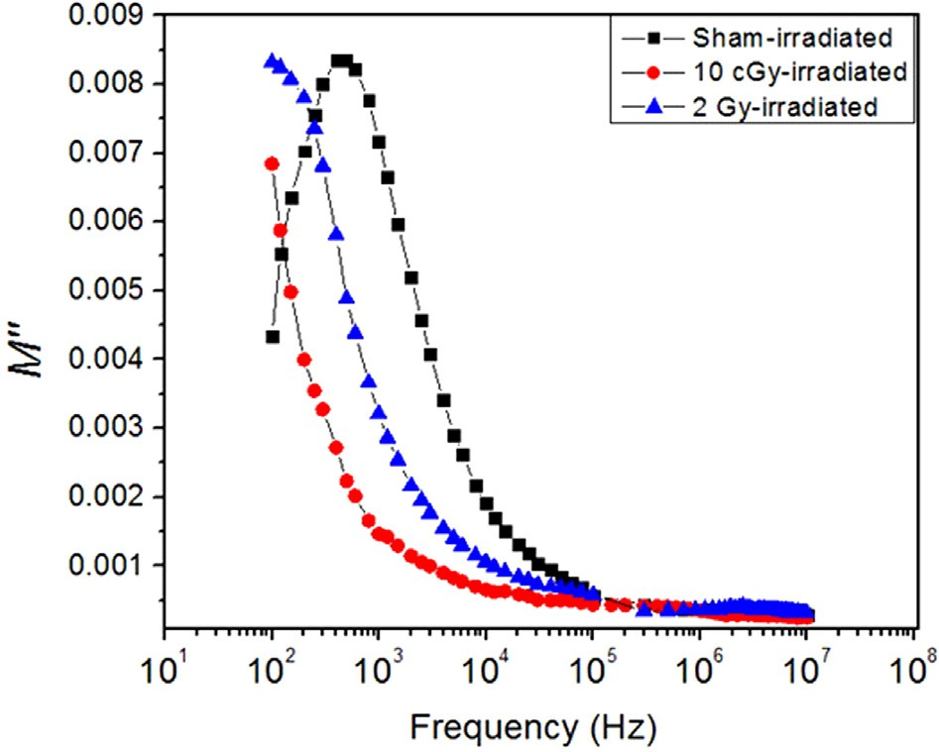

Fig. 4. The imaginary part of electric modulus (*M*''). The imaginary part of electric modulus (M'' ) of the sham, 10 cGy and 2 Gy-irradiated groups measured versus frequency.

Fig. 5 shows the dc conductivity as illustrated in the equation before. All irradiated and sham-irradiated groups show the same behavior of lipid and polymeric attributes. At low frequencies, no charge carriers movement through the samples can be detected,

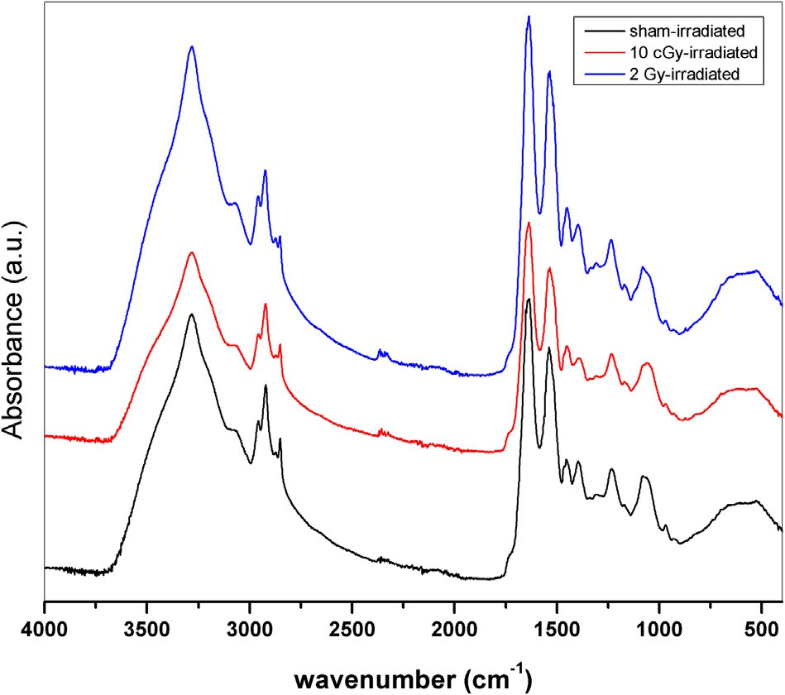Fig. 6. FTIR spectra. The FTIR spectra of the rat lung of the sham, 10 cGy and 2 Gy- irradiated groups.

Table 1

Changes in the band position and full width at half maximum (FWHM) values of CH2 asymmetric stretching FTIR band of sham, 10 cGy and 2 Gy-irradiated groups.

|  |  |  |  |
| --- | --- | --- | --- |
| while the threshold of moving charges and ions through the sam- |  | Band position (cm—1) | FWHM |
| ples start at 106 Hz, where high energy field is applied. The follow- | Sham-irradiated | 2920 | 24.4353 |
| ing dramatic and significant increase is due to the start of charge | 10 cGy-irradiated | 2921 | 25.0501 |
| carries movements between the electrodes. There is no saturation | 2 Gy-irradiated | 2922 | 24.7212 |
| level (plateau) reached at higher frequency, which means continu- |  |  |  |
| ous increase in charges moving with increasing the applied field. |  |  |  |

To further investigate the effect of low and high doses of ioniz-

ing radiation on the conformational disorder of the cell membrane, FTIR spectroscopy was used. Fig. 6 shows the FTIR spectra of the sham, 10 cGy and 2 Gy-irradiated groups in the spectral range

4000–400 cm—1. As illustrated in Fig. 6 and Table 1, the CH2 asym-

metric stretching vibration band located at 2920 cm—1 in the sham-irradiated group. However, this band was slightly shifted towards higher wavenumber in both 10 cGy and 2 Gy-irradiated groups with the higher shift seen in the 2 Gy-irradiated group. The shift in this band indicates a decrease in the order of the sys-

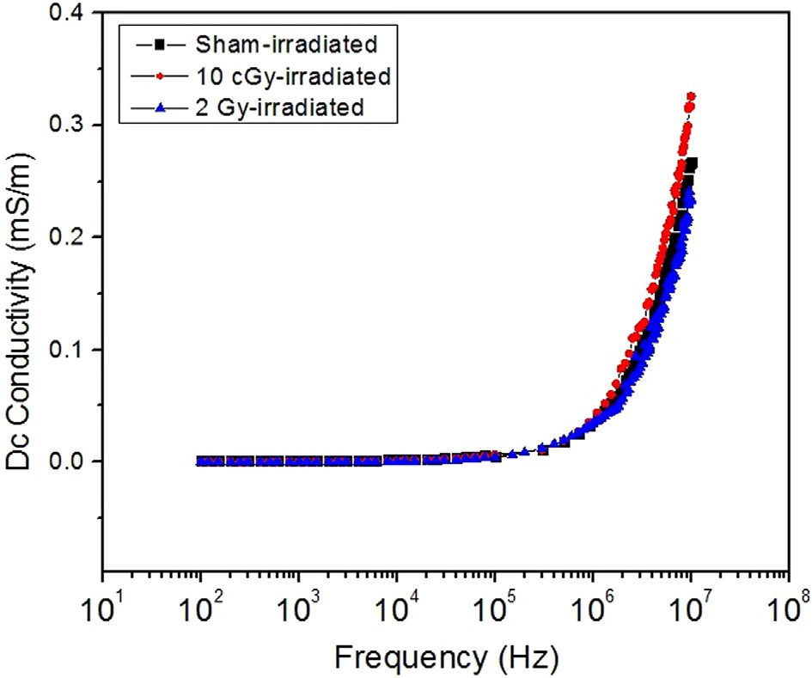

Fig. 5. The DC conductivity. Changes in the DC conductivity of the sham, 10 cGy and 2 Gy-irradiated groups as a function of frequency.

tem which can be correlated to the increase in the membrane fluidity [17,24] with the 2 Gy-irradiation having a higher effect on membrane fluidity. These results are in agreement with our dielectric data showing that the 2 Gy-irradiated group shows more flexibility (due to increased fluidity) than the 10 cGy-irradiated group as indicated by the difference in the dielectric relaxation processes between the two groups.

Furthermore, an increase of the bandwidth of the CH2 asym- metric stretching vibration band was also recorded (Table 1). This indicates an increase in the membrane fluidity on the irradiated groups [18]. The increase in the membrane fluidity is always accompanied by a decrease in order as a result of free rotation of lipid acyl chains and lateral lipid motion [15,25]. These data all together suggest varying degrees of disorders in the molecular structure of the cell membrane as a result of radiation with the highest degree of disorder is seen following 2 Gy-irradiation. Our findings however seem to be logical, that a higher radiation dose induces the higher effect, they point out the risk associated with low-dose radiation and its implications on human health.

1. Conclusions

Our findings reveal significant conformational changes in the cell membrane of the rat lung cells following 10 cGy and 2 Gy-irradiations. Measuring the various dielectric parameters of

permittivity e', dielectric loss e'', electric modulus *M*', the imaginary

part of the electric modulus *M*'' and DC conductivity divulge that both irradiations increased the membrane fluidity. The remarkable shifts of the relaxation peaks toward low frequencies following irradiation indicate changes in the fluidity of the cellular mem- branes. The dielectric constant values are considerably high even in absence of water contents after freeze drying. 2 Gy-irradiation-

induced membrane fluidity was way higher than that recorded following 10 cGy-irradiation. Furthermore, FTIR data confirms the remarkable conformational changes in the cell membrane follow- ing irradiation with the 2 Gy-irradiation having the major effect. The data also emphasize the risk associated with low-dose radia- tion exposure through its damaging effect at the cellular level.

1. Role of funding

This research did not receive any specific grant from funding agencies in the public, commercial, or not-for-profit sectors.

References

1. [Hall EJ, Giaccia AJ. Radiobiology for the Radiologist. Lippincott Williams &](http://refhub.elsevier.com/S2314-808X(18)30267-7/h0005) [Wilkins Philadelphia; 2006](http://refhub.elsevier.com/S2314-808X(18)30267-7/h0005).
2. [Gaschler MM, Stockwell BR. Lipid peroxidation in cell death. Biochem Biophys](http://refhub.elsevier.com/S2314-808X(18)30267-7/h0010) [Res Commun 2017;482(3):419–25](http://refhub.elsevier.com/S2314-808X(18)30267-7/h0010).
3. [Gabriel S, Lau R, Gabriel C. The dielectric properties of biological tissues: II.](http://refhub.elsevier.com/S2314-808X(18)30267-7/h0015) [Measurements in the frequency range 10 Hz to 20 GHz. Phys Med Biol 1996;41](http://refhub.elsevier.com/S2314-808X(18)30267-7/h0015) [(11):2251](http://refhub.elsevier.com/S2314-808X(18)30267-7/h0015).
4. [Peyman A, Holden S, Gabriel C. Dielectric properties of tissues at microwave](http://refhub.elsevier.com/S2314-808X(18)30267-7/h0020) [frequencies. Mobile Telecommun Health Res Program Final Report 2005](http://refhub.elsevier.com/S2314-808X(18)30267-7/h0020).
5. [Sasaki K, Wake K, Watanabe S. Measurement of the dielectric properties of the](http://refhub.elsevier.com/S2314-808X(18)30267-7/h0025) [epidermis and dermis at frequencies from 0.5 GHz to 110 GHz. Phys Med Biol](http://refhub.elsevier.com/S2314-808X(18)30267-7/h0025) [2014;59(16):4739](http://refhub.elsevier.com/S2314-808X(18)30267-7/h0025).
6. [Schmid G, Neubauer G, Illievich UM, Alesch F. Dielectric properties of porcine](http://refhub.elsevier.com/S2314-808X(18)30267-7/h0030) [brain tissue in the transition from life to death at frequencies from 800 to](http://refhub.elsevier.com/S2314-808X(18)30267-7/h0030) [1900 MHz. Bioelectromagnetics 2003;24(6):413–22](http://refhub.elsevier.com/S2314-808X(18)30267-7/h0030).
7. [Wasserman E, Wood B, Brodholt J. Molecular dynamics study of the dielectric](http://refhub.elsevier.com/S2314-808X(18)30267-7/h0035) [constant of water under high pressure and temperature conditions. Ber](http://refhub.elsevier.com/S2314-808X(18)30267-7/h0035) [Bunsenges Phys Chem 1994;98(7):906–11](http://refhub.elsevier.com/S2314-808X(18)30267-7/h0035).
8. [Golio M. The RF and microwave handbook. CRC Press; 2000](http://refhub.elsevier.com/S2314-808X(18)30267-7/h0040).
9. [Wübbenhorst M. Broadband dielectric spectroscopy. Edited by Friedrich](http://refhub.elsevier.com/S2314-808X(18)30267-7/h0045) [Kremer and Andreas Schonhals. Wiley Online Library; 2004](http://refhub.elsevier.com/S2314-808X(18)30267-7/h0045).
10. [Gereben O, Pusztai L. On the accurate calculation of the dielectric constant](http://refhub.elsevier.com/S2314-808X(18)30267-7/h0050) [from molecular dynamics simulations: the case of SPC/E and SWM4-DP water.](http://refhub.elsevier.com/S2314-808X(18)30267-7/h0050) [Chem Phys Lett 2011;507(1–3):80–3](http://refhub.elsevier.com/S2314-808X(18)30267-7/h0050).
11. [Cosman B, Cosman E. Guide to radio frequency lesion generation in](http://refhub.elsevier.com/S2314-808X(18)30267-7/h0055) [neurosurgery. Burlington, MA: Radionics; 1974](http://refhub.elsevier.com/S2314-808X(18)30267-7/h0055).
12. Cosman B, Cosman E. Guide to radiofrequency lesion generation in neurosurgery. Radionics Procedure Technique Series Monographs. Burlington (MA): Radionics, Inc; 1974.
13. [Wagner H, Richert R. Dielectric relaxation of the electric field in poly (vinyl](http://refhub.elsevier.com/S2314-808X(18)30267-7/h0065) [acetate): a time domain study in the range 10](http://refhub.elsevier.com/S2314-808X(18)30267-7/h0065)—[3–106](http://refhub.elsevier.com/S2314-808X(18)30267-7/h0065) [s. Polymer 1997;38](http://refhub.elsevier.com/S2314-808X(18)30267-7/h0065) [(2):255–61](http://refhub.elsevier.com/S2314-808X(18)30267-7/h0065).
14. [Gabriel C. Dielectric properties of biological tissue: variation with age.](http://refhub.elsevier.com/S2314-808X(18)30267-7/h0070) [Bioelectromagnetics 2005;26(S7)](http://refhub.elsevier.com/S2314-808X(18)30267-7/h0070).
15. [Bozkurt O, Severcan M, Severcan F. Diabetes induces compositional, structural](http://refhub.elsevier.com/S2314-808X(18)30267-7/h0075) [and functional alterations on rat skeletal soleus muscle revealed by FTIR](http://refhub.elsevier.com/S2314-808X(18)30267-7/h0075) [spectroscopy: a comparative study with EDL muscle. Analyst 2010;135](http://refhub.elsevier.com/S2314-808X(18)30267-7/h0075) [(12):3110–9](http://refhub.elsevier.com/S2314-808X(18)30267-7/h0075).
16. [Cakmak G, Togan I, Severcan F. 17b-Estradiol induced compositional,](http://refhub.elsevier.com/S2314-808X(18)30267-7/h0080) [structural and functional changes in rainbow trout liver, revealed by FT-IR](http://refhub.elsevier.com/S2314-808X(18)30267-7/h0080) [spectroscopy: a comparative study with nonylphenol. Aquat Toxicol 2006;77](http://refhub.elsevier.com/S2314-808X(18)30267-7/h0080) [(1):53–63](http://refhub.elsevier.com/S2314-808X(18)30267-7/h0080).
17. [Severcan F, Kaptan N, Turan B. Fourier transform infrared spectroscopic](http://refhub.elsevier.com/S2314-808X(18)30267-7/h0085) [studies of diabetic rat heart crude membranes. J Spectroscopy 2003;17(2–](http://refhub.elsevier.com/S2314-808X(18)30267-7/h0085) [3):569–77](http://refhub.elsevier.com/S2314-808X(18)30267-7/h0085).
18. [Gasper R, Dewelle J, Kiss R, Mijatovic T, Goormaghtigh E. IR spectroscopy as a](http://refhub.elsevier.com/S2314-808X(18)30267-7/h0090) [new tool for evidencing antitumor drug signatures, Biochimica et Biophysica.](http://refhub.elsevier.com/S2314-808X(18)30267-7/h0090) [Acta (BBA)-Biomembranes 2009;1788(6):1263–70](http://refhub.elsevier.com/S2314-808X(18)30267-7/h0090).
19. McCrum NG, Read BE, Williams G. Anelastic and dielectric effects in polymeric solids, 1967.
20. [Shahzad A, Khan S, Jones M, Dwyer RM, O’Halloran M. Investigation of the](http://refhub.elsevier.com/S2314-808X(18)30267-7/h0100) [effect of dehydration on tissue dielectric properties in ex vivo measurements.](http://refhub.elsevier.com/S2314-808X(18)30267-7/h0100) [Biomed Phys Eng Express 2017;3(4):045001](http://refhub.elsevier.com/S2314-808X(18)30267-7/h0100).
21. [Ishai PB, Talary MS, Caduff A, Levy E, Feldman Y. Electrode polarization in](http://refhub.elsevier.com/S2314-808X(18)30267-7/h0105) [dielectric measurements: a review. Meas Sci Technol 2013;24(10):102001](http://refhub.elsevier.com/S2314-808X(18)30267-7/h0105).
22. [Kakizaki M, Abe Y, Hideshima T. Distribution of free volume and dielectric](http://refhub.elsevier.com/S2314-808X(18)30267-7/h0110) [relaxation due to segmental motion of amorphous chains in chlorinated poly](http://refhub.elsevier.com/S2314-808X(18)30267-7/h0110) [(ethylene). Jpn J Appl Phys 1986;25(3R):485](http://refhub.elsevier.com/S2314-808X(18)30267-7/h0110).
23. [Riande E, Díaz-Calleja R. Electrical properties of polymers. Wiley Online](http://refhub.elsevier.com/S2314-808X(18)30267-7/h0115) [Library 2004](http://refhub.elsevier.com/S2314-808X(18)30267-7/h0115).
24. [Severcan F, Sahin I, Kazancı](http://refhub.elsevier.com/S2314-808X(18)30267-7/h0120) [N. Melatonin strongly interacts with zwitterionic](http://refhub.elsevier.com/S2314-808X(18)30267-7/h0120) [model membranes—evidence from Fourier transform infrared spectroscopy](http://refhub.elsevier.com/S2314-808X(18)30267-7/h0120) [and differential scanning calorimetry. Biochimica et Biophysica Acta (BBA)-](http://refhub.elsevier.com/S2314-808X(18)30267-7/h0120) [Biomembranes 2005;1668(2):215–22](http://refhub.elsevier.com/S2314-808X(18)30267-7/h0120).
25. [Subczynski WK, Widomska J, Feix JB. Physical properties of lipid bilayers from](http://refhub.elsevier.com/S2314-808X(18)30267-7/h0125) [EPR spin labeling and their influence on chemical reactions in a membrane](http://refhub.elsevier.com/S2314-808X(18)30267-7/h0125) [environment. Free Radical Biol Med 2009;46(6):707–18](http://refhub.elsevier.com/S2314-808X(18)30267-7/h0125).