HOSTE D BY

Available online at [www.sciencedirect.com](http://www.sciencedirect.com/science/journal/2314808X)

**ScienceDirect**

journal homepage: [http://ees.elsevier.com/ejbas/default.asp](http://http//ees.elsevier.com/ejbas/default.asp)

egyptian journal of basic and applied sciences 3 (2016) 44–60



**Full Length Article**

**Characterization, quantum, antibacterial, antifungal and antioxidant studies on Hg(II) and Cd(II) complexes of allyl and ethyl thiosemicarbazides derived from**



**2-aminothiazole-4-yl acetohydrazide**

***T.A. Yousef*** ***a******,******b******, G.M. Abu El-Reash*** ***c******,******\*******, O.A. El-Gammal*** ***c******, B.M. Sharaa*** ***a***

a *Department of Toxic and Narcotic Drug, Forensic Medicine, Mansoura Laboratory, Medicolegal Organization,*

*Ministry of Justice, Egypt*

b *Department of Chemistry, Science College, Al Imam Mohammad Bin Saud Islamic University, (IMSIU), P.O Box* *90950, Riyadh 11623, Saudi Arabia*

c *Department of Chemistry, Faculty of Science, Mansoura University, P.O. Box 70, Mansoura, Egypt*

A R T I C L E I N F O A B S T R A C T

*Article history:*

Received 26 May 2015

Received in revised form 16 August 2015

Accepted 2 September 2015

Available online 22 December 2015

*Keywords:* Thiosemicarbazide complex Spectral characterization Thermal degradation Biological activity

Two thiosemicarbazide ligands were derived from the addition of 2-(2-aminothiazol-4-yl) acetohydrazide to both ethyl isothiocyanate (H2TAET) and allyl isothiocyanate (H2TAAT) where their Cd (II) and Hg (II) complexes were synthesized and characterized by traditional tech- niques. The complexes were assigned the formulas [Cd(HTAET)(H2O)Cl](H2O)2, [Hg(TAET)(H2O)2]2,

[Cd(HTAAT)(H2O)Cl]H2O and [Hg(H2TAAT)(H2O)Cl2], respectively. In Cd (II) complexes, the IR spectra show that the ligands behave as monobasic bidentate through (C=N) thiazole ring and deprotonated enolized (CO). In Hg (II) complexes, H2TAET acts as dibasic tridentate (NSO) via thiol (CS), enolized (CO) and new azomethine (N=C)* groups, while H2TAAT acts as neutral

tridentate (NNO) through (C=N) of thiazole ring, (CO) and new (C=N) due to SH forma-

tion. A tetrahedral geometry for Cd (II) complexes, square pyramidal geometry for [Hg(TAET)(H2O)2]2 and octahedral geometry for [Hg(H2TAAT)(H2O)Cl2] were proposed. The data of theoretical and experimental vibrational frequencies of ligands are comparable. The cal- culated HOMO-LUMO energies gap data decided the possibility of charge transfer within the molecule. The binding energies calculations showed that the stability of complexes is higher than that of ligands. The kinetic and thermodynamic parameters of the Cd (II) com- plexes have been calculated by Coats–Redfern and Horowitz–Metzger methods. Moreover, the antimicrobial activities of the compounds have been discussed using a wide spectrum of bacterial and fungal strains. Representatives of the synthesized compounds were tested and evaluated for anti-oxidant and antitumour activities.

© 2015 Mansoura University. Production and hosting by Elsevier B.V. This is an open access article under the CC BY-NC-ND license (<http://creativecommons.org/licenses/by->

nc-nd/4.0/).

* *Corresponding author.* Tel.: +20 002 01000373155.

*E-mail address:* [gaelreash@mans.edu.eg](mailto:gaelreash@mans.edu.eg) (G.M. Abu El-Reash). <http://dx.doi.org/10.1016/j.ejbas.2015.09.005>

2314-808X/© 2015 Mansoura University. Production and hosting by Elsevier B.V. This is an open access article under the CC BY-NC-ND license ([http://creativecommons.org/licenses/by-nc-nd/4.0/).](http://creativecommons.org/licenses/by-nc-nd/4.0/))

egyptian journal of basic and applied sciences 3 (2016) 44–60 **45**

# Introduction

Thiazole and its derivatives have shown a wide range of bio- logical significance, for example vitamin B1 and the coenzyme cocarboxylase with a thiazole ring [1]. It is known that 2-aminothiazole is an effective compound with a broad range of biological activity; also, it is an intermediate in the prepa- ration of antibiotics and dyes [2] according to more than one type of donor atoms in thiosemicarbazide derivatives and their pronounced microbial activities [3–5]. Their metal complexes have attracted considerable attention which can introduce novel reactivity and frequently stabilize the metal cluster frame- work [6–9]. As an extension of our study on thiosemicarbazide moiety [10–13], we report herein the preparation of Cd (II) and Hg (II) complexes derived from a new thiosemicarbazide, namely 2-amino-4-yl acetothiosemicarbazide ending by ethyl (H2TAET) and allyl (H2TAAT) groups. The study determined the struc- ture of ligands and complexes by traditional techniques and conceded by molecular modelling, DFT calculations and their thermal degradation kinetics using Coats–Redfern and Horowitz–Metzger techniques. Also, the microbial activities of the prepared compounds have been studied using a wide spec- trum of bacterial and fungal strains.

# Experimental

## *Instrumentation and materials*

All the chemicals used were from Aldrich and Fluka without further purification. Elemental analyses (C, H, N) have been de- termined with a Perkin-Elmer 2400 series II analyzer. The Molar conductance values (10−3 mol L−1) of the complexes in DMF were measured using a Tacussel conductivity bridge model CD6NG. The IR spectra were shown at a Mattson 5000 FTIR spectro- photometer with KBr discs within the range of IR spectra 4000– 400 cm−1. Electronic spectra have been recorded on a Unicam UV–Vis spectrophotometer UV2. 1H NMR and 13C NMR were measured in d6-DMSO at room temperature on Bruker Bio Spin GmbH 400 MHz spectrometer. Thermogravimetric measure- ments (TGA, DTG and 20–800 °C) have been recorded on a DTG- 50 Shimadzu thermo gravimetric analyzer with a heating rate of 10 °C/min and nitrogen flow rate of 15 ml/min.

## *Synthesis of H2TAET and H2TAAT*

H2TAET and H2TAAT have been synthesized by heating 1 mmol of 2-(2-aminothiazol-4-yl) acetohydrazide with 1 mmol ethyl and allyl isothiocyanate under reflux for 2 h. The resulting pre- cipitate that formed for each has been filtered, washed more than once with ethanol and dried under vacuum over anhy- drous CaCl2.

## *Synthesis of complexes*

### *Preparation of Cd(II) and Hg(II) complexes*

Dissolved Cd and Hg chloride (1.0 mmol) has been added to ethanolic solution of H2TAET (0.259 g, 1.0 mmol) and H2TAAT

(0.271 g, 1.0 mmol). The mixture was refluxed for 2–3 h and the precipitates formed were filtered, washed and dried in a vacuum desiccator over anhydrous CaCl2. The complexes are stable in air and insoluble in most organic solvents but soluble in both dimethyl formamide (DMF) and dimethyl sulphoxide (DMSO). The molar conductivity values of all complexes were deter- mined in DMF at the range 1–18 ohm−1 cm2 mol−1 of non- electrolytes. Unfortunately, we could not get single crystals from the solid metal complexes.

## *Biology*

### *Antibacterial activity*

Chemical compounds have been tested against gram posi- tive *Staphylococcus aureus* and gram negative *Escherichia coli* bacteria. Each of the compounds dissolved in DMSO, this so- lution with concentration (1 mg /ml) were made ready by separately paper discs of Whatman filter paper which were pre- pared with standard size (5 cm) and cut with sterilized in an autoclave. The paper discs were soaked in the desired con- centration of the complex solution and put in the Petri dishes containing nutrient agar media (agar 20 g + beef extract 3 g + peptone 5 g) seeded with *S. aureus* and *E. coli*. The Petri dishes have been incubated at 36 °C and the inhibition zones were recorded after 24 h of incubation. Each treatment was done three times. The antimicrobial activity of a standard antibi- otic ampicillin was also recorded using the same concentration and solvents. The % activity index for the complex was deter- mined by the following formula:

%Activity Index

 Zone of inhibition by test compound (diametre)  100 Zone of inhibition by standard (diametre)

### *Antifungal activity*

Antifungal activity, depend on the growth inhibition rates of the mycelia of *Candida albicans* in Potato Dextrose Broth medium (PDB) to determine growth inhibition rates. It was detected from the infected organs on potato dextrose agar (potato 250 g + dex- trose 20 g + agar 20 g) medium of the host plants. The cultures of the fungi were filtered by single spore isolation technique. The solution with the concentration 1 mg/ml for all com- pounds in DMSO has been synthesized for testing against spore germination. A drop of the solution of each concentration was kept separately on glass slides. The conidia and fungal repro- ducing spores hoisted up with the help of an inoculating needle, which mixed in every drop for all compounds separately. Each treatment was repeated three times and a parallel DMSO solvent control set was done concurrently on separate glass slides. All the slides have been incubated in humid chambers at 25 ± 2 °C for 24 h. Each slide was observed under the microscope for spore germination and finally per cent germination was deter- mined. A zone of inhibition of growth referred to an indication of antifungal activity. The results have been also compared with a blank antifungal drug Clotrimazole at the same concentration.

### *Antioxidant activity*

The antioxidant activity [14] employed a technique depend- ing on measuring the reducing of stable free radicals. The

**46** egyptian journal of basic and applied sciences 3 (2016) 44–60

methodology explains that the consumption of the stable free radical (X’) will be calculated by reactions as follows:

X  YH  XH  Y

The rate or the extent of the process measured in terms of the decrease in X’ concentration would be related to the ability of the added compounds to trap free radicals. The colour in- tensity of the solution will decrease due to scavenging of the free radical by the antioxidant material and this can be measured colorimetry at a specific wavelength. The assay employs the radical cation derived from 2,2′-azino-bis(3- ethylbenzthiazoline-6-sulphonic acid) (ABTS) or diphenyl picryl hydrazyl (DPPH) as stable free radical to be antioxidant and ex- tracts. Inhibition per cent of free radical DPPH or ABTS has been determined owing to the equation:

I%  (Ablank  Asample )(Ablank )  100

where Ablank is the absorbance of the control reaction (con- taining all reagents except the test compound), and Asample is the absorbance of the test sample.

* + - 1. *DPPH free radical activity.* All different concentra- tions of the tested chemical compounds under study have been dissolved in methanol to obtain final concentration ranging from 6.25 to 200 mg/ml to show IC50 (concentration makes 50% inhibition of DPPH colour). Fifty microlitres of different sample concentrations was added to 5 ml of 0.004% methanolic solu- tion of DPPH. We let the solution dry for 60 min in the dark then the absorbance was recorded vs a blank at 517 nm.
      2. *ABTS free radical activity.* For 3 ml of MnO2 solution (25 mg/ml), we added the solution containing both the inves- tigated compounds and 2 ml of ABTS solution (60 mM). All were synthesized in 5 ml aqueous phosphate buffer solution (pH 7, 0.1 M). The solution was shaken, centrifuged, filtered and the absorbance of the resulting green–blue solution (ABTS radical solution) at λ734 nm was referred to approx. 0.5. Then, 50 ml of (2 mM) mixture of the tested compound in spectroscopic grade MeOH/phosphate buffer (1:1) was added. The absorbance was calculated, and the reduction in colour intensity was referred to inhibition percentage. L-ascorbic acid was used as a blank

antioxidant (positive control). Blank was run without ABTS and using MeOH/phosphate buffer (1:1) instead of tested compounds.

Negative control was run with ABTS and MeOH/phosphate buffer (1:1) only [15,16].

* + 1. In vitro *cytotoxic activities (MTT-dye reduction assay) In vitro* cytotoxicity was done at a range of concentrations 500, 200, 100, 50, 10 and 1 μg/ml against mammary gland (Breast) MCF7 with a standard MTT assay as shown by Mosmann [17] with minor modifications [18].The cell line made from ATCC through holding company for biological products and vaccines, Cairo, Egypt and cultured in RPMI 1640 medium with 10% foetal bovine serum. Antibiotics added were 100 units/ml penicillin and 100 μg/ml streptomycin at 37 °C in a 5% CO2 incubator.The reagents RPMI- 1640 medium, MTT and DMSO and 5-fluorouracil (Sigma Co., St. Louis, MO, USA), Foetal Bovine serum (GIBCO, UK) and the cell line MCF7 (obtained from ATCC) have been used. MTT was based on the reduction of the yellow tetrazolium dye MTT to a violet formazan product through the mitochondrial succinate dehydrogenase in viable cells. MTT was poured at 5 mg/ml in PBS and filtered to remove a small amount of insoluble residue in some batches of MTT. The cells harvested from exponential phase have been plated in 96-well plates (104 cells/well in 100 μl of medium) and incubated for 24 h for attachment. Test com- pounds have been synthesized prior to the experiment by dissolving in 0.1% DMSO and diluting with medium. Consider- ing the cytotoxicity effect of DMSO, the concentration of DMSO in the medium was set below 1%; under this condition, DMSO did not affect the growth and viability of the cell [19].

The cells have been then exposed to various concentra- tions of the compounds in the volume of 100 μl/well. Control wells have been synthesized by addition of an equal volume of

the culture medium having 0.1% DMSO. Wells having culture medium without cells have been used as standard. 5-Fluorouracil was used as a blank anticancer drug for comparison. After 24 h, the medium was rinsed and cell cultures have been incubated

by 100 μl MTT reagent (5 mg/ml MTT stock in PBS diluted to 1 mg/

ml with 10% RPMI-1640 medium) for 4 h at 37 °C. The formazan produced by the viable cells was solubilized by using 100 μl DMSO. Then, the absorbances have been calculated at 570 nm

using a plate reader (EXL 800) and the cytotoxic midpoint value, the concentration of chemical agent needed to reduce the spec- trophotometric absorbance to 50% (IC50), was shown by linear

|  |  |  |  |  |  |  |  |
| --- | --- | --- | --- | --- | --- | --- | --- |
| **Table 1 – Analytical and physical data of H2TAET, H2TAAT and their Cd(II) and Hg(II) complexes.** | | | | | | | |
| Compound molecular formula | (F.Wt) | Colour | M.P. (°C) | M | Found (calcd.)%  Cl C H | N | Yield % |
| H2TAET | 259.35 | White | 195 | – | – 36.98 5.25 | 27.14 | 88 |
| C8H13N5OS2 |  |  |  |  | (37.05) (5.05) | (27.00) |  |
| [Cd(HTAET)(H2O)Cl](H2O)2 | 460.24 | Pale Yellow | 202 | 24.72 | 6.16 20.85 3.91 | 15.21 | 91 |
| C8H18ClCdN5O4S2 |  |  |  | (24.42) | (7.7) (20.88) (3.94) | (15.22) |  |
| [Hg(TAET)(H2O)2]2 | 987.9 | Cream | 210 | 40.37 | – 19.63 3.16 | 14.28 | 92 |
| C16H30Hg2N10O6S24 |  |  |  | (40.61) | (19.45) (3.06) | (14.18) |  |
| H2TAAT | 271.36 | White | 165 | – | – 39.96 4.66 | 26.03 | 85 |
| C9H13N5OS2 |  |  |  |  | (39.84) (4.83) | (25.81) |  |
| [Cd(HTAAT)(H2O)Cl]H2O | 454.22 | Yellowish white | 222 | 24.77 | 7.64 23.78 3.34 | 15.65 | 93 |
| C9H16ClCdN5O3S2 |  |  |  | (24.75) | (7.8) (23.8) (3.55) | (15.42) |  |
| [Hg(H2TAAT)(H2O)Cl2] | 561.87 | White | 220 | 35.7 | 12.62 19.24 2.87 | 12.46 | 89 |
| C9H15Cl2HgN5O2S2 |  |  |  | (35.76) | (12.64) (19.27) (2.7) | (12.49) |  |

egyptian journal of basic and applied sciences 3 (2016) 44–60 **47**

|  |  |  |  |
| --- | --- | --- | --- |
| **Table 2 – IR bands of H2TAET, H2TAAT and their Cd(II) and Hg(II) complexes.** | Compound v(NH2) ν(NH)a v(NH)b found (Theo.) v(NH)c v(C=O) ν(C=N)th ν(N=C)* v(C—O) ν(N—N) ν/ δ (C=S) ν(C—S) ν(SH) found found found found found found found  (Theo.) (Theo.) (Theo.) (Theo.) (Theo.) (Theo.) (Theo.) | H2TAET 3360 (3496) 3282 (3359) 3146 (3486) 3107 (3496) 1680 (1607) 1641 (1607) – – 985 (956) 1323, 843 (1315), (828) – –  [Cd(HTAET)(H2O)Cl](H2O)2 3378 – – 3196 – 1622 1569 1223 1105 – 718 2337  [Hg(TAET)(H2O)2]2 3413 – – 3101 – 1626 1574 1197 1047 – 724 –  H2TAAT 3437 (3515) 3342 (3462) 3278 (3462) 3179 (330) 1681 (1721) 1648 (1598) – – 982(996) 1330, 845 (1305),(866) – –  [Cd(HTAAT)(H2O)Cl]H2O 3398 – – 3197 – 1622 1566 1197 1045 – 717 2360  [Hg(H2TAAT)(H2O)Cl2] 3265 3182 – 3121 1695 1626 1537 – 1037 – 723 2358 | Th, thiazole; Theo, theoretical.  * New. |

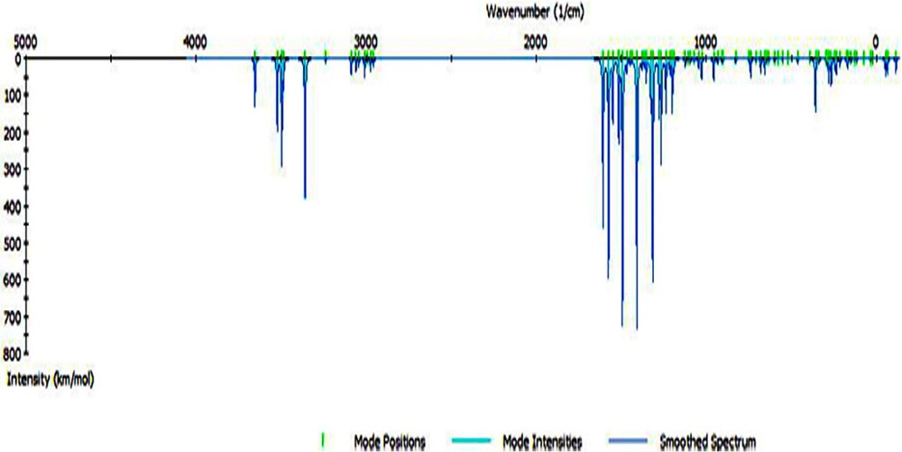

#### Fig. 1 – Theoretical IR spectrum of H2TAET.

regression analysis with 95% of confidence limits. The IC50 was defined as the medium of two independent experiments through the equation of graphic line obtained. The experiment was per- formed in triplicate to get the mean values. The percentage viability was calculated using the formula

The relative cell viability%

 A 570 of treated samples  100 A 570 of untreated sample

## *Molecular modelling*

We performed cluster calculations by DMOL3 program [20] in Ma- terials Studio program [21], which was designed for large scale density functional theory (DFT) calculations. DFT semi-core pseudo pods determinations (dspp) have been shown with the double numerical basis sets plus polarization (DNP) func- tional. The DNP basis sets are of comparable quality to 6-31G Gaussian basis sets [22]. Kessi and Delley assumed that the DNP basis sets are highly more accurate than Gaussian basis sets of the same size [23]. The RPBE functional [24] is so far the best exchange-correlation functional [25], based on the generalized gradient approximation (GGA), employed to take account of the exchange and correlation effects of electrons. The geometric op- timization was shown without any symmetry restriction.

# Results and discussion

The data of elemental analysis and some physical properties of the complexes were shown in Table 1.

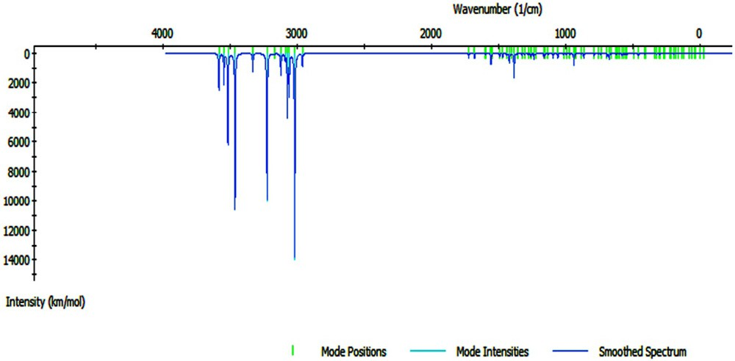

#### Fig. 2 – Theoretical IR spectrum of H2TAAT.

**48** egyptian journal of basic and applied sciences 3 (2016) 44–60

## *Molecular modelling*

### *IR*

Theoretical calculations of the IR spectra of H2TAET and H2TAAT (Table 2) were carried out using a previously mentioned method (Figs. 1 and 2), and from a comparison with the experimental data we can conclude that: The calculated IR vibrations of H2TAET and H2TAAT show high agreement with the experi- mental data.

### *Bond lengths and angles calculations*

The molecular structures along with atom numbering of H2TAET, H2TAAT and their complexes have been shown in Structures 1–6. Their analysis data and the calculated data of bond lengths and angles for the bonds are shown in Tables S1–S13 (Supplementary Materials), which give us the fol- lowing concluding remarks:

* + - 1. All bond lengths of both ligands became slightly shorter in the complexes, except C(10)-S(16) which became slightly longer in [Hg(H2TAAT)(H2O)Cl]2 [26].

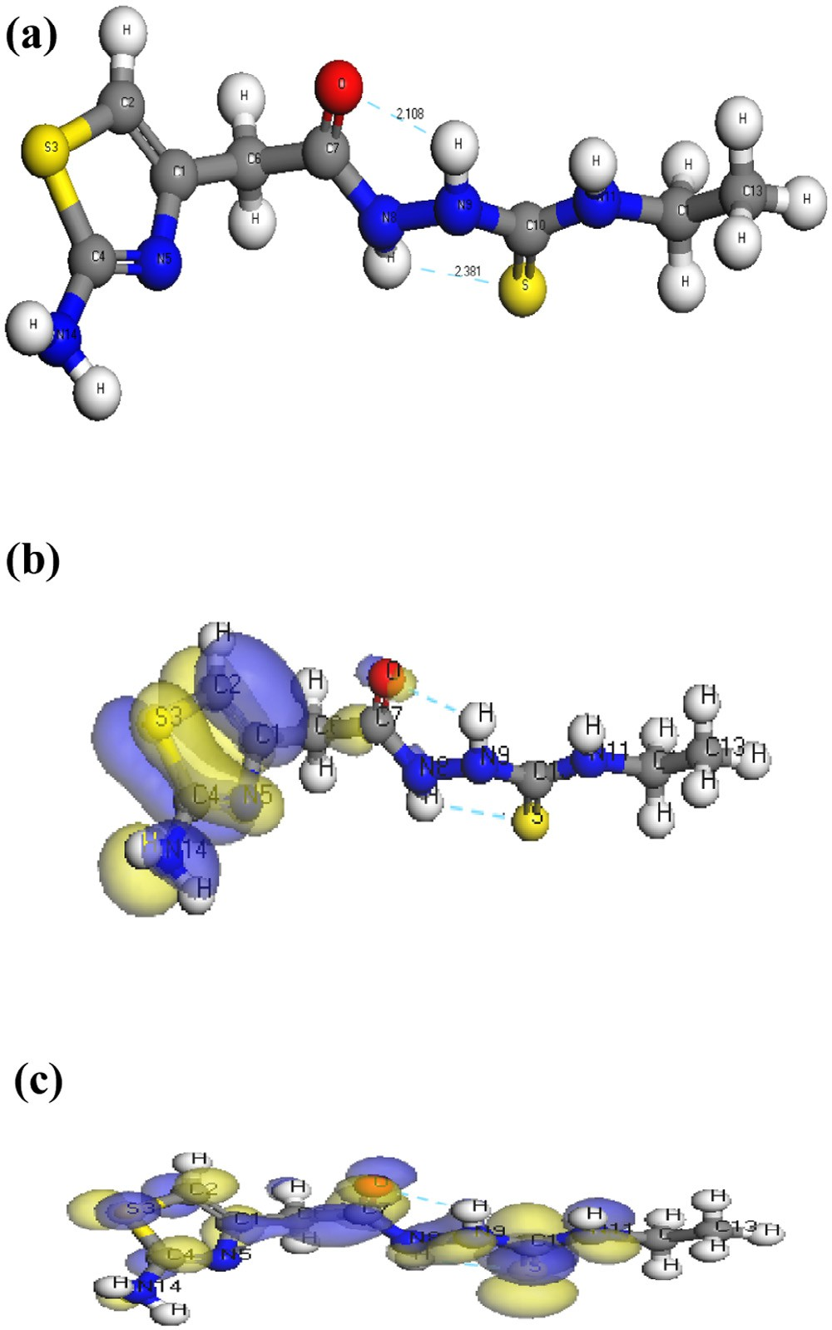

#### Structure 1 – Molecular structure of (a) H2TAET, (b) HOMO of H2TAET, (c) LUMO of H2TAET.

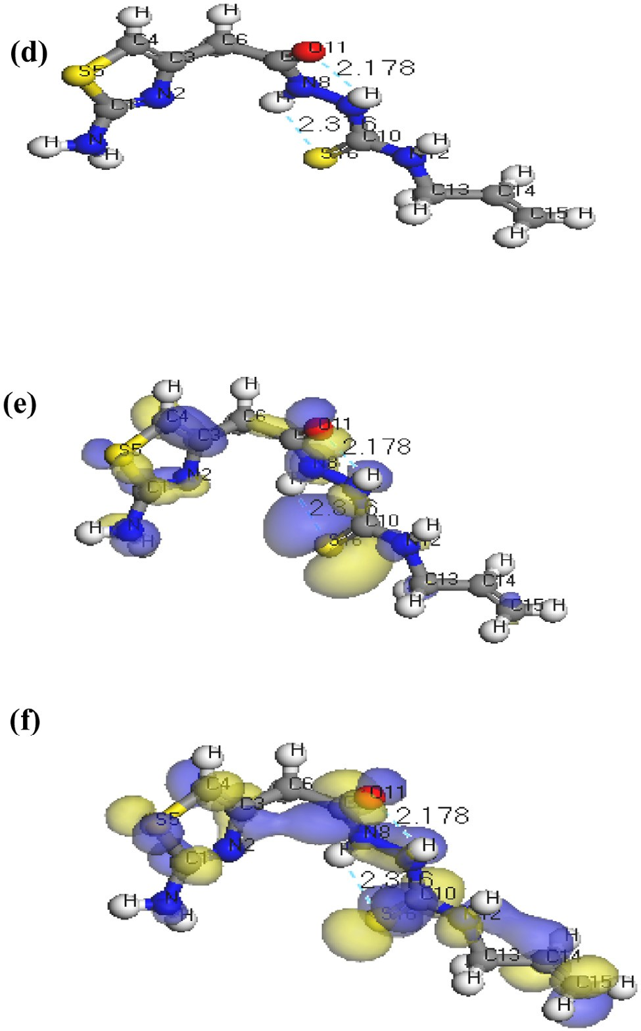

#### Structure 2 – Molecular structure of (d) H2TAAT, (e) HOMO of H2TAAT, (f) LUMO of H2TAAT.

* + - 1. In all Cd(II) and Hg(II) complexes, the bond distances [C(15)-N(7) and C(15)-O(16)] of H2TAET and the bond dis- tances [C(7)-N(8) and C(7)-O(11)] of H2TAAT became shorter owing to the formation of M—O bond that makes C—O bond strong.
      2. In all complexes, the bond distances [C(1)-N(5) and N(5)- C(4)] of H2TAET and the bond distances [C(1)-N(2) and N(2)-C(3)] of H2TAAT are shorter. Due to formation of M—N bond in both Cd (II) and Hg(II) complexes of H2TAAT, C—N bond weakened, which formed a double bond character.
      3. The bond angles of the thiosemicarbazide moiety of H2TAET and H2TAAT are altered somewhat upon coor- dination; the largest change affects C(1)-N(5)-C(3), O(16)- C(15)-N(7), N(8)-N(7)-C(15), C(9)-N(8)-N(7), N(8)-C(9)-

S(13) and C(9)-N(10)-C(11) angles of H2TAET and C(1)- N(2)-C(3), O(11)-C(7)-N(8), N(9)-N(8)-C(7), C(10)-N(9)- N(8), N(8)-C(10)-S(16) and C(10)-N(11)-C(12) angles of

H2TAAT which are reduced or increased on complex for- mation as a consequence of bonding.

* + - 1. The O(16)-C(15)-N(7) angle of H2TAET changes from

119.92° to 118.74° in Cd complex owing to formation of

egyptian journal of basic and applied sciences 3 (2016) 44–60 **49**

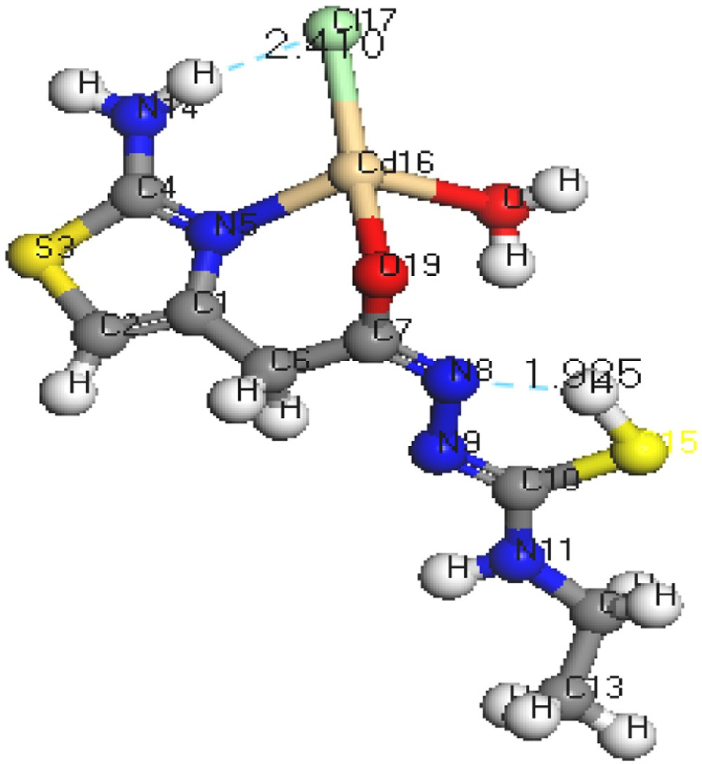

#### Structure 3 – Molecular structure of [Cd(HTAET)(H2O)Cl](H2O)2.

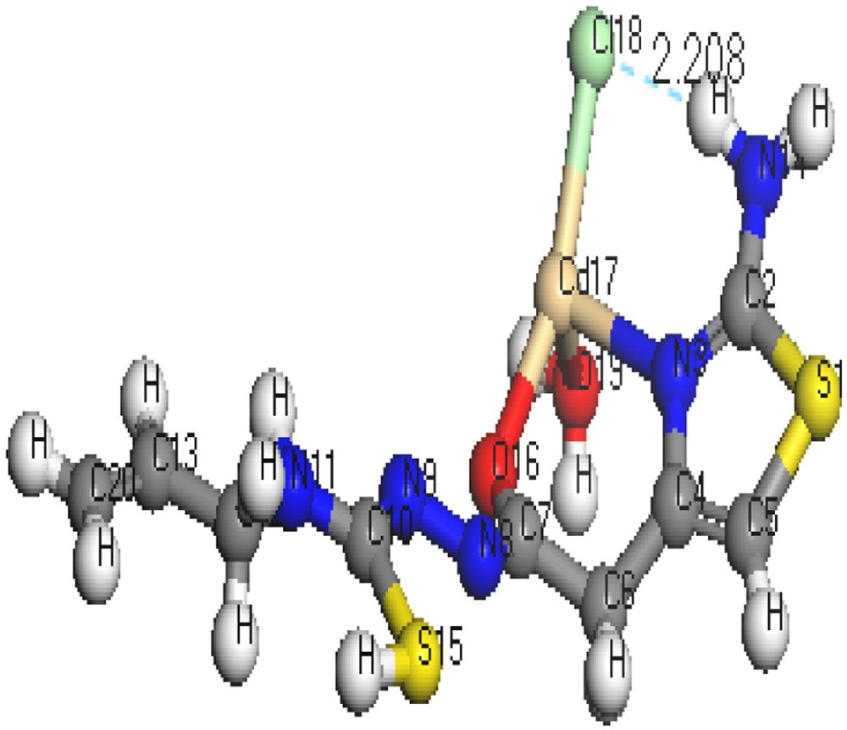

#### Structure 4 – Molecular structure of [Cd(HTAAT)(H2O)Cl]H2O.

bands at 3437, 3342, 3273 and 3179 cm−1, respectively. The broad- ness of (NH) bands in both H2TAAT and H2TAET may be owing

to the chance of H-bond formation as in Structures 1 and 2. The ν(C=N)th of (H2TAET and H2TAAT) at 1641 and 1648 cm−1

undergoes a negative shift of wave number and the ν(C=N)

thiazole ring appears at 1622 and 1626 cm−1 [28] in the Cd(II)

O(19)-Cd(16)-N(5) chelate ring, whereas in H2TAAT, the O(15)-C(7)-N(8) angle changes from 120.93° to 126.9° due to formation of O(15)-Cd(17)-N(3) chelate ring.

* + - 1. The N(7)-N(8)-C(9) angle of H2TAET changes from 119.81° to 119.82° and 119.33° in Hg complex owing to forma- tion of S(16)-Hg(33)-N(8) and S(32)-Hg(38)-N(24), but in H2TAAT, the N(9)-N(8)-C(7) angle changes from 112.46° to 120.504° owing to formation of N(9)-Hg(17)-O(15) and O(15)-Hg(17)-N(3) chelate angle.
      2. The bond angles N(5)-Cd(16)-O(19), O(19)-Cd(16)-O(18),

O(18)-Cd(16)-Cl(17), Cl(17)-Cd(16)-N(5), and N(3)-Cd(17)-

O(15), O(15)-Cd(17)-Cl(18), Cl(18)-Cd(17)-O(19), O(19)-

Cd(17)-N(3) of Cd(II) complexes indicate that they are quite near to a tetrahedral geometry predicting sp3 hybridiza- tion where Hg(II) of H2TAET and H2TAAT show a square pyramidal and adopt an octahedral arrangement pre- dicting sp3d2 hybridization.

* + - 1. The complexes were arranged by their (M—N)azomethine bond lengths as: Hg-N > Cd-N; reflecting Cd-N bond as the strongest among the others [27].
      2. The lower values of HOMO energy show that mol- ecules donating electron ability are weaker. On the contrary, a higher energy of HOMO implies that it is a good electron donor. LUMO energy showed that the mol- ecule can receive electron.

## *IR spectral studies*

The most important IR frequencies have been shown in Table 2.

The H2TAET exhibits four bands at 3360, 3282, 3146 and 3107 cm−1 due to ν(NH2), ν(NH)a, ν(NH)b and ν(NH)c respec- tively. While in H2TAAT, ν(NH2), ν(NH)a, ν(NH)b and ν(NH)c show

and Hg(II).

Spectra of all complexes showed that the bands assigned to the newly formed (N=C)* band owing to the thiolating of the (C=S) group and enolization of (C=O) group were located

at 1569 and 1574 cm−1 in the complexes of H2TAET, respec- tively. While in complexes of H2TAAT, the new (N=C)* band appears at 1566 and 1537 cm−1, respectively. The bands

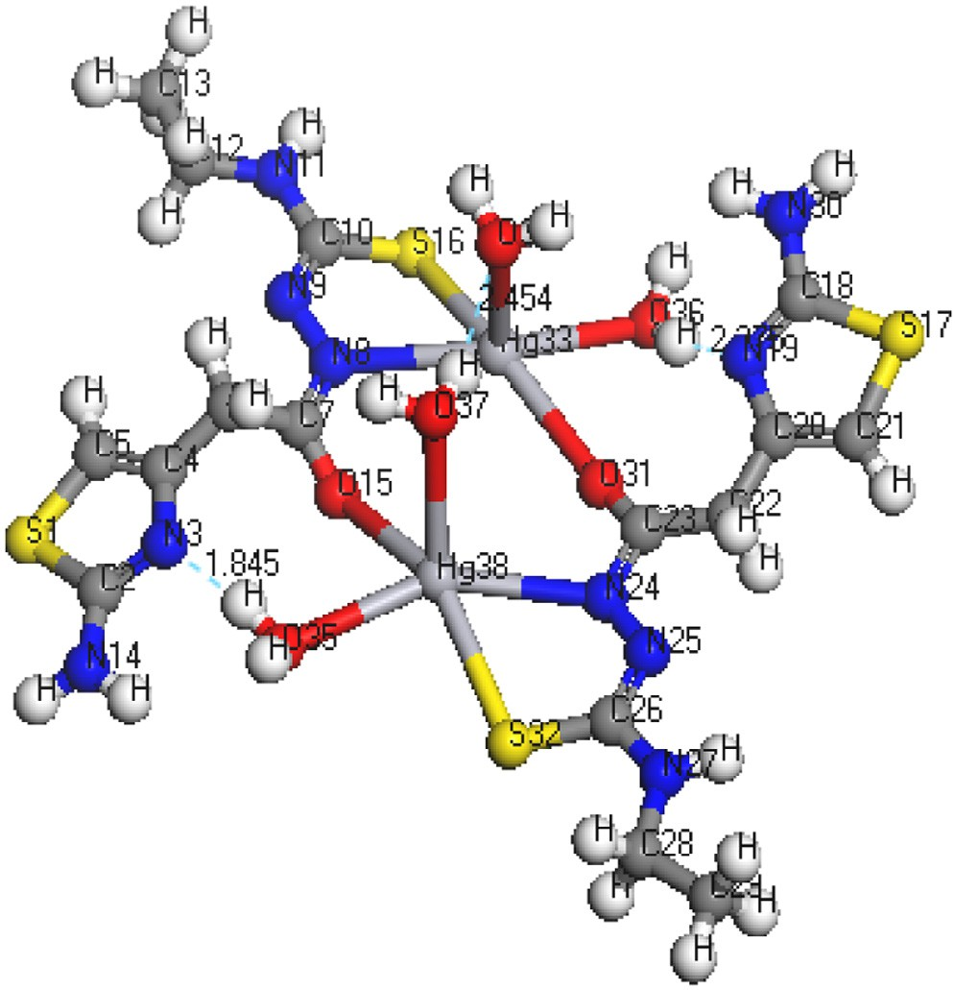

#### Structure 5 – Molecular structure of [Hg(HTAET)(H2O)2]2.

**50** egyptian journal of basic and applied sciences 3 (2016) 44–60

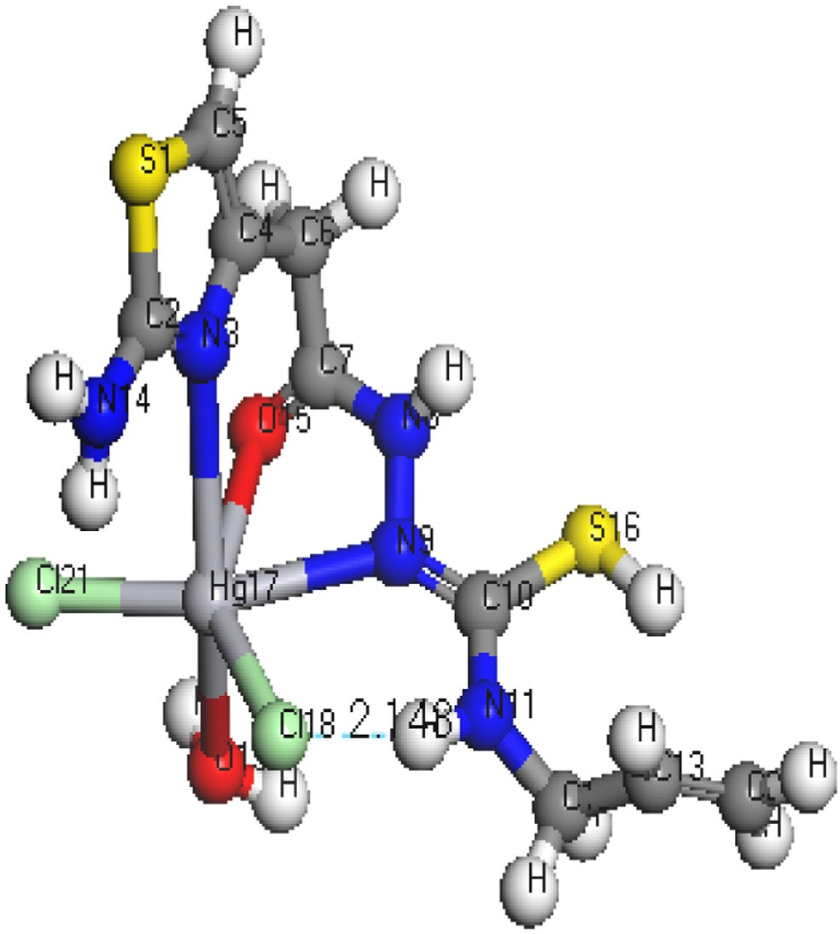

#### Structure 6 – Molecular sturcture of [Hg(H2TAAT)(H2O)Cl2].

plexes, H2TAET acts as dibasic tridentate via the sulphur atom of thiolate (C—S), oxygen atom of (C—O) and the new

azomethine (N=C)* group. H2TAAT acts as tridentate through (C=N)Th, (C=O) and the new azomethine (N=C)* group. The positive shift of ν(N—N) is owing to the increase in the char-

acter of double bond of N—N showing the decrease of electron density through donation to metal ion and is a good evi- dence of coordination via azomethine nitrogen atom. In all

complexes, appearance of bands in the regions 426–435 cm−1

and 464–531 cm−1 assigned to ν(M—N) and ν(M—O), respec- tively supports the proposed modes of coordination. Also, the spectra of complexes exhibit bands at ≈3389–3509, 873–860, and

≈565cm−1 referred to the coordinated water vibrations (Δ(H2O),

pr (H2O) and Pw (H2O), respectively.

## *1NMR studies*

The 1H NMR and 13C spectra of H2TAET, H2TAAT and both com- plexes have been recorded in d6-DMSO. The spectra of the H2TAET (Fig. 3) revealing signals at δ 7.87, 9.23 and 9.9 ppm are assigned to (NH)a, (NH)b and (NH)c respectively, which disap- pears on addition of D2O. The signals at δ = 6.31, 6.89 and

3.3 ppm are attributed to CH of thiazole ring, (NH2) and (CH2)

which are attached to the ring respectively. The signals owing to CH2 protons of ethyl group appeared as a quartet at 3.48 ppm

(q, J = 4, 2H) and those due to CH3 protons as a triplet at 1.02 ppm

(t, J = 6.96, 3H).

assigned to ν(C=O) in both ligands disappeared in both Cd(II)

and Hg(II) complexes of H2TAET with the appearance of an as- signed band of ν(C—O) groups. On the other hand, the ν(C=O) in Hg(II) complex of H2TAAT undergoes an increase in the band

value resulting from the coordination to the metal. The strong

bands observed at 985 and 982 cm−1 in both ligand spectra are assignable to the ν(N—N) vibrational modes. These bands were shifted to higher wave numbers in the complexes of H2TAET, ν(C=S) and δ(C=S) appear at the frequencies 1323 and 843, while in H2TAAT they appear at 1330 and 845 cm−1 [29]. In all complexes except in Hg(II) complex of H2TAET, appearance of weak bands assigned to ν(C—S) owing to the formation of (SH) group without deprotonation. Based on the above evidence, the

two ligands behave as monobasic bidentate through (C=N)Th and (C—O) groups in both Cd(II) complexes. In Hg(II) com-

The 1H NMR spectrum of the H2TAAT represented in Fig. 4 shows signals at δ 8.10, 9.35 and 9.94 ppm are assigned to (NH)a, (NH)b and (NH)c respectively, which disappears on addition of D2O. The signals at δ = 3.31, 6.30 and 6.84 ppm are revealing to (CH2) protons attached to the ring, (CH) group of thiazole ring

and NH2, respectively. The quartet signal at 4.36 ppm while the doublet at 5.03 ppm are assignable to the protons of CH2

(—NH—CH2) and CH2 (—CH=CH2), respectively. Moreover, the sextet signal centred at 5.78 ppm is assigned to the protons

of the allyl CH group (ddd, J = 5.14, H).

In the 1H NMR spectra of Cd(II) complexes and Hg(II) of H2TAAT complexes (Figs. 5–7), the disappearance of the signal

assignable to (NH)a and (NH)b protons and the appearance of SH proton at new signal at δ 10.18 and 10.21 ppm confirm the deprotonation of ligands without involving this S atom in

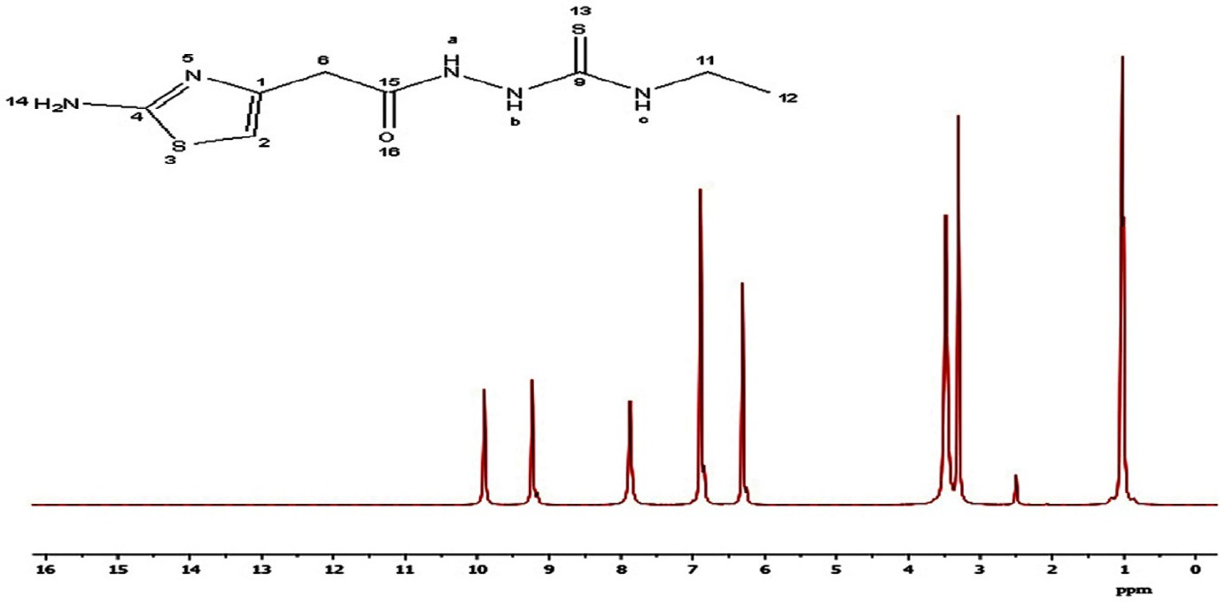

#### Fig. 3 – 1H NMR spectrum of H2TAET.

egyptian journal of basic and applied sciences 3 (2016) 44–60 **51**

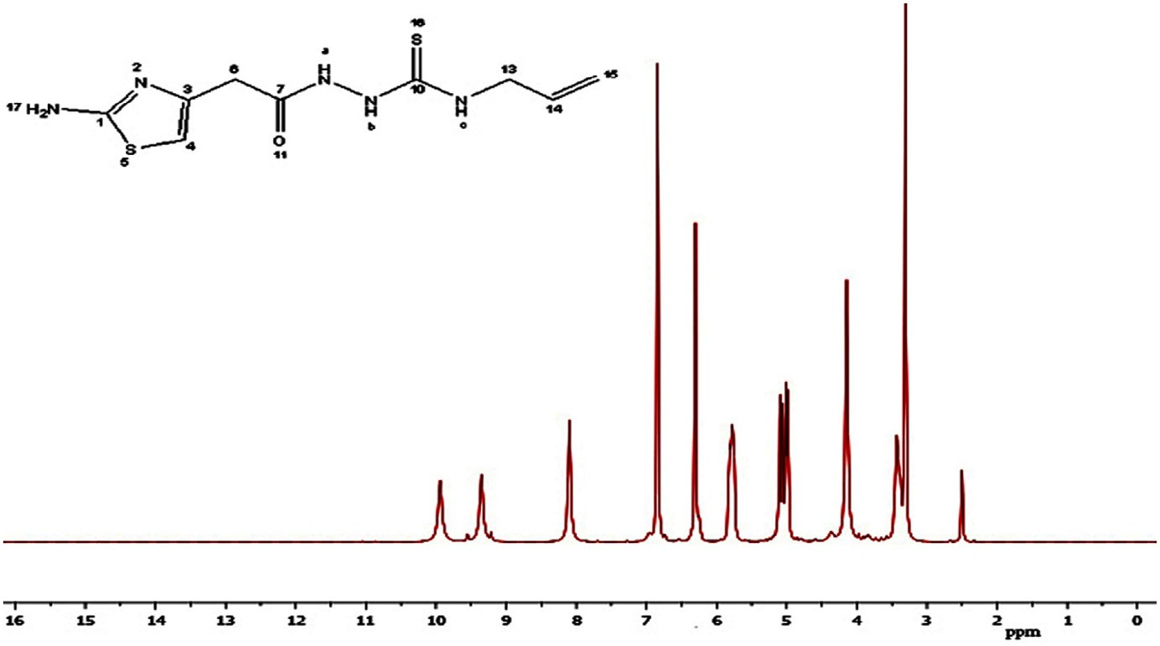

**Fig. 4 – 1H NMR spectrum of H2TAAT.**

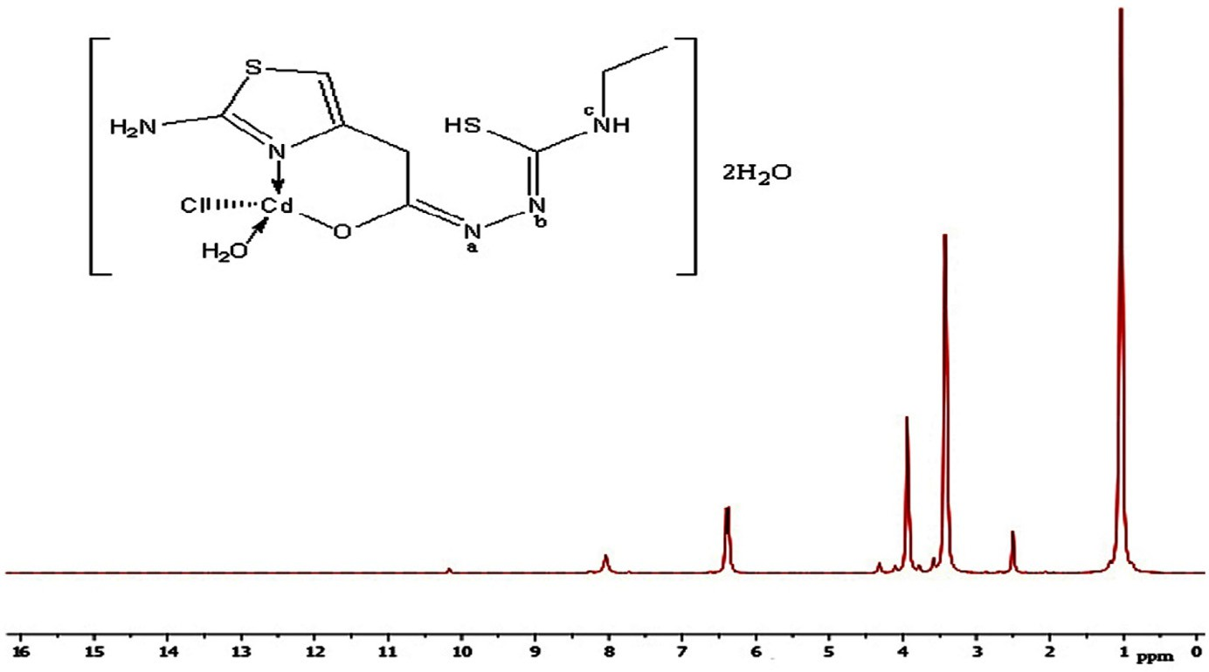

**Fig. 5 – The 1H NMR spectrum of [Cd(HTAET)(H2O)Cl](H2O)2.**

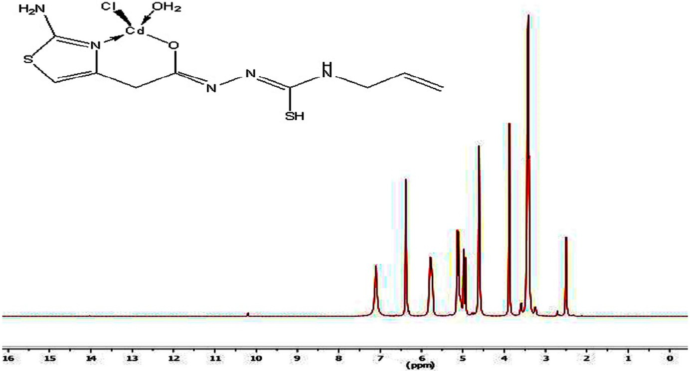

**Fig. 6 – The 1H NMR spectrum of [Cd(H2TAAT)(H2O)Cl]H2O.**

**52** egyptian journal of basic and applied sciences 3 (2016) 44–60

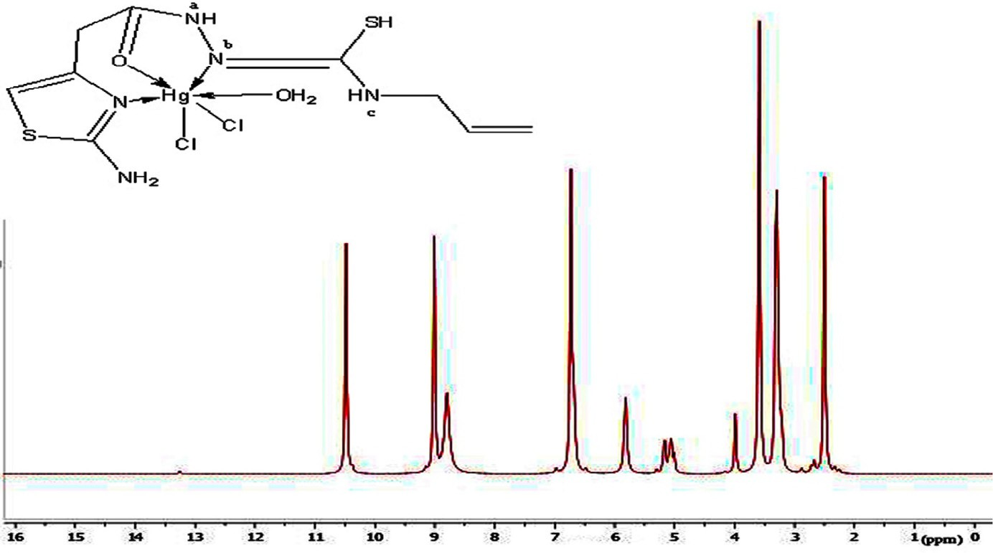

#### Fig. 7 – The 1H NMR spectrum of [Hg(H2TAAT)(H2O)Cl2].

coordination. But, in the 1H NMR spectrum of Hg(II) complex of H2TAET, the signal attributed to (NH)b proton disappeared with the presence of signal at 10.49 due to SH group. Also, the shift of the signal owing to thiazole proton supports the co-

ordination through (C=N)Th. The conclusions drawn from this study lend further support to the mode of bonding discussed

in IR spectra under study (Fig. 8).

The important peaks of 13C NMR of ligands and its diamag- netic complexes are listed in Table 3. From the 13C NMR data

of the complexes, [Cd(HTAET)(H2O)Cl](H2O)2 and [Cd(HTAAT) (H2O)Cl]H2O, the signals for the (C—SH), (C—N)th, and (C—O) carbon led to an upfield shift compared to the corresponding free ligand. On other hand for [Hg(TAET)(H2O)2]2 complex the signals for the (C—SH) carbon and (C—N)th carbon led to an up field shift compared to the free ligand. Finally for the complex [Hg(H2TAAT)(H2O)Cl2] the signals for the (C—SH) carbon, (C—N)th carbon and (C—O) carbon showed an up field shift on complexation compared with the corresponding free ligand.

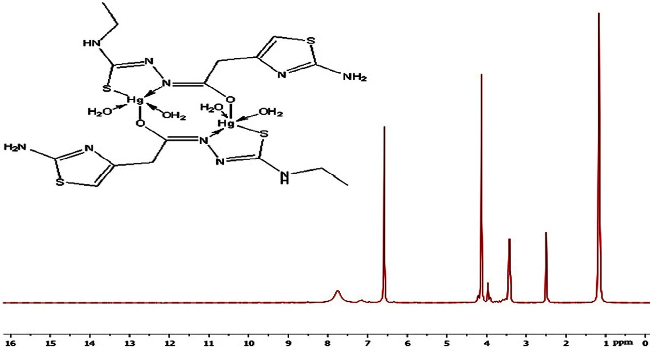

#### Fig. 8 – The 1H NMR spectrum of [Hg(HTAET)(H2O)2]2.

|  |  |  |  |  |  |  |  |  |
| --- | --- | --- | --- | --- | --- | --- | --- | --- |
| **Table 3 – 13C NMR chemical shifts in (ppm) assignments for H2TAET, H2TAAT and their Cd(II) and Hg(II) complexes.** | | | | | | | | |
| Compound | C1 | C2 | C4 | C6 | C9 | C11 | C12 | C15 |
| H2TAET | 145.1 | 103.9 | 167.7 | 40.3 | 181.4 | 40.5 | 14.5 | 167.6 |
| [Cd(HTAET)(H2O)Cl](H2O)2 | 149.6 | 103.8 | 167.7 | 40.4 | 181.2 | 40.2 | 14.5 | 173.2 |
| [Hg(TAET)(H2O)2]2 | 149.9 | 103.9 | 167.8 | 40.5 | 181.3 | 40.4 | 14.3 | 174.1 |
| Compound | C1 | C3 | C4 | C6 | C7 | C10 | C13 | C15 |
| H2TAAT | 166.7 | 145.8 | 103.6 | 40.6 | 166.3 | 183.0 | 47.0 | 116.4 |
| [Cd(HTAAT)(H2O)Cl]H2O | 166.8 | 149.9 | 103.5 | 40.5 | 172.8 | 183.1 | 47.2 | 116.4 |
| [Hg(H2TAAT)(H2O)Cl2] | 166.9 | 145.9 | 103.8 | 40.3 | 173.5 | 188.8 | 47.1 | 116.5 |

egyptian journal of basic and applied sciences 3 (2016) 44–60 **53**

|  |  |  |  |  |  |
| --- | --- | --- | --- | --- | --- |
| **Table 4 – Decomposition steps with the temperature range and weight loss for H2TAET, H2TAAT and their Cd(II) and Hg(II) complexes.** | | | | | |
| Compound | Temp. Range, °C | Removed species | Found% | Wt.Loss | Calcd% |
| [Cd(HTAET)(H2O)Cl](H2O)2 | 62–89 | −2H2O | 6.29 |  | 6.82 |
|  | 113–134 | −H2O | 3.49 |  | 3.92 |
|  | 165–351 | −Thiazole + NH2 | 21.96 |  | 21.54 |
|  | 391–556 | −C2H5Cl | 15.02 |  | 15.01 |
|  | 695–745 | −H2S + N2 + NH2 + C | 19.86 |  | 19.58 |
|  | 745–800 | −CdO + C2 (residue) | 33.57 |  | 33.12 |
|  | 43–99.6 | −H2O | 3.55 |  | 3.96 |
| [Cd(HTAAT)(H2O)Cl]H2O | 160–283 | −H2O | 4.9 |  | 3.96 |
|  | 313–362 | −H2S + NH2 + N2 + CH4 | 20.54 |  | 20.69 |
|  | 411–554 | −HCl | 8.45 |  | 8.03 |
|  | 598–721 | −Thiazole + NH2 | 20.17 |  | 20.7 |
|  | 725–800 | −CdO + 5C (residue) | 42.16 |  | 42.34 |

## *Thermogravimetric studies*

Thermogravimetric analysis data (TGA) for Cd (II) complexes were shown in Table 4. One of the aims in the TGA data showed that the associated molecules of water within complexes support the elemental analyses. The data represented in Table 4 indicate that water of crystallization has been lost in tem- perature range 75–147 °C. Also, the TG thermograms for the same complexes represented a high part of residual includ- ing M—O with carbon revealing a good stability of the formed chelates.

## *Kinetic data*

The influences of the structural properties of chelating agent on the thermal behaviour of complexes, the order (n) and the heat of activation Ea of the different decomposition stages have been determined from the TG and DTG by Coats– Redfern [30] (Figs. 9 and 10) and Horowitz–Metzger [31] (Figs. 11

and 12).

The  *d*  rate of thermal decomposition expressed by the Arrhenius equation has the following form:

 *dt* 

|  |  |  |  |  |  |  |  |
| --- | --- | --- | --- | --- | --- | --- | --- |
| **Table 5 – Kinetic parameters of complexes evaluated by Coats–Redfern equation.** | | | | | | | |
| Compound | Peak | Mid Temp(K) | Ea KJ\mol | A (S−1) | ΔH* KJ\mol | ΔS* KJ\mol·K | ΔG* KJ\mol |
| [Cd(HTAET)(H2O)Cl](H2O)2 | 1st | 352.32 | 112.02 | 13.97 × 1014 | 109.09 | 0.033 | 97.4 |
|  | 2nd | 398.02 | 211.94 | 1.42 × 1026 | 208.63 | 0.2533 | 107.78 |
|  | 3rd | 527.4 | 251.27 | 2.78 × 1027 | 247.56 | 0.277 | 124.13 |
|  | 4th | 713.5 | 139.26 | 7.43 × 104 | 133.33 | −0.101 | 205.72 |
|  | 5th | 990.24 | 673.65 | 2.11 × 1033 | 665.42 | 0.38 | 286.09 |
| [Cd(HTAAT)(H2O)Cl]H2O | 1st | 344.3 | 52.48 | 5.3 × 104 | 54.62 | −0.11 | 95.01 |
|  | 2nd | 494.51 | 322.59 | 3.18 × 1040 | 319.24 | 0.053 | 106.68 |
|  | 3rd | 610.23 | 236.37 | 1.37 × 1018 | 231.3 | 0.096 | 172.48 |
|  | 4th | 755.43 | 96.14 | 1.2 × 102 | 89.86 | −0.172 | 221.42 |
|  | 5th | 932.44 | 235.9 | 2.62 × 1010 | 228.18 | −0.055 | 279.41 |

|  |  |  |  |  |  |  |  |
| --- | --- | --- | --- | --- | --- | --- | --- |
| **Table 6 – Kinetic parameters of complexes evaluated by Horowitz–Metzger equation.** | | | | | | | |
| Compound | Peak | Mid Temp(K) | Ea KJ\mol | A (S−1) | ΔH* KJ\mol | ΔS* KJ\mol·K | ΔG* KJ\mol |
| [Cd(HTAET)(H2O)Cl](H2O)2 | 1st | 352.32 | 116.37 | 1.68 × 1015 | 113.44 | 0.045 | 97.53 |
|  | 2nd | 398.02 | 219.51 | 5.28 × 1027 | 216.2 | 0.2723 | 107.83 |
|  | 3rd | 527.4 | 252.95 | 4.26 × 1027 | 249.24 | 0.231 | 124.22 |
|  | 4th | 713.5 | 150.00 | 4.34 × 108 | 144.07 | −0.087 | 206.00 |
|  | 5th | 990.24 | 684.47 | 7.69 × 1033 | 676.24 | 0.3914 | 286.36 |
| [Cd(HTAAT)(H2O)Cl]H2O | 1st | 344.3 | 63.02 | 3.5 × 106 | 60.16 | −0.102 | 95.16 |
|  | 2nd | 494.51 | 332.29 | 5.78 × 1041 | 328.94 | 0.55 | 106.85 |
|  | 3rd | 610.23 | 246.18 | 9.23 × 1018 | 241.1 | 0.11 | 172.61 |
|  | 4th | 755.43 | 108.3 | 8.7 × 103 | 102.41 | −0.161 | 221.76 |
|  | 5th | 932.44 | 283.3 | 1.47 × 1013 | 275.54 | −0.0023 | 277.67 |

**54** egyptian journal of basic and applied sciences 3 (2016) 44–60

1st step (coats)

-10



ln X:n=1.00 ln X:n=0.00 ln X:n=0.33 ln X:n=0.50

ln X:n=0.66

-11

-12

-13

ln X

-14

-15

-16

2.75 2.8 2.85 2.9 2.95 3 3.05

1/T

x 10–3

#### Fig. 9 – First step Coats–Redfern of [Cd(HTAET)(H2O)Cl](H2O)2.

*d*  *A* exp   *Ea*  *g*(** ) (1)

 

*dt RT*

t order reaction. Under this assumption the integration of Equa- tion (1) leads to:

where (A) is the Arrhenius pre-exponential factor; (E ) is the

A T

 Ea 

a

To

activation energy; (R) is the gas constant and g(α) is the dif- ferential conversion factor and equal (1-α)n where n is the

ln(1  )     Exp  RT dT

(2)

reaction order, assumed to remain constant through the re- action. The degradation of metal complexes was shown as firs

From Equation (2), the degradation kinetic parameters A and Ea can be determined. Thermodynamic parameters can be

egyptian journal of basic and applied sciences 3 (2016) 44–60 **55**

1st step (Horowites)

3



ln X:n=1.00 ln X:n=0.00 ln X:n=0.33 ln X:n=0.50 ln X:n=0.66

2

1

0

-1

ln X

-2

-3

-4

-20 -15 -10 -5 0 5 10 15

T-Ts

#### Fig. 10 – First step Coats–Redfern of [Cd(H2TAAT)(H2O)Cl]H2O.

determined by the Eyring equation [32]. From results obtained in Tables 5 and 6, the following remarks showed that:

1. Decomposition steps showed a best fit of n = 1.
2. A (+) sign of activation enthalpy, ΔH* shows that the de- composition steps were endothermic processes.
3. The activation energy Ea of complexes increases, indicating the higher stability of the remaining part due

to their covalent bond character [33] and the decrease of Ea on going from [Cd(HTAET)(H2O)Cl](H2O)2 complex to [Cd(HTAAT)(H2O)Cl](H2O) complex reflects the greater thermal stability of the first one than the

second complex as Ea depends on the strength of (O→M→N).

1. The (+) sign of ΔG* for the complexes reveals that all

the decomposition stages were nonspontaneous processes.

**56** egyptian journal of basic and applied sciences 3 (2016) 44–60

1st step (coats)

-10



ln X:n=1.00 ln X:n=0.00 ln X:n=0.33 ln X:n=0.50

ln X:n=0.66

-10.5

-11

-11.5

-12

-12.5

ln X

-13

-13.5

-14

-14.5

2.85 2.9 2.95 3 3.05 3.1 3.15 3.2 3.25

1/T

x 10–3

**Fig. 11 – First step Horowitz–Metzger plots of [Cd(HTAET)(H2O)Cl](H2O)2.**

## *Biological studies*

### *Antifungal activity*

In our screening of antimicrobial activity it has been shown that the studies must lead to an overall comparison of activi- ties between the H2TAET, H2TAAT and their complexes so that the mechanism of their activities can be understood. The ex- perimental antifungal activity data (Table 7) indicate that H2TAET, H2TAAT and their complexes show an appreciable ac- tivity against *C. albicans*. DMSO control has shown a negligible

activity as compared to H2TAET, H2TAAT and their complexes. [Hg(TAET)(H2O)2]2 showed a highly good activity (92.6%) com- pared with the rest of the complexes. From the data, we also observed that complexes are more active than the correspond- ing ligands. The toxicity of complexes was related to the strength of metal–ligand bond, besides other factors such as the size of the cation [34]. The action mode of the com-

pounds may involve formation of a hydrogen bond via the azomethine group (>C=N—) with the active centres of cell con- stituents resulting in interferences with the normal cell process.

egyptian journal of basic and applied sciences 3 (2016) 44–60 **57**

1st step (Horowites)

2



ln X:n=1.00 ln X:n=0.00 ln X:n=0.33 ln X:n=0.50 ln X:n=0.66

1.5

1

0.5

0

-0.5

ln X

-1

-1.5

-2

-2.5

-3

-25 -20 -15 -10 -5 0 5 10 15 20

T-Ts

**Fig. 12 – First step Horowitz–Metzger plots of [Cd(H2TAAT)(H2O)Cl]H2O.**

### *Antibacterial activity*

H2TAET, H2TAAT and their complexes, standard drug Ampicil- lin and DMSO solvent were screened separately for their antibacterial activity vs *E. coli* and *S. aureus*. Activity of com- plexes has been compared to activity of a standard antibiotic Ampicillin and % Activity Index for the complexes has been calculated. The antibacterial results (Table 7) suggest that [Cd(HTAAT)(H2O)Cl]H2O, [Cd(HTAET)(H2O)Cl](H2O)2 and

[Hg(TAET)(H2O)2]2 show highest activity against both bacteria

[26,34] as compared to the standard drug. The complexes show

higher antibacterial activity than their corresponding ligands.

The complexes with negative results showed inability of it to diffuse into the Gram-negative bacteria cell membranes and hence unable to interfere its biological activity and inactivated by unknown cellular mechanism i.e. bacterial enzymes.

The (+) results suggested the highest diffusion of com-

plexes into the bacterial cells and this complexes with positive results are able to kill the bacterium as shown by the zones of inhibition of bacterial growth [34].

**58** egyptian journal of basic and applied sciences 3 (2016) 44–60

|  |  |  |  |  |  |  |
| --- | --- | --- | --- | --- | --- | --- |
| **Table 7 – Antibacterial and antifungal activity of H2TAET, H2TAAT and their Cd(II) and Hg(II) complexes.** | | | | | | |
| Compound | *E. coli* (mg/ml)  Diameter of % inhibition Activity  zone (in mm) index | | *S. aureus*  Diameter of inhibition zone (in mm) | (mg/ml)  %  Activity index | *C. albicans*  Diameter of inhibition zone (in mm) | (mg/ml)  %  Activity index |
| H2TAET | 20 | 80 | 14 | 60.9 | NA | – |
| [Cd(HTAET)(H2O)Cl](H2O)2 | 25 | 100 | 23 | 100 | 22 | 81.5 |
| [Hg(TAET)(H2O)2]2 | 25 | 100 | 23 | 100 | 25 | 92.6 |
| H2TAAT | 6 | 24 | 22 | 95.6 | 6 | 22.2 |
| [Cd(HTAAT)(H2O)Cl]H2O | 25 | 100 | 21 | 91.3 | 21 | 77.7 |
| [Hg(H2TAAT)(H2O)Cl2] | 7 | 28 | 22 | 95.6 | 9 | 33.3 |
| Ampicillin | 25 | 100 | 23 | 100 | NA | – |
| Clotrimazole | NA | – | NA | – | 27 | 100 |
| NA, No Activity. | | | | | | |

### *Antioxidant activity*

Increasing effect of the radical-scavenging of phenolic acids and their ester derivatives (Table 8) and the antioxidant ca- pacity assays (DPPH 2- diphenyl-1-picrylhydrazyl radical; ABTS 2,2′-azino-bis(3-ethylbenzthiazoline-6-sulphonic acid) were used. The DPPH method was done in a homogeneous phase with the advantage of establishing a real ranking hierarchy of antioxi- dant activity of electron- or H-donating agents, where DPPH method was not affected by any factors and this leads to in- terfere with another model systems, as metal chelation or partitioning abilities [35,36]. The generation of the ABTS radical cation is a basis of other spectrophotometric methods that are currently being used for the calculations of antioxidant activity in solutions of pure substances, mix- tures and beverages [37]. Where H2TAET, H2TAAT and

[Cd(HTAAT)(H2O)Cl]H2O showed the best activity which are near to standard Ascorbic acid comparing to the ABTS•+ radical- scavenging activity.

The data obtained with DPPH radical revealed that all compounds showed good antioxidant capacity except [Cd(HTAET)(H2O)Cl](H2O)2 which showed low activity while [Hg(TAET)(H2O)2]2 showed moderate activity, as shown in Table 8. The effective anticancer drug, “5-fluorouracil” has been used as standard.

* + 1. In vitro *cytotoxic activities (MTT-dye reduction assay) In vitro* cytotoxic tests were conducted utilizing all the pre- pared compounds against human tumour cell line MCF7 normal cell line by means of a colorimetric assay (MTT assay) that mea- sures mitochondrial dehydrogenase activity as an indication of cell viability. The activities corresponding to viability of growth

cell cancer are shown in Table 9. In parallel, the effectiveness of spread used anticancer drug, “5-fluorouracil” has been used as standard. H2TAAT and its complexes covered a high range of activity with viability (%) near the standard. 5-Florouracil indicated that these compounds exhibited anti-tumour activ- ity vs. cell lines without causing significant damage to normal cells. H2TAET and its complexes showed low potential activ- ity. It means that the chemical structure of compounds is important to express biological activity of the complex and can be essential in designing and synthesizing anti-cancer drugs.

# Conclusion

The addition of 2-(2-amino thiazole -4-yl acetohydrazide) to both ethyl isothiocyanate (H2TAET) and allyl isothiocyanate (H2TAAT) has shown a versatility that leads to a rise in the com- plexes with metal chlorides by various stoichiometries in spite of similar experimental conditions. The experimental and theo- retical frequency results of ligands are comparable. The calculated HOMO-LUMO energies gap confirmed the possi- bility of charge transfer. Also, the data of thermal degra- dation of the solid complexes were shown by Coats–Redfern and Horowitz–Metzger methods. [Cd(HTAAT)(H2O)Cl]H2O, [Cd(HTAET)(H2O)Cl](H2O)2 and [Hg(TAET)(H2O)2]2 showed high

antibacterial activity while [Hg(TAET)(H2O)2]2 showed the highest antifungal activity. The present results are of significance, con- sidering the pharmacological and antimicrobial activity of thiosemicarbazides; therefore, compound [Hg(TAET)(H2O)2]2 can be used as a promising antimicrobial activity agent.

|  |  |  |  |  |  |
| --- | --- | --- | --- | --- | --- |
| **Table 8 – Free radical scavenging capacities of H2TAET, H2TAAT and their Cd(II) and Hg(II) complexes measured in DPPH and ABTS assay.** | | | | | |
| Compound |  | DPPH inhibition (%) |  | Absorbance | ABTS inhibition (%) |
| Ascorbic acid | 100 ppm | 200 ppm 500 ppm | 1000 ppm | 0.019 | 96.57 |
| H2TAET | 10.75 | 19.83 45.49 | 91.32 | 0.031 | 94.28 |
| [Cd(HTAET)(H2O)Cl](H2O)2 | 10.06 | 18.92 45.50 | 89.80 | 0.342 | 35.23 |
| [Hg(TAET)(H2O)2]2 | 5.91 | 9.67 19.95 | 35.75 | 0.114 | 78.66 |
| H2TAAT | 9.25 | 15.31 33.49 | 63.79 | 0.029 | 94.28 |
| [Cd(HTAAT)(H2O)Cl]H2O | 10.32 | 18.91 43.80 | 86.03 | 0.042 | 91.42 |
| [Hg(H2TAAT)(H2O)Cl2] | 8.65 | 17.09 42.41 | 84.61 | 0.150 | 71.80 |

egyptian journal of basic and applied sciences 3 (2016) 44–60 **59**

# Appendix: Supplementary material

Supplementary data associated with this article can be found in the online version at [doi:10.1016/j.ejbas.2015.09.005](http://dx.doi.org/10.1016/j.ejbas.2015.09.005).

R E F E R E N C E S

1. [Schrauzer GN, Kohnle J. Coenzym B12-modelle. Chem Ber](http://refhub.elsevier.com/S2314-808X(15)00067-6/sr0010) [1964;97:3056–63.](http://refhub.elsevier.com/S2314-808X(15)00067-6/sr0010)
2. [Dash B, Patra M, Praharaj S. Synthesis and biological-activity](http://refhub.elsevier.com/S2314-808X(15)00067-6/sr0015) [of some Schiff-bases derived from thiazoles and](http://refhub.elsevier.com/S2314-808X(15)00067-6/sr0015) [benzothiazoles. Indian J Chem 1980;19B:894–7.](http://refhub.elsevier.com/S2314-808X(15)00067-6/sr0015)
3. [Ali Akbar M, Livingstone SE. Metal complexes of sulphur-](http://refhub.elsevier.com/S2314-808X(15)00067-6/sr0020) [nitrogen chelating agents. Coord Chem Rev 1974;13:101–32.](http://refhub.elsevier.com/S2314-808X(15)00067-6/sr0020)
4. [Campbell MJM. Transition metal complexes of](http://refhub.elsevier.com/S2314-808X(15)00067-6/sr0025) [thiosemicarbazide and thiosemicarbazones. Coord Chem](http://refhub.elsevier.com/S2314-808X(15)00067-6/sr0025) [Rev 1975;15:279–319.](http://refhub.elsevier.com/S2314-808X(15)00067-6/sr0025)
5. [Padhye S, Kauffman GB. An unusual dimeric structure of a](http://refhub.elsevier.com/S2314-808X(15)00067-6/sr0030) [Cu(I) Bis(thiosemicarbazone) complex: implications for the](http://refhub.elsevier.com/S2314-808X(15)00067-6/sr0030) [mechanism of hypoxic selectivity of the Cu(II) derivatives.](http://refhub.elsevier.com/S2314-808X(15)00067-6/sr0030) [Coord Chem Rev 1985;63:127–60.](http://refhub.elsevier.com/S2314-808X(15)00067-6/sr0030)
6. [Au YK, Cheung K-K, Wong W-T. Synthesis and structural](http://refhub.elsevier.com/S2314-808X(15)00067-6/sr0035) [characterization of ruthenium and osmium carbonyl](http://refhub.elsevier.com/S2314-808X(15)00067-6/sr0035) [clusters containing 4, 6-dimethylpyrimidine-2-thione.](http://refhub.elsevier.com/S2314-808X(15)00067-6/sr0035) [Inorganica Chim Acta 1995;228:267–75.](http://refhub.elsevier.com/S2314-808X(15)00067-6/sr0035)
7. [Au YK, Cheung K-K, Wong W-T. Synthesis, structural](http://refhub.elsevier.com/S2314-808X(15)00067-6/sr0040) [characterization and thermal reactivities of osmium](http://refhub.elsevier.com/S2314-808X(15)00067-6/sr0040) [carbonyl clusters containing 4, 6-dimethylpyrimidine-2-](http://refhub.elsevier.com/S2314-808X(15)00067-6/sr0040) [thione. J Chem Soc Dalton Trans 1995;1047–57.](http://refhub.elsevier.com/S2314-808X(15)00067-6/sr0040)
8. [Deeming AJ, Hardcastle KI, Karim M. Suppression of cluster](http://refhub.elsevier.com/S2314-808X(15)00067-6/sr0045) [unsaturation by formation of extensive but long-range](http://refhub.elsevier.com/S2314-808X(15)00067-6/sr0045) [metal-metal bonding: crystal structures of [Ru3H(pyS)(CO)9]](http://refhub.elsevier.com/S2314-808X(15)00067-6/sr0045) [and [{Ru3H(pyS)(CO)7}3], where pyS is the pyridine-2-](http://refhub.elsevier.com/S2314-808X(15)00067-6/sr0045) [thiolato ligand. Inorg Chem 1991;31:4792–6.](http://refhub.elsevier.com/S2314-808X(15)00067-6/sr0045)
9. [Brodie AM, Holden HD, Lewis J, Taylor MJ. The reaction of](http://refhub.elsevier.com/S2314-808X(15)00067-6/sr0050)

[[Os3(CO)10(MeCN)2], with heterocyclic thioamides. The crystal](http://refhub.elsevier.com/S2314-808X(15)00067-6/sr0050) [and molecular structure of [Os3(μ-H)(CO)10(μ-SC[double bond,](http://refhub.elsevier.com/S2314-808X(15)00067-6/sr0050) [length half m-dash]NCH2CH2S)]. J Chem Soc Dalton Trans](http://refhub.elsevier.com/S2314-808X(15)00067-6/sr0050) [1986;633–9.](http://refhub.elsevier.com/S2314-808X(15)00067-6/sr0050)

1. [Yousef TA, Badria FA, Ghazy SE, El-Gammal OA, Abu El-](http://refhub.elsevier.com/S2314-808X(15)00067-6/sr0055) [Reash GM. In vitro and in vivo antitumor activity of some](http://refhub.elsevier.com/S2314-808X(15)00067-6/sr0055) [synthesized 4-(2-pyridyl)-3-Thiosemicarbazides derivatives.](http://refhub.elsevier.com/S2314-808X(15)00067-6/sr0055) [J Med Med Sci 2011;3:37–46.](http://refhub.elsevier.com/S2314-808X(15)00067-6/sr0055)
2. [Yousef TA, El-Gammal OA, Ghazy SE, Abu El-Reash GM.](http://refhub.elsevier.com/S2314-808X(15)00067-6/sr0060) [Synthesis, spectroscopic characterization, pH-metric and](http://refhub.elsevier.com/S2314-808X(15)00067-6/sr0060) [thermal behavior on Co (II) complexes formed with 4-(2-](http://refhub.elsevier.com/S2314-808X(15)00067-6/sr0060) [pyridyl)-3-thiosemicarbazide derivatives. J Mol Struct](http://refhub.elsevier.com/S2314-808X(15)00067-6/sr0060) [2011;1004:271–83.](http://refhub.elsevier.com/S2314-808X(15)00067-6/sr0060)
3. [El-Gammal OA, Abu El-Reash GM, Ghazy SE, Yousef TA.](http://refhub.elsevier.com/S2314-808X(15)00067-6/sr0065) [Heterocyclic substituted thiosemicarbazides and their Cu (II)](http://refhub.elsevier.com/S2314-808X(15)00067-6/sr0065) [complexes: synthesis, spectral characterization, thermal,](http://refhub.elsevier.com/S2314-808X(15)00067-6/sr0065) [molecular modeling, and DNA degradation studies. J Coord](http://refhub.elsevier.com/S2314-808X(15)00067-6/sr0065) [Chem 2012;6510:1655–71.](http://refhub.elsevier.com/S2314-808X(15)00067-6/sr0065)

|  |  |  |  |  |  |  |
| --- | --- | --- | --- | --- | --- | --- |
| **Table 9 – MTT viability (percentage) assay of various concentrations of H2TAET, H2TAAT and their Cd(II) and Hg(II) complexes.** | | | | | | |
| Compound | 500 ppm | 200 ppm | Conc. MTT viability  100 ppm | (%)  50 ppm | 10 ppm | 1 ppm |
| 5-Florouracil | 27.308 | 29.336 | 31.399 | 33.322 | 36.888 | 41.993 |
| H2TAET | 63.769 | 60.007 | 62.874 | 65.727 | 71.825 | 85.965 |
| [Cd(HTAET)(H2O)Cl](H2O)2 | 58.091 | 62.098 | 63.636 | 65.434 | 63.790 | 74.475 |
| [Hg(TAET)(H2O)2]2 | 41.552 | 47.399 | 47.972 | 50.280 | 55.091 | 60.021 |
| H2TAAT | 24.070 | 27.007 | 29.000 | 31.273 | 34.280 | 40.89 |
| [Cd(HTAAT)(H2O)Cl]H2O | 29.426 | 31.413 | 33.161 | 37.573 | 40.825 | 42.336 |
| [Hg(H2TAAT)(H2O)Cl2] | 30.105 | 32.552 | 33.8112 | 35.699 | 39.301 | 42.972 |

1. [Ghazy SE, Abu El-Reash GM, El-Gammal OA, Yousef TA.](http://refhub.elsevier.com/S2314-808X(15)00067-6/sr0070) [Flotation separation of mercury (II) from environmental](http://refhub.elsevier.com/S2314-808X(15)00067-6/sr0070) [water samples using thiosemicarbazide derivatives as](http://refhub.elsevier.com/S2314-808X(15)00067-6/sr0070) [chelating agents and oleic acid as surfactant. Chem Speciat](http://refhub.elsevier.com/S2314-808X(15)00067-6/sr0070) [Bioavail 2010;22:127–34.](http://refhub.elsevier.com/S2314-808X(15)00067-6/sr0070)
2. [Aliage C, Lissi EA. Reaction of 2,2′-azinobis (3-](http://refhub.elsevier.com/S2314-808X(15)00067-6/sr0075)

[ethylbenzothiazoline-6-sulfonic acid) (ABTS) derived](http://refhub.elsevier.com/S2314-808X(15)00067-6/sr0075) [radicals with hydroperoxides. Int J Chem Kinet 1998;30:565–](http://refhub.elsevier.com/S2314-808X(15)00067-6/sr0075) [70.](http://refhub.elsevier.com/S2314-808X(15)00067-6/sr0075)

1. [Lissi E, Modak B, Torres R, Escobar J, Urza A. Total](http://refhub.elsevier.com/S2314-808X(15)00067-6/sr0080) [antioxidant potential of resinous exudates from](http://refhub.elsevier.com/S2314-808X(15)00067-6/sr0080) [Heliotropium species, and a comparison of the ABTS and](http://refhub.elsevier.com/S2314-808X(15)00067-6/sr0080) [DPPH methods. Free Radic Res 1999;30:471–7.](http://refhub.elsevier.com/S2314-808X(15)00067-6/sr0080)
2. [Aeschlach R, Loliger J, Scott CB, Murcia A, Butler J, Halliwel B,](http://refhub.elsevier.com/S2314-808X(15)00067-6/sr0085) [et al. Antioxidant actions of thymol, carvacrol, 6-gingerol,](http://refhub.elsevier.com/S2314-808X(15)00067-6/sr0085) [zingerone and hydroxytyrosol. Food Chem Toxicol](http://refhub.elsevier.com/S2314-808X(15)00067-6/sr0085) [1994;32:31–6.](http://refhub.elsevier.com/S2314-808X(15)00067-6/sr0085)
3. [Mosmann T. Rapid colorimetric assay for cellular growth](http://refhub.elsevier.com/S2314-808X(15)00067-6/sr0090) [and survival: application to proliferation and cytotoxicity](http://refhub.elsevier.com/S2314-808X(15)00067-6/sr0090) [assays. J Immunol Methods 1983;65(1):55–63.](http://refhub.elsevier.com/S2314-808X(15)00067-6/sr0090)
4. [Konstantinov SM, Eibl H, Berger MR. BCR-ABL influences the](http://refhub.elsevier.com/S2314-808X(15)00067-6/sr0095) [antileukaemic efficacy of alkylphosphocholines. Br J](http://refhub.elsevier.com/S2314-808X(15)00067-6/sr0095) [Haematol 1999;107(2):365–80.](http://refhub.elsevier.com/S2314-808X(15)00067-6/sr0095)
5. [Dodoff N, Grancharov K, Gugova R, Spassovska N. Platinum](http://refhub.elsevier.com/S2314-808X(15)00067-6/sr0100)

[(II) complexes of benzoic-and 3-methoxybenzoic acid](http://refhub.elsevier.com/S2314-808X(15)00067-6/sr0100) [hydrazides. Synthesis, characterization, and cytotoxic effect.](http://refhub.elsevier.com/S2314-808X(15)00067-6/sr0100) [J Inorg Biochem 1994;54(3):221–33.](http://refhub.elsevier.com/S2314-808X(15)00067-6/sr0100)

1. [Delley B. Hardness conserving semilocal pseudopotentials.](http://refhub.elsevier.com/S2314-808X(15)00067-6/sr0105) [Phys Rev B 2002;65:85403–9.](http://refhub.elsevier.com/S2314-808X(15)00067-6/sr0105)
2. [Charmm JZ, Schaefer M, Tidor B, Venable RM, Woodcock HL,](http://refhub.elsevier.com/S2314-808X(15)00067-6/sr0110) [Wu X, et al. Modeling and Simulation Solutions for](http://refhub.elsevier.com/S2314-808X(15)00067-6/sr0110) [Chemicals and Materials Research, Accelrys Materials Studio](http://refhub.elsevier.com/S2314-808X(15)00067-6/sr0110) [(Version 5.0). San Diego, USA: Accelrys Software Inc.; 2009](http://refhub.elsevier.com/S2314-808X(15)00067-6/sr0110)

<[http://www.accelrys.com](http://www.accelrys.com/)>.

1. [Hehre WJ, Radom L, Schlyer PVR, Pople JA. Ab Initio](http://refhub.elsevier.com/S2314-808X(15)00067-6/sr0115) [Molecular Orbital Theory. New York: Wiley; 1986.](http://refhub.elsevier.com/S2314-808X(15)00067-6/sr0115)
2. [Kessi A, Delley B. Density functional crystal vs. cluster](http://refhub.elsevier.com/S2314-808X(15)00067-6/sr0120) [models as applied to zeolites. Int J Quantum Chem](http://refhub.elsevier.com/S2314-808X(15)00067-6/sr0120) [1998;68:135–44.](http://refhub.elsevier.com/S2314-808X(15)00067-6/sr0120)
3. [Hammer B, Hansen LB, Nørskov JK. Improved adsorption](http://refhub.elsevier.com/S2314-808X(15)00067-6/sr0125) [energetics within density-functional theory using revised](http://refhub.elsevier.com/S2314-808X(15)00067-6/sr0125) [Perdew-Burke-Ernzerhof functionals. Phys Rev B](http://refhub.elsevier.com/S2314-808X(15)00067-6/sr0125) [1999;59:7413–21.](http://refhub.elsevier.com/S2314-808X(15)00067-6/sr0125)
4. [Matveev A, Staufer M, Mayer M, Rösch N. Density functional](http://refhub.elsevier.com/S2314-808X(15)00067-6/sr0130) [study of small molecules and transition-metal carbonyls](http://refhub.elsevier.com/S2314-808X(15)00067-6/sr0130) [using revised PBE functionals. Int J Quantum Chem](http://refhub.elsevier.com/S2314-808X(15)00067-6/sr0130) [1999;75:863–73.](http://refhub.elsevier.com/S2314-808X(15)00067-6/sr0130)

**60** egyptian journal of basic and applied sciences 3 (2016) 44–60

1. [Zaky RR, Yousef TA. Spectral, magnetic, thermal, molecular](http://refhub.elsevier.com/S2314-808X(15)00067-6/sr0135) [modelling, ESR studies and antimicrobial activity of (E)-3-(2-](http://refhub.elsevier.com/S2314-808X(15)00067-6/sr0135) [(2-hydroxybenzylidene) hydrazinyl)-3-oxo-n(thiazole-2-](http://refhub.elsevier.com/S2314-808X(15)00067-6/sr0135) [yl)propanamide complexes. J Mol Struct 2011;1002:76–85.](http://refhub.elsevier.com/S2314-808X(15)00067-6/sr0135)
2. [Yousef TA, Abu El-Reash GM, El Morshedy RM. Quantum](http://refhub.elsevier.com/S2314-808X(15)00067-6/sr0140) [chemical calculations, experimental investigations and DNA](http://refhub.elsevier.com/S2314-808X(15)00067-6/sr0140) [studies on (E)-2-((3-hydroxynaphthalen-2-yl)methylene)-N-](http://refhub.elsevier.com/S2314-808X(15)00067-6/sr0140) [(pyridin-2-yl)hydrazinecarbothioamide and its Mn(II), Ni(II),](http://refhub.elsevier.com/S2314-808X(15)00067-6/sr0140) [Cu(II), Zn(II) and Cd(II) complexes. J Polyhedron 2012;45:71–](http://refhub.elsevier.com/S2314-808X(15)00067-6/sr0140) [85.](http://refhub.elsevier.com/S2314-808X(15)00067-6/sr0140)
3. [Garg BS, Kurup MRP, Jain SK, Bhoon YK. Manganese(II)](http://refhub.elsevier.com/S2314-808X(15)00067-6/sr0145) [complexes of substituted thio- and selenosemicarbazones of](http://refhub.elsevier.com/S2314-808X(15)00067-6/sr0145) [2-acetylpyridine: Esr, magnetic and electronic spectral](http://refhub.elsevier.com/S2314-808X(15)00067-6/sr0145) [studies. Transit Met Chem 1988;13:92–5.](http://refhub.elsevier.com/S2314-808X(15)00067-6/sr0145)
4. [Yousef TA, El-Reash GMA, Al-Jahdali M, El-Rakhawy ER.](http://refhub.elsevier.com/S2314-808X(15)00067-6/sr0150) [Synthesis, spectral characterization and biological](http://refhub.elsevier.com/S2314-808X(15)00067-6/sr0150) [evaluation of Mn(II), Co(II), Ni(II), Cu(II), Zn(II) and Cd(II)](http://refhub.elsevier.com/S2314-808X(15)00067-6/sr0150) [complexes with thiosemicarbazone ending by pyrazole and](http://refhub.elsevier.com/S2314-808X(15)00067-6/sr0150) [pyridyl rings. Spectrochim Acta A Mol Biomol Spectrosc](http://refhub.elsevier.com/S2314-808X(15)00067-6/sr0150) [2014;129:163–72.](http://refhub.elsevier.com/S2314-808X(15)00067-6/sr0150)
5. [Coats AW, Redfern JP. Kinetic parameters from](http://refhub.elsevier.com/S2314-808X(15)00067-6/sr0155) [thermogravimetric data. Nature 1964;20:68–9.](http://refhub.elsevier.com/S2314-808X(15)00067-6/sr0155)
6. [Horowitz HH, Metzger G. A new analysis of](http://refhub.elsevier.com/S2314-808X(15)00067-6/sr0160) [thermogravimetric traces. Anal Chem 1963;25:1464–8.](http://refhub.elsevier.com/S2314-808X(15)00067-6/sr0160)
7. [Broido A. A simple, sensitive graphical method of treating](http://refhub.elsevier.com/S2314-808X(15)00067-6/sr0165) [thermogravimetric analysis data. J Ploym Sci A 1969;2:1761–](http://refhub.elsevier.com/S2314-808X(15)00067-6/sr0165) [73.](http://refhub.elsevier.com/S2314-808X(15)00067-6/sr0165)
8. [Britton HTS. Hydrogen Ions. 3rd ed. London: Chapman and](http://refhub.elsevier.com/S2314-808X(15)00067-6/sr0170) [Hall; 1942.](http://refhub.elsevier.com/S2314-808X(15)00067-6/sr0170)
9. [Zaky RR, Yousef TA, Abdelghany AM. Computational studies](http://refhub.elsevier.com/S2314-808X(15)00067-6/sr0175) [of the first order kinetic reactions for mononuclear](http://refhub.elsevier.com/S2314-808X(15)00067-6/sr0175) [copper(II) complexes having a hard–soft NS donor ligand.](http://refhub.elsevier.com/S2314-808X(15)00067-6/sr0175) [Spectrochim Acta A Mol Biomol Spectrosc 2014;130:178–87.](http://refhub.elsevier.com/S2314-808X(15)00067-6/sr0175)
10. [Silva FAM, Borges F, Guimarães C, Lima JLFC, Matos C, Reis S.](http://refhub.elsevier.com/S2314-808X(15)00067-6/sr0180) [Phenolic acids and derivatives: studies on the relationship](http://refhub.elsevier.com/S2314-808X(15)00067-6/sr0180) [among structure, radical scavenging activity, and](http://refhub.elsevier.com/S2314-808X(15)00067-6/sr0180) [physicochemical parameters. J Agric Food Chem](http://refhub.elsevier.com/S2314-808X(15)00067-6/sr0180) [2000;48:2122–6.](http://refhub.elsevier.com/S2314-808X(15)00067-6/sr0180)
11. [Siquet C, Paiva-Martins F, Lima JLFC, Reis S, Borges F.](http://refhub.elsevier.com/S2314-808X(15)00067-6/sr0185) [Antioxidant profile of dihydroxy- and trihydroxyphenolic](http://refhub.elsevier.com/S2314-808X(15)00067-6/sr0185) [acids – a structure–activity relationship study. Free Radic](http://refhub.elsevier.com/S2314-808X(15)00067-6/sr0185) [Res 2006;40:433–42.](http://refhub.elsevier.com/S2314-808X(15)00067-6/sr0185)
12. [Miller NJ, Rice-Evans CA. Factors influencing the antioxidant](http://refhub.elsevier.com/S2314-808X(15)00067-6/sr0190) [activity determined by the ABTS•+ radical cation assay. Free](http://refhub.elsevier.com/S2314-808X(15)00067-6/sr0190) [Radic Res 1997;26:195–9.](http://refhub.elsevier.com/S2314-808X(15)00067-6/sr0190)