HOSTE D BY

Available online at [www.sciencedirect.com](http://www.sciencedirect.com/science/journal/2314808X)

**ScienceDirect**

journal homepage: [http://ees.elsevier.com/ejbas/default.asp](http://http//ees.elsevier.com/ejbas/default.asp)

egyptian journal of basic and applied sciences 3 (2016) 3 5 0–3 5 6



**Full Length Article**

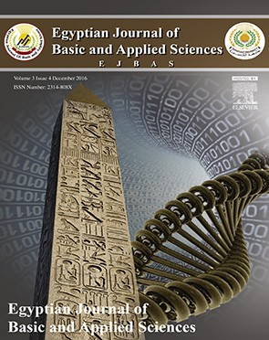**Characterization of new strains of *Hortaea werneckii* isolated from salt marshes of Egypt**



***Ashraf Elsayed*** ***\*******, Amr M. Mowafy, Hoda M. Soliman, Ahmed Gebreil, Nada I. Magdy***

*Botany Department, Faculty of Science, Mansoura University, Mansoura, Egypt*

A R T I C L E I N F O A B S T R A C T

*Article history:*

Received 28 June 2016 Received in revised form 8 September 2016

Accepted 9 September 2016

Available online 26 September 2016

*Keywords:*

Black yeast

*Hortaea* and salt marshes

Three new black yeast strains (EGYNDA08, EGYNDA16 and EGYNDA90) of marine origin were isolated from the Egyptian off shore salt marshes and molecularly identified by ITS1 and ITS2 5.8S rRNA gene sequencing. The molecular identification showed a high sequence iden- tity between the two of them and *Hortaea werneckii* Hw6 strain, while the other strain was unique. The biochemical characterization using different nutritional media showed differ- ent growth capabilities and the qualitative enzyme tests (such as catalase, urease, lipase, proteases, amylases and cellulose) showed different activity levels. The morphological char- acterization showed different developmental stages of hyphal maturation. The phylogenetic analysis of the three strains indicated that, two isolates were evolutionary relevant to the Hw6 strain isolated from Spain and one novel strain was isolated with rather different mo- lecular and morphological characteristics.

© 2016 Mansoura University. Production and hosting by Elsevier B.V. This is an open access article under the CC BY-NC-ND license (<http://creativecommons.org/licenses/by->

nc-nd/4.0/).

# Introduction

From the taxonomic and phylogenetic point of view, ‘Black yeast’ is a polyphyletic group [1,2] of dematiaceous, filamen- tous [3] fungi of which several representatives share morphological features [4] such as reproducing by unicellular growth [5]. They thrive in extreme environments character- ized by scarce nutrients, low oxygen tension, high temperature, harmful UV radiation, osmotic stress as well as a mixture of these conditions [4].

*Hortaea werneckii* was identified as an extreme halotolerant fungus [6] that belongs to the black yeast group and was iso- lated from different marine habitats. *H. wernrckii* was reported to inhibit the afore-mentioned extreme conditions. *Hortaea* sp. belongs to the Capnodiales order in the Ascomycota phylum [7]. Based on the state of the niche (static or dynamic) [5],

*H. werneckii* switches between two main life phases yeast phase and hyphal phase [8]. Both phases ended up with sclerotial bodies under sever environmental conditions [8].

Under light microscope, *H. werneckii* is a synanomorphic mi- croorganism which produces buds, conidia, arthrocondia and

* *Corresponding author.*

*E-mail address:* [ashraf.badawy@yahoo.com](mailto:ashraf.badawy@yahoo.com) (A. Elsayed). <http://dx.doi.org/10.1016/j.ejbas.2016.09.001>

2314-808X/© 2016 Mansoura University. Production and hosting by Elsevier B.V. This is an open access article under the CC BY-NC-ND license ([http://creativecommons.org/licenses/by-nc-nd/4.0/).](http://creativecommons.org/licenses/by-nc-nd/4.0/))

egyptian journal of basic and applied sciences 3 (2016) 3 5 0–3 5 6

**351**

endoconidia. Buds are enteroblastic annellidic ones [8] and they emerged as polar, lateral, and bipolar from yeast-like forms [9]. Conidiogenesis and budding mode are the same as both buds and conidia are released by the complete separation of the de- veloped abscission line in a septum [3]. When cells are successively generated from the same locus, the remnants of the outer layers of the cell wall are arranged consecutively around the tip, an increase in neck (collars) of the mother cell results in bottle-shaped cells marked by many rings directed toward the pole and the number of rings is dependent on the number of buds or conidia released [8]. The conidia are pro- duced from the generative apex of annellidophores which are unbranched intercalary hyphal cells with tapered tips. Conidia are mainly unicellular; however two-celled conidia separated by conspicuous dark cross wall were found [3]. *H. werneckii* pro- duces hydrophobic dematiaceous septated mycelia [3] which are formed of coherent thalli and extended from the mother cell wall [8] and lateral branches sometimes are expanded from them [9].

Hyphal cells septa have an abscission line separating between septum sheets. In addition to the simple central pore, triangular points in mature cells are laying at the anastomo- sis of inner and outer layer which marks the future points of separation and the adjacent outer layer remains intact without a separation line until releasing enteroarthric thin-walled scar- free cells either in the form of an endogenous conidia from the yeast-like cells or arthroconidia from the fragmentation of hyphae by shedding off parts of the outer cell wall layers, which are easily ruptured [8,9].

Up to our knowledge, isolation and characterization of

*H. werneckii* from the Egyptian environment was not reported before. In this survey, the isolated strains of *H. werneckii* from Egypt were molecularly, biochemically and morphologically characterized to focus on differences between them and between other previously published characterized *H. werneckii* strains.

# Materials and methods

## *Sample collection*

Water samples from different off shore salt marshes located after 10 kilometers from west of Gamasa on Damietta road, were collected at the beginning of December and three samples in the end of March. Samples were stored in glass sealed jars.

## *Isolation and purification of the marine black yeast*

One milliliter from the collected samples was inoculated in two saline enriched liquid medium (0.5% yeast extract without/ with 1% glucose) dissolved in sea water and 100 μg/ml of streptomycin was added after sterilization in order to inhibit undesired bacterial growth. The incubation was held at 15 °C, 25 °C and 30 °C in an orbital incubator shaker at 150 rpm for three weeks [10].

After one week, sub-culturing from the liquid media of tur- bidity was performed on the same saline enriched agar media. Temperatures 15 °C, 25 °C and 30 °C were repeated until the

filamentous community invading during the first week and then developed to unicellular communities appeared on the third week until the appearance of yeast-like melanized colonies which are purified by sub-culturing on media containing 10% NaCl. The pure cultures were preserved in 20% glycerol and stored at −20 °C.

## *Molecular identification of the isolates*

Fungal DNA was extracted by employing the FastDNA® Spin Kit according to the supplier’s instructions. The yield of genomic DNA was measured by a Nano Drop spectrophotometer by mea- suring the absorbance at 260 nm. The ITS1 region from DNA sample extracts was amplified in triplicate using primers with high specificity for ascomycete fungi (18FITS1 (CTTGGTCATTTAG AGGAAGTAA) and 18RITS4 (TCCTCCGCTTATTGATATGC). The

PCR reactions were performed in a thermo-cycler at a total volume of 50 μl using the temperature programs: 94 °C for 5 min, 94 °C for 40 s, 55 °C for 45 s, 72 °C for 1.5 min, 72 °C for 7 min

(35 cycles). The sizes of the PCR products were determined by electrophoresis on 1.5% agarose gels. The desired products were excised and purified by the Qiagen II Agarose Gel Extraction Kit.

The sequencing reactions were performed in a thermocycler (Master cycler, Eppendorf, Hamburg, Germany) at a total volume of 10 μl by using the temperature program: 96 °C for 1 min, 96 °C

for 30 s, 60 °C for 10 s, 60 °C for 4 min, 72 °C for 5 min (25 cycles).

The sequencing reaction products were purified by employ- ing the Dye Ex 2.0 Spin Kit. The purified sequencing reaction products were dried in vacuum centrifuge and then analyzed using applied biosystems (ABI PRISM Big Dye Terminator v1.1), Ready Reaction Cycle Sequencing Kit and employing an ABI 3130 XL Genetic Analyser (Applied Biosystems, Darmstadt) [11]. The obtained sequences were annotated using the Sequencher™ 4.8 Software. DNA similarity searches were per- formed using the BlastN program and the databases of European Molecular Biology Laboratory (EMBL) and GenBank from the National Center for Biotechnology Information website (NCBI).

Phylogenetic and molecular evolutionary analyses for 18S rRNA gene nucleotide sequences were conducted for se- quence alignments using the computer programs ClustalW and BioEdit 7.0.5.3 and implement in MEGA software version 5. Phy- logenetic trees were constructed using the Neighbor-Joining [12] algorithm method. Distances were generated using the Kimura Matrix, and the tree stability was supported through Boot- strap analysis (1000 replications).

## *Biochemical characterization*

### *Nutritional characteristics*

Different media were tested for supporting the growth of the isolates such as Malt Extract Agar media (MEA) (2% malt extract and 1.5% agar) [2], Potato Dextrose Agar media (PDA) (2% dex- trose 20 g, sliced potato 1.5% agar) and modified Yeast Extract Peptone Dextrose media (YPD) (2% glucose-1% pepton-1% yeast extract-1.5% agar) [13]. All media were dissolved in sea water and cultures were incubated at 25 °C.

**352** egyptian journal of basic and applied sciences 3 (2016) 3 5 0–3 5 6

### *Enzyme tests*

* + - 1. *Catalase test.* In room temperature, a drop of diluted 30% Hydrogen Peroxide was placed onto a slide containing a drop of liquid modified YPD containing tested organisms with 6 days old. Effervescence reaction could be observed in- stantly as a positive result [14].
      2. *Urease test.* Rustigian and Stuart’s urea broth media

De-staining process was repeated continuously until a clear zone appeared around the growing hyphae.

## *Microscopic characterization*

Specimens of the three strains of the five days old light green colonies for yeast phase formation and one month old black colonies for hyphal phase formation were examined under light microscope (40×).

[15] containing urea 20 g, monopotassium phosphate 9.1 g, di-

potassium phosphate 9.5 g and Phenol Red 0.01 g were dissolved in one liter of distilled water with final pH 6.8, were sterilized using Millipore filter papers, poured into sterilized tubes, in- oculated with culture and incubated at 25 °C for five days. The change in media color from yellow to pink was regarded as a positive result.

* + - 1. *Lipase test.* Sierra lipase test protocol was done [16] using Tween-80 (10.0 g) and agar 20.0 g in one liter of sea water and the final pH was 6. Agar was dissolved in sea water and autoclaved and Tween was sterilized separately. After inocu- lation, the plates were incubated at 25 °C for three days. The observation of white precipitation around the growing inoculums was considered as a positive result.
      2. *Proteases test.* A modified protocol of 30% skim milk- agar medium [17] was done by adding 30 ml packed liquid skim milk (the used skim milk nutrition label on the pack: Fats .44 g, Carbohydrates: 10.6 g, Protein: 6.9 g, Vitamin: B1 .1 mg and Vitamin: B2 .14 mg). The formation of transparent zone around the growing isolates was considered as a positive result.
      3. *Amylases test.* Vedder starch media composed of soluble starch 10 g, agar 12 g and sodium nitrate 6.5 g were dis- solved in one liter sea water and adjusted to pH 6. Amylases activity was detected by flooding the surface of inoculated media with Grams Iodine [18].
      4. *Cellulase test.* The Carboxymethylcellulose (CMC) media [19,20], which were composed of: CMC 10 g, Sodium Nitrate 6.5 g, Potassium Hydrogen Phosphate 6.5 g, Potassium chloride 6.5 g, Magnesium sulphate heptahydrate 3.0 g and Agar 17.5 g in one liter with final pH of 6, were used for cellulose activity. The ac- tivity was visualized by staining the media with Congo red dye followed by de-staining with Sodium Chloride solution.

# Results

## *Black yeast isolation*

The incubational temperature 25 °C and 10% NaCl enhanced the growth of the black yeast isolates. Two isolates were re- covered from water samples, EGYNDA08 at the beginning of December and EGYNDA16 at the end of March, while another isolate EGYNDA90 was recovered from NaCl crystals of salt marshes at the beginning of May.

## *Molecular identification*

From the phylogenetic tree (Fig. 1), three new black yeast strains (EGYNDA08, EGYNDA16 and EGYNDA90) were visualized. One of them (EGYNDA90, accession number KU341734) lay in a sepa- rate branch while the others, EGYNDA08 (accession number KU341732) and EGYNDA16 (accession number KU341733), were very close to each other and to Hw6-JN997370.1 which was iso- lated from Spain. The similarity between EGYNDA16 and the other ecotypes was 97.4% maximum using Pairwise Sequence Alignment (Table 1).

## *Biochemical characterization*

### *Nutritional characteristics*

EGYNDA08 grew on MEA as black small colonies with hyphal growth stimulation; also it grew on the modified YPD media, meanwhile, EGYNDA16 and EGYNDA90 grew on YPD media and they hardly grew on MEA and the media contained 0.5% yeast extract.

### *Enzymes tests*

* + - 1. *Catalase test.* The effervescence that resulted on a slide was very weak in case of EGYNDA08, very strong in case of

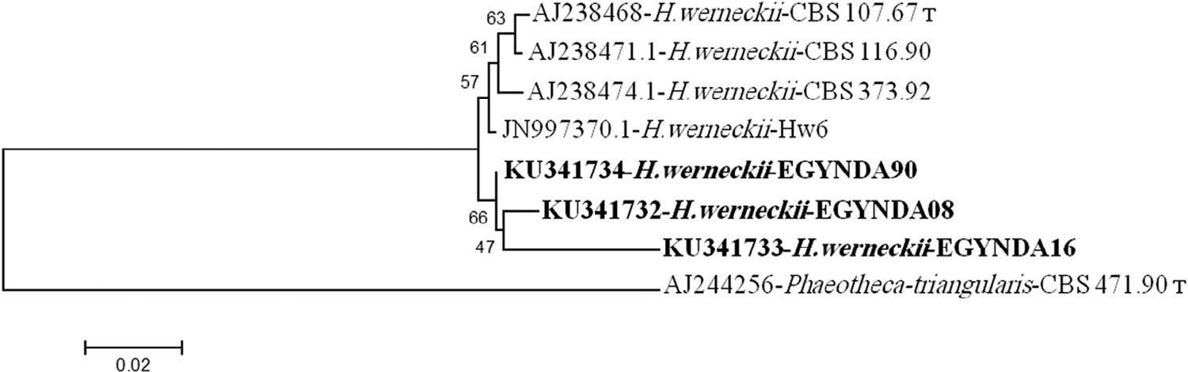

#### Fig. 1 – Phylogenetic tree constructed by MEGA using Neighbor-Joining tree, with number of Bootstrap replications 500, between different *Hortaea werneckii* strains including the three isolates and *Phaeotheca triangularis*.T = ex-type strain.

egyptian journal of basic and applied sciences 3 (2016) 3 5 0–3 5 6

**353**

|  |  |  |  |  |
| --- | --- | --- | --- | --- |
| **Table 1 – Sequence homology of the 18S rRNA gene of *H. werneckii* isolates from the salt marshes with yeast isolates from public data bases.** | | | | |
| Isolate | Accession number | Closely related yeast | Homology (%) | Size (bp) |
| EGYNDA08 | KU341732 | *H. wernechii* 6-JN997370 | 100 | 501 |
| EGYNDA16 | KU341733 | *H. wernechii* 6-JN997370 | 97.4 | 471 |
| EGYNDA90 | KU341734 | *H. wernechii* 6-JN997370 | 100 | 459 |

EGYNDA16 and almost intermediate in case of EGYNDA90 (Fig. 2A).

* + - 1. *Urease test.* In case of EGYNDA08, the color change from yellow to pink was sharper than that in case of EGYNDA90

indicating higher urease activity, while, the lowest activity was recorded for EGYNDA16 (Fig. 2B).

* + - 1. *Lipase test.* White precipitate appeared around all the isolates (Fig. 2C) indicating the lipase activity for all.

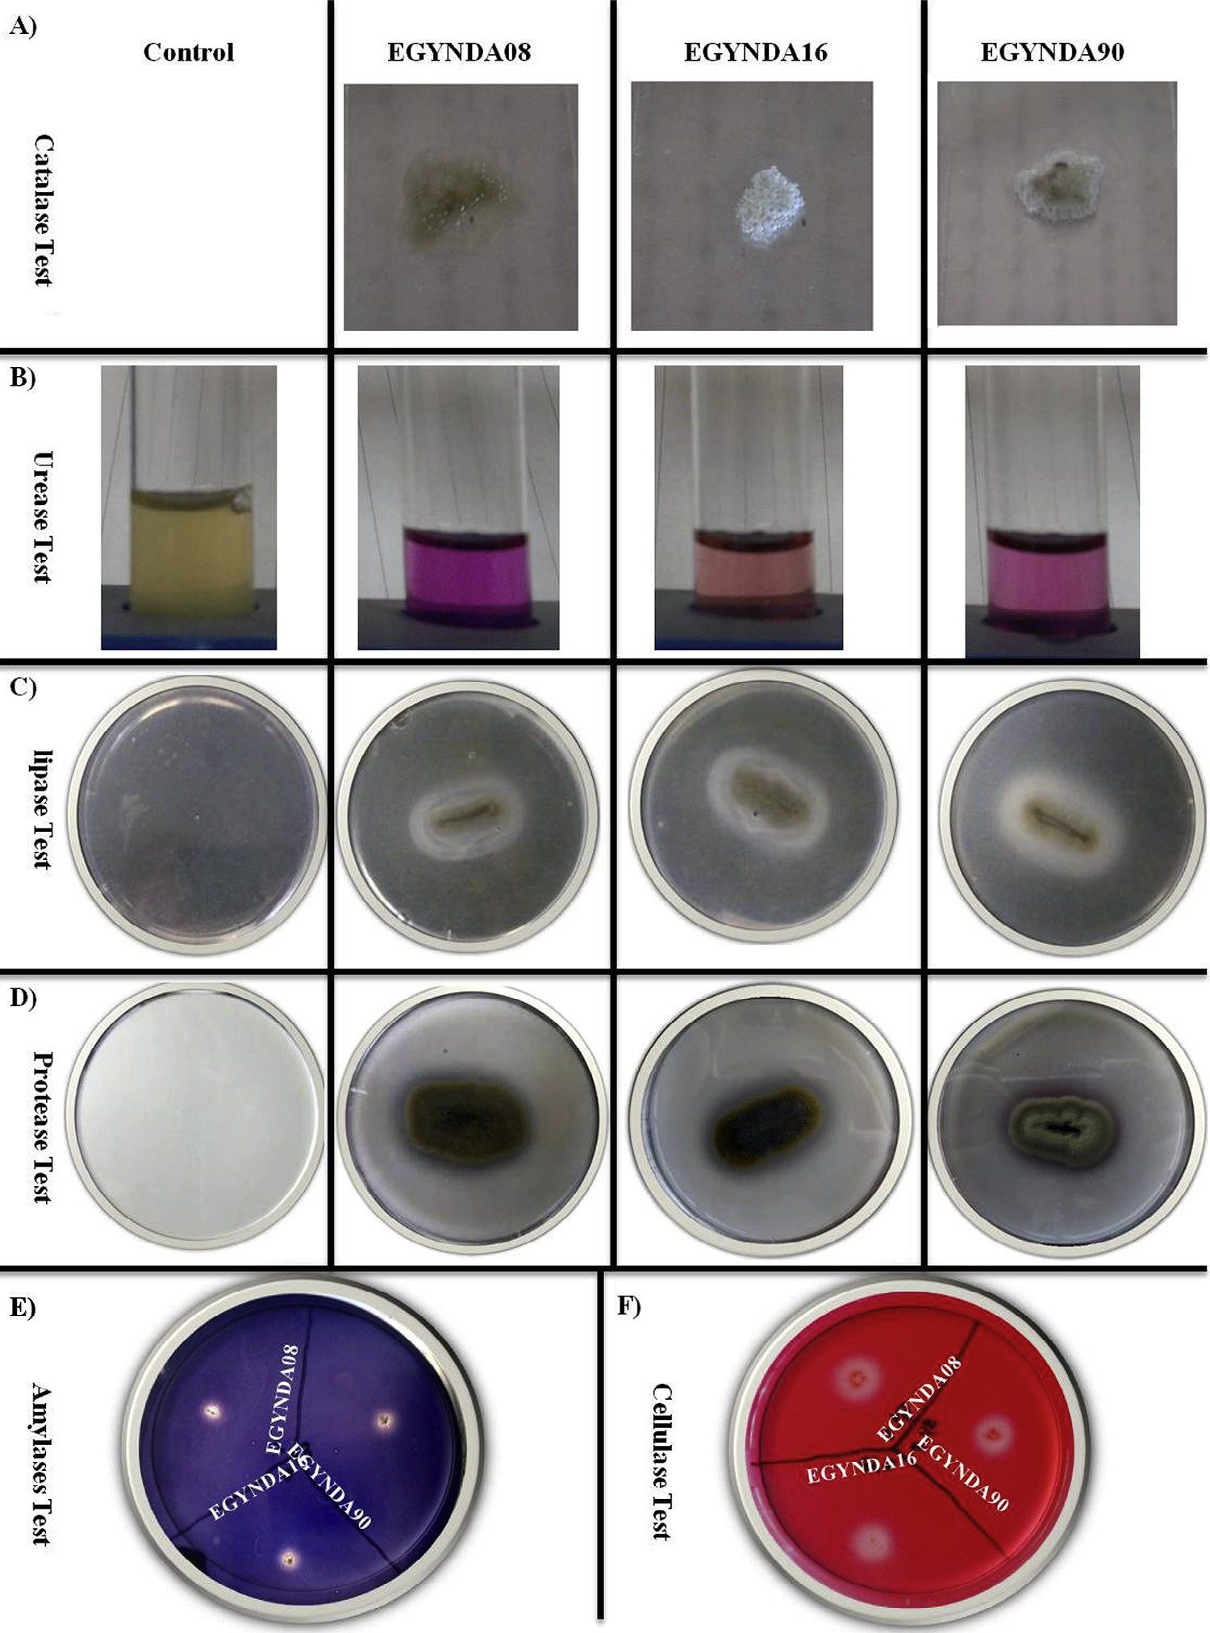

#### Fig. 2 – Enzyme tests results. (A) Positive results of catalase test, (B) positive results of urease test, (C) positive results of lipase test, (D) positive results of proteases test, (E) positive results of amylases test and (F) positive results of cellulase test.

**354** egyptian journal of basic and applied sciences 3 (2016) 3 5 0–3 5 6

|  |  |  |  |
| --- | --- | --- | --- |
| **Table 2 – Morphological characteristics of *H. werneckii* strains isolated from salt marshes.** | | | |
| Characteristic | EGYNDA08 | Strain  EGYNDA16 | EGYNDA90 |
| Cell length Cell width Spherical cells  Cell description  Hyphal development Budding style Annellidic ring | 5.2–7.8 μm  2.6–5 μm  Not present  Two-celled pattern, conspicuous and heavily melanized thick septum and cell wall. (Fig. 3A). Melanosomes were low in numbers and large in size, they were located inside and outside the cell (Fig. 3B1), anastomosis triangles in septum are pigmented (Fig. 3B2).  Short mucilage  Polar (Fig. 3C1), sided polar (Fig. 3C2), bipolar (Fig. 3C3) and sympodial (Fig. 3C4)  Few rings max. 3 (Fig. 3D2) | 5.2–46.8 μm  ~2.6 μm  10.4 μm  Two shapes of cells: rod and spherical (Fig. 4A). Cell wall, septum and melanization were weak (Fig. 4A). Many fine melanosomes.  Rare, if present, zigzag non- septated (Fig. 4C).  Mainly polar and other styles were rare  Many rings (Fig. 4B1, B2 and B3). | 5.2–20.8 μm  2.6–5.2 μm  6.5–7.8 μm  Cell wall and septum were medium in thickness and melanization  Melanosomes were many and fine (Fig. 5A).  Zigzag coenocytic (Fig. 5B). Long, albino aerial mycelium (Fig. 2D). Mainly polar and other styles were rare  Medium number of rings |

* + - 1. *Protease test.* Hydrolysis of proteins around colonies was achieved by the three isolates (Fig. 2D) indicating prote- ase activity for all the isolates.
      2. *Amylase test.* Clear zone around colonies was achieved by the three isolates (Fig. 2F) indicating the ability for all of them to degrade starch.

### *Microscopic characteristics*

Generally, the isolated strains have all morphological fea- tures recorded previously to other *H. werneckii* strains and mentioned briefly in the introduction. Table 2 summarizes the morphological differences among the isolated black yeast

strains. EGYNDA08 was studied as a model for the develop- mental stages of hyphal maturation. Newly developed hyphae appeared as non-septated coenocytic thin hyphae (Fig. 3D1).

Polar septum formation started from the older parts of the filaments at the colony base and continued to the tip of the filaments and the intercalary cells become wider by age and followed by conidiogenesis (Fig. 3D2). Two weeks old fila- ments terminated conidiogenesis and intercalary cells started to divide leading to the irregular size and shape of cells. Frag- mentation has also been noticed in old filaments (Fig. 3D3) then sclerotial elements production was the final step in the cycle (Fig. 3D4).

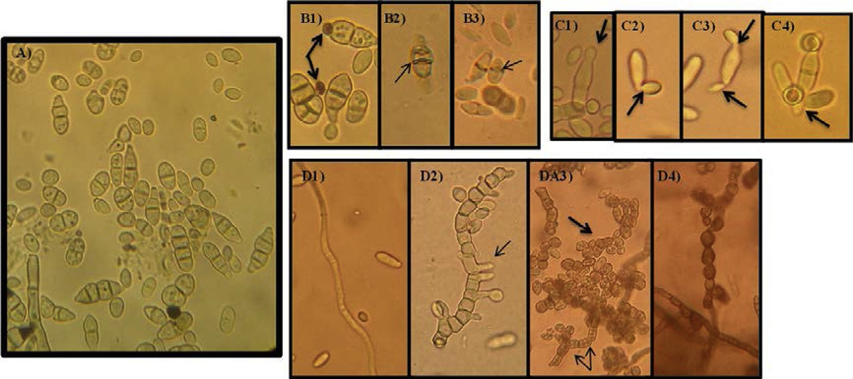

#### Fig. 3 – EGYNDA08 isolate under light microscope (40×). (A) The most frequent morphological characteristics (two-celled pattern, conspicuous septa and melanized cell wall. (B1) Bold arrows showing the cytoplasmic melanosomes aggregated inside and outside the cell. (B2 and B3) Light arrows referring to the accumulation of melanin position. (C1–C4) Different styles of budding cells (C1) polar, (C2) sided polar, (C3), bipolar (C4) sympodial. (D1–D4) Filaments at different ages. (D1) Five days old hyphae, (D2) ten days old hyphae, arrows are pointing to annellidophores, (D3) twenty days old petri-dish bold arrow pointing to fragmented filament and double-headed arrow is pointing to the same number of vesicles inside two cells and inside fragmented hyphae, (D4) one month old culture with irregular sclerotial elements.

egyptian journal of basic and applied sciences 3 (2016) 3 5 0–3 5 6

**355**

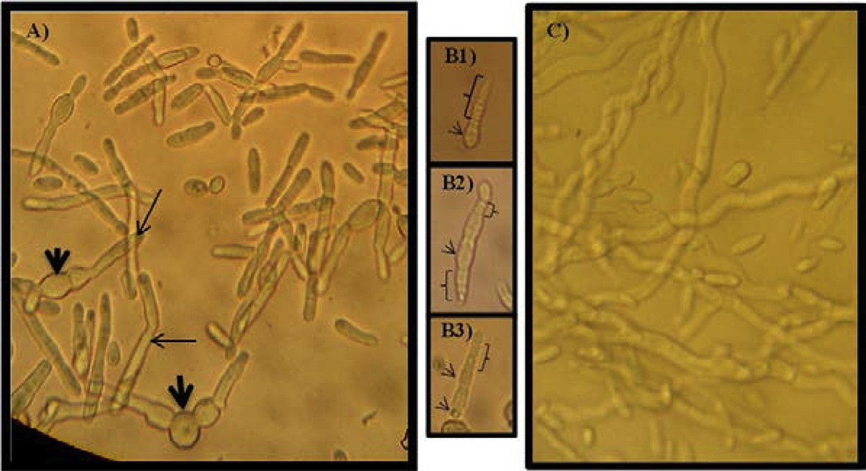

**Fig. 4 – EGYNDA16 isolate under light microscope (40×). (A) Black bold arrows are pointing to big cells while thin arrows are pointing to long cells. (B1–B3) Annellidic budding and brackets are referring to annellidic conidiogenesis, arrows are pointing to the original cell (B3) which was potential for shedding off endoconidia. (C) Isolated hyphaea from broth media.**

# Discussion

The biggest obstacle to the halophilic black yeasts study is not laying in extreme conditions but in their inability to prohibit the invasion of other competing microorganisms that is similar to the behavior of the acidophilic fungi [21]. Additionally, iso- lating *H. werneckii* was a big challenge [4] because a successful purification depends on choosing the unsuitable isolation con- ditions to other fungi contaminating the sample and in the same time tolerable by the organism of interest such as high salt concentration in media [4], high pH >9 and low tempera- ture <20 °C. Media type, temperature and media state affected the examined shape and the stages of *Hortaea* cells under mi- croscope, even the temperature in which they are growing affected the relativity between hyphal and yeast phase. Yeast

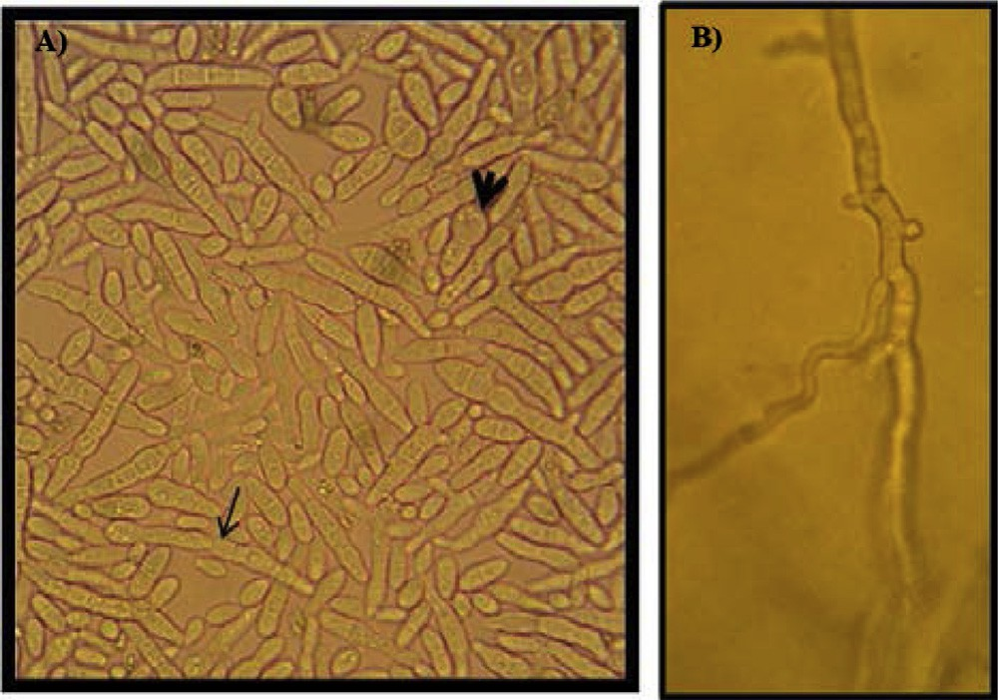

#### Fig. 5 – EGYNDA90 isolate under light microscope. (A) Black bold arrow is pointing to a relatively big cell while thin arrow is pointing to long cells. (B) Zigzag-shaped branched hyphae growing on the figure after few days; filament is straightened once it gets septated.

phase was more frequently observed and could be described as the dominant phase at low temperatures (15–20 °C), however, hyphal phase was the dominant phase at high temperatures (25–30 °C). When a four-day-old colony was picked and exam- ined by light microscope, it showed the different growth phases except the sclerotial bodies. On the other hand, the isolates examined from the liquid media were much more homog- enous cells with almost the same shape and size.

Morphological differences were observed and recorded by careful comparison between the three isolates cultivated under the same laboratory conditions to avoid the gradual change and loss in the unnecessary morphological characteristics of the tested lab organisms over the research study period.

The general environmental or controlled conditions sur- rounding black yeasts are majorly responsible for sculpturing their morphological identity so culturing the organisms re- peatedly in controlled conditions probably leads to different phenotype. As an example, EGYNDA16 was rarely observed to produce filaments until it was cultured repeatedly on solid media at which wide spaces between spots were considered indicating that the laboratory conditions and the cultivation method forced the cultured organism to produce hyphae which might be necessary for the organism to obtain nutrients.

The yeast-like pattern gave a wide variety in budding styles: polar and sided polar budding (Fig. 3C1 and C2) which was trig- gered by growing on solid media may be when cells on the surface of colony were budding vertically downward then hori- zontally outward. Bipolar budding (Fig. 3C3) maybe due to nuclear division occurrence in one mother cell and each nuclei ordered its half with budding from each pole before a sepa- rating septum is formed. Sympodial budding (Fig. 3C4) was triggered in old cultures. Hyphal branches’ irregularity has been mentioned as a cause to prolonged culturing of the organism in liquid culture [22]. The characteristic shape of zigzag hyphae has been noticed in *Ashbya gossypii* and the dimorphic patho- genic fungus *Histoplasma capsulatum* as the studies proved that the hyphae shape might be affected with calcium availability in surrounding media [23] or calcium binding protein gene mutation [24].

**356** egyptian journal of basic and applied sciences 3 (2016) 3 5 0–3 5 6

It could be concluded that new black yeast strains have been isolated and characterized in this study. They all have been iden- tified as *H. werneckii,* two of them EGYNDA08 and EGYNDA16 were ecotypes of each other and EGYNDA90 lay in a separate branch. Up to our knowledge, this is the first report describ- ing the occurrence of this organism in Egypt. The isolates show differences in morphological characteristics as described in the results and the enzymatic assays showed qualitative differ- ences. Further studies are ongoing to verify the pleomorphic characterization and the adaptation mechanism of these iso- lates to the saline habitat they could survive.

# Acknowledgments

Many thanks to Prof. Samia Ali Haroun, the former head of botany department, Faculty of Science, Mansoura University, Egypt and many thanks to Prof. Heshmat Soliman Aldesuquy the current head of the department for their valuable help and encouragement. We thank Dr. Eladl Gala from the same de- partment for his continuous support and valuable discussions.

R E F E R E N C E S

1. [De Hoog G, Zalar P, Urzi C, De Leo F, Yurlova N, Sterflinger K.](http://refhub.elsevier.com/S2314-808X(16)30055-0/sr0010) [Relationships of dothideaceous black yeasts and](http://refhub.elsevier.com/S2314-808X(16)30055-0/sr0010) [meristematic fungi based on 5.8 S and ITS2 rDNA sequence](http://refhub.elsevier.com/S2314-808X(16)30055-0/sr0010) [comparison. Stud Mycol 1999;31–7.](http://refhub.elsevier.com/S2314-808X(16)30055-0/sr0010)
2. [Sterflinger K, De Hoog G, Haase G. Phylogeny and ecology of](http://refhub.elsevier.com/S2314-808X(16)30055-0/sr0015) [meristematic ascomycetes. Stud Mycol 1999;5–22.](http://refhub.elsevier.com/S2314-808X(16)30055-0/sr0015)
3. [Ajello L. The black yeasts as disease agents: historical](http://refhub.elsevier.com/S2314-808X(16)30055-0/sr0020) [perspective. Pan Am Health Organ Sci Pub 1978;356:9–19.](http://refhub.elsevier.com/S2314-808X(16)30055-0/sr0020)
4. [Sterflinger K. Black yeasts and meristematic fungi: ecology,](http://refhub.elsevier.com/S2314-808X(16)30055-0/sr0025) [diversity and identification Biodiversity and ecophysiology](http://refhub.elsevier.com/S2314-808X(16)30055-0/sr0025) [of yeasts. Springer; 2006. p. 501–14.](http://refhub.elsevier.com/S2314-808X(16)30055-0/sr0025)
5. [de Hoog GS. Evolution of black yeasts: possible adaptation to](http://refhub.elsevier.com/S2314-808X(16)30055-0/sr0030) [the human host. Antonie Van Leeuwenhoek 1993;63(2):105–](http://refhub.elsevier.com/S2314-808X(16)30055-0/sr0030) [9.](http://refhub.elsevier.com/S2314-808X(16)30055-0/sr0030)
6. [Vaupotic T, Gunde-Cimerman N, Plemenitas A. Novel](http://refhub.elsevier.com/S2314-808X(16)30055-0/sr0035) [3’-phosphoadenosine-5’-phosphatases from extremely](http://refhub.elsevier.com/S2314-808X(16)30055-0/sr0035)

[halotolerant *Hortaea werneckii* reveal insight into molecular](http://refhub.elsevier.com/S2314-808X(16)30055-0/sr0035) [determinants of salt tolerance of black yeasts. Fungal Genet](http://refhub.elsevier.com/S2314-808X(16)30055-0/sr0035) [Biol 2007;44(11):1109–22.](http://refhub.elsevier.com/S2314-808X(16)30055-0/sr0035)

1. [Revankar SG, Sutton DA. Melanized fungi in human disease.](http://refhub.elsevier.com/S2314-808X(16)30055-0/sr0040) [Clin Microbiol Rev 2010;23(4):884–928.](http://refhub.elsevier.com/S2314-808X(16)30055-0/sr0040)
2. [de Hoog GS, Gerrits van den Ende AH. Nutritional pattern](http://refhub.elsevier.com/S2314-808X(16)30055-0/sr0045) [and eco-physiology of *Hortaea werneckii*, agent of human](http://refhub.elsevier.com/S2314-808X(16)30055-0/sr0045) [tinea nigra. Antonie Van Leeuwenhoek 1992;62(4):321–9.](http://refhub.elsevier.com/S2314-808X(16)30055-0/sr0045)
3. [Mittag H. The fine structure of *Hortaea werneckii*. Mycoses](http://refhub.elsevier.com/S2314-808X(16)30055-0/sr0050) [1993;36(11–12):343–50.](http://refhub.elsevier.com/S2314-808X(16)30055-0/sr0050)
4. [Gunde-Cimermana N, Zalarb P, de Hoogc S, Plemenitasd A.](http://refhub.elsevier.com/S2314-808X(16)30055-0/sr0055) [Hypersaline waters in salterns – natural ecological niches](http://refhub.elsevier.com/S2314-808X(16)30055-0/sr0055) [for halophilic black yeasts. FEMS Microbiol Ecol](http://refhub.elsevier.com/S2314-808X(16)30055-0/sr0055) [2000;32(3):235–40.](http://refhub.elsevier.com/S2314-808X(16)30055-0/sr0055)
5. [Mullis KB. The unusual origin of the polymerase chain](http://refhub.elsevier.com/S2314-808X(16)30055-0/sr0060) [reaction. Sci Am 1990;262(4):56–61.](http://refhub.elsevier.com/S2314-808X(16)30055-0/sr0060)
6. [Muzyka D, Pantin-Jackwood M, Stegniy B, Rula O, Bolotin V,](http://refhub.elsevier.com/S2314-808X(16)30055-0/sr0065) [Stegniy A. Wild bird surveillance for avian paramyxoviruses](http://refhub.elsevier.com/S2314-808X(16)30055-0/sr0065) [in the Azov-black sea region of Ukraine (2006 to 2011)](http://refhub.elsevier.com/S2314-808X(16)30055-0/sr0065) [reveals epidemiological connections with Europe and Africa.](http://refhub.elsevier.com/S2314-808X(16)30055-0/sr0065) [Appl Environ Microbiol 2014;80(17):5427–38.](http://refhub.elsevier.com/S2314-808X(16)30055-0/sr0065)
7. [Kejzar A, Gobec S, Plemenitas A, Lenassi M. Melanin is](http://refhub.elsevier.com/S2314-808X(16)30055-0/sr0070) [crucial for growth of the black yeast Hortaea werneckii in its](http://refhub.elsevier.com/S2314-808X(16)30055-0/sr0070) [natural hypersaline environment. Fungal Biol](http://refhub.elsevier.com/S2314-808X(16)30055-0/sr0070) [2013;117(5):368–79.](http://refhub.elsevier.com/S2314-808X(16)30055-0/sr0070)
8. [Taylor WI, Achanzar D. Catalase test as an aid to the](http://refhub.elsevier.com/S2314-808X(16)30055-0/sr0075) [identification of Enterobacteriaceae. Appl Microbiol](http://refhub.elsevier.com/S2314-808X(16)30055-0/sr0075) [1972;24(1):58–61.](http://refhub.elsevier.com/S2314-808X(16)30055-0/sr0075)
9. [Rustigian R, Stuart CA. Decomposition of urea by Proteus.](http://refhub.elsevier.com/S2314-808X(16)30055-0/sr0080) [Proc Soc Exp Biol Med 1941;47(1):108–12.](http://refhub.elsevier.com/S2314-808X(16)30055-0/sr0080)
10. [Sierra G. A simple method for the detection of lipolytic](http://refhub.elsevier.com/S2314-808X(16)30055-0/sr0085) [activity of micro-organisms and some observations on the](http://refhub.elsevier.com/S2314-808X(16)30055-0/sr0085) [influence of the contact between cells and fatty substrates.](http://refhub.elsevier.com/S2314-808X(16)30055-0/sr0085) [Antonie Van Leeuwenhoek 1957;23(1):15–22.](http://refhub.elsevier.com/S2314-808X(16)30055-0/sr0085)
11. [Kazanas N. Proteolytic activity of microorganisms isolated](http://refhub.elsevier.com/S2314-808X(16)30055-0/sr0090) [from freshwater fish. Appl Microbiol 1968;16(1):](http://refhub.elsevier.com/S2314-808X(16)30055-0/sr0090)

[128–32.](http://refhub.elsevier.com/S2314-808X(16)30055-0/sr0090)

1. [Vedder EB. Starch agar, a useful culture medium. J Infect Dis](http://refhub.elsevier.com/S2314-808X(16)30055-0/sr0095) [1915;16(3):385–8.](http://refhub.elsevier.com/S2314-808X(16)30055-0/sr0095)
2. [Stewart JC, Stewart CS, Heptinstall J. The use of tritiated](http://refhub.elsevier.com/S2314-808X(16)30055-0/sr0100) [cellulose in screening for cellulolytic microorganisms.](http://refhub.elsevier.com/S2314-808X(16)30055-0/sr0100) [Biotechnol Lett 1982;4(7):459–64.](http://refhub.elsevier.com/S2314-808X(16)30055-0/sr0100)
3. [Shahriarinour M, Mohd Noor A, Ariff A, Mohamad R.](http://refhub.elsevier.com/S2314-808X(16)30055-0/sr0105) [Screening, isolation and selection of cellulolytic fungi from](http://refhub.elsevier.com/S2314-808X(16)30055-0/sr0105) [oil palm empty fruit bunch fibre. Biotechnology](http://refhub.elsevier.com/S2314-808X(16)30055-0/sr0105) [2011;10(1):108–13.](http://refhub.elsevier.com/S2314-808X(16)30055-0/sr0105)
4. [Selbmann L, de Hoog GS, Zucconi L, Isola D, Ruisi S, van den](http://refhub.elsevier.com/S2314-808X(16)30055-0/sr0110) [Ende AH. Drought meets acid: three new genera in a](http://refhub.elsevier.com/S2314-808X(16)30055-0/sr0110) [dothidealean clade of extremotolerant fungi. Stud Mycol](http://refhub.elsevier.com/S2314-808X(16)30055-0/sr0110) [2008;61:1–20.](http://refhub.elsevier.com/S2314-808X(16)30055-0/sr0110)
5. [Takeo K, De Hoog G. Karyology and hyphal characters as](http://refhub.elsevier.com/S2314-808X(16)30055-0/sr0115) [taxonomic criteria in ascomycetous black yeasts and](http://refhub.elsevier.com/S2314-808X(16)30055-0/sr0115) [related fungi. Antonie Van Leeuwenhoek 1991;60(1):](http://refhub.elsevier.com/S2314-808X(16)30055-0/sr0115) [35–42.](http://refhub.elsevier.com/S2314-808X(16)30055-0/sr0115)
6. [Bauer Y, Knechtle P, Wendland J, Helfer H, Philippsen P. A](http://refhub.elsevier.com/S2314-808X(16)30055-0/sr0120) [Ras-like GTPase is involved in hyphal growth guidance in](http://refhub.elsevier.com/S2314-808X(16)30055-0/sr0120) [the filamentous fungus *Ashbya gossypii*. Mol Biol Cell](http://refhub.elsevier.com/S2314-808X(16)30055-0/sr0120) [2004;15(10):4622–32.](http://refhub.elsevier.com/S2314-808X(16)30055-0/sr0120)
7. [Tian XB, Shearer G. The mold-specific MS8 gene is required](http://refhub.elsevier.com/S2314-808X(16)30055-0/sr0125) [for normal hypha formation in the dimorphic pathogenic](http://refhub.elsevier.com/S2314-808X(16)30055-0/sr0125) [fungus Histoplasma capsulatum. Eukaryot Cell](http://refhub.elsevier.com/S2314-808X(16)30055-0/sr0125) [2002;1(2):249–56.](http://refhub.elsevier.com/S2314-808X(16)30055-0/sr0125)