

Cairo University

Egyptian Informatics Journal

[www.elsevier.com/locate/eij](http://www.elsevier.com/locate/eij) [www.sciencedirect.com](http://www.sciencedirect.com/science/journal/11108665)



FULL-LENGTH ARTICLE

Computing geometric median to locate the sink node with the aim of extending the lifetime of wireless sensor networks



# Yahya Kord Tamandani a,*, Mohammad Ubaidullah Bokhari a,

Mohammad Zarif Kord b

a *Department of Computer Science, Aligarh Muslim University, Aligarh, India*

b *Islamic Azad University Branch of Iranshahr, Iran*

Received 23 September 2015; revised 27 November 2015; accepted 21 June 2016

Available online 29 August 2016

Abstract In case of wireless sensor networks (WSNs) the sensed data which are collected by the ordinary senor nodes will have to be forwarded to the sink node (Base Station) in order to be acces- sible by the remote users. The location of the sink could significantly affect the energy dissipation and throughput of the network. This paper aims to investigate an optimal location for the sink node in such a way that the sum of distances from all the sensor nodes to the sink node is minimized. In an effort to place the sink node within the network our algorithm finds the geometric median of all the location associated with the sensor nodes. In a discrete set of points, the geometric median could be defined as the location which basically minimizes the sum of distances to all the points. Perfor- mance evaluation reveals that the proposed location for the sink node extends the network lifetime comparing with other possible location within the network field.

© 2016 Production and hosting by Elsevier B.V. on behalf of Faculty of Computers and Information,

KEYWORDS

WSNs;

Location of sink node; Geometric median; Network lifetime

Cairo University. This is an open access article under the CC BY-NC-ND license [(http://creativecommons.](http://creativecommons/)

org/licenses/by-nc-nd/4.0/).

1. Introduction

* Corresponding author.

E-mail addresses: [Yahya.kord@gmail.com](mailto:Yahya.kord@gmail.com) (Y.K. Tamandani), [mubo-](mailto:mubokhari.cs@amu.ac.in) [khari.cs@amu.ac.in](mailto:mubokhari.cs@amu.ac.in) (M.U. Bokhari), [dozdab@gmail.com](mailto:dozdab@gmail.com) (M. Zarif Kord).

Peer review under responsibility of Faculty of Computers and Information, Cairo University.

**Production and hosting by Elsevier**

Wireless sensor networks (WSNs) due to variety of applica- tions [1–3] and future potential [4,5] has gained a tremendous attention among the researchers. Two main components of a WSN are the sensor nodes and the sink node. Despite the fact that wireless sensor networks (WSNs) are capable of having a variety of topologies, for instance star, mesh or ring, the sig- nals generated by the sensor nodes are provided to the end users through the sink nodes. A sink node or a base station is basically a designated device similar to the normal sensor nodes but more powerful. One of the primary tasks of the sink

<http://dx.doi.org/10.1016/j.eij.2016.06.003>

1110-8665 © 2016 Production and hosting by Elsevier B.V. on behalf of Faculty of Computers and Information, Cairo University. This is an open access article under the CC BY-NC-ND license [(http://creativecommons.org/licenses/by-nc-nd/4.0/).](http://creativecommons.org/licenses/by-nc-nd/4.0/))

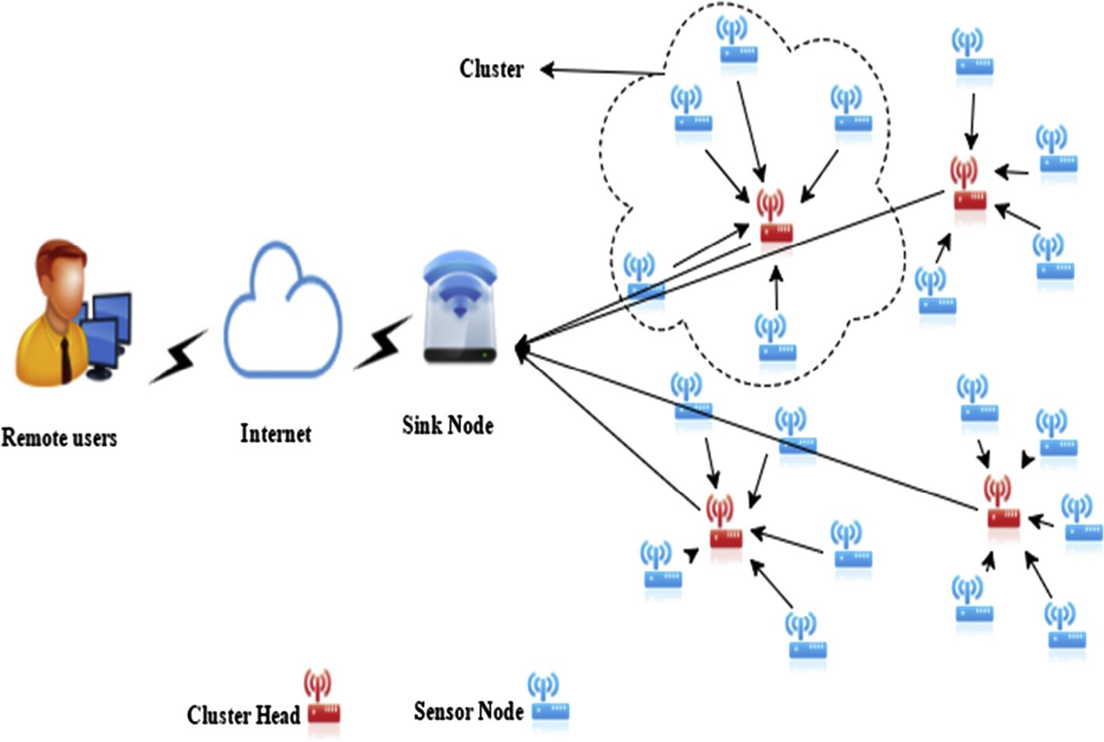

Figure 1 A typical wireless network.

node is to bridge a WSN with the remote users (Fig. 1). Actu- ally being not the same as ad hoc networks, sensor nodes in WSNs are powered by non-rechargeable batteries. Therefore the techniques [6–8] and design of new protocol [9,10] to pro- long the lifetime of the network are of great importance. The energy required to route a message to the sink node, for each and every sensor node depends on the distance from the sink node and number hops that message will have to travel. Hav- ing several sink nodes, employed effectively within the network field would help to reduce the energy needed for a message to be delivered and prolong the network lifetime. Though, there are some constraints of employing several sink nodes such as the cost of the device or not being practical to have more than one within the field. Due to the fact that, the sensed data, col- lected by the ordinary SNs are transferred to the sink node, the overall network performance can be influenced by the place of the sink node.

There are several challenges to be faced in order to locate the optimal spot of the sink node within the network field. Few of main issues are as follows:

* There exists a huge solution space which means the sink node can be possibly located at anywhere in the network

field.

* Massive number of sensor nodes in the WSNs is another main challenge in locating the sink node.
* There are different routing protocols each having its own energy model and technique to optimize and route data

toward the sink node.

* Possible changes in the network topology due to any sort of failure or improvements which might require the sink node

to be relocated.

* Optimization of sink node location for different sampling mode such as periodical or event-driven, might require dif-

ferent considerations [11].

* Increment of sensor nodes within the network field requires the sink node to be repositioned in order to improve the

lifetime as well as the throughput of the network.

This paper intends to find out an optimal location for the sink node so that the sum of distances from all the nodes to the sink node is minimized. To spot the optimal place our algo- rithm finds the geometric median of all the locations associated with the sensor nodes. In a discrete set of points, the geometric median could be defined as the location which basically mini- mizes the sum of distances to all the points. Despite of being a straightforward concept, its computation is a challenge. The remainder of the paper is structured as follows. In Section 2 the related work and proposed solutions are discussed. Sec- tion 3 discusses our strategy and algorithm in order to find the optimal location for the sink node. The network model along various parameters that are used in the simulation is pre- sented in Section 4. Section 5 contains the performance evalu- ation and the result of our simulation and conclusion of the work is given in Section 6.

1. Related work

In [12] the sink has been located on different places and the con- clusion indicates that the center of the network as well as the center of the quarter having the highest density of nodes are far better choices for the sink location. In [13,14] the P- median, a well-known NP-hard problem was used to decide the optimal location of the sink node. The result given in [14] shows the optimal placement of the sink would be the center. Authors in [15] fix the sinks location by taking into account the nodes whose data are conveyed through a node close to the sink. In [16] optimal base-station locations regarding two- tiered WSNs have been proposed. The network lifetime was evaluated by the distances of all the nodes and the sink as well as the average rate of bit stream. In [17] the result from the sim- ulation shows that improvements on data rate and power Effi- ciency can be accomplished by employing different algorithms to discover a layout for the base station. The sink node position was selected to increase the joint weight of data flows in an effort to reduce the energy consumption of the WSN. In [18]

the P-Median Problem model was utilized in order to express the problem of placing several sink nodes by the help of an iter- ative algorithm. This paper attempts to determine an optimal location for the sink node with the intention that sum of dis-

tances from all the nodes to the sink node is minimized. In order

of an iterative procedure, where in each step the algorithm gen- erates a more accurate result to the problem.

If *b* is distinct from the points, *ai* then *b* is the geometric median iff it satisfies:

*m*

to spot the ideal place, the geometric median of all the locations

0 = X *ai* — *b*

(2)

associated with the sensor nodes is found.

*i*=1

*ai* — *b*

1. Sink node placement strategy

Basically if there is a discrete set of points located in a Eucli- dean Space the geometric median would be defined as the

Generally, *b* would be the geometric median iff there exist vec-

tors *ui* so that:

*m*

0 = *ui* (3)

X

*i*=1

point which actually minimizes the sum of distances to all

the points. In statics, geometric median is a significant method to calculate an estimate of a location. Additionally it is a typ- ical problem in facility location, in which it deals with the issue of locating a facility in an effort to minimize the total cost of transportation [19].

where for *xi* – *b*,

*u* = *ai* — *b*



*ai* — *b*

*i*

and for *xi* = *b*,

(4)

For a set of m points *a*1,*a*2, ... , *am* where each *ai* s R*n*, the geometric would be as:

X*m * 

*ui* 6 1 (5)

In our approach to find the geometric median and locate the

sink node, we first approximate the best location (*x, y*) which

*GM* = *argmin*

*b*∈R*n*

*i*=1

*ai* — *b* 2 (1)

is the center of gravity. Then the sum of distances from the input points (assumed to be locations of sensor nodes) is com-

where *argmin* means the argument *b* that will minimize the

sum.

Although the geometric median’s appearing as a simple and straightforward concept to comprehend, its computation poses a challenge. There exists no exact formula nor any precise algorithm, only numerical approximations are practical toward the solution. However it can be calculated by the help

puted to the point (*x, y*). In the next step the four neighboring points of (*x, y*) which are away an experimental distance *e* in every directions (up, down, right, left) are found and the sum of distances to each of them is calculated. If any of the points give a better result, then the (*x, y*) will be updated and the same procedure with the same value of *e* will be carried out. In case if none of the points improves the present value of

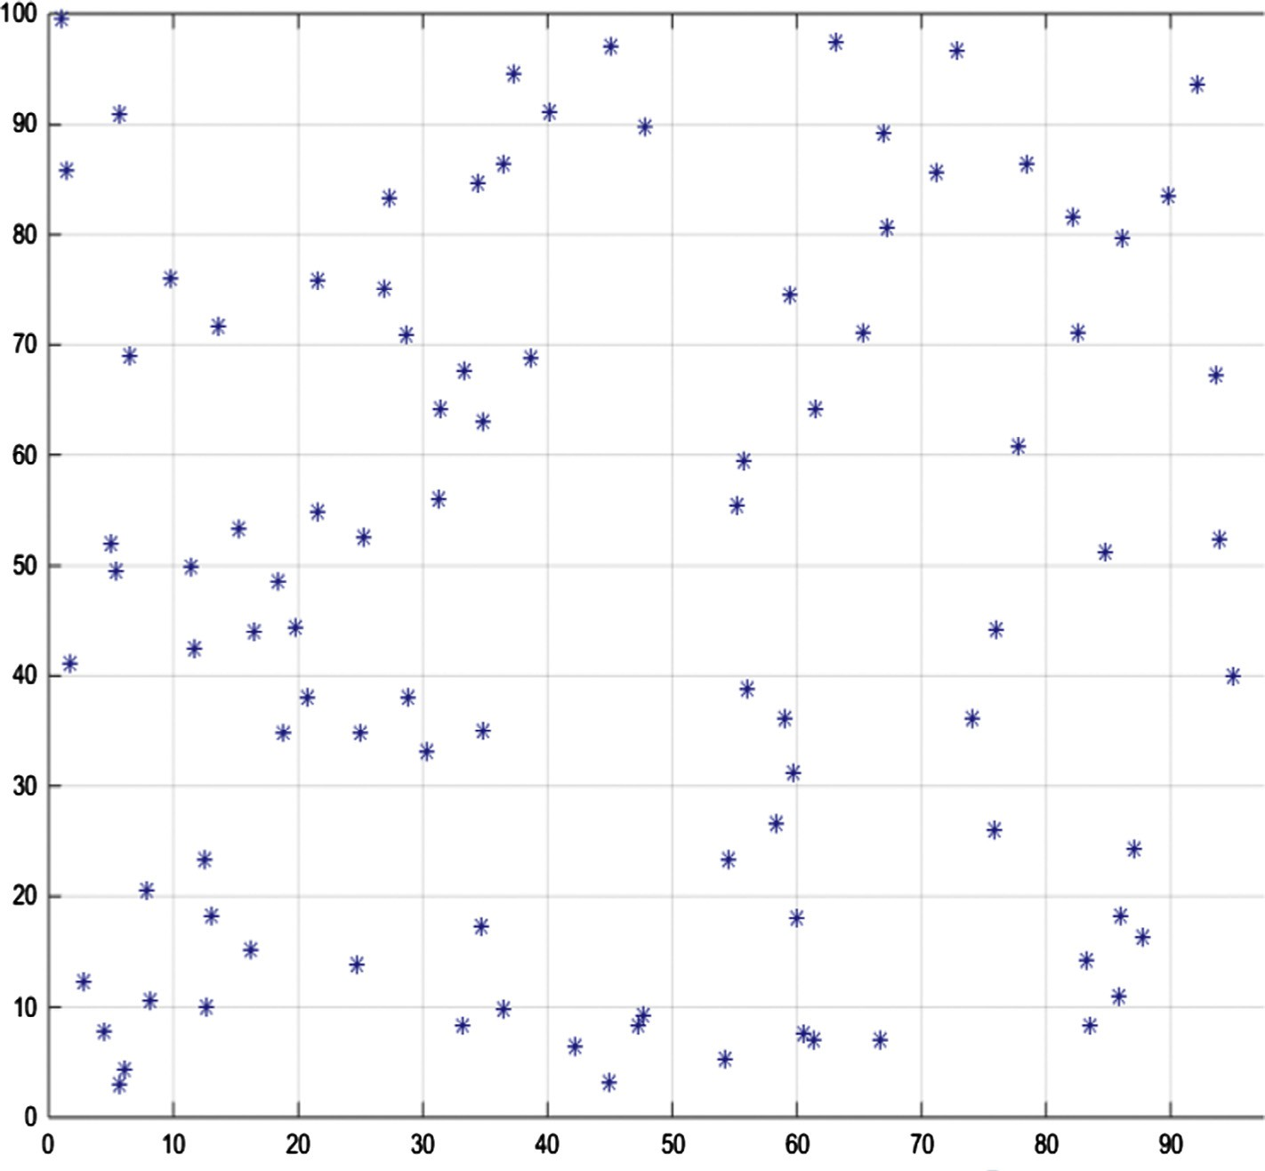

Figure 2 Arrangement of sensor nodes within field.

max

the (*x, y*) then the same procedure will be carried out but the value of *e* will be reduced as we need to look closer to the cur- rent point to find the optimal location for the sink node.

The following algorithm shows our approach to find the geometric median which is used to locate the sink node.

1. *Reading all the points*
2. *Calculating the center of gravity (x,y) and using it as the first approximation to the answer*
3. *Computing sum of distances to (x,y)*
4. *Finding the neighboring points (up, down, right, left) of (x,y), each far away by an experimental value (e)*
5. *Computing the sum of distances to the neighbors of (x,y)*
6. *Comparing the results with the (x,y)*
7. *If none of neighbor improves the solution look closer to the current point (reducing the value of experimental value e) and go to step (4)*

*Else*

*Update the value of the (x, y) and go to step (4)*

1. *Continue till obtaining a precise approximation of the location*

|  |  |  |
| --- | --- | --- |
| Table 1 Various parameters used in the simulation. | | |
| Sr*.*  no*.* | Parameters | Value |
| 1 | Routing protocols | LEACH |
| 2 | Base station position | Divergent |
| 2 | Environment size | 100 × 100 |
| 3 | Number of nodes | 100 |
| 4 | Packet size | 4000 bits |
| 5 | Speed of EM wave | 3 × 108 m/s |
| 6 | Election probability value of cluster- | 0.1 |
|  | heads (*P*) |  |
| 7 | Number of rounds (*r* ) | 4000 rounds |
| 8 | Initial energy per node (*E*0) | 0.5 J |
| 9 | *E*elec = *E*bit | 50 nJ/bit |
| 10  11 | *E*fs  *E* | 0.0013 pJ/ bit/ m4  100 pJ/bit/ m4 |
| 12 *E*DA 5 nJ/bit | | |

amp

Table 2 Various locations for the base station.

Sink node Location

Proposed (22.62, 51.06)

Centre (50, 50)

Random location (1) (20, 60)

Random location (2) (30, 45)

Random location (3) (50, 20)

* 1. *Required energy for sink node placement*

Minimizing the overall energy consumption of the WSN is the core objective of our proposed work. The proposed scheme needs no sensor nodes, which are energy constrained to be involved in the main process of computation. Generally the optimal location of the base station is calculated at the deployment stage of the WSN (the same was carried out in this

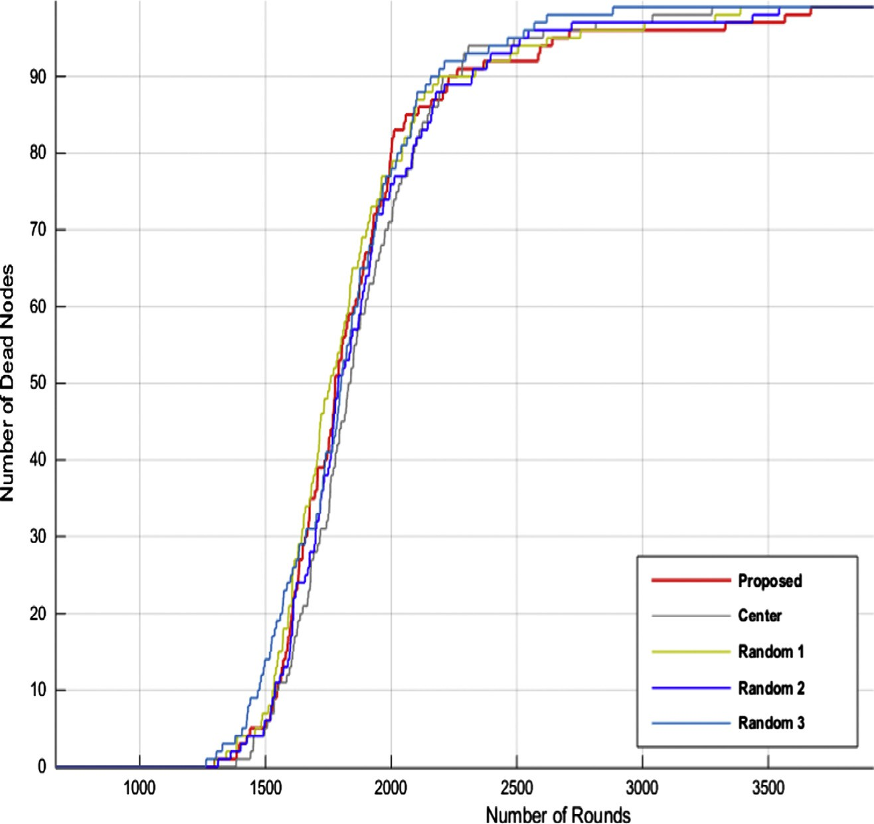

Figure 3 Number of nodes dead vs. number of rounds.

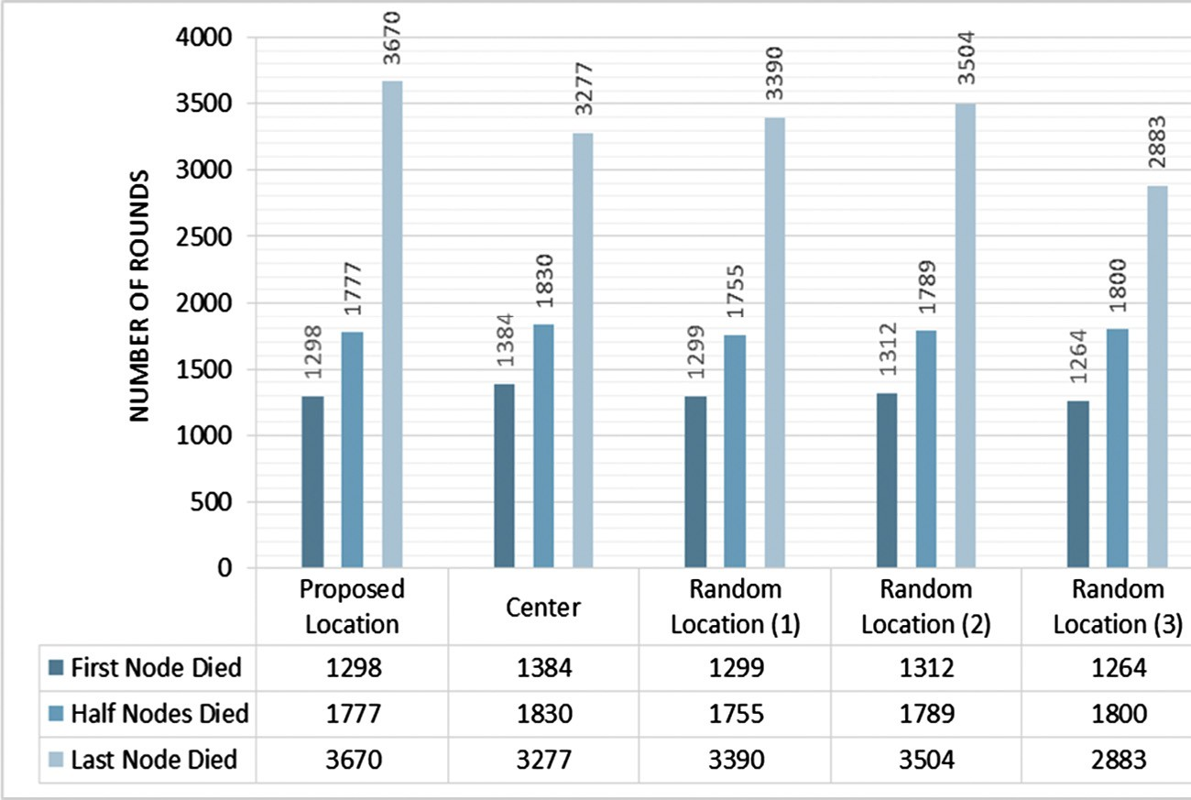

Figure 4 Nodes death vs. number of rounds.

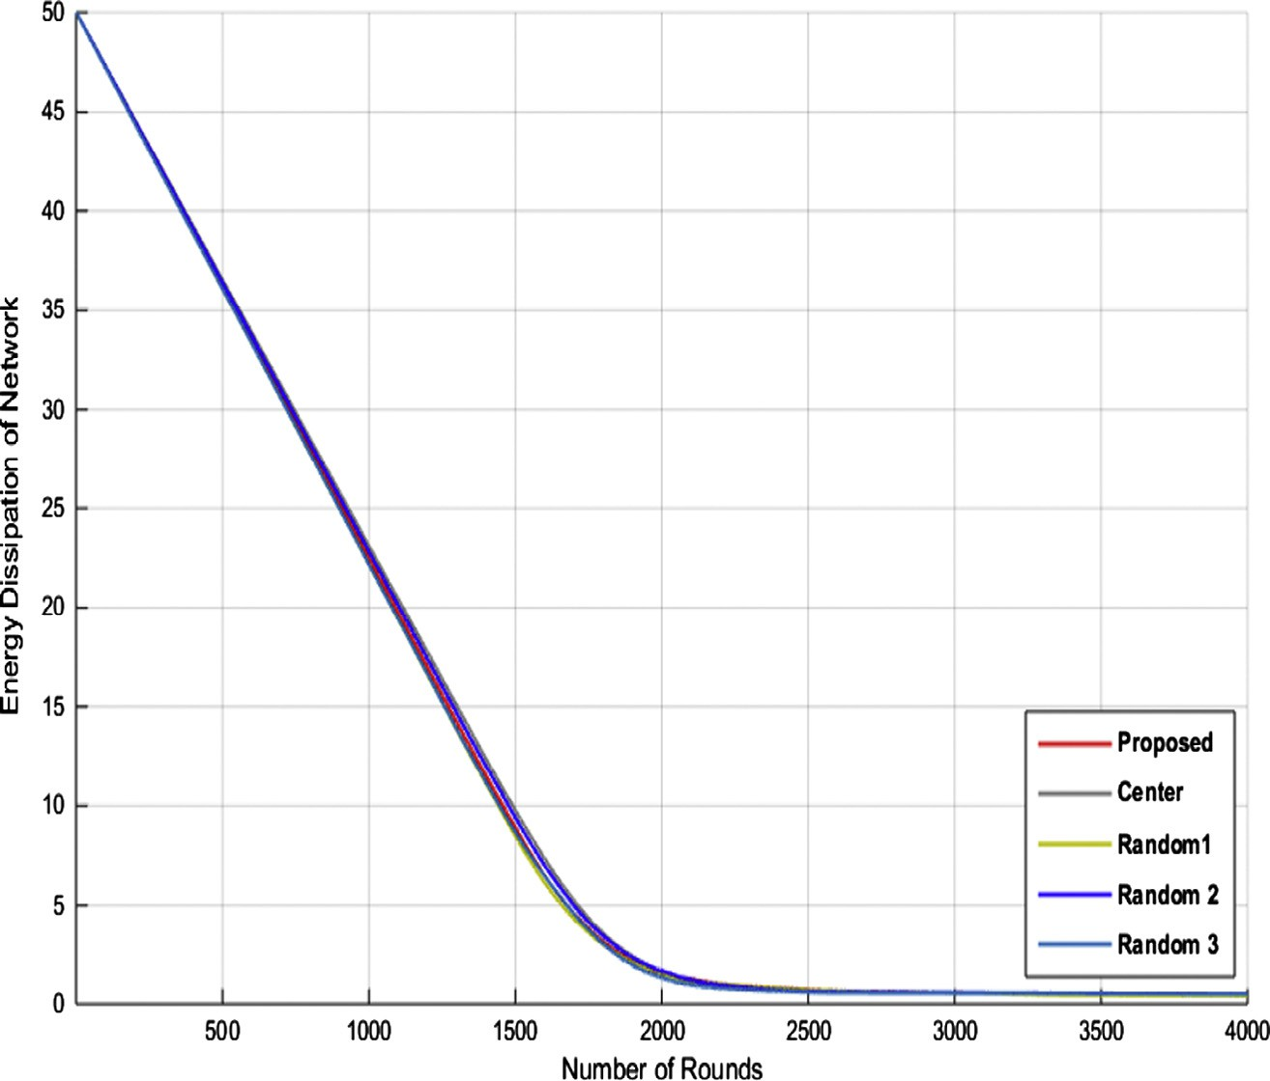

Figure 5 Energy dissipation of WSN.

experimental work). However in case of several changes which might take place after the deployment stage, such as changing the number of sensor nodes or their location, optimal position of sink node has to be recalculated. The recalculation will be done by the sink node itself (assuming to have unlimited power) once recognizing any alterations in the number or position of the sensor nodes. The information regarding the positions of GPS-enabled sensor nodes which are mainly used for routing purposes [20,21] is sent to the base station. Then the base sta- tion (if it is required) will recalculate its own ideal position which can be applied within the network field accordingly.

1. Implementation

In our experiment the sink node each time has been placed in a different location in order to evaluate the performance of the WSN. The following basic characteristics are assumed to sim- plify the WSN model:

* All SNs have limited energy resources and not rechargeable.
* All nodes are homogeneous.
* The base station is static and has no mobility.

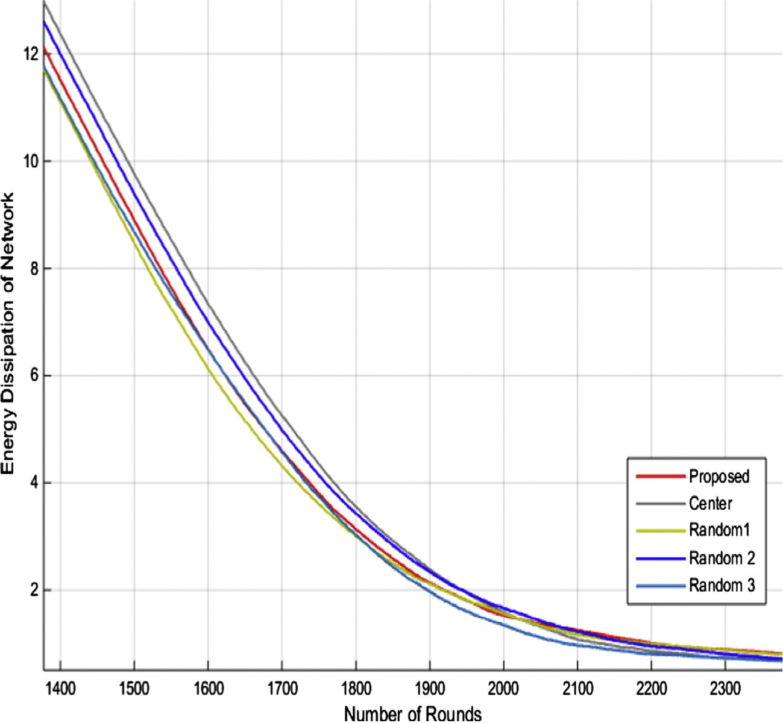

Figure 6 Closer view of energy dissipation of WSN.

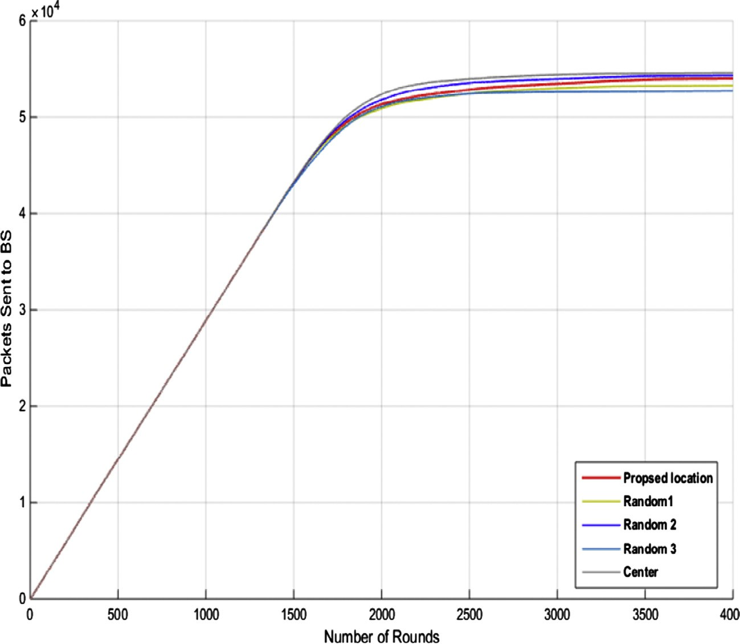

Figure 7 Packet sent to the BS.

* + Position of all the SNs is fixed.
  + The base station has unlimited power and aware of the loca- tion of all SNs.

100 homogeneous sensor nodes have been employed in the simulation and each node has an initial energy of 0.5 Joule,

which have been spread over a 100 × 100 m field, depicted in

Fig. 2. To evaluate the performance of the WSN the LEACH

[22] which is one of the earliest and well-known hierarchical routing protocols have been engaged. MATLAB [23] is used to carry out the simulation tests. The various parameters used in the simulation are given in the following Table 1 and the var- ious locations for the base station are presented in the Table 2.

1. Performance evaluation

The number of dead nodes versus number of rounds is illus- trated in Figs. 3 and 4 as well. By locating the base station at the center of the network field (50, 50), it is observed that the first node dies on 1384th round and half of the nodes died on 1830th round which gives a better result comparing with the rest of the locations. However considering the round that all the nodes die and the WSN functions no more, it is realized that the proposed location (22.62, 51.06) offers a better result in which the last node of the WSN dies on 3670th round.

Figs. 5 and 6 represent the energy dissipation of the net- work. Considering the Fig. 6 which is a closer look obtained from the Fig. 5, we realize that the proposed sink location (22.62, 51.06) offers a better energy management and balanc- ing after the second halve of the rounds (2100th round) which result the WSN to function for a longer time comparing with the other locations. However the location of the sink at the center (50, 50) and the random location 2 (30, 45) gives a better result at the first halve of the rounds.

The Fig. 7 points out that the number of packets received at base station located at the center (50,50) as well as the random location 2 (30, 45) are slightly higher than the proposed loca- tion(22.62, 51.06).

1. Conclusion

The location of the Base Station has a significant effect on the energy dissipation and lifetime of the WSNs. An optimal loca- tion for the base station has been investigated within this paper, in such a way that the sum of distances from all the sen- sor nodes to the base station is minimized. In an effort to place the sink node within the network our algorithm finds the geo- metric median of all the location associated with the sensor nodes. The optimal spot of the sink node found by our algo- rithm has been compared with various other options such as center of WSN field. Performance evaluation reveals that the proposed location for the sink node prolongs the network life- time comparing with other possible location within the net- work field. However the throughput of the network is slightly better while the sink node is placed at the center of the field (50, 50) as well as at location (30, 45) comparing with

our optimal spot (22.62, 51.06).

References

1. [Werner-Allen G, Lorincz K, Ruiz M, Marcillo O, Johnson J, Lees](http://refhub.elsevier.com/S1110-8665(16)30027-5/h0005) [J, et al. Deploying a wireless sensor network on an active volcano.](http://refhub.elsevier.com/S1110-8665(16)30027-5/h0005) [IEEE Internet Comput 2006;10(2):18–25](http://refhub.elsevier.com/S1110-8665(16)30027-5/h0005).
2. [Durisic MP, Tafa Z, Dimic G, Milutinovic V. A survey of military](http://refhub.elsevier.com/S1110-8665(16)30027-5/h0010) [applications of wireless sensor networks,‘‘. In: Mediterranean](http://refhub.elsevier.com/S1110-8665(16)30027-5/h0010) [conference on embedded computing (MECO). p. 196–9](http://refhub.elsevier.com/S1110-8665(16)30027-5/h0010).
3. [JeongGil Ko, Chenyang Lu, Srivastava MB, Stankovic JA, Terzis](http://refhub.elsevier.com/S1110-8665(16)30027-5/h0015) [A, Welsh M. Wireless sensor networks for healthcare. Proc IEEE](http://refhub.elsevier.com/S1110-8665(16)30027-5/h0015) [2010;98(11):1947–60](http://refhub.elsevier.com/S1110-8665(16)30027-5/h0015).
4. [Gubbi J, Buyya R, Marusic S, Palaniswami M. Internet of Things](http://refhub.elsevier.com/S1110-8665(16)30027-5/h0020) [(IoT): a vision, architectural elements, and future directions.](http://refhub.elsevier.com/S1110-8665(16)30027-5/h0020) [Futur Gener Comput Syst 2013;29(7):1645–60](http://refhub.elsevier.com/S1110-8665(16)30027-5/h0020).
5. [Huang Jun, Meng Yu, Gong Xuehong, Liu Yanbing, Duan](http://refhub.elsevier.com/S1110-8665(16)30027-5/h0025) [Qiang. A novel deployment scheme for green Internet of things.](http://refhub.elsevier.com/S1110-8665(16)30027-5/h0025) [IEEE Internet Things J 2014;1(2):196–205](http://refhub.elsevier.com/S1110-8665(16)30027-5/h0025).
6. [Fuu-Cheng Jiang, Chao-Tung Yang, Shih-Meng Teng, Hsiang-](http://refhub.elsevier.com/S1110-8665(16)30027-5/h0030) [Wei Wu, Yi-Ju Chiang. Modeling and prolonging techniques on](http://refhub.elsevier.com/S1110-8665(16)30027-5/h0030) [operational lifetime of wireless sensor networks. In: 2010 IEEE](http://refhub.elsevier.com/S1110-8665(16)30027-5/h0030) [13th international conference on computational science and](http://refhub.elsevier.com/S1110-8665(16)30027-5/h0030) [engineering (CSE). p. 6–13](http://refhub.elsevier.com/S1110-8665(16)30027-5/h0030).
7. [Rahman Md Nafees, Matin MA. Efficient algorithm for prolong-](http://refhub.elsevier.com/S1110-8665(16)30027-5/h0035) [ing network lifetime of wireless sensor networks. Tsinghua Sci](http://refhub.elsevier.com/S1110-8665(16)30027-5/h0035) [Technol 2011;16(6):561–8](http://refhub.elsevier.com/S1110-8665(16)30027-5/h0035).
8. [Cho Jaekyu, Lee Jeongkeun, Kwon Taekyoung, Choi Yanghee.](http://refhub.elsevier.com/S1110-8665(16)30027-5/h0040) [Directional antenna at sink (DAaS) to prolong network lifetime in](http://refhub.elsevier.com/S1110-8665(16)30027-5/h0040) [wireless sensor networks. In: 12th European wireless conference](http://refhub.elsevier.com/S1110-8665(16)30027-5/h0040) [2006 - enabling technologies for wireless multimedia communica-](http://refhub.elsevier.com/S1110-8665(16)30027-5/h0040) [tions (European Wireless). p. 1–5](http://refhub.elsevier.com/S1110-8665(16)30027-5/h0040).
9. [Tamandani Y, Bokhari M. SEPFL routing protocol based on](http://refhub.elsevier.com/S1110-8665(16)30027-5/h0045) [fuzzy logic control to extend the lifetime and throughput of the](http://refhub.elsevier.com/S1110-8665(16)30027-5/h0045) [wireless sensor network. Wireless Netw 2015](http://refhub.elsevier.com/S1110-8665(16)30027-5/h0045).
10. [Yao Yanjun, Cao Qing, Vasilakos AV. EDAL: an energy-](http://refhub.elsevier.com/S1110-8665(16)30027-5/h0050) [efficient, delay-aware, and lifetime-balancing data collection](http://refhub.elsevier.com/S1110-8665(16)30027-5/h0050) [protocol for wireless sensor networks. In: 2013 IEEE 10th](http://refhub.elsevier.com/S1110-8665(16)30027-5/h0050) [international conference on mobile ad-hoc and sensor systems](http://refhub.elsevier.com/S1110-8665(16)30027-5/h0050) [(MASS). p. 182–90](http://refhub.elsevier.com/S1110-8665(16)30027-5/h0050).
11. [Sohraby K, Minoli D, Znati T. Wireless sensor networks.](http://refhub.elsevier.com/S1110-8665(16)30027-5/h0055) [Hoboken, N.J.: Wiley-Interscience; 2007](http://refhub.elsevier.com/S1110-8665(16)30027-5/h0055).
12. Tamandani YK, Bokhari MU. The impact of sink location on the performance, throughput and energy efficiency of the WSNs; 2015.
13. [Efrat A, Har-Peled S, Mitchell JSB. Approximation algorithms](http://refhub.elsevier.com/S1110-8665(16)30027-5/h0065) [for two optimal location problems in sensor networks. In: 2nd Int.](http://refhub.elsevier.com/S1110-8665(16)30027-5/h0065) [conf. broadband networks. p. 767–76](http://refhub.elsevier.com/S1110-8665(16)30027-5/h0065).
14. Jun Luo, Hubaux J-P. Joint mobility and routing for lifetime elongation in wireless sensor networks. In: INFOCOM 2005. 24th Annual joint conference of the IEEE computer and communica- tions societies. Proceedings IEEE, vol. 3, 13–17 March 2005; 2005.

p. 1735–46.

1. [Vincze Zoltan, Vida Rolland, Vidacs Attila. Deploying multiple](http://refhub.elsevier.com/S1110-8665(16)30027-5/h0075) [sinks in multi-hop wireless sensor networks. In: IEEE interna-](http://refhub.elsevier.com/S1110-8665(16)30027-5/h0075) [tional conference on pervasive services. p. 55–63](http://refhub.elsevier.com/S1110-8665(16)30027-5/h0075).
2. [Pan J, Cai L, Hou YT, Shi Y, Shen SX. Optimal base-station](http://refhub.elsevier.com/S1110-8665(16)30027-5/h0080) [locations in two-tiered wireless sensor networks. IEEE Trans Mob](http://refhub.elsevier.com/S1110-8665(16)30027-5/h0080) [Comput 2005;4(5):458–73](http://refhub.elsevier.com/S1110-8665(16)30027-5/h0080).
3. Bogdanov A, Maneva E, Riesenfeld S. Power-aware base station positioning for sensor networks. In: INFOCOM 2004. Twenty- third annual joint conference of the IEEE computer and commu- nications societies, vol. 1, 7–11 March 2004; 2004. p. 585.
4. [Dingding Luo, Hai Zhao, Yuanguo Bi, Kai Lin, Xiyuan Zhang,](http://refhub.elsevier.com/S1110-8665(16)30027-5/h0090) [Zhenyu Yin, Peigang Sun. Multiple sink nodes’ deployment based](http://refhub.elsevier.com/S1110-8665(16)30027-5/h0090) [on PMP in WSNs. In: 2nd International conference on pervasive](http://refhub.elsevier.com/S1110-8665(16)30027-5/h0090) [computing and applications, 2007 (ICPCA 2007). p. 675–8](http://refhub.elsevier.com/S1110-8665(16)30027-5/h0090).
5. [Eiselt H, Marianov V. Foundations of location analysis. New](http://refhub.elsevier.com/S1110-8665(16)30027-5/h0095) [York: Springer; 2011](http://refhub.elsevier.com/S1110-8665(16)30027-5/h0095).
6. [Ding F, Song G, Yin K, Li J, Song A. A GPS-enabled wireless](http://refhub.elsevier.com/S1110-8665(16)30027-5/h0100) [sensor network for monitoring radioactive materials. Sens Actuat](http://refhub.elsevier.com/S1110-8665(16)30027-5/h0100) [A 2009;155(1):210–5](http://refhub.elsevier.com/S1110-8665(16)30027-5/h0100).
7. [Mahapatra A, Anand K, Agrawal D. QoS and energy aware](http://refhub.elsevier.com/S1110-8665(16)30027-5/h0105) [routing for real-time traffic in wireless sensor networks. Comput](http://refhub.elsevier.com/S1110-8665(16)30027-5/h0105) [Commun 2006;29(4):437–45](http://refhub.elsevier.com/S1110-8665(16)30027-5/h0105).
8. Heinzelman WR, Chandrakasan A, Balakrishnan H. Energy- efficient communication protocol for wireless microsensor net- works. In: System sciences, 2000. Proceedings of the 33rd annual Hawaii international conference, vol. 2; 2000. 10 pp.
9. Mathworks.com. MATLAB - the language of technical comput- ing; 2015. <<http://www.mathworks.com/products/matlab/>> [ac- cessed: 21-Sep-2015].