[Egyptian Journal of Basic and Applied Sciences 4 (2017) 74–79](http://dx.doi.org/10.1016/j.ejbas.2016.11.002)



Contents lists available at [ScienceDirect](http://www.sciencedirect.com/science/journal/2314808X)

Egyptian Journal of Basic and Applied Sciences

journal homepage: [www.elsevier.com/locate/ejbas](http://www.elsevier.com/locate/ejbas)

Full Length Article

Controlled synthesis, characterization and reduction of graphene oxide: A convenient method for large scale production



Tarko Fentaw Emiru a, Delele Worku Ayele a,b,c,⇑

a *Material Science and Engineering Program, College of Science, Bahir Dar University, P.O. Box 79, Bahir Dar, Ethiopia*

b *Department of Chemistry, College of Science, Bahir Dar University, P.O. Box 79, Bahir Dar, Ethiopia*

c *Energy Research Center, Bahir Dar Institute of Technology, Bahir Dar University, P.O. Box 79, Bahir Dar, Ethiopia*

# a r t i c l e i n f o

*Article history:*

Received 24 April 2016

Received in revised form 10 September 2016

Accepted 30 November 2016

Available online 20 December 2016

*Keywords:* Graphite powder Graphene oxide

Reduced graphene oxide Optical properties

Large scale production

# a b s t r a c t

In this work, graphene oxide was synthesized by treating graphite powder with KMnO4 and a mixture of concentrated H2SO4/H3PO4 and reduced with ascorbic acid to produce reduced graphene oxide. The effects of reaction parameters such as reaction time, reaction temperature and amount of KMnO4 on the degree of oxidation of graphite powder to graphene oxide were studied. The prepared graphene oxide and reduced

graphene oxide were characterized by UV–Visible spectroscopy, FT-IR spectroscopy, and XRD. The results showed that treating graphite powder with KMnO4 at 40 °C for 12 h resulted in better degree of oxidation. The designed synthesis strategy could be simple/convenient, easily controlled and an alternative approach for large scale production of graphene oxide (GO) and reduced graphene oxide (rGO).

© 2016 Mansoura University. Production and hosting by Elsevier B.V. This is an open access article under

the CC BY-NC-ND license (<http://creativecommons.org/licenses/by-nc-nd/4.0/>).

Introduction

Graphene related materials have so many potential applications such as light weight, thin, flexible, durable display screens and electric circuits, super capacitors [1], transistors [2], transparent conducting electrodes for the replacement of ITO, conductive poly- mer composite [3], energy storage materials due to having an extre- mely high surface area [4], and solar cells [5]. However, there is a challenge of producing high quality graphene in large quantity using low cost and environmental friendly method. Among gra- phene synthesizing mechanisms, mechanical exfoliation [6] can produce the pristine graphene. But, the process is complicated and the product is small size, which is limited for large scale quan- tities. CVD [7,8] also allows production of large area graphene films of single to few-layers. However, it requires high temperature up to

1000 °C along with a hydrocarbon gas flow as precursor and pure

hydrogen as a carrier gas, which limits the application range. Epi- taxial growth [9] can also produce graphene with perfect structure (defect free) and excellent properties but the products are small- size and are difficult to assemble into films. In addition, require- ment of high energy limits its application for large scale production. Chemical method is the prominent method of producing graphene

* Corresponding author at: Material Science and Engineering Program, College of Science, Bahir Dar University, P.O. Box 79, Bahir Dar, Ethiopia.

*E-mail addresses:* [delelew@bdu.edu.et](mailto:delelew@bdu.edu.et), [delelewww@yahoo.com](mailto:delelewww@yahoo.com) (D.W. Ayele).

based materials in large quantity [10]. However, the well-known chemical synthesis methods such as Brodie method [11], Stauden- maier method [12] and Hummer’s method [13] were hazardous and toxic since ClO2 and NO2evolves during the process. The Tour method (improved green synthesis method) is the one that is rela- tively safe (environmental friendly) [14]. In addition, the final yield is much higher than the former methods. This method describes that GO is synthesized by treating graphite powder with H3PO4, H2SO4 and high quantity of KMnO4. However, the influence of the quantity of KMnO4, reaction time, and the temperature on graphite oxide preparation was not clear.

In this work, we prepared graphene oxide by easy, cost effective and convenient method via treating graphite powder with KMnO4 and a 9:1 mixture of concentrated H2SO4/H3PO4 as oxidant. Moreover, reduction of graphene oxide (GO) to produce reduced graphene oxide (rGO) was carried out using anon-toxic reducing agent, ascorbic acid (AA). To optimize the oxidation level, the effects of KMnO4, reaction time and reaction temperature were studied. Graphene oxide and reduced graphene oxide were charac- terized by visual inspection, UV–Visible spectroscopy, FT-IR spec- troscopy, and XRD.

The route to prepare rGO involves three steps. Firstly, graphite powder is oxidized to graphite oxide, which can be dispersed in water or another polar solvent due to the presence of hydroxyl and epoxide groups across the basal planes of graphite oxide and carboxyl groups located at the edges [13]. Secondly, graphite oxide

<http://dx.doi.org/10.1016/j.ejbas.2016.11.002>

2314-808X/© 2016 Mansoura University. Production and hosting by Elsevier B.V.

This is an open access article under the CC BY-NC-ND license (<http://creativecommons.org/licenses/by-nc-nd/4.0/>).

can be exfoliated either by sonication or mechanical stirring to form few or single layer graphene oxide sheets [6]. Thirdly, graphene oxide is reduced by removing oxygen containing functional groups.

Experimental

*Chemicals*

Graphite powder and H2SO4 (98 wt%), Potassium Permanganate (KMnO4), H3PO4 (85 wt%), Hydrochloric acid (HC 35 wt%), barium chloride (BaCl2), (C6H8O6) and H2O2 (30%), CH3CH2OH (Assay; 97%). All reactants and solvents have been used without further purification.

*Synthesis of graphite oxide*

For a typical synthesis of graphite oxide, a mixture of 96 ml of concentrated H2SO4 and 10.7 ml of concentrated H3PO4 (9:1 vol- ume ratio) was prepared. The mixture of these acids was poured slowly into the mixture of 0.6 g graphite powder and 4.8 g potas- sium permanganate (1:8) in a beaker under stirring with glass

road. The reaction was then heated to 40 °C controlled by water

bath and stirred for 12 h. Then, the mixture was added into 250 ml of de-ionized water to stop the reaction. Following that 15 ml of H2O2 was added into the mixture. The addition of H2O2 resulted in yellow color, indicating high level of oxidation. The solution was then filtered to remove metal ions using filter paper and funnel. A yellow paste was produced. The paste was washed with 5% HCl aqueous solution using centrifuge until SO2— was removed completely. The removal of SO2— was detected by addi- tion of barium chloride where the presence of sulfate ion showed a white precipitate when barium chloride was added to the super- natant. The supernatant was decanted away and the remaining solid material was collected. Then the mixture was washed multi- ple times with de-ionized water using centrifuge until the pH of

4

4

the supernatant was neutral. Finally the material was dried at 50 °C for 24 h and a brown black sample was obtained.

*Preparation of graphene oxide*

For a typical preparation of graphene oxide solution, 0.5 g of graphite oxide solid sample was grounded with mortar and pestle. The powder was dispersed in de-ionized water and stirred with magnetic stirrer at 60 °C for 12 h.

*Formation mechanism of grapheneoxide*

The active species to oxidize graphite is diamanganese heptox- ide (Mn2O7) which is obtained via the reaction of monometallic tetra oxide and MnO+ as shown in the reaction 1 below [15].

3

*Reduction of graphene oxide*

Graphene oxide was reduced by using ascorbic acid (C6H8O6). 5 g ascorbic acid was added to the GO solution and stirred with magnetic stirrer for 30 min at 60 °C. The product was centrifuged to remove the supernatant. Then, excess H2O2 was added to the black paste to oxide the unreacted ascorbic acid by stirring for 30 min at 60 °C. After stirring, the resulted black product was col- lected by centrifugation and washed with ethanol and water 3 times respectively and then dried at 100 °C for 24 h.

*The proposed mechanism for reduction of GO by ascorbic acid*

The epoxy groups of GO can be easily attacked by nucleophilic regents, resulting in a nucleophilic substitution reaction to open the epoxy rings [17]. It is supposed that ascorbic acid donates proton and electron to graphene oxide. It opens the epoxide rings and converts to easily leaving group (OH) and finally dehydrates, leaving a graphene sheet. To remove the OH group it is believed that ascorbic acid donates one proton to the OH group and finally dehydrates.

*Designation of the prepared samples*

GO1, GO2, GO3 and GO4 were graphite oxide samples. These samples were synthesized by taking the same amount of graphite powder, for the same reaction time and at the same reaction tem- perature. But, the concentration of KMnO4 was varied.

GO5 and GO6 were graphite oxide samples. These samples were synthesized by taking the same amount of graphite powder, the same amount of KMnO4 and for the same reaction time. But the reaction temperature was varied.

GO7, GO8, GO9 and GO10 were graphite oxide samples synthe- sized by taking the same amount of graphite powder, the same amount of KMnO4 and at the same reaction temperature. But the reaction time was varied. The parameters and designations of the prepared samples are shown in the Table 1 below.

*Characterization techniques*

UV–Visible spectroscopy was used in detection of the conjuga- tion network and absorption of GO and rGO. Double beam Lambda 35 UV–Vis spectrophotometer (Perkin Elmer, USA) was used to obtain the absorption spectra of GO and rGO. The GO and rGO solu- tion samples were scanned for wavelength range from 200 to 800 nm. FTIR (Perkin Elmer, USA) was employed to analyze the presence/absence of functional groups on GO and rGO sheets. GO and rGO pellets were prepared using KBr and the samples were scanned in the range from 400 cm—1 to 4000 cm—1 to obtain the FTIR spectra. The X-ray diffraction (XRD) patterns of graphite,

## KMnO4 + 3H2SO4 → K+ + MnO+ + H3O+ + 3HSO—

(1)

GTO and rGO powders were recorded with a scanning rate of 1°

3 4 per minute in a 2h range from 10° to 80° with Cu Ka radiation

## MnO+ + MnO— → Mn2O7 (2)

(k = 1.5418 Å) to characterize the inter layer spacing. It was done

3 4 at 40 keV and 30 mA.

The transformation of MnO— into a more reactive form Mn O

4 2 7

will certainly help oxidize graphite powder as shown in the reac- tion below [16].

Result and discussion

0 C — O — C 1

*Visual observations*

Mn2O7 + H2SO4 + C(graphite) → B@

C — OH COOH

CA + MnO5 + H2O + SO—2

(3)

4

Formation of graphite oxide was preliminarily well known by changing of color as shown in Fig. 1(E). Initially, when the mixture of acids was added slowly into the mixture of graphite powder and

But the bimetallic form of manganese oxide has been reported to detonate when heated up to 55 °C temperature or when reacted with organic compounds [15].

potassium permanganate, it produced a dark green color with a slight exothermic to 30–40 °C as shown in the Fig. 1(A). The dark green color seems to indicate that Mn2O7 was formed. As the

Table 1

Synthesis parameters (reaction time, reaction temperature and concentration of KMnO4) and designations of the prepared samples.

|  |  |  |  |  |  |  |
| --- | --- | --- | --- | --- | --- | --- |
| Sample | Graphite (g) | KMnO4 (g) | H2SO4/H3PO4 ratio | H2O2 (ml) | Temperature (°C) | Time (h) |
| GO1 | 0.6 | 3.6 | 9:1 | 15 | 50 | 12 |
| GO2 | 0.6 | 4.2 | 9:1 | 15 | 50 | 12 |
| GO3 | 0.6 | 4.8 | 9:1 | 15 | 50 | 12 |
| GO4 | 0.6 | 5.4 | 9:1 | 15 | 50 | 12 |
| GO5 | 0.6 | 4.8 | 9:1 | 15 | 40 | 12 |
| GO6 | 0.6 | 4.8 | 9:1 | 15 | 50 | 12 |
| GO7 | 0.6 | 4.8 | 9:1 | 15 | 40 | 8 |
| GO8 | 0.6 | 4.8 | 9:1 | 15 | 40 | 10 |
| GO9 | 0.6 | 4.8 | 9:1 | 15 | 40 | 12 |
| GO10 | 0.6 | 4.8 | 9:1 | 15 | 40 | 14 |

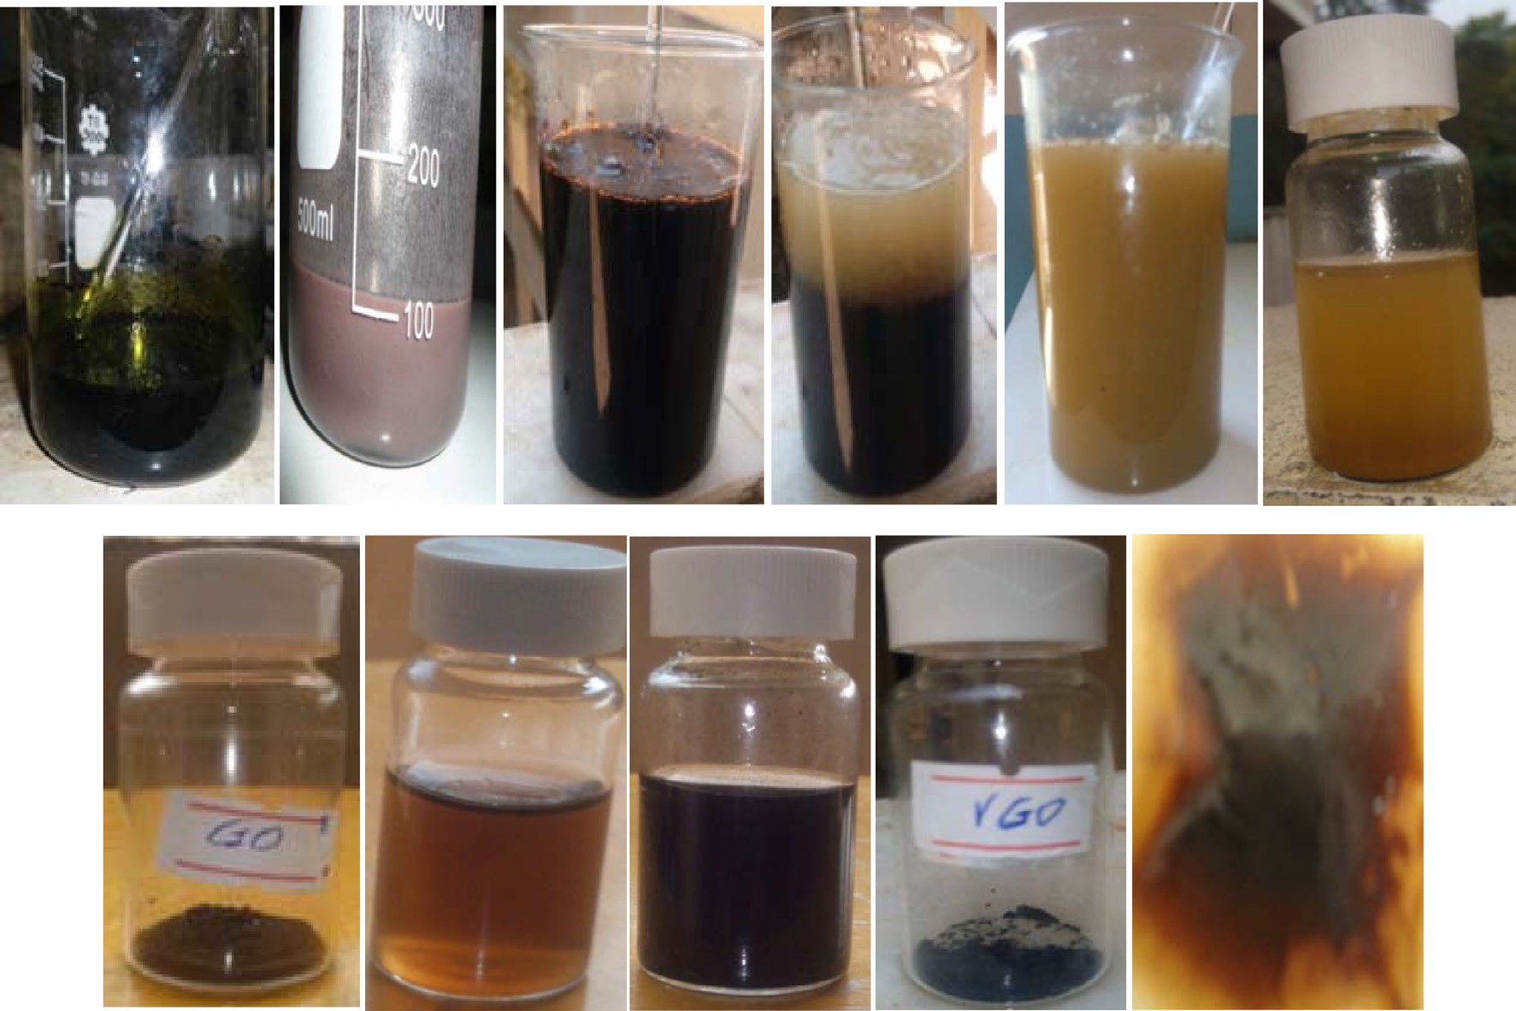

**A**

**B**

**C**

**D**

**E**

**F**

**Bahir Dar University**

**G**

**H**

**I**

**J**

**K**

Fig. 1. Digital images taken (A) when the mixture of acids was poured into the mixture of graphite powder and KMnO4, (B) slurry obtained at the end of 12 h of heating and stirring, (C) after the slurry was added into 250 ml de-ionized water, (D) after H2O2 was added without stirring, (E) when stirred after adding H2O2, (F) graphite oxide dispersion in de-ionized water, (G) graphene oxide powder after dried in oven and grounded, (H) graphene oxide solution in de-ionized water, (I) reduced graphene oxide solution in de-ionized water, (J) reduced graphene oxide (rGO) powder, (K) graphene oxide (GO) film.

reaction continued, the mixture turned to slurry as seen in the Fig. 1(B). When the slurry was added to 250 ml of de-ionized water, after cooling at room temperature, it releases heat and a dark purple color was observed as shown in the Fig. 1(C). This color indicates there might be unreacted KMnO4 since the solution of KMnO4 gives purple color. The addition of H2O2 into the mixture also releases heat and effervesces (evolution of steam and oxygen gas) as shown in the Fig. 1(D) and a bright yellow color was observed as shown in the Fig. 1(E). The purpose of H2O2 was to consume the residue KMnO4 [18]. The color change indicated the high level oxidation of graphite powder [19]. The obtained graphite oxide was dispersed in H2O upon mechanical stirring. This might be through the introduction of functional groups which are respon- sible for hydrophilic nature of graphite oxide.

The filtration of the mixture resulted in a brown paste, which was graphite oxide product. The washing process of graphite oxide paste with 5% HCl aqueous solution was done using centrifuge

until SO2— was removed. During this process the removal of SO2—

the supernatant resulted in white precipitate (formation of barite or BaSO4) indicating the presence of sulfate ions and no change was observed when there was no SO2—.

The graphite oxide powder dispersions in de-ionized water resulted in non-homogeneous suspension. Aggregated graphite oxide particles were observed. When graphite oxide powder was treated with heat under magnetic stirring in distilled water, the inhomogeneous graphite oxide suspension turned into yellow– brown homogenous dispersion as shown in Fig. 1(H), resulted in the exfoliation of graphite oxide. When the heat treatment contin- ued the water released large amount of heat. As the treatment of magnetic stirring and heating further continued, the functional groups on the graphene oxide layers in graphite oxide particles may gradually ionize, resulted in growing negatively charged gra- phene oxide layers and increasing electrostatic repulsion among them [20]. This might increase the interlayer distance of graphite oxide layers and reduced the van der Waals forces which resulted

4

in exfoliation of graphite oxide into single or few layers graphene

4 4

was detected by barium chloride (BaCl2). The addition of BaCl2 into oxide nanosheets.

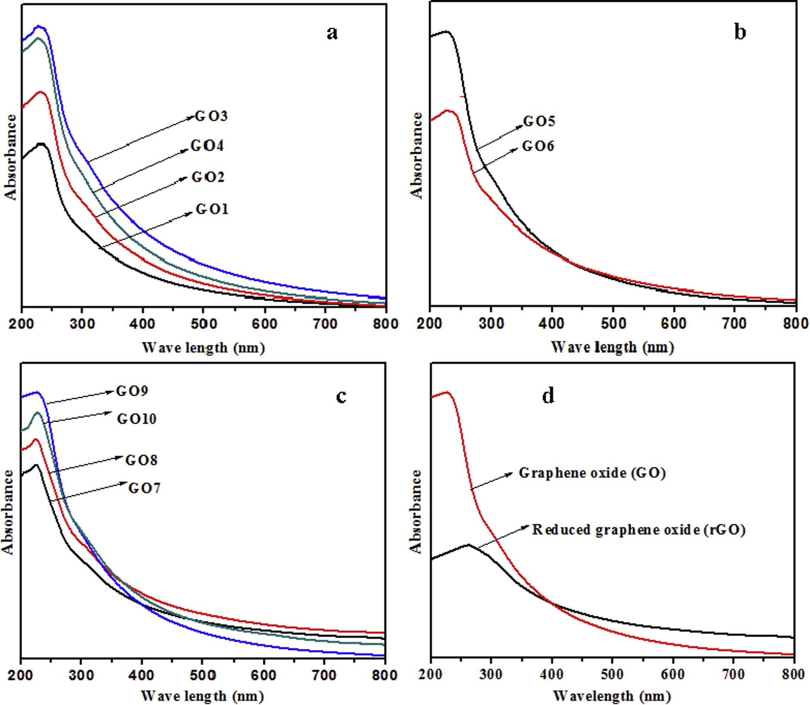

Fig. 2. UV–Visible spectra recorded in aqueous solutions (0.4 g/L) of GO at different (a) concentration of KMnO4, (b) reaction temperature, and (c) reaction time (d) Comparison of UV–Visible spectra recorded in aqueous solutions of graphene oxide and reduced graphene oxide.

The reduction of GO was also monitored by visual observation. As shownin Fig. 1(H), the GO dispersion was brownish yellow while the reduction of GO with ascorbic acid resulted in a black dispersion (Fig.1(I)). This was probably a result of an increase in the hydrophobicity of the material caused by a decrease in oxygen containing functional groups (removal of the majority of functional groups) on the surface of the sheets [21]. The color change or the black color of rGO can also be assigned to the partial restoration

of the p-network between the sheets due to removal of oxygen-

containing functional groups resulted in electronic conjugation with in reduced sheets [22].

The amount of oxidizing agent, reaction temperature and reac- tion time were the most determinant factors of graphene oxide synthesis. The effect of these parameters on the oxidation level of graphene oxide was studied using UV–Visible spectra. To study the effect of the oxidizing agent (KMnO4) on the oxidation degree of graphite powder, equal concentration of graphite oxide powder from four samples (GO1, GC2 GO3 and GO4) were first grounded with a mortar and pestle, and dispersed in one liter of de-ionized water to make graphene oxide solution. The dispersions with the same concentration were characterized by UV–Visible spec- troscopy. The spectra for each sample were recorded as shown in the Fig. 2(a). The absorption peak was at 230 nm for GO1, 228 nm forGO2, and 226 nm for GO3 and GO4. These peaks are

corresponding to p ? p⁄ transitions for the C@C bonding, which is similar to the reported value in the literature [23,24]. A similar shoulder was also observed around 300 nm for all four samples, which is attributed to n ? p⁄ transition of the carbonyl groups (C@O) [14].

The degree of oxidation (or the degree of remaining conjugation in graphene oxide sheets) can be determined by kmax of UV–Visible spectrum [14]. The more p—p⁄ transitions (conjugation), the less

energy needs to be used for the electronic transition, which results in a higher kmax [14]. The absorption peak for sample GO3 and GO4 is the lowest wavelength (226 nm) compared to others. There might be a decrease of the delocalized electrons and it is believed that higher energy was required for the electronic transition as compared with the other two samples, GO1 and GO2. This indi- cates that the samples were more oxidized with more functional groups on the basal planes.

As seen from the Fig. 2(a), the intensity of the peak of each sam- ple is different. The higher the intensity at around 300 nm, the lar- ger the degree of oxidation of GO whereas the less intensity is for less degree of oxidation [25]. Thus the absorption band around 300 nm indicated the degree of oxidation. Here, the intensity at around 300 nm for GO3 was highest suggests that the degree of oxidation was highest for it. This might be the effect of high con- centration of the oxidizing agent (KMnO4) which found to increase

the oxidation level of GO. However, the intensity at around 300 nm for GO4 is relatively low as compared to GOC3. This seems to indi- cate that more potassium permanganate will over oxidize graphite. To study the effect of reaction temperature on the degree of oxidation two samples (GO4 and GO5) were taken. There ratio of graphite powder to KMnO4 was 1:8 and temperatures were fixed

at 40 °C and 50 °C. As seen from Fig. 2(b), the intensity of the

absorption peaks at 40 °C (GO5) was higher than the absorption peak at 50 °C (GO6). This suggests that GO5 was more oxidized and high temperature might reduce the oxidation level of graphite.

The reason seems that the increasing temperature leads to a decrease in the degree of oxidation due to this may be only a few exfoliated layers get oxidized [26]. It has also been reported that high temperature during the oxidation process reduces the size of the graphene oxide produced [27].

Reaction time was also one of the determinant factors of degree of oxidation. Four samples (GO7, GO8, GO9 and GTO10) were taken for this study. The reaction temperature was fixed at 40 °C for all samples since the oxidation level was better at this temperature and the reactions were performed for 8, 10, 12 and 14 h. As depicted from Fig. 2(c), the peak intensity of GO increased with increasing reaction time from 8 to 12 h. This suggests that enough time is required for higher degree of oxidation. However, as the

reaction time further increased from 12 to 14 h, the absorption peak intensity decreased. This might be the result of over oxida- tion. The successful reduction of graphene oxide was also con- firmed by UV–Visible spectroscopy as shown in the Fig. 2(d). The UV–Visible spectrum of graphene oxide showed an absorption peak at 226 nm. After reduction by ascorbic acid, the peak of reduced graphene oxide was observed at 262 nm. The absorption of reduced graphene oxide red shifted to 262 nm suggests that the electronic conjugation within graphene sheets was restored (increased electron concentration after the reduction) [22].

FT-IR spectroscopy is a power full technique to characterize the presence of different functional groups in graphene oxide including oxygen containing functional groups. FT-IR spectrum was recorded and the spectrum of GO obtained confirmed the successful oxidation of the graphite (Fig. 3). Some functional groups such as OAH, CAOH, COOH and CAO were observed. A broad peak between 3500 cm—1- and 2500 cm—1 in the IR spectrum of GO is due to the carboxyl OAH stretching mode [28,29,18,30,31]. The absorption peaks corre- sponding to OAH stretching (a peak ~3400 cm—1) which is superim- posed on the OH stretch of carboxylic acid, is due to the presence of

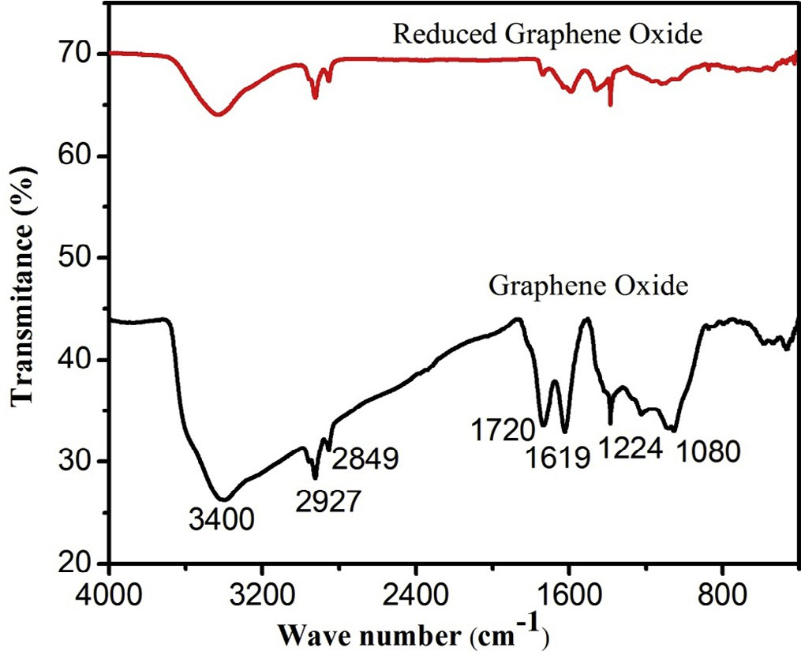

Fig. 3. FT-IR spectra of graphene oxide (GO) and reduced graphene oxide (rGO) powder.

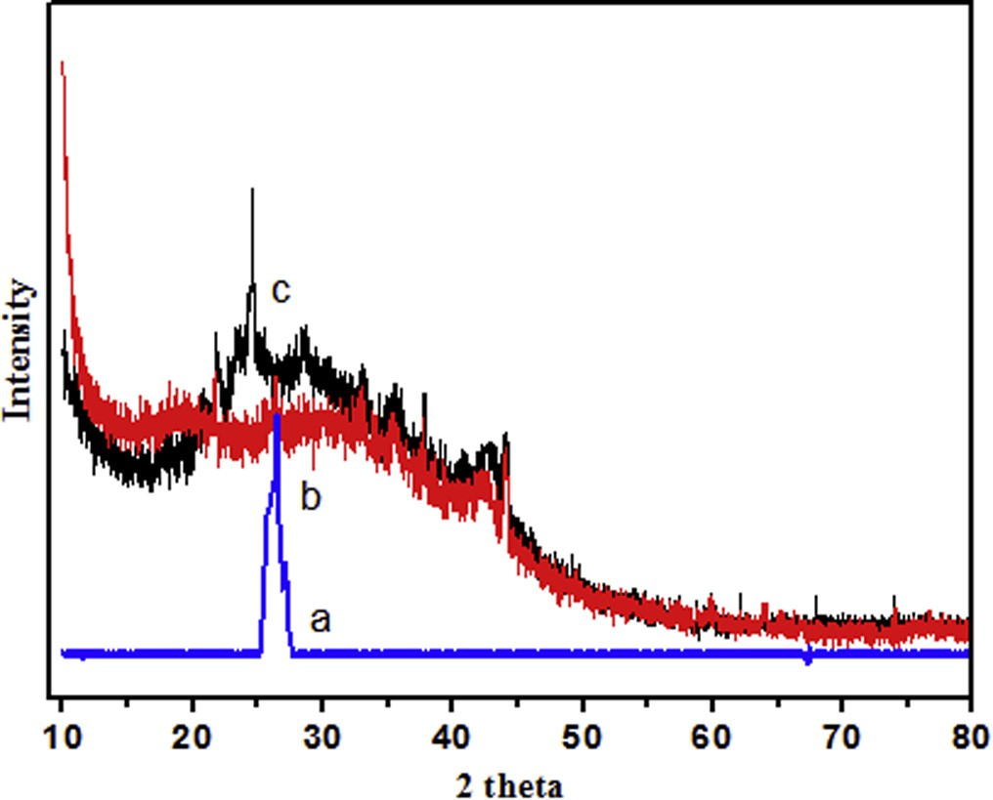

Fig. 4. X-ray diffraction patterns of (a) graphite (b) graphene oxide and (c) reduced graphene oxide.

absorbed water molecules and alcohol groups [28]. The IR peaks cor- responding to 2927 cm—1 and 2849 cm—1 are due the asymmetric and symmetric CH2 stretching of GO respectively while the peak around 1619 cm—1is attributed to C@C stretches from unoxidized graphitic domain [29]. The peak at around 1720 cm—1is attributed to C@O stretch of carboxyl group [18], 1224 cm—1 corresponds to CAOH stretch of alcohol group [30], 1080 cm—1is attributed to CAO stretching vibrations of CAOAC [31].

The reduction of GO was also characterized by FT-IR spec- troscopy. As seen from the Fig. 3, all the intensities of the peaks corresponding to the oxygen containing functionalities of reduced graphene oxide were decreased as compared to the intensities of peaks of graphene oxide and even some were disappeared. This showed the successful reduction of graphene oxide by ascorbic acid. But all the peaks were not disappeared which seems to indicate that GO was not completely reduced by ascorbic acid and indicating the presence of some functional groups.

X-ray diffraction patterns for graphite, graphene oxide and reduced graphene oxide are shown in Fig. 4. The diffraction peak for graphite powder was at 2h = 26.4° with a corresponding layer to layer distance of 0.34 nm, which is similar in the literature [32]. After oxidation of graphite powder, the diffraction peak for graphene oxide was at around 2h = 10°corresponding to a layer- to-layer distance of 0.88 nm which is close to in the literature [16]. The patterns showed a larger interlayer spacing of graphene oxide than graphite powder layers due to the insertion of oxygen containing functional groups between the layers [33]. In addition, the diffraction peak appeared at around 2h = 43°in XRD pattern of graphene oxide, indicates that graphene oxide exhibits turbostratic disorder [34]. XRD analysis also confirmed the reduction of graphene oxide. As seen from the Fig. 4, the diffraction peak of gra- phene oxide (2h = 10°) shifted to 2h = 23.8° (diffraction peak of reduced graphene oxide) corresponding to a layer to layer distance of 0.37 nm. This indicates that when graphene oxide is reduced to reduced graphene oxide the inter layer distance was decreased due to the removal of oxygen containing functional groups, resulted in restacking of the reduced graphene oxide sheets.

Conclusion

In this study graphene oxide was synthesized and then reduced to reduced graphene oxide (rGO) by easy and convenient method. Graphene oxide was obtained by treating graphite powder with

KMnO4 and a 9:1mixture of H2SO4to H3PO4. The obtained graphene oxide was reduced to reduced graphene oxide by ascorbic acid. The preparation of graphene oxide was controlled by reaction temperature, reaction time and concentration of KMnO4. Both gra- phene oxide and reduced graphene oxide were characterized by UV–Visible spectroscopy, FT-IR spectroscopy, and XRD techniques. The result showed that better oxidation degree of graphite powder was obtained by treating 0.6 g graphite powder with 4.8 g of

KMnO4 (1:8) for 12 h of reaction time and at 40 °C reaction

temperature with UV–Vis maximum absorption at 226 nm. The developed synthesis method for graphene oxide and reduced gra- phene oxide is an alternative approach and could be advantageous for large scale production.

Acknowledgment

The authors gratefully acknowledge the financial and material supports provided by Energy Research center, Bahir Dar Institute of Technology, Bahir Dar University.

References

1. [Jiang X, Setodoi S, Fukumoto S, Imae I, Komaguchi K, Yano J, et al. An easy one](http://refhub.elsevier.com/S2314-808X(16)30176-2/h0005) [step electro synthesis of graphene/ polyaniline composites and](http://refhub.elsevier.com/S2314-808X(16)30176-2/h0005) [electrochemical capacitor. Carbon 2014;67:662–72](http://refhub.elsevier.com/S2314-808X(16)30176-2/h0005).
2. [Lemme MC, Echtermeyer TJ, Baus M, Kurz HA. Field-effect device. IEEE Electron](http://refhub.elsevier.com/S2314-808X(16)30176-2/h0010) [Device Lett 2007;28:282–4](http://refhub.elsevier.com/S2314-808X(16)30176-2/h0010).
3. [Stankovich S, Dikin DA, Dommett GHB, Kohlhaas KM, Zimney EJ, Stach EA, et al.](http://refhub.elsevier.com/S2314-808X(16)30176-2/h0015) [Graphene-based composite materials. Nature 2006;442:282–6](http://refhub.elsevier.com/S2314-808X(16)30176-2/h0015).
4. [Stoller MD, Park S, Zhu Y, An J, Ruoff RS. Graphene-based ultracapacitors. Nano](http://refhub.elsevier.com/S2314-808X(16)30176-2/h0020) [Lett 2008;8:3498–502](http://refhub.elsevier.com/S2314-808X(16)30176-2/h0020).
5. [Yanwu Z, Shanthi M, Weiwei C, Xuesong L, Ji WS, Jeffrey RP, et al. Graphene](http://refhub.elsevier.com/S2314-808X(16)30176-2/h0025) [and graphene oxide: synthesis, properties, and applications. Adv Mater](http://refhub.elsevier.com/S2314-808X(16)30176-2/h0025) [2010;22:3906–24](http://refhub.elsevier.com/S2314-808X(16)30176-2/h0025).
6. [Novoselov KS, Geim AK, Morozov SV, Jiang D, Zhang Y, Dubonos SV. Electric](http://refhub.elsevier.com/S2314-808X(16)30176-2/h0030) [field effect in atomically thin carbon films. Science 2004;306:666–9](http://refhub.elsevier.com/S2314-808X(16)30176-2/h0030).
7. [Obraztsov AN, Obraztsova EA, Tyurnina AV, Zolotukhin AA. Chemical vapor](http://refhub.elsevier.com/S2314-808X(16)30176-2/h0035) [deposition of thin graphite films of nanometer thickness. Carbon](http://refhub.elsevier.com/S2314-808X(16)30176-2/h0035) [2007;45:2017–21](http://refhub.elsevier.com/S2314-808X(16)30176-2/h0035).
8. [Kim KS, Zhao Y, Jang H, Lee SY, Kim JM. Large scale pattern growth of graphene](http://refhub.elsevier.com/S2314-808X(16)30176-2/h0040) [films for stretchable transparent electrodes. Nature 2009;457:706–10](http://refhub.elsevier.com/S2314-808X(16)30176-2/h0040).
9. [Land TA, Michely T, Behm RJ, Hemminger JC, Comsa G. STM investigation of](http://refhub.elsevier.com/S2314-808X(16)30176-2/h0045) [single layer graphite structures produced on Pt (111) by hydrocarbon](http://refhub.elsevier.com/S2314-808X(16)30176-2/h0045) [decomposition. Surf Sci 1992;264:261–70](http://refhub.elsevier.com/S2314-808X(16)30176-2/h0045).
10. [Ruoff R. Graphene calling all chemists. Nat Nanotechnol 2008;3:10–1](http://refhub.elsevier.com/S2314-808X(16)30176-2/h0050).
11. [Brodie BC. On the atomic weight of graphite. Philos Trans R Soc London](http://refhub.elsevier.com/S2314-808X(16)30176-2/h0055) [1859;149:249–59](http://refhub.elsevier.com/S2314-808X(16)30176-2/h0055).
12. [Staudenmaier L. Verfahrenzurdarstellung der graphitsäure. Ber Dtsch Chem](http://refhub.elsevier.com/S2314-808X(16)30176-2/h0060) [Ges 1898;31:1481–7](http://refhub.elsevier.com/S2314-808X(16)30176-2/h0060).
13. [Hummers WS, Offeman RE. Preparation of graphitic oxide. J Am Chem Soc](http://refhub.elsevier.com/S2314-808X(16)30176-2/h0065) [1958;80:1339](http://refhub.elsevier.com/S2314-808X(16)30176-2/h0065).
14. [Marcano DC, Kosynkin DV, Berlin JM, Sinitskii A, Sun Z, Slesarev A, et al.](http://refhub.elsevier.com/S2314-808X(16)30176-2/h0070) [Improved synthesis of graphene oxide. ACS Nano 2010;4:4806–14](http://refhub.elsevier.com/S2314-808X(16)30176-2/h0070).
15. [Koch KR. Oxidation by Mn207: an impressive demonstration of the powerful](http://refhub.elsevier.com/S2314-808X(16)30176-2/h0075) [oxidizing property of dimanganeseheptoxide. J Chem Ed 1982;59:973](http://refhub.elsevier.com/S2314-808X(16)30176-2/h0075).
16. [Allahbakhsh A, Sharif F, Mazinani S, Kalaee MR. Synthesis and characterization](http://refhub.elsevier.com/S2314-808X(16)30176-2/h0080) [of graphene oxide in suspension and powder forms by chemical exfoliation](http://refhub.elsevier.com/S2314-808X(16)30176-2/h0080) [method. Int J Nano Dimens 2014;5:11–20](http://refhub.elsevier.com/S2314-808X(16)30176-2/h0080).
17. [Li Jianchang, Zeng Xiangqiong, Ren Tianhui, VanderHeide Emile. The](http://refhub.elsevier.com/S2314-808X(16)30176-2/h0085) [preparation of graphene oxide and its derivatives and their application in](http://refhub.elsevier.com/S2314-808X(16)30176-2/h0085) [Bio-Tribological systems. Lubricants 2014;2:137–61](http://refhub.elsevier.com/S2314-808X(16)30176-2/h0085).
18. [Shahriary L, Athawale AA. Graphene oxide synthesized by using modified](http://refhub.elsevier.com/S2314-808X(16)30176-2/h0090) [hummers approach. Int J Renew Energy Environ Eng 2014;2:58–63](http://refhub.elsevier.com/S2314-808X(16)30176-2/h0090).
19. [Huang NM, Lim HNN, Chia CH, Yarmo MA, Muhamad MR. Simple room-](http://refhub.elsevier.com/S2314-808X(16)30176-2/h0095) [temperature preparation of high-yield large-area grapheneoxide. Int J](http://refhub.elsevier.com/S2314-808X(16)30176-2/h0095) [Nanomed 2011;6:3443–8](http://refhub.elsevier.com/S2314-808X(16)30176-2/h0095).
20. [Zhang TY, Zhang D. Aqueous colloids of graphene oxide nanosheets by](http://refhub.elsevier.com/S2314-808X(16)30176-2/h0100) [exfoliation of graphite oxide without ultrasonication. Bull Mater Sci 2011;34:](http://refhub.elsevier.com/S2314-808X(16)30176-2/h0100) [25–8](http://refhub.elsevier.com/S2314-808X(16)30176-2/h0100).
21. [Stankovich S, Dikin DA, Piner RD, Kohlhaas KA, Kleinhammes A, Jia Y. Synthesis](http://refhub.elsevier.com/S2314-808X(16)30176-2/h0105) [of graphene- based nanosheets via chemical reduction of exfoliated graphite](http://refhub.elsevier.com/S2314-808X(16)30176-2/h0105) [oxide. Carbon 2007;45:1558–65](http://refhub.elsevier.com/S2314-808X(16)30176-2/h0105).
22. [Li D, Muller MB, Gilje S, Kaner RB, Wallace GG. Processable aqueous](http://refhub.elsevier.com/S2314-808X(16)30176-2/h0110) [dispersions of graphenenanosheets. Nat Nanotechnol 2008;3:101–5](http://refhub.elsevier.com/S2314-808X(16)30176-2/h0110).
23. [Clark BJ, Frost T, Russell MA. UV spectroscopy: techniques, instrumentation,](http://refhub.elsevier.com/S2314-808X(16)30176-2/h0115) [data handling/UV Spectrometry Group. London: Chapman & Hall; 1997. p. 4](http://refhub.elsevier.com/S2314-808X(16)30176-2/h0115).
24. [Mei Q, Zhang K, Guan G, Liu B, Wang S, Zhang Z. Highly efficient](http://refhub.elsevier.com/S2314-808X(16)30176-2/h0120) [photoluminescent graphene oxide with tunable surface properties. Chem](http://refhub.elsevier.com/S2314-808X(16)30176-2/h0120) [Commun 2010;46:7319–21](http://refhub.elsevier.com/S2314-808X(16)30176-2/h0120).
25. [Peng S, Fan X, Li S, Zhang J. Green synthesis and characterization of graphite](http://refhub.elsevier.com/S2314-808X(16)30176-2/h0125) [oxide by orthogonal experiment. J Chil Chem Soc 2013;58](http://refhub.elsevier.com/S2314-808X(16)30176-2/h0125).
26. [Aarthi R, Lalithambika KC. Influence of chemical reactions over the formation](http://refhub.elsevier.com/S2314-808X(16)30176-2/h0130) [of graphene oxide nanoparticles. Rasayan J Chem 2014;7:340–2](http://refhub.elsevier.com/S2314-808X(16)30176-2/h0130).
27. [Zhao J, Pei S, Ren W, Gao L, Cheng H-M. Efficient preparation of large-area](http://refhub.elsevier.com/S2314-808X(16)30176-2/h0135) [graphene oxide sheets for transparent conductive films. ACS Nano](http://refhub.elsevier.com/S2314-808X(16)30176-2/h0135) [2010;4:5245–52](http://refhub.elsevier.com/S2314-808X(16)30176-2/h0135).
28. [Mo Z, Sun Y, Chen H, Zhang P, Zuo D, Liu Y, et al. Preparation and](http://refhub.elsevier.com/S2314-808X(16)30176-2/h0140) [characterization of a PMMA/Ce(OH)3, Pr2O3/graphite nanosheet composite.](http://refhub.elsevier.com/S2314-808X(16)30176-2/h0140) [Polymer 2005;4:12670–6](http://refhub.elsevier.com/S2314-808X(16)30176-2/h0140).
29. [Guo HL, Wang XF, Qian QY, Wang FB, Xia XH. A green approach to the](http://refhub.elsevier.com/S2314-808X(16)30176-2/h0145) [synthesis of graphenenanosheets. ACS Nano 2009;3:2653–9](http://refhub.elsevier.com/S2314-808X(16)30176-2/h0145).
30. [Zhang Tian-You, Zhang Dong. Aqueous colloids of graphene oxide nanosheets](http://refhub.elsevier.com/S2314-808X(16)30176-2/h0150) [by exfoliation of graphite oxide without ultrasonication. Bull Mater Sci](http://refhub.elsevier.com/S2314-808X(16)30176-2/h0150) [2011;34:25–8](http://refhub.elsevier.com/S2314-808X(16)30176-2/h0150).
31. Lin Z. Functionalized graphene for energy storage and conversion [A Thesis]. In: Partial fulfillment of the requirements for the degree philosophy in the school of chemistry and biochemistry presented to Georgia Institute of Technology; 2014.
32. [Kim H, Miura Y, Macosko CW. Graphene/ polyurethane nanocomposites for](http://refhub.elsevier.com/S2314-808X(16)30176-2/h0160) [improved gas barrier and electrical conductivity. Chem Mater 2010;22:](http://refhub.elsevier.com/S2314-808X(16)30176-2/h0160) [3441–50](http://refhub.elsevier.com/S2314-808X(16)30176-2/h0160).
33. [Lerf A, Buchsteiner A, Pieper J, Schottle S, Dekahy D. Hydration behavior and](http://refhub.elsevier.com/S2314-808X(16)30176-2/h0165) [dynamics of water molecules in graphite oxide. J Phy Chem Solids](http://refhub.elsevier.com/S2314-808X(16)30176-2/h0165) [2006;67:1106–10](http://refhub.elsevier.com/S2314-808X(16)30176-2/h0165).
34. [Nethravathi C, Rajamathi JT, Ravishankar N, Shivakumara C, Rajamathi M.](http://refhub.elsevier.com/S2314-808X(16)30176-2/h0170) [Graphite oxide intercalated anionic clay and its decomposition to graphene.](http://refhub.elsevier.com/S2314-808X(16)30176-2/h0170) [Inorganic material nanocomposites. Langmuir 2008;24:8240–4](http://refhub.elsevier.com/S2314-808X(16)30176-2/h0170).