

Electronic Notes in Theoretical Computer Science

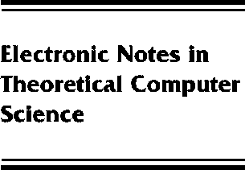[www.elsevier.com/locate/entcs](http://www.elsevier.com/locate/entcs)

Debugging Haskell by Observing Intermediate Data Structures

Gill Andy

**Abstract**

Haskell has long needed a debugger. Although there has been much research into the topic of debugging lazy functional programs, no robust tool has yet come from the Haskell community that can help debug full Haskell. This paper describes a portable debugger for full Haskell, building only on commonly implemented extensions. It is based on the concept of observation of intermediate data structures, rather than the more traditional stepping and variable examination paradigm used by traditional imperative debuggers.

1571-0661 *⃝*c Elsevier Ltd Open access under [CC BY NC ND license.](http://creativecommons.org/licenses/by-nc-nd/3.0/)

10.1016/S1571-0661(05)80538-9