[Egyptian Informatics Journal 24 (2023) 265–275](https://doi.org/10.1016/j.eij.2023.04.001)

Contents lists available at [ScienceDirect](http://www.sciencedirect.com/science/journal/11108665)

Egyptian Informatics Journal

journal homepage: [www.sciencedirect.com](http://www.sciencedirect.com/)

[](http://crossmark.crossref.org/dialog/?doi=10.1016/j.eij.2023.04.001&domain=pdf)Deployment of an intelligent and secure cattle health monitoring system

Jehangir Arshad a,⇑, Talha Ahmad Siddiqui a, M. Ismail Sheikh a, M. Sadeed Waseem a,

M. Abu Bakar Nawaz a, Elsayed Tag Eldin b, Ateeq Ur Rehman c

a *Department of Electrical & Computer Engineering, COMSATS University Islamabad, Lahore Campus, Lahore 54000, Pakistan*

b *Faculty of Engineering and Technology, Future University in Egypt, New Cairo 11835, Egypt*

c *Department of Electrical Engineering, Government College University, Lahore 54000, Pakistan*

a r t i c l e i n f o

*Article history:*

Received 1 August 2022

Revised 22 March 2023

Accepted 2 April 2023

Available online 8 April 2023

*Keywords:*

Artificial neural network Cattle health monitoring IoT

Livestock

Message queuing telemetry transport protocol

Multi-class classification Security

Two-factor authentication Wireless sensor networks

a b s t r a c t

Wireless Sensor Networks (WSNs) are revolutionizing the globe with their sensing technologies. This ini- tiative aims to design and deploy a cattle health monitoring system (CHMS) for the agriculture sector for the well-being of livestock and the eradication of hunger. The production and consumption of all dairy and meat products can only be conducted responsibly if the health of the source animal is protected. In this regard, WSNs, a component of the Internet-of-things (IoT) system, can be utilized for monitoring cow health due to their adaptability and portability, which enables them to be applied to expansive domains such as cattle healthcare. The integration of IoT and artificial intelligence enables the prediction of livestock illnesses. The primary purpose of this proposed system is to forecast cattle diseases utilizing real-time data from non-invasive body-area sensors and Artificial Neural Networks (ANN) and to display the expected results to authorized personnel via a web application. Popular authentication schemes are used in this system as it is susceptible to hacking and requires robust network security to protect the con- fidentiality, integrity, and availability of its resources. The presented results validates the accuracy of the proposed novel system for cow diseases prediction that is approximately 98 percent. The proposed CHMS can assist concerned farmers in remotely monitoring the health of their livestock from a variety of loca- tions and in taking appropriate and timely measures to protect animal health. Technological automation will lower prices and labor inputs while enhancing farm output.

© 2023 THE AUTHORS. Published by Elsevier BV on behalf of Faculty of Computers and Artificial Intel-

ligence, Cairo University. This is an open access article under the CC BY license ([http://creativecommons.](http://creativecommons.org/licenses/by/4.0/)

[org/licenses/by/4.0/](http://creativecommons.org/licenses/by/4.0/)).

1. Introduction

Wireless Sensor Networks (WSNs) have evolved in healthcare based on low-powered wireless technologies and medical sensors as they are the most modern technologies and are more favorable than conventional systems [1]. This is because data transmission between nodes in a mesh-based architecture network uses less energy.

The demand for dairy products is rapidly expanding because of exponential population growth that leads to greater cooperation between the dairy sector and academic institutions to achieve the UN’s specified Sustainable Development Goals (SDGs) [2]. This research aligns with the ’Zero Hunger’ (SDG 2) as it seeks to mon- itor the health of cows and predict diseases to prevent their spread among animals. This study aims to produce healthier meat and dairy products, addressing the global challenge of food insecurity.

* Corresponding author.

*E-mail address:* [jehangirarshad@cuilahore.edu.pk](mailto:jehangirarshad@cuilahore.edu.pk) (J. Arshad).

Additionally, this integration would contribute to mitigate the threat of life extinction on land and promoting healthy ecosystems, aligning with ‘life on land’ (UN’s SDG 15). Livestock farming help individuals in emerging countries like Pakistan as it boosts their standard of living and leads to to monitor cattle’s health data finan- cial progress. In 2019, Pakistan produced 47 million tons of milk

[3]; the third most in the world however, farmers in Pakistan face huge financial losses owing to a lack of technology and rapid cli- mate change. In recent past, it has greatly affected the production of dairy products and healthy meat that ultimately declines the economic condition of agricultural dependent countries like Pak- istan [4]. Therefore, the livestock farming sector must employ the newest technology to monitor and regulate livestock herds. Farm scientific technologies must be used to continuously monitor cattle health data to reduce production costs and battle diseases.

This study covers a wireless cattle health monitoring system that uses advanced technologies to continuously monitor cattle health data, predict early diseases using artificial neural networks, and secure the WSN against any intrusions. WSN will allow the

<https://doi.org/10.1016/j.eij.2023.04.001>

1110-8665/© 2023 THE AUTHORS. Published by Elsevier BV on behalf of Faculty of Computers and Artificial Intelligence, Cairo University. This is an open access article under the CC BY license (<http://creativecommons.org/licenses/by/4.0/>).

farmer to take intelligent and accurate precautions to avoid any loss [5]. This solution will include a reliable authentication scheme to guarantee only trustworthy nodes send data to the base station [6]. This ensures the authenticity and transportation of sensor data to the base station. Using an artificial neural network on real-time data will allow us to predict diseases. This information will also be provided on a web-based application for end-users to monitor cat- tle behavior. Only users who have authenticated can access this information.

This paper is organized as follows: Section 2 provides the literature review of different health monitoring systems. Section 3 presents the IoT-based livestock infrastructure consisting of three layers i.e. physical layer, network layer, and application layer. Section 4 presents the research issues and the challenges. Section 5 presents the future research directions. Lastly, the article has been concluded in Section 6.

1. Related works

Wireless Sensor Networks have piqued the interest of techno- logical and scientific research organizations. Sensor-based auto- matic health monitoring is essential to follow the individual animal movement and monitor the health conditions [5,7]. WSNs are a low-cost solution for identifying cattle illnesses. An advanced automated farm will improve output by reducing human interven- tion since continuous monitoring needs more resources and time. Constant visual surveillance by farmers isn’t entirely accurate since animal health issues are complicated to detect without proper tools. WSNs enable continuous welfare monitoring easier with more robustness than manual observation.

Several external sensors, such as heart rate, accelerometer, pedometer, and vibration sensor, have been designed to solve ani- mal health issues [8]. Automated approaches are utilized to diag- nose metabolic issues in cattle. Cattle have tags or collars on their necks that provide information. The microphone is placed in a plastic device on the head collar’s left side dorsally [9]. A com- plex algorithm is used to assess tag noise.

Handcock et al. presented a satellite, WSN, and GPS animal monitoring system and its ecological impact. Animal landscape interactions were created using satellite pictures and ground- based sensors [10]. Nadimi et al. designed a ZigBee-based animal monitoring system. The authors used a single-hop 2.4-GHz WSN to measure dairy cow motion. WSNs address animal behavior and pasture time [8].

According to many researchers, healthy and sick cows behave differently when lying, standing, and feeding. González et al. dis- covered differences in short-term feeding behavior when ketosis and chronic lameness first occurred [11]. Another health monitor- ing method for cattle was introduced by Smith et al., where cardio- vascular, respiratory, and head movements were all monitored [12]. The system is built on a turn microcontroller board on an AMD186 processor. Changes in rumination and feeding behavior in cattle could be indicators of health issues. The Rumi Watch Sys- tem (RWS) is a sensor-based instrument that monitors dairy cat- tle’s fundamental activities [12]. The device uses a pressure sensor to track the cow’s jaw movement.

Using a 2.4 GHz frequency-based communication module, Nadimi et al. presented ad hoc WSNs-based monitoring and classi- fication of animal behavior [8]. This system can provide communi- cation consistency, low packet loss, and low energy consumption. Using a multi-layer perception-based artificial neural network, behavioral parameters are converted into behavioral modes.

Convolutional Neural Network (CNN) employs accelerometer collars to identify cow activity (rumination, feeding, and other)

[13]. 18 steers were examined for raw acceleration during three farm trials in the UK (Easter Howgate Farm, Edinburgh, UK), using muzzle-mounted pressure sensor halters providing ground truth data. Various neural network topologies are studied and hyper- parameter searches optimize the network. In 2020, Eduardo da Silva raised concerns about smart agriculture’s security, status, and future. Smart agriculture is a vulnerable target. Commercial, ideological, or terrorist objectives might justify attacks [14]. Ter- rorist groups, economic opportunists, and individual employees can create economic turmoil. Security is a critical resource in intel- ligent farming, helping to create reliable and efficient systems.

Several wearable devices have been identified in this research as a possible method for real-time monitoring of cow health, aiding veterinarians, and evaluating vital markers that can provide reli- able information on the health of cows. Thus, WSN will lower the cost of cattle health care. A monitoring system that can capture rumination, heart rate, body temperature, bellowing, jaw move- ment, movement patterns when resting and walking, and disease prediction using an artificial neural network is required. Low energy consumption, fast speed, high performance, high precision, intelligence, and mobility are key. With all these research advances, real-world implementations of the new technologies are still lacking. There is no real-time health monitoring system with these features, especially disease prediction and secure cattle health monitoring [14,15].

Physiological and behavioral data are mostly hand-collected by veterinarians. The device’s durability is another concern with the above cattle health monitoring alternatives. If cattle are uncom- fortable with equipment, they may remove sensors. Most approaches for predicting cow health use heart rate data. Wearable sensors for real-time cow health monitoring devices let veterinar- ians measure parameters and provide reliable information.

1. IOT based-livestock infrastructure

In livestock, IoT networks monitor and track animal behavior. An IoT network supports the livestock infrastructure and gives access to its backbone. The IoT livestock monitoring platform can help cattle farming. IoT-powered livestock management systems give health information to cattle [16]. Using a collar or tag with sensors to monitor cattle position, temperature, and heart rate and wirelessly communicate the data to servers for processing and subsequently to farmers’ devices. This system displays cow behavior via a Web Application. The system sends predicted result of disease classification with the sensor data to a user-friendly website. In this manner, farmers may treat sick animals early. The proposed cattle health monitoring system has four tiers i.e. physical layer, network layer, ANN, and web application.

* 1. *Physical Layer*

This layer has two sensor nodes holding six body area sensors. Sensor nodes consist of a sensing unit, a processor unit, a transcei- ver unit, and a power unit as their core components. Although ana- log inputs were not utilized, it is deemed necessary to provide a comprehensive understanding of the system’s configuration for contextual purposes. Sensor analog signals are converted to digital by the built-in ADC and sent to the processor. The processing and transcribing unit consist of ESP 8266 12e Wi-Fi Module, the newest integrated chip built for a new linked world, and Raspberry Pi 3 Model B, perfect for Internet of Things (IoT) projects. The power unit is a LIPO battery of 3.7v 1000mAh. MQTT (Message Queuing Telemetry Transport) protocol is utilized to send data between ESP8266 12e and Raspberry Pi wirelessly.

* + 1. Structure of node

The designed sensor node attached to the collar with schematic is shown below:

The sensor node deployed in the collar detects certain parame- ters using the hardware components shown in Table 1. Theses sen- sors are connected to an ESP-12 module with built-in Wi-Fi to transmit the attribute–value pairs to the base station wirelessly.

The vital parameters being detected are:

* + - 1. Temperature measurement

A Dallas Temperature sensor (DS18B20) with a built-in 12-bit ADC is employed for this purpose [17].

* + - 1. Heart rate

MAX30100 sensor counts heartbeats per minute. IR pair detects heartbeat from blood flow. To effectively monitor heartbeat rate, the IR transmitter and receiver must be aligned.

* + - 1. Jaw movement

ADXL335 senses cattle jaw movement in the X, Y, and Z axes [17,19]. An NED reference system was used to distort the body’s axis from front to rear (X), horizontally (Y), and vertically (Z) before the investigation began, so that each of these three axes could be seen clearly. ADXL335 are low-power, 3-axis MEMS accelerometer

modules with analogue voltage outputs that are radiometric. The sensitivity of analogue signal accelerometers is determined at a supply voltage and is given in millivolts per gramme.

* + - 1. Acetone detection

MQ138 gas sensor is used for the detection of acetone [20]. To detect any gas, the sensor must be located near the mouth of the calf, or if it is placed in the sensor box, it must have an opening, which is impractical because the sensor box must be waterproof to protect other electrical components. Intake of food(grazing and rumination) can also be used to detect ketosis.

* + - 1. Bellowing

KY-037 sound sensor converts sound into electrical signals. As the movable plate (diaphragm) vibrates with the sound wave, the capacitance changes. Capacitance changes are turned into an electric signal [21]. A microphone turns sound into an electrical signal. The microphone’s diaphragm vibrates additives add audible signal from vibrations.

* 1. *Network layer*

The ESP 12 Wi-Fi module installed in each sensor node sends sensor data to a web-based database. The ESP 12 links microcon- trollers to a Wi-Fi network and enables TCP/IP communications [22]. Farmers and veterinarians may monitor animals from

Table 1

Components required to develop the sensor node.

*Body Area Sensors*

Temperature sensor DS18B20 [17]

*Model Parameters*

*Detected*

Body Temperature

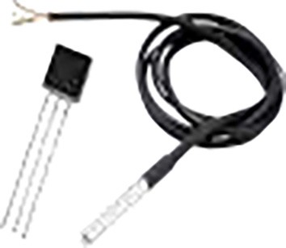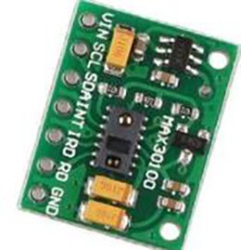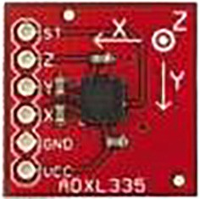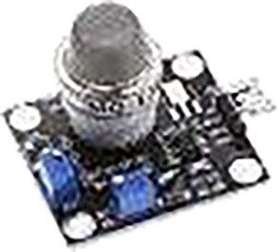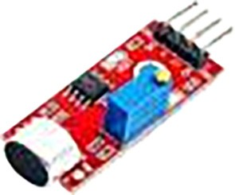

*Specifications*

* A power supply is 3.3 V to 5 V.
* Accuracy is ± 0.5 °C.
* It requires one digital pin for communication.
* Built-in 12-bit ADC
* It is a waterproof sensor.

Pulse Oximeter MAX30100 [18]

Pulse Detection ● Its operating voltages are 1.8 V-5.5 V.

* + Its Output type is digital.
  + Its interface type is I2C.
  + Heart Sensor weight is 1.2 g.

Accelerometer ADXL335 [19]

Grazing Motion ● Power Supply value is 1.8 V- 3.6 V.

* + It has Analog output.
  + Y axis has 0.5 Hz – 1600 Hz bandwidth.
  + Z-axis has a 0.5 Hz to 550 Hz bandwidth.
  + Measures 3G in X,Y and Z axes

Gas Sensor MQ138 [20]

Acetone ● Detection Gas: toluene, acetone, alcohol, hydrogen.

* + Working voltage: 5 V DC.
  + The analogue output grows with increasing concentration, and the voltage increases as con- centration increases.

Microphone KY-037 [21]

Bellowing ● Input Voltage: 3.3 V ~ 5 V

* + It has two outputs: AO, DO.
  + There is a mounting screw hole 3 mm.
  + It has four Pins i.e. AO, DO, G, +

anywhere on the farm. The ESP 12 Wi-Fi module transfers informa- tion for physical contact.

* + 1. Design of a base station

The base station, or sink node, processes body area sensor data. It’s a strong device and meets the computational demands as they were minimal. The base station is the gateway to the WSN. A credit-card-sized PC Raspberry Pi 4 Model B as a base station is uti- lized due to its affordability and portability, making it a practical alternative to a full-fledged PC. Raspberry Pi may be used as a desk computer with a monitor, keyboard, and mouse. It can run Debian- based Linux, or Raspberry Pi OS [17]. An Ethernet cable or USB Wi- Fi adapter can connect the Raspberry Pi to a LAN for SSH access. MQTT is the most popular IoT protocol for data transfer between broker (base station) and client (ESP) [23]. The MQTT server on the base station was solely utilized for receiving data from the sen- sor nodes, while it excels at sending and receiving small packets of data, it may not be the best choice for more complex interactions such as presenation of the data on a web interface. For this pur- pose, having a webserver on the base station allows for the devel- opment of a web-based graphical user interface that can provide more features, such as real-time data visualization and control, that may not be possible or efficient through MQTT alone (Fig. 3).

* + 1. Wireless communication

MQTT is a popular used in IoT and M2M applications due to its simplicity and open-source nature. MQTT is asynchronous, pub- lish/subscribe protocol that works over TCP transport protocols with TLS and SSL for security, making it lightweight and straight- forward to implement. Here, Fig. 4 dipicts the functionality of MQTT protocol briefly which includes the role of the MQTT Broker which in our case is the Raspberry Pi (Fig. 5).

* + 1. Implementation of network security

Insider security and outsider security have been implemented for data efficiency and reliability in this system’s general architec- ture [6]. The data transmission between the sensor nodes and base station is protected against insider access. For data transmission between the base station and the website that keeps data in the system’s database, outsider security is introduced (Fig. 6).

* + - 1. *Collection of data through secure nodes*

Insider Security covers secure sensor node connectivity/ communication with the base station or Raspberry Pi. By adopting Mosquito’s inbuilt security plugin, the sensor nodes are

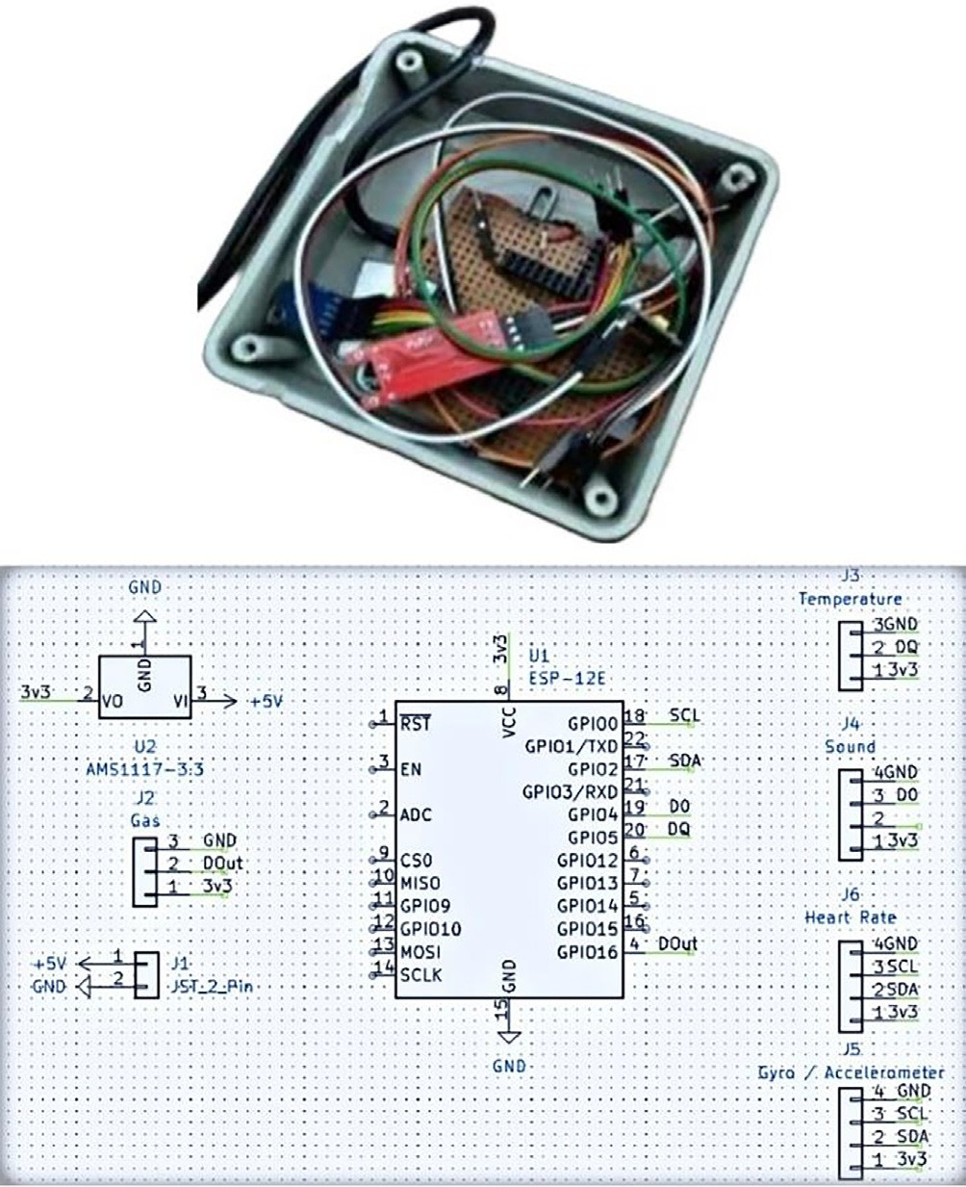

Fig. 2. Cow collar sensor node.

authenticated with *sha512-pbkdf2* encrypted passwords [24]. It allows the communication between the node and base station to be secure using SSL/TLS. The diagram below shows the flow of insi- der security integrated into this system.

* + - 1. *User authentication*

Outsider Security concerns the security of user-to-web applica- tion communication. It is implemented using Django-two-factor authentication. TOTP devices are generated per user to allow for multi-user 2FA [25]. TOTP allows for unique passwords generated through a standardized algorithm that uses time as an input. This allows the user to get their TOTP key even when they are offline.

1. Implementation of artificial neural network

An artificial neural network (ANN) is one of the prediction approaches utilized in animal sciences because of its capabilities

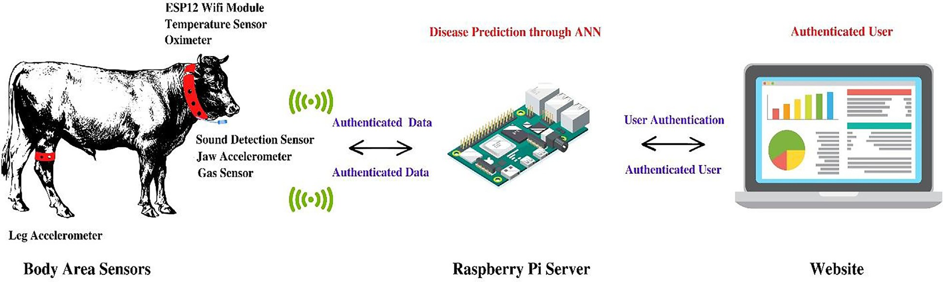

Fig. 1. System overview diagram of the system.

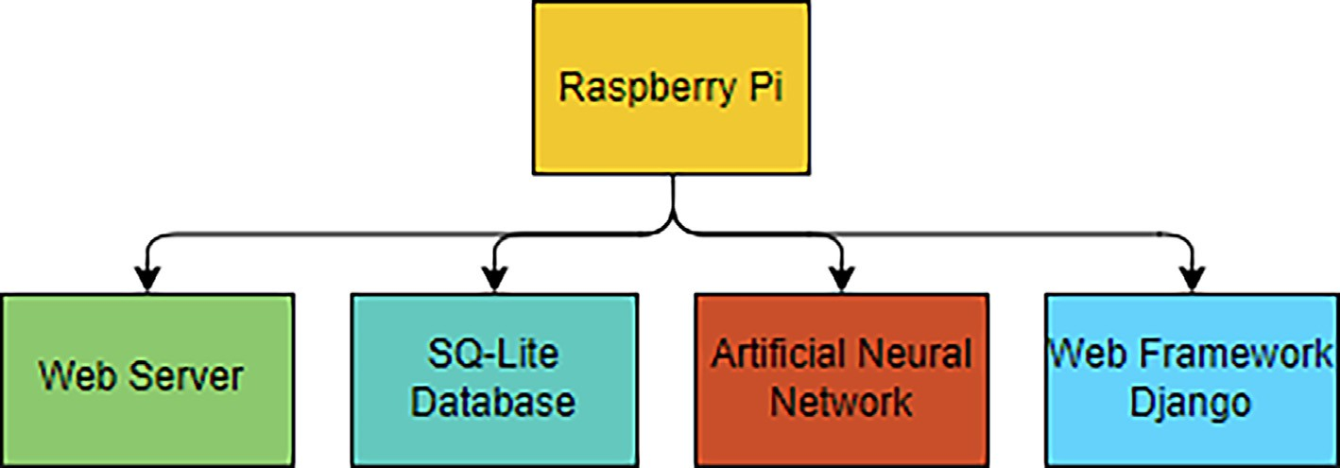

Fig. 3. Functions of the Base Station.

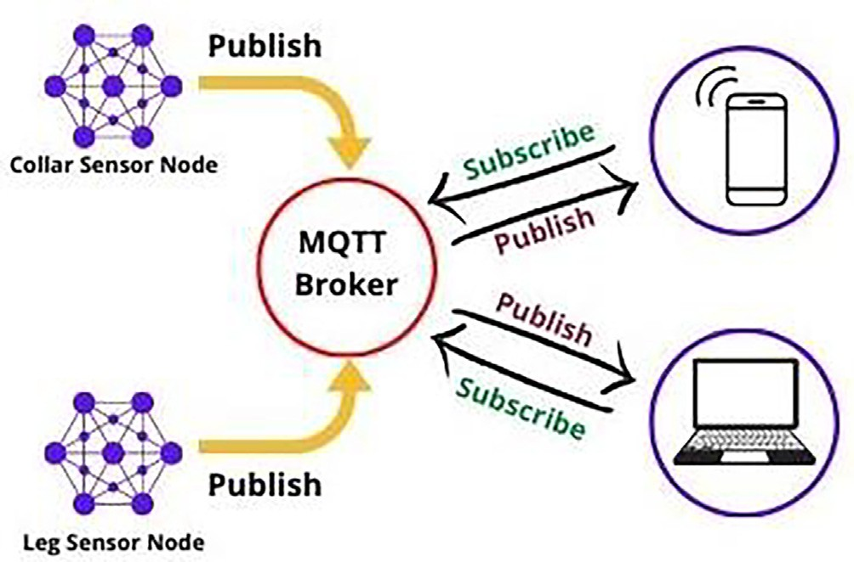

Fig. 4. Working of MQTT protocol.

Generate unique passwords for all nodes using **mosquitto_passwd**

Add passwords to the password file along with the

**node_id / username**

Specify password file in

**Mosquitto.conf file**

Disable anonymous functions

Start mosquitto server

Node authenticated NO

Show error on the website

as an information processing system inspired by biological struc- ture in the human brain [26].

This section discusses the processes of training, implementa- tion, and testing of the model.

1. Preparation of the data set

The real-time dataset for the implementation of ANN was gath- ered over a span of 7 months from different locations in Punjab, Pakistan as shown in Table 2 above. The data collected from cows under the supervision of a veterinary doctor was for specific dis- eases which are often found in the local farm animals.

The balanced dataset, meaning that the number of examples for each class (health condition) is roughly equal as shown in Fig. 7 below was preprocessed using the scikit library [27]. Use of such balanced dataset can help to improve the overall accuracy of the ANN model as the network is not biased towards any particular class, and therefore is better able to generalize to new, unseen examples (Fig. 8).

The data were cleansed by eliminating missing values, smooth- ing noisy data, resolving inconsistency, and reducing outliers by data preprocessing. Fig. 7 below shows the number of instances for every output class (represented by 0,1,2 after encoding) was approcimately equal. Standardization of a dataset is a frequent pre- requisite for several estimators based on machine learning: their performance will be compromised if features aren’t normalized individually. For this purpose, the proposed model was trained with a normalized dataset using the Sklearn Standard Scaler which removes the mean and scales to unit variance in order to standard- ize characteristics. Classifiers based on machine learning cannot directly interpret categorical values; thus, such data must be trans- formed to nominal values. The Neural model was trained on data

YES

Start receiving data from the node

Fig. 5. Insider security between sensor nodes and base station.

with categorical values converted into nominal values using Scikit Learn Library [28]. One-Hot encoding and Label encoders both were used during the preprocessing phase. Label Encoder was used to convert each categorical value into a numeric value and then One-hot encoding was used to convert the data by splitting the output column into multiple columns depending on the initial value in the dataset.

1. Correlation matrix

The correlation matrix is a Table that illustrates the correlation coefficients between the various variables. The line of 1.00 s

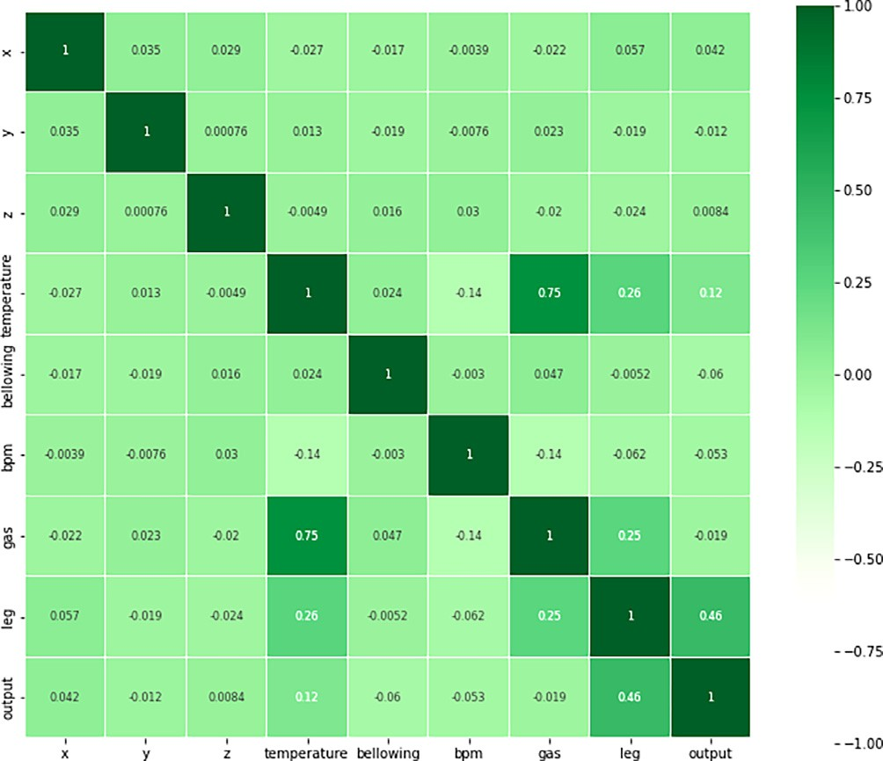

Fig. 8. ANN architecture.

Account Creation

User logs into their account

User enables 2FA

Scan 2FA QR code on authenticator app

2FA

enabled

Yes

User provides 2FA key

Key

**Error**

**Correct Key**

Ask user to re enter

Takes user to dashboard

Asks user for 2FA key

Table 2

Fig. 6. Outsider security between user and web application.

extending from the upper left to the lower right is the major diag- onal, which demonstrates that each variable always corresponds precisely with itself. This matrix showed us that the ‘z’ matrix had the minimal correlation with the output parameter where as other input parameters had higher impact and therefore, ‘z’ was dropped before training the model which improved the accuracy of the trained model.

1. Working of ANN

Real, discrete, or vector-valued functions can be approximated using an ANN, which is resistant to errors in training data [29]. ANN learns the mapping between inputs and outputs from the training data in a way that is highly parallel and distributed pro- cess of automatically tuning the weights [30]. The model is

Summary of a collected dataset for ANN.

Health Condition Dataset Month Data Collection Location Healthy 600–615 November and UVAS (Pattoki) and

January Aspire Dairy Farm High Fever 600–615 March Padana Village Ketosis 600–615 April Hier Village

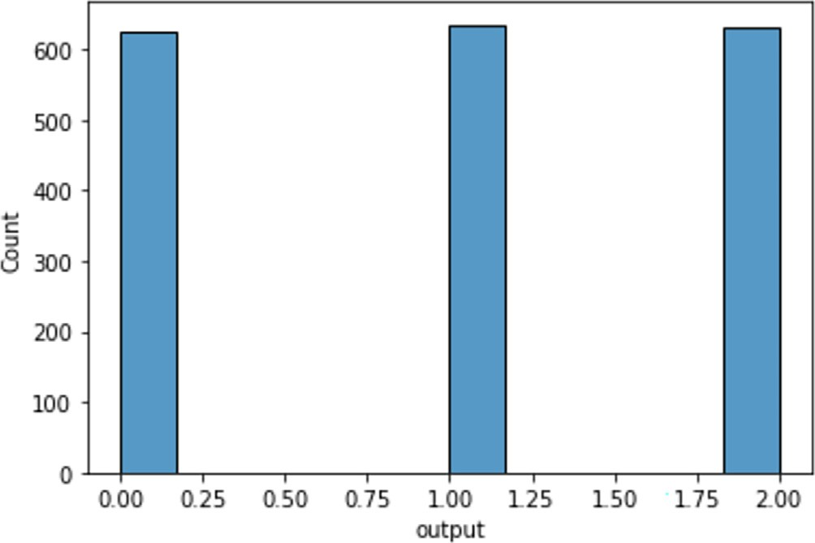

Fig. 7. Balanced dataset for ANN.

intended to demonstrate the relationship between species- specific sensory data inputs and animal sickness without highlight- ing the process, initial and boundary conditions, and the nature of the associations. The network is trained using the backpropagation technique and optimized using the loss function and optimization algorithm defined during model compilation [31]. Although we have built the sequential ANN model using Keras deep learning API, the backpropagation algorithm’s generic pseudo code used for training of the ANN model is produced in Fig. 9. The symbols and variables used in this algorithm are mentioned are given below.

*x*(*i*) : input vector for the *i*-th training example; *y*(*i*): target out- put for the *i*-th training example; W(1): weight matrix of the con-

nections between the input layer and the hidden layer; W(2): weight matrix of the connections between the hidden layer and the output layer; d2(*i*): gradient of the cost function with respect

to the weighted input of the output layer for the *i*-th training

example; d1(*i*): gradient of the cost function with respect to the weighted input of the hidden layer for the *i*-th training example; ʘ: element-wise multiplication; *f* '(.): derivative of the activation

function with respect to its input; b(1): bias vector of the hidden layer; b(2): bias vector of the output layer; *a*(*i*): activation of the hidden layer for the *i*-th training example; *y*(*i*) : predicted output of the neural network for the *i*-th training example; *e*(*i*): error between the predicted output and the actual output for the *i*-th

training example.

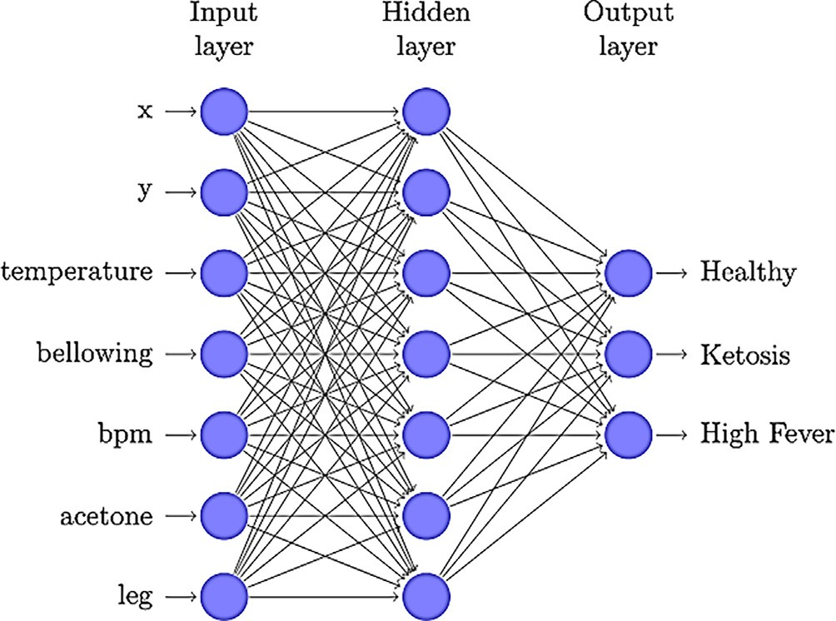

Fig. 9. Confusion metrics of the trained ANN model.

Algorithm 1: Pseudocode of backpropagation algorithm Input: Training set {x(i), y(i)}, learning rate g*,* number of

epochs *N*

Output: Trained neural network weights and biases Initialize weights and biases randomly

*for epoch = 1 to N do for i = 1 to m do*

*Feedforward:* z(i) = W(1)x(i) + b(1); a(i) = *f* (z(i));

z(i) = W(2)a(i) + b(2); yˆ(i) = *f* (z(i));

2

However, increasing the number of neurons and layers would have increased the computational cost, which is not practical in this implementation. This is because the hardware implementation has energy constraints that require careful consideration to avoid resource wastage.

The initialization procedure involved providing weights ran- domly and biases to the layer using Keras library. Following the completion of the initialization procedure, the created neural net- work must be trained Adaptive estimate of first-order and second- order moments was employed to update the weights of the neural network using the stochastic gradient descent approach called Adam optimization [32]. To learn something new, the learning algorithm must go through the training dataset a certain number of times, and this hyperparameter is expressed as epochs. The error between the target and computed output values is minimized iter- atively until the termination condition is fulfilled, i.e. the total net- work error is reduced to a predefined level or a predefined number of training steps has been reached. The model was fit on the train- ing set with a batch size of 10 and 100 epochs.

The model after testing was saved and deployed on Raspberry Pi for processing real-time input data and displaying the results for the user on the Web Application.

1. Performance measure analysis

The suggested architecture is evaluated using the most stan- dard performance measurement parameters, namely precision, recall, and the F1-measure. Due to the multiclass classification, the selection of these criteria was determined. [33]. The formulas to calculate these performance parameters are given in (1)–(4).

2

(i)

(i) ˆ(i) *TP*

calculate error: e = y -y

# *Precision* =

(1)

calculate output layer gradient: d(i) = *f’* (z(i))ʘ e(i)

(*TP* + *FP*)

2 2

calculate hidden layer gradient: d(i) = *f’*(z (i)) ʘ W(2)*T* d(i)

1 2

update weights and biases: W(2) ← W(2) + gd(i) a(i)*T TP*

b(2)

← b(2)

+ gd(i);

2 *Recall* =

(*TP* + *FN*)

(2)

W(1) ← W(1) + gd(i) x(i)*T*; b(1) ← b(1) gd(i)

2

1 1

end end

*F*1 — *Score* =

# *Accuracy* =

2 × (*Precision* × *Recall*) (*Precision* + *Recall*)

(*TP* + *TN*)

(3)

(4)

This system has been trained to do multi-class disease classifi- cation using a three-layer (input, hidden, output) feedforward backpropagation ANN. The performance of this network using the ReLU and SoftMax activation functions was assessed. The num- ber of layers was capped at three because adding too many hidden layers leads the network to memorise the training set and hinders its ability to generalise to new input sets. After splitting (2/3 for Training and 1/3 for testing) the dataset into training, validation, and testing datasets, a neural network with a single hidden layer, 7 neurons per hidden layer, 7 input neurons, and 3 output neurons was created as shown in Fig. 9. The choice of 7 neurons with a sin- gle hidden layer ANN architecture was based on comprehensive hyperparameter tuning. The size of the dataset in this case was not very large, and using more neurons or hidden layers could increase the risk of overfitting, meaning that the model with higher capacity can memorize the properties of the training set instead of learning the general patterns, resulting in poor performance on new data [32,33]. This risk was monitored using learning curves that produce mathematical representation of the learning process that takes place as task repetition occurs. Additionally, increasing the number of hidden layers and neurons did not significantly improve the performance of the network in this case. This could be due to the fact that the dataset did not have complex patterns that required more layers or neurons to learn.

(*TP* + *TN* + *FP* + *FN*)

where TP, TN, FP, and FN stand for total positive, total negative, false positive, and false negative, respectively. Precision is defined as the exactness of measurements, and recall is the fraction of relevant (i.e., TP value) instances retrieved throughout an experiment [34]. Precision (or exactness) is the percentage of instances predicted as positives are positive (or are relevant. Recall (or completeness) is the percentage of positive instances predicted as positive. Notable is the fact that both precision and recall, relative measures of rele- vance, were determined to be nearly 97 percent using Eqs. (1) and (2).

Accuracy represents the proportion of instances that were cor- rectly classified, which was also approximately 98 percent using Eq. (4). The F1 score, a simpler metric that incorporates both pre- cision and recall, was also 97 percent calculated using the formula in Eq. (3). Using the Confusion matrix, the performance of the clas- sification was visualized and the summary is displayed below in Fig. 10:

The Figs. 11 and 12, illustrate learning curves for the change in accuracy and loss against number of training iterations over the training and validation data examples. The training learning curve helps us evaluate how well the model is learning from the training dataset, while the validation learning curve helps us assess the

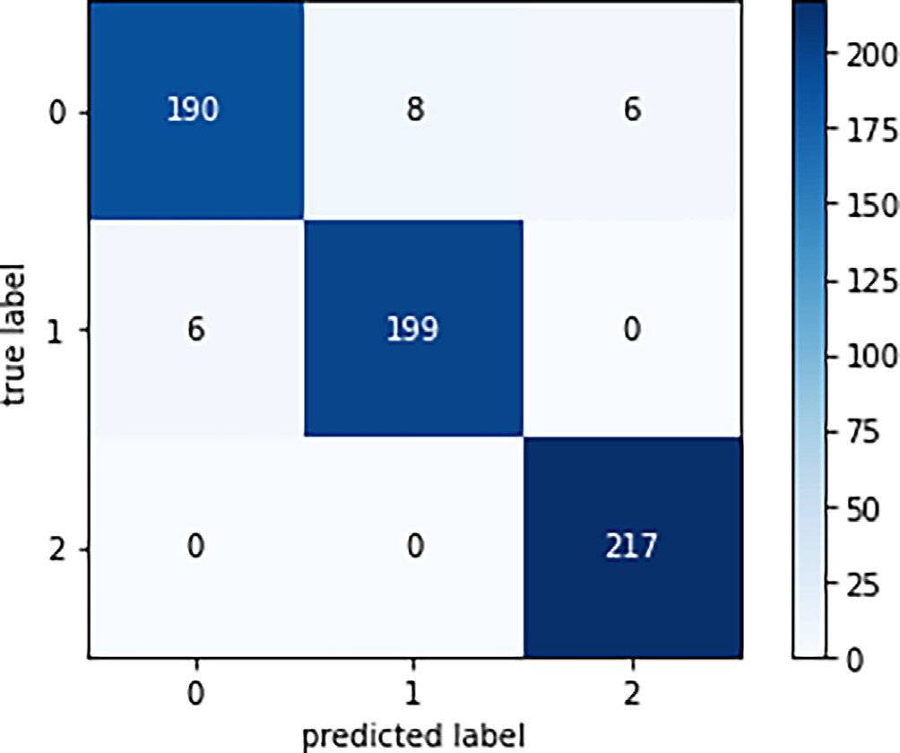

Fig. 10. Training and validation accuracy.

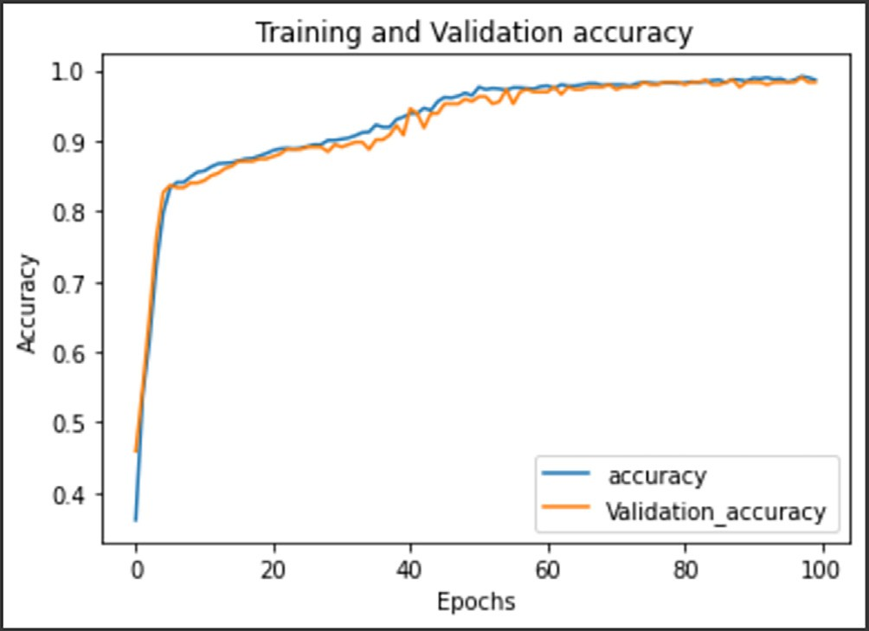

Fig. 11. Training and validation loss.

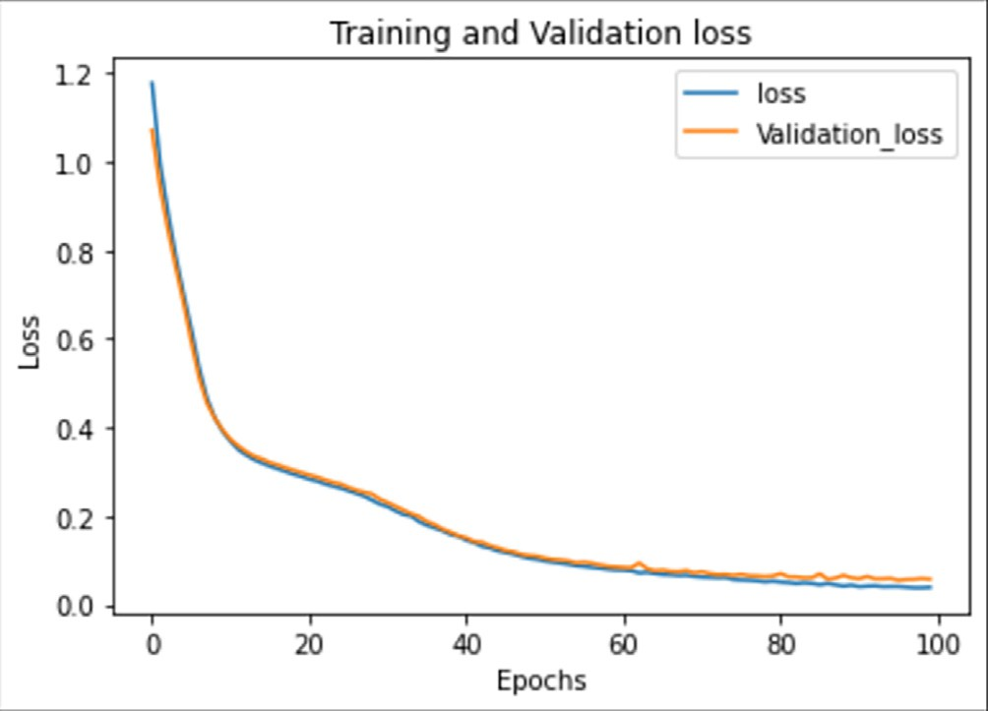

Fig. 12. Sign-in Form.

model’s generalization performance on a hold-out validation data- set (Fig. 13).

The accuracy learning curves in Fig. 1 depict a good-fit ANN model [35]. The training accuracy and validation accuracy both improve steadily over time without significant leveling off before reaching a plateau. Similarly, analyzing the loss learning curves in Fig. 2 of the trained model, conclusion can be drawn from the fact the model is a good fit as it is able to maintain a sufficiently low error value on the training set and the generalization gap between the training and validation error is also very small (Fig. 14).

Overall, based on the learning curves, we can confidently say that the trained model is not underfitting, nor is it overfitting. The small gap between the training and validation curves indicates that the model is generalizing well, while the low error value on the training set indicates that the model is not underfitting.

1. *Application layer*

To manage and process the data coming from the nodes a Web application is developed using Django as a backend framework and SQLite as system’s database to display not only sensor data but also processed data from the output nodes of the artificial neural net- work. The web application is user-friendly and responsive for all devices like mobile, tablets, and computer monitors. The respon- siveness of the website is because of the use of media queries for different screen sizes.

Access to the web dashboard is available to authenticated users only. Among numerous security techniques, authentication is the first line of defense and the foundation for access control. For Authentication, users must first be validated prior to being granted access to application data. Authentication is the process of estab- lishing that a person is who he or she claims to be [36] Authenti- cation allows the recipient of a message to verify that it has not been altered or corrupted.

The application layer consists of following tiers described below:

1. Features

Web application presents product with appealing landing page, features, user guide, and contact us option. It offers login and reg- istration for ‘‘cattle care” users. Once signed into ‘‘cattle care,” the online app takes the user to the dashboard. In the dashboard por- tion, the online application shows cattle vital statistics extracted from the database by sensors and any suspected disease after being processed by an artificial neural network algorithm.

1. Homepage The homepage has a simple navbar to navigate through the web

app with signup and login buttons. It introduces the product to the

visitor. It provides basic information about all the features of the product. ‘‘Cattle care” will provide information on how to use the product and any precautionary measures to take to avoid any dam- age. It will provide the option to contact the developer team if a user has any queries.

1. Dashboard

The user dashboard interface has a side drawer for navigation. The main page shows the user’s profile picture, username, and email. It provides total data of healthy and sick cattle and active or offline devices. All cattle tracked by this project are included in a table with their id, temperature, heart rate, and ketosis status. The user may click on any entry in the table to view that cow’s health data and analysis.



Fig. 13. Homepage of web application.

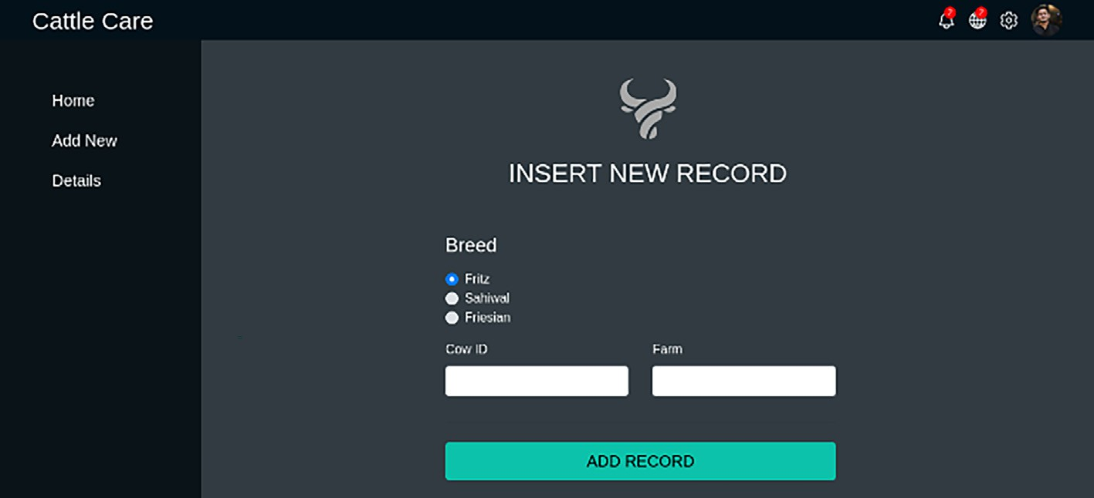

Fig. 14. New entry record.

1. Database

SQLite is a C library that provides a fast, reliable SQL database engine [37]. This project uses SQLite, the most popular database engine. Using a valid id and password, the admin may access the database management system. The admin may add, remove, or change any product, gadget, or cow. Administrators may download any information. The admin may monitor new devices. The dash- board allowed for all of these functions.

1. Research issues and challenges

The final product can inform the user about individual cattle health status, but some uncertainties and challenges were encoun- tered along the way. Due to worldwide chip shortage, difficulties were faced in the procurement of hardware such as Raspberry Pi. The proposed system is based on real-time cattle health moni- toring for which sensor data had to be acquired to train and deploy a high-performing ANN model which was difficult keeping in mind the accuracy required in health applications on unseen data. It had to be made sure that the dataset gathered is accurate and under the supervision of veterinary doctors at all times for cross verification. This was important as it was required for the final product to not just best fit the training data but predict unseen instances accu- rately. As the local farm animals are not used to the sensor-based collar, it was difficult to gather data from multiple animals as every individual took some time to get comfortable. Considering all the difficulties being faced to gather an accurate dataset from far away

farms with access grants through a formal permission letter, the Neural model was only trained on the two of the most common diseases found locally. As the product is based on Machine Learn- ing (ML), there is always a risk of the scope of error which may result in minor misclassifications as shown by the confusion matrix earlier.

1. Future research directions

The wireless sensor network is a unique technology that has changed communication ways and brings in a lot of money for energy, health, agriculture, etc. Future sensor node advancements must deliver powerful and cost-effective devices for animal health monitoring systems. As the sensor node’s battery life is limited, using Li-Ion rechargeable batteries increases maintenance costs. Solar energy should be employed in this regard. Solar power is available throughout the day that can be used to guarantee a longer lifetime with autonomous operation as solutions must be energy-efficient.

This system employed low-cost wearable body area sensors since the cost is a consideration for sensor nodes. ADXL335 accelerometer monitors cattle ruminating, standing, and walking, although adding sensors may be uncomfortable. Animals, primarily black and brown cattle, are tough to determine differently but cat- tle activity may be detected using a camera. Day and night images data may be gathered to train the learning model for 24 h instead. An artificial neural network is used to forecast illnesses (High- fever, Ketosis) after collecting datasets of healthy and sick cows’

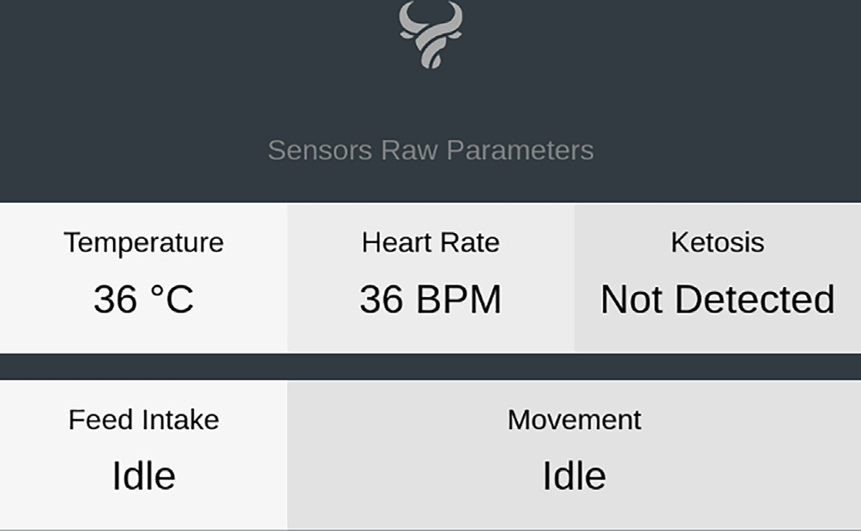

Fig. 15. Recorded sensor data on web application.

temperature, heart rate, lameness, and behavioral activities (graz- ing, standing, lying, etc.). ANN may be used to predict other dis- eases commonly found in livestock animals such as Mastitis after collecting larger datasets.

Authentication systems are utilized to safeguard this system due to the need of precise data. Otherwise, data-driven decisions would fail. Integrity, availability, and availability of data should be managed in livestock monitoring systems. Security of the sys- tem should be enhanced by integrating other cyber defense tech- niques such as Firewalls that may prevent harmful assaults. WSN’s autonomy may make these options fail but better methods like HRM can be adopted to mitigate harmful attacks.

1. Conclusion

This system is designed to support cattle farm owners by mak- ing the able to predict cattle diseases and monitor cattle health parameters from remote locations which will increase farm output with less labor costs. The proposed system is capable of informing the user of individual cattle health data coming from sensor nodes placed on different body areas through a secure wireless commu- nication channel. The base station will be collecting data wirelessly from authenticated sensor nodes only and performing AI algo- rithms on that data after storing it in the system’s database. The end-user will only be able to access information through system’s web application after they have been authenticated by the health monitoring system. The user will be able to see predicted result from ANN model with performance measure evaluation of nearly 98%. The web application will be receiving signals from the base station in real-time that will be updated on the user interface as shown in Fig. 15.

This information will prove to be highly valuable for the end- user to foresee possible health diseases that may be communicable which will allow them to take appropriate precautionary measures in a timely manner limiting huge losses. The health monitoring system will not only help the end-user to increase their production but bring the attention of others to this industry.

CRediT authorship contribution statement

Jehangir Arshad: Conceptualization, Methodology, Software, Data curation, Writing – original draft, Visualization, Investigation. Talha Ahmad Siddiqui: Conceptualization, Methodology, Soft- ware, Data curation, Writing – original draft, Visualization, Investi- gation. M. Ismail Sheikh: Conceptualization, Methodology, Software, Data curation, Writing – original draft. M. Sadeed Waseem: Conceptualization, Methodology, Software, Data cura-

tion, Writing – original draft. M. Abu Bakar Nawaz: Conceptualiza- tion, Methodology, Software, Data curation, Writing – original draft. Elsayed Tag Eldin: Supervision, Validation, Writing – review & editing. Ateeq Ur Rehman: Visualization, Investigation.

Declaration of Competing Interest

This research is supported by Future University Researchers Sup- porting Project Number FUESP-2020/48 at Future University in Egypt, New Cairo 11845, Egypt.

References

1. [Gardaševic´ G, Katzis K, Bajic´ D, Berbakov LB. Emerging Wireless Sensor](http://refhub.elsevier.com/S1110-8665(23)00021-X/h0005) [Networks and Internet of Things Technologies—Foundations of Smart](http://refhub.elsevier.com/S1110-8665(23)00021-X/h0005) [Healthcare. Sensors 2020:30](http://refhub.elsevier.com/S1110-8665(23)00021-X/h0005).
2. ‘‘Sustainable development goals (SDGS),” undp, 2020. [Online]. Available: [https://www.undp.org/sustainable-development-goals?c_src=CENTRAL&c_](https://www.undp.org/sustainable-development-goals?c_src=CENTRAL%26c_src2%3DGSR) [src2=GSR](https://www.undp.org/sustainable-development-goals?c_src=CENTRAL%26c_src2%3DGSR).
3. Sattar A, Ahmad U. Pakistan’s dairy trade. The News International; 2021.
4. Sohaib M, Jamil F. ‘‘An Insight of Meat Industry in Pakistan with Special Reference to Halal Meat: A Comprehensive Review.” National Library of Medicine; 2021.
5. [Garcia-Hernandez I-G. Wireless sensor networks and application: A survey. Int](http://refhub.elsevier.com/S1110-8665(23)00021-X/h0025) [J Comput Sci Network Secur 2007;7](http://refhub.elsevier.com/S1110-8665(23)00021-X/h0025).
6. Jain U, Hussain M. Simple, secure, and dynamic protocol for mutual authentication of nodes in wireless sensor networks; 2017. p. 7.
7. Rehman Au, Ahmad M, Arshad J. Deployment of Wireless Sensor Network and IoT Platform to Implement an Intelligent Animal Monitoring System. mdpi 2022:23.
8. Koundal D, Sharma B. Cattle health monitoring system using wireless sensor network: a survey from innovation perspective. IET Wireless Sens Syst 2018.
9. Awasthi A, Awasthi A, Riordan D, Walsh J. Non-Invasive Sensor Technology for the Development of a Dairy Cattle Health Monitoring System. MDPI 2016.
10. Kim S-H, Kim D-H, Park H-D. Animal Situation Tracking Service Using RFID, GPS, and Sensors.
11. Dobbelaar P, Mottram T, Nyabadza C, Schukken YH. Detection of ketosis in dairy cows by analysis of exhaled breath; 2011.
12. [Jemila JS, Priyadharsini SS. A Sensor-Based Forage Monitoring of Grazing Cattle](http://refhub.elsevier.com/S1110-8665(23)00021-X/h0060) [in Diary. Int J Smart Sens Intell Syst 2018:9](http://refhub.elsevier.com/S1110-8665(23)00021-X/h0060).
13. [Yukun S, Pengju H, Yujie W, Yang L. Automatic monitoring system for](http://refhub.elsevier.com/S1110-8665(23)00021-X/h0065) [individual dairy cows based on a deep learning framework that provides](http://refhub.elsevier.com/S1110-8665(23)00021-X/h0065) [identification via body parts and estimation of body condition score.](http://refhub.elsevier.com/S1110-8665(23)00021-X/h0065) [Sciencedirect 2019;102(11):pp](http://refhub.elsevier.com/S1110-8665(23)00021-X/h0065).
14. [Araujo Zanella ARd, Silva Ed, Carlos L, Albini P. Security challenges to smart](http://refhub.elsevier.com/S1110-8665(23)00021-X/h0070) [agriculture: Current state, key issues and future directions. Sciencedirect](http://refhub.elsevier.com/S1110-8665(23)00021-X/h0070) [2020;8](http://refhub.elsevier.com/S1110-8665(23)00021-X/h0070).
15. Shabani I, Biba T, Cico B. Design of a Cattle-Health-Monitoring System Using Microservices and IoT Devices. Mdpi 2022:17.
16. [Farooq MS, Sohail OO, Abid A. A Survey on the Role of IoT in Agriculture for the](http://refhub.elsevier.com/S1110-8665(23)00021-X/h0080) [implementation of Smart Livestock Environment. IEEE Access 2022:23](http://refhub.elsevier.com/S1110-8665(23)00021-X/h0080).
17. ‘‘last minute engineers,” [Online]. Available: [https://lastminuteengineers.com/](https://lastminuteengineers.com/ds18b20-arduino-tutorial/) [ds18b20-arduino-tutorial/](https://lastminuteengineers.com/ds18b20-arduino-tutorial/).
18. ‘‘Components101,” 2021. [Online]. Available: [https://components101.com/](https://components101.com/sensors/max30100-heart-rate-oxygen-pulse-sensor-pinout-features-datasheet) [sensors/max30100-heart-rate-oxygen-pulse-sensor-pinout-features-](https://components101.com/sensors/max30100-heart-rate-oxygen-pulse-sensor-pinout-features-datasheet) [datasheet](https://components101.com/sensors/max30100-heart-rate-oxygen-pulse-sensor-pinout-features-datasheet).
19. Arcidiacono C, Porto SMC, Mancino M, Cascone G. Development of a threshold- based classifier for real-time recognition of cow feeding and standing behavioural activities from accelerometer data 2017;134:124-134.
20. ‘‘circuits-diy,” [Online]. Available: [https://www.circuits-diy.com/mq138-voc-](https://www.circuits-diy.com/mq138-voc-volatile-organic-compound-gas-sensor-module/) [volatile-organic-compound-gas-sensor-module/](https://www.circuits-diy.com/mq138-voc-volatile-organic-compound-gas-sensor-module/).
21. ‘‘electropeak,” [Online]. Available: [https://electropeak.com/learn/interfacing-](https://electropeak.com/learn/interfacing-ky-037-sound-sensor-with-arduino/) [ky-037-sound-sensor-with-arduino/](https://electropeak.com/learn/interfacing-ky-037-sound-sensor-with-arduino/).
22. [Thaker T. ESP8266 based Implementation of Wireless Sensor Network with](http://refhub.elsevier.com/S1110-8665(23)00021-X/h0110) [Linux Based Web-Server. IEEE 2016;6(3)](http://refhub.elsevier.com/S1110-8665(23)00021-X/h0110).
23. [Akhila Suresh TVS. An IoT Solution for Cattle Health Monitoring. ResearchGate](http://refhub.elsevier.com/S1110-8665(23)00021-X/h0115) [2019](http://refhub.elsevier.com/S1110-8665(23)00021-X/h0115).
24. ‘‘Datatracker,” [Online]. Available: [https://datatracker.ietf.org/doc/html/](https://datatracker.ietf.org/doc/html/rfc3962) [rfc3962](https://datatracker.ietf.org/doc/html/rfc3962).
25. ‘‘twilio,” [Online]. Available: <https://www.twilio.com/docs/glossary/totp>.
26. Alias N, Farid F, Al-Rahmi W, Yahaya N. A modeling of animal diseases through using artificial neural network 2018;7.
27. ‘‘scikit-learn 1.1.1,” 2022. [Online]. Available: [https://pypi.org/project/scikit-](https://pypi.org/project/scikit-learn/) [learn/](https://pypi.org/project/scikit-learn/).
28. [Chaudhry AA, Mumtaz R, Hassan Zaidi SM. Internet of Things (IoT) and](http://refhub.elsevier.com/S1110-8665(23)00021-X/h0140) [Machine Learning (ML) enabled Livestock Monitoring. IEEE Xplore 2020](http://refhub.elsevier.com/S1110-8665(23)00021-X/h0140).
29. Hojjat Adeli S-LH. Machine Learning: Neural Networks, Genetic Algorithms, and Fuzzy Systems. vol. 1, p. 211.
30. [Amato A, Amato F, Angrisani L. Artificial Intelligence-Based Early Prediction](http://refhub.elsevier.com/S1110-8665(23)00021-X/h0150) [Techniques in Agri-Tech Domain. SpringerLink 2021](http://refhub.elsevier.com/S1110-8665(23)00021-X/h0150).
31. [Nguyen H, Bui X-N, Vu D-A. Forecasting mining capital cost for open-pit](http://refhub.elsevier.com/S1110-8665(23)00021-X/h0155) [mining projects based on artificial neural network approach. ELSEVIER 2019:3](http://refhub.elsevier.com/S1110-8665(23)00021-X/h0155).
32. ‘‘Machine learning mastery,” [Online]. Available: [https://machinelearningmastery.com/adam-optimization-algorithm-for-](https://machinelearningmastery.com/adam-optimization-algorithm-for-deep-learning/)

[deep-learning/](https://machinelearningmastery.com/adam-optimization-algorithm-for-deep-learning/).

1. Singh A, Singh P, Singh N, Singh Kk. Diagnosing of disease using machine learning. Mach Learn Internet Med Things Healthcare 2021;89–111.
2. Jayaswal V. ‘‘towardsdatascience,” 2020. [Online]. Available: [https://towardsdatascience.com/performance-metrics-confusion-matrix-](https://towardsdatascience.com/performance-metrics-confusion-matrix-precision-recall-and-f1-score-a8fe076a2262) [precision-recall-and-f1-score-a8fe076a2262](https://towardsdatascience.com/performance-metrics-confusion-matrix-precision-recall-and-f1-score-a8fe076a2262).
3. YB, AC. Ian Goodfellow, Deep Learning Book. MIT Press; 2016.
4. Sikdar B, Gope P. Lightweight and Privacy-Preserving Two-Factor Authentication Scheme for IoT Devices 2018:12.
5. [Suwimon Vongsingthong ASS. A Review of Data Management in Internet of](http://refhub.elsevier.com/S1110-8665(23)00021-X/h0185) [Things. resjournal 2015](http://refhub.elsevier.com/S1110-8665(23)00021-X/h0185).