[Egyptian Journal of Basic and Applied Sciences 4 (2017) 270–287](https://doi.org/10.1016/j.ejbas.2017.10.003)



Contents lists available at [ScienceDirect](http://www.sciencedirect.com/science/journal/2314808X)

Egyptian Journal of Basic and Applied Sciences

journal homepage: [www.elsevier.com/locate/ejbas](http://www.elsevier.com/locate/ejbas)

Full Length Article

Design, synthesis, spectroscopic characterization and anti-psychotic investigation of some novel Azo dye/Schiff base/Chalcone derivatives



Chandravadivelu Gopi a,b, Vedula Girija Sastry c, Magharla Dasaratha Dhanaraju a,⇑

a *Research Lab, GIET School of Pharmacy, Rajahmundry, Andhra Pradesh 533296, India*

b *School of Pharmaceutical Sciences and Technologies, Jawaharlal Nehru Technological University, Kakinada, Andhra Pradesh 533003, India*

c *A.U. College of Pharmaceutical Sciences, Andhra University, Visakhapatnam, Andhra Pradesh 530017, India*

a r t i c l e i n f o

*Article history:*

Received 26 December 2016

Received in revised form 7 October 2017 Accepted 10 October 2017

Available online 22 October 2017

*Keywords:* Design MVD

Catalepsy Antipsychotic agent X-ray crystallography

a b s t r a c t

The purpose of the study is to design, synthesise and assess the antipsychotic activity of a set of the novel (5-(10-(3-*N, N*-Dimethylamino) propyl)-10*H*-phenothiazine-3-yl)-1,3,4-thiadiazo-2-yl) Azodye/Schiff base/Chalcone derivatives. The newly synthesised compound structure was characterised by FT-IR, 1H NMR, Mass spectroscopy and elemental analysis. Each compound has been shown an excellent anti- psychotic activity in a haloperidol-induced catalepsy metallic bar test. The results found are firmly sim- ilar to docking study. Among the synthesised derivatives, compound 2-Amino-6-(3-hydroxy-4-methyl phenyl) pyrimidine-4-yl) (7-chloro-10-(3-(*N, N*-dimethylamino) propyl)-10*H*-phenothiazine-3-yl) methanone (GC8) exhibiting high potency of catalepsy induction. Therefore, the derivative of GC8 has been considered that a potent anti-psychotic agent among the synthesised compounds.

© 2017 Mansoura University. Production and hosting by Elsevier B.V. This is an open access article under

the CC BY-NC-ND license (<http://creativecommons.org/licenses/by-nc-nd/4.0/>).

1. Introduction

Dopamine receptors are responsible for several functions such as fine motor control, emotion, learning, cognition, pleasure, sensa- tion, motivation, memory and modulation of neuroendocrine behaviour, movements etc., [1]. Some changes in the role of dopaminergic receptor actions are generated many diseases like parkinsonism, psychomotor, schizophrenia, neurodegeneration, drug abuse, delusions and hallucinations etc., [2]. These receptors are mainly divided into D1-5. They belong to the class of G- protein-coupled-receptors [3,4]. Here, D1 and D5 receptors are known as D1 family associates, whereas D2, D3 and D4 receptors are known as D2 family associates [5]. Both families coupled with G-protein and retard the adenylyl cyclase [6,7]. With the knowl- edge of some evidence state that the possibility of the existence of D6 and D7 dopamine receptors, but such a type of receptor has not been sturdily documented. Generally, these receptors bind to the plasma membrane as a homodimer, heterodimers or higher- order oligomers etc., [8]. It has been targeted for different psy- chotic illnesses and also be considered in some non-psychotic disorders [9]. Drugs used to treat the psychotic problem are known as antipsychotic agents (or neuroleptic) is majorly classified into two types. Earlier antipsychotic drugs are called as typical or classical

* Corresponding author.

*E-mail address:* [mddhanaraju@yahoo.com](mailto:mddhanaraju@yahoo.com) (M.D. Dhanaraju).

antipsychotic agents, whereas; currently available drugs are recog- nised as a second generation or atypical antipsychotic agents. Both the type of the antipsychotic agent is having a tendency to obstruct receptors in brain’s dopamine pathways [10]. Most of the antipsychotic agents are having substantial side effects, such as dysphoria, parkinsonism, tardive dyskinesia, galactorrhea, seda- tion, irritability, hyperprolactinaemia, sexual functioning disorder and symptoms of ADHD, depression, narcolepsy, anxiety, improved appetite, obesity threat, paranoia, aggression, psychomotor agita- tion, diabetes mellitus (Type 2), akathisia, extrapyramidal symp- toms and menstrual trouble [11]. Therefore, identification of a novel antagonist of dopamine receptor is needed to treat nervous diseases effectively. In recent years, there has been an immense awareness among the scientists toward the design of new drugs, which consumes less time, highly potent and lower cost to prepare an effective drug molecule against various health problems. Rapid and high throughput method of drug discovery is an only way to improve the therapeutic value of drugs in the animal model. Molecular docking is a one among the method to measure the bio- logical activity of the proposed molecule with the targeted recep- tor rapidly using Molegro Virtual Docker (MVD). With the support of MVD, we found a bunch of novel compounds known as potent dopamine pathway inhibitors and bearing least side effect due to the presence of trusted thiadiazole and phenothiazine nucleus as part of the molecular structure. This study stated that easy way for the synthesis of novel Azo dye/Schiff bases/Chalcone

<https://doi.org/10.1016/j.ejbas.2017.10.003>

2314-808X/© 2017 Mansoura University. Production and hosting by Elsevier B.V.

This is an open access article under the CC BY-NC-ND license (<http://creativecommons.org/licenses/by-nc-nd/4.0/>).

derivatives and their antipsychotic activity by using virtual dock- ing and a metallic bar test. The synthesised compound structure was characterised by FT-IR, 1H NMR, mass spectroscopy and ele- mental analysis.

1. Materials and method
   1. *Molecular docking*

Virtual screening has been playing an important role in drug discovery processes which deal with a quick search of chemical structures likely to have more chemical binding to the drug target (protein or enzyme) from large libraries. MVD is a powerful dock- ing tool used to detect the binding ability lies between the ligand and receptor. Before we start the docking process, the human dopamine D2 receptor template was collected from the protein bank as mentioned in Fig. 1. A setup of 26 different ligands was built in ChemDraw (Table 1), and the 2D structure was converted to the 3D structure using molegro virtual software [12]. The best 3D structure of ligand was selected from energy minimization through molecular objective functions and modeller score in MVD [13,14]. The properties of each ligand such as absorption, dis- tribution, metabolism and excretion were also studied. The best conformation was selected and used to predict the strength of the bond between the receptor and ligand. The result reveals that around 10 compounds (Table 2) out of 26 are capable of making a perfect binding to the active site of the receptor amino acid. It also helped us to find out the order of prioritising molecules to synthe- sise from the bunch of the molecule based on moledock score, rerank score and hydrogen bond binding energy with DA. The docking study pathway was presented in Fig. 2.

* 1. *Chemistry*

The raw materials and solvents were purchased from Ranbaxy, Sigma-Alrich, Ranchem companies. The melting points of prepared analogues were recorded in open capillary tube method on an Elec- trothermal 9100 melting point apparatus and are uncorrected. Functional group of synthesised compound was confirmed by using Fourier transform infrared spectroscopy (FT-IR) between

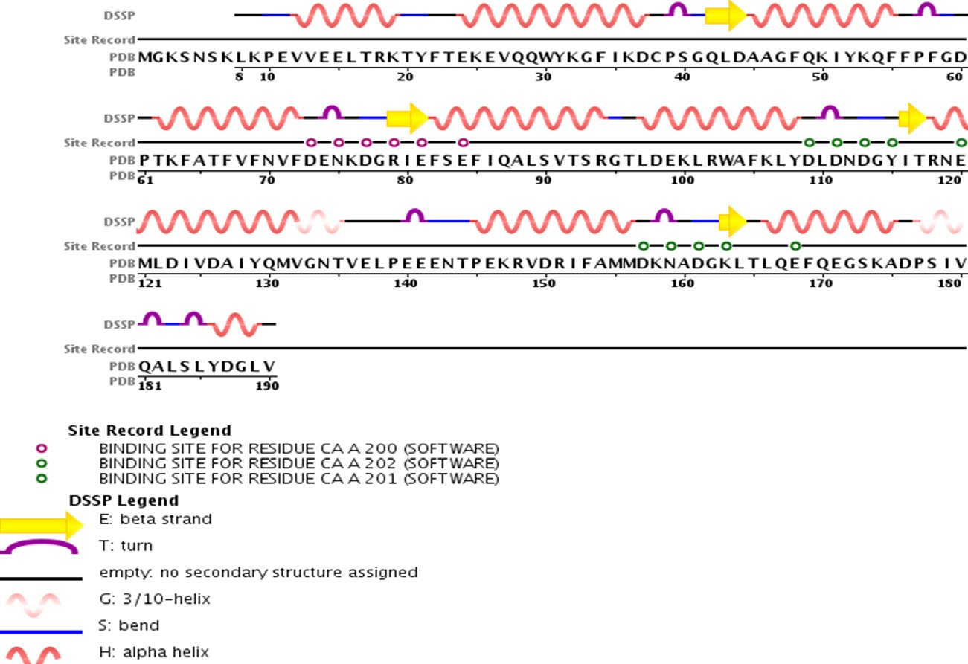the ranges from 4000 cm—1 to 400 cm—1. The number of proton

present in the analogues was recorded on the Bruker 1H NMR spec- troscopy from chemical shift (d) and the molecular mass of the compound was analysed by the Shimadzu mass spectroscopy. The element analysis was performed on Perkin Elmer 2400 CHN elemental analyser.

* + 1. *Synthesis of 4-(Phenylamino)benzoic acid (Scheme-I)*

Aniline (0.1 mol, 9.3 ml), para chloro benzoic acid (0.1 mol, 15.6 g), potassium carbonate (0.01 mol, 1.38 g) and 0.63 g of cop- per wire were dissolved in 30 ml of *N, N*-dimethylformamide

(DMF) contained round bottom flask of about 250 ml capacity. The mixture was allowed to agitate for 30 min at 20–25 °C. The flask was fitted with a reflux condenser and heated at 80 °C for 4 h with occasional shaking. The crude 4-(Phenylamino) benzoic acid

was filtered, washed with little cold water and crystallized from ethanol.

* + 1. *Synthesis of 10H-Phenothiazine 3-carboxylic acid*

An ethanolic solution of 4-(Phenylamino) benzoic acid (0.01 mol, 2.13 g) was added dropwise to a mixture of sulphur (0.01 mol, 0.32 g) and iodine (0.01 mol, 1.26 g). Shake the mixture until it became a solution. Placed the solution in a round bottom flask of about 250 capacities and fitted with the reflux condenser. The mix- ture was subjected to reflux on a water bath around 3 h with occa- sional shaking. The crude 10*H*-Phenothiazine 3-carboxylic acid was separated with a vacuum pump, washed with a small portion of cold water and re-crystallized from ethanol.

* + 1. *Synthesis of 5-(10-(3-(N,N-Dimethylamino)propyl-10H- phenothiazine-3-yl)-1,3,4-thiadiazole-2-amine*

10*H*-Phenothiazine 3-carboxylic acid (0.01 mol, 2.43 g) and thiosemicarbazide (0.01 mol, 0.75 g) were dissolved in 60 ml of phosphorus oxychloride with the stirring duration of 10 min. The contents were placed in a distillation flask fitted with the reflux condenser. The flask was heated on a water bath for around 4 h. The reflux was detached from reflux condenser and added drop- wise 3-Chloro-*N, N*-dimethyl propanamine (0.01 mol, 1.21 ml), sodium hydride (0.01 mol, 0.24 g) in DMF. Again, the reaction mix- ture was warmed for 3 h in a water bath. The hot solution was cooled to room temperature and separated crude product was

Fig. 1. Dopamine D2 Receptor (DA) pdb format structure from protein data bank.

Table 1

Structure and name of proposed molecules (ligand).

Compound Structure 1

N N

N  N OH

S

S

N

CH2 C H2

CH3

H2

C N

CH3

4-((5-(10-(3-(*N,N*-Dimethylamino)propyl)-10*H*-phenothiazine-3yl)-1,3,4-thiadiazole-2-yl)diazenyl)phenol

2 N N

S

S

N  N NO2

N

CH2 C H2

CH3

H2

C N

CH3

4-((5-(10-(3-(*N,N*-Dimethylamino)propyl)-10*H*-phenothiazine-3yl)-1,3,4-thiadiazole-2-yl)diazenyl)-3-nitrobenzylidene

3 N N

S

S

N  N NH2

N

CH2 C H2

CH3

H2

C N

CH3

4-((5-(10-(3-(*N,N*-Dimethylamino)propyl)-10*H*-phenothiazine-3yl)-1,3,4-thiadiazole-2-yl)diazenyl)benzenamine

4 N N

S

S

N  N N

CH3

CH3

N

CH2 C H2

CH3

H2

C N

CH3

4-((5-(10-(3-(*N,N*-Dimethylamino)propyl)-10*H*-phenothiazine-3yl)-1,3,4-thiadiazole-2-yl)diazenyl)*N,N*-dimethylbenzenamine

5 N N

S

S

N  N OH

N

CH2 C H2

CH3

H2

C N

CH3

4-((5-(10-(3-(*N,N*-Dimethylamino)propyl)-10*H*-phenothiazine-3yl)-1,3,4-thiadiazole-2-yl)diazenyl)naphthalene-1-ol

6 N N

S

S

N  CH

CH3

N

CH3

N

CH2 C H2

CH3

H2

C N

CH3

*N*-(4(*N,N*-Dimethylamino)benzylidene)-5-(10-(3-*N,N*-dimethylamino)poropyl)-10*H*-phenothiazine-3yl)-1,3,4-thiadiazole-2-amine

Compound Structure 7

S

N N

N  CH

OH

OCH3

S

N

CH2 C H2

CH3

H2

C N

CH3

4-((5-(10-(3-(*N,N*-Dimethylamino)propyl)-10*H*-phenothiazine-3yl)-1,3,4-thiadiazole-2-ylimino)methyl)-2-methoxyphenol

8 N N

S

S

N  CH

N

CH2 C H2

CH3

H2

C N

CH3

*N*-Benzylidene-5-(10-(3-(*N,N*-dimethylamino)propyl)-10*H*-phenothiazine-3yl)-1,3,4-thiadiazole-2-amine

9 N N

S

S

N  CH OH

N

CH2 C H2

CH3

H2

C N

CH3

4-((5-(10-(3-(*N,N*-Dimethylamino)propyl)-10*H*-phenothiazine-3yl)-1,3,4-thiadiazole-2-ylimino)methyl)phenol

10 N N

S

S

N  CH Cl

N

CH2 C H2

CH3

H2

C N

CH3

*N*-(4-Chlorobenzylidene)-5-(10-(3-(*N,N*-dimethylamino)propyl)-10*H*-phenothiazine-3yl)-1,3,4-thiadiazole-2-amine

11 N N

S

S

N  CH

OCH3

N

CH2 C H2

CH3

H2

C N

CH3

*N*-(4-Methoxybenzylidene)-5-(10-(3-(*N,N*-dimethylamino)propyl)-10*H*-phenothiazine-3yl)-1,3,4-thiadiazole-2-amine

12

S

N

CH2 C H2

N N

S

CH3

N  CH

HO

H2 C N

CH3

2-((5-(10-(3-(*N,N*-Dimethylamino)propyl)-10*H*-phenothiazine-3yl)-1,3,4-thiadiazole-2-ylimino)methyl)phenol

(*continued on next page*)

Compound Structure 13

S

N

CH2 C H2

N N

S

CH3

N  CH

HOOC

H2 C N

CH3

2-((5-(10-(3-(*N,N*-Dimethylamino)propyl)-10*H*-phenothiazine-3yl)-1,3,4-thiadiazole-2-ylimino)methyl)benzoic acid

14 NO2

N N

N  CH

S

S

N

CH2 C H2

CH3

H2

C N

CH3

*N*-(3-Nitrobenzylidene)-5-(10-(3-(*N,N*-dimethylamino)propyl)-10*H*-phenothiazine-3yl)-1,3,4-thiadiazole-2-amine

15 N N

S

S

N  CH

CH3

N

CH2 C H2

CH3

H2

C N

CH3

*N*-(p-tolyl)-5-(10-(3-(*N,N*-dimethylamino)propyl)-10*H*-phenothiazine-3yl)-1,3,4-thiadiazole-2-amine

16 N N

O

N  C

S H

S

N

CH2 C H2

CH3

H2

C N

CH3

5-(10-(3-(*N,N*-Dimethylamino)propyl)-10*H*-phenothiazine-3yl)-*N*-(furan-2-ylmethylene)-1,3,4-thiadiazole-2-amine

17

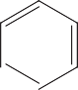

O

Cl S C

N H2C

C H2

CH3

H2

C N

CH3

N N

NH2

2-Amino-6-phenylpyrimidine-4yl)(7-chloro-10-(3(*N,N*-dimethylamino)propyl)-10*H*-phenothiazine-3yl)methanone

18 OCH3

O

Cl S

N H2C

C H2

C

CH3

H2

C N

CH3

OH

N N

NH2

2-Amino-6-(3-hydroxyl-4methoxyphenyl)pyrimidine-4yl)(7-chloro-10-(3(*N,N*-dimethylamino)propyl)-10*H*-phenothiazine-3yl)methanone

Compound Structure 19

O

CH3

N

CH3

Cl S C

N H2C

C H2

CH3

H2

C N

CH3

N N

NH2

2-Amino-6-(4-dimethylamino)phenyl)pyrimidine-4yl)(7-chloro-10-(3(*N,N*-dimethylamino)propyl)-10*H*-phenothiazine-3yl)methanone

20 OH

O

Cl S C

N H2C

C H2

CH3

H2

C N

CH3

N N

NH2

2-Amino-6-(4-hydroxyphenyl)pyrimidine-4yl)(7-chloro-10-(3(*N,N*-dimethylamino)propyl)-10*H*-phenothiazine-3yl)methanone

21 Cl

O

Cl S C

N H2C

C H2

CH3

H2

C N

CH3

N N

NH2

2-Amino-6-(4-chloroyphenyl)pyrimidine-4yl)(7-chloro-10-(3(dimethylamino)propyl)-10*H*-phenothiazine-3yl)methanone

22 OCH3

O

Cl S C

N H2C

C H2

CH3

H2

C N

CH3

N N

NH2

2-Amino-6-(4-methoxyphenyl)pyrimidine-4yl)(7-chloro-10-(3(*N,N*-dimethylamino)propyl)-10*H*-phenothiazine-3yl)methanone

23

O

Cl S C

N H2C

C H2

CH3

H2

C N

CH3

N N HO

NH2

2-Amino-6-(2-hydroxyphenyl)pyrimidine-4yl)(7-chloro-10-(3(*N,N*-dimethylamino)propyl)-10*H*-phenothiazine-3yl)methanone

(*continued on next page*)

Compound Structure 24

NO2

O

Cl S C

N H2C

C H2

CH3

H2

C N

CH3

N N

NH2

2-Amino-6-(3-nitrophenyl)pyrimidine-4yl)(7-chloro-10-(3(*N,N*-dimethylamino)propyl)-10*H*-phenothiazine-3yl)methanone

25 CH3

O

Cl S C

N H2C

C H2

CH3

H2

C N

CH3

N N

NH2

2-Amino-6-*p*-tolylpyrimidine-4yl)(7-chloro-10-(3(*N,N*-dimethylamino)propyl)-10*H*-phenothiazine-3yl)methanone

26

O

Cl S C O

N H2C

C H2

CH3

H2

C N

CH3

N N

NH2

2-Amino-6-(furan-2-yl)pyrimidine-4yl)(7-chloro-10-(3(*N,N*-dimethylamino)propyl)-10*H*-phenothiazine-3yl)methanone

filtered, washed with a small quantity of water and re-crystallized from ethyl acetate.

* + 1. *General procedure for preparation of varies Azo dye: (GC1-GC2)*

5-(10-(3-(*N,N*-Dimethylamino) propyl-10*H*-phenothiazine-3-y l)-1,3,4-thiadiazole-2-amine (0.01 mol, 3.83 g), sodium nitrite (0.01 mol, 0.68 g) and Con. HCl (0.1 mol, 3.6 ml) were placed in a

50 ml Erlenmeyer flask, immerse the flask in an ice bath and main- tained the temperature below 0–5 °C. Diazotization took place and formation of phenyl diazonium chlorde. Coupling reagents were allowed to interact with phenyl diazonium chloride at 4 °C. The separated azo dye was filtered, washed thoroughly with a small portion of cold water and re-crystallized from ethyl acetate and n-hexane.

* + 1. *General procedure for preparation of various Schiff base: (GC3– GC7)*

An equimolar mixture of aromatic aldehydes (0.01 mol) and 5- (10-(3-(*N,N*-Dimethylamino)propyl-10*H*-phenothiazine-3-yl)-1,3, 4-thiadiazole-2-amine (0.01 mol, 3.83 g) were added gradually to

10 ml of GAA contained two-necked round bottom flask. Then it was refluxed at 80 °C for 6 h with constant stirring. The precipi- tated solid was filtered, washed with 50 ml of water and re-crystallized from ethanol. The azo dye and Schiff base com-

pounds were synthesised according to the reported procedure

[15] (Fig. 3).

* + 1. *Synthesis of 1-(4-(4-Chlorophenylamino)phenyl)ethanone (Scheme II)*

4-Chlorobenzene amine (0.01 mol, 1.27 g), *p-*chloroacetophe- none (0.01 mol, 1.54 g), potassium carbonate (0.01 mol, 1.38 g) and 0.63 g of copper wire were dissolved in 30 ml of DMF con- tained round bottom flask of about 250 ml capacity. The mixture

was stirred for 30 min. The flask was fitted with a reflux condenser and heated at 80 °C for 4 h with occasional shaking. The crude 4- (Phenylamino) benzoic acid was filtered, washed with little cold water and crystallized from ethyl acetate [16].

* + 1. *Synthesis of 1-(7-Chloro-10H-Phenothiazine-3-yl)ethanone*

To a solution of 1-(4-(4(Chlorobenzeneamino) phenyl) etha- none (0.01 mol, 2.45 g) in rectified spirit, sulphur (0.01 mol, 0.3 g) and iodine (0.01 mol, 1.26 g) were placed in a two-necked flask fitted with a reflux condenser. The mixture was subjected to reflux on a water bath around 3 h with occasional shaking. The separated 1-(7-Chloro-10*H*-Phenothiazine-3-yl) ethanone was filtered, washed with distilled water, dried and crystallized from acetone [17].

Table 2

Structure and name of synthesised compounds.



N N

S

S

N

CH3

N

Compound name Structure of synthesised compounds GC1

N  N OH

GC2

CH3

(E)-4-((5-(10-(3-(*N,N*-Dimethylamino)propyl)-10*H*-phenothiazine-3yl)-1,3,4-thiadiazole-2-yl)diazenyl phenol

N  N N(CH3)2



N N

S

S

N

CH3

N

GC3

CH3

(E)-4-((5-(10-(3-(*N,N*-Dimethylamino)propyl)-10*H*-phenothiazine-3yl)-1,3,4-thiadiazole-2-yl)diazenyl)-*N,N*-dimethylbenzenamine



N N

S

S

N

CH3

N

N  C

H

NO2

GC4

CH3

*N*-(3-Nitrobenzylidene)-5-(10-(3-(*N,N*-dimethylamino)propyl)-10*H*-phenothiazine-3yl)-1,3,4-thiadiazole-2-amine

N  C OH



N N

S

S

N

CH3

N

H

OCH3

GC5

CH3

4-((5-(10-(3-(*N,N*-Dimethylamino)propyl)-10*H*-phenothiazine-3yl)-1,3,4-thiadiazole-2-ylimino)methyl)-2-methoxyphenol

N  C OH



N N

S

S

N

CH3

N

H

GC6

CH3

4-((5-(10-(3-(*N,N*-Dimethylamino)propyl)-10*H*-phenothiazine-3yl)-1,3,4-thiadiazole-2-ylimino)methyl)phenol

N  C Cl



N N

S

S

N

CH3

N

H

GC7

CH3

*N*-(4-Chlorobenzylidene)-5-(10-(3-(*N,N*-dimethylamino)propyl)-10*H*-phenothiazine-3yl)-1,3,4-thiadiazole-2-amine



N N

S

S

N

CH3

N

N  C

H

HOOC

CH3

2-((5-(10-(3-(*N,N*-Dimethylamino)propyl)-10*H*-phenothiazine-3yl)-1,3,4-thiadiazole-2-ylimino)methyl)benzoic acid

(*continued on next page*)

Table 2 (*continued*)

Compound name Structure of synthesised compounds

GC8 OH

O

Cl S

N

C OCH3

N N

H2C CH2  CH N  CH3

2

CH3

NH2

GC9

2-Amino-6-(4-hydroxy-3-methoxyphenyl)pyrimidine-4-yl)(7-chloro-10-(3-(*N,N*-dimethylamino)propyl)-10*H*-phenothiazine-3-yl) methanone

N(CH3)2

O

Cl S C

N N

N

H2C CH2  CH N  CH3

2

CH3

NH2

GC10

2-Amino-6-(4-(*N,N*-dimethylamino)phenyl)pyrimidine-4-yl)(7-chloro-10-(3-(*N,N*-dimethylamino)propyl)-10*H*-phenothiazine-3-yl) methanone.

Cl

O

Cl S C

N N

N

H2C CH2  CH N  CH3

2

CH3

NH2

2-Amino-6-(4-chlorophenyl)pyrimidine-4-yl)(7-chloro-10-(3-(*N,N*-dimethylamino)propyl)-10*H*-phenothiazine-3-yl) methanone

* + 1. *Synthesis of 1-(7-Chloro-10-(3(N,N-dimethylamino)propyl)- 10H-phenothiazine-3-yl) ethanone*

A mixture of 1-(7-Chloro-10*H*-Phenothiazine-3-yl) ethanone (0.01 mol, 2.75 g), 3-Chloro *N, N*-dimethyl propanamine (0.01 mol, 1.21 ml), sodium hydride (0.01 mol, 0.239 g) in DMF was kept in a reflux condenser and heated on a water bath at 80 °C for 3 h. The resulting solution was cooled and separated 1-(7-Chloro-10- (3(*N*,*N*-dimethylamino)propyl)-10*H*-phenothiazine-3-yl) ethanone

and washed with small quantities of cold water and re-crystallized from ethyl acetate [18,19].

* + 1. *General procedure for preparation of Chalcone derivatives (GC8–GC10)*

Dissolve 1-(7-Chloro-10-(3(*N,N*-Dimethylamino)-10*H*- phenothiazine-3-yl)ethanone (0.01 mol, 3.60 g) and aromatic alde- hyde (0.01 mol) in a 20 ml ethyl alcohol contained 10% potassium hydroxide, stirring with a glass rod for 7 h or until it became a clear solution. Guanidine (0.01 mol, 0.59 g) in *N, N*-dimethylformamide was added and stirred. Then the mixture was refluxed for 2 h with continuous stirring. The hot solution was cooled to room tempera- ture and the separated compound was filtered, washed with a por- tion of cold water and re-crystallized from ethyl alcohol and ethyl acetate [20,21] (Fig. 4).

* 1. *X-ray crystallography*

X-ray crystallography is a tool used to investigate the three- dimensional picture of the atomic and molecular structure of a

(10—8 cm). The beam of X-ray strikes a crystal and causes the crystal by using X-ray light, which has wavelengths of 1 angstrom diffraction of light into specific directions, fed into the computer

and using a mathematical equation to calculate the position of every atom in the crystallized molecule.

1. Results
   1. *Molecular docking*

Each ligand potency has been identified from moldock score (Table 3), rerank score (Table 4) and hydrogen bonding score (Table 5) after successful interaction with DA. The potent anti- psychotic agents are perfectly docked to a hydrophobic and the hydrophilic center of the target (DA) and were exhibiting excellent score as compared to standard drugs. The key amino-acids respon- sible for the binding site of DA were found to be Asp 123, Lue110, Asp 111, Asp 109, Asn 112, Thr 66, Asn 70 Lys 76, Glu 74, Arg 79, Asn 75 and Glu 84 residues etc., Each compound had shown a sig- nificant affinity towards DA due to the formation of a salt bridge between the ligand and some hydrophobic amino acid residue (Asp111 and Asp123), hydrogen bond formation with hydrophilic

amino acid (Asn112, Glu74) and p-p interaction with some

hydrophobic amino acid residue (Phe67). Here, compound GC8 and GC2 had exhibited admirable moldock score as compared to other derivatives due to presence of electron releasing groups such as OH, OCH3 and N(CH3)2 etc., The overall decreasing order of dopamine-inhibiting action of the entire synthesised analogues

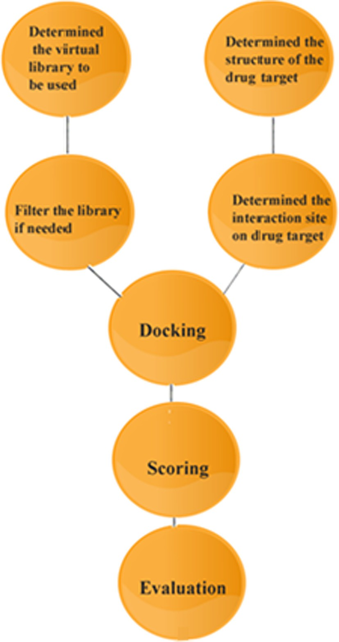

Fig. 2. Different steps involved in docking process.

was found to GC8 > GC2 > GC1 > GC7 > GC3 > GC5 > GC4 > GC9 >

GC6 > GC10. The interaction of each ligand and DA was shown in Fig. 5.

* 1. *X-ray crystallography determination and refinement*

Diffraction data of the compound GC8 were collected from 8031 reflections using X calibur CCD diffractometer equipped with area detector and graphite monochromator (k = 0.71835). The dimen-

sion of the crystal employed for data collection was 0.28 × 0.28

× 0.25 mm at 30% probability with selected bond length and bond angle. The refinement was carried out by full-matrix least squares

using SHELXL 97 [22]. The complete detail of data collections, con- dition and different parameters of refinement process were fur- nished in Table 6. The ORTEP view of the crystal, bond length and bond angle were shown in Fig. 6 and Table 7.

* 1. *Spectral data*
     1. *Preparation of azo dye and Schiff base derivative: (GC1-GC7)*

*[15]*

* + - 1. *Preparation of 2-Amino-6-(3-hydroxy-4-methylphenyl) pyrimidine-4-yl)(7-chloro-10-(3-(N,N-dimethylamino)propyl)-10H- phenothiazine-3-yl)methanone: (GC8).* Molecular formula – C29H28- ClN5O3S; Yield (86%); M.P – 217 °C; IR (mmax, cm–1): 3045 (Ar-H str), 1426(Ar-C str), 1503 (C@N), 1167(CAN), 1663(C@O), 3405

(OH), 1245 (OCH3), 3492 (NH2), Cl (6 2 3); 1*H* NMR (CDCl3, dppm, 500 MHz): d1.30–1.62 (q, 2H, CH2-H, *J* = 13.6 Hz), d2.52–2.64(s,

6H, N(CH3)2), d2.67–2.85 (t, 2H, CH2-H, *J* = 4.7 Hz), d2.91–3.18(t,

2H, CH2-H, *J* = 7.8 Hz), d3.71–3.78(s, 3H, OCH3-H), d4.15–4.28(s,

2H, NH2-H), d5.10–5.27(s, 1H, OH-H) d6.46–6.63(t, 1H, Ar-H, *J* = 1

5.8 Hz), d6.72–6.79(s, 1H, Ar-H), d6.85–6.94(s, 1H, Ar-H), d6.97–

7.08(s, 1H, Ar-H), d7.09–7.22(m, 2H, Ar-H), d7.43–7.48(s, 1H, Ar-

H), d7.53–7.60(s, 1H, Ar-H), d8.06–8.15(s, 1H, Ar-H), d8.20–8.37(s,

1H, Ar-H); Mass(*m*/*z*)-561(38) [M+], 563(15)[M++2], 489 (42), 345

(100), 203 (55), 85 (50), 58 (37); Anal. Calcd for C29H28ClN5O3S

(561): C, 61.97; H, 5.02; N, 12.46; S, 5.70; O, 8.54; Cl, 6.31. Found:

C, 61.82; H, 5.14; N, 12.26%.

* + - 1. *Preparation of 2-Amino-6-(4-methylphenyl) pyrimidine-4-yl) (7-chloro-10-(3-(N,N-dimethylamino)propyl)-10H-phenothiazine-3- yl)methanone: (GC9).* Molecular formula – C30H31ClN6OS; Yield (79%); M.P – 222 °C; IR (mmax, cm–1): 3093 (Ar-H str), 1452(Ar-H

ben), 1514 (C@N), 1240(CAN), 1670(C@O), 3426 (NH2), Cl (6 1 2);

1*H* NMR (CDCl3, dppm, 500 MHz): d1.27–1.48 (q, 2H, CH2-H, *J* = 1

5.1 Hz), d2.53–2.71(s, 6H, N(CH3)2), d2.72–2.85 (t, 2H, CH2-H, *J* =

9.8 Hz), d2.87–2.95(s, 6H, N(CH3)2), d3.00–3.22(t, 2H, CH2-H, *J* = 9.

8 Hz), d4.15–4.29(s, 2H, NH2-H), d6.42–6.58(m, 3H, Ar-H), d6.59–

6.87(m, 2H, Ar-H), d6.88–7.00(t, 1H, Ar-H, *J* = 15.1 Hz), d7.06–7.21

(d, 2H, Ar-H, *J* = 15.5 Hz), d7.23–7.31(s, 1H, Ar-H), d7.37–7.44(s,

1H, Ar-H), d7.46–7.63(d, 1H, Ar-H, *J* = 16.8 Hz); Mass (*m*/*z*)-558

(40) [M+], 560(15) [M++2], 528(22), 514 (33), 345 (1 0 0), 203

(53), 197 (49), 59 (33); Anal. Calcd for C30H31ClN6OS (5 5 8): C,

64.44; H, 5.59; N, 15.03; S, 5.73; O, 2.86; Cl, 6.35. Found: C,

64.38; H, 5.62; N, 15.10%.

* + - 1. *Preparation of 2-Amino-6-(4-chlorophenyl) pyrimidine-4-yl) 10-(3-(N,N-dimethylamino) propyl)-10H-phenothiazine-3-yl)metha- none: (GC10).* Molecular formula – C28H25Cl2N5OS; Yield (71%);

M.P – 217 °C; IR (mmax, cm–1): 3187 (Ar-H str), 1473(Ar-H ben),

1514 (C@N), 1257(CAN), 1665(C@O), 3436 (NH2), Cl (7 3 5); 1*H* NMR (CDCl3, dppm, 500 MHz): d1.20–1.44 (q, 2H, CH2-H, *J* = 14.8 Hz), d2.47–2.62(s, 6H, N(CH3)2), d2.64–2.82 (t, 2H, CH2-H, *J* = 10.

1 Hz), d2.83–3.02(t, 2H, CH2-H, *J* = 10.5 Hz), d4.12–4.29(s, 2H,

NH2-H) d6.52–6.67(d, 2H, Ar-H, *J* = 13.2 Hz), d6.70–6.91(t, 2H, Ar-

H, *J* = 8.1 Hz), d6.94–7.20(m, 1H, Ar-H), d7.22–7.34(t, 1H, Ar-H, *J*

= 9.6 Hz), d7.37–7.52(m, 2H, Ar-H), d7.54–7.64(m, 2H, Ar-H),

d7.68–7.82(d, 1H, Ar-H, *J* = 15.1 Hz); Mass (*m*/*z*)-549 (56) [M+],

551(19)[M++2], 505 (1 0 0), 476 (31), 317 (61), 203 (42), 59 (29);

Anal. Calcd for C28H25Cl2N5OS (5 4 9): C, 61.09; H, 4.58; N, 12.72;

S, 5.82; O, 2.91; Cl, 12.88. Found: C, 61.15; H, 4.46; N, 12.80%.

FT-IR, 1H NMR and Mass spectroscopy of compound GC8 was shown in Figs. 7–9.

* + - 1. *Mass fragmentation of compound (GC8).* The mass spectral decomposition mode of the prepared 2-Amino-6-(3-hydroxy-4- methyl phenyl) pyrimidine-4-yl) (7-chloro-10-(3-(*N,N*- dimethylamino) propyl)-10*H*-phenothiazine-3-yl)methanone (GC8) has been investigated by electrospray ionization mass spec- trometry (ESI-MS). The mass spectrum of compound GC8 showed the molecular ion (M+)/(molecular isotope ion (M++2) peaks (*m*/*z*) at 561/563 corresponding to the molecular formula of C29H28ClN5- O3S (Fig. 10). The molecular ion of *m*/*z* 561 has been fragmented and gives a peak at 488 *m*/*z*. The peak at *m*/*z* 488 underwent frag- mentation and produced a daughter ion at *m*/*z* 345.It further loss of the certain group of atoms such as C6H11ClS, C7H3NO and C2H4 to give a peak at *m*/*z* 203, 85 and 56 respectively. The ESI mass spec- tral fragmentation pathway of compound GC8 was discussed with typical example and other chalcone derivatives displayed similar mass spectral fragmentation pattern.

+

NH2 Cl

Aniline

O O O

OH

C OH

(i)

C OH

(ii)

S C

N N

## p-chlorobenzoic acid H H

4-(Phenylamino)benzoic acid

[1]

## 10*H*-phenothiazine-3-carboxylic acid

[2]

NH2

N N

S

S

N

CH3

N

[3] CH3

5-(10-(3-(dimethylamino)propyl)-10*H*-phenothiazin-3-yl)-1,3,4-thiadiazol-2-amine

N CH R



N N

S

S

N

CH3

N

[4]

N N

S

S

N

CH3

N

NN Cl

R'' R'

CH3

CH3

[6a-j] Schiff bases

NN X



N N

S

S

N

CH3

N

# GC3 = R = H, R'= H , R'' = NO2 GC4 = R =OH, R'=OCH3, R''= H GC5 = R = OH, R'=H, R'' = H GC6 = R = Cl, R'= H, R'' = H GC7 = R = H, R'= H, R'' =COOH

[5a-e] Azo dye

CH3

# GC1 = X = C6H5O GC2 = X = C8H10N

Reagent and condition: (i) potassium carbonate, copper wire, DMF, 4 hours reflux (ii) Sulphur, iodine, 3 hours reflux (iii) Thiosemicarbazide, phosphorus oxychloride, 3 chloro-N,N-dimethyl propanamine, sodium hydride, DMF, 7 hours reflux (iv& v) Sodium nitrite, Con HCl, coupling reagents, 0-5oC(vi) Aromatic aldehyd, glacial acetic acid, 6 hours reflux

Fig. 3. Synthesis of novel series of Azodye (GC1–GC2) and Schiff bases (GC3–GC7) derivatives.

1. Biological evaluation
   1. *Catalepsy test*

Catalepsy is defined as the inability of an animal to correct its abnormal posture after a particular period of time [23]. It can accurately predict by haloperidol-induced catalepsy metallic bar test [24]. To test the catalepsy, Wistar rats of either sex with an average weight of 200–225 g were selected, grouped (standard, test and control) and placed into different cages. Before starting the experiment protocol has been approved by the institutional

animal ethics committee at GIET School of pharmacy, Rajah- mundry, India (GSP/PY/04/2015). Each group maintained six ani- mals under standard lab conditions. Haloperidol was administered 1 mg/kg, IP route to induce catalepsy in standard group of animals. Synthesised compounds (7.5 mg/kg and 15 mg/kg) were also given simultaneously to test group of animals. The animal front paws had been placed on a metallic bar, which elevated at 10 cm above the base of the cage. If the animal main- tained abnormal posture more than 30 s called as catalepsy. The response observed at the various intervals like 0, 30, 60, 120,

180 and 240 min etc.,

Cl

+

NH2 Cl

O

O

O

C CH3

Cl

(ii)

CH3

S C

N N

C CH3

Cl

(i)

4-chlorobenzenamine 1-(4-chlorophenyl)ethanone H H

1-(4-(4-chlorophenylamino)phenyl)ethanone 1-(7-chloro-10*H*-phenothiazine-3-yl)ethanone

(iii)

O

S

C CH

N

H2C

CH2CH2  N

CH3

Cl

(v)

O

S C CH CH R

N R'

(iv)

Cl 3

H2C CH2 CH N CH3

2

CH3

CH3

1-(7-chloro-10-(3-(dimethylamino)propyl)-10 *H*- phenothiazin-3-yl)ethanone

O

Cl S C

R

R''

N N

N

CH3

H C CH

2 2  CH2 N

CH3

NH2

**GC8 = R = OCH3; R' = OH GC9 = R = N(CH3)2; R' = H** **GC10 = R = Cl; R' = H**

Reagent and condition: (i) Potassium carbonate, copper wire, DMF, 4 hours reflux (ii) Sulphur, iodine, 3 hours reflux (iii) Thi osemicarbazide, phosphorus oxychloride, 3 chloro-N,N-dimethyl propanamine, sodium hydride, DMF, 7 hours reflux (iv) Aromatic aldehyd, ethanol, potassium hydroxide, 7 hours stirring, (v) Gu anidine, 2 hours reflux,

Fig. 4. Synthesis of novel series of Chalcone (GC8–GC10) derivatives.

Table 3

In-silico docking analysis of GC1–GC10 on dopamine D2 receptor (DA) ranking based on MolDock Score.

|  |  |  |  |  |
| --- | --- | --- | --- | --- |
| Name | Ligand | MolDock Score | Re rank Score | HBond |
| GC8 | GC8 | —131.74 | —100.047 | —9.19985 |
| GC2 | GC2 | —125.962 | —88.3381 | 0 |
| GC1 | GC1 | —125.306 | —92.3564 | —4.97835 |
| GC7 | GC7 | —120.894 | —95.0643 | —1.31705 |
| GC3 | GC3 | —120.529 | —88.0914 | —3.40765 |
| GC5 | GC5 | —116.655 | —87.1045 | —1.27654 |
| GC4 | GC4 | —116.105 | —81.3478 | —3.67334 |
| GC9 | GC9 | —115.915 | —86.9129 | —4.2662 |
| Paliperidone | Paliperidone | —115.616 | —78.6045 | —4.77099 |
| Pimozide | Pimozide | —112.327 | —74.7795 | —3.38109 |
| Amisulpride | Amisulpride | —107.705 | —73.6292 | —3.59328 |
| GC6 | GC6 | —106.161 | —58.463 | —3.2839 |
| GC10 | GC10 | —104.659 | —76.7722 | —0.533093 |
| Risperidone | Risperidone | —100.451 | —70.9697 | 0 |
| Aripiprazole | Aripiprazole | —98.0063 | —59.924 | 0 |
| Chlorpromazine | Chlorpromazine | —88.7884 | —63.6353 | —2.24238 |
| Haloperidol | Haloperidol | —71.0573 | —44.1023 | —4.09793 |
| Clozapine | Clozapine | —70.8065 | —30.9689 | —1.42074 |

Bold values indicate the comparison of Compound GC8 MVD Score (Moldock score, Rerank score and HBond) VS Commercial anti-psychotic agents.

*4.2. Catalepsy score*

The cataleptic score of test, standard and control batch of Wis- ter rats had taken at the interval of 30, 60, 120, 180 and 240 min. The score is significantly increased with the standard and test com- pounds in between 60 min and 120 min and the highest catalepsy

score was achieved after 120 min of administration of standard and test compounds. This evidence proves that our test compounds were the severely block the dopaminergic neurotransmission in the striatum effectively to show anti-psychotic activity. Among the synthesised analogues, compound 2-Amino-6-(3-hydroxy-4- methylphenyl) pyrimidin-4-yl) (7-chloro-10-(3-(*N, N*-

Table 4

In-silico docking analysis of GC1–GC10 on dopamine D2 receptor (DA) ranking based on Rerank score.

|  |  |  |  |  |
| --- | --- | --- | --- | --- |
| Name | Ligand | MolDock Score | Rerank Score | HBond |
| GC8 | GC8 | —131.74 | —100.047 | —9.19985 |
| GC7 | GC7 | —120.894 | —95.0643 | —1.31705 |
| GC1 | GC1 | —125.306 | —92.3564 | —4.97835 |
| GC2 | GC2 | —125.962 | —88.3381 | 0 |
| GC3 | GC3 | —120.529 | —88.0914 | —3.40765 |
| GC5 | GC5 | —116.655 | —87.1045 | —1.27654 |
| GC9 | GC9 | —115.915 | —86.9129 | —4.2662 |
| GC4 | GC4 | —116.105 | —81.3478 | —3.67334 |
| Paliperidone | Paliperidone | —115.616 | —78.6045 | —4.77099 |
| GC10 | GC10 | —104.659 | —76.7722 | —0.533093 |
| Pimozide | Pimozide | —112.327 | —74.7795 | —3.38109 |
| Amisulpride | Amisulpride | —107.705 | —73.6292 | —3.59328 |
| Risperidone | Risperidone | —100.451 | —70.9697 | 0 |
| GC6 | GC6 | —95.1296 | —67.8326 | —3.04164 |
| Chlorpromazine | Chlorpromazine | —88.7884 | —63.6353 | —2.24238 |
| Aripiprazole | Aripiprazole | —98.0063 | —59.924 | 0 |
| Haloperidol | Haloperidol | —71.0573 | —44.1023 | —4.09793 |
| Clozapine | Clozapine | —63.4029 | —42.8125 | 0 |

Bold values indicate the comparison of Compound GC8 MVD Score (Moldock score, Rerank score and HBond) VS Commercial anti-psychotic agents.

Table 5

In-silico docking analysis of GC1–GC10 on human dopamine D2 receptor (DA) ranking based on H bond.

|  |  |  |  |  |
| --- | --- | --- | --- | --- |
| Name | Ligand | MolDock Score | Rerank Score | *HBond* |
| GC8 | GC8 | —119.655 | —90.0228 | —09.19985 |
| GC1 | GC1 | —125.306 | —92.3564 | —4.97835 |
| Paliperidone | Paliperidone | —115.616 | —78.6045 | —4.77099 |
| GC9 | GC9 | —115.915 | —86.9129 | —4.2662 |
| Haloperidol | Haloperidol | —71.0573 | —44.1023 | —4.09793 |
| GC4 | GC4 | —105.318 | —72.9724 | —3.70795 |
| Amisulpride | Amisulpride | —107.705 | —73.6292 | —3.59328 |
| GC3 | GC3 | —120.529 | —88.0914 | —3.40765 |
| Pimozide | Pimozide | —112.327 | —74.7795 | —3.38109 |
| GC6 | GC6 | —106.161 | —58.463 | —3.2839 |
| GC10 | GC10 | —97.4928 | —74.954 | —3.17228 |
| GC5 | GC5 | —108.666 | —79.2343 | —2.3231 |
| Chlorpromazine | Chlorpromazine | —88.7884 | —63.6353 | —2.24238 |
| Aripiprazole | Aripiprazole | —85.4159 | —40.5995 | —2.02837 |
| Clozapine | Clozapine | —70.8065 | —30.9689 | —1.42074 |
| GC7 | GC7 | —116.268 | —82.2282 | —1.37673 |
| GC2 | GC2 | —114.849 | —25.4314 | —0.90971 |
| Risperidone | Risperidone | —87.1754 | —56.9585 | —0.13061 |

Bold values indicate the comparison of Compound GC8 MVD Score (Moldock score, Rerank score and HBond) VS Commercial anti-psychotic agents.

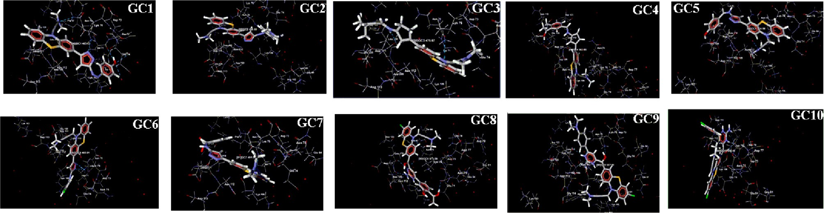

Fig. 5. Interaction between synthesised compounds and human Dopamine D2 receptor (DA).

dimethylamino) propyl)-10*H*-phenothiazin-3-yl) methanone (GC8) induced the highest catalepsy period at the various time intervals such as 60, 120, 180 and 240 min. Compound GC8 (7.5 mg/kg and 15 mg/kg) significantly reduces the level of normal dopamine and generated catalepsy as similar to that of haloperidol treated animals with the percentage of 17.3%,41.6%,37.0%,35.8% and 39.5%, 57.1%, 54.0%, 51.8% respectively at various time interval

such as 60, 120, 180 and 240 min. Effects of behavioural assess-

ment in haloperidol/synthesised compound administered rat by metallic bar test were shown in Table 8 and Fig. 11.

1. Discussion

The route of prepared analogues was depicted in the synthetic scheme (Figs. 1 & 2) outlines the preparation part of the synthe- sised analogues. The Azodye compounds were prepared by

Table 6

Crystal data and structural refinement for compound GC8.

Table 7

Bond distances and bond angle of GC8 compound.

|  |  |  |  |  |  |
| --- | --- | --- | --- | --- | --- |
| Identification code | Compound GC8 |  | Bond distances (Å) | Bond angle (°) |  |
| Empirical formula | C29H28ClN5O3S |  | C10A-C13A 1.562(3) | C10A-C13A-C14A | 113.7(2) |
| Formula weight | 561 |  | C13A-C14A 1.507(8) | C22A-O03A-C24A | 117.5(8) |
| Crystal system | Monoclinic |  | C13A-O01A 1.236(5) | C20A-C21A-O02A | 119.7(2) |
| Crystal size (mm) | 0.28 × 0.28 × 0.25 |  | C21A-O02A 1.427(5) | N01A-C25A-C26A | 124.2(3) |
| Temperature (K) | 296 |  | C22A-O03A 1.473(2) | C25A-C26A-C27A | 116.4(5) |
| Space group | P 21/n |  | O03A-C24A 1.412(3) | C26A-C27A-N05A | 126.8(3) |
| Wave length (Ao) | 0.71835 |  | N01A-C25A 1.406(2) | C27A-N05A-C28A | 124.1(8) |
| Volume (Ao3) | 1687.46 (12) |  | C25A-C26A 1.519(3) | C27A-N05A-C29A | 127.4(5) |
| Absorption coefficient (mm—1) | 0.058 |  | C26A-C27A 1.502(5) | N05A-C28A-C29A | 121.4(5) |
| F (ooo) | 1017 |  | C27A-N05A 1.418(6) |  |  |
| Z | 4 |  | N05A-C28A 1.424(3) |  |  |
| Calculated density (Mg/m3) | 1.572 |  | N05A-C29A 1.405(2) |  |  |
| Theta range for data collection | 2.81°–29.47° |  |  |  |  |
| Index range | —9 ≤ *h* ≤ 13 |  |  |  |  |

—12 ≤ *k* ≤ 14

—14 ≤ *l* ≤ 10

Measured reflections 8031

Independent/observed reflections 3185

Data/restraints/parameters 13352/1/528

Refinement method Full-matrix least-squares on F2

Goodness-of-fit on F2 1.168

Final R indices [I > 2 r (I)] R1 = 0.0548, xR2 = 0.1428

R indices [all data] R1 = 0.0149, xR2 = 0.1784

Extinction coefficient 0.03819 (12)

Largest diff. Peak and hole (e·Å3) 0.314/—0.232

the synthetic compounds was identified by 1H NMR spectroscopy from the chemical shift. The spectra showed a quintet at d 1.20–

1.90 ppm corresponding to methylene proton (CH2), a triplet at d

2.52–3.47 ppm corresponding to methylene proton (CH2), a singlet at d 2.24–2.71 ppm corresponding to *N,N*-dimethyl amine proton (*N*-(CH3)2); a singlet at d 3.64–3.70 ppm corresponding to a meth- oxy proton (OCH3); a singlet at d 4.11–4.28 ppm corresponding to amine proton (NH2); a singlet at d 4.95–5.27 ppm corresponding to hydroxyl proton (OH)); a singlet at d 6.72–8.37 ppm corresponding

performing an interaction between 5-(10-(3-(*N,N*-Dimethylamino) propyl-10*H*-phenothiazine-3-yl)-1,3,4-thiadiazole-2-amine, sodium nitrite, Con. HCl and the different coupling reagents. The Schiff base derivatives were prepared by condensation of 5-(10- (3-(*N,N*-Dimethylamino) propyl-10*H*-phenothiazine-3-yl)-1,3,4-th iadiazole-2-amine and different aromatic aldehydes. The deriva- tives of Chalcone were prepared from Claisen-Schmidt condensa- tion reaction between 1-(7-Chloro-10-(3-(*N,N*-dimethylamino)- 10*H*-Phenothiazine-3-yl) ethanone, different aldehyde and quani- dine. The FT-IR and 1H NMR spectrum of synthetic analogues were shown peaks due to different groups present in the analogues. In FT-IR spectrum, strong bands at the region of 704, 735, 623, 612,

1502, 1306, 1210, 1245, 3457, 3364, 3414, 3405, 1725, 2854,

3436, 3492, 3426, 1663, 1670, 1665 cm—1 could be attributed to the chloro, nitro, methoxy, hydroxyl, carboxylic, amino and car-

in between 3187–3016 cm—1 and 1473–1403 cm—1. A strong absorption peak at 1662–1649 cm—1 is due to the presence of the bonyl group respectively. The aryl ring was raised stretching peak

azomethine group (AC@NH). The number of proton present in

to aromatic protons(Ar-H); a doublet at d 6.42–8.62 ppm corre- sponding to aromatic protons (Ar-H); a triplet at d 6.46–8.23 ppm corresponding to aromatic protons (Ar-H); a multiplet at d

6.25–7.65 ppm corresponding to aromatic protons (Ar-H) and a singlet at d 7.94–8.71 ppm corresponding to azomethine proton (C@NH), a singlet at d 10.95–11.05 ppm corresponding to a car- boxylic acid proton (COOH). The synthesised compound molecular mass was confirmed by the Shimadzu mass spectrometer. The result of the antipsychotic activity of synthetic compounds was depicted in Table 8. It indicates catalepsy time of experimental ani- mals after administration of haloperidol/synthesised compounds at the interval of 30, 60, 120, 180 and 240 min. Compound with electron donating groups on aryl ring showed remarkable antipsy- chotic activity over the unsubstituted and electron withdrawing group oriented compound.

1. Conclusion

The study stated that easy way of synthesis of novel Azodye/ Schiff base/Chalcone derivatives and act as a powerful template for making a potent antipsychotic agent through molecular

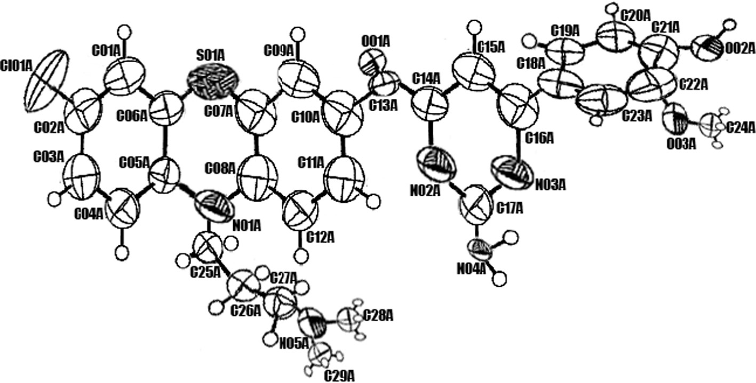

Fig. 6. Compound GC8 ORTEP view at 30% probability level.

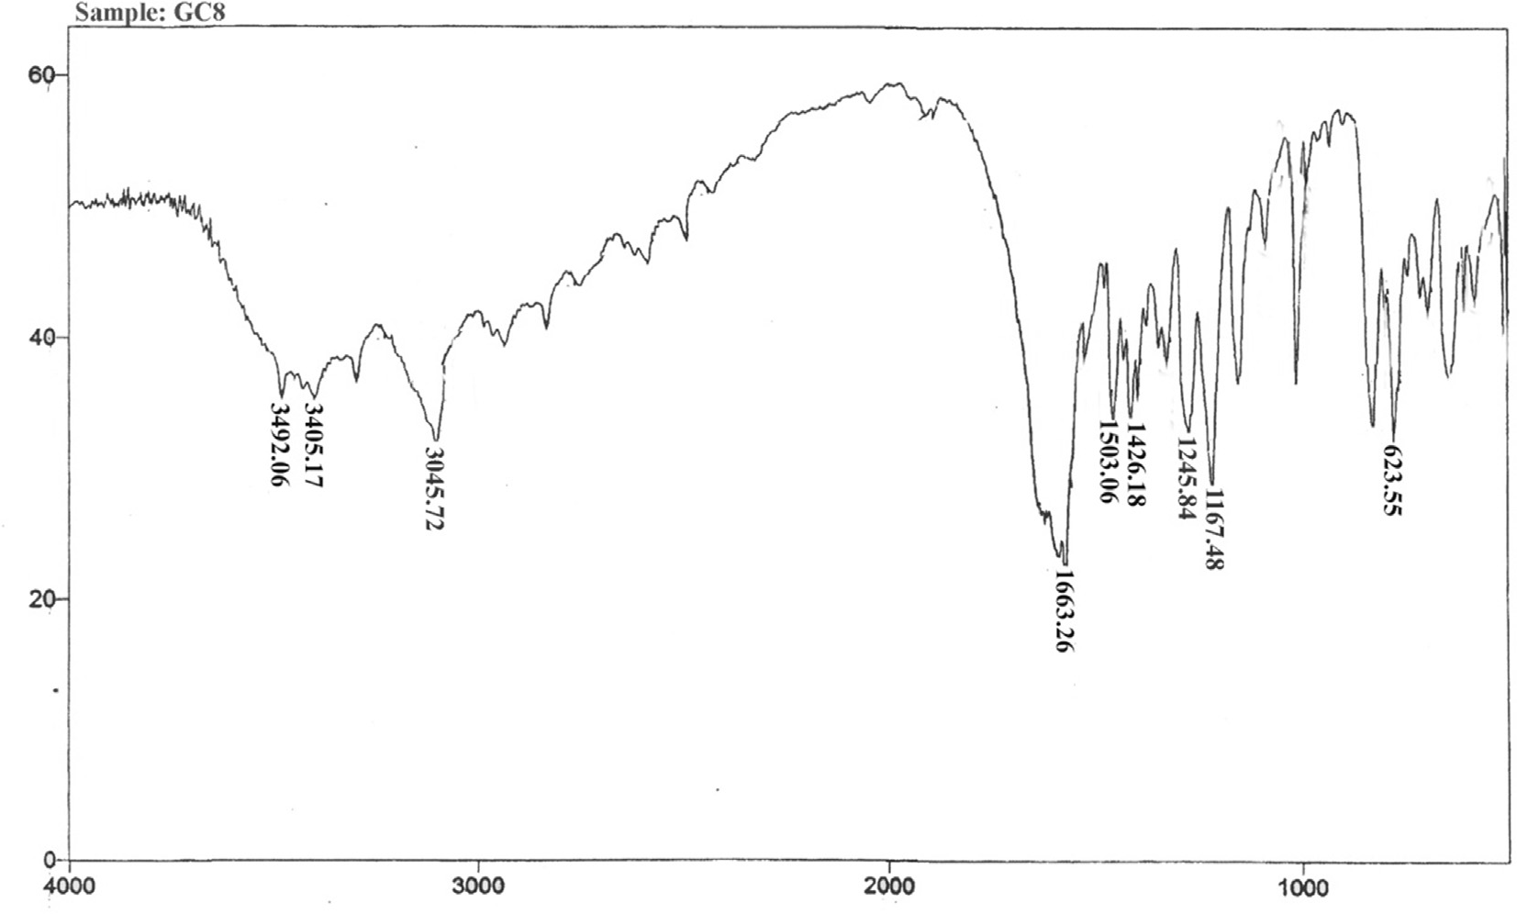

Fig. 7. FT-IR spectrum of synthesised compound (GC8).

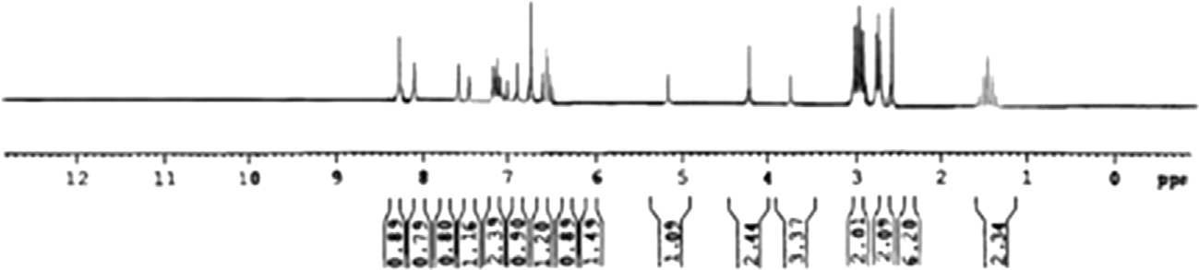

Fig. 8. 1H NMR spectrum of synthesised compound (GC8).

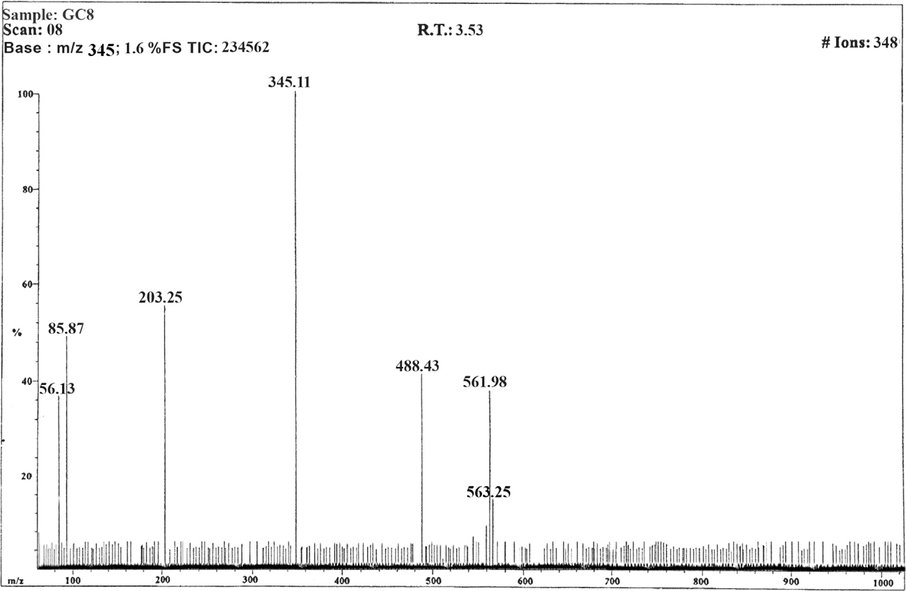

Fig. 9. Mass spectrum of synthesised compound (GC8).

CH3

CH2 CH2 N

H2C

N

Cl

CH3

O

S

OCH3

OH

S

C

N N

N

H2C

CH2 CH2 N

CH3

NH2

C

N N

CH3 NH2

Cl

-C3H2O2

O

C29H28ClN5O3S C26H26ClN5OS

m/z = 561 m/z = 488

-C8N3O2

O C

N

CH3

O

Cl

S

C

N

H2C

CH2  CH2  N

CH3

-C6H11ClS

H2C CH2CH2  N

C12H15N2O

m/z = 203

CH3

C18H26ClN2OS

m/z = 345

CH3

-C7H3NO

CH3

H C CH

2 2  CH2  N

CH3

C5H12N

-C2H4

CH3

CH2  N

CH3

C H N

3 8

m/z = 85

m/z = 56

Fig. 10. Positive ion ESI mass spectrum of compound GC8.

Table 8

Effect of anti-psychotic activity of synthesised compounds in Wistar rats.

|  |  |  |  |  |  |  |  |  |  |  |  |  |  |  |  |
| --- | --- | --- | --- | --- | --- | --- | --- | --- | --- | --- | --- | --- | --- | --- | --- |
| Drug treatment | 30 min |  |  | 60 min |  |  | 120 min |  |  | 180 min |  |  | 240 min |  |  |
|  | 7.5 mg | 15 mg |  | 7.5 mg | 15 mg |  | 7.5 mg | 15 mg |  | 7.5 mg | 15 mg |  | 7.5 mg | 15 mg |
| GC1 | 69.773 ± | 39.452 ± |  | 125.035 ± | 89.864 ± |  | 101.052 ± | 74.156 ± |  | 87.164 ± | 65.821 ± |  | 54.264 ± | 41.742 ± |  |
|  | 0.417 | 0.364 |  | 2.754* | 3.045* |  | 4.013** | 3.572** |  | 3.027* | 5.174* |  | 3.842 | 2.845 |  |
| GC2 | 68.502 ± | 37.371 ± |  | 121.271 ± | 88.428 ± |  | 99.863 ± | 73.095 ± |  | 86.653 ± | 64.749 ± |  | 53.054 ± | 40.162 ± |  |
|  | 0.182 | 0.742 |  | 2.471* | 3.062** |  | 3.372* | 3.026** |  | 3.853* | 4.028** |  | 3.026* | 2.063* |  |
| GC3 | 73.975 ± | 43.771 ± |  | 128.656 ± | 97.112 ± |  | 114.658 ± | 82.367 ± |  | 95.452 ± | 73.672 ± |  | 59.386 ± | 46.755 ± |  |
|  | 0.174 | 0.165 |  | 2.874* | 3.853* |  | 3.629** | 3.952** |  | 2.967* | 3.453* |  | 3.652 | 2.425 |  |
| GC4 | 76.917 ± | 46.911 ± |  | 131.372 ± | 102.115 ± |  | 123.094 ± | 91.576 ± |  | 105.424 ± | 83.163 ± |  | 69.243 ± | 51.022 ± |  |
|  | 0.152 | 0.167 |  | 2.110** | 2.088* |  | 2.654* | 3.081** |  | 2.113* | 2.113* |  | 2.671 | 2.537 |  |
| GC5 | 75.834 ± | 44.829 ± |  | 129.763 ± | 99.156 ± |  | 118.214 ± | 86.548 ± |  | 99.401 ± | 80.172 ± |  | 63.052 ± | 49.014 ± |  |
|  | 0.174 | 0.056 |  | 2.387** | 3.056* |  | 2.764** | 3.542 |  | 2.273** | 2.942* |  | 2.621* | 2.210 |  |
| GC6 | 80.151 ± | 49.832 ± |  | 135.022 ± | 113.201 ± |  | 136.167 ± | 99.017 ± |  | 119.265 ± | 93.134 ± |  | 76.136 ± | 58.263 ± |  |
|  | 0.212 | 0.547 |  | 2.985* | 2.914** |  | 2.097* | 4.943** |  | 2.267** | 2.324* |  | 2.567 | 2.374 |  |
| GC7 | 71.801 ± | 41.743 ± |  | 126.548 ± | 94.176 ± |  | 109.372 ± | 77.843 ± |  | 91.864 ± | 69.658 ± |  | 56.761 ± | 42.751 ± |  |
|  | 0.482 | 0.548 |  | 2.631** | 3.642* |  | 3.065** | 3.127** |  | 3.547* | 4.153* |  | 3.052 | 2.092 |  |
| GC8 | 66.512 ± | 36.163 ± |  | 119.275 ± | 87.146 ± |  | 98.175 ± | 72.356 ± |  | 85.182 ± | 62.651 ± |  | 52.614 ± | 39.761 ± |  |
|  | 0.154 | 0.127 |  | 2.053* | 3.267** |  | 3.953** | 3.093** |  | 3.163* | 4.028** |  | 3.031* | 2.165* |  |
| GC9 | 78.247 ± | 47.927 ± |  | 133.037 ± | 107.258 ± |  | 130.113 ± | 97.036 ± |  | 112.253 ± | 88.108 ± |  | 72.861 ± | 55.763 ± |  |
|  | 0.763 | 0.131 |  | 2.243** | 2.932* |  | 2.871** | 4.022** |  | 2.372** | 2.076* |  | 2.325* | 2.121 |  |

(*continued on next page*)

|  |  |  |  |  |  |  |  |  |  |  |  |  |  |  |  |
| --- | --- | --- | --- | --- | --- | --- | --- | --- | --- | --- | --- | --- | --- | --- | --- |
| Table 8 (*continued*) |  |  |  |  |  |  |  |  |  |  |  |  |  |  |  |
| Drug treatment | 30 min |  |  | 60 min |  |  | 120 min |  |  | 180 min |  |  | 240 min |  |  |
|  | 7.5 mg | 15 mg |  | 7.5 mg | 15 mg |  | 7.5 mg | 15 mg |  | 7.5 mg | 15 mg |  | 7.5 mg | 15 mg |  |
| GC10 | 82.351 ± | 51.942 ± |  | 137.022 ± | 121.534 ± |  | 141.132 ± | 103.017 ± |  | 124.224 ± | 96.104 ± |  | 77.133 ± | 61.244 ± |  |
|  | 0.178 | 0.512 |  | 2.985* | 2.354** |  | 2.127* | 4.943** |  | 2.065* | 2.322* |  | 2.431 | 2.021 |  |
| Haloperidol (1 g) | 85.742 ± 0.546** | | 144.654 ± 3.172** | | | 168.159 ± 3.572** | | | 135.438 ± 4.743** | | | 81.852 ± 5.563** | | | |
| Blank | 0.0 ± 0.0 | | 0.0 ± 0.0 | | | 0.0 ± 0.0 | | | 0.0 ± 0.0 | | | 0.0 ± 0.0 | | | |

** P < .05.

* P < 0.01as compared to blank and standard respectively. Statistical analysis – One way ANOVA.

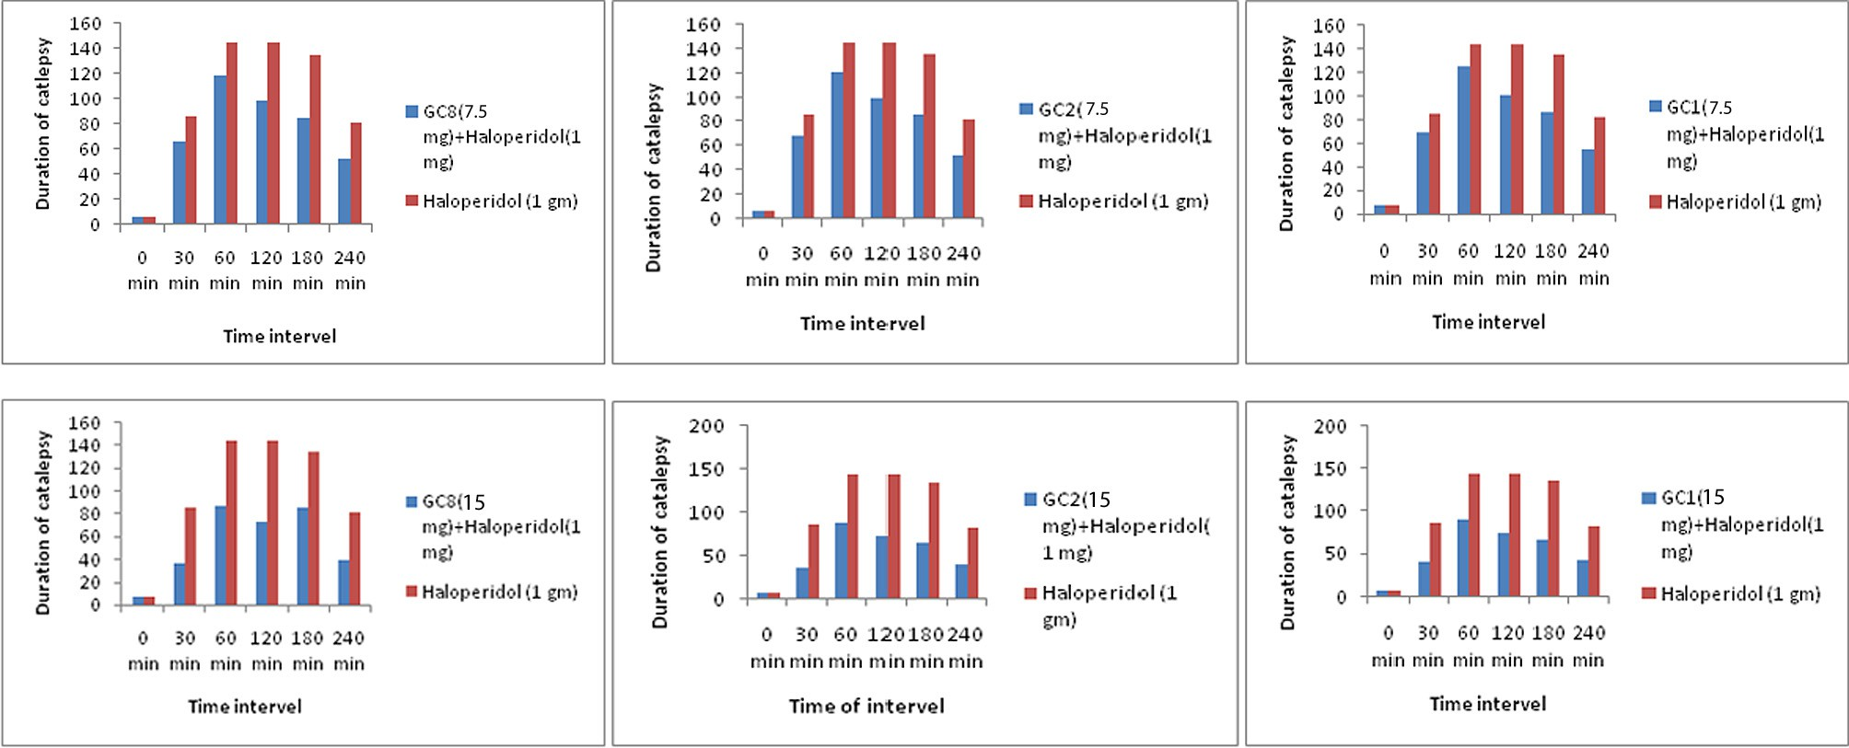

Fig. 11. Effects of synthesised compounds (GC8, GC2 and GC1) induced catalepsy in Wistar rats.

docking and haloperidol-induced catalepsy metallic bar test. Most of the compounds were perfectly docked to a hydrophobic and hydrophilic centre of the human dopamine D2 receptor with the support of key amino-acids like Asp 123, Leu110, Asp 111, Asp 109, Asn 112, Thr 66, Asn 70 Lys 76, Glu 74, Arg 79, Asn 75 and Glu 84 etc., these amino acid residues are allowing the molecules to bind firmly with human dopamine D2 receptor by forming a salt

bridge, hydrogen bond and p-p interaction with the ligand. There-

fore, the binding energy of each ligand lies between the ranges of 09.19985–0.533093 kcal/moles (Table 4). In addition to that each compound had been shown an excellent anti-psychotic activity in a haloperidol-induced catalepsy metallic bar test. The results found are firmly similar to docking study. Among the various ana- logues, compound GC8 and GC2 were bound more effectively to the receptor through electron donating groups such as OH, OCH3 and N (CH3)2 present in the part of the molecular structure and offered excellent antipsychotic activity. Therefore, there is a need for fur- ther study of the above-mentioned compounds for the develop- ment of the novel atypical antipsychotic agent.

Acknowledgments

All authors wish to express the gratitude to GIET School of Phar- macy, Rajahmundry, Andhra Pradesh, India, for providing research facilities. We are also thankful to Dr N. Murugeshan, Indian Insti- tute of Technology, Chennai, Tamil Nadu, India, for providing a spectral data of synthesised compounds time to time.

Appendix A. Supplementary data

Supplementary data associated with this article can be found, in the online version, at <https://doi.org/10.1016/j.ejbas.2017.10.003>.

References

1. [Qian Y, Chen M, Forssberg H, Diaz Heijtz R. Genetic variation in dopamine-](http://refhub.elsevier.com/S2314-808X(16)30204-4/h0005) [related gene expression influences motor skill learning in mice. Genes Brain](http://refhub.elsevier.com/S2314-808X(16)30204-4/h0005) [Behav 2013;12:604–14](http://refhub.elsevier.com/S2314-808X(16)30204-4/h0005).
2. [Song J, Kim J. Degeneration of dopaminergic neurons due to metabolic](http://refhub.elsevier.com/S2314-808X(16)30204-4/h0010) [alterations and parkinson’s disease. Front Aging Neurosci 2016;8:1–11](http://refhub.elsevier.com/S2314-808X(16)30204-4/h0010).
3. [Bradley SJ, Tobin AB. Design of next-generation g protein–coupled receptor](http://refhub.elsevier.com/S2314-808X(16)30204-4/h0015) [drugs: linking novel pharmacology and *in vivo* animal models. Annu Rev](http://refhub.elsevier.com/S2314-808X(16)30204-4/h0015) [Pharmacol Toxicol 2016;56:535–59](http://refhub.elsevier.com/S2314-808X(16)30204-4/h0015).
4. [Gurevich EV, Gainetdinov RR, Gurevich VV. G protein-coupled receptor kinases](http://refhub.elsevier.com/S2314-808X(16)30204-4/h0020) [as regulators of dopamine receptor functions. Pharmacol Res 2016;111:1–16](http://refhub.elsevier.com/S2314-808X(16)30204-4/h0020).
5. [Lanzenka MF, Legakis LP, Negus SS. Opposing effects of dopamine D1- and D2-](http://refhub.elsevier.com/S2314-808X(16)30204-4/h0025) [like agonists on intracranial self-stimulation in male rats. Exp Clin](http://refhub.elsevier.com/S2314-808X(16)30204-4/h0025) [Psychopharmacol 2016;24. 193-05](http://refhub.elsevier.com/S2314-808X(16)30204-4/h0025).
6. [Cho DI, Min C, Jung KS, Cheong SY, Zheng M, Cheong SJ, et al. The *N*-terminal](http://refhub.elsevier.com/S2314-808X(16)30204-4/h0030) [region of the dopamine D2](http://refhub.elsevier.com/S2314-808X(16)30204-4/h0030) [receptor, a rhodopsin-like GPCR, regulates correct](http://refhub.elsevier.com/S2314-808X(16)30204-4/h0030) [integration into the plasma membrane and endocytic routes. Br J Pharmacol](http://refhub.elsevier.com/S2314-808X(16)30204-4/h0030) [2012;166:659–75](http://refhub.elsevier.com/S2314-808X(16)30204-4/h0030).
7. [Dreyer JK. Three mechanisms by which striatal denervation causes breakdown](http://refhub.elsevier.com/S2314-808X(16)30204-4/h0035) [of dopamine signaling. J Neuro Sci 2014;34:12444–56](http://refhub.elsevier.com/S2314-808X(16)30204-4/h0035).
8. [Meng XY, Mezei M, Cui M. Computational approaches for modeling gpcr](http://refhub.elsevier.com/S2314-808X(16)30204-4/h0040) [dimerization. Curr Pharm Biotechnol 2014;15. 996-06](http://refhub.elsevier.com/S2314-808X(16)30204-4/h0040).
9. [Kumar S, Wahi SK, Singh R. Synthesis and preliminary pharmacological](http://refhub.elsevier.com/S2314-808X(16)30204-4/h0045) [evaluation of 2-[4-(aryl substituted) piperazin-1-yl]-N-phenylacetamides:](http://refhub.elsevier.com/S2314-808X(16)30204-4/h0045) [potential antipsychotics. Trop J Pharm Res 2011;10:265–72](http://refhub.elsevier.com/S2314-808X(16)30204-4/h0045).
10. [Jaszczyszyn A, Gsiorowski K, Swiatek P, Malinka W, Cieoelik-Boczula K, Petrus](http://refhub.elsevier.com/S2314-808X(16)30204-4/h0050) [J, et al. Chemical structure of phenothiazines and their biological activity.](http://refhub.elsevier.com/S2314-808X(16)30204-4/h0050) [Pharmacol Rep 2012;64:16–23](http://refhub.elsevier.com/S2314-808X(16)30204-4/h0050).
11. [Mao YM, Zhang MD. Augmentation with antidepressants in schizophrenia](http://refhub.elsevier.com/S2314-808X(16)30204-4/h0055) [treatment: benefit or risk. Neuropsychiatr Dis Treat 2015;11:701–13](http://refhub.elsevier.com/S2314-808X(16)30204-4/h0055).
12. [Singh SP, Deb CR, Ahmed SU, Saratchandra Y, Konwar BK. Molecular docking](http://refhub.elsevier.com/S2314-808X(16)30204-4/h0060) [simulation analysis of the interaction of dietary flavonols with heat shock](http://refhub.elsevier.com/S2314-808X(16)30204-4/h0060) [protein 90. J Biomed Res 2016;30:67–74](http://refhub.elsevier.com/S2314-808X(16)30204-4/h0060).
13. [Korb O, Ten BT, Victor Paul Raj FR, Keil M, Exner TE. Are predefined decoy sets](http://refhub.elsevier.com/S2314-808X(16)30204-4/h0065) [of ligand poses able to quantify scoring function accuracy. J Comput Aided Mol](http://refhub.elsevier.com/S2314-808X(16)30204-4/h0065) [Des 2012;26:185–97](http://refhub.elsevier.com/S2314-808X(16)30204-4/h0065).
14. [Cen G, Herold JM, Kireev D. Assessment of free energy predictors for ligand](http://refhub.elsevier.com/S2314-808X(16)30204-4/h0070) [binding to a methyllysine histone code reader. J Comput Chem](http://refhub.elsevier.com/S2314-808X(16)30204-4/h0070) [2012;33:659–66](http://refhub.elsevier.com/S2314-808X(16)30204-4/h0070).
15. [Gopi C, Sastry VG, Dhanaraju MD. Synthesis, spectroscopic characterization, X-](http://refhub.elsevier.com/S2314-808X(16)30204-4/h0075) [ray crystallography, structural activity relationship and antimicrobial activity](http://refhub.elsevier.com/S2314-808X(16)30204-4/h0075)

[of some novel 4- (5-(10-(3-N,N-dimethylamino) propyl)-10H-phenothiazine-](http://refhub.elsevier.com/S2314-808X(16)30204-4/h0075) [3-yl) -1,3,4-thiadiazole-2yl) Azo dye/Schiff base derivatives. Future J Pharma](http://refhub.elsevier.com/S2314-808X(16)30204-4/h0075) [Sci 2017. xx: 1-11](http://refhub.elsevier.com/S2314-808X(16)30204-4/h0075).

1. [Kumar R, Singh M, Prasad DN, Silakari OM, Sharma S. Synthesis and chemical](http://refhub.elsevier.com/S2314-808X(16)30204-4/h0080) [characterization of 9-anilinoacridines. Chem Sci Trans 2013;2:246–50](http://refhub.elsevier.com/S2314-808X(16)30204-4/h0080).
2. [Satyanarayana B, Muralikrishna P, Kumar DR, Ramachandran D. Preparation](http://refhub.elsevier.com/S2314-808X(16)30204-4/h0085) [and biological evaluation of phenothiazine derivatives. J Chem Pharma Res](http://refhub.elsevier.com/S2314-808X(16)30204-4/h0085) [2013;5:262–6](http://refhub.elsevier.com/S2314-808X(16)30204-4/h0085).
3. [Pooja M, Suroor AK, Surajpal V, Ozair A. Synthesis, characterization and](http://refhub.elsevier.com/S2314-808X(16)30204-4/h0090) [antimicrobial activity of new thiadiazole derivative. Bull Korean Chem Soc](http://refhub.elsevier.com/S2314-808X(16)30204-4/h0090) [2010;31:2345–50](http://refhub.elsevier.com/S2314-808X(16)30204-4/h0090).
4. [Morak-Mlodawska B, Pluta K, Zimecki M, Jelen M, Artym J, Kocieba M.](http://refhub.elsevier.com/S2314-808X(16)30204-4/h0095) [Synthesis and selected immunological properties of 10-substituted 1,8-](http://refhub.elsevier.com/S2314-808X(16)30204-4/h0095) [diazaphenothiazines. Med Chem Res 2015;24:1408–18](http://refhub.elsevier.com/S2314-808X(16)30204-4/h0095).
5. [Kumar N, Drabu S, Shalini K. Synthesis and pharmacological screening of 4,6-](http://refhub.elsevier.com/S2314-808X(16)30204-4/h0100) [substituted di-(phenyl) pyrimidin-2-amine. Arab J Chem 2017;10:S877–80](http://refhub.elsevier.com/S2314-808X(16)30204-4/h0100).
6. [Kant R, Kumar D, Agarwa D, Gupta RD, Tilak R, Awasthi SK, Agarwal A.](http://refhub.elsevier.com/S2314-808X(16)30204-4/h0105) [Synthesis of newer 1,2,3-triazole linked chalcone and flavone hybrid](http://refhub.elsevier.com/S2314-808X(16)30204-4/h0105) [compounds and evaluation of their antimicrobial and cytotoxic activities.](http://refhub.elsevier.com/S2314-808X(16)30204-4/h0105) [Eur J Med Chem 2016;113:34–49](http://refhub.elsevier.com/S2314-808X(16)30204-4/h0105).
7. [Ganapayya B, Jayarama A, Sankolli R, Hathwar VR, Dharmaprakash SM.](http://refhub.elsevier.com/S2314-808X(16)30204-4/h0110) [Synthesis, growth, and characterization of a new NLO material3-(2,3-](http://refhub.elsevier.com/S2314-808X(16)30204-4/h0110) [dimethoxyphenyl)-1-(pyridin-2-yl)prop-2-en-1-one. J Mol Struct](http://refhub.elsevier.com/S2314-808X(16)30204-4/h0110) [2012;1007:175–8](http://refhub.elsevier.com/S2314-808X(16)30204-4/h0110).
8. [Bhattacharjee N, Paul R, Giri A, Borah A. Chronic exposure of homocysteine in](http://refhub.elsevier.com/S2314-808X(16)30204-4/h0115) [mice contributes to dopamine loss by enhancing oxidative stress in](http://refhub.elsevier.com/S2314-808X(16)30204-4/h0115) [nigrostriatum and produces behavioral phenotypes of Parkinson’s disease.](http://refhub.elsevier.com/S2314-808X(16)30204-4/h0115) [Biochem Biophys Rep 2016;6:47–53](http://refhub.elsevier.com/S2314-808X(16)30204-4/h0115).
9. [Nishchal BS, Rai S, Prabhu MN, Ullal SD, Rajeswari S, Gopalakrishna HN. Effect](http://refhub.elsevier.com/S2314-808X(16)30204-4/h0120) [of Tribulus terrestris on Haloperidol-induced Catalepsy in Mice. Indian J Pharm](http://refhub.elsevier.com/S2314-808X(16)30204-4/h0120) [Sci 2014;76:564–7](http://refhub.elsevier.com/S2314-808X(16)30204-4/h0120).