

[Egyptian Informatics Journal (2016) 17, 89](http://dx.doi.org/10.1016/j.eij.2015.08.004)–[98](http://dx.doi.org/10.1016/j.eij.2015.08.004)

Cairo University

Egyptian Informatics Journal

[www.elsevier.com/locate/eij](http://www.elsevier.com/locate/eij) [www.sciencedirect.com](http://www.sciencedirect.com/science/journal/11108665)

FULL-LENGTH ARTICLE

Design of a hybrid reconfigurable Software Defined Radio transceiver based on frequency shift keying using multiple encoding schemes



Nikhil Marriwala a,*, O.P. Sahu b, Anil Vohra c

a *Electronics and Communication Engg. Dept., University Institute of Engineering and Technology, Kurukshetra* *University, Kurukshetra, India*

b *Electronics and Communication Engineering Department, NIT, Kurukshetra, India*

c *Department of Electronic Science, Kurukshetra University, Kurukshetra, India*

Received 31 May 2015; revised 1 August 2015; accepted 16 August 2015

Available online 9 October 2015

Abstract Software Defined Radio (SDR) is the technology which has given researchers the oppor- tunity and flexibility of integration and intercommunication of existing and future networks together. The radio spectrum is the most vital resource for a mobile operator in today’s world of modern wireless communications. After analyzing the spectrum allocation map one can conclude that the most of the prime spectrums falling under the licensed bands have already been allocated for licensed users for exclusive use. There are very few unlicensed bands for the unlicensed users. SDR offers a perfect solution to this problem of spectrum scarcity being experienced in wireless communication systems. The demand for reliable, high data rate transmission has increased signif- icantly these days, which leads the way to adoption, of different digital modulation techniques.

The aim of this paper was to analyze Frequency Shift Keying (FSK) Transceiver built using Lab- oratory Virtual Instrumentation Engineering Workbench (LabVIEW) and to measure the reduction in data errors in the presence of Forward Error Correction (FEC) channel coding algorithms namely the Convolution and the Turbo Codes. Through this design a graphical representation of Bit Error Rate (BER) vs *E*b/*N*0 where (*E*b) is Energy per bit and (*N*0) is Spectral noise density has been given in the presence of Additive White Gaussian Noise (AWGN) introduced in the chan- nel. FSK is widely used for data transmission over band pass channels; hence, we have chosen FSK for the implementation of SDR. The SDR transceiver module designed has been fully implemented and has the ability to navigate over a wide range of frequencies with programmable channel bandwidth and modulation characteristics. We are able to build an interactive FSK based SDR

KEYWORDS

Software Defined Radio; Bit Error Rate (BER); Wireless communication; Frequency shift keying; Signal-to-Noise Ratio (SNR)

* Corresponding author.

E-mail address: [nikhilmarriwala@gmail.com](mailto:nikhilmarriwala@gmail.com) (N. Marriwala).

Peer review under responsibility of Faculty of Computers and Information, Cairo University.

**Production and hosting by Elsevier**

<http://dx.doi.org/10.1016/j.eij.2015.08.004>

1110-8665 © 2015 Production and hosting by Elsevier B.V. on behalf of Faculty of Computers and Information, Cairo University. This is an open access article under the CC BY-NC-ND license ([http://creativecommons.org/licenses/by-nc-nd/4.0/).](http://creativecommons.org/licenses/by-nc-nd/4.0/))

90 N. Marriwala et al.

transceiver in a shorter time with the use of LabVIEW. The outputs achieved show a low BER for very high data rates in the presence of AWGN noise.

© 2015 Production and hosting by Elsevier B.V. on behalf of Faculty of Computers and Information, Cairo University. This is an open access article under the CC BY-NC-ND license ([http://creativecommons.](http://creativecommons/)

org/licenses/by-nc-nd/4.0/).

1. Introduction

SDR systems are the ones which can adapt to the future-proof solution and it covers both existing and emerging standards. An SDR has to possess elements of reconfigurability, intelli- gence and software programmable hardware. As the function- ality is defined in software, a new technology can be easily implemented in a software radio by means of a software upgrade. Channel equalization is an important subsystem in the Software Defined Radio (SDR) receiver [15]. For many years modulation techniques have been extensively used for various wireless applications, but the modern communication system requires data transmitted at a higher rate, larger bandwidth [16].

This paper discusses an SDR system built using LabVIEW for FSK Transceiver. SDR provides an alternative to systems such as the third generation (3G) and the fourth generation (4G) systems. There are two frequency bands where the Soft- ware Defined Radio might operate in the near future, i.e. 54–862 MHz Very High Frequency (VHF) and Ultra High Frequency (UHF) TV bands and 3–10 GHz Ultra-wideband (UWB) radios [19,6]. A Software Defined Radio comprises of a programmable communication system where functional changes can be made by merely updating the software. SDR can be reconfigured and can talk and listen to multiple chan- nels at the same time. The transmitter of an SDR system con- verts digital signals to analog waveforms. The analog waveforms generated are then transmitted to the receiver. The received analog waveforms are then down converted, sam- pled, and demodulated using software on a reconfigurable baseband processor. Normally, high performance digital signal processors are used to serve as the baseband processor. SDR systems can be used in ubiquitous network environments because of its flexibility and programmability. The use of dig- ital signals reduces hardware, noise and interference problems as compared to the analog signal in transmission, which is one of the main advantages of digital transmission.

In this paper, the software simulator of the FSK Transceiver has been designed using LabVIEW [7,14,13]. FSK is chosen to be the modulation scheme of the designed Software Defined Radio system due to its easy implementation and widespread usage of legacy communications equipment, and FSK modula- tion techniques are considered to be very common technology for transmission and reception in current and future wireless communication, especially in the VHF and UHF frequency bands giving excellent BER vs SNR ratio with high data rates. A fully implemented SDR has the ability to navigate over a wide range of frequencies with programmable channel bandwidth and modulation characteristics [5,20,9]. The role of modulation techniques in an SDR is very crucial since modulation tech- niques define the core part of any wireless technology. They can be reconfigured and can talk and listen to multiple channels at the same. The role of modulation techniques in an SDR is very crucial since modulation techniques define the core part of any

wireless technology. SDR’s inherent flexibility must, however, be planned for in advance via hardware and software consider- ations, ultimately resulting in increased code portability, improved communications system life cycles, and reduced costs [1,18,10]. The elementary concept of the SDR is that the radio can be totally configured or defined by the software so that a common platform can be used across a number of areas and the software used to change the configuration of the radio for the function required at a given time. There is also the beingness that it can be re-configured as upgrades to standards arrive, or if it is required to manage other role, or if the ambit of its process is denatured. SDR can be reconfigured and can peach and hear to duplex channels at the identical time. The personation of mod- ulation techniques in an SDR is very important since modula- tion techniques define the core for any wireless systems [11,8,3]. The main interest in any communication group is the sure sending of signals of information from a transmitter to a recei- ver. The signals are transmitted via a guide who corrupts the signal. It is needful that the distorting effects of the channel and noise are minimized and that the information transmitted through the channel at any given time is maximized. The chan- nel is subject to various types of dissonance, twisting, and inter- ference [2]. Also, some communication systems have limitations on Transmitter power. All of this may lead to various types of errors. Consequently, we may need some form of error control

encoding in order to recover the information reliably [22].

1. Related work

To ensure reliable communication forward error-correcting (FEC) codes are the main part of a communication system. FEC is a technique in which we add redundant bits to the trans- mitted data to help the receiver correct errors. There are two types of FEC codes: the convolutional codes and block codes. When we use Block codes they are defined by *n* and *k*, where *n* describes the total number of coded bits and *k* gives the num- ber of input bits. In convolutional codes the coding is applied to the entire data stream as one code word [4]. In the year 1948, Shannon showed that arbitrarily reliable communication is only possible till the signal transmission rate does not exceed a certain limit which was termed as channel capacity. After this different algebraic codes such as Golay codes, Bose–Chaud huri–Hocquenghem (BCH) codes [1], and Reed–Solomon (RS) codes were created and used for error correction. The next series of codes originally referred as recurrent codes or Convo- lutional codes were given which helped further to improve the error control coding. The convolutional codes have efficient encoding and decoding algorithms and high performance over AWGN channels. Later on concatenated coding schemes were also given. Also some weak points were there of convolutional codes during bursty transmissions which were later on reduced using Reed–Solomon codes (RS codes) [17] by serially concate- nating a convolutional code with an RS code. Development of

Design of a Software Defined Radio transceiver 91

turbo codes is the most recent discovery in the coding theory. Turbo codes show performance of near to Shannon limit with iterative decoding algorithms. Many iterative decoding algorithms came into existence such as Gallagher’s low parity density check (LDPC) codes [21]. Though these Turbo codes exhibit excellent bit error performance but there are some prob- lems associated with them such as these codes generate a certain number of low weight code words which results in exhibition of an error ‘‘floor” in the BER curve at high SNR. Also the com- plexity of the soft-input, soft-output (SISO) decoder is such that low cost decoders are unavailable for many commercial applications. For these reasons, many applications still deploy RS codes because of its efficient decoder implementation [17] and excellent error correction capabilities.

The organization of this paper is as follows: Section 1 gives the Introduction about the SDR, Section 2 describes the Related work, Section 3 describes FSK Transceiver design, Section 4 presents the FSK Transceiver parameters, Section 5 describes the simulation of FSK Transceiver, in Section 6 we discuss the results achieved in detail and finally Section 7 explains the drawn Conclusions.

1. Frequency shift keying transceiver

In this paper, we have examined the digital modulation scheme Frequency Shift Keying (FSK) has dynamic characteristics of the carrier signal with respect to time and this alteration results in a sine gesticulate in a divergent phase, amplitude or fre- quency. This results in, contrasting ‘‘states” of the sine curve are referred to as symbols which represent few digital bit orna- mentation. The general Block Diagram of a generic Digital Transceiver is shown in Fig. 1.

The building blocks of the FSK Transceiver system are sta- ted in this section. This system has two parts: transmitter and receiver. The VI hierarchy for an FSK Transceiver with Multiple Encode and Decode techniques is shown in Fig. 2.

* 1. *Message source*

During the transmission pseudo noise (PN) bit sequences are generated as message signal. The selected pattern is repeated until the user-specified number of total bits is generated. PN sequence order specifies the order of the PN bit sequence to be generated. Valid values are 5–31, inclusive. If the PN sequence order is *N*, the output data are periodic with period

*T* = 2*N* — 1. Pseudorandom or pseudo noise (PN) sequences,

though deterministic in nature, satisfy many properties (auto- correlation, cross correlation, and so on) of random numbers. A *m*-sequence generates a periodic sequence of length

*L* = 2*m* — 1 bits and is generated by Linear Feedback Shift Registers (LFSR) as shown in Eq. (i):

*h* (*K*)= 1 + *K*2 + *K*5 (i)

where *K* denotes delay and the summations represent modulo 2 additions. The frame marker bits are inserted in front of the generated PN sequences as shown in Fig. 3.

* 1. *Source encoder*

This instance maps, bits to complex valued symbols for FSK modulation scheme and frequency deviations for FSK. Input byte stream specifies the incoming bit stream to be mapped to FSK symbols. Symbol map specifies an ordered array that maps each symbol value to its desired deviation frequency. The number of FSK levels in the array must be 2*N*, where *N* is the number of bits per symbol. To specify a prebuilt map, unbundle the symbol map element from the system parameters cluster generated by the FSK (M) or FSK (Map) instance. When the input bit stream is not comprised of an integer num- ber of symbols, the carryover bits are buffered. When reset? Is set to TRUE (default), this buffer is cleared at each call. When reset? Is set to FALSE, the carryover bits are added to the beginning of the input bit stream at the next call to this VI. This option is useful when the current block of data is contigu- ous with the preceding block of data.

* 1. *Pulse shaped filter*

The polymorphic instance uses Pulse shaping samples per sym- bol which specifies the number of desired samples per symbol for the pulse-shaping filter. If the pulse-shaping filter is used for demodulation, this parameter value must match the sam- ples per symbol element of the system parameters cluster passed to the demodulation VI. Specify an even number greater than 2. Matched samples per symbol, specify the num- ber of desired samples per symbol for the demodulation matched filter. This parameter value must match the samples per symbol element of the system parameters cluster passed to the digital demodulation VI. Specify an even number greater than 2. Pulse shaping filter coefficients return an ordered array of filter coefficients corresponding to the desired filter response to the pulse-shaping filter used in modulation. The calculated filter coefficients are used during modulation to reduce the bandwidth of the transmitted signal and during demodulation to reduce inter symbol interference. The pulse- shaping filter can be used either in transmission or for demod- ulation of FSK modulated signals. The matched filter is only used for demodulation. The VI calculates the impulse response of the filter using the following formulas:

Raised Cosine Filter is given by

1 —

RF

Rx

RF Front End

Tx

ADC

DUC

DAC

Baseband Processing

DDC

Section

IF

*T*

Baseband Section

*h*(*t*)= sinc

*t* cos pb*t*

(ii)

Section

*T* 4b2 *t*2

*T*2

Figure 1 Block Diagram of a generic Digital Transceiver.

* 1. *Channel encoder (line)*

This polymorphic instance generates an encoded bit stream based on a specified generator matrix. Input byte stream spec- ifies the bit sequence representing the data word to encode.

92 N. Marriwala et al.

Figure 2 VI hierarchy of FSK Transceiver.

Figure 3 Message source VI.

Generator matrix (*n* × *k*) specifies the generator connection polynomial matrix used for setting the convolutional feedfor- ward encoder connections in octal format. The Convolutional Encoder is modeled as a linear feedforward shift register

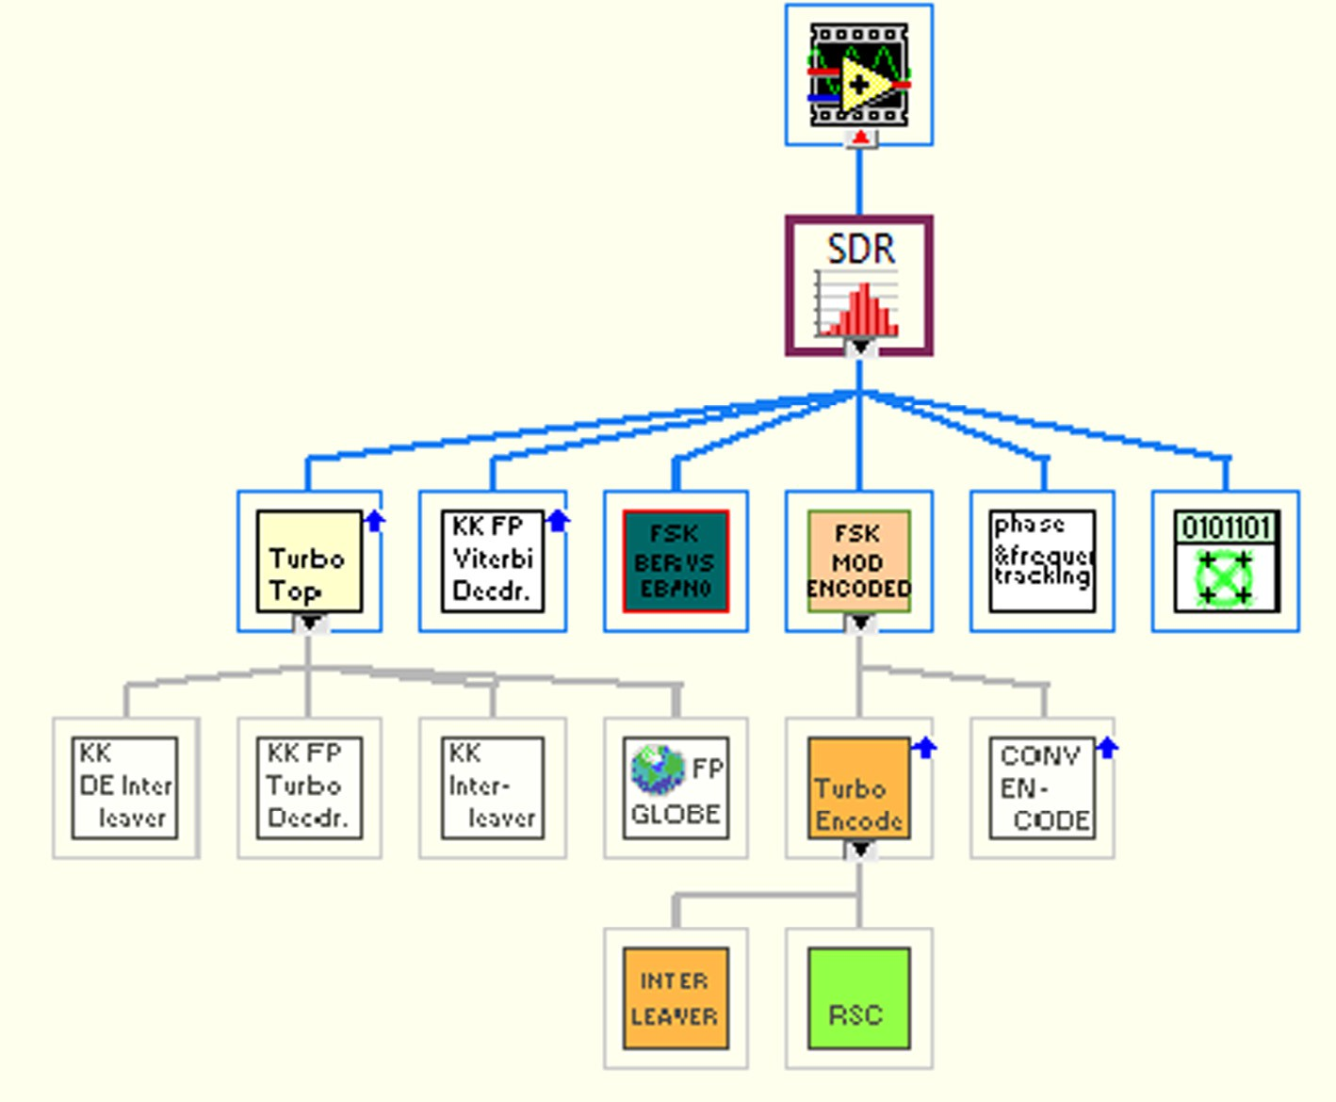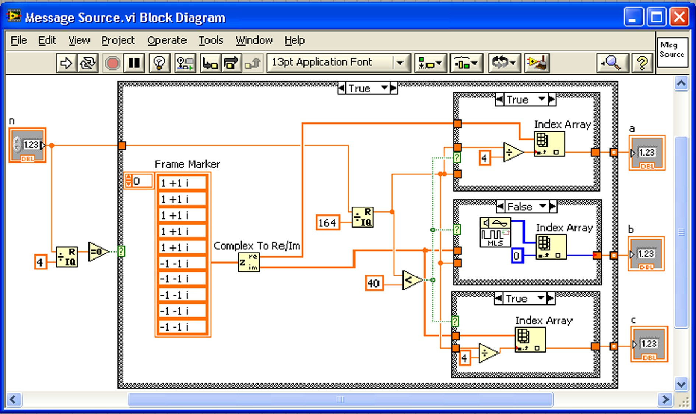

arrangement consisting of *k* rows with *K* — 1 shift registers per row, where *k* denotes the data word length and *K* denotes the constraint length. If *aij* {0 6 *i* 6 *n* — 1, 0 6 *j* 6 *k* — 1} denotes a particular element in the generator matrix, the row

Design of a Software Defined Radio transceiver 93

index *i* corresponds to the Convolutional Encoder output *yi* that is affected by this element, while the column index *j* cor- responds to the *j*th row in the *k* row shift register arrangement. Zeros are padded at the end of the corresponding code gener- ator sequences such that their total length is a multiple of three digits. Fig. 4 depicts the rate 2/3 Convolutional Encoder corre- sponding to the previously mentioned generator matrix, with a constraint length equal to 4. In Fig. 4, *D* represents a shift reg- ister or memory element.

Here, *yj*; 0 6 *j* 6 *n* — 1 denotes the *j*th output of the Convolutional Encoder, in the *i*th encoding instance.

*i*

modulation, and returns the modulated complex baseband waveform in the output complex waveform parameter. For FSK systems with more than 1 bit per symbol, such as 4- FSK, the symbols are converted to bits in least significant bit (LSB) first order. One frequency is designated as the ‘‘mark”

(1) frequency and the other as the ‘‘space” (0) frequency.

* 1. *Time varying channel*

We add time-varying channel to observe the adaptability of the system. The VI used for this purpose returns a signal–plus–

∞ noise waveform with a user-specified *E* /*N* , where *E* repre-

*yj* = X*hj x*

(iii)

b 0 b

*i k i*—*k*

*k*=0

sents the energy per bit, and *N*0 represents the Spectral noise

density. This VI generates zero-mean complex additive white

where *x* is an input sequence, *yj* is a sequence from output *j* and *hj* is an impulse response for output *j*. Convolution Encoder VI is shown in Fig. 5.

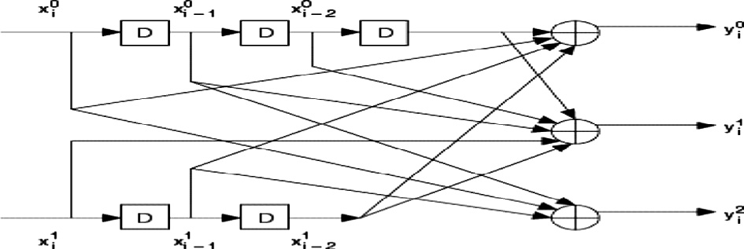

In this design we have used the Turbo Encoder for the sec- ond Encoding technique as shown in Fig. 6 which works by using two Convolutional Encoders. One encoder receives the data to be sent and the other receives an interleaved version of the data to be sent. The Convolutional Encoders are identi- cal and are rated 1. Each has 3 linear shift registers with a feed- back loop. The original data, the output from encoder 1, and the output from encoder 2 are then interleaved together before being transmitted.

* 1. *FSK modulator*

The FSK modulator accepts a *M*-ary value that specifies a pre- defined symbol map with the number of distinct symbol map values to use as symbols. The FSK instance calculates param- eters for use within the modulator. The system parameters cluster from this VI wire to the corresponding parameter of the appropriate modulation VI. M-FSK specifies the *M*-ary number, which is the number of distinct frequency deviations to use as symbols. This value must be a positive power of 2. FSK deviation specifies the maximum FSK frequency devia- tion. At baseband frequencies, deviations for individual sym- bols are evenly spaced in the interval [–fd, fd], where fd represents the frequency deviation. With discontinuous phase-FSK, modulation consists of selecting the appropriate sinusoid based on the input data. Thus, when switching between symbols, there is a discontinuity in the FSK signal phase. This VI maintains the phase of each independent sinu- soid versus time. In this way, the FSK modulator acts like a hardware-based (multiple switched tone generators) FSK modulator as shown in Fig. 7. Bits per symbol return the num- ber of bits represented by each symbol. This value is equal to Log2 (*M*), where *M* is the order of the modulation. FSK modulator receives a sequence of data bits, performs FSK

Figure 4 Convolutional Encoder.

Gaussian noise (AWGN) with a uniform power spectral den- sity and adds it to the complex baseband modulated wave- form. Input, complex waveform specifies the modulated complex baseband waveform data. The input bits per symbol specify the number of bits per symbol in the modulation for- mat underlying the input complex waveform. *E*b/*N*0 specifies the desired *E*b/*N*0 of the output complex waveform in dB. Out- put, complex waveform returns the signal–plus–noise complex baseband waveform data. The channel is Gaussian in nature because its probability density function can be accurately mod- eled to behave like a Gaussian distribution and it is called white as it has a constant power spectral density. The charac- teristic of the channel has varied with time by swinging the fil- ter passband from 100 to 900 Hz. Fig. 8 shows the time varying channel with the AWGN noise source. For true AWGN, the I and Q components of the additive noise must be interrelated.

* 1. *FSK demodulator*

The process of recovering the original message from the mod- ulated waveform is accomplished by the FSK demodulator. The VI used for demodulation demodulates an FSK- modulated complex baseband waveform and returns the time-aligned demodulated waveform, the demodulated infor- mation bit stream, and measurement results obtained during demodulation. This VI attempts to remove the carrier and phase offset by locking to the carrier signal. Samples per sym- bol specify an even, positive number of samples dedicated to each symbol. Multiply this value by the symbol rate to deter- mine the sample rate. Matched filter coefficients specify an ordered array containing the desired matched filter coeffi- cients. Frequency offset returns the measured carrier frequency offset, in hertz (Hz). Frequency drift returns the measured car- rier frequency drift, in hertz (Hz). Viterbi decoding is an opti- mization (in a maximum-likelihood sense) algorithm for decoding of a Convolutional code as this simplifies the decod- ing operation [5,7]. The decoder is a Viterbi decoder which then solves for the global optimum bit sequence. The algo- rithm updates a path cost as it steps through each stage of the possible output sequences. At each state, it also calculates the likelihood of entering each possible new state based on the cost of the previous state. The algorithm then needs two addi- tional zero bits after every sequence in order to force the enco- der back into the zero state and to assume that the encoder ends at the all zero state. These two tail bits represent a frac- tional loss rate between the coded and un-coded bit sequences. The Viterbi Decoder VI is shown in Fig. 9. Fig. 10 shows the

94 N. Marriwala et al.

Figure 5 Convolution Encoder VI.

Figure 6 Turbo Encoder VI.

Turbo Decoder VI used in this design. It Works by using a set of Maximum A posteriori Probability (MAP) decoders. When the data are received, it is deinterleaved back into the three streams which were sent from the transmitter:

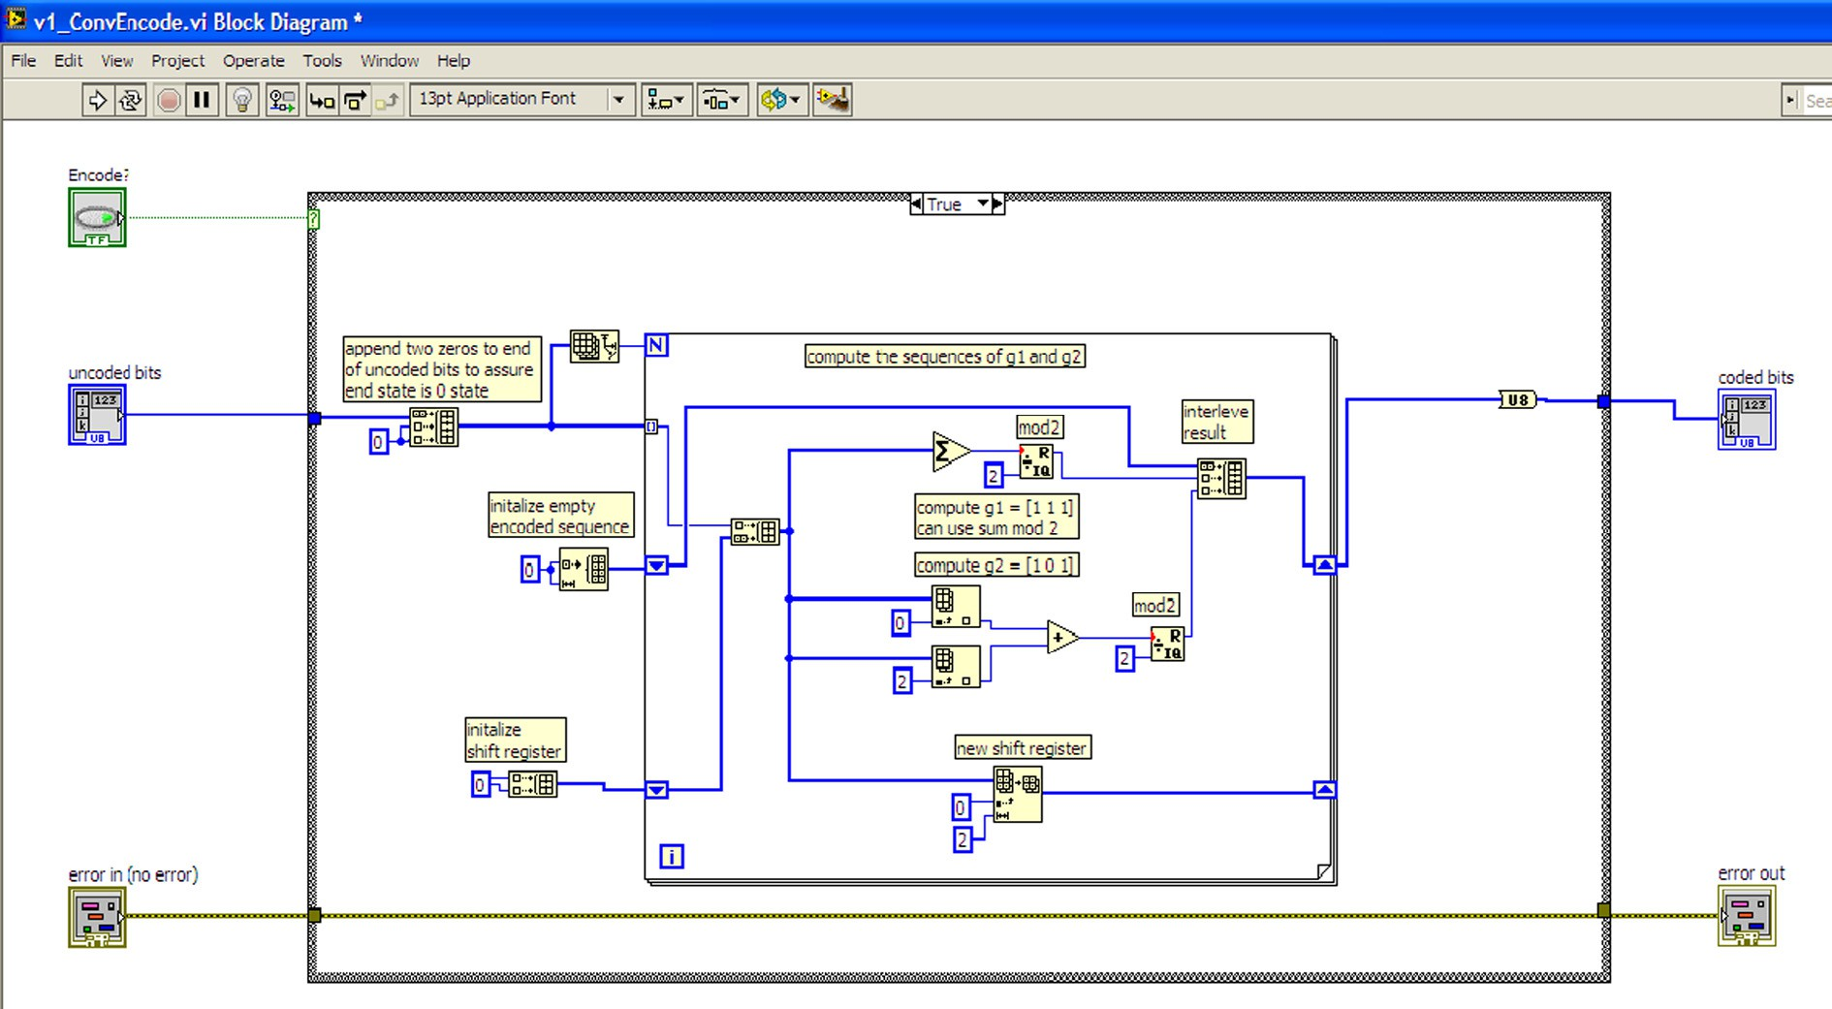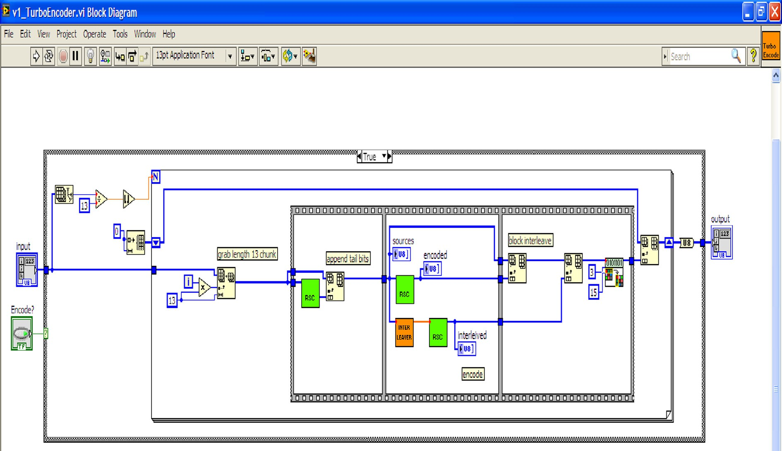

1. Original Data.
2. Output from Convolutional Encoder 1.
3. Output from Convolutional Encoder 2.

The first MAP Decoder takes as an input stream 1 and stream 2 and also the output from MAP Decoder 2 (initialized to zeros for the first iteration) [12,8]. The second MAP Decoder takes in an interleaved adaptation of stream 2 (the aforementioned interleaver used to interleave the original data before it was sent to the Convolutional Encoder), and the output from the original MAP Decoder. The two MAP Decoders then work together to converge on a solution: the most likely original bit sequence.

Design of a Software Defined Radio transceiver 95

Figure 7 FSK modulator VI.

output by the modulator. In this design the user has the option to choose any of the varieties of the filters from the given filters Raised Cosine (Nyquist), Square-root Raised Cosine, Gaussian Filters as shown in Table 1. Thus this design makes it a unique SDR where the user has the option to select the required filter and see that which filter gives the minimum BER.

Figure 8 AWGN and IQ impairments.

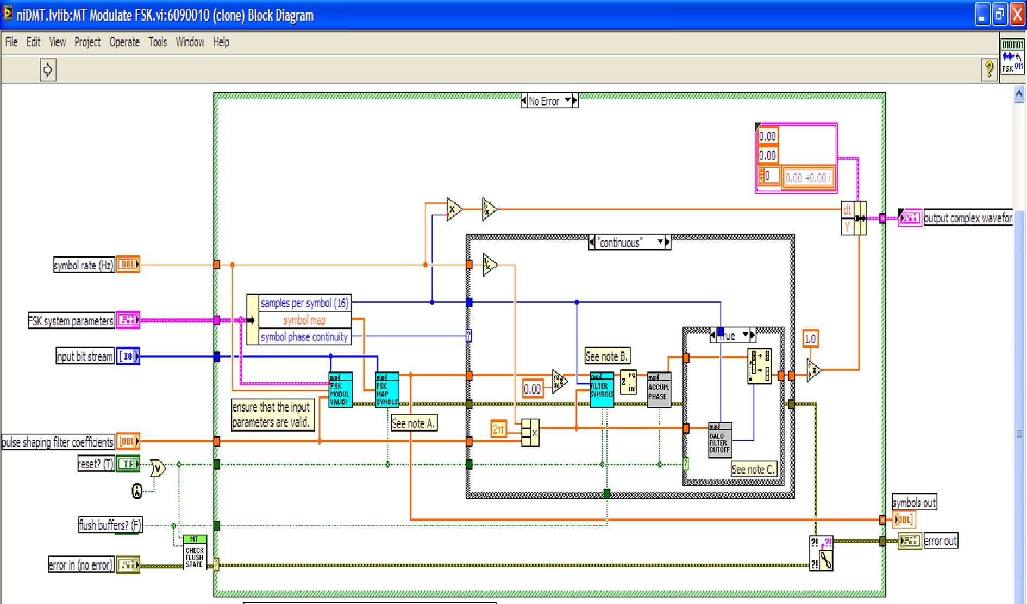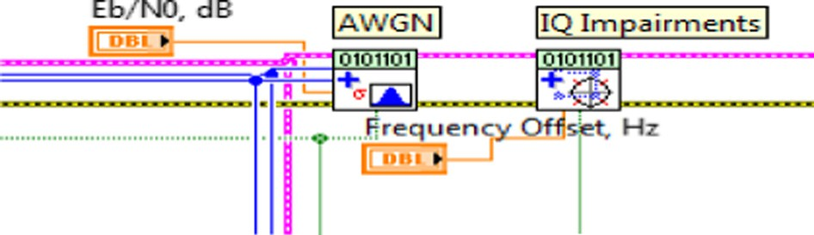

* 1. *Acquire symbol timing – frame synchronization mode*

The next step is to locate the first occurrence of the ideal symbol timing instant in the matched filter input complex waveform. It then applies phase-continuous re-sampling to align the first sample of the input complex waveform to the ideal symbol timing instant. The returned waveform is symbol-time aligned such that its first sample corresponds to the optimal (ideal) symbol instant. In VI shown in Fig. 11 the input samples are passed through Complex Queue PtByPt VI, which creates a data queue of complex numbers to obtain a beginning of a frame. This VI decimates the input complex waveform and returns the decimated output complex wave- form. This VI is used to decimate the matched filtered wave- form at the output to recover the symbols corresponding to the ideal symbol timing location.

1. FSK transceiver parameters
   1. *Transmitter filters*

Transmitter filter defines the type of band-limiting filter employed at the transmitter for pulse shaping the symbols

* + 1. *Raised Cosine Filter:* A Raised Cosine Filter is one of the most common pulse-shaping filters in communication systems. The Raised Cosine Filter is used to minimize inter symbol interference (ISI).
    2. *Root Raised Cosine Filter:* The Root Raised Cosine Filter is used to produce a frequency response with unity gain at low frequencies.

1. Lab-VIEW simulation of FSK Transceiver

In this section we describe the simulation results of M-FSK FSK Transceiver system. BER vs *E*b/*N*0 (dB) for 2, 4, 8, 16, 32, 64, 128, 256 bits FSK has been given in Figs. 12 and 13. Output Results for Convolution Coding and Turbo Coding have been illus- trated with the FSK parameters for Simulation as shown in Table 1. By taking a look at the output results we can very clearly say that Turbo Coding gives a much improved and better mini- mization of the data errors than the Convolution Coding. With the help of this design we can also show that how fast and effec- tively we can build a FSK Transceiver for SDR.

* 1. *Bit Error Rate (BER)*

The Bit Error Rate (BER) is the number of bit errors divided by the total number of transferring bits during a considered

96 N. Marriwala et al.

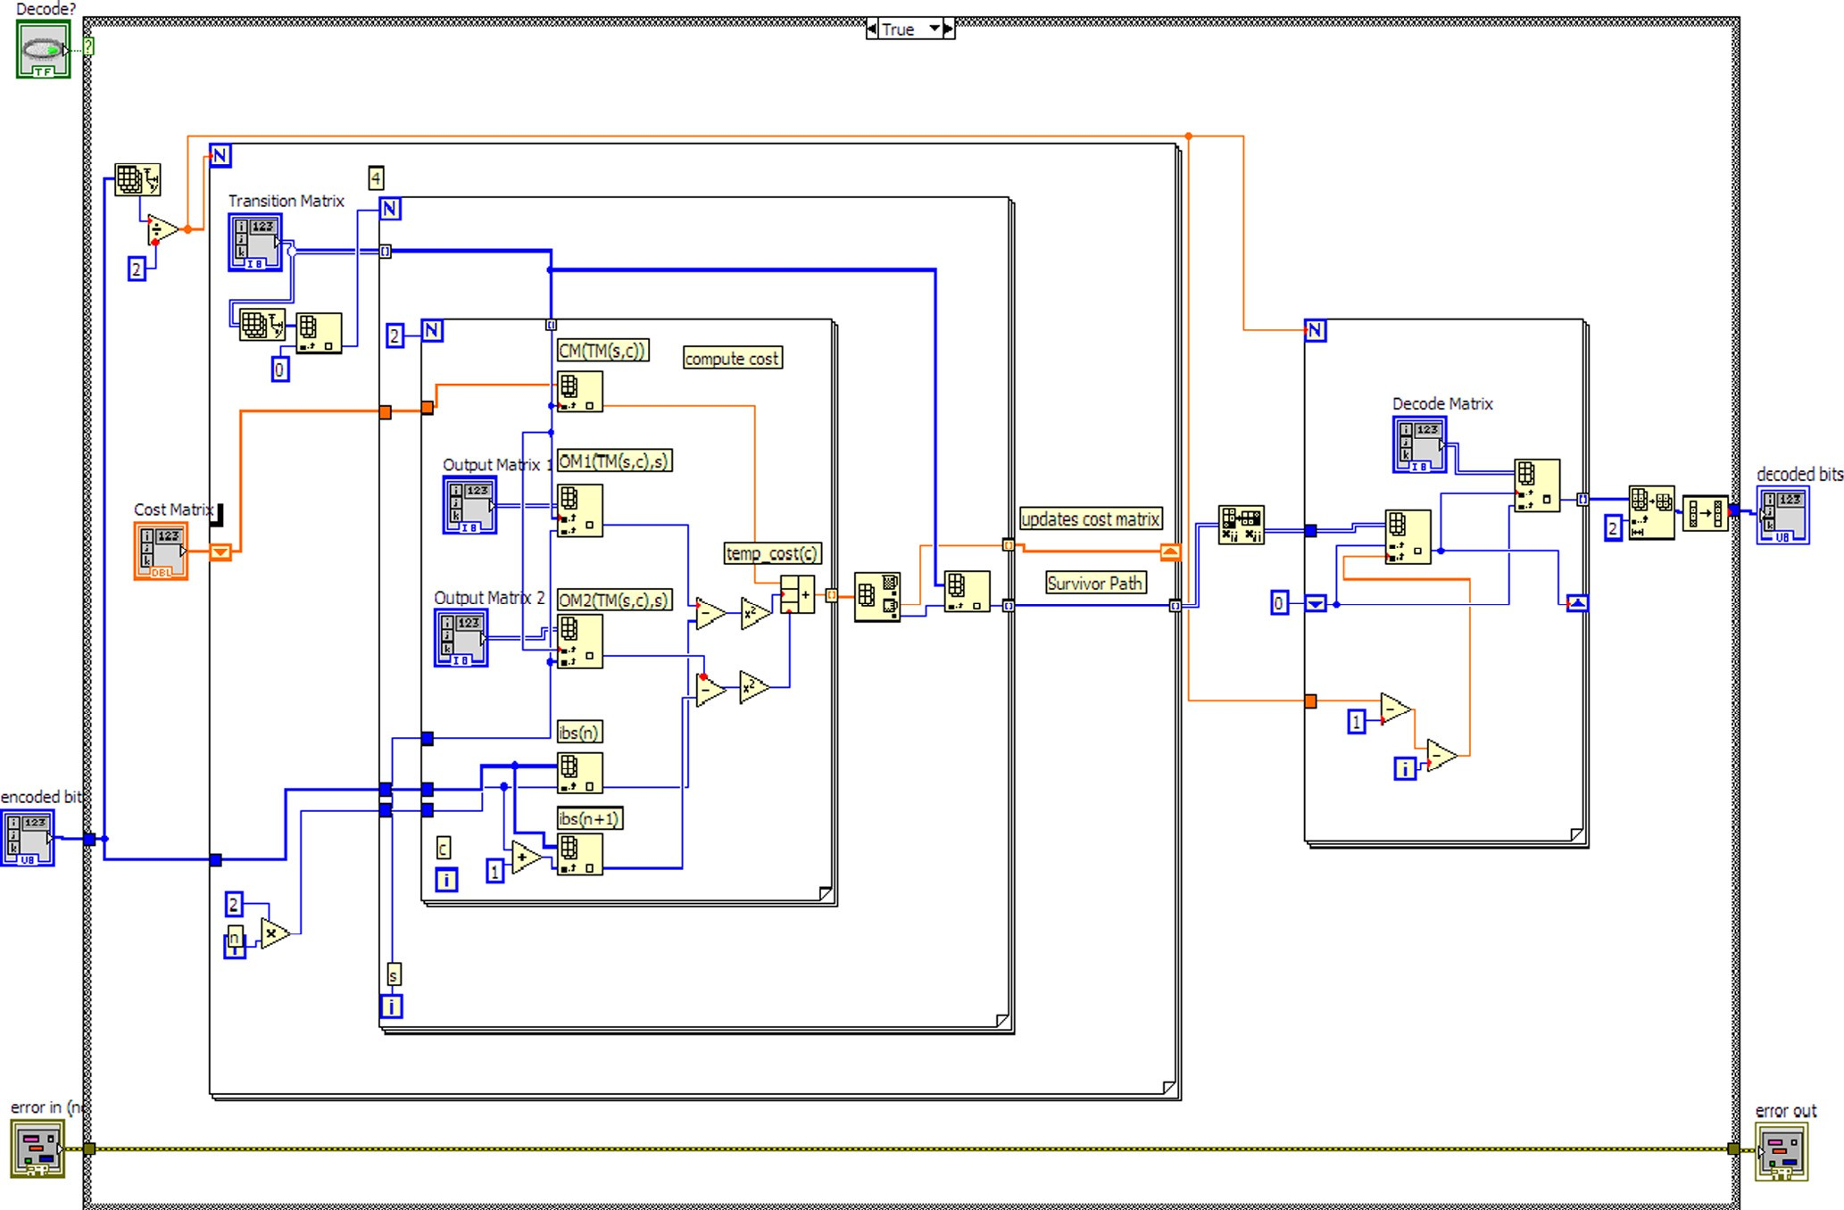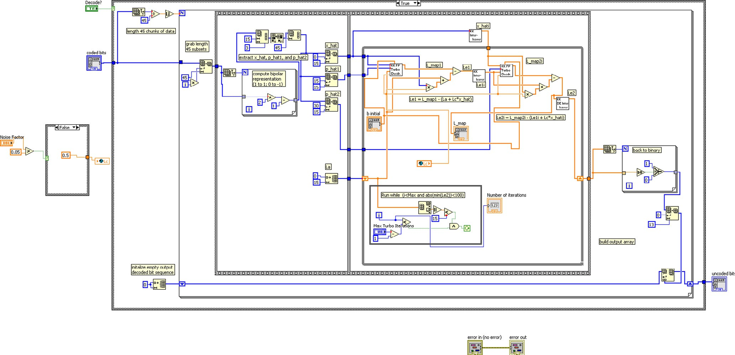

Figure 9 Viterbi Decoder VI.

Figure 10 Turbo Decoder VI.

Design of a Software Defined Radio transceiver 97

Figure 11 Symbol timing VI.

Table 1 Simulation parameters.

Sl. Reconfigurable parameters Values taken by the user no. for the user

1. PN sequence order 15 or any value
2. *E*b/*N*0 80 dB or any value
3. Message symbol 1000 or any value
4. Transmission B.W (BT) 0.5 or any value
5. Symbol phase continuity Continuous

clearly seen in terms of the BER *E*b/*N*0 output graph. We can also see very clearly with these results that data errors can be minimized using coding techniques, which in turn improves the Signal to Noise Ratio (SNR); further, we can also say looking at the results that Turbo Coding gives a much improved and better minimization of the data errors than the Convolution and Viterbi Codes. The performance of M-level FSK systems (2, 4, 8, 16, 32, 64, 128, 256) for additive white Gaussian noise channel has been evaluated and compared on

1. FSK frequency deviation (Hz)

25KHz or any value

the basis of the simulations in Lab-VIEW as shown in Figs. 12

and 13. In this paper we have shown that how fast and effec-

1. Filter used Cosine Filter, Root Raised Cosine Filter
2. Symbol rate 100.00 kHz or any value
3. *E*b/*N*0 sample 5 or any value
4. Sample per symbol 16 or any value
5. Modulation index 0.5 or any value

tively we can build an FSK Transceiver for Software Defined Radio. We have used the Graphical programming language Lab-VIEW for building an FSK Transceiver system which consists of a message source, a pulse shape filter, a modulator on the Transmitter section and demodulator, a frame synchro-

nizer, a phase continuity and frequency deviation on the Recei-

1. BER vs *E*b/*N*0 (without

filter)

None

ver section. The only limitation that we can see for the design is

time interval. BER is a unitless performance measured which is often expressed as a percentage (%). A pseudo-random, data sequence (15) is used for the analysis in this design. The BER parameter represents the current operating BER of a specific modulation type and in this design the modulation scheme selected is M-FSK. This value depends on various channel characteristics, including the transmit power and noise level.

1. Discussion and simulation

In this section we discuss the simulation results of the FSK Transceiver VI for noisy channels. From the results it becomes clear that the wireless system designed based on FSK tech- nique provides high data rate and SNR. This can be very

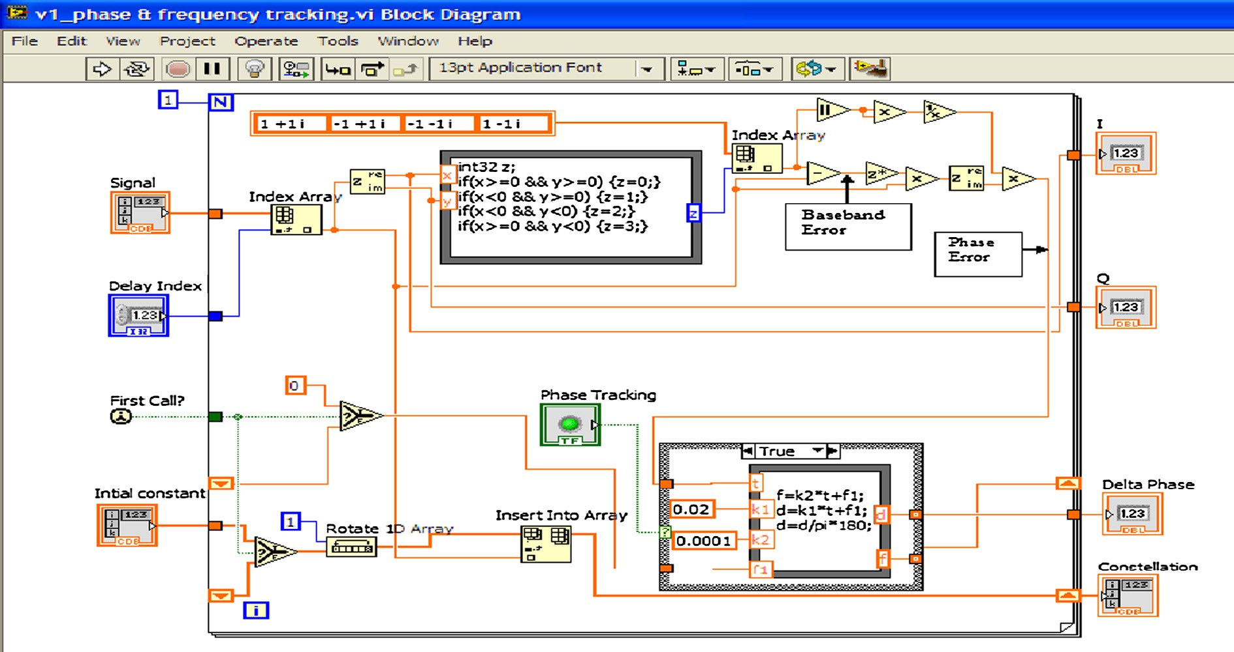

Figure 12 BER vs *E*b/*N*0 (dB) (2, 4, 8, 16, 32, 64, 128, 256 bits

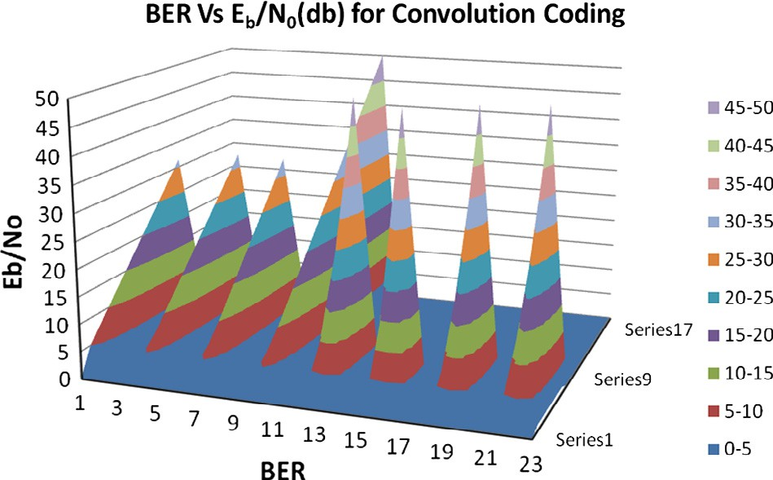

FSK) Output Results for Convolution Coding.

98 N. Marriwala et al.

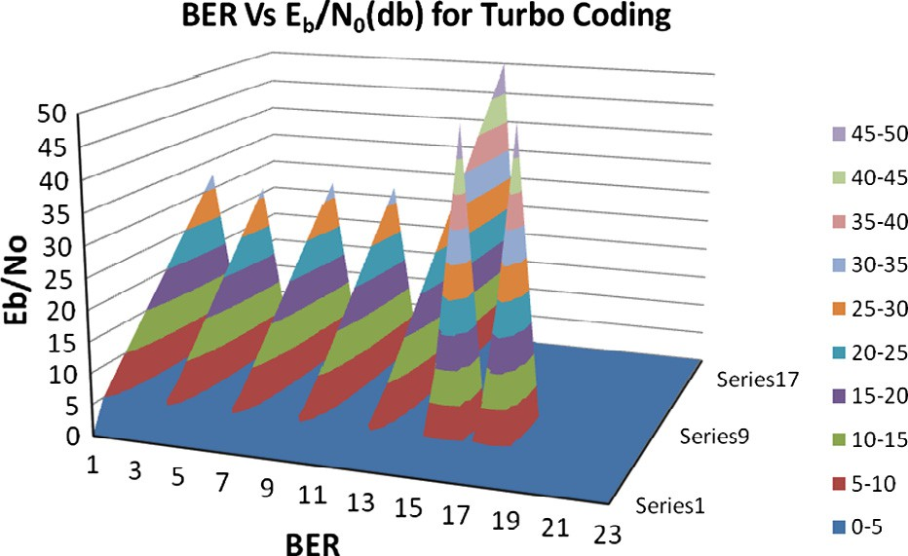

Figure 13 BER vs *E*b/*N*0 (dB) (2, 4, 8, 16, 32, 64, 128, 256 bits

FSK) Output Results for Turbo Coding.

that we need a machine with high processing speed for transfer and analysis of larger data, because we can add more coding and encoding techniques to the same design for better security of the transmitted data but if we will try to process it using the existing computers it takes a lot of time for the analysis of the data bits. Hence the computing capabilities of the processing machines have to be enhanced.

1. Conclusion

With the help of LabVIEW an interactive Software Defined Radio system has been built in a shorter time as compared to other text-based programming languages. With the help of this design we are able to see and prove that data errors can be minimized using coding techniques, which in turn improves the Signal to Noise Ratio (SNR). Also we can say by looking at the results that Turbo Coding gives a much improved and better minimization of the data errors than the Convolution Coding. In the end, we can say that the signal can be recovered with very less probability of error in Turbo Coding than in Convolution Coding with the increase in the *M* (number of levels) at the destination.

References

1. Adachi F, Ohno K. BER performance of QDPSK with postde- tection diversity reception in mobile radio channels. IEEE Trans Veh Technol 1991;40(1 pt 2):237–49. [http://dx.doi.org/10.1109/](http://dx.doi.org/10.1109/25.69994)

[25.69994](http://dx.doi.org/10.1109/25.69994).

1. Adrat M, Ascheid G. Special issue on recent innovations in wireless software-defined radio systems. J Signal Process Syst 2015;78(3):239–41. <http://dx.doi.org/10.1007/s11265-014-0968->.
2. [Bonior J, Hu Z, Guo TN, Qiu RC, Browning JP, Wicks MC.](http://refhub.elsevier.com/S1110-8665(15)00046-8/h0015) [Software-defined-radio-based wireless tomography: experimental](http://refhub.elsevier.com/S1110-8665(15)00046-8/h0015) [demonstration and verification. IEEE Geosci Remote Sens Lett](http://refhub.elsevier.com/S1110-8665(15)00046-8/h0015) [2015;12(1):175–9](http://refhub.elsevier.com/S1110-8665(15)00046-8/h0015).
3. [Shannon CE. A mathematical theory of communication. Bell Syst](http://refhub.elsevier.com/S1110-8665(15)00046-8/h0020) [Tech J 1948;27:379–423](http://refhub.elsevier.com/S1110-8665(15)00046-8/h0020).
4. Forney GD. Convolutional codes. II – Maximum-likelihood decoding. III – Sequential decoding. Inform Control 1974;266:222–66. [http://dx.doi.org/10.1016/S0019-9958(74)90870-](http://dx.doi.org/10.1016/S0019-9958(74)90870-5)

[5](http://dx.doi.org/10.1016/S0019-9958(74)90870-5).

1. [Haykin S. Cognitive radio: brain-empowered wireless communi-](http://refhub.elsevier.com/S1110-8665(15)00046-8/h0030) [cations. IEEE J Sel Areas Commun 2005;23(2):201–20](http://refhub.elsevier.com/S1110-8665(15)00046-8/h0030).
2. Jondral FK. Software-defined radio—basics and evolution to cognitive radio. EURASIP J Wireless Commun Network 2005;2005(3):652784. <http://dx.doi.org/10.1155/WCN.2005.275>.
3. Kang AS, Vig R. Computer aided BER performance analysis of FBMC cognitive radio for physical layer under the effect of binary symmetric radio fading channel. Wireless Pers Commun 2015;82 (3):1263–78. <http://dx.doi.org/10.1007/s11277-015-2281-x>.
4. Kim N, Kehtarnavaz N, Torlak M. LabVIEW-based software- defined radio: 4-QAM modem n.d.; 4(3): 54–61.
5. Knauth S. Implementation of an IEEE 802.15.4 transceiver with a software-defined radio setup. Lucerne University of Applied Sciences; 2008, <[http://www.i-o-t.ch/fileadmin/Dateien/PDF/](http://www.i-o-t.ch/fileadmin/Dateien/PDF/NewsEvents/emw2008_paper_Knauth.pdf) [NewsEvents/emw2008_paper_Knauth.pdf](http://www.i-o-t.ch/fileadmin/Dateien/PDF/NewsEvents/emw2008_paper_Knauth.pdf)>.
6. Marriwala N. LabVIEW based design implementation of M-PSK transceiver using multiple forward error correction coding tech- nique for software defined radio applications. J Electr Electr Eng 2014;2(4):55. <http://dx.doi.org/10.11648/j.jeee.20140204.11>.
7. Marriwala N, Sahu OP. 8-QAM software defined radio based approach for channel encoding and decoding using forward error correction. Wireless Pers Commun 2013;72(4):2957–69. [http://dx.](http://dx.doi.org/10.1007/s11277-013-1191-z) [doi.org/10.1007/s11277-013-1191-z](http://dx.doi.org/10.1007/s11277-013-1191-z).
8. [Marriwala N, Sahu OP, Kapoor S, Vohra A. A review on](http://refhub.elsevier.com/S1110-8665(15)00046-8/h0065) [channel equalization for software defined radio. Wireless](http://refhub.elsevier.com/S1110-8665(15)00046-8/h0065) [Commun 2011;3(3)](http://refhub.elsevier.com/S1110-8665(15)00046-8/h0065).
9. [Marriwala N, Sahu OP, Khullar R, Vohra A. Software defined](http://refhub.elsevier.com/S1110-8665(15)00046-8/h0070) [radio (SDR) 4-bit QAM modem using lab-VIEW for Gaussian](http://refhub.elsevier.com/S1110-8665(15)00046-8/h0070) [channel. Wireless Commun 2011;3(4)](http://refhub.elsevier.com/S1110-8665(15)00046-8/h0070).
10. [Mitola J. Software radios: survey, critical evaluation and future](http://refhub.elsevier.com/S1110-8665(15)00046-8/h0075) [directions. IEEE Aerosp Electr Syst Mag 1993;8(4)](http://refhub.elsevier.com/S1110-8665(15)00046-8/h0075).
11. Sadiku Matthew NO, Akujuobi Cajetan M. Software-defined radio: a brief overview. IEEE Potentials 2004;25–36:14–5. [http://](http://dx.doi.org/10.1109/62.210638) [dx.doi.org/10.1109/62.210638](http://dx.doi.org/10.1109/62.210638).
12. Naoues M, Noguet D, Alaus L, Loue¨ t Y. A common operator for FFT and FEC decoding. Microprocess Microsyst 2011;35 (8):708–15. <http://dx.doi.org/10.1016/j.micpro.2011.08.007>.
13. [Nicollet E, Demeure C. Software defined radio architecture for](http://refhub.elsevier.com/S1110-8665(15)00046-8/h0090) [cellular networks base stations: the SUNBEAM project. Ann](http://refhub.elsevier.com/S1110-8665(15)00046-8/h0090) [Telecommun J 2002:626–52](http://refhub.elsevier.com/S1110-8665(15)00046-8/h0090).
14. Wipro Technologies Innovative Solutions. Quality leadership ‘‘Software-Defined Radio, White Paper: A Technology Over- view”, August 2002.
15. Wohaishi M Al. Analysis of M state digitally modulated signals in communication systems based on SDR concept. In: The 6th IEEE international conference on intelligent data acquisition and advanced computing systems: technology and applications, vol. 1(September); 2011. p. 171–5.
16. Zhao J, Zhao M, Yang H, Chen J, Chen X, Wang J. High performance LDPC decoder on CELL BE for WiMAX system. In: 2011. p. 278–81. <http://dx.doi.org/10.1109/CMC.2011.117>.
17. Zhu Z, Waqar Aslam M, Nandi AK. Genetic algorithm optimized distribution sampling test for M-QAM modulation classification. Signal Process 2014;94:264–77. [http://dx.doi.org/10.1016/j.sigpro.](http://dx.doi.org/10.1016/j.sigpro.2013.05.024) [2013.05.024](http://dx.doi.org/10.1016/j.sigpro.2013.05.024).