[Egyptian Journal of Basic and Applied Sciences 4 (2017) 168–174](http://dx.doi.org/10.1016/j.ejbas.2017.06.005)

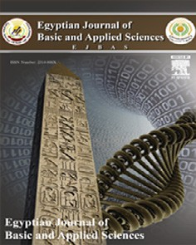

Contents lists available at [ScienceDirect](http://www.sciencedirect.com/science/journal/2314808X)

Egyptian Journal of Basic and Applied Sciences

journal homepage: [www.elsevier.com/locate/ejbas](http://www.elsevier.com/locate/ejbas)

Full Length Article

Dichloro-substituted phenyl amino propanamides exhibit anticonvulsant effect and reduce inward sodium ion current (NaV1.6)



S. Malami a,⇑, A.Y. Idris b, A.H. Yaro a, J.A. Anuka c, I.M. Hussaini d, M.K. Patel e

a *Department of Pharmacology and Therapeutics, Bayero University, Kano, Nigeria*

b *Department of Pharmaceutical and Medicinal Chemistry, Ahmadu Bello University, Zaria, Nigeria*

c *Department of Pharmacology and Therapeutics, Ahmadu Bello University, Zaria, Nigeria*

d *Department of Pharmacology, University of Maiduguri, Nigeria*

e *Department of Anesthesiology, University of Virginia, Charlottesville, VA, USA*

# a r t i c l e i n f o

*Article history:*

Received 4 April 2017

Received in revised form 12 May 2017 Accepted 18 June 2017

Available online 28 June 2017

*Keywords:*

Voltage-gated sodium channels Anticonvulsant Dichloroanilines

Kindling

Maximal electroshock

# a b s t r a c t

This research studied the anticonvulsant properties of three synthesized isomers of dichloro-substituted phenyl amino propanamides in rodents and determined their effects on votage-gated sodium channels (NaV1.6) stably expressed in Human Embryonic Kidney (HEK Cells 293). 2,3-, 2,5- and 3,4- Dichloro ani- lines were reacted with acrylamide according to Michael-type addition reaction to obtain their corre- sponding isomers; DCP23, DCP25 and DCP34. Each isomer was evaluated for anticonvulsant effects using maximal electroshock (MES)- and pentylenetetrazole (PTZ)- induced seizure models in mice; tested against PTZ-induced kindling in rats and its synergistic effect with fluphenamic acid in mice. Effects of DCP23 and DCP25 were studied on voltage-gated sodium channels (NaV1.6) at different states of the channel, using electrophysiology techniques. The test compounds generally offered dose dependent pro- tection against maximal electroshock- and pentylenetetrazole (PTZ)- induced seizure; demonstrated syn- ergistic effect when co-administered with fluphenamic acid; and produced significant (*p* < 0.05) decrease in seizure progression in PTZ-kindled rats. DCP23 and DCP25 reduced sodium currents at different chan- nel states in a concentration dependant manner. The results of this study showed that the compounds possess anticonvulsant effects and reduced the inward sodium currents. Therefore, they could exert anti- convulsant activity via sodium channels blockade.

© 2017 Mansoura University. Production and hosting by Elsevier B.V. This is an open access article under

the CC BY-NC-ND license (<http://creativecommons.org/licenses/by-nc-nd/4.0/>).

1. Introduction

Epilepsy poses serious disability among afflicted individuals and its treatment involves the use of antiepileptic agents with abil- ity to inhibit neuronal action potential [1]. Generation of normal and seizure types action potentials are under the control of voltage-gated sodium channels [2]. These channels are vital in the electrical signaling of cells under the regulation of membrane potential [3], thus, determine neuronal excitability [4] and serve as molecular target for antiepileptic drugs [5]. Blockers of voltage-dependent sodium channels are capable of reducing peak sodium current by decreasing the number of available channels during abnormal neuronal firing [2]. Previous researches have shown the upregulation of NaV1.6, an isoform of voltage- dependent sodium channel, in animal models of epilepsy [6].

* Corresponding author at: Department of Pharmacology and Therapeutics, Bayero University, Kano, Nigeria.

*E-mail address:* [malamisani@gmail.com](mailto:malamisani@gmail.com) (S. Malami).

Blockade of this isoform indicates the effectiveness of antiepileptic drugs and further suggests their key role in epilepsy [7]. Strategies such as structural modification of existing drugs, targeting novel molecular substrates, have been adopted in the development of newer antiepileptic agents [8]. The preclinical evaluation of these agents is achieved by employing various predictable acute and chronic seizure models, which are closely related to human pathol- ogy [9]. The present research studied anticonvulsant properties of three synthesized dichloro-substituted phenyl amino propana- mides in animal models, and also determined the effects of DCP23 and DCP25 on voltage-gated sodium channels steadily expressed in Human Embryonic Kidney Cells.

1. Materials and methods
   1. *Equipment*

Electroconvulsive machine (Ugo Basile, model no. 7801), Metler balance (P162 Gallen Kamp, UK), Water bath (Gallenkamp),

<http://dx.doi.org/10.1016/j.ejbas.2017.06.005>

2314-808X/© 2017 Mansoura University. Production and hosting by Elsevier B.V.

This is an open access article under the CC BY-NC-ND license (<http://creativecommons.org/licenses/by-nc-nd/4.0/>).

Gallenkamp), Thin Layer Chromatographic Plates (5 × 20 cm), Weighing balance (Ohio, New York, USA), Oven (BS model OV33 Whatman filter paper, Melting Point Apparatus (Gallenkamp), Axo-

patch 200 amplifier (Molecular Devices, Sunnyvale, CA), pClamp 9 software and a Digidata 1322A (Molecular Devices), Microscope, Eppendorf pipettes and tubes, Brown-Flaming puller (model P97; Sutter Instruments Company, Novato, CA), Incubator, Hood with air lamina flow and UV light.

* 1. *Chemicals*

Pentylenetetrazole, Phenytoin sodium, Sodium valproate and Fluphenamic acid (Sigma Chemical Company, Louis Mo, USA), Ana- lytical grade of 2,3-, 2,5- and 3,4- dichloroanilines, Iodine crystals, Solvents – ethyl acetate, benzene, chloroform (BDH Chemicals Co.), HEK Cells 293 (Patel Laboratory, University of Virginia), Dulbecco’s modified Eagle’s medium/F-12 media (Invitrogen, Carlsbad, CA) supplemented with 10% fetal bovine serum and Geneticin [(G418, 500 mg/ml) (2.5 ml/500 ml media)].

* 1. *Synthesis and chemical analysis*
     1. *Synthesis*

The reactants were 2,3- dichloroaniline, 2,5- dichloroaniline, and 3,4- dichloroaniline; each of these was reacted with pure acry- lamide. The reaction is a Michael-type addition reaction according to the scheme below:

*Reaction scheme with dichloro-substitution at positions 2*0*,3*0*.*

v/cm—1, 3362 (NH of amide), 3155 (C–H of aromatic), 1430 (C@C % yield (54.6%), M. point (room temp.), Rf value (0.64). IR (KBr): aromatic double bond), 1612 (C@O of amide), 1276 (C–N of amino

group), 721 (C–Cl of aromatic substitution). 1H NMR (CDCl3, 300 MHz) d ppm: 6.15 (2H, CH2, H-2), 6.28 (2H, CH2, H-3), 6.75

(1H, Aro–CH, H-40 ), 6.64 (1H, Ar–CH, H-50 ), 6.94 (1H, Ar–CH, H-

60 ), 4.25 (2H, CO-NH2), 5.6 (1H, Ar–NH-CH2CH2). 13C NMR (CDCl3,

300 MHz) d ppm: 168.08 (1C, –CO, C-1), 113.70 (1C, CH2, C-2),

117.36 (1C, CH2, C-3), 114.72 (1C, Ar–C, C-10 ), 133.00 (1C, Ar–C,

C-20 ), 130.28 (1C, Ar–C, C-30 ), 127.58 (1C, Ar–C, C-40 ), 127.53 (1C,

Ar–C, C-50 ), 119.39 (1C, Ar–C, C-60 ). MS (*m*/*z*): 235 (67, M+), 233

(100).

*2,5-Substituted isomer.* A portion of the isomer (32.4 g, 0.2 mol) was mixed with pure acrylamide (14.2 g, 0.2 mol) in a beaker of 250 ml capacity, and heated on a water bath (maintained at about 85 °C) for about 30 minutes until homogenous mixture was obtained. The mixture was left to stand at room temperature for 2 weeks. The residue was washed several times with benzene until

a single spot on TLC was obtained.

  

The reaction scheme was similar to other isomers (20,50 , and 30 ,40 ).

*Identification and characterization of the compounds*

Percentage yield, form, appearance and melting point of each compound were determined. Melting point was determined using an electro-thermal melting point apparatus (Model 2038 – Eng- land). Infrared (IR) spectroscopy was conducted at National Research Institute of Chemical Technology (NARICT), Basawa,

absorption (cm—1) of each compound with the use of Parkin Elmer Zaria, Nigeria. This was achieved by recording the frequency of Paragon 1000 as KBr disc. Nuclear Magnetic Resonance (NMR) was

conducted at the University of Kwazulu, South Africa. Data for both proton and carbon-13 NMR were reported as chemical shift in parts per million (ppm). Mass spectra were measured on an AP2000 (IS, 70ev) instrument at the University of Virginia, USA.

* + 1. *Procedure*

*2,3-Substituted isomer.* An equivalent volume based on its density was measured using pipette and mixed with 0.2 mol (14.2 g) of acrylamide in a 250 ml beaker. The flask containing the two reac- tants were heated on a water bath (maintained at about 85 °C) for about 25 min until homogenous solution was obtained. The mixture was left to stand at room temperature; on cooling, traces of crystals were beginning to form. This was left to stand for

3 weeks when the formed crystals had completely dissolved to form homogenous semi-solid compound.

cm—1, 3354 (NH of amide), 3188 (C–H of aromatic), 1428 (C@C aro- % yield (37.4%), M. point (60-62 °C), Rf value (0.46). IR (KBr): v/ matic double bond), 1685 (C@O of amide), 1291 (C–N of amino

group), 672 (C–Cl of aromatic substitution). 1H NMR (CDCl3, 300 MHz) d ppm: 6.09 (2H, CH2, H-2), 6.16 (2H, CH2, H-3), 7.10

(1H, Ar–CH, H-30 ), 7.09 (1H, Ar–CH, H-40 ), 7.28(1H, Ar–CH, H-60 ),

4.12 (2H, CO-NH2), 5.7 (1H, Ar–NH-CH2CH2). 13C NMR (CDCl3,

300 MHz) d ppm: 167.82 (1C, –CO, C-1), 115.34 (1C, CH2, C-2),

118.72 (1C, CH2, C-3), 143.88 (1C, Ar–C, C-10 ), 133.08 (1C, Ar–C,

C-20 ),130.14 (1C, Ar–C, C-30 ), 130.19 (1C, Ar–C, C-40 ), 117.38 (1C,

Ar–C, C-50 ), 127.65 (1C, Ar–C, C-60 ). MS (*m*/*z*): 236 (39, M+),

233.03 (100).

*3,4-Substituted isomers.* A portion of the isomer (32.4 g, 0.2 mol) was mixed with pure acrylamide (14.2 g, 0.2 mol) in a beaker (250 ml), and heated on a water bath (maintained at about 85 °C) for 30 minutes until homogenous mixture was obtained. The mix- ture was left to stand at room temperature for 2 weeks. The residue

was washed several times with benzene until a single spot on TLC was obtained.

H H H O

5' 1'

4' 3' 2'

6'

N

3

C

2

C C

1

H H H

N  H

H

Cl

Cl

cm—1, 3390 (NH of amide), 3169 (C–H of aromatic), 1439 (C@C aro- % yield (34.2%), M. point (57-59 °C), Rf value (0.58). IR (KBr): v/ matic double bond), 1673 (C@O of amide), 1291 (C-N of amino

group), 682 (C-Cl of aromatic substitution). 1H NMR (CDCl3,

300 MHz) d ppm: 6.13 (2H, CH2, H-2), 6.27 (2H, CH2, H-3), 6.74 (1H,

Aro–CH, H-2'), 6.46 (1H, Ar–CH, H-5'), 7.16 (1H, Ar–CH, H-6'), 3.75 (2H, CO-NH2), 5.66 (1H, Ar–NH-CH2CH2). 13C NMR (CDCl3,

300 MHz) d ppm: 167.76 (1C, –CO, C-1), 114.70 (1C, CH2, C-2),

116.38 (1C, CH2, C-3), 146.10 (1C, Ar–C, C-1'), 130.16(1C, Ar–C, C-

2'), 132.63 (1C, Ar–C, C-3'), 130.69 (1C, Ar–C, C-4'), 127.69 (1C,

Ar–C, C-5'), 120.97 (1C, Ar–C, C-6') 240 (35, M+), 233.03 (100).

* 1. *Animals*

Swiss albino mice (18–24 g) and Wistar rats (120–160 g) were obtained from Animal House Facility of the Department of Pharma- cology and Therapeutics, Ahmadu Bello University, Zaria, Nigeria. They were maintained at room temperature, at approximately 12 h light and dark cycle, fed with standard animal feed (Feeds Masters, Ilorin, Nigeria) and water was provided *ad libitum*. The animals were used in compliance with the National Institute of Health Guide for the Care and Use of Laboratory Animals (Publica- tion nos. 85–23, revised 1985).

* 1. *Cell lines*

Humam Embryonic Kidney Cells (HEK Cells 293) stably express- ing voltage-gated sodium channels (NaV 1.6) were used. They were grown in Dulbecco’s modified Eagle’s medium/F-12 media (Invitro- gen, Carlsbad, CA) supplemented with 10% fetal bovine serum and Geneticin [(G418, 500 mg/ml (2.5 ml/500 ml media); Sigma

Aldrich)]. The cells were maintained in a humidified atmosphere of 5% CO2 and 95% air at 37 °C.

* 1. *In vivo studies*
     1. *Maximal electroshock-induced seizure in mice*

Seventy seven mice were divided into eleven groups of seven mice each. Group 1 served as control while groups 2, 3, and 4 received 50, 25 and 12.5 mg/kg (*i.p.*) of DCP23. Similarly, groups 5–7 received DCP25 while groups 8–10 received DCP34, each at 50, 25 and 12.5 mg/kg, respectively. Phenytoin at the dose of 20 mg/kg was used as standard drug and administered to mice in group 11. One hour post treatment, maximal electroshock was delivered to each mouse to induce seizure using an Ugobasile electro-convulsive machine (Model No. 7801) connected with cor- neal electrodes connected to both ears. The shock parameters were 50 (mA), 50 (Hz), 0.3 (s) and 0.4 (ms); the value for each parameter was predetermined through pilot study. Episode of tonic extension of the hind limb was regarded as full convulsion while lack of tonic extension of the hind limbs was considered as protection [10].

* + 1. *Pentylenetetrazole-induced seizure test*

Sixty six adult albino mice weighing 18–24 g were divided into eleven groups of six mice each. Group 1 served as control while mice in groups 2, 3, and 4 received 50, 25 and 12.5 mg/kg (*i.p.*) of DCP23; groups 5–7 and 8–10 received DCP25 and DCP34 at similar graded doses to that of DCP23, respectively. Group 11 was admin- istered sodium valproate at the dose of 200 mg/kg (*i.p.*). Thirty minutes later 90 m/kg (*s.c.*) of freshly prepared solution of pentylenetetrazole was administered to each mouse. Animals were observed for presence or absence of clonic seizures characterized by loss of righting reflex [11].

* + 1. *Effect of co-administration of fluphenamic acid with DCP23, DCP25 and DCP34 in maximal electroshock-induced seizures in mice*

Mice of either sex were divided into twelve groups of six mice per group. Group 1 served as control, while Groups 2, 3 and 4 received fluphenamic acid (*i.p.*) at graded doses of 20, 10 and 5 mg/kg. One hour post fluphenamic acid administration these

groups including the control, were electro-shocked via corneal electrodes clipped to both ears. The dose which elicited least quan- tal protection was used for the interaction study. Thus, groups 6, 8 and 10 received fluphenamic acid at the dose of 5 mg/kg. Five min- utes post fluphenamic acid administration; groups 5 and 6 received DCP23 (50 mg/kg, *i.p.*), groups 7 and 8 received DCP25 (50 mg/kg, *i.p.*) and groups 9 and 10 received DCP34 (50 mg/kg, *i. p.*). Groups 11 and 12 received phenytoin (10 mg/kg); fluphenamic acid (5 mg/kg) and phenytoin (10 mg/kg), each respectively. One hour post treatments, seizures were induced using electroshock machine as previously described [10].

* + 1. *Pentylenetetrazole-induced kindling test*

Twenty eight rats were divided into four groups of seven rats each. Group 1 served as control while other groups (2, 3 and 4) received DCP23, DCP25 and DCP34 respectively; each at the dose of 50 mg/kg (*i.p.*). Thirty minutes post treatment; all the groups were administered sub-convulsive dose of PTZ (40 mg/kg, *i.p.*) and were observed for a period of 20 minutes. Administration of PTZ and the test compounds were done on alternate days for a total period of 15 days. Seizure activity was scored using a scoring sys- tem from 0–5 as follows: Stage 0: no change in response; Stage 1: ear and facial twitching; Stage 2: convulsive twitching axially through the body; Stage 3: myoclonic jerks and rearing; Stage 4: turn over onto side position, wild running and wild jumping; and Stage 5: generalized clonic-tonic seizures [12–14].

* 1. *Effects of DCP23 and DCP25 on voltage-gated sodium (NaV1.6) channels*

Human Embryonic Kidney Cells (HEK Cells 293) stably express- ing human NaV1.6 were grown in Dulbecco’s modified Eagle’s medium/F-12 media (Invitrogen, Carlsbad, CA) supplemented with 10% fetal bovine serum and Geneticin [(G418, 500 mg/ml (2.5 ml/500 ml media)]; Sigma Aldrich). Cells were grown in a

humidified atmosphere of 5% CO2 and 95% air at 37 °C. Sodium cur-

rents were recorded using the whole-cell configuration of the patch-clamp recording technique with an Axopatch 200 amplifier (Molecular Devices, Sunnyvale, CA). All voltage protocols were applied using pClamp 9 software (Molecular Devices) and a Digi- data 1322A (Molecular Devices). Currents were amplified, low pass filtered (2 kHz), and sampled at 33 kHz. Borosilicate glass pipettes were pulled using a Brown-Flaming puller (model P97; Sutter Instruments Company, Novato, CA) and heat-polished to produce electrode resistances of 0.5–1.5 mX when filled with the following electrode solution: 130 mM CsCl, 1 mM MgCl2, 5 mM MgATP, 10 mM BAPTA, and 5 mM HEPES (pH adjusted to 7.4 with CsOH). Cells were plated on glass cover slips and perfused with solution containing the following composition: 130 mM NaCl, 4 mM KCl, 1 mM CaCl2, 5 mM MgCl2, 5 mM HEPES, and 5 mM glucose (pH

adjusted to 7.4 with NaOH). All sodium channel current experi- ments were performed at room temperature (20–22 °C). After establishing whole-cell configuration, a minimum series resistance

compensation of 60% was applied, and cells were held at —60 mV or —100 mV for 5 min to account for any equilibrium gating shifts. After control recordings, compound solutions were applied for

5 min to allow for bath equilibration. Tonic block was assessed by comparing peak sodium current in drug-free conditions with peak current when drug was present. For the current–voltage experiment, the effect of the drug on the sodium currents was recorded during depolarization phase when the cells were not volt- age clamped at either resting or inactivated states. Similarly the current reduction was assessed by comparing peak sodium current in drug-free conditions with peak current when drug was present.

* 1. *Statistical analysis*

Statistical analysis was carried out using SPSS (Version 20) and data obtained were expressed as mean ± SEM and percentages where applicable. Analyses were done using analysis of variance (ANOVA), and followed by post hoc test (Scheffe) for multiple com-

parison, values where applicable with *p* ≤ 0.05 were considered

significant.

1. Results

The compounds, DCP23, DCP25 and DCP34, offered dose depen- dent protection against tonic hind limb extension (THLE); the per- centage protections against seizure exhibited by DCP23, DCP25 and DCP34, at 50 mg/kg, were 71.4%, 57.2% and 42.9% respectively. Whereas at 25 mg/kg the protections were 42.9%, 28.5% and 14.3% respectively, while the lowest dose (12.5 mg/kg) offered minimal / no protection. Thus, DCP23 offered highest protection while that of DCP34 was the lowest (Table 1).

The highest dose (50 mg/kg) of DCP23, DCP25 and DCP34 as used in pentylenetetrazole-induced seizure test, offered 66.7%, 66.7% and 0% protections against clonic seizures, respectively. There was a statistically significant (*p* < 0.001) increase in the latency of seizures exhibited by DCP23 at doses of 50 mg/kg and 25 mg/kg. Similarly, sodium valproate (200 mg/kg) offered 83.3% protection against episode of clonic seizures (Table 2).

Fluphenamic acid treated groups (20 mg/kg, 10 mg/kg and 5 mg/kg) produced 100%, 100% and 0% protections against tonic

hind limb extension (THLE). Co-administration of fluphenamic acid (5 mg/kg) and the test compounds produced synergistic effect against THLE; 100% for DCP23 and DCP25, while that of DCP34 was 50%. Also, there was an enhanced effect when phenytoin (10 mg/kg) was co-administered with fluphenamic acid (5 mg/kg) (Table 3).

DCP23, DCP25 and DCP34 (50 mg/kg) retarded the severity of seizure episodes induced by sub convulsive dose (40 mg/kg) of PTZ. There was graded increase in the severity of seizure from Day 1 to Day 5 where it reached plateau, there after the severity dropped at Day 6 and was maintained through Day 7 up to the last treatment day (Fig. 1).

The compounds (DCP23 and DCP25) as tested on voltage-gated sodium channels (NaV1.6), showed graded degree of channel blockade. DCP23 had the highest potency when tested at the rest-

ing state (—60 mV) of the sodium channels; it exhibited

concentration-dependent tonic blockade of 9.73% (10 mM), 18.04%

(30 mM), 46.80% (60 mM), 68.46% (100 mM), 95.64 (300 mM) and

98.10% (600 mM); while at —100 mV the blockade were 0% (10 mM), 10% (30 mM), 28.93% (60 mM), 50.12% (100 mM), 88.51%

(300 mM) and 90.10% (600 mM) (Fig. 2). The IC50 values of DCP23 were 64.76 mM and 100.37 mM at both resting/close and inacti- vated/opened states of the sodium channels respectively.

DCP25 at —60 mV and —100 mV produced states-dependent

blockade at 100 mM and 600 mM (Fig. 3).

The activation/inactivation pattern in the presence of DCP23 (100 mM) indicated significant reduction in the elicited current even at depolarized potential (Fig. 4).

Table 1

Effects of DCP23, DCP25, DCP34 and phenytoin on maximal electroshock-induced seizure in mice.

|  |  |  |  |  |
| --- | --- | --- | --- | --- |
| Treatment (mg/kg) | Recovery from seizures (min) | Quantal protection | Protection against seizures (%) | Protection from mortality (%) |
| Control | 6.75 ± 0.31 | 0/7 | 0.0 | 100 |
| DCP23 (50) | 8.13 ± 1.14 | 5/7 | 71.4 | 100 |
| DCP25 (50) | 6.88 ± 1.06 | 4/7 | 57.2 | 100 |
| DCP34 (50) | 8.63 ± 0.65 | 3/7 | 42.9 | 100 |
| DCP23 (25) | 8.75 ± 0.84 | 3/7 | 42.9 | 100 |
| DCP25 (25) | 7.00 ± 0.42 | 2/7 | 28.5 | 100 |
| DCP34 (25) | 7.88 ± 0.35 | 1/7 | 14.3 | 100 |
| DCP23 (12.5) | 7.25 ± 0.53 | 1/7 | 14.3 | 100 |
| DCP25 (12.5) | 7.13 ± 0.90 | 0/7 | 0.0 | 100 |
| DCP34 (12.5) | 7.25 ± 0.45 | 0/7 | 0.0 | 100 |
| PHT (20) | – | 7/7 | 100.0 | 100 |

Values are presented as mean ± SEM, *n* = 7; DCP23, DCP25 and DCP34 = 2,3-, 2,5- and 3,4- Dichloro – 3(aminophenyl) propanamides respectively, PHT = Phenytoin; Con- trol = 30% propylene glycol, 70% distilled water.

Table 2

Effects of DCP23, DCP25, DCP34 and valproate on pentylenetetrazole-induced seizure in mice.

|  |  |  |  |  |
| --- | --- | --- | --- | --- |
| Treatment (mg/kg) | Mean latency of seizures (min) | Quantal protection | (%) Protection against seizures | Protection against mortality (%) |
| Control | 8.00 ± 1.29 | 0/6 | 0.0 | 50.0 |
| DCP23 (50) | 27.00 ± 1.00** | 4/6 | 66.7 | 100.0 |
| DCP25 (50) | 12.00 ± 1.00 | 4/6 | 66.7 | 100.0 |
| DCP34 (50) | 6.83 ± 1.35 | 0/6 | 0.0 | 16.7 |
| DCP23 (25) | 19.40 ± 2.18* | 1/6 | 16.7 | 100.0 |
| DCP25 (25) | 11.67 ± 1.98 | 0/6 | 0.0 | 50.0 |
| DCP34 (25) | 8.67 ± 2.83 | 0/6 | 0.0 | 16.7 |
| DCP23 (12.5) | 8.60 ± 1.29 | 1/6 | 16.7 | 0.0 |
| DCP25 (12.5) | 6.83 ± 1.30 | 0/6 | 0.0 | 33.3 |
| DCP34 (12.5) | 9.17 ± 1.51 | 0/6 | 0.0 | 50.0 |
| VA (200) | 13.00 ± 00 | 5/6 | 83.3 | 100.0 |

Values are presented as mean ± SEM, *n* = 6; DCP23, DCP25 and DCP34 = 2,3-, 2,5- and 3,4- Dichloro – 3(aminophenyl) propanamides respectively, VA = Sodium valproate; Control = 30% propylene glycol, 70% distilled water; significant difference in the mean latency to onset of seizures between control (vehicle) group and treated groups at

\**p* < 0.001 and \*\**p* < 0.000 (ANOVA) followed by post hoc (Scheffe) for multiple comparison.

Table 3

Effects of fluphenamic acid on anticonvulsant activity of DCP23, DCP25 and DCP34 in maximal electroshock-induced seizure in mice.

|  |  |  |  |
| --- | --- | --- | --- |
| Treatment (mg/kg) | Quantal protection | % Protection against seizure | % Mortality protection |
| Control | 0/6 | 0.0 | 100.0 |
| FA (20) | 6/6 | 100.0 | 100.0 |
| FA (10) | 6/6 | 100.0 | 100.0 |
| FA (5) | 0/6 | 0.0 | 100.0 |
| DCP23 (50) | 4/6 | 66.67 | 100.0 |
| FA (5) + DCP23 (50) | 6/6 | 100.0 | 100.0 |
| DCP25 (50) | 3/6 | 50.0 | 100.0 |
| FA (5) + DCP25 (50) | 6/6 | 100.0 | 100.0 |
| DCP34 (50) | 1/6 | 16.67 | 100.0 |
| FA (5) + DCP34 (50) | 3/6 | 50.0 | 100.0 |
| PHT (10) | 0/6 | 0.0 | 100.0 |
| FA (5) + PHT (10) | 6/6 | 100.0 | 100.0 |

DCP23, DCP25 and DCP34 = 2,3-, 2,5- and 3,4- Dichloro – 3(aminophenyl) propanamides respectively, FA = Fluphenamic acid, *n* = 6 per group.

**Fractional Block**

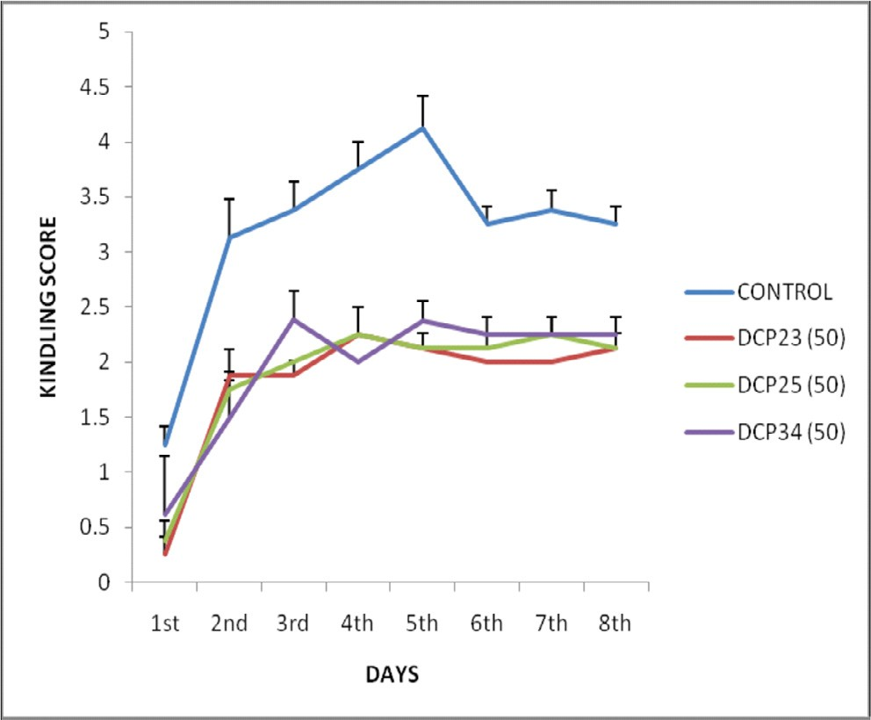Fig. 1. Effects of DCP23, DCP25 ad DCP34 at a dose of 50 mg/kg against pentylenetetrazole-induced kindling in rats *n* = 7 rats per group.

1.2

1

0.8

0.6

0.4

0.2

0

**CONCENTRATION (uM)**

Resting State

Inactivated State

10

30

60

100

300

600

Fig. 2. Concentration–response curves for DCP23 at resting and inactivated states of NaV1.6 *n* = 5 cells per concentration.

1. Discussion

The design of the test compounds (DCP23, DCP25 and DCP34) was on the basis of suggested pharmacophore model for com- pounds acting as blockers of the voltage-gated sodium channels [15,16]. Infrared spectroscopy (IR) revealed the presence of expected functional groups in the compounds. Similarly, Nuclear Magnetic Resonance (NMR) spectra for the three compounds were recorded and the spectral analysis revealed the structures of the products.

Maximal electroshock (MES) facilitates entry of positive ions like Na+ and its blockade can prevent the MES-induced tonic exten- sion [17]. Also, MES causes cellular damage through facilitation of Ca2+ entry into the cells in large amount and thus, disrupt the sig- nal transduction in the neurons and prolong the duration of con- vulsions [18]. Protection against hind limb tonic extension (HLTE) in the MEST indicates the ability of an antiepileptic agent to serve in the treatment of generalized tonic-clonic and partial seizures [19]. All the test compounds (DCP23, DCP25 and DCP34) demonstrated significant activity against MES-induced seizure in a dose dependent manner (Table 1).

Pentylenetetrazole (PTZ) is believed to be an antagonist at GABA pathway in the CNS resulting in an imbalance between the ionic concentrations of the membrane [20]. Pharmacological profile of PTZ seizure model is closely consistent with the human petitmal condition [21]. PTZ induces seizures by blocking the major inhibi-

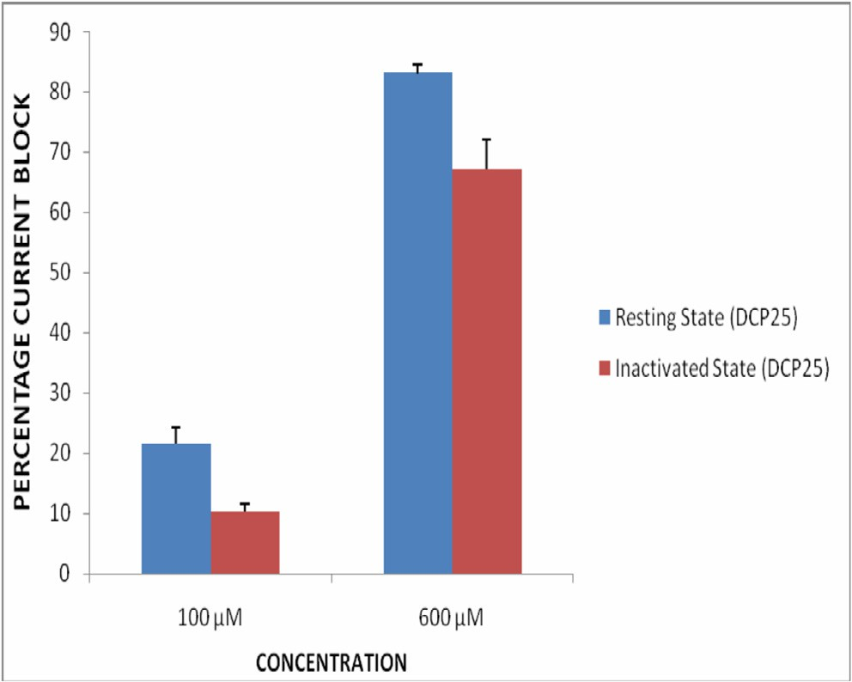

Fig. 3. Current blockade by DCP25 at resting and inactivated states of NaV1.6 *n* = 4 cells per concentration.

tory pathways mediated by the predominant inhibitory neuro- transmitter GABA, at all levels of the CNS [22]. Also, seizures induced by PTZ can be blocked by drugs such as ethosuximide that

1. Conclusion

0.4

0.2

-100

0

-50 0

-0.2

50 100

-0.4

-0.6

-0.8

-1

-1.2

Test Pulse Potential (mV)

CONTROL

DCP23 (100

μM)

The test compounds demonstrated significant anticonvulsant activity and reduced the inward sodium currents. Therefore, they could exert their action via sodium channels blockade.

Peak Current during Test Pulse (pA

Acknowledgements

We appreciate Tertiary Education Trust Fund through Ahmadu Bello University, Zaria (TETfund-ABU) for providing full travel grant to the United States of America. Also, we appreciate Patel Laboratory, Department of Anesthesiology, University of Virginia, Charlottesville, Virginia, USA, for the technical assistance, provision of consumables and equipment.

References

Fig. 4. Current–voltage curves obtained in control solution and in the presence of DCP23 (100 mM) using NaV1.6 (*n* = 5).

reduces T-type Ca2+ currents [23]. It is therefore possible that the anticonvulsant effects shown by DCP23 and DCP25 against this model might be due to activation of GABA neurotransmissions or Ca2+ currents blockade. However, DCP34 may lack these properties as it did not show significant anticonvulsant activity (Table 2).

Fluphenamic acid possesses modulatory effect on neuronal sodium channels, reducing sodium current availability and slowing down inactivation and recovery from inactivation, leading to diminished repetitive and burst firing [24]. The test compounds (DCP23 and DCP25) demonstrated synergistic effects with fuphenamic acid and phenytoin when co-administered (Table 3). Thus, suggested possible effect of the test compounds on sodium channels.

Kindling is a well-established model of abnormal plasticity leading to prolonged seizures and to epilepsy [7]. It is a model of epilepsy and epileptogenesis where repeated administration of a subconvulsive dose of PTZ produced a progressive increase in con- vulsant activity, culminating in generalized seizures in animals [13]. Hippocampus is the brain area that participates in seizure generation following kindling [25]. It was also found that kindling was associated with higher expression of NaV1.6 sodium channel isoform in hippocampal CA3 neurons [7]. The test compounds retarded the severity of seizures by not allowing the progression to classical convulsion stages (Fig. 1).

The test compounds (DCP23 and DCP25) produced tonic states-dependent inhibition of the sodium current; resting and open/inactivated states. Thus, indicated higher binding affinity of the compound to inactivated channels where sodium channels accumulate in high-affinity drug binding conformations [26]. DCP23 being the most potent, was tested at depolarized state of the sodium channels and similarly reduced the inward conduction of sodium ions (Fig. 4); indicated by reduction of the normalized current recorded during steady state activation [27]. Phenytoin- like drugs blocked sodium channels at specific receptor site at the pore of the channels and impede ion permeation [28]. Thus, DCP23 could be said to have blocked a receptor site in the channel and impeded inward sodium ions conductance, and thus, shifted the steady state activation curve to more hyperpolarized voltage. Therefore, this effect suggests sodium channel blocking activity of the compound.

1. [Cook AM, Bensalem-Owen MK. Mechanisms of action of antiepileptic drugs.](http://refhub.elsevier.com/S2314-808X(17)30151-3/h0005) [Therapy 2011;8(3):307–13](http://refhub.elsevier.com/S2314-808X(17)30151-3/h0005).
2. [Lason W, Chlebicka M, Rejdak K. Research advances in basic mechanisms of](http://refhub.elsevier.com/S2314-808X(17)30151-3/h0010) [seizures and antiepileptic drug action. Pharmacol Rep 2013;65:787–801](http://refhub.elsevier.com/S2314-808X(17)30151-3/h0010).
3. [Ruiz ML, Kraw R. Voltage-gated sodium channels: structure, function,](http://refhub.elsevier.com/S2314-808X(17)30151-3/h0015) [pharmacology and clinical indications. J Med Chem 2015;58:7093–118](http://refhub.elsevier.com/S2314-808X(17)30151-3/h0015).
4. [Benjamin ER, Fruthi F, Olanrewaju S, Ilyin VI, Crumley G, Kutlini E, et al. State-](http://refhub.elsevier.com/S2314-808X(17)30151-3/h0020) [dependent compound inhibition of NaV 1.2 sodium channels using the FLIPR](http://refhub.elsevier.com/S2314-808X(17)30151-3/h0020) [Vm dye: on-target and off-target effects of diverse pharmacological agents. J](http://refhub.elsevier.com/S2314-808X(17)30151-3/h0020) [Biomol Screening 2006;11(1):29–39](http://refhub.elsevier.com/S2314-808X(17)30151-3/h0020).
5. [Lipkind GM, Fozzard HA. Molecular model of anticonvulsant drug binding to](http://refhub.elsevier.com/S2314-808X(17)30151-3/h0025) [the voltage-gated sodium channel inner pore. Mol Pharmacol 2010;78](http://refhub.elsevier.com/S2314-808X(17)30151-3/h0025) [(4):631–8](http://refhub.elsevier.com/S2314-808X(17)30151-3/h0025).
6. [Hargus NJ, Merrick EC, Nigam A, Kalmar CL, Baheti AR, Bertram EH, et al.](http://refhub.elsevier.com/S2314-808X(17)30151-3/h0030) [Temporal lobe epilepsy induces intrinsic alterations in Na channel gating in](http://refhub.elsevier.com/S2314-808X(17)30151-3/h0030) [layer II medial entorhinal cortex neurons. Neurobiol Dis 2011;41(2):361–76](http://refhub.elsevier.com/S2314-808X(17)30151-3/h0030).
7. [Rivera M, Patel MK, Zuliani V. Inhibition of NaV1.6 sodium channel currents by](http://refhub.elsevier.com/S2314-808X(17)30151-3/h0035) [a novel series of 1,4-disubstituted-triazole derivatives obtained via copper-](http://refhub.elsevier.com/S2314-808X(17)30151-3/h0035) [catalyzed click chemistry. Bioorg Med Chem 2012;22:6401–4](http://refhub.elsevier.com/S2314-808X(17)30151-3/h0035).
8. [Gitto R, Pagano B, Citraro R, Scicchitano F, DeSarro G, Chimirri A. Solution](http://refhub.elsevier.com/S2314-808X(17)30151-3/h0040) [phase parallel synthesis and evaluation of anticonvulsant activity of N-](http://refhub.elsevier.com/S2314-808X(17)30151-3/h0040) [substituted-3,4-dihydroisoquinoline-2(1H)-carboxamides. Eur J Med Chem](http://refhub.elsevier.com/S2314-808X(17)30151-3/h0040) [2009;44:1349–54](http://refhub.elsevier.com/S2314-808X(17)30151-3/h0040).
9. [Obniska J, Rapacz A, Rybka S, Gora M, Kaminski K, Salat K, et al. Synthesis, and](http://refhub.elsevier.com/S2314-808X(17)30151-3/h0045) [anticonvulsant activity of new amides derived from 3-methyl- or 3-ethyl-3](http://refhub.elsevier.com/S2314-808X(17)30151-3/h0045) [methyl-2,5-dioxo-pyrrolidin-1-yl-acetic acids. Bioorg Med Chem](http://refhub.elsevier.com/S2314-808X(17)30151-3/h0045) [2016;24:1598–607](http://refhub.elsevier.com/S2314-808X(17)30151-3/h0045).
10. [Swinyard EA, Kupferberg HJ. Antiepileptic drugs: detection, quantification and](http://refhub.elsevier.com/S2314-808X(17)30151-3/h0050) [evaluation. Fed Proc. 1985;44:39–43](http://refhub.elsevier.com/S2314-808X(17)30151-3/h0050).
11. [Swinyard EA. Laboratory evaluation of antiepileptic drugs. Reviews of](http://refhub.elsevier.com/S2314-808X(17)30151-3/h0055) [laboratory methods. Epilepsia 1969;10:107–19](http://refhub.elsevier.com/S2314-808X(17)30151-3/h0055).
12. [Gupta YK, Shirma M, Chaudhary G. Antiepileptic activity of *Panax Ginseng*](http://refhub.elsevier.com/S2314-808X(17)30151-3/h0060)[against pentylenetetrazole-induced kindling in rats. Indian J Pharmacol](http://refhub.elsevier.com/S2314-808X(17)30151-3/h0060) [2001;45(4):502–6](http://refhub.elsevier.com/S2314-808X(17)30151-3/h0060).
13. [Dhir A, Naida PS, Kulkarni SK. Neuroprotective effect of nimesulide, a](http://refhub.elsevier.com/S2314-808X(17)30151-3/h0065) [preferencial COX-2 inhibitor against pentylenetetrazole PTZ-induced](http://refhub.elsevier.com/S2314-808X(17)30151-3/h0065) [chemical parameters in mice. Seizure 2007;16:691–7](http://refhub.elsevier.com/S2314-808X(17)30151-3/h0065).
14. [Rajabzadeh A, Bideskan AE, Fazel A, Sankian M, Rafatpanah H, Haghir H. The](http://refhub.elsevier.com/S2314-808X(17)30151-3/h0070) [effect of PTZ-induced epileptic seizures on hippocampal expression of PSA-](http://refhub.elsevier.com/S2314-808X(17)30151-3/h0070) [NCAM in offspring born to kindled rats. J Biomed Sci 2012;19(1):56–64](http://refhub.elsevier.com/S2314-808X(17)30151-3/h0070).
15. [Unverferth K, Engel J, Hofgen N, Rostock A, Gunther R, Lankau HJ, et al.](http://refhub.elsevier.com/S2314-808X(17)30151-3/h0075) [Synthesis, anticonvulsant activity, and structure-activity relationships of](http://refhub.elsevier.com/S2314-808X(17)30151-3/h0075) [sodium channel blocking 3-aminopyrroles. J Med Chem 1998;41:63–73](http://refhub.elsevier.com/S2314-808X(17)30151-3/h0075).
16. [Shindikar AV, Khan F, Viswanathan CL. Design, synthesis and in vivo](http://refhub.elsevier.com/S2314-808X(17)30151-3/h0080) [anticonvulsant screening in mice of novel phenylacetamides. Eur J Med](http://refhub.elsevier.com/S2314-808X(17)30151-3/h0080) [Chem 2006;41:786–92](http://refhub.elsevier.com/S2314-808X(17)30151-3/h0080).
17. [Bum EN, Nkantchoua GN, Njikam N, Taiwe GS, Ngoupaye GT, Pelanken MM.](http://refhub.elsevier.com/S2314-808X(17)30151-3/h0085) [Anticonvulsant and sedative activity of leaves Senna spectabilis in mice. Int J](http://refhub.elsevier.com/S2314-808X(17)30151-3/h0085) [Pharmacol 2010;6:123–8](http://refhub.elsevier.com/S2314-808X(17)30151-3/h0085).
18. [Inan SY, Buyukafsar K. Antiepileptic effects of two Rho-kinase inhibitors, Y-](http://refhub.elsevier.com/S2314-808X(17)30151-3/h0090) [27632 and fusudil, in mice. Br J Pharmacol 2008;155:44–51](http://refhub.elsevier.com/S2314-808X(17)30151-3/h0090).
19. [Raza M, Shaheen F, Choudhary MI, Suria A, Attaur-Rahman, Sombati S, et al.](http://refhub.elsevier.com/S2314-808X(17)30151-3/h0095) [Anticonvulsant activities of the FS-1 subfraction isolated from roots of](http://refhub.elsevier.com/S2314-808X(17)30151-3/h0095) [*Delphinium denudatum*. Phytother Res 2001;15:426–30](http://refhub.elsevier.com/S2314-808X(17)30151-3/h0095).
20. [Nagakannan P, Shivasharan BD, Veerapur VP, Thppeswamy BS. Sedative and](http://refhub.elsevier.com/S2314-808X(17)30151-3/h0100) [antiepileptic effects of *Anthocephalus cadamba* Roxb. in mice and rats. Indian J](http://refhub.elsevier.com/S2314-808X(17)30151-3/h0100) [Pharmacol 2011;43(6):699–702](http://refhub.elsevier.com/S2314-808X(17)30151-3/h0100).
21. [Malawska B. Anticonvulsant Agents. Top Med Chem 2005;5:69–85](http://refhub.elsevier.com/S2314-808X(17)30151-3/h0105).
22. [DeSarro A, Cecchetti V, Fravolin P, Naccari F, Tabarrini O, DeSarro G. Effects of](http://refhub.elsevier.com/S2314-808X(17)30151-3/h0110) [novel 6-defluroquinolones and classic quinolones on Pentylenetetrazole-](http://refhub.elsevier.com/S2314-808X(17)30151-3/h0110) [induced seizures in mice. Antimicrob Agents Chemother 1999;43:1729–36](http://refhub.elsevier.com/S2314-808X(17)30151-3/h0110).
23. [Rho JM, Sankar R. The pharmacological basis of antiepileptic drug action.](http://refhub.elsevier.com/S2314-808X(17)30151-3/h0115) [Epilepsia 1999;40:1471–83](http://refhub.elsevier.com/S2314-808X(17)30151-3/h0115).
24. [Hau-Jie Y, Baranauskas G, Martina M. Flufenamic acid decreases neuronal](http://refhub.elsevier.com/S2314-808X(17)30151-3/h0120) [excitability through modulation of voltage-gated sodium channel gating. J](http://refhub.elsevier.com/S2314-808X(17)30151-3/h0120) [Physiol 2010;588(20):3869–82](http://refhub.elsevier.com/S2314-808X(17)30151-3/h0120).
25. [Takemiya T, Suzuki K, Sugiura H, Yasuda S, Yamagata K, Kawakami Y. Inducible](http://refhub.elsevier.com/S2314-808X(17)30151-3/h0125) [brain COX-2 facilitates the recurrence of hippocampal seizures in mouse rapid](http://refhub.elsevier.com/S2314-808X(17)30151-3/h0125) [kindling. Prostaglandin Lipid Mediator 2003;71:205–16](http://refhub.elsevier.com/S2314-808X(17)30151-3/h0125).
26. [Rogawski MA, Loscher W. The neurobiology of antiepileptic drugs. Nat Rev](http://refhub.elsevier.com/S2314-808X(17)30151-3/h0130) [Neurosci 2004;5:553–64](http://refhub.elsevier.com/S2314-808X(17)30151-3/h0130).
27. [Catterall WA. From ionic currents to molecular mechanisms: the structure and](http://refhub.elsevier.com/S2314-808X(17)30151-3/h0135) [function of voltage-gated sodium channels. Neuron 2000;26:13–25](http://refhub.elsevier.com/S2314-808X(17)30151-3/h0135).
28. [Catterall WA. Voltage-gated sodium channels at 60: structure, function and](http://refhub.elsevier.com/S2314-808X(17)30151-3/h0140) [pathophysiology. J Physiol 2012;590(11):2577–89](http://refhub.elsevier.com/S2314-808X(17)30151-3/h0140).