Journal Pre-proof

Dynamic relationship between volume and volatility in the Chinese stock market: Evidence from the MS-VAR model

Feipeng Zhang, Yilin Zhang, Yixiong Xu, Yan Chen

PII: S2666-7649(23)00041-3

DOI: <https://doi.org/10.1016/j.dsm.2023.09.003>

Reference: DSM 70

To appear in: *Data Science and Management*

Received Date: 17 June 2023

Revised Date: 18 September 2023

Accepted Date: 19 September 2023

Please cite this article as: Zhang, F., Zhang, Y., Xu, Y., Chen, Y., Dynamic relationship between volume and volatility in the Chinese stock market: Evidence from the MS-VAR model, *Data Science and Management* (2023), doi: <https://doi.org/10.1016/j.dsm.2023.09.003>.

This is a PDF file of an article that has undergone enhancements after acceptance, such as the addition of a cover page and metadata, and formatting for readability, but it is not yet the definitive version of record. This version will undergo additional copyediting, typesetting and review before it is published

in its final form, but we are providing this version to give early visibility of the article. Please note that, during the production process, errors may be discovered which could affect the content, and all legal disclaimers that apply to the journal pertain.

© 2023 Xi’an Jiaotong University. Publishing services by Elsevier B.V. on behalf of KeAi Communications Co. Ltd.

**Dynamic relationship between volume and volatility in the Chinese stock market: evidence from the MS-VAR model**

Feipeng Zhang1, Yilin Zhang1, Yixiong Xu1, Yan Chen2, *

1. School of Economics and Finance, Xi’an Jiaotong University, Xi’an, 710049, China
2. Business School, Hunan University, Changsha, 410082, China Corresponding author: Yan Chen [(chenyan15153@hotmail.com)](mailto:(chenyan15153@hotmail.com)

**Abstract**

Since market uncertainty, or volatility, serves as a crucial gauge for assessing the traits of market fluctuations, the link between stock market volume and price continues to be a focal point of interest in finance. This study examines the dynamic, nonlinear correlations between Chinese stock volatility, trading volume, and return using a hybrid approach that combines the Markov switching regime with the vector autoregressive model (MS-VAR). The empirical findings are as follows. (1) The Chinese stock market can be divided into three regional systems: steady downward, steady upward, and high volatility. The three states have similar frequencies of occurrence, and their corresponding stable probabilities are not high, indicating that the Chinese stock market is unstable. (2) Asymmetric dynamic relationships exist between market volatility, investment return, and trading volume. For different regimes, while the effect of trading volume on volatility and return appears to be insignificant, the impacts of volatility and return on trading volume are considerably strong. (3) A regime-dependent, contemporaneous correlation between volatility and return is observed, which also reflects the behavior of the Chinese stock market ‘chasing up and down.’ However, a positive contemporaneous correlation always exists between volatility and trading volumes in different regimes, indicating that uncertainty in the Chinese stock market is closely related to information inflow.

**Key words**: Volatility; Trading volume; MS-VAR model; Chinese stock market.

# Introduction

Volatility is a key component of the stock market, as excessive volatility can result in high uncertainty. Since 2005, the Chinese stock market has experienced many ups and downs, including the 2008 financial crisis and the 2015 stock market crash. With the outbreak of the COVID-19 pandemic, fluctuations in the Chinese stock market seem to have become more intense and elusive as the Shanghai A-share index experienced a 20% decline from January to April 2022. The high uncertainty in the Chinese stock market places investors at great risk and fosters speculation (Yin and Wei, 2021). Therefore, examining volatility characteristics within the stock market is especially relevant. As an important indicator for identifying market trends, trading volume can effectively represent the inflow of market information (Blume et al., 1994; Clark, 1973; Copeland, 1976; Wang, 1994). Fluctuations within the stock market are inevitable due to the uncertainty in market information. Therefore, to better understand the microstructure and price volatility transmission mechanism of the Chinese stock market, trading volume can be used to examine the stock market’s fluctuation features.

A large body of literature has focused on the connection between trading volume and return in the stock market (Chen and Song, 2000; Truong et al., 2022; Wang and Wu, 2002; Zhao and Xue, 2005) and identified correlational and causal relationships (Chen and Song, 2000; Wang and Wu, 2002; Zada, 2021). However, some studies have shown that their correlation is weak (Karpoff, 1987) and that trading volume does not act as the underlying cause of return (Alhussayen, 2022; Lee and Rui, 2002). According to the mixed distribution theory proposed by Clark (1973) and Tauchen and

Pitts (1983), both trading volume and volatility are influenced by a shared stream of information, which indicates that their correlation may be significantly positive.

Yang (2005) employed Granger causality analysis and expanded the GARCH model to discover bidirectional Granger causality within market characteristics in the Shanghai A-share market. He found that trading volume is not only limited to explaining the sustained nature of volatility, but it is also not an ideal option as a substitute variable for market information. However, Tan et al. (2008) found that the trading volume in the Chinese stock market is informative: when it is large, a greater trading intensity leads to higher volatility, and when it is small, a greater trading intensity leads to lower volatility. Nevertheless, due to differences in the selected data and econometric methods, the conclusions obtained are not always consistent. In various markets, the connection within trading volume and volatility does not consistently remain the same, which shows heterogeneity in different markets (Brailsford, 1996; Chan and Fong, 2000; Henry and McKenzie, 2006; Pasquale and Renò, 2005; Rossi and Santucci de Magistris, 2013).

Other studies have addressed whether trading volume can predict volatility by exploring their dynamic relationship. Brooks (1998) investigated whether lagged trading volume could improve volatility forecasting based on the GARCH family models and found that the addition of lagged trading volume only slightly improved the prediction of volatility. Liu (2007) and Yang (2005) also obtained similar conclusions: insufficient effective and robust evidence is available to explain the connection between trading volume and market fluctuations. Sun et al. (2019) focused on predicting stock volatility by trading volume information in both the stock and foreign exchange markets. They found that information related to trading volume is useful for forecasting stock volatility. However, this trading volume information only has an indirect influence on price in the foreign exchange market. Thus, despite being influenced by factors such as market maturity, trading volume holds considerable explanatory significance for market fluctuations (Bessembinder and Seguin, 1993; Ni et al., 2008; Wen et al., 2013; Zhang and Ma, 2007).

All the aforementioned studies have found a cause-and-effect link between trading volume and volatility using ordinal least squares (OLS) regression models. Although these regression models are simple and easy to interpret, they are difficult to adapt to complex and ever-changing stock markets because of their linear and normal assumptions; thus, they may not be suitable under different market conditions (Yang, 2005; Zheng and Wu, 2007). To this end, vector autoregression (VAR) models, which have unstructured features, can analyze dynamic relationships more effectively. Most VAR models have focused on the relationship between trading volume and investment return (Fan and Xu, 2002; Gupta et al., 2018; Liu, 2007; Statman et al., 2006), but little studies have examined the relationship between trading volume and market volatility. Xu et al. (2006) used VAR models to investigate the dynamic relationship between volatility and trading volume. They found that a strong correlation exists between them and that they are correlated with their own lagged volatility and lagged trading volume. Tang and Liu (2008) used structural vector autoregression (SVAR) models to study the comprehensive index of the Chinese stock market from 1996 to 2007 and found an asymmetric relationship between trading volume and market volatility. Shi et al. (2017) used threshold VAR to find that market uncertainty strongly influenced the correlation between return and trading volume. The authors also showed that trading volume has a significant impact on prices only when volatility is low. Similar conclusions were found by Bouri et al. (2019) in the cryptocurrency market. Other methods are commonly used to examine volatility in capital markets, including ARCH-type models (Liu et al., 2021) and quantile regression (Chuang

et al., 2009). However, Tuaneh et al.(2021) showed that linear models overlook unobservable states, regime transitions, and duration in the economic system, rendering them inadequate for studying real-world problems. Consequently, non-linear models should be utilized in stock market research because they effectively address these limitations and offer valuable insights into the dynamics of market behaviors.

This study uses the Markov-switching vector autoregressive model (MS-VAR) to examine the dynamic, nonlinear relationships among Chinese stock market characteristics for the following reasons. From the above literature review, we find the following. (1) The Chinese stock market, characterized by its relative immaturity, exhibits lower stability in the sense that its volatility is often characterized by complexity and nonlinearity (He et al., 2020). Compared to conventional linear models, the MS-VAR model enables the incorporation of nonlinear state variables. In addition, by introducing multiple regimes or states and assuming market transitions between them, the MS-VAR model provides a better description of the nonlinear characteristics of market volatility (Zhang and Qin, 2022). (2) Recent studies on the Chinese stock market have focused on isolated aspects of market characteristics, such as volatility forecasting (Li et al., 2020; Lang et al., 2021) and volume- price relationships (Wang et al., 2020; Yang et al., 2023), but they have not systematically examined the relationships among these features. To this end, the MS-VAR model can capture the comprehensive relationships among market characteristics. By incorporating factors such as trading volume, price fluctuations, and market uncertainty comprehensively into the model as state or influencing variables, the MS-VAR model allows for dynamic relationships among them. This facilitates a better understanding of the interactions among the various characteristics of the Chinese stock market. (3) The market characteristics may exhibit dynamic, bidirectional causal relationships (Ngene and Mungai, 2022; Ozdemir, 2020; Yousaf and Yarovaya, 2022). By constructing a VAR model with multiple states and switching mechanisms, the MS-VAR method not only enables a more precise description of their dynamic relationships, but it also captures the bidirectional nature of causality; thus, it can comprehensively analyze the interactive effects of volatility, trading volume, and return rates.

The main contributions of this study are twofold. First, from the perspective of market microstructure, both market participant behaviors (Dhall and Singh, 2020; Papadamou et al., 2021; Tiwari et al., 2022) and information flow are significantly influenced by market states. For instance, under extreme market conditions, such as bull or bear markets, investors tend to exhibit different investment behaviors. These microstructural differences further contribute to the regional dependence of market features such as trading volume and volatility. Therefore, it is important to investigate the categorization of various stock market states. Second, from the perspective of market characteristics, the MS-VAR model, based on the principles of the Hidden Markov Chain (HMM), can effectively uncover potential factors in the stock market, such as market sentiment, internal news, and market manipulation, from the market characteristics. This approach is not only entirely data-driven, with the incorporation of multiple feature variables, but it also offers superior objectivity, adaptability, and comprehensiveness compared to traditional methods of market state determination (Su and Yi, 2022). In summary, the MS-VAR model is adept at identifying and capturing the distinct statistical characteristics of different market states used to segment the market, such as high/low volatility and high/low trading volumes. It provides an adaptive framework that evolves with market changes and transitions, thereby facilitating a more precise reflection and prediction of market behavior across different conditions. This nonlinear relationship aligns more

closely with market conditions.

The remainder of this paper is organized as follows. Section 2 briefly introduces econometric models, including the linear VAR and MS-VAR models. Section 3 presents the empirical analysis of the Chinese stock market using the MS-VAR model. Section 4 provides a robustness analysis, and Section 5 concludes this paper with possible policy implications.

# Econometric models

In this section, two econometric models are presented: the vector autoregression model and the Markov switching vector autoregressive model.

# Linear VAR model

The vector autoregression (VAR) model proposed by Sims (1980) is useful for handling multiple endogenous time series variables. It incorporates endogenous variables and lagged values into its model structure. The ordinary VAR model, which assumes linear relationships between variables, is also known as the linear VAR model.

We employ a linear vector autoregressive (VAR) model to examine the overall characteristics of the relationship between trading volume, returns, and volatility in the Chinese stock market. For the time index *t*, we consider three dependent variables: volatility (𝑟𝑣𝑡), trading volume (𝑣𝑜𝑙𝑡), and

return (𝑟𝑡). We denote 𝑦𝑡 = (𝑟𝑡, 𝑟𝑣𝑡, 𝑣𝑜𝑙𝑡)𝑇. Using the lagged values of these variables up to order

*p* as explanatory variables, we construct the following three-variable VAR(*p*) system:

𝑝

𝑦𝑡 = 𝑣 + ∑ 𝐴𝑗𝑦𝑡−𝑗 + 𝜀𝑡, (1)

𝑗=1

where 𝑣 is the intercept term, and 𝐴𝑗 is the coefficient matrix.

# MS-VAR model

In practice, relationships between the two variables can vary across different periods due to changes in policies, environmental factors, economic situations, or external shocks. To extend the traditional VAR model, Hamilton (1989) introduced the Markov switching regime change model, namely the MS-VAR model. Such a nonlinear MS-VAR model is adept at uncovering hidden stock market states. It further facilitates the examination of the dynamic interplay among stock market characteristics across various regional systems.

The MS-VAR model assumes that the state of the economic system varies and that the parameters of the VAR process may also change accordingly. An unobservable latent variable 𝑠𝑡

represents the state at time *t*, 𝑠𝑡 ∈ {1,2, … , 𝑀}, where *M* represents the number of possible states.

The conditional probability density for the observed vector of the time series is given by

𝑓(𝑦𝑡|𝑌𝑡−1, 𝜃1), 𝑖𝑓 𝑠𝑡 = 1

𝑝(𝑦𝑡|𝑌𝑡−1, 𝑠𝑡) = { ⋯ ⋯ ⋯

(2)

𝑓(𝑦𝑡|𝑌𝑡−1, 𝜃𝑀), 𝑖𝑓𝑠𝑡 = 𝑀

where 𝜃𝑚 represents the parameter vector of the VAR model under the state 𝑚 = 1, . . . , 𝑀, and 𝑌𝑡−1

is the observed value sequence {𝑦 ∞ .

𝑡−𝑗}𝑗=1

Then, for a given state 𝑠𝑡 ∈ {1,2, … , 𝑀}, the MS-VAR model is given by

𝑝

𝑦𝑡 − 𝜇(𝑠𝑡) = 𝑣(𝑠𝑡) + ∑ 𝐴𝑗(𝑠𝑡)[𝑦𝑡−𝑗 − 𝜇(𝑠𝑡−𝑗)] + 𝜀𝑡(𝑠𝑡) (3)

𝑗=1

where 𝜀𝑡~𝑁𝐼𝐷(0, Σ(𝑠𝑡)), 𝜇(𝑠𝑡) is the mean of the time series variables; 𝑣(𝑠𝑡) is the intercept term;

𝐴𝑗 is the parameter matrix dependent on the state, and *p* is the lag order, 𝑦𝑡 = (𝑣𝑡, 𝑣𝑜𝑙𝑡)𝑇 . The probability of a regime transition is given by

𝑝11 ⋯ 𝑝1𝑀

𝑃 = [

⋮ 𝑝𝑖𝑗 ⋮

] (4)

𝑝𝑀1 ⋯ 𝑝𝑀𝑀

A key advantage of the MS-VAR model is its ability to systematically segregate price fluctuations into distinct regimes. Furthermore, it allows for an independent estimation of the VAR model’s parameters for each regime. Consequently, this study sheds light on price volatility characteristics under both high and low volatility conditions. Additionally, it provides an intuitive representation of the changes in influencing factors in different regimes.

Based on the mean changes with the regimes, the MS-VAR model can be divided into two distinct types: mean regime-switching VAR (MSM-VAR) and intercept-dependent VAR (MSI- VAR). If the means are different among regimes and the random process has a jump when the regime changes, an MSM-VAR model can be proposed as

𝑦𝑡 − 𝜇(𝑠𝑡) = 𝐴1(𝑠𝑡)(𝑦𝑡−1 − 𝜇(𝑠𝑡−1)) + ⋯ + 𝐴𝑝(𝑠𝑡) (𝑦𝑡−𝑝 − 𝜇(𝑠𝑡−𝑝)) + 𝜀𝑡(𝑠𝑡) (5)

However, if the stochastic process transitions smoothly from one regime to another, employing an intercept-adjustment model (MSI-VAR) is more appropriate.

𝑦𝑡 = 𝑣(𝑠𝑡)+1(𝑠𝑡)(𝑦𝑡−1) + ⋯ + 𝐴𝑝(𝑠𝑡)(𝑦𝑡−𝑝) + 𝜀𝑡(𝑠𝑡) (6)

In practice, to account for heteroskedasticity and the potential regime dependence of autoregressive coefficients, the two aforementioned types of MS-VAR models can be further subdivided. Please refer to Table 1 for various types of MS-VAR models.

Table 1. Various types of MS-VAR models

|  |  |  |
| --- | --- | --- |
| Coefficient setting Variance setting | MSM | MSI |
| Constant Autoregressive coefficients Constant Σ | MSM-VAR | MSI-VAR |
| Variable Σ | MSMH-VAR | MSIH-VAR |
| Variable Autoregressive coefficients Constant Σ | MSMA-VAR | MSIA-VAR |
| Variable Σ | MSMAH-VAR | MSIAH-VAR |

# Empirical analysis

* 1. **Data and descriptive statistical analysis**

Our sample data consist of the CSI 300 Index spanning from January 4, 2005 to March 1, 2022, sourced from the Wind database. Daily stock-index prices are based on closing prices, whereas monthly stock-index prices are determined based on closing prices on the last trading day of each month. In this study, we assess trading volume using its logarithmic value, while return and volatility are given by

𝑅𝑡 = 𝑙𝑛 𝑃𝑡 − 𝑙𝑛 𝑃𝑡−1

𝑉𝑡 = (𝑅𝑡)2 (7)

where 𝑃𝑡 is the closing price of the stock index; 𝑅𝑡 is the return rate, and 𝑉𝑡 is volatility.

Table 2 summarizes the descriptive statistics of the CSA300 index. From Table 2, the absolute magnitudes of return and volatility are notably smaller than those of the logarithm of trading volume. Regarding standard deviation (SD), the return is more dispersed compared to trading volume and volatility, which implies more moderate fluctuations. Notably, the logarithmic trading volume has

significant stability; in addition, return exhibits left skewness, while other variables exhibit right skewness. Additionally, the logarithmic trading volume displays a flatter distribution, in contrast to the steeper distributions observed in return and volatility. Based on the Jarque-Bera (JB) test, none of the sample data for the four variables follow a normal distribution. The ADF statistic indicates that the logarithmic trading volume, return, and volatility are stationarity; therefore, the logarithmic trading volume sequence is used.

Table 2. Descriptive statistics of the CSI 300 index.

|  |  |  |  |  |  |  |
| --- | --- | --- | --- | --- | --- | --- |
| Variable | Mean | S.D. | Skewness | Kurtosis | ADF | J.B. test |
| Return | 0.0004 | 0.0168 | -0.5188 | 4.0256 | -62.966*** | 0 |
| Volatility | 0.0000 | 0.0010 | 5.9870 | 47.9440 | -9.8950*** | 0 |
| Log Volume | 18.1050 | 0.7960 | 0.4520 | 0.6240 | -4.5340*** | 0 |

Note: S.D. stands for standard deviation, ADF stands for augmented Dickey-Fuller test, and

J.B. test stands for the p-value of Jarque-Bera statistic. *, **, and *** represent the rejection of the null hypothesis at significance levels of 10%, 5%, and 1%, respectively. The symbols appearing below have the same meaning.

# Granger causality within market characteristics

Using the BIC (Bayesian information criterion), the lag order *p* for the VAR model was selected as 7. The Granger causality test results in Table 3 reveal that volatility serves as a Granger cause of trading volume with strong significance at the 1% level. Similarly, trading volume serves as a Granger cause of volatility, although it is statistically significant only at the 5% level. In addition, volatility and return are each other’s Granger, but trading volume does not qualify as a Granger cause for return. The findings indicate that in the Chinese stock market, spanning the sampled period from 2005 to 2022, both volatility and return have strong influence on variations in trading volume. Conversely, the impact of trading volume on volatility is relatively weak. Overall, trading volume does not significantly affect return in the Chinese stock market.

Table 3. Granger causality test results based on linear VAR model for the CSI 300 index

|  |  |  |
| --- | --- | --- |
| Original hypothesis | F-statistic | *P*-value |
| Log Volume⇏Return | 1.1859 | 0.3070 |
| Return⇏Log Volume | 40.3888 | 0.0000*** |
| Volatility⇏Return | 4.0653 | 0.0002*** |
| Return⇏Volatility | 7.2555 | 0.0000*** |
| Volatility⇏Log Volume | 5.8417 | 0.0000*** |
| Log Volume⇏Volatility | 2.3015 | 0.0243** |

# Dynamic Relationship between Trading Volume and Volatility

* + 1. **Model selection for the optimal MS-VAR model**

As mentioned in Section 2.2, the MS-VAR is a good model that can be further divided into various types according to the changes in the mean, intercept, autoregressive coefficients, and variance with the state. Table 4 lists the models used.

Table 4. State Parameter Specification for MS-VAR Models

Symbol Meaning

M Markov-transformed mean

I Markov-transformed intercept

A Markov-transformed autoregressive coefficient H Markov-transformed variance

Generally, the number of regimes for MS-VAR models should not exceed four to ensure a good fitting performance. The dynamics of the Chinese stock market are commonly segmented into two or three regimes defined by the patterns of volatility and return. Therefore, we determined the number of regimes to be no more than three and selected the ideal number using the logarithmic likelihood value and information criterion. Additionally, to determine the optimal lag order for the MS-VAR model, we used a lag order of 7 from the linear VAR model as the basis for our selection. Using the best lag order and a suitable number of regimes for the model, we formulate an MS-VAR model that encompasses return, volatility, and trading volume. Table 5 reports the results of model selection. The AIC and likelihood function values indicate that MSIAH(2)-VAR(7) is the optimal choice, but HQ and BIC select MSIH(3)-VAR(7). Because the MS-VAR model is complex, and the selection results are very close, the BIC information criterion, as a measure, can effectively select the model to ensure its simplicity. Therefore, the final optimal model is MSIH(3)-VAR(7), which is a Markov switching vector autoregressive model with three regimes and intercept-dependent heteroskedasticity. Despite incorporating different sets of input variables, the conclusions drawn from Zheng (2022) on the Chinese stock market confirm our findings, particularly regarding the selection criteria for the MS-VAR model and the division of market regimes. These findings demonstrate the robustness of the model configuration used in our study.

Table 5. Information criteria values of different MS-VAR models for CSI 300 index.

|  |  |  |  |  |
| --- | --- | --- | --- | --- |
| Specification of model | Log-likelihood | AIC | HQ | BIC |
| Linear VAR(7) | 37207.6090 | -17.8494 | -17.8106 | -17.7398 |
| MSI(2)-VAR(7) | 38884.6299 | -18.653 | -18.6116 | -18.5358 |
| MSIA(2)-VAR(7) | 39483.5310 | -18.9106 | -18.8352 | -18.6975 |
| MSIH(2)-VAR(7) | 43961.1860 | -21.0902 | -21.0455 | -20.9639 |
| MSIAH(2)-VAR(7) | 44116.3034 | -21.1345 | -21.0559 | -20.9123 |
| MSM(2)-VAR(7) | 38737.4837 | -18.5823 | -18.5408 | -18.4651 |
| MSMA(2)-VAR(7) | 31067.0822 | -14.8652 | -14.7898 | -14.6521 |
| MSMAH(2)-VAR(7) | 31067.0822 | -14.8623 | -14.7837 | -14.6401 |
| MSI(3)-VAR(7) | 39436.1781 | -18.9148 | -18.8695 | -18.7869 |
| MSIA(3)-VAR(7) | 40443.1025 | -19.3382 | -19.2251 | -19.0185 |
| MSIH(3)-VAR(7) | 47442.6515 | -22.7573 | -22.7056 | -22.6112 |
| MSIAH(3)-VAR(7) | 47677.3553 | -22.8096 | -22.6901 | -22.4717 |
| MSMA(3)-VAR(7) | 31317.3962 | -14.9519 | -14.8388 | -14.6322 |
| MSMAH(3)-VAR(7) | 31317.3962 | -14.9461 | -14.8266 | -14.6082 |

Note: AIC, HQ and BIC stand for Akaike information criterion, Hannan-Quinn Criterion and Bayesian information criterion.

# Empirical results

Table 6 lists the parameter estimation results for the MSIH(3)–VAR(7) model. From Table 6, the lagged values of return, volatility, and trading volume do not significantly impact return. This finding suggests that fluctuations in China’s stock market return are primarily driven by market shocks that occur on the current day; however, volatility is primarily influenced by its lagged value and return. In the short term, a stock market downturn leads to an increase in market volatility, whereas trading volume does not have a significant impact on volatility. In addition, all the lagged values of returns, volatility, and trading volume significantly impact future trading volume. Furthermore, both return and volatility positively impact trading volume. This suggests that high return and high volatility not only lead to an increase in trading volume in the short term but also contribute to an increase in trading volume over the long term. This finding implies that market shocks and short-term positive news may increase market activity in the short term without long-

term positive news or information support, making it difficult to sustain market activity. Additionally, the impact of the lagged trading volume on the current trading volume is always positive, indicating that new information entering the Chinese stock market drives market activity in the long term.

From the regime decomposition perspective, the MS-VAR model categorizes the Chinese stock market into three regimes. In regime 1, the intercept of return is negative, corresponding to lower volatility and a lower trading volume intercept. However, in regime 2, the intercept of return is positive, and the intercepts of volatility and trading volume are slightly higher than those in regime

1. In regime 3, the intercept of return is not significant, while those of volatility and trading volume are significantly higher than those in regimes 1 and 2. Based on the standard deviation of the variables in each regime, regime 3 exhibits significantly higher volatility than regimes 1 and 2, indicating a higher overall volatility of the Chinese stock market in regime 3.

Table 6. Parameter estimation results of MS-VAR model for CSI 300 index

|  |  |  |  |
| --- | --- | --- | --- |
| Variable coefficients | Return | Volatility | Log volume |
| Intercept (regime 1) | -0.006284*** | 0.000048*** | 0.202225*** |
| Intercept (regime 2) | 0.005503*** | 0.000056*** | 0.258742*** |
| Intercept (regime 3) | -0.001044 | 0.000903*** | 0.413652*** |
| Return_1 | -0.000557 | -0.000012 | 3.832379*** |
| Return_2 | -0.005149 | -0.000053** | 0.758252*** |
| Return_3 | 0.000771 | 0.000023 | 0.420026*** |
| Return_4 | 0.000565 | -0.000005 | 0.077217 |
| Return_5 | 0.002546 | 0.000041 | -0.267582** |
| Return_6 | 0.000335 | 0.000034** | -0.652381*** |
| Return_7 | -0.001487 | 0.000012 | -0.453309*** |
| Volatility_1 | 0.029913 | -0.000589 | 26.048493*** |
| Volatility_2 | 0.046880 | 0.000313 | -32.603654*** |
| Volatility_3 | 0.024399 | 0.000843 | -28.765342*** |
| Volatility_4 | 0.040759 | 0.001193** | -14.847501*** |
| Volatility_5 | 0.098798* | -0.000104 | -22.616575*** |
| Volatility_6 | -0.05464 | -0.000936 | -13.118496*** |
| Volatility_7 | -0.028628 | 0.001276** | -20.760556*** |
| Log_vol_1 | 0.000118 | 0.000002 | 0.541259*** |
| Log_vol_2 | -0.000051 | 0.000002 | 0.180092*** |
| Log_vol_3 | -0.000041 | -0.000004 | 0.071148*** |
| Log_vol_4 | -0.000230 | -0.000001 | 0.055401*** |
| Log_vol_5 | -0.000131 | 0.000000 | 0.064355*** |
| Log_vol_6 | 0.000232 | -0.000001 | 0.034445** |
| Log_vol_7 | 0.000139 | 0.000002 | 0.039449*** |
| Standard Deviation (regime 1) | 0.004035 | 0.000053 | 0.152813 |
| Standard Deviation (regime 2) | 0.004178 | 0.000062 | 0.161910 |
| Standard Deviation (regime 3) | 0.030046 | 0.001105 | 0.221572 |

Therefore, we can observe that regime 1 represents the period of stable decline (the sluggish period) in the stock market, with low trading volume, weak volatility, and negative returns; regime 2 is the era of stable growth (the stable upward period), with slightly high volatility and trading volume and positive returns; and regime 3 represents a period of large ups and downs, that is, a period of sharp shock. In the late stage of the bull market, stock market return grows rapidly, and

investors constantly chase after them, resulting in an increase in trading volume and market volatility. During the initial phase of the bear market, stock market return rapidly and sharply declines, and investors quickly sell their stock assets, resulting in high trading volume and market volatility. As stock market information is complex and chaotic, the market return during this period is zero.

By the transition probabilities between the regimes presented in Table 7, the chances of maintaining stability in regimes 1, 2, and 3 are 0.362, 0.377, and 0.328, respectively, suggesting that the three distinct regimes within the Chinese stock market lack stability and have a high probability of transition. In terms of the frequency of each regime, the sample frequency of regimes 1 and 2 is longer than that of regime 3; this indicates that regime 3 (the period of sharp shock) has a short duration within the Chinese stock market, reflecting the pattern of a ‘fast bull’ market in China. In terms of the transitions between regimes, the likelihood of shifting from regime 1 to 2 is relatively high. Conversely, the probabilities of transition from regimes 1 and 2 to regime 3 are notably lower. This finding indicates that it is difficult for the Chinese stock market to develop a long-term bull market. However, regime 3 is more likely to transition to regime 2 (the period of slow growth) mainly because the Chinese stock market forms a bull market relatively quickly and lasts for a short time. Therefore, at the end of the bull market, owing to the emergence of negative news, the stock market quickly plummets until it returns to a normal valuation or even undervaluation. Nevertheless, with the swift adjustment of the stock market and the appearance of positive news, the Chinese stock market gradually ascends again, matching the characteristics of regime 2.

Next, to investigate potential structural differences in the dynamic relationship of the Chinese stock market before and after the COVID-19 pandemic in 2020, we calculate the frequencies of occurrence of the three regimes since January 2020. Interestingly, we find that the frequencies of the regimes do not exhibit significant differences compared with the overall sample average level. Furthermore, when we analyze the subsample data before January 2020, we find that the MS-VAR model exhibits no significant differences in differentiating market states, dynamic relationships among market features, and dynamic correlations compared to the results for the whole sample. Due to space limitations, the detailed results are not presented in this paper. This observation may stem from our study’s use of high-frequency daily data, which allows the MS-VAR model to capture short-term transitions in market states more effectively. Although the COVID-19 pandemic has had a long-term and extensive influence, our in-depth analysis reveals a lack of pronounced disparities in nonlinear dynamic interconnections among various market attributes in the immediate term.

Table 7. MS-VAR model regime shift probability matrix for the CSI 300 index

|  |  |  |  |  |  |
| --- | --- | --- | --- | --- | --- |
| Regime | Regime 1 | Regime 2 | Regime 3 | Observations | Frequency |
| Regime 1 | 0.3620 | 0.3873 | 0.2507 | 1433.4 | 0.3442 |
| Regime 2 | 0.3752 | 0.377 | 0.2478 | 1602.1 | 0.3853 |
| Regime 3 | 0.2774 | 0.3945 | 0.3281 | 1125.5 | 0.2705 |

# Impulse response analysis

To further analyze the dynamic relationships among volatility, trading volume, and return under different regimes, we apply standardized positive shocks to return, volatility, and trading volume and obtain orthogonal impulse response graphs for the different regimes in Fig. 1–3.

Fig. 1 depicts the impulse response plot of return to positive shocks. In regime 1, both return and trading volume show a positive response, whereas volatility shows a negative response. Additionally, both return and volatility converge rapidly, while trading volume initially increases

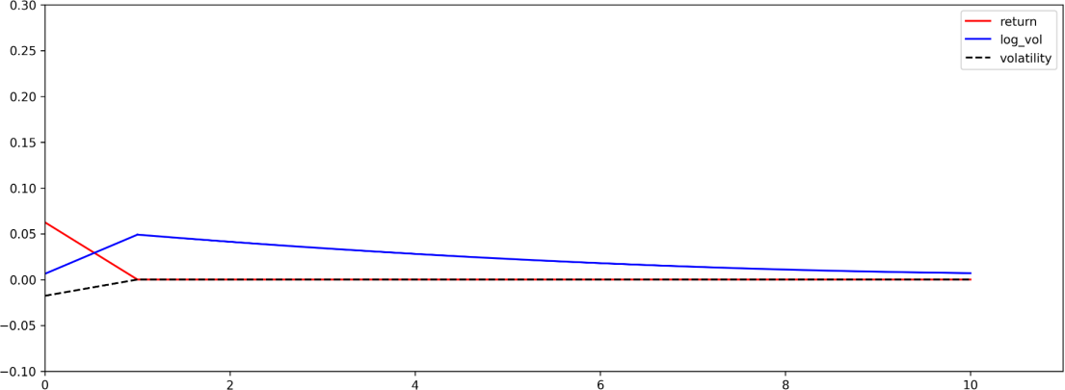and then gradually converges. In regime 2, both return and trading volume show a positive response, but volatility shows almost no response. Subsequently, return converges rapidly, while trading volume shows a large response in the current period and then gradually converges. In regime 3, all three variables exhibit a positive response. Return and volatility converge rapidly after the initial shock, whereas trading volume initially rises and then converges gradually. Regardless of the market conditions, return consistently affects trading volume. However, in stable market environments, return either negatively impacts or does not impact volatility. This finding implies that positive fluctuations in return do not lead to increased market uncertainty in a stable market environment. This phenomenon can be largely attributed to the scarcity and complete circulation of market information under stable conditions, making it difficult for market uncertainty affected by return fluctuations. However, under market shock conditions, market fluctuations cause an increase in market uncertainty, due to the insufficient circulation of market information.

* + - 1. Regime 1

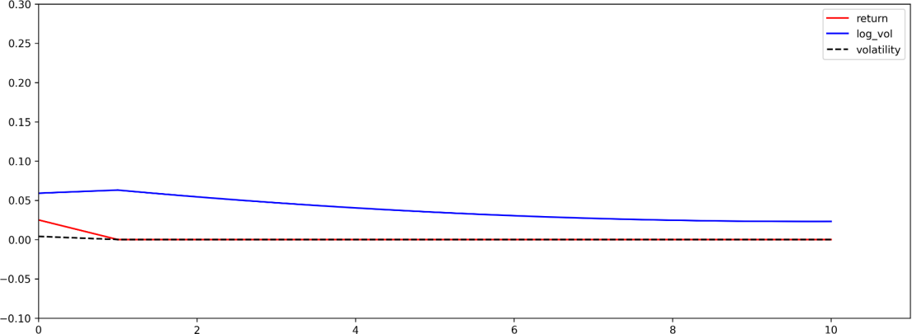

* + - 1. Regime 2

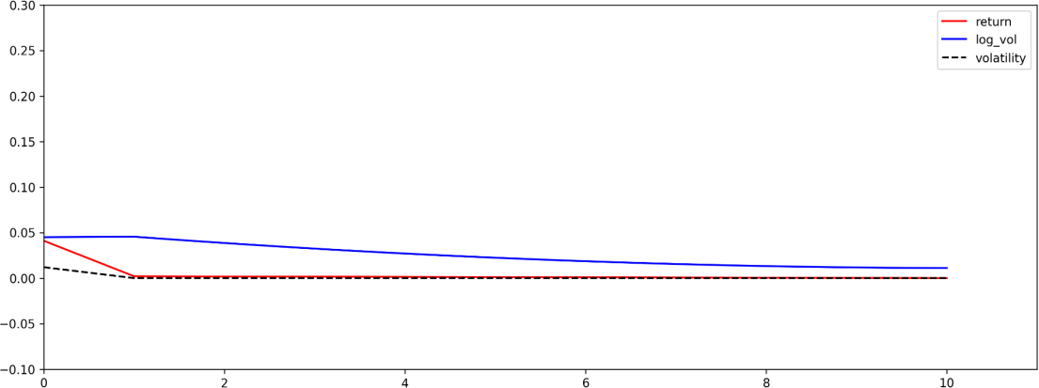

* + - 1. Regime 3

Fig. 1 Impulse response plots of return for CSI 300 index daily data.

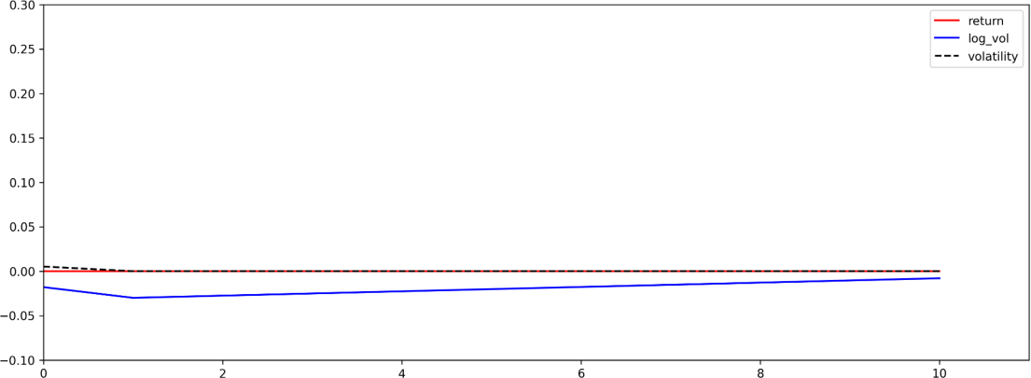Fig. 2 illustrates the effects of standardized positive shocks to market volatility. An increase in volatility has a negligible effect on return, which suggests that uncertainty does not affect volatility in the Chinese market. This may be due to the blind investment behavior of retail investors who fail to properly assess market risks and focus only on market prices. In downward and volatile markets (regimes 1 and 3), volatility negatively affects trading volume. This prompts investors to scale back their operations and wait for clearer market signals. Conversely, in an upward market, heightened uncertainty directly boosts trading volume. This surge might be due to the market’s positive trajectory and heightened uncertainty, which prompts investors to engage more frequently to capitalize on profits or make new market entries.

1. Regime 1

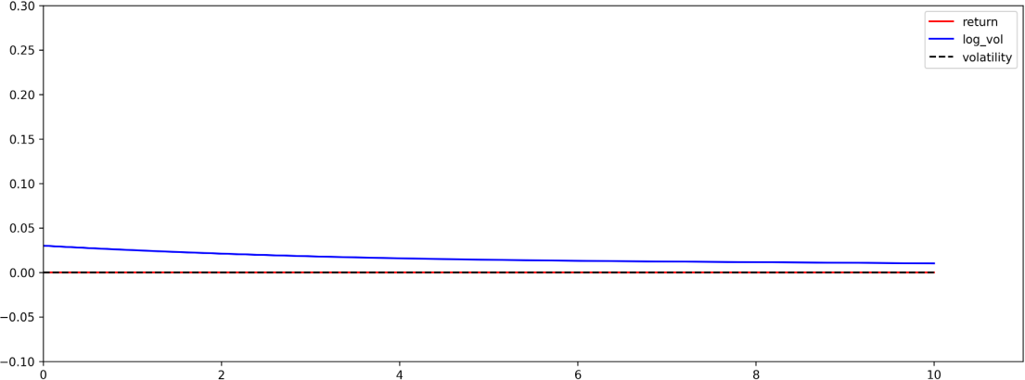

1. Regime 2

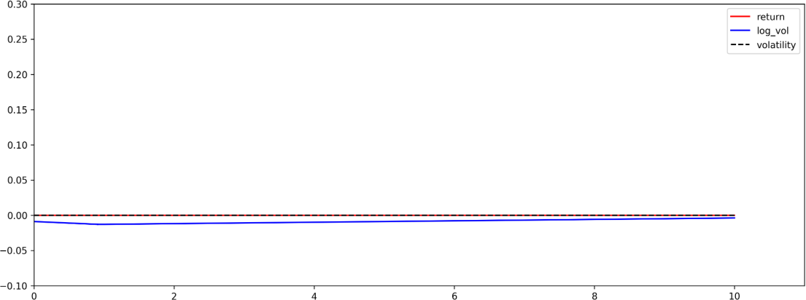

1. Regime 3

Fig. 2 Impulse response plots of volatility for CSI 300 index daily data.

Fig. 3 depicts the impact of positive shocks to trading volume on the market. The intensity of the response in both return and volatility is minimal, whereas trading volume peaks during period 0

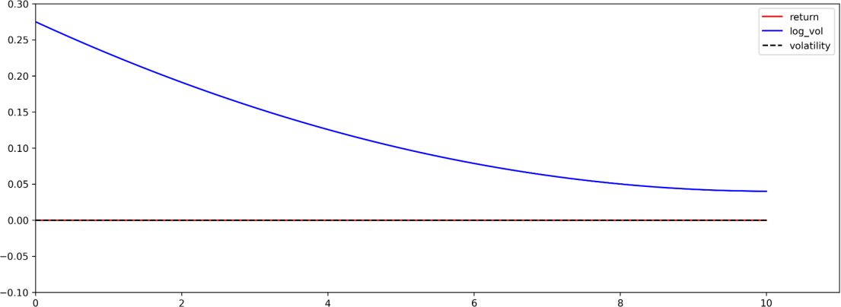and steadily diminishes to zero thereafter. This finding suggests that trading volume has little influence on either volatility or return in the Chinese stock market; thus, it is challenging to predict volatility using trading volume. This further implies that the flow of information within the Chinese stock market may be insufficient or not adequately disseminated, and hence, cannot be fully reflected in stock market indicators; this indicates that the market is still immature.

1. Regime 1

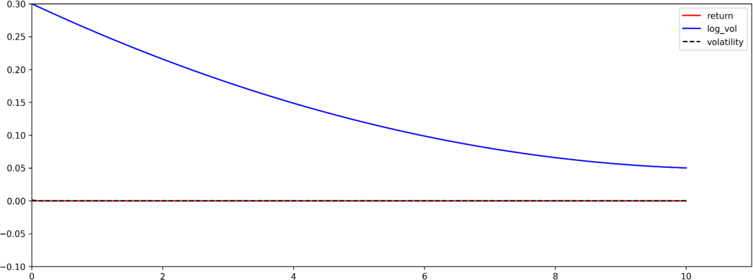

1. Regime 2

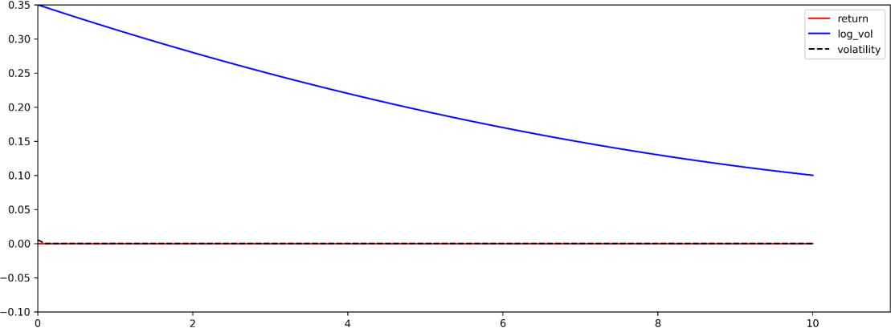

1. Regime 3

Fig. 3 Impulse response plots of trading volume for CSI 300 index daily data.

# Analysis of contemporaneous correlation

The previous analysis examined the nonlinear dynamic relationships among volatility, trading volume, and return. However, because the dynamic relationships among the three variables may also be regime-dependent, the dynamic correlation coefficients between each pair of variables are calculated in Table 8. According to the classification of stock market states, we calculate Pearson’s correlation coefficient matrices for each market feature within the same regime. This analysis

examines the interrelationships among market features within each specific state. It is evident that the concurrent correlation between volatility and either return or trading volume exhibits notable variations across different market regimes.

Under regime 1, a pronounced negative correlation exists simultaneously between market volatility and return in the Chinese stock market, whereas the positive contemporaneous correlation between market volatility and trading volume is less prominent. This indicates that, in a bearish market, declines in stock market return intensify market fluctuations. In regime 2, we observe a strong positive contemporaneous correlation between market volatility and return, indicating that an increase in market return intensifies market uncertainty. Compared to regime 1, the synchrony between market volatility and trading volume is more pronounced in regime 2. This finding reveals that the influence of trading volume on volatility strengthens during periods of stable market growth. However, under regime 3 (the sharp shock period), the contemporaneous correlation between the variables is weak, suggesting that Chinese stock investors are less reliant on on-site information in this state and may be more dependent on off-site information to determine their market behaviors.

Table 8. Contemporaneous correlation analysis of MS-VAR model for CSI 300 index

|  |  |  |  |  |
| --- | --- | --- | --- | --- |
| Regime | Variable | Return | Volatility | Log volume |
|  | Return | 1.0000 | -0.959 | -0.1215 |
| Regime 1 | Volatility | -0.9590 | 1.0000 | 0.1170 |
|  | Log volume | -0.1215 | 0.1170 | 1.0000 |
|  |  | Return | Volatility | Log volume |
|  | Return | 1.0000 | 0.9639 | 0.3087 |
| Regime 2 | Volatility | 0.9639 | 1.0000 | 0.3069 |
|  | Log volume | 0.3087 | 0.3069 | 1.0000 |
|  |  | Return | Volatility | Log volume |
|  | Return | 1.0000 | -0.2387 | 0.3172 |
| Regime 3 | Volatility | -0.2387 | 1.0000 | 0.2242 |
|  | Log volume | 0.3172 | 0.2242 | 1.0000 |

# Robustness analysis

To assess the effect of stock index selection on the Chinese stock market, we use the Shanghai Stock Exchange 50 (SSE 50) Index to explore the robustness of the conclusions. The sample period is the same, spanning from January 4, 2005 to March 1, 2022, with data collected daily. After testing the stationarity of the variables, the optimal lag order is selected as 7 by the information criteria summarized in Table 9. This is consistent with the optimal lag order for the CSI300 index. According to the Bayesian information criterion (BIC), the model selected for the SSE50 Index is the same as that selected for the CSI300 index. This emphasizes that the selection of the stock index does not significantly influence the number of regimes, determination of the lag order, or overall structure of the model.

Table 10 reports the results of the parameter estimation of MS-VAR model for the daily data of the SSE50 Index. The results are similar to those of the original model in identifying the regime states of the stock market, that is, a high-volatility, near-zero mean regime, and two relatively stable regimes with opposite directions. This suggests that the selection of the stock index does not significantly influence the identification of the regimes. Furthermore, the influence of volatility and return on trading volume remains strong and consistent, whereas the reverse effect is still not noteworthy. This further confirms that the results of this study are robust across various comprehensive stock indices in China.

Table 9. Information criteria values of different MS-VAR models for the SSE 50 index.

|  |  |  |  |  |
| --- | --- | --- | --- | --- |
| Specification of model | Log-likelihood | AIC | HQ | BIC |
| Linear VAR(7) | 36139.4260 | -17.3359 | -17.2972 | -17.2263 |
| MSI(2)-VAR(7) | 37663.5560 | -18.0661 | -18.0247 | -17.9489 |
| MSIA(2)-VAR(7) | 38352.1096 | -18.3668 | -18.2914 | -18.1537 |
| MSIH(2)-VAR(7) | 43061.5005 | -20.6578 | -20.6131 | -20.5314 |
| MSIAH(2)-VAR(7) | 43227.9208 | -20.7075 | -20.6289 | -20.4853 |
| MSM(2)-VAR(7) | 37496.0819 | -17.9856 | -17.9442 | -17.8684 |
| MSMA(2)-VAR(7) | 31088.8058 | -14.8757 | -14.8003 | -14.6626 |
| MSMAH(2)-VAR(7) | 31088.8058 | -14.8728 | -14.7942 | -14.6505 |
| MSI(3)-VAR(7) | 38291.2898 | -18.3645 | -18.3192 | -18.2366 |
| MSIA(3)-VAR(7) | 39211.0409 | -18.7460 | -18.6329 | -18.4264 |
| MSIH(3)-VAR(7) | 46549.2746 | -22.3279 | -22.2762 | -22.1818 |
| MSIAH(3)-VAR(7) | 46753.2618 | -22.3654 | -22.2459 | -22.0275 |
| MSMA(3)-VAR(7) | 31419.9654 | -15.0012 | -14.8881 | -14.6815 |
| MSMAH(3)-VAR(7) | 31419.9654 | -14.9954 | -14.8759 | -14.6575 |

Note: AIC, HQ and BIC stand for Akaike information criterion, Hannan-quinn Criterion and Bayesian information criterion.

Table 10. Parameter estimation results of MS-VAR model for the SSE 50 index.

|  |  |  |  |
| --- | --- | --- | --- |
| Variable coefficients | Return | Volatility | Volume |
| Intercept (Regime 1) | -0.005078*** | 0.000052*** | 0.483685*** |
| Intercept (Regime 2) | 0.006677*** | 0.000062*** | 0.5869*** |
| Intercept (Regime 3) | 0.000557 | 0.000933*** | 0.761432*** |
| Return_1 | 0.000441 | 0.000015 | 3.249963*** |
| Return_2 | 0.002629 | -0.000047 | 1.040928*** |
| Return_3 | 0.004840 | -0.000013 | 0.568476*** |
| Return_4 | 0.001542 | -0.000027 | 0.174337*** |
| Return_5 | 0.000596 | 0.000022 | -0.156656 |
| Return_6 | -0.001284 | 0.000000 | -0.638357*** |
| Return_7 | -0.001869 | 0.000006 | -0.508551*** |
| Volatility_1 | 0.029132 | 0.001411** | 24.418484*** |
| Volatility_2 | 0.034267 | 0.000225 | -27.593700*** |
| Volatility_3 | -0.061366 | 0.000741 | -28.835886*** |
| Volatility_4 | -0.000554 | 0.000064 | -18.604401*** |
| Volatility_5 | -0.001474 | 0.000313 | -24.386309*** |
| Volatility_6 | -0.028831 | -0.001009* | -19.446313*** |
| Volatility_7 | 0.043552 | 0.001540 | -22.568391*** |
| Log_vol_1 | -0.000071 | 0.000001 | 0.486982*** |
| Log_vol_2 | 0.000021 | 0.000002 | 0.167981*** |
| Log_vol_3 | -0.000045 | -0.000002 | 0.085539*** |
| Log_vol_4 | -0.000188 | -0.000001 | 0.058479*** |
| Log_vol_5 | 0.000217 | 0.000000 | 0.064190*** |
| Log_vol_6 | 0.000113 | 0.000000 | 0.057705*** |
| Log_vol_7 | -0.000072 | -0.000002 | 0.046024*** |
| Standard (Regime 1) | 0.004019 | 0.000054 | 0.185921 |
| Standard (Regime 2) | 0.004219 | 0.000063 | 0.215368 |
| Standard (Regime 3) | 0.030469 | 0.001144 | 0.264907 |

# Conclusion and policy implications

This study explored the dynamic relationships between stock market volatility, trading volume, and return in the Chinese stock market by introducing a combination of the VAR framework and Markov switching model. Compared to conventional linear VAR frameworks, the MS-VAR model can capture the nonlinear relationships between variables. We analyzed the daily data of the

Shanghai and Shenzhen 300 (CSI300) Index from January 4, 2005 to March 1, 2022 to study the dynamic relationships between volatility, trading volume, and return. The following conclusions are drawn from the empirical findings. First, the MS-VAR model divides the Chinese stock market into three states: stable downward, stable upward, and high volatility. Although the Chinese stock market has the shortest time in the high-volatility state, the difference between this state and the other two states is not significant. In addition, the Chinese stock market is unstable in any state, and the probability of conversion into the other two states is high. This indicates that the overall trend in the Chinese stock market is unstable and challenging to maintain consistent over an extended period. Therefore, investors must always pay attention to the state transition of the stock market.

Second, although the influence of trading volume on return and volatility is not substantial, the effects of return and volatility on trading volume are significant. This reveals the asymmetric dynamic relationships between trading volume, volatility, and return in the Chinese stock market. Therefore, it is challenging to predict changes in volatility or return in the Chinese stock market based on fluctuations in trading volume. According to Gebka and Wohar (2013), these asymmetric dynamic relationships may be due to private information and uninformed trading motivations. This ultimately leads to an insignificant impact of trading volume on volatility and return.

Finally, the contemporaneous correlation between volatility and return varies with the market regime. In a stable downward state, a decrease in return often leads to increased market volatility, whereas in a stable upward state, an increase in return can lead to additional market volatility. This is mainly due to the well-known ‘buy high, sell low’ behavior in the Chinese stock market. Moreover, a positive contemporaneous correlation exists between volatility and trading volume across various market regimes. This finding suggests that market uncertainty is linked to the flow of stock market information on trading days.

This study examines the complex, nonlinear, and asymmetric interactions between volatility, trading volume, and return in the Chinese stock market. The conclusions drawn from this research lead to two distinct policy implications. First, it is desirable to optimize the stock market’s investment structure. The Chinese stock market mainly consists of individual investors, but with a relatively small proportion of institutional investors. Due to information delays and individual limitations, irrational behavior is common among individual investors. Therefore, to promote a reasonable investment structure and stable market operations in the Chinese stock market, it is essential to appropriately augment the proportion of institutional investors and guide individual investors to invest scientifically through institutions in a prudent and rational manner.

Second, it is necessary to enhance regulations to improve the efficiency and stability of the stock market. Empirical studies show that in the Chinese stock market, trading volume lacks predictive capability concerning both return and volatility, but changes in return and volatility can be used to predict trading volume. This differs from empirical findings in developed markets (Balcilar et al., 2017; Chen, 2012), by which trading volume can forecast return within a specific range. Therefore, it is essential to improve the efficiency of the Chinese stock market. First, relevant institutions should strengthen their regulations and improve market mechanisms to ensure market fairness, efficiency, and transparency as much as possible. Second, they should gradually open the Chinese stock market and achieve a two-way opening up for internationalization. Finally, for the stable operation of the stock market, it is essential to maintain policy continuity and effectiveness and promote stable macroeconomic development through the stable development of financial markets.

# Acknowledgments

This work was partially supported by the National Natural Science Foundation of China (Grant No.: 72171192), the MOE Layout Foundation of Humanities and Social Sciences (Grant No.: 22YJA790007), the Science and Technology Innovation Program of Hunan Province (Grant No.: 2021RC3057), the Youth Innovation Team of Shanxi University, and the Fundamental Research Funds for the Central Universities.

# References

Alhussayen, H., 2022. The relationship between trading volume and market returns: A VAR/Granger causality testing approach in the context of Saudi Arabia. Organ. Mark. Emerg. Econ. 13 (1), 260–275.

Balcilar, M., Bouri, E., Gupta, R., et al., 2017. Can volume predict Bitcoin returns and volatility? A quantiles-based approach. Econ. Model. 64, 74–81.

Bessembinder, H., Seguin, P.J., 1993. Price volatility, trading volume, and market depth: Evidence from futures markets. J. Financ. Quant. Anal. 28 (1), 21–39.

Blume, L., Easley, D., O’Hara, M., 1994. Market statistics and technical analysis: The role of volume. J. Finance 49 (1), 153–181.

Bouri, E., Lau, C.K.M., Lucey, B., et al., 2019. Trading volume and the predictability of return and volatility in the cryptocurrency market. Finance Res. Lett. 29, 340–346.

Brailsford, T.J., 1996. The empirical relationship between trading volume, returns and volatility.

Account. Finance 36 (1), 89–111.

Brooks, C., 1998. Predicting stock index volatility: can market volume help? J. Forecast. 17 (1), 59– 80.

Chan, K., Fong, W.M., 2000. Trade size, order imbalance, and the volatility–volume relation. J. Financ. Econ. 57 (2), 247–273.

Chen, S.S., 2012. Revisiting the empirical linkages between stock returns and trading volume. J. Bank. Finance 36 (6), 1781–1788.

Chen, Y.L., Song, F.M., 2000. An empirical study on the relationship between price changes and trading volume in China stock market. J. Manag. Sci. China 3 (2), 62–68.

Clark, P.K., 1973. A subordinated stochastic process model with finite variance for speculative prices. Econom. J. Econom. Soc. 135–155.

Copeland, T.E., 1976. A model of asset trading under the assumption of sequential information arrival. J. Finance 31 (4), 1149–1168.

Dhall, R., Singh, B., 2020. The COVID-19 pandemic and herding behaviour: Evidence from India’s stock market. Millenn. Asia 11 (3), 366–390.

Fan, C.L., Xu, K.J., 2002. A case study of the coherency between the yield rate and business volume on China’s stock market. Adm. World 0 (7), 31–36.

Gebka, B., Wohar, M.E., 2013. Causality between trading volume and returns: Evidence from quantile regressions. Int. Rev. Econ. Finance 27, 144–159.

Gupta, S., Das, D., Hasim, H., et al., 2018. The dynamic relationship between stock returns and trading volume revisited: A MODWT-VAR approach. Finance Res. Lett. 27, 91–98.

Hamilton, J.D., 1989. A new approach to the economic analysis of nonstationary time series and the business cycle. Econom. J. Econom. Soc. 357–384.

He, G., Zhu, S.Z., Gu, H.F., 2020. The nonlinear relationship between investor sentiment, stock

return, and volatility. Discrete Dyn. Nat. Soc. 2020, 1–11.

Henry, Ó.T., McKenzie, M., 2006. The impact of short selling on the price–volume relationship: Evidence from Hong Kong. J. Bus. 79 (2), 671–691.

Karpoff, J.M., 1987. The relation between price changes and trading volume: A survey. J. Financ.

Quant. Anal. 22 (1), 109–126.

Lang, Q.Q., Wang, J.Q., Ma, F., et al., Mohamed Ismail, M.W., 2021. Is Baidu index really powerful to predict the Chinese stock market volatility? New evidence from the internet information. China Finance Rev. Int. 13 (2), 263–284.

Lee, B.S., Rui, O.M., 2002. The dynamic relationship between stock returns and trading volume: Domestic and cross-country evidence. J. Bank. Finance 26 (1), 51–78.

Li, T., Ma, F., Zhang, X.H., Zhang, Y.J., 2020. Economic policy uncertainty and the Chinese stock market volatility: Novel evidence. Econ. Model. 87, 24–33.

Liu, H.Z., 2007. An empirical study on the relationship between return, volatility and trading volume in Shanghai and Shenzhen stock markets. Oper. Res. Manag. Sci. 16 (6), 123–127.

Liu, M., Lee, C.C., Choo, W.C., 2021. An empirical study on the role of trading volume and data frequency in volatility forecasting. J. Forecast. 40 (5), 792–816.

Ngene, G.M., Mungai, A.N., 2022. Stock returns, trading volume, and volatility: The case of African stock markets. Int. Rev. Financ. Anal. 82, 102176.

Ni, S.X., Pan, J., Poteshman, A.M., 2008. Volatility information trading in the option market. J. Finance 63 (3), 1059–1091.

Ozdemir, L., 2020. Volatility spillover between stock prices and trading volume: Evidence from the pre-, in-, and post global financial crisis periods. Front. Appl. Math. Stat. 5, Article 65.

Papadamou, S., Kyriazis, N.A., Tzeremes, P., et al., 2021. Herding behaviour and price convergence clubs in cryptocurrencies during bull and bear markets. J. Behav. Exp. Finance 30, 100469. Pasquale, M., Renò, R., 2005. Statistical properties of trading volume depending on size. Phys. Stat.

Mech. Its Appl. 346 (3), 518–528.

Rossi, E., Santucci de Magistris, P., 2013. Long memory and tail dependence in trading volume and volatility. J. Empir. Finance 22, 94–112.

Sims, C.A., 1980. Macroeconomics and reality. Econometrica 48 (1), 1–48.

Statman, M., Thorley, S., Vorkink, K., 2006. Investor overconfidence and trading volume. Rev.

Financ. Stud. 19 (4), 1531–1565.

Su, Z., Yi, B., 2022. Research on HMM-based efficient stock price prediction. Mob. Inf. Syst. 2022, e8124149.

Sun, Y.L., Chen, S.D., Liu, Y., 2019. Forecast of stock price fluctuation based on the perspective of volume information in stock and foreign exchange market. Syst. Eng.-Theory Pract. 39 (4), 935–945.

Tan, D.J., Tian, Y.X., Huang, W.G., 2008. Duration, volume, volatility and informed trading. Stat.

Res. 196 (2), 71–77.

Tang, Q.M., Liu, Y.Q., 2008. SVAR analysis of the relationship between A and B stock volume, return and volatility under market segmentation. Financ. Stud. 332 (02), 113–126.

Tauchen, G.E., Pitts, M., 1983. The price variability-volume relationship on speculative markets.

Econometrica 51 (2), 485–505.

Tiwari, A.K., Abakah, E.J.A., Bonsu, C.O., et al., 2022. The effects of public sentiments and feelings on stock market behavior: Evidence from Australia. J. Econ. Behav. Organ. 193,

443–472.

Truong, L.D., Friday, H.S., Nguyen, A.T., 2022. The effects of index futures trading volume on spot market volatility in a frontier market: Evidence from Ho Chi Minh stock exchange. Risks 10 (12), 219–234.

Tuaneh, G., Essi, I., Etuk, E., 2021. Markov-switching vector autoregressive (MS-VAR) modelling (mean adjusted): Application to macroeconomic data. Arch. Bus. Res. 9, 261–274.

Wang, C., Wu, C., 2002. Linear and nonlinear Granger causality test of stock price-volume relation: Evidences from Chinese markets. J. Manag. Sci. 5 (4), 7–12.

Wang, J., 1994. A model of competitive stock trading volume. J. Polit. Econ. 102 (1), 127–168. Wang, P.P., Ho, T., Li, Y.S., 2020. The price-volume relationship of the Shanghai stock index:

Structural change and the threshold effect of volatility. Sustainability 12 (8), 1–17.

Wen, F.H., Gong, X., Huang, C.X., et al., 2013. Impact of information flow on returns and return volatility in Chinese stock market. Theory Pract. Finance Econ. 16 (11), 69–80.

Xu, X.E., Chen, P., Wu, C.C., 2006. Time and dynamic volume–volatility relation. J. Bank. Finance 30 (5), 1535–1558.

Yang, B., 2005. The relationship between trading volume and return and volatility of Shanghai A- shares - an empirical study based on mixed distribution model. Stat. Decis. (8), 91–93.

Yang, J., Tong, M., Yu, Z.L., 2023. Can volume be more informative than prices? Evidence from Chinese housing markets. Rev. Quant. Finance Account. 61 (2), 633–672.

Yin, L.B., Wei, Y., 2021. Does the volatility of stock market increase market speculation? Manage.

Rev. 33 (12), 15–29.

Yousaf, I., Yarovaya, L., 2022. The relationship between trading volume, volatility and returns of non-fungible tokens: evidence from a quantile approach. Finance Res. Lett. 50, 103175.

Zada, R.S.E., 2021. The relationship between trading volume، stock returns and volatility in the Saudi stock market. Qalaai Zanist J. 6 (3), 790–822.

Zhang, X.Y., Ma, C.Q., 2007. A cross country comparison of the explanatory power of trading volume to price variability. Theory Pract. Finance Econ. 150 (6), 44–88.

Zhang, Z.T., Qin, Y., 2022. Study on the nonlinear interactions among the international oil price, the RMB exchange rate and China’s gold price. Resour. Policy 77, 102683.

Zhao, Z.Q., Xue, F.H., 2005. Dynamic linkages and influences between trading volume and stock returns. World Econ. (11), 64–70.

Zheng, C., 2022. An innovative MS-VAR model with integrated financial knowledge for measuring the impact of stock market bubbles on financial security. J. Innov. Knowl. 7 (3), 100207.

Zheng, F.B., Wu, C.P., 2007. An empirical study on trading volume and stock-return serial correlation: Evidence from Chinese Stock Market. Financ. Stud. (3), 140–150.



**Declaration of interests**

☒ The authors declare that they have no known competing financial interests or personal relationships that could have appeared to influence the work reported in this paper.

* The author is an Editorial Board Member/Editor-in-Chief/Associate Editor/Guest Editor for [Journal name] and was not involved in the editorial review or the decision to publish this article.
* The authors declare the following financial interests/personal relationships which may be considered as potential competing interests: