

[Egyptian Informatics Journal (2011) 12, 177](http://dx.doi.org/10.1016/j.eij.2011.08.001)–[183](http://dx.doi.org/10.1016/j.eij.2011.08.001)

Cairo University

Egyptian Informatics Journal

[www.elsevier.com/locate/eij](http://www.elsevier.com/locate/eij) [www.sciencedirect.com](http://www.sciencedirect.com/science/journal/11108665)

ORIGINAL ARTICLE

Dynamic room pricing model for hotel revenue management systems

Heba Abdel Aziz a, Mohamed Saleh a,*, Mohamed H. Rasmy a,

Hisham ElShishiny b

a *Department of Operations Research and Decision Support, Faculty of Computers and Information, Cairo University, Egypt*

b *Advanced Technology and Center for Advanced Studies, IBM Technology Development Center, Cairo, Egypt*

Received 23 January 2011; revised 1 August 2011; accepted 24 August 2011

Available online 29 September 2011

KEYWORDS

Revenue management sys- tem;

Dynamic pricing;

Optimal hotel rooms alloca- tion;

Demand elasticity

Abstract This paper addresses the problem of room pricing in hotels. We propose a hotel revenue management model based on dynamic pricing to provide hotel managers with a flexible and efficient decision support tool for room revenue maximization. The two pillars of the proposed framework are a novel optimization model, and a multi-class scheme similar to the one implemented in airlines. Our hypothesis is that this framework can overcome the limitations associated with the research gaps in pricing literature; and can also contribute significantly in increasing the revenue of hotels. We test this hypothesis on three different approaches, and the results show an increase in revenue compared to the classical model used in literature.

© 2011 Faculty of Computers and Information, Cairo University. Production and hosting by Elsevier B.V. All rights reserved.

1. Introduction

* Corresponding author. Address: Faculty of Computers and Infor- mation, Cairo University, 5 Dr. Ahmed Zewail Street, Orman, Giza 12613, Egypt.

E-mail address: [m.saleh@fci-cu.edu.eg](mailto:m.saleh@fci-cu.edu.eg) (M. Saleh).

1110-8665 © 2011 Faculty of Computers and Information, Cairo University. Production and hosting by Elsevier B.V. All rights reserved.

Peer review under responsibility of Faculty of Computers and Information, Cairo University.

doi:[10.1016/j.eij.2011.08.001](http://dx.doi.org/10.1016/j.eij.2011.08.001)

Production and hosting by Elsevier

Revenue management is commonly practiced in the hotel industry to help hotels decide on room rate and allocation. Hotel revenue management is perceived as a managerial tool for attempting to sell each room with the highest price so as to achieve the highest revenue [1].

A revenue management system applies basic economic prin- ciples to pricing and controlling rooms’ inventory. In fact there are three basic categories of demand-management decisions that are addressed by revenue management in general [2,3].

* *Structural decisions*: Decide which selling format to use; which segmentation or differentiation mechanisms to use; which terms to trade to offer.
* *Price decisions*: Decide on how to set posted prices, individ- ual-offer prices, and reserve prices; how to price across product categories; how to price over time; how to discount over the product lifetime.

– *Quantity decisions*: Decide whether to accept or reject an offer to buy; how to allocate capacity to different segments; when to withhold a product from the market and sale at later points in time.

Traditionally hotels use the capacity controls/quantity deci- sions as a default tactic, this is due to its simplicity as the different products a hotel offers (different room types sold at different times under different terms) are all supplied using the same, homogeneous hotel capacity. This gives hotel systems tremen- dous quantity flexibility [4]. Our main assumption is that using price decisions in hotel revenue management systems will signif- icantly increase the revenue of the hotel. In this paper, we pro- pose a revenue management framework based on price decisions. Particularly, we are concerned with dynamic pricing as a component of hotels’ revenue management systems. In recent years, the revenue management field in hotel industry has wit- nessed an increased adoption of existing dynamic pricing poli- cies [5–12]. Pricing policies are a fundamental component of the daily operations of manufacturing and services companies, because price is one of the most effective variables that managers can manipulate to encourage or discourage demand in short run. Price is not only important from a financial point of view, but also from an operational standpoint. It is a tool that helps

to regulate inventory and production pressures.

Based on a comprehensive literature review we conducted [13], we identified the following research gaps:

1. Many of the research on dynamic pricing have focused on the problem of a single product, where multiple product dynamic pricing problems have received considerably less attention. Moreover, the previous work on multiple prod- uct use dynamic programming formulation to solve the problem of profit maximization [14–18]. Dynamic pro- gramming cannot be applied to solve realistic sized prob- lems in hotels systems, as in Ref. [19]; p. 5]:

*‘‘The dynamic programming formulation baseline cannot solve realistically sized problems. In a typical large hotel, the number of rate classes is about 25, there are 7 different lengths-of-stay, and the planning horizon is about 365 days. The dynamic program would then have 175(25* · *7) states to be solved over about 365 stages (i.e., 63875 combinations). This is not computationally feasible, especially with multiple updates during a day.’’*

1. Previous work on dynamic pricing use a predetermined dis- crete set of prices from which they optimally allocate the price for a given night, since using a continuous set of prices would add to the complexity of the model and will need a sophisticated large-scale programming solver to obtain the optimal solution [20–24].
2. Another deficiency in the previous work is that most of the models use pre-defined probability distributions to repre- sent guest arrivals [14,15,25–27], and hence the price elastic- ity of demand is incorporated implicitly in their models. The price elasticity of demand is defined such as, for all nor- mal goods and services, a price drop results in an increase in the quantity demanded by customers, and vice versa. This also applies to the demand on hotel rooms [2,3]. As explained later, instead of pre-defined distributions we

propose a sophisticated simulator in order to have the flex- ibility of representing any complex demand scenario, and in order to explicitly represent demand elasticity to price.

Our optimization model is novel, because it addresses the research gaps in the current state of the art. Basically the con- tribution of this paper is to enhance the classical revenue man- agement optimization model (described in the next section) by the following four features to overcome the limitations associ- ated with the research gaps.

First, our proposed model dynamically sets prices for rooms at each night instead of using a predetermined set of prices, since a discrete set of prices could possibly lead to suboptimal pricing, and hence a loss of revenue. The prices can be set to any real va- lue within a certain range.

Second, instead of using pre-defined probability distribution, we use a highly sophisticated simulator for estimating arrivals, for the coming year. The simulator takes as an input the reserva- tion scenarios that took place in the past. A reservation scenario contains all the parameters that portray a certain reservation like (Arrival Date, Reservation Date, Length of Stay, Room Type, etc.). It then analyzes and uses these data to extract many parameters and components like (Trend, Seasonality, Booking Curve, Cancellations, etc.). These parameters and components are then used to generate forward reservation scenarios that would take place in the future. Analyzing this generated reserva- tion cases one can obtain realistic perceptions for occupancy, arrivals, and even revenue of the future. The future generated reservations are passed with all their attributes to the optimiza- tion module as an input. This will be described more elaborately later in the paper. The simulator gives quite accurate estimates as it uses a bottom-up approach to comprehensively model all the basic processes in the hotel; e.g. reservations arrivals, canc- elations, duration of stays, group modeling, and seasonality, etc. Moreover the simulator has been validated with real data from hotels to ensure accuracy; for more details, the reader may refer to [28].

Third, a vital feature of our proposed model is that it cap- tures the demand elasticity to price.

Finally, instead of using a dynamic programming formula- tion, we use a non-linear programming formulation that can solve realistically sized problems. The plan is to resolve the model every night, after midnight (for around half an hour) on the hotel server, in its idle time. Therefore there would be no significant overhead cost.

The rest of this paper is organized as follows: In Section 2 – the classical revenue management model – we give a brief description of the classical model in literature. In Section 3 – the proposed model framework – we propose a new model to help overcome the limitations associated with the research gaps (described above); then we discuss several approaches to adopt our model in the revenue management framework. In Section 4, we present a case study to illustrate the imple- mentation of the proposed framework. Finally, in Section 5, we conclude, and mention some possible future work.

1. The classical revenue management model

This section gives a brief overview of the classical deterministic model [4,8]. This model is based on a capacity control formu- lation; where we seek an optimal allocation for rooms to be

reserved for different types of stay in the hotel. It treats de- mand as if it was deterministic and equals it to its expectation. To formulate this model, we define a stay in the hotel by (*a*, *L*, *k*), where ‘*a*’ is the first night of the stay, ‘*L*’ is the length of the stay and ‘*k*’ the price class. Further, denote the set of stays that make use of night ‘*l*’ by *Nl*, where *Nl* = {(*a*, *L*, *k*):

*l* = *a*: *a* + *L* — 1}. Also, define the following parameters:

*Pk*: The price associated with a price class ‘*k*’.

*da*,*L*,*k*: The expected demand of a stay of type (*a*, *L*, *k*).

*Cl*: The capacity (number of rooms) of the hotel available on night *l*.

And the decision variables for this model will be:

*Xa*,*L*,*k*: Optimal allocation to a stay of type (*a*, *L*, *k*). The model is then formulated as follows:

Maximize

*f* = *Pk* * *L* * *Xa*;*L*;*k*

X

*a*;*L*;*k*

Subject to

summation over nights of the multiplication of the price of a certain night and the number of rooms reserved in the same night. Moreover, the only restriction in our model is that the total number of reservations for each night does not exceed the capacity associated with this night.

*3.1. Proposed mathematical model formulation*

Maximize

*Max l*

X

*PlOl*

*l*=1

Subject to

*Ol* 6 *Cl* ∀*l*

*Pl* 6 0 ∀*l*

where the decision variables for this model are:

*Pl*: Price allocated in night *‘l*’ 6*l*

and these are the computed auxiliary variables:

*Xa*,*L*: The number of rooms allocated to a stay of type (*a*, *L*)

*a*;*L*X;*k*∈*Nl*

*Xa*;*L*;*k* 6 *da*;*L*;*k* ∀*a*; *L*; *k*

P 0 ∀*a*; *L*; *k*

*Xa*;*L*;*k*

*Xa*;*L*;*k*

6 *Cl* ∀*l*

and it is defined as

P*a*+*L*—1*P* !*e*

*X*

= *d*

*l*=*a l*

*a*;*L*

*a*;*L*

*L* * *Pnominal*

The objective of this model is to maximize the total revenue under the restriction that the total number of reservations for a night does not exceed the capacity of the night. Moreover, in order to prevent vacant rooms, the number of rooms allocated

*Ol*: The number of rooms reserved in a given night and it equals

to each type of stay is restricted by the level of the expected de- mand. This model uses a capacity control tactic; the decision variables are the allocated rooms in the hotel, and the price

*Ol* =

*a*;*L*;∈*Nl*

X

*Xa*;*L*

associated with each price class is set beforehand, i.e. the price elasticity of demand is not taken into consideration.

In the next section we present some modifications to the model described above to enable prices to be adjusted every night. In this model, we incorporate price elasticity of demand; so that decision makers in hotel management systems can ad- just prices adequately, for every night, to meet the change in total demand for the rooms.

1. The proposed dynamic pricing model

As mentioned above, the classical model is using a capacity control tactic; the decision variables are the allocated rooms in the hotel, and the price associated with each price class is set beforehand. To formulate this problem as a price control tactic, we need to change the decision variables to be the prices set every day, and incorporate the price elasticity of demand as a parameter in the model.

In our model, a stay in the hotel is defined by (*a*, *L*); where ‘*k*’ is being omitted since the new trend in hotels is to reserve using an online reservation system, thus you cannot segment the market into different price classes. We have also added additional parameters and auxiliary variables to formulate a dynamic pricing optimization model.

The objective of this model is to maximize the total revenue of the hotel; so the objective function is defined as the

And the models’ input parameters are:

*Pnominal*: Nominal price of the hotel (usually the average his- torical price).

*e*: Elasticity between price and demand.

*da*,*L* and *Nl*: defined as in the classical model.

*Cl*: The total number of rooms available in the hotel; i.e. a given input parameter (as defined in the classical model).

The output of this model is the optimal prices for each night to determine the pricing policy of the hotel. It can be noted that this resulting price can be continuous, similarly to the out- put of most online booking systems; therefore no further approximation will be needed. Nevertheless, the system can only present the average room price to the customer to avoid his dissatisfaction from changing the price daily.

In order to incorporate this dynamic pricing model into revenue management systems, several interviews have been conducted with domain experts to understand the most impor- tant features of hotel management. Managers mainly wanted to develop a multi-category mechanism like the one imple- mented in airlines. In this multi-category system, in each night, there will be different prices; where each price is associated with a certain category. To implement this, we conducted a parametric analysis on the proposed model to determine differ- ent rates for each category. The goal of this parametric analy- sis is to create a way to induce a dynamic change in the price as

new reservations arrive. Otherwise it would have been very exhausting and time consuming to run the simulator and our model, after each reservation.

The idea of this paper is as follows: A hotel typically desig- nates a number of price categories. It assigns a number of rooms for each category. Low priced categories are for the early reservations, and as they get successively booked, we move onto the higher-rated categories. In general, allocating too many rooms to the lower-priced category, will lead to more bookings, but at the expense of potentially losing higher revenue from higher-priced categories (lost opportunity). In the other extreme, allocating more rooms to the higher- priced categories could leave more rooms un-booked. The goal of this paper is to develop a framework that enables us to find the optimal price for each category, in each night, so as to maximize revenue. This leads to a sophisticated optimization problem that takes into account future bookings and their probabilities. The prices are dynamic and can change day by day. Note that in order to properly solve this optimization problem, we need to properly estimate the future demand for the rooms. The use of an accurate suitable estimation tool will ensure a minimum margin of error, since it has been validated using real data from the hotel.

In this paper we propose three approaches to implement this idea:

* The first approach is to obtain different scenarios of the forecasted demand, and then calculate different percentiles

of these forecasted scenarios. Then use each percentile as the estimated demand to solve the dynamic model. The out- put of this approach is different prices for each day along the forecasted horizon; each price is related to the amount of demand, i.e. if the demand is low, so will be the price associated with it. The problem with this approach is that we must generate several demand forecasts from the simulator.

* For the second approach, we obtain only one scenario for

the estimated demand and we divide it into *m overlapping*

*segments*; each of which is used as the estimated demand. This approach also generates different prices for each day, where each price is related to the percentage of the total demand used.

* The third approach manipulates the capacity of the hotel, it

partitions the total capacity of the hotel into *n overlapping*

*segments*; and for each segment the proposed model is solved to obtain a different set of prices. So each price set is related to the occupancy level in the hotel, i.e. when the hotel is not fully occupied, the price will be low and it will increase as long as the number of available rooms in the hotel decreases.

1. Case study

In this section we present the results of our proposed model using the three approaches, described above. We assume a case where a hotel manager would like to know the optimal prices to set for each night 3 months ahead of the actual reservation. We use a hotel simulator to represent and generate the fore- casted demand that will be used as input to the optimization model. The simulator takes as an input the actual reservation

scenarios, obtained from Plaza hotel in Alexandria, which took place in the past 3 years. The future generated reserva- tions are passed with all their attributes to the optimization module as an input. In particular, the optimization model uses the following attributes (available in each forward reservation record): Arrival Date, and Length of Stay.

In our particular case study, the future time horizon of the study is 90 nights, and the maximum length a guest can stay is 14 days. The hotel room capacity is 80 rooms with nominal price of $120. To mine the data to obtain the price elasticity parameter, we carried out numerous experiments on the avail- able data. For example, to calibrate the value of elasticity in the third approach we implemented the following algorithm:

* Loop for different values of the elasticity *‘e’*.

s Begin loop For *Cl*=Lowest capacity: Highest capacity.

* + Solve the optimization model given ‘*Cl*’ and *‘e*’.
  + Plot the graph of optimized prices along the simulated horizon.

s End loop.

s Compare all plotted prices (*for a given e*) with the price range extracted from the actual data in Plaza hotel.

* End Loop.

Note that in the above algorithm we loop for different val- ues of elasticity, in order to identify the appropriate range for elasticity that guarantees a feasible solution to the model. Ex- treme values for elasticity can lead to infeasible solution. At the end of our experiments (in the various approached), we have concluded that the best value for the price elasticity of de-

mand in the case of Plaza Hotel is equal to —2, i.e. an increase

in the price by 1% will be met by a decrease in the demand by

2% and vice versa.

Based on the above information, and based on the demand scenarios generated by the simulator, we iteratively solved the proposed optimization model according to the three parametric analysis approaches, described in the previous section. We used the ‘*fmincon*’ advanced non-linear solver, in the Matlab optimi- zation toolbox to solve the model [29,30]. It takes around 30 min to solve the model on a normal speed computer.

After iteratively solving the model, we obtain the optimal price (for each night) associated with each category, in each approach. In general, the change of price over time is a reflec- tion of the corresponding change of the forecasted demand; where if the forecasted demand is high so will be the optimized price to attempt to maximize the revenue, and vice versa.

* For the first approach, we run the simulator for 500 runs and we use these 500 runs to calculate the 20th, 40th,

60th, and 80th percentiles. These percentiles are going to be used as the estimated demand one at a time. Fig. 1 por- trays the forecasted demand percentiles; Fig. 2 portrays the price for each night using different demand scenarios; Moreover, for better visualization and comparison, Fig. 3 portrays the demand vs. prices, in the case of the 80th per- centile (as an example).

* For the second approach, we use the average of the 500 sim-

ulated runs as the expected demand. This expected demand

is divided into four overlapping segments; i.e. we start with 25% of the demand, and this percentage is increased by 25% for the rest of the four segments. Fig. 4 portrays the





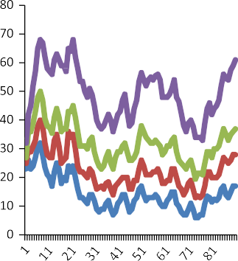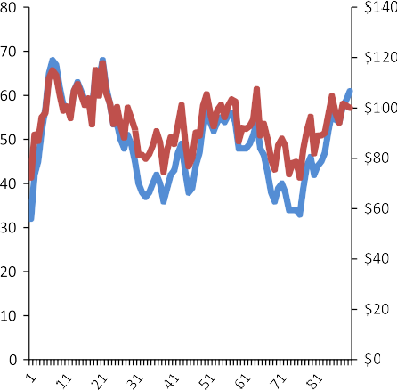Figure 1 Forecasted demand percentiles.



demand segments’’; Fig. 5 portrays the price for each night, using different demand segments’’. And Fig. 6 portrays the demand vs. prices, in the last segment (as an example); i.e. in the case of 100% demand.

* For the third approach, we also use the average of the 500

simulated runs as the expected demand for rooms in the

hotel. Then we divide the hotel capacity into four segments,

i.e. we start with a capacity = 20 rooms, and this capacity is being incremented by 20 for the rest of the four segments (recall that the total hotel capacity is 80 rooms). Fig. 7 por- trays the expected demand, and Fig. 8 portrays the price for each night, using the four capacity segments. Fig. 9, por- trays demand vs. prices, in the case of full capacity.

As shown from the results of the three different approaches, the output prices for all classes follow the same pattern. In gen- eral, the prices decrease as the demand for the rooms decreases and vice versa.

We then conducted several interviews with field’s experts to collect their feedbacks on the outputs of the different ap- proaches. The results of our interviews showed that the third approach is much more convenient in the hotel industry; since the system checks for the number of rooms available, and based on this information the system decides which price to of- fer for the guest. So this approach can be easily understood and implemented by hotel managers.

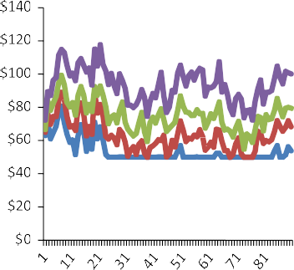Finally as part of the validation of our proposed model, we compare the results of the third approach with the classical model described in Section 2, using demand scenarios gener-



Figure 2 Price for each night using different demand scenarios.

Figure 3 Price vs. demand (demand: 80th percentile).



Figure 4 Demand segments.



Figure 5 Price for each night using different demand segments.

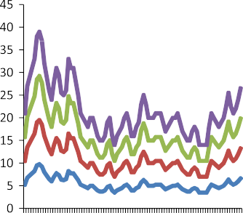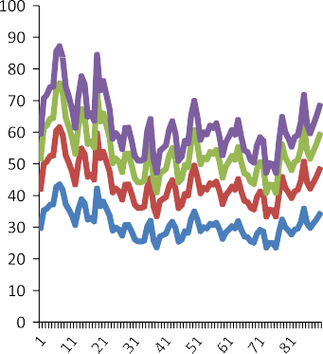ated for single rooms, double rooms and suites.1 After running both models, the revenue obtained from each model is as shown in Table 1.

1 The total number of single rooms used to obtain these revenues in both models is 11 rooms, while the total number of double rooms is 80 rooms and the total number of suites is 46 rooms. The optimization horizon is 90 days.

 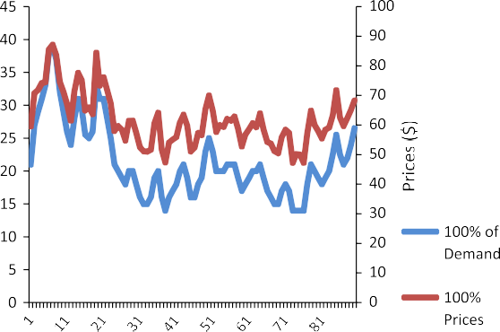 



Figure 6 Price vs. demand (demand: 100%).

 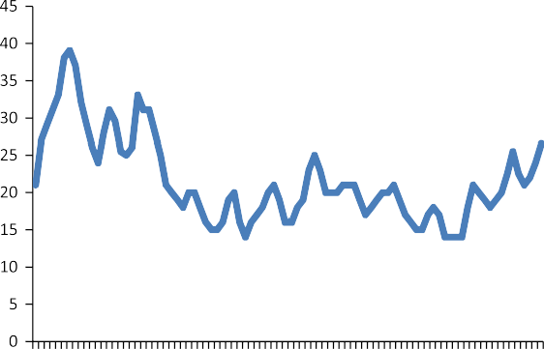

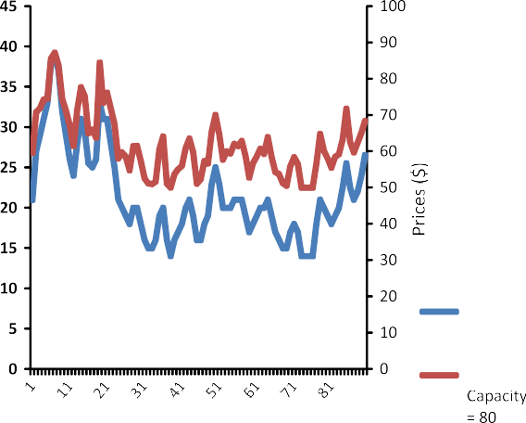



Figure 7 Expected demand.



Figure 8 Price for each night using the four capacity segments.

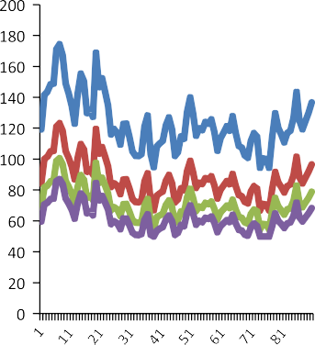It is quite clear that our proposed dynamic pricing model can contribute in increasing the total revenue of the hotel when compared to the former classical model. Note that both the simulator and the optimization model are designed to be gen- eric (i.e. there is no specific assumptions related to a certain class of hotels). For this reason, the proposed system can be applied to any class of hotels.

Figure 9 Price vs. demand (capacity: 80 rooms).

|  |  |  |
| --- | --- | --- |
| Table 1 A comparison between the classical and proposed  models. | | |
|  | Classical model ($) | Dynamic pricing model ($) |
| Single rooms | 5350 | 10,700 |
| Double rooms | 241,890 | 460,206 |
| King rooms | 11,325 | 33,975 |
|  |  |  |

1. Conclusion

This paper addresses the problem of optimally setting the price of the hotel rooms in order to maximize revenue. It first pre- sents the classical model used in literature for solving room allocation problem. We then explain how to modify it based on a dynamic pricing approach.

The main idea is to reformulate the classical model in order to incorporate the price elasticity of demand. Furthermore, in order to integrate this dynamic pricing model into revenue management systems, we propose a novel multi-category idea. We postulate that our proposed revenue management frame- work overcomes the limitations associated with the research gaps in dynamic pricing literature and can contribute in increasing the revenue of a hotel.

In future work, we will consider groups’ reservations [31–](#_bookmark18) [33] combined with dynamic pricing. We will also consider overbooking policies to compensate for guests cancellations, or no show ups. Finally we may consider using general regres- sion techniques, as an alternative approach to estimate the elasticity [34].

References

1. El-Gayar N, Hendawi AT, Zakhary A, El-Shishiny H. A proposed decision support model for hotel room revenue man- agement. ICGST Int J Artif Intell Mach Learn 2008;8(1):23–8.
2. Ingold A, McMahon-Beattie U, Yeoman I. Yield management: strategies for the service industries. In: Ingold A, McMahon- Beattie U, Yeoman I, editors. 2nd ed. London: Continuum; 2000.
3. Talluri KT, Van Ryzin G. The theory and practice of revenue management. Springer Verlag; 2005.
4. Goldman P, Freling R, Pak K, Piersma N. Models and techniques for hotel revenue management using a rolling horizon. J Revenue Pricing Manage 2002;1(3):207–19.
5. Anjos MF, Cheng RC, Currie CS. Optimal pricing policies for perishable products. Eur J Oper Res 2005;166(1):246–54.
6. Bertismans D, De Boer S. Special issue papers: dynamic pricing and inventory control for multiple products. J Revenue Pricing Manage 2005;3(4):303–19.
7. Feng Y, Xiao B. Integration of pricing and capacity allocation for perishable products. Eur J Oper Res 2006;168(1):17–34.
8. Klein R. Network capacity control using self-adjusting bid-prices. OR Spectrum 2007;29(1):39–60.
9. Lin KY. Dynamic pricing with real-time demand learning. Eur J Oper Res 2006;174(1):522–38.
10. Oliveira FS. A constraint logic programming algorithm for modeling dynamic pricing. INFORMS J Comput 2008;20(1):69.
11. Popescu I, Wu Y. Dynamic Pricing strategies with reference effects. Oper Res 2007;55(3):413.
12. Zhao W, Zheng YS. Optimal dynamic pricing for perishable assets with nonhomogenous demand. Manage Sci 2000;46(3):375–88.
13. Abdel Aziz H, Saleh M, El-Gayar N, El-Shishiny H. Dynamic pricing literature review. Technical report #3, Egyptian Data Mining and Computer Modeling Center of Excellence; Informa- tion Technology Industry Development Agency, Egypt; 2008.
14. Bitran G, Caldentey R. An overview of pricing models for revenue management. Manuf Serv Oper Manage 2003;5(3):203–29.
15. Ding Q, Kouvelis P, Miner JM. Dynamic pricing through discounts for optimizing multiple-class demand fulfillment. Oper Res 2006;54(1):169–83.
16. Elmaghraby W, Keskinocak P. Dynamic pricing in the presence of inventory considerations: research overview, current practices, and future directions. Manage Sci 2003;49(10):1287–309.
17. Levin Y, McGill J, Nediak M. Price guarantees in dynamic pricing and revenue management. Oper Res 2007;55(1):75–97.
18. McAfee P, Te Velde V. Dynamic pricing in the airline industry. In: Hendershott TJ, editor. Forthcoming in Handbook on Economics and Information Systems. Elsevier; 2006.
19. Baker TK, Collier DA. The benefits of optimizing prices to manage demand in hotel revenue management systems. Prod Oper Manag 2003;12(4):502–18.
20. Feng Y, Xiao B. Optimal policies of yield management with multiple predetermined prices. Oper Res 2000;48(2):332–43.
21. Fibich G, Gavious A, Lowengart O. The dynamics of price elasticity of demand in the presence of reference price effects. J Acad Market Sci 2005;33(1):66–78.
22. Harewood SI. Managing a hotel’s perishable inventory using bid prices. Int J Oper Prod Manage 2006;26(10):1108–22.
23. Xiao YB, Chen J, Chen Y. On a semi-dynamic pricing and seat inventory allocation problem. OR Spectrum 2007;29(1):85–103.
24. Lai Kin-Keung, Ng Wan-Lung. A stochastic approach to hotel revenue optimization. Comput Oper Res 2005;32(5):1059–72.
25. Feng Y, Xiao B. A continuous-time yield management model with multiple prices and reversible price changes. Manage Sci 2000;46(5):644–57.
26. McGill JI, van Ryzin GJ. Revenue management: research overview and prospects. Transport Sci 1999;33(2):233–57.
27. You PS. Dynamic pricing in airline seat management for flights with multiple flight legs. Transport Sci 1999;33(2):192–206.
28. Zakhary A, Atyia A, El-Shishiny H, El-Gayar N. Forecasting hotel arrivals and occupancy using Monte Carlo simulation. J Revenue Pricing Manage 2009.
29. Waltz RA, Morales JL, Nocedal J, Orban D. An interior algorithm for nonlinear optimization that combines line search and trust region steps. Math Prog 2006;107(3):391–408.
30. Find minimum of constrained nonlinear multivariable function.

<[http://www.mathworks.com/help/toolbox/optim/ug/fmin-](http://www.mathworks.com/help/toolbox/optim/ug/fmincon.html) [con.html](http://www.mathworks.com/help/toolbox/optim/ug/fmincon.html)> [accessed 06.07.11].

1. Abdel Aziz H, Saleh M, El Shishiny H, El Gayar N. A randomized model for group reservations in a hotel’s revenue management system. In: Faculty of Computers and Information, Cairo University. Sixth International Conference; 2008.
2. El Gayar N, Zakhary A, Abdel Aziz H, Saleh M, Atiya A, El-Shishiny

H. A new approach for room revenue maximization using advanced forecasting and optimization methods. In: Proceedings of the EuroCH- RIE conference: Dubai, United Arab Emirates; 2008.

1. ElGayar N, Saleh M, Atiya A, El-Shishiny H, Zakhary A, Abdel Aziz H. An integrated framework for advanced hotel revenue management. Int J Contemp Hospital Manage 2011;23(1):84–98.
2. Abas AR. Using general regression with local tuning for learning mixture models from incomplete data sets. Egypt Inform J 2010;11(2):49–57.