HOSTE D BY

Available online at [www.sciencedirect.com](http://www.sciencedirect.com/science/journal/2314808X)

ScienceDirect

journal homepage: <http://ees.elsevier.com/ejbas/default.asp>

[e g ypti an j o ur nal o f b a sic and a pp l i e d sci en c e s 2 ( 201 5 ) 75](http://dx.doi.org/10.1016/j.ejbas.2015.01.002) e[86](http://dx.doi.org/10.1016/j.ejbas.2015.01.002)



Effects of omega-3 fatty acids and pioglitazone combination on insulin resistance through fibroblast growth factor 21 in type 2 diabetes mellitus

*Laila A. Eissa*\**, Noha Abdel-Rahman, Salma M. Eraky*\*



*Biochemistry Department, Faculty of Pharmacy, Mansoura University, 35514, Egypt*

## a r t i c l e i n f o

*Article history:*

Received 9 November 2014 Received in revised form 13 January 2015

Accepted 28 January 2015

Available online 18 February 2015

*Keywords:*

Fibroblast growth factor 21 Insulin resistance

Type 2 diabetes Omega-3 fatty acids Pioglitazone

## a b s t r a c t

Fibroblast growth factor 21 (FGF21) is an effective regulator of glucose and lipid metabolism. It is mainly regulated by peroxisome proliferator activated receptors, and is widely associated with cases of insulin resistance as obesity and type 2 diabetes (T2D). Our study aimed to investigate thepotentialeffects of omega-3 fatty acids, pioglitazone, andtheircombination on serum and liver FGF21 concentrations, and its hepatic gene expression in a rat model of T2D. We also studied the modulating effects of these treatments on blood glucose, lipid profile, and insulin resistance. T2D was induced in male SpragueeDawley rats by combination of high fat diet and low dose streptozotocin (35 mg/kg). Diabetic rats were treated with omega-3 fatty acids (10%W/W diet), pioglitazone (20 mg/kg), and their combination for a period of 4 weeks. Serum FGF21 concentration was significantly increased in diabetic rats. In contrast, hepatic FGF21 concentration, and gene expression were significantly decreased. Omega-3 fatty acids, pioglitazone, andtheir combination significantly decreased serum FGF21. Omega-3 fatty acids and combination therapy significantly decreased liver FGF21 concentration, with non- significant changes in gene expression. On the other hand, pioglitazone significantly increased hepatic FGF21 concentration and gene expression. Omega-3 fatty acids, pioglita- zone and their combination significantly improved lipid profile. Pioglitazone and combination significantly decreased blood glucose levels and improved insulin resistance. In conclusion, this study introduces the first evidence regarding the antidiabetic effects of omega-3 fatty acids and pioglitazone combination, such effects are mediated through FGF21.

Copyright 2015, Mansoura University. Production and hosting by Elsevier B.V. This is an open access article under the CC BY-NC-ND license ([http://creativecommons.org/licenses/](http://creativecommons.org/licenses/by-nc-nd/4.„0/)

[by-nc-nd/4.0/](http://creativecommons.org/licenses/by-nc-nd/4.„0/)).

# Introduction

Diabetes prevalence is increasing at an accelerating rate approaching epidemic levels. Currently, there are 382 million

diabetic patients worldwide. In the Middle East and North Africa, 1 in 10 adults have diabetes. Egypt is one of the top 10 countries in the number of people with diabetes (7.5 million in 2013) and the number is expected to increase to 13.1 million by 2035 [1]. Diabetes is characterized by hyperglycemia resulting

* *Corresponding authors*. Tel.: +20 1097400781, +20 1098969384.

E-mail addresses: [lailaeissa2002@yahoo.com](mailto:lailaeissa2002@yahoo.com) (L.A. Eissa), [salmamossad2012@gmail.com](mailto:salmamossad2012@gmail.com) (S.M. Eraky).

Peer review under responsibility of Mansoura University. <http://dx.doi.org/10.1016/j.ejbas.2015.01.002>

2314-808X/Copyright 2015, Mansoura University. Production and hosting by Elsevier B.V. This is an open access article under the CC BY- NC-ND license ([http://creativecommons.org/licenses/by-nc-nd/4.0/](http://creativecommons.org/licenses/by-nc-nd/4.„0/)).

76 [e gypti an j o ur nal o f b a sic and a pp l i ed sci e n c e s 2 ( 201 5 ) 75](http://dx.doi.org/10.1016/j.ejbas.2015.01.002) e[86](http://dx.doi.org/10.1016/j.ejbas.2015.01.002)

from disorders in insulin secretion, insulin action or both [2]. Type 2 diabetes (T2D) is a heterogeneous, progressive disorder initially characterized by glucose intolerance and compensa- tory hyperinsulinemia, which in later stages progresses to insulin resistance and impaired beta cell function [3].

Type 2 Diabetes, which accounts for 90e95% of diabetic cases, is largely caused by social and lifestyle factors that can be readily controlled [1,2]. Obesity leads to an increase in the adipose tissue mass. This in turn triggers insulin resistance in fat, skeletal muscle, and liver leading to T2D [4]. A medical approach is not always sufficient for T2D management and lifestyle modification should be considered.

Omega-3 fatty acids (u-3 fatty acids) have shown to possess

anti-inflammatory, and lipid lowering effects, suggesting a possible beneficial effect in management of T2D and its complications [5,6]. Several animal studies have shown that administration of the u-3 fatty acids, eicosapentaenoic acid (EPA) and docosahexaenoic acid (DHA), prevented the devel- opment of insulin resistance, obesity, and dyslipidemia [6](#_bookmark14)e[8]. These effects are mediated via interaction with peroxisome proliferator-activated receptor a (PPAR-a) [9]. PPAR is a nuclear receptor that plays important roles in adipocyte differentia- tion, lipid and carbohydrate metabolism through transcrip-

tional regulation of different genes [10]. Other studies in T2D patients and rat models of insulin resistance showed that u-3 fatty acids failed to reverse insulin resistance [6,11](#_bookmark14)e[14].

Pharmacological management of T2D aims to increase in- sulin secretion or improve insulin sensitivity [15]. Pioglitazone belongs to a class of drugs named thiazolidinediones, which improve insulin sensitivity, lipid metabolism, and glucose homeostasis through activation of PPAR-ˠ [16].

Fibroblast growth factor 21 (FGF21) is a recently identified hormone that has an important role in glucose and lipid ho- meostasis [17](#_bookmark20)e[19]. Rat FGF21 is a circulating protein derived from a 208-amino acid mature protein encoded by the FGF21 gene located in chromosome 1 [20]. FGF 21 is detected in plasma, so it is proposed to be secreted into circulation acting as a true hormone. Its activity depends on binding to FGF re- ceptors (FGFR) and a cofactor called b-Klotho, a trans- membrane protein whose expression is stimulated during development of preadipocytes to adipocytes [21]. The cofactor b-Klotho is predominantly expressed in metabolic organs including liver, white adipose tissue, and pancreas [22]. FGF21 has glucose-lowering effects through several mechanisms. It stimulates glucose uptake in differentiated adipocytes via the induction of glucose transporter-1 (GLUT1) [17,23,24]. Glucose uptake induced by FGF21 is additive and independent of in- sulin. It has also been reported that FGF21 might act on glucagon metabolism, leading to decreased hepatic glucose production, and increased liver glycogen [25]. Finally, FGF21 was shown to preserve b-cell function and survival [26].

Fibroblast growth factor 21 is produced by the liver and white adipose tissue, under the influence of PPAR-a and PPAR- g respectively [27,28]. It was reported that serum FGF21 con- centration is significantly increased in case of hyper- triglyceridemia, insulin resistance, and metabolic syndrome, indicating a state of FGF21 resistance [29].

Peroxisome Proliferator Activated Receptor-g agonists have been shown to lower blood glucose, total cholesterol, and triglycerides concentrations and improve insulin resistance.

Whether these effects are mediated via modulation of hepatic FGF21 is still unclear. The aim of this study is to investigate the

potential anti-diabetic effects of combining a PPAR-a agonist (u-3 fatty acids) and a PPAR-ˠ agonist (pioglitazone), and whether these effects are mediated through modulation of

FGF21.

# Materials and methods

### *Drugs and chemicals*

Omega-3 fish oil (containing EPA 180 mg and DHA 120 mg) was purchased from Lifeplan (Lutterworth, Leicestershire, England). Pioglitazone was supplied in the form of pharma- ceutical product (Diabetin tablets, Uni Pharma co., Cairo, Egypt). Streptozotocin (STZ) was purchased from Sigma- eAldrich (St. Louis, Mo., USA). The feeding ingredients were obtained from commercial sources and were of analytical grades.

### *Animals*

Fifty male SpragueeDawley (SD) rats weighing 150e190 g were allowed free access to food and tap water. Rats were kept under standard conditions of temperature (22 ± 2oC) and relative humidity (55 ± 5%) with 12-light/12-dark cycles. The animal care and experiments described in this study were

complied with “ Research Ethics Committee” Faculty of Pharmacy, Mansoura University, Egypt, in accordance with “ Principles of Laboratory Animal Care” (NIH publication No. 85- 23, revised 1985).

### *Induction of T2D*

Experimental rats were maintained on a high fat diet (58% fat, 25% protein and 17% carbohydrate, as a percentage of total kcal) ad libitum. The high-fat diet (HFD) was prepared and composed as described by Srinivasan et al. (2005) [30]. After 1 month on high fat diet, experimental rats were injected intraperitoneally with freshly prepared STZ (35 mg/kg body weight) in 0.1 M citrate buffer (pH 4.5) after an overnight fasting [30]. Control rats were injected with citrate buffer only. Rats were continued on high fat diet until the end of study. To overcome the hypoglycemia during the first 24 h after STZ injection, diabetic rats were given 5% glucose solution instead of drinking water. Only animals with persistent blood glucose levels higher than 250 mg/dL for 7 days after STZ adminis- tration were considered diabetic.

### *Experimental design*

Animals were divided into:

1. Control group: maintained on normal pellet diet (3.15 kcal/ g), and intraperitoneally received single dose of citrate buffer (0.1 M, pH 4.5).
2. Diabetic rats were divided into four groups as follows:
   1. Diabetes: in which diabetes was induced as previously mentioned.

[e g ypti an j o ur nal o f b a sic and a pp l i e d sci en c e s 2 ( 201 5 ) 75](http://dx.doi.org/10.1016/j.ejbas.2015.01.002) e[86](http://dx.doi.org/10.1016/j.ejbas.2015.01.002) 77

* 1. Diabetes + u-3: diabetic rats received u-3 fatty acids (EPA and DHA) (10% of dietary intake of rats) [31].
  2. Diabetes + pio: diabetic rats treated with pioglitazone (20 mg/kg body weight) [32].
  3. Diabetes + u-3 + pio: diabetic rats treated with a combination of both u-3 fatty acids (10% of dietary

intake of rats) and pioglitazone (20 mg/kg body weight).

Treatments were administered by orogastric gavage, and continued for 4 weeks.

### *Body weight*

Body weights were monitored weekly during the study.

### *Collection of blood and tissue samples*

At the end of the experiment, blood samples were withdrawn

ture and centrifuged at 1200 × g for 10 min at 4 ◦C for serum from thiopental-anesthetized animals via retro-orbital punc- preparation. Immediately after sacrificing the rats, dissection

was done for isolation of the liver. Sections of liver tissues

stored at —80 ◦C for quantitative real-time reverse were collected, immediately immersed in liquid nitrogen, and transcription-polymerase chain reaction (RT-PCR) analysis.

0.5 g of liver tissues were homogenized in 5 ml ice-cold phosphate buffer saline (0.02 M, pH 7.4) (10% w/v), centri-

fuged at 1500 × g for 15 min at 4 ◦C and frozen at —80 ◦C until

further analysis of FGF21 by ELISA technique.

### *Analysis of serum total cholesterol, triglycerides,* and blood glucose

Serum triglycerides and total cholesterol concentrations were measured using commercial kits (Spinreact, Spain). Blood glucose was measured from tail vein using (ACCU-CHECK GO, Roche Diagnostics, Mannheim, Germany) glucometer.

### *Measurementoffastinginsulinconcentration(mU/L)*

Serum insulin concentration was measured by ELISA using commercially available kit (MyBioSource, Inc., California, USA).

### *Calculation of homeostasis model assessment of* insulin resistance (HOMA-IR) HOMA-IR was calculated using the following formula

HOMA-IR = Fasting plasma glucose (mg/dl) × fasting insulin (mU/L)/405.

HOMA-IR, first described by Matthews et al. (1985), is a method for estimating insulin sensitivity [33].

### *Measurement of FGF21 concentration (pg/ml) using* ELISA

FGF21 concentration was measured in serum and liver ho- mogenate by ELISA using a commercially available kit (MyBioSource, Inc., California, USA).

### *Gene expression of FGF21*

* + - RNA isolation and c-DNA synthesis

Total RNA was isolated from liver tissues using easy-RED

total RNA extraction kit (iNtRON Biotechnology, *Seongnam*,

extracted with chloroform, followed by centrifugation at 4 ◦C Korea) according to the manufacturer's protocol. RNA was to separate into aqueous and organic phases. RNA pellets

were recovered from the aqueous phase by isopropyl alcohol precipitation and resuspended in nuclease-free water (Thermo Fisher Scientific Inc.). A total of 1 mg of RNA was used for c-DNA synthesis using Maxima First Strand cDNA Syn- thesis Kit for RT-qPCR (Thermo Fisher Scientific Inc.), ac- cording to the manufacturer's instructions. The resulting c-

DNA products were stored at e 20 ◦C.

* + - Real-time RT-PCR

Real-time RT-PCR was performed using Piko Real-PCR

System (Thermo Fisher Scientific Inc.), according to the manufacturer's instructions. For a final reaction volume of 20 mL, the following reagents were added: 4 mL HOT FIREPol EvaGreen qPCR Mix (Solis BioDyne, Tartu, Estonia), 1 mL each of forward and reverse 10 mM primers, 12 mL nuclease free water and 2 mL cDNA template. The primers used were designed using PREMIER Biosoft, USA and the specific gene sequences were obtained from Pubmed (Entrez Gene). Primer

sequence is described in Table 1.

initial activation of DNA polymerase at 95 ◦C for 15 min, then The amplification was performed as follows: 1 cycle of repeated three-step cycling for 40 cycles: denaturation at 95 ◦C for 15 s, annealing at 60 ◦C for 20 s and elongation at 72 ◦C for 20 s.

method (2—DD*C* method). The data were normalized to GAPDH mRNA levels were quantified by using comparative *C*T RNA to account for differences in reverse transcriptase effi-

T

ciencies and the amount of template in the reaction mixtures. The amplified samples were subjected to electrophoresis through 2% agarose gel.

|  |  |  |  |  |
| --- | --- | --- | --- | --- |
| Table 1 | e | Primers sequence and direction. | | |
| Gene | Direction | | Sequence | Reference sequence |
| FGF21 | Forward | | 5'-ACAGATGACGACCAGGACAC-3' | NC_005100.4 |
|  | Reverse | | 5'-TAGAGGCTTTGACACCCAGG-3' |  |
| GAPDH | Forward | | 5'-CCATCAACGACCCCTTCATT-3' | NC_005103.4 |
|  | Reverse | | 5'-CACGACATACTCAGCACCAGC-3' |  |

78 [e gypti an j o ur nal o f b a sic and a pp l i ed sci e n c e s 2 ( 201 5 ) 75](http://dx.doi.org/10.1016/j.ejbas.2015.01.002) e[86](http://dx.doi.org/10.1016/j.ejbas.2015.01.002)

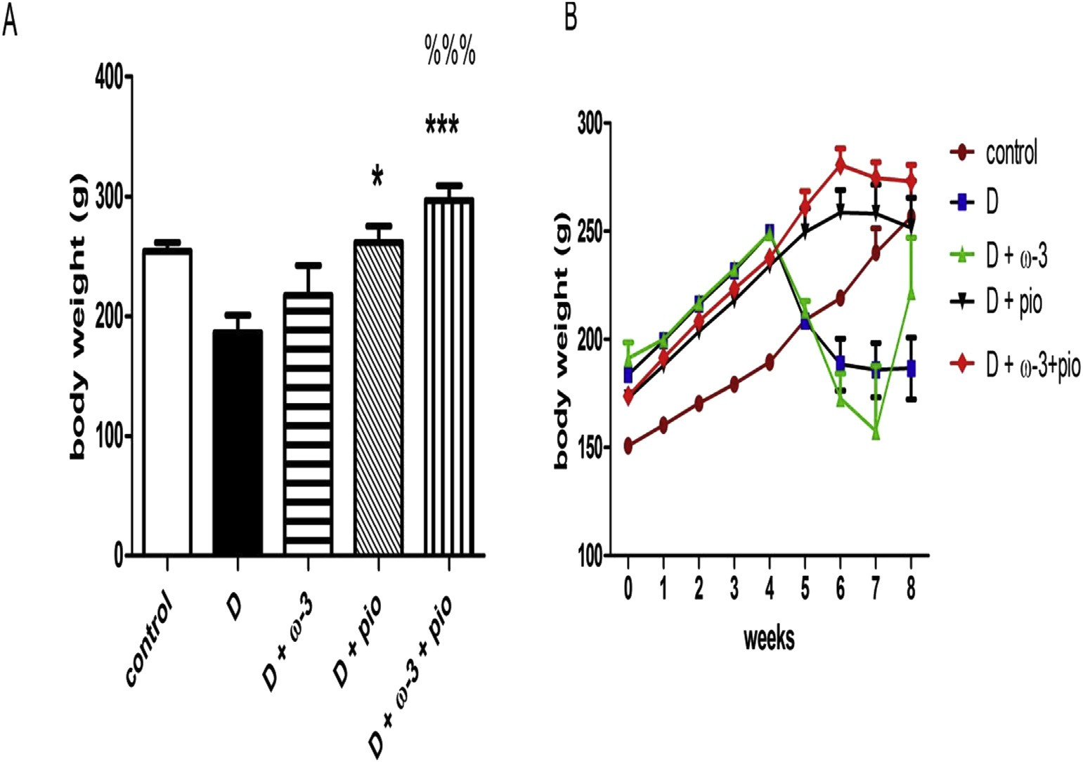

Fig. 1 e Effects of u-3 fatty acids (10% of diet), pioglitazone (20 mg/kg body weight) and their combination on body weight of diabetic (D) animals. (A) A bar chart showing body weight at the end of the study. (B) A curve showing the weights of animals in each group monitored weekly. Data are represented as means ± SEM of 6e8 animals/group. Statistically significant differences are indicated as: *p < 0.05, ***p < 0.001, compared to D group. %%% p < 0.001, compared to D + u-3 group. D:diabetes. D + u-3:

diabetes + u-3 fatty acids. D + pio: diabetes + pioglitazone. D + u-3 + pio: diabetes + u-3 fatty acids + pioglitazone.

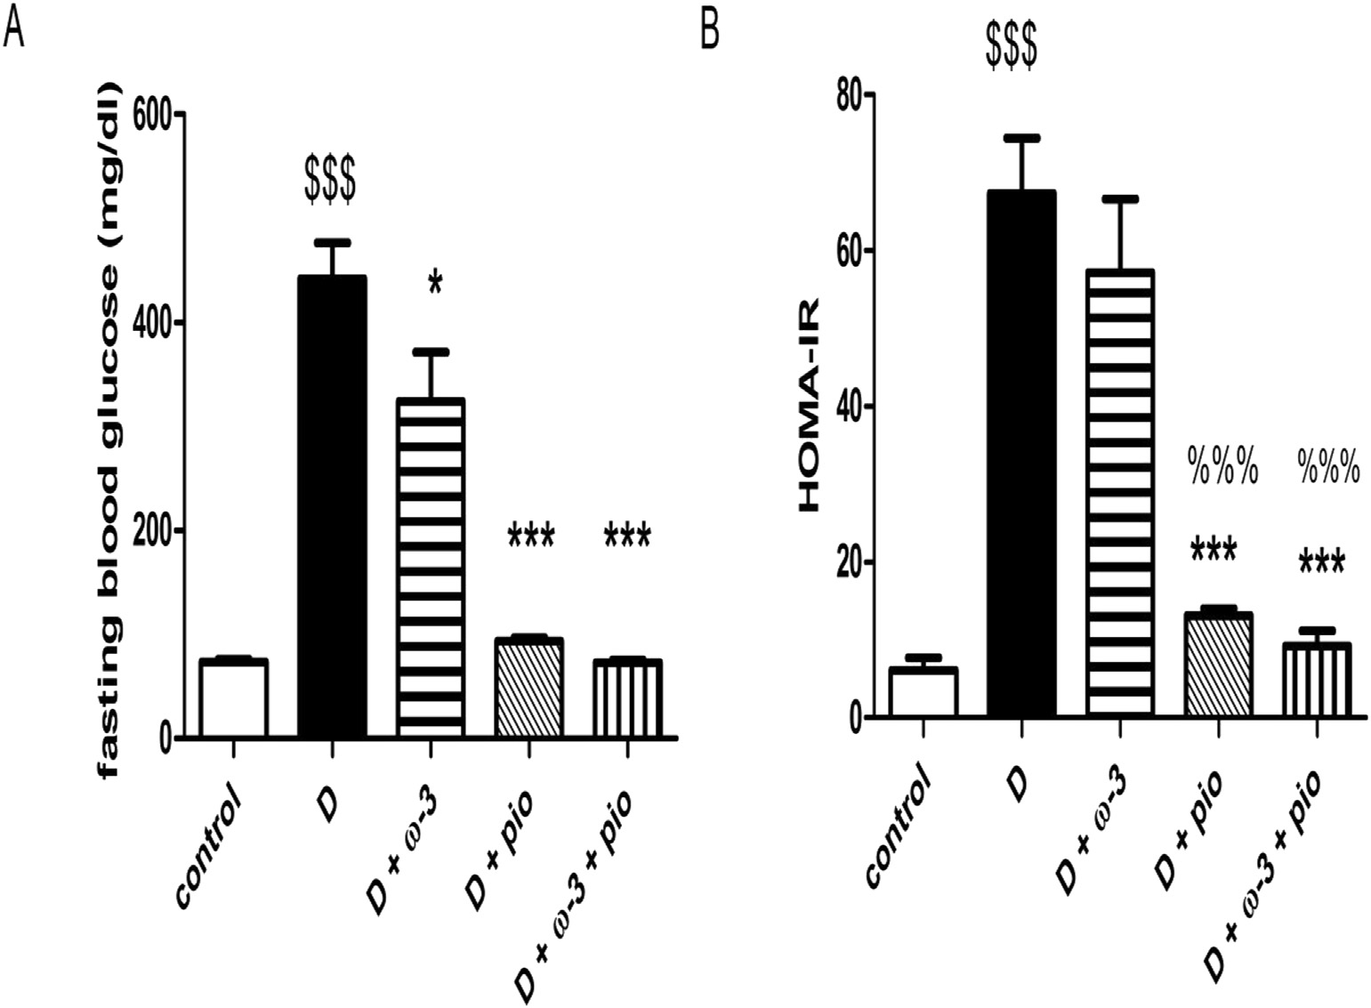

Fig. 2 e Effects of u-3 fatty acids (10% of diet), pioglitazone (20 mg/kg body weight), and their combination on fasting blood glucose (A) and HOMA-IR (B) of D animals. Data are represented as means ± SEM of 6e8 animals/group. Statistically significant differences are indicated as: $$$ p < 0.001, compared to control group. *p < 0.05, ***p < 0.001, compared to D group. %%% p < 0.001, compared to D + u-3 group. D: diabetes D + u-3: diabetes + u-3 fatty acids. D + pio:

diabetes + pioglitazone D + u-3 + pio: diabetes + u-3 fatty acids + pioglitazone.

[e g ypti an j o ur nal o f b a sic and a pp l i e d sci en c e s 2 ( 201 5 ) 75](http://dx.doi.org/10.1016/j.ejbas.2015.01.002) e[86](http://dx.doi.org/10.1016/j.ejbas.2015.01.002) 79

# Statistical analysis

Data are expressed as means ± standard error of mean (SEM) in each group. Statistical evaluations of the results, were carried out by means of one way analysis of variance, followed by Bonferroni multiple comparisontest. The correlational analysis was performed using Pearson Correlation. Statistical tests were performed using Statistical Package for the Social Sciences

(SPSS) version 13 (Chicago, IL, USA). Statistical significance was taken at P < 0.05. Graphing was carried out using Graphpad Prism software (Graphpad Software Inc., San Diego, USA).

# Results

### *Effects of* u*-3 fatty acids, pioglitazone, and their* combination on body weight

Diabetic (D) group showed an increase in body weight fol- lowed by acute weight loss after STZ injection (Fig. 1a). At the end of study, pioglitazone monotherapy significantly increased the body weight compared to diabetic (D) group

(p < 0.05). u-3 fatty acids treated group (D+u-3) showed non- group (D+u-3+pio) showed highly significant increase in the significant change from diabetic (D) group. Combination body weight compared to diabetic (D) group (p < 0.001)

(Fig. 1b).

### *Effects of* u*-3 fatty acids, pioglitazone, and their* combination on fasting blood glucose concentration

u-3 fatty acids monotherapy significantly reduced fasting blood glucose concentrations, compared to diabetic (D) rats (p < 0.05), but remained higher than normal fasting blood glucose concentration. Both pioglitazone and combination therapy caused highly significant decrease in fasting blood

glucose concentration, compared to diabetic (D) group (p < 0.001) (Fig. 2a).

### *Effects of* u*-3 fatty acids, pioglitazone, and their* combination on HOMA-IR

Diabetic (D) rats exhibited highly significant increase in HOMA-IR compared to control group (p < 0.001), indicating a state of insulin resistance. u-3 fatty acids monotherapy

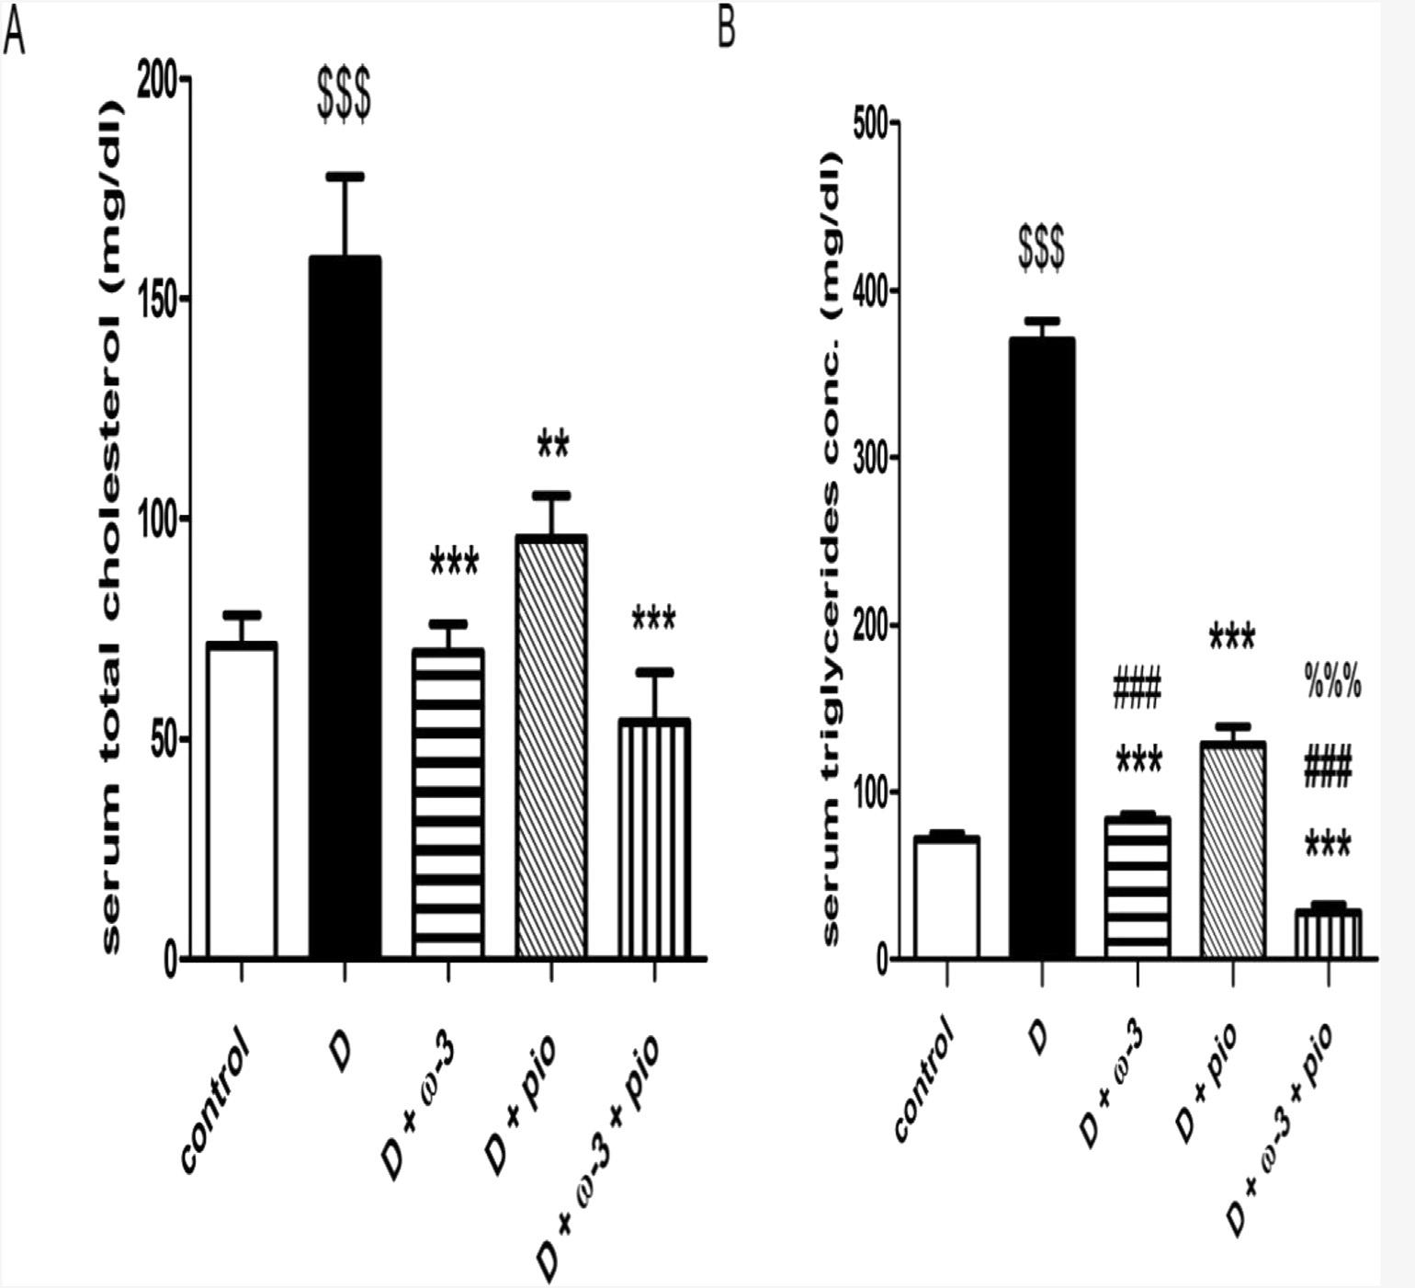

Fig. 3 e Effects of u-3 fatty acids (10% of diet), pioglitazone (20 mg/kg body weight) and their combination on serum total cholesterol (A) and serum triglycerides (B) of D animals. Data are represented as means ± SEM of 6e8 animals/group.

Statistically significant differences are indicated as: $$$ p < 0.001, compared to control group. ** p < 0.01, *** p < 0.001, compared to D group. ### p < 0.001, compared to D + pio. %%% p < 0.001, compared to D + u-3 group. D: diabetes. D + u-3: diabetes + u-3 fatty acids. D + pio: diabetes + pioglitazone. D + u-3 + pio: diabetes + u-3 fatty acids + pioglitazone.

80 [e gypti an j o ur nal o f b a sic and a pp l i ed sci e n c e s 2 ( 201 5 ) 75](http://dx.doi.org/10.1016/j.ejbas.2015.01.002) e[86](http://dx.doi.org/10.1016/j.ejbas.2015.01.002)

showed non-significant change compared to diabetic (D) group, suggesting absence of insulin-sensitizing effects. Pio- glitazone and combination therapy showed a highly signifi- cant decrease in HOMA-IR (p < 0.001) (Fig. 2b).

### *Effects of* u*-3 fatty acids, pioglitazone, and their* combination on serum total cholesterol (mg/dl) and serum triglycerides (mg/dl)

Diabetic (D) rats showed a highly significant elevation in serum total cholesterol and triglycerides concentrations, compared to control group (p < 0.001). u-3 fatty acids, piogli- tazone, and combination therapy caused a highly significant reduction in serum total cholesterol and triglycerides, compared to diabetic (D) group (p < 0.001). Interestingly, combination therapy showed a highly significant decrease in triglycerides concentration than either u-3 fatty acids or pio- glitazone alone (p < 0.001) (Fig. 3a and b).

### *Effects of* u*-3 fatty acids, pioglitazone, and their* combination on serum FGF21 concentration (pg/ml) and hepatic FGF21 concentration (pg/g liver tissue)

Serum FGF21 was increased z 2-fold in diabetic (D) group, compared to control group. u-3 fatty acids, pioglitazone, and combination therapy significantly lowered serum FGF21, compared to diabetic (D) group (p < 0.001) (Fig. 4a). As for he- patic FGF21 concentration, diabetic (D) rats showed a highly

significant decrease, compared to control group (p < 0.01). Pioglitazone monotherapy caused a highly significant in- crease in hepatic FGF21 concentration (p < 0.001), while u-3

fatty acids therapy resulted in a highly significant decrease whether administered alone or in combination with pioglita- zone (p < 0.001) (Fig. 4b).

### *Effects of* u —*3 fatty acids, pioglitazone, and their* combination on hepatic FGF21 mRNA expression

Diabetic (D) group showed highly significant decrease in FGF21 mRNA expression in liver (p < 0.001). Pioglitazone treated group showed highly significant increase in hepatic FGF21 mRNA expression (p < 0.001), while both u-3 and combination therapy showed non-significant changes from diabetic (D) group (Fig. 5).

### *Correlation studies*

Data in Table 2 show the correlational analysis of glucose, HOMA-IR index, serum total cholesterol, serum triglycerides, serum FGF21 concentration, hepatic FGF21 concentration and FGF21 relative gene expression.

tive correlation with blood glucose (r = 0.5, p < 0.01), HOMA-IR As shown in Fig. 6, serum FGF 21 showed significant posi- (r = 0.390, p < 0.05).

positive correlation with serum total cholesterol (r = 0.695, As shown in Table 2, serum FGF 21 showed significant

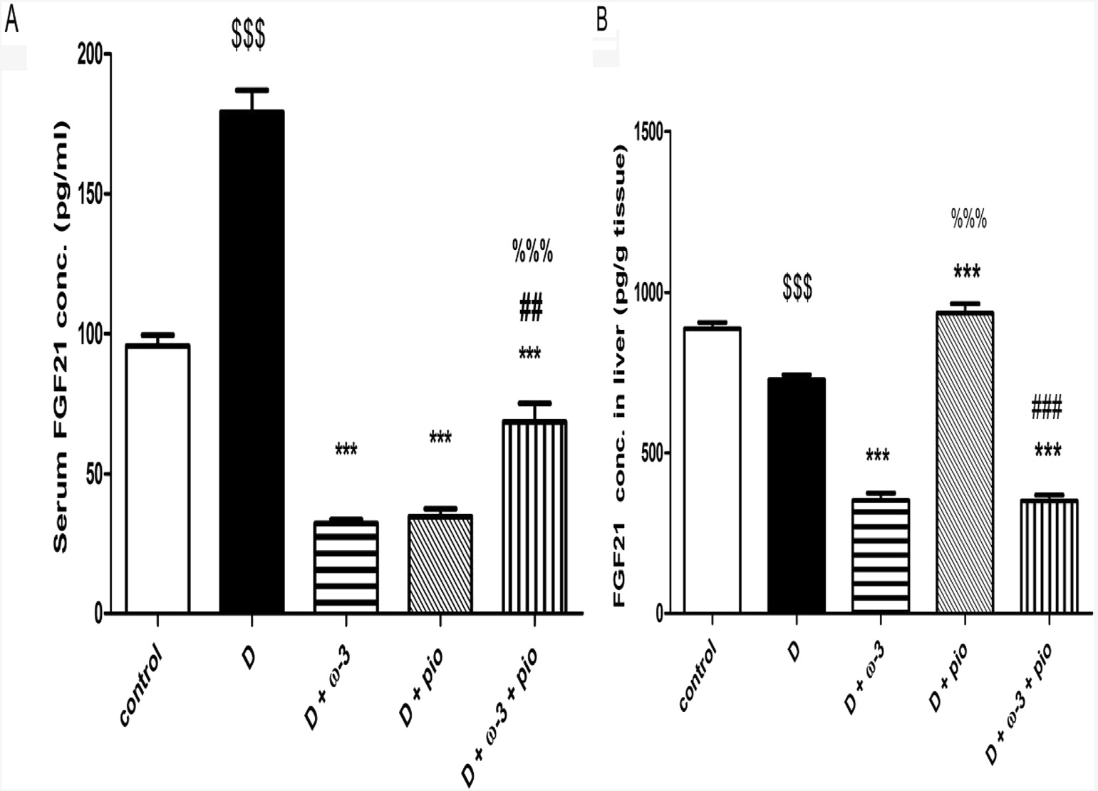

Fig. 4 e Effects of u-3 fatty acids (10% of diet), pioglitazone (20 mg/kg body weight), and their combination on serum FGF21 concentration (pg/ml) (A), hepatic FGF21 concentration (pg/g tissue) (B). Data are represented as means ± SEM of 6e8 animals/group. Statistically significant differences are indicated as: $$$ p < 0.001, compared to control group. *** p < 0.001, compared to D group. ## p < 0.01, ### p < 0.001, compared to D + pio. %%% p < 0.001, compared to D + u-3 group. D: diabetes. D + u-3: diabetes + u-3 fatty acids. D + pio: diabetes + pioglitazone. D + u-3 + pio: diabetes + u-3 fatty

acids + pioglitazone.

[e g ypti an j o ur nal o f b a sic and a pp l i e d sci en c e s 2 ( 201 5 ) 75](http://dx.doi.org/10.1016/j.ejbas.2015.01.002) e[86](http://dx.doi.org/10.1016/j.ejbas.2015.01.002) 81

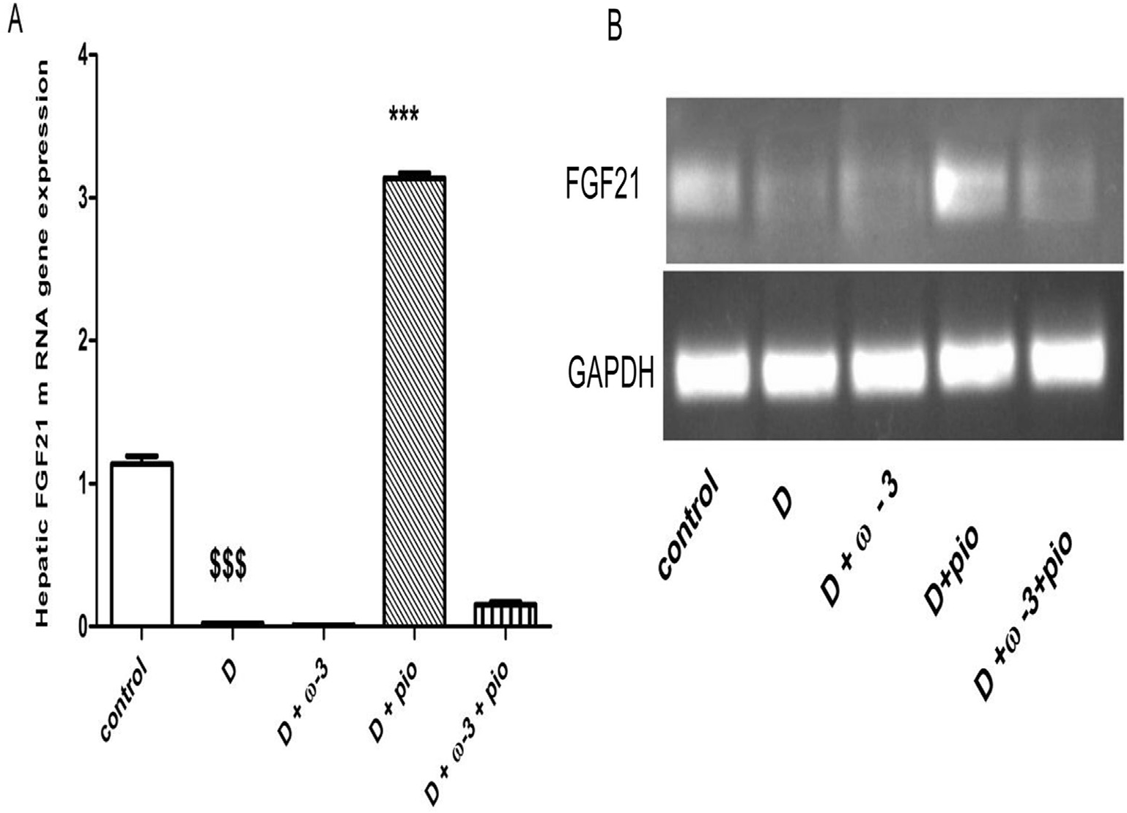

Fig. 5 e Effects of u-3 fatty acids (10% of diet), pioglitazone (20 mg/kg body weight), and their combination on FGF21 mRNA expression (A), gel electrophoresis (B). Data are represented as means ± SEM of 4 animals from each group. Statistically significant differences are indicated as: $$$ p < 0.001, compared to control group. *** p < 0.001, compared to D group. D: diabetes. D + u-3: diabetes + u-3 fatty acids. D + pio: diabetes + pioglitazone. D + u-3 + pio: diabetes + u-3 fatty

acids + pioglitazone.

p < 0.01) and serum triglycerides (r = 0.775, p < 0.01). A sig- concentration and its mRNA expression (r = 0.448, p < 0.05). As nificant positive correlation was found between hepatic FGF21 for HOMA-IR, it is positively correlated with serum total

cholesterol (r = 0.55, p < 0.01), serum triglycerides (r = 0.648, p < 0.01) and blood glucose (r = 0.963, p < 0.01).

# Discussion

Combining life style changes with pharmacological therapy has become mandatory for management of diseases

associated with metabolic disorders. Previous studies showed the effectiveness of combining u-3 fatty acids with thiazoli- dinediones, pioglitazone and rosiglitazone, in mice fed a high- fat diet, possibly through induction of adiponectin [34].

In this study, we generated a rat model for T2D using a high- fat diet followed by low dose STZ as previously described by Srinivasan et al. (2005) [30]. T2D was confirmed by hyperglyce- mia, mild hyperinsulinemia, and a significant increase in HOMA-

IR index in diabetic rats. Our study is the first to investigate the potential anti-diabetic effects of u-3 fatty acids and pioglitazone combination through modulating FGF21. We have also corre-

lated FGF21 changes with different metabolic parameters.

|  |  |  |  |  |  |  |  |
| --- | --- | --- | --- | --- | --- | --- | --- |
| Table 2 e Correlational analysis of the studied parameters. | | | | | | | |
|  | Blood glucose (mg/dl) | HOMA-IR  index | Serum total cholesterol (mg/dl) | Serum triglycerides (mg/dl) | Serum FGF21  (pg/ml) | FGF21 conc. in liver (pg/gm  tissue) | Hepatic FGF21 m-RNA  expression |
| Blood glucose (mg/dl) (r) | 1 | 0.963** | 0.567** | 0.724** | 0.500** | —0.203 | —0.435 |
| HOMA-IR index (r) | 0.963** | 1 | 0.550** | 0.648** | 0.390* | —0.252 | —0.345 |
| Serum total cholesterol | 0.567** | 0.550** | 1 | 0.851** | 0.695** | 0.378* | —0.163 |
| (mg/dl) (r) |  |  |  |  |  |  |  |
| Serum triglycerides | 0.724** | 0.648** | 0.851** | 1 | 0.775** | 0.304 | —0.222 |
| (mg/dl)(r) |  |  |  |  |  |  |  |
| Serum FGF21 (pg/ml) (r) | 0.500** | 0.390* | 0.695** | 0.775** | 1 | 0.219 | —0.460* |
| Liver FGF21 (pg/g.tissue) (r) | —0.203 | —0.252 | 0.378* | 0.304 | 0.219 | 1 | 0.448* |
| *p < 0.05.  **p < 0.01. | | | | | | | |

82 [e gypti an j o ur nal o f b a sic and a pp l i ed sci e n c e s 2 ( 201 5 ) 75](http://dx.doi.org/10.1016/j.ejbas.2015.01.002) e[86](http://dx.doi.org/10.1016/j.ejbas.2015.01.002)

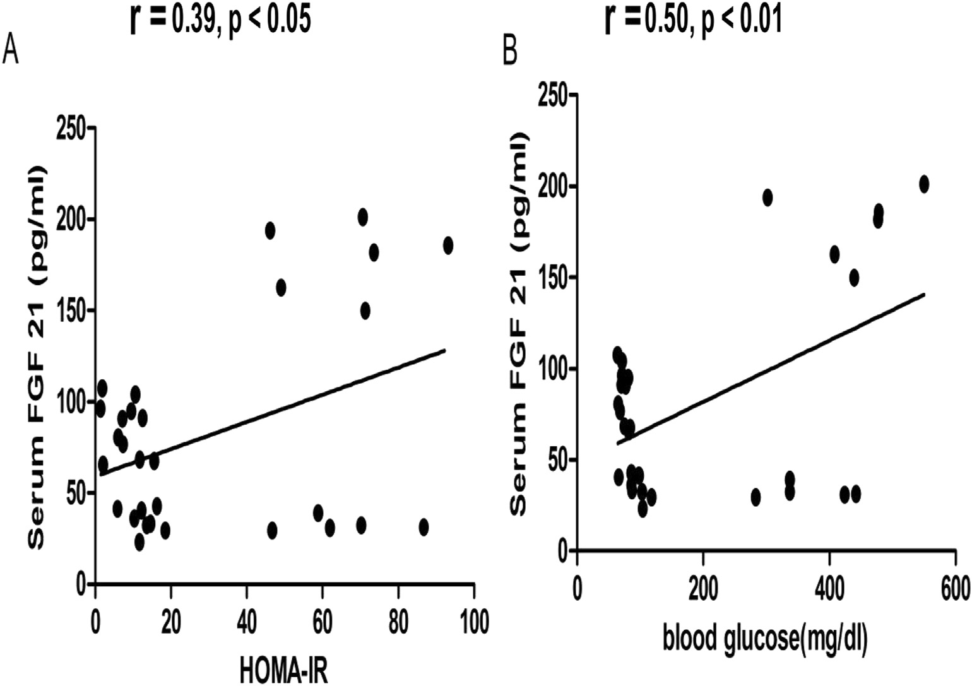

Fig. 6 e Correlation between serum FGF21 (pg/ml) and HOMA-IR (A) and blood glucose (B).

We have shown that u-3 fatty acids and pioglitazone combination exerted an additive improvement in insulin sensitivity. This is in agreement with previous studies that employed pioglitazone and rosiglitazone in combination with

u-3 fatty acids in rats fed a high-fat diet [34,35]. However, in

our study, rats were treated with much lower doses of pio- glitazone in the combination therapy and managed to revert insulin resistance.

The effect of u-3 fatty acids on insulin resistance has been

studied extensively leading to contradicting results. Consis- tent with our results, human studies suggested that none of u-

3 fatty acids improve insulin sensitivity [36,37]. Similarly, Gillam, et al. (2009) [11] found no beneficial effects of u-3 fatty acids on insulin sensitivity in fa/fa Zucker rats, a rat model of

insulin resistance. In a rat model of T2D induced by high fat diet, low dose STZ, Coppey et al. (2012) found that partial replacement of saturated fats with menhaden oil, a natural

source of u-3 fatty acids failed to improve impaired glucose

utilization [38].

On the other hand, several murine models of insulin resistance have shown beneficial effects of u-3 fatty acids in prevention or reversal of insulin resistance. In an obesity model of insulin resistance and fatty liver disease, dietary intake of fish oil (8% wt/wt) had insulin sensitizing actions in adipose tissue and liver [39]. In high sucrose diet-fed rats, 7%

fish oil supplementation reversed the insulin resistance [40]. However, the aforementioned studies are models of insulin resistance or pre-diabetes state, none of them represent a model of T2D, as we had in this study.

Pioglitazone caused significant reduction in blood glucose concentrations as shown in various animal species by acting

as insulin sensitizer [41]. u-3 fatty acids significantly decreased fasting blood glucose, but still in levels higher than normal ones. In a rat model of T2D, treatment with menhaden oil did not significantly change blood glucose levels, compared to untreated diabetic rats [38].

Combining u-3 fatty acids with pioglitazone resulted in a

strong synergistic triglyceride-lowering effect. This is in accordance with a previous study that showed an additive effect with higher pioglitazone doses [34]. In the current study, u-3 fatty acids significantly lowered total cholesterol and tri- glycerides, compared to the untreated group. u-3 fatty acids exert potential hypocholesterolemic effect through inhibition of key enzymes related to cholesterol synthesis and transfer such as 3-Hydroxy-3-methylglutaryl reductase and acyl-

CoA:cholesterol acyltransferase [42]. u-3 fatty acids selec- tively lower triglycerides by increasing glucose flux to glycogen, increasing mitochondrial b-oxidation, and decreasing triglycerides synthesis, an effect that is mediated partially by PPAR-a activation [43]. Pioglitazone was found to significantly lower total cholesterol and triglycerides concen- trations, compared to diabetic rats. PPAR-g activation controls a variety of genes involved in different pathways of lipid metabolism such as fatty acid uptake, fatty acid oxidation, lipolysis, and lipoprotein assembly and transport [44](#_bookmark41)e[46].

Pioglitazone and combination therapy significantly increased body weight, compared to diabetic group. Weight gain is a major side effect of pioglitazone treatment, since PPAR- g increases feeding by reducing leptin levels, a hormone that regulates satiety center [43].

Several studies have reported the use of FGF21 as an interesting external therapeutic agent for modulating insulin

[e g ypti an j o ur nal o f b a sic and a pp l i e d sci en c e s 2 ( 201 5 ) 75](http://dx.doi.org/10.1016/j.ejbas.2015.01.002) e[86](http://dx.doi.org/10.1016/j.ejbas.2015.01.002) 83

resistance. Evidence from animal-based studies suggested that FGF21 possesses beneficial effects on carbohydrate and lipid metabolism, improving obesity and diabetes [17,47]. As well, administration of recombinant FGF21 has been shown to reverse hyperglycemia, hyperinsulinemia, and dyslipidemia in *ob/ob* and diet-induced obese mice and in diabetic monkeys [48](#_bookmark42)e[50].

Consistent with our results, many studies showed that circulating FGF21 concentrations are elevated in insulin- resistant states, such as glucose intolerance and T2D [51](#_bookmark43)e[54], indicating a possible compensatory increase of FGF21 to over- come insulin resistance. PPAR is a pivotal regulator of hepatic FGF21 [27,55]. A recent study showed that FGF21 could be regulated by PPAR-g activation in pancreatic islets of mice [56]. We investigated the possibility of regulating FGF21 con- centrations in serum and liver and its gene expression by

combining u-3 fatty acids as a PPAR-a agonist with pioglita- zone as a PPAR-g agonist. Our results have shown that pio- glitazone, u-3 fatty acids, and their combination significantly

decreased serum FGF21, compared to diabetic group, allevi- ating the state of FGF21 resistance. Consistent with our re- sults, Villarroya et al. (2014) showed that long-term dietary

treatment with u-3 fatty acids significantly decreased FGF21

protein levels in plasma, compared to high fat diet group [57]. A study on patients with T2D showed that addition of piogli- tazone to exenatide therapy significantly reduced plasma FGF21 levels [58].

Fibroblast growth factor 21 was previously thought to be a hepatic hormone, preferentially expressed in the liver. How- ever, it was reported that other tissues as adipose and muscle tissue are important sources of FGF21 production [19,59](#_bookmark21)e[61]. In our study, serum FGF21 concentration was increased in

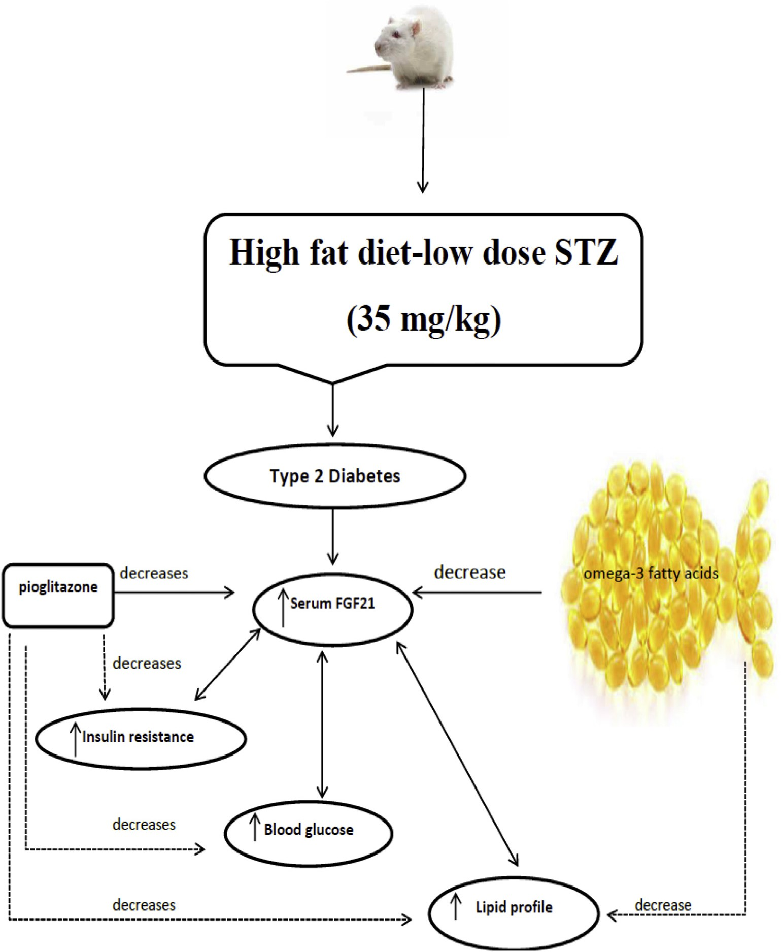

Fig. 7 e Lipid-lowering effect of u-3 fatty acids and pioglitazone as well as blood glucose lowering and insulin-sensitizing effects of pioglitazone, mediated through FGF21.

84 [e gypti an j o ur nal o f b a sic and a pp l i ed sci e n c e s 2 ( 201 5 ) 75](http://dx.doi.org/10.1016/j.ejbas.2015.01.002) e[86](http://dx.doi.org/10.1016/j.ejbas.2015.01.002)

diabetic group, while its hepatic concentration was decreased. This discrepancy may be due to the contribution of adipose tissue and other tissues in circulating FGF21 concentration. Hepatic mRNA expression of FGF21 showed significant decrease in diabetic group, which correlated positively to he- patic FGF21 concentration. Consistent with our results, Oishi and Tomita (2011) showed that pioglitazone significantly increased hepatic FGF21 mRNA expression in mouse liver and in cultured hepatocytes [62].

In agreement with our results, recent studies of Jin et al. (2014) and Lin et al. (2014) found that circulating FGF21 was significantly and positively correlated with fasting blood glucose concentration and HOMA-IR [63,64]. Also, we have found a significant positive correlation between serum FGF21 and both serum total cholesterol and triglycerides, which is consistent with Matuszek et al. (2010) [59].

# Conclusion

Combining PPAR-a agonists, as u-3 fatty acids, with PPAR-ˠ agonists, as pioglitazone, showed potential effects in lowering blood glucose concentration, improving lipid profile and in- sulin resistance. Such effects are mediated through modula- tion of FGF21 expression (Fig. 7).

## references

1. International Diabetes Federation. IDF diabetes atlas. 6th ed. Brussels, Belgium: International Diabetes Fedration; 2013.. <http://www.idf.org/diabetesatlas> [accessed 23.09.14].
2. [Diagnosis and classification of diabetes mellitus. American](http://refhub.elsevier.com/S2314-808X(15)00013-5/sref2) [diabetes association. Diabetes Care 2013;36:S67](http://refhub.elsevier.com/S2314-808X(15)00013-5/sref2)e[74](http://refhub.elsevier.com/S2314-808X(15)00013-5/sref2).
3. [Singh B, Sangle GV, Murugan J, Umrani R, Roy S, Kulkarni O,](http://refhub.elsevier.com/S2314-808X(15)00013-5/sref3) [et al. Effect of combination treatment of S](http://refhub.elsevier.com/S2314-808X(15)00013-5/sref3)e[amlodipine with](http://refhub.elsevier.com/S2314-808X(15)00013-5/sref3) [peroxisome proliferator-activated receptor agonists on](http://refhub.elsevier.com/S2314-808X(15)00013-5/sref3) [metabolic and cardiovascular parameters in Zucker fa/fa](http://refhub.elsevier.com/S2314-808X(15)00013-5/sref3) [rats. Diabetol Metab Syndr 2014;6:45](http://refhub.elsevier.com/S2314-808X(15)00013-5/sref3).
4. [Reaven G, Abbasi F, McLaughlin T. Obesity, insulin](http://refhub.elsevier.com/S2314-808X(15)00013-5/sref4) [resistance, and cardiovascular disease. Recent Prog Horm](http://refhub.elsevier.com/S2314-808X(15)00013-5/sref4) [Res 2004;59:207](http://refhub.elsevier.com/S2314-808X(15)00013-5/sref4)e[23](http://refhub.elsevier.com/S2314-808X(15)00013-5/sref4).
5. [Kromhout D, Yasuda S, Geleijnse JM, Shimokawa H. Fish oil](http://refhub.elsevier.com/S2314-808X(15)00013-5/sref5) [and omega-3 fatty acids in cardiovascular disease: do they](http://refhub.elsevier.com/S2314-808X(15)00013-5/sref5) [really work? Eur Heart J 2012;33:436](http://refhub.elsevier.com/S2314-808X(15)00013-5/sref5)e[43](http://refhub.elsevier.com/S2314-808X(15)00013-5/sref5).
6. [Flachs P, Rossmeisl M, Kopecky J. The effect of *n-3* fatty acids](http://refhub.elsevier.com/S2314-808X(15)00013-5/sref6) [on glucose homeostasis and insulin sensitivity. Physiol Res](http://refhub.elsevier.com/S2314-808X(15)00013-5/sref6) [2014;63:S93](http://refhub.elsevier.com/S2314-808X(15)00013-5/sref6)e[118](http://refhub.elsevier.com/S2314-808X(15)00013-5/sref6).
7. [Flachs P, Mohamed-Ali V, Horakova O, Rossmeisl M,](http://refhub.elsevier.com/S2314-808X(15)00013-5/sref7) [Hosseinzadeh-Attar MJ, Hensler M, et al. Polyunsaturated](http://refhub.elsevier.com/S2314-808X(15)00013-5/sref7) [fatty acids of marine origin induce adiponectin in mice fed a](http://refhub.elsevier.com/S2314-808X(15)00013-5/sref7) [high-fat diet. Diabetologia 2006;49:394](http://refhub.elsevier.com/S2314-808X(15)00013-5/sref7)e[7](http://refhub.elsevier.com/S2314-808X(15)00013-5/sref7).
8. [Peyron-Caso E, Fluteau-Nadler S, Kabir M, Guerre-Millo M,](http://refhub.elsevier.com/S2314-808X(15)00013-5/sref8) [Quignard-Boulang](http://refhub.elsevier.com/S2314-808X(15)00013-5/sref8)e´ [A, Slama G, et al. Regulation of glucose](http://refhub.elsevier.com/S2314-808X(15)00013-5/sref8) [transport and transporter 4 (GLUT-4) in muscle and](http://refhub.elsevier.com/S2314-808X(15)00013-5/sref8) [adipocytes of sucrose-fed rats: effects of N-3 poly- and](http://refhub.elsevier.com/S2314-808X(15)00013-5/sref8) [monounsaturated fatty acids. Horm Metab Res 2002;34:360](http://refhub.elsevier.com/S2314-808X(15)00013-5/sref8)e[6](http://refhub.elsevier.com/S2314-808X(15)00013-5/sref8).
9. [Jump DB. N-3 polyunsaturated fatty acid regulation of](http://refhub.elsevier.com/S2314-808X(15)00013-5/sref9) [hepatic gene transcription. Curr Opin Lipidol 2008;19:242](http://refhub.elsevier.com/S2314-808X(15)00013-5/sref9)e[7](http://refhub.elsevier.com/S2314-808X(15)00013-5/sref9).
10. [Varga T, Czimmerer Z, Nagy L. PPARs are a unique set of fatty](http://refhub.elsevier.com/S2314-808X(15)00013-5/sref10) [acid regulated transcription factors controlling both lipid](http://refhub.elsevier.com/S2314-808X(15)00013-5/sref10) [metabolism and inflammation. Biochim Biophys Acta](http://refhub.elsevier.com/S2314-808X(15)00013-5/sref10) [2011;1812:1007](http://refhub.elsevier.com/S2314-808X(15)00013-5/sref10)e[22](http://refhub.elsevier.com/S2314-808X(15)00013-5/sref10).
11. [Gillam M, Noto A, Zahradka P, Taylor CG. Improved n-3 fatty](http://refhub.elsevier.com/S2314-808X(15)00013-5/sref11) [acid status does not modulate insulin resistance in fa/fa](http://refhub.elsevier.com/S2314-808X(15)00013-5/sref11) [Zucker rats. Prostagl Leukot Essent Fat Acids 2009;81:331](http://refhub.elsevier.com/S2314-808X(15)00013-5/sref11)e[9](http://refhub.elsevier.com/S2314-808X(15)00013-5/sref11).
12. [Spencer M, Finlin BS, Unal R, Zhu B, Morris AJ, Shipp LR, et al.](http://refhub.elsevier.com/S2314-808X(15)00013-5/sref12) [Omega-3 fatty acids reduce adipose tissue macrophages in](http://refhub.elsevier.com/S2314-808X(15)00013-5/sref12) [human subjects with insulin resistance. Diabetes](http://refhub.elsevier.com/S2314-808X(15)00013-5/sref12) [2013;62:1709](http://refhub.elsevier.com/S2314-808X(15)00013-5/sref12)e[17](http://refhub.elsevier.com/S2314-808X(15)00013-5/sref12).
13. [Holness MJ, Smith ND, Greenwood GK, Sugden MC. Acute](http://refhub.elsevier.com/S2314-808X(15)00013-5/sref13) [omega-3 fatty acid enrichment selectively reverses high-](http://refhub.elsevier.com/S2314-808X(15)00013-5/sref13) [saturated fat feeding-induced insulin hypersecretion but](http://refhub.elsevier.com/S2314-808X(15)00013-5/sref13) [does not improve peripheral insulin resistance. Diabetes](http://refhub.elsevier.com/S2314-808X(15)00013-5/sref13) [2004;53:S166](http://refhub.elsevier.com/S2314-808X(15)00013-5/sref13)e[71](http://refhub.elsevier.com/S2314-808X(15)00013-5/sref13).
14. [Podolin DA, Gayles EC, Wei Y, Thresher JS, Pagliassotti MJ.](http://refhub.elsevier.com/S2314-808X(15)00013-5/sref14) [Menhaden oil prevents but does not reverse sucrose-induced](http://refhub.elsevier.com/S2314-808X(15)00013-5/sref14) [insulin resistance in rats. Am J Physiol 1998;274:R840](http://refhub.elsevier.com/S2314-808X(15)00013-5/sref14)e[8](http://refhub.elsevier.com/S2314-808X(15)00013-5/sref14).
15. [Inzucchi SE, Bergenstal RM, Buse JB, Diamant M,](http://refhub.elsevier.com/S2314-808X(15)00013-5/sref15)

[Ferrannini E, Nauck M, et al. Management of hyperglycaemia](http://refhub.elsevier.com/S2314-808X(15)00013-5/sref15) [in type 2 diabetes: a patient-centered approach position](http://refhub.elsevier.com/S2314-808X(15)00013-5/sref15) [statement of the American Diabetes Association(ADA) and](http://refhub.elsevier.com/S2314-808X(15)00013-5/sref15) [the European Association for the Study of Diabetes (EASD).](http://refhub.elsevier.com/S2314-808X(15)00013-5/sref15) [Diabetologia 2012;55:1577](http://refhub.elsevier.com/S2314-808X(15)00013-5/sref15)e[96](http://refhub.elsevier.com/S2314-808X(15)00013-5/sref15).

1. [Konda VR, Desai A, Darland G, Grayson N, Bland JS. KDT501,](http://refhub.elsevier.com/S2314-808X(15)00013-5/sref16) [a derivative from Hops, normalizes glucose metabolism and](http://refhub.elsevier.com/S2314-808X(15)00013-5/sref16) [body weight in rodent models of diabetes. PLoS One](http://refhub.elsevier.com/S2314-808X(15)00013-5/sref16) [2014;9:e87848](http://refhub.elsevier.com/S2314-808X(15)00013-5/sref16).
2. [Kharitonenkov A, Shiyanova TL, Koester A, Ford AM,](http://refhub.elsevier.com/S2314-808X(15)00013-5/sref17) [Micanovic R, Galbreath EJ, et al. FGF-21 as a novel metabolic](http://refhub.elsevier.com/S2314-808X(15)00013-5/sref17) [regulator. J Clin Invest 2005;115:1627](http://refhub.elsevier.com/S2314-808X(15)00013-5/sref17)e[35](http://refhub.elsevier.com/S2314-808X(15)00013-5/sref17).
3. [Dost](http://refhub.elsevier.com/S2314-808X(15)00013-5/sref18)a´[lov](http://refhub.elsevier.com/S2314-808X(15)00013-5/sref18)a´ [I, Haluzı´kov](http://refhub.elsevier.com/S2314-808X(15)00013-5/sref18)a´ [D, Haluzı´k M. Fibroblast growth](http://refhub.elsevier.com/S2314-808X(15)00013-5/sref18)

[factor 21: a novel metabolic regulator with potential](http://refhub.elsevier.com/S2314-808X(15)00013-5/sref18) [therapeutic properties in obesity/type 2 diabetes mellitus.](http://refhub.elsevier.com/S2314-808X(15)00013-5/sref18) [Physiol Res 2009;58:1](http://refhub.elsevier.com/S2314-808X(15)00013-5/sref18)e[7](http://refhub.elsevier.com/S2314-808X(15)00013-5/sref18).

1. [Zhang X, Yeung DC, Karpisek M, Stejskal D, Zhou ZG, Liu F,](http://refhub.elsevier.com/S2314-808X(15)00013-5/sref19) [et al. Serum FGF21 levels are increased in obesity and are](http://refhub.elsevier.com/S2314-808X(15)00013-5/sref19) [independently associated with the metabolic syndrome in](http://refhub.elsevier.com/S2314-808X(15)00013-5/sref19) [humans. Diabetes 2008;57:1246](http://refhub.elsevier.com/S2314-808X(15)00013-5/sref19)e[53](http://refhub.elsevier.com/S2314-808X(15)00013-5/sref19).
2. FGF21 fibroblast growth factor 21 Rattus Norvegicus, Gene ID: 26291, <http://www.ncbi.nlm.nih.gov/gene/170580> [accessed

23.09.14].

1. [Iglesias P, Selgas R, Romero S, Dı´ez JJ. Biological role, clinical](http://refhub.elsevier.com/S2314-808X(15)00013-5/sref20) [significance, and therapeutic possibilities of the recently](http://refhub.elsevier.com/S2314-808X(15)00013-5/sref20) [discovered metabolic hormone fibroblastic growth factor 21.](http://refhub.elsevier.com/S2314-808X(15)00013-5/sref20) [Eur J Endocrinol 2012;167:301](http://refhub.elsevier.com/S2314-808X(15)00013-5/sref20)e[9](http://refhub.elsevier.com/S2314-808X(15)00013-5/sref20).
2. [Ito S, Kinoshita S, Shiraishi N, Nakagawa S, Sekine S,](http://refhub.elsevier.com/S2314-808X(15)00013-5/sref21) [Fujimori T, et al. Molecular cloning and expression analyses](http://refhub.elsevier.com/S2314-808X(15)00013-5/sref21) [of mouse b klotho, which encodes a novel klotho family](http://refhub.elsevier.com/S2314-808X(15)00013-5/sref21) [protein. Mech Dev 2000;98:115](http://refhub.elsevier.com/S2314-808X(15)00013-5/sref21)e[9](http://refhub.elsevier.com/S2314-808X(15)00013-5/sref21).
3. [Li K, Li L, Yang M, Liu H, Boden G, Yang G. The effects of](http://refhub.elsevier.com/S2314-808X(15)00013-5/sref22) [fibroblast growth factor-21 knockdown and over-expression](http://refhub.elsevier.com/S2314-808X(15)00013-5/sref22) [on its signaling pathway and glucose](http://refhub.elsevier.com/S2314-808X(15)00013-5/sref22)e[lipid metabolism](http://refhub.elsevier.com/S2314-808X(15)00013-5/sref22)

[in vitro. Mol Cell Endocrinol 2012;348:21](http://refhub.elsevier.com/S2314-808X(15)00013-5/sref22)e[6](http://refhub.elsevier.com/S2314-808X(15)00013-5/sref22).

1. [Ge X, Chen C, Hui X, Wang Y, Lam KS, Xu A. Fibroblast](http://refhub.elsevier.com/S2314-808X(15)00013-5/sref23) [growth factor 21 induces glucose transporter-1 expression](http://refhub.elsevier.com/S2314-808X(15)00013-5/sref23) [through activation of the serum response factor/Ets-like](http://refhub.elsevier.com/S2314-808X(15)00013-5/sref23) [protein-1 in adipocytes. J Biol Chem 2011;286:34533](http://refhub.elsevier.com/S2314-808X(15)00013-5/sref23)e[41](http://refhub.elsevier.com/S2314-808X(15)00013-5/sref23).
2. [Berglund ED, Li CY, Bina HA, Lynes SE, Michael MD,](http://refhub.elsevier.com/S2314-808X(15)00013-5/sref24) [Shanafelt AB, et al. Fibroblast growth factor 21 controls](http://refhub.elsevier.com/S2314-808X(15)00013-5/sref24) [glycemia via regulation of hepatic glucose flux and insulin](http://refhub.elsevier.com/S2314-808X(15)00013-5/sref24) [sensitivity. Endocrinology 2009;150:4084](http://refhub.elsevier.com/S2314-808X(15)00013-5/sref24)e[93](http://refhub.elsevier.com/S2314-808X(15)00013-5/sref24).
3. [Wente W, Efanov AM, Brenner M, Kharitonenkov A, Koster A,](http://refhub.elsevier.com/S2314-808X(15)00013-5/sref25) [Sandusky GE, et al. Fibroblast growth factor-21 improves](http://refhub.elsevier.com/S2314-808X(15)00013-5/sref25) [pancreatic beta-cell function and survival by activation of](http://refhub.elsevier.com/S2314-808X(15)00013-5/sref25) [extracellular signal-regulated kinase 1/2 and akt signaling](http://refhub.elsevier.com/S2314-808X(15)00013-5/sref25) [pathways. Diabetes 2006;55:2470](http://refhub.elsevier.com/S2314-808X(15)00013-5/sref25)e[8](http://refhub.elsevier.com/S2314-808X(15)00013-5/sref25).
4. [Badman MK, Pissios P, Kennedy AR, Koukos G, Flier JS,](http://refhub.elsevier.com/S2314-808X(15)00013-5/sref26) [Maratos-Flier E. Hepatic fibroblast growth factor 21 is](http://refhub.elsevier.com/S2314-808X(15)00013-5/sref26) [regulated by PPARalpha and is a key mediator of hepatic lipid](http://refhub.elsevier.com/S2314-808X(15)00013-5/sref26) [metabolism in ketotic states. Cell Metab 2007;5:426](http://refhub.elsevier.com/S2314-808X(15)00013-5/sref26)e[37](http://refhub.elsevier.com/S2314-808X(15)00013-5/sref26).

[e g ypti an j o ur nal o f b a sic and a pp l i e d sci en c e s 2 ( 201 5 ) 75](http://dx.doi.org/10.1016/j.ejbas.2015.01.002) e[86](http://dx.doi.org/10.1016/j.ejbas.2015.01.002) 85

1. [Fon Tacer K, Bookout AL, Ding X, Kurosu H, John GB, Wang L,](http://refhub.elsevier.com/S2314-808X(15)00013-5/sref27) [et al. Research resource: comprehensive expression atlas of](http://refhub.elsevier.com/S2314-808X(15)00013-5/sref27) [the fibroblast growth factor system in adult mouse. Mol](http://refhub.elsevier.com/S2314-808X(15)00013-5/sref27) [Endocrinol 2010;24:2050](http://refhub.elsevier.com/S2314-808X(15)00013-5/sref27)e[64](http://refhub.elsevier.com/S2314-808X(15)00013-5/sref27).
2. [Lee Y, Lim S, Hong ES, Kim JH, Moon MK, Chun EJ, et al. Serum](http://refhub.elsevier.com/S2314-808X(15)00013-5/sref28) [FGF21 concentration is associated with](http://refhub.elsevier.com/S2314-808X(15)00013-5/sref28) [hypertriglyceridaemia, hyperinsulinaemia and pericardial fat](http://refhub.elsevier.com/S2314-808X(15)00013-5/sref28) [accumulation, independently of obesity, but not with current](http://refhub.elsevier.com/S2314-808X(15)00013-5/sref28) [coronary artery status. Clin Endocrinol (Oxf) 2014;80:57](http://refhub.elsevier.com/S2314-808X(15)00013-5/sref28)e[64](http://refhub.elsevier.com/S2314-808X(15)00013-5/sref28).
3. [Srinivasan K, Viswanad B, Asrat Lydia, Kaul CL, Ramarao P.](http://refhub.elsevier.com/S2314-808X(15)00013-5/sref29) [Combination of high-fat diet-fed and low-dose](http://refhub.elsevier.com/S2314-808X(15)00013-5/sref29) [streptozotocin-treated rat: a model for type 2 diabetes and](http://refhub.elsevier.com/S2314-808X(15)00013-5/sref29) [pharmacological screening. Pharmacol Res 2005;52:313](http://refhub.elsevier.com/S2314-808X(15)00013-5/sref29)e[20](http://refhub.elsevier.com/S2314-808X(15)00013-5/sref29).
4. [Devarshi PP, Jangale NM, Ghule AE, Bodhankar SL,](http://refhub.elsevier.com/S2314-808X(15)00013-5/sref30) [Harsulkar AM. Beneficial effects of flaxseed oil and fish oil](http://refhub.elsevier.com/S2314-808X(15)00013-5/sref30) [diet are through modulation of different hepatic genes](http://refhub.elsevier.com/S2314-808X(15)00013-5/sref30) [involved in lipid metabolism in streptozotocin](http://refhub.elsevier.com/S2314-808X(15)00013-5/sref30)e[nicotinamide](http://refhub.elsevier.com/S2314-808X(15)00013-5/sref30) [induced diabetic rats. Genes Nutr 2013;8:329](http://refhub.elsevier.com/S2314-808X(15)00013-5/sref30)e[42](http://refhub.elsevier.com/S2314-808X(15)00013-5/sref30).
5. [Ding SY, Shen ZF, Chen YT, Sun SJ, Liu Q, Xie MZ.](http://refhub.elsevier.com/S2314-808X(15)00013-5/sref31) [Pioglitazone can ameliorate insulin resistance in low-dose](http://refhub.elsevier.com/S2314-808X(15)00013-5/sref31) [streptozotocin and high sucrose-fat diet induced obese rats.](http://refhub.elsevier.com/S2314-808X(15)00013-5/sref31) [Acta Pharmacol Sin 2005;26:575](http://refhub.elsevier.com/S2314-808X(15)00013-5/sref31)e[80](http://refhub.elsevier.com/S2314-808X(15)00013-5/sref31).
6. [Matthews DR, Hosker JP, Rudenski AS, Naylor BA,](http://refhub.elsevier.com/S2314-808X(15)00013-5/sref32) [Treacher DF, Turner RC. Homeostasis model assessment:](http://refhub.elsevier.com/S2314-808X(15)00013-5/sref32)

[insulin resistance and beta-cell function from fasting plasma](http://refhub.elsevier.com/S2314-808X(15)00013-5/sref32) [glucose and insulin concentrations in man. Diabetologia](http://refhub.elsevier.com/S2314-808X(15)00013-5/sref32) [1985;28:412](http://refhub.elsevier.com/S2314-808X(15)00013-5/sref32)e[9](http://refhub.elsevier.com/S2314-808X(15)00013-5/sref32).

1. [Kus V, Flachs P, Kuda O, Bardova K, Janovska P,](http://refhub.elsevier.com/S2314-808X(15)00013-5/sref33)

[Svobodova M, et al. Unmasking differential effects of](http://refhub.elsevier.com/S2314-808X(15)00013-5/sref33) [rosiglitazone and pioglitazone in the combination treatment](http://refhub.elsevier.com/S2314-808X(15)00013-5/sref33) [with n-3 fatty acids in mice fed a high-fat diet. PLoS One](http://refhub.elsevier.com/S2314-808X(15)00013-5/sref33) [2011;6:e27126](http://refhub.elsevier.com/S2314-808X(15)00013-5/sref33).

1. [Kuda O, Jelenik T, Jilkova Z, Flachs P, Rossmeisl M,](http://refhub.elsevier.com/S2314-808X(15)00013-5/sref34) [Hensler M, et al. n3 fatty acids and rosiglitazone improve](http://refhub.elsevier.com/S2314-808X(15)00013-5/sref34) [insulin sensitivity through additive stimulatory effects on](http://refhub.elsevier.com/S2314-808X(15)00013-5/sref34) [muscle glycogen synthesis in mice fed a high-fat diet.](http://refhub.elsevier.com/S2314-808X(15)00013-5/sref34) [Diabetologia 2009;52:941](http://refhub.elsevier.com/S2314-808X(15)00013-5/sref34)e[51](http://refhub.elsevier.com/S2314-808X(15)00013-5/sref34).
2. [Poudyal H, Panchal SK, Diwan V, Brown L. Omega-3 fatty](http://refhub.elsevier.com/S2314-808X(15)00013-5/sref35) [acids and metabolic syndrome: effects and emerging](http://refhub.elsevier.com/S2314-808X(15)00013-5/sref35) [mechanisms of action. Prog Lipid Res 2011;50:372](http://refhub.elsevier.com/S2314-808X(15)00013-5/sref35)e[87](http://refhub.elsevier.com/S2314-808X(15)00013-5/sref35).
3. [Oh PC, Koh KK, Sakuma I, Lim S, Lee Y, Lee S, et al. Omega-3](http://refhub.elsevier.com/S2314-808X(15)00013-5/sref36) [fatty acid therapy dose-dependently and significantly](http://refhub.elsevier.com/S2314-808X(15)00013-5/sref36) [decreased triglycerides and improved flow-mediated](http://refhub.elsevier.com/S2314-808X(15)00013-5/sref36) [dilation, however, did not significantly improve insulin](http://refhub.elsevier.com/S2314-808X(15)00013-5/sref36) [sensitivity in patients with hypertriglyceridemia. Int J](http://refhub.elsevier.com/S2314-808X(15)00013-5/sref36) [Cardiol 2014;176:696](http://refhub.elsevier.com/S2314-808X(15)00013-5/sref36)e[702](http://refhub.elsevier.com/S2314-808X(15)00013-5/sref36).
4. [Coppey LJ, Holmes A, Davidson EP, Yorek MA. Partial](http://refhub.elsevier.com/S2314-808X(15)00013-5/sref37) [replacement with menhaden oil improves peripheral](http://refhub.elsevier.com/S2314-808X(15)00013-5/sref37) [neuropathy in high-fat fed low-dose streptozotocin type 2](http://refhub.elsevier.com/S2314-808X(15)00013-5/sref37) [diabetic rat. J Nutr Metab 2012;2012:950517](http://refhub.elsevier.com/S2314-808X(15)00013-5/sref37).
5. [Gonzalez-Periz A, Horrillo R, Ferre N, Gronert K, Dong B,](http://refhub.elsevier.com/S2314-808X(15)00013-5/sref38) [Mor](http://refhub.elsevier.com/S2314-808X(15)00013-5/sref38)a´[n-Salvador E, et al. Obesity-induced insulin resistance](http://refhub.elsevier.com/S2314-808X(15)00013-5/sref38) [and hepatic steatosis are alleviated by omega-3 fatty acids: a](http://refhub.elsevier.com/S2314-808X(15)00013-5/sref38) [role for resolvins and protectins. FASEB J 2009;23:1946](http://refhub.elsevier.com/S2314-808X(15)00013-5/sref38)e[57](http://refhub.elsevier.com/S2314-808X(15)00013-5/sref38).
6. [Lombardo YB, Hein G, Chicco A. Metabolic syndrome: effects](http://refhub.elsevier.com/S2314-808X(15)00013-5/sref39) [of n_3 PUFAs on a model of dyslipidemia, insulin resistance](http://refhub.elsevier.com/S2314-808X(15)00013-5/sref39) [and adiposity. Lipids 2007;42:427](http://refhub.elsevier.com/S2314-808X(15)00013-5/sref39)e[37](http://refhub.elsevier.com/S2314-808X(15)00013-5/sref39).
7. [Murakami K, Tobe K, Ide T, Mochizuki T, Ohashi M,](http://refhub.elsevier.com/S2314-808X(15)00013-5/sref40) [Akanuma Y, et al. A novel insulin sensitizer acts as a](http://refhub.elsevier.com/S2314-808X(15)00013-5/sref40) [coligand for peroxisome proliferator-activated receptor-](http://refhub.elsevier.com/S2314-808X(15)00013-5/sref40) [alpha (PPAR-alpha) and PPAR-gamma: effect of PPAR-alpha](http://refhub.elsevier.com/S2314-808X(15)00013-5/sref40) [activation on abnormal lipid metabolism in liver of Zucker](http://refhub.elsevier.com/S2314-808X(15)00013-5/sref40) [fatty rats. Diabetes 1998;47:1841](http://refhub.elsevier.com/S2314-808X(15)00013-5/sref40)e[7](http://refhub.elsevier.com/S2314-808X(15)00013-5/sref40).
8. [Davidson MH. Mechanisms for the hypotriglyceridemic](http://refhub.elsevier.com/S2314-808X(15)00013-5/sref41) [effect of marine omega-3 fatty acids. Am J Cardiol](http://refhub.elsevier.com/S2314-808X(15)00013-5/sref41) [2006;98:27](http://refhub.elsevier.com/S2314-808X(15)00013-5/sref41)e[33](http://refhub.elsevier.com/S2314-808X(15)00013-5/sref41).
9. [Brand CL, Sturis J, Gotfredsen CF, Fleckner J, Fledelius C,](http://refhub.elsevier.com/S2314-808X(15)00013-5/sref42) [Hansen BF, et al. Dual PPARalpha/gamma activation provides](http://refhub.elsevier.com/S2314-808X(15)00013-5/sref42)

[enhanced improvement of insulin sensitivity and glycemic](http://refhub.elsevier.com/S2314-808X(15)00013-5/sref42) [control in ZDF rats. Am J Physiol Endocrinol Metab](http://refhub.elsevier.com/S2314-808X(15)00013-5/sref42) [2003;284:E841](http://refhub.elsevier.com/S2314-808X(15)00013-5/sref42)e[54](http://refhub.elsevier.com/S2314-808X(15)00013-5/sref42).

1. [Grygiel-G](http://refhub.elsevier.com/S2314-808X(15)00013-5/sref43)o´[rniak B. Peroxisome proliferator-activated](http://refhub.elsevier.com/S2314-808X(15)00013-5/sref43) [receptors and their ligands : nutritional and clinical](http://refhub.elsevier.com/S2314-808X(15)00013-5/sref43) [implications](http://refhub.elsevier.com/S2314-808X(15)00013-5/sref43)e[a review. Nutr J 2014;13:17](http://refhub.elsevier.com/S2314-808X(15)00013-5/sref43).
2. [Shamsi BH, Ma C, Naqvi S, Xiao Y. Effects of pioglitazone](http://refhub.elsevier.com/S2314-808X(15)00013-5/sref44) [mediated activation of PPAR-g on CIDEC and obesity related](http://refhub.elsevier.com/S2314-808X(15)00013-5/sref44) [changes in mice. PLOS One 2014;9:e106992](http://refhub.elsevier.com/S2314-808X(15)00013-5/sref44).
3. [Medina-Gomez G, Gray SL, Yetukuri L, Shimomura K,](http://refhub.elsevier.com/S2314-808X(15)00013-5/sref45) [Virtue S, Campbell M, et al. PPAR gamma 2 prevents](http://refhub.elsevier.com/S2314-808X(15)00013-5/sref45) [lipotoxicity by controlling adipose tissue expandability and](http://refhub.elsevier.com/S2314-808X(15)00013-5/sref45) [peripheral lipid metabolism. PLoS Genet 2007;3:e64](http://refhub.elsevier.com/S2314-808X(15)00013-5/sref45).
4. [Kharitonenkov A, Shanafelt AB. Fibroblast growth factor-21](http://refhub.elsevier.com/S2314-808X(15)00013-5/sref46) [as a therapeutic agent for metabolic diseases. BioDrugs](http://refhub.elsevier.com/S2314-808X(15)00013-5/sref46) [2008;22:37](http://refhub.elsevier.com/S2314-808X(15)00013-5/sref46)e[44](http://refhub.elsevier.com/S2314-808X(15)00013-5/sref46).
5. [Xu J, Lloyd DJ, Hale C, Stanislaus S, Chen M, Sivits G, et al.](http://refhub.elsevier.com/S2314-808X(15)00013-5/sref47) [Fibroblast growth factor 21 reverses hepatic steatosis,](http://refhub.elsevier.com/S2314-808X(15)00013-5/sref47) [increases energy expenditure, and improves insulin](http://refhub.elsevier.com/S2314-808X(15)00013-5/sref47) [sensitivity in diet-induced obese mice. Diabetes](http://refhub.elsevier.com/S2314-808X(15)00013-5/sref47) [2009;58:250](http://refhub.elsevier.com/S2314-808X(15)00013-5/sref47)e[9](http://refhub.elsevier.com/S2314-808X(15)00013-5/sref47).
6. [Kharitonenkov A, Wroblewski VJ, Koester A, Chen YF,](http://refhub.elsevier.com/S2314-808X(15)00013-5/sref48) [Clutinger CK, Tigno XT, et al. The metabolic state of diabetic](http://refhub.elsevier.com/S2314-808X(15)00013-5/sref48) [monkeys is regulated by fibroblast growth factor-21.](http://refhub.elsevier.com/S2314-808X(15)00013-5/sref48) [Endocrinology 2007;148:774](http://refhub.elsevier.com/S2314-808X(15)00013-5/sref48)e[81](http://refhub.elsevier.com/S2314-808X(15)00013-5/sref48).
7. [Berglund ED, Li CY, Lynes SE, Bina HA, Michael MD,](http://refhub.elsevier.com/S2314-808X(15)00013-5/sref49) [Kharitonenkov A, et al. Chronic FGF-21 treatment improves](http://refhub.elsevier.com/S2314-808X(15)00013-5/sref49) [insulin sensitivity in *ob/ob* mice (Abstract 187-OR). In: 68th](http://refhub.elsevier.com/S2314-808X(15)00013-5/sref49) [scientific meeting of American diabetes association, San](http://refhub.elsevier.com/S2314-808X(15)00013-5/sref49) [Francisco, CA; June 6](http://refhub.elsevier.com/S2314-808X(15)00013-5/sref49)e[10, 2008](http://refhub.elsevier.com/S2314-808X(15)00013-5/sref49).
8. [Chen WW, Li L, Yang GY, Li K, Qi XY, Zhu W, et al. Circulating](http://refhub.elsevier.com/S2314-808X(15)00013-5/sref50) [FGF-21 levels in normal subjects and in newly diagnose](http://refhub.elsevier.com/S2314-808X(15)00013-5/sref50) [patients with type 2 diabetes mellitus. Exp Clin Endocrinol](http://refhub.elsevier.com/S2314-808X(15)00013-5/sref50) [Diabetes 2008;116:65](http://refhub.elsevier.com/S2314-808X(15)00013-5/sref50)e[8](http://refhub.elsevier.com/S2314-808X(15)00013-5/sref50).
9. [Chavez AO, Molina-Carrion M, Abdul-Ghani MA, Folli F,](http://refhub.elsevier.com/S2314-808X(15)00013-5/sref51) [Defronzo RA, Tripathy D. Circulating fibroblast growth](http://refhub.elsevier.com/S2314-808X(15)00013-5/sref51) [factor-21 is elevated in impaired glucose tolerance and type 2](http://refhub.elsevier.com/S2314-808X(15)00013-5/sref51) [diabetes and correlates with muscle and hepatic insulin](http://refhub.elsevier.com/S2314-808X(15)00013-5/sref51) [resistance. Diabetes Care 2009;32:1542](http://refhub.elsevier.com/S2314-808X(15)00013-5/sref51)e[6](http://refhub.elsevier.com/S2314-808X(15)00013-5/sref51).
10. [An SY, Lee MS, Yi SA, Ha ES, Han SJ, Kim HJ, et al. Serum](http://refhub.elsevier.com/S2314-808X(15)00013-5/sref52) [fibroblast growth factor 21 was elevated in subjects with type 2](http://refhub.elsevier.com/S2314-808X(15)00013-5/sref52) [diabetes mellitus and was associated with the presence of](http://refhub.elsevier.com/S2314-808X(15)00013-5/sref52) [carotid artery plaques. Diabetes Res Clin Pract 2012;96:196](http://refhub.elsevier.com/S2314-808X(15)00013-5/sref52)e[203](http://refhub.elsevier.com/S2314-808X(15)00013-5/sref52).
11. [Mashili FL, Austin RL, Deshmukh AS, Fritz T, Caidahl K,](http://refhub.elsevier.com/S2314-808X(15)00013-5/sref53) [Bergdahl K, et al. Direct effects of FGF21 on glucose uptake in](http://refhub.elsevier.com/S2314-808X(15)00013-5/sref53) [human skeletal muscle: implications for type 2 diabetes and](http://refhub.elsevier.com/S2314-808X(15)00013-5/sref53) [obesity. Diabetes Metab Res Rev 2011;27:286](http://refhub.elsevier.com/S2314-808X(15)00013-5/sref53)e[97](http://refhub.elsevier.com/S2314-808X(15)00013-5/sref53).
12. [Lunda˚ sen T, Hunt MC, Nilsson LM, Sanyal S, Angelin B,](http://refhub.elsevier.com/S2314-808X(15)00013-5/sref54) [Alexson SE, et al. PPARalpha is a key regulator of hepatic](http://refhub.elsevier.com/S2314-808X(15)00013-5/sref54) [FGF21. Biochem Biophys Res Commun 2007;360:437](http://refhub.elsevier.com/S2314-808X(15)00013-5/sref54)e[40](http://refhub.elsevier.com/S2314-808X(15)00013-5/sref54).
13. [So WY, Cheng Q, Chen L, Evans-Molina C, Xu A, Lam KS, et al.](http://refhub.elsevier.com/S2314-808X(15)00013-5/sref55) [High glucose represses b-klotho expression and impairs](http://refhub.elsevier.com/S2314-808X(15)00013-5/sref55) [fibroblast growth factor 21 action in mouse pancreatic islets:](http://refhub.elsevier.com/S2314-808X(15)00013-5/sref55) [involvement of peroxisome proliferator-activated receptor g](http://refhub.elsevier.com/S2314-808X(15)00013-5/sref55) [signaling. Diabetes 2013;62:3751](http://refhub.elsevier.com/S2314-808X(15)00013-5/sref55)e[9](http://refhub.elsevier.com/S2314-808X(15)00013-5/sref55).
14. [Villarroya J, Flachs P, Redondo-Angulo I, Giralt M,](http://refhub.elsevier.com/S2314-808X(15)00013-5/sref56) [Medrikova D, Villarroya F, et al. Fibroblast growth Factor-21](http://refhub.elsevier.com/S2314-808X(15)00013-5/sref56) [and the beneficial effects of long-chain n-3 polyunsaturated](http://refhub.elsevier.com/S2314-808X(15)00013-5/sref56) [fatty acids. Lipids 2014;49:1081](http://refhub.elsevier.com/S2314-808X(15)00013-5/sref56)e[9](http://refhub.elsevier.com/S2314-808X(15)00013-5/sref56).
15. [Samson SL, Sathyanarayana P, Jogi M, Gonzalez EV,](http://refhub.elsevier.com/S2314-808X(15)00013-5/sref57) [Gutierrez A, Krishnamurthy R, et al. Exenatide decreases](http://refhub.elsevier.com/S2314-808X(15)00013-5/sref57) [hepatic fibroblast growth factor 21 resistance in non-alcoholic](http://refhub.elsevier.com/S2314-808X(15)00013-5/sref57) [fatty liver disease in a mouse model of obesity and in a](http://refhub.elsevier.com/S2314-808X(15)00013-5/sref57) [randomised controlled trial. Diabetologia 2011;54:3093](http://refhub.elsevier.com/S2314-808X(15)00013-5/sref57)e[100](http://refhub.elsevier.com/S2314-808X(15)00013-5/sref57).
16. [Matuszek B, Lenart-Lipi](http://refhub.elsevier.com/S2314-808X(15)00013-5/sref58)n´[ska M, Duma D, Solski J,](http://refhub.elsevier.com/S2314-808X(15)00013-5/sref58) [Nowakowski A. Evaluation of concentrations of FGF21 a new](http://refhub.elsevier.com/S2314-808X(15)00013-5/sref58) [adipocytokine in type 2 diabetes. Endokrynol Pol](http://refhub.elsevier.com/S2314-808X(15)00013-5/sref58) [2010;61:50](http://refhub.elsevier.com/S2314-808X(15)00013-5/sref58)e[4](http://refhub.elsevier.com/S2314-808X(15)00013-5/sref58).

86 [e gypti an j o ur nal o f b a sic and a pp l i ed sci e n c e s 2 ( 201 5 ) 75](http://dx.doi.org/10.1016/j.ejbas.2015.01.002) e[86](http://dx.doi.org/10.1016/j.ejbas.2015.01.002)

1. [Itoh N. FGF21 as a hepatokine, adipokine, and myokine in](http://refhub.elsevier.com/S2314-808X(15)00013-5/sref59) [metabolism and diseases. Front Endocrinol (Lausanne)](http://refhub.elsevier.com/S2314-808X(15)00013-5/sref59) [2014;5:107](http://refhub.elsevier.com/S2314-808X(15)00013-5/sref59).
2. [Nishimura T, Nakatake Y, Konishi M, Itoh N. Identification of](http://refhub.elsevier.com/S2314-808X(15)00013-5/sref60) [a novel FGF, FGF-21, preferentially expressed in the liver.](http://refhub.elsevier.com/S2314-808X(15)00013-5/sref60) [Biochim Biophys Acta 2000;1492:203](http://refhub.elsevier.com/S2314-808X(15)00013-5/sref60)e[6](http://refhub.elsevier.com/S2314-808X(15)00013-5/sref60).
3. [Oishi K, Tomita T. Thiazolidinediones are potent inducers of](http://refhub.elsevier.com/S2314-808X(15)00013-5/sref61) [fibroblast growth factor 21 expression in the liver. Biol Pharm](http://refhub.elsevier.com/S2314-808X(15)00013-5/sref61) [Bull 2011;34:1120](http://refhub.elsevier.com/S2314-808X(15)00013-5/sref61)e[1](http://refhub.elsevier.com/S2314-808X(15)00013-5/sref61).
4. [Jin QR, Bando Y, Miyawaki K, Shikama Y, Kosugi C, Aki N,](http://refhub.elsevier.com/S2314-808X(15)00013-5/sref62) [et al. Correlation of fibroblast growth factor 21 serum levels](http://refhub.elsevier.com/S2314-808X(15)00013-5/sref62) [with metabolic parameters in Japanese subjects. J Med Invest](http://refhub.elsevier.com/S2314-808X(15)00013-5/sref62) [2014;61:28](http://refhub.elsevier.com/S2314-808X(15)00013-5/sref62)e[34](http://refhub.elsevier.com/S2314-808X(15)00013-5/sref62).
5. [Lin Y, Xiao YC, Zhu H, Xu QY, Qi L, Wang YB, et al. Serum](http://refhub.elsevier.com/S2314-808X(15)00013-5/sref63) [fibroblast growth factor 21 levels are correlated with the](http://refhub.elsevier.com/S2314-808X(15)00013-5/sref63) [severity of diabetic retinopathy. J Diabetes Res](http://refhub.elsevier.com/S2314-808X(15)00013-5/sref63) [2014;2014:929756](http://refhub.elsevier.com/S2314-808X(15)00013-5/sref63).