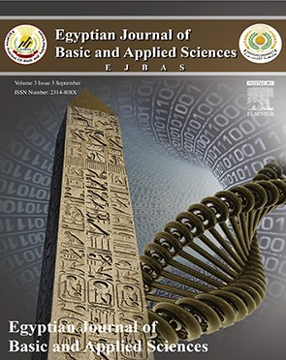 HOSTE D BY

Available online at [www.sciencedirect.com](http://www.sciencedirect.com/science/journal/2314808X)

**ScienceDirect**

journal homepage: [http://ees.elsevier.com/ejbas/default.asp](http://http//ees.elsevier.com/ejbas/default.asp)

**Full Length Article**

**Effects of two weeks administration of *Ocimum gratissimum* leaf on feeding pattern and markers of renal function in rats treated with gentamicin**



***Dare J. Ogundipe*** ***a******,******\*******, Rufus O. Akomolafe*** ***a******, Abubarkar A. Sanusi*** ***b******,***

***Christian E. Imafidon*** ***a******, Olaoluwa S. Olukiran*** ***a******, Ayowole A. Oladele*** ***c***

a *Department of Physiological Sciences, Faculty of Basic Medical Sciences, Obafemi Awolowo University, Ile-Ife,*

*Osun State, Nigeria*

b *Department of Medicine, Faculty of Clinical Sciences, Obafemi Awolowo University, Ile-Ife, Osun State, Nigeria*

c *Department of Medical Laboratory Sciences, College of Medicine, Afe Babalola University, Ado Ekiti, Ekiti State, Nigeria*

A R T I C L E I N F O A B S T R A C T

*Article history:*

Received 20 November 2015 Received in revised form 12 July 2016

Accepted 12 July 2016

Available online 19 July 2016

*Keywords:*

*Ocimum gratissimum* Gentamicin Creatinine

Urea Kidney Rat

This study investigated the effects of aqueous extract of *Ocimum gratissimum* leaf (AOGL) on some markers of renal function in rats with gentamicin-induced nephropathy. Thirty adult male Wistar rats were used for this study. They were divided into 5 groups as follows:

Group 1 (the control) (n = 5) received distilled water daily by oral route for the whole period

of the study. Group 2 (the toxic control) (n = 10) received 100 mg/kg/day of gentamicin i.p. for a week. Groups 3, 4, and 5 (n = 5) were pre-treated with gentamicin as the Group 2 rats, after which they received 100, 200 and 400 mg/kg/day each of AOGL *p.o.*, respectively, for 14

days. Rats in each groups were placed inside separate metabolic cages to obtain their food consumption, water intake and urine output for 24 hours after the last administration. Markers of renal function such as creatinine, urea and total protein were determined both in the plasma and urine. Oxidative stress markers such as TBARS and GSH were assayed in the tissue homogenate. Creatinine clearance was calculated using a standard formula. Genta- micin treatment induced significant (p < 0.05) increases in urine output, plasma urea, creatinine, urinary protein, relative kidney weight and TBARS in the toxic control when compared to the control group. Significant decreases (p < 0.05) in urine creatinine and GSH were also as- sociated with gentamicin administration. Post-treatment with AOGL caused significant increases in food consumption, body weight, water intake, urine creatinine, and GSH, and significant (p < 0.05) decreases in urine output, plasma creatinine, urea, TBARS and urine total protein in the treated groups when compared with the toxic control group. This was

* *Corresponding author.*

*E-mail address:* [darejoshua97@gmail.com](mailto:darejoshua97@gmail.com) (D.J. Ogundipe). <http://dx.doi.org/10.1016/j.ejbas.2016.07.002>

2314-808X/© 2016 Mansoura University. Production and hosting by Elsevier B.V. This is an open access article under the CC BY-NC-ND license ([http://creativecommons.org/licenses/by-nc-nd/4.0/).](http://creativecommons.org/licenses/by-nc-nd/4.0/))

further evident by a significant improvement or reversal of the histopathological alterations of kidney tissues in the groups treated with AOGL. The results of this study indicated that AOGL ameliorated the kidney injury caused by gentamicin in rats. Hence, the extracts have the potential of being used for the management of gentamicin-induced nephropathies.

© 2016 Mansoura University. Production and hosting by Elsevier B.V. This is an open access article under the CC BY-NC-ND license (<http://creativecommons.org/licenses/by-nc-nd/>

4.0/).

# Introduction

Gentamicin (Gen.) is an antibiotic that is widely used against serious and life-threatening gram-negative bacterial infec- tion. However, the clinical use of gentamicin is limited due to its nephrotoxicity [1]. Gentamicin induces nephrotoxicity via oxidative and nitrosative stress [2]. It also causes nephrotox- icity by inhibiting protein synthesis in renal cells. This mechanism specifically causes necrosis of cells in the proxi- mal tubule, resulting in acute tubular necrosis which can lead to acute renal failure [3]. Gentamicin binds to the phos- pholipids of the cell membrane of the renal tubules and enters the cells, then it binds to sub-cellular organelles and alters mitochondrial respiration, while small amounts may be taken up by lysosomes [4]. In addition, induction of acute tubular necrosis, glomerular damage and renal inflammation are the major events implicated in gentamicin nephrotoxic- ity [5,6]. *Ocimum gratissimum* (OG) is an herbaceous plant that belongs to the Labiatae family. The plant is indigenous to tropical areas especially India and West Africa. In Nigeria, it is found in the savannah and coastal areas. It is cultivated in Sri Lanka, South Sea Islands, and also within Nepal, Bengal, Chittagong and Deccan [7]. It is known by various names in different parts of the world. In India it is known by its several vernacular names, the most commonly used ones being Vriddhutulsi (Sanskrit), Ram tulsi (Hindi), and Nimma tulasi (Kannada). In the southern part of Nigeria, the plant is called “effinrin-nla” by the Yoruba speaking tribe. It is called “Ahuji” by the Igbos, while in the Northern part of Nigeria, the Hausas call it “Daidoya” [8]. OG has been used extensively in the traditional system of medicine in many countries. In the north east of Brazil, it is used for medicinal, condiment and culinary purposes. The flowers and the leaves of this plant are rich in essential oils so it is used in preparation of teas and infusion [9]. In the coastal areas of Nigeria, the plant is used in the treatment of epilepsy, high fever and diarrhea [8]. In the savannah areas decoctions of the leaves are used to treat mental illness [10]. OG is used by the Ibos of Southeast- ern Nigeria in the management of baby’s cord, to keep the wound surfaces sterile. It is also used in the treatment of fungal infections, fever, cold and catarrh [11]. Despite all these medicinal values of *O. gratissimum*, there is a paucity of litera- ture on the use of this plant in the treatment of drug- induced kidney injury. Therefore, this study is aimed at investigating the effect of aqueous extract of *Ocimum gratissimum* (AOGL) on markers of renal function in rats following genta- micin administration.

# Materials and methods

## *Drugs and materials*

Gentamicin injection 80 mg/2 ml (manufactured by Shanxi Shuguang Pharmaceutical Co., limited) is marketed as an an- tibiotic drug against a wide variety of pathogenic gram negative and positive bacteria.

Metabolic cages used for this study were fabricated by Central Technological Laboratory and Workshops (CTLW), OAU, Ile-Ife.

## *Plant extraction*

The plant leaves were collected, washed, air dried under shade and ground into fine powder using a blender. The aqueous extract was obtained by extracting the powdered leaves (323 g) with 3 liters of distilled water in an electric shaker for 48 hours. The extract was filtered through Whatman No. 1 (Whatman International Ltd, Maidstone, UK) paper and evaporated under reduced pressure using a rotary evaporator. The residue (33.60 g) was kept in a bottle with a tight fitting cover until it was needed for the study.

**Extraction yield in %**  33.60323  100

 **10.4%**.

## *Animal care and management*

Sixty-five adult male Wistar rats weighing 150 g–200 g were used for this study; they were obtained from the Animal House of the College of Health Sciences, Obafemi Awolowo University, Ile-Ife, and were housed in a plastic cage. The animals were kept inside metabolic cages under normal environmental con- ditions of light/dark cycle and had free access to standard rodent pellet diet (Caps Feed PLC Osogbo, Nigeria) and water. They were allowed to acclimatize in the laboratory for two weeks before the commencement of the study. The experimental proce- dures adopted in this study were in strict compliance with the Experimental Animal Care and Use of Laboratory Animals in Biomedical Research, College of Health Sciences, Obafemi Awolowo University, Ile-Ife.

## *Experimental design*

The rats were divided into 5 groups as follows: Group 1 (the control) consisting of 5 rats received 2 ml/kg distilled water daily

by oral route for the whole period of study (2 weeks). Twenty- four hours after the last administration of distilled water, the rats were sacrificed by cervical dislocation. Group 2 (the toxic control) consisted of 10 rats, each of which received 100 mg/ kg/day of gentamicin *i.p.* for a week. They were left untreated with aqueous extract of *Ocimum gratissimum* (AOGL) for 2 weeks. Five of the rats were sacrificed twenty-four hours after the last administration of gentamicin, while the remaining 5 rats were sacrificed on the 14th day of recovery period. Groups 3, 4 and 5 consist of 5 rats each. They were pre-treated with gentami- cin as the Group 2 rats, after which they received 100, 200 and 400 mg/kg/day each of AOGL *p.o.*, respectively, for 14 days. Rats from each group were sacrificed on the 14th day of

### *Urine creatinine and urea*

Urine samples obtained were diluted 1 + 49 with distilled water before 0.1 ml of the diluted urine sample was pipetted into the test tube for creatinine and urea determination.

### *Protein determination*

Protein determination was carried out according to the method of Lowry et al. [13] as described by Holme and Peck [14].

## *Creatinine clearance*

This was determined using the following equation:

Creatinine clearance  urine creatinine mol L  volume of urine ml 24 hrs 1440 min

plasma creatinine mol L.

treatment with AOGL. Throughout the study period, the body weights of the rats were measured once a week. Their 24- hour food consumption, water intake and urine output were also recorded weekly. Renal creatinine clearance was calcu- lated for all the groups using standard formula (C = U × V / P).

**C**  **clearance**, **U**  **urine creatinine concentration**, **V**  **urine flow rate** **volume of urinetime**,

**P**  **plasma creatinine concentration**.

## *Measurement of body weight*

The body weight of the rats were measured throughout the study period using a digital weighing scale (Camry weighing balance; China) to access the weight gain or loss in each group.

## *Measurement of food consumption, water intake and* urine volume

The food consumption and water intake of the rats were de- termined by taking the difference between the previous weight and volumes respectively from the left over after 24 hours. The value obtained was taken as the daily food consumption and water intake of the group. The volumes of water consumed and urine produced by each rat were measured with a measuring cylinder and the food consumption by the digital weighing scale.

## *Biochemical assay*

About 3 ml of whole blood collected into an EDTA tube was centrifuged at 4000 rpm for 15 min using a Cold Centrifuge (Centurium Scientific, Model 8881, UK). The plasma obtained was analyzed for creatinine, urea and total protein. Similar pro- cedure was applied to the urine sample.

### *Plasma creatinine and urea*

The plasma creatinine concentration was estimated by colo- rimetric method [12] using the laboratory protocol outlined by Randox Manual/RX Monza CR 510 (standard laboratory kit).

## *Measurement of non-enzymatic antioxidants*

The kidneys of the rats were carefully excised and weighed. One of the kidneys was homogenized with 10 ml of sucrose solution (0.25 M) using Electric Homogenizer (SI601001). The ho- mogenate was centrifuged at 3000 rpm for 20 minutes and the supernatant was collected for the assessment of glutathione and TBARS activities.

* + 1. *Estimation of reduced glutathione (GSH) and estimation of thiobarbituric acid reactive substance (TBARS)* Reduced glutathione (GSH) was measured by the method of Beutler et al. [15] and TBARS level was determined by the method of Ohkawa et al. [16].

## *Histopathological studies*

The tissues were fixed in 10% formo-saline to prevent putre- faction and autolysis, embedded in paraffin wax, sectioned and stained with hematoxylin and eosin (H&E) for histological analy- sis. The slides were examined under a light microscope (Olympus CH; Olympus, Tokyo, Japan) and photomicrographs were taken with a Leica DM 750 Camera at ×400 magnification.

## *Statistical analysis*

The results obtained were expressed as mean ± SEM. The data were analyzed using one-way ANOVA followed by Newman– Keuls test using Graph Pad 5.03 (Graph Pad Software Inc., CA, USA). The results were considered significant when p < 0.05.

# Results

## *Food consumption and body weight*

The food consumption and body weight of the control group increased significantly (p < 0.05) throughout the study period (Table 1). An insignificant increase in food consumption and body weight was observed in the gentamicin treated rats when

|  |  |  |  |  |  |  |
| --- | --- | --- | --- | --- | --- | --- |
| **Table 1 – Effect of aqueous extract of *Ocimum gratissimum* on food consumption (g) and body weight in gentamicin- induced nephrotoxicity in rats.** | | | | | | |
|  | Pre-treatment | Food consumption  Gentamicin treatment | 14 days’ treatment | Pre-treatment | Body weight  Gentamicin treatment | 14 days’ treatment |
| Control | 18.00 ± 1.26 | 21.40 ± 2.91 | 26.40 ± 0.68* | 204.0 ± 3.55 | 212.6 ± 3.89 | 226.0 ± 2.92*,† |
| Toxic control | 27.00 ± 2.00 | 33.60 ± 5.27 | – | 188.0 ± 12.41 | 195.6 ± 11.74 | – |
| Toxic recovery | 15.00 ± 0.76 | 14.40 ± 1.63 | 26.00 ± 1.4*,† | 94.00 ± 1.73 | 101.2 ± 2.44 | 136.0 ± 4.14*,† |
| 100 mg AOGL | 11.00 ± 1.79 | 14.80 ± 2.15 | 21.00 ± 2.04*,† | 98.00 ± 3.86 | 87.40 ± 5.14 | 132.8 ± 10.00*,† |
| 200 mg AOGL | 12.60 ± 2.56 | 17.80 ± 1.16 | 24.40 ± 3.14*,† | 117.4 ± 9.05 | 118.8 ± 8.62 | 142.0 ± 6.61*,† |
| 400 mg AOGL | 15.60 ± 1.69 | 17.20 ± 2.06 | 20.80 ± 1.77*,† | 92.20 ± 4.34 | 96.60 ± 6.38 | 129.8 ± 7.94*,† |
| Values are given as mean ± SEM. * = Significantly different from pre-treatment values. † = Significantly different from toxic control (p < 0.05). AOGL, aqueous extract of *Ocimum gratissimum*. | | | | | | |

compared with its pre-treatment values during the 8-day treat- ment with gentamicin (Table 1). However, a significantly higher food consumption and body weight was recorded in the rats treated with AOGL after gentamicin administration when com- pared with their pre-treatment values and during gentamicin treatment (p < 0.05) (Table 1). The food consumption and body weight of the toxic recovery group were significantly higher (p < 0.05) when compared with its pre-treatment values and after the administration of gentamicin.

## *Water intake and urine volume*

The urine volume of the toxic control group was significantly higher (p < 0.05) than that of its pre-treatment value (Table 2). This increase was accompanied by a reduction in water intake, which was significantly lower (p < 0.05) than its pre-treatment value. At the end of the 14-day treatment with AOGL, the water intake of the treated rats was significantly higher (p < 0.05) than that of their pre-treatment values and 8-day gentamicin treat- ment period except for rats treated with 400 mg/kg/day of AOGL, which showed no significant difference in water intake com- pared to its pre-treatment value and during gentamicin administration (Table 2). The experimental groups had a sig- nificantly higher urine volume (p < 0.05) during the 8 days of treatment with gentamicin when compared with their pre- treatment values. However, their urine volume dropped significantly at the end of treatment with AOGL (p < 0.05). Simi- larly, rats that were allowed a 2-week recovery period after

gentamicin treatment had a significantly lower (p < 0.05) urine volume compared to the value obtained during gentamicin ad- ministration (Table 2).

## *Plasma and urine creatinine, urea and total protein*

A significant increase in the plasma creatinine and urea con- centrations was observed in the toxic control and the recovery group when compared with the control rats (p < 0.05) (Figs. 1 and 2). The plasma creatinine and urea concentrations of the rats treated with AOGL were found to be significantly lower (p < 0.05) than that of the toxic control group. The concentra- tions of urea and creatinine in the plasma of the treated rats were not significantly different from that of the control groups, but the rats that were allowed a 2-week recovery period after gentamicin treatment had a significantly higher (p < 0.05) plasma creatinine concentration when compared to the control rats (Figs. 1 and 2).

The plasma total protein of the toxic control group and the AOGL treated group reduced significantly (p < 0.05) when com- pared with the control group (Fig. 3). Similarly, the toxic recovery group had significantly lower (p < 0.05) plasma total protein con- centration compared to the control group (Fig. 3).

The urine creatinine concentration of the toxic control was observed to be significantly lower (p < 0.05) than that of the control group (Fig. 4). However, the urine creatinine concentration of the

treated rats and recovery group was significantly higher (p < 0.05) than that of the toxic control, but significantly lower (p < 0.05)

|  |  |  |  |  |  |  |
| --- | --- | --- | --- | --- | --- | --- |
| **Table 2 – Effect of aqueous extract of *Ocimum gratissimum* on water consumption (ml) and urine volume (ml) in gentamicin-induced nephrotoxicity in rats.** | | | | | | |
|  | Pre-treatment | Water consumption  Gentamicin treatment | 14 days’ treatment | Pre-treatment | Urine output  Gentamicin treatment | 14 days’ treatment |
| Control | 31.00 ± 2.12 | 30.60 ± 9.51 | 29.20 ± 3.40 | 9.20 ± 1.02 | 10.90 ± 0.95 | 9.40 ± 1.45 |
| Toxic control | 17.40 ± 2.16 | 13.00 ± 0.95 | – | 6.00 ± 0.89 | 9.50 ± 0.80* | **–** |
| Toxic recovery | 10.00 ± 1.38 | 13.80 ± 1.59 | 33.50 ± 4.29* | 5.00 ± 0.45 | 8.90 ± 1.07* | 3.12 ± 1.32† |
| 100 mg AOGL | 9.400 ± 0.60 | 15.00 ± 1.92 | 29.00 ± 3.14*,† | 3.90 ± 0.58 | 7.60 ± 0.37* | 4.25 ± 1.74† |
| 200 mg AOGL | 11.20 ± 0.97 | 16.60 ± 2.38 | 28.00 ± 3.56*,† | 3.90 ± 0.43 | 7.00 ± 1.19* | 4.60 ± 1.45† |
| 400 mg AOGL | 11.60 ± 1.86 | 23.60 ± 2.75 | 30.40 ± 4.57 | 4.50 ± 0.54 | 8.10 ± 1.22* | 4.20 ± 0.97† |
| Values are given as mean ± SEM. * = Significantly different from pre-treatment values. † = Significantly different from toxic control (p < 0.05). AOGL, aqueous extract of *Ocimum gratissimum*. | | | | | | |

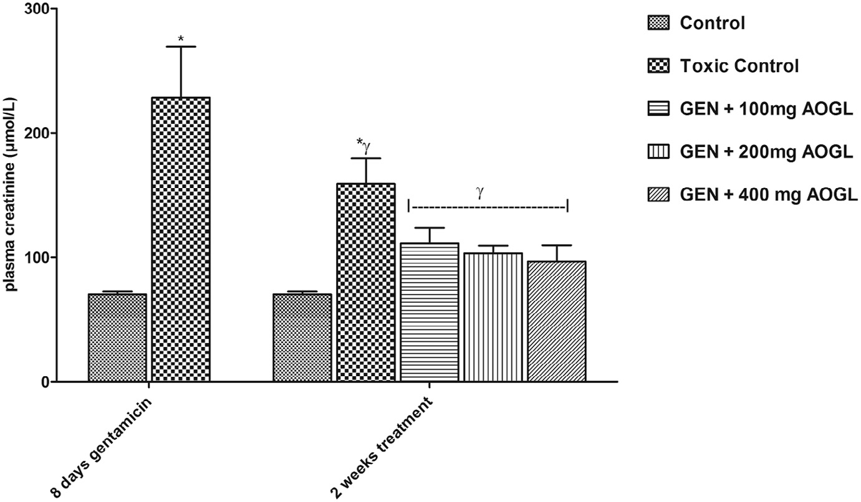

**Fig. 1 – Effect of aqueous extract of *Ocimum gratissimum* on plasma creatinine level in gentamicin-induced kidney injury in rats. Values are given as mean ± SEM. * = Significantly different from control. γ = Significantly different from toxic control**

**(p < 0.05).**

than that of the control group (Fig. 4). The urine concentration of urea in the toxic control group was significantly higher (p < 0.05) than that of the control group (Fig. 5). However, AOGL treated groups and the toxic recovery group had a significantly lower (p < 0.05) urine concentration of urea when compared with the toxic control group, which was not significantly different from the control rats (Fig. 5). The urine total protein concentration of the toxic control was significantly higher (p < 0.05) when com- pared to the control group (Fig. 6). The toxic recovery group had urine total protein concentration which was significantly lower (p < 0.05) than that of the control and toxic control. The group treated with 100 mg/kg/day of AOGL had a significantly higher (p < 0.05) urine total protein concentration when compared to the toxic recovery group, which was significantly lower (p < 0.05) than that of the toxic control group (Fig. 6). The plasma total

protein concentration of rats treated with 400 mg/kg/day of AOGL was significantly higher (p < 0.05) than that of the toxic recovery group.

## *Relative kidney weight, TBARS and GSH*

A significant increase in the relative kidney weight was ob- served in the toxic control group, toxic recovery group and the AOGL treated rats when compared with the control group (p < 0.05) (Fig. 7).

The TBARS and GSH of the toxic control group were sig- nificantly higher (p < 0.05) when compared with the control group, while the TBARS and GSH of the toxic recovery group and rats treated with AOGL decreased significantly (p < 0.05) when compared with the toxic control group (Figs. 8 and 9).

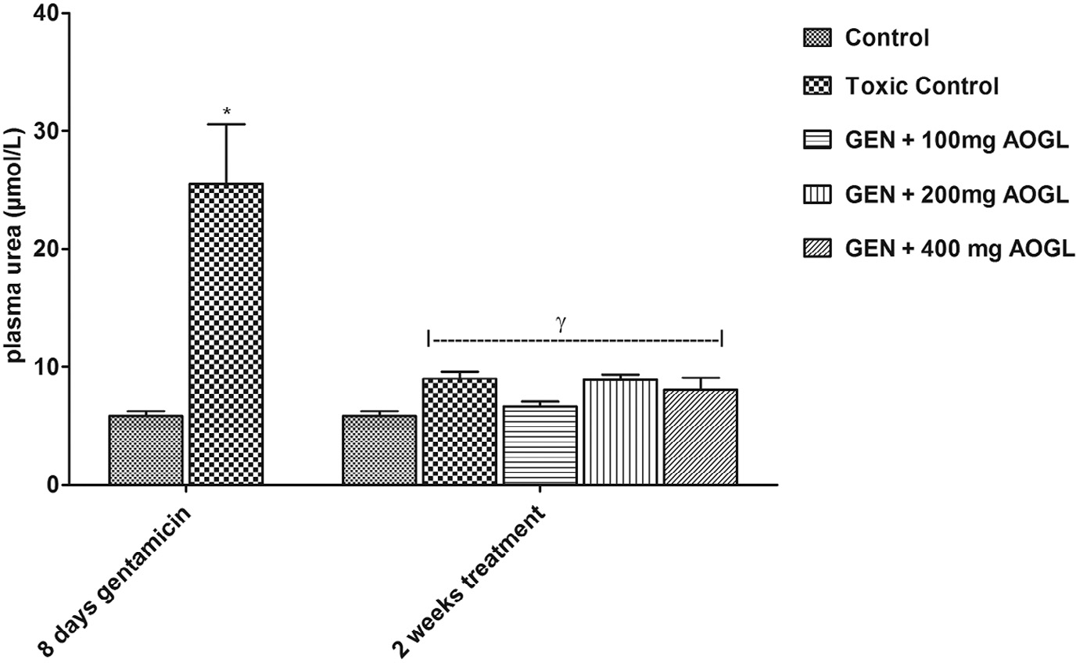

**Fig. 2 – Effect of aqueous extract of *Ocimum gratissimum* on plasma urea in gentamicin-induced kidney injury in rats. Values are given as mean ± SEM. * = Significantly different from control. γ = Significantly different from toxic control (p < 0.05).**

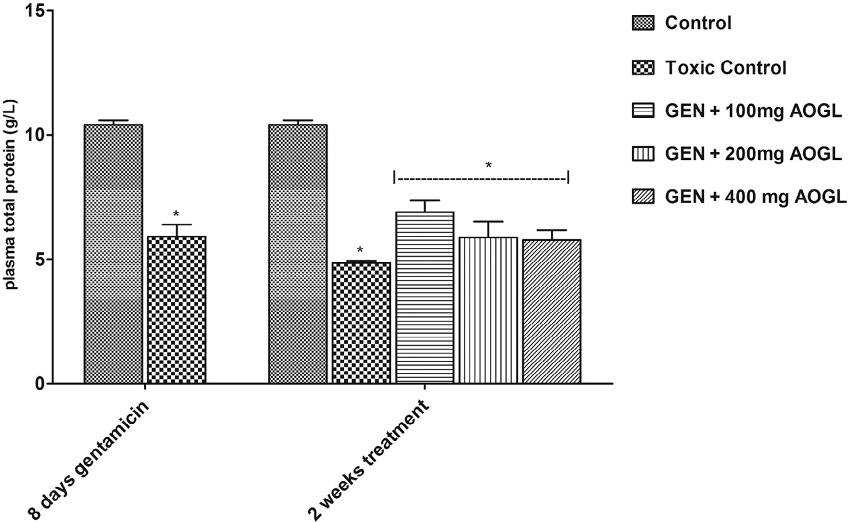

**Fig. 3 – Effect of aqueous extract of *Ocimum gratissimum* on plasma total protein in gentamicin-induced kidney injury in r****ats. Values are given as mean ± SEM. * = Significantly different from control (p < 0.05).**

## *Creatinine clearance*

A significant decrease in the renal creatinine clearance was ob- served in the toxic control group, toxic recovery group and the AOGL treated rats when compared with the control group (p < 0.05) (Fig. 10).

## *Histological examination*

The photomicrograph of the toxic control showed decreased cellularity in the glomeruli (G), loss of cellular constituents (double arrow) and densely eosinophilic cast in the lumen of the tubules (dashed arrow) resulting in atrophy and severe cloudy swelling of the distal convoluted tubule (yellow arrow)

when compared with the control, which showed intact renal corpuscles with normal appearing glomeruli (G) and tubules (T), as well as intact Bowman’s space (black arrow) and epi- thelial lining of Bowman’s capsule (arrowhead) (Figs. 11 and 12), while the toxic recovery group showed marked decrease cellularity in the glomeruli, loss of cellular constituents of tubules (double arrow), densely eosinophilic (‘colloid’) cast in the lumen of some tubules (dashed arrow), cloudy swelling/ inflammation of the proximal and distal convoluted tubules (yellow arrow) (Fig. 13).

The photomicrographs of the kidneys of rats treated with graded doses of AOGL revealed that the glomeruli (G) and surrounding Bowman’s space (black arrow) are mostly intact. There is slight loss of cellular constituents of tubules and no

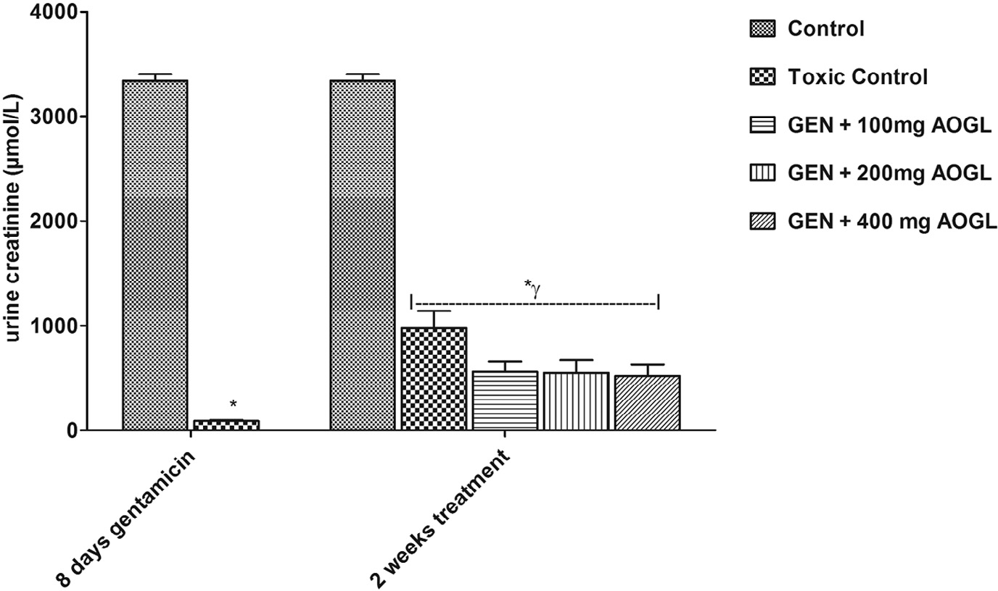

**Fig. 4 – Effect of aqueous extract of *Ocimum gratissimum* on urine creatinine in gentamicin-induced kidney injury in rats.**

**Values are given as mean ± SEM. * = Significantly different from control. γ = Significantly different from toxic control (p < 0.05).**

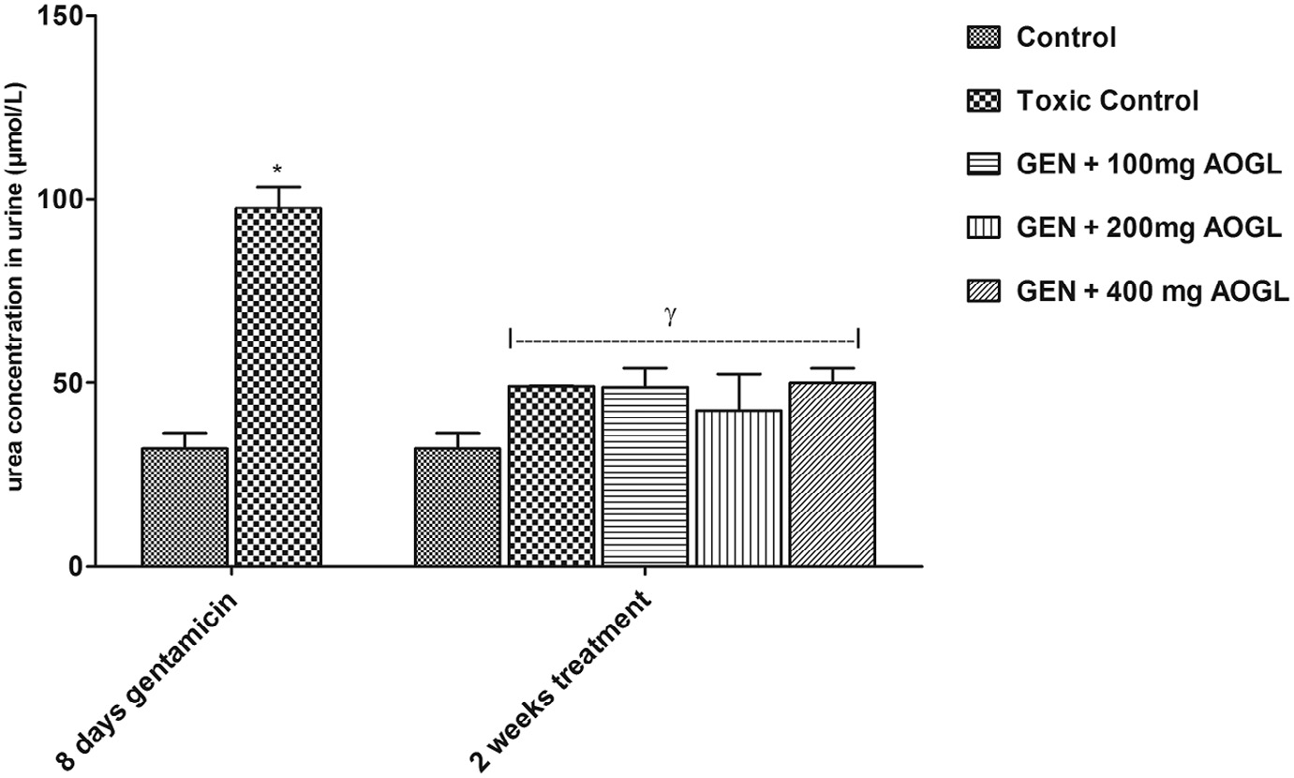

**Fig. 5 – Effect of aqueous extract of *Ocimum gratissimum* on urine urea in gentamicin-induced kidney injury in rats. Values are given as mean ± SEM. * = Significantly different from control. γ = Significantly different from toxic control (p < 0.05).**

eosinophilic (‘colloid’) casts are observed in the lumen of tubules (Figs. 14–16).

# Discussion

In this study, an insignificant increase in food consumption and body weight was observed in the gentamicin treated rats when compared with its pre-treatment values. This is in contrast with the findings of Erdem et al. [4] and El-Zawahry and Abu El Kheir [17], who reported that gentamicin administration caused re- duction in food intake and body weight.

Morley et al. [18] reported that there was a physiological decline in food intake with aging which is multi-factorial and involves both peripheral and central mechanisms. Altered hedonic qualities of food occur due to alterations in taste and, more particularly, smell with aging. They further explained that a decline in adaptive relaxation of the fundus of the stomach and an increased rate of antral filling appear to play a role in the early satiation seen in many aged persons. Cholecystoki- nin levels are increased with aging and aged persons are more sensitive to the satiating effects of this gut hormone. For these reasons, the increase in food consumption and body weight that was observed in the gentamicin treated rats may be due to the wide differences in the age and body weight of the rats

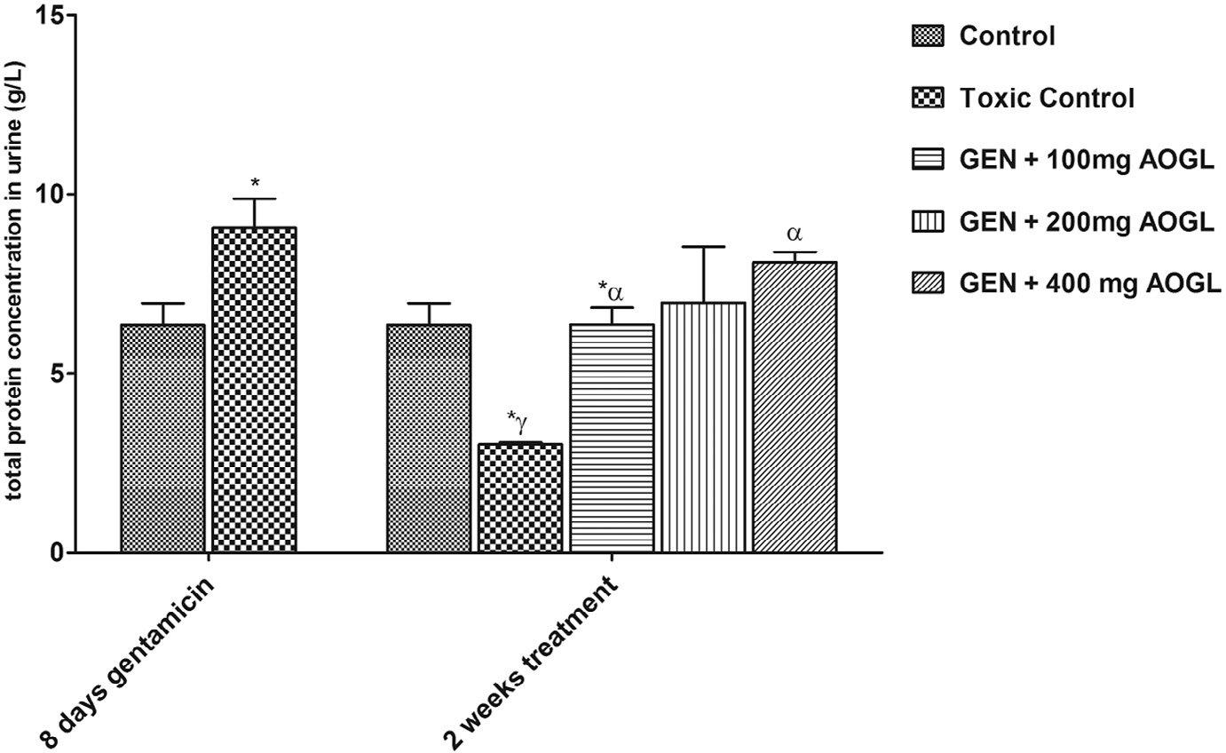

**Fig. 6 – Effect of aqueous extract of *Ocimum gratissimum* on urine total protein in gentamicin-induced kidney injury in rats.**

**Values are given as mean ± SEM. * = Significantly different from control. γ = Significantly different from toxic control (p < 0.05). α = Significantly different from toxic recovery group (p < 0.05).**

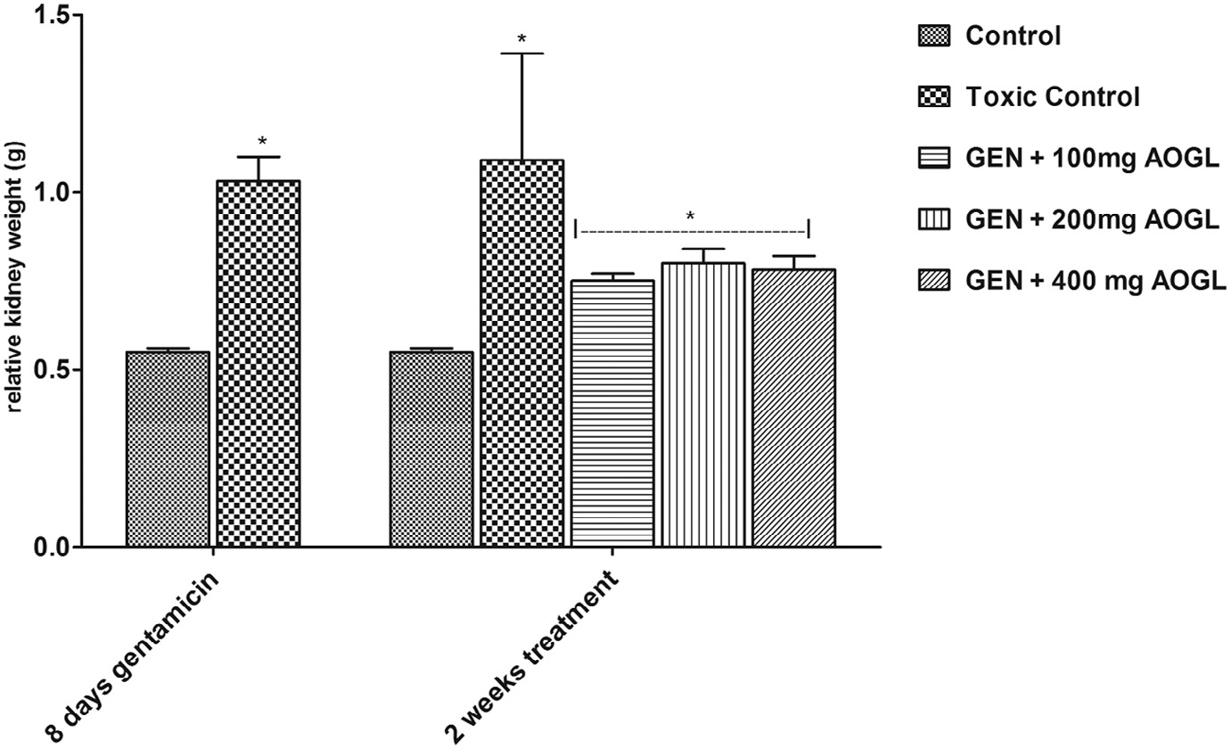

**Fig. 7 – Effect of aqueous extract of *Ocimum gratissimum* on the relative kidney weight in gentamicin-induced kidney injury in rats. Values are given as mean ± SEM. * = Significantly different from control (p < 0.05).**

used in this study (100–150 g) compared with that of the rats used by El-Zawahry and Abu El Kheir [17] (210–230 g).

Gentamicin has been reported to cause a decrease in the number of cytokines cells (such as CD3(+), CD56(+), CD3(+), CD8(+), CD3(+), CD56(+)) with some cytotoxicity [19]. Cytokines

are immune-regulatory peptides released in response to chronic inflammation, infections, injuries, and neoplasms [20]. Cytokines are potent anorectic agents, they decrease serum albumin, induce lipolysis, produce muscle protein breakdown, and induce nitrogen loss [20]. These have a variety of effects that can lead to severe malnutrition [20]. Hence, the significant increase in food consumption and body weight that was observed in the toxic recovery group when compared with the pre-treatment values is an indication of the ability of gentamicin to de- crease the numbers of cytokines in the rats’ body.

Study has shown that administration of AOGL in rats caused significant histological changes in the intestines, revealing the presence of increased villi and larger goblets cells [21]. The in- crease in the numbers of villi in the intestine facilitates increase in nutrient absorption due to increase in the surface area of the intestine [22]. Furthermore, AOGL enhances anti-diarrhea effect by inhibiting intestinal motility, partly via muscarinic re- ceptor inhibition [23], thereby facilitating nutrient absorption in the intestine. The significant increase in body weight that was seen in the experimental groups treated with AOGL may be as a result of AOGL-induced inhibition of the intestinal mo- tility, together with increase in the number of villi of the intestine and larger goblets cells, which favor rapid absorp- tion of nutrient from the gastro-intestinal tract. However, this is not in agreement with the report of Ajibade et al. [24], who

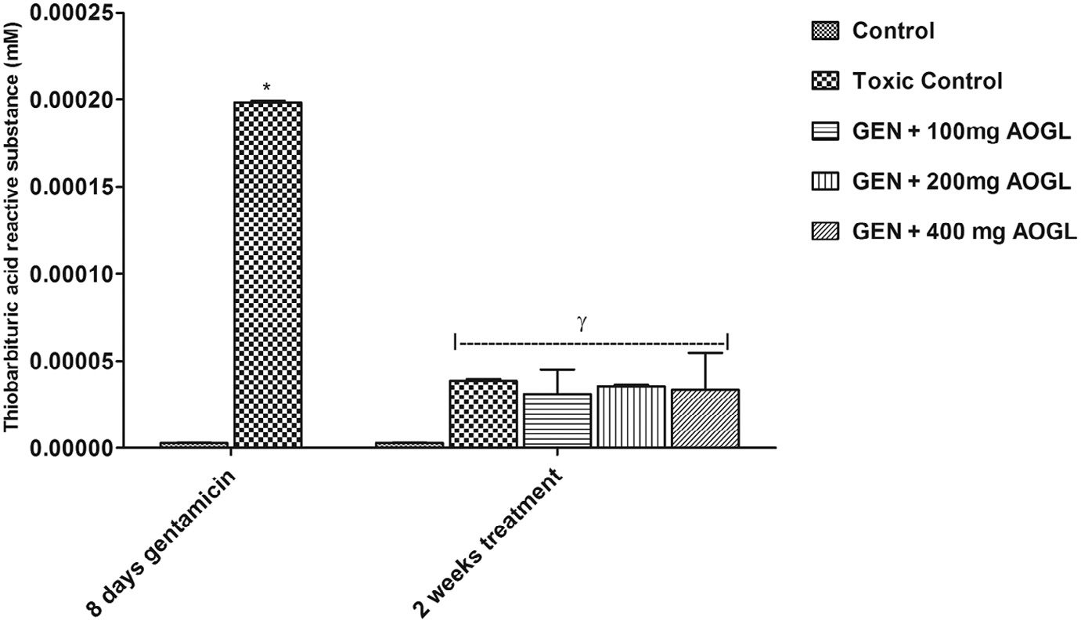

**Fig. 8 – Effect of aqueous extract of *Ocimum gratissimum* on TBARS in gentamicin-induced kidney injury in rats. Values are given as mean ± SEM. * = Significantly different from control. γ = Significantly different from toxic control (p < 0.05).**

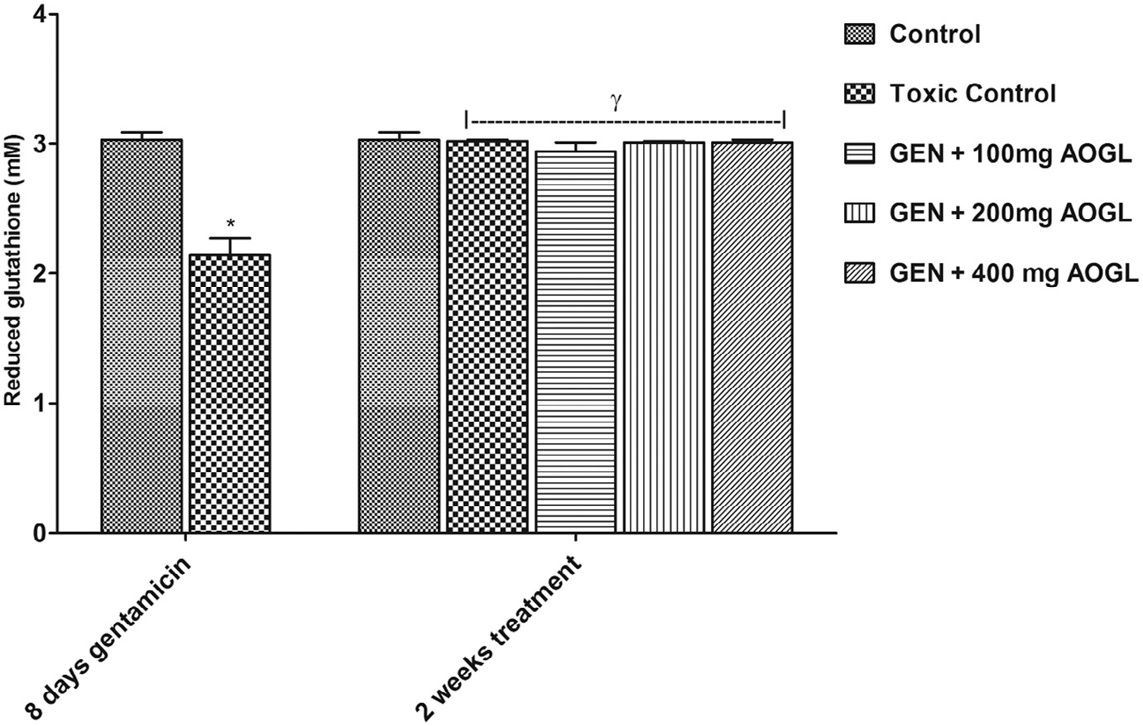

**Fig. 9 – Effect of aqueous extract of *Ocimum gratissimum* on GSH in gentamicin-induced kidney injury in rats. Values are given as mean ± SEM. * = Significantly different from control. γ = Significantly different from toxic control (p < 0.05).**

reported that AOGL administered at different doses caused a significant decrease in the body weight. This disparity may have resulted from the differences in the doses administered to the rats. While Ajibade et al. used 400, 800, 1600 and 3200 mg/kg/ bw, in this study 100, 200 and 400 mg/kg/bw were used. Another possible explanation for the significant increase in food con- sumption and body weight that was observed in the groups treated with AOGL could be due to its hypoglycemic property attributed to flavonoids and other phytochemical constitu- ents [25]. The extract also contains major mineral elements,

e.g. calcium, chloride, manganese, magnesium, zinc and po- tassium, which might also play a contributory role in enhancing its hypoglycemic property [25]. Administration of the AOGL

caused a significant reduction in plasma glucose level in streptozotocin induced diabetic rats [26]. Decrease in the plasma glucose level is said to inhibit the satiety center, thus activat- ing the feeding center to increase appetite leading to increase in food intake [27]. Leptin, a cytokine-like peptide hormone that is secreted from adipose cells deficiency, has been found to be responsible for the hyperphagia and obesity of the geneti- cally obese mouse [28]. Hence, the increase in food consumption and body weight of rats treated with AOGL is indicative of its ability to reduce the secretion of leptin. This requires further study.

The significant increase in urine volume that was ob- served in the toxic control rats without a corresponding increase

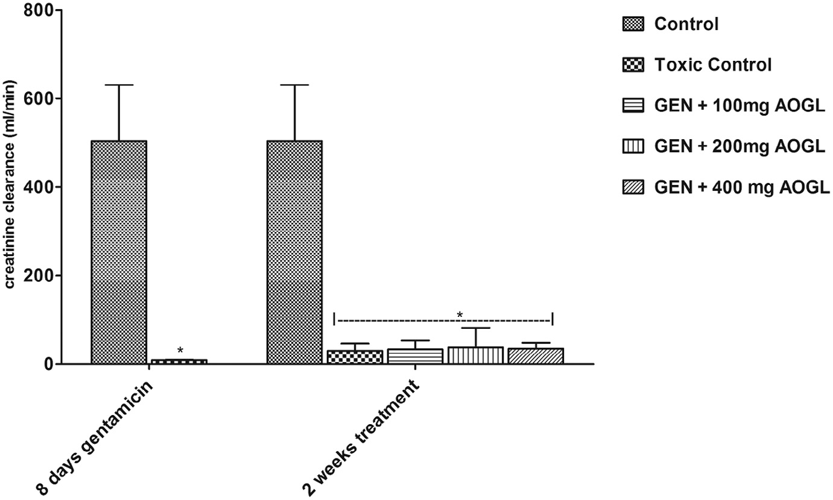

**Fig. 10 – Effect of aqueous extract of *Ocimum gratissimum* on creatinine clearance in gentamicin-induced kidney injury in rats. Values are given as mean ± SEM. * = Significantly different from control. γ = Significantly different from toxic control (p < 0.05).**

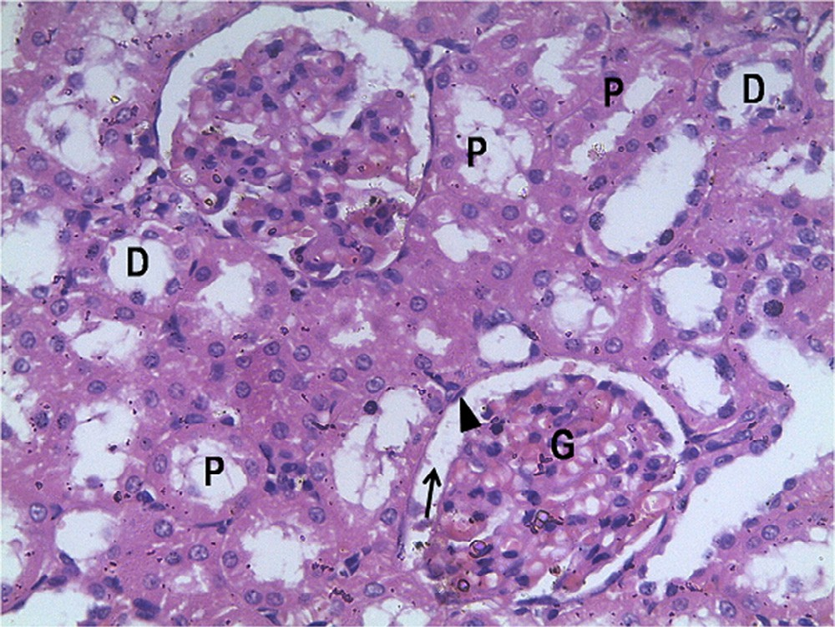 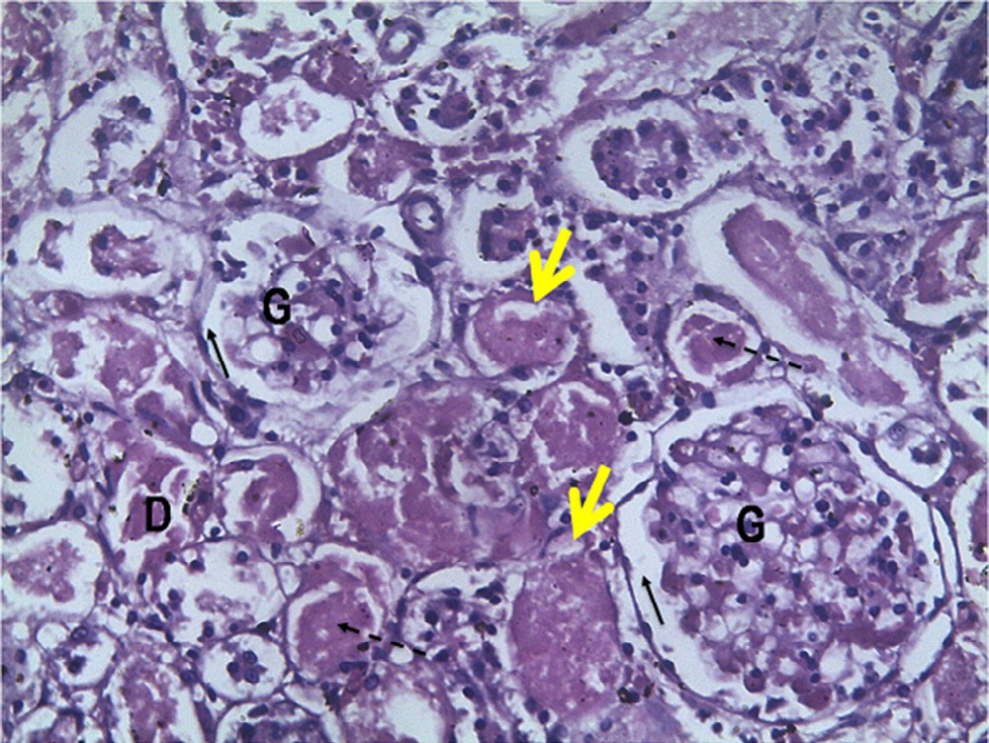

**Fig. 11 – Photomicrograph of the kidney of the control (CN). H&E ×400. Intact renal corpuscles with normal appearing glomeruli (G) and tubules (T), including the PCT (P) and DCT (D), are seen in control, as well as intact Bowman space (black arrow) and epithelial lining of Bowman capsule (arrowhead).**

**Fig. 13 – Photomicrograph of the kidney of toxic recovery group. H&E ×400. Marked decreased cellularity in the glomeruli, loss of cellular constituents of tubules (double arrow), densely eosinophilic (‘colloid’) cast in the lumen of some tubules (dashed arrow), and cloudy swelling/ inflammation of the proximal and distal convoluted**

**tubules (yellow arrow) are seen in the toxic recovery**

**group.**

in water intake may lead to dehydration and severe deple- tion of the major electrolytes of their body fluid with the attendant consequences on the cardiovascular system. This ob- served change in urine volume is in accordance with the finding of El-Zawahry and Abu El Kheir [17], who reported that gen- tamicin administration to rats induced polyuria. However, the water intake of the toxic recovery group and rats treated with AOGL increased significantly without a corresponding in- crease in urine output. This could be due to an attempt by the

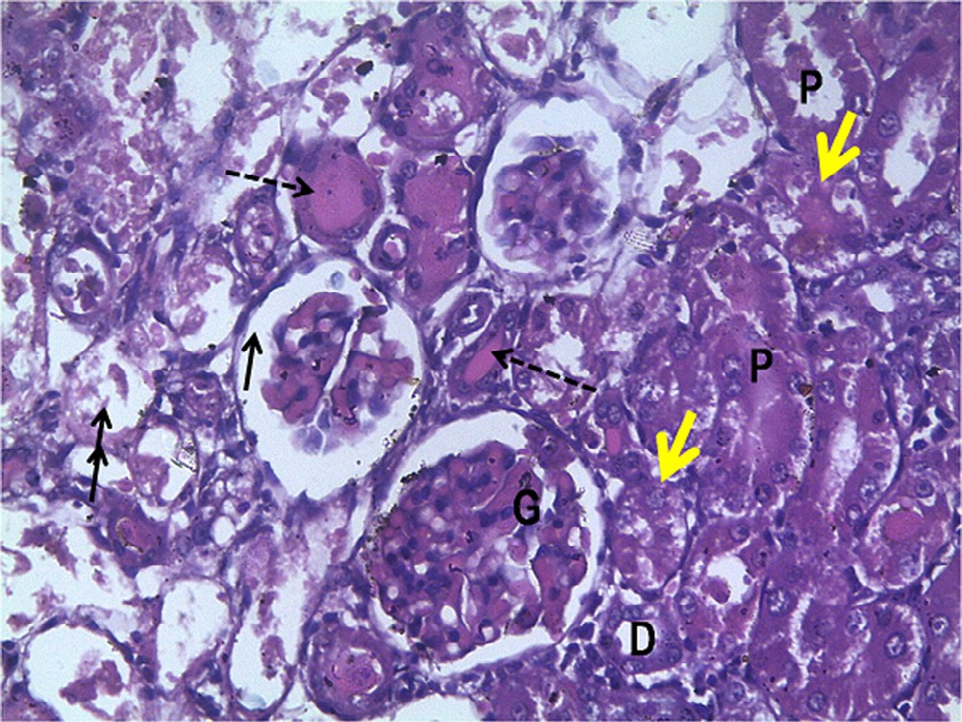

**Fig. 12 – Photomicrograph of the kidney of the toxic control (TX). H&E ×400. Decreased cellularity in the glomeruli, loss of cellular constituents of tubules (double arrow), densely eosinophilic (‘colloid’) cast in the lumen of some tubules (dashed arrow) resulting in atrophy, loss of epithelia cells and severe cloudy swelling/inflammation of the distal convoluted tubules (yellow arrow) are observed in the**

**toxic control group.**

rats to restore the body fluid volume resulting from dehydra- tion that followed gentamicin treatment or increased osmolarity caused by depletion of their body fluid. This leads to stimu- lation of osmoreceptor cells which activate the thirst center in the hypothalamus to facilitate increase in water intake.

The significant increase in relative kidney weight that was observed in the toxic control group and toxic recovery group may be due to inflammation in response to injury caused by this drug. This is corroborated by the photomicrograph of the

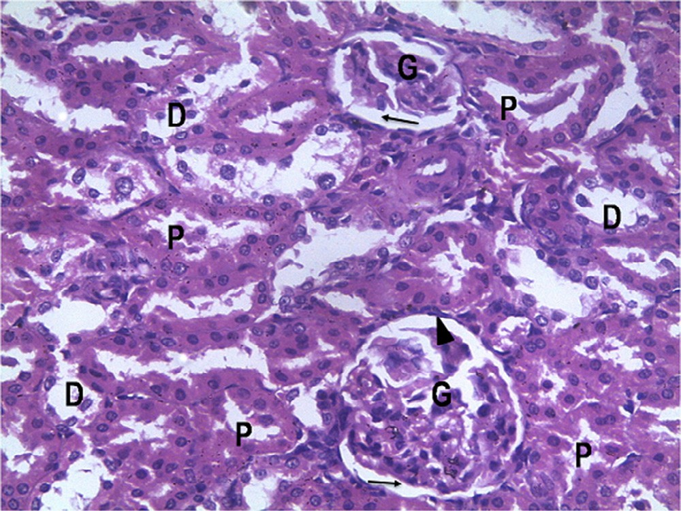

**Fig. 14 – Photomicrograph of the kidney of 2 weeks’ treatment with 100 mg/kg/day of AOGL. H&E ×400. Glomeruli (G) and surrounding Bowman’s space (black arrow) are mostly intact. There is slight loss of cellular constituents of tubules and no eosinophilic (‘colloid’) casts are observed in the lumen of tubules.**

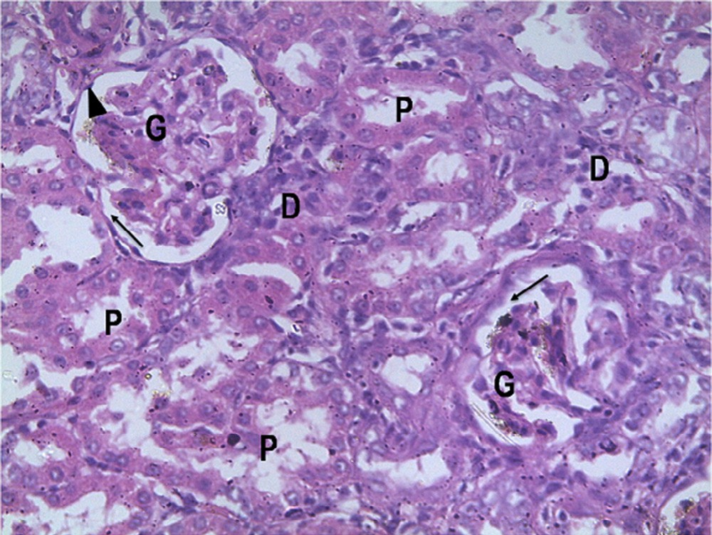

**Fig. 15 – Photomicrograph of the kidney of 2 weeks’ treatment with 200 mg/kg/day of AOGL. H&E ×400. Glomeruli (G) and surrounding Bowman’s space (black arrow) are mostly intact. There is slight loss of cellular constituents of tubules and no eosinophilic (‘colloid’) casts are observed in the lumen of tubules.**

kidney of this group which showed severe cloudy swelling of the renal tubules. Similar observation was made by El-Zawahry and Abu El Kheir [17]. Also, a significant increase in relative kidney weight was observed in the groups treated with AOGL. This finding is not in agreement with Sahouo et al. [29], who reported that AOGL exhibited an anti-inflammatory effect on the kidney of rats. The observed discrepancy is likely attrib- utable to the duration of administration of AOGL.

The plasma creatinine and urea concentrations of the toxic control group were significantly higher than that of the control rats. The creatinine and urea concentrations in

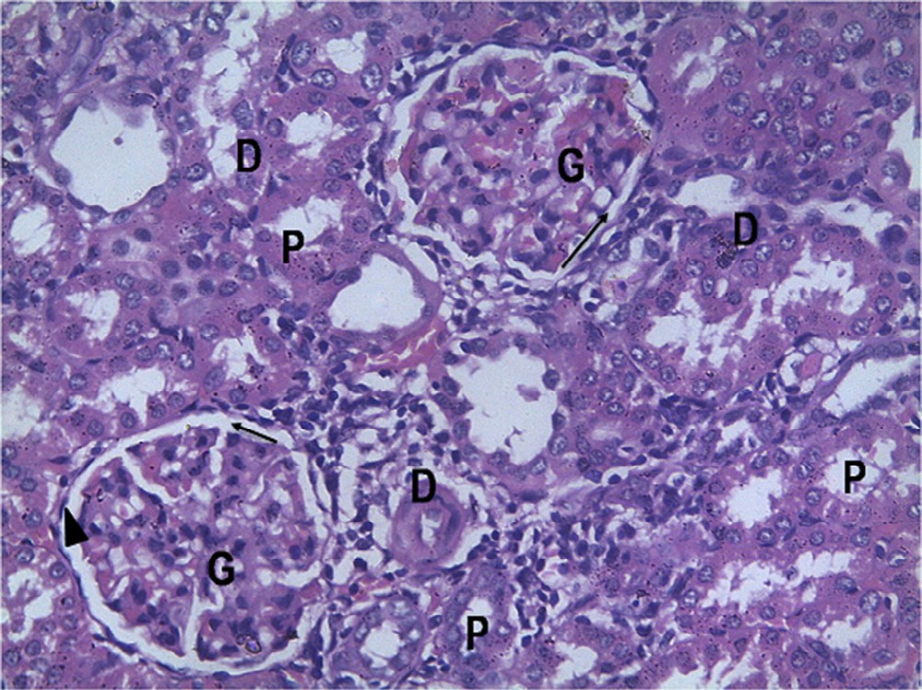

**Fig. 16 – Photomicrograph of the kidney of 2 weeks’ treatment with 400 mg/kg/day of AOGL. H&E ×400 (right). Glomeruli (G) and surrounding Bowman’s space (black arrow) are mostly intact. There is slight loss of cellular constituents of tubules and no eosinophilic (‘colloid’) casts are observed in the lumen of tubules.**

the urine reduced significantly in this group compared to the control. These observed changes are in accordance with the report of Pedrazha-Chaverri et al. [30], who reported that administration of gentamicin caused marked impairment in renal function. The decrease in urine creatinine is a further evidence of reduced ability of the renal tubules to extract and remove creatinine from the plasma of the toxic control rats. The elevated concentration of plasma urea observed may have resulted from the inability of the glomeruli to filter urea. A significant decrease toward normal plasma level of creatinine and urea that was observed in the toxic recovery group is an indication of tubular regeneration resulting from the release of reparative and prosurvival factors from the distal tubular cells [31]. The marked decrease in plasma cre- atinine and urea in AOGL treated groups is in conformity with report of other researchers, who reported that AOGL decreased serum urea, creatinine, uric acid, urine volume, urinary protein and increased urine creatinine level in cisplatin induced nephrotoxicity in rats [32,33].

A significant decrease in renal creatinine clearance that was observed in the toxic control and toxic recovery group is in agreement with the report of Raheem et al. [34] and Bibu et al. [35] that gentamicin administration to rats reduced their glomerular filtration rate and renal blood flow, resulting from a rise in renal vascular resistance or damage to the glomerular capillary endothelium leading to impairment in glomerular function. Similarly, a significant decrease in renal creatinine clearance was observed in rats treated with AOGL when compared to the control. However, the creatinine clear- ance of these rats increased when compared to the toxic control group. This is an indication of improved blood flow to the kidney as well as repair of kidney tissue damage caused by gentamicin.

A significant increase in the urinary total protein was ob- served in the toxic control group. It is an evidence of inflammation of the glomerular capillaries. This observed change is in accordance with the result of El-Zawahry and Abu El Kheir [17], who reported that gentamicin administration to rats induced proteinuria. In contrast, rats treated with AOGL showed a decrease in urine protein. This may be due to the antioxidant properties of AOGL since it has been found that reactive oxygen species (ROS) may be involved in the impair- ment of glomerular filtration [2].

A significant increase in the TBARS level and significant de- crease in GSH level that were observed in the toxic control group are evidence of increased lipid peroxidation, which is an in- dicator of oxidative stress. This observed change is in conformity with the report of Reddy et al. [36], who reported that genta- micin administration caused oxidative damage to the kidney. Also a significant decrease in the TBARS level and increase in GSH level were observed in the toxic recovery group when com- pared with the control group. This finding is an indication of the release of reparative and prosurvival factors from the distal tubular cells [37]. Furthermore, a significant decrease in the TBARS and increase in GSH level were observed in the AOGL treated group when compared with the control group. This is in agreement with Reddy et al. [36], who reported that simvastatin increased GSH and decreased TBARS in gentami- cin induced kidney injury. The change observed may be due to the anti-oxidant activities of AOGL.

# Conclusion

This study demonstrated the nephron-restorative effect of *O. gratissimum* in gentamicin induced nephrotoxicity in rats. The ameliorative effect of *O. gratissimum* is evident by a remark- able restoration of markers of renal function such as protein, urea, creatinine levels, creatinine clearance and antioxidant enzymes in gentamicin treated rats.

# Acknowledgments

The authors appreciate Mrs. Olatoye T.R, Department of Medical Pharmacology and Therapeutics, OAU, Ile-Ife; Mr. K. Ilesanmi, Department of Physiological Sciences, OAU, Ile-Ife; and Dr. E.M. Obuotor, Department of Biochemistry, for providing us with some necessary equipment and for their technical assis- tance in the process of carrying out this research work

R E F E R E N C E S

1. [Moulds RFW, Jeyasingham MS. Gentamicin: a great way to](http://refhub.elsevier.com/S2314-808X(16)30020-3/sr0010) [start. Aust Prescr 2010;33:134–5.](http://refhub.elsevier.com/S2314-808X(16)30020-3/sr0010)
2. [Dhanarajan R, Abraham P, Issac B. Protective effect of](http://refhub.elsevier.com/S2314-808X(16)30020-3/sr0015) [ebselen drug, against gentamicin-induced renal damage in](http://refhub.elsevier.com/S2314-808X(16)30020-3/sr0015) [rats. Basic Clin Pharmacol Toxicol 2006;99:267–72.](http://refhub.elsevier.com/S2314-808X(16)30020-3/sr0015)
3. [Sundin DP, Meyer C, Dahl R, Geerdes A, Sandoval R, Molitoris](http://refhub.elsevier.com/S2314-808X(16)30020-3/sr0020) [BA. Cellular mechanism of aminoglycoside tolerance in](http://refhub.elsevier.com/S2314-808X(16)30020-3/sr0020)

[long-term gentamicin treatment. Am J Physiol](http://refhub.elsevier.com/S2314-808X(16)30020-3/sr0020) [1997;411:C1309–18.](http://refhub.elsevier.com/S2314-808X(16)30020-3/sr0020)

1. [Erdem A, Gundogan N, Alp U, Kara A. The protective effect of](http://refhub.elsevier.com/S2314-808X(16)30020-3/sr0025) [taurine against gentamicin-induced acute tubular necrosis](http://refhub.elsevier.com/S2314-808X(16)30020-3/sr0025) [in rats. Nephrol Dial Transplant 2000;15:1175–82.](http://refhub.elsevier.com/S2314-808X(16)30020-3/sr0025)
2. [Elfarra AA, Duescher RJ, Sausen PJ, Ohara TM, Cooley AJ.](http://refhub.elsevier.com/S2314-808X(16)30020-3/sr0030) [Methimazole protection of rats against gentamicin-induced](http://refhub.elsevier.com/S2314-808X(16)30020-3/sr0030) [nephrotoxicity. Can J Physiol Pharmacol 1994;72:1238–44.](http://refhub.elsevier.com/S2314-808X(16)30020-3/sr0030)
3. [Abdel-Raheem IT, Abdel-Ghany AA, Mohamed G. Protective](http://refhub.elsevier.com/S2314-808X(16)30020-3/sr0035) [effect of quercetin against gentamicin-induced](http://refhub.elsevier.com/S2314-808X(16)30020-3/sr0035) [nephrotoxicity in rats. Biol Pharm Bull 2009;32:61–7.](http://refhub.elsevier.com/S2314-808X(16)30020-3/sr0035)
4. [Nadkarni KM. Indian materia medica. 3rd ed. India: Popular](http://refhub.elsevier.com/S2314-808X(16)30020-3/sr0040) [Prakashan Pvt Ltd; 1999.](http://refhub.elsevier.com/S2314-808X(16)30020-3/sr0040)
5. [Effraim KD, Jacks TW, Sodipo OA. Histopathological studies](http://refhub.elsevier.com/S2314-808X(16)30020-3/sr0045) [on the toxicity of *Ocimum gratissimum* leave extract on some](http://refhub.elsevier.com/S2314-808X(16)30020-3/sr0045) [organs of rabbit. Afr J Biomed Res 2003;6:21–5.](http://refhub.elsevier.com/S2314-808X(16)30020-3/sr0045)
6. [Rabelo M, Souza EP, Soares PMG, Miranda AV, Matos FJA,](http://refhub.elsevier.com/S2314-808X(16)30020-3/sr0050) [Criddle DN. Antinociceptive properties of the essential oil of](http://refhub.elsevier.com/S2314-808X(16)30020-3/sr0050) [*Ocimum gratissimum* L. (Labiatae) in mice. Braz J Med Biol Res](http://refhub.elsevier.com/S2314-808X(16)30020-3/sr0050) [2003;36:521–4.](http://refhub.elsevier.com/S2314-808X(16)30020-3/sr0050)
7. [Akinmoladun AC, Ibukun EO, Emmanuel A, Obuotor EM,](http://refhub.elsevier.com/S2314-808X(16)30020-3/sr0055) [Farombi EO. Phytochemical constituent and antioxidant](http://refhub.elsevier.com/S2314-808X(16)30020-3/sr0055) [activity of extract from the leaves of *Ocimum gratissimum*. Sci](http://refhub.elsevier.com/S2314-808X(16)30020-3/sr0055) [Res Essays 2007;2:163–6.](http://refhub.elsevier.com/S2314-808X(16)30020-3/sr0055)
8. [Ijeh II, Omodamiro OD, Nwanna IJ. Antimicrobial effects of](http://refhub.elsevier.com/S2314-808X(16)30020-3/sr0060) [aqueous and ethanolic fractions of two spices, *Ocimum*](http://refhub.elsevier.com/S2314-808X(16)30020-3/sr0060)[*gratissimum* and *Xylopia aethiopica*. Afr J Biotechnol](http://refhub.elsevier.com/S2314-808X(16)30020-3/sr0060) [2005;4:953–6.](http://refhub.elsevier.com/S2314-808X(16)30020-3/sr0060)
9. [Bartels H, Bohmer M. Serum creatinine determination](http://refhub.elsevier.com/S2314-808X(16)30020-3/sr0065) [without protein precipitation. Clin Chim Acta 1972;37:](http://refhub.elsevier.com/S2314-808X(16)30020-3/sr0065) [193–7.](http://refhub.elsevier.com/S2314-808X(16)30020-3/sr0065)
10. [Lowry OH, Rosenbrough NJ, Farr A Randallm RJ. Protein](http://refhub.elsevier.com/S2314-808X(16)30020-3/sr0070) [measurement with the folin phenol reagent. J Biol Chem](http://refhub.elsevier.com/S2314-808X(16)30020-3/sr0070) [1951;193:265–75.](http://refhub.elsevier.com/S2314-808X(16)30020-3/sr0070)
11. [Holme DJ, Peck H. Analytical biochemistry. 3rd ed. New York:](http://refhub.elsevier.com/S2314-808X(16)30020-3/sr0075) [Longman; 1998.](http://refhub.elsevier.com/S2314-808X(16)30020-3/sr0075)
12. [Beutler E, Duron O, Kelly BM. Improved method for](http://refhub.elsevier.com/S2314-808X(16)30020-3/sr0080) [determination of blood glutathione. J Lab Clin Med](http://refhub.elsevier.com/S2314-808X(16)30020-3/sr0080) [1963;61:882–8.](http://refhub.elsevier.com/S2314-808X(16)30020-3/sr0080)
13. [Ohkawa H, Ohishi N, Yagi K. Assay for lipid peroxidation in](http://refhub.elsevier.com/S2314-808X(16)30020-3/sr0085) [animal tissues by thiobarbituric acid reaction. Anal Biochem](http://refhub.elsevier.com/S2314-808X(16)30020-3/sr0085) [1979;95:351–8.](http://refhub.elsevier.com/S2314-808X(16)30020-3/sr0085)
14. [El-Zawahry BH, Abu El Kheir EM. The protective effect of](http://refhub.elsevier.com/S2314-808X(16)30020-3/sr0090) [curcumin against gentamicin-induced renal dysfunction](http://refhub.elsevier.com/S2314-808X(16)30020-3/sr0090) [and oxidative stress in male Wistar rats. Egypt J Hosp Med](http://refhub.elsevier.com/S2314-808X(16)30020-3/sr0090) [2007;29:546–56.](http://refhub.elsevier.com/S2314-808X(16)30020-3/sr0090)
15. [Morley JE, Perry HM, Baumgartner RP, Garry PJ. Leptin,](http://refhub.elsevier.com/S2314-808X(16)30020-3/sr0095) [adipose tissue and aging – is there a role for testosterone?](http://refhub.elsevier.com/S2314-808X(16)30020-3/sr0095) [J Gerontol Biol Sci Med Sci 1999;54A:B108–9.](http://refhub.elsevier.com/S2314-808X(16)30020-3/sr0095)
16. [Cao J, Yin W, Chen C, Luo X. Effects of autologous plasma](http://refhub.elsevier.com/S2314-808X(16)30020-3/sr0100) [and gentamicin on immunophenotype and viability of](http://refhub.elsevier.com/S2314-808X(16)30020-3/sr0100) [cytokine-induced killer cells. Xi Bao Yu Fen Zi Mian Yi Xue](http://refhub.elsevier.com/S2314-808X(16)30020-3/sr0100) [Za Zhi 2014;30:906–8.](http://refhub.elsevier.com/S2314-808X(16)30020-3/sr0100)
17. [Baez-Franceschi D, Morley JE. Physiopathology of the](http://refhub.elsevier.com/S2314-808X(16)30020-3/sr0105) [catabolism associated with malnutrition in the elderly.](http://refhub.elsevier.com/S2314-808X(16)30020-3/sr0105) [Z Gerontol Geriatr 1999;32:12–19.](http://refhub.elsevier.com/S2314-808X(16)30020-3/sr0105)
18. [Iweala EEJ, Obidoa O. Studies on some biochemical and](http://refhub.elsevier.com/S2314-808X(16)30020-3/sr0110) [histological changes associated with long term consumption](http://refhub.elsevier.com/S2314-808X(16)30020-3/sr0110) [of leaves of *Ocimum gratissimum* L. in male rats. Am J Food](http://refhub.elsevier.com/S2314-808X(16)30020-3/sr0110) [Tech 2010;5:376–84.](http://refhub.elsevier.com/S2314-808X(16)30020-3/sr0110)
19. [Pappenheimer JP. Intestinal absorption of hexoses and](http://refhub.elsevier.com/S2314-808X(16)30020-3/sr0115) [amino acids: from apical cytosol to villus capillaries.](http://refhub.elsevier.com/S2314-808X(16)30020-3/sr0115)

[J Membr Biol 2001;184:233.](http://refhub.elsevier.com/S2314-808X(16)30020-3/sr0115)

1. [Offiah VN, Chikwendu UA. Antidiarrhoeal effects of *Ocimum*](http://refhub.elsevier.com/S2314-808X(16)30020-3/sr0120)[*gratissimum* leaf extract in experimental animals.](http://refhub.elsevier.com/S2314-808X(16)30020-3/sr0120)

[J Ethnopharmacol 1999;68:327–30.](http://refhub.elsevier.com/S2314-808X(16)30020-3/sr0120)

1. [Ajibade AJ, Fakunle PB, Ashamu EA, Owolabi SO. Some](http://refhub.elsevier.com/S2314-808X(16)30020-3/sr0125) [morphological changes on the kidney of adult Wistar rats](http://refhub.elsevier.com/S2314-808X(16)30020-3/sr0125) [following administration of crude extract of *Ocimum*](http://refhub.elsevier.com/S2314-808X(16)30020-3/sr0125)[*gratissimum*. J Med Plants Res 2011;5:6435–8.](http://refhub.elsevier.com/S2314-808X(16)30020-3/sr0125)
2. [Chen MD, Lin PY, Tsou CT, Wang JJ, Lin WH. Selected metal](http://refhub.elsevier.com/S2314-808X(16)30020-3/sr0130) [status in patients with non-insulin-dependent diabetes](http://refhub.elsevier.com/S2314-808X(16)30020-3/sr0130) [mellitus. Biol Trace Elem Res 1995;50:119–24.](http://refhub.elsevier.com/S2314-808X(16)30020-3/sr0130)
3. [Egesie UG, Adelaiye AB, Ibu JO, Egesie OJ. Safety and](http://refhub.elsevier.com/S2314-808X(16)30020-3/sr0135) [hypoglycaemic properties of aqueous leaf extract of *Ocimum*](http://refhub.elsevier.com/S2314-808X(16)30020-3/sr0135)[*gratissimum* in streptozotocin induced diabetic rats. Niger J](http://refhub.elsevier.com/S2314-808X(16)30020-3/sr0135) [Physiol Sci 2006;21:31–5.](http://refhub.elsevier.com/S2314-808X(16)30020-3/sr0135)
4. [Guyton AC, Hall JE. Textbook of medical physiology. 10th ed.](http://refhub.elsevier.com/S2314-808X(16)30020-3/sr0140) [Philadelphia (PA): Elsevier Publishers; 2001.](http://refhub.elsevier.com/S2314-808X(16)30020-3/sr0140)
5. [Friedman JM, Halaas JL. Leptin and the regulation of body](http://refhub.elsevier.com/S2314-808X(16)30020-3/sr0145) [weight in mammals. Nature 1998;395:763–70.](http://refhub.elsevier.com/S2314-808X(16)30020-3/sr0145)
6. [Sahouo GB, Tonzibo ZF, Boti B, Chopard C, Mahy JP. Anti-](http://refhub.elsevier.com/S2314-808X(16)30020-3/sr0150) [inflammatory and analgesic activities. Chem Pathol](http://refhub.elsevier.com/S2314-808X(16)30020-3/sr0150) [2003;12:63–6.](http://refhub.elsevier.com/S2314-808X(16)30020-3/sr0150)
7. [Pedrazha-Chaverri J, Maldonado PD, Barrera D, Ceron A,](http://refhub.elsevier.com/S2314-808X(16)30020-3/sr0155) [Medina N, Campos R, et al. Garlic ameliorates](http://refhub.elsevier.com/S2314-808X(16)30020-3/sr0155) [nephrotoxicity: relation to antioxidant enzymes. Free Radic](http://refhub.elsevier.com/S2314-808X(16)30020-3/sr0155) [Biol Med 2000;29:602–11.](http://refhub.elsevier.com/S2314-808X(16)30020-3/sr0155)
8. [Gobe GC, Johnson DW. Distal tubular epithelial cells of](http://refhub.elsevier.com/S2314-808X(16)30020-3/sr0160) [the kidney: potential support for proximal tubular cell](http://refhub.elsevier.com/S2314-808X(16)30020-3/sr0160) [survival after renal injury. Int J Biochem Cell Biol](http://refhub.elsevier.com/S2314-808X(16)30020-3/sr0160) [2007;39:1551–61.](http://refhub.elsevier.com/S2314-808X(16)30020-3/sr0160)
9. [Mansour HH, Hafez HF, Fahmy NM. Silymarin modulates](http://refhub.elsevier.com/S2314-808X(16)30020-3/sr0165) [cisplatin induced oxidative stress and hepatotoxicity in rats.](http://refhub.elsevier.com/S2314-808X(16)30020-3/sr0165) [J Biochem Mol Biol 2006;39:656–61.](http://refhub.elsevier.com/S2314-808X(16)30020-3/sr0165)
10. [Naghizadeh B, Boroushaki TM, Mashhadian V, Mansouri Y.](http://refhub.elsevier.com/S2314-808X(16)30020-3/sr0170) [Protective effects of crocin against cisplatin induced acute](http://refhub.elsevier.com/S2314-808X(16)30020-3/sr0170) [renal failure and oxidative stress in rats. Iran Biomed J](http://refhub.elsevier.com/S2314-808X(16)30020-3/sr0170) [2008;12:93–100.](http://refhub.elsevier.com/S2314-808X(16)30020-3/sr0170)
11. [Raheem IA, El-Sherbiny GA, Taye A. Green tea ameliorates](http://refhub.elsevier.com/S2314-808X(16)30020-3/sr0175) [renal oxidative damage Induced by gentamicin in rats. Pak J](http://refhub.elsevier.com/S2314-808X(16)30020-3/sr0175) [Pharm Sci 2010;23:21–8.](http://refhub.elsevier.com/S2314-808X(16)30020-3/sr0175)
12. [Bibu KJ, Joy AD, Mercey KA. Therapeutic effect of ethanolic](http://refhub.elsevier.com/S2314-808X(16)30020-3/sr0180) [extract of *Hygrophila spinosa* T. Anders on gentamicin-](http://refhub.elsevier.com/S2314-808X(16)30020-3/sr0180) [induced nephrotoxicity in rats. Indian J Exp Biol 2010;48:911–](http://refhub.elsevier.com/S2314-808X(16)30020-3/sr0180) [17.](http://refhub.elsevier.com/S2314-808X(16)30020-3/sr0180)
13. [Reddy V, Chinnapa V, Amulya CH, Lakshmi A, Bala D,](http://refhub.elsevier.com/S2314-808X(16)30020-3/sr0185) [Praveen Kumar Reddy D, et al. Effect of simvastatin in](http://refhub.elsevier.com/S2314-808X(16)30020-3/sr0185)

[gentamicin- induced nephrotoxicity in Wistar rats. Asian J](http://refhub.elsevier.com/S2314-808X(16)30020-3/sr0185) [Pharm Clin Res 2012;5:1.](http://refhub.elsevier.com/S2314-808X(16)30020-3/sr0185)

1. [Wolf G, Ziyadeh FN. Cellular and molecular mechanisms of](http://refhub.elsevier.com/S2314-808X(16)30020-3/sr0190) [proteinuria in diabetic nephropathy. Nephron Physiol](http://refhub.elsevier.com/S2314-808X(16)30020-3/sr0190) [2007;106:26–31.](http://refhub.elsevier.com/S2314-808X(16)30020-3/sr0190)