[Cyber Security and Applications 2 (2024) 100027](https://doi.org/10.1016/j.csa.2023.100027)

 

Contents lists available at [ScienceDirect](http://www.ScienceDirect.com/)

Cyber Security and Applications

journal homepage: <http://www.keaipublishing.com/en/journals/cyber-security-and-applications/>

Eﬃcient time-oriented latency-based secure data encryption for cloud storage

Shahnawaz Ahmad∗, Shabana Mehfuz

*Department of Electrical Engineering, Jamia Millia Islamia (A Central University), New Delhi, 110025, India*

a r t i c l e i n f o a b s t r a c t

*Keywords:*

Cloud security Data encryption Data security

Latency approximation TLADE

QoSV

QoS

To ensure data security in the cloud, there exist several techniques proposed by various researchers. The most common method is the usage of data encryption techniques like profile, rule, and attribute-based encryption techniques. However, they struggle in achieving higher data security performance due to insuﬃcient resistance to tampering. Also, the existing techniques are not good enough for achieving a higher quality of service perfor- mance. To handle this issue, an eﬃcient time-oriented latency approximation-based data encryption technique (TLADE) has been presented in this article. The method focuses on the selection of optimal encryption techniques at different time stamps according to the latency approximation. Accordingly, the method would select an opti- mal technique for data encryption based on the QoS values. To perform this, different encryption schemes have been implemented and each of them is measured for their QoS support values (QoSV) based on latency. Based on the values of QoSV, an eﬃcient approach for the current duty cycle has been selected and applied to the cloud service data. The proposed approach improves the performance of different QoS factors and also has reduced the latency factor.

# Introduction

The cloud environment provides different services at various levels to support the organizational process. The cost-effectiveness of cloud services has helped organizations in maintaining their data at the least cost. Unlike traditional data management, organizations do not need to maintain their data servers which claim higher costs from the organiza- tions which cannot be offered by all the units [1]. To support such or- ganizations in maintaining their data at the least cost, the cloud service providers provide several services at various levels like presentation, network, and data layers. This has encouraged organizations to main- tain their data at the least cost while allowing users to access his/her data through different services.

Like any other network and environment, the cloud faces several threats at various levels. The security threats could be directed toward data as well as services. Various types of cyber-attacks, such as Dis- tributed Denial of Service (DDoS) attacks and brute force attacks, specif- ically aim at disrupting the functioning of services. However, all the threats target the service functionality and are targeted to degrade the service performance. If the service is targeted by a DDoS attack, then the malicious user would generate several service requests to the service provider which generates traﬃc at the service point. Also, the malicious user would keep the service handled without any data transfer or would place malformed data on the service. Both approaches would degrade

∗ Corresponding author.

*E-mail address:* [shahnawaz98976@gmail.com](mailto:shahnawaz98976@gmail.com) (S. Ahmad).

the service throughput and affect the performance of the entire environ- ment [2]. To handle this issue, there exist numerous approaches which monitor the service request and allow the service access based on the profile, trust, and so on. The trust-based approaches are becoming popu- lar in this case, which maintains the traces of service access belonging to different users. According to the traces available, the method measures the trust of the users. The value of trust can be measured using service access behaviors, service protocol being followed, frequency of service access, completeness of service access, and so on. Still, the performance of access restriction schemes is not addressable. So, by enforcing a rigid security algorithm at the service level, the security performance of the model can be improved [3].

In terms of data security, it has been a huge threat to the cloud sys- tems as the malicious user can post malicious data to the service which in turn would end up in failure and affect the performance [4–5]. Similarly, if the adversary is capable of fetching the service packets in the network, they can modify, or steal the data from the service packets. Both of these activities in turn would adversely affect the service performance. To ad- dress this issue there exist different data encryption schemes that use various encryption standards. All these approaches lack higher perfor- mance metrics in data security [6].

In this way, the service packets are transmitted through several routes and pass-through various routers, hubs, and so on. If there ex- ists a malicious node, then it would involve different routing attacks to

<https://doi.org/10.1016/j.csa.2023.100027>

Received 30 March 2023; Received in revised form 22 June 2023; Accepted 30 June 2023

Available online 30 June 2023

2772-9184/© 2023 The Authors. Published by Elsevier B.V. on behalf of KeAi Communications Co., Ltd. This is an open access article under the CC BY license (<http://creativecommons.org/licenses/by/4.0/>)

maximize the delay, minimize the throughput, and so on. However, the performance of the entire system depends on various factors like the selection of a routing scheme, the selection of an encryption scheme, and so on. Choosing an eﬃcient data encryption scheme and routing scheme would support the performance achievement of various QoS pa- rameters. This work is focused on improving the QoS of the environ- ment by choosing an eﬃcient latency-centric data encryption scheme. Any data encryption scheme takes a specific amount of time. Therefore, by choosing the least latency data encryption scheme, the performance of the entire system can be improved.

QoS of any environment is greatly dependent on how well the se- curity performance is and how effective trust verification has been en- forced [6]. By considering all this, an eﬃcient TLADE is presented in this paper. The method is focused on the selection of eﬃcient data encryp- tions scheme and route selection in such a way as to reduce the latency. The method performs latency approximation on the working of the data encryption scheme and routing. For each of them, QoSV is measured to perform an eﬃcient selection of routes as well as security schemes. Both methods are focused on improving the QoS of the complete envi- ronment. The detailed approach has been discussed in this section.

The contributions of this paper are as follows:

* To enhance the Quality of Service (QoS) in the environment by se- lecting a data encryption scheme that prioritizes low latency.
* Choosing the most suitable encryption techniques at various time intervals based on an estimated latency.
* An effective method has been chosen and implemented to handle the cloud service data based on the QoSV values for the current opera- tional cycle.
* To enhance the performance of various QoS aspects while simulta- neously reducing latency.

The rest of the paper is structured as follows: Section 2 provides an overview of the relevant previous research. Section 3 introduces the Time Oriented Latency Approximation Based Data Encryption Tech- nique. Section 4 presents the results and accompanying discussion. Sec- tion 5 elaborates on the findings, followed by the paper’s conclusion.

# Related previous work

The methods proposed by various researchers regarding the problem have been discussed in this section for the identification of the problem and understanding. The literature review which has been carried out in tabulated form (as shown in Table 1) provides a meta-analysis of available work and has established a ground for the proposed work.

A Markov decision-based SLA violation detection scheme has been presented in [7], which uses the requirements of various users in regulating the actions. In [8], an encryption scheme based on Non- Orthogonal Multiple Access (NOMA) and homomorphic encryption is introduced. This scheme incorporates a channel coding mechanism to address the presence of malicious nodes. In [9], a public key encryp- tion scheme called Probabilistic Public Key Encryption (EPPKE) is intro- duced. This scheme leverages Covariance Matrix Adaptation Evolution Strategies (CMA-ES) to enhance data security. Furthermore, reference

[10] presents a scheme called Revocable Storage Identity-Based Encryp- tion (RS-IBE), which is designed to optimize data security. A Dynamic Data Encryption Strategy (D2ES) has been presented in [11], which per- forms selective encryption of data with the use of classified privacy.

Dynamic updatable searchable encryption cloud storage (DUSECS) scheme has been presented in [12], which uses characteristics of ho- momorphic encryption and uses the structure of a linked list. A chaotic fuzzy transformation method has been discussed in [13], which uses keyword indexing with fuzzy logic and ranked results are populated for mobile users. A time and attribute-based dual access control have been presented in [14], which performs attribute-based encryption with hier- archical identity-based encryption schemes. An encrypted data-sharing scheme has been presented in [15], which enables dynamic data sharing

without the use of public keys and applies proxy re-encryption technol- ogy to maximize data security. In [16], a combined approach has been presented toward privacy preservation, which uses the Lanczos algo- rithm and the Nyström algorithm with additive homomorphic encryp- tion. A user-side encrypted file system is presented in [17], which per- forms transparent encryption with structure-based information. A multi- Authority vector policy (MAVP) is presented in [18], which uses various access policies in the form of a matrix and uses a multi-authority vector policy function encryption scheme (MAVP-FE). In [19], an encryption transformation called Identity-Based Encryption Transformation (IBET) is introduced. This transformation combines Identity-Based Encryption (IBE) and Identity-Based Broadcast Encryption (IBBE) schemes with the goal of enhancing data security.

In [20], a public key searchable encryption scheme with forward security is introduced. This scheme utilizes a public key to enhance se- curity. In order to safeguard medical data, reference [21] presents a Se- cure and Eﬃcient Dynamic Searchable Symmetric Encryption (SEDSSE) scheme. This scheme aims to establish a dynamic searchable symmet- ric encryption system for the purpose of preserving privacy. A dis- crete wavelet transform-based selective encryption scheme has been presented in [22], which divides the data into three fragments and each has been enforced with different protection levels. In [23], a rekeying-aware encrypted deduplication scheme (RAEDS) has been pre- sented, which handles various attacks by applying a convergent all-or- nothing transform (CAONT) on the data provided which challenges the adversaries. Reference [24] introduces a revocable storage ciphertext- policy attribute-based encryption scheme known as RS-CPABE-ASP. This scheme employs an arithmetic span program (ASP) access structure to address the challenges associated with policy maintenance costs. By leveraging the structure, access restrictions are enforced. On the other hand, in reference [25], a privacy-preserving aggregation scheme is pre- sented. This scheme utilizes the Simulated Annealing Module Partition (SAMP) algorithm to divide the data into multiple blocks and applies the Differential Aggregation Encryption (DAE) scheme for encryption.

The state of the art in KMS security has primarily focused on tradi-

tional security mechanisms, leaving a gap for integrated technological solutions to handle complex cybersecurity issues. In this context, our research addresses a pressing need and contributes to the state of the art in KMS security by proposing a novel approach. By leveraging ad- vanced cryptographic techniques, machine learning, deep learning, and IoT technologies, our framework enhances KMS security [47–49], filling this critical gap in the literature. This unique amalgamation of technolo- gies promises a robust defense against evolving cyber threats, thereby paving the way for a more secure digital world.

The methods discussed in the literature have been analyzed and have been found to have poor performance. This is the motivation behind this work of designing an optimal eﬃcient approach towards achieving higher QoS performance as compared to other approaches.

# Time-oriented latency approximation-based data encryption: a proposed methodology

The proposed time-oriented latency approximation-based data en- cryption scheme has been remarked for and destination initially where the data is available. The method first determines the set of available routes to reach the desired source location or the location where the data needs to be delivered. The method performs route discovery which col- lects traﬃc data in different hops and routers present between the source and the service point. Such data has been maintained in the server and using the information, the method finds the routes available to perform latency approximation. Similarly, according to the service requested, the method finds the set of data encryption schemes available and their time complexity in encrypting the data. Using both of them, the method per- forms latency approximation to select an optimal route and an optimal encryption scheme to perform data transmission.

**Table 1**

Analysis of related work.

|  |  |  |
| --- | --- | --- |
| Reference | Focus | Description |
| Shanmuga Priya, et al. [26] | Authentication Service and Security | The researchers have proposed an enhanced approach for the information security model in cloud computing.  In the proposed information security model, user authentication is achieved through the utilization of a group of  HMAC-based OTP (One-Time Passwords). The study also includes a performance comparison between the MDS5 and SHA algorithms, aiming to improve the overall eﬃciency of the system. |
| Neela, K. L. et al. [27] | Maintaining the confidentiality of data and ensuring its security | The suggested paradigm relies on a decentralized architecture that operates without relying on any third-party scheme. The data security within this architecture can be enhanced through the implementation of the cyclic shift transposition method.  To ensure secure data transmission and retrieval and mitigate real-time attacks, the authors utilized a quick response code  and a timestamp based on hashing. |
| Wazid et al. [28] | Authenticated key management protocol | Wazid et al. introduced the AKM-IoV secure authenticated KMP, specifically designed for the placement of Internet of Vehicles (IoV) in fog computing scenarios.  Once the IoV transmitting entities successfully authenticate within the configured AKM-IoV, they generate session keys to  facilitate secure data transfers. |
| Miao et al. [29] | Hybrid Keyword-Field Search on encoded data | The researchers have presented a hybrid keyword-field search method for outsourced data, incorporating an eﬃcient key management technique involving a keyed hash tree and a well-suited score function.  This method enables simultaneous searching of keywords and fields on encoded data. |
| Park et al. [30] | key agreement mechanism for V2G in SIoT | The researchers have introduced a dynamic key agreement mechanism for Vehicle-to-Grid (V2G) in the context of the Secure Internet of Things (SIoT). This mechanism ensures user privacy while requiring minimal resources.  The proposed protocol provides protection against various types of attacks, including trace attacks and impersonation.  It also ensures anonymity, safeguards session key integrity against man-in-the-middle attacks, enables secure mutual authentication with protection against replay attacks and oﬄine password guessing and ensures perfect forward secrecy. |
| Manish Kumar et al. [31] | ECC-based technique | The objective of this approach was to enhance the eﬃciency of DNA encoding by employing the proposed ECC algorithm. The RGB image undergoes two encoding stages: first, it is encoded using DNA encoding, and then it undergoes encoding using an asymmetric encryption technique based on the Diﬃe-Hellman key exchange.  In order to assess the eﬃcacy of the proposed method, it is applied to a standard set of test images for evaluation. |
| R. Balasubrama- nian et al.  [32] | Data Security in Cloud | This study considers key spaces, key sensitivity, and statistical analysis as important factors.  The authors have examined the result obtained by multiplying two real-valued multiplicative functions with distinct inputs. |
| Vijayakumar, V., et al. [33] | A planning-enabled intermediary encryption solution | Vijayakumar, V., et al. introduced an intermediary encryption solution with planning capabilities to mitigate security concerns.  Under this approach, authorized individuals will have limited access to the documents for a predetermined duration. The proposed strategy combines searchable encryption and proxy re-encryption techniques to achieve the desired  outcomes. |
| Pallavi et al. [34] | Ensuring the security and eﬃciency of managing databases that serve multiple tenants | This study introduces a database management system designed for a cloud computing environment, specifically catering to multi-tenancy requirements.  Before suggesting a secureness weight metric for tenant worker selection, SEMTDBMS assesses the security requirements of tenant workers.  A novel workload scheduler has then been presented for allocating workload among tenants. |
| Alassafi et al. [35] | A model for determining the security aspects relevant to the adoption of cloud computing | This research offers a significant contribution by investigating the impact of various independent security-related parameters on the selected security taxonomy. The analysis considers critical ratio, standard error, and significance levels, distinguishing it from previous studies.  Information was gathered from IT and security professionals working for Saudi Arabian government agencies. For data analysis in [44], the Analysis of Moment Structures (AMOS) tool has been utilized. |
| Sharma et al. [36] | Optimized load balancing methods designed for multi-datacenter cloud environments | For load balancing and appropriate work scheduling, authors have presented two multi-datacenter two-phase load adjustment algorithms.  Proposed approaches distribute user jobs to various virtual machines located in various data centers according to better makespan.  Here, authors have taken into account the amount of bandwidth needed for inter-datacenter task transfer as well as communication delay. |
| Jain et al. [37] | Ensuring the secure exchange of healthcare data through cloud-based solutions | Reference [46] employs the SHA1 hash-based message authentication code and an Elliptic Curve Cryptography (ECC)-based mechanism to securely share sensitive data in the context of robotic healthcare. |

The architecture of the proposed TLADE approach has been pre- sented in Fig. 1. It involves several operations and each has been pre- sented in detail in this section.

*Preprocessing*

The preprocessing process involves two different operations in this approach (as shown by Algorithm 1). First, the access trace set has been processed to eliminate the noise. It has been performed by finding a set of features of the trace and verifying each trace for the presence of all the features with values. If any of the traces have been found incomplete, then it has been removed from the data set. Second, the method finds the service requested and the user’s location. Using these two values, a set of routes available to deliver the result has been identified. The

routes available are identified and given to the next stage to perform approximation.

The preprocessing algorithm finds the features and performs noise removal from the access trace data set. Additionally, the method iden- tifies and adds the list of routes to reach the source and destination to the set. The features extracted and preprocessed traces have been used to perform latency approximation.

*Traffic-Throughput-Latency QoSV estimation*

The quality of service of the cloud system depends on traﬃc and throughput factors. When the traﬃc is higher it introduces higher la- tency and affects the throughput performance. So, by choosing a route with the least traﬃc, the throughput performance can be improved

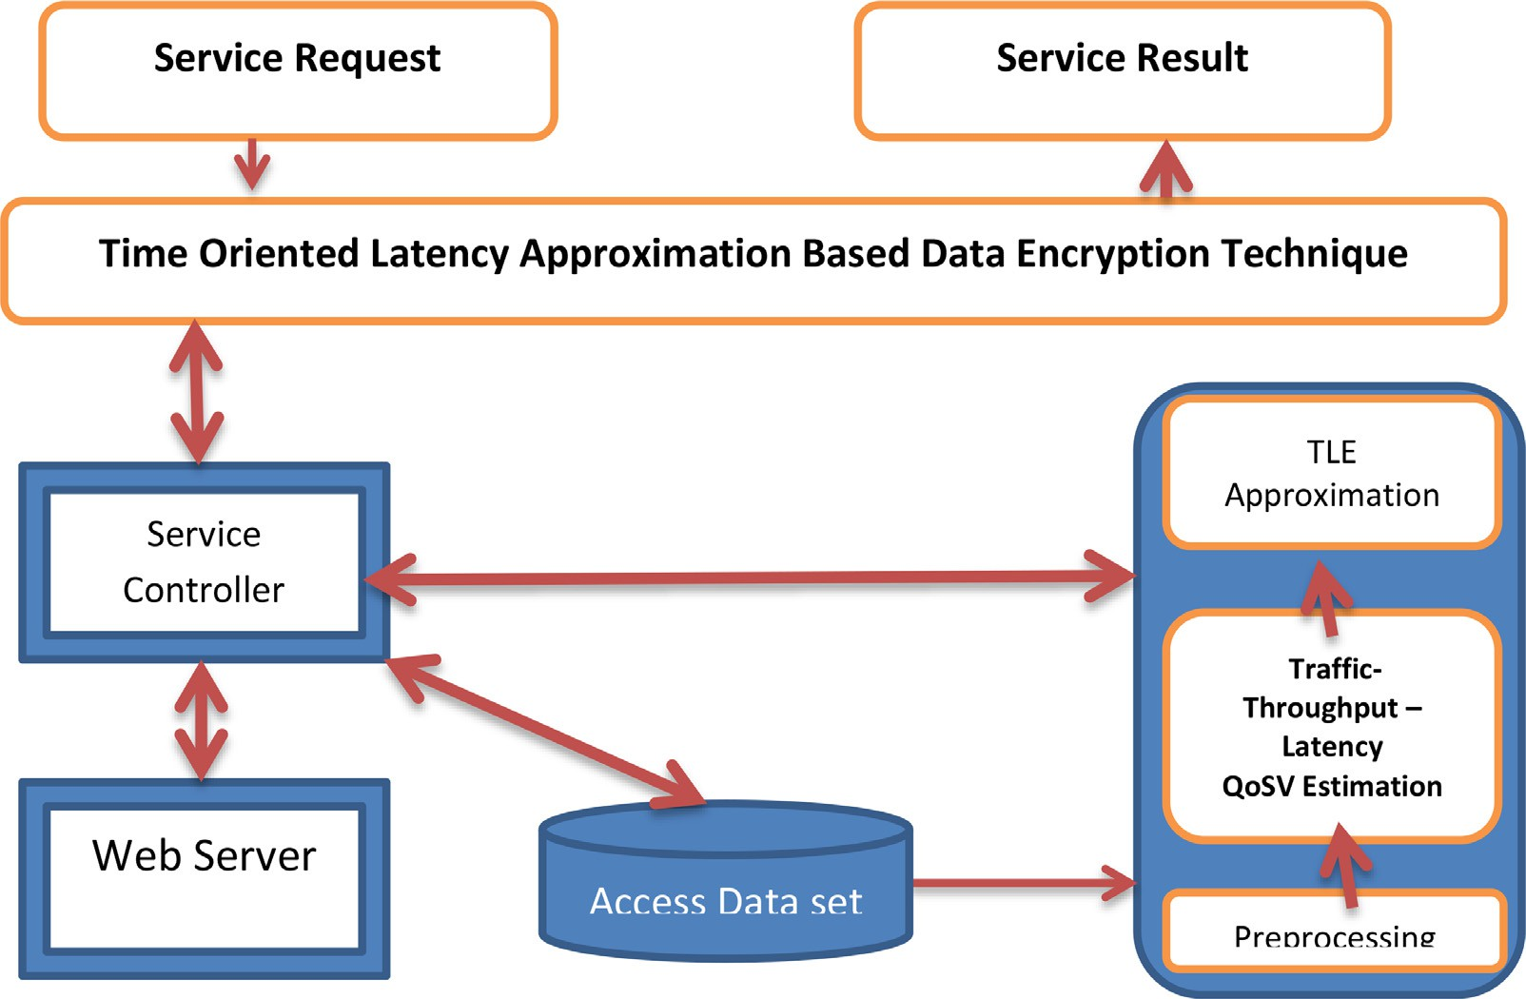

**Fig. 1.** Proposed architecture for the TLADE approach .

**Appendix A**

Algorithm 1: Preprocessing.

|  |
| --- |
| Given: Service Access Trace SaT, Service Request SR |
| Obtain Preprocessed Trace PT, Route List RL. |
| Start |
| Read SaT and SR. |
| *𝑠𝑖𝑧𝑒*(*𝑆𝑎𝑇* )  Fetch a list of features F_list = ∑ *𝑆𝑎𝑇* (*𝑖*)*.𝐹 𝑒𝑎𝑡𝑢𝑟𝑒𝑠* ∋ *𝐹* _*𝐿𝑖𝑠𝑡*  *𝑖* = 1 |
| For each tuple T |
| If T∈ ∀*𝐹𝑒𝑎𝑡𝑢𝑟𝑒𝑠*(*𝐹𝐿𝑖𝑠𝑡* ) then |
| For each feature F |
| *𝑠𝑖𝑧𝑒*(*𝐹𝐿𝑖𝑠𝑡* )  If *𝑇* (*𝐹𝐿𝑖𝑠𝑡*(*𝑖*) )! = *𝑁𝑢𝑙𝑙 𝑡ℎ𝑒𝑛*  *𝑖* = 1 |
| Complete. |
| Else |
| Break; |
| End |
| End |
| If Complete then |
| PT = ∑ *𝑇 𝑟𝑎𝑐𝑒𝑠*(*𝑃𝑇*)*𝑇* |
| End |
| End |
| End |
| Route List Rl = ∑ *𝑅𝑜𝑢𝑡𝑒𝑠*(*𝑆* → *𝐷*) ∈ *𝑁𝑒𝑡𝑤𝑜𝑟𝑘* |
| Stop |

which in turn would improve the QoS performance. The value of Traﬃc QoSV (TQoSV) is measured according to the traﬃc present on the route in different time stamps and current time stamps. Similarly, the value of throughput QoSV is measured according to the throughput present in a specific route in the various time stamp. Similarly, the latency QoSV is measured based on the average latency in various time stamps and cur- rents. The values estimated have been used in latency approximation.

The equations (i) to (vi) are presented in Algorithm 2 which cal- culates the average throughput, average latency, TQoSV, ThQoSV, and LQoSV respectively. The traﬃc-throughput-latency QoS estimation al- gorithm computes the QoS support value produced by different routes in terms of latency, throughput, and traﬃc. Such computed parameters

are converted into feature sets and are used to perform latency Approx- imation.

*Time-oriented latency (TLE) approximation*

The time-oriented latency approximation technique estimates differ- ent QoS support values for given routes (As shown by Algorithm 3). Different routes would have different traﬃc, latency, and throughput according to different conditions. However, if the route is free of adver- saries and traﬃc, then it would produce higher throughput and latency will be less. So, this approach estimates QoS support values on differ- ent parameters like traﬃc, throughput, and latency. To perform this, the method preprocesses the access traces and then traces from which noise has been removed have been used in estimating different QoS support values throughput Traﬃc-Throughput-Latency QoSV estimation scheme. The method returns values of TqosV, ThQoSv, and LQoSV sets which contains values of QoS support belonging to different factors at the different time stamp. The method calculates QoSV values for various routes using the provided values. By evaluating the QoSV value [21], the method selects a specific route for data transmission. Equation (vii) is employed to compute the QoSV, and equation (viii) is used to calculate the route R. The time complexity of the proposed method is determined by the encryption time, denoted as O(n).

The time-oriented latency approximation algorithm measures differ- ent QoS support values on latency, traﬃc, and throughput on different routes with various time stamps. The method calculates a distinctive Quality of Service Value (QoSV) and chooses the route with the highest QoSV value. This selected route is utilized for secure data transmission [23]. The general outline of Algorithm 3 is provided in Table 4.

*TLADE data encryption*

Cloud computing has gained immense popularity as a storage and data access solution, facilitated by the Internet and remote servers. In- stead of owning physical resources, clients lease them from third-party providers. User management and key management are crucial aspects in cloud computing, encompassing tasks such as user setup, key gener- ation, expiration, and destruction. The security of data is a significant

**Appendix B**

Algorithm 2: Traﬃc-throughput-latency QoSV estimation.

Given: Preprocessed Trace PT, Route List Rl Obtain Feature Set Fs.

Start

Read PT and RL.

*𝑆𝑖𝑧𝑒*(*𝑃𝑇*)

Find total time stamp Tts = ∑(*𝑇 𝑖𝑚𝑒𝑆𝑡𝑎𝑚𝑝* ∈ *𝑃𝑇*(*𝑖*))*𝑇 𝑡𝑠*

*𝑖* = 1

For each route R

*𝑠𝑖𝑧𝑒*(*𝑇 𝑡𝑠*)

Find traces RT = ∑ *𝑇 𝑡𝑠*(*𝑖*)*.𝑅𝑜𝑢𝑡𝑒* == *𝑅*

*𝑖* = 1

For each timestamp Ti

Compute average Traﬃc ATr =

∑*𝑠𝑖𝑧𝑒*(*𝑅𝑇* ) *𝑅𝑇* (*𝑖*)*.𝑇 𝑟𝑎𝑓 𝑓 𝑖𝑐* && *𝑅𝑇* (*𝑖*)*.𝑇 𝑖𝑚𝑒* == *𝑇 𝑖*

*𝑠𝑖𝑧𝑒*(*𝑅𝑇* )

*𝑖*=1

(*𝑖*)

Compute Average throughput AThr =

∑*𝑠𝑖𝑧𝑒*(*𝑅𝑇* ) *𝑅𝑇* (*𝑖*)*.𝐵𝑦𝑡𝑒𝑠𝑇 𝑟𝑎𝑛𝑠𝑓 𝑒𝑟𝑒𝑑* && *𝑅𝑇* (*𝑖*)*.𝑇 𝑖𝑚𝑒* == *𝑇 𝑖*

*𝑠𝑖𝑧𝑒*(*𝑅𝑇* )

*𝑖*=1

(*𝑖𝑖*)

Compute average latency Alt =

∑*𝑠𝑖𝑧𝑒*(*𝑅𝑇* ) *𝑅𝑇* (*𝑖*)*.𝑙𝑎𝑡𝑒𝑛𝑐𝑦* && *𝑅𝑇* (*𝑖*)*.𝑇 𝑖𝑚𝑒* == *𝑇 𝑖*

*𝑠𝑖𝑧𝑒*(*𝑅𝑇* )

*𝑖*=1

(*𝑖𝑖𝑖*)

Compute TQoSv =

∑*𝑠𝑖𝑧𝑒*(*𝑅𝑇* ) *𝑅𝑇* (*𝑖*)*.𝑇 𝑟𝑎𝑓 𝑓 𝑖𝑐 < 𝐴𝑇 𝑟*

*𝑠𝑖𝑧𝑒*(*𝑅𝑇* )

*𝑖*=1

(*𝑖𝑣*)

Compute ThQoSV =

∑*𝑠𝑖𝑧𝑒*(*𝑅𝑇* ) *𝑅𝑇* (*𝑖*)*.𝐵𝑦𝑡𝑒𝑠𝑇 𝑟𝑎𝑛𝑠𝑓 𝑒𝑟𝑒𝑑 > 𝐴𝑡ℎ𝑟*

*𝑠𝑖𝑧𝑒*(*𝑅𝑇* )

*𝑖*=1

(*𝑣*)

Compute LQoSV =

∑*𝑠𝑖𝑧𝑒*(*𝑅𝑇* ) *𝑅𝑇* (*𝑖*)*.𝐿𝑎𝑡𝑒𝑛𝑐𝑦 < 𝐴𝑙𝑇*

*𝑠𝑖𝑧𝑒*(*𝑅𝑇* )

*𝑖*=1

(*𝑣𝑖*)

Generate Feature Vector Fv = {Ti,TQoSV, ThQoSV, LQoSV}

Add to feature set Fs.

End

End Stop

**Appendix C**

Algorithm 3: Time-oriented latency (TLE) approximation.

Given: Feature Set Fs, Route List Rl Obtain Route R.

Start

Read Fs and Rl.

For each route R

∑*𝑠𝑖𝑧𝑒*(*𝑅𝑇* ) *𝑅𝑇* (*𝑖*)*.𝑇 𝑟𝑎𝑓 𝑓 𝑖𝑐* && *𝑅𝑇* (*𝑖*)*.𝑇 𝑖𝑚𝑒* == *𝐶𝑖* ∑*𝑠𝑖𝑧𝑒*(*𝑅𝑇* ) *𝑅𝑇* (*𝑖*)*.𝐵𝑦𝑡𝑒𝑠𝑡𝑇 𝑟𝑎𝑛𝑠𝑓 𝑒𝑟𝑒𝑑* && *𝑅𝑇* (*𝑖*)*.𝑇 𝑖𝑚𝑒* == *𝐶𝑖*

*𝑖*=1

*𝑖*=1

*𝑖*=1

∑*𝑠𝑖𝑧𝑒*(*𝑅𝑇* ) *𝑅𝑇* (*𝑖*)*.𝐿𝑎𝑡𝑒𝑛𝑐𝑦* && *𝑅𝑇* (*𝑖*)*.𝑇 𝑖𝑚𝑒* == *𝐶𝑖*

Compute QoSv =

*𝑠𝑖𝑧𝑒*(*𝑅𝑇* )

∑

× ∑ *𝑠𝑖𝑧𝑒*(*𝑅𝑇* )

× ∑ *𝑠𝑖𝑧𝑒*(*𝑅𝑇* )

(*𝑣𝑖𝑖*)

*𝑠𝑖𝑧𝑒*(*𝑇 𝑇 𝑠*) *𝑇 𝑇 𝑆*(*𝑢*∖*𝑖*)*.𝑇 𝑄𝑜𝑆𝑣*

*𝑖*=1

*𝑠𝑖𝑧𝑒*(*𝑇 𝑇 𝑆*)

*𝑠𝑖𝑧𝑒*(*𝑇 𝑇 𝑠*) *𝑇 𝑇 𝑆*(*𝑢*∖*𝑖*)*.𝑇 ℎ𝑄𝑜𝑆𝑣*

*𝑠𝑖𝑧𝑒*(*𝑇 𝑇 𝑆*)

*𝑖*=1

*𝑠𝑖𝑧𝑒*(*𝑇 𝑇 𝑠*) *𝑇 𝑇 𝑆*(*𝑢*∖*𝑖*)*.𝑇 𝑄𝑜𝑆𝑣*

*𝑠𝑖𝑧𝑒*(*𝑇 𝑇 𝑆*)

*𝑖*=1

End

*𝑠𝑖𝑧𝑒*(*𝑅𝑙*)

Route *R* = *𝑀𝑎𝑥*(*𝑅𝑙.𝑄𝑜𝑆𝑉* ) (*𝑣𝑖𝑖𝑖*)

*𝑖* = 1

Stop

concern for businesses due to the sensitive information transmitted over the Internet [38–43]. The term "key management" encompasses the cre- ation, distribution, processing, usage, destruction, and replacement of cryptographic keys during the process of crypto shredding. It includes cryptographic protocols, key servers, client procedures, and other rel- evant protocols. Keys can be shared at the user or system level, and this concept differs from key preparation, which pertains to managing keys within the internal functioning of a cipher. The effectiveness of a cryptosystem’s security relies on its ability to manage keys eﬃciently. Cryptography involves not only computational aspects but also social technology features such as system processes, user training, organiza- tional interactions, and departmental collaborations.

The TLADE scheme maintains a set of encryption schemes to enforce data security. The method first identifies the set of schemes available and measures their average latency from the trace. According to the trace available, the method computes latency support according to the data size and calculated latency. Using these values, the method finds the most effective scheme for data encryption and hands over the data to be transmitted through the selected route. The latency support LS has been presented in Algorithm 4 and calculated by equation (ix).

The TLADE data encryption algorithm evaluates the latency support of various schemes and selects a route with the highest latency sup- port. Subsequently, the data is encrypted and transmitted through the selected route.

# Results and discussion

The time-variant latency approximation-based data encryption scheme, as proposed, has been implemented and thoroughly evaluated across various scenarios to assess its performance. The evaluation results are compared against the outcomes of alternative approaches.

The details of the evaluation considered for performance analysis of the proposed approach have been presented in Table 2. The proposed technique has been compared with techniques present in literature on the basis of encryption/decryption time with respect to varying data size. This has been presented in Table 3.

The encryption/decryption time introduced by various methods is measured and presented in Fig. 2. The proposed TLADE technique takes less time due to its eﬃcient methodology that optimizes encryption and

**Appendix D**

Algorithm 4: TLADE data encryption.

|  |
| --- |
| Given: Route R, Service Access Trace SaT, Data D |
| Obtain; Null |
| Start |
| Read R, D, and SaT. |
| For each service S |
| ∑*𝑆𝑎𝑇 𝑆𝑎𝑇* (*𝑖*)*.𝐵𝑦𝑡𝑒𝑠* && *𝑆𝑎𝑇* (*𝑖*)*.𝑆𝑐ℎ𝑒𝑚𝑒* = *𝑆* ∑*𝑆𝑎𝑇 𝑆𝑎𝑇* (*𝑖*)*.𝑇 𝑖𝑚𝑒* && *𝑆𝑎𝑇* (*𝑖*)*.𝑆𝑐ℎ𝑒𝑚𝑒* = *𝑆*  Compute Latency Support LS = *𝑖*=1 ∑ × *𝑖*=1 ∑ (*𝑖𝑥*)  *𝑆𝑎𝑇 𝑆𝑎𝑇* (*𝑖*)*.𝑆𝑐ℎ𝑒𝑚𝑒* = *𝑆 𝑆𝑎𝑇 𝑆𝑎𝑇* (*𝑖*)*.𝑆𝑐ℎ𝑒𝑚𝑒* = *𝑆*  *𝑖*=1 *𝑖*=1 |
| End |
| Scheme s = Choose the most latency support scheme. |
| Cipher text CT = perform Encryption (D, S) |
| Send data in the selected route. |
| Stop |

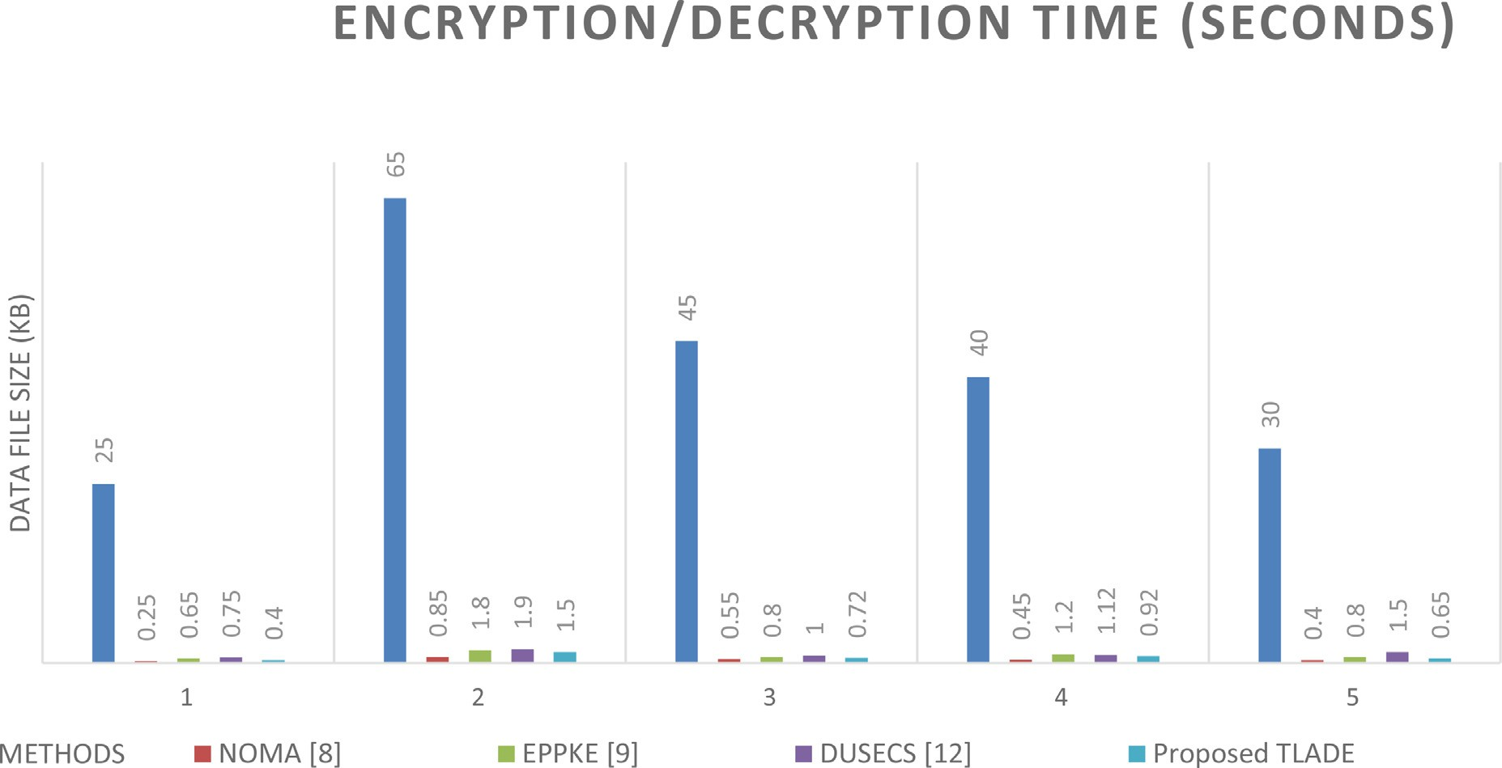

**Fig. 2.** Encryption/decryption time (Seconds).

**Table 2**

Evaluation details.

|  |  |
| --- | --- |
| Details | Values |
| Tool Used | Advanced Java |
| No of services | 100 |
| Number of Users | 500 |
| Size of Data set | 1 million tuples |

decryption functions, reducing computational overhead and enhancing overall performance.

The average latency can be computed using Appendix B, as presented in Table 4, which provides a general representation of the algorithm.

The Table 5 represents the results for each timestamp (Ti) analyzed in the algorithm. For each timestamp, the average traﬃc, throughput, and latency values are computed based on the corresponding traces. The QoS values for traﬃc, throughput, and latency are have also been cal- culated using Appendix B. Table 5 shows the traﬃc-throughput-latency QoSV estimation.

To calculate the average latency (Alt) (see equation x) for each times- tamp in the table, you need the sum of latencies and the number of traces available for each timestamp. Assuming you have the following data:

*For T1:*

∑ *𝐿𝑎𝑡𝑒𝑛𝑐𝑦 𝑓𝑜𝑟* T1: 50 Number of traces for T1: 5

*For T2:*

**Table 3**

Comparative analysis of TLADE with existing techniques.

|  |  |  |  |  |
| --- | --- | --- | --- | --- |
|  | Encryption/Decryption Time (In Seconds) | |  |  |
| Data File Size (kb) | |  |  |  |
|  | NOMA [8] | EPPKE [9] | DUSECS [12] | Proposed TLADE |
| 25 | 0.25 | 0.65 | 0.75 | 0.4 |
| 65 | 0.85 | 1.8 | 1.9 | 1.5 |
| 45 | 0.55 | 0.8 | 1 | 0.72 |
| 40 | 0.45 | 1.2 | 1.12 | 0.92 |
| 30 | 0.4 | 0.8 | 1.5 | 0.65 |
| Average Time | 0.5 | 1.05 | 1.254 | 0.838 |

**Table 4**

General representation of algorithm 2.

|  |  |  |  |  |  |  |
| --- | --- | --- | --- | --- | --- | --- |
| Timestamp (Ti) | Traﬃc Average (ATr) | Throughput Average (AThr) | Latency Average (Alt) | Traﬃc QoS Value (TQoSV) | Throughput QoS Value (ThQoSV) | Latency QoS Value (LQoSV) |
| T1 | ATr(T1) | AThr(T1) | Alt(T1) | TQoSV(T1) | ThQoSV(T1) | LQoSV(T1) |
| T2 | ATr(T2) | AThr(T2) | Alt(T2) | TQoSV(T2) | ThQoSV(T2) | LQoSV(T2) |
| T3 | ATr(T3) | AThr(T3) | Alt(T3) | TQoSV(T3) | ThQoSV(T3) | LQoSV(T3) |
| **…** | **…** | **…** | **…** | **…** | **…** | **…** |

**Table 5**

Traﬃc-throughput-latency QoSV estimation.

|  |  |  |  |  |  |  |
| --- | --- | --- | --- | --- | --- | --- |
| Timestamp (Ti) | Traﬃc Average (ATr) | Throughput Average (Athr) | Latency Average (Alt) | Traﬃc QoS Values (TQoSV) | Throughput QoS Value (ThQoSV) | Latency QoS Value (LQoSSV) |
| T1 | 100 | 200 | 10 | 0.8 | 0.9 | 0.6 |
| T2 | 150 | 180 | 15 | 0.7 | 0.8 | 0.7 |
| T3 | 120 | 220 | 12 | 0.9 | 0.7 | 0.8 |
| T4 | 180 | 190 | 18 | 0.6 | 0.8 | 0.5 |

∑ *𝐿𝑎𝑡𝑒𝑛𝑐𝑦 𝑓𝑜𝑟* T2: 60

Number of traces for T2: 4

For T3:

∑ *𝐿𝑎𝑡𝑒𝑛𝑐𝑦 𝑓𝑜𝑟* T3: 48 Number of traces for T3: 4

For T4:

∑ *𝐿𝑎𝑡𝑒𝑛𝑐𝑦 𝑓𝑜𝑟* T4: 36 Number of traces for T3: 2

The formula to calculate the average latency (Alt) for a specific timestamp (Ti) is:

Alt(Ti)= ∑ *𝐿𝑎𝑡𝑒𝑛𝑐𝑦 𝑓𝑜𝑟* Ti∕Numberof tracesforTi(x)

Now, let’s calculate the values for the table:

For T1: Alt(T1) = 50 / 5 = 10

For T2: Alt(T2) = 60 / 4 = 15

For T3: Alt(T3) = 48 / 4 = 12

For T4: Alt(T4) = 36 / 2 = 18

An evaluation of the latency ratio can be derived from Appendix D. To determine the Analysis of the Latency Ratio, we require the Latency Average (Alt) values obtained from the previous table (Table 5) and

**Table 6**

Latency support for the different Schemes.

|  |  |  |
| --- | --- | --- |
| Timestamp (Ti) | Latency Average (Alt) | Latency Support (LS) |
| T1 | 10 | 8 |
| T2 | 15 | 12 |
| T3 | 8 | 10 |
| T4 | 18 | 15 |

random Latency Support (LS) values. With these inputs, we can calculate the Latency Ratio and present the results in a new table (Table 6).

Now, we can calculate the Analysis of Latency Ratio using the equa- tion (xi):

Latency Ratio (LR) = Latency Average (Alt) / Latency Support (LS)

(xi)

LR for T1, T2, T3, and T4 can be calculated using equation (xi) LRT1 = 10 / 8 = 1.25

LRT2 = 15 / 12 = 1.25

LRT3 = 8 / 10 = 0.8

LRT4 = 18 / 15 = 1.20

Based on the provided Table 5, the calculations for Traﬃc QoS Value (TQoSV) and Throughput QoS Value (ThQoSV) are as follows:

For Traﬃc QoS Value (TQoSV):

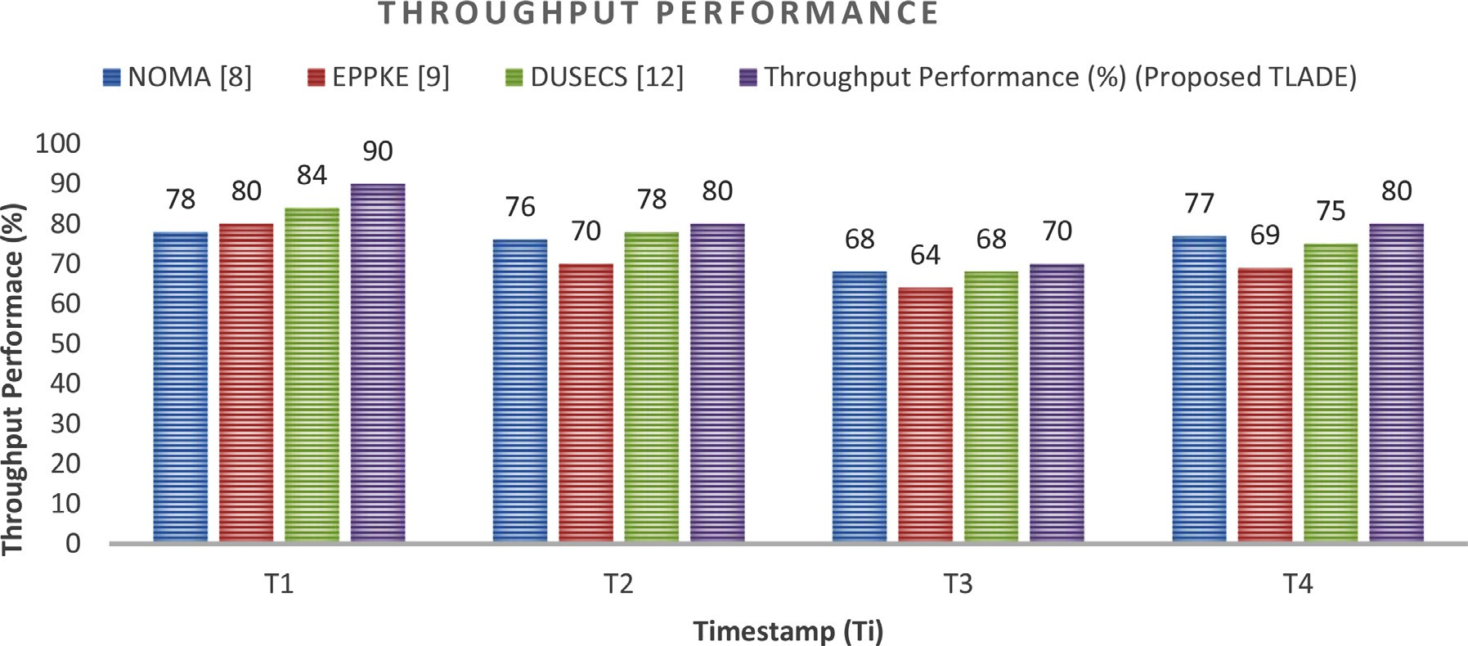

**Fig. 3.** Analysis of throughput performance.











**Fig. 4.** Performance of Alt/LS/LR in terms of LR.



**Table 7**

Throughput performance.

|  |  |  |  |  |
| --- | --- | --- | --- | --- |
| Timestamp (Ti) | NOMA [8] | EPPKE [9] | DUSECS [12] | Throughput Performance (%) (Proposed TLADE) |
| T1 | 78 | 80 | 84 | 90 |
| T2 | 76 | 70 | 78 | 80 |
| T3 | 68 | 64 | 68 | 70 |
| T4 | 77 | 69 | 75 | 80 |

TQoSV at T1: 0.8 TQoSV at T2: 0.7 TQoSV at T3: 0.9 TQoSV at T4: 0.6

For Throughput QoS Value (ThQoSV):

ThQoSV at T1: 0.9 ThQoSV at T2: 0.8 ThQoSV at T3: 0.7 ThQoSV at T4: 0.8

Table 7 and Fig. 3 present the measured throughput performance at- tained by various approaches. The proposed TLADE technique achieves higher throughput performance by implementing a streamlined method- ology for encryption and decryption functions, minimizing processing delays and maximizing data transfer rates [44–46].

Using the provided values, the updated Table 8 with the Analysis of Latency Ratio will be as follows:

The details of the Comparative Analysis of LR have been presented in Table 9 and Fig. 5. The proposed technique has been compared with techniques present in literature.

Fig. 4 illustrates the measurement and presentation of the latency ratio introduced by different methods, namely Alt and LS. The proposed TLADE technique yields lower values of latency ratio compared to other

**Table 8**

Analysis of latency ratio.

|  |  |  |  |
| --- | --- | --- | --- |
| Timestamp (Ti) | Latency Average (Alt) | Latency Support (LS) | Analysis of Latency Ratio (ms) |
| T1 | 10 | 8 | 1.25 |
| T2 | 15 | 12 | 1.25 |
| T3 | 8 | 10 | 0.8 |
| T4 | 18 | 15 | 1.20 |

existing methods due to its optimized methodology for encryption and decryption functions, reducing processing overhead and minimizing de- lays in data transmission, resulting in improved latency performance.

# Conclusion

A novel approach to TLADE has been presented in the papers. The method identifies the routes and services. For the routes identified, the support of the route on latency, throughput, and traﬃc toward QoS max- imization is measured. Based on the QoS support values, the method selects an optimal route for data transmission. Also, towards data en- cryption, the method estimates latency support according to the bytes encrypted and the time taken. Using the value of latency support an op-



**Table 9**

Comparative analysis of TLADE with existing techniques.

|  |  |  |  |  |
| --- | --- | --- | --- | --- |
| Timestamp (Ti) | NOMA [8] | EPPKE [9] | DUSECS [12] | Analysis of Latency Ratio (in ms) (Proposed TLADE) |
| T1 | 1.72 | 1.88 | 1.35 | 1.25 |
| T2 | 1.4 | 1.31 | 1.61 | 1.25 |
| T3 | 1 | 1.2 | 1.11 | 0.8 |
| T4 | 1.35 | 1.45 | 1.63 | 1.2 |

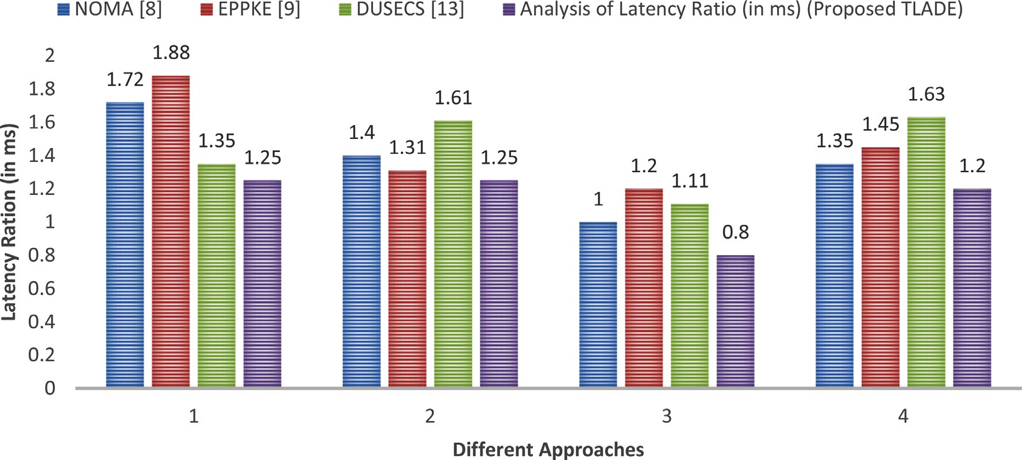

**Fig. 5.** Comparative analysis of LR.

timal service is selected and data has been encrypted. Encrypted data has been forwarded through the selected route. The proposed approach improves the performance of different QoS factors with reduced latency. As an extension of this work, multi-key homomorphic encryption tech- niques can be implemented to further increase secrecy and address cloud security challenges.

# Declaration of Competing Interest

The authors declare that they have no competing interests.

# CRediT authorship contribution statement

**Shahnawaz Ahmad:** Conceptualization, Data curation, Formal anal- ysis, Investigation, Methodology, Resources, Validation, Writing – origi- nal draft, Writing – review & editing. **Shabana Mehfuz:** Conceptualiza- tion, Data curation, Formal analysis, Investigation, Methodology, Re- sources, Supervision, Validation, Visualization, Writing – review & edit- ing.

# Funding

Not applicable.

# Acknowledgments

The authors acknowledge the financial support received own, for their support and encouragement in carrying out his college work. The authors also would like to acknowledge the administration of Jamia Mil- lia Islamia, which the authors represent.

# References

1. S. Ahmad, S. Mehfuz, F. Mebarek-Oudina, et al., RSM analysis-based cloud access security broker: a systematic literature review, Clust. Comput. (2022), doi:[10.1007/s10586-022-03598-z](https://doi.org/10.1007/s10586-022-03598-z).
2. Shahnawaz Ahmad, Shabana Mehfuz, Javed Beg, Assessment on potential se- curity threats and introducing novel data security model in a cloud environ- ment, Mater. Today: Proc. 62 (2022) Part 7Pages 4909-4915, ISSN 2214-7853, doi:[10.1016/j.matpr.2022.03.536](https://doi.org/10.1016/j.matpr.2022.03.536).
3. Shahnawaz Ahmad, Shabana Mehfuz, Javed Beg, Cloud security frame- work and key management services collectively for implementing DLP and IRM, Mater. Today: Proc. 62 (Part 7) (2022) 4828–4836 ISSN 2214-7853,

doi:[10.1016/j.matpr.2022.03.420](https://doi.org/10.1016/j.matpr.2022.03.420).

1. S. Ahmad, S. Mehfuz, J Beg, Fuzzy TOPSIS-based cloud model to evaluate cloud computing services, in: G. Manik, S. Kalia, S.K. Sahoo, T.K. Sharma, O.P. Verma (Eds.), Advances in Mechanical Engineering. Lecture Notes in Mechanical Engineer- ing, Springer, Singapore, 2021, doi:[10.1007/978-981-16-0942-8_4](https://doi.org/10.1007/978-981-16-0942-8_4).
2. S. Ahmad, S. Mehfuz, J. Beg, Enhancing security of cloud platform with cloud access security broker, in: M.S. Kaiser, J. Xie, V.S. Rathore (Eds.), Informa- tion and Communication Technology For Competitive Strategies (ICTCS 2020). Lecture Notes in Networks and Systems, Vol 190, Springer, Singapore, 2021, doi:[10.1007/978-981-16-0882-7_27](https://doi.org/10.1007/978-981-16-0882-7_27).
3. Y.M. Mahaboob John, G. Ravi, Real-time regional mobility energy feature approximation-based secure routing for improved quality of service in MANET, Int.

J. Commun. Syst. (2021), doi:[10.1002/dac.4713](https://doi.org/10.1002/dac.4713).

1. S. Zhou, L. Wu, C. Jin, A privacy-based SLA violation detection model for the security of cloud computing, China Commun. 14 (9) (Sept. 2017) 155–165, doi:[10.1109/CC.2017.8068773](https://doi.org/10.1109/CC.2017.8068773).
2. F. Hu, B. Chen, Channel coding scheme for relay edge computing wire- less networks via homomorphic encryption and NOMA, in: IEEE Transactions on Cognitive Communications and Networking, 6, Dec. 2020, pp. 1180–1192, doi:[10.1109/TCCN.2020.3023724](https://doi.org/10.1109/TCCN.2020.3023724).
3. M.G. Aruna, K.G. Mohan, Secured cloud data migration technique by competent probabilistic public key encryption, China Commun. 17 (5) (May 2020) 168–190, doi:[10.23919/JCC.2020.05.014](https://doi.org/10.23919/JCC.2020.05.014).
4. K. Lee, Comments on “Secure data sharing in cloud computing using revocable- storage identity-based encryption”, in: IEEE Transactions on Cloud Computing, 8, 1 Oct.-Dec. 2020, pp. 1299–1300, doi:[10.1109/TCC.2020.2973623](https://doi.org/10.1109/TCC.2020.2973623).
5. K. Gai, M. Qiu, H. Zhao, Privacy-preserving data encryption strategy for big data in mobile cloud computing, in: IEEE Transactions on Big Data, 7, 1 Oct. 2021, pp. 678– 688, doi:[10.1109/TBDATA.2017.2705807](https://doi.org/10.1109/TBDATA.2017.2705807).
6. L. Cao, Y. Kang, Q. Wu, R. Wu, X. Guo, T. Feng, Searchable encryption cloud storage with dynamic data update to support eﬃcient policy hiding, China Commun. 17 (6) (June 2020) 153–163, doi:[10.23919/JCC.2020.06.013](https://doi.org/10.23919/JCC.2020.06.013).
7. A. Awad, A. Matthews, Y. Qiao, B. Lee, Chaotic searchable encryption for mobile cloud storage, in: IEEE Transactions on Cloud Computing, 6, 1 April-June 2018,

pp. 440–452, doi:[10.1109/TCC.2015.2511747](https://doi.org/10.1109/TCC.2015.2511747).

1. Q. Zhang, S. Wang, D. Zhang, J. Wang, Y. Zhang, Time and attribute based dual access control and data integrity verifiable scheme in cloud computing applications, IEEE Access 7 (2019) 137594–137607, doi:[10.1109/ACCESS.2019.2942649](https://doi.org/10.1109/ACCESS.2019.2942649).
2. L. Jiang, D. Guo, Dynamic encrypted data sharing scheme based on conditional proxy broadcast re-encryption for cloud storage, IEEE Access 5 (2017) 13336–13345, doi:[10.1109/ACCESS.2017.2726584](https://doi.org/10.1109/ACCESS.2017.2726584).
3. S. Sharma, J. Powers, K. Chen, PrivateGraph: privacy-preserving spectral analysis of encrypted graphs in the cloud, IEEE Trans. Knowl. Data Eng. 31 (5) (1 May 2019) 981–995, doi:[10.1109/TKDE.2018.2847662](https://doi.org/10.1109/TKDE.2018.2847662).
4. O.A. Khashan, Secure outsourcing and sharing of cloud data using a user-side [encrypted file system, IEEE Access 8 (2020) 210855–210867, doi:10.1109/AC- CESS.2020.3039163.](https://doi.org/10.1109/ACCESS.2020.3039163)
5. J. Wang, C. Huang, K. Yang, J. Wang, X. Wang, X. Chen, MAVP-FE: multi-authority vector policy functional encryption with eﬃcient encryption and decryption, China Commun. 12 (6) (June 2015) 126–140, doi:[10.1109/CC.2015.7122471](https://doi.org/10.1109/CC.2015.7122471).
6. H. Deng, et al., Identity-based encryption transformation for flexible sharing of en- crypted data in public cloud, in: IEEE Transactions on Information Forensics and Security, 15, 2020, pp. 3168–3180, doi:[10.1109/TIFS.2020.2985532](https://doi.org/10.1109/TIFS.2020.2985532).
7. M. Zeng, H. Qian, J. Chen, K. Zhang, Forward secure public key encryption with keyword search for outsourced cloud storage, in: IEEE Transactions on Cloud Com- puting, 10, 1 Jan.-March 2022, pp. 426–438, doi:[10.1109/TCC.2019.2944367](https://doi.org/10.1109/TCC.2019.2944367).
8. H. Li, Y. Yang, Y. Dai, S. Yu, Y. Xiang, Achieving secure and eﬃcient dynamic search- able symmetric encryption over medical cloud data, in: IEEE Transactions on Cloud Computing, 8, 1 April-June 2020, pp. 484–494, doi:[10.1109/TCC.2017.2769645](https://doi.org/10.1109/TCC.2017.2769645).
9. H. Qiu, H. Noura, M. Qiu, Z. Ming, G. Memmi, A user-centric data protection method for cloud storage based on invertible DWT, in: IEEE Transactions on Cloud Comput- ing, 9, 1 Oct.-Dec. 2021, pp. 1293–1304, doi:[10.1109/TCC.2019.2911679](https://doi.org/10.1109/TCC.2019.2911679).
10. H. Yuan, X. Chen, J. Li, T. Jiang, J. Wang, R.H. Deng, Secure cloud data deduplication with eﬃcient re-encryption, in: IEEE Transactions on Services Computing, 15, 1 Jan.- Feb. 2022, pp. 442–456, doi:[10.1109/TSC.2019.2948007](https://doi.org/10.1109/TSC.2019.2948007).
11. X. Huang, H. Xiong, J. Chen and M. Yang, "Eﬃcient revocable storage attribute-based encryption with arithmetic span programs in cloud-assisted Internet of Things," in IEEE Transactions on Cloud Computing, doi:[10.1109/TCC.2021.3131686](https://www.doi.org/10.1109/TCC.2021.3131686).
12. J. Wu, X. Sheng, G. Li, K. Yu, J. Liu, An eﬃcient and secure aggregation encryp- tion scheme in edge computing, China Commun. 19 (3) (March 2022) 245–257, doi:[10.23919/JCC.2022.03.018](https://doi.org/10.23919/JCC.2022.03.018).
13. [S. ShanmugaPriya, A. Valarmathi, D. Yuvaraj, The personal authentication service and security enhancement for an optimal strong password, Concurr. Comput.: Pract. Exper. (2019) e5009.](http://refhub.elsevier.com/S2772-9184(23)00015-2/sbref0026)
14. [K.L. Neela, V. Kavitha, Enhancement of data confidentiality and secure data trans- action in the cloud storage environment, Cluster Comput 21.1 (2018) 115–124.](http://refhub.elsevier.com/S2772-9184(23)00015-2/sbref0027)
15. [M. Wazid, P. Bagga, A.K. Das, S. Shetty, J.J. Rodrigues, Y. Park, AKM­ IoV: au- thenticated key management protocol in fog computing-based Internet of vehicles deployment, IEEE Internet Thing J. 6 (5) (2019) 8804–8817.](http://refhub.elsevier.com/S2772-9184(23)00015-2/sbref0028)
16. [Y. Miao, X. Liu, R.H. Deng, H. Wu, H. Li, J. Li, D. Wu, Hybrid keyword­ field search with eﬃcient key management for the industrial internet of things, IEEE Transact. Indus. lnfom., I 5 (6) (2018) 3206–3217.](http://refhub.elsevier.com/S2772-9184(23)00015-2/sbref0029)
17. [K. Park, Y. Park, A.K. Das, S. Yu, J. Lee, Y. Park, A dynamic privacy­ preserving key management protocol for V2G in social internet of things, IEEE Access 7 (2019) 76812–76832.](http://refhub.elsevier.com/S2772-9184(23)00015-2/sbref0030)
18. [Manish Kumar, Akhlad Iqbal, Pranjal Kumar, A new RGB image encryption algo- rithm based on DNA encoding and elliptic curve Diﬃe-Hellman cryptography, Signal Process. 125 (August 2016) 187–202.](http://refhub.elsevier.com/S2772-9184(23)00015-2/sbref0031)
19. [DI George Amalarethinam, H.M. Leena, Asymmetric addition chaining crypto- graphic algorithm (ACCA) for data security in cloud, in: Advances in Big Data and Cloud Computing, Springer, Singapore, 2018, pp. 331–340.](http://refhub.elsevier.com/S2772-9184(23)00015-2/sbref0032)
20. [A. Askarzadeh, A novel metaheuristic method for solving constrained engineering optimization problems: crow search algorithm, Comput. Struct. 169 (2016) 1–12.](http://refhub.elsevier.com/S2772-9184(23)00015-2/sbref0033)
21. G.B. Pallavi, P. Jayarekha, Secure, and eﬃcient multi-tenant database management system for the cloud computing environment, Int. j. inf. tecnol. 14 (2022) 703–711, doi:[10.1007/s41870-019-00416-5](https://doi.org/10.1007/s41870-019-00416-5).
22. M.O. Alassafi, H.F. Atlam, A.A. Alshdadi, et al., A validation of security determinants model for cloud adoption in Saudi organizations’ context, Int. j. inf. tecnol. 14 (2022) 1075–1085, doi:[10.1007/s41870-019-00360-4](https://doi.org/10.1007/s41870-019-00360-4).
23. S.C.M. Sharma, A.K. Rath, B.R Parida, Eﬃcient load balancing techniques for multi-datacenter cloud milieu, Int. j. inf. tecnol. 14 (2022) 979–989, doi:[10.1007/s41870-020-00529-2](https://doi.org/10.1007/s41870-020-00529-2).
24. S. Jain, R. Doriya, Security framework to healthcare robots for secure sharing of healthcare data from the cloud, Int. j. inf. tecnol. 14 (2022) 2429–2439, doi:[10.1007/s41870-022-00997-8](https://doi.org/10.1007/s41870-022-00997-8).
25. C. Song, et al., Hierarchical edge cloud enabling network slicing for 5 G optical fronthaul, J. Opt. Commun. Network. 11 (4) (April 2019) B60–B70, doi:[10.1364/JOCN.11.000B60](https://doi.org/10.1364/JOCN.11.000B60).
26. Y. Yao, Z. Zhai, J. Liu, Z. Li, Lattice-based key-aggregate (searchable) encryp- [tion in cloud storage, IEEE Access 7 (2019) 164544–164555, doi:10.1109/AC- CESS.2019.2952163.](https://doi.org/10.1109/ACCESS.2019.2952163)
27. S. Wang, R. Pei, Y. Zhang, EIDM: a ethereum-based cloud user identity [management protocol, IEEE Access 7 (2019) 115281–115291, doi:10.1109/AC- CESS.2019.2933989.](https://doi.org/10.1109/ACCESS.2019.2933989)
28. Y. Miao, et al., Hybrid keyword-field search with eﬃcient key management for in- dustrial Internet of Things, IEEE Trans. Ind. Inf. 15 (6) (June 2019) 3206–3217, doi:[10.1109/TII.2018.2877146](https://doi.org/10.1109/TII.2018.2877146).
29. M. Ma, G. Shi, F. Li, Privacy-oriented blockchain-based distributed key management architecture for hierarchical access control in the IoT scenario, IEEE Access 7 (2019) 34045–34059, doi:[10.1109/ACCESS.2019.2904042](https://doi.org/10.1109/ACCESS.2019.2904042).
30. F. Wang, L. Xu, W. Gao, Comments on “SCLPV: secure certificateless pub- lic verification for cloud-based cyber-physical-social systems against malicious auditors, IEEE Transact. Comput. Soc. Syst. 5 (3) (Sept. 2018) 854–857, doi:[10.1109/TCSS.2018.2858805](https://doi.org/10.1109/TCSS.2018.2858805).
31. N. Babu, T. Suresh, Real time continuous behavior class based secure rout- ing for improved QoS in industrial networks, in: 2022 International Conference on Electronic Systems and Intelligent Computing (ICESIC), 2022, pp. 111–116, doi:[10.1109/ICESIC53714.2022.9783571](https://doi.org/10.1109/ICESIC53714.2022.9783571).
32. S. Muruganandam, J.A. Ranjit, Real-time reliable clustering and secure transmission scheme for QoS development in MANET, Peer-to-Peer Netw. Appl. 14 (2021) 3502– 3517, doi:[10.1007/s12083-021-01175-6](https://doi.org/10.1007/s12083-021-01175-6).
33. P. Sathyaraj, D.R. Devi, Retraction note to designing the routing proto- col with secured IoT devices and QoS over Manet using trust-based per- formance evaluation method, J. Ambient Intell. Human. Comput. (2022), doi:[10.1007/s12652-022-03956-0](https://doi.org/10.1007/s12652-022-03956-0).
34. S. Ahmad, S. Mehfuz, J. Beg, An eﬃcient and secure key management with the ex- tended convolutional neural network for intrusion detection in cloud storage, Con- curr. Comput. Pract. Exper. (2023), doi:[10.1002/cpe.7806](https://doi.org/10.1002/cpe.7806).
35. S. Ahmad, S. Mehfuz, J. Beg, Hybrid cryptographic approach to enhance the mode of key management system in cloud environment, J. Supercomput. (2022), doi:[10.1007/s11227-022-04964-9](https://doi.org/10.1007/s11227-022-04964-9).
36. S. Urooj, S. Lata, S. Ahmad, S. Mehfuz, S. Kalathil, Cryptographic data security for reliable wireless sensor network, Alexand. Eng. J. 72 (2023) 37–50 ISSN 1110-0168, doi:[10.1016/j.aej.2023.03.061](https://doi.org/10.1016/j.aej.2023.03.061).