

[Egyptian Informatics Journal (2013) 14, 235–238](http://dx.doi.org/10.1016/j.eij.2013.07.002)

Cairo University

Egyptian Informatics Journal

[www.elsevier.com/locate/eij](http://www.elsevier.com/locate/eij) [www.sciencedirect.com](http://www.sciencedirect.com/science/journal/11108665)

ORIGINAL ARTICLE

Energy-Aware Fisheye Routing (EA-FSR) algorithm for wireless mobile sensor networks

Harish Kumar a,*, Harneet Arora a, R.K. Singla b

a *UIET, Panjab University, Chandigarh (UT), India*

b *DCSA, Panjab University, Chandigarh (UT), India*

Received 3 August 2012; revised 24 July 2013; accepted 28 July 2013

Available online 21 August 2013

Abstract Energy consumption is prominent and critical issue faced by wireless sensor networks. The maximum amount of energy is consumed when the sensors communicate with each other. Therefore energy efficient routing mechanisms are required. In this paper, a routing scheme based on the fisheye state routing with a difference in route selection mechanism has been proposed to ensure the reduction in the overall energy consumption of the network. This scheme is named as Energy-Aware Fisheye State Routing (EA-FSR). It is simulated considering various parameters using QualNet5.0. Performance of EA-FSR has been compared with the original fisheye state rout- ing algorithm which is also simulated in the same environment. For comparison various parameters like end-to-end delay average, energy consumption and throughput have been considered.

© 2013 Production and hosting by Elsevier B.V. on behalf of Faculty of Computers and Information,

KEYWORDS

Energy aware-fisheye routing;

Fisheye state;

Wireless sensor networks; Energy consumption

Cairo University.

1. Introduction

Wireless sensor networks (WSN) consists of large number of energy constrained devices that autonomously form networks through which sensed information is transported from the place covered under sensor to the central control station (known as sink) [1]. The major purpose of sensor networks is

* Corresponding author. Tel.: +91 9815964121.

E-mail addresses: [harishk@pu.ac.in](mailto:harishk@pu.ac.in) (H. Kumar), harneet159@gmail. com (H. Arora), [rksingla@pu.ac.in](mailto:rksingla@pu.ac.in) (R.K. Singla).

Peer review under responsibility of Faculty of Computers and Information, Cairo University.

**Production and hosting by Elsevier**

to gather regional/local information to participate in global decision about the physical environment [2]. Different type of sensors like magnetic, visual, infrared, thermal, acoustic, seismic, and radar are available that encourage the use of these networks in wide range of applications like traffic control, environment monitoring, precision agriculture, weather forecasting, military surveillance, industrial sensing, etc. [3]. Despite of wide range of applications, wireless sensor networks face several design and architectural issues [4]. Energy con- sumption by the sensor nodes while communicating is one of the prominent issues. Energy constrained sensors hamper the communication. Improvements in the routing protocols can reduce the requirement of overhead communication, hence reducing the energy requirements of the sensors in a network.

This paper is divided into five different sections. Routing in wireless ad-hoc sensor networks and Fisheye State Routing

1110-8665 © 2013 Production and hosting by Elsevier B.V. on behalf of Faculty of Computers and Information, Cairo University. <http://dx.doi.org/10.1016/j.eij.2013.07.002>

236 H. Kumar et al.

(FSR) algorithm has been explained in Section 2. Section 3 discusses proposed Energy-Aware Fisheye State Routing (EA-FSR) algorithm. The simulation set-up and various environmental parameters used are discussed in Section 4. Results have been presented and discussed in Section 5. Finally, Section 6 sets the conclusion of the work done and its future scope.

1. Wireless sensor networks and routing

Routing of the information packets is one of the most difficult task due to innate characteristics of sensor networks like node mobility, dense deployment and energy consumption. The ma-

jor concerns related to routing are: *lower latency,maximising net-* *work lifetime, resource awareness, topological changes, location awareness and scalability.* Out of all these issues, network life-

time is the most critical. The lifetime of a network depends upon the energy consumption of the nodes which in turn depends upon the different tasks performed by the sensor nodes. The maximum amount of energy is consumed during the communi- cation task followed by computation and sensing respectively. Communication mechanisms that perform route selection on the basis of the residual energy of the network can improve the overall network energy thereby increasing network life time. This imposes rigorous constraints on the routing protocols [5].

* 1. *Fisheye State Routing (FSR)*

It is a table driven implicit hierarchical routing protocol. It uses the ‘‘fisheye’’ technique [6], i.e. eye of a fish captures more details of pixels near focal point. Number of details is inversely proportional to the distance from focal point. In routing, this approach corresponds to maintaining accurate distance and path quality information about the immediate neighbours of a node, with progressively less detail as the distance increases. This protocol is similar to link-state based routing protocol as it maintains topology information at each node. The difference lies in the way routing information is disseminated in the net- work. In link state routing, the link state messages are gener- ated and disseminated into the network whenever a node detects a topology change. But in FSR, link state messages are not flooded. Each node maintains a link state table based on the up-to-date information received from neighbouring nodes, and periodically exchanges this information with its lo- cal neighbours only. The neighbour does not perform flooding of the messages. Through this exchange process, the entries in the topology table with small sequence numbers are replaced by the ones with larger sequence numbers. This allows nodes to have the most recent information at every point of time. Dijkstra’s shortest path algorithm is then applied on the topol- ogy table to select a node from the set of neighbour nodes to forward the data packets [7]. This mechanism ensures the shortest path length between a source node and the sink node but this may lead to the selection of the same neighbour node every time a source node transmits data. This leads to the in- creased energy consumption of the selected node while decreasing the energy consumption of the other neighbouring nodes. It causes energy imbalances in the network and also forms energy holes.

// *N* is the set of all nodes in a network.

// ‘*s*’ denotes node that transmits data towards sink node at any instant of time.

// ‘*v*’ is any neighbour node of ‘*s*’ and *D*(*v*) is the energy of the node ‘*v*’ at a particular instant.

// ‘*w*’ is neighbour of node ‘*s*’ that is selected for further transmission of the information

1. Initialization:

*N* = {*s*}

1. for all neighbours ‘*v*’ of ‘*s*’ if ‘*v*’ is one hop neighbour then

*D*(*v*) = energy(*v*)

1. loop
2. Find ‘*w*’ not in ‘*N*’ such that *D*(*w*) is maximum. Add ‘*w*’ to ‘*N*’
3. Repeat 2–4 for each ‘*w*’ until sink node in ‘*N*’
4. Energy-Aware Fisheye State Routing (EA-FSR)

To avoid the problem of energy imbalance and the forma- tion of energy holes, a new mechanism for path selection is suggested in EA-FSR. It uses the energy as the basis for selecting a neighbour node rather than the shortest path length. The energy of all the neighbouring nodes is com- pared to find the node having maximum residual energy. Then this node is selected to forward the packets. This pro- cess is performed for every node which has some packets to transmit.

This mechanism ensures the energy balancing in the net- work as only one node is not constrained with the task of for- warding the data packets. Also, this ensures uniform energy consumption of all nodes in the network which decreases chances of the energy-hole formation.

* 1. *Modified route-selection mechanism*

Route in the Energy-Aware Fisheye algorithm is selected based on residual energy of the neighbouring nodes. Node having the maximum residual energy is selected to forward the informa- tion towards sink node. This mechanism is explained below using Fig. 1 as illustration.

A network of six nodes with their respective energy levels at an instant of time is shown. Node ‘1’ acts as source node and ‘3’ acts as sink node. Steps to select a route in this network are:

Step 1: Node ‘1’ searches its one hop neighbours. Residual energy of these nodes is compared to find the node with the maximum energy. From the one hop neighbours {2, 4, 6}; ‘4’ has maximum energy, hence it has been selected as next hop.

Step 2: Node ‘4’ selects from its neighbours {3, 5}, node ‘3’ as it has maximum residual energy and forwards the data to it.

Hence, the path formed is 1–4–3

* 1. *Energy-aware path selection algorithm*

Energy-Aware Fisheye Routing (EA-FSR) algorithm for wireless mobile sensor networks 237

Figure 1 Sensor network used for route selection in EA-FSR.

Figure 2 Variation of average end to end delay with increasing mobility of sensor nodes.

Figure 3 Variation of average jitter with increasing mobility of sensor nodes.

Table 1 Simulation parameters.

Parameter Value

Area of simulation 1500 \ 1500 m2

Network density 300 nodes

Simulation time 1800 s

Physical/MAC layer protocol 802.15.4

Node mobility model Random waypoint mobility model

Schedulers/Queues DiffServ/FIFO

Routing protocol FSR/EA-FSR

Battery model Linear Model

Energy model MicaZ

Transmission power 3 dBm Battery charge monitoring interval 30 s

Full battery capacity 1200 mA h (sensor nodes) 12,000 mA h (Sink node)

Traﬃc type CBR

Number of connections 150

Source ID Variable

Destination ID 1 (Sink node)

Start/End time Variable

1. Simulation setup

Simulation experiment is set up using QualNet 5.0 network simulator [8]. Over an area of about 1500 \ 1500 m2, a total of 300 nodes are deployed. 299 nodes are configured as sensor nodes and 1 node is configured as the sink node. Each sensor

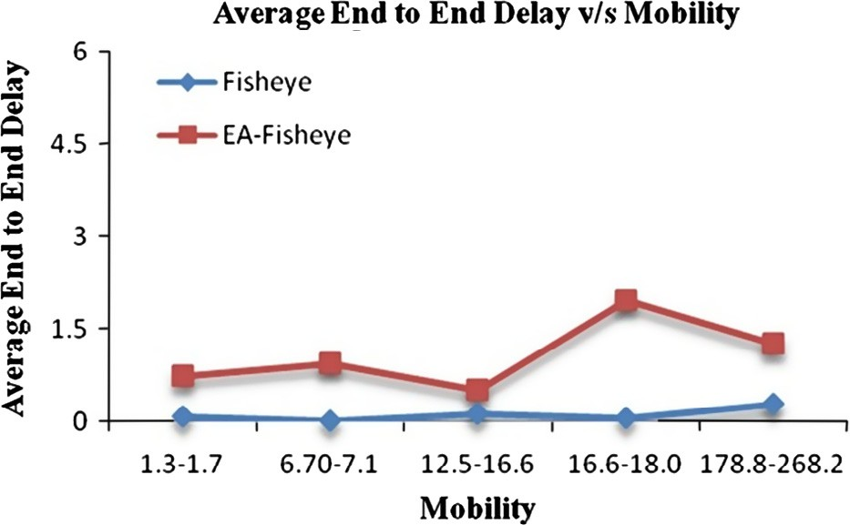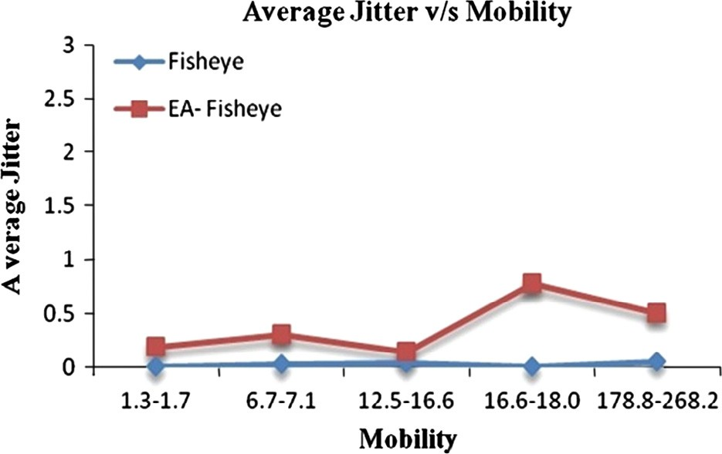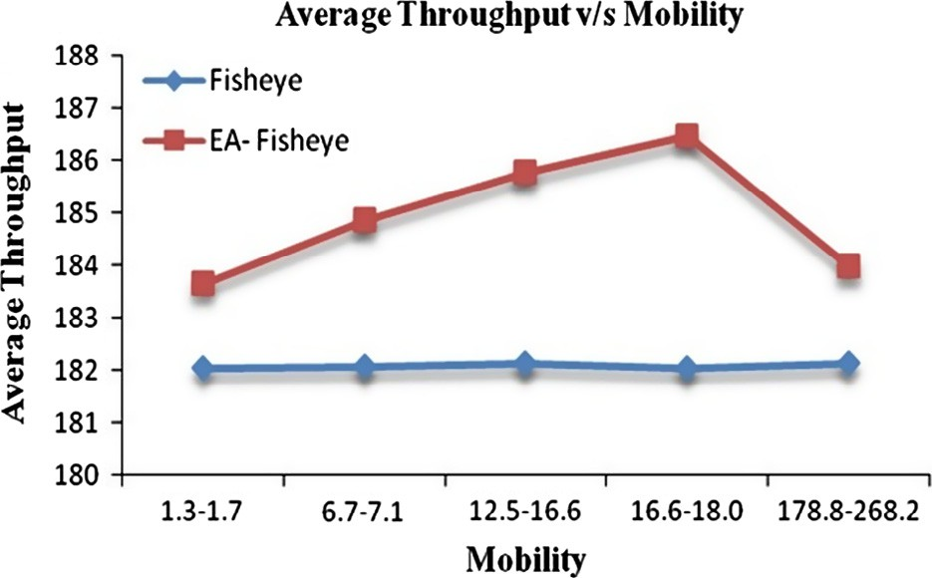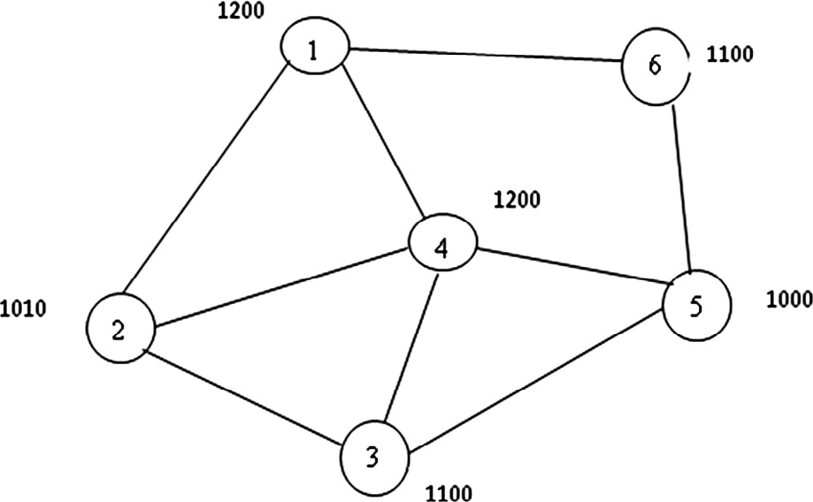

node is made mobile by varying its speed while the sink node is kept static throughout the simulation. The sensor nodes gener- ate CBR traffic towards the sink node at varying intervals of time. Random waypoint mobility model [9] is taken as the mobility model of the nodes with a pause time of 5 s. Speed of nodes is considered corresponding to the real scenario. Var- ious values are: walking 1.3–1.78 meter per second (mps) [10], cycling 6.70–7.15 mps [11], speed of a bike 12.5–16.66 mps, speed of a car 16.66–18.05 mps [12] and speed of a plane 178.81–268.24 mps. Effect of the changing mobility of the data gathering nodes on the network throughput, end-to-end delay and average jitter has been analysed. All the other simulations parameters are listed in Table 1 along with their values.

Figure 4 Variation of average throughput with increasing mobility of sensor nodes.

1. Simulation results
   1. *Average end to end delay*

End-to-end delay measures the delay in the delivery of a packet

i.e. the time gap between the transmission and reception of the

238 H. Kumar et al.

Table 2 Variation of energy consumption.

Routing Protocol

Energy Aware-Fisheye State Routing (EA-FSR) Fisheye state routing (FSR)

Energy Consumption (Joule (mA h))

3.13

3.55

packet from a source node to the sink. Average end-to-end delay gives the average delay suffered by all the packets in the network.

Fig. 2 shows that the average end-to-end delay in EA-FSR initially increases with the increase in mobility and then de- creases whereas for FSR, the delay values remain almost con- stant. Also, there is trivial difference between the values of these protocols for the given mobility values.

* 1. *Average Jitter*

of a network measures the variability over time of the packet latency across the network. Fig. 3 shows that the value of aver- age jitter is higher in case of EA-FSR than FSR. It is also found that for EA-FSR, the value varies randomly with the in- crease in the speed of the nodes whereas for FSR, the jitter val- ues remain almost constant.

* 1. *Average throughput*

is defined as the average rate of successful message delivery across a network. Fig. 4 shows that for FSR, the value of aver- age throughput remains almost constant with the increasing mobility while in the case of EA-FSR the throughput initially increases with the increase in mobility but decreases suddenly when the mobility becomes very high. Also, the throughput of EA-FSR is higher than the FSR.

* 1. *Energy consumption*

is the amount of energy consumed by a sensor node while per- forming the tasks of sensing, computing and communicating in the network.

Table 2 shows the energy consumption on per node basis by EA-FSR and FSR. It is found that the energy consumption of the EA-FSR is lower than the original fisheye routing. The per- centage decrease is around 11.8% after implementing energy aware route selection.

1. Conclusions and future scope

The results obtained from simulations shows that the Energy- Aware Fisheye Routing (EA-FSR) performs better for varying mobility values of the sensor nodes. As there is significant in- crease in the throughput of the network. Also the overall en- ergy consumption of the network has decreased to almost 12%, ensuring longer network lifetime. But there is slight in- crease in the average end-to-end delay and jitter values. Thus this protocol can be used as a replacement for the Fisheye

routing protocol for the applications in which the network life- time and successful message delivery is more critical than the on time delivery.

In future, the energy-aware fisheye can be modified further to consume less energy and generate low control overhead by incorporating some optimisation techniques like swarm intelli- gence. Also, this protocol can further be analysed for other parameters like topological changes, change in duty cycles, etc. Also, real time environment can be used to study the ac- tual behaviour of this protocol.

References

1. Sharif A, Potdar VM, Rathnayaka AJD. Priority enabled transport layer protocol for wireless sensor network. In: IEEE 24th international conference on advanced information network- ing and applications workshops, Perth, Australia; April 20–23, 2010. p. 583–8.
2. Abd-El-Barr ML, Al-Otaibi MM, Youssef MA. Wireless sensor networks – Part II: routing protocols and security issues. In: 18th Annual Canadian conference on electrical and computer engi- neering, Saskatoon, Sask; May 1–4, 2005. p. 69–72.
3. [Chong CY, Hamilton BA, Kumar SP. Sensor networks:](http://refhub.elsevier.com/S1110-8665(13)00027-3/h0005) [evolution, opportunities and challenges. Proc IEEE](http://refhub.elsevier.com/S1110-8665(13)00027-3/h0005) [2003;91(8):1247–56](http://refhub.elsevier.com/S1110-8665(13)00027-3/h0005).
4. Kumar Harish, Kaur Harneet. Issues and trends in wireless sensor networks. In: 25th National convention of computer engineers and national seminar on networked home systems and services (NHSS-2011). Udaipur: The Institution of Engineers (India); February 4–6, 2011. p. 13–8.
5. [Al-Karaki JN, Kamal AE. Routing techniques in wireless sensor](http://refhub.elsevier.com/S1110-8665(13)00027-3/h0030) [networks: a survey. IEEE J Wireless Commun 2004;11(6):6–28](http://refhub.elsevier.com/S1110-8665(13)00027-3/h0030).
6. Kleinrock L, Stevens K. Fisheye: a lenslike computer display transformation. Technical report. UCLA, Computer Science Department; 1971.
7. Guangyu P, Gerla M, Tsu-Wei C. Fisheye state routing: a routing scheme for ad hoc wireless networks. In: IEEE international conference on communications (ICC 2000), New Orleans, LA, vol. 1; June 18–22, 2000. p. 70–4.
8. The Qualnet Network Simulator Website. <[http://www.scalable-](http://www.scalable-networks.com/products/qualnet) [networks.com/products/qualnet](http://www.scalable-networks.com/products/qualnet)>. Last seen on July 20, 2013.
9. Jardosh A, Belding-Royer EM, Almeroth KC, Suri S. Towards realistic mobility models for mobile ad-hoc networks. In: Pro- ceedings of the 9th annual international conference on mobile computing and networking (MobiCom’03); September 14–19, 2003. p. 217–29.
10. Crawford D. Average walking pace or speed. <[http://www.bel-](http://www.bellaonline.com/articles/art20257.asp) [laonline.com/articles/art20257.asp](http://www.bellaonline.com/articles/art20257.asp)> Last seen on April 2, 2013.
11. Average cycling speed. <[http://www.road-bike.co.uk/articles/](http://www.road-bike.co.uk/articles/average-speed.php) [average-speed.php](http://www.road-bike.co.uk/articles/average-speed.php)>. Last seen on April 2, 2013.
12. Speed limit and vehicle control signs. <[http://www.chandigarh-](http://www.chandigarhtrafficpolice.org/speedlimit.php) [trafficpolice.org/speedlimit.php](http://www.chandigarhtrafficpolice.org/speedlimit.php)> Last seen on April 2, 2013.