[Egyptian Informatics Journal 23 (2022) 77–88](https://doi.org/10.1016/j.eij.2022.06.008)

Contents lists available at [ScienceDirect](http://www.sciencedirect.com/science/journal/11108665)

Egyptian Informatics Journal

journal homepage: [www.sciencedirect.com](http://www.sciencedirect.com/)

[](http://crossmark.crossref.org/dialog/?doi=10.1016/j.eij.2022.06.008&domain=pdf)Energy efficiency in cognitive radio network using cooperative spectrum sensing based on hybrid spectrum handoff

Kaleem Arshid a, Zhang Jianbiao a, Iftikhar Hussain b, Muhammad Salman Pathan c,d,⇑, Muhammad Yaqub a,

Abdul Jawad e, Rizwan Munir f, Fahad Ahmad g

a *Beijing Key Laboratory of Trusted Computing, Faculty of Information Technology, Beijing University of Technology, Beijing 100124, China*

b *Edinburgh Business School, School of Social Sciences, Heriot-Watt University, Edinburgh, Scotland EH12 4AS, UK*

c *Department of Computer Science, National University of Ireland, Maynooth, Ireland*

d *ADAPT SFI Research Centre, Ireland*

e *Planning and Development Department, Govt. of Khyber Pakhtunkhwa, Peshawar 25000, Pakistan*

f *Beijing University of Post and Telecommunications, Beijing 10086, China*

g *Department of Basic Sciences, Deanship of Common First Year, Jouf University, Sakaka, Aljouf 72341, Saudi Arabia*

a r t i c l e i n f o

*Article history:*

Received 2 February 2022

Revised 16 May 2022

Accepted 22 June 2022

Available online 16 July 2022

*Keywords:*

Cognitive radio network Spectrum sensing

Cooperative spectrum sensing Energy detection

Energy efficiency Handoff decision

a b s t r a c t

Rapid spectrum usage in wireless networks may reduce energy efficiency, requiring cognitive radio net- works to be more efficient than conventional ones. Due to increased data transmission demand, cognitive radio networks arose from a lack of spectrum bandwidth. Spectrum sensing and handoff decision are two cognitive radio network strategies that help avoid interference, channel access, and cohabitation between primary and secondary users. Current research focuses on handoff decision and cooperative spectrum sensing to improve sensing efficiency and system throughput while neglecting energy efficiency and handoff latency. Spectrum mobility and sensing are essential for energy-efficient cognitive radio net- works. This study provides a second priority user transmission system using cooperative spectrum sens- ing to sense available channels. An energy detection technique optimizes the sensing process’s energy usage, leading to energy efficiency. A primary user traffic pattern-based threshold approach is presented for spectrum mobility management. A threshold approach is utilized to calculate probabilistic stay-and- wait and QoS handoff values. The transmission channel is selected using a hybrid handoff strategy based on dynamic spectrum aggregation. Moreover, a cooperative spectrum sensing algorithm is described and simulated to identify the optimum channel with the greatest throughput and minimum energy consump- tion. The proposed approach increases energy efficiency and throughput while maintaining handoff delay and avoids miss-detection and false alarm. This technique improves energy efficiency, sensing perfor- mance, throughput, and handoff time. miss-detection.

© 2022 THE AUTHORS. Published by Elsevier BV on behalf of Faculty of Computers and Artificial Intel-

ligence, Cairo University. This is an open access article under the CC BY license ([http://creativecommons.](http://creativecommons.org/licenses/by/4.0/)

[org/licenses/by/4.0/](http://creativecommons.org/licenses/by/4.0/)).

1. Introduction

The rapid growth of wireless applications frequently increases requests for higher information rates, putting the spectrum’s fixed

* Corresponding author at: Department of Computer Science, National University of Ireland Maynooth.

*E-mail address:* [muhammad.pathan@mu.ie](mailto:muhammad.pathan@mu.ie) (M.S. Pathan).

Peer review under responsibility of Faculty of Computers and Information, Cairo University.

**Production and hosting by Elsevier**

properties and allocation policies to the test. To effectively improve static spectrum usage policies, the advantageous attribute of Cog- nitive Radio (CR) has been established based on the dynamic spec- trum. Cognitive radio is one of the promising techniques that prominently resolve the spectrum scarcity issue by optimizing the spectrum. A cognitive radio observes the spectrum and its sur- roundings while properly utilizing its radio parameters [1]. Cogni- tive radio is formally defined as ‘‘a smart system that varies according to the existing environment of the spectrum, defines the spectrum hole, and communicates opportunistically over the spectrum hole with negligible interference to FPUs” [2].

While utilizing the existing Quality of Service (QoS) require- ments on the same spectrum where the First Priority User (FPU) is working, the licensed user of a primary network that has the ownership of a specific radio spectrum is known as the FPU. The

<https://doi.org/10.1016/j.eij.2022.06.008>

1110-8665/© 2022 THE AUTHORS. Published by Elsevier BV on behalf of Faculty of Computers and Artificial Intelligence, Cairo University. This is an open access article under the CC BY license (<http://creativecommons.org/licenses/by/4.0/>).

Second Priority User (SPU) faced several new challenges. A Cogni- tive Radio User (CRU) or SPU has no licensed access to a specific channel, and it rather opportunistically accesses the temporally free channel of an FPU in order to perform its communication. The communication of an SPU can be interrupted by an FPU. New Spectrum Management (SM) challenges such as interference avoidance, QoS demands, and seamless communication is critical parameters for Cognitive Radio Networks (CRNs).

Spectrum sensing, spectrum management/decision, spectrum sharing, and spectrum mobility/sharing entirely depend on the CRN. Spectrum Sensing (SS) and Spectrum Decisions (SD) are key enabling functionalities for FPUs based on sensing results due to channel utilization and channel vacating decisions. The FPU and SPU in SS are constantly monitoring the spectrum, and it also mon- itors and identifies spectrum openings available for SPU communi- cation. The SS is classified into three types: cooperative detection, non-cooperative detection, and interference detection [3]. In Coop- erative Spectrum Sensing (CSS), many SPUs decided to sense the idle channels by sharing information about the available channels among all SPUs for better performance of the FPUs while also min- imizing the probability values [4].

A large number of studies have been conducted on CSS in order to improve sensing in the field of communication. Although it pro- vided better sensing performance, it consumed more energy by increasing sensing time. While using CSS to improve sensing time and maximize CRN overall performance, energy efficiency equality is required.

This paper presents an SPU transmission model in CRN by using the CSS approach. The model has three steps: sensing and trans- mission, mobility management, and handoff decision. Spectrum handoff is the licensed spectrum captured by the CRUs or SPUs for a short time. Hence, if FPU attempts to use that spectrum, CRU transmission must resume in the next empty channel. The CSS is used in the sensing and transmission process to improve sensing routines by considering all SPUs’ propagated sensing choices. Although the CSS is complex, it produces precise results by improving the sensing process. An energy detection technique is used in CSS to optimize the energy consumption in the sensing process, resulting in energy efficiency. SPUs continuously monitor their surroundings and detect available channels via an energy detection scheme. Spectrum mobility management is used for handoff decisions and managing SPU transmission on available channels based on FPU arrival patterns and transmission require- ments. It aids in achieving coordination and avoiding collisions on the selected channels. Spectrum sharing eliminates interference between FPUs and SPUs by allocating channels and energy. To select the appropriate channel for transmission, a hybrid handoff approach based on Dynamic Spectrum Aggregation (DSA) is used. The use of spectrum and FPU interference is determined by the miss-detection and false alarm probability values. The primary goal of these functions is to reduce false alarms and miss- detection. An algorithm is also proposed that uses components from each step of the model. The model is implemented in Java as a proof of concept by following the steps described in the algo- rithm and using the synthetic dataset.

The rest of the paper is organized as follows. The related work is presented in section 2. Section 3 designates the SPU transmission model, which begins with an architectural view of the CRN. The framework is then described in detail, followed by a model over- view. The framework is divided into three parts: sensing and trans- mission, mobility management, and handoff decision. An algorithm is comprehensively described at the end of this section. Section 4 discusses experiments and their outcomes. Finally, section 5 con- tains the conclusion and future work.

1. Literature review

Generally, three methods are commonly used for primary trans- mitter detection: Energy Detection Method (ED), Cyclostationary Detection Method (CD), and Matched Filter Detection Method (MFD) [3,5]. Due to multipath fading, shadowing, and noise uncer- tainty, the execution of SS is limited because these are the basic attributes of wireless channels. In experiences of fading by obsta- cles, the power of FPUs signal received at SPUs will be profound and too weak to identify. The core purpose of cooperative sensing is to upgrade the sensing performance by combining the sensing results of all SPUs. Furthermore, to decide based on these results is more precise than the single user decision.

Non-cooperative methods are based on detecting signals trans- mitted from the main system. The non-cooperative techniques are often based on the hypothesis that the primary transmission area is known to the sensory devices. Therefore, the SPU should rely solely on detecting weak primary transmission signals and use only local detections to perform SS. The sensing device does not have complete spectrum retention information in its coverage area. As a result, it is impossible to avoid detrimental interference with the FPU altogether.

Three methods are commonly used for primary transmitter detection: According to the authors in [6,7], CSS has presented a precise solution for improving sensing achievements. Cognitive radio spectrum assignment is categorized into two schemes: cen- tralized and distributed. In a centralized scheme, the spectrum is sensed by a sensing controller (Base station), and the result is shared with all other neighbor nodes. In distributed, the SPUs sense the spectrum and avail the spectrum opportunity, SPUs can take the decision either (non-cooperative sensing) or on the bases of other SPUs sensing (distributed sensing).

In several kinds of research [8–11], centralized spectrum assignment is measured and has attained the following: (i) the sensing controller can view the spectrum globally, (ii) the through- put of the network is increased, and (iii) the interference of the SPU’s is minimized to maximum level. In addition, the spectrum server can be utilized for fairness on the accessible spectrum and control the throughput among the greedy users who mostly occupy the whole spectrum band for performing their throughput and creating problems for other users. Hence the centralized spec- trum assignment performs better for accessing throughput and fairness. Centralized spectrum assignment controls the interfer- ence of SPUs by conflict graphs. The sensing controller can sense the spectrum globally. Therefore, it is a crucial point for mainte- nance. It also supports assigning spectrum to SPU and sharing information about the spectrum throughput. A considerable chal- lenge in the centralized spectrum assignment is how a sensing controller can share information with other SPUs. Moreover, if the sensing controller falls flat because of power or accidental fail- ures, the network assignment is impossible.

In the distributive spectrum assignment, the central controller cannot exchange information with all other SPUs in the network [12–15]. In the distributive scheme, SPUs can select a target chan- nel for communication and decide by coordinating with their neighbors based on the neighbor’s sensing results. In the distribu- tive spectrum, each SPU calculates metrics and shares information with neighbors, computes the traffic load of nearest spectrums, and chooses a spectrum with minimum traffic load and minimum interference with FPUs.

The centralized scheme is considered slower than the distribu- tive because when the centralized scheme shares information, the changes need to be done on all nodes, and hence the traffic load will be increased. Using the distributive scheme, the decision is

taken based on local nodes; thus, the decision is faster. However, the drawback in the distributive scheme is that the nodes have information of their neighbor SPUs only and not the entire net- work. Moreover, any inaccurate information can influence the results in a distributive scheme. For an energy detector, the sensing time affects the detector’s performance in terms of false alarms and undetected detection.

In research [16–18], the sensing period affects the detector’s ability to detect and process spectrum possibilities with time. However, energy availability is limited. Many investigators have studied the functionality of CSS when reporting channels (channels from SPUs to Fusion Center (FC)) are an additive white Gaussian noise (AWGN) [19–25].

A framework is discussed in [26] that allows combining the relationship between CSS and handoff techniques to improve energy efficiency in CRN. In CSS, when there is a weaker signal, SPU’s control effect of shadowing and discover spectrum access chances in removing miss-detection and false alarm probabilities. Sensing increasing will result in higher energy consumption; therefore, there is an optimal spectrum space to maximize user throughput and energy efficiency.

In [27,28], the energy efficiency at the physical and network layer of the OSI model is theoretically discussed. SPU requires mas- sive energy utilization contrasted with traditional devices and for increasing complexity and modern functionalities. It gives a theo- retical concept of how to regulate the energy consumption and also of energy management in CRNs. Due to the various SPU locations and channel conditions, the [29] indicates that interaction of all SPUs in the SS is incorrect, and complete detection of false alarms is only available in collaboration with a group of users with high SNR of the main signal detector. Numerous studies have shown that CSS can significantly increase the chances of being found in dying channels [5].

In [30], the FC scheme is used where tricky (Single bit) and soft (multiple bits) decisions are used for sharing information. For the final decision, FC follows the K-out-of-N rule in hard decisions. In the soft decision, an optimal fusion rule is applied, which combines all information sent by SPUs in the presence of reporting channel error in a given quantization scheme. Soft decision-based CSS per- formance is considered more robust than the hard decision in terms of energy consumption, and it needs wider bandwidth for channel control, but there is no resulting energy efficiency.

Authors in [31], SPUs sensing at the initial stage is called coarse sensing and the sensing time is conceivable to deal with diminish- ing the energy consumption. The two-stage sensing is performed for the time saving with the one-bit decision (hard decision). Despite this fact, the two-stage sensing technique effectively miti- gates the sensing time. It causes additional energy utilization in the reporting stage and is repetitive twice. Additionally, the impact of holding up with the first result on the reachable throughput is not examined, which might degrade the energy efficiency.

In [32,33], the model is presented for low complexity sensing and handoff with efficient energy usage but cannot check the effect of CSS on energy and throughput. SPUs are partitioned into two groups for decisions, and both groups’ sensing results are sent to FC for the final decision. By enhancing the SPUs in each group and the threshold of FC, the energy is maximized. The maximiza- tion problem is solved by using a particle swarm optimization algorithm. In light of results assembled from two unique stages, this might debase the dependability of the final decision.

In [34], the author described rapid and high performance based on SPU power harvest, sensitivity, and reporting qualities. In [35,36], two energy-saving schemes have been presented to reduce energy consumption. In a reduced power sensor and reporting sys- tem, power consumption is minimized by decreasing the sensing station and reducing the reporting stations in the FC.

Authors described in [37,38] that the MFD is an appropriate detection method. Mid-range wavelengths [39] are extracted from ED and can be used as reference elements for the separation and determination of FPU. By using MFD detection, SPU needs to be fully aligned with FPU. According to [40,32], the MFD can associate a pre-identified key signal with a signal obtained to detect FPU presence. The benefits of MFD are that it requires a few available signal samples for the short term and requires to achieve accept- able detection function [21,41].

The SS method based on the high selectivity of cyclic autocorre- lation is suggested in [42–44], where the maximum and minimum value of cyclic autocorrelation activity is compared to determine whether a primary signal exists or not. Furthermore, the corre- sponding acquisition exceeds the ED in the sensitivity of the junc- tion. The sensitivity of the ED increases in sequence with the reduction of the SNR, whereas the corresponding detection increases only in proportion. However, details regarding waveform patterns are a requirement for making consistent acquisitions.

According to [45,34], the CD is one of the most effective SS methods, which uses the cyclostationary feature to detect signals after a dry sound or in low SNR states. The cyclostationary feature detector uses the time signal strength as test statistics. It transi- tions from the time zone to the frequency factor domain, followed by performing a hypothesis test on a new domain. The detection of a cyclostationary element was first introduced in [46]. The cyclo- stationary feature identifier uses these randomly randomized sta- tistical signals and is detected by reference to the mean and automatic signal detection. If the mean and autocorrelation vary from time to time, then the received signal is associated with the FPU; otherwise, it is noise, timeless. As a result, cyclostationary fac- tor detectors may be adequate in very low SNR areas. Operating time estimates are considered in [47] and [48] to improve the durability of the detector. Typical feature detection refers to the acquisition and segmentation process that excludes data included without cyclostationarity.

All SPUs perform local spectrum measurements independently, use detection algorithms, and make binary decisions. Since energy detection is a facile and straightforward method, as discussed in the above literature, many studies, i.e. [49–51], have used this method to test local SS performance. When applied to the local SS, each SPU transmits the received power signal or decision results to the destination node. The reported research effort pri- marily focused on the cooperative spectrum sensing and the hand- off decision by improving the sensing efficiency and maximizing the system throughput but ignores the effects of energy efficiency and handoff delay. To make cognitive radio networks an energy- efficient system, spectrum mobility and sensing are deliberated as main factors. The equality in energy efficiency is mandatory while using CSS to improve sensing time and maximize the overall performance of CRNs. In this research, an energy detection approach is used in the CSS to optimize energy consumption in the sensing process, leading to energy efficiency.

Table 1 compares and contrasts the SS techniques. Handoff delay, energy efficiency, and throughput compare the strategies. CSS is a technique that has the advantage of lowering thresholds, sensitivities, and requirements while having the disadvantage of increasing data overhead. When the handoff delay is at its shortest, the energy efficiency and throughput suffer. Because energy detec- tion is simple to implement, the handoff delay, energy efficiency, and throughput are average, requiring a long sensing time. Because the matched filter detection technique requires less dedication time and is more effective at detecting noise, the handoff delay can be minimized when the energy efficiency is lowest. Cyclization feature detection techniques with height computational and sens- ing time result in average handoff delay, throughput, and mini- mum energy efficiency. The proposed sensing technique, ‘Energy

Table 1

Comparison of Some of the Existing Spectrum Sensing Techniques with respect to the Handoff Delay, Energy Efficiency and Throughput.

|  |  |  |  |  |  |  |  |
| --- | --- | --- | --- | --- | --- | --- | --- |
| Spectrum Sensing Techniques | And References | Methods Used for Sensing | Throughput | Energy Efficiency | Handoff Delay | Advantages | Limitations |
| Cooperative Spectrum Sensing Technique  Energy Detection | [6,28,29,54–56]  [16–24,46–48] | Cooperation between Multiple SPUs  Sensed Energy | Average  Average | Average  Average | Maximum  Average | Reduction in Threshold. Sensitivity and Requirements.  Easy to Implement.Do | Sometime wide channels need to be scanned.  Increased Data Overhead.  High Sensing Times. |
|  |  |  |  |  |  | not Require Previous | Uncertainty of Noise |
| Matched Filter | [21,30,34,35,37,38] | Previous | Average | Minimum | Maximum | Information of FPU’s.  Less Detection Time. | Power. Need Tight  Synchronization.  Requires FPU’s Previous |
| Detection  Cyclisationary | [39–45] | Information of FPU  Periodicity of | Average | Minimum | Average | Noise Detection is optimal.  Robust to Noise. | Information. Need a Dedicated Receiver.  Long Sensing Time. |
| Feature Detection |  | Received Signal |  |  |  | Improves SPU Throughput. | High Computation  Complexity. |

Proposed Energy Efficiency in CRN Energy Detection

on Target Channel

Improved Improved Minimized Energy Efficiency

Easy to Implement. — Fewer Sensing Time.

FPU’s Previous Information is not Required

Efficient Spectrum Sensing Technique,’ is more efficient than exist- ing handoff techniques because it improves energy efficiency and throughput and minimizes handoff delay.

1. Proposed second priority user transmission model

According to existing research, CSS yields better results for detecting FPUs in the CRN to remove interference. CSS consumes more energy while detecting FPUs in order to improve sensing time while also increasing system overhead. The researchers focused primarily on increasing spectrum throughput and improv- ing sensing performance, but they ignored energy consumption and optimization in wireless communication [52,53]. Energy effi- ciency equality is considered important when using CSS to improve sensing time and maximize CRN overall performance. Energy crises and environmental standards motivate wireless communication researchers to support energy efficiency [25].

This study anticipated an SPU transmission framework by incorporating the CSS technique to sense available channels in the spectrum. In the CSS, an energy detection technique is used to optimize the energy consumption in the sensing process, result- ing in energy efficiency. In addition, an arrival pattern-based spec- trum technique is presented for the handoff decision. To select the appropriate channel for SPU transmission, a hybrid handoff approach based on Dynamic Spectrum Aggregation (DSA) is also proposed. After describing the generalized CRN architecture and an overview of the proposed model, this section divides the frame- work into two sub-sections: model framework and algorithm framework (as the solution). Firstly, the framework is described by breaking down the CRN process into different steps. Secondly, as a solution domain, an algorithm for the components (energy detection, spectrum mobility, and hybrid handoff decision) is des- ignated and described in the algorithm section.

* 1. *Architecture of the cognitive radio network*

A network with opportunistic access to a specific channel implemented as an infrastructure network is known as CRN. The main objectives of improving the entire network utilization in

the CRN architecture are spectrum consumption and energy effi- ciency. The users can satisfy their needs anytime and anywhere using CRNs. The Service Providers (SP) can deliver better services to (mobile) users. The SPs allocate the CRN resources efficiently to transport additional packets per unit bandwidth.

Additionally, an SPU in CRN can sense vacant channels and other communication resources. A CRN comprises several users, communication resources, and networks and can perform as a heterogeneous system. The heterogeneity occurs in the following tools: wireless communication resources, networks, base stations, applications, and SPs. The universal architecture of the CRN is shown in Fig. 1 to understand the process and the components of CRN are described.

* + 1. *First priority network*

A network with special rights or ownership of a specific channel is known as a First Priority Network (FPN). Following are some of the examples of the FPN: CDMA, WiMAX, ISM, TV broadcast, and standard cellular networks. The licensed user of a primary network that owns a specific radio spectrum is known as FPU. The FPU has a primitive right, and its communication should not be interfered with by the communication of SPUs. FPN operates in dedicated fre- quency channels and works either in licensed or unlicensed chan- nels. In FPN, the licensed channels have the highest priorities in utilizing the frequency bands by the FPUs. While using the licensed channel by an FPU, other users (FPU or SPU) are not allowed to interfere and occupy that specific channel. In FPN, the unlicensed band compatibly is utilized by FPUs and operates in the same fre- quency band by coexistence and considering interference to each other.

* + 1. *Second priority network*

A network with opportunistic access to a specific channel is the Second Priority Network (SPN). Ad-hoc networks are examples of the SPN. An SPN neither has a fixed operational frequency channel nor has rights to access that channel when utilized by the FPU. The Objects residing in this network interact dynamically by using the spectrum holes. An SPU has no licensed access to a dedicated chan- nel, and it rather opportunistically accesses the temporarily free channel of an FPU in order to perform its communication. The com-

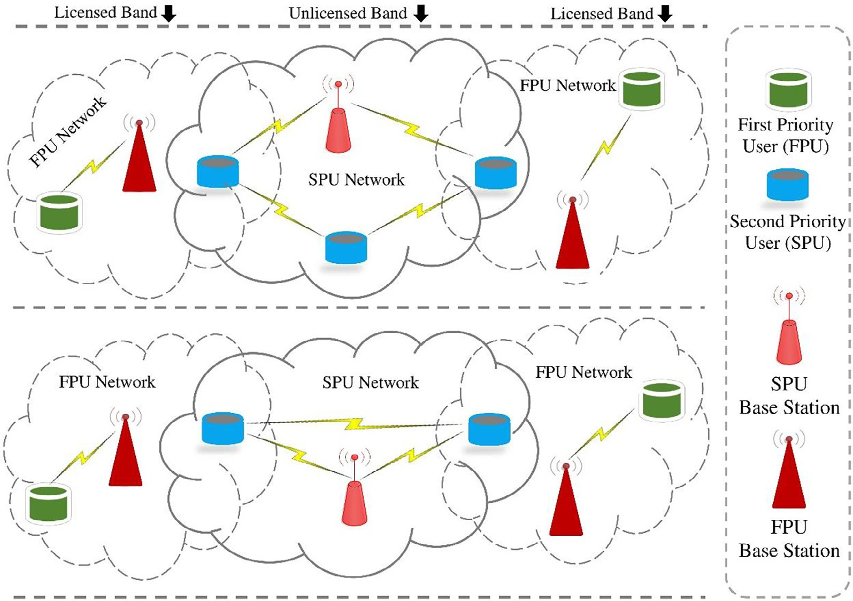

Fig. 1. System Model of the Generalized Cognitive Radio Network.

munication currently performed by SPU can be interrupted by an FPU.

* + 1. *Base stations*

The base stations of the FPN and SPN are fixed components and have the capabilities of the cognitive radios. The base stations rep- resent the groundwork side of the system and deliver the following services: i.e., mobility management, management of vacant chan- nels, and base station security management. It provides a gateway to access the Internet and form a wireless network by enabling wireless communications between users. In the SPN, some of the base stations may act as repeaters when those are connected to each other.

* 1. *Overview of the proposed model*

An SPU transmission model is proposed for sensing, mobility management, and handoff decision in CRN. The energy detection- based CSS approach is used for sensing the available vacant chan- nels, and the spectrum mobility management is used for the hand- off decision. A hybrid handoff approach based on DSA is proposed to select the appropriate channel for transmission. The proposed model has the following features:

1. The CRN is supposed to be a recurring and time-dividing system where every SPU prioritizes sensing and transmission.
2. The actual transmission of the SPU is performed when the tar- get channel (dedicated to the FPU) is sensed as vacant and hired by the SPU.
3. The spectrum sensing is performed by CSS, which uses an energy detection technique to optimize the energy consump- tion, leading to energy efficiency.
4. The SPU continues its transmission on the vacant channel (ded- icated to the FPU) until it is interrupted by the FPU and commu- nication requirements are satisfied.
5. When the FPU resumes its transmission on its dedicated chan- nel or the transmission requirements are not fulfilled, the SPU calls the mobility management function to decide whether to perform handoff or not.
6. The FPU arrival pattern-based approach is used to either wait for the current channel or perform a handoff decision process to hire the new available channel from the list of vacant channels.
7. A DSA-based hybrid handoff approach is used in the handoff decision process to perform sensing on the list of available channels.
8. The SPU selects any vacant channel for transmission from the list of vacant channels agreeing to the uniform distribution by DSA.
   1. *Framework or energy efficient framework based on cooperative spectrum sensing*

Fig. 2 demonstrates the proposed SPU framework for transmis- sion. The planned design is divided into the following general steps: (i) sensing and transmission, (ii) mobility management, and (iii) handoff decision; and also described in detail in the fol- lowing subsections.

* + 1. *Sensing and transmission*

This step is divided into two processes: sensing and transmis- sion. The SPU continuously senses for the vacant channels to per- form transmission in the sensing process. The spectrum sensing process can be performed by using one of the currently available sensing techniques, i.e., Cooperative Spectrum Sensing (CSS) [17,13], Matched Filter Detection (MFD) [38], or Cyclo-Stationary Feature Detection (CFD). In this research, we have incorporated the Energy Detection Technique (EDT) [51,27,32] based CSS approach for sensing. The energy detection technique is used in spectrum sensing for its difficult nature and its lower computa- tional properties [26,24,49]. The SPU performs the actual transmis- sion on the currently occupied vacant channel in the transmission

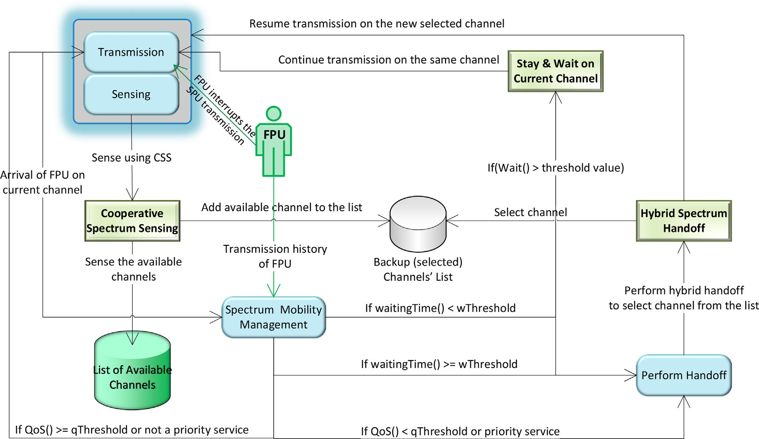

Fig. 2. Proposed Cooperative Spectrum Sensing based Transmission Framework for the Second Priority User.

process. The occupied channel is dedicated to FPU and released when it becomes vacant. During transmission on the occupied channel, the movement of the FPU (owner of the channel) is con- tinuously monitored by the SPU. When FPU interrupts transmis- sion by occupying its dedicated channel again, the SPU, through mobility management, decides to either wait for the current chan- nel or perform handoff to occupy the new vacant channel. There- fore, the SPU continues its transmission on the newly occupied channel. In the proposed model, the EDT-based CSS approach plays a vital role in sensing and transmission and CSS is described in detail as below.

* + - 1. *Cooperative spectrum sensing.* CSS scheme is reliable in spectrum sensing and helpful in sensing vacant channels, monitor- ing the FPUs, sharing data (sensing choices) among all SPUs, and removing the intrusion, shadowing, and hidden problems. CSS is used in the sensing and transmission process to improve the sens- ing routines by the propagated sensing choices of all SPUs. The coordinated (agreed upon) decision is designated based on propa- gated sensing choices and is considered more precise than the sin- gle user decision. The local sensing information is transmitted to the base station (BS), known as a data Fusion Center (FC). The base station decides based on the data sent by the SPUs. Initially, SPU starts transmission on the occupied channel, and during transmis- sion, it also monitors the FPU activities. When the FPU takes con- trol of the occupied channel by SPU, the new target (vacant) channel is selected to continue transmission when the threshold value is not satisfactory for staying at the current channel.

Furthermore, CSS is considered a challenging task; however, it gives precise results by improving the sensing process. SPUs (shown in Fig. 3) continuously monitors the environment and sense the available channels using an energy detection scheme. The energy detection scheme is described in detail below.

* + - 1. *Energy detection.* The energy detection technique is consid- ered superior to other techniques, i.e., MFD and CFD. In the EDT approach, the energy is computed based on the signal established on a static bandwidth and time period. The energy signal is

detected by associating the specified (detected) value with the threshold value set for the energy detector. A constant value can be considered; however, it depends on the FPU arrival pattern, and the value can be calculated dynamically. The apparent energy point is improved with the FPU arrival on its dedicated channel. As the value is calculated, the apparent energy point is verified several times, either during the existence or absence of FPU. When the energy level value calculated from the arrived pattern signal increases than the threshold value, the handoff process is executed to start the spectrum handoff.

There are two types of energy detectors (shown in Fig. 4): ana- log and digital. The analog energy detector contains a noise pre- filter and a temporary connector (integrator). The noise pre-filter is compatible with a square device (*z*)2. The previous filter is used to control the noise and noise variations. The signal strength (test statistics) is received equal to the output generated by the integra- tor. The character *a* (with the dashed line with a grey color) repre- sents the analog energy detector flow. Secondly, the Digital energy detector is based on a low pass pre-filter and neighboring band- width signals. An analog-to-digital converter (ADC) converts con- tinuous analog signals into discrete digital signals. A square device (*z*)2 is compiled by the compiler at the end. The character *b* (with an arrow line in blue color) is used in to show the flow of the digital energy detector. For processes of energy detection (analog and digital detectors) are shown here.

A threshold optimization of energy activity is described in the sub-section below.

* + - 1. *Threshold optimization of energy activity.* Spectrum and FPU interference depend on the probability values of miss-miss- detection (MD) and False Alarm (FA). Both probability values are contingent on the sensing time and detection threshold. The term FA is used when SPU detects an FPU; similarly, the term MD is used when the SPU mistakenly detects an FPU. The primary purpose of the threshold optimization (of the energy activity) is to reduce the probabilistic values of the MD and FA situations.

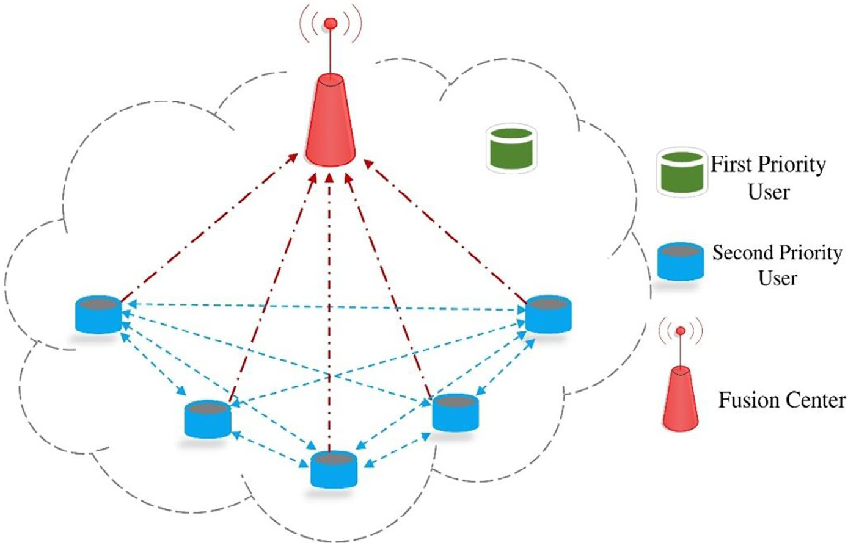

Fig. 3. Cooperative Spectrum Sensing Behavior.

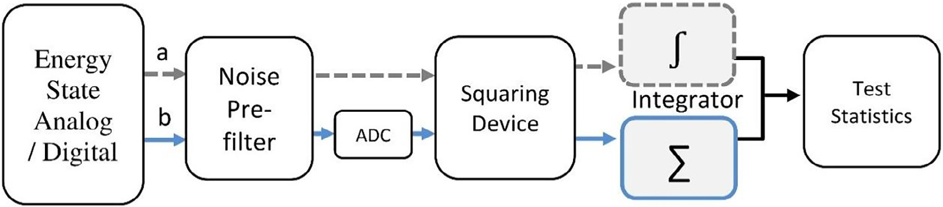

Fig. 4. Conventional Energy Detector a. Analog b. Digital.

If an error occurs in the FA, the following strategy is used to detect and may reduce the possibilities of its occurrence. Let H0 denotes the idle channel and H1 denotes the busy channel. Equa-

probability, (iii) the signal strength performance obtained by the hypothesis *H*. The probabilistic value to reduce/detect error is cal- culated by Equation (4).

tion (1) is used to calculate the probabilistic values for H0.

c*

*H*0 : *xi*(*m*) = *ui*(*m*) (1)

*i*

In Equation (3), we assume that *xi*(*m*) is the mth sample of the ith

SPU active energy detector, *I={1,2,3,*.. .*,n}* are the SPUs belonging to

*i* = *arg*c* min (g.*PFA*,*i* + *PMD*,*i*)(*P*(*H*)*i*

* + 1. *Mobility management*

(4)

the set *I* where *i* is the active SPU and *ui*(*m*) is the noise of the active SPU. The sample-set S is denoted as S*={1,2,3,*.. .*,n}* where the active sample is denoted as *m*. The *H*1 is calculated by Equation

(2) below.

*H*1 : *xi*(*m*) = *hi*,*amplitude*(*m*).*sprimary*(*m*)+*ui*(*m*) (2)

Spectrum management manages the SPU transmission on avail- able channels based on FPU arrival patterns. It helps achieve coor- dination access and prevent a collision on the selected channel. Different SPUs can try to access spectrum for communication at a time, and overlapping may occur. Spectrum sharing removes inter- ference among FPUs and SPUs by using the channel and power

where *hi*,*amplitude*

(*m*) is the channel fading coefficient used to rep-

allocation.

The spectrum mobility function is executed in the following

resent the amplitude gain of the channel and *sprimary*(*m*) is the pri-

mary signal.

The probabilistic value for the error detection *EDprobability* is cal- culated by Equation (3). The *P*(*H*0) and *P*(*H*1) are the probabilistic values for the idleness and business channels, respectively. Sup- pose the calculated probabilistic value for the false alarm is *PFA*,*i* and for the miss-detection is *PMD*,*i*.

*EDprobability*,*i* = *P*(*H*0).*PFA*,*i* + *P*(*H*1).*PMD*,*i* (3)

A mechanism is required to reduce the chances of error occur- rence. To do so, here we assume that *P*(*H*0)/*P*(*H*1)= g, and an

cases: (1) when the FPUs are interrupted (reclaim the licensed spectrum) during the SPU transmission on the licensed channel and (2) when the QoS is not up to the mark as required by the SPU on the current channel. When FPU reclaims its dedicated chan- nel for a shorter period of time, the SPU can stay and wait for the same channel to resume its transmission, and the threshold value is calculated based on the arrival pattern. The SPU doesn’t make the handoff decision if the FPU uses its dedicated channel for a shorter time period. The stay and wait of the SPU at the current channel depend on its transmission requirements and the time period. In other cases, the SPU leaves the explicit spectrum for

effective value is obtained by c*

i

where ci represents the

the FPU and selects a new vacant channel for transmission from

decision-making threshold value by assessing the following parameters: (i) probability ratio, (ii) the size of the conditional

the list of vacant channels. This feature can be achieved by detect- ing multiple probabilistic values, i.e., energy, QoS, and compared

with a constant threshold value (assigned explicitly). The threshold value is extracted to compare the constant values associated with the energy, QoS, and waiting time values.

* + - 1. *Threshold optimization.* A primary user traffic pattern-based threshold scheme is designed to perform mobility management. In mobility management, the SPU transmission is managed by con- sidering the QoS, stay and wait, and the communication require- ments. The SPU monitored QoS regularly during transmission on the current channel; a handoff will be performed when it is not sat- isfactory. The SPU performs handoff based on QoS only rather than FPU interruption. By considering the FPU traffic pattern, the scheme calculates the QoS threshold calculated based on current channel performance.

The threshold value of QoS is graded as when the value is higher; the performance is considered satisfactory. When the cal- culated threshold value is below the required threshold, the hand- off will be performed. In the stay and wait case, the presented scheme will either stay on the current channel or perform a hand- off. It can be achieved by considering the waiting time calculated based on the FPU traffic pattern. The handoff will be performed when the waiting time is higher than the threshold value. The transmission requirement case is considered for the real-time application transmissions where the waiting at the current channel is not bearable. Therefore, as FPU interrupts its dedicated channel, the SPU will perform handoff without calling the stay and wait for function.

* + 1. *Handoff decision*

When FPUs or the QoS reclaim the selected licensed channel is not better at the currently occupied channel, in both situations, based on the mobility management process, the SPUs can vacate the current channel. The selection process for a new channel is known as spectrum handoff. The handoff is performed using the approach described in the [54]. The described approach is based on the hybrid spectrum handoff technique; both proactive and reactive handoff schemes are shared by taking the selection part of proactive while the spectrum handoff decision of reactive. SPUs sense the channel before communication, and spectrum handoff is performed after the event’s occurrence. The advantage of the hybrid handoff scheme is that during spectrum handoff, the chan- nel sensing is not completed and may cause performance improve- ment [55,56].

The spectrum handoff decision chooses a suitable handoff class between reactive and proactive with respect to the lowest overall service time of the SPU. The overall service time is based on the fol- lowing times: sensing time, processing time, waiting time, and transmission time. The overall minimal service time is imple- mented for the spectrum handoff decision. Subsequently, the SPU can maintain its transmission on the recently selected channel. In the hybrid handoff approach based on dynamic spectrum aggrega- tion, a threshold value is selected for the FPUs arrival pattern. The SPUs select a backup channel for communication using the proac- tive part when FPUs’ traffic pattern value is below the threshold, but when the arrival pattern value of FPUs crosses the threshold value, the reactive handoff will be used. The hybrid handoff approach is considered better while providing low-cost services and delays when streaming the live media channels on the net- work applications.

* 1. *Proposed algorithm of energy-efficient model*

The pseudocode for the SPU transmission process is shown by Algorithm 1. The algorithm starts by taking the *list of channels* and

the *list of FPUs* with their arrivals patterns as input. The main driving function calls two sub-functions named as *transmissionAndSensing()* and *mobilityManagement()* for transmission and sensing, and mobil- ity management processes. The SPU transmission starts when a con- nection is established. In *step 1,* the *setTransmitting()* function is set either as true or false to set for transmission. In *step 2*, a variable *cur- rentChannel* is used to store the currently occupied channel by the SPU. The list of vacant channels is stored in the list *vacantChan- nelList[ ]* and initialized by the null value in *step 3*. In *step 4*, the *firstVacantChannel()* function selects the first vacant channel from the list of channels. In *step 5*, the *while*() loop is used to manage the transmission intervals and check by *isTransmitting()* function. The functions *transmissionAndSensing()* and *mobilityManagement()* are called in *step 6* and *step 7,* respectively, to perform the transmis- sion and sensing, and the mobility management processes. Finally, in *step 8*, the while loop is closed.

The transmissionAndSensing() function performs the actual trans- mission and sensing dedicated to the specific intervals. This function takes *channelsList[ ]* and *currentChanne*l as input and returns list of at most four vacant channels as output. Through this function the trans- mission of specific interval is also performed. The transmission and sensing process interval are divided into two time slots. The first time slot is used for transmission only while the second time slot is used for the sensing. The *transmissionAndSensing()* function starts by checking the time slot in *step 1,* if *isTimeSlot1()* is true then call the *transmission()* function for the actual transmission and returns the *currentChannel (*the occupied channel for transmission*)* in *step 2.* As the transmission ends, the *step 4* is used to check for *timeSlot2* by *isTi- meSlot2()* and *performSensing()* function is called to perform the sens- ing process in the *step 5*. The *performSensing()* function returns the list of at most four vacant channels.

The *Sensing()* function is used for sensing the vacant channels during transmission. The 3 or 4 vacant channels are added to the *vacantChannelList[ ]* as backup channels. This function takes *chan- nelsList[ ]* as input and returns 3 or 4 vacant channels in a list. The *while()* loop in *step 1* used to check for the vacant channel using *isDetectedVacantChannel()* function. When the vacant chan- nel is detected by using the *vacantChannel(channelsList[ ])* function in the *step 2* and assign channel to the *vacantChannel* variable. In *step 3*, a condition is used to detect the energy level for the *va- cantChannel* and compare it with the *energyLevelThreshold* and monitor the *vacantChannelList[ ]* for its size. If both the conditions are satisfied, then in *step 4*, the detected *vacantChannel* is added to the *vacantChannelList[ ]*. In the *step 6*, the *while()* is ended.

The *mobilityManagement()* function returns the current channel (occupied by the SPU for transmission) through the mobility manage- ment process when a handoff is performed. It takes a list of vacant channels and current channels as inputs. S*tep 1* checks the FPU inter- ruption in the SPU transmission while occupying its channel. In *step 2*, the SPU will check for the waiting time at the current channel of the FPU through the *waitingTime ()* function. The required service for the real-time application is also checked in the same *step 2* using the *isRealTimeApplicationService()* function. If any of the conditions is true, then a handoff is performed in step 3 using the performHandoff() func- tion, which returns the *currentChannel*. Else in *step 6,* the *stayAndWait()* is applied to wait for the shorter intervals and restart transmission of the same current channel after some intervals. Else If the current chan- nel is not interrupted by the FPU, SPU will check the energy level on the current channel using *energyLevel()* function in *step 9.* When the energy level of the current level is not as required, a handoff is per- formed using performHandoff() at *step 10.* Else If the energy level is satisfactory, then the QoS of the current channel is detected by the function *QoSLevel()* and compared with the *QoSThreshold* in *step 12*. If the QoS of the current channel is not as required, then a handoff is performed by the *performHandoff()* in *step 13*.

Algorithm 1.

Input: List of channels, List of FPUs with their arrival patterns, Output: Transmission performed

Begin

1. setTransmitting(true); //either as true or false
2. currentChannel ← null;
3. vacantChannelList[ ]← null;
4. currentChannel ← firstVacantChannel(channelsList[ ]);
5. while(isTransmitting())
6. vacantChannelList[ ] ← transmissionAndSensing(chan nelsList[ ], currentChannel);
7. currentChannel ← mobilityManagement

(currentChannel);

1. End WhileEnd transmissionAndSensing() Function Input: channelsList[ ], currentChannel

Output: transmission of interval is performed and the list of at most 3 or 4 vacant channels

1. Bief g(isTimeSlot1())
2. currentChannel ← transmission(); // send and receive data packets
3. End if
4. if (isTimeSlot2())
5. vacantChannelList[ ] ← performSensing(channelsList[ ]);
6. End Else IfEnd Sensing() Function Input: channelsList[ ]

Output: list of at most 3 or 4 vacant channels Begin

1. While (isDetectedVacantChannel(channelsList[ ]))
2. vacantChannel ← vacantChannel(channelsList[ ])
3. If (vacantChannel .energyLevel() > energyLevelThresh- old) AND(vacantChannelList[ ].size() <= 3)
4. vacantChannelList[ ].add(vacantChannel);
5. End If
6. End WhileEnd mobilityManagement() Function

Input: vacantChannelList[ ], currentChannelOutput: currentChannel returned by handoff processBegin

1. If (isCurrentChannelInterrupted())
2. If (currentChannel.waitingTime () > waitingTimeThresh- old) ORisRealTimeApplicationService()
3. currentChannel ← performHandoff(vacantChannel List[ ]);
4. End If
5. Else
6. stayAndWait();
7. End Else
8. End If
9. Else If (currentChannel.energyLevel() < energyLevelThreshold)
10. currentChannel ← performHandoff(vacantChannel

List[ ]);

1. End Else If
2. Else If (currentChannel.QoSLevel() < QoSThreshold)
3. currentChannel ← performHandoff(vacantChannel List[ ]); // set the first available channel having better QoS
4. End Else IfEnd
5. Experimental results

As a proof of concept, the SPU transmission model is translated into a tool. The model is implemented using the Java programming language and is based on the algorithm described in Section 3.4. The synthetic data is used to validate the algorithm and test vari- ous important parameters during the transmission process. The model was executed several times (usually around 1000 times), and standard values were used to plot graphs differently.

SPU’s total service time includes waiting, a channel operating, transfer data, and Sensing time. Channel operating time should be 0.05 msec. We assume the packet length of SPUs and FPUs was 10 bytes for experiments, and Poisson processes followed arri- val rates for FPUs and SPUs. For simplicity, the SPU arrival value was approximately 0.1 compared to the parameters in different values, i.e., 0.02 to 0.08 FPU concentration levels. Different features helped us understand SPU performance in the proposed scheme at various FPU integration levels. In addition, the standard service time of FPU and SPU was taken as 0.4 and 0.5, respectively, and FPU alignment was considered superior to SPU. Therefore, CRU’s total service time depends on the arrival level of the FPUs, and the different arrival levels of the FPU may be active throughout the service.

The proposed hybrid handoff scheme moves strategically between effective and efficient strategies for completing energy use and performance time. To attain this goal, we need to find a certain SPU arrival level to move between proactive and reactive handoff schemes. The FPU arrival rate on the x-axis and service time on the y-axis for hybrid, proactive and reactive handoff schemes is shown in Fig. 5. The blue-colored line shows the proac- tive handoff, the green-colored curve is used for the reactive hand- off, and the red-colored line is used for the hybrid schemes. The threshold value is where both (reactive and proactive) handoff lines intersect (in Fig. 5, the threshold value is 0.05). When the FPU arrival rate is below the threshold value (i.e., 0.05), the total service time for reactive handoff is recorded as higher than the proactive handoff.

If the FPU arrival rate is greater than the threshold value, the total service time for the proactive handoff is recorded as higher than the reactive handoff. But in the hybrid handoff, which uses both the reactive and proactive handoff schemes, the SPU will per- form the actual handoff when the FPU avails its channel back; hence the total service time is recorded lower in either scheme.

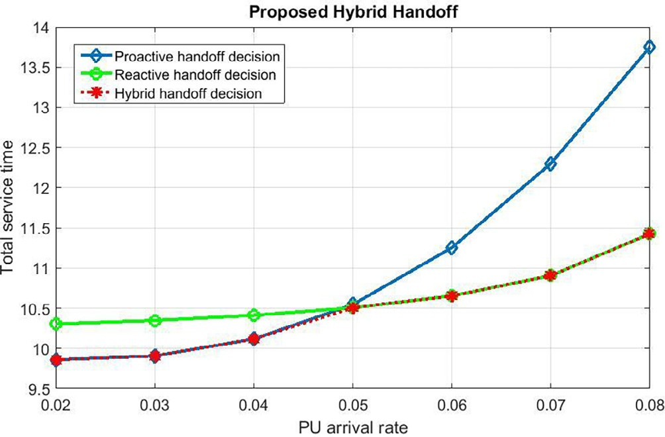

Fig. 5. The Recommended Hybrid Handoff.

Therefore, the threshold to move between reactive or proactive handoff strategies in the recommended (hybrid) approach is 0.05. In terms of total service time, our recommended strategy is corre- lated with the other two proactive and reactive handoff techniques, also shown in Fig. 5. As the arrival rate crosses the threshold point, the hybrid handoff mode moves to the reactive handoff scheme that empowers it to attain superior performance over the proactive handoff scheme. The hybrid spectrum handoff strategy permits SPUs to move from a proactive to reactive approach when the arrival rate of FPU is lower than the threshold point. Hence the recommended hybrid spectrum handoff strategy uses the benefits of both proactive and reactive handoff schemes at whatever point required.

The probabilistic values of false alarm and miss-detection are primary metrics for sensing channels and mainly affect the FPUs. On the one hand, when the sensing detection is weaker at a partic- ular channel during the FPU access, higher miss-detection is inferred, and the SPUs fail to vacate the channel. As a result, strin- gent conditions are forced to estimate probabilistic value for the miss-detection. On the other hand, when the probabilistic value for the false alarm increases in sensing, the occupation of white spaces will definitely decrease. Therefore, the adjustment of prob- abilistic values between a false alarm and miss-detection is essen- tial to observe.

The failure rate for different numbers of SPUs by considering a false alarm and the miss-detection compared to the Signal to Noise Ratio (SNR) is shown in Fig. 6 (for false alarm) and Fig. 7 (for miss- detection), respectively. The increased sensitivity will obviously increase energy consumption and result in better performance associated with energy efficiency. Therefore, it causes to reduce the false alarm chances and does not miss out on the hearing time for FPU to get back its channel. By considering both the factors, (i) the increase of SNR and (ii) the number of SPUs, it may potentially reduce the false alarm and lose access failure chances. The fore- most reason for the assumed operating system is that the SPUs col- laborate to create spectrum sensations.

The proposed method allows obtaining better enhancements during the coordination process between the miss-detection (for the acquisition of FPUs) and false alarm. Fig. 8 shows a comparison in the form of a hybrid handoff of the failure chances caused by the false alarm and miss-detection. The x-axis represents the proba- bilistic values for the false alarm, and the y-axis shows the proba- bilistic values for the miss-detection. It is apparent from both Fig. 5 and Fig. 6 that with the increased number of SPUs, the chances of a false alarm and miss (undetectable) detection are reduced suffi- ciently. It can be analyzed from Fig. 8 that using a different number of SPUs, i.e., 2, 5, and 10, and an increase in the number of SPUs has

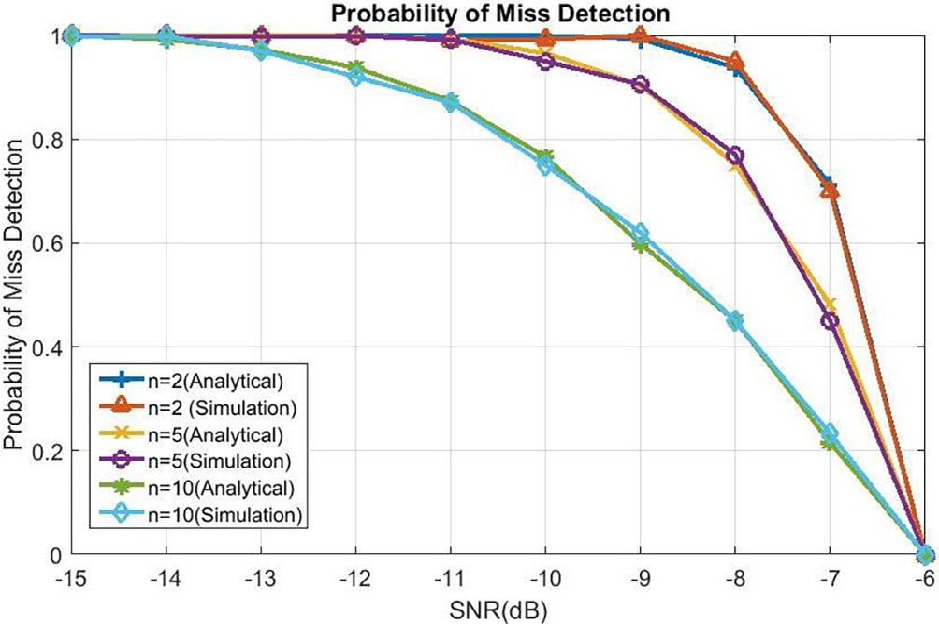

Fig. 6. Probability of Miss-Detection.

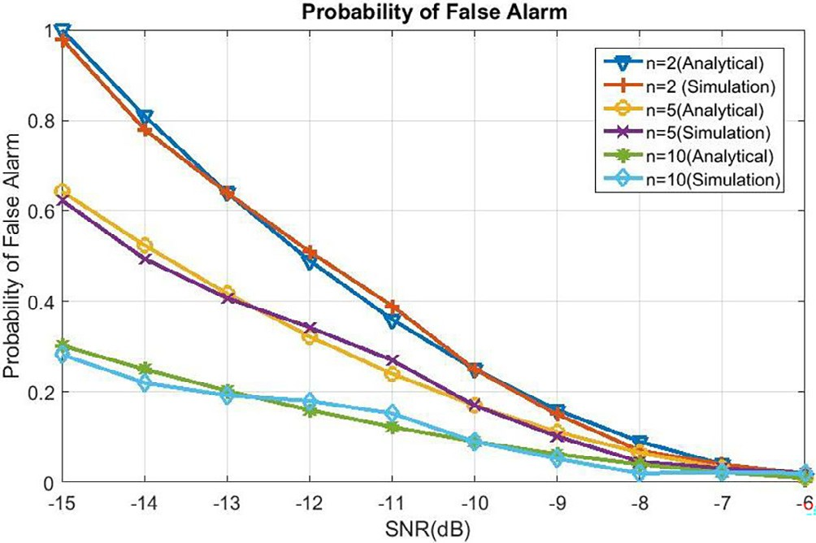

Fig. 7. Probability of False Alarm.

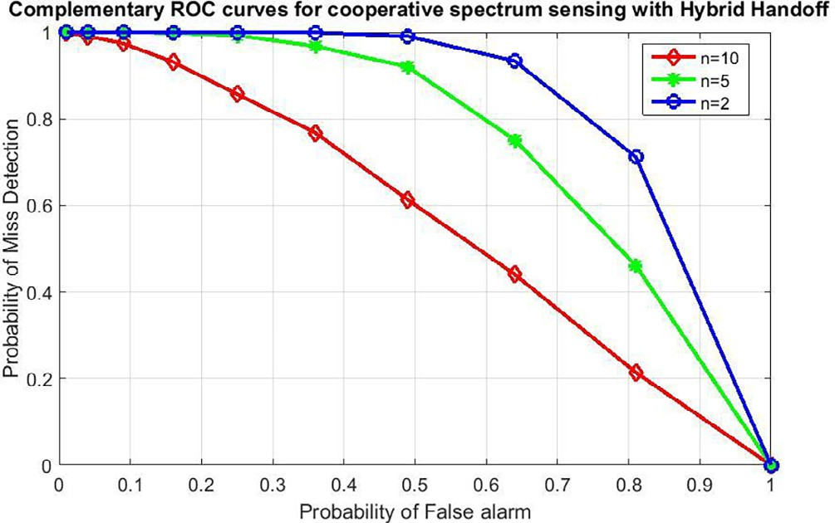

Fig. 8. Probability of Miss-Detection and False Alarm using Proposed Approach.

a similar decreasing effect on chances of failure due to the miss- detection and false alarms.

In this paper, the goal of using CSS and hybrid handoff approaches is to accomplish high accuracy during the FPU detection process while decreasing the energy consumption and improving the throughput. To achieve high accuracy during detection, both the throughput and energy consumption are associated with sens- ing. The effect of the FPUs arrival rate with respect to the overall accomplished throughput is shown in Fig. 9. Besides the throughput of users (FPUs and SPUs), the overall throughput is also shown in Fig. 10. It can be observed that the overall throughput is improved when the involvement of FPUs in performing activities is reduced on the CRN. Increasing the number of SPUs and transmission time improves the throughput for both (FPUs and SPUs) users. As described earlier, the FPU is a licensed user, and when it utilizes the channel further, the SPU transmission will decrease. Therefore, the SPUs will collaborate to detect FPU’s activities by using CSS. Due to this collaboration, the bit error rate (BER) on the spectrum will decrease, and the system’s throughput will increase. The overall throughput is the coalescing throughput of FPUs and SPUs achieved employing CSS and hybrid handoff schemes.

Fig. 10 demonstrates the comparison of the power consumption pattern of the recommended strategy. The graph shows three peak values of the power consumption pattern at 1000 Hz, 2000 Hz, and 3000 Hz, respectively. It shows that the model consumes consis- tent power with increased operating frequency values due to the use of the CSS approach. The SPUs cooperate to share information for sensing parameters that result in minimum energy consump- tion. The primary benefit of consuming less energy is to accomplish

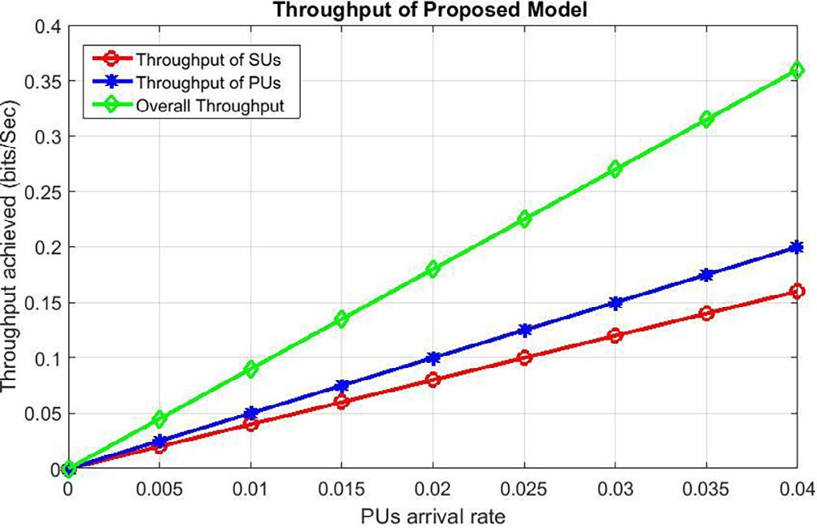

Fig. 9. Throughput of Proposed Framework.

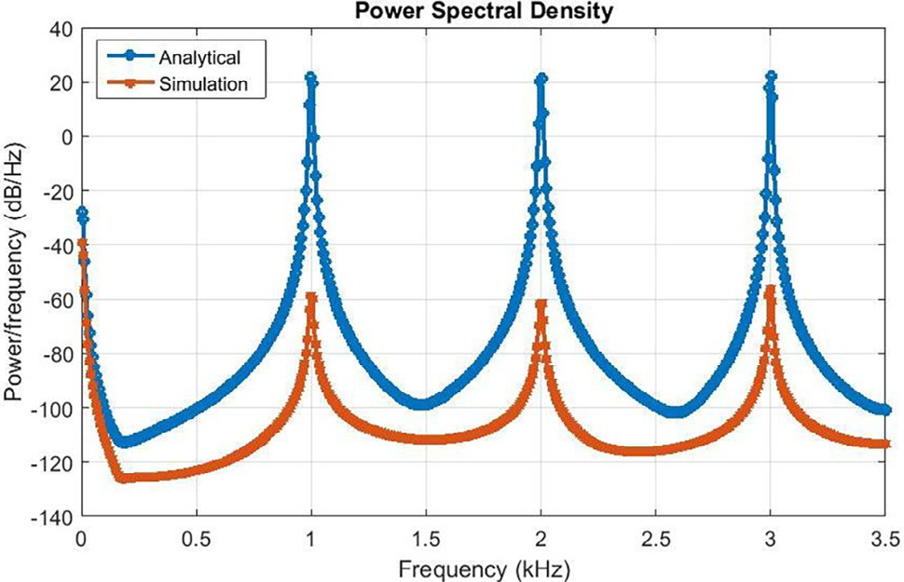

Fig. 10. Energy Efficiency of Proposed Framework.

the stability between energy consumption and throughput. Hence, energy efficiency is specified as the ratio between total expended energy and total attainable throughput. Therefore, to avoid inter- ference at the licensed FPUs, the missed detection probability is restricted by keeping it within the acceptable range.

The above results show that the model can increase energy effi- ciency by lowering energy consumption while increasing through- put and sensing efficiency. The handoff scheme reduces the overall handoff delay to an absolute minimum. As the number of SPUs increases, false alarm and miss-detection probability decrease, resulting in efficient CRNs throughput. Aside from that, a few lim- itations to this research must be addressed in future research, such as the additional unoccupied spectrums that are available for transmission but are not used, resulting in extra energy consump- tion. Furthermore, a method for sharing or distributing reliable information about channels between SPUs is required.

As described in the literature review by Table 1, the proposed scheme is thought to outperform existing approaches in terms of energy efficiency, throughput, and handoff delay. The results show that the model is capable of increasing energy efficiency by lower- ing energy consumption while increasing throughput and sensing efficiency. The handoff scheme reduces the overall handoff delay to an absolute minimum. As the number of SPUs increases, the probability of false alarm and miss-detection decreases, resulting in efficient CRN throughput. Aside from that, there are a few limi- tations to this research that must be addressed in future research, such as the additional unoccupied spectrums that are available for transmission but are not used, resulting in extra energy consump- tion. Furthermore, a method for sharing or distributing reliable information about channels between SPUs is required.

1. Conclusion and future work

The SPU leads to a broad position in energy efficiency in com- munication technologies, where the spectrum is shared rather than diminished. A CSS-based SPU transmission model for CRN is pre- sented in this paper. An energy detection technique has been developed to optimize energy consumption while sensing, result- ing in energy efficiency. To select the appropriate vacant channel for transmission, a DSA-based hybrid handoff scheme was repro- cessed. These approaches have been combined to improve the sensing routine and throughput while reducing energy consump- tion through the false alarm and miss-detection probabilistic val- ues. The results show that the presented model is robust in increasing energy efficiency by reducing energy consumption while improving throughput and sensing efficiency. The handoff scheme keeps the overall handoff delay to a bare minimum. The false alarm and miss-detection probabilistic values decrease as the number of SPUs increases, resulting in efficient CRN through- put. The proposed scheme is consistent in terms of (a) optimizing energy efficiency, (b) sensing performance, (c) throughput, and (d) minimizing handoff delay.

This research can be improved by considering the additional unoccupied spectrums available for transmission but are not used, resulting in extra energy consumption. In order to attain a high level of energy efficiency, it is necessary to suggest innovative ways in which users can employ multiple spectrums for their transmissions. In addition, a method is necessary to share or dis- tribute reliable information regarding channels between SPUs. Because malicious users can spread incorrect information about spectrum gaps and continues to exploit them, the other SPUs con- sume energy by repeatedly detecting the occupied channel.

1. Data availability statement

The synthetic dataset is used in this study.

Author contributions

All authors listed have made a substantial, direct, and intellec- tual contribution to the work and approved it for publication.

Declaration of Competing Interest

The authors declare that they have no known competing finan- cial interests or personal relationships that could have appeared to influence the work reported in this paper.

Acknowledgments

Part of this research work was done at University College Dublin, Ireland.

References

1. Wang B, Liu KJR. Advances in cognitive radio networks: A survey. IEEE J Sel Top Signal Process Feb. 2011;5(1):5–23. doi: [https://doi.org/10.1109/](https://doi.org/10.1109/JSTSP.2010.2093210) [JSTSP.2010.2093210](https://doi.org/10.1109/JSTSP.2010.2093210).
2. Akan OB, Karli OB, Ergul O. Cognitive radio sensor networks. IEEE Netw 2009;23(4):34–40. doi: <https://doi.org/10.1109/MNET.2009.5191144>.
3. [Sudhamani C, M. SSR. Energy Efficiency in Cognitive Radio Network Using](http://refhub.elsevier.com/S1110-8665(22)00050-0/h0015) [Cooperative Spectrum Sensing. Wireless Pers Commun 2019;104(3):907–19](http://refhub.elsevier.com/S1110-8665(22)00050-0/h0015).
4. Xue D, Ekici E, Vuran MC. Cooperative Spectrum Sensing in Cognitive Radio Networks Using Multidimensional Correlations. IEEE Trans Wirel Commun 2014;13(4):1832–43. doi: <https://doi.org/10.1109/TWC.2014.022714.130351>.
5. Pandit S, Singh G. ‘Spectrum Sensing in Cognitive Radio Networks: Potential Challenges and Future Perspective’, 2017, pp. 35–75. doi: 10.1007/978-3-319- 53147-2_2.
6. [Zargarzadeh S, Moghim N, Ghahfarokhi BS. A consensus-based cooperative](http://refhub.elsevier.com/S1110-8665(22)00050-0/h0030) [Spectrum sensing technique for CR-VANET. Peer-Peer Netw Appl 2021;14](http://refhub.elsevier.com/S1110-8665(22)00050-0/h0030) [(2):781–93](http://refhub.elsevier.com/S1110-8665(22)00050-0/h0030).
7. Noorshams N, Malboubi M, Bahai A. Centralized and decentralized cooperative spectrum sensing in cognitive radio networks: A novel approach. In: in 2010 IEEE 11th International Workshop on Signal Processing Advances in Wireless Communications (SPAWC). p. 1–5. doi: [https://doi.org/10.1109/](https://doi.org/10.1109/SPAWC.2010.5670998) [SPAWC.2010.5670998](https://doi.org/10.1109/SPAWC.2010.5670998).
8. [Rauniyar A, Jang JM, Shin SY. Optimal hard decision fusion rule for centralized](http://refhub.elsevier.com/S1110-8665(22)00050-0/h0040) [and decentralized cooperative spectrum sensing in cognitive radio networks. J](http://refhub.elsevier.com/S1110-8665(22)00050-0/h0040) [Adv Comput Netw 2015;3(3):207–12. 0.7763/JACN.2015.V3.168](http://refhub.elsevier.com/S1110-8665(22)00050-0/h0040).
9. He X, Jiang H, Song Y, Luo Y, Zhang Q. Joint optimization of channel allocation and power control for cognitive radio networks with multiple constraints. Wirel Netw Jan. 2020;26(1):101–20. doi: [https://doi.org/10.1007/s11276-018-](https://doi.org/10.1007/s11276-018-1785-1) [1785-1](https://doi.org/10.1007/s11276-018-1785-1).
10. [Bae S, So J, Kim H. On optimal cooperative sensing with energy detection in](http://refhub.elsevier.com/S1110-8665(22)00050-0/h0050) [cognitive radio. Sensors 2017;17(9):2111](http://refhub.elsevier.com/S1110-8665(22)00050-0/h0050).
11. Ghorbel MB, Hamdaoui B, Hamdi R, Guizani R, NoroozOliaee M. ‘Distributed dynamic spectrum access with adaptive power allocation: Energy efficiency and cross-layer awareness’, in 2014 IEEE Conference on Computer Communications Workshops (INFOCOM WKSHPS), 2014, pp. 694–699. doi: 10.1109/INFCOMW.2014.6849315.
12. [Ma J, Hasegawa S, Kim S-J, Hasegawa M. A Reinforcement-Learning-Based](http://refhub.elsevier.com/S1110-8665(22)00050-0/h0060) [Distributed Resource Selection Algorithm for Massive IoT. Appl Sci 2019;9](http://refhub.elsevier.com/S1110-8665(22)00050-0/h0060) [(18):3730](http://refhub.elsevier.com/S1110-8665(22)00050-0/h0060).
13. [Plummer A, Biswas S. Distributed spectrum assignment for cognitive networks](http://refhub.elsevier.com/S1110-8665(22)00050-0/h0065) [with heterogeneous spectrum opportunities. Wirel Commun Mob Comput](http://refhub.elsevier.com/S1110-8665(22)00050-0/h0065) [2011;11(9):1239–53](http://refhub.elsevier.com/S1110-8665(22)00050-0/h0065).
14. Ping S, Aijaz A, Holland O, Aghvami A. SACRP: A Spectrum Aggregation-Based Cooperative Routing Protocol for Cognitive Radio Ad-Hoc Networks. IEEE Trans Commun 2015;63(6):2015–30. doi: [https://doi.org/10.1109/](https://doi.org/10.1109/TCOMM.2015.2424239) [TCOMM.2015.2424239](https://doi.org/10.1109/TCOMM.2015.2424239).
15. Zareei M, Islam AKMM, Mansoor N, Baharun S. ‘Dynamic spectrum allocation for cognitive radio ad hoc network’, in. International Conference on Advances in Electrical Engineering (ICAEE) 2015;2015:178–81. doi: [https://doi.org/](https://doi.org/10.1109/ICAEE.2015.7506825) [10.1109/ICAEE.2015.7506825](https://doi.org/10.1109/ICAEE.2015.7506825).
16. Yucek T, Arslan H. A survey of spectrum sensing algorithms for cognitive radio applications. IEEE Commun Surv Tutor 2009;11(1):116–30. doi: [https://doi.](https://doi.org/10.1109/SURV.2009.090109) [org/10.1109/SURV.2009.090109](https://doi.org/10.1109/SURV.2009.090109).
17. [Ali A, Hamouda W. Advances on Spectrum Sensing for Cognitive Radio](http://refhub.elsevier.com/S1110-8665(22)00050-0/h0085) [Networks: Theory and Applications. IEEE Commun Surv Tutorials 2017;19](http://refhub.elsevier.com/S1110-8665(22)00050-0/h0085) [(2):1277–304](http://refhub.elsevier.com/S1110-8665(22)00050-0/h0085).
18. Bhandari S, Moh S. A Survey of MAC Protocols for Cognitive Radio Body Area Networks. Sensors Apr. 2015;15(4):9189–209. doi: [https://doi.org/10.3390/](https://doi.org/10.3390/s150409189) [s150409189](https://doi.org/10.3390/s150409189).
19. Darsena D, Gelli G, Verde F. An Opportunistic Spectrum Access Scheme for Multicarrier Cognitive Sensor Networks. IEEE Sens J 2017;17(8):2596–606. doi: <https://doi.org/10.1109/JSEN.2017.2674181>.
20. Muralidharan A, Venkateswaran P, Ajay SG, Prakash DA, Arora M, Kirthiga S. An adaptive threshold method for energy based spectrum sensing in Cognitive Radio Networks. In: 2015 International Conference on Control, Instrumentation, Communication and Computational Technologies (ICCICCT).

p. 8–11. doi: <https://doi.org/10.1109/ICCICCT.2015.7475239>.

1. Haldorai A, Kandaswamy U. Cooperative Spectrum Handovers in Cognitive Radio Networks. In: Intelligent Spectrum Handovers in Cognitive Radio Networks. Cham: Springer International Publishing; 2019. p. 1–18. doi: <https://doi.org/10.1007/978-3-030-15416-5_1>.
2. [Qian X, Hao L, Ni D, Tran QT. Hard fusion based spectrum sensing over mobile](http://refhub.elsevier.com/S1110-8665(22)00050-0/h0110) [fading channels in cognitive vehicular networks. Sensors 2018;18(2):475](http://refhub.elsevier.com/S1110-8665(22)00050-0/h0110).
3. Ganesan G, Li Y. Cooperative Spectrum Sensing in Cognitive Radio, Part II: Multiuser Networks. IEEE Trans Wirel Commun 2007;6(6):2214–22. doi: <https://doi.org/10.1109/TWC.2007.05776>.
4. Dey S. Misra IS. ‘Modeling of an Efficient Sensing Strategy for Real Time Video Communication over Cognitive Radio Network’, in 2020 IEEE Calcutta Conference (CALCON), 2020, pp. 69–73. doi: 10.1109/ CALCON49167.2020.9106566.
5. Rauniyar A, Shin SY. Cooperative spectrum sensing based on adaptive activation of energy and preamble detector for cognitive radio networks. APSIPA Trans Signal Inf Process 2018;7:. doi: <https://doi.org/10.1017/ATSIP.2018.5>e2.
6. Shokri-Ghadikolaei H, Glaropoulos I, Fodor V, Fischione C, Dimou K. Energy Efficient Spectrum Sensing and Handoff Strategies in Cognitive Radio Networks. 2013.
7. [Orumwense EF, Afullo TJ, Srivastava VM. Energy efficiency metrics in cognitive](http://refhub.elsevier.com/S1110-8665(22)00050-0/h0135) [radio networks: A hollistic overview. Int J Commun Netw Inf Secur 2016;8](http://refhub.elsevier.com/S1110-8665(22)00050-0/h0135) [(2):75](http://refhub.elsevier.com/S1110-8665(22)00050-0/h0135).
8. [Alsarhan A. An optimal configuration-based trading scheme for profit](http://refhub.elsevier.com/S1110-8665(22)00050-0/h0140) [optimization in wireless networks. Egypt Inform J 2022;23(1):13–9](http://refhub.elsevier.com/S1110-8665(22)00050-0/h0140).
9. Fu Y, Yang F, He Z. A Quantization-Based Multibit Data Fusion Scheme for Cooperative Spectrum Sensing in Cognitive Radio Networks. Sensors Feb. 2018;18(2):473. doi: <https://doi.org/10.3390/s18020473>.
10. Chaudhari S, Lunden J, Koivunen V, Poor HV. Cooperative Sensing With Imperfect Reporting Channels: Hard Decisions or Soft Decisions? IEEE Trans Signal Process 2012;60(1):18–28. doi: <https://doi.org/10.1109/TSP.2011.2170978>.
11. Zhong W, Chen K, Liu X. Joint optimal energy-efficient cooperative spectrum sensing and transmission in cognitive radio. China Commun 2017;14 (1):98–110. doi: <https://doi.org/10.1109/CC.2017.7839761>.
12. Althunibat S, Di Renzo M, Granelli F. Towards energy-efficient cooperative spectrum sensing for cognitive radio networks: an overview. Telecommun Syst May 2015;59(1):77–91. doi: <https://doi.org/10.1007/s11235-014-9887-2>.
13. Lee C, Wolf W. Energy Efficient Techniques for Cooperative Spectrum Sensing in Cognitive Radios. In: 2008 5th IEEE Consumer Communications and Networking Conference. p. 968–72. doi: <https://doi.org/10.1109/ccnc08.2007.223>.
14. Mashhour M, Hussein AI, Mogahed HS. Sub-Nyquist Wideband Spectrum Sensing Based on Analog to Information Converter for Cognitive Radio. Procedia Comput Sci 2021;182:132–9. doi: [https://doi.org/10.1016/j.](https://doi.org/10.1016/j.procs.2021.02.018) [procs.2021.02.018](https://doi.org/10.1016/j.procs.2021.02.018).
15. Althunibat S, Vuong TM, Granelli F. Multi-channel collaborative spectrum sensing in cognitive radio networks. In: 2014 IEEE 19th International Workshop on Computer Aided Modeling and Design of Communication Links and Networks (CAMAD). p. 234–8. doi: [https://doi.org/10.1109/](https://doi.org/10.1109/CAMAD.2014.7033241) [CAMAD.2014.7033241](https://doi.org/10.1109/CAMAD.2014.7033241).
16. Saleh SS, Mabrouk TF, Tarabishi RA. An improved energy-efficient head election protocol for clustering techniques of wireless sensor network (June 2020). Egypt Inform J 2021;22(4):439–45. doi: [https://doi.org/10.1016/j.](https://doi.org/10.1016/j.eij.2021.01.003) [eij.2021.01.003](https://doi.org/10.1016/j.eij.2021.01.003).
17. Matikolaei EG, Meghdadi H, Shahzadi A, Darzikolaei MA. Threshold optimization of collaborative spectrum sensing by maximizing the Sensing Reliability Index under Nakagami-m fading. AEU - Int J Electron Commun 2019;111:. doi: <https://doi.org/10.1016/j.aeue.2019.05.027>152760.
18. [Salahdine F, El Ghazi H, Kaabouch N, Fihri WF. Matched filter detection with](http://refhub.elsevier.com/S1110-8665(22)00050-0/h0190) [dynamic threshold for cognitive radio networks. In: 2015 international](http://refhub.elsevier.com/S1110-8665(22)00050-0/h0190) [conference on wireless networks and mobile communications (WINCOM). p. 1–6](http://refhub.elsevier.com/S1110-8665(22)00050-0/h0190).
19. Moon B. Dynamic Spectrum Access for Internet of Things Service in Cognitive Radio-Enabled LPWANs. Sensors Dec. 2017;17(12):2818. doi: [https://doi.org/](https://doi.org/10.3390/s17122818) [10.3390/s17122818](https://doi.org/10.3390/s17122818).
20. Lu L, Zhou X, Onunkwo U, Li GY. Ten years of research in spectrum sensing and sharing in cognitive radio. EURASIP J Wirel Commun Netw Jan. 2012;2012

(1):28. doi: <https://doi.org/10.1186/1687-1499-2012-28>.

1. Delpha C, Diallo D, Samrout HA, Moubayed N. Multiple incipient fault diagnosis in three-phase electrical systems using multivariate statistical signal processing. Eng Appl Artif Intell 2018;73:68–79. doi: [https://doi.org/](https://doi.org/10.1016/j.engappai.2018.04.007) [10.1016/j.engappai.2018.04.007](https://doi.org/10.1016/j.engappai.2018.04.007).
2. [Khatbi O, Hachkar Z, Mouhsen A. ‘Cyclostationary Spectrum Sensing Based on](http://refhub.elsevier.com/S1110-8665(22)00050-0/h0210) [FFT Accumulation Method in Cognitive Radio Technology’, in Trends and](http://refhub.elsevier.com/S1110-8665(22)00050-0/h0210) [Advances in Information Systems and Technologies. Cham 2018:542–52](http://refhub.elsevier.com/S1110-8665(22)00050-0/h0210).
3. Al-Dulaimi A, Radhi N, Al-Raweshidy HS. ‘Cyclostationary Detection of Undefined Secondary Users’, in 2009 Third International Conference on Next Generation Mobile Applications, Services and Technologies, 2009, pp. 230–

233. doi: 10.1109/NGMAST.2009.101.

1. Sharma M, Raval M, Acharya UR. A new approach to identify obstructive sleep apnea using an optimal orthogonal wavelet filter bank with ECG signals. Inform Med Unlocked 2019;16:. doi: [https://doi.org/10.1016/j.](https://doi.org/10.1016/j.imu.2019.100170) [imu.2019.100170](https://doi.org/10.1016/j.imu.2019.100170)100170.
2. Kumar A, N. p,. OFDM system with cyclostationary feature detection spectrum sensing. ICT Express 2019;5(1):21–5. doi: [https://doi.org/10.1016/j.](https://doi.org/10.1016/j.icte.2018.01.007) [icte.2018.01.007](https://doi.org/10.1016/j.icte.2018.01.007).
3. DasMahapatra S, Sharan SN. A general framework for multiuser de-centralized cooperative spectrum sensing game. AEU - Int J Electron Commun 2018;92:74–81. doi: <https://doi.org/10.1016/j.aeue.2018.05.010>.
4. Tandra R, Sahai A. SNR Walls for Signal Detection. IEEE J Sel Top Signal Process 2008;2(1):4–17. doi: <https://doi.org/10.1109/JSTSP.2007.914879>.
5. Murty MS, Shrestha R. ‘Reconfigurable and Memory-Efficient Cyclostationary Spectrum Sensor for Cognitive-Radio Wireless Networks’, IEEE Trans. Circuits Syst II Express Briefs 2018;65(8):1039–43. doi: [https://doi.org/10.1109/](https://doi.org/10.1109/TCSII.2018.2790952) [TCSII.2018.2790952](https://doi.org/10.1109/TCSII.2018.2790952).
6. Hillenbrand J, Weiss TA, Jondral FK. Calculation of detection and false alarm probabilities in spectrum pooling systems. IEEE Commun Lett 2005;9 (4):349–51. doi: <https://doi.org/10.1109/LCOMM.2005.1413630>.
7. [Kavaiya S, Patel DK, Guan YL, Sun S, Chang YC, Lim J-Y. On the energy detection](http://refhub.elsevier.com/S1110-8665(22)00050-0/h0250) [performance of multi-antenna correlated receiver for vehicular](http://refhub.elsevier.com/S1110-8665(22)00050-0/h0250) [communication using MGF approach. IET Commun 2020;14(12):1858–68](http://refhub.elsevier.com/S1110-8665(22)00050-0/h0250).
8. Sofotasios PC, Mohjazi L, Muhaidat S, Al-Qutayri M, Karagiannidis GK. Energy Detection of Unknown Signals Over Cascaded Fading Channels. IEEE Antennas Wirel Propag Lett 2016;15:135–8. doi: [https://doi.org/10.1109/](https://doi.org/10.1109/LAWP.2015.2433212) [LAWP.2015.2433212](https://doi.org/10.1109/LAWP.2015.2433212).
9. [Zheng M, Liang W, Yu H, Sharif H. Utility-based opportunistic spectrum access](http://refhub.elsevier.com/S1110-8665(22)00050-0/h0260) [for cognitive radio sensor networks: Joint spectrum sensing and random](http://refhub.elsevier.com/S1110-8665(22)00050-0/h0260) [access control. IET Commun 2016;10(9):1044–52](http://refhub.elsevier.com/S1110-8665(22)00050-0/h0260).
10. Yuvaraj KS, Priya P. ‘A Review of Medium Access Control Protocols in Cognitive Radio Networks’, in 2018 International Conference on Current Trends towards Converging Technologies (ICCTCT), 2018, pp. 1–7. doi: 10.1109/ ICCTCT.2018.8550881.
11. [Arshid K, Hussain I, Bashir MK, Naseem S, Ditta A, Mian NA, et al. Primary User](http://refhub.elsevier.com/S1110-8665(22)00050-0/h0270) [Traffic Pattern Based Opportunistic Spectrum Handoff in Cognitive Radio](http://refhub.elsevier.com/S1110-8665(22)00050-0/h0270) [Networks. Appl Sci 2020;10(5):1674](http://refhub.elsevier.com/S1110-8665(22)00050-0/h0270).
12. Yin C, Tan X, Ma L. ‘A hybrid handoff strategy based on dynamic spectrum aggregation in cognitive radio system’, in IEEE. Tencon - Spring 2013;2013:213–7. doi: <https://doi.org/10.1109/TENCONSpring.2013.6584442>.
13. [Rathee G, Jaglan N, Garg S, Choi BJ, Choo K-K. A Secure Spectrum Handoff](http://refhub.elsevier.com/S1110-8665(22)00050-0/h0280) [Mechanism in Cognitive Radio Networks. IEEE Trans Cogn Commun Netw](http://refhub.elsevier.com/S1110-8665(22)00050-0/h0280) [2020;6(3):959–69](http://refhub.elsevier.com/S1110-8665(22)00050-0/h0280).