Journal Pre-proof



Enhancing Hourly Heat Demand Prediction through Artificial Neural Networks: A National Level Case Study

Meng Zhang , Michael-Allan Millar , Si Chen , Yaxing Ren , Zhibin Yu , James Yu

PII: S2666-5468(23)00087-3

DOI: <https://doi.org/10.1016/j.egyai.2023.100315>

Reference: EGYAI 100315

To appear in: *Energy and AI*

Received date: 17 May 2023

Revised date: 30 October 2023

Accepted date: 2 November 2023

Please cite this article as: Meng Zhang , Michael-Allan Millar , Si Chen , Yaxing Ren , Zhibin Yu , James Yu , Enhancing Hourly Heat Demand Prediction through Artificial Neural Networks: A National Level Case Study, *Energy and AI* (2023), doi: <https://doi.org/10.1016/j.egyai.2023.100315>

This is a PDF file of an article that has undergone enhancements after acceptance, such as the addition of a cover page and metadata, and formatting for readability, but it is not yet the definitive version of record. This version will undergo additional copyediting, typesetting and review before it is published in its final form, but we are providing this version to give early visibility of the article. Please note that, during the production process, errors may be discovered which could affect the content, and all legal disclaimers that apply to the journal pertain.

 2023 Published by Elsevier Ltd.

This is an open access article under the CC BY-NC-ND license (<http://creativecommons.org/licenses/by-nc-nd/4.0/>)

Enhancing Hourly Heat Demand Prediction through Artificial Neural Networks: A National Level Case Study

Meng Zhang1, Michael-Allan Millar2, Si Chen3, Yaxing Ren4, Zhibin Yu 5*, and James Yu6

[*12341999z@student.gla.ac.uk,*](mailto:12341999z@student.gla.ac.uk) *James Watt School of Engineering, University of Glasgow, Glasgow, G12 8QQ, UK*

*2* [*Michael.millar@glasgow.ac.uk,*](mailto:Michael.millar@glasgow.ac.uk) *James Watt School of Engineering, University of Glasgow, Glasgow, G12 8QQ, UK*

*3* [*si.chen@glasgow.ac.uk,*](mailto:si.chen@glasgow.ac.uk) *James Watt School of Engineering, University of Glasgow, Glasgow, G12 8QQ, UK*

[*4yren@lincoln.ac.uk,*](mailto:4yren@lincoln.ac.uk) *University of Lincoln, Brayford Pool, Lincoln, LN6 7TS*

[*5Zhibin.yu@glasgow.ac.uk,*](mailto:5Zhibin.yu@glasgow.ac.uk) *James Watt School of Engineering, University of Glasgow, Glasgow, G12 8QQ, UK*

[*6James.yu@spenergynetworks.co.uk,*](mailto:6James.yu@spenergynetworks.co.uk) *Scottish Power, Glasgow, G2 8DQ, UK*

# Abstract

Meeting the goal of zero emissions in the energy sector by 2050 requires accurate prediction of energy consumption, which is increasingly important. However, conventional bottom-up model-based heat demand forecasting methods are not suitable for large-scale, high-resolution, and fast forecasting due to their complexity and the difficulty in obtaining model parameters. This paper presents an artificial neural network (ANN) model to predict hourly heat demand on a national level, which replaces the traditional bottom-up model based on extensive building simulations and computation. The ANN model significantly reduces prediction time and complexity by reducing the number of model input types through feature selection, making the model more realistic by removing non-essential inputs. The improved model can be trained using fewer meteorological data types and insufficient data, while accurately forecasting the hourly heat demand throughout the year within an acceptable error range. The model provides a framework to obtain accurate heat demand predictions for large- scale areas, which can be used as a reference for stakeholders, especially policymakers, to make informed decisions.



*Keywords: Heating demand in buildings; National level forecast; Feature selection; Machine learning; Artificial neural network*

## Introduction

Space heating for buildings accounts for approximately 25% of the UK’s energy demand while this proportion is higher in high-latitude regions, such as Scotland [1]. In 2016, heating accounted for 37% of the total greenhouse gas emissions in the UK, making heat a critical energy sector for decarbonisation [2]. A number of technologies (e.g. low carbon heat networks, hydrogen and heat pumps) have been proposed to support the decarbonisation of heat to ‘net zero’ by 2050. The most promising low-carbon heating technologies are all electrical based, which can place significant strain on local electricity infrastructure. As the Boiler Upgrade Scheme (BUS) project moves forward, more heat pumps will be installed in domestic buildings [3]. However, there is currently very little understanding of how the electrification of heat will affect the resilience of the electrical grid in the lead to 2050. This makes the predictions of heat demand an important milestone on the path to the net-zero emission targets. In particular, a high-resolution and rapid response model for heating demand prediction is necessary to give policymakers the essential data support. Many research methods for heating demand estimation for different purposes or scenarios have been proposed.

Monitoring heating demand is not as simple as electricity meters and the meter for heat is not widely used today. As mentioned in many pieces of research, the real demand data for heat is not easily accessible. It can be found that not all buildings have advanced building automation systems. Also, the heating is always provided by different technologies and multiple sources, which increases the difficulty of measurement. As real data on the heating demand of district heating systems are more accessible than in a national area, forecasts of heating demand are mostly concentrated on district heating systems. The availability of high-resolution data at the district level is a contributing factor to this phenomenon. Also, construction data of buildings, such as wall and window insulation, is comparatively easier to collect at the district level. Nonetheless, it should be noted that not

all district-level heating systems have monitoring systems installed, leading some studies to rely on the construction of physical models to obtain high-resolution data. In many investigations, therefore, training data is derived from building simulations, especially for the early design of a building. Singaravel et al. designed a data-driven model for the design stage of buildings, in which specific data from similar circumstances can be reused [4]. Singh et al. proposed that enrichment is more effective than increment to decrease the generalization for early-stage building energy prediction and develop an efficient data collection approach [5]. However, high- resolution models are often used for small areas, such as a campus. There is not sufficient data for long-term forecasts for large areas such as a city or country. Large-scale heat demand estimations, such as national demand, are always based on economic data which can only calculate the annual demand. However, as decarbonisation is being implemented and the interaction of different energy sectors deepens, it becomes apparent that long-term forecasts based on economic models are not sufficient.

In energy demand estimation methods, machine learning (ML) based models can make fast and accurate predictions after being trained using large amounts of data. ML can make more reliable predictions than other statistical or physical methods, which can significantly reduce labour costs and time consumption [6]. Therefore, the application of ML in the energy sector has grown exponentially over the past decade, especially in forecasting electricity demand and renewable power generation [7], such as solar and wind power [8]. ML energy prediction has also been increasingly applied to building energy consumption [9]. Kurek et al. analysed heat demand forecasting for district heating (DH) systems using various ML methods [10]. Deng et al compared the statistical and ML prediction model with publicly available building energy data from US commercial buildings [11]. Co-author Si used the University of Glasgow campus as a case study, using ML in place of physical models to predict the heat demand of the campus quickly and accurately [12]. The Extra-Trees Regressor and Extreme Learning Machines algorithm were used individually and coupled in a heat prediction model for District Heating Systems [13]. Olu-Ajayi et al. developed an annual prediction model for residential buildings in the design stage with ANN, Gradient Boosting (GB), Deep Neural Network (DNN), Random Forest (RF), Stacking, K Nearest Neighbour (KNN), SVM, Decision tree (DT) and Linear Regression (LR) [14].

The ANN-based method is one of the most popular forecasting methods for energy planning models, and it has been used for the prediction of energy consumption at both the district level and national levels [15]. ANNs have extensive applications at the district level and are renowned for their high accuracy. Conversely, national- level predictions typically concentrate on forecasting annual demand which is based on economic data. Geem et al. developed an ANN model based on population, GDP and energy consumption data to predict the annual energy demand for South Korea [16]. Liu et al. proposed an annual energy prediction model for different sectors in Spain with ANN and grey neural network according to three different GDP growth scenarios (optimistic, baseline and pessimistic) [17]. Luo et al. designed a prediction framework for multiple building energy loads with different machine-learning methods and the ANN-based model is the best accuracy and average time- consuming [18]. Elbeltagi et al. designed a user-friendly interface based on the ANN algorithm to calculate the heating and cooling consumption of any building with the need for building physical chrematistics and building location [19]. Li et al. proposed an ANN-based model with the method of characterization decomposition (MCD) and the method of spatial homogenization decomposition (MSHD), which can be used to predict buildings with complex architectural forms [20]. Kannari et al. developed prediction models based on ANN for different types of buildings [21]. Bünning et al. enhanced the accuracy of a daytime ANN model with online corrections [22]. Parfenenko et al. forecasted the daily heat demand of district-heated public sector buildings based on an ANN model [23]. Li et al. designed an ANN-based building energy model with transfer learning for one hour ahead energy prediction based on the data from the Building Genome Project, which have a better performance for information-poor buildings by taking advantage of rich data from other buildings [24]. Seyedzadeh et al. proposed that choosing the right method for building energy prediction is important by analysing methods of ANN, SVM, Gaussian-based regressions and clustering [25]. Singaravel et al. proposed a faster and more accurate model for predicting heating demand based on model data from Energy Plus by using a component- based ML (CBML) algorithm [26]. Nutkiewicz et al. proposed a Data-driven Urban Energy Simulation (DUE-S) framework that combines ML with building simulation [27]. The algorithm application or development of ML is the most attractive topic in building load prediction, but it is still a challenge to realise automation in the industry. In the meantime, more research on the effects of climate change on buildings' energy performance by using ML approaches is necessary for the future [28].

However, the lack of data exists not only in the case of heat demand data or building data but also in the case of meteorological data. It is also the reason why ML is used less for heating demand forecasting in the reality. The

meteorological data of recent years is more complete and has more data types. However, there are fewer data types in the historical meteorological database. This gap would result in ML methods built on current meteorological data types not being able to train with historical meteorological data that misses some data types. Therefore, feature selection methods are used to extract more sensitive meteorological data from the database to train ML models. In this way, the trained ML model can use fewer types of meteorological data, incorporating historical data into the training dataset. The complexity of predicting future meteorological conditions and heat demand can also be reduced, thus making heat demand forecasting more reliable and achievable. Especially when applied to ML models, some inputs can bring perturbation to the system. Seyedzadeh et al. made some specific tunings to several popular ML algorithms and compared the performance of the tuned model with the original model through sensitivity analysis [29]. Potočnik et al. combined feature extraction and various ML methods to develop a multi-step short-term heat demand forecasting model in district heating (DH) systems [30]. Zhang et al. proposed a new approach for feature selection by combining three global sensitivity analyses, Pearson, Sobol' and PAWN, with RF. The GSA-based feature selection method is significantly better than the feature extraction method principle component analysis (PCA) in predicting settlement in tunnel applications [31]. Shen et al. proposed a feature selection method based on sensitivity analysis and applicable to SVM. The method assesses the importance of a selected feature by calculating the total value of the absolute difference between the probability output of an SVM on the feature space with or without the feature [31, 32]. Hana et al. developed a wrapper feature selection method for supervised learning based on Sobol' global sensitivity analysis. Random Forest and a set of published data are used to validate this feature selection method and the proposed feature selection significantly improves the accuracy of the predictions [33]. Becker et al. applied global sensitivity analysis to select variables in Regression Models and a competitive novel model selection method based on the ‘Pantula-principle’ was obtained [34]. Guo et al. combined correlation analysis with the LASSO method to select optimised feature sets for a building energy prediction model which includes four different ML methods: MLR, SVR, BPNN and ELM. [35]. Eseye et al. also combined ML with feature selection to develop a model for predicting the heating demand of a specific building [36]. Li et al. developed a prediction model with support vector regression (SVR), linear model stepwise regression (LMSR), distance-weighted K-nearest neighbours (KNN) and naive Bayes (NB) for electricity and heating demand on campus and select the optimised feature set to improve the model by using Particle Swarm Optimization and Genetic Algorithms (GA) [37]. Salcedo-Sanz et al. improved the accuracy of wind energy predictions with a new packaging method for feature selection [38]. Ahmad et al. designed a prediction model for district energy consumption by comparing several different feature selection methods [39].

Based on the literature review presented, the following key issues are summarised for ML applications in heat demand prediction.

* For heating demand prediction, ML is mainly applied to individual buildings or small-scale building complexes.
* Most research has focused on improving ML algorithms and applying different ML algorithms, but there is a lack of assessments of future scenarios like 2050.
* The lack of architectural and meteorological data is also an important reason for the low application of ML for large-scale, high-precision heat demand forecasting.

This research paper aims to introduce a novel framework for the efficient acquisition of high-resolution national-level data. The proposed approach replaces the traditional physical model with an Artificial Neural Network (ANN)-based model, which is a first in the field of high-resolution modelling at a national level. In this framework, information pertaining to buildings is omitted, while weather and timing data are retained as the main inputs. The lack of high-resolution heating demand data in the UK is a prominent issue, as it is challenging to directly monitor and is typically recorded on a yearly or monthly basis, as stated at the beginning of the paper. To address this limitation, this study relies on a validated simulation model to provide data. The simulation model acts as a source of data, while the ANN model simplifies the construction of the simulation model. Furthermore, this paper suggests a combination of sensitivity analysis and correlation analysis for selecting relevant features, thereby reducing the required types of meteorological data. This feature selection technique enhances the efficiency of the model. To validate the practical application of this framework, the model will be employed to predict the domestic heating demand in Scotland in the year 2050. The key innovations of this model are as follows:

1. The proposed model provides a fast response compared to the physical model, while maintaining the same high resolution at a national level.
2. It offers a prediction model solely based on weather data for building space heating, thereby eliminating the need for building-specific information.
3. The improved model successfully reduces the number of inputs required, while still ensuring accuracy. This enhancement greatly enhances the practical applicability of the model.

The remainder of the paper is organised as follows. Section 2 describes the methodology of the model. Section 3 provides the application of the model to Scotland. Section 4 presents the results and discussion. Section 5 is the conclusion of the study.

## Methodology

Figure 1 describes the overall process of modelling. A physical model is mainly composed of the building simulation and the building stock, which is not the task of this paper. The meteorological data and the heat demand obtained from the physical model are used as training data to train the ANN network. At the same time, sensitivity analysis and correlation analysis are applied to select features for the models. ANN networks and feature selection have constituted the model in this paper and are described further in this section.

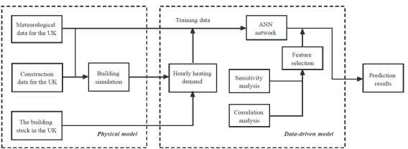

Figure 1 Block diagram of the prediction model

## ANN

ANN is proposed based on the structure of the human brain. It is a simplified model of the biological neural network, which has the ability to store empirical knowledge and process-related problems [40]. The basic elements of an ANN are neurons, which are connected in parallel to form each layer of the ANN. The simplest ANN is called perceptron, which has only one layer with one neuron. Each input of the perceptron has a corresponding weight, while the neuron can be considered as a mapping function. A single neuron is connected to thousands of other neurons. The information from the environment or other neurons is transmitted through numerous dendritic links. It is mentionable that a neural network is considered as a black box due to the unviewable internal working. It is difficult to investigate the relevance between the addressed problem and its internal structure. The ANN should be trained with a large amount of data before using it to solve the corresponding problems [41]. Because of its massively parallel distributed structure and its powerful learning and generalisation capabilities, ANN can solve many complex problems.

* + 1. Back propagation network

A back propagation (BP) neural network is a multi-layer feedforward neural network, which is characterised by the forward propagation of signals and backward propagation of errors. The BP neural network propagates forward layer by layer to obtain a result, and this result 𝑜 is compared with the expected result 𝒹 to obtain an error 𝔢. The neural network passes the error from the back to the front using the 'gradient descent' strategy to adjust weights and thresholds until a selected stopping criterion is met. The specific analysis of the working process of the BP neural network can be divided into five steps. The first step is initialization, which refers to setting the initial values of the weights and thresholds, generally set to zero without prior information. An error equation and an activation function need to be chosen and used in the BP network. The learning rate, number of iterations, and target error also need to be set. The second step is briefly summarised as input training data and the desired output. The third and fourth steps are the forward and backward computations, which are the most important processes for BP to adjust the weights and bias. The fifth step is the iterative forward and backward computations with the training data [42].

## Feature selection

The selection of model inputs is essential to the result. The selection of inputs is known as feature selection (FS) in ML, which is the process of selecting the most relevant features for use in model construction. Features are divided into three categories: those that are useful for the learning task and can enhance the effectiveness of the learning algorithm are called relevant features; features that do not help the algorithm in any way and do not bring any improvement to the effectiveness of the algorithm are called irrelevant features; features that do not bring new information to the algorithm, or whose information can be inferred from other features, are called redundant features [43]. Removing irrelevant and redundant features reduces the difficulty of the learning task, simplifies the model and makes it easier to understand. Fewer inputs also save on storage and computational overheads. The additional features, while better fitting the training data, may also increase the variance. Typically, the training sample of a model increases significantly with the number of features. Therefore, FS reduces the risk of overfitting and improves generalization ability. The three types of feature selection methods are filter, wrapper and embedded [33]. The filter applies feature selection before training the network, so the process of feature selection is independent of the learning process. It is similar to applying a filter to the features and then using a subset of the features to train the network. It does not rely on any ML methods and does not require cross-validation, making it computationally more efficient. However, the characteristics of ML algorithms are not considered. Wrapper combines FS with ML algorithms. The usage of ML algorithms to evaluate the effectiveness of feature subsets allows the detection of interactions between two or more features. In general, different combinations of subsets are generated. These combinations are compared, and the selection of subsets can be considered as an optimization problem. However, this method requires training a model for each subset of features, which is computationally intensive. It is likely to be overfitting if the training sample is not sufficient, and the computational complexity is too high when the number of feature variables is large. Embedded in the selection of those features that are important for the training of the model in the process of determining the model, which has the advantage of being combined with an ML algorithm, as well as the computational efficiency of the filter method. However, this method does not eliminate noisy or irrelevant features and therefore sacrifices model performance [33] [43] [44].

* + 1. Sensitivity analysis

Sensitivity analysis is the study of the importance of different inputs to a model and measures the effect of changes in the inputs on the output. Typical sensitivity analysis is divided into local and global sensitivity analyses. The one-way method is a type of local sensitivity analysis where one parameter is changed at a time and the change in output is observed to determine the effect of the input on the output. Although local sensitivity analysis does not consider the interactions between inputs, it is a simple and intuitive way of explaining the effects of inputs. Hence, the local sensitivity analysis method is a common approach in engineering research.

Global sensitivity analysis has the ability to show the influence between inputs and it can be applied to non- linear models. However, global sensitivity analysis is computationally intensive and is highly dependent on the assumed probability distribution of the input parameters or their range of variation [45]. At the same time, global sensitivity analysis does not have a uniform definition of sensitivity coefficients, so different methods



often lead to different sensitivity rankings. The Morris method is a global sensitivity analysis method developed based on the local derivative-based sensitivity method, which incorporates the advantages of both local and global sensitivity analyses. Morris method approximates this derivative using a finite difference scheme [46].

The elementary effect 𝐸𝐸𝑖 of the 𝑖𝑡ℎ factor is

EEi

= f(X1,X2,…+∆,…,X𝚗,)−f(X1,X2,…+Xi,…,X𝚗,)

∆

(1)

where ∆ is step size, n is the number of factors

𝜇𝑖 = ∑𝑟

𝑘=1

𝐸𝐸𝑘/𝑟

𝑖

(2)

𝜇𝑖 is the mean of these elementary effects, *r* is the repetition time

𝜇* = ∑𝑟 |𝐸𝐸𝑘|/𝑟

(3)

𝑖 𝑘=1 𝑖

𝜇* 𝑖𝑠 absolute values of 𝜇𝑖 and this value is used to reflect the significance of the input.

𝑖

* + 1. Correlation analysis

Correlation analysis is the analysis of two or more variables that are correlated to measure how closely the variables are related to each other. There needs to be a certain association or probability between the variables for correlation analysis to be carried out. Correlation analysis in statistics usually refers to the degree to which a pair of variables are linearly correlated. A well-known correlation analysis method is the Pearson Correlation Coefficient, which is defined as the quotient of the covariance and standard deviation between two variables, with a value between -1 and 1. If the coefficient is positive, the two variables are positively correlated, i.e., the larger the value of one variable, the larger the value of the other variable. If the coefficient is negative, the two variables are negatively correlated, i.e., the larger the value of one variable, the smaller the value of the other variable. The larger the absolute value of the coefficient, the stronger the correlation, but it should be noted that there is no causality between them. If the coefficient is zero, it indicates that the two variables are not linearly related. The Pearson Correlation Coefficient is a linear correlation analysis method. In addition to this, linear regression is a very powerful tool in terms of studying the relationships between variables, but the complexity of engineering problems makes it difficult to describe the variable relationships with a straight line. Polynomial regression can handle nonlinear problems, and it occupies an important place in regression analysis because any function can be approximated by polynomials in segments. The great advantage of polynomial regression is that it can approach the objective by adding higher terms of inputs until the results are satisfactory. Therefore, polynomial regression can always be used to analyse the usual practical problems, regardless of the relationship between the dependent variable and other independent variables [47].

A kth-order polynomial model in one variable can be represented by the following equation, where *x* is the independent variable *y* is the dependent variable, 𝛽 is the regression coefficient, and *ε* is an unobserved random error.

𝑦 = 𝛽0 + 𝛽1𝑥 + 𝛽1𝑥2 + ⋯ + 𝛽𝑘𝑥𝑘 + 𝜀 (4)

In regression models, the Coefficient of determination is usually used to indicate the strength of the variable association. The coefficient of determination 𝑅2 is defined by the following equation.

SST is the total sum of squares,

𝑅2 = 1 − 𝑆𝑆𝐸

𝑆𝑆𝑇

(5)

𝑆𝑆𝑇 = ∑(𝑦𝑖 − 𝑦̅)2 (6)

𝑦 is the real value of data set, 𝑦 = [𝑦1, 𝑦2 … 𝑦𝑖 … 𝑦𝑛], 𝑦̅ is the mean value of the data set.

𝑛

1

𝑦̅ = 𝑛 ∑ 𝑦𝑖

0

(7)

SSE is the error sum of the square,

𝑆𝑆𝐸 = ∑(𝑦𝑖 − 𝑦̂𝑖 )2 (8)

𝑦̂ is the fitted value, 𝑦̂ = [𝑦̂1, 𝑦̂2 … 𝑦̂𝑖 … 𝑦̂𝑛]

## Case study

* 1. ANN topology

An ANN has input layers, hidden layers, and output layers, where the hidden layer can have one or more layers. In many ANN models for estimating building energy consumption, four different types of inputs will be included: time, meteorological data, building characteristics and human activity. Depending on the purpose of the model, time is generally quarterly, monthly, weekly and hourly. Building characteristics mainly include floor area, volume, wall isolation and window area. ANN models built for a specific building will generally have building characteristics as interim parameters. The impact of human activities, such as heating schedules, numbers of occupants and heating setpoints, are also included in a particular building model. Different from most simplified models, the model used in this paper is specific to an area. Therefore, building characteristics and human activities will not be counted. As inputs such as building construction parameters, heating schedules and set temperatures that have a significant impact on thermal demand are removed, it is more difficult to forecast heating demand for regions compared to forecasting for specific buildings. In the case study, the inputs are meteorological data and time while the output is the hourly heating demand in Scotland. Figure 2 shows the ANN topology used in this paper. There are 13 inputs to the ANN model, two hidden layers with 40 and 1 neuron respectively, and one output. After repeated training, a two-layer hidden layer gives more accurate results than a one-layer hidden layer, but more neurons in the second layer did not improve the accuracy but increased the computation time. The determination of the hidden layers and nodes of an ANN is still a research topic and there is no exact formula to give an optimal structure. The common approaches to determine the ANN structure are summarised in Rules of Thumb, Trial and Error, Exhaustive Search, Growing Algorithms, etc [48]. In the past, a number of works have summarised a formula based on experience or case studies to provide an approximate range for determining the number of hidden layers and nodes. In this paper, the formula in [49] is used to determine the approximate range, based on which the final number of layers and nodes is determined by manual adjustment.

Dry-bulb temp. Wet-bulb temp. Atmospheric pressure

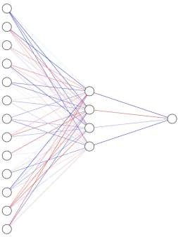

***40 neurons***

Meteorological

Time

Relative humidity

GHI DNI DHI

Wind speed Wind direction

Heating demand

Hour of day Quarter of year Month of year Day of week

Input layer

Hidden layer 1 & Hidden layer 2

Output layer

Figure 2 ANN topology in this paper

* 1. Training data

Scotland, as a complex region where energy policy is governed by both the Scottish and UK governments, is often neglected in research. In the case study, we took the Scottish domestic sector as an example to analyse its heating demands. There are many monitoring stations in Scotland, and it is impossible to obtain data from all of them. The meteorological data of Glasgow has been chosen to represent Scotland because Glasgow is one of the most densely populated areas in Scotland, and secondly the meteorological data for Glasgow are the most comprehensive we have access to. Figure 3 shows some of the meteorological data used by the model.

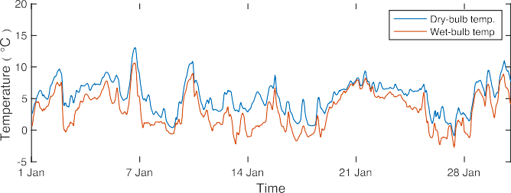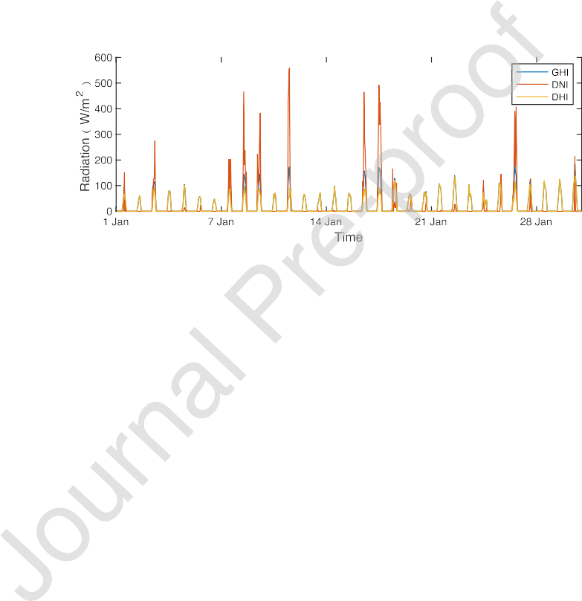





Figure 3 Examples of meteorological data used by the model: (a) temperature and (b) radiation.

In a previous study, the authors of this paper presented a bottom-up physical model to predict the hourly heat demand in the UK by 2050 [50]. The building simulation model was developed based on the theory of heat balance. The establishment of a physical building model requires the collection of environmental and building parameters, such as location, area size and building materials. It is obvious that the physical model is very time- consuming and has high computational costs when the method is applied to large areas. The simulation results (monthly demand) from DesignBuiler were used as the training data in this work. The authors of this paper have used a building simulation model to build a bottom-up physical prediction model for the UK and the data used in this paper are taken from this physical model [50]. The model divides the UK into six regions, each of which is split into three scenarios: residential, service, and industrial. The three scenarios contain a set of eight building types. Each building type includes three different levels of insulation. Thus, a total of 144 building heat demand profiles were derived. The profiles for each building type were combined with the building stock to calculate the heat demand for the whole of the UK.

The physical model of the Scottish domestic buildings was built with the software DesignBuilder, which is used to simulate building energy consumption with key algorithms from the software EnergyPlus. According to the UK government’s survey, domestic buildings in the UK are classified into four categories. Figure 4 shows the four types of building models in the software, including detached, semi-detached, terraced, and flat. In addition, each type of building is divided into three levels of insulation based on their age. In total, the domestic buildings in Scotland are divided into twelve types and the stock is estimated for each type of building to produce a specific heating demand profile. The DesignBuilder model produces 12 heating demand profiles. The Scottish domestic heating profile is the sum of these profiles, which are used as the training data for the ANN model. The training data on heating demand is taken from the building simulation model of Scottish domestic buildings for the period between January to November 2020. The trained model was used to predict the heating demand in December 2020 to validate the ANN model.

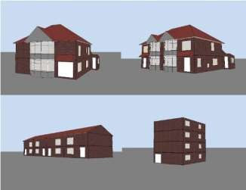

Figure 4 Domestic building models from DesignBuiler[50]

* 1. Model evaluation

As previously stated, the absence of monitors for heating demand has resulted in a scarcity of actual heating data. In an expansive region like Scotland, obtaining hourly heating data is not as readily available as data for electricity demand. The evaluation of the model involves two crucial elements to verify the reliability of the model. Firstly, a comparison is made between the annual heating demand obtained from the DesignBuilder and the official data obtained from the government. Secondly, a comparison of the hourly heating data in this paper with the data obtained from the building simulation is conducted.

* + 1. Comparison DesignBuilder data with Government Data.

The Department for Business, Energy and Industrial Strategy provides energy consumption in the UK, including subnational total final energy consumption in 2020. the domestic energy consumption in Scotland in 2020 is 3750 ktoe (thousand tonnes of oil equivalent) [51]. Scottish Energy Statistics Hub provides the percentage of the end use of household energy consumption, with space heating accounting for 76% [52]. Based on the percentage and efficiency of the four main types of heating in the UK (Gas boiler, Resistive heating, Oil-fired boiler, and Solid-fuel boiler), the average energy efficiency of all heating methods is estimated as 84% [53]. According to official statistics, domestic space heating in Scotland in 2020 is estimated at 2,394 ktoe, converting energy units from thousand tonnes of oil equivalent to Terawatt hour is 27.84 TWh. The total domestic heating demand in 2020 from the DesignBuilder model is 27.59TWh. It can be demonstrated that the results of the DesignBuilder (DB) model are highly reliable.

* + 1. Comparison prediction results with DesignBuilder Data

In accordance with the guidelines set forth by the ASHRAE, the performance evaluation of an ANN model is conducted through the computation of the normalised mean bias error (NMBE) and the coefficient of variation of the root mean squared error (CV-RMSE). NMBE is the mean of the prediction errors divided by the mean of the actual values. It gives the total difference between the predicted and actual values of the model. CV-RMSE is the root mean square error divided by the mean of the actual values. This metric shows the ability of the model to predict the overall shape of the load reflected in the data. Their acceptable ranges for building energy prediction are indicated in Table 1. This study commences by contrasting the training performance and the test performance of a basic ANN model, depicted in Figure 1, to assess its performance. Subsequently, the basic model is compared with an improved model, with the objective of determining the efficacy of the proposed method in enhancing the performance of the ANN model.

Table-1 Acceptable range of building energy prediction

|  |  |  |
| --- | --- | --- |
| Data resolution | NMBE | Acceptable range (%)  CV-RMSE |
| Monthly | ±5 | 15 |
| Daily | ±7.5 | 22.5 |
| Hourly | ±10 | 30 |

## Results and analysis

* 1. Training and testing performance of 2020

20

15

10

5

0

1 Jan

Training results

Testing results

20

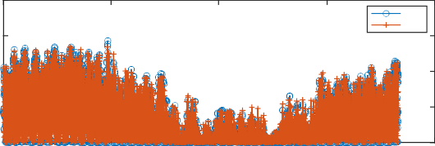

DB ANN

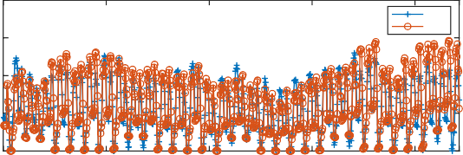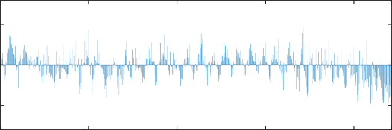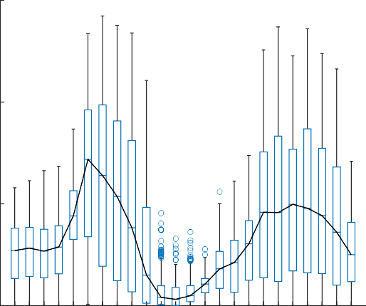

1 Apr

1 Jul

time

Training error

1 Oct

31 Dec

0

1 Dec

7 Dec

5

0

-5

1 Apr

1 Jul

time

1 Oct

31 Dec

1 Dec

7 Dec

(a)

Figure 5 The comparison of predicted results and DB results

15

10

5

ANN DB

15

10

5

14 Dec 21 Dec 28 Dec

time Testing error

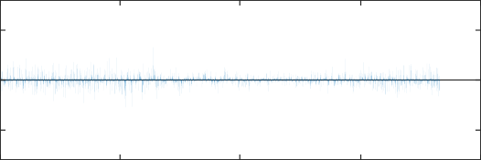5

0

-5

1 Jan

14 Dec 21 Dec 28 Dec

time

(b)

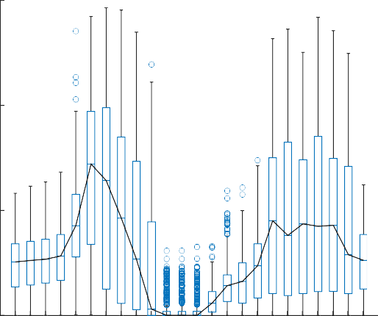15

10

DB demand / MW

Prediction demand / MW

5

0 0

Time / h Time / h

(a) (b)

Figure 6 Boxplot of (a) DB results and (b) prediction results of ANN

Figure 5 shows a comparison of the predicted results of ANN and the DB results. Figure 5(a) shows the training results, where the training data is from January to December 2020. Figure 5(b) shows the test results of the model, using data from December 2020. The error percentage is not used to show the difference as there are periods where the heating demand is zero or almost zero. When expressing the predicted difference as a percentage of error, the prediction error needs to be divided by the heating demand, resulting in infinite errors in some cases. To enhance the clarity of analysis, Figure 6 presents a comparison of the box plots for the DB and

ANN models. This comparison allows for a more comprehensive examination of the results. The findings indicate that the discrepancy between ANN and DB primarily occurs during periods of low heating demand, specifically from 11 a.m. to 3 p.m. Notably, the black curves representing the median values in both box plots exhibit a similar overall trend. This investigation provides valuable insights into the performance and behaviour of the two models. The NMBE value of training data is 2.1% and the CV-RMSE value is 23.1%. The NMBE value of testing data is 2.2% and the CV-RMSE value is 26.6%. The acceptable value of NMBE and CV-RMSE is 10% and 30%. Table-2 gives the comparison of CVRMSE and NMBE for the training and test results, both of which are within the accepted limits. The maximum error in the training results is 3.75 MW, the minimum error is 0 MW, and the average error is 0.432 MW. The graph also shows that large errors occur mainly when high heating demand. The maximum error in the test results is 4.67MW, the minimum error is 0.02MW and the average error is 1.22MW. Even though the model achieves good results during training, it still had large errors when it is used to test new data, indicating the weak generalisation ability of the network. The most basic reason for the weak generalisation capability is the lack of training data in the case of complex models. An important reason for weak generalisation is excessive sample noise, i.e. the network disrupts the system by treating noise as an important feature. Therefore, it is important to remove the inputs that are not causally related or that interfere more than they contribute from the ANN network. On the other hand, it is also possible to add inputs where features have a significant impact on the results.

Table 2 Comparison of training and testing performance of ANN based on 2020 Scottish domestic heating demand.

|  |  |  |  |
| --- | --- | --- | --- |
|  | Acceptable value | Training | Testing |
| NMBE | 10% | 2.1% | 2.2% |
| CV-RMSE | 30% | 23.1% | 26.6% |

* 1. Results of sensitivity analysis and correlation analysis



Figure 7 Sensitivity analysis of meteorological data and time (normalized results)

Figure 7 (a) shows the sensitivity analysis of the meteorological data. The result shows that the dry-bulb temperature has the highest sensitivity, followed by the Diffuse Horizontal Irradiance (DHI). Wet-bulb temperature and Global Horizontal Irradiance (GHI) also have large effects on the results. Direct Normal Irradiance (DNI) and atmospheric pressure have the lowest impact on the predicted results. Neither wind speed nor wind direction has a high sensitivity. It can be concluded that temperature and radiation are the two most

important factors influencing heating demand, while wind and atmospheric pressure have a small effect on heating demand, and they can be neglected in the ANN model in order to reduce interference. Figure 7(b) shows the sensitivity analysis of temporal data, and the results show a quarter of the year and day of the week can be ignored. As the temperature is the most important physical parameter, it is important to improve the impact of temperature on the network. The temperature input to the model is the temperature point at the current time, but the change in heating demand is not sudden but has a process. Since the heating demand changes with the temperature, the temperature profile is also important. After removing some meteorological data, the temperature profile for the following 24 hours is used as input to the ANN.

Table 3 𝑅2 value of correlation analysis

|  |  |  |
| --- | --- | --- |
|  | Dry-bulb temp. | DHI |
| Wind direction | 0.01 | 0.03 |
| Wind speed | 0.02 | 0.01 |
| DHI | 0.29 | 1 |
| DNI | 0.08 | 0.14 |
| GHI | 0.3 | 0.79 |
| Relative humidity | 0.16 | 0.25 |
| Atmospheric pressure | 0.07 | 0.02 |
| Wet-bulb temp. | 0.75 | 0.07 |

 Dry-bulb temp. 1 0.3

The correlation analysis is done to analyse the relationship between the meteorological inputs and to identify features of the inputs. For example, if an input can be fitted by several other inputs, then removing one or two of the duplicate inputs can be effective in reducing the interference, especially if this input has a low sensitivity. In this model, time does not have physical significance and therefore the correlation analysis does not consider temporal inputs. Taking the example of dry bulb temperature and DHI being selected as dependent variables for correlation analysis, with other meteorological data as independent variables, Table-3 is the results of the correlation analysis. A higher 𝑅2 value means a higher correlation. The highest correlation with the dry bulb temperature is the wet bulb temperature and the highest correlation with the DHI is the GHI. It is not reasonable to remove the wet bulb temperature and GHI as they also have a high sensitivity. Also, the results in Table-3 only show the correlation of two parameters, in real engineering problems more parameters are often included in complex relationships.

The correlations were further analysed with the dry bulb temperature as the dependent variable, the wet bulb temperature as one independent variable, and the input in the model introduced as another independent variable. Using the same polynomial regression approach, the 𝑅2 value increases significantly with the introduction of humidity as the third independent variable. The same calculations were applied to the DHI and GHI, with a significant increase in 𝑅2 value with the introduction of DNI. Figure 8(a) is a polynomial regression fit curve for dry bulb temperature, wet bulb temperature, and humidity with an 𝑅2 value of 0.926. Figure 8(b) is a polynomial regression fit curve for DHI, GHI and DNI with an R-value of 0.985. The results indicate that there is some relationship between the three meteorological data, which allows one item to be removed, reducing duplicate meteorological information while retaining all features. Combined with the sensitivity analysis results, the removal of DNI and humidity is reasonable.

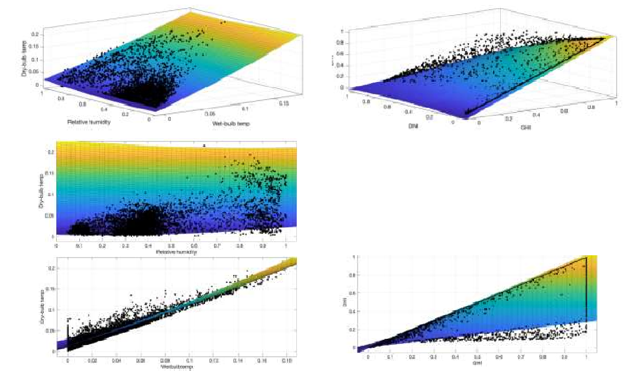

(a) (b)

Figure 8 Polynomial regression fit curve for three inputs

(a)Dry-bulb temperature, relative humidity wet-bulb temperature; (b)DHI, DNI, GHI

* 1. Results of improved ANN network

Training results

20 20

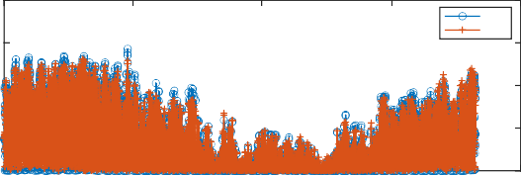

DB ANN

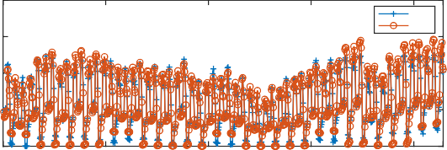

ANN DB

15 15

10 10

5 5

Testing results

0

1 Jan 1 Apr 1 Jul 1 Oct 31 Dec

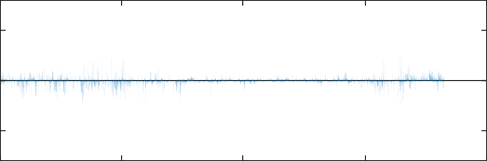time Training error

5

0

-5

1 Jan 1 Apr 1 Jul 1 Oct 31 Dec

time

(a)

0

1 Dec 7 Dec 14 Dec 21 Dec 28 Dec

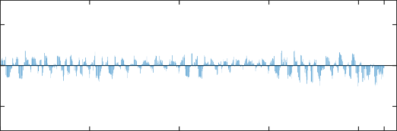time Testing error

5

0

-5

1 Dec 7 Dec 14 Dec 21 Dec 28 Dec

time

(b)

Figure 9 Training and testing results of improved ANN model

15 15

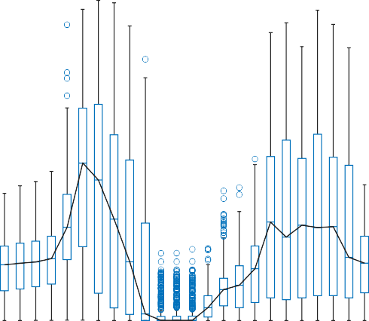

10 10

Prediction demand / MW

5 5

DB demand / MW

0 0

Time / h Time / h

(a) (b)

Figure 10 Boxplot of (a) DB results and (b) prediction results of improved ANN

The improved ANN model includes a dry-bulb temperature 24h profile, wet-bulb temperature, DHI, GHI, month and hour. Although the variety of inputs has become less, the number of inputs has increased. The modified ANN is the same as Figure 1 except for the inputs. Figure 9 shows the results of the modified ANN training and testing. The maximum error in the training of the modified ANN model is 3.17 MW, the minimum error is 0 MW, and the average error is 0.37 MW. The maximum error in the test data is 1.85 MW, the minimum error is 0.01 MW, and the average error is 0.71 MW. While the error reduction for training is minimal, the error reduction for testing is significant. The box plots in Figures 6 and 10 show that the improved ANN is yielding results that are much more consistent with DB. The prediction results from 11:00 a.m. to 3:00 p.m. have decreased to a much closer proximity with the results of DB, and the trend of the median curve is now much more aligned. Comparing Tables 1 and 4, it can be found that although both training and testing performance have improved, the testing performance has improved significantly. The NMBE of testing results was improved from 2.1% to 1.2% and the CVRMSE was reduced from 26.6% to 14.6%, while the trained NMBE improved from 2.2% to 1.3% and the CVRMSE was reduced from 23.1% to 18.5%. The results show that removing and selecting appropriate inputs of ANN models when predicting building heating demand of a large-scale can effectively improve the generalisation ability of the model.

Table 4 Performance of improved ANN model

|  |  |  |  |
| --- | --- | --- | --- |
|  | Acceptable value | Training | Testing |
| NMBE | 10% | 1.3% | 1.2% |
| CV-RMSE | 30% | 18.5% | 14.6% |

The initial ANN weights were assigned randomly by the code, which can lead to large differences in results. The models were therefore trained 100 times to compare the distributions of the NMBE and CVRMSE data sets. Figure 11(a) compares the NMBE values for the basic and improved ANN. The values of NMBE are distributed in the range of -0.4 to 0.8 before the improvement and approximately -0.1 to 0.2 after the improvement. Figure 11(b) shows the CVRMSE of the ANNs. The values of CVRMSE for the basic ANN are distributed between 0.1 and 0.7. The CVRMSE of the improved ANN is distributed between 0.15 and 0.35, but mainly in the range of

0.15 to 0.25. The performance of improved ANN is much better than basic ANN and the values for both NMBE and CVRMSE are within reasonable limits.

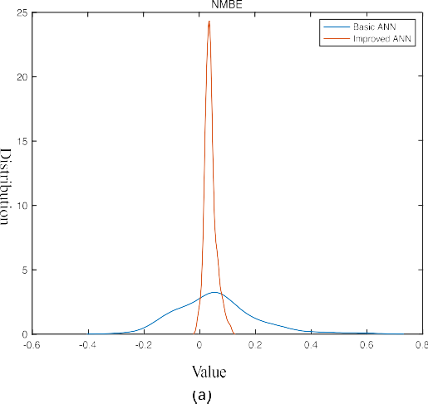 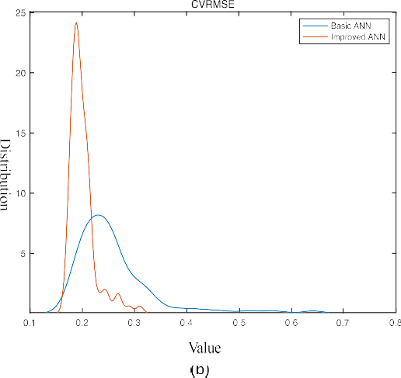

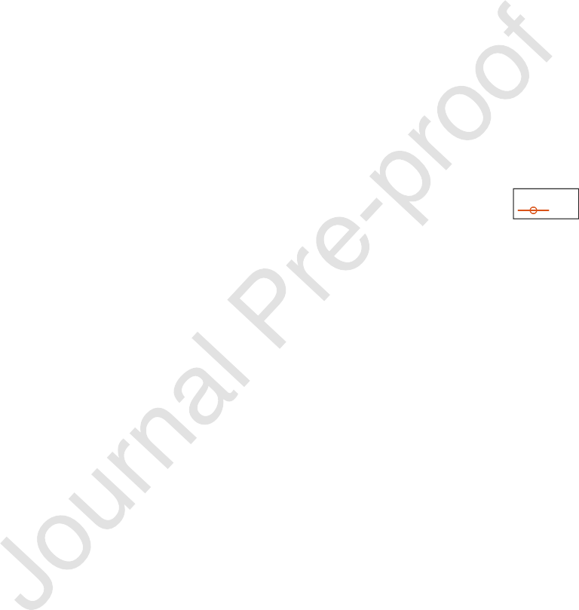Figure 11 The distribution of (a) NMBE and (b) CVRMSE vale of basic ANN and improved ANN

* 1. Prediction of 2050

16

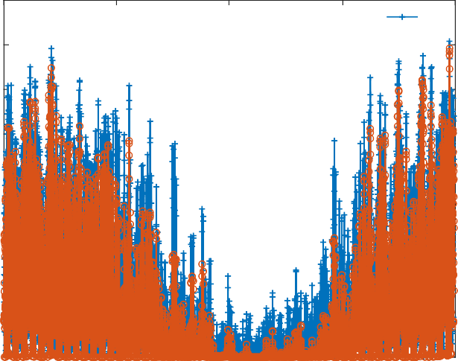

ANN DB

14

12

10

8

6

4

2

0

1 Jan 1 Apr 1 Jul 1 Oct 31 Dec

time

Figure 12 Prediction results with improved ANN model of 2050

14 14

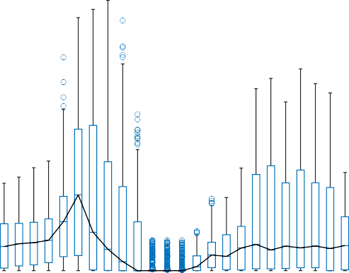

12 12

10 10

8 8

DB demand / MW

Prediction demand / MW

6 6

4 4

2 2

0 0

Time / h Time / h

(a) (b)

Figure 13 Boxplot of (a) DB results and (b) prediction results of improved ANN

Generally, the training data is at least ten times larger than the predicted data to give a reasonably accurate result. Due to the shortage of meteorological data, hourly heating demand for ten years cannot be calculated through the building simulation model. Hence, the heating demand data (from DB model) and meteorological data from January to November 2020 were used as training data when predicting the heating demand in 2050. Figure 12 shows the results of the predictions for 2050. The figure shows that the prediction errors between ANN model and DB model are mainly concentrated in the summer months, with the smallest forecast errors in the winter months. It can be seen from Figure 13's box plot that the results of ANN are generally greater than those of DB. This is attributed to the fact that the training data for the model is from 2020 and is too limited. With the heat demand usually higher in 2020 than in 2050, the estimations for 2050 will be on the high side. The performance of the forecasts for each month is given in Table 5, from which the errors increase as the year progresses, peaking in July and then gradually decreasing. The forecasts for January, February and March are all within the error range, and the forecast errors for November and December are also close to the error allowance. There are three reasons for the large errors in summer and the small errors in winter. The first is that the 2010 and 2020 data are insufficient to forecast heating demand for the whole of 2050. The second is that both 2010 and 2020 temperatures are lower than 2050 temperatures due to global warming, so the predictions are more accurate in the lower temperature bands. The third is that the error in the calculation is increased by the low heating demand in summer as well as the fact that the heating demand is often zero for the period. Overall, the model can be used to predict heating demand in winter, but more data is needed to support the prediction of heating demand in summer.

Table 5 The performance of each month in 2050

|  |  |  |  |  |  |  |
| --- | --- | --- | --- | --- | --- | --- |
| **High scenario in 2050** | **Jan** | **Feb** | **Mar** | **Apr** | **May** | **Jun** |
| CVRMSE | 25.01% | 29.74% | 27.38% | 55.64% | 88.55% | 136.42% |
| NMBE | 8.28% | 1.16% | -5.70% | -27.09% | -36.41% | -38.30% |
| **High scenario in 2050** | **Jul** | **Aug** | **Sept** | **Oct** | **Nov** | **Dec** |
| CVRMSE | 684.14% | 453.14% | 203.09% | 71.69% | 33.53% | 35.31% |
| NMBE | -152.37% | -140.88% | -118.20% | -43.97% | -1.05% | 1.89% |

## Conclusion

In this study, an ANN was used to predict the domestic heating demand in Scotland based on meteorological data. The results show that ANN is a useful tool for predicting heating demand, with a reasonable level of accuracy. The model achieved good results during training, with an NMBE value of 2.1% and a CV-RMSE value of 23.1% for the training data, and an NMBE value of 2.2% and a CV-RMSE value of 26.6% for the testing data, which were within the acceptable limits of 10% and 30%, respectively. Sensitivity and correlation

analysis were conducted to identify the most important meteorological inputs, with temperature and radiation being identified as the two most important factors affecting heating demand.

The performance of the improved ANN improves in both NMBE and CV-RMSE by removing the inputs that have the least impact on the ANN prediction. The improved ANN demonstrates better performance than its predecessor, as evidenced by a shift in NMBE values from -0.4 to 0.8 before the improvement to approximately

-0.1 to 0.2 after the enhancement. Additionally, the CVRMSE values for the improved ANN range from 0.15 to 0.35, with the majority between 0.15 and 0.25, while the basic ANN had values between 0.1 and 0.7. The improved ANN model predicts heating demand for 2050 using data from 2010 and 2020. The results show that the errors in the predictions increase as the year progresses, peaking in July and gradually decreasing. The model's limitations include insufficient data for heating demand in summer and the low heating demand during this period, which leads to a higher error in the calculation. Overall, the improved ANN model can be used to predict heating demand in winter, but additional data is needed to support the prediction of heating demand in summer. Furthermore, this paper does not delve into the exploration of machine learning algorithms. Instead, it emphasizes the application of machine learning and the significance of discussing the performance of various algorithms in terms of prediction. Subsequently, our forthcoming paper will concentrate on investigating the predictive effects of different alternative algorithms like LSTM.

## Acknowledgement

This research has benefited from the financial support provided by EPSRC (EP/T022701/1, EP/V042033/1, EP/V030515/1, EP/W027593/1) in the UK. Author Meng Zhang likes to acknowledge Scottish Power Energy Networks for the PhD studentship.

**Reference**

*1+ S. Cran-McGreehin, "Heating buildings-Reducing energy demand and greenhouse gas

emissions," Energy Research Partnership, London2016, Available: https://erpuk.org/wp- content/uploads/2017/01/ERP-Heating-Buildings-report-Oct-2016.pdf.

*2+ "Transforming heating-Overview of current evidence," Department for business, energy & industrial strategy2018, Available:

https://assets.publishing.service.gov.uk/government/uploads/system/uploads/attachment_d ata/file/766109/decarbonising-heating.pdf.

*3+ (2021). *Apply for the Boiler Upgrade Scheme*. Available: https://[www.gov.uk/apply-boiler-](http://www.gov.uk/apply-boiler-)

upgrade-scheme

*4+ S. Singaravel, P. Geyer, and J. Suykens, "Component-based machine learning modelling approach for design stage building energy prediction: weather conditions and size," in *Proceedings of the 15th IBPSA conference*, 2017, pp. 2617-2626.

*5+ M. M. Singh, S. Singaravel, and P. Geyer, "Machine learning for early stage building energy prediction: Increment and enrichment," *Applied Energy,* vol. 304, p. 117787, 2021.

*6+ Z. Liu *et al.*, "Accuracy analyses and model comparison of machine learning adopted in

building energy consumption prediction," *Energy Exploration & Exploitation,* vol. 37, no. 4,

pp. 1426-1451, 2019.

*7+ A. Mosavi, M. Salimi, S. Faizollahzadeh Ardabili, T. Rabczuk, S. Shamshirband, and A. R.

Varkonyi-Koczy, "State of the art of machine learning models in energy systems, a systematic review," *Energies,* vol. 12, no. 7, p. 1301, 2019.

*8+ J.-P. Lai, Y.-M. Chang, C.-H. Chen, and P.-F. Pai, "A survey of machine learning models in renewable energy predictions," *Applied Sciences,* vol. 10, no. 17, p. 5975, 2020.

*9+ L. Zhang *et al.*, "A review of machine learning in building load prediction," *Applied Energy,*

vol. 285, p. 116452, 2021.

*10+ T. Kurek *et al.*, "Heat demand forecasting algorithm for a Warsaw district heating network,"

*Energy,* vol. 217, p. 119347, 2021.

*11+ H. Deng, D. Fannon, and M. J. Eckelman, "Predictive modeling for US commercial building

energy use: A comparison of existing statistical and machine learning algorithms using CBECS microdata," *Energy and Buildings,* vol. 163, pp. 34-43, 2018.

*12+ S. Chen, Y. Ren, D. Friedrich, Z. Yu, and J. Yu, "Sensitivity analysis to reduce duplicated features in ANN training for district heat demand prediction," *Energy and AI,* vol. 2, p. 100028, 2020.

*13+ K. Amasyali and N. El-Gohary, "Machine learning for occupant-behavior-sensitive cooling energy consumption prediction in office buildings," *Renewable and Sustainable Energy Reviews,* vol. 142, p. 110714, 2021.

*14+ R. Olu-Ajayi, H. Alaka, I. Sulaimon, F. Sunmola, and S. Ajayi, "Building energy consumption prediction for residential buildings using deep learning and other machine learning techniques," *Journal of Building Engineering,* vol. 45, p. 103406, 2022.

*15+ H. Ghoddusi, G. G. Creamer, and N. Rafizadeh, "Machine learning in energy economics and finance: A review," *Energy Economics,* vol. 81, pp. 709-727, 2019.

*16+ Z. W. Geem and W. E. Roper, "Energy demand estimation of South Korea using artificial neural network," *Energy policy,* vol. 37, no. 10, pp. 4049-4054, 2009.

*17+ X. Liu, B. Moreno, and A. S. García, "A grey neural network and input-output combined forecasting model. Primary energy consumption forecasts in Spanish economic sectors," *Energy,* vol. 115, pp. 1042-1054, 2016.

*18+ X. Luo, L. O. Oyedele, A. O. Ajayi, and O. O. Akinade, "Comparative study of machine learning-based multi-objective prediction framework for multiple building energy loads," *Sustainable Cities and Society,* vol. 61, p. 102283, 2020.

*19+ E. Elbeltagi and H. Wefki, "Predicting energy consumption for residential buildings using ANN through parametric modeling," *Energy Reports,* vol. 7, pp. 2534-2545, 2021.

*20+ Z. Li, J. Dai, H. Chen, and B. Lin, "An ANN-based fast building energy consumption prediction method for complex architectural form at the early design stage," in *Building Simulation*, 2019, vol. 12, pp. 665-681: Springer.

*21+ L. Kannari, J. Kiljander, K. Piira, J. Piippo, and P. Koponen, "Building heat demand forecasting by training a common machine learning model with physics-based simulator," *Forecasting,* vol. 3, no. 2, pp. 290-302, 2021.

*22+ F. Bünning, P. Heer, R. S. Smith, and J. Lygeros, "Improved day ahead heating demand

forecasting by online correction methods," *Energy and Buildings,* vol. 211, p. 109821, 2020.

*23+ Y. Parfenenko, V. Shendryk, S. Vashchenko, and N. Fedotova, "The forecasting of the daily heat demand of the public sector buildings with district heating," in *Information and Software Technologies: 21st International Conference, ICIST 2015, Druskininkai, Lithuania, October 15-16, 2015, Proceedings 21*, 2015, pp. 187-198: Springer.

*24+ A. Li, F. Xiao, C. Fan, and M. Hu, "Development of an ANN-based building energy model for information-poor buildings using transfer learning," in *Building simulation*, 2021, vol. 14, pp. 89-101: Springer.

*25+ S. Seyedzadeh, F. P. Rahimian, I. Glesk, and M. Roper, "Machine learning for estimation of building energy consumption and performance: a review," *Visualization in Engineering,* vol. 6, pp. 1-20, 2018.

*26+ S. Singaravel, J. Suykens, and P. Geyer, "Deep-learning neural-network architectures and methods: Using component-based models in building-design energy prediction," *Advanced Engineering Informatics,* vol. 38, pp. 81-90, 2018.

*27+ A. Nutkiewicz, Z. Yang, and R. K. Jain, "Data-driven Urban Energy Simulation (DUE-S): A

framework for integrating engineering simulation and machine learning methods in a multi- scale urban energy modeling workflow," *Applied energy,* vol. 225, pp. 1176-1189, 2018.

*28+ S. Fathi, R. Srinivasan, A. Fenner, and S. Fathi, "Machine learning applications in urban

building energy performance forecasting: A systematic review," *Renewable and Sustainable Energy Reviews,* vol. 133, p. 110287, 2020.

*29+ S. Seyedzadeh, F. P. Rahimian, P. Rastogi, and I. Glesk, "Tuning machine learning models for prediction of building energy loads," *Sustainable Cities and Society,* vol. 47, p. 101484, 2019.

*30+ P. Potočnik, P. Škerl, and E. Govekar, "Machine-learning-based multi-step heat demand forecasting in a district heating system," *Energy and Buildings,* vol. 233, p. 110673, 2021.

*31+ P. Zhang, "A novel feature selection method based on global sensitivity analysis with

application in machine learning-based prediction model," *Applied Soft Computing,* vol. 85, p. 105859, 2019.

*32+ K.-Q. Shen, C.-J. Ong, X.-P. Li, and E. P. Wilder-Smith, "Feature selection via sensitivity analysis of SVM probabilistic outputs," *Machine Learning,* vol. 70, pp. 1-20, 2008.

*33+ H. Sulieman and A. Alzaatreh, "A supervised feature selection approach based on global sensitivity," *Arch. Data Sci. Ser. A (Online First),* vol. 5, no. 3, 2018.

*34+ W. Becker, P. Paruolo, and A. Saltelli, "Variable Selection in Regression Models Using Global Sensitivity Analysis," *Journal of Time Series Econometrics,* vol. 13, no. 2, pp. 187-233, 2021.

*35+ Y. Guo *et al.*, "Machine learning-based thermal response time ahead energy demand prediction for building heating systems," *Applied energy,* vol. 221, pp. 16-27, 2018.

*36+ A. T. Eseye and M. Lehtonen, "Short-term forecasting of heat demand of buildings for

efficient and optimal energy management based on integrated machine learning models,"

*IEEE Transactions on Industrial Informatics,* vol. 16, no. 12, pp. 7743-7755, 2020.

*37+ Z. Li, D. Friedrich, and G. P. Harrison, "Demand forecasting for a mixed-use building using

agent-schedule information with a data-driven model," *Energies,* vol. 13, no. 4, p. 780, 2020.

*38+ S. Salcedo-Sanz, L. Cornejo-Bueno, L. Prieto, D. Paredes, and R. García-Herrera, "Feature selection in machine learning prediction systems for renewable energy applications," *Renewable and Sustainable Energy Reviews,* vol. 90, pp. 728-741, 2018.

*39+ T. Ahmad, H. Chen, and Y. Huang, "Short-term energy prediction for district-level load management using machine learning based approaches," *Energy Procedia,* vol. 158, pp. 3331-3338, 2019.

*40+ D. W. Patterson, "Artificial Neural Networks: Theory and Applications," *Prentice Hall, Englewood Cliffs,* 1996.

*41+ S. Shanmuganathan, *Artificial neural network modelling: An introduction*. Springer, 2016.

*42+ J. Li, J.-h. Cheng, J.-y. Shi, and F. Huang, "Brief introduction of back propagation (BP) neural network algorithm and its improvement," in *Advances in Computer Science and Information Engineering: Volume 2*, 2012, pp. 553-558: Springer.

*43+ J. Cai, J. Luo, S. Wang, and S. Yang, "Feature selection in machine learning: A new perspective," *Neurocomputing,* vol. 300, pp. 70-79, 2018.

*44+ G. Chandrashekar and F. Sahin, "A survey on feature selection methods," *Computers & Electrical Engineering,* vol. 40, no. 1, pp. 16-28, 2014.

*45+ A. Saltelli *et al.*, *Global sensitivity analysis: the primer*. John Wiley & Sons, 2008.

*46+ P. Wate, V. Coors, M. Iglesias, and D. Robinson, "Uncertainty assessment of building performance simulation: An insight into suitability of methods and their applications," in *Urban Energy Systems for Low-Carbon Cities*: Elsevier, 2019, pp. 257-287.

*47+ P. Schober, C. Boer, and L. A. Schwarte, "Correlation coefficients: appropriate use and interpretation," *Anesthesia & analgesia,* vol. 126, no. 5, pp. 1763-1768, 2018.

*48+ A. J. Thomas, M. Petridis, S. D. Walters, S. M. Gheytassi, and R. E. Morgan, "On predicting the optimal number of hidden nodes," in *2015 International Conference on Computational*

*Science and Computational Intelligence (CSCI)*, 2015, pp. 565-570: IEEE.

*49+ D. Stathakis, "How many hidden layers and nodes?," *International Journal of Remote Sensing,*

vol. 30, no. 8, pp. 2133-2147, 2009.

*50+ M. Zhang, M.-A. Millar, Z. Yu, and J. Yu, "An assessment of the impacts of heat electrification on the electric grid in the UK," *Energy Reports,* vol. 8, pp. 14934-14946, 2022.

*51+ S. Parker, "Energy Consumption in the UK (ECUK) 1970 to 2020," Department for Business, Energy & Industrial Strategy, London2021.

*52+ (2023). *Scottish Energy Statistics Hub: Energy Efficiency-End use of energy consumption*.

Available: https://scotland.shinyapps.io/sg-scottish-energy-

statistics/?Section=EnergyEfficiency&Subsection=DemandReduction&Chart=HHoldEnConsu mption

*53+ S. Clegg and P. Mancarella, "Integrated electricity-heat-gas modelling and assessment, with applications to the Great Britain system. Part I: High-resolution spatial and temporal heat demand modelling," *Energy,* vol. 184, pp. 180-190, 2019.

Graphical Abstract



HIGHLIGHTS

* The rapid response model, in comparison to the physical model, maintains the latter's resolution on a national scale.
* Furthermore, this prediction model for building space heating solely relies on weather data inputs.
* The enhanced model demonstrates the ability to reduce input requirements whilst preserving accuracy, thereby increasing its practical applicability.

# Declaration of interests

☒The authors declare that they have no known competing financial interests or personal relationships that could have appeared to influence the work reported in this paper.

☐The authors declare the following financial interests/personal relationships which may be considered as potential competing interests:

