

[Egyptian Informatics Journal (2011) 12, 95](http://dx.doi.org/10.1016/j.eij.2011.04.001)–[106](http://dx.doi.org/10.1016/j.eij.2011.04.001)

Cairo University

Egyptian Informatics Journal

[www.elsevier.com/locate/eij](http://www.elsevier.com/locate/eij) [www.sciencedirect.com](http://www.sciencedirect.com/science/journal/11108665)

ORIGINAL ARTICLE

Evaluation comparison of some ad hoc networks routing protocols

A.A.A. Radwan a,*, T.M. Mahmoud b, E.H. Houssein c

a *Faculty of Computers and Information, Minia University, Egypt*

b *Department of CS, Faculty of Science, Minia University, Egypt*

c *Department of CS, Faculty of Computers and Informatics, Benha University, Egypt*

Received 20 January 2011; revised 7 April 2011; accepted 10 April 2011

Available online 23 July 2011

Abstract Mobile ad hoc networks (MANETs) are characterized by multi-hop wireless connectiv- ity, frequently changing network topology and the need for efficient dynamic routing protocols plays an important role. A variety of routing protocols targeted specifically at this environment have been developed and some performance simulations are made on numbers of routing protocols like Ad hoc On-Demand Distance Vector Routing (AODV), Dynamic Source Routing (DSR) and Location-Aided Routing (LAR). To the best of our knowledge, no published work is available in the literature, which compares as many criteria as we have done to evaluate the performance of the considered routing protocols. In this paper we perform extensive simulations using GloMoSim sim- ulator considering 18 performance metrics. To determine the impact of network size on the perfor- mance of these protocols we considered two different scenarios, namely, 100 and 200 nodes, with rectangular area sizes 1500 · 1000 and 2000 · 1500 m2, respectively.

© 2011 Faculty of Computers and Information, Cairo University. Production and hosting by Elsevier B.V. All rights reserved.

KEYWORDS

Mobile ad hoc networks (MANETs);

Routing protocols; AODV;

DSR;

LAR;

GloMoSim

* Corresponding author.

E-mail addresses: [aaaradwan2008@yahoo.com](mailto:aaaradwan2008@yahoo.com) (A.A.A. Radwan), [tarek@minia.edu.eg](mailto:tarek@minia.edu.eg) (T.M. Mahmoud), [esam.halim@fci.bu.edu.eg](mailto:esam.halim@fci.bu.edu.eg) (E.H. Houssein).

1110-8665 © 2011 Faculty of Computers and Information, Cairo University. Production and hosting by Elsevier B.V. All rights reserved.

Peer review under responsibility of Faculty of Computers and Information, Cairo University.

doi:[10.1016/j.eij.2011.04.001](http://dx.doi.org/10.1016/j.eij.2011.04.001)

Production and hosting by Elsevier

1. Introduction

With the advance in networking and communications technol- ogies, portable wireless devices are found in our common activities. Most people carry and use laptop computers, cellu- lar phones, and pagers that support nomadic computing of network users. A mobile ad hoc network (MANET), which is one form of wireless networks, is an autonomous system of mobile hosts connected by wireless links. There is no static infrastructure such as base stations. Each node in the network also acts as a router, forwarding data packets for other nodes [1,2].

In MANET, nodes move arbitrarily, therefore the network may experience rapidly and unpredictably topology changes.

Additionally, because nodes in MANET normally have limited transmission ranges, some nodes cannot communicate directly with each other. Hence, routing paths MANETs potentially contain multiple hops, and every node in mobile ad hoc net- works has the respon to act as a router [3].

Many protocols have been proposed for MANETs, with the goal of achieving efficient routing [4–7]. These algorithms differ in the approach used for searching a new route and/or modifying a known route, when hosts move. The ad hoc rout- ing protocols may be generally categorized as table-driven and source initiated on-demand driven. The simulation results reported in several papers show that normally on demand routing protocols have higher packet delivery ratio and need less routing messages than table-driven routing protocols [8,9]. Energy consumption in ad hoc networks is a very impor- tant factor. Because batteries carried by each mobile node have limited power supply, processing power is limited, which in turn limits services and applications that can be supported by each node. This becomes a bigger issue in mobile ad hoc networks because, as each node is acting as both an end system and a router at the same time, additional energy is required to forward packets from other nodes [10,11]. However, little is known about the actual performance of these protocols, and no attempt has previously been made to directly compare them in a realistic manner.

These ad hoc routing protocols can be divided into two categories: proactive driven routing protocols, consistent and up-to-date routing information to all nodes is maintained at each node. Reactive routing protocols, the routes are created as and when required, when a source wants to send to a destination, it invokes the route discovery mechanisms to find the path to the destination [12].

At this time, the parallel discrete event-driven simulator, GloMoSim 2.03, contains the following routing protocols:

* Ad Hoc On Demand Distance Vector (AODV)
* Location Aided Routing (LAR)
* Wireless Routing Protocol (WRP)
* Dynamic Source Routing (DSR)
* Fisheye State Routing (FSR)
* Zone Routing Protocol (ZRP)

As a result, a comprehensive performance evaluation of ad hoc routing protocols is essential. This paper compares the performance of three ad hoc routing protocols namely, AODV, DSR and LAR routing protocols using the GloMo- Sim simulator version 2.03. We evaluated all available metrics supported by GloMoSim for these protocols and then per- formed a comparative performance evaluation. Since these protocols have different characteristics, the comparison of all performance differentials is not always possible. However, the following system parameters are utilized for comparative study on the protocols:

* Normalized routing overhead,
* throughput,
* data packets sent,
* data packets retransmitted,
* ACK packets received,
* signals arrived with power above RX sensitivity,
* signals transmitted,
* BCAST (pkts rcvd clearly),
* UCAST (pkts rcvd clearly),
* average end-to-end delay,
* collisions,
* data packets received,
* number of packet attempt to be sent to MAC,
* signals arrived with power above RX threshold,
* BCAST (pkts sent to channel),
* UCAST (pkts sent to channel),
* total of the TTL’s of delivered packets.

The rest of the paper is organized as follows. Section 2 gives briefly a review of the related work. The simulation environment is presented in Section 3. Section 4 discusses the simulation results and performance analysis. Section 5 introduces the summarized results. Finally, the conclusions are given in Sec- tion 6.

1. Related work
   1. *Ad hoc On-Demand Distance Vector Routing (AODV)*

AODV is a state-of-the-art routing protocol that adopts a purely reactive strategy: it sets up a route on-demand at the start of a communication session, and uses it till it breaks, after which a new route setup is initiated. AODV adopts a very different mechanism to maintain routing information. It uses traditional routing tables, one entry per destination [13–16]. Without source routing, AODV relies on routing table entries to propagate a route replay (RREP) back to the source and, subsequently, to route data packets to the destination. AODV uses sequence numbers maintained at each destination to determine the freshness of routing information and to prevent routing loops. All routing packets carry these sequence num- bers. An important feature of AODV is the maintenance of timer-based states in each node, regarding utilization of indi- vidual routing table entries. A routing table entry is expired if not used recently. A set of predecessor nodes is maintained for each routing table entry, indicating the set of neighboring nodes which use that entry to route data packets. These nodes are notified with route error (RERR) packets when the next- hop link breaks. Each predecessor node, in turn, forwards the RERR to its own set of predecessors, thus effectively eras- ing all routes using the broken link. Route error propagation in AODV can be visualized conceptually as a tree whose root is the node at the point of failure and all sources using the failed link [17].

* 1. *Dynamic Source Routing (DSR)*

The key distinguishing feature of the reactive protocol DSR is the use of source routing. That is, the sender knows the com- plete hop-by-hop route to the destination. These routes are stored in a route cache; this is in contrast to AODV which uses traditional routing tables, one entry per destination. DSR can maintain multiple route cache entries for each destination. The data packets carry the source route in the packet header. When a node in the ad hoc network attempts to send a data packet to a destination for which it does not already know the route, it uses a route discovery process to dynamically determine such a route [18]. Route discovery works by flooding the network with route request (RREQ) packets. Each node receiving an RREQ rebroadcasts it, unless it is the destination or it has a

route to the destination in its route cache. Such a node replies to the RREQ with a route reply (RREP) packet that is routed back to the original source. RREQ and RREP packets are also source routed. The RREQ builds up the path traversed across the network. The RREP routes itself back to the source by tra- versing this path backward. The route carried back by the RREP packet is cached at the source for future use. If any link on a source route is broken, the source node is notified using a route error (RERR) packet. The source removes any route using this link from its cache. A new route discovery process must be initiated by the source if this route is still needed. DSR makes very aggressive use of source routing and route caching [19].

* 1. *Location-Aided Routing (LAR)*

LAR is reactive routing protocol like AODV and DSR. It attempts to reduce the routing overheads present in the tradi- tional flooding algorithm by using location information. This protocol assumes that each node knows its location through a Global Positioning System (GPS). Two different LAR schemes were proposed in [20,21], the first scheme calculates a request zone which defines a boundary where the route re- quest packets can travel to reach the required destination. The second method stores the coordinates of the destination in the route request packets. These packets can only travel in the direction as the relative distance to the destination becomes smaller as they travel from one hop to another. Both methods limit the control overhead transmitted through the network and hence conserve bandwidth. They will also determine the shortest path (in most cases) to the destination, since the route request packets travel away from the source and toward the destination. The disadvantage of this protocol is that each node is required to carry a GPS [22].

1. Simulation environment

To compare the performance of the three routing protocols de- scribed in section 2, simulation experiments were performed. The simulations were carried out with the GloMoSim library which is widely used in the academic research [23,24]. The number of nodes used in the simulation scenarios is 100 and

200 nodes, with rectangular area sizes 1500 · 1000 and 2000 · 1500 m2, respectively. The nodes are placed randomly within the simulation area. The radio propagation range for each node is 376 m and channel capacity is 2 Mb/s. Each sim- ulation is executed for 300 s of simulation time. IEEE 802.11 MAC protocol was used in the experiments for the MAC layer. The sources used for the simulations are constant bit rate (CBR) sources. Twenty data sessions with randomly se- lected sources and destinations are used in the simulations. Each source transmits data packets at 4 packets/s rate with packet size 512 bytes until the simulation run ends.

The mobility model used is the random waypoint model [25]. In this model, a node selects a random destination within the terrain range and moves toward it at a speed between the pre-defined minimum and maximum speed. Once the node ar- rives at the destination, it stays for a pause time. After being stationary for the pause time, it randomly selects another des- tination and speed and then resumes movement. The minimum and the maximum speed for the simulations are 0 and 10 m/s, respectively. Simulation runs are done on variance pause time values from 0 to 300 s. The simulations have been done on a PC Pentium IV, 2 GHz processor and 3 GB RAM.

1. Simulation results and performance analysis

The following subsections present the two simulation scenarios that have been chosen and the performance analysis to evalu- ate the performance of AODV, DSR, and LAR routing proto- cols. The system parameters given in section 1 are used for the comparative study.

* 1. *Normalized routing overhead*

The normalized routing overhead resulted from the considered routing protocols have been presented in Figs. 1 and 2. It could be noticed that the DSR routing protocol has less routing overhead than the other protocols in the small network and then increases in the large one at the end of the simulation time. DSR has less overhead than AODV because instead of maintaining a route table for tracking routing information, DSR utilizes a route cache. The cache allows multiple route en- tries to be maintained per destination, thereby enabling

AODV DSR LAR

AODV DSR LAR

60



50

Normalized Routing Overhead

40

30

20

10

0

0 100

200

80

70

Normalized Routing Overhead

60

50

40

30

20

10

0

300 0

100

200

300

Pause Time (Sec.) Pause Time (Sec.)

Figure 1 Normalized routing overhead vs. pause time for 100 nodes.

Figure 2 Normalized routing overhead vs. pause time for 200 nodes.

0.035

AODV DSR LAR

0.03

Average End to End Delay

0.025

0.02

0.015

0.01

0.005

0

0

100

200

300

The average end to end delay for AODV is higher than LAR because, due to its single path nature and inefficient man- ner to handle route failure. LAR, on the other hand, shows low delays in all cases. This is because, instead of buffering data packets for a new route to be found, LAR forwards the data packets through alternative routes.

* 1. *Throughput*

The throughput resulted from the considered routing protocols have been presented in Figs. 5 and 6. As can been seen, LAR protocol shows higher throughput than AODV and DSR rout- ing protocols since its routing overhead is less than the others. The number of packets dropped or left wait for a route affect

the throughput.

Pause Time (Sec.)

Figure 3 Average end to end delay vs. pause time for 100 nodes.

* 1. *Collisions*

0.12

AODV DSR LAR

0.1

Average End to End Delay

0.08

0.06

0.04

0.02

0

0

100

200

300

Figs. 7 and 8, depicts the collisions resulted from the consid- ered protocols. As can been seen in these figures, DSR proto- col has lower collisions compared with the AODV and LAR routing protocols. Because of the mobility of the nodes, links along paths are likely to break. Breaks in active routes must be quickly repaired so that data packets are not dropped. When a link break along an active path occurs, the node up- stream of the break (i.e., closer to the source node) invalidates the routes to each of those destinations in its route table. It then creates a route error (RERR) message. In this message it lists all of the destinations that are now unreachable due to the loss of the link. After creating the RERR message, it sends this message to its upstream neighbors that were also uti- lizing the link. These nodes, in turn, invalidate the broken routes and send their own RERR messages to their upstream

neighbors that were utilizing the link. The RERR message thus

Pause Time (Sec.)

Figure 4 Average end to end delay vs. pause time for 200 nodes.

multipath routing. When one route to a destination breaks, the source can utilize alternate routes from the route cache, if they are available, to prevent another route discovery and able to react quickly to changes in the network. On the other side, LAR is utilizes location information of mobile nodes to de- crease the routing overhead. LAR uses flooding like AODV and DSR to discover the route but flooding is restricted to a certain area called "request zone". It uses location information to flood a route request packet for destination in request zone instead of in the entire ad hoc network. Finally, AODV con- tains a number of the routing control messages such as RREQ, RREP, RRER and Hello, etc., and accordingly the routing overhead is increased.

* 1. *Average end to end delay*

traverses the reverse path to the source node, once the source node receives the RERR, it can repair the route if the route is still needed. Also, the collisions resulted from the DSR routing protocol lower because instead of maintaining a route table for tracking routing information, DSR utilizes a route cache. The cache allows multiple route entries to be maintained per desti- nation, thereby enabling multipath routing. When one route to a destination breaks, the source can utilize alternate routes

AODV DSR LAR

6000

5000

4000

Throughput

3000

Figs. 3 and 4, demonstrates the average end to end delay of the considered routing protocols. It is clear that DSR gives aver- age end to end delay higher than the AODV and LAR routing protocols. DSR gives largest delay because the source node will obtain a suitable source route by searching its route cache of routes previously learned. If no route is found in its cache, it will initiate the route discovery to dynamically find a new route

2000

1000

0

0 60 120 180 240 300

Pause Time (Sec.)

to distention which leads to the delay.

Figure 5 Throughput vs. pause time for 100 nodes.

6000

5000

4000

Throughput

3000

2000

1000

0



AODV DSR LAR

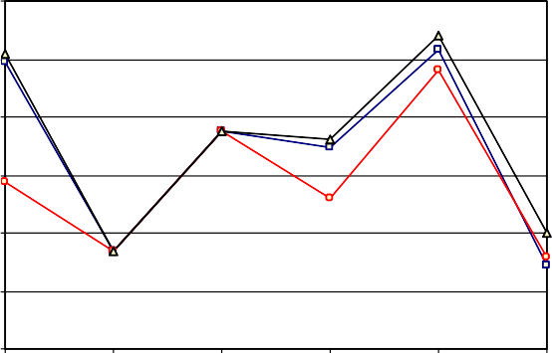

0 60 120 180 240 300

Pause Time (Sec.)

to inform it of the break. The collisions for the considered pro- tocols increased when the number of nodes increased.

* 1. *Data packets sent*

As can been seen in Figs. 9 and 10, the LAR protocol performs better than the other two protocols. At the start of the simula- tion time the data packets sent by the routing protocols have the same value and decreased to the minimum value at pause time 100. During the range pause time between 100 and 200 the data packets sent using the considered protocols is in- creased. At pause time 200 the data packets sent is increased using AODV protocol with 100 nodes and decreased.

* 1. *Data packets received*

160

140

120

100

Collisions

80

60

40

20

0

Figure 6 Throughput vs. pause time for 200 nodes.

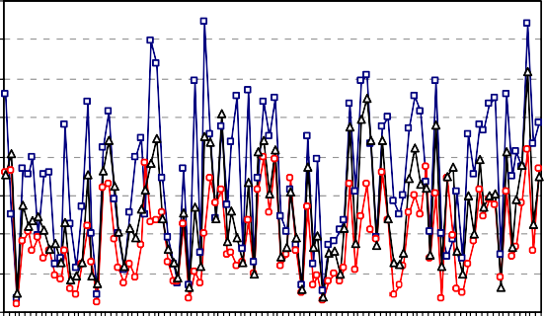



AODV DSR LAR

0 33 67 100 133 167 200 233 267 300

Pause Time (Sec.)

Figure 7 Collisions vs. pause time for 100 nodes.

Figs. 11 and 12, demonstrate the data packets received for the considered protocols. It is clear from the figure that LAR pro- tocol performs better than the other two protocols. At the start of the simulation time the data packets received by the proto- cols have the same value and increased until pause time 100. During the range pause time between 100 and 200 the data packets received using the considered protocols is decreased. Starting with pause time 200, LAR and DSR routing protocols performs better than the AODV protocol.

* 1. *Data packets retransmitted*

The data packets retransmitted using the considered protocols are shown in Figs. 13 and 14. It is clear that although AODV does not perform well at the beginning, later it does well near the end of simulation time. The DSR and LAR routing proto- cols increased and decreased according to the increase of pause time. Obviously from the figures the DSR protocol is better in the small network size otherwise the AODV protocol is better in the large network size.

The ratio between the number of packets sent by sources

from the route cache, if they are available, to prevent another route discovery.

Similarly, when a link break in a route occurs, the node up- stream of the break can perform route salvaging, whereby it utilizes a different route from its route cache, if one is avail- able, to repair the route. However, even when route salvaging is performed, a RERR message must still be sent to the source



AODV DSR LAR

and the number of received packets at the destination. This performance evaluation parameter measures effectiveness, reli- ability and efficiency of a protocol called packet delivery ratio. Figs. 9–12, indicates the fraction of the originated application data packets each protocol was able to deliver, as a function of node mobility rate (pause time) and network load (number of nodes). For AODV, DSR and LAR packet delivery ratio is independent of offered traffic load. In case of LAR protocol



AODV DSR LAR

200

180

160

140

Collisions

120

100

80

60

40

20

0

30

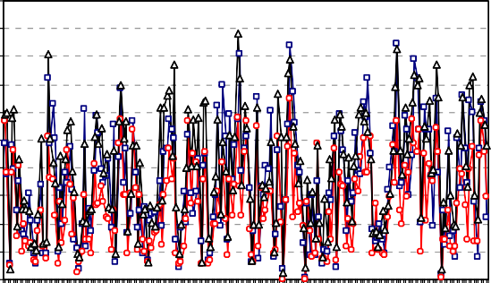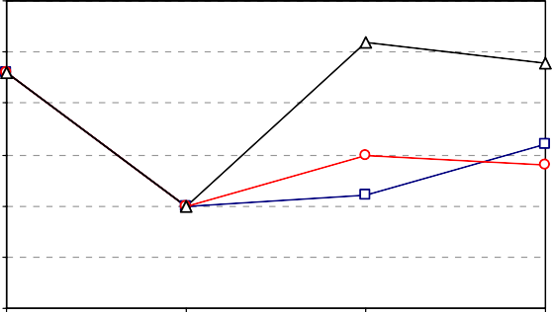25

Data Packets Sent

20

15

10

5

0

0 33 67 100 133 167 200 233 267 300 0

100

200

300

Pause Time (Sec.)

Figure 8 Collisions vs. pause time for 200 nodes.

Pause Time (Sec.)

Figure 9 Data packets sent vs. pause time for 100 nodes.

AODV DSR LAR

AODV DSR LAR

25 25



20 20

Data Packets Sent

Data Packets Received

15 15

10 10

5 5

0

0 100

200

0

300 0

100

200

300

Pause Time (Sec.)

Figure 10 Data packets sent vs. pause time for 200 nodes.

Pause Time (Sec.)

Figure 12 Data packets received vs. pause time for 200 nodes.

AODV DSR LAR

30 8

AODV DSR LAR



7

Data Packets Retransmitted

25 6

Data Packets Received

20 5

4

15

3

10 2

5 1

0

0 0

100

200

300

0 100

200

300

Pause Time (Sec.)

Pause Time (Sec.)

Figure 11 Data packets received vs. pause time for 100 nodes.

AODV DSR LAR

Figure 13 Data packets retransmitted vs. pause time for 100 nodes.

when numbers of nodes increases, initially throughput in- creases as number of routes are available compared to AODV

and DSR protocols. Regretfully DSR was not up to the task 8

and it performed poorly throughout all the simulation

sequences because increasing the overhead resulted from 7

Data packets Retransmitted

carrying source routes in data packets which reduces the 6

throughput. 5

* 1. *Energy consumption* 4

3

Figs. 15 and 16, present the energy consumption vs. pause time 2

for the considered protocols. It is clear that AODV and DSR

routing protocols show nearing performance as compared to 1

LAR protocol. When the pause time increases the energy 0

seems to be increased and decreased. The energy consumption 0

100

200

300

of the LAR protocol is higher than both AODV and DSR pro- tocols nearly for the small network size other wise the DSR protocol is higher than for the large network size. However, sending RREQ, RREP, controls packets and spreading traffic requires that some packets take long ‘‘detours’’, which will in- cur extra energy cost.

* 1. *ACK packets received*

Figs. 17 and 18, illustrates the ACK packets received using the considered protocols. They decreased at the beginning of the

Pause Time (Sec.)

Figure 14 Data packets retransmitted vs. pause time for 200 nodes.

simulation. The ACK packets are increased using LAR and DSR routing protocols between pause time 100 and 200 com- pared to the AODV protocol. For the large network size and at the pause time 200, the ACK packets received using the LAR protocol is increased compared to the other two proto- cols. We note the ACK packets received for the DSR protocol



AODV DSR LAR



AODV DSR LAR

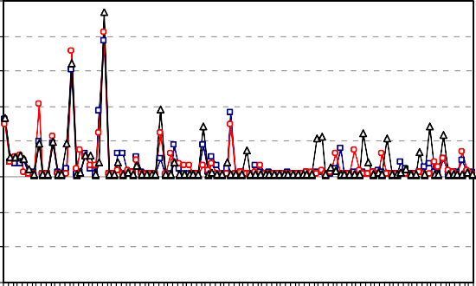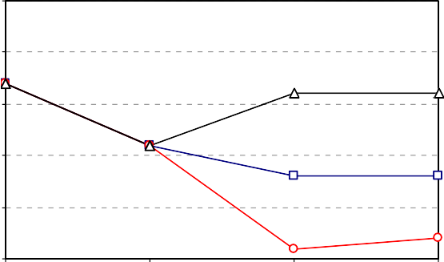75.1 25

75.08

75.06 20

Energy Consumption

ACK Packets Received

75.04

15

75.02

75 10

74.98

74.96

74.94

5

0

0 33 67 100 133 167 200 233 267 300 0

100

200

300

Pause Time (Sec.)

Figure 15 Energy consumption vs. pause time for 100 nodes.

Pause Time (Sec.)

Figure 18 ACK packet received vs. pause time for 200 nodes.



AODV DSR LAR

75.12



AODV DSR LAR

75.1

75.08

Energy Consumption

75.06

75.04

75.02

75

74.98

74.96

74.94

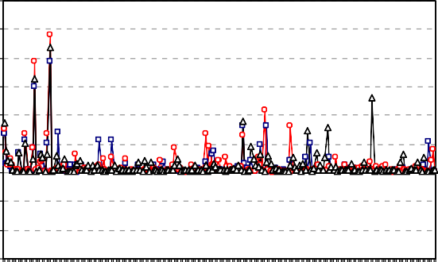

0 33 67 100 133 167 200 233 267 300

Pause Time (Sec.)

300

250

Number od Packet Attempt to be sent to MAC

200

150

100

50

0

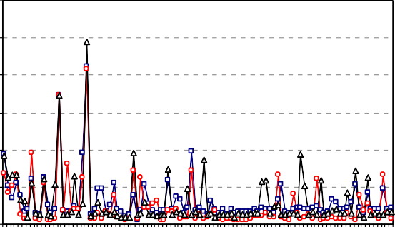

0 33 67 100 133 167 200 233 267 300

Pause Time (Sec.)

Figure 16 Energy consumption vs. pause time for 200 nodes.

Figure 19 Number of packet attempt to be sent to MAC vs.

pause time for 100 nodes.



AODV DSR LAR

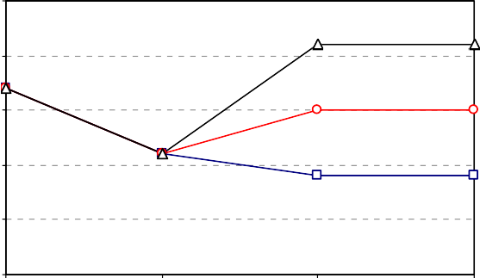25



AODV DSR LAR

20

ACK Packet Received

15

10

5

0

0 100

200

300

250

200

Number of Packet Attempt to be sent to MAC

150

100

50

0

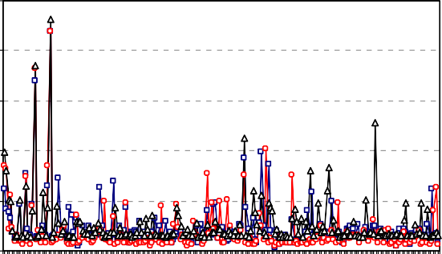

0 33 67 100 133 167 200 233 267 300

Pause Time (Sec.)

Pause Time (Sec.)

Figure 17 ACK packet received vs. pause time for 100 nodes.

Figure 20 Number of packet attempt to be sent to MAC vs. pause time for 200 nodes.

is lower than the other two protocols because another optional feature is the RREP acknowledgment (RREP-ACK). When unidirectional links are suspected, the RREP-ACK can be uti- lized to ensure the next hop received the RREP. If an RREP- ACK is not received, blacklists can be utilized to indicate uni- directional links so that these links are not used in future route discoveries.

* 1. *Number of packet attempt to be sent to MAC*

The number of packet attempt to be sent to MAC for the LAR protocol is higher than the other two protocols as shown in Figs. 19 and 20. However, DSR and LAR nodes have the op- tion of promiscuous listening, whereby nodes can receive and process data and control packets that are not addressed, at



AODV DSR LAR



AODV DSR LAR

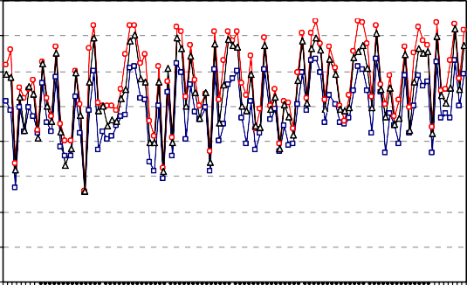8000

Signals Arrived with power above RX sensitivity

7000

6000

5000

4000

3000

2000

1000

0

4500

4000

Signals Arrived with power above RX threshold

3500

3000

2500

2000

1500

1000

500

0

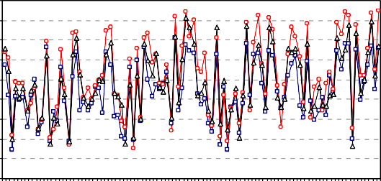

0 33 67 100 133 167 200 233 267 300

Pause Time (Sec.)

0 33 67 100 133 167 200 233 267 300

Pause Time (Sec.)

Figure 21 Signals arrived with power above RX sensitivity vs. pause time for 100 nodes.

Figure 23 Signals arrived with power above RX threshold vs.

pause time for 100 nodes.

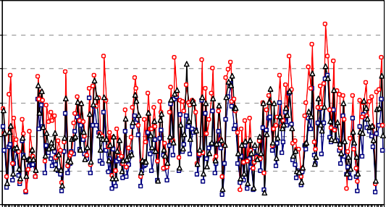6000



AODV DSR LAR

Signals Arrived with power above RX threshold



AODV DSR LAR

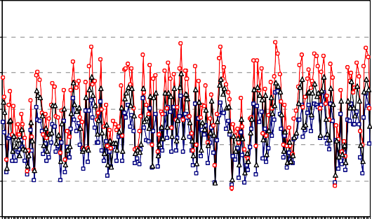12000

Signals arrived with power above RX sensitivity

10000

8000

6000

4000

2000

5000

4000

3000

2000

1000

0

0 33 67 100 133 167 200 233 267 300

Pause Time (Sec.)

0

0 33 67 100 133 167 200 233 267 300

Pause Time (Sec.)

Figure 24 Signals arrived with power above RX threshold vs. pause time for 200 nodes.

Figure 22 Signals arrived with power above RX sensitivity vs. pause time for 200 nodes.

the MAC layer, to themselves. Through promiscuous listening, nodes can utilize the source routes carried in both control mes- sages and data packets to gratuitously learn routing informa- tion for other network destinations.

* 1. *Signals*
     1. *Signals arrived with power above RX sensitivity*

The RX sensitivity of an electronic device, such as a communi- cations system receiver, or detection device, such as a PIN diode, is the minimum magnitude of input signal required to produce a specified output signal having a specified Signal Noise Ratio (SNR). Because receive sensitivity indicates how faint an input signal can be to be successfully received by the receiver, the lower the power level, the better. Lower power for a given SNR means better sensitivity since the receiver’s contribution is smaller [18].

Figs. 21 and 22, give the signals arrived with power above RX sensitivity. The performance of AODV is the better be- cause its RX sensitivity is lower than the other two protocols.

* + 1. *Signals arrived with power above RX threshold*

The RX threshold is defined as the minimum power required by the receiver to detect the received packet. If the Signal to Noise Ratio (SNR) is more than RX threshold, it receives



AODV DSR LAR

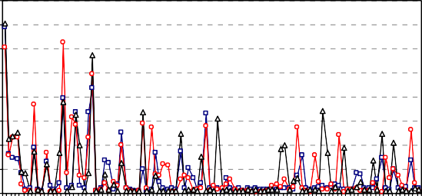800

700

Signals Transmitted

600

500

400

300

200

100

0

0 33 67 100 133 167 200 233 267 300

Pause Time (Sec.)

Figure 25 Signals transmitted vs. pause time for 100 nodes.

the signal without error, otherwise the packet is dropped [18]. Figs. 23 and 24 illustrate the signals arrived with power above RX threshold for the considered protocols. As can been seen in these figures, the performance of DSR protocol is bet- ter than the other protocols because its RX threshold is higher.

* + 1. *Signals transmitted*

Signal transmitted along radio waves travel at the speed of light, in straight lines, and by more than one path. Local sig- nals that you hear from nearby FM radio stations are usually traveling by space wave or ‘‘line of sight’’. These travels, as the name suggest, from antenna to antenna direct.



AODV DSR LAR

1000

900

800

Signals Transmitted

700

600

500

400

300

200

100

0

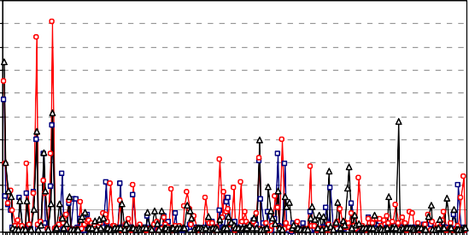

0 33 67 100 133 167 200 233 267 300

Pause Time (Sec.)

30

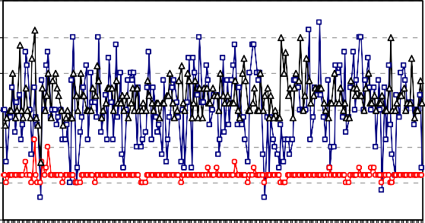25



AODV DSR LAR

BCAST (Pkts sent to channel)

20

15

10

5

0

0 33 67 100 133 167 200 233 267 300

Pause Time (Sec.)

Figure 26 Signals transmitted vs. pause time for 200 nodes.

Figure 28 BCAST (pkts sent to channel) vs. pause time for 200 nodes.



AODV DSR LAR

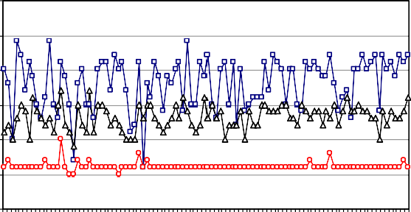30

BCAST (pkts sent to channel)



AODV DSR LAR

25

20

15

10

5

0

0 33 67 100 133 167 200 233 267 300

Pause Time (Sec.)

Figure 27 BCAST (pkts sent to channel) vs. pause time for 100 nodes.

700

600

BCAST ( Pkts rcvd clearly)

500

400

300

200

100

0

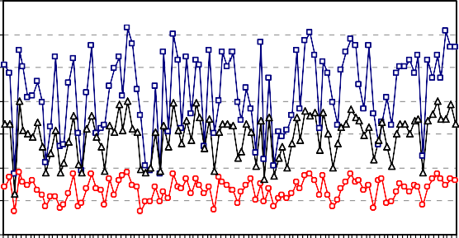

0 33 67 100 133 167 200 233 267 300

Pause Time (Sec.)

Figs. 25 and 26, illustrate the signals transmitted using the considered protocols. The performance of DSR is the better because its signal transmitted is higher than the other two protocols.

* 1. *BCAST and UCAST packets*
     1. *BCAST (pkts sent to channel)*

Figs. 27 and 28, show the BCAST (pkts sent to channel) using the considered protocols. It is clear that the AODV protocol performs better than the other two routing protocols.

* + 1. *BCAST (pkts rcvd clearly)*

The BCAST (pkts rcvd clearly) using the considered routing protocols are shown in Figs. 29 and 30. It is clear from the fig- ure AODV protocol performs better than the other two rout- ing protocols.

Like most reactive routing protocols, when a source node has data packets to send to some destination, it must initiate a route discovery procedure to find a route. To start route dis- covery, the source node creates a route request (RREQ) packet (broadcast). Thus, the reverse route that was created as the RREQ was forwarded is utilized to route the route reply RREP back to the source node (unicast). When a link break along an active path occurs, the node upstream of the break invalidates the routes to each of those destinations in its route table. It then creates a route error (RERR) message. After cre- ating the RERR message, it sends this message to its upstream

Figure 29 BCAST (pkts rcvd clearly) vs. pause time for 100

nodes.



AODV DSR LAR

800

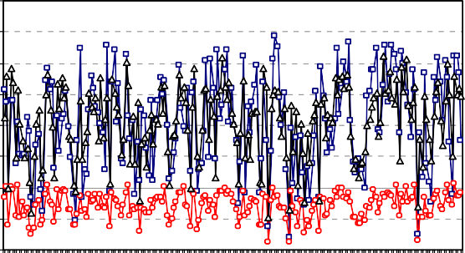700

BCAST ( Pkts rcvd clearly)

600

500

400

300

200

100

0

0 33 67 100 133 167 200 233 267 300

Pause Time (Sec.)

Figure 30 BCAST (pkts rcvd clearly) vs. pause time for 200 nodes.

neighbors that were also utilizing the link. These nodes, in turn, invalidate the broken routes and send their own RERR messages to their upstream neighbors that were utilizing the link. The RERR message thus traverses the reverse path to the source node. In addition, AODV allows the use of periodic Hello messages for monitoring connectivity to neighboring nodes. It’s obvious from the behavior of the AODV protocol



AODV DSR LAR



AODV DSR LAR

250

UCAST (Pkts sent to channel)

200

150

100

50

0

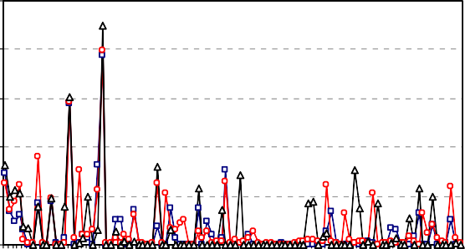

0 33 67 100 133 167 200 233 267 300

Pause Time (Sec.)

300

250

UCAST (pkts rcvd clearly)

200

150

100

50

0

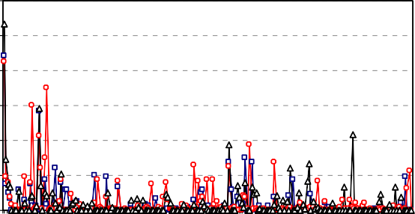

0 33 67 100 133 167 200 233 267 300

Pause Time (Sec.)

Figure 31 UCAST (pkts sent to channel) vs. pause time for 100 nodes.

Figure 34 UCAST (pkts rcvd clearly) vs. pause time for 200 nodes.



AODV DSR LAR



AODV

DSR

LAR

300

UCAST (pkts sent to channel)

250

200

150

100

50

0

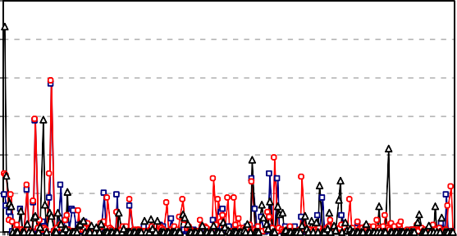

0 33 67 100 133 167 200 233 267 300

Pause Time (Sec.)

16000

14000

Total of the TTL's of delivered packets

12000

10000

8000

6000

4000

2000

0

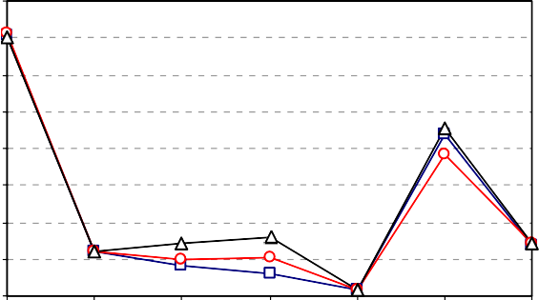

0 50 100 150 200 250 30

Pause Time (Sec.)

Figure 32 UCAST (pkts sent to channel) vs. pause time for 200

nodes.

Figure 35 TTL’s of delivered packets vs. pause time for 100 nodes.



AODV DSR LAR

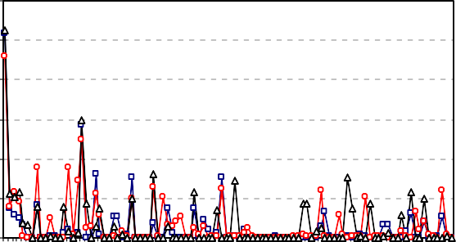300



AODV DSR LAR

250

UCAST (Pkts rcvd clearly)

200

150

100

50

0

0 33 67 100 133 167 200 233 267 300

Pause Time (Sec.)

16000

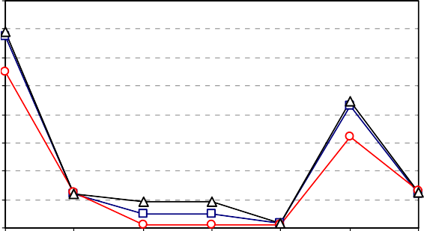14000

Total of the TTL's of delivered packets

12000

10000

8000

6000

4000

2000

0

Figure 33 UCAST (pkts rcvd clearly) vs. pause time for 100

nodes.

0 50 100 150 200 250 30

Pause Time (Sec.)

it broadcasts and unicasts much messages more than the other two protocols as shown in Figs. 27–34.

* + 1. *UCAST (pkts sent to channel)*

Figs. 31 and 32, illustrates the UCAST (pkts sent to channel) using the considered protocols. As can been seen in this figure LAR protocol performs better than the other two routing protocols.

Figure 36 TTL’s of delivered packets vs. pause time for 200 nodes.

* + 1. *UCAST (pkts rcvd clearly)*

Figs. 33 and 34, illustrates the UCAST (pkts rcvd clearly) using the considered protocols. As can been seen in this figure LAR protocol performs better than the other two routing protocols.

|  |  |  |  |  |  |  |  |
| --- | --- | --- | --- | --- | --- | --- | --- |
| Table 1 Summary of performance results. |  | | | | | | |
| Performance | 100 nodes |  |  |  | 200 nodes |  |  |
| Matrices | AODV | DSR | LAR |  | AODV | DSR | LAR |
| Normalized routing overhead | H | M | L |  | H | M | L |
| Average end-to-end delay | M | H | L |  | M | H | L |
| Throughput | M | L | H |  | M | L | H |
| Collisions | L | M | H |  | M | H | L |
| Data packets sent | L | M | H |  | M | L | H |
| Data packets received | L | M | H |  | M | L | H |
| Packets retransmitted | H | L | M |  | L | H | M |
| Energy consumption | H | M | L |  | H | L | M |
| ACK packets rcvd | L | M | H |  | M | L | H |
| Packet attempt to be sent to MAC | M | L | H |  | L | M | H |
| Signals arrived with power above RX sensitivity | L | H | M |  | L | H | M |
| Signals arrived with power above RX threshold | L | H | M |  | L | H | M |
| Signals transmitted | L | H | M |  | L | H | M |
| BCAST (pkts sent) and BCAST (pkts rcvd) | H | L | M |  | H | L | M |
| UCAST (pkts sent) and UCAST (pkts rcvd) | L | M | H |  | L | M | H |
| TTL’s of packets | M | L | H |  | M | L | H |
|  |  |  |  |  |  |  |  |

* 1. *Total of the TTL’s of delivered packets*

As can been seen in Figs. 35 and 36, the total of the TTL’s of delivered packets using the considered protocols, we find out that the TTL’s decrease as the pause time is increasing until the pause time reaches 200. Starting from the pause time 200 we can note that the TTL’s is increasing to its maximum value at pause time 250 and then decreases. Other characteristics that distinguish LAR from other reactive routing protocols in- clude the fact that LAR’s route cache entries need not have lifetimes. Once if the source recently had a route to the desti- nation, then the source calculates the expected zone and the re- quest zone, and places the coordinates of the request zone boundary into the RREQ message.

1. Summarized results

Our goal was to compare the three routing protocols to each other, not to find the optimal performance possible in our sce- narios, we observe that the mobility pattern does influence the performance of MANET routing protocols. This conclusion is consistent with the observation of previous studies. But unlike previous studies that compared different mobile ad hoc net- work routing protocols under variety of performance metrics, there is no clear winner among the protocols in our case, since different performance metrics and network size seems to give different performance rankings of the protocols.

Finally, Table 1 summarizes the performance evaluation of the considered routing protocols mentioned in this paper. It provides correspondingly, the protocol name, the network size, and the performance matrices, where, H, M and L mean High, Medium and Lower performance, respectively.

1. Conclusion

This paper evaluated the performance of AODV, DSR, and LAR routing protocols for MANET using GloMoSim simula- tor. Comparison was based on variety of performances met-

rics, namely normalized routing overhead, average end-to- end delay, throughput, collisions, data packets sent, data pack- ets received, data packets retransmitted, energy consumption (in mWhr), ACK packets received, packet attempt to be sent to MAC, signals arrived with power above RX sensitivity, sig- nals arrived with power above RX threshold, signals transmit- ted, BCAST (pkts sent to channel), BCAST (pkts rcvd clearly), UCAST (pkts sent to channel), UCAST (pkts rcvd clearly), and total of the TTL’s of delivered packets. To determine the impact of network size on the performance of the consid- ered protocols we considered two different scenarios, namely, 100 and 200 nodes, with rectangular area sizes 1500 · 1000 and 2000 · 1500 m2, respectively.

In the *first scenario (100 nodes)*, LAR protocol showed good performance for normalized routing overhead, average end-to-end delay, throughput, data packets sent, data packets received, energy consumption (in mWhr), number of packet at- tempt to be sent to MAC, UCAST (pkts sent to channel), UCAST (pkts rcvd clearly), and total of the TTL’s of delivered packets. However, AODV protocol showed better perfor- mance for collisions, ACK packets received, signals arrived with power above RX sensitivity, BCAST (pkts sent to chan- nel) and BCAST (pkts rcvd clearly). Finally, DSR protocol showed good performance for packets retransmitted and sig- nals arrived with power above RX threshold and signals transmitted.

In the *second scenario (200 nodes)*, LAR protocol showed good performance for normalized routing overhead, average end-to-end delay, throughput, collisions, data packets sent, data packets received, ACK packets received, packet attempt to be sent to MAC, UCAST (pkts sent to channel), UCAST (pkts rcvd clearly), and total of the TTL’s of delivered packets. However, AODV protocol showed better performance for throughput, packets retransmitted, signals arrived with power above RX sensitivity, BCAST (pkts sent to channel) and BCAST (pkts rcvd clearly). Finally, DSR protocol showed good performance for signals arrived with power above RX threshold and signals transmitted.

References

1. Rahman A, Islam S, Talevski A. Performance measurement of various routing protocols in ad-hoc network. In: Proceedings of the international multiconference of engineers and computer scientists, vol. 1. Hong Kong: IMECS; 2009.
2. Tyagi SS, Chauhan RK. Performance analysis of proactive and reactive routing protocols for ad hoc networks. Int J Comput Appl 2010;1(14).
3. Basagni S, Conti M, Giordano S, Stojmenovic I. Mobile ad hoc networking. A John wiley and sons, Inc., Publication; 2004.
4. Duyen Trung H, Benjapolakul W, Minh Duc P. Performance evaluation and comparison of different ad hoc routing protocols. Elsevier Comput Commun 2007;30:2478–96.
5. Ahvar E, Fathy M. Performance evaluation of routing protocols for high density ad hoc networks based on energy consumption by GloMoSim simulator. World Acad Sci Eng Technol; 2007.
6. Radwan AAA, Mahmoud TM, Houssein EH. Performance measurement of some mobile ad hoc network routing protocols. Int J Comput Sci Issues (IJCSI) 2011;8(1).
7. Jayakumar G, Gopinath G. Performance comparison of two on- demand routing protocols for ad-hoc networks based on random way point mobility model. Am J Appl Sci 2008:659–64.
8. Patil1 VC, Biradar RV, Mudholkar RR, Sawant SR. On-demand multipath routing protocols for mobile ad hoc networks issues and comparison. Int J Wireless Commun Simulation 2010;2(1):21–38.
9. Nassef L. On the effect of fading and mobility in on-demand routing protocols. Elsevier Egyptian Informatics Journal 2010;11(2).
10. Chlamtac I, Conti M, Liu JJ-N. Mobile ad hoc networking: imperatives and challenges. Elsevier Ad Hoc Networks 2003;1:13–64.
11. Yahya A. Energy-aware architecture of multi-rate ad hoc networks. Elsevier Egyptian Informatics J 2010;11(1).
12. Lang D. On the evaluation and classification of routing protocols for mobile ad hoc networks, PhD thesis, Fakulta¨t fu¨r Informatik der Technischen, Universita¨t Mu¨nchen, Germany, 2006.
13. Perkins CE, Royer EM, Das SR. Ad Hoc on Demand Distance Vector (AODV) routing. Available from: [http://www.ietf.org/](http://www.ietf.org/internetdrafts/draft-ietfmanet-aodv-06.txt) [internetdrafts/draft-ietfmanet-aodv-06.txt](http://www.ietf.org/internetdrafts/draft-ietfmanet-aodv-06.txt), IETF Internet Draft, work in progress, 2000.
14. Perkins C, Belding-Royer E, Das S. Ad hoc On-Demand Distance Vector (AODV) routing. Network working group, IETF RFC, RFC 3561, 2003.
15. Gallissot M. Routing on ad hoc networks, Project, Supervisor, Maurice Mitchell Date, 2007.
16. Mistry N, Jinwala DC, Zaveri M. Improving AODV protocol against black hole attacks. Proceeding of international multicon- ference of engineers and computer scientists 2010;II.
17. Jaisankar N, Saravanan R. An extended AODV protocol for multipath routing in MANETs. Int J Eng Technol 2010;2(40).
18. Maltz DA, On-demand routing in multi-hop wireless mobile ad hoc networks, PhD Thesis, School of Computer Science Carnegie Mellon University Pittsburgh, PA 15213, 2001.
19. Norouzi A, Berk Ustundag B. Improvement of DSR protocol using group broadcasting. Int J Comput Sci Netw Secur 2010;10(6).
20. Blazˇevic´L, Le Boudec J, Giordano S. A location based routing method for irregular mobile ad hoc networks, EPFL-IC Report Number IC/2003/30, 2003.
21. Ashtiani H, Alirezaee S, Mohsen mir hosseini S, Khosravi H. NR: new position based routing algorithm for mobile ad hoc networks. In: Proceedings of the world congress on engineering, UK, vol. 1. 2009.
22. Mangai S, Tamilarasi A. Evaluation of the performance metrics in improved location aided cluster based routing protocol for GPS enabled MANETs. Eur J Sci Res 2010;46(2).
23. The official GloMoSim website. Available from: [http://pcl.cs.u-](http://pcl.cs.ucla.edu/projects/glomosim/lastaccess) [cla.edu/projects/glomosim/lastaccess](http://pcl.cs.ucla.edu/projects/glomosim/lastaccess), 2010.
24. The official PARSEC website. Available from: [http://pcl.cs.u-](http://pcl.cs.ucla.edu/projects/parsec/lastaccess) [cla.edu/projects/parsec/lastaccess](http://pcl.cs.ucla.edu/projects/parsec/lastaccess), 2010.
25. Kumar MK, Rajesh RS. Performance analysis of MANET routing protocols in different mobility models. Int J Comput Sci Netw Secur 2009;9(2).