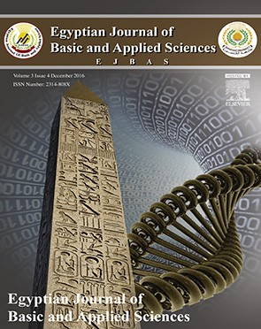 HOSTE D BY

Available online at [www.sciencedirect.com](http://www.sciencedirect.com/science/journal/2314808X)

**ScienceDirect**

journal homepage: [http://ees.elsevier.com/ejbas/default.asp](http://http//ees.elsevier.com/ejbas/default.asp)

**Full Length Article**

**FT-IR analysis of *Sapium ellipticum* (Hochst) pax ethanol leaf extract and its inhibitory effects on pancreatic α-amylase and intestinal**



**α-glucosidase activities *in vitro***

***Osasenaga Macdonald Ighodaro*** ***a******,******b******,******\*******, Oluseyi Adeboye Akinloye*** ***b******, Regina Ngozi Ugbaja*** ***b******, Samuel Olatunbosun Omotainse*** ***c******,***

***Opeyemi Faokunla*** ***a******,******d***

a *Department of Biochemistry, Faculty Sciences, Lead City University, Ibadan, Nigeria*

b *Department of Biochemistry, College of Biological Sciences, Federal University of Agriculture, Abeokuta* *(FUNAAB), Abeokuta, Nigeria*

c *Department of Veterinary Pathology, College of Veterinary Medicine, Federal University of Agriculture,*

*Abeokuta (FUNAAB), Abeokuta, Nigeria*

d *Department of Biological Sciences, Wesley University of Science and Technology, Ondo State, Nigeria*

A R T I C L E I N F O A B S T R A C T

*Article history:*

Received 4 August 2016 Received in revised form 18 September 2016

Accepted 20 September 2016

Available online 7 October 2016

*Keywords: Sapium ellipticum* α-Amylase

α-Glucosidase Hyperglycemia

This study investigated the inhibitory effects of *Sapium ellipticum* (SE) (Hochst) Pax leaf extract on some carbohydrate metabolizing enzymes, pancreatic α-amylase and intestinal α-glucosidase activities *in vitro*. The inhibitory potential of SE extract was measured against Quercetin. SE extract in a dose dependent pattern significantly inhibited the activity of pancreatic α-amylase by 67.2% at 10 mg/mL. This effect was comparable to that of quercetin which offered 82.6% α-amylase inhibition. In terms of intestinal α-glucosidase activity, the inhibitory effect of the extract was significantly lower than that of quercetin at all investigated concentrations. At 10 mg mL−1 (maximum tested concentration), SE extract exhibited 35.8% inhibitory activity

on α-intestinal glucosidase compared to the 74.3% exhibited by Quercetin at the same con-

centration. Phytochemical analysis results showed that SE contained 74 ± 3.12 milligram Gallic acid equivalents of total phenols and 67.2 ± 2.04 milligram Quercetin equivalents of flavo- noids per gram of extract. Fourier Transformed Infra red spectroscopy (FT-IR) of SE extract

revealed the presence of active functional groups reminiscence of polyphenols. Alpha amylase and α-glucosidase activities (*in vivo*) greatly contribute to postprandial hyperglycemia which is a great risk factor for type 2 diabetes mellitus. The inhibitory potential of SE extract on these enzymes as observed in this study suggests a positive and probable role of the extract in the management and treatment of diabetes mellitus, particularly, type 2.

© 2016 Mansoura University. Production and hosting by Elsevier B.V. This is an open access article under the CC BY-NC-ND license (<http://creativecommons.org/licenses/by->

nc-nd/4.0/).

* *Corresponding author.*

*E-mail address:* [macigho@yahoo.com](mailto:macigho@yahoo.com), [macigho@gmail.com](mailto:macigho@gmail.com) (O.M. Ighodaro). <http://dx.doi.org/10.1016/j.ejbas.2016.09.003>

2314-808X/© 2016 Mansoura University. Production and hosting by Elsevier B.V. This is an open access article under the CC BY-NC-ND license ([http://creativecommons.org/licenses/by-nc-nd/4.0/).](http://creativecommons.org/licenses/by-nc-nd/4.0/))

# Introduction

The effective role of medicinal plants in the management and treatment of diabetes mellitus is becoming increasingly popular. This is not only because of their ability to reverse elevated blood glucose through insulin-tropic functions but also as a result of their inhibitory effects on key carbohydrate metabo- lizing enzymes including pancreatic α-amylase and intestinal α-glucosidase. Digestion of complex dietary carbohydrates is the primary source of glucose in the blood, and pancreatic α-amylase and intestinal α-glucosidase are key enzymes in carbohydrate catabolism [1,2]. These enzymes contribute enor- mously to postprandial hyperglycemia, by breaking down complex carbohydrates such as starch into simple and ab- sorbable units like glucose and fructose, leading to increased concentration of simple sugars in the blood. Availability of monosaccharides particularly glucose in the blood is what results in postprandial hyperglycemia which is a great risk factor for type 2 diabetes mellitus (T2DM) [3,4]. Conversely, inhibition of these enzymes significantly decreases the diges- tion and uptake of carbohydrates, thereby lowering the postprandial blood glucose concentration in T2DM patients [5,6].

Various orthodox drugs including acarbose and voglibose have been in use as inhibitors of α-glucosidase and α-amylase. However, they have been reported to excessively inhibit pan- creatic α-amylase causing abnormal bacterial fermentation of undigested carbohydrates in the colon [7,8], which usually

results in undesirable side effects such as abdominal disten- tion, bloating, meteorism, and in some cases, diarrhea [9].

A number of studies have reported the inhibitory ability of

medicinal plants with hypoglycemic properties on α-glucosidase and α-amylase [6,10–12]. *Sapium ellipticum* (Hochst) Pax has a number therapeutic applications in folk medicine [13,14], in- cluding treatment of diabetes (ethno botanical survey). It belongs to the family *Euphorbiaceae* and is commonly referred to as jumping seed tree. *S. ellipticum* is widely distributed in eastern and tropical Africa. In southwest part of Nigeria, particularly among the Ilorin indigenes, the plant is popularly known as *aloko-a· gbo· .*

A few scientific investigations have been carried out on it. Adesegun et al. [15] in their *in vitro* study credited substan- tial antioxidant properties to the stem bark extract of the plant. Cytotoxicity screening of selected Nigerian plants used in traditional cancer treatment on HT29 (colon cancer) and MCF-7 (breast cancer) cell lines (HeLa cervix adenocarci- noma cells) indicated that *S. ellipticum* leaf extract expressed the highest cytotoxic activity among other plants with anti- cancer potential which was comparable to the reference drug, cisplatin [16]. The phythochemical constituents, *in vitro* anti- oxidant capacities and antiplasmodial activities of *S. ellipticum* stem bark extracts were documented by Nana et al. [17]. This present study sought to investigate the effects of the

plant leaf extract on the activities of carbohydrate metabo- lizing enzymes such as pancreatic α-amylase and intestinal

α-glucosidase which play significant roles in glucose

homeostasis.

# Materials and methods

* 1. ***Preparation of* S. ellipticum *leaf extract***

The plant material was freed of extraneous materials; air dried at room temperature and milled to a fine powder, using a Waring blender. Three hundred grams of the powdered sample was macerated in 2.5 liters of the extracting solvent (ethanol). The mixture was allowed to stand for 72 h and stirred inter- mittently with a glass rod to facilitate extraction. Sieving of the mixture was achieved with a muslin cloth (maximum pore size 2 mm). The resulting filtrate on sieving was further fil- tered through Whatman filter paper (No 42) and subsequently reduced in volume with a rotary evaporator at 40 °C. Final elimi- nation of solvent and drying was done using a regulated water bath at 40 °C.

## *Effect of SE extract on α-amylase activity in vitro*

The method described by Bernfield [18] was used to assess the effect of SE extract on α-pancreatic amylase activity. Querce- tin was used as a reference compound. Various extract and quercetin concentrations ranging from 2 to10 mg/L were pro- duced. One hundred microliters each of the concentrations was added to 500 μL of 0.02 M sodium phosphate buffer (pH 6.9 with 0.006 M NaCl) containing Porcine pancreatic α-amylase (EC 3.2.1.1) (0.5 mg/mL). The mixture in each case was incubated at 25 °C for 10 minutes. Then, 500 μL of 1% starch solution in

0.02 M sodium phosphate buffer (pH 6.9 with 0.006M NaCl) was added to each tube. The reaction mixture was incubated at 25 °C for 10 minutes and stopped with 1.0 mL of dinitrosalicylic acid color reagent. Thereafter, the mixture was incubated in a boiling water bath for 5 minutes, and cooled to room temperature. The reaction mixture was then diluted by adding 10 mL of dis- tilled water, and absorbance was measured at 540 nm. A complete reaction mixture without quercetin or SE extract was

used as control. The α-amylase inhibitory activity was calcu-

lated using the formula:

% inhibition  Acontrol  Asample Acontrol   100.

Where Acontrol is the absorbance of the control reaction (con- taining all reagents except the test extract or quercetin) and Asample is the absorbance of the test material or quercetin. The

α-amylase inhibitory activity was expressed as percentage

inhibition.

## *Effect of SE extract on α-glucosidase activity in vitro*

Evaluation of the effect of SE extract on α-glucosidase activ- ity was performed according to the procedure described by Apostolidis et al. [19]. Quercetin was used as a reference com- pound. Various extract and quercetin solutions with concentrations ranging from 2 to 10 mg/L were prepared. Twenty microliters each of the solutions and 100 μL of α-glucosidase (EC 3.2.1.20) solution in 0.1M phosphate buffer (pH 6.9) were incubated at 25oC for 10 minutes. Then, 50 μL of 5 mM

*p*-nitrophenyl-α-*D*-glucopyranoside solution in 0.1M phos- phate buffer (pH 6.9) was added. The mixtures were incubated at 25 °C for 5 minutes, before reading the absorbance at 405 nm in the spectrophotometer. A complete reaction mixture without quercetin or SE extract was used as control. The α-glucosidase inhibitory activity was expressed as percentage inhibition and calculated using the formula:

% inhibition  Acontrol  Asample Acontrol   100

## *Total phenol estimation*

The total phenol content of SE extract was estimated using the Folin–Ciocalteu reagent method as described by Singleton et al.

1. and Demiray et al. [21]. The plant sample (100 mg mL−1,

1.0 mL) was mixed thoroughly with 5 mL Folin–Ciocalteu reagent (diluted ten-fold) and after 5 minutes, 4.0 mL of sodium car- bonate (0.7 M) was added and the mixture was allowed to stand for 1 h with intermittent shaking; for color development. The absorbance was measured at 765 nm in a spectrophotometer against a blank. The blank solution contained the solvent used to dissolve the plant extract. Gallic acid was used as a stan- dard. Serial dilution of 10 mg/mL of the standard was made to obtain a calibration curve. Total phenol contained in SE extract was calculated as gallic acid equivalents (GAE) using

the following equation: C = (c × V)/m. Where C = Total Phenol, mg/g SE extract, in GAE, c = the concentration of gallic acid es- tablished from the calibration curve (mg/mL), V = the volume of extract in mL, and m = the weight of crude plant extract

in g.

## *Total flavonoids estimation*

The total flavonoid content of SE extract was determined using a colorimetric method described by Zhishen et al. [6] with slight modifications. SE (100 mg) was dissolved in 10 mL of 80% metha- nol and the resultant homogenous mixture was allowed to stand for 20 minutes at room temperature. This was followed by filtration through Whatman filter paper (No 42). An aliquot of 0.4 mL of the filtrate was mixed with 0.6 mL distilled water and 5% NaNO2 solution (0.0 6 mL). The mixture was allowed to stand for 5 minutes at room temperature. After 6 minutes 10% AlCl3 solution (0.0 6 mL) was added to the mixture. This was immediately followed by the addition of 1M NaOH (0.4 mL) and 0.45 mL distilled water to the mixture and allowed to stand for another 30 minutes. Absorbance of the mixture was de- termined at 510 nm. Quercetin calibration curve was prepared at the same wavelength (510 nm) and used for the quantifi- cation of total flavonoid content. The total content of flavonoid compounds in SE extract was calculated by the following equa-

tion: **C = (c × V)/m**. The result was expressed as milligram of

Quercetin equivalents per gram (dry weight) of SE.

## *Fourier transformed infrared (FT-IR) spectroscopic* analysis of SE crude extract

Dried ethanol extract was used for FT-IR analysis according to the combined methods of Hussein et al. [22] and Huda et al.

[23]. 2 mg of SE sample was mixed with 100 mg potassium bromide (KBr)| (FT-IR grade) and then compressed to prepare a translucent sample disc (3 mm diameter). The disc was im- mediately kept in the sample holder. The sample was scanned and the FT-IR spectra were recorded in the absorption range between 1000 and 3500 nm. FT-IR analysis was performed using Perkin Elmer Spectrophotometer system, which was used to detect the characteristic peaks, types of chemical bonds and probable functional groups present in SE sample. The peak values of the FT-IR were recorded and the analysis was re- peated twice for the spectrum confirmation.

## *Effect of SE on intestinal glucose absorption in* normoglycemic rats

Twelve rats were fasted for 12 h and assigned randomly to 2 groups, each containing 6 rats. The control animals received corn oil (0.5 mL, p.o) while the experimental animals were ad- ministered SE (800 mg/kgBW, p.o). Thirty minutes, after the administrations, all rats in both groups were orally loaded with 10 mL 50% (w/v) of glucose solution per kilogram body weight. Thereafter, the rats were sacrificed and their small intestines were excised. Fifty milliliters of distilled water was then infused from one cut end of the intestine and the content was col- lected at the other end. The content was centrifuged at 3000 rpm for 5 minutes. Glucose level in the supernatant was then es- timated by the glucose oxidase method using a Randox kit. The animals were not allowed access to laboratory chow and water *ad libitum* during the experiment.

# Results

## *Effects of SE on α-amylase and α-glucosidase* activities

The inhibitory ability of SE extract and quercetin on pancre- atic α-amylase and α-glucosidase activities *in vitro* are represented by Figs. 1 and 2. Fig. 1 depicts that SE extract in a dose dependent pattern significantly inhibited the activity of pancreatic α-amylase affording 67.2% inhibition at 10 mg/mL. This effect was comparable to that of quercetin which offered 82.6% α-amylase inhibition. In terms of intestinal α-glucosidase activity, the effect of the extract was significantly lower than that of quercetin at all investigated concentrations. At 10 mg mL−1 (maximum tested concentration), SE extract ex- hibited 35.8% inhibitory activity on α-intestinal glucosidase compared to the 74.3% exhibited by Quercetin at the same con- centration as summarized in Fig. 2.

## *Total phenolic and flavonoid content of SE*

The total phenol content of SE leaf extract was estimated as

74.0 mg GEA/g of extract as shown in Fig. 3. The extract af- forded total flavonoid content (C) of 65.2 mg QE/g of extract (Fig. 4).

From C = (c × V)/m, total flavonoid content = (1.68 × 0.4)/

0.01 (10 mg) = 67.2 mg QE per gram of SE.

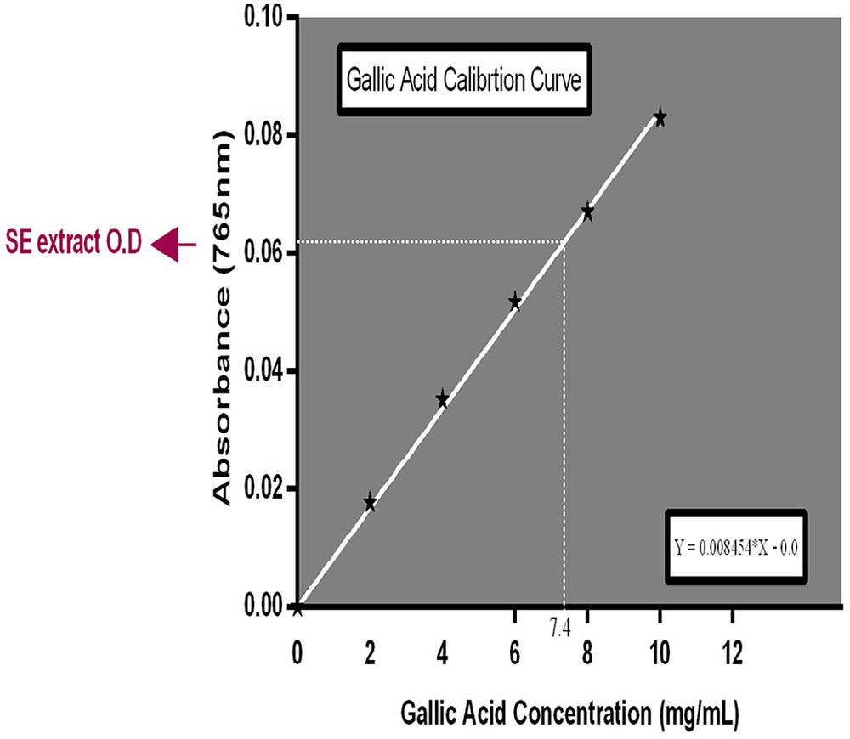

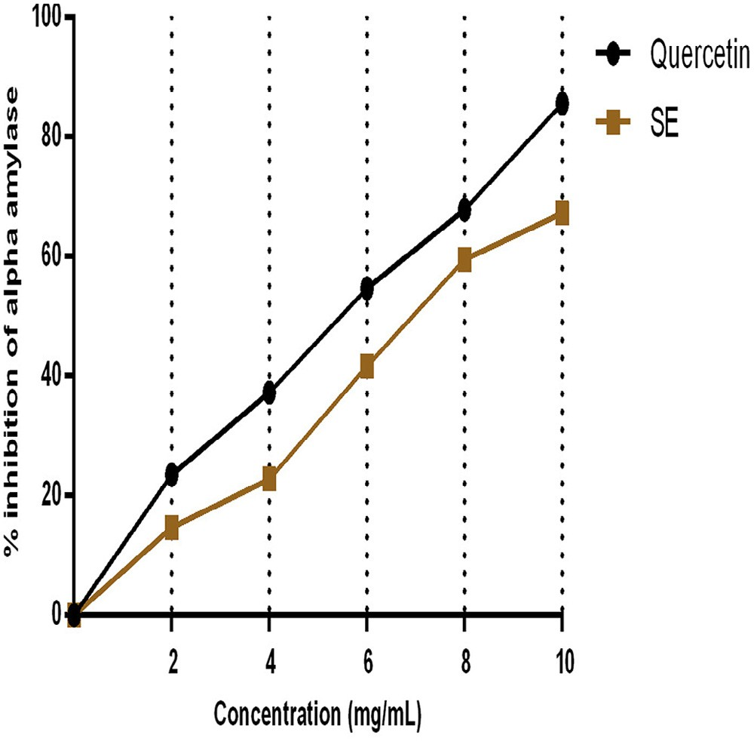**Fig. 1 – *In vitro* inhibitory effect of SE and Quercetin on**

**α-amylase activity.**

## *Effect of SE extract on intestinal glucose absorption*

The effect of SE on glucose absorption is shown in Fig. 5. Com- pared to the control group, SE did not significantly influence intestinal glucose absorption in the experimental animals.

## *FT-IR spectra of SE extract*

Fig. 6 shows the result of the Fourier Transform Infra Red (FT- IR) spectroscopic study of SE extract. The FT-IR spectra depict

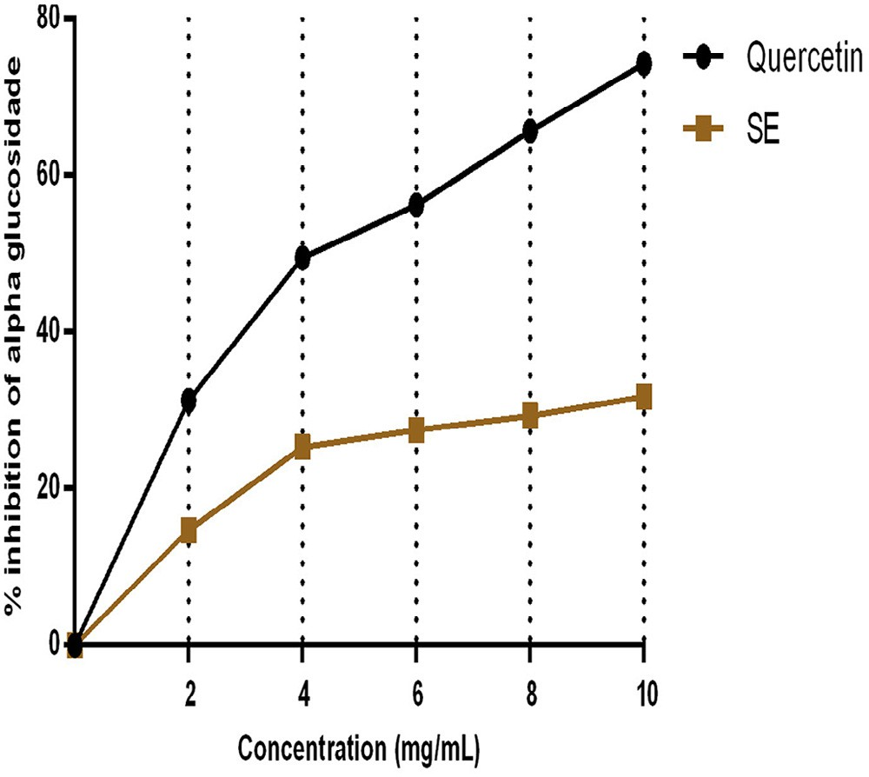

**Fig. 2 – *In vitro* inhibitory effect of SE and Quercetin on**

**α-glucosidase activity.**

**Fig. 3 – Estimation of total phenol.**

different characteristic peak values with various functional groups of compound (s) in SE extracts. Broad O—H stretching around 3734 cm−1 and 3375 cm−1 respectively depict the pres- ence of an alcohol and amide functional groups. This justifies the presence of compound (s) with alcohol and amide char- acteristics in SE. Moderately to strong intense stretches around 2854 cm−1 and 2925 cm−1 show O—H stretching which respec- tively depict an amide and carboxylic acid functional groups. The stretching and bending around 1448 cm−1 and 1323 cm−1 respectively reveals an SP3 functionality which is indicative of the presence of saturated compounds in SE The stretch around 1712 though not of a strong absorption band is indicative of the presence of a carbonyl (C=O) in the crude extract. This car- bonyl stretch suggest the presence of aldehydes, acyclic esters or cyclic esters and carboxylic acids in the crude

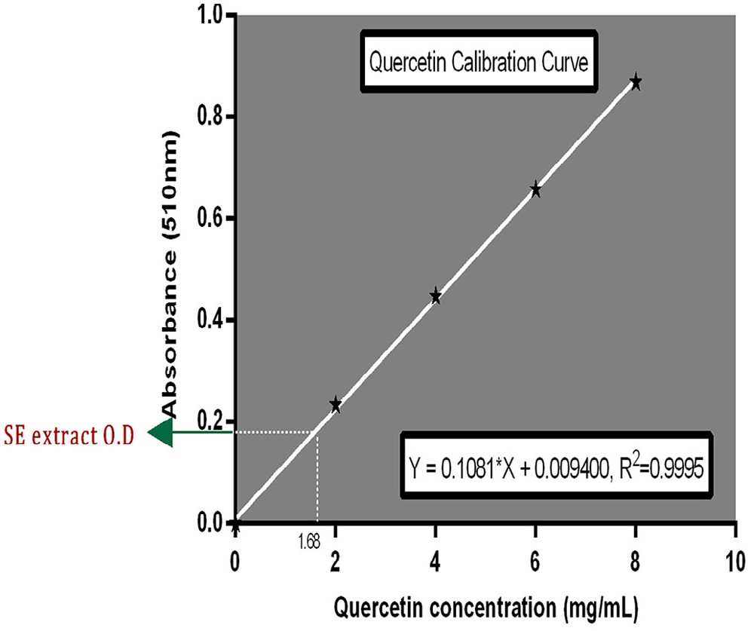

**Fig. 4 – Estimation of total flavonoids.**

|  |  |  |  |
| --- | --- | --- | --- |
| **Table 1 – FT-IR peak values and functional groups of ethanol extract of SE.** | | | |
| Peak/band values | ATR  units | Chemical bonds | Functional groups |
| 3734.08 | 0.023 | N—H | O—H stretching/amide group |
| 33765 | 0.176 | O—H | O—H stretching/alcohol group |
| 2925.95 | 0.230 | O—H | O—H stretching/alcohol |
| 2854.93 | 0.163 | O—H | O—H stretching/carboxylic acid |
|  |  |  | group |
| 1712.03 | 0.135 | C=O | C=O stretching/lactone group |
| 1612.55 | 0.100 | C=C/C=O | Carbonyl/unsaturated carbon |
|  |  |  | group |
| 1448.55 | 0.112 | C—H | C—H stretching/alkane group |
| 1323.47 | 0.130 | C—H | C—H bending/aromatic group |
| 1204.27 | 0.150 | C—H | C—H stretching/aromatic group |
| 1029.23 | 0.190 | C—O | C—O stretching/ether group |

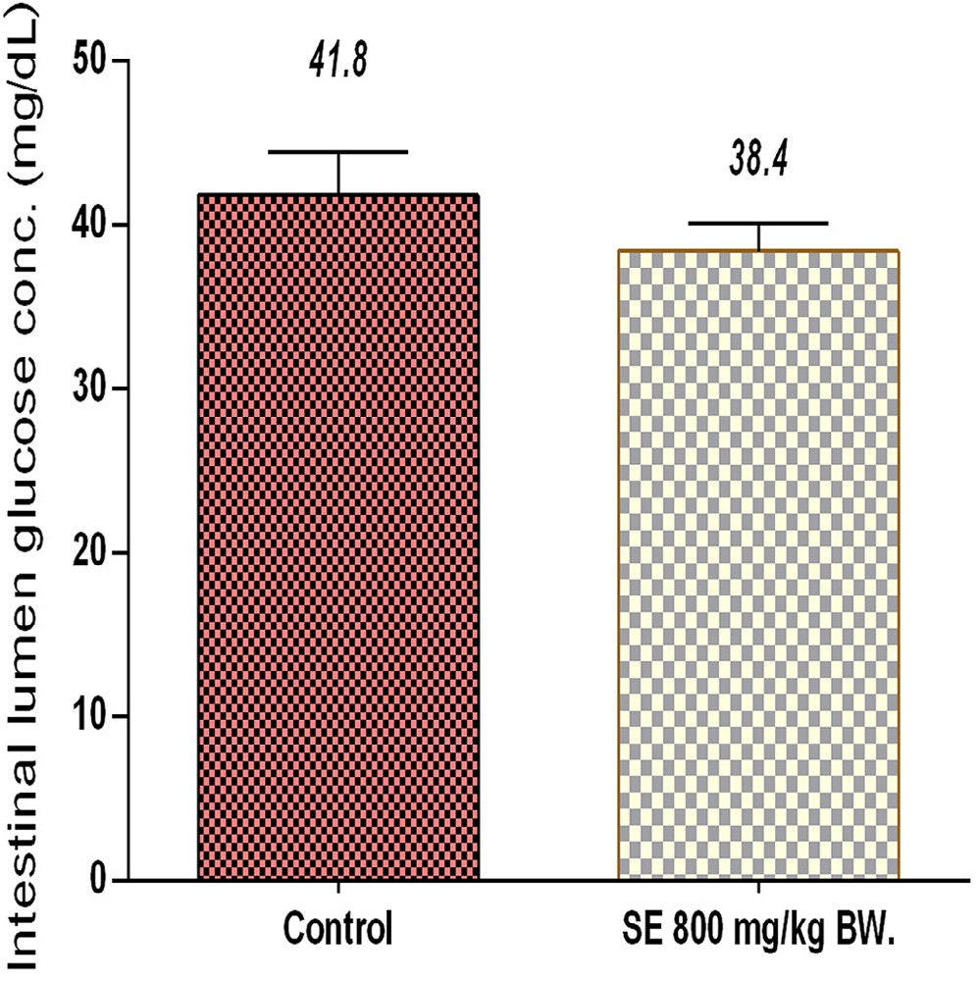**Fig. 5 – Intestinal glucose absorption effect of SE in glucose-loaded rats.**

extract.1612 cm−1 gives a clue as to the presence of a C=C func- tional group. The peak values, ATR units, chemical bonds, functional groups and possible groups of compounds present in SE are summarized in Table 1.

# Discussion

Carbohydrate catabolism, release of glucose and transport across the intestinal brush border membrane down to the blood stream has in recent times attracted serious attention as potential targets to controlling postprandial hyperglycemia. According to Rains and Jain [24] control of blood glucose concentration is a crucial factor in the management of diabetes and its associated com- plications. Inhibitors of α-amylase and α-glucosidase such as acarbose are known to delay carbohydrate breakdown and extend total carbohydrates digestion time, causing a reduction in the rate of glucose uptake and ultimately lowering postprandial blood glucose upsurge, especially in type 2 diabetes mellitus

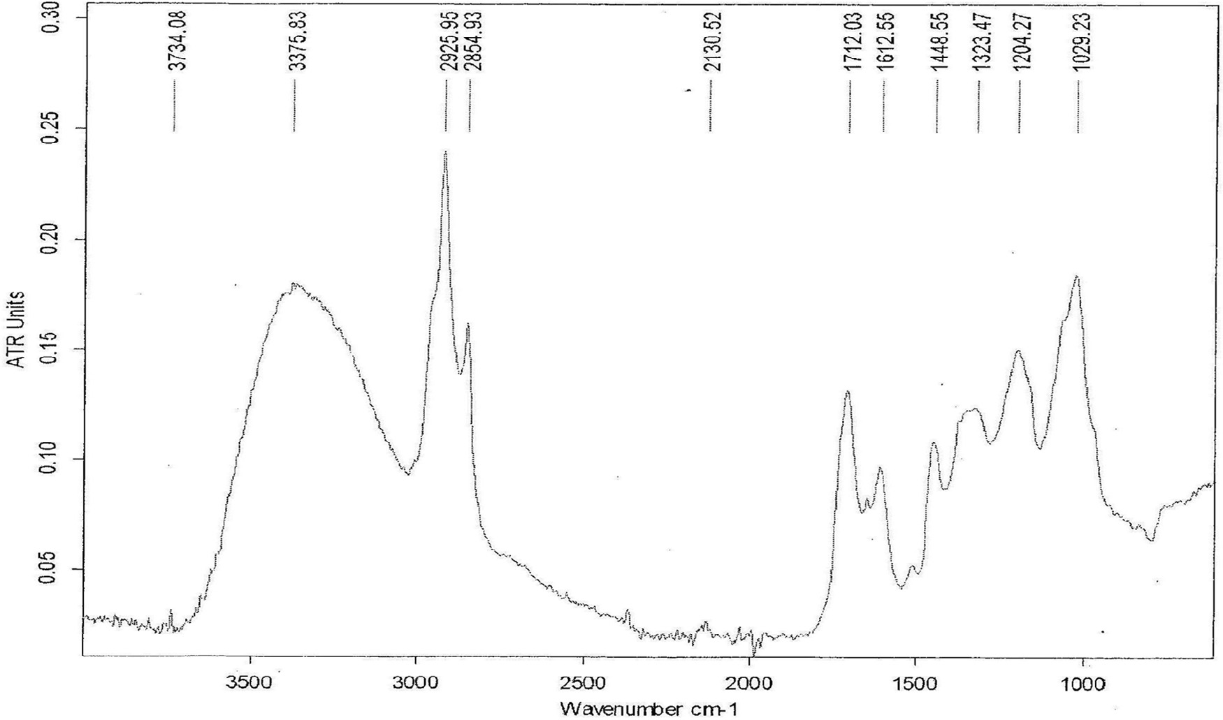

**Fig. 6 – FT-IR Spectra of SE ethanol crude extract.**

patients [4,25,26]. Besides, Scorpiglione et al. [27] had estab- lished that long-term inhibition of α-glucosidase partly decreased the level of HbA1c in diabetic patients, resulting in a significant

reduction in the incidence of chronic vascular complication such as macro and micro vascular diseases.

In the same vein, inhibitors of α -amylase and α-glucosidase

contained in plants have been found to largely suppress post- prandial hyperglycemia in diabetes [28–30].

SE extract in the current study, significantly inhibited the activity of pancreatic α-amylase *in vitro* in a measure compa- rable to that offered by quercetin. The extract however failed

to replicate the same level of activity when assessed with in- testinal α-glucosidase. Its inhibitory effect on this enzyme was

approximately half of its effect on pancreatic α-amylase. This

observation is noteworthy, knowing that alpha-amylase cata- lyzes the first step in the hydrolysis of starch and other related

polysaccharides by cleaving the internal α-1, 4-glycosidic bonds

linking the monomers of these compounds, while α-glucosidase completes the hydrolysis to yield monosaccharides. Increased

monosaccharide level (glucose) in the blood pool results in post- prandial hyperglycemia which is an underlining factor in all forms of diabetes mellitus, particularly type 2 [3,4]. In light of this, the above findings suggest that SE extract will be more effective in delaying carbohydrate digestion into absorbable units than reducing the rate of intestinal glucose uptake. This postulation is substantiated by the fact that the extract did not significantly affect glucose absorption in the experimental rats relatively to their control counterparts (Fig. 5).

Quercetin is a well known flavonoid and its choice as a

benchmark in this study is hinged on the fact that flavonoids are popular and efficient inhibitors of pancreatic α-amylase and intestinal α-glucosidase *in vitro* [31,32]. The hydroxyl group in the chemical structure of these polyphenolic compounds has been implicated in the inhibitory process. It is suggested to form hydrogen bonds with the polar side chains of the amino acids which line the allosteric site of the enzymes. This interaction readily results in alteration of an enzyme’s molecular confor- mation as well as its hydrophilic and hydrophobic properties, leading to a decrease in enzyme activity [32,33], as observed with SE in this study. This may be associated with the high phenol and flavonoid contents of the extract (74 ± 3.12 milli- gram Gallic acid equivalents of total phenols and 67.2 ± 2.04 milligram Quercetin equivalents of flavonoids per gram of extract) as shown by the phytochemical analysis results (Figs. 3 and 4). Moreover, a number of peak values revealed by FT-IR spectroscopic analysis of SE extracts demonstrated the pres- ence of functional groups which are indicative of flavonoids and polyphenols among other compounds. Besides, HPLC- MS analysis of SE fractions in a yet to be published study unveiled an array of polyphenols and flavonoids in the form Luteolin-7-O-glucoside and Amentoflavone. The presence of these compounds in SE leaf extract underscores its ability to inhibit the activities of pancreatic α-amylase and intestinal α-glucosidase *in vitro* as noted in this investigation.

thus suggestive of the possible role the plant extract in con- trolling postprandial blood glucose rise in the diabetics.

R E F E R E N C E S

1. [Mayur B, Sandesh S, Shruti S, Sung-Yum S. Antioxidant and](http://refhub.elsevier.com/S2314-808X(16)30058-6/sr0010)

[α-glucosidase inhibitory properties of *Carpesium abrotanoides*](http://refhub.elsevier.com/S2314-808X(16)30058-6/sr0010)

[L. J Med Plants Res 2010;4(15):1547–53.](http://refhub.elsevier.com/S2314-808X(16)30058-6/sr0010)

1. [Shai LJ, Masoko P, Mokgotho MP, Magano SR, Mogale AM,](http://refhub.elsevier.com/S2314-808X(16)30058-6/sr0015) [Boaduo N, et al. Yeast alpha glucosidase inhibitory and](http://refhub.elsevier.com/S2314-808X(16)30058-6/sr0015) [antioxidant activities of six medicinal plants collected in](http://refhub.elsevier.com/S2314-808X(16)30058-6/sr0015) [Phalaborwa, South Africa. S Afr J Bot 2010;76:465–70.](http://refhub.elsevier.com/S2314-808X(16)30058-6/sr0015)
2. [Lopes-Virella MF, Virella G. The role of immune and](http://refhub.elsevier.com/S2314-808X(16)30058-6/sr0020) [inflammatory processes in the development of](http://refhub.elsevier.com/S2314-808X(16)30058-6/sr0020) [macrovascular disease in diabetes. Front Biosci](http://refhub.elsevier.com/S2314-808X(16)30058-6/sr0020) [2003;8(Suppl.):750–68.](http://refhub.elsevier.com/S2314-808X(16)30058-6/sr0020)
3. [Narkhede MB. Investigation of *in vitro* α-amylase and](http://refhub.elsevier.com/S2314-808X(16)30058-6/sr0025)

[α-glucosidase inhibitory activities of polyherbal extract. Int J](http://refhub.elsevier.com/S2314-808X(16)30058-6/sr0025) [Pharm Res Dev 2011;3(8):97–103.](http://refhub.elsevier.com/S2314-808X(16)30058-6/sr0025)

1. [Fred-Jaiyesimi A, Kio A, Richard W. α-Amylase inhibitory](http://refhub.elsevier.com/S2314-808X(16)30058-6/sr0030) [effect of 3β-olean-12-en-3-yl (9Z)-hexadec-9-enoate isolated](http://refhub.elsevier.com/S2314-808X(16)30058-6/sr0030) [from *Spondias mombin* leaf. Food Chem 2009;116:285–8.](http://refhub.elsevier.com/S2314-808X(16)30058-6/sr0030)
2. [Zhishen Y, Meugcheng T, Jianming W. Determination of](http://refhub.elsevier.com/S2314-808X(16)30058-6/sr0035) [flavonoids content in mulberry and their scavenging effect](http://refhub.elsevier.com/S2314-808X(16)30058-6/sr0035) [on superoxide radicals. Food Chem 1999;64:555–9.](http://refhub.elsevier.com/S2314-808X(16)30058-6/sr0035)
3. [Bischoff H. Pharmacology of alpha-glucosidase inhibition.](http://refhub.elsevier.com/S2314-808X(16)30058-6/sr0040) [Eur J Clin Invest 1994;24:3–10.](http://refhub.elsevier.com/S2314-808X(16)30058-6/sr0040)
4. [Kumar S, Narwal S, Kumar V, Prakash O. α-Glucosidase](http://refhub.elsevier.com/S2314-808X(16)30058-6/sr0045)

[inhibitor from plants. A natural approach to treat diabetes.](http://refhub.elsevier.com/S2314-808X(16)30058-6/sr0045) [Pharmacogn Rev 2011;5:19–29.](http://refhub.elsevier.com/S2314-808X(16)30058-6/sr0045)

1. [Kimmel B, Inzucchi S. Oral agents for type 2 diabetes: an](http://refhub.elsevier.com/S2314-808X(16)30058-6/sr0050) [update. Clin Diabetes 2005;23:64–76.](http://refhub.elsevier.com/S2314-808X(16)30058-6/sr0050)
2. [Kazeem MI, Raimi OG, Balogun RM, Ogundajo AL.](http://refhub.elsevier.com/S2314-808X(16)30058-6/sr0055) [Comparative study on the α-amylase and α-glucosidase](http://refhub.elsevier.com/S2314-808X(16)30058-6/sr0055) [inhibitory potential of different extracts of *Blighia sapida*](http://refhub.elsevier.com/S2314-808X(16)30058-6/sr0055)

[Koenig. Am J Res Commun 2013;1(7):178–92.](http://refhub.elsevier.com/S2314-808X(16)30058-6/sr0055)

1. [Kim GN, Shin JG, Jang HD. Antioxidant and antidiabetic](http://refhub.elsevier.com/S2314-808X(16)30058-6/sr0060) [activity of *Dangyuja* (*Citrus grandis* Osbeck) extract treated](http://refhub.elsevier.com/S2314-808X(16)30058-6/sr0060) [with *Aspergillus saitoi*. Food Chem 2009;117:35–41.](http://refhub.elsevier.com/S2314-808X(16)30058-6/sr0060)
2. [Oboh G, Ademosun AO, Odubanjo OV, Akinbola IA.](http://refhub.elsevier.com/S2314-808X(16)30058-6/sr0065) [Antioxidative properties and inhibition of key enzymes](http://refhub.elsevier.com/S2314-808X(16)30058-6/sr0065) [relevant to type-2 diabetes and hypertension by essential](http://refhub.elsevier.com/S2314-808X(16)30058-6/sr0065) [oils from black pepper. Adv Pharmacol Sci 2013;5:1–7.](http://refhub.elsevier.com/S2314-808X(16)30058-6/sr0065)
3. [Burkill HM. The useful plants of west tropical Africa, vol. 1.](http://refhub.elsevier.com/S2314-808X(16)30058-6/sr0070) [2nd ed. Families AD. Kew: Royal Botanic Gardens; 1985.](http://refhub.elsevier.com/S2314-808X(16)30058-6/sr0070)
4. [Burkill HM. The useful plants of west tropical Africa, vol. 1–3.](http://refhub.elsevier.com/S2314-808X(16)30058-6/sr0075) [2nd ed. Kew: Royal Botanic Gardens; 1995.](http://refhub.elsevier.com/S2314-808X(16)30058-6/sr0075)
5. [Adesegun SA, Elechi NA, Coker HA. Antioxidant activities of](http://refhub.elsevier.com/S2314-808X(16)30058-6/sr0080) [methanolic extract of *Sapium ellipticum*. Pak J Biol Sci](http://refhub.elsevier.com/S2314-808X(16)30058-6/sr0080) [2008;11:453–7.](http://refhub.elsevier.com/S2314-808X(16)30058-6/sr0080)
6. [Sowemimo A, Van de Venter M, Baatjies L, Koekemoer T.](http://refhub.elsevier.com/S2314-808X(16)30058-6/sr0085) [Cytotoxicity evaluation of selected Nigerian plants used in](http://refhub.elsevier.com/S2314-808X(16)30058-6/sr0085) [traditional cancer treatment. J Med Plants Res](http://refhub.elsevier.com/S2314-808X(16)30058-6/sr0085) [2011;5(11):2442–4.](http://refhub.elsevier.com/S2314-808X(16)30058-6/sr0085)
7. [Nana O, Momeni J, Nzangué Tepongning R, Ngassoum MB.](http://refhub.elsevier.com/S2314-808X(16)30058-6/sr0090) [Phythochemical screening, antioxydant and antiplasmodial](http://refhub.elsevier.com/S2314-808X(16)30058-6/sr0090) [activities of extracts from *Trichilia roka* and *Sapium ellipticum*.](http://refhub.elsevier.com/S2314-808X(16)30058-6/sr0090) [J Phytopharmacol 2013;2(4):22–9.](http://refhub.elsevier.com/S2314-808X(16)30058-6/sr0090)
8. [Bernfield H. Enzymes of starch degradation and synthesis.](http://refhub.elsevier.com/S2314-808X(16)30058-6/sr0095) [Adv Enzymol Relat Subj Biochem 1951;12:379–428.](http://refhub.elsevier.com/S2314-808X(16)30058-6/sr0095)

[19] [Apostolidis E, Kwon YI, Shetty K. Inhibitory potential of](http://refhub.elsevier.com/S2314-808X(16)30058-6/sr0100)

# Conclusion

The data obtained in this study indicate that SE extracts in- hibited key enzymes involved in carbohydrate catabolism and

[herb, fruit, and fungal-enriched cheese against key enzymes](http://refhub.elsevier.com/S2314-808X(16)30058-6/sr0100) [linked to type 2 diabetes and hypertension. Innov Food Sci](http://refhub.elsevier.com/S2314-808X(16)30058-6/sr0100) [Emerg Technol 2007;8(1):46–54.](http://refhub.elsevier.com/S2314-808X(16)30058-6/sr0100)

[20] [Singleton P. Bacteria in biology, biotechnology and medicine.](http://refhub.elsevier.com/S2314-808X(16)30058-6/sr0105) [4th ed. New York: John Wiley and Sons Ltd; 1999. p. 324–37.](http://refhub.elsevier.com/S2314-808X(16)30058-6/sr0105)

1. [Demiray S, Pintado ME, Castro PM. Evaluation of phenolic](http://refhub.elsevier.com/S2314-808X(16)30058-6/sr0110) [profiles and antioxidant activities of Turkish medicinal](http://refhub.elsevier.com/S2314-808X(16)30058-6/sr0110) [plants: *Tilia argentea, Crataegi folium* leaves and *Polygonum*](http://refhub.elsevier.com/S2314-808X(16)30058-6/sr0110)[*bistorta* roots. World Acad Sci Eng Technol 2009;54:312–](http://refhub.elsevier.com/S2314-808X(16)30058-6/sr0110) [17.](http://refhub.elsevier.com/S2314-808X(16)30058-6/sr0110)
2. [Huda J, Ameera OH, Imad HH, Muhanned AK.](http://refhub.elsevier.com/S2314-808X(16)30058-6/sr0115) [Characterization of alkaloid constitution and evaluation of](http://refhub.elsevier.com/S2314-808X(16)30058-6/sr0115) [antimicrobial activity of *Solanum nigrum* by using (GC-MS). J](http://refhub.elsevier.com/S2314-808X(16)30058-6/sr0115) [Pharmacogn Phytother 2015;7(4):56–72.](http://refhub.elsevier.com/S2314-808X(16)30058-6/sr0115)
3. [Hussein AO, Hameed IH, Jasim H, Kareem MA.](http://refhub.elsevier.com/S2314-808X(16)30058-6/sr0120) [Determination of alkaloid compounds of *Ricinus communis* by](http://refhub.elsevier.com/S2314-808X(16)30058-6/sr0120) [using gas chromatography-mass spectroscopy (GC-MS). J](http://refhub.elsevier.com/S2314-808X(16)30058-6/sr0120) [Med Plants Res 2015;9(10):349–59.](http://refhub.elsevier.com/S2314-808X(16)30058-6/sr0120)
4. [Rains JL, Jain SK. Oxidative stress, insulin signaling, and](http://refhub.elsevier.com/S2314-808X(16)30058-6/sr0125) [diabetes. Free Radic Biol Med 2011;50(5):567–75.](http://refhub.elsevier.com/S2314-808X(16)30058-6/sr0125)
5. [Shimabukuro M, Higa N, Chinen I, Yamakawa K, Takasu N.](http://refhub.elsevier.com/S2314-808X(16)30058-6/sr0130) [Effects of a single administration of acarbose on](http://refhub.elsevier.com/S2314-808X(16)30058-6/sr0130) [postprandial glucose excursion and endothelial dysfunction](http://refhub.elsevier.com/S2314-808X(16)30058-6/sr0130) [in type 2 diabetic patients: a randomized crossover study. J](http://refhub.elsevier.com/S2314-808X(16)30058-6/sr0130) [Clin Endocrinol Metab 2006;91:837–42.](http://refhub.elsevier.com/S2314-808X(16)30058-6/sr0130)
6. [Zhang L, Li J, Hogan S, Chung H, Welbaum GE, Zhou K.](http://refhub.elsevier.com/S2314-808X(16)30058-6/sr0135) [Inhibitory effect of raspberries on starch digestive enzyme](http://refhub.elsevier.com/S2314-808X(16)30058-6/sr0135) [and their antioxidant properties and phenolic composition.](http://refhub.elsevier.com/S2314-808X(16)30058-6/sr0135) [Food Chem 2010;119:592–9.](http://refhub.elsevier.com/S2314-808X(16)30058-6/sr0135)
7. [Scorpiglione N, Belfiglio M, Carinci F, Cavaliere D, De Curtis](http://refhub.elsevier.com/S2314-808X(16)30058-6/sr0140) [A, Franciosi M, et al. The effectiveness, safety and](http://refhub.elsevier.com/S2314-808X(16)30058-6/sr0140) [epidemiology of the use of acarbose in the treatment of](http://refhub.elsevier.com/S2314-808X(16)30058-6/sr0140) [patients with type II diabetes mellitus. A model of medicine-](http://refhub.elsevier.com/S2314-808X(16)30058-6/sr0140) [based evidence. Eur J Clin Pharmacol 1999;55(4):239–49.](http://refhub.elsevier.com/S2314-808X(16)30058-6/sr0140)
8. [Frantz S, Calvillo L, Tillmanns J, Elbing I, Dienesch C, Bischoff](http://refhub.elsevier.com/S2314-808X(16)30058-6/sr0145) [H, et al. Repetitive postprandial hyperglycemia increases](http://refhub.elsevier.com/S2314-808X(16)30058-6/sr0145) [cardiac ischemia/reperfusion injury: prevention by the](http://refhub.elsevier.com/S2314-808X(16)30058-6/sr0145) [alpha-glucosidase inhibitor acarbose. FASEB J 2005;19:591–3.](http://refhub.elsevier.com/S2314-808X(16)30058-6/sr0145)
9. [Lordan S, Smyth TJ, Soler-Vila A, Stanton C, Ross RP. The](http://refhub.elsevier.com/S2314-808X(16)30058-6/sr0150) [α-amylase and α-glucosidase inhibitory effects of Irish](http://refhub.elsevier.com/S2314-808X(16)30058-6/sr0150) [seaweed extracts. Food Chem 2013;141(3):2170–6.](http://refhub.elsevier.com/S2314-808X(16)30058-6/sr0150)
10. [McCue P, Vattem D, Shetty K. Inhibitory effect of clonal](http://refhub.elsevier.com/S2314-808X(16)30058-6/sr0155) [oregano extracts against porcine pancreatic amylase *in vitro*.](http://refhub.elsevier.com/S2314-808X(16)30058-6/sr0155) [Asia Pac J Clin Nutr 2004;13(4):401–8.](http://refhub.elsevier.com/S2314-808X(16)30058-6/sr0155)
11. [Griffiths G, Trueman L, Crowther T, Thomas B, Smith B.](http://refhub.elsevier.com/S2314-808X(16)30058-6/sr0160) [Onions – a global benefit to health. Phytother Res](http://refhub.elsevier.com/S2314-808X(16)30058-6/sr0160) [2002;16(7):603–15.](http://refhub.elsevier.com/S2314-808X(16)30058-6/sr0160)
12. [Tadera K, Minami Y, Takamatsu K, Matsuoka T. Inhibition of](http://refhub.elsevier.com/S2314-808X(16)30058-6/sr0165) [alpha-glucosidase and alpha-amylase by flavonoids. J Nutr](http://refhub.elsevier.com/S2314-808X(16)30058-6/sr0165) [Sci Vitaminol (Tokyo) 2006;52(2):149–53.](http://refhub.elsevier.com/S2314-808X(16)30058-6/sr0165)
13. [Wang Y, Ma L, Li Z, Du Z, Liu Z, Qin J, et al. Synergetic](http://refhub.elsevier.com/S2314-808X(16)30058-6/sr0170) [inhibition of metal ions and genistein on alpha-glucosidase.](http://refhub.elsevier.com/S2314-808X(16)30058-6/sr0170) [FEBS Lett 2004;576:46–50.](http://refhub.elsevier.com/S2314-808X(16)30058-6/sr0170)