Available online at [www.sciencedirect.com](http://www.sciencedirect.com/)

[Electronic Notes in Theoretical Computer Science 346 (2019) 265–274](https://doi.org/10.1016/j.entcs.2019.08.024)

[www.elsevier.com/locate/entcs](http://www.elsevier.com/locate/entcs)

Families of Induced Trees and Their Intersection Graphs

Pablo De Caria1

*CONICET/ Departamento de Matem´atica Universidad Nacional de La Plata*

*La Plata, Argentina*

**Abstract**

This paper is inspired in the well known characterization of chordal graphs as the intersection graphs of subtrees of a tree. We consider families of induced trees of any graph and we prove that their recognition is NP-Complete. A consequence of this fact is that the concept of clique tree of chordal graphs cannot be widely generalized. Finally, we consider the fact that every graph is the intersection graph of induced trees of a bipartite graph and we characterize some classes that arise when we impose restrictions on the host bipartite graph.

*Keywords:* Subtree, Intersection Graph, Clique Tree, Bipartite Graph

# Introduction

A graph *G* is *chordal* if it has no induced cycle *Cn*, with *n ≥* 4. This class has many diverse characterizations. The one that is relevant for this paper states that a graph is chordal if and only if it is the intersection graph of a family of subtrees of a tree *T* [3]. This characterization has many applications in the structural study of chordal graphs and the resolution of problems on the class. For that reason, it would be desirable to have a similar representation for other graphs that are not chordal.

The first effort in that direction can be found in [2]. Recall that a graph is *locally chordal* when the neighborhood of every vertex induces a chordal graph. A family of subtrees of a graph *H* is said to be *2-acyclic* if the union of every pair of trees of the family is acyclic. A family *F* of sets is *Helly* if for every subfamily of *F* consisting of pairwise intersecting sets *F*1*, F*2*, ..., Fn*, the intersection of these *n* sets is not empty. It turns out that locally chordal graphs can be characterized as the intersection graphs of a Helly 2-acyclic family of induced subtrees of a graph *H*.

1 Email: [pdecaria@mate.unlp.edu.ar](mailto:pdecaria@mate.unlp.edu.ar)

<https://doi.org/10.1016/j.entcs.2019.08.024>

1571-0661/© 2019 The Author(s). Published by Elsevier B.V.

This is an open access article under the CC BY-NC-ND license (<http://creativecommons.org/licenses/by-nc-nd/4.0/>).

This paper is focused on a much more general case. First, it is useful to note that every graph can be represented as the intersection graph of a family of induced trees of a graph. Given a graph *G*, the *incidence graph* of *G* is the bipartite graph with vertex set *V* (*G*) *∪ E*(*G*) so that a vertex *v* and an edge *e* are adjacent if and only if *v* is an endpoint of *e*.

**Proposition 1.1** *Let G be a graph. Then G is the intersection graph of induced trees of some bipartite graph H.*

**Proof.** Let *H* be the incidence graph of *G*. For every *v ∈ V* (*G*), the neighborhood

*NH* [*v*] induces a subtree in *H*.

Given two vertices *v* and *w*, we have that they are adjacent if and only if *{u, v}∈*

*E*(*G*), which is in turn true if and only if *NH* [*v*] *∩ NH* [*w*] */*= *∅*.

Therefore, *v* is the intersection graph of the neighborhoods *NH* [*v*], with *v ∈*

*V* (*G*). *2*

When we work with a chordal graph *G* and we wish to represent *G* as the intersection graph of a family of subtrees of a tree *T* , the possibilities for what *T* can be are infinite. However, it is more interesting when *T* has as few vertices as possible. If the number of vertices of *T* is the smallest possible, it is not difficult to verify that the vertices of *T* correspond to the maximal cliques of *G*, thus giving rise to the concept of clique tree.

A *clique tree* of a graph *G* is a tree *T* such that *V* (*T* ) is the set *C*(*G*) of maximal cliques of *G* and, for every *v ∈ V* (*G*), the set *Cv* of maximal cliques of *G* that contain *v* induces a subtree. A graph is chordal if and only if it has a clique tree.[3]

In view of the fact that every non-chordal graph clearly has no clique tree, it is natural to wonder whether there is a weaker similar structure that the graph may have. In this context, a generalization of the clique tree is desirable. We will say that a *clique representation* of *G* is a graph *H* such that the vertex set of *H* consists of all the maximal cliques of *G* and, for every *v ∈ V* (*G*), the set *Cv* of maximal cliques of *G* that contain *v* induces a tree in *H*.

It is not difficult to see that not every graph has a clique representation. Consider for example the wheel *W*4 on top of Figure 1. By considering the maximal cliques that contain each non-universal vertex of *W*4, we conclude that a potential clique representation for *W*4 should have the edges *C*1*C*2, *C*2*C*3, *C*3*C*4 and *C*4*C*1, which form a cycle; but the universal vertex of *W*4, call it *u*, is contained in all the maximal cliques of the graph, so *Cu* cannot induce a tree.

However, the graph at the bottom of the figure, which has *W*4 as an induced subgraph, does have the clique representation shown to the right of it.

We know that the conditions that a graph is the intersection graph of a family of subtrees of a tree and that a graph has a clique tree are equivalent. However, every graph is the intersection graph of induced trees of a graph, but not every graph has a clique representation, as the first example shows. Furthermore, the graphs in the figure also show that the property of having a clique representation is not hereditary.

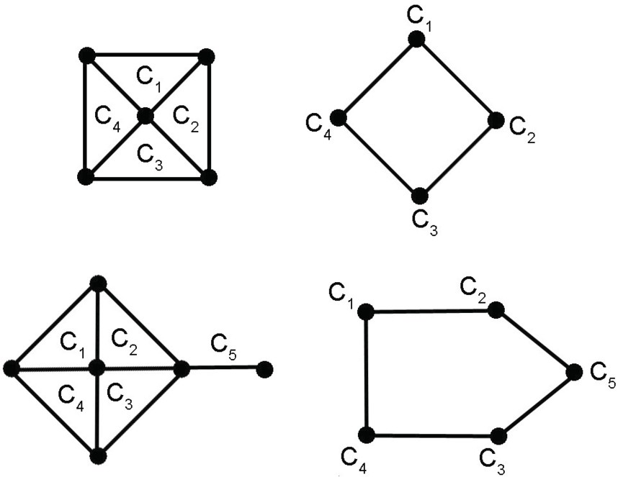

Fig. 1.

We can conclude that our attempt of generalization has some weak points, since there are important properties that are no longer valid.

In Section 2, we analyze the complexity of recognizing a family of induced trees of a graph and of determining whether a graph has a clique representation. We prove that both problems are NP-Complete.

In Section 3, we study the intersection graphs of induced trees of some particular classes of bipartite graphs.

# Results on complexity

Given a family *F* of sets, we will use the notation *V* (*F*) to denote the union of all the sets in *F*.

Let us call SUBTREE FAMILY the problem where, given a family *F* of sets, we have to decide whether there exists a graph *H* with vertex set *V* (*F*) such that, for every *F ∈ F*, the subgraph of *H* induced by *F* is a tree.

**Theorem 2.1** *Subtree Family is NP-Complete*

**Proof.** We prove that every instance of 3-SAT can be reduced in polynomial time to an instance of Subtree Family.

Consider a formula in normal conjunctive form, where each clause consists of three literals. We form a family *F* as follows:

For every variable *p* appearing in the formula, *V* (*F*) has elements *p*,*∼ p* and *p∗*

and *F* has the sets *{p, ∼ p}* and *{p, ∼ p, p∗}*.

For every clause *R* with literals *l*1*, l*2*, l*3 that feature variables *p*1*, p*2*, p*3, *V* (*F*) has elements *R*1*, R*2*, R*3 and *F* has the sets *{p∗, R*1*}*, *{p∗, R*2*}*, *{p∗, R*3*}*, *{R*1*, l*2*}*,

1 2 3

*{R*2*, l*3*}*, *{R*3*, l*1*}* and *{l*1*, l*2*, l*3*, p∗, p∗, p∗, R*1*, R*2*, R*3*}*.

1 2 3

Suppose that *F* is a family of induced trees of a graph *G*. Then, for every

variable *p* of the formula, *G* has the edge *pp∗* or *∼ pp∗*, but not both.

For every clause *R*, we cannot have all the edges *l*1*p∗*, *l*2*p∗* and *l*3*p∗*

because

1 2 3

otherwise the subgraph induced by *{l*1*, l*2*, l*3*, p∗, p∗, p∗, R*1*, R*2*, R*3*}* would contain a

cycle (see Figure 2).

1 2 3

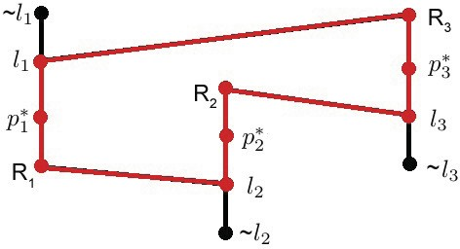

Fig. 2.

Therefore, if for every variable *p* we set it true if and only if *∼ p* is adjacent to

*p∗* in *G*, the formula is satisfied.

Conversely, suppose that the formula is satisfiable and consider one particular assignation of truth values to the variables that make the formula true. Let *G* be the graph with vertex set *V* (*F*) such that every set of *F* with exactly two elements is an edge of *G* and, for every variable *p* of the formula, *p* is adjacent to *p∗* if and only if *p* is false and *∼ p* is adjacent to *p∗* if and only if *p* is true. Furthermore, *G* may have additional edges. If so, every additional edge will be of the form *RiRj* for some clause *R*. We decide later which of these edges have to be included in *G*.

It is clear from the construction that *{p, ∼ p, p∗}* induces a subtree of *G*.

For every clause *R*, *{l*1*, l*2*, l*3*, p∗, p∗, p∗, R*1*, R*2*, R*3*}* induces a subtree of *G* if

1 2 3

exactly one of the literals of *R* is true. Otherwise, *{l*1*, l*2*, l*3*, p∗, p∗, p∗, R*1*, R*2*, R*3*}*

1 2 3

induces a forest that has two or three connected components. In this case, it is

possible to conveniently add edges to *G* connecting vertices of the form *Ri* to now ensure that *{l*1*, l*2*, l*3*, p∗, p∗, p∗, R*1*, R*2*, R*3*}* induces a tree.

1 2 3

Therefore, *F* is a family of induced subtrees of a graph.

The polynomial-time reduction is now proven.

*2*

Now we see that the problem remains NP-Complete even when restricted to

Helly families. This restriction of the problem will be called HELLY SUBTREE FAMILY.

**Theorem 2.2** *Helly Subtree Family is NP-complete.*

**Proof.** We see that every instance of Subtree Family can be reduced in polynomial time to an instance of Helly Subtree Family.

Let *F* be any family whose sets are *F*1*, F*2*, ..., Fn*. We construct a Helly Family

*Fj* by following the steps below:

* If *F* is Helly, then set *Fj* = *F*. Otherwise, we introduce new elements *u, v*1*, ..., vn*

so that *V* (*F*) S*{u, v*1*, ..., vn}⊆ V* (*Fj*), and the sets *{u, vi}* and *Fj* := *Fi ∪ {u, vi}*

*i*

are in *Fj*, for 1 *≤ i ≤ n*.

* For every *w ∈ V* (*F*), we have new elements *wj* and *wjj* and the sets *{w, wj}*,

*{wj, wjj}*, *{wjj, u}* and *{u, w, wj, wjj}* in *Fj*.

* For every *i* between 1 and *n*, we choose an element *xi ∈ Fi* and we add the set

*{u, xi, vi}* to *Fj*.

* For every *i* between 1 and *n* and *y ∈ Fi*, *y /*= *xi*, we add new elements *yj* and *yjj*

and sets *{y, yj}*, *{yj, yjj}*, *{yjj, vi}* and *{u, vi, y, yj, yjj}* to *Fj*.

* *V* (*Fjj*) has no elements other than the ones implied by the previous steps. *Fj* has no set other than the ones implied by the previous steps.

We first prove that *Fj* is Helly. Suppose to the contrary that *Fj* has a subfamily *A* of pairwise intersecting sets such that the intersection of all them is empty. Then there is a set *A ∈A* such that *u ∈/ A*. By the construction, *A* is of the form *{w, wj}*,

*{wj, wjj}*, *{y, yj}*, *{yj, yjj}* or *{yjj, vi}*.

Suppose that *A* = *{w, wj}*,with *w ∈ V* (*F*). As the intersection of all the sets of *A* is empty, there is a set *B ∈A* such that *w ∈/ B*. Since *A∩B* is not empty, *wj ∈ B*. Therefore *B* = *{wj, wjj}*. Similarly, there is a set *C ∈ A* such that *wj ∈/ C*. Since *A ∩ C* and *B ∩ C* are not empty, *w* and *wjj* are elements of *C*. However the only set of *Fj* that has both *w* and *wjj* is *{u, w, wj, wjj}*, thus contradicting that *wj ∈/ C*. Therefore *A /*= *{w, wj}*.

Suppose now that *A* = *{wj, wjj}*. Reasoning like before, *A* must have a set *B* such that *wjj ∈/ B* and that set has to be *{w, wj}*, which by the previous paragraph is impossible.

The cases that *A* is of the form *{y, yj}* or *{yj, yjj}* are discarded in an identical way.

Finally, suppose that *A* = *{yjj, vi}*, for some *y* and some *i*. Then *A* must have a set *B* such that *vi ∈/ B*. It follows that *B* = *{yj, yjj}* or *B* = *{yjj, vj}*, with *j /*= *i*. Reasoning like before, *B* cannot be equal to *{yj, yjj}*, so assume that *B* = *{yjj, vj}* for some *j /*= *i*. Let *C* be a set in *A* such that *yjj ∈/ C*. Thus *vi* and *vj* are elements of *C*, which is a contradiction because no set of *Fj* satisfies this condition.

Therefore, *Fj* is Helly.

We now prove that *F* is a family of induced trees of a graph if and only if *Fj* is a family of induced trees of a graph.

Suppose that *G* is a graph such that *V* (*G*)= *V* (*F*) and every set of *F* induces a subtree in *G*. Let *Gj* be the graph such that *V* (*Gj*)= *V* (*Fj*), *G* is a subgraph of *Gj*, every set in *Fj* with exactly two elements is an edge of *Gj*, *xivi* is an edge of *Gj* for every *i* between 1 and *n* and *Gj* has no edge other than the ones implied by the previous conditions. It is not difficult to verify that every set in *Fj* induces a subtree in *Gj*.

Conversely, suppose that *Fj* is a family of induced trees of a graph *G*. We now prove that *Fi* induces a subtree in *G* for every 1 *≤ i ≤ n*.

For every *w ∈ Fi*, we have that *u* is not adjacent to *w* in *G*, because otherwise

*{u, w, wj, wjj}* would not induce a tree in *G*. Similarly, for every *y ∈ Fi*, *y /*= *xi*, we have that *y* is not adjacent to *vi* in *G*, because otherwise *{u, vi, y, yj, yjj}* would not induce a tree in *G*. Therefore, *Fj* induces in *G* a tree *Ti* such that *u* is a leaf of *Ti* and *vi* is a leaf of *Ti − u*. Therefore, *Fi* induces the tree *Ti − u − vi* in *G*.

*i*

*2*

The fact that the problem is still NP-complete for Helly families allows us to establish the complexity of deciding whether a graph has a clique representation. To find a connection, we need the lemma below. There *L*(*F*) denotes the intersection graph of *F* and *DF* denotes the dual family of *F*, which consists of the sets of the form *{F ∈ F* : *v ∈ F}*, for *v ∈ V* (*F*). Also recall that *F* is said to be *separating* when, for every pair of different elements *u* and *v* in *V* (*F*), there exists *F ∈F* such that *u ∈ F* and *v ∈/ F* .

**Lemma 2.3** *Let F de a Helly and separating family. Then,*

* 1. *C*(*L*(*F*)) = *DF*
  2. *DC*(*L*(*F*)) = *F*

The first part of Lemma 2.3 is proved in [4]. If we now take the dual on both sides, the second part is derived.

Let us call CLIQUE REPRESENTATION to the problem where, given a graph

*G*, we have to decide whether *G* has a clique representation.

**Theorem 2.4** *Clique Representation is NP-complete.*

**Proof.** We will see that every instance of Helly Subtree Family can be reduced in polynomial time to an instance of Clique Representation.

Let *F* be a Helly Family. Define a new family *Fj* by *Fj* = *F* S*{{x}* : *x ∈ V* (*F*)*}*.

Thus *Fj* is Helly and separating. It is trivial that *Fj* is a family of induced subtrees of a graph if and only if *F* is a family of induced subtrees of a graph. By Lemma 2.3, we have that *Fj* = *DC*(*L*(*Fj*)). Consequently, *Fj* is a family of induced subtrees of a graph if and only if *L*(*Fj*) has a clique representation, which yields the desired polynomial reduction. *2*

# Intersection graphs of induced trees of some particu- lar classes of bipartite graphs

We saw in the introduction that every graph *G* can be represented as the intersection graph of induced trees of a bipartite graph *H*. Now we see that *H* can be chosen to be complete.

**Proposition 3.1** *Let G be a graph. Then G is the intersection graph of induced trees of some complete bipartite graph.*

**Proof.** Consider the proof of Proposition 1.1 in the Introduction. Let *H* be the incidence graph of *G*. If we add to *H* every possible edge between one vertex in *V* (*G*) and one vertex in *E*(*G*), the graph becomes complete bipartite and *G* is still equal to the intersection graph of the closed neighborhoods of the vertices in *V* (*G*).*2*

Given a bipartite graph *H*, define *μ*(*H*) as the minimum cardinality of a subset *A* of *V* (*H*) such that *A* and its complement form a bipartition. Recall that a vertex is said to be *simplicial* when its neighborhood is a clique.

Cerioli and Szwarcfiter considered in [1] the intersection graphs of subtrees of a star (a tree with a universal vertex). Among several characterizations, they proved that a graph *G* is the intersection of subtrees of a star if and only if the set of nonsimplicial vertices of *G* is a clique.

Note that stars are just the complete bipartite graphs for which *μ* equals 1. Furthermore, that the set of nonsimplicial vertices is a clique implies that the sub- graph they induce in the complement can be colored using just one color. As a consequence, the following result provides a generalization:

**Theorem 3.2** *Let G be a graph and let S be the set of simplicial vertices of G. Let*

*k be an integer greater than or equal to* 1*. The following are equivalent:*

1. *G is the intersection graph of induced trees of a bipartite graph H such that*

*μ*(*H*) *≤ k.*

1. *G is the intersection graph of induced trees of a complete bipartite graph H such that μ*(*H*) *≤ k.*
2. *The complement of G − S has chromatic number less than or equal to k.*

**Proof.** 1) *⇒* 2) : Let *H* be a bipartite graph such that *G* is the intersection graph of induced trees *{Tv}v∈V* (*G*) of *H* and let *A, A* form a bipartition of the vertices of *H*, where *|A|≤ k*.

For every nonsimplicial vertex *v* of *G*, pick a vertex *xv* of *Tv* that is also an element of *A* (if such a vertex does not exist, then *v* would be simplicial).

Now consider the complete bipartite graph *Hj* with bipartition *B, Bj*, where *B* contains all the vertices of the form *xv* and *Bj* consists of all the maximal cliques of *G*.

For every nonsimplicial vertex *v* of *G*, the set *Iv* consisting of *xv* and all the maximal cliques of *G* containing *v* induces a subtree in *Hj*.

If *v* is simplicial, let *Iv* be the set consisting of the unique maximal clique *C* of

*G* that contains *v*.

It is not difficult to verify that *G* is the intersection graph of the sets *Iv*, with

*v ∈ V* (*G*).

1. *⇒* 3) : Let *G* be the intersection graph of induced trees *{Tv}v∈V* (*G*) of a complete bipartite graph *H* with bipartition *A, Aj* and *|A|≤ k*.

Like before, every nonsimplicial vertex *v* of *G* must satisfy that *Tv* has a vertex in *A*. Pick one vertex *xv* that is both in *Tv* and *A*.

For every *a ∈ A*, define *Sa* = *{v ∈ V* (*G*) *\ S* : *xv* = *a}*. Thus, the sets *Sa* form a partition of *V* (*G*) *\ S* into *k* or less cliques. In the complement of *G − S*, it becomes a partition of its vertex set into *k* or less independent sets. Therefore, the chromatic number of *G − S* is less than or equal to *k*.

1. *⇒* 1) : Color the vertices of *G − S* properly using colors 1*, ..., k*. Let *H* be the complete bipartite graph *H* with bipartition *A, Aj*, where *A* = *{*1*, ..., k}* and *Aj* consists of all the maximal cliques of *G*.

Let *v ∈ V* (*G*). If *v* is simplicial, let *Iv* consist of the only maximal clique of *G* containing *v*. If *v* is not simplicial and has color *i*, let *Iv* consist of *i* and the maximal cliques of *G* containing *v*.

It is easy to demonstrate that every *Iv* induces a subtree in *H*.

We now prove that the intersection graph of the sets *Iv* is equal to *G*.

Let *v* and *w* be two adjacent vertices of *G*. Let *C* be a maximal clique of *G*

containing both *v* and *w*. Thus *C ∈ Iv ∩ Iw*.

Conversely, suppose that *Iv ∩ Iw /*= *∅* for two different vertices *v* and *w* of *G*. If *Iv ∩ Iw* has a maximal clique *C* of *G*, then *v* and *w* are elements of *C* and hence they are adjacent. If *i ∈ Iv ∩ Iw*, for some *i* between 1 and *n*, then *v* and *w* have the same color in *G − S*, so they are not adjacent in *G − S*. It follows that *v* and *w* are adjacent in *G − S*, so they are adjacent in *G*.

Therefore, *G* is the intersection graph of the sets *Iv*, with *v ∈ V* (*G*).

*2*

**Corollary 3.3** *Let G be a graph and let S be the set of simplicial vertices of G. The following are equivalent:*

1. *G is the intersection graph of induced subtrees of a bipartite graph H with*

*μ*(*H*) *≤* 2*.*

1. *G is the intersection graph of induced stars of a bipartite graph H with μ*(*H*) *≤* 2*.*
2. *G − S is co-bipartite.*

**Proof.** The equivalences between 1), 2) and 3) follow immediately from Theorem 3.2, noting that every induced tree of a complete bipartite graph is an induced star; and that a graph can be properly colored with two or less colors if and only if it is bipartite. *2*

Part 3) of the corollary also allows to characterize the class through a family of minimal forbidden induced subgraphs.

Suppose that *G − S* is not co-bipartite. Then *G − S* has an induced odd cycle

*Cn*, which means that *G − S* has an induced *Cn*, with *n* odd.

In case that *n >* 3, it is simple to verify that the graphs *Cn* are minimal forbidden induced subgraphs.

If *n* = 3, then *G − S* has an independent set *{v*1*, v*2*, v*3*}*. These vertices are not

simplicial in *G*, so there exist vertices *u*1*, uj , u*2*, uj , u*3*, uj*

such that, for i=1,2,3, *vi*

1 2 3

is adjacent in *G* to *ui* and *uj* and these two vertices are not adjacent. Let *H* be the

*i*

subgraph induced by *{v*1*, v*2*, v*3*, u*1*, u*2*, u*3*, uj , uj , uj }*. Some vertices of this set can

1 2 3

be equal. Assume that *H* is minimal in the sense that it contains no proper induced

subgraph with an independent set of three nonsimplicial vertices. Considering all the possibilities about how these vertices are connected gives a finite but lengthy list of minimal forbidden induced subgraphs. To give more details on this list, we define a finite family of graphs:

A graph with nine vertices partitioned into sets *{vi, ui, uj }*, for *i ∈ {*1*,* 2*,* 3*}*, is

*i*

called a *triptych* if it satisfies the following conditions:

* *{v*1*, v*2*, v*3*}* is an independent set.
* For every *i ∈ {*1*,* 2*,* 3*}*, *vi* is adjacent to *ui* and *uj* , but *ui* and *uj* are not adjacent.

*i* *i*

* For every two different numbers *i* and *j*, *vi* is adjacent to at most one element of

*{uj, uj }*.

*j*

* For every *i* between 1 and 3, *N* [*vi*] *\ {ui}* and *N* [*vi*] *\ {uj }* are cliques.

*i*

* If *x* is not a simplicial vertex and *x ∈/ {v*1*, v*2*, v*3*}*, then *x* is adjacent to at least two elements of *{v*1*, v*2*, v*3*}*.

It is not hard to prove that there is (up to isomorphism) a total of 30 triptychs.

Using this terminology we have:

**Theorem 3.4** *A graph G is the intersection graph of induced subtrees of a bipartite*

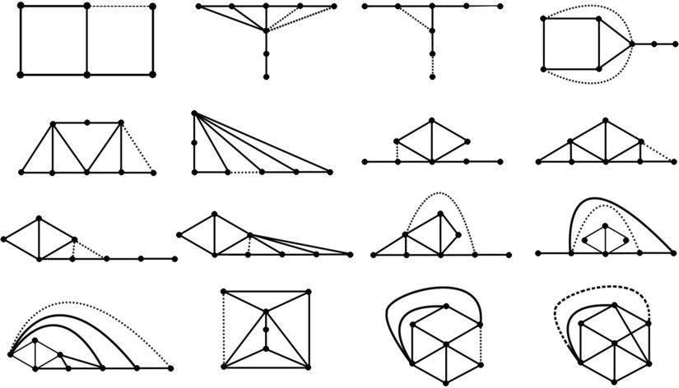

Fig. 3. Some forbidden induced subgraphs for the class of intersection graphs of induced trees of a bipartite graph with *μ ≤* 2. The meaning of the dotted edges is that the removal of all of them gives another forbidden induced subgraph.

*graph H with μ*(*H*) *≤* 2 *if and only if it does not contain C*2*n*+1*, n ≥* 2*, C*6*, C*7*, P*7*, K*2*,*3*, C*4 + *P*3*, P*5 + *P*3*, a triptych or a graph in Figure* *3* *as an induced subgraph.*

# Conclusions

Clique representations were introduced in an attempt to generalize clique trees of chordal graphs. However, there are several properties of clique trees that clique representations do not have. To make things harder, the problem of determining whether a graph has a clique representation is NP-complete.

In view of these limitations, the most reasonable research path consists in study- ing intersection graphs of induced subtrees of special types of graphs. This paper considers the intersection graphs of induced subtrees of some classes of bipartite graphs. It would be desirable to consider the intersection graphs of induced sub- trees of other graphs for future work.

# References

1. M. Cerioli and J. Szwarcfiter, Characterizing Intersection Graphs of Substars of a Star, ARS COMBINATORIA 79(2006), pp. 21-31.
2. F. Gavril, Intersection graphs of Helly families of subtrees, Discrete Applied Mathematics 66 (1996) 45-56.
3. F. Gavril, The intersection graphs of subtrees in trees are exactly the chordal graphs, J. Combin. Theory Ser. B 116 (1974), 47-56.
4. M. Gutierrez and J. Meidanis, Algebraic theory for the clique operator, J. Braz. Comp. Soc. 7 (2001), 53-64.