 HOSTE D BY

Available online at [www.sciencedirect.com](http://www.sciencedirect.com/science/journal/2314808X)

**ScienceDirect**

journal homepage: [http://ees.elsevier.com/ejbas/default.asp](http://http//ees.elsevier.com/ejbas/default.asp)

**Fungal keratitis: Rapid diagnosis using methylene blue stain**

***Dalia Moemen*** ***a******,******\*******, Tamer Bedir*** ***a******, Eman A. Awad*** ***b******, Adel Ellayeh*** ***b***



a *Department of Medical Microbiology and Immunology, Faculty of Medicine, Mansoura University, Mansoura, Egypt*

b *Department of Ophthalmology, Faculty of Medicine, Mansoura University, Mansoura, Egypt*

A R T I C L E I N F O A B S T R A C T

*Article history:*

Received 5 April 2015

Received in revised form 16 July 2015

Accepted 10 August 2015

Available online 19 August 2015

*Keywords:* Fungal keratitis Rapid diagnosis Methylene blue

Earlier and accurate diagnosis of the fungal infection in the cornea is necessary for effec- tive treatment. In developing countries, microscopical evaluation is the most valuable and rapid diagnostic tool. Therefore we aimed to investigate the efficacy of methylene blue (MB) staining in comparison with potassium hydroxide (KOH) and calcofluor white (CW) stain. Corneal scraping from 48 cases with suspected fungal keratitis were included in the study from January 2014 to December 2014. The specimens were subjected to direct examination by MB, 10% KOH and CW stain. The staining results were confirmed with fungal culture and strain identification. Topical amphotericin B was started for all positive fungal cases; 39 (81.25%) were proven fungal cases. Positive rate of calcofluor white, MB and 10% KOH staining were 79.2%, 75% and 68.75% respectively. CW showed higher sensitivity and specificity (99.44% and 90.91% respectively), followed by MB (92.31% and 80.0% respectively) and lastly KOH 10% (84.62% and 71.43% respectively). 71.8% of cases had healed scars and only 4 patients (10.3%) required keratoplasty (PK). Direct microscopic detection of fungal structures by MB staining in corneal scrapes is a fast and effective method for the early diagnosis of fungal keratitis.

© 2015 Mansoura University. Production and hosting by Elsevier B.V. This is an open access article under the CC BY-NC-ND license (<http://creativecommons.org/licenses/by->

nc-nd/4.0/).

# Introduction

Fungal keratitis is a leading cause of serious ocular morbid- ity and blindness. It is worldwide in distribution, but is more common in the tropics and subtropical regions [1]. It was re- ported that the incidence of fungal keratitis in Egypt is increasing, correlating with the climatic changes (rises in minimum temperature and the maximum atmospheric hu- midity) in the region [2].

In fungal keratitis, early diagnosis and antifungal therapy is necessary in preventing further complications such as hy- popyon formation, endophthalmitis, or loss of vision [3]. The diagnosis of fungal keratitis remains dependent upon stain- ing smear and fungal cultures [4,5]. Fungal culture is the ‘gold standard’ for the diagnosis of fungal keratitis [6]; however, this process takes time (2–21 days), which delays clinical treat- ment [7,8]. Therefore although culture helps in definite diagnosis and identification, direct microscopic detection of fungal struc- tures in corneal scrapes permits a rapid presumptive diagnosis

* *Corresponding author.* Tel.: +0201224647147.

*E-mail address:* [dr_daliamoemen@yahoo.com](mailto:dr_daliamoemen@yahoo.com) (D. Moemen). <http://dx.doi.org/10.1016/j.ejbas.2015.08.001>

2314-808X/© 2015 Mansoura University. Production and hosting by Elsevier B.V. This is an open access article under the CC BY-NC-ND license ([http://creativecommons.org/licenses/by-nc-nd/4.0/).](http://creativecommons.org/licenses/by-nc-nd/4.0/))

[1]. In developing countries, microscopic evaluation is the most valuable and rapid diagnostic tool for detection of fungal el- ements in corneal scrapings. Thus, there is a need to identify a staining method for fungal keratitis diagnosis that is rapid, easy to perform and has a high sensitivity in the clinical setting.

Methylene blue (MB) is widely used in clinics as a dye and a biological staining agent. MB detects gonococci, early cancer cells, metastasized cancer cells in lymph nodes in early- stage breast cancer, and is also used to diagnose pre-cancerous pathological changes and early gastric cancer [9,10]. The effi- cacy of MB has been investigated for the diagnosis of fungal keratitis in one study, and has been found to be a fast and ef- fective method for the early diagnosis of fungal keratitis [11]. Therefore we aimed in the current study to confirm the ef- ficacy of MB staining for the rapid detection of fungal keratitis and to compare the positive rates, sensitivity and specificity with those of a 10% KOH-based smear and calcofluor white (CW)

stain.

# Materials and methods

## *Patients*

Patients with clinically suspected fungal keratitis who at- tended the outpatient clinic of Mansoura ophthalmic center (Dakahlia, Egypt) from January, 2014 until December, 2014 were included in this study. For all patients, a detailed medical history was taken including duration of the symptoms, presence of predisposing factors (e.g. presence and nature of trauma, contact lens usage, previous history of ocular surgeries, history of dia- betes, and usage of topical or systemic steroids), type of immediate treatment administered. Full clinical examina- tion was done with assessment of elevation of slough (raised or flat), texture of slough (wet or dry), ulcer margins (serrated or well defined), size of the abscess, pigmentation, Descemet’s folds, satellite lesions, dendritic lesions, immune ring, hypo- pyon, fibrin, flare or cells in the anterior chamber, deep lesions and endothelial plaque. Clinical photographs were taken using the Haag Streit slit, with photo slit attachment. Clinically sus- pected cases of fungal keratitis were diagnosed on the basis of the presence of the following: (i) a history of trauma with plant origin to the eye; (ii) the presence of clinical signs such as ulcers with irregular and feathery margins, satellite lesions or dry eye, and mild discomfort due to mild photophobia, tears, or mild irritation [12]. Patients were excluded from the study if they had proven bacterial keratitis or had received antifun- gal drugs. This study was conducted with approval from the Medical Research Ethics Committee, Mansoura University. Written informed consents were obtained from all participants.

## *Sample collection*

Following topical anesthesia of the eye with topical benoxinate eye drops and under slit-lamp magnification, corneal scrap- ings were taken from the base and edge of each ulcer. This procedure was carried out aseptically with a special triangle ended sterilized scalpel. Two scrapings were obtained for each patient, the first scraping was tapped over 3 slides for direct

microscopic examination using MB, 10% KOH and CW stain. The second scraping was inoculated on Sabouraud dextrose agar (SDA) media using C shaped slit technique.

## *Detection of the fungus by KOH-based smears*

One drop of 10% potassium hydroxide was added to the first slide, a cover slip was applied and the wet mount was exam- ined by direct microscopy.

## *Detection of the fungus by MB staining*

One drop of MB (20 μl) was added to the second slide and a cover slip was applied and the slide was examined by direct microscopy.

## *Detection of the fungus by CW stain*

One drop of CW (comprising 1 g/l Calcofluor White M2R and 0.5 g/l Evans blue; Sigma-Aldrich, St Louis, MO, USA) was then added to the third slide at one edge of the cover slip and a filter paper was placed at the opposite edge to draw the stain over the smears between the slide and cover slip. The slide was then left to stand for 1–2 min before being examined by fluores- cence microscopy using blue light excitation (300–400 nm for the emission wavelength with excitation at around 355 nm).

## *Fungal cultivation*

Inoculated SDA media were incubated at 27 °C for up to 3 weeks. The cultures were observed at intervals for fungal growth. The strains of fungi were identified according to the colony char- acters, growth rate and the morphology of the hyphae and spores.

## *Antifungal topical therapy*

Antifungal topical therapy with amphotericin B in concentra- tions of 5 mg/ml was started for all cases immediately on receiving a positive report of fungal filaments by microscopic examination of the corneal scraping. The product was pre- pared from the intravenous formulation (Fungizone, Bristol- Myers Squibb, New York, NY) diluted in distilled water. One hourly topical drops was applied for a week, then each two hours for three weeks and then continued on a tapering basis depending on the activity of keratitis till resolution of the ulcers. Additional surgical procedures were undertaken for patients not responding to medical therapy and these procedures in- cluded therapeutic penetrating keratoplasty (PK), anterior chamber wash with amphotericin B or evisceration if needed.

## *Statistical analysis*

Statistical analyses were carried out using the SPSS statisti- cal package, version 10.0 (SPSS Inc., Chicago, IL, USA) for Windows. The results obtained from examination of the smear

samples were compared with those obtained from the fungal culture results using the χ2 test with respect to sensitivity and specificity of the various smear examination techniques.

# Results

During the study period of one year, 48 patients attending out- patient clinics of Mansoura ophthalmic center were clinically suspected of fungal keratitis. The total number of corneal scrap- ing specimens obtained was 48. The fungal etiology was proven in 39 keratitis cases with a rate of 81.25% based on the culture results. Of the total 39 patients 24 (61.5%) were males and 15 (38.5%) were females. The predominance of fungal keratitis was most distinct in the middle decades with age ranged from 23 years to 73 years (mean age 53.2 + 15.23). Analysis of predis- posing factors revealed that rural residency was the first predominant predisposing factor (58.97%), followed by plant trauma (38.46%), and previous eye surgery (15.38%) (Table 1). There were no cases of contact lens wear and there also was no seasonal variations noted during the study period. The cul- tures of the corneal scraping samples revealed that the most frequent fungal pathogen recovered from the corneal ulcers were *Fusarium* spp. (18/39), *Alternaria* spp. (7/39), *Aspergillus fumigatus* (5/39), *Candida albicans* (4/39), non-albicans *Candida* (3/39) and *Aspergillus flavus* (2/39) (Table 2). Regarding the as- sociation of characteristic clinical findings with etiologic fungal elements, the presence of ulcers with irregular and feathery margin, satellite lesions, and dry appearance was evident in most of the cases. Central corneal lesions were detected in 26 patients (54.2% of total cultures and 66.7% of positive cultures)

|  |  |  |
| --- | --- | --- |
| **Table 1 – Risk factors associated with fungal keratitis.** | | |
| No % | | |
| Diabetes | 5/39 | 12.82 |
| Old age >60 years | 8/39 | 20.51 |
| Plant trauma | 15/39 | 39.47 |
| Previous eye surgery | 6/39 | 15.38 |
| Rural | 23/39 | 58.97 |
| Dry eye | 3/39 | 7.69 |
| Trauma by inorganic | 2/39 | 5.13 |
| material |  |  |
| Urban | 16/39 | 37.2 |

|  |
| --- |
| **Table 2 – Mycological diagnosis of fungal keratitis.** |
| Positive direct microscopic Culture examination on SDA  CW KOH 20% MB |
| *Alternaria* spp. 7 (18.4%) 7 (21.21%) 7 (19.4%) 7 (17.95%) |
| *Aspergillus flavus* 2 (5.26%) 1 (3.03%) 2 (5.56%) 2 (5.13%) |
| *Aspergillus* 5 (13.16%) 3 (9.09%) 4 (11.1%) 5 (13.89%) |
| *fumigatus* |
| *Candida albicans* 4 (36.8%) 4 (12.12%) 4 (11.1%) 4 (10.26%) |
| *Fusiarium* spp. 17 (44.7%) 16 (48.48%) 17 (47.2%) 18 (46.15%) |
| Non-albicans 3 (7.89%) 2 (6.06%) 2 (5.56%) 3 (7.69%) |
| *Candida* |
| Total 38 (100%) 33 (100%) 36 (100%) 39 (100%) |

and were highest with *Fusarium* spp. (10/18) followed by *As- pergillus* spp. (3/7), *Alternaria* spp. (2/7) and *Candida* spp. (2/7). Hypopyon was detected in 14 patients (29.2% of total cul- tures and 35.9% of positive cultures) and was highest with *Candida* spp. (5/7), followed by *Alternaria* spp. (2/7) and *Fu- sarium* spp. (3/18). Pigmentations were detected in 9 patients (18.8% of total patients and 23.1% of positive cultures) and were highest with *Alternaria* spp. (5/7) followed by *Aspergillus* spp. (3/7). Endothelial plaques were detected in 4 patients (8.3% of total patients and 10.3% of positive cultures): 3 cases with *As- pergillus* spp. (3/7) and 1 case with *Candida albicans* (1/4). Dendritic lesions were detected in 3 cases of *Aspergillus* spp. (3/7). The culture technique was considered as the gold standard for di- agnosing of fungal keratitis. After comparing the three different rapid detection methods used for diagnosis of fugal keratits, we found that positive rate of direct microscopic examina- tion of 39 corneal scraping specimens for fungal elements by CW, MB and 10% KOH were 79.2%, 75% and 68.75% respec- tively. On comparing sensitivity and specificity of direct microscopic examination with culture on SDA (Table 3), CW showed higher sensitivity (99.44%) and specificity (90.91%) fol- lowed by MB (sensitivity 92.31% and specificity 80.0%) and lastly KOH 20% (sensitivity 84.62% and specificity 71.43%). Also on comparing accuracy or efficiency of direct microscopic exami- nation with culture on SDA, CW showed higher accuracy (96.0%), followed by MB (88.89% ) and lastly KOH 20% (80.0) as reliable tools in diagnosis of fungal keratitis. The fungal hyphae ex- amined using MB stain showed that the hyphea were stained blue, thus better highlighted against the pale background (Fig. 1). On the other hand, the hyphae in the KOH-based smears were transparent and not well highlighted (Fig. 2). With the CW stain, fungal hyphae were delineated clearly because the cell walls and cross walls (septa) were stained a distinctive green color; there was no staining of the collagen fibers, necrotic tissue debris or other structures (Fig. 3). Treatment outcome of the patients showed that the healed scar was achieved in 28 (71.8%) cases. 4 patients (10.3%) required therapeutic PK, 2 patients (5.1%) required evisceration and 5 patients were lost to follow-up.

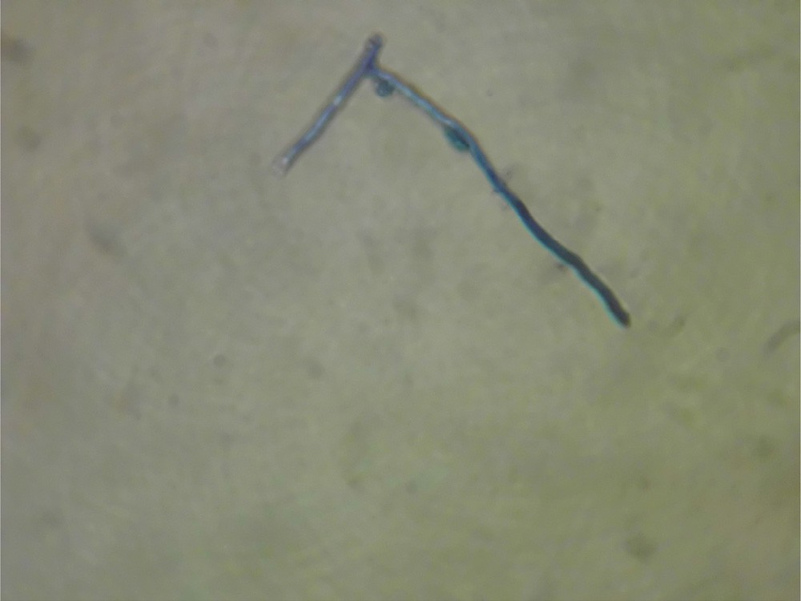

**Fig. 1 – Fungus from specimens of corneal ulcer, detected by methylene blue MB staining smear (magnification,**

**×100).**

Accuracy

96.0 %

88.89 %

80.0 %

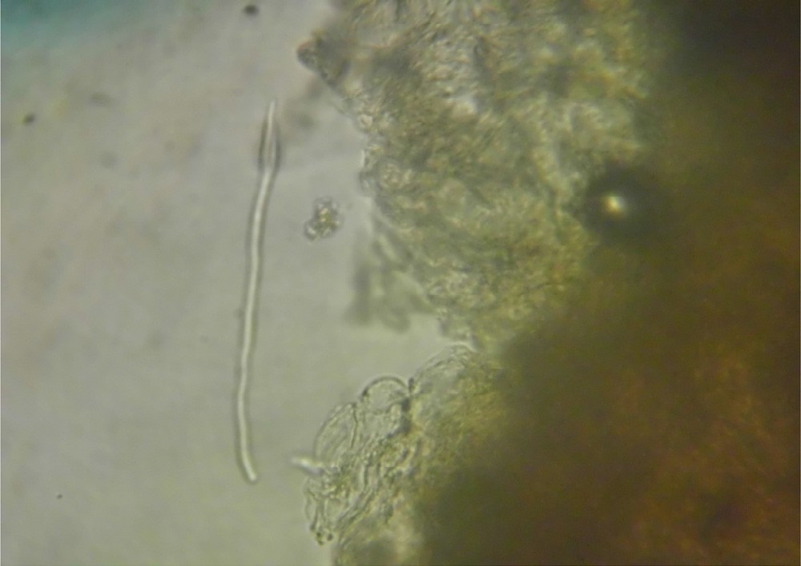

**Fig. 2 – Fungus from specimens of corneal ulcer, detected by potassium hydroxide (KOH)-based smears (magnification, ×100).**

Positive likelihood ratio

Negative likelihood ratio

Positive predictive value

Negative predictive value

95% CI

1.65–69.51

%

0.03

95% CI

0.00–0.20

%

97.44

95% CI

86.47–99.57

%

90.91

95% CI

58.67–98.49

1.67–12.75

0.10

0.03–0.29

92.31

79.11–98.30

80.00

51.91–95.43

1.49–5.9

0.22

0.1–0.47

84.62

69.46–94.1

71.43

47.83–88.65

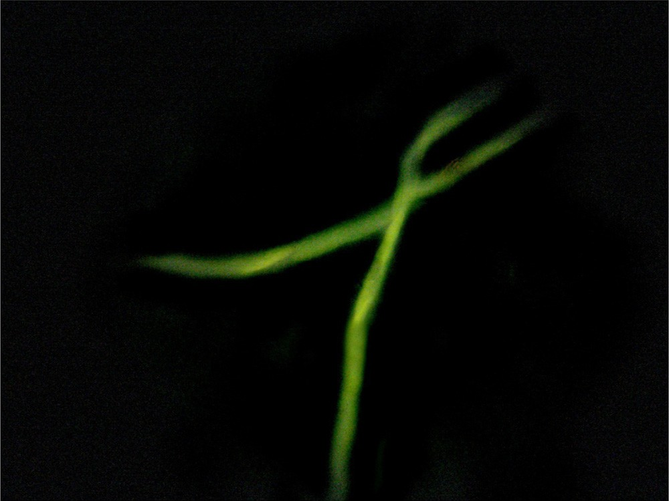

**Fig. 3 – Calcofluor white staining of corneal scrapings from patient with fungal keratitis, showing fungal filaments (hyphae) of *Fusarium* spp. (magnification, ×400).**

**Table 3 – Comparison of direct microscopic examinations to fungal culture in diagnosis of fungal keratitis.**

Sensitivity

Specificity

95% CI

86.47–99.57

%

90.91

95% CI

58.67–98.49

%

10.72

79.11–98.30

80.00

51.91–95.43

4.62

69.46–94.1

71.43

47.83–88.65

2.96

# Discussion

Fungal keratitis has become one of the leading causes of visual loss especially in many developing countries, where the large numbers of the population are farmers. Fungal keratitis remains a diagnostic and therapeutic challenge to ophthalmologist. The difficult matters lie in establishing a clinical diagnosis, isolat- ing the etiologic fungal organisms in the laboratory, and treating the keratitis effectively with topical antifungal agents [13,14]. The fungal etiology was proven in 39 keratitis cases with a rate of 81.25% based on the culture results. The population in the present study included patients clinically diagnosed with fungal keratitis, i.e., belonging to a high-risk population, and, there- fore, the positive rate of fungal culture of corneal samples was relatively high. In the current study, the largest proportion of the patients were in the middle decades, which was the same in many developing countries such as south India, north China

Culture on SDA

Positive

38

1

36

3

33

6

Negative

1

10

3

12

6

15

%

97.44

CW

Positive Negative Positive Negative Positive Negative

MB

92.31

KOH 20%

84.62

and southeast Brazil [15–17]. This also may be explained by the fact that the subjects ages 40 to 59 in this study are the main force of the manual works, especially agricultural works, and more involved in outdoor activities. In the present study, rural residency was the first predominant predisposing factor (58.97%). This is attributed to the fact that people in rural areas in Egypt are more involved in agricultural activities, which sub- sequently increases their vulnerability to fungal keratitis. History of plant trauma (38.46%) was one of the most frequent and major associated condition for fungal keratitis. Plant trauma was the main cause in many previous studies [18–20]. However, others found that trauma with plant debris and straws were noted in only 28.6% of patients with fungal keratitis [21,22]. Diabetes mellitus was an associated factor in five cases (12.82%). These findings were also supported by the other reports which found that chronic systemic diseases were important predis- posing factor for fungal keratitis due to suppressed immune system [18–23]. There was no case of contact lens wear in our study. Contact lens wear was reportedly one of the major as- sociated conditions in other studies [22,24]. The lesser incidence could be explained in view of the low socioeconomic level of the patients included. In this study, the most frequent fungal pathogen recovered from the corneal ulcers were *Fusarium* spp. (46.2%), similar to the reported study from South Florida and Ghana [18], southeast Brazil [17], North China [16], India [20] and Malaysia [25], where the climate is warm and humid. However other works demonstrated that *Aspergillus flavus* was the most common fungus isolated [1,26]. In our study 17.9% of the isolates were *Candida* spp. It was previously reported that the yeast isolation from the corneal ulcers was as low as 15% especially in hot areas [20]. However, in a study from the United Kingdom more than half of the isolates were reported as *Candida* spp. This finding confirms the importance of yeast as a cause of fungal keratitis in urbanized and colder areas [19]. Our results agree with the generally accepted clinical features for the di- agnosis of fungal keratitis, e.g. the presence of a dry, raised ulcer with a feathery border, satellite lesions, and recurrent hypo- pyon [27]. Besides, this study showed that pigmentation was highly associated with *Alternaria* spp. (71.4%) and dendritic lesions were detected in 42.86% of *Aspergillus* spp. These pre- sentations are similar to the reports by Garg et al. [28] and Gajjar et al. [29]. In the current study, the fungal hyphae examined using MB stain showed that the filamentous fungi were stained blue and nuclei were stained purple-blue which made the hyphae easily distinguished from corneal fibers and impuri- ties; thus hyphea were better highlighted against the pale background. Moreover, MB can also identify bacterial or mixed infections. In contrast, the hyphae in the KOH-based smears were transparent and not well highlighted as the cell walls and septa were unstained and could be seen by their refractive prop- erties. In our study, CW stain had the highest positive rate, sensitivity, specificity, accuracy index and positive and nega- tive predictive values of the fungi followed by MB stain and lastly KOH-based smears. Therefore, if UV microscope and CW are not available, direct smear by MB stain is a simple, eco- nomic and effective technique for rapid diagnosis of fungal keratitis. PCR was not evaluated in this study because, al- though PCR is able to detect fungal DNA in a high proportion of culture negative cases, it is difficult to be used as a routine diagnostic test in our hospitals due to the economic reasons.

Therefore, we strongly recommend the use of direct MB stained corneal smear as a rapid, economic and sensitive method for screening of fungal keratitis. Treatment outcome in this study was favorable in which 71.8% of cases had healed scars in <3 weeks from the date of presentation and only 4 patients (10.3%) required PK and two patients required evisceration. On the other hand, treatment outcome in mycotic keratitis remains less than satisfactory in most reports [30,31]. Saha et al. reported PK in 60% of their patients [31]. Also, a large number of patients require therapeutic keratoplasty (PK) despite full treatment with natamycin in the study of Rautaraya et al. [32]. Expectedly, early diagnosis and treatment in our study resulted in that prom- ising outcome.

# Conclusion

Direct microscopic detection of fungal structures by MB stain- ing in corneal scrapes is a fast and effective method for the early diagnosis of fungal keratitis.

R E F E R E N C E S

1. [Tilak R, Singh A, Maurya OP, Chandra A, Tilak V, Gulati AK.](http://refhub.elsevier.com/S2314-808X(15)00058-5/sr0010) [Mycotic keratitis in India: a five-year retrospective study. J](http://refhub.elsevier.com/S2314-808X(15)00058-5/sr0010) [Infect Dev Ctries 2010;4:171–4.](http://refhub.elsevier.com/S2314-808X(15)00058-5/sr0010)
2. [Saad-Hussein A, El-Mofty HM, Hassanien MA. Climate](http://refhub.elsevier.com/S2314-808X(15)00058-5/sr0015) [change and predicted trend of fungal keratitis in Egypt. East](http://refhub.elsevier.com/S2314-808X(15)00058-5/sr0015) [Mediterr Health J 2011;17:468–73.](http://refhub.elsevier.com/S2314-808X(15)00058-5/sr0015)
3. [Xie L, Dong X, Shi W. Treatment of fungal keratitis by](http://refhub.elsevier.com/S2314-808X(15)00058-5/sr0020) [penetrating keratoplasty. Br J Ophthalmol 2001;85:1070–4.](http://refhub.elsevier.com/S2314-808X(15)00058-5/sr0020)
4. [Das S, Sharma S, Kar S, Sahu SK, Samal B, Mallick A. Is](http://refhub.elsevier.com/S2314-808X(15)00058-5/sr0025) [inclusion of Sabouraud dextrose agar essential for the](http://refhub.elsevier.com/S2314-808X(15)00058-5/sr0025) [laboratory diagnosis of fungal keratitis? Indian J Ophthalmol](http://refhub.elsevier.com/S2314-808X(15)00058-5/sr0025) [2010;58:281–6.](http://refhub.elsevier.com/S2314-808X(15)00058-5/sr0025)
5. [Nayak N. Fungal infections of the eye: laboratory diagnosis](http://refhub.elsevier.com/S2314-808X(15)00058-5/sr0030) [and treatment. Nepal Med Coll J 2008;10:48–63.](http://refhub.elsevier.com/S2314-808X(15)00058-5/sr0030)
6. [Liu X, Zhao Y, Yang Y, Xu Y, Jiang Y, Dong F, et al.](http://refhub.elsevier.com/S2314-808X(15)00058-5/sr0035) [Mycobacterium massiliense keratitis. Optom Vis Sci](http://refhub.elsevier.com/S2314-808X(15)00058-5/sr0035) [2012;89:944–7.](http://refhub.elsevier.com/S2314-808X(15)00058-5/sr0035)
7. [Bashir G, Shah A, Thokar MA, Rashid S, Shakeel S. Bacterial](http://refhub.elsevier.com/S2314-808X(15)00058-5/sr0040) [and fungal profile of corneal ulcers: a prospective study.](http://refhub.elsevier.com/S2314-808X(15)00058-5/sr0040) [Indian J Pathol Microbiol 2005;48:273–7.](http://refhub.elsevier.com/S2314-808X(15)00058-5/sr0040)
8. [Galperin G, Berra M, Tau J, Boscaro G, Zarate J, Berra A.](http://refhub.elsevier.com/S2314-808X(15)00058-5/sr0045) [Treatment of fungal keratitis from *Fusarium* infection by](http://refhub.elsevier.com/S2314-808X(15)00058-5/sr0045) [corneal cross-linking. Cornea 2012;31:176–80.](http://refhub.elsevier.com/S2314-808X(15)00058-5/sr0045)
9. [Mathelin C, Salvador S, Croce S, Andriamisandratsoa N,](http://refhub.elsevier.com/S2314-808X(15)00058-5/sr0050) [Huss D, Guyonnet JL. Optimization of sentinel lymph node](http://refhub.elsevier.com/S2314-808X(15)00058-5/sr0050) [biopsy in breast cancer using an operative gamma camera.](http://refhub.elsevier.com/S2314-808X(15)00058-5/sr0050) [World J Surg Oncol 2007;5:132.](http://refhub.elsevier.com/S2314-808X(15)00058-5/sr0050)
10. [Zhang B, Bai Y, Chen G. Clinical significance of sentinel](http://refhub.elsevier.com/S2314-808X(15)00058-5/sr0055) [lymph node biopsy in breast Cancer. Zhonghua Zhong Liu](http://refhub.elsevier.com/S2314-808X(15)00058-5/sr0055) [Za Zhi 2000;22:395–7, [in Chinese].](http://refhub.elsevier.com/S2314-808X(15)00058-5/sr0055)
11. [Lan L, Wang FY, Zeng G. Staining with methylthioninium](http://refhub.elsevier.com/S2314-808X(15)00058-5/sr0060) [chloride for the diagnosis of fungal keratitis. Exp Ther Med](http://refhub.elsevier.com/S2314-808X(15)00058-5/sr0060) [2013;6(5):1229–32.](http://refhub.elsevier.com/S2314-808X(15)00058-5/sr0060)
12. [Jain AK, Bansal R, Felcida V, Rajwanshi A. Evaluation of](http://refhub.elsevier.com/S2314-808X(15)00058-5/sr0065) [impression smear in the diagnosis of fungal keratitis. Indian](http://refhub.elsevier.com/S2314-808X(15)00058-5/sr0065) [J Ophthalmol 2007;55:33–6.](http://refhub.elsevier.com/S2314-808X(15)00058-5/sr0065)
13. [Vemuganti GK, Garg P, Gopinathan U, Naduvilath TJ, John](http://refhub.elsevier.com/S2314-808X(15)00058-5/sr0070) [RK, Buddi R, et al. Evaluation of agent and host factors in](http://refhub.elsevier.com/S2314-808X(15)00058-5/sr0070) [progression of mycotic keratitis: a histologic and](http://refhub.elsevier.com/S2314-808X(15)00058-5/sr0070)

microbiologic study of 167 corneal buttons. Ophthalmology [2002;109:1538–46.](http://refhub.elsevier.com/S2314-808X(15)00058-5/sr0070)

1. [Shukla PK, Kumar M, Keshava GB. Mycotic keratitis: an](http://refhub.elsevier.com/S2314-808X(15)00058-5/sr0075) [overview of diagnosis and therapy. Mycoses 2008;51:183–](http://refhub.elsevier.com/S2314-808X(15)00058-5/sr0075) [99.](http://refhub.elsevier.com/S2314-808X(15)00058-5/sr0075)
2. [Srinivasan M, Gonzales CA, George C, Cevallos V,](http://refhub.elsevier.com/S2314-808X(15)00058-5/sr0080) [Mascarenhas JM, Asokan B, et al. Epidemiology and](http://refhub.elsevier.com/S2314-808X(15)00058-5/sr0080) [aetiological diagnosis of corneal ulceration in Madurai,](http://refhub.elsevier.com/S2314-808X(15)00058-5/sr0080) [south India. Br J Ophthalmol 1997;81:965–71.](http://refhub.elsevier.com/S2314-808X(15)00058-5/sr0080)
3. [Xie L, Zhong W, Shi W, Sun S. Spectrum of fungal keratitis in](http://refhub.elsevier.com/S2314-808X(15)00058-5/sr0085) [north China. Ophthalmology 2006;113:1943–8.](http://refhub.elsevier.com/S2314-808X(15)00058-5/sr0085)
4. [Ibrahim MM, Vanini R, Ibrahim FM, Wde P, Carvalho RT.](http://refhub.elsevier.com/S2314-808X(15)00058-5/sr0090) [Epidemiology and medical prediction of microbial keratitis](http://refhub.elsevier.com/S2314-808X(15)00058-5/sr0090) [in southeast Brazil. Arq Bras Oftalmol 2011;74:7–12.](http://refhub.elsevier.com/S2314-808X(15)00058-5/sr0090)
5. [Bharathi MJ, Ramakrishnan R, Vasu S, Meenakshi R,](http://refhub.elsevier.com/S2314-808X(15)00058-5/sr0095) [Palaniappan R. Epidemiological characteristics and](http://refhub.elsevier.com/S2314-808X(15)00058-5/sr0095) [laboratory diagnosis of fungal keratitis. A three-year study.](http://refhub.elsevier.com/S2314-808X(15)00058-5/sr0095) [Indian J Ophthalmol 2003;51:315–21.](http://refhub.elsevier.com/S2314-808X(15)00058-5/sr0095)
6. [Tuft SJ, Tullo AB. Fungal keratitis in the United Kingdom](http://refhub.elsevier.com/S2314-808X(15)00058-5/sr0100) [2003–2005. Eye (Lond) 2009;23:1308–13.](http://refhub.elsevier.com/S2314-808X(15)00058-5/sr0100)
7. [Nath R, Baruah S, Saikia L, Devi B, Borthakur AK, Mahanta J.](http://refhub.elsevier.com/S2314-808X(15)00058-5/sr0105) [Mycotic corneal ulcers in upper Assam. Indian J Ophthalmol](http://refhub.elsevier.com/S2314-808X(15)00058-5/sr0105) [2011;59:367–71.](http://refhub.elsevier.com/S2314-808X(15)00058-5/sr0105)
8. [Basak SK, Basak S, Mohanta A, Bhowmick A. Epidemiological](http://refhub.elsevier.com/S2314-808X(15)00058-5/sr0110) [and microbiological diagnosis of suppurative keratitis in](http://refhub.elsevier.com/S2314-808X(15)00058-5/sr0110) [Gangetic West Bengal, eastern India. Indian J Ophthalmol](http://refhub.elsevier.com/S2314-808X(15)00058-5/sr0110) [2005;53:17–22.](http://refhub.elsevier.com/S2314-808X(15)00058-5/sr0110)
9. [Keay LJ, Gower EW, Iovieno A, Oechsler RA, Alfonso EC,](http://refhub.elsevier.com/S2314-808X(15)00058-5/sr0115) [Matoba A, et al. Clinical and microbiological characteristics](http://refhub.elsevier.com/S2314-808X(15)00058-5/sr0115) [of fungal keratitis in the United States, 2001-2007: a](http://refhub.elsevier.com/S2314-808X(15)00058-5/sr0115) [multicenter study. Ophthalmology 2011;118:920–6.](http://refhub.elsevier.com/S2314-808X(15)00058-5/sr0115)
10. [Shokohi T, Nowroozpoor-Dailami K, Moaddel-Haghighi T.](http://refhub.elsevier.com/S2314-808X(15)00058-5/sr0120) [Fungal keratitis in patients with corneal ulcer in Sari,](http://refhub.elsevier.com/S2314-808X(15)00058-5/sr0120) [Northern Iran. Arch Iran Med 2006;9:222–7.](http://refhub.elsevier.com/S2314-808X(15)00058-5/sr0120)
11. [Sengupta J, Khetan A, Saha S, Banerjee D, Gangopadhyay N,](http://refhub.elsevier.com/S2314-808X(15)00058-5/sr0125) [Pal D. Candida keratitis: emerging problem in India. Cornea](http://refhub.elsevier.com/S2314-808X(15)00058-5/sr0125) [2012;31:371–5.](http://refhub.elsevier.com/S2314-808X(15)00058-5/sr0125)
12. [Ferrer C, Colom F, Frases S, Mulet E, Abad JL, Alió JL.](http://refhub.elsevier.com/S2314-808X(15)00058-5/sr0130) [Detection and identification of fungal pathogens by PCR and](http://refhub.elsevier.com/S2314-808X(15)00058-5/sr0130) [by ITS2 and 5.8S ribosomal DNA typing in ocular infections. J](http://refhub.elsevier.com/S2314-808X(15)00058-5/sr0130) [Clin Microbiol 2001;39:2873–9.](http://refhub.elsevier.com/S2314-808X(15)00058-5/sr0130)
13. [Alkatan H, Athmanathan S, Canites CC. Incidence and](http://refhub.elsevier.com/S2314-808X(15)00058-5/sr0135) [microbiological profile of mycotic keratitis in a tertiary care](http://refhub.elsevier.com/S2314-808X(15)00058-5/sr0135) [eye hospital: a retrospective analysis. Saudi J Ophthalmol](http://refhub.elsevier.com/S2314-808X(15)00058-5/sr0135) [2012;26:217–21.](http://refhub.elsevier.com/S2314-808X(15)00058-5/sr0135)
14. [Thomas PA, Leck AK, Myatt M. Characteristic clinical](http://refhub.elsevier.com/S2314-808X(15)00058-5/sr0140) [features as an aid to the diagnosis of suppurative keratitis](http://refhub.elsevier.com/S2314-808X(15)00058-5/sr0140) [caused by filamentous fungi. Br J Ophthalmol](http://refhub.elsevier.com/S2314-808X(15)00058-5/sr0140) [2005;89(12):1554–8.](http://refhub.elsevier.com/S2314-808X(15)00058-5/sr0140)
15. [Garg P, Vemuganti GK, Chatarjee S, Gopinathan U, Rao GN.](http://refhub.elsevier.com/S2314-808X(15)00058-5/sr0145) [Pigmented plaque presentation of dematiaceous fungal](http://refhub.elsevier.com/S2314-808X(15)00058-5/sr0145) [keratitis: a clinicopathologic correlation. Cornea](http://refhub.elsevier.com/S2314-808X(15)00058-5/sr0145) [2004;23(6):571–6.](http://refhub.elsevier.com/S2314-808X(15)00058-5/sr0145)
16. [Gajjar DU, Pal AK, Ghodadra BK, Vasavada AR. Microscopic](http://refhub.elsevier.com/S2314-808X(15)00058-5/sr0150) [evaluation, molecular identification, antifungal](http://refhub.elsevier.com/S2314-808X(15)00058-5/sr0150) [susceptibility, and clinical outcomes in *Fusarium*, Aspergillus](http://refhub.elsevier.com/S2314-808X(15)00058-5/sr0150) [and, dematiaceous keratitis. Biomed Res Int 2013;605308.](http://refhub.elsevier.com/S2314-808X(15)00058-5/sr0150) [doi:10.1155/2013/605308.](http://refhub.elsevier.com/S2314-808X(15)00058-5/sr0150)
17. [Gopinathan U, Garg P, Sharma S, Rao GN. Review of](http://refhub.elsevier.com/S2314-808X(15)00058-5/sr0155) [epidemiological features, microbiological diagnosis and](http://refhub.elsevier.com/S2314-808X(15)00058-5/sr0155) [treatment outcome of microbial keratitis: experience over a](http://refhub.elsevier.com/S2314-808X(15)00058-5/sr0155) [decade. Indian J Ophthalmol 2009;57:273–9.](http://refhub.elsevier.com/S2314-808X(15)00058-5/sr0155)
18. [Saha S, Banerjee D, Khetan A, Sengupta J. Epidemiological](http://refhub.elsevier.com/S2314-808X(15)00058-5/sr0160) [profile of fungal keratitis in urban population of West Bengal](http://refhub.elsevier.com/S2314-808X(15)00058-5/sr0160) [India. Oman J Ophthamol 2009;2:114–18.](http://refhub.elsevier.com/S2314-808X(15)00058-5/sr0160)
19. [Rautaraya B, Sharma S, Kar S, Das S, Sahu SK. Diagnosis and](http://refhub.elsevier.com/S2314-808X(15)00058-5/sr0165) [treatment outcome of mycotic keratitis at tertiary eye care](http://refhub.elsevier.com/S2314-808X(15)00058-5/sr0165) [center in eastern India. BMC Ophthalmol 2011;11:39.](http://refhub.elsevier.com/S2314-808X(15)00058-5/sr0165)