[Egyptian Informatics Journal 23 (2022) 315–327](https://doi.org/10.1016/j.eij.2022.02.003)

Contents lists available at [ScienceDirect](http://www.sciencedirect.com/science/journal/11108665)

Egyptian Informatics Journal

journal homepage: [www.sciencedirect.com](http://www.sciencedirect.com/)

[](http://crossmark.crossref.org/dialog/?doi=10.1016/j.eij.2022.02.003&domain=pdf)Game theory based node clustering for cognitive radio wireless sensor networks

Prativa Rai a, MK Ghose b, Hiren Kumar Deva Sarma c,⇑

a *Assistant Professor, Dept of CSE, Sikkim Institute of Science & Technology, Chisopani, Sikkim, India*

b *Professor, Department of Computer Engineering & Applications, GLA University, Mathura, UP, India*

c *Professor, Dept of IT, Sikkim Manipal Institute of Technology, Sikkim Manipal University, Sikkim, India*

a r t i c l e i n f o

*Article history:*

Received 4 September 2021

Revised 1 February 2022

Accepted 11 February 2022

Available online 23 February 2022

*Keywords:*

Cognitive radio wireless sensor networks Primary user

Cognitive user Node clustering

a b s t r a c t

Cognitive radio wireless sensor networks (CRWSN) is a promising technology for developing bandwidth constrained applications. Future Internet of Things (IoT) applications may extensively use CRWSN. CRWSN consists of cognitive radio enabled sensor nodes which are energy constrained, in general. Hierarchical cluster based approach for overall network management is suitable for network stability and scalability. Thus node clustering is an important problem in CRWSN setup. Objective of this work is to develop a suitable node clustering algorithm for CRWSN, in which nodes are expected to be mobile. A node clustering protocol for CRWSN has been proposed in this paper. The proposed clustering protocol is based on evolutionary game theory (EGT). Initial clusters are formed through a simple partitioning approach. Eventually, initial clusters are merged to form the final clusters. After forming the clusters by the resourceful sink node, the cluster head nodes for respective clusters are determined. The sink node runs the EGT based algorithm to identify the most capable node as the cluster head. The strength of this approach is that while identifying the cluster head node, various parameters such as residual energy level, geographic location, mobility, and the probability of primary user (PU) arrival are considered. The clusters and therefore, the cluster head nodes are distributed uniformly in the geographical area. The proposed clustering protocol has been compared with LEACH, RARE and the spectrum aware cluster- ing algorithm. The simulation results show that the proposed clustering protocol outperforms all these similar node clustering protocols. On average, the proposed protocol outperforms the benchmarks proto- cols by 25% in terms of number of high energy nodes selected as cluster head, by 37% in terms of uniform geographical distribution of cluster head nodes, by 23% in terms of total energy consumed during the simulation time, and by 27% in terms of network lifetime. The future scope of the work has been outlined.

© 2022 THE AUTHORS. Published by Elsevier B.V. on behalf of Faculty of Computers and Information,

Cairo University. This is an open access article under the CC BY license ([http://creativecommons.org/](http://creativecommons.org/licenses/by/4.0/)

[licenses/by/4.0/](http://creativecommons.org/licenses/by/4.0/)).

1. Introduction

Cognitive radio networks have opened up the possibilities for opportunistic usage of the available spectrum. In Cognitive Radio Wireless Sensor Networks (CRWSN), the sensor nodes are expected

* Corresponding author.

*E-mail address:* [hirenkdsarma@gmail.com](mailto:hirenkdsarma@gmail.com) (H. Kumar Deva Sarma).

Peer review under responsibility of Faculty of Computers and Information, Cairo University.

**Production and hosting by Elsevier**

to be cognitive radio enabled. The licensed users are known as Pri- mary Users (PU) and the opportunistic users (i.e., unlicensed) are known as Secondary Users (SU). In a CRWSN setup, the sensor nodes are resource-constrained in terms of low computing power, low available memory capacity, limited available communication bandwidth, and also limited on-board battery power. However, CRWSN is expected to resolve the issues like highly growing wire- less network traffic due to extensive usage of handheld and other mobile devices connected to the Internet, and spectrum scarcity [24]. Even the CRWSN has capabilities to meet the stringent user requirements in terms of Quality of Services (QoS) if the available spectrum is used optimally [25].

Wireless sensor networks are nowadays integrated with the Internet of Things (IoT) [26]. Thus, production processes are opti- mized, operational efficiencies in the enterprises are improved,

<https://doi.org/10.1016/j.eij.2022.02.003>

1110-8665/© 2022 THE AUTHORS. Published by Elsevier B.V. on behalf of Faculty of Computers and Information, Cairo University. This is an open access article under the CC BY license (<http://creativecommons.org/licenses/by/4.0/>).

and delivery of high-quality services is now possible. Various types of devices are getting connected to the Internet and it is estimated that 10 billion different devices used in industries are now con- nected to the Internet. CRWSN is going to play a vital role in the Industrial Internet of Things (IIoT), in the days to come. Moreover, research and development in the area of wireless sensor networks for various research issues such as energy efficiency, load balanc- ing, congestion control, etc are still ongoing and recent publica- tions are available [33,34].

Routing is an important task in any network including CRWSN. Such a network is always energy-constrained, and therefore, hier- archical routing or cluster-based routing is considered to be an energy-efficient approach. Cluster formation in a CRWSN setup, considering the geographically closed nodes together inside one cluster, is again a computationally challenging task. When the sen- sor nodes are mobile, the situation becomes even more complex. Still, communications can effectively be managed in distributed wireless systems through clustering [27]. Properly designed clus- tering protocols can improve network performance, can ensure stable operations, and also can handle network scaling issues. Clus- tering is highly important for CRWSN considering the dynamics involved in such networks. Node mobility, unpredictable arrival of PUs, availability of channels in cognitive radio environment (which is highly dynamic), and unavailability of sensor nodes (which are SUs) due to various reasons like untimely depletion of battery power, etc., make CRWSN highly dynamic. To exploit the advantages of clustering in network operation, the clustering pro- tocol must take care of these aspects. Therefore, the design of an appropriate node clustering protocol for CRWSN is a problem that has attracted researchers in recent times.

Clustering of points is a well-studied problem in statistics as well as in the context of data mining. Let us consider a set of n patterns X, where X = {x1, x2, x3, ,xn}; here xi is a vector with

N dimensions in given space of features. Clustering essentially means the grouping of the patterns in such a way that patterns belonging to one group are more similar to each other than the pat- terns belonging to other distinct groups. Similarity may be mea- sured in terms of distance. In the context of sensor networks, clustering also means the grouping of the sensor nodes into clus- ters considering similarities concerning different parameters as applicable. Clustering of nodes in the network setup is necessary because it enables better management of the network in terms of routing and other dimensions. There are various clustering approaches used for cognitive radio sensor networks. For example, the Bayesian method for channel clustering was adopted in [30]. This method is based on unsupervised clustering methodology, and it outperforms the K-means clustering algorithm. In [29], an enhanced version of LEACH (Low Energy Adaptive Clustering Hier- archy) named CogLEACH which a spectrum-aware clustering pro- tocol for cognitive radio networks was proposed. This protocol performs better than LEACH but does not take care of issues related to topology and channel quality properly. Clustering is essential for taking care of the issues like energy expenditure optimization and scalability.

Game theory is a theory of decision-making. It was developed by John Von Neumann, who is a Hungarian-born American math- ematician, in the year 1944 [32]. In the present scenario, it has been increasingly used in network research. There are few papers recently published that explore the application of game theory in cognitive radio networks [3–5]. Evolutionary game theory is an enhancement over the classical game theory that can handle the dynamics of a system where population change over time. Tradi- tional game theory is more static. This mathematical extension to traditional game theory has recently been explored for solving issues in different engineering systems. There are few papers recently published in which evolutionary game theory has been

applied for solving some of the issues in wireless sensor networks [6,12,14].

In this paper, a node clustering protocol for CRWSN has been proposed. During the design process, evolutionary game theory has been applied. Various characteristics of CRWSN such as node mobility, dynamically available communication channels, the residual energy level of nodes, and geographic locations of the nodes are considered as input parameters to the clustering algorithm.

* 1. *Motivation*

The sensor networks are resource constrained. Topology is highly dynamic and when mobility is added to the sensor nodes, the issue of managing the network with limited energy in the nodes becomes more complex. Thus, energy efficiency is an essen- tial requirement for the longer lifetime of such networks. Cluster- based management of the network reduces the communication overhead, and therefore, is more energy-efficient. Moreover, cluster-based hierarchy-based management of the network makes it more scalable. In a cognitive radio network setup, PU arrivals make the network unstable in the sense that the SUs are compelled to leave their ongoing transmissions. Again, mobility of the nodes creates a highly dynamic topology.

Considering these aspects, providing a proper cluster-based stable network management approach for cognitive radio wireless sensor networks is the motivation behind this work. The first requirement in this direction is to develop a node clustering scheme that is spectrum aware, node mobility aware, and also energy aware.

* 1. *The contributions made in this paper are as mentioned below:*

A node clustering algorithm for CRWSN has been proposed. The proposed clustering algorithm considers mobility, available energy, and also channel availability in terms of the probability of PU arrival while selecting cluster head nodes.

* + - A game theory (evolutionary) based node clustering protocol for CRWSN has been proposed. The proposed protocol involves

minimum message exchange (communication).

* + - The proposed node clustering algorithm can also select geo- graphically uniformly distributed cluster head nodes.
    - The node clustering algorithm that involves minimum compu- tation in the resource-constrained sensor nodes is the major

contribution in this work; moreover, the proposed algorithm is energy efficient.

* + - A theoretical analysis of the proposed node clustering approach

is also provided in this study.

The rest of the paper is organized as follows. Section 2 presents the related work along with a background of this work. The system model is highlighted in section 3. The proposed protocol is pre- sented in section 4 followed by a theoretical analysis of the proto- col presented in section 5. Simulation results related to the performance evaluation of the proposed protocol are presented in section 6. The paper is concluded in section 7.

1. Related work and background

There are several papers published in the area of node clustering and cluster-based routing in wireless sensor networks [19–21]. The energy efficiency issue in the context of resource- constrained wireless sensor networks has been extensively stud- ied. Relevant protocols for different layers of the protocol stack

including the network layer have been developed [22,23]. More- over, node clustering protocol and medium access control protocol for cognitive radio ad hoc networks is proposed in [35]. In this sec- tion, a few papers in the line of game theory-based node clustering for wireless sensor networks, and CRWSN are highlighted.

A game theory-cluster-based routing protocol for wireless sen- sor networks is proposed in [1]. Energy efficiency is the major con- cern in this paper. Evolutionary game theory has been used in clustering the nodes in the WSN setup. In this work, node mobility is not considered, and the cognitive radio (CR) aspect is out of scope. However, the performance of the proposed protocol is com- pared with LEACH [2], and LEACH-C [2]. The proposed game theory-based protocol shows improved performance.

A game theory-based distributed clustering approach for wire- less sensor networks is proposed in [3]. A non-cooperative game theory-based algorithm is proposed in this work to control the sen- sor node’s energy consumption in the network. The work shows that it is better in terms of energy consumption, and therefore, net- work lifetime to use game theory-based protocols than protocols without game theory. This approach does not consider the mobility of nodes as well as the CR aspect of the sensor network.

A game theory-based clustering algorithm for wireless sensor networks is proposed in [4]. The proposed approach is based on LEACH [2] and CROSS [5], and a game-theoretic approach is consid- ered during the selection of cluster heads. The proposed work achieves an even distribution of cluster heads and uniform energy consumption across the network. However, the proposed approach does not consider the mobility of the nodes and the CR aspect of the network.

Evolutionary game-based routing protocol for wireless multi- media sensor networks is proposed in [6]. After cluster formation in the network, the cluster head node for each cluster is elected by using the evolutionary game. The proposed approach shows improved performance in terms of energy efficiency, end-to-end delay, packet delivery ratio, network lifetime, and cluster forma- tion time.

A spectrum-aware version of LEACH was proposed in [7] that is applicable for CRWSN. The proposed protocol was named CogLE- ACH. In this enhanced version, the number of free channels was considered as a weight in computing the probability of each sensor node for becoming cluster head. CogLEACH outperformed LEACH. However, the issues of network topology, mobility of nodes, and channel quality were not properly considered in the design.

A spectrum-aware clustering approach was proposed in [8] for CRWSN. In this work, network topology and spectrum availability were represented jointly through an undirected bipartite graph. Spectrum aware clusters were formed by constructing bicliques of maximum size from the bipartite graph. This protocol does not consider the residual energy of the nodes and incurs heavy compu- tational loads. Node mobility was also not considered.

A cluster formation approach was introduced in [9] considering various weighted clustering metrics such as temporal-spatial corre- lation, confidence level, and residual energy level that are applicable for CRWSN. The assumptions made in this work were very firm, for example, the Euclidean distance between any two nodes is known and it does not change. Channel state was also not considered.

Network Stability Aware Clustering protocol (NSAC) has recently been proposed in [10] for CRWSN. This protocol considers power consumption and spectrum dynamics simultaneously. Channel quality has been considered as a metric while cluster head nodes were selected. A modified version of NSAC applicable for CRWSN has very recently been proposed in [11]. However, both protocols do not consider node mobility in CRWSN.

In [15], a node clustering approach for heterogeneous cognitive radio wireless sensor networks has been proposed. The scheme

aims at energy saving. However, node mobility is not considered in the network.

Thus, there is a research gap considering the issue of node clus- tering in CRWSN in which a solution handles node mobility, spec- trum availability, and energy availability simultaneously. In this work, all these above-mentioned three dimensions are considered while clusters are being formed in a given CRWSN setup.

In the following part of this section, a brief introduction to Evo- lutionary Game Theory (EGT) is presented. The EGT concept was first introduced in 1973 by John Maynard Smith and G. R. Price [12,13]. In recent times, game theory has widely been used in the area of computer networks. The biological evolution with organism and mutation process has been included in the concept of EGT and it is different from the classical Game Theory. In EGT, each player is interacting with other players, and they learn and adapt from each other’s strategies. In EGT, players are known as a *population* that consists of individual players, and the expected payoff is known as the *fitness* of individuals. Therefore, in EGT, an individual can observe the activities of other individuals and learn from these observations, and subsequently adapt its strategy so that the entire population reaches equilibrium. EGT helps to under- stand the dynamics of interactions among individuals in a popula- tion [14]. Also, when the entire population is using the same strategy, there can be a small group of invaders within the popula- tion using a different strategy. However, these invaders will even- tually die off over multiple generations as they learn from other individuals and adapt to the best strategy.

There are two basic concepts involved in EGT, i.e., evolutionary stable strategy (ESS) and replicator dynamics.

1. Evolutionary Stable Strategy (ESS): A strategy S is an ESS if there is a (small) positive number *y* such that when any other strategy T invades S at any level *x* < *y*, the fitness of

an organism playing T. For all the strategy *T*(*S*–*T*), then an organism playing S is strictly greater than the fitness of ESS is given by such that

*U*(*S*; *xT* + (1 — *x*)*S*) > *U*(*T*; *xT* + (1 — *x*)*S*) (1)

where *x* ∈ (0; *y*), *y* is invasion bound, which is a constant associated with strategy *T*, and*xT* + (1 — *x*)*S* is computed from groups that select the ESS and groups that adopt a mutation strategy.

1. Replicator Dynamics: It is used to analyse the behaviour of the entire population based on the ‘‘survival of the fittest” principle of evolution theory. The equation that determines population behaviour is given as

*X*(*t*) = *dx* = *Xi*(*t*) *Ui*(*t*) — *U*(*t*) (2)

*dt*

where *Xi*(*t*) represents the group in the population choosing strat- egy *i* at time*t*; *Ui*(*t*) represents the payoff of individuals in the group who select strategy *i* at time *t*, and *U*(*t*) is the average payoff received by each individual in the group at time *t* [12]. It indicates

that the group with better fitness will grow whereas the group hav- ing less fitness will be diminishing in size slowly.

1. System model

In this section, the entire system model adopted in this work has been detailed.

Network model: The sensor nodes are cognitive radio enabled. The sensor nodes are distributed randomly in the sensor field. The cognitive radio sensor nodes are resource-constrained, and the nodes are mobile with low speed, 2–4 m/min. The sink node is

located outside the sensor field. The sink node is static. It has been assumed that the PUs who are licensed users arrive in the system following the Poison Arrival process. Cognitive radio-enabled sen- sor nodes are opportunistic users and are also known as the SUs. The SUs are going to form the clusters and finally, the communica- tion shall take place through a cluster-based hierarchical approach among the SUs considering the sink as the destination. Fig. 1 shows this network model.

The nodes are deployed randomly in inaccessible environments. The sensor field is unattended and also of hostile nature. The nodes are deployed by uncontrolled means, for example, from helicopter or airplane. It has been assumed that as per the above considera- tion, the deployment of nodes follows poison distribution. Thus, the probability that there are *m* nodes within area *s* is given by the following expression [28].

(k*s*)*m*

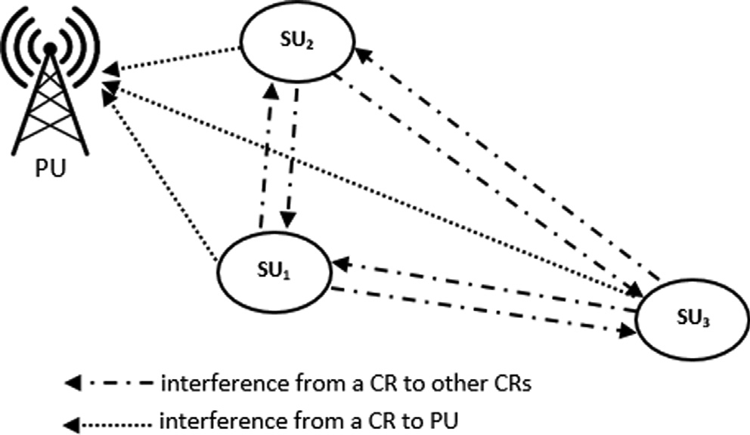

Fig. 2. Interference in different channels by different entities.

*P*(*m*) =

*e*—k*s* (3)

!

*m*

Channel model: It is considered that there are *N*channels avail- where *eRF* is the energy consumed by the radio frequency circuit to

*amp*

able to be accessed by the SUs opportunistically. Each of these *N*

receive and transmit the signal,*eamp* and *e*'

are the amplifier

channels is licensed to the PUs. All the channels can be modelled as Rayleigh fading channels. Based on the proximity of the commu- nicating nodes, there can be interference among the SUs. The terms SU node and CR node are used interchangeably. Fig. 2 shows how the CR nodes (i.e., nodes numbered as 1,2,3, & 4) can interfere with each other. The figure also shows how the CR nodes can interfere with the PU even. It is assumed that the interference radius is dou- ble the communication radius.

Energy model: In CRWSN, the CR nodes apart from data trans- mission and reception perform additional tasks of spectrum sens- ing and switching. Hence, the energy consumption is more in CRWSN as compared to traditional WSN. So, while designing the energy consumption model all four tasks have to be considered. Assume, *Ess* to be the energy consumed during spectrum sensing,

*Esw* to be the energy consumed during spectrum switching. The

energy related to path loss model used, *d* is the distance between transmitter node to receiver node, and *d*0 is the distance threshold used to differentiate path loss model where

*d*0 = q*e*ﬃﬃﬃ*a*ﬃ*m*ﬃﬃﬃ*p*ﬃﬃ/ﬃﬃﬃ*e*ﬃﬃ'ﬃﬃﬃﬃﬃﬃ [16].

*amp*

Considering the *ith* SU receives L bits of data, the energy con-

sumed during the reception mode is

*Erx*;*i*(L) = *eRF* × L (5)

Mobility model: The objective behind this work is to achieve

stable clusters. Therefore, the cluster head nodes are expected to be the nodes with relatively low mobility. To characterize the instantaneous nodal mobility *Mi*, the following expression is used [17,18].

*T*

*th* 1 X

## qﬃﬃﬃﬃﬃﬃﬃﬃﬃﬃﬃﬃﬃﬃﬃﬃﬃﬃﬃﬃﬃﬃ2ﬃﬃﬃﬃﬃﬃﬃﬃﬃﬃﬃﬃﬃﬃﬃﬃﬃﬃﬃﬃﬃﬃﬃﬃﬃﬃﬃﬃﬃﬃ2ﬃﬃ

energy consumed by *i* SU during data transmission of L bits is *Mi* = *T*

(*xt* — *xt*—1) + (*yt* — *yt*—1)

(6)

expressed as mentioned below [15,31].

8>< *eRF* + *eampd*2 × *L*; *d* < *d*0

*t*=1

where (*xt*; *yt* ) and (*xt*—1; *yt*—1) are coordinates of a node *ni* at time

instants *t* and *t* — 1 respectively. Again, *T* is the period for which this

*Etx*;*i*(L) = >: *e*

*RF* +

*e*

'

*amp*

*d*4

× *L*; *d*

≥ *d*0

(4)

parameter is going to be estimated. It is also assumed that the nodes move following the random waypoint mobility model.

Mi is defined to be the movement profile of a node i, and is com- puted by using (6).

1. Proposed clustering approach

In this section, a node clustering algorithm for cognitive radio wireless sensor networks is proposed. The majority of the comput- ing burdens have been shifted to the sink as the sink is considered to be a resourceful node.

Assumptions. *There are a few assumptions made concerning the characteristics of the nodes*. *It is assumed that the sensor nodes* (*i*.*e*., *the PU or CR nodes*) *know their residual energy level and geographic location*. *Movement profile as per* (6) *is also computed by each node*. *Moreover*, *it has been assumed that each node is aware of the probability of PU arrival at its proximity that can be interfered with by itself*. *The phenomenon of interference is shown in* Fig. 2.

The entire process of node clustering may be presented in terms of various stages as mentioned below.

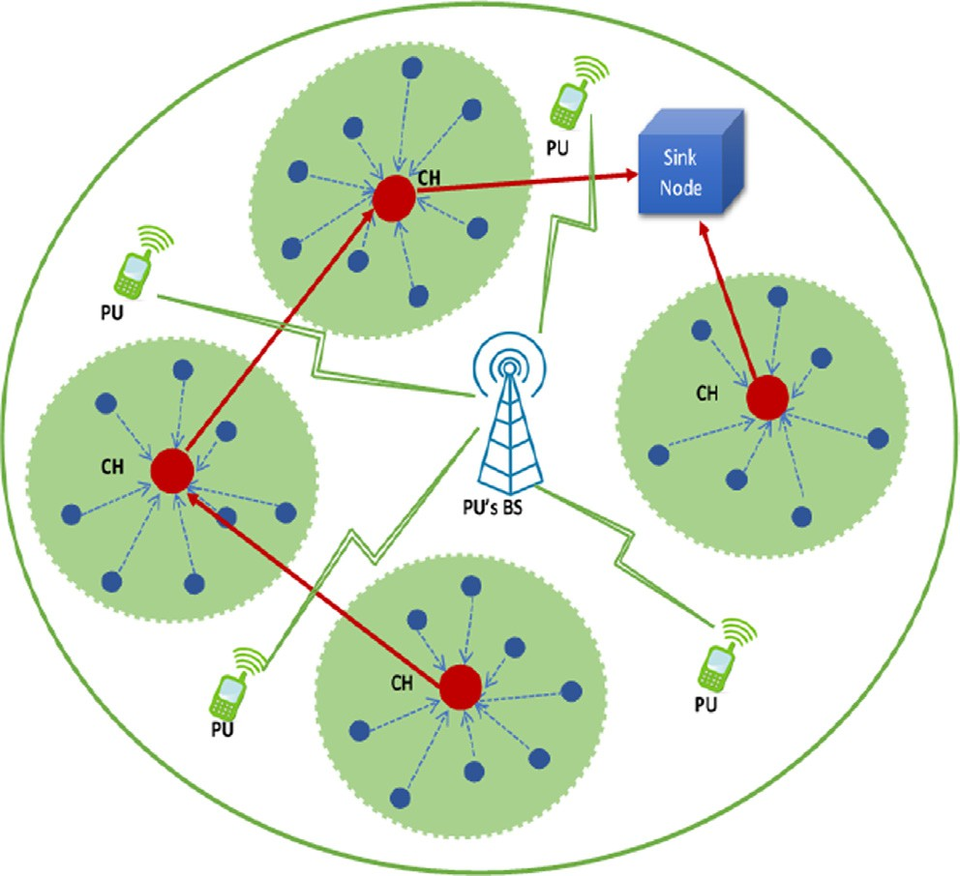Fig. 1. Cluster-based hierarchical communication among the SUs.

Stage 1: In this stage, the sink collects data from the participat- ing nodes. The important parameters collected from the nodes are *node_id, residual energy level, geographic location, PU arrival probability, and the movement profile.*

Stage 2: The sink node creates the topology of the cognitive radio sensor network. This topology is created based on the geo- graphic location and movement profiles of the sensor nodes. Stage 3: The sink node forms the clusters after forming virtual grids across the sensor field. Grids are merged based on the necessity to form clusters.

each cluster, into two classes as eligible (*ECH*) and ineligible (*NECH*). Stage 4: The sink node classifies the participating nodes inside

Stage 5: The sink node runs Evolutionary Game Theory-based

computations and selects the respective cluster head nodes inside each cluster.

The advantage of this approach is that as the computational overhead is shifted toward the sink, and communication overhead is minimized, the sensor nodes save energy. Moreover, the cluster head nodes selected are always the nodes having a balanced cumu- lative value among various parameters such as residual energy level, mobility, PU arrival probability, and geographic locations. Therefore, the cluster head nodes tend to be geographically uni- formly distributed. The entire process of cluster formation and cluster head selection has been depicted in Fig. 3.

Details of the stages are mentioned below.

In stage 1, the sink node collects the following five different parameters from each of the nodes: <*node_id, residual energy level, geographic location, PU arrival probability, and the movement profile* > .

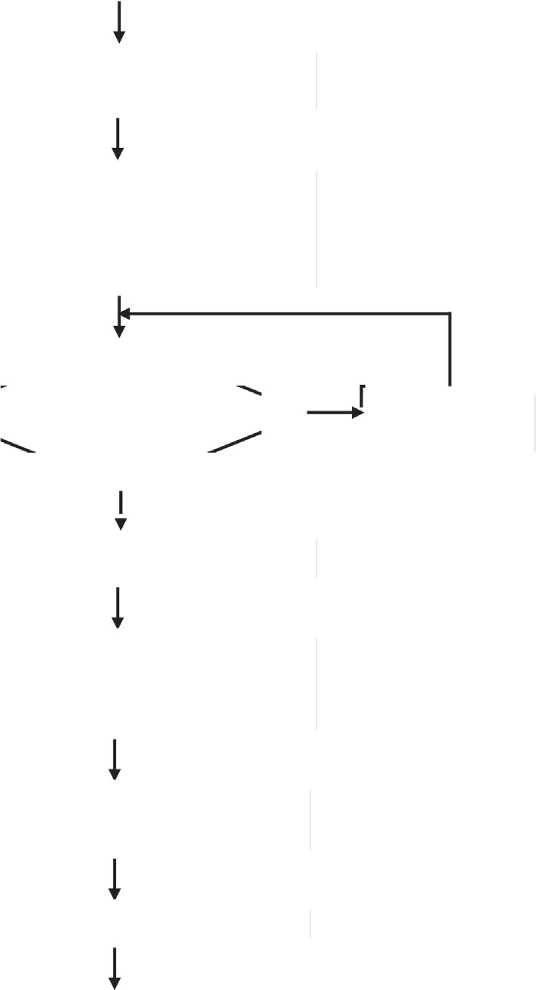

Start

If no. of nodes within

a cluster <

Yes

No

Stop

CH is selected

Sink initiates EGT based CH selection game for each clusters

Sink classifies nodes within each cluster into two classes: eligible ( ) and ineligible ( )

Sink creates final clusters

Merge clusters

Sink creates topology based on the geographic location and movement profiles of the sensor nodes and forms initial clusters.

Sink collects data from the participating sensor nodes

Fig. 3. Cluster formation and cluster head selection process.

In stage 2, once the sink node gathers the information from all the sensor nodes, it creates the topology of the cognitive radio sen- sor network. This initial topology is created based on the geo- graphic locations, and the movement profiles of the sensor nodes. In stage 3, the sink node forms various clusters covering the entire sensor field. Depending on the location of the nodes, the sink node forms the initial cluster by dividing the deployed area into *nbyn* grids. Each grid is initially considered as a cluster. Then the number of nodes within each cluster is examined. Each cluster should have a minimum threshold number of nodes. For example, a minimum of 10% of the total nodes deployed in the field may be considered as the threshold, to determine the minimum number of nodes required inside each cluster. The clusters are scanned from

left to right and top to bottom, as given below:

1. The sink node divides the deployed are into *nbyn* equal vir- tual grids. Each grid forms one cluster. Therefore, there will be *n*2 clusters initially.
2. A minimum number of nodes that each cluster should have is pre-decided, and a threshold value, *NTH*, is set; for exam-

ple, *NTH* = 10%*ofTotalnumberofnodesdeployed*.

1. The sink node scans each cluster (from left to right in the

entire grid set) and checks the number of nodes present in the cluster. If the cluster *i* has less then *NTH* then it checks its neighbour clusters horizontally, and the nodes within cluster *i* are assigned to its neighbour (the cluster on the right side). The maximum number of merge operations that

set is *n*/2 + 1. And thus, the minimum number of individual are permitted to occur in a horizontal row of the initial grid clusters that can form in a given row isn/2

1. Step c is repeated until all the clusters are scanned. There- fore, from the initial *n*2 clusters, the final clusters are formed; and this final number of clusters is generally less than *n*2. This is due to the merging of initial clusters for the low density of the nodes inside initial clusters.
2. The sink classifies all the nodes into different final clusters.

[Note: if after the maximum number of permitted merge oper- ations, some clusters in a row, are left with less than the threshold number of sensor nodes, then it is left as it is; vertical merging is not attempted in this work.]

Fig. 4 depicts the process of cluster formation. Initially, virtual grids are formed. The scan happens from left to right and top to bottom. Initially, each grid is a cluster. Due to the fewer number of nodes inside each initial cluster, the adjacent clusters are merged. For example, cluster (1,1) and (1,2) are merged. Similarly, the remaining three initial clusters in the same row are merged and one cluster is formed. The black solid arrow indicates the merging of initial clusters.

In stage 4, nodes are classified as eligible (*ECH*) and ineligible

(*NECH*) respectively.

The sink node collects various node information during stage 1.

Various information collected from the nodes are as mentioned below: < *node_id, residual energy level, geographic location, PU arri- val probability, and the movement profile* > . These parameters are processed by the sink node and the sensor nodes inside each clus-

ter are classified into two sets: eligible (*ECH*) and ineligible (*NECH*).

Three main parameters contribute the maximum in selecting

the elements for the above mentioned two sets *ECH* and *NECH*. The parameters are *residual energy level, PU arrival probability, and the movement profile*. Ideally, the node with higher *residual energy*, hav- ing lower *PU arrival probability*, and being relatively a more stable one, although all the nodes are mobile, is the most suitable node for the cluster head role.

Sensor Node

(2,1)

(1,2)

(1,1)

Fig. 4. Schematic diagram demonstrating the process of clustering.

Then a weighted cumulative value for each node *i* (denoted as

*Wi*), considering these three parameters is computed.

*Wi*= *W*1 (residual energy level) + *W*2 /(PU arrival probability) +

*W*3 /(mobility in terms of movement profile)

the nodes are now players (p) as per the game theory under consideration.

If a node has a residual energy percentage greater than a certain

energy threshold percentage (*RET* ) then it is grouped into *EP* other-

*Wi* = *W*1 × *Ei* + *W*2

### *Pi*

*W*3

+ *Mi*

(7)

wise into *NEP* . Therefore, the player set *P* = *EP* ∪ *NEP*. The strategy

that the players can choose is either to become a cluster head

(*sCH*) or not be a cluster head (*sNCH*). Therefore, the strategy set is

where *W*1 + *W*2 + *W*3 = 1 and 0 ≤ *Pi* ≤ 1 ; *Mi* is computed using

(6).

Thus, the nodes having the }*Wi*} value above a threshold (*WTH*), become members of *ECH* set, and the remaining nodes become

members of *NECH* set.

*ECH* = n*ni*|*niistheithsensornodeandWi* ≥ *WTH*o (8a)

*NECH* = n*nj*|*njisthejthsensornodeandWj* < *WTH*o (8b)

Moreover, *ECH* ∪ *NECH* = *Ns*, where *Ns* is the set of all the cogni- tive radio sensor nodes deployed in the field.

The nodes in the *ECH* set shall compete for the cluster head role and the nodes in the *NECH* set shall remain as ordinary cluster member nodes.

In stage 5, the sink node does the necessary computation, as mentioned below, to select the most suitable nodes, as respective cluster head nodes for each of the clusters.

A game is designed for the selection of cluster heads based on evolutionary game theory inspired by the work presented in [6]. Let the cluster head selection game be denoted by

*CHSG* < *P*; *S*; *U* > where *P* represents the player set, *S* represents

the strategy set that will be used by the players, and *U* represents the utility or payoff earned while playing a certain strategy.

into two classes i.e., eligible (*EP*) and ineligible (*NEP*) as mentioned in stage 4. It is worth mentioning that eligible (*EP* ) and ineligible The sink node classifies the sensor nodes within each cluster (*NEP* ) node sets are equivalent to eligible (*ECH*) and ineligible (*NECH*) node-set mentioned in stage 4, respectively; the reason behind the symbol p being used instead of CH is that, in stage 5,

given as

*S* = {*sCH*; *sNCH*} (9)

Depending on the strategy selected by a node *i* within a cluster,

the utility function of node *i* is defined as

*Ui* = *Ri* — *Pi* (10)

where *Ri* denotes the reward earned and *Pi* denotes the penalty

imposed for the strategy selected during the game. The reward and penalty are essential because there should be some incentive for performing the role of cluster head and penalty for escaping to be a cluster head. The cluster head nodes have to perform additional tasks therefore, the energy depletion will be higher compared to normal nodes and many nodes can act selfishly to conserve their

ter head by a node ∈ *EP* is h and the reward gained by nodes ∈ *NEP* is energy. So, we consider that the reward gained for becoming a clus-

x. Also, a step of incentive or disincentive (represented by d) for

becoming a cluster head is assumed.

In evolutionary game theory, it is very important to formulate the ESS. An ESS is a state in the game that ensures that different species in a population co-exist together and do not threaten each other by increasing the extinction probability through a selfish choice of strategies. For this *CHSG* (Cluster Head Selection Game) game, the ESS is the nodes in *EP* subset should select the strategy *sCH* and the nodes in *NEP* subset should select the strategy, *sNCH*.

Suppose we consider that the nodes belonging to *EP* subset

for selecting the strategy *sNCH* will be (1 — *p*). Similarly, for the selects the strategy *sCH* with the probability *p* then the probability nodes belonging to the subset *NEP*, the probability of choosing

the strategy *sCH* is *q* then the probability for selecting the strategy

*sNCH* will be (1 — *q*). Using these probabilities and rewards, a payoff matrix can be formulated as shown in Fig. 5.

Using the payoff matrix, the expected utility or payoff earned by nodes in *EP* set by choosing the strategy to become cluster head i.e., *sCH* is

Table 1

Interpretation of various symbols used in the mathematical framework.

|  |  |  |  |
| --- | --- | --- | --- |
| Symbol | Interpretation | Symbol | Interpretation |
| *P* | Player set | *q* | The probability that nodes |
|  |  |  | belonging to *NEP* subset |
| *S* | Strategy Set | d | selects the strategy *sCH*  A step of incentive or |
|  |  |  | disincentive for becoming a |
|  |  |  | cluster head |
| *Ui* | Utility function for node  *i* | *UE* (*s* ) | The expected utility or  payoff earned by nodes ∈ *EP* |
|  |  |  | to become cluster head by |
| *Ri* | Reward earned for node *i* | *UEP* (*sNCH* ) | selecting the strategy *sCH*  The expected utility or |
|  |  |  | payoff earned by nodes ∈ *EP*  choosing strategy *sNCH* i.e.,  not to become cluster head |

*UEP* (*sCH* )

## = *q*h + (1 — *q*)(h + 2d) = h + 2d — 2d*q* (11)

The expected utility or payoff earned by nodes in *EP* set by choosing the strategy not to become cluster head i.e., *sNCH* is

*P CH*

*UEP* (*sNCH*

## ) = *q*(h — d) + (1 — *q*)(—d) = *q*h — d (12)

Therefore, the total reward for nodes in *EP* set will be

## *UEP* = *p*(h + 2d — 2d*q*) + (1 — *p*)(*q*h — d) (13)

Similarly, the expected utility or payoff earned by nodes in *NEP*

set is formulated as

*UNEP* (*sCH* ) = *p*x + (1 — *p*)(x + d) = x + d — d*p* (14)

*Pi* Penalty imposed for node *i*

h The reward gained for becoming a cluster head

*UEP* The total payoff for nodes in

*EP*

*UNEP* (*sCH* ) The expected utility or

payoff earned by nodes

*UNEP* (*sNCH* )

= *p*(x + 2d) + (1 — *p*)(—d) = x*p* + 3d*p* — d (15)

by a node ∈ *EP*

∈ *NEP* to become cluster

head by selecting the

Therefore, the total reward for nodes in *NEP* set will be

x The reward gained for

strategy *sCH*

*UNEP* (*sNCH* ) The expected utility or

*UNEP*

= *q*(x + d — d*p*) + (1 — *q*)(x*p* + 3d*p* — d) (16)

becoming a cluster head

by nodes ∈ *NEP*

payoff earned by nodes

∈ *NEP* choosing strategy

Using eq. (11) and (14), the utility of each node within a cluster is calculated. The node having the highest utility value is elected as cluster head and other nodes act as cluster members.

Interpretations of various symbols used in the above mathe- matical framework (eq. 9–16) are given in Table 1.

Finally, the sink node sends a < cluster_info > message to all the nodes, which contains the information about the cluster to which a node belongs. The message format will contain *< node_id, clus-*

*p* The probability that nodes belonging to *EP* subset selects the strategy *sCH*

*sNCH* i.e., not to become cluster head

*UNEP* The total payoff for nodes in N *EP*

*ter_id, clusterhead_id > .*

Following are the various data structures necessary to be used in the proposed approach (Table 2):

1. Analysis of the proposed clustering approach

In this section, an analysis of the presented clustering approach is presented.

* 1. *Theoretical analysis*

Lemma 1. *Formed clusters are mutually exclusive.*

*Proof*: The sink node forms the clusters. The sensor field is geo- graphically virtually partitioned into the grids. In the process of forming the final clusters, initial clusters are merged sometimes, if the total number of nodes inside a cluster does not reach at least the threshold number. Thus, there is no chance that a sensor node can become a member of more than one cluster. As the sensor node does not choose a cluster head node, rather it is the sink node that forms the clusters and also selects the cluster head nodes, the formed clusters are always mutually exclusive.

(1 )

|  |  |  |
| --- | --- | --- |
|  |  |  |
|  | , | +2 , +2 |
|  | , + | , |



(1 ) 

Fig. 5. Payoff matrix.

Theorem 1. *The number of clusters to be formed* (*N*) *satisfies the condition n*/2 ≤ *N* ≤ *n*2 *where n is the initial number of grids in a row after partitioning the sensor field into n* × *n grids.*

sor field is logically partitioned into n × n grids. At this stage, the *Proof*: During the initial stage of the clustering process, the sen- number of clusters *NTH*. Then the grids are scanned from left to

right and top to bottom. Considering the geographic locations of

is less than a threshold value (*NTH*), then horizontally adjacent the sensor nodes, if the number of sensor nodes inside a cluster grids are merged one by one to form a new cluster; this process

continues till the number of nodes inside each cluster > *NTH*. Thus, depending on the geographic distribution of the sensor nodes, and the value of *NTH*, the largest possible number of clusters is *n*2. On the other hand, the merging of grids in a particular row can con-

tinue for a maximum of n/2 times. Thus, the number of clusters in each row can never be lesser than *n*/2, provided each grid con- tains at least one sensor node. And it has been assumed that

although the sensor nodes are deployed randomly, each virtual grid contains at least one sensor node.

Theorem 2. *Uniform geographic distribution of the cluster heads is ensured.*

*Proof*: The cluster head nodes are selected after the formation of the clusters. Again, the clusters are either the initially formed grids or merged grids. Due to the virtual partitions created in the sensor field in terms of grids, and the process of conditional merg- ing of grids, the final clusters are geographically uniformly dis- tributed. Cluster head nodes are selected in such a way that the most suitable node in terms of parameters such as < *noterid, resid- ual energy level, geographic location, PU arrival probability, and the movement profile >* becomes the cluster head for the respective cluster. Thus, the cluster head nodes are uniformly geographically distributed.

Table 2

Data Structures used.

Available channel list for the cognitive nodes (i.e., the sensor nodes) List of cluster head nodes

List of cluster members for the cluster ci

List of common channels between any two cognitive nodes Residual energy levels of the cognitive nodes

Movement profile/mobility of the cognitive nodes

PU arrival probability against each available channel for cognitive nodes.

Theorem 3. *Communication overhead is minimized.*

*Proof*: The process of cluster formation involves the broadcast- ing of only one packet originated by each node containing the parameters mentioned as < *nomeid, residual energy level, geographic location, PU arrival probability, and the movement profile>*. Although the intermediate nodes in the sensor field may have to forward other packets as well, originated elsewhere, as per the broadcast policy. Then the sink node creates clusters and also selects the cluster head node for each cluster. Then each cluster head node advertises its role, and subsequently, cluster member nodes join the respective cluster just by sending one < ack > message. There- fore, it is evident that the number of communications involved in the process of cluster formation, cluster head selection, and joining the clusters by member nodes is the minimum, and the communi- cation complexity is O (1).

Theorem 4. *Unique clusters are formed.*

*Proof*: The process of cluster head node selection is based on evolutionary game theory and inspired by the process depicted in [6]. However, the outcome of our protocol in terms of cluster formation is different and unique. This is so because the way sen- sor nodes are classified into eligible, and ineligible is unique, and different from that of [6].

Theorem 5. *In the event of executing the cluster formation protocol, every sensor node receives a role either cluster member or cluster head.*

*Proof*: The sink node is responsible for forming the clusters and also for identifying one cluster head node per cluster. After the for- mation of the clusters, the sink node classifies all the sensor nodes

belonging to each cluster into two sets, namely, eligible (*ECH*) and

the most suitable node from the eligible (*ECH*) set receives the role of cluster head. The remaining nodes of the eligible (*ECH*) set, and ineligible (*NECH*) set of nodes (stage 4 of the procedure). Eventually

bers. It is already stated that *ECH* ∪ *NECH* = *Ns*, where *Ns* is the set all the elements of the ineligible (*NECH*) set become cluster mem- of all the nodes deployed in the field. Therefore, every node

deployed in the field receives a role either cluster member or clus- ter head.

Theorem 6. *The cluster formation and cluster head selection algo- rithms terminate.*

*Proof*: The sink node collects various node information initially. This data collection happens for a suitable period. The movement profile also includes the direction of movement, apart from relative speed. Once preliminary data collection is over, the rest is only a matter of processing. Being the sink node a resourceful one, it can form the clusters and also select the cluster head nodes by run- ning appropriate algorithms as discussed. Since the processing of initial data takes place in the sink, and this processing does not need any more intermediate data from the sensor nodes, the for-

rithms would have gone into loops. The collected movement profile of a node is sufficient to estimate the location of the node at a different instance of time, then the time of data collection.

1. Performance evaluation

The proposed clustering scheme is simulated for its perfor- mance evaluation. A cognitive radio wireless sensor network setup consisting of wireless sensor nodes enabled with cognitive radio has been considered. The simulation has been carried out in MATLAB 7.1. The sensor nodes are considered to be deployed ran- domly. The sink node is located outside the sensor field. The sensor nodes have mobility; however, the sink node is considered to be static. Each simulation ran for 1800 s. There were six rounds each of 250 s, in each simulation. During one round, the cluster setup was considered to be the same. Various essential parameters con- sidered for simulation are presented in Table 3. The presented val- ues of different parameters are an average of six different simulations taken repeatedly.

In this section, various results showing the performance of the proposed clustering scheme are presented.

As mentioned earlier, the sensor nodes are deployed randomly. Fig. 6 depicts initial random node deployment across the sensor field.

Fig. 7 shows the initial cluster formation as per the proposed clustering protocol. At this stage, the merging of clusters consider- ing the number of nodes inside each cluster has not taken place. Different colours are used to show unique clusters.

Fig. 8 shows the final cluster formation as per the proposed pro- tocol. At this stage, the merging of initial clusters formed has taken place. The clusters are geographically uniformly distributed. Since the nodes are mobile, the presented scenario is valid for a duration t only. Figs. 6, 7, and 8 represent the snapshots at appropriate instants, during the entire simulation duration.

Fig. 9 presents the status regarding energy consumption during cluster formation. This energy consumption is due to necessary communication by the nodes as per the clustering protocol and required computation. The blue-coloured portion represents the total initial energy in the entire system of a varying number of

Table 3

Simulation setup.

Parameter Value

Node deployment area 200 m × 200 m

Sink position (250, 100)

Number of sensor nodes deployed 200

Number of primary users 5

Number of available channels 5

Initial energy of the sensor nodes 0.5 J

*eRF* 50 nJ/bit

*eamp* 10 pJ/bit/m2

mation of clusters and the selection of cluster head nodes eventu-

'

*amp*

*e*

0.0013 pJ/bit/m2

ally come to an end within a finite time. Had there been any necessity of data from the sensor nodes, in the middle of the com- putation, there could have been a situation under which the algo-

*d*0 87 m

Data packet size 50 bytes

Control packet size 20 bytes

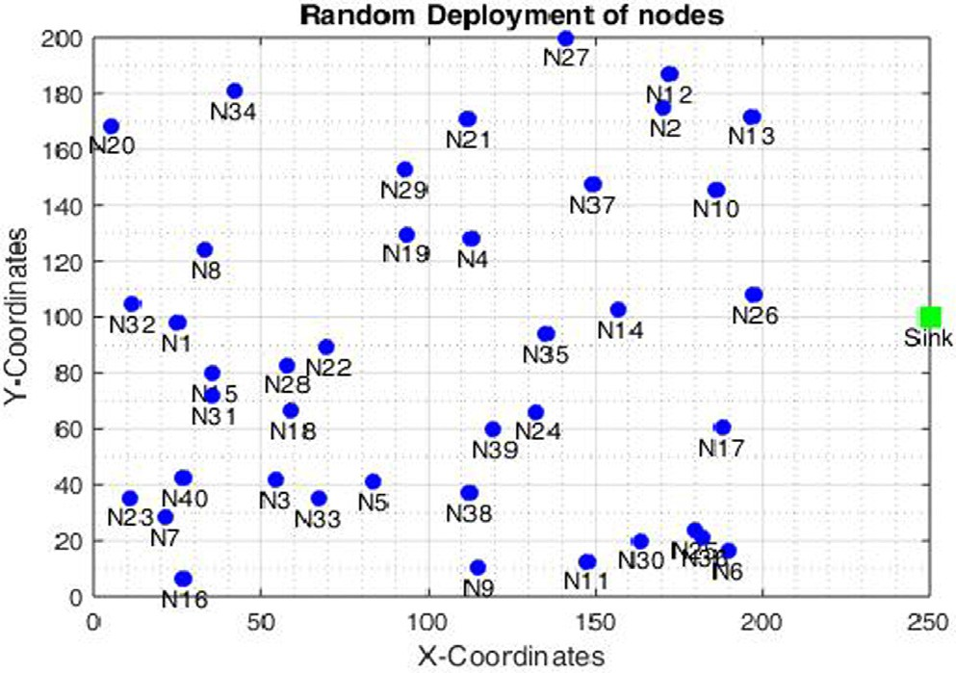200

100

0.450468

80

0.460081

60

0.47144

40

0.478687

20

0.490955

160

**Number of nodes**

120

80

40

0 20 40 60 80 100 120

**Total Energy (in J)**

 Total Energy  Avg Energy Spent

Fig. 9. Energy consumption against cluster formation.

Fig. 6. Random deployment of 40 nodes.

Fig. 10 presents the rate of energy depletion during cluster for- mation. The rate of energy depletion is calculated as per the expression given in (17). The rate of energy depletion during clus- ter formation varies along with the number of nodes in the system. The rate declines along with the increase in the number of deployed nodes. This is because, as the number of nodes increases, the sensor field becomes denser, and the relative distances between the nodes decrease. As a result, the energy requirements for communication are reduced proportionally.

*Rateofenergydepletion* = *InitialTotalEnergy* — *RemainingTotalEnergy*

*InitialTotalEnergy*

## × 100%

(17)

Fig. 7. Initial cluster formation.

Energy expenditure that occurred during the process of cluster head selection is shown in Fig. 11. Again, the blue-coloured potion represents the total energy available in the network system consid- ering all the sensor nodes, whereas the red portion represents the average energy spent during the cluster head node selection. The average energy spent during cluster head node selection increases along with the increase in the number of nodes in the system. This is because as the number of nodes increases the number of cluster head (CH) nodes also increase. However, the energy spent is quite less as compared to the cluster formation process, because as per the protocol the sink nodes select the CH nodes based on the initial information collected. Thus, processing happens in the sink node only. Finally, the sink node informs all other nodes about the selected cluster head nodes. Thus, the sensor nodes spend energy

3

|  |  |  |  |  |
| --- | --- | --- | --- | --- |
|  |  |  |  |  |
|  |  |  |  |  |
|  |  |  |  |  |
|  |  |  |  |  |
|  |  |  |  |  |
|  |  |  |  |  |

2.5

**Energy depletion rate %**

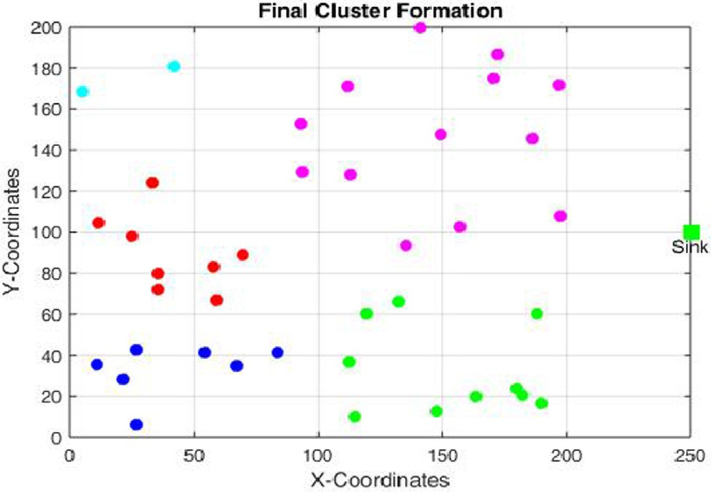Fig. 8. Final cluster formation.

nodes, whereas the red portion represents the average energy spent in the entire system, due to cluster formation. It is observed that the average energy spent in the system decreases as the num- ber of nodes increases. This is because, with the growth in the number of nodes, the network becomes dense. As a result, the physical distance between two nodes that need to be traversed reduces, and this incurs less energy as per the energy model con- sidered (eq. (4)) in this work.

2

1.5

1

0.5

0

40 80 120 160 200

**Number of nodes**

Fig. 10. Rate of energy depletion during cluster formation.

200

160

**Number of nodes**

120

80

40

99.549532

0.001031

79.539919

0.000977

59.52856

0.000939

39.521313

0.0009

19.509045 0.000628

0 20 40 60 80 100 120

**Total Energy (in J)**

 Total Energy  Avg Energy Spent

Fig. 11. Energy consumption in selecting CH.

nodes. However, the rate of increase is very low because as the number of nodes increases, the total energy of the network increases. It is also observed that the rate of energy depletion is lower during CH selection as compared to cluster formation.

The performance of the proposed clustering protocol in terms of the quality of the selected CH node has been compared with the protocol proposed in [9], RARE [35] and LEACH [2]. Here, the qual- ity of the selected cluster head node indicates two parameters. The first one is the *percentage of high-energy sensor nodes* that has got selected as cluster head. High energy indicates that the residual energy level of the selected cluster head node is above a certain threshold. Here this threshold has been considered as 75% of the initial energy level. The second parameter is the *geographical distri- bution* of the selected cluster head nodes. The way, the selected cluster head nodes are geographically uniformly distributed in the parameter under consideration. No two selected cluster head nodes are expected to be geographically close to each other.

0.0035

0.003

**Energy depletion rate %**

0.0025

0.002

0.0015

0.001

0.0005

0

40 80 120 160 200

|  |  |  |  |  |
| --- | --- | --- | --- | --- |
|  |  |  |  |  |
|  |  |  |  |  |
|  |  |  |  |  |
|  |  |  |  |  |
|  |  |  |  |  |
|  |  |  |  |  |
|  |  |  |  |  |

**Number of nodes**

Fig. 12. Rate of energy depletion during CH selection.

Although this term ‘‘close” is qualitative, intuition has been consid- ered in judging the uniform distribution of the cluster head nodes in terms of geographic location. Since the simulated system is rel- atively smaller in terms of the number of deployed nodes, this was quite possible to determine without any hassle.

Fig. 13 shows the percentage of high-energy nodes that have been selected as cluster head nodes, during the entire simulation duration. This parameter is calculated under the influence of the proposed protocol, LEACH [2], RARE [35] and the protocol reported in [9].

It is observed that the proposed protocol outperforms protocol in [9] by 23%, LEACH by 26%, and RARE by 28%. This is because the residual energy in the nodes has been considered as a param- eter while selecting the nodes suitable as candidate nodes for the cluster head role.

Fig. 14 presents the geographic distribution of the selected clus- ter head nodes under the influence of the proposed protocol,

in receiving such messages sent by the sink. As a result, the energy consumption is very less in the process of CH selection, and increases proportionally, as the number of nodes increase.

As per eq. (17), the energy depletion rate during the process of cluster head selection is computed. Fig. 12 represents this energy depletion rate. This energy depletion is due to the necessary com- munications between the sensor nodes and the sink node. Here, this parameter represents the rate of reduction or depletion of energy levels in the nodes during the cluster head selection. The rate declines along with the increase in the number of deployed

LEACH, RARE and the protocol reported in [9].

It is observed that the proposed protocol outperforms the pro- tocol in [9] by 28%, LEACH by 40%, and RARE by 43%. This is because, the way grids are formed in the sensor field, and the way grids are merged to form the final clusters, naturally lead toward the uniform geographic distribution of the cluster head nodes.

Fig. 15 presents the total energy consumed in the system due to packet transfer under the influence of various protocols over the simulation span.

100

**%age of nodes with higher energy level selected as CH**

90

80

70

60

50

40

30

20

10

0

20 40 60 80 100

# Number of nodes

 For Proposed  For the Protocol in [9]  For LEACH  For RARE

Fig. 13. Energy levels of the CH nodes.

120

**%age of the total CH nodes, which are geographically uniformly distributed**

100

80

60

40

20

0

20 40 60 80 100

# Number of nodes

 For Proposed  For the Protocol in [9]  For LEACH  For RARE

Fig. 14. Uniformity in the geographical distribution of the CH nodes.

180

**Total energy consumed (J)**

160

140

120

100

80

60

40

20

0

300 600 900 1200 1500

# Simulation time (seconds)

 For Proposed  For the Protocol in [9]  For LEACH  For RARE

Fig. 15. Energy consumption versus simulation time.

1800

1600

1400

**Lifetime (seconds)**

1200

1000

800

600

400

200

0

20 40 60 80 100

#### Number of nodes

For Proposed  For the Protocol in [9]  For LEACH  For RARE

Fig. 16. Number of nodes versus network lifetime.

It is observed that the proposed protocol reduces energy con- sumption by 17% as compared to the protocol in [9], by 31% as compared to LEACH, and by 23% as compared to RARE.

This is mainly because of the geographically uniform distribu- tion of the cluster head nodes under the influence of the proposed protocol.

Fig. 16 presents the network lifetime analysis under the influ- ence of various protocols. Lifetime is considered to be the time duration elapsed, till the death of 50% of the nodes deployed in the field.

It is observed that the proposed protocol increases the network lifetime by 20% as compared to the protocol in [9], by 33% as com- pared to LEACH, and 28% as compared to RARE.This is again due to the energy saving in the system and most of the energy saved under the influence of the proposed protocol is mainly due to uni- form geographic distribution of the cluster head nodes, and lesser PU arrival in the channels of the CH nodes.

1. Conclusion and future work

In this paper, a node clustering protocol for CRWSN has been proposed. The sensor nodes are considered to be mobile. The pro- posed protocol is based on EGT. The sensor field is virtually parti- tioned into a suitable number of grids. Then grids are subsequently merged to form an optimal number of clusters depending on the geographical locations of the nodes. The sensor nodes are classified into two sets as {eligible}, and {ineligible} containing the identity of the nodes that are suitable to become cluster head, and not suit- able to become cluster head, respectively. Once classification is done, the most suitable candidate node is selected as the CH for a particular cluster. This selection procedure is based on EGT. Moreover, as an outcome of this protocol, the most suitable candi- date node inside each cluster, in terms of residual energy, geo- graphic location, and movement profile, is selected as the CH node. The entire computing burden is shifted to the sink node. The proposed protocol outperforms the similar protocol proposed in [9], RARE [35] and also LEACH [2]. The performance of the pro- posed protocol was analysed in terms of the parameters like the number of high energy nodes selected as CH node, the percentage of uniform geographical distribution of CH nodes, the total energy consumed during the simulation time, and also the network life- time. Shifting of computational load from the sensor nodes to the sink node is highly essential since the sink node is resourceful and it also possible to refuel the sink node. Moreover, uniform geo- graphical distribution of the CH nodes is also important consider- ing the uniform coverage of the sensor field and also to minimize the energy expenditure due to communication. Again, sensor nodes with higher level of residual energy should be selected as the CH nodes as it helps in prolonging the network lifetime by avoiding the necessity of frequent re-clustering.

As a future scope of the work, a hierarchical routing protocol for CRWSN may be designed that can use the clustering protocol pro- posed in this paper, to create clusters and select CH nodes.

Declaration of Competing Interest

The authors declare that they have no known competing finan- cial interests or personal relationships that could have appeared to influence the work reported in this paper.

References

1. Lin D, Wang Q. A game theory based energy efficient clustering routing protocol for WSNs. Wireless Netw 2017;23(4):1101–11. doi: [https://doi.org/](https://doi.org/10.1007/s11276-016-1206-2) [10.1007/s11276-016-1206-2](https://doi.org/10.1007/s11276-016-1206-2).
2. [Heinzelman WB, Chandrakasan AP, Balakrishnan H. An application-specific](http://refhub.elsevier.com/S1110-8665(22)00015-9/h0010) [protocol architecture for wireless microsensor networks. IEEE Trans Wireless](http://refhub.elsevier.com/S1110-8665(22)00015-9/h0010) [Commun 2002;1(4):660–70](http://refhub.elsevier.com/S1110-8665(22)00015-9/h0010).
3. [Kassan S, Gaber J, Lorenz P. Game theory based distributed clustering approach](http://refhub.elsevier.com/S1110-8665(22)00015-9/h0015) [to maximize wireless sensors network lifetime. J Network Comput Appl](http://refhub.elsevier.com/S1110-8665(22)00015-9/h0015) [2018;123:80–8](http://refhub.elsevier.com/S1110-8665(22)00015-9/h0015).
4. [Liu Q, Liu M. Energy-efficient clustering algorithm based on game theory for](http://refhub.elsevier.com/S1110-8665(22)00015-9/h0020) [wireless sensor networks. Int J Distrib Sens Netw 2017;13(11):1–12](http://refhub.elsevier.com/S1110-8665(22)00015-9/h0020).
5. [Koltsidas G, Pavlidou F-N. A game theoretical approach to clustering of ad-hoc](http://refhub.elsevier.com/S1110-8665(22)00015-9/h0025) [and sensor networks. Telecommun Syst 2011;47(1-2):81–93](http://refhub.elsevier.com/S1110-8665(22)00015-9/h0025).
6. Habib, M.A.; Moh, S., ‘‘Robust Evolutionary-Game-Based Routing for Wireless Multimedia Sensor Networks”, Sensors 19, (3544), 2019, 1-27. Doi: 10.3390/ s19163544.
7. Eletreby, R.M.; Elsayed, H.M.; Khairy, M.M., ‘‘CogLEACH: A spectrum aware clustering protocol for cognitive radio sensor networks”, in *Proceedings of the IEEE 9th International Conference on Cognitive Radio Oriented Wireless Networks and Communications*, 2–4 June 2014; pp. 179–184, Oulu, Finland.
8. [Bradonjic´ M, Lazos L. Graph-based criteria for spectrum-aware clustering in](http://refhub.elsevier.com/S1110-8665(22)00015-9/h0040) [cognitive radio networks. Ad Hoc Netw 2012;10(1):75–94](http://refhub.elsevier.com/S1110-8665(22)00015-9/h0040).
9. [Wang T, Guan X, Wan X, Shen H, Zhu X. A Spectrum-Aware Clustering](http://refhub.elsevier.com/S1110-8665(22)00015-9/h0045) [Algorithm Based on Weighted Clustering Metric in Cognitive Radio Sensor](http://refhub.elsevier.com/S1110-8665(22)00015-9/h0045) [Networks. IEEE Access 2019;7:109555–65](http://refhub.elsevier.com/S1110-8665(22)00015-9/h0045).
10. [Zheng M, Chen Si, Liang W, Song M. NSAC, ‘‘A Novel Clustering Protocol in](http://refhub.elsevier.com/S1110-8665(22)00015-9/h0050) [Cognitive Radio Sensor Networks for Internet of Things”.](http://refhub.elsevier.com/S1110-8665(22)00015-9/h0050) [IEEE Internet Things J](http://refhub.elsevier.com/S1110-8665(22)00015-9/h0050) [2019;6(3):5864–5](http://refhub.elsevier.com/S1110-8665(22)00015-9/h0050).
11. Shakhov, V., Koo, I., ‘‘An Efficient Clustering Protocol for Cognitive Radio Sensor Networks”, *Electronics*, 10, 84; 2021, Doi: 10.3390/electronics10010084, pp. 1-

14.

1. [Song Yu, Liu Z, He X, Zhang L. Hybrid PSO and Evolutionary Game Theory](http://refhub.elsevier.com/S1110-8665(22)00015-9/h0060) [Protocol for Clustering and Routing in Wireless Sensor Network. J Sens](http://refhub.elsevier.com/S1110-8665(22)00015-9/h0060) [2020;2020:1–20](http://refhub.elsevier.com/S1110-8665(22)00015-9/h0060).
2. [Easley D, Kleinberg J, et al. Networks, crowds, and markets: Reasoning about a](http://refhub.elsevier.com/S1110-8665(22)00015-9/h0065) [highly connected world. Significance 2012;9(1):43–4](http://refhub.elsevier.com/S1110-8665(22)00015-9/h0065).
3. Jiang G, Shen S, Hu K, Huang L, Li H, Han R. Evolutionary Game-Based Secrecy Rate Adaptation in Wireless Sensor Networks. Int J Distrib Sens Netw 2015;11 (3):975454. doi: <https://doi.org/10.1155/2015/975454>.
4. [Joshi GP et al. A Novel Clustering Scheme For Heterogeneous Cognitive Radio](http://refhub.elsevier.com/S1110-8665(22)00015-9/h0075) [Wireless Sensor Networks. Ingeniería Solidaria 2020;16(3):1–14](http://refhub.elsevier.com/S1110-8665(22)00015-9/h0075).
5. [Yang L, Lu Y-Z, Zhong Y-C, Wu X-G, Xing S-J. A hybrid, game theory based, and](http://refhub.elsevier.com/S1110-8665(22)00015-9/h0080) [distributed clustering protocol for wireless sensor networks. Wireless Netw](http://refhub.elsevier.com/S1110-8665(22)00015-9/h0080) [2016;22(3):1007–21](http://refhub.elsevier.com/S1110-8665(22)00015-9/h0080).
6. Dahane, A. Berrached, N. E. Kechar, B. ‘‘Energy efficient and safe weighted clustering algorithm for mobile wireless sensor networks,” in *Proceedings of the 9th International Conference on Future Networks and Communications (FNC ’14)*, vol. 34, 2014, pp. 63–70, Procedia Computer Science (Elsevier), Niagara Falls, Canada.
7. Li, Y. Wang, F. Huang, F. Yang, D. ‘‘A novel enhanced weighted clustering algorithm for mobile networks,” in *Proceedings of the IEEE 5th International Conference on Wireless Communications, Networking and Mobile Computing (WiCOM ’09)*; 2009, pp. 2801–2804, Beijing, China.
8. Sarma H.K.D., Kar. Avijit, Mall, Rajib, ‘‘Energy Efficient Cluster Based Routing Protocol for Wireless Sensor Networks”, in *Proceedings of the IEEE ICWET*, Feb 24-25; 2012, pp. 283- 289, Mumbai, India.
9. Sarma, H.K.D., Kar Avijit, Mall, Rajib, ‘‘A Cross Layer Based Energy Efficient Routing Protocol for Wireless Sensor Networks”, in *Proceedings of the Indo-US workshop on System of Systems Engineering (SoSE)*, Oct 26-28; 2009, Indian Institute of Technology Kanpur, India.
10. Sarma. H, K, D, Kar, Avijit, Mall. Rajib, ‘‘Routing in Wireless Sensor Networks”, in *Proceedings of the International Conference on Stochastic Processes and Applications*, Jul 16-21; 2007, Indian Institute of Science, Bangalore, India.
11. Sarma H.K.D., ‘‘Energy Efficient Routing Protocol for Wireless Sensor Networks”’ in *Proceedings of the XXVIII th General Assembly (GA) of International Union of Radio Science (URSI)*, 2005, New Delhi, India.
12. Sarma, K.D, Rai, P, Handique M, Biradar, S, R, ‘‘Energy Efficient Hierarchical Cluster Based Communication Protocol for Wireless Sensor Networks with Base Station Mobility”, in: *Proceedings of the IEEE CODEC*; 2006, 214-221,

Kolkata, India

1. [Liu M, Liu L, Song H, Hu Y, Yi Y, Gong F. Signal Estimation in Underlay Cognitive](http://refhub.elsevier.com/S1110-8665(22)00015-9/h0120) [Networks for Industrial Internet of Things. IEEE Trans Industr Inform](http://refhub.elsevier.com/S1110-8665(22)00015-9/h0120) [2020;16:5478–88](http://refhub.elsevier.com/S1110-8665(22)00015-9/h0120).
2. Aslam S, Ansar-ul-Haq, Jang Ju, Lee K-G. Unified Channel Management for Cognitive Radio Sensor Networks Aided Internet of Things. Sensors 2018;18

(8):2665. doi: <https://doi.org/10.3390/s18082665>.

1. [Boubiche DE, Pathan A-S, Lloret J, Zhou H, Hong S, Amin SO, et al. Advanced](http://refhub.elsevier.com/S1110-8665(22)00015-9/h0130) [Industrial Wireless Sensor Networks and Intelligent IoT. IEEE Commun Mag](http://refhub.elsevier.com/S1110-8665(22)00015-9/h0130) [2018;56(2):14–5](http://refhub.elsevier.com/S1110-8665(22)00015-9/h0130).
2. [Ozger M, Alagoz F, Akan OB. Clustering in Multi-Channel Cognitive Radio Ad](http://refhub.elsevier.com/S1110-8665(22)00015-9/h0135) [Hoc and Sensor Networks. IEEE Commun Mag 2018;56(4):156–62](http://refhub.elsevier.com/S1110-8665(22)00015-9/h0135).
3. Zheng, J., Jamalipour, A., *Wireless Sensor Networks: A Networking Perspective*, JohnWiley & Sons: Hoboken, NJ, USA; 2009.
4. Eletreby, R.M., Elsayed, H.M., Khairy, M.M., ‘‘CogLEACH: A spectrum aware clustering protocol for cognitive radio sensor networks”, In: *Proceedings of the IEEE 9th International Conference on Cognitive Radio Oriented Wireless Networks and Communications*, 2–4 June; 2014, pp. 179–184, Oulu, Finland.
5. [Ali A, Yaqoob I, Ahmed E, Imran M, Kwak KS, Ahmad A, et al. Channel](http://refhub.elsevier.com/S1110-8665(22)00015-9/h0150) [Clustering and QoS Level Identification Scheme for Multi-Channel Cognitive](http://refhub.elsevier.com/S1110-8665(22)00015-9/h0150) [Radio Networks. IEEE Commun. Mag. 2018;56(4):164–71](http://refhub.elsevier.com/S1110-8665(22)00015-9/h0150).
6. [Li X, Wang D, McNair J, Chen J. Residual energy aware channel assignment in](http://refhub.elsevier.com/S1110-8665(22)00015-9/h0155) [cognitive radio sensor networks. In: *Proceedings of IEEE Wireless*](http://refhub.elsevier.com/S1110-8665(22)00015-9/h0155)[*Communications and Networking Conference*. p. 398–403](http://refhub.elsevier.com/S1110-8665(22)00015-9/h0155).
7. John von Neumann, Oskar Morgenstern, *Theory of Games and Economic Behavior,* Princeton University Press; 1944.
8. Mohit Angurala, Manju Bala, Sukhvinder Singh Bamber, ‘‘A novel technique for energy replenishment and load balancing in wireless sensor networks”, *Optik*, volume 248; 2021, 168136, ISSN 0030-4026, Doi: 10.1016/j.ijleo.2021.168136.
9. [Grover A, Mohan Kumar R, Angurala M, Singh M, Sheetal A, Maheswar R. Rate](http://refhub.elsevier.com/S1110-8665(22)00015-9/h0170) [aware congestion control mechanism for wireless sensor networks. Alexand.](http://refhub.elsevier.com/S1110-8665(22)00015-9/h0170) [Eng. J. 2022;61(6):4765–77](http://refhub.elsevier.com/S1110-8665(22)00015-9/h0170).
10. Mansoor N, Islam AKMM, Zareei M, Vargas-Rosales C. RARE: A Spectrum Aware Cross-Layer MAC Protocol for Cognitive Radio Ad-Hoc Networks. IEEE Access 2018;6:22210–27. doi: <https://doi.org/10.1109/ACCESS.2018.2807781>.