

Electronic Notes in Theoretical Computer Science

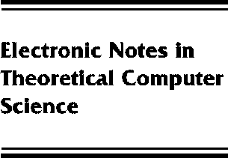[www.elsevier.com/locate/entcs](http://www.elsevier.com/locate/entcs)

Haskell Server Pages

**Functional Programming and the Battle for the Middle Tier**

Meijer Erik and van Velzen Danny

**Abstract**

Haskell Server (HSP) provide an easy way to create dynamic web and simplify the task of building middle tier components.This article gives an overview of HSP from a programmer’s perspective. It includes examples of HSP in action and gives a precise description of translating HSP scripts into plain Haskell.

1571-0661 *⃝*c Elsevier B.V. Open access under [CC BY-NC-ND license.](http://creativecommons.org/licenses/by-nc-nd/3.0/)

10.1016/S1571-0661(05)80547-X