HOSTE D BY

Available online at [www.sciencedirect.com](http://www.sciencedirect.com/science/journal/2314808X)

ScienceDirect

journal homepage: <http://ees.elsevier.com/ejbas/default.asp>

[e g ypti an j o ur nal o f b a sic and a pp l i e d sci en c e s 2 ( 201 5 ) 6 5](http://dx.doi.org/10.1016/j.ejbas.2014.12.005) e[7](http://dx.doi.org/10.1016/j.ejbas.2014.12.005) 4



Full Length Article

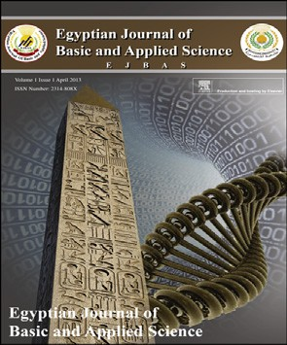Hepatoprotective effects of glycyrrhizin and omega-3 fatty acids on Nuclear Factor-kappa B pathway in thioacetamide-induced fibrosis in rats



*Nada F. Abo El-Magd* *a**,*\**, Amro El-Karef* *b**, Mamdouh M. El-Shishtawy* *a**,*

*Laila A. Eissa* *a**,*\*

a *Department of Biochemistry, Faculty of Pharmacy, Mansoura University, Mansoura 35516, Egypt*

b *Department of Pathology, Faculty of Medicine, Mansoura University, Mansoura 35516, Egypt*

## a r t i c l e i n f o

*Article history:*

Received 8 November 2014 Received in revised form 17 December 2014

Accepted 17 December 2014

Available online 15 January 2015

*Keywords:*

Liver fibrosis Glycyrrhizin

Omega-3 fatty acids NF-kB

MDA

## a b s t r a c t

Nuclear Factor kappa B (NF-kB) is a key transcriptional regulator that plays important roles in the pathogenesis of hepatic inflammation and fibrosis in chronic liver diseases. NF-kB activation leads to production of pro-inflammatory and fibrogenic cytokines. Glycyrrhizin (GL) is reported to suppress liver fibrosis and cirrhosis. Omega-3 fatty acids

(u-3) play an anti-inflammatory role and they are reported to decrease hepatic injury in

Thioacetamide (TAA) fibrotic model. We investigated the effects of GL and u-3 on liver inflammation and fibrosis in rats and clarified the effects of these natural compounds on NF-kB level. 50 male Wistar rats randomized to 5 groups: Control group and 4 groups received TAA 200 mg/kg i.p. twice weekly for 8 weeks: TAA group, GL group (received GL 25 mg/kg daily by oral tube), u-3 group (received u-3150 mg/kg daily by oral tube),

(GL + u-3) group (received similar combined doses of both natural compounds). GL and

u-3 alone or in combination protected the liver from TAA hepatotoxic effects as they

significantly decreased serum AST activity and serum total bilirubin level, they also significantly increased serum albumin and total protein levels. The hepatoprotective effects of GL and u-3 were confirmed by the histopathological analysis as they signifi-

cantly reduced the necroinflammatory scores and the extent of fibrosis. GL and u-3

significantly decreased liver malondialdehyde level (P < 0.005), liver NF-ƙB level (P < 0.005) and its tissue expression as detected by immunohistochemistry. In conclu- sion, glycyrrhizin and omega-3 fatty acids alone or in combination have potent anti- inflammatory, anti-oxidant and anti-fibrotic effects.

Copyright 2014, Mansoura University. Production and hosting by Elsevier B.V. This is an open access article under the CC BY-NC-ND license ([http://creativecommons.org/licenses/](http://creativecommons.org/licenses/by-nc-nd/4.„0/)

[by-nc-nd/4.0/](http://creativecommons.org/licenses/by-nc-nd/4.„0/)).

* *Corresponding authors*.

E-mail addresses: [Dr.nada.fawzy@gmail.com](mailto:Dr.nada.fawzy@gmail.com) (N.F. Abo El-Magd), [lailaeissa2002@yahoo.com](mailto:lailaeissa2002@yahoo.com) (L.A. Eissa).

Peer review under responsibility of Mansoura University. <http://dx.doi.org/10.1016/j.ejbas.2014.12.005>

2314-808X/Copyright 2014, Mansoura University. Production and hosting by Elsevier B.V. This is an open access article under the CC BY- NC-ND license ([http://creativecommons.org/licenses/by-nc-nd/4.0/](http://creativecommons.org/licenses/by-nc-nd/4.„0/)).

66 [e gypti an j o ur nal o f b a sic and a pp l i ed sci e n c e s 2 ( 201 5 ) 6 5](http://dx.doi.org/10.1016/j.ejbas.2014.12.005) e[7](http://dx.doi.org/10.1016/j.ejbas.2014.12.005) 4

# Introduction

Chronic liver diseases are an increasing cause of morbidity and mortality in more developed countries [1]. Most chronic liver diseases, including viral hepatitis (B and C), alcoholic liver disease, and biliary diseases, ultimately lead to liver fibrosis [2]. Liver fibrosis is the wound-healing response of the liver to many causes of chronic injury. Iterative liver injury causes inflammatory damage, matrix deposition, paren- chymal cell death and angiogenesis leading to progressive fibrosis. The scar matrix typically accumulates very slowly but once cirrhosis is established the potential for reversing this process is decreased and complications develop [3].

Without effective treatments at an early stage, reversible liver fibrosis will lead to irreversible cirrhosis and hepatocel- lular carcinoma (HCC) [4]. Supplementation with antioxidants which reduce oxidative stress is an effective strategy for pre- venting liver fibrosis [5]. The development of targeted thera- pies for the management and treatment of hepatitis requires a better knowledge of the immune response mechanisms involved in the pathogenesis of liver disease [6]. Anti-fibrotic therapies are emerging that can slow, halt or reverse fibrosis progression [3].

Glycyrrhizin (GL) is the main bioactive component of lico- rice root extract. GL is a glycosylated saponin composed of one molecule of glycyrrhetinic acid and two molecules of glucur- onic acid [7]. GL is reported to be used in chronic hepatitis resulted from different causes, such as viral infections, toxin exposure and ischemic-reperfusion injury [8]. GL has potent anti-inflammatory properties which thought to play a vital role in its hepatoprotective effects [9]. GL is reported to bind directly to high mobility group box 1 (HMGB1) so it decreases the HMGB1 concentration [10]. HMGB1 is a highly conserved protein released by injured or dying cells as a result for pathogenic products. HMGB1 plays a central role in the path- ogenesis of both sterile and infectious inflammation [11]. HMGB1 may trigger an inflammatory response via activation of TLR-4 (Toll like receptor-4) pathway which activates Nu- clear Factor-kappa B (NF-kB), so it enhances the production of tumor necrosis factor ɑ (TNF-ɑ), interleukine-1b (IL-1b) and nitric oxide [12]. Experimental strategies that selectively target HMGB1 effectively prevent activation of innate immunity and inflammation so protect different tissues against injury and damage [11].

Omega-3 fatty acids (u-3) such as eiocosapentaenoic acid

(EPA) and docosahexaenoic acid (DHA) are bioactive dietary compounds. Marine-derived food sources such as fatty fish, seaweed, shellfish, microalgae and krill are rich in u-3 [13,14]. u-3 supplements are reported to be used in hepatic injury and steatosis [15]. EPA and DHA protected against arachidonic acid produced pro-inflammatory molecules through conversion to less inflammatory mediators, so EPA and DHA have anti-

inflammatory effects [16]. u-3 are also reported to alter the production of inflammatory mediators such as chemokines, growth factors and matrix proteases [17].

Hepatitis is modulated by several mechanisms such as inflammatory signaling pathway and innate immunity response [18]. Inflammation produces by an innate host de- fense mechanism against infections and a variety of tissue

injuries. The inflammatory process passes through distinct stages, including acute, adaptive, and resolution, and more- over, inflammation may become a chronic condition as in autoimmune diseases [19]. The NF-kB system plays a vital role in regulating the innate immunity responses and cellular stress in different cell types [19,20]. NF-kB remains in the cytoplasm in unstimulated cells as a complex with inhibitory- kappaB proteins (I-kB) that prevent their translocation to the nucleus. During cell activation, I-kB is phosphorylated and dissocaited, which exposes the nuclear translocation sites of NF-kB leading to translocation of NF-kB to the nucleus and DNA binding [21,22]. NF-kB composes of p65/p50 heterodimers in macrophages and binds to the promoter region of various pro-inflamamatory genes leading to gene transactivation. NF- kB plays an important regulatory role in hepatic macrophage expression of pro-inflammatory mediators [22].

The aim of this study was to evaluate the potential hep- atoprotective effect of GL and u-3 alone or in combination

against TAA-induced liver fibrosis in rats, and to elucidate its underlying molecular mechanism through its effect on NF-kB and oxidative stress.

# Materials and methods

### *Drugs and chemicals*

Thioacetamide and Glycyrrhizin (Glycyrrihizic acid ammo- nium salt) from licorice (Glycyrrhiza Glabra) root (Sigma- eAldrich: Sigma, St. Louis, MO, USA). Omega-3 fatty acids containing EPA and DHA in a 3:2 ratio (Lifeplan: Elizabethan Way, Lutterworth, United Kingdom).

### *Animals*

Fifty Male SpragueeDawley rats weighing (180e200 g) were purchased from “Egyptian Organization for Biological Prod- ucts and Vaccines”, Giza, Egypt. Animals were housed and had free access to standard rat food and tap water for one week for acclimatization. The animal care and experiments described in this study were complied with “Research Ethics Commit- tee” Faculty of Pharmacy, Mansoura University, Egypt which are in accordance with “Principles of Laboratory Animal Care” (NIH publication No. 85-23, revised 1985).

### *Induction of liver fibrosis*

Liver fibrosis was induced according to the method of Esmat et al. [23] and Furtado et al. [24]. Fourty two male Sprague- Dawly rats were intraperitoneally (i.p.) injected with freshly prepared TAA (200 mg/kg of body weight) in 0.2 ml sterile saline twice weekly (days 2 and 6) for 8 consecutive weeks.

### *Experimental design*

Rats were distributed randomly to five groups: Control group (8 rats): injected i.p. with 0.2 ml sterile saline twice weekly (days 2 and 6) for 8 consecutive weeks, TAA group (12 rats): TAA-induced fibrotic group, GL group (10 rats): hepatic fibrosis treated with GL (25 mg/kg/day by oral tube dissolved in

[e g ypti an j o ur nal o f b a sic and a pp l i e d sci en c e s 2 ( 201 5 ) 6 5](http://dx.doi.org/10.1016/j.ejbas.2014.12.005) e[7](http://dx.doi.org/10.1016/j.ejbas.2014.12.005) 4 67

distilled water) [25] for 8 weeks started with TAA, u-3 group (10

tube) [26,27] for 8 weeks started with TAA, GL + u-3 group (10 rats): hepatic fibrosis treated with u-3 (150 mg/kg/day by oral rats): hepatic fibrosis treated with a combination of GL and u-3

(received similar doses) with TAA.

### *Collection of blood samples and liver tissues*

At the end of the experiment, rats were fasted for 12 h then 5 ml blood samples were taken from the retro-orbital punc- ture under light ether anesthesia. The clotted blood samples were centrifugated at 5000 rpm for 5 min for serum separa- tion. Serum was divided into aliquots for analysis. Animals were sacrificed and the liver dissected out, rinsed in ice-cold phosphate buffer saline (PBS) PH 7.4 and blotted dry on a fil- ter paper. A small part from right lobe of liver was cut and fixed in 10% phosphate-buffered formalin (pH 7.2) for histo- pathological examination. Part of the remaining liver tissues were homogenized in cold PBS then centrifuged at 5000 rpm for 15 min. The supernatant was removed for assay of malondialdehyde (MDA). While other part of the liver tissues were homogenized in cold PBS, with ultrasonic homogenizer then centrifuged at 5000 rpm for 15 min. The supernatant removed for assay of liver NF-kB. Serum samples and super-

natant from liver homogenates were stored at —80 ◦C for

biochemical analysis.

### *Biochemical analysis*

* + - Serum was used for determination of ALT, AST activities, serum total bilirubin, total protein and albumin levels

using commercial kits from Biodiagnostic (Cairo, Egypt).

* + - Liver tissue homogenate was used for assaying lipid per- oxidation by measuring MDA using commercial kit from

Biodiagnostic (Cairo, Egypt) and assaying Rat NF-kB using ELISA kit from Mybiosource (MBS722386) (San Diego, CA, USA).

### *Histopathological examination*

Phosphate-buffered formalin fixed liver tissues were embedded in paraffin, then they were cut into 4 mm thick sections and they were stained with hematoxylin and eosin

(H&E) and Masson's trichrome for histopathological examination.

### *Assessment of necroinflammatory activity grades*

Liver samples stained with (H&E) were assessed for total and individual activity parameters guided by Ishak's activity index [28]. Classified according to the following parameters: inter- face hepatitis (piecemeal necrosis) (P1eP4), confluent necrosis (C0eC5), focal lobular necrosis and degeneration (FN0eFN4),

and portal inflammation (PI1ePI4).

### *Quantification of fibrotic areas*

Quantitative analysis of collagen fiber deposition in Masson's trichrome stained liver tissues was performed by morphometric

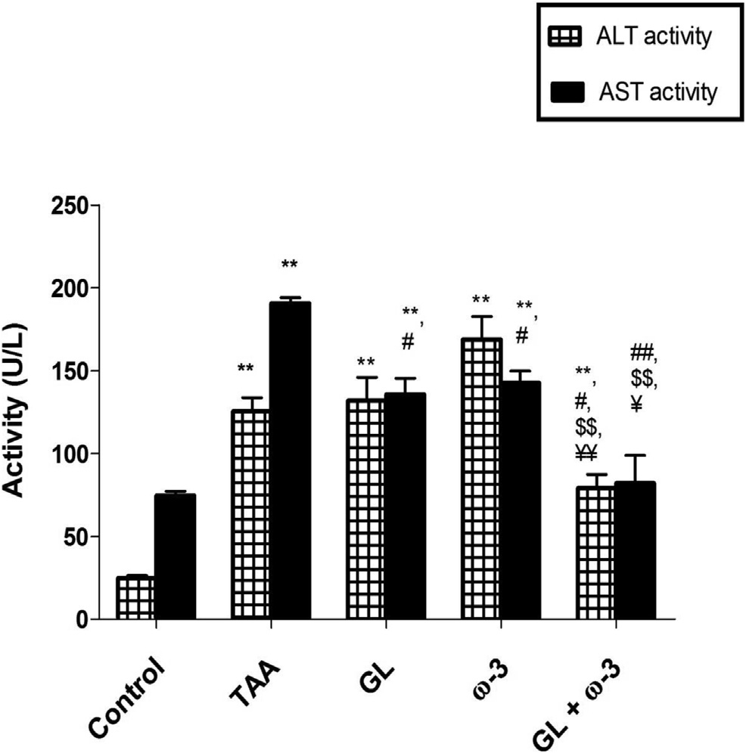

Fig. 1 e Effect of thioacetamide (TAA) (200 mg/kg twice weekly for 8 weeks), glycyrrhizin (GL) (25 mg/kg daily) and omega-3 fatty acids (u-3) (150 mg/kg daily) alone or in combination on serum ALT and AST activities. Values: (Mean ± SE). **P < 0.005 vs. Control group. #P < 0.05,

##P < 0.005 vs. TAA group. $$P < 0.005 vs. GL group.

¥P < 0.05, ¥¥P < 0.005 vs. u-3 group.

analysis [29]. Images were taken by a digital camera mounted on a BX51 Olympus optical microscope (Olympus Corporation, Tokyo, Japan). The NIH Image software was used for extraction and analyzing of collagenous areas stained with masson's tri-

chrome. The extent of fibrosis was expressed as the percentage

of fibrotic area relative to the total tissue area.

### *Immunohistochemical detection of NF-*k*B*

For immunohistochemistry, mouse NF-kB/65 Rabbit Poly- clonal Antibody antibodies (Thermo Fisher Scientific, CA, USA) were applied to deparaffinized and rehydrated sections. After removal of the unbound primary antibodies by rinsing with PBS, slides were incubated with secondary antibody. The analysis of antibody binding was performed with a dia- minobenzidine (DAB) kit, and hematoxylin was used as the counterstain. The slides were then observed by light micro- scopy. Expression of NF-kB was detected in the cytoplasm of liver tissue and inflammatory cells at the areas of inflamma- tion and fibrosis (according to manufacturer instructions). Expression in different groups was compared as regards to the distribution and intensity (compared to endothelium as an internal control) and distribution of positive areas.

### *Statistical analysis*

All the results were expressed as the mean ± Standard error (SE). One-way analysis of variance (ANOVA) followed by bonferroni test was used for analyzing statistically significant

68 [e gypti an j o ur nal o f b a sic and a pp l i ed sci e n c e s 2 ( 201 5 ) 6 5](http://dx.doi.org/10.1016/j.ejbas.2014.12.005) e[7](http://dx.doi.org/10.1016/j.ejbas.2014.12.005) 4

|  |  |  |  |  |  |
| --- | --- | --- | --- | --- | --- |
| Table 1 e Effect of thioacetamide (TAA) (200 mg/kg twice weekly for 8 weeks), glycyrrhizin (GL) (25 mg/kg), omega-3 fatty acids (u-3) (150 mg/kg) alone or in combination on serum total bilirubin, albumin and total protein levels. Values:  (Mean ± SE). | | | | | |
|  | Control | TAA | GL | u-3 | GL + u-3 |
| Number of animals Total bilirubin (mg/dl) Albumin (g/dL)  Total protein (g/dl) | 8 rats  0.158 ± 0.029  3.267 ± 0.070  7.101 ± 0.087 | 8 rats  0.964 ± 0.074**  2.593 ± 0.050**  5.648 ± 0.157** | 8 rats  0.184 ± 0.010##  3.045 ± 0.044##  6.541 ± 0.172# | 8 rats  0.228 ± 0.025##  3.027 ± 0.050##  6.616 ± 0.154# | 10 rats  0.208 ± 0.046##  3.258 ± 0.112##  7.200 ± 0.273## |
| *P < 0.05, **P < 0.005 vs. control group.  #P < 0.05, ##P < 0.005 vs. TAA group. | | | | | |

differences between groups. P values of less than 0.05 were considered significant. The analysis was carried out using Statistical Package for the Social Sciences (SPSS) version 18. Graphs were performed with GraphPad Prism V 5.02 (Graph- Pad Software Inc., San Diego, CA, USA).

# Results

### *Effect of GL and* u*-3 on liver function*

Thioacetamide produced liver fibrosis characterized by significant increase in serum ALT and AST activities

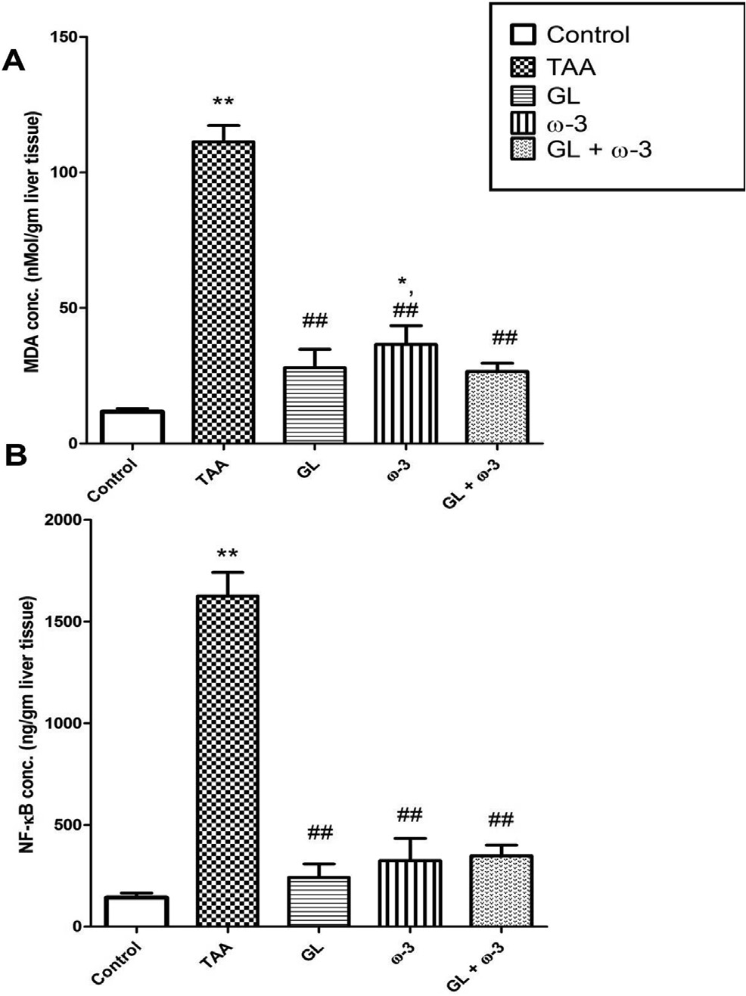

Fig. 2 e Effect of thioacetamide (TAA) (200 mg/kg twice weekly for 8 weeks), glycyrrhizin (GL) (25 mg/kg daily) and omega-3 fatty acids (u-3) (150 mg/kg daily) alone or in combination on (A) liver MDA level and (B) liver NF-kB level. Values: (Mean ± SE). **P < 0.005 vs. Control group.

##P < 0.005 vs. TAA group.

compared with control group (P < 0.005), while treatment with GL or u-3 had no significant change in ALT activity, but significantly decreased AST activity compared with TAA group (P < 0.05). Treatment with GL and u-3 combination

significantly decreased serum ALT and AST activities compared with TAA group (P < 0.05, P < 0.005), respectively, and significantly decreased serum ALT and AST activities compared with either GL or u-3 groups (P < 0.05), as shown in (Fig. 1).

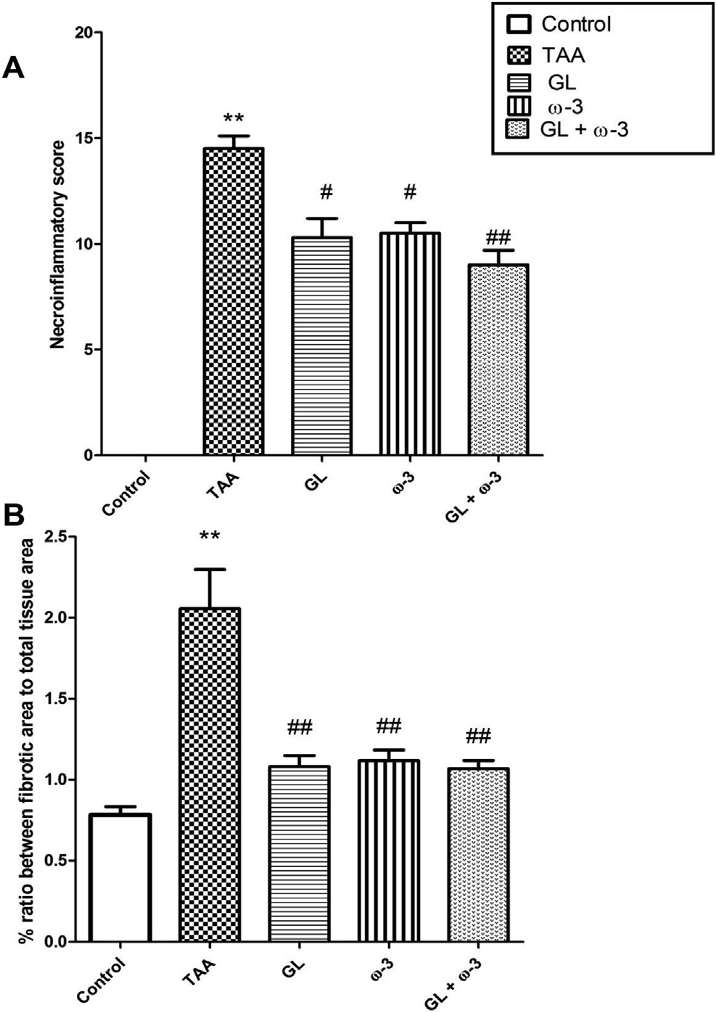

Fig. 3 e Effect of thioacetamide (TAA) (200 mg/kg twice weekly for 8 weeks), glycyrrhizin (GL) (25 mg/kg daily) and omega-3 fatty acids (u-3) (150 mg/kg daily) alone or in combination on (A) liver necroinflammatory score and (B) % ratio between fibrotic area to total tissue area. Values: (Mean ± SE). **P < 0.005 vs. Control group. #P < 0.05,

##P < 0.005 vs. TAA group.

[e g ypti an j o ur nal o f b a sic and a pp l i e d sci en c e s 2 ( 201 5 ) 6 5](http://dx.doi.org/10.1016/j.ejbas.2014.12.005) e[7](http://dx.doi.org/10.1016/j.ejbas.2014.12.005) 4 69

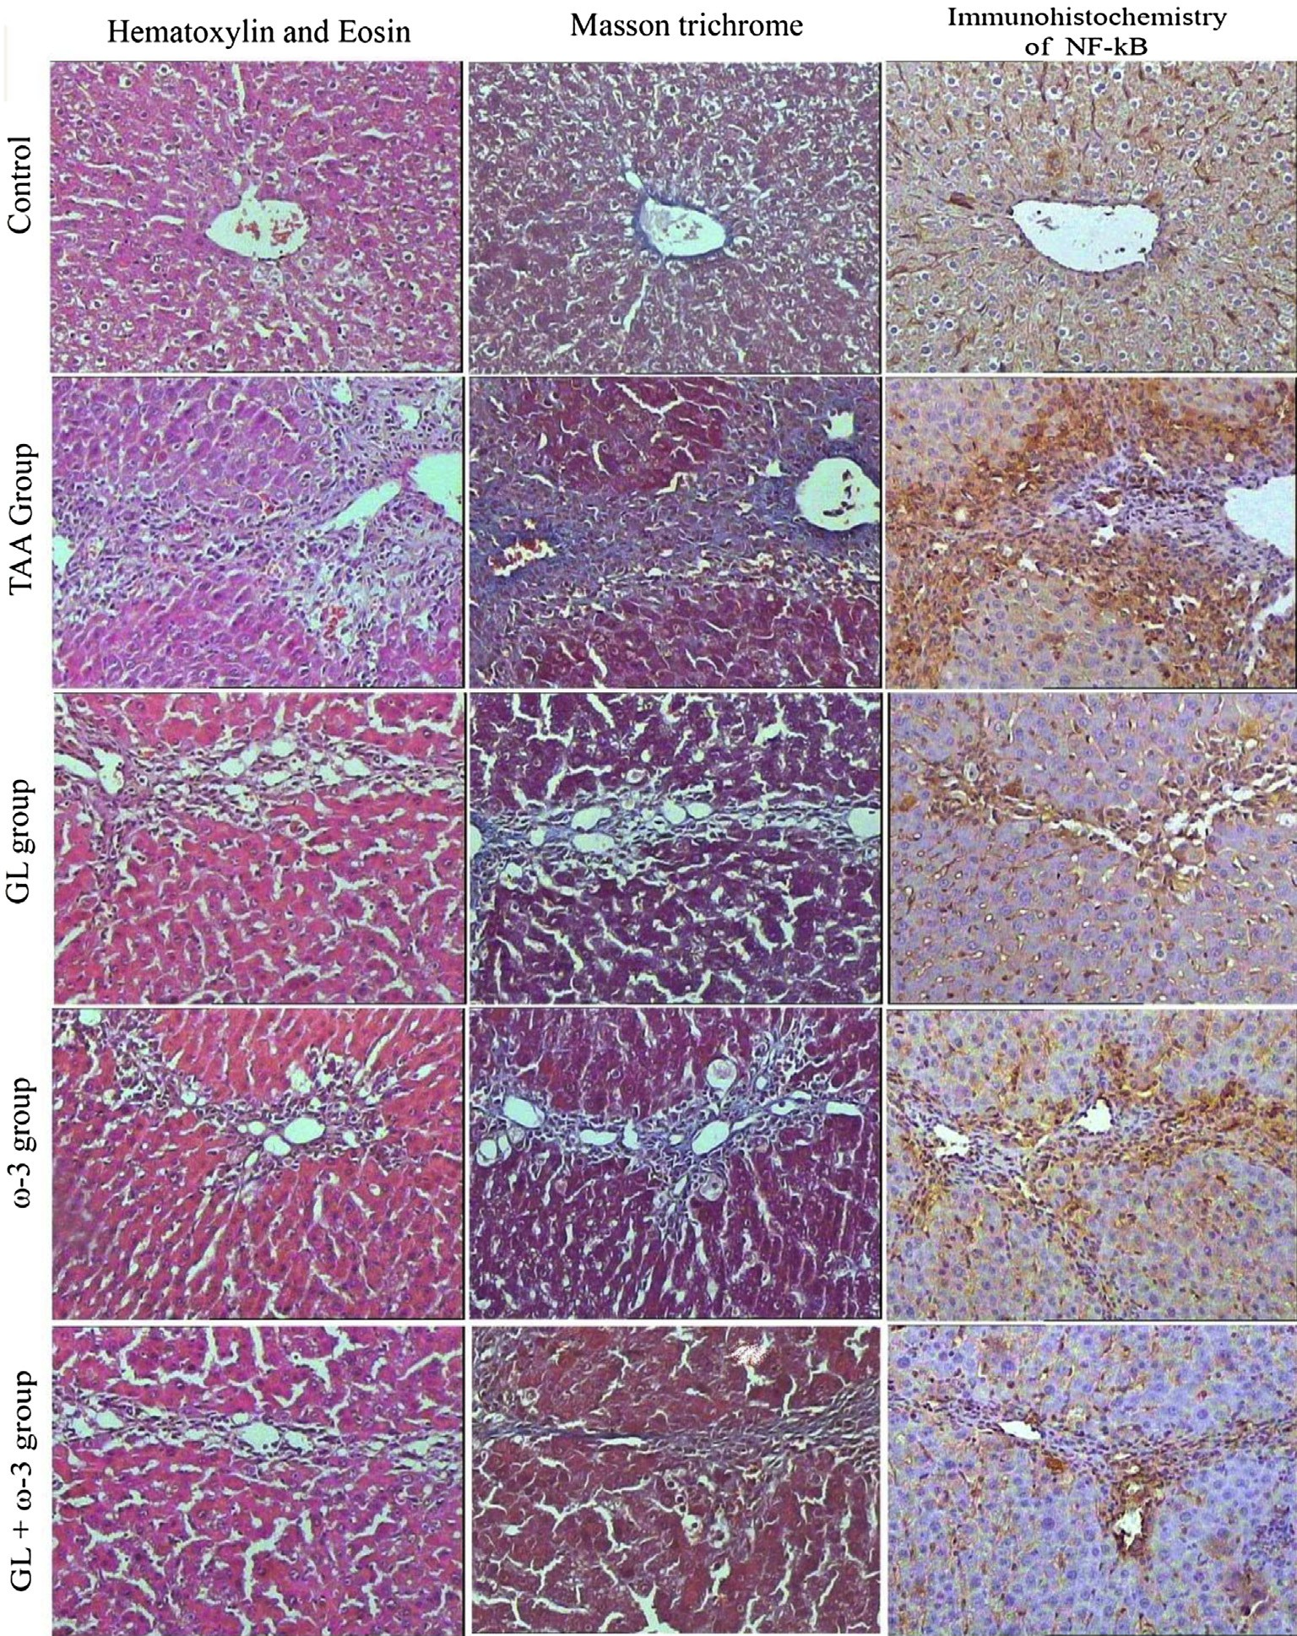

Fig. 4 e The left vertical panel showed marked necroinflammation in the TAA group that became reduced after combined treatment with (GL + u-3) more than single treatment (arrows around bridging necrosis). The middle panel showed increased collagen deposition in TAA group with its reduction after combined treatment (GL + u-3) more than single treatment (arrows around fibrous bridges). The right panel showed increased NF-kB expression colocalized at the same areas of necroinflammation and bridging fibrosis in TAA group with much reduced expression with combined treatment (GL + u-3) than single treatment. Thioacetamide (TAA), Glycyrrhizin (GL), Omega-3 fatty acids (u-3) and (GL + u-3) groups (magnification x100).

Thioacetamide also produced a highly significant in- crease in serum total bilirubin level compared with control group (P < 0.005).While treatment with GL and u-3 alone or

in combination produced highly significant decrease in

serum total bilirubin level compared with TAA group

GL, u-3 and GL + u-3 groups and the control group, as (P < 0.005) and there are no significant difference between shown in Table 1.

Thioacetamide affected the liver function significantly as it decreased the ability of liver to synthesize the albumin and other proteins as the serum levels of albumin and total protein

decreased significantly in TAA group compared with control group (P < 0.005). While treatment with GL and u-3 alone or in combination protected the liver as the serum levels of albu-

min and total protein increased significantly compared with TAA group (P < 0.005, P < 0.05), respectively and there are no

70 [e gypti an j o ur nal o f b a sic and a pp l i ed sci e n c e s 2 ( 201 5 ) 6 5](http://dx.doi.org/10.1016/j.ejbas.2014.12.005) e[7](http://dx.doi.org/10.1016/j.ejbas.2014.12.005) 4

|  |  |  |  |  |  |
| --- | --- | --- | --- | --- | --- |
| Table 2 e Correlational analysis of the studied parameters. | | | | | |
|  | AST activity | Total bilirubin level | Albumin level | Total protein level | Liver NF-kB level |
| AST activity (r) | 1 | 0.581a | —0.731a | —0.591a | 0.626a |
| Total bilirubin level (r) | 0.581a | 1 | —0.701a | —0.669a | 0.875a |
| Albumin level (r) | —0.731a | —0.701a | 1 | 0.594a | —0.685a |
| Total protein level (r) | —0.591a | —0.669a | 0.594a | 1 | —0.519a |
| Liver NF-kB level (r) | 0.626a | 0.875a | —0.685a | —0.519a | 1 |
| a Correlation is significant at P < 0.001 level. | | | | | |

significant difference between GL, u-3 and GL + u-3 groups and the control group, as shown in Table 1.

### *Effect of GL and* u*-3 on hepatic lipid peroxidation*

Thioacetamide caused a significant increase in hepatic MDA content in comparison to control group (P < 0.005), while treatment with GL and u-3 alone or in combination signifi- cantly decreased the elevated MDA levels compared with TAA

group (P < 0.005), as shown in (Fig. 2A).

### *Effect of GL and* u*-3 on hepatic NF-*k*B concentration*

Thioacetamide caused significant increase in the hepatic concentration of NF-kB compared with control group

(P < 0.005), while treatment with GL and u-3 alone or in combination highly significantly decreased NF-kB level compared with TAA group (P < 0.005) and there are no sig-

nificant difference between GL, u-3 and GL + u-3 groups and

the control group, as shown in (Fig. 2B).

### *Effect of GL and* u*-3 on hepatic necroinflammatory* activity

Examination of TAA group showed moderate to severe nec- roinflammatory activity with average scores of (14.5) with marked piecemeal necrosis, zone 3 necrosis and multiple portal central bridging necrosis, frequent apoptosis and focal inflammation with moderate and marked portal inflamma-

tion. Treatment with GL and u-3 alone or in combination

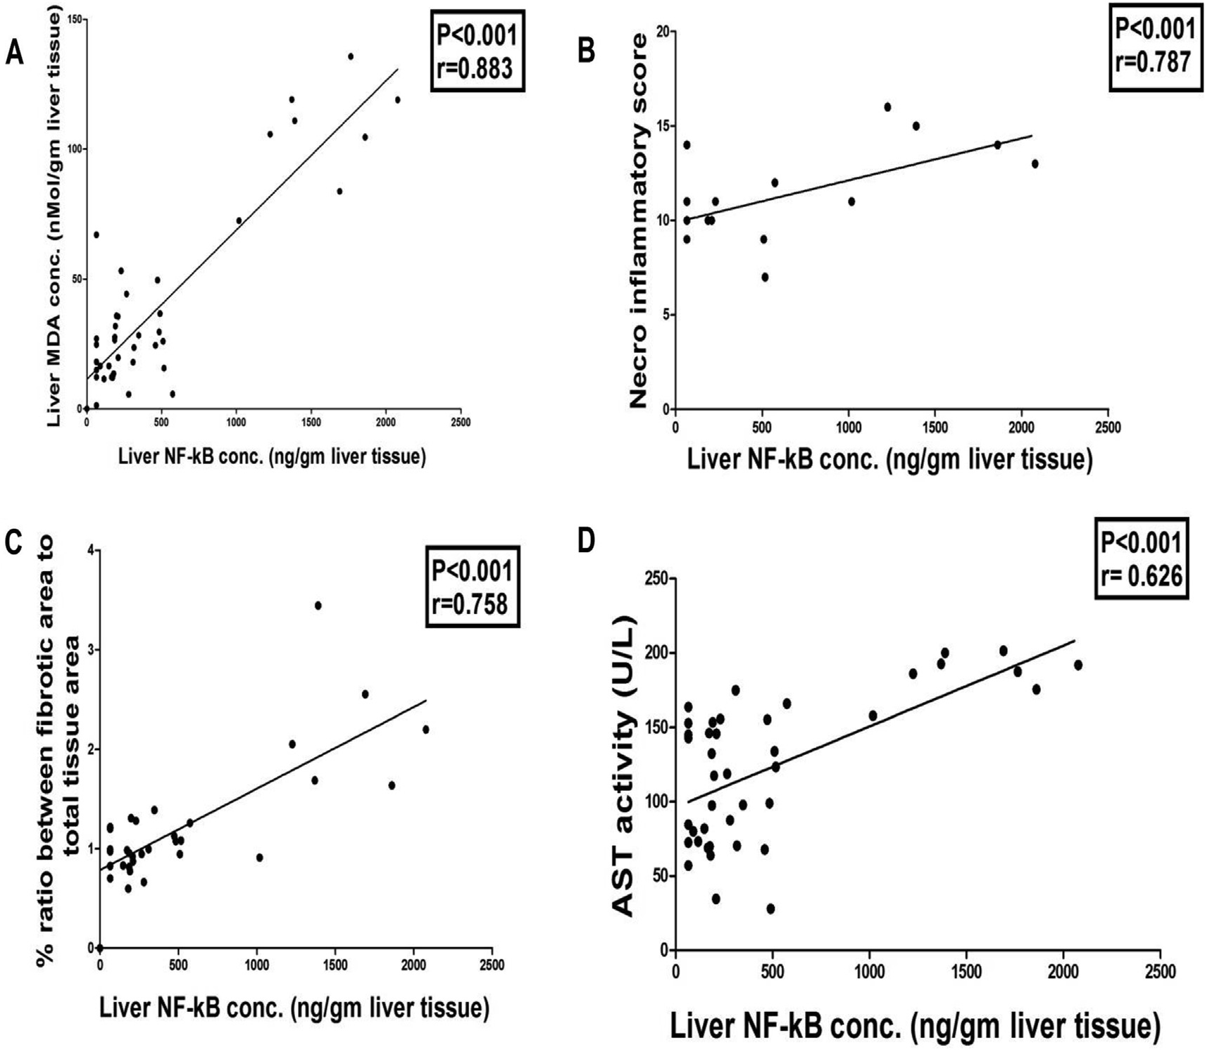

Fig. 5 e Positive correlation between liver NF-kB level and (A) Liver MDA level (r ¼ 0.883), (B) Liver necroinflammatory score (r ¼ 0.787), (C) Liver % ratio between fibrotic area to total tissue area (r ¼ 0.758) and (D) Serum AST activity (r ¼ 0.626).

[e g ypti an j o ur nal o f b a sic and a pp l i e d sci en c e s 2 ( 201 5 ) 6 5](http://dx.doi.org/10.1016/j.ejbas.2014.12.005) e[7](http://dx.doi.org/10.1016/j.ejbas.2014.12.005) 4 71

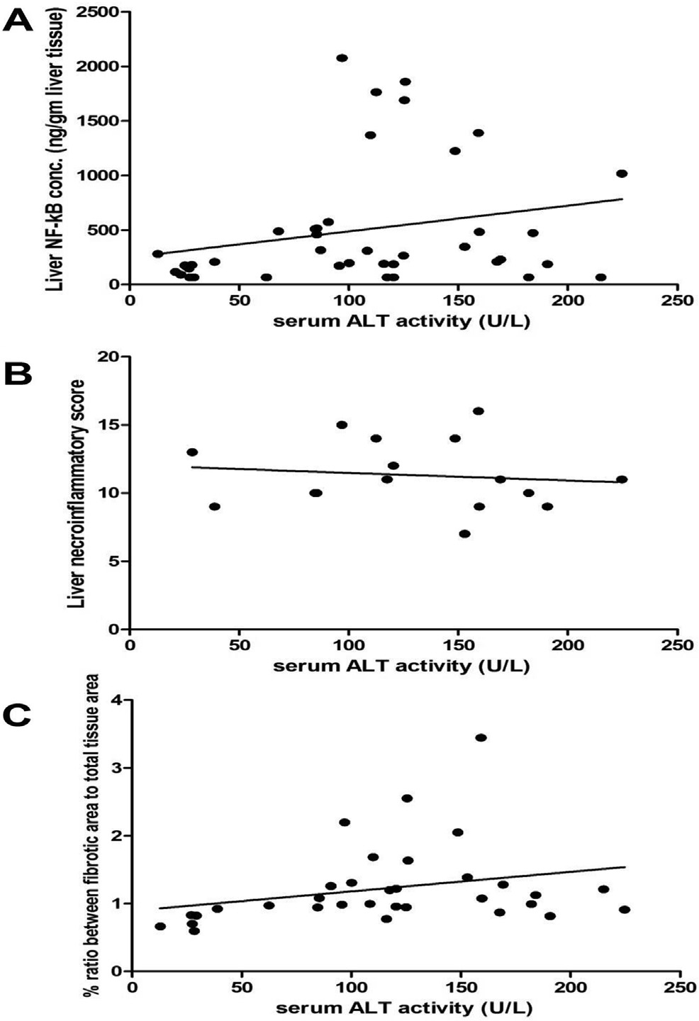

Fig. 6 e Non-significant positive correlations between serum ALT activity and (A) Liver NF-kB level (r ¼ 0.243), (B) Liver necroinflammatory score (r ¼ 0.228) and (C) Liver % ratio between fibrotic area to total tissue area (r ¼ 0.275).

increased necroinflammation and fibrosis, while expression of NF-kB was reduced in hepatic tissues treated with GL and u-

3 alone or in combination compared with TAA group (Fig. 4, right vertical panel).

### *3.7. The correlation analysis of studied parameters*

The data in Table 2 and Figs. 5 and 6 show the correlation analysis of all studied parameters. Liver NF-kB level positively correlated with liver MDA level (0.883, P < 0.001), liver nec- roinflammatory score (0.787, P < 0.001) and % ratio between fibrotic area to total tissue area (0.0758, P < 0.001), as shown in (Fig. 5). Also liver NF-kB level positively correlated with serum AST activity (0.626, P < 0.001) and serum total bilirubin level

albumin level (—0.685, P < 0.001) and serum total protein level (0.875, P < 0.001). NF-kB level negatively correlated with serum (—0.519, P < 0.001), as shown in Table 2. Serum ALT activity

had non-significant positive correlation with liver NF-kB level

(0.243), liver necroinflammatory score (0.228) and liver % ratio between fibrotic area to total tissue area (0.275) as shown in (Fig. 6).

# Discussion

Liver fibrosis is considered as the main complication of chronic liver diseases and a range of chronic inflammatory diseases [2]. Chronic inflammation is followed by accumula- tion of collagen which resulted from a cascade of events that involves cytokines produced by both liver resident cells and circulating immune cells. These inflammatory stimuli cause activation of quiescent hepatic stellate cells (HSCs) to myofi- broblast like cells to produce collagen [30,31]. When hepatic fibrosis occurs, collagen (mainly types 1 and 3) proliferation accounts for 50% of the total protein in fibrotic liver [32]. With

ongoing injury, fibrosis develops to bridging fibrosis with

nodule formation which ends with cirrhosis and HCC. So, initial prevention of liver fibrosis is a critical strategy for

significantly protected the liver from hepatotoxic effects of TAA reflected by reduction of necroinflammation to (10.3) (p < 0.05), (10.5) (p < 0.05) and (9) (p < 0.005), respectively and

GL + u-3 groups and the control group, as shown in (Fig. 3A there are no significant difference between GL, u-3 and and Fig. 4, left vertical panel).

### *Effect of GL and* u*-3 on hepatic fibrosis*

Thioacetamide increased amount of collagen deposition in liver tissue stained with Masson's trichrome significantly, while treatment with GL and u-3 alone or in combination significantly protected the liver from this increase (P < 0.005) and there are no significant difference between GL, u-3 and

GL + u-3 groups and the control group. So GL and u-3 alone or

in combination decreased the fibrotic areas and collagen

content significantly (Fig. 3B and Fig. 4, middle vertical panel).

### *Expression of NF-*k*B*

Expression of NF-kB was increased in hepatic tissues of rats injected with TAA that colocalized at the same areas of

curing chronic liver diseases [31].

In our study, TAA intoxication caused an intense oxidative stress as evident by the dramatic increase in the hepatic MDA level. MDA is a toxic product of peroxidation of biological membrane polyunsaturated fatty acids. Therefore the mea- surement of MDA is used as an indicator of oxidative stress [33]. TAA is a potent hepatotoxin, so it is used in producing hepatic injury showed lesions similar to those seen in most cases of human liver disease. TAA causes cytotoxic injury through a two-step bioactivation mediated by the microsomal cytochrome P450 isozyme E1 and/or flavin-containing mono- oxygenase systems. TAA converts to TAA-sulfoxide and further to a reactive metabolite, TAA-S, S-dioxide, which responsible for lipid peroxidation at the plasma membrane level [34].

Glycyrrhizin and u-3 alone or in combination protected the

liver from the oxidative stress caused by TAA as they decreased significantly the elevated liver MDA. GL and u-3 act as scavengers of free radicals, so they decrease the oxidative stress. A decrease of lipid peroxidation mediated oxidative stress may be a potential and effective strategy for the pre- vention and treatment of hepatic failure [35].

72 [e gypti an j o ur nal o f b a sic and a pp l i ed sci e n c e s 2 ( 201 5 ) 6 5](http://dx.doi.org/10.1016/j.ejbas.2014.12.005) e[7](http://dx.doi.org/10.1016/j.ejbas.2014.12.005) 4

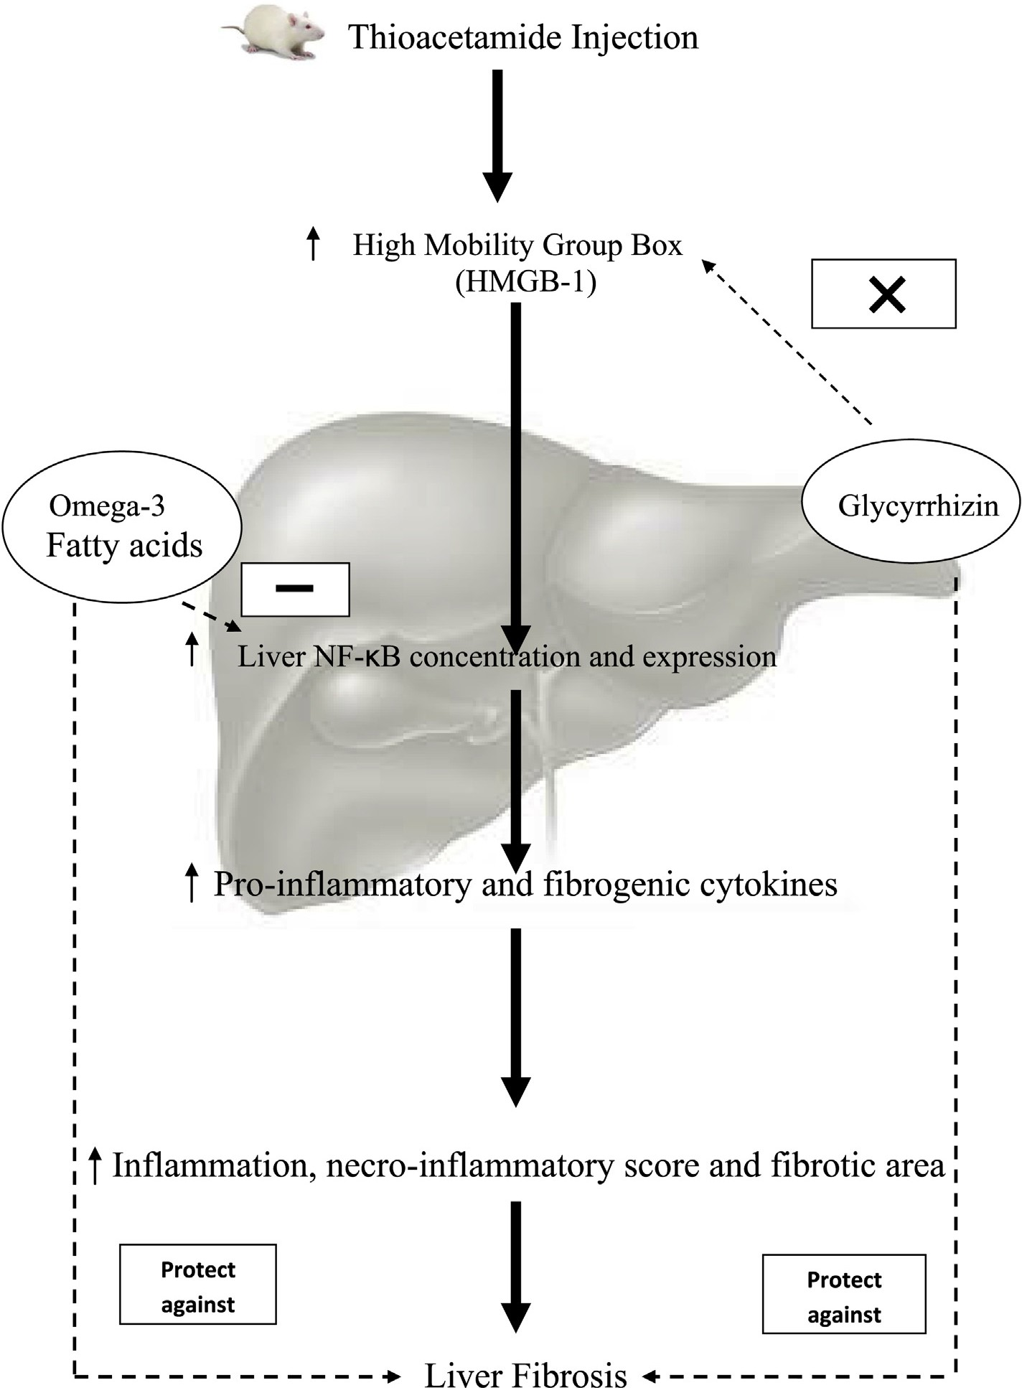

Fig. 7 e The proposed hepatoprotective mechanism of glycyrrhizin and omega-3 fatty acids in thioacetamide-induced fibrosis in rats.

Thioacetamide-induced hepatotoxic effects characterized by piecemeal necrosis, confluent necrosis, focal lytic necrosis, apoptosis, focal inflammation and portal inflammation at the tissue levels which reflected in our study by significant eleva- tion of serum liver enzymes and bilirubin as well as increased

collagen deposition and fibrotic areas significantly. GL and u-3

alone or in combination protected liver from this inflammation at tissue level which is reflected by significant increased serum AST activity and serum bilirubin level, and decreased collagen and fibrotic areas. These are evidence for the hepatoprotective effect of GL and u-3 alone or in combination.

Glycyrrhizinand u-3 groupsshowednosignificantchange in ALT activities compared with TAA group. Also, there is no sig- nificant correlation between ALT activity and both liver fibrosis

and liver necroinflammatory score. These may be explained as enzyme activity does not reflect the severity of fibrosis and there is no significant correlation between serum ALT activity and histological activity [36]. In accordance to these results, our observations indicated that: a decreased ALT activity in TAA group may be a result of massive necrosis and late stage of

fibrosis, while decreased ALT activity in GL and u-3 groups may

be due to recovery, as decreasing ALT activity in hepatic injury occur both with recovery and with massive necrosis [36,37].

We found that TAA caused a significant increase in liver NF-kB concentration. GL, u-3 and their combination prevented

the increase in liver NF-kB concentration. So GL, u-3 and their combination have a hepatoprotective effect through blocking NF-kB pathway, since NF-kB plays a regulatory role in liver

[e g ypti an j o ur nal o f b a sic and a pp l i e d sci en c e s 2 ( 201 5 ) 6 5](http://dx.doi.org/10.1016/j.ejbas.2014.12.005) e[7](http://dx.doi.org/10.1016/j.ejbas.2014.12.005) 4 73

fibrosis and inflammation. NF-kB modulates hepatic fibro- genesis predominantly in three different cellular compart- ments by: (A) Regulating hepatocyte injury, the primary trigger of fibrogenic responses in the liver; (B) Regulating in- flammatory signals elicited in macrophages and other in- flammatory cells in the liver and (C) Regulating fibrogenic responses in HSCs [38].

Our results indicated positive correlations between liver NF-kB level and both liver necroinflammatory score and liver collagen deposition. So we suggested that NF-kB has a critical role in the pathogenesis of fibrosis and necroinflammation development in liver. NF-kB increased significantly in TAA

group, while the treatment with GL, u-3 or their combination

prevented the increase in NF-kB, so they prevented the development of liver fibrosis and necroinflammation. We also found a positive correlation between liver NF-kB level and lipid peroxidation, so oxidative stress has a positive effective role in liver inflammation and fibrosis in TAA group. The anti- oxidant properties of GL and u-3 have also an effective role as anti-inflammatory and anti-fibrotic.

Glycyrrhizin has a variety of pharmacologic effects such as anti-inflammatory, antiviral, antioxidant, immunomodula- tory, hepatoprotective and cardioprotective activities [39]. We

found that GL and u-3 have dramatic effects on NF-kB and

MDA, as they significantly decreased when compared with TAA group. These results may confirm the anti-inflammatory, anti-fibrotic and anti-oxidant effects of either GL or u-3. Studies supposed that GL binded to HMGB1 directly to sup- press HMGB1-induced injury, inhibit TLR-4 pathway, lower NF-kB concentration and inhibit the production of inflam- matory cytokines [40](#_bookmark46)e[42]. u-3 reduced the inflammation by lowering NF-kB concentration. Lowering NF-kB inhibited the production of inflammatory cytokines including TNF-a and IL- 1b, reduced arachidonic acidederived eicosanoids and pro-

tected against oxidative stress [43,44]. Studies found that u-3 decrease the production of inflammatory proteins which may be mediated by altered activation of key transcription factors in regulating inflammatory gene expression, such as NF-kB

and peroxisome proliferator activated receptors  (PPAR-). Both NF-kB and PPAR- may be regulated by u-3 [17,43].

Fig. 7 indicates our proposed hepatoprotective mecha- nisms of GL and u-3 in TAA-induced fibrosis in rats. GL pro-

tected the liver from TAA-toxic effects through decreasing liver NF-kB level which indicated the blocking HMGB1. It also decreased the lipid peroxidation. Also, u-3 decreased NF-kB

level and the lipid peroxidation so they protected the liver from TAA-toxic effects.

We found that GL, u-3 and their combination have high

protection potency against liver fibrosis as they decrease the collagen deposition, fibrotic areas, oxidative stress, NF-kB level and tissue expression, pro-inflammatory cytokines and fibrogenic cytokines. We also found that the protection po- tency of either GL or u-3 alone is the same as their combina- tion against liver fibrosis.

# Conclusions

The results of the current study supported the potential role of NF-kB in liver fibrosis and demonstrated that the

hepatoprotective effect of glycyrrhizin and omega-3 fatty acids alone or in combination against liver fibrosis as they decreased both the fibrotic areas and the necroinflammatory scores. The mechanism behind hepatoprotective effects of glycyrrhizin and omega-3 fatty acids included suppression of oxidative stress and Inhibition of NF-kB. So the hepatoprotective effects of glycyrrhizin, omega-3 fatty acids and their combination against TAA-induced fibrosis appear to be mediated via its antioxidant, anti-inflammatory and anti-fibrotic properties. We advise to fulfill some clinical studies on these natural compounds as nutrient to protect against liver fibrosis.

## references

1. [Lozano R, Naghavi M, Foreman K, Lim S, Shibuya K,](http://refhub.elsevier.com/S2314-808X(14)00060-8/sref1) [Aboyans V, et al. Global and regional mortality from 235](http://refhub.elsevier.com/S2314-808X(14)00060-8/sref1) [causes of death for 20 age groups in 1990 and 2010: a](http://refhub.elsevier.com/S2314-808X(14)00060-8/sref1) [systematic analysis for the Global Burden of Disease Study.](http://refhub.elsevier.com/S2314-808X(14)00060-8/sref1) [Lancet 2010;2012(380):2095](http://refhub.elsevier.com/S2314-808X(14)00060-8/sref1)e[128](http://refhub.elsevier.com/S2314-808X(14)00060-8/sref1).
2. [Hernandez-Gea V, Friedman SL. Pathogenesis of liver](http://refhub.elsevier.com/S2314-808X(14)00060-8/sref2) [fibrosis. Annu Rev Pathol 2011;6:425](http://refhub.elsevier.com/S2314-808X(14)00060-8/sref2)e[56](http://refhub.elsevier.com/S2314-808X(14)00060-8/sref2).
3. [Pellicoro A, Ramachandran P, Iredale JP, Fallowfield JA. Liver](http://refhub.elsevier.com/S2314-808X(14)00060-8/sref3) [fibrosis and repair: immune regulation of wound healing in a](http://refhub.elsevier.com/S2314-808X(14)00060-8/sref3) [solid organ. Nat Rev Immunol 2014;14:181](http://refhub.elsevier.com/S2314-808X(14)00060-8/sref3)e[94](http://refhub.elsevier.com/S2314-808X(14)00060-8/sref3).
4. [Bataller R, Brenner DA. Liver fibrosis. J Clin Invest](http://refhub.elsevier.com/S2314-808X(14)00060-8/sref4) [2005;115:209](http://refhub.elsevier.com/S2314-808X(14)00060-8/sref4)e[18](http://refhub.elsevier.com/S2314-808X(14)00060-8/sref4).
5. [Gebhardt R. Oxidative stress, plant-derived antioxidants and](http://refhub.elsevier.com/S2314-808X(14)00060-8/sref5) [liver fibrosis. Planta Med 2002;68:289](http://refhub.elsevier.com/S2314-808X(14)00060-8/sref5)e[96](http://refhub.elsevier.com/S2314-808X(14)00060-8/sref5).
6. [Lavanchy D. Chronic viral hepatitis as a public health issue](http://refhub.elsevier.com/S2314-808X(14)00060-8/sref6) [in the world. Best Pract Res Clin Gastroenterol](http://refhub.elsevier.com/S2314-808X(14)00060-8/sref6) [2008;22:991](http://refhub.elsevier.com/S2314-808X(14)00060-8/sref6)e[1008](http://refhub.elsevier.com/S2314-808X(14)00060-8/sref6).
7. [Tolstikov GA, Baltina LA, Shul'ts EE, Pokrovskił AG.](http://refhub.elsevier.com/S2314-808X(14)00060-8/sref7)

[Glycyrrhizic acid. Bioorg Khim 1997;23:691](http://refhub.elsevier.com/S2314-808X(14)00060-8/sref7)e[709](http://refhub.elsevier.com/S2314-808X(14)00060-8/sref7).

1. [Del Prete A, Scalera A, Iadevaia MD, Miranda A, Zulli C,](http://refhub.elsevier.com/S2314-808X(14)00060-8/sref8) [Gaeta L, et al. Herbal products: benefits, limits, and](http://refhub.elsevier.com/S2314-808X(14)00060-8/sref8) [applications in chronic liver disease. Evid Based Compl](http://refhub.elsevier.com/S2314-808X(14)00060-8/sref8) [Altern Med 2012;2012:837939](http://refhub.elsevier.com/S2314-808X(14)00060-8/sref8).
2. [Kimura M, Moro T, Motegi H, Maruyama H, Sekine M,](http://refhub.elsevier.com/S2314-808X(14)00060-8/sref9) [Okamoto H, et al. In vivo glycyrrhizin accelerates liver](http://refhub.elsevier.com/S2314-808X(14)00060-8/sref9) [regeneration and rapidly lowers serum transaminase](http://refhub.elsevier.com/S2314-808X(14)00060-8/sref9) [activities in 70% partially hepatectomized rats. Eur J](http://refhub.elsevier.com/S2314-808X(14)00060-8/sref9) [Pharmacol 2008;579:357](http://refhub.elsevier.com/S2314-808X(14)00060-8/sref9)e[64](http://refhub.elsevier.com/S2314-808X(14)00060-8/sref9).
3. [Sitia G, Iannacone M, Mu¨ ller S, Bianchi ME, Guidotti LG.](http://refhub.elsevier.com/S2314-808X(14)00060-8/sref10) [TreatmentwithHMGB1 inhibitorsdiminishesCTL-inducedliver](http://refhub.elsevier.com/S2314-808X(14)00060-8/sref10) [disease in HBV transgenic mice. J Leukoc Biol 2007;81:100](http://refhub.elsevier.com/S2314-808X(14)00060-8/sref10)e[7](http://refhub.elsevier.com/S2314-808X(14)00060-8/sref10).
4. [Andersson U, Tracey KJ. HMGB1 is a therapeutic target for](http://refhub.elsevier.com/S2314-808X(14)00060-8/sref11) [sterile inflammation and infection. Annu Rev Immunol](http://refhub.elsevier.com/S2314-808X(14)00060-8/sref11) [2011;29:139](http://refhub.elsevier.com/S2314-808X(14)00060-8/sref11)e[62](http://refhub.elsevier.com/S2314-808X(14)00060-8/sref11).
5. [Bianchi ME. HMGB1 loves company. J Leukoc Biol](http://refhub.elsevier.com/S2314-808X(14)00060-8/sref12) [2009;86:573](http://refhub.elsevier.com/S2314-808X(14)00060-8/sref12)e[6](http://refhub.elsevier.com/S2314-808X(14)00060-8/sref12).
6. [Kromhout D, de Goede J. Update on cardiometabolic health](http://refhub.elsevier.com/S2314-808X(14)00060-8/sref13) [effects of omega-3 fatty acids. Curr Opin Lipidol](http://refhub.elsevier.com/S2314-808X(14)00060-8/sref13) [2014;25:85](http://refhub.elsevier.com/S2314-808X(14)00060-8/sref13)e[90](http://refhub.elsevier.com/S2314-808X(14)00060-8/sref13).
7. [Lorente-Cebrian S, Costa AG, Navas-Carretero S, Zabala M,](http://refhub.elsevier.com/S2314-808X(14)00060-8/sref14) [Martinez JA, Moreno-Aliaga MJ. Role of omega-3 fatty acids in](http://refhub.elsevier.com/S2314-808X(14)00060-8/sref14) [obesity, metabolic syndrome, and cardiovascular diseases: a](http://refhub.elsevier.com/S2314-808X(14)00060-8/sref14) [review of the evidence. J Physiol Biochem 2013;69:633](http://refhub.elsevier.com/S2314-808X(14)00060-8/sref14)e[51](http://refhub.elsevier.com/S2314-808X(14)00060-8/sref14).
8. [Marsman HA, de Graaf W, Heger M, van Golen RF, Ten](http://refhub.elsevier.com/S2314-808X(14)00060-8/sref15)

[Kate FJ, Bennink R, et al. Hepatic regeneration and functional](http://refhub.elsevier.com/S2314-808X(14)00060-8/sref15) [recovery following partial liver resection in an experimental](http://refhub.elsevier.com/S2314-808X(14)00060-8/sref15) [model of hepatic steatosis treated with omega-3 fatty acids.](http://refhub.elsevier.com/S2314-808X(14)00060-8/sref15) [Br J Surg 2013;100:674](http://refhub.elsevier.com/S2314-808X(14)00060-8/sref15)e[83](http://refhub.elsevier.com/S2314-808X(14)00060-8/sref15).

1. [Larsen R, Eilertsen KE, Elvevoll EO. Health benefits of marine](http://refhub.elsevier.com/S2314-808X(14)00060-8/sref16) [foods and ingredients. Biotechnol Adv 2011;29:508](http://refhub.elsevier.com/S2314-808X(14)00060-8/sref16)e[18](http://refhub.elsevier.com/S2314-808X(14)00060-8/sref16).

74 [e gypti an j o ur nal o f b a sic and a pp l i ed sci e n c e s 2 ( 201 5 ) 6 5](http://dx.doi.org/10.1016/j.ejbas.2014.12.005) e[7](http://dx.doi.org/10.1016/j.ejbas.2014.12.005) 4

1. [Calder PC. Omega-3 fatty acids and inflammatory processes.](http://refhub.elsevier.com/S2314-808X(14)00060-8/sref17) [Nutrients 2010;2:355](http://refhub.elsevier.com/S2314-808X(14)00060-8/sref17)e[74](http://refhub.elsevier.com/S2314-808X(14)00060-8/sref17).
2. [Ajuebor MN, Carey JA, Swain MG. CCR5 in T cell-mediated](http://refhub.elsevier.com/S2314-808X(14)00060-8/sref18) [liver diseases: what's going on? J Immunol 2006;177:2039](http://refhub.elsevier.com/S2314-808X(14)00060-8/sref18)e[45](http://refhub.elsevier.com/S2314-808X(14)00060-8/sref18).
3. [Vallabhapurapu S, Karin M. Regulation and function of NF-kB](http://refhub.elsevier.com/S2314-808X(14)00060-8/sref19)

[transcription factors in the immune system. Annu Rev](http://refhub.elsevier.com/S2314-808X(14)00060-8/sref19) [Immunol 2009;27:693](http://refhub.elsevier.com/S2314-808X(14)00060-8/sref19)e[733](http://refhub.elsevier.com/S2314-808X(14)00060-8/sref19).

1. [Ghosh S. Regulation of inducible gene expression by the](http://refhub.elsevier.com/S2314-808X(14)00060-8/sref20) [transcription factor NF-kappaB. Immunol Res 1999;19:183](http://refhub.elsevier.com/S2314-808X(14)00060-8/sref20)e[9](http://refhub.elsevier.com/S2314-808X(14)00060-8/sref20).
2. [Baldwin AS. The NF-kB and IkB proteins: new discoveries and](http://refhub.elsevier.com/S2314-808X(14)00060-8/sref21) [insights. Annu Rev Immunol 1996;14:649](http://refhub.elsevier.com/S2314-808X(14)00060-8/sref21)e[81](http://refhub.elsevier.com/S2314-808X(14)00060-8/sref21).
3. [Mandrekar P, Szabo G. Signalling pathways in alcohol-](http://refhub.elsevier.com/S2314-808X(14)00060-8/sref22) [induced liver inflammation. J Hepatol 2009;5:1258](http://refhub.elsevier.com/S2314-808X(14)00060-8/sref22)e[66](http://refhub.elsevier.com/S2314-808X(14)00060-8/sref22).
4. [Esmat AY, Said MM, Soliman AA, El-Masry KS, Badiea EA.](http://refhub.elsevier.com/S2314-808X(14)00060-8/sref23) [Bioactive compounds, antioxidant potential, and](http://refhub.elsevier.com/S2314-808X(14)00060-8/sref23) [hepatoprotective activity of sea cucumber (Holothuriaatra)](http://refhub.elsevier.com/S2314-808X(14)00060-8/sref23) [against thioacetamide intoxication in rats. Nutrition](http://refhub.elsevier.com/S2314-808X(14)00060-8/sref23) [2013;29:258](http://refhub.elsevier.com/S2314-808X(14)00060-8/sref23)e[67](http://refhub.elsevier.com/S2314-808X(14)00060-8/sref23).
5. [Furtado KS, Prado MG, Aguiar E, Silva MA, Dias MC,](http://refhub.elsevier.com/S2314-808X(14)00060-8/sref24)

[Rivelli DP, et al. Coffee and caffeine protect against liver](http://refhub.elsevier.com/S2314-808X(14)00060-8/sref24) [injury induced by thioacetamide in male wistar rats. Basic](http://refhub.elsevier.com/S2314-808X(14)00060-8/sref24) [Clin Pharmacol Toxicol 2012;111:339](http://refhub.elsevier.com/S2314-808X(14)00060-8/sref24)e[47](http://refhub.elsevier.com/S2314-808X(14)00060-8/sref24).

1. [Zhao J, Wan X, Luo M, Chen T, He P. Antifibrotic effects of](http://refhub.elsevier.com/S2314-808X(14)00060-8/sref25) [glycyrrhizin and matrine in vitro and in vivo. Biomed Prev](http://refhub.elsevier.com/S2314-808X(14)00060-8/sref25) [Nutr 2012;2:132](http://refhub.elsevier.com/S2314-808X(14)00060-8/sref25)e[7](http://refhub.elsevier.com/S2314-808X(14)00060-8/sref25).
2. [Shaaban AA, Shaker ME, Zalata KR, El-kashef HA,](http://refhub.elsevier.com/S2314-808X(14)00060-8/sref26)

[Ibrahim TM. Modulation of carbon tetrachloride-induced](http://refhub.elsevier.com/S2314-808X(14)00060-8/sref26) [hepatic oxidative stress, injury and fibrosis by olmesartan](http://refhub.elsevier.com/S2314-808X(14)00060-8/sref26) [and omega-3. Chem Biol Interact 2014;207:81](http://refhub.elsevier.com/S2314-808X(14)00060-8/sref26)e[91](http://refhub.elsevier.com/S2314-808X(14)00060-8/sref26).

1. [Yokoyama M, Origasa H, Matsuzaki M, Matsuzawa Y, Saito Y,](http://refhub.elsevier.com/S2314-808X(14)00060-8/sref27) [Ishikawa Y, et al. Effects of eicosapentaenoic acid on major](http://refhub.elsevier.com/S2314-808X(14)00060-8/sref27) [coronary events in hypercholesterolaemic patients (JELIS): a](http://refhub.elsevier.com/S2314-808X(14)00060-8/sref27) [randomised open-label, blinded endpoint analysis. Lancet](http://refhub.elsevier.com/S2314-808X(14)00060-8/sref27) [2007;369:1090](http://refhub.elsevier.com/S2314-808X(14)00060-8/sref27)e[8](http://refhub.elsevier.com/S2314-808X(14)00060-8/sref27).
2. [Ishak KG, Bapitesta A, Bianchi L, Callea F, DeGroote J,](http://refhub.elsevier.com/S2314-808X(14)00060-8/sref28) [Gudat F, et al. Histological grading and staging of chronic](http://refhub.elsevier.com/S2314-808X(14)00060-8/sref28) [hepatitis. J Hepatol 1995;22:696](http://refhub.elsevier.com/S2314-808X(14)00060-8/sref28)e[9](http://refhub.elsevier.com/S2314-808X(14)00060-8/sref28).
3. [James J, Bosch KS, Aronson DC, Houtkooper JM. Sirius red](http://refhub.elsevier.com/S2314-808X(14)00060-8/sref29) [histophotometry and spectrophotometry of sections in the](http://refhub.elsevier.com/S2314-808X(14)00060-8/sref29) [assessment of the collagen content of liver tissue and its](http://refhub.elsevier.com/S2314-808X(14)00060-8/sref29) [application in growing rat liver. Liver 1990;10:1](http://refhub.elsevier.com/S2314-808X(14)00060-8/sref29)e[5](http://refhub.elsevier.com/S2314-808X(14)00060-8/sref29).
4. [Schuppan D, Gorrell MD, Klein T, Mark M, Afdhal NH. The](http://refhub.elsevier.com/S2314-808X(14)00060-8/sref30) [challenge of developing novel pharmacological therapies for](http://refhub.elsevier.com/S2314-808X(14)00060-8/sref30) [non-alcoholic steatohepatitis. Liver Int 2010;30:795](http://refhub.elsevier.com/S2314-808X(14)00060-8/sref30)e[808](http://refhub.elsevier.com/S2314-808X(14)00060-8/sref30).
5. [PG Traber, Chou H, Zomer E, Hong F, Klyosov A, Fiel MI, et al.](http://refhub.elsevier.com/S2314-808X(14)00060-8/sref31) [Regression of fibrosis and reversal of cirrhosis in rats by](http://refhub.elsevier.com/S2314-808X(14)00060-8/sref31) [galectin inhibitors in thioacetamide-induced liver disease.](http://refhub.elsevier.com/S2314-808X(14)00060-8/sref31) [PLoS One 2013;8:e75361](http://refhub.elsevier.com/S2314-808X(14)00060-8/sref31).
6. [Benyon RC, Arthur MJ. Extracellular matrix degradation and](http://refhub.elsevier.com/S2314-808X(14)00060-8/sref32) [the role of hepatic stellate cells. Semin Liver Dis](http://refhub.elsevier.com/S2314-808X(14)00060-8/sref32) [2001;21:373](http://refhub.elsevier.com/S2314-808X(14)00060-8/sref32)e[84](http://refhub.elsevier.com/S2314-808X(14)00060-8/sref32).
7. [Vaca CE, Wilhelm J, Harms-Ringdahl M. Interaction of lipid](http://refhub.elsevier.com/S2314-808X(14)00060-8/sref33) [peroxidation product with DNA, a review. Mutat Res Genet](http://refhub.elsevier.com/S2314-808X(14)00060-8/sref33) [Toxicol 1988;195:137](http://refhub.elsevier.com/S2314-808X(14)00060-8/sref33)e[49](http://refhub.elsevier.com/S2314-808X(14)00060-8/sref33).
8. [Hessien M, El-Sharkawi I, El-Barbary A, Beltagy DM.](http://refhub.elsevier.com/S2314-808X(14)00060-8/sref34) [Regression of thioacetamide, alcohol and schistosomiasis](http://refhub.elsevier.com/S2314-808X(14)00060-8/sref34) [induced liver fibrosis in mice by silymarin. Turk J Biochem](http://refhub.elsevier.com/S2314-808X(14)00060-8/sref34) [2008;33:131](http://refhub.elsevier.com/S2314-808X(14)00060-8/sref34)e[7](http://refhub.elsevier.com/S2314-808X(14)00060-8/sref34).
9. [Tsuchiya D, Hong S, Matsumori Y, Shiina H, Kayama T,](http://refhub.elsevier.com/S2314-808X(14)00060-8/sref35) [Swanson RA, et al. Overexpression of rat heat shock protein](http://refhub.elsevier.com/S2314-808X(14)00060-8/sref35) [70 is associated with reduction of early mitochondrial](http://refhub.elsevier.com/S2314-808X(14)00060-8/sref35) [cytochrome c release and subsequent DNA fragmentation](http://refhub.elsevier.com/S2314-808X(14)00060-8/sref35) [after permanent focal ischemia. J Cereb Blood Flow Metab](http://refhub.elsevier.com/S2314-808X(14)00060-8/sref35) [2003;23:718](http://refhub.elsevier.com/S2314-808X(14)00060-8/sref35)e[27](http://refhub.elsevier.com/S2314-808X(14)00060-8/sref35).
10. [Haber MM, West AB, Haber AD, Reuben A. Relationship of](http://refhub.elsevier.com/S2314-808X(14)00060-8/sref36) [aminotransferases to liver histological status in chronic](http://refhub.elsevier.com/S2314-808X(14)00060-8/sref36) [hepatitis C. Am J Gastroenterol 1995;90:1250](http://refhub.elsevier.com/S2314-808X(14)00060-8/sref36)e[7](http://refhub.elsevier.com/S2314-808X(14)00060-8/sref36).
11. [Tygstrup N, Ranek L. Assessment of prognosis in fulminant](http://refhub.elsevier.com/S2314-808X(14)00060-8/sref37) [in hepatic failure. Semin Liver Dis 1986;6:129](http://refhub.elsevier.com/S2314-808X(14)00060-8/sref37)e[37](http://refhub.elsevier.com/S2314-808X(14)00060-8/sref37).
12. [Luedde T, Schwabe RF. NF-kB in the liver linking injury,](http://refhub.elsevier.com/S2314-808X(14)00060-8/sref38) [fibrosis and hepatocellular carcinoma. Nat Rev Gastroenterol](http://refhub.elsevier.com/S2314-808X(14)00060-8/sref38) [Hepatol 2011;8:108](http://refhub.elsevier.com/S2314-808X(14)00060-8/sref38)e[18](http://refhub.elsevier.com/S2314-808X(14)00060-8/sref38).
13. [Asl MN, Hosseinzadeh H. Review of pharmacological effects](http://refhub.elsevier.com/S2314-808X(14)00060-8/sref39) [of Glycyrrhiza sp. and its bioactive compounds. Phytother](http://refhub.elsevier.com/S2314-808X(14)00060-8/sref39) [Res 2008;22:709](http://refhub.elsevier.com/S2314-808X(14)00060-8/sref39)e[24](http://refhub.elsevier.com/S2314-808X(14)00060-8/sref39).
14. [Gwak GY, Moon TG, Lee DH, Yoo BC. Glycyrrhizin attenuates](http://refhub.elsevier.com/S2314-808X(14)00060-8/sref40) [HMGB1 induced hepatocyte apoptosis by inhibiting the p38-](http://refhub.elsevier.com/S2314-808X(14)00060-8/sref40) [dependent mitochondrial pathway. World J Gastroenterol](http://refhub.elsevier.com/S2314-808X(14)00060-8/sref40) [2012;18:679](http://refhub.elsevier.com/S2314-808X(14)00060-8/sref40)e[84](http://refhub.elsevier.com/S2314-808X(14)00060-8/sref40).
15. [Youn JH, Oh YJ, Kim ES, Choi JE, Shin JS. High mobility group](http://refhub.elsevier.com/S2314-808X(14)00060-8/sref41) [box 1 protein binding to lipopolysaccharide facilitates](http://refhub.elsevier.com/S2314-808X(14)00060-8/sref41) [transfer of lipopolysaccharide to CD14 and enhances](http://refhub.elsevier.com/S2314-808X(14)00060-8/sref41) [lipopolysaccharide-mediated TNF-alpha production in](http://refhub.elsevier.com/S2314-808X(14)00060-8/sref41) [human monocytes. J Immunol 2008;180:5067](http://refhub.elsevier.com/S2314-808X(14)00060-8/sref41)e[74](http://refhub.elsevier.com/S2314-808X(14)00060-8/sref41).
16. [Mollica L, De Marchis F, Spitaleri A, Dallacosta C,](http://refhub.elsevier.com/S2314-808X(14)00060-8/sref42) [Pennacchini D, Zamai M, et al. Glycyrrhizin binds to high](http://refhub.elsevier.com/S2314-808X(14)00060-8/sref42) [mobility group box 1 protein and inhibits its cytokine](http://refhub.elsevier.com/S2314-808X(14)00060-8/sref42) [activities. Chem Biol 2007;14:431](http://refhub.elsevier.com/S2314-808X(14)00060-8/sref42)e[41](http://refhub.elsevier.com/S2314-808X(14)00060-8/sref42).
17. [Scorletti E, Byrne CD. Omega-3 fatty acids, hepatic lipid](http://refhub.elsevier.com/S2314-808X(14)00060-8/sref43) [metabolism, and nonalcoholic fatty liver disease. Annu Rev](http://refhub.elsevier.com/S2314-808X(14)00060-8/sref43) [Nutr 2013;33:231](http://refhub.elsevier.com/S2314-808X(14)00060-8/sref43)e[48](http://refhub.elsevier.com/S2314-808X(14)00060-8/sref43).
18. [Xiao C, Ghosh S. NF-kappaB, an evolutionarily conserved](http://refhub.elsevier.com/S2314-808X(14)00060-8/sref44) [mediator of immune and inflammatory responses. Adv Exp](http://refhub.elsevier.com/S2314-808X(14)00060-8/sref44) [Med Biol 2005;560:41](http://refhub.elsevier.com/S2314-808X(14)00060-8/sref44)e[5](http://refhub.elsevier.com/S2314-808X(14)00060-8/sref44).