

[Egyptian Informatics Journal (2013) 14, 67–78](http://dx.doi.org/10.1016/j.eij.2012.12.001)

Cairo University

Egyptian Informatics Journal

[www.elsevier.com/locate/eij](http://www.elsevier.com/locate/eij) [www.sciencedirect.com](http://www.sciencedirect.com/science/journal/11108665)

ORIGINAL ARTICLE

Hybrid attribute-based recommender system

for learning material using genetic algorithm and a multidimensional information model

Mojtaba Salehi a,*, Mohammad Pourzaferani b, Seyed Amir Razavi c

a *Department of Industrial Engineering, Tarbiat Modares University, Tehran, Iran*

b *Department of Computer Engineering, University of Isfahan, Isfahan, Iran*

c *Department of Computer Engineering and Information Technology, Amirkabir University of Technology, Tehran, Iran*

Received 6 May 2012; revised 6 December 2012; accepted 11 December 2012

Available online 3 January 2013

Abstract In recent years, the explosion of learning materials in the web-based educational systems has caused difficulty of locating appropriate learning materials to learners. A personalized recom- mendation is an enabling mechanism to overcome information overload occurred in the new learn- ing environments and deliver suitable materials to learners. Since users express their opinions based on some specific attributes of items, this paper proposes a hybrid recommender system for learning materials based on their attributes to improve the accuracy and quality of recommendation. The presented system has two main modules: explicit attribute-based recommender and implicit attri- bute-based recommender. In the first module, weights of implicit or latent attributes of materials for learner are considered as chromosomes in genetic algorithm then this algorithm optimizes the weights according to historical rating. Then, recommendation is generated by Nearest Neighbor- hood Algorithm (NNA) using the optimized weight vectors implicit attributes that represent the opinions of learners. In the second, preference matrix (PM) is introduced that can model the inter- ests of learner based on explicit attributes of learning materials in a multidimensional information model. Then, a new similarity measure between PMs is introduced and recommendations are generated by NNA. The experimental results show that our proposed method outperforms current algorithms on accuracy measures and can alleviate some problems such as cold-start and sparsity.

© 2012 Faculty of Computers and Information, Cairo University. Production and hosting by Elsevier B.V. All rights reserved.

KEYWORDS

Collaborative filtering; Sparsity;

Personalized recommender; Learning material;

Genetic algorithm

* Corresponding author. Tel./fax: +98 2182884323.

E-mail addresses: [m_salehi61@yahoo.com](mailto:m_salehi61@yahoo.com), [mojtaba.salehi@modares.](mailto:mojtaba.salehi@modares.ac.ir) [ac.ir](mailto:mojtaba.salehi@modares.ac.ir) (M. Salehi).

Peer review under responsibility of Faculty of Computers and Information, Cairo University.

**Production and hosting by Elsevier**

1. Introduction

With the growth of technology in educational organizations at recent years, Web-based learning environments are becoming very popular. Typical electronic learning (e-learning) environ- ments that can be accessed by mobile, such as Moodle and Blackboard include course content delivery tools, synchronous

1110-8665 © 2012 Faculty of Computers and Information, Cairo University. Production and hosting by Elsevier B.V. All rights reserved. <http://dx.doi.org/10.1016/j.eij.2012.12.001>

and asynchronous conferencing systems, Forums, quiz mod- ules, sharing materials, white boards and etc. [1,2].

One of the important parts in the new learning environ- ments is recommender system (RS). A recommender system in an e-learning context is a software agent that tries to ’’intel- ligently’’ recommend actions to a learner based on the actions of previous learners. This recommendation could be an on-line activity such as doing an exercise, reading posted messages on a conferencing system, or running an on-line simulation, or could be simply a web material [3]. One of the most important applications of recommender systems in learning environments is material recommendation. RSs use opinions of a community of users to help individuals identify material and content of interest from a potentially overwhelming set of choices more effectively [4]. By using material recommender systems in learning environments, we can address two problems, person- alization and information overload. In this situation, recom- mender system offers which learning objects should learners study next [5], or offers learning objects in order to contribute to the learners’ progress towards particular goals [6].

While the recommender system algorithms try to address information overload and personalization problems, with growing numbers of existing users and items tremendously, these algorithms will suffer serious scalability and sparsity problems. In addition, most of traditional recommendation algorithms have been developed for e-commerce applications that cannot cover some necessary requirements of learning environments. One of these drawbacks is that they usually con- sider user’s rating information alone and cannot take into ac- count contextual information of user and item such as their attributes. But considering attributes of learner and learning materials such as subject and publisher is a necessary require- ment to have a good recommendation. Therefore, it is neces- sary to consider attributes of materials and learners to improve the quality and accuracy of recommendations in learning environment.

On the other hand, we can consider two groups of attri- butes for learning material including explicit attributes and im- plicit (latent) attributes. Explicit attributes are known such as subject and publisher for learning materials and can be ex- tracted by experts, but implicit attributes that are latent can be inferred by historical ratings of learners. Some researches tried to combine attributes (features) of users or items with his- torical rating for recommendation. Robin [7] reviewed several hybrid recommender methods developed to combine the exter- nal (we called explicit) features and historical rating data for higher prediction accuracy. According to the experiment re- sults reported, it is believed that both features and the histor- ical ratings have great values to estimate the prediction function for recommendation.

In order to generate recommendations with higher quality and accuracy and alleviating some problems in existing recom- mender algorithms such as sparsity in learning environment, this research combines explicit and implicit attributes of learn- ers and materials in the unified model. This model has two modules. In the implicit attribute-based module, genetic algo- rithm is used for extracting implicit attributes of leaners from historical rating in the shape of weight vectors. In the explicit attribute-based module, preference matrix (PM) is introduced that can model the interest of learners based on explicit attri- butes of learning materials in a multidimensional space. The main contribution of this paper is improving the quality and

accuracy of recommendation and addressing sparsity problem using combining implicit and explicit attributes of learners in a unified model by genetic algorithm and a multidimensional information model. Using this recommender system, tutors can improve the performance of the teaching process and learners can find their suitable online materials.

Rest of this paper is organized as follows: In Section 2, the previous related works on e-learning material recommender systems are discussed. Section 3 introduces the overall system framework and describes the proposed mechanism step by step. Experiment section applies the proposed algorithm for a dataset to evaluate and analyze the performance of method. Finally, Conclusion section provides the concluding remarks.

1. Literature review

Recommender systems have already been implemented in real e-commerce applications such as Amazon [8] and CDNow [7] where they are used to recommend to online shoppers, prod- ucts and services that they might otherwise never discover on their own. There have also been several pioneering research system prototypes, such as Syskill and Webert [9], Fab [10], and GroupLens [11]. Many recommendation systems in vari- ous fields such as movies, music, news, commerce and medicine have been developed but few in education field [12]. With the appearance of e-learning, learning material (learning content or learning resource) recommendation is a new topic in recom- mendation systems.

Most of recommendation systems are designed either based on content-based filtering or collaborative filtering. Both types of systems have inherent strengths and weaknesses, where con- tent-based approaches directly exploit the product informa- tion, and the collaboration filtering approaches utilize specific user rating information. In addition, to produce the accurate and effective recommendations, researchers proposed several different algorithms, some of which derive from the achievements of data mining. Some of recommending algo- rithms are user-based collaborative filtering [13], Item-based collaborative filtering [10], Cluster-based collaborative filtering [14], Dimension reduction based collaborative filtering [15], Horting Graph-theoretic collaborative filtering [16] and Bayes- ian network based recommendation [17]. In the following of this section, we explain some researches about recommender systems in the area of e-learning in four categories.

*Collaborative filtering*: Majority of researchers used collab- orative filtering (CF) based recommendation system [18–](#_bookmark16) [21]. Based on the assumption that users with similar past behaviors have similar interests, a CF system recommends items that are liked by other users with similar interests. Collaborative filtering methods are completely independent of the intrinsic properties of the items being rated or recom- mended. CF was used by Soonthornphisaj et al. [22] for prediction the most suitable materials for the learner. At first, the weight between all users and the active learner is calculated by Pearson correlation. Then, n users that have the highest similarity to the active learner are selected as the neighborhoods. Finally, using the weight combination obtained from the neighborhoods, the rating prediction is calculated. This strategy considers learner’s rating informa- tion alone and neglects content-based relativity between

materials and other contextual information. Bobadilla et al.

[23] incorporated the learners score (obtained from a test) into the calculations by a new equation for CF for material prediction. Their experiment showed that the method obtained high item-prediction accuracy. However CF approach does not consider attribute of items and users. *Content based filtering*: The recommendations are done based only on the profile made taking into consideration the object content analysis the user has evaluated in the past. The content based RSs are mainly used to recommend doc- uments, Web pages, publications, jokes or news. Khribi et al. [24] used learners’ recent navigation histories and sim- ilarities and dissimilarities among among the contents of the learning materials for online automatic recommendations. *Data mining*: The data mining techniques use the gathered information about the learner behavior, such as navigation history, to produce recommendations. These techniques are suitable to recommend the sequence of learning materials (i.e., learning path) rather than the learning materials itself. For example, Romero et al. [25] developed a specific Web mining tool for discovering suitable rules in recommender engine. Their objective was to be able to recommend to a student the most appropriate links/WebPages to visit next. This strategy does not consider contents of learning materi- als for improving the accuracy of recommendation. Cluster- ing was proposed by Hammouda and Kamel [26] to group learning documents based on their topics and similarities. Data mining techniques such as Association Rule mining, and inter-session and intra-session frequent pattern mining, were applied by Zaiane [3]. Sunita and Lobo used a classi- fication algorithm for the data selected from Moodle data- base to classify the data, then they used Apriori Association Rule algorithm for Recommendation [27].

*Hybrids*: Each recommendation strategy has its own strengths and weaknesses. Hence, combining several recom- mendation strategies can be expected to provide better results than either strategy alone [28,29]. Most hybrids work by combining several input data sources or several recommendation strategies. Liang et al. [30] implemented the combination of content-based filtering and collabora- tive filtering to make personalized recommendations for a courseware selection module. Liu and Shih [31] designed a material recommendation system based on association

ear combination of recommendation scores from different rec- ommenders. Robin [7] reviewed some of main approaches that use this approach. In summary, in order to improve the learn- ing material recommendation efficiency and alleviate some problems such as sparsity, this research develops a unified model for combining multi-dimensional attributes of materials and learner’s rating information. In addition, this research introduces implicit attributes and uses genetic algorithm for optimized extraction of these attributes.

1. Proposed recommendation approach

In this section, at first the system framework is presented and then the proposed recommendation mechanism is described step by step.

* 1. *Proposed recommender framework*

Vector space model is implemented for user’s preference mod- eling in the most of recommendation algorithms. These vectors are ratings of user for items. In these approaches, according to the similarity between vectors or similarity between ratings of users, most relevant items are recommended to users. But these approaches do not have adequate accuracy for learning envi- ronment, because materials usually have several kinds of attri- butes with different values and different learners may place different emphases on these attributes. For example materials have subject, sub-subject and publisher as attributes and each attribute has values for example for subject we have ‘‘mathe- matic, computer science’’.

Truly, rating of a user for an item represents the overall rat- ing value on different attribute value of product. Therefore, two users that have similar overall rating values for a specific item may place different emphases on its attributes. As a result, to have a good personalization in e-learning recommender sys- tems, it is necessary to consider different attributes of materials [36].

Learning materials usually have several kinds of attributes. Therefore, in order to consider learner’s preference accurately, attributes of learning materials should be taken into account as much as possible. Since the ratings depend on needs and attri- butes of learners and also attributes of materials, the rating

function could be denoted as *u* *M*; ! ! , *M* is a prediction

*U* ; *I*

rule mining and collaborative filtering. Since the user’ pref- ! !

erences were predetermined (from the result of the web usage mining), the system was able to reduce the work load that was required to develop the system as search engine. Khribi et al. [32] proposed two modules: an off-line module which preprocesses data to build learner and content mod- els, and an online module which uses these models on-the- fly torecognize the students’ needs and goals, and predict a recommendation list. Li et al. [33] discovered content- related item sets CF then applied the item sets to sequential pattern mining and generated sequential pattern recom- mendations to learners. Some researchers also try to use semantic information for recommendation [34].

As said before some researches combine attributes (fea- tures) of items or users with historical ratings to get better rec- ommendations. These researches really combine only explicit attributes. Claypool and Gokhale [35] introduced a simple lin-

model learned from the historical rating data. *U* and *I* are

attributes of the learners and learning materials, respectively. Based on this view, the objective of recommender system prob- lem is to find a fit relationship between spaces attributes of user and items to generate appropriate recommendation. Unfortu- nately, in most cases we cannot use the mentioned model. Be- cause the selection of all suitable attributes for the learner and material in a CF problem is an almost impossible mission. Even if the attribute set is chosen, it is approximately impossible to collect the corresponding data because some data are involved the privacy of people or some attributes could not be described and coded formally. This leads to low accuracy of prediction as it is only based on the limited observed attributes [37,38].

However, we can use the historical rating data in a user- item matrix for discovering some valuable attributes of learner and learning material that are called implicit attributes reflecting characteristics of learning material and learner.

Thus, we can use the prediction models built based on the ob- served attributes or explicit attributes plus latent attributes or implicit attributes to improve the recommendation process for acquiring higher prediction accuracy [36]. In this research, the explicit attributes were modeled using PM and also genetic algorithm is used to find the relationship between the overall rating and the underlying implicit attributes weight vector for each learner. More specifically, given the ratings data of a learner, GA computes his/her preference model in terms of implicit attributes weight.

Fig. 1 shows the framework of the proposed recommender system. The proposed framework has two recommenders. In the multidimensional information model based recommender for learners’ modeling, server usage logs of learners are col- lected in the certain period. Then using this information and rating information, PM is built for each learner. Then, accord- ing to the new similarity between learners, ratings are pre-

dicted. In genetic based recommender module, the weights of

offspring. Each candidate solution is represented by a sequence of numbers known as chromosome. In this research, each ele- ment (gene) in a string represents an implicit attribute weight. A judiciously selected set of chromosomes is called a popula- tion and the population at a given time is a generation. The population size, which remains fixed from generation to gener- ation, has a significant impact on the performance of the GA. This size is to be specified by the user depending upon the number of elements in the string and the problem complexity. In this research, this parameter is selected by trial and error. A randomly generated set of strings makes the initial population. Optimization of the initial population is done by GA, using an appropriately defined fitness function. In the following of this section we, describe GA process step by step.

*Coding strategy*: Let *wi* = (*wi1*, *wi2*, ... , *wiK*) and *ei* = (*ei1*, *ei2*, .. . , *eiK*) indicate attributes weight vector for user

*i* item *i* where *K* is number of defined attributes and

P

*j*=1

implicit attributes for each learner are calculated using genetic

*K*

*j*=1

*wij* = 1; P*K*

*eij* = 1. In this research, each weight vec-

algorithm. The proposed genetic algorithm can calculate the

interest of learners for each attribute of learning materials. In the online mode, the material access history of the active

tor will be represented by the following string of 0 s and 1 s:

*b*9 .. . *b*1*b*0 *b*9 .. . *b*1*b*0 ... *b*9 ... *b*1 *b*0 *b*9 .. . *b*1 *b*0

learner is extracted from the server log file, starting from the

1 1 1 2 2 2

*K*—1

*K*—1

*K*—1 *K K K*

time that the learner connected to the e-learning system until s/he asks for recommendations. Finally, results of two recom- mender systems are combined with each other. In the following of this section, the detailed steps are presented.

Since the value of each weight is continuous and also between

0 and 1, we make 1/1000th precision for each attribute weight by 10 bits. These 10 bit binary numbers are transformed into decimal floating numbers, ranging from 0 to 1 by applying the following equation:

* 1. *Genetic based recommender*

*x*' = *x*

210 — 1

(1)

With growing number of users and items tremendously for learning environment, recommendation algorithms will suffer serious scalability problems, with computational materials going beyond practical or acceptable levels. Therefore, this re- search uses genetic algorithm as a metaheuristic algorithm for optimization of attributes weight.

* + 1. *Optimization of implicit attributes*

The GA mimics the process of natural evolution by combining the survival of the fittest among solution structures with a structured, yet randomized, information exchange and creates

where *x* is the decimal number of the binary code for each attribute weight. Two matrixes of attributes weight *WU* = (*w*1, *w*1, ... , *wN*)*T* and *WI* = (*e*1, *e*1, .. . , *eM*)*T* that indi- cate attributes weight vectors for *N* users and *M* items respec- tively become the optimizing targets. Its initial solution could be some random values gained by an off-line process. At the basis of initial population, new individuals produced in each iteration are evaluated by fitness function.

*Fitness function*: Fitness is an evaluated function to analyze the attributes weight of individual and judge its prediction

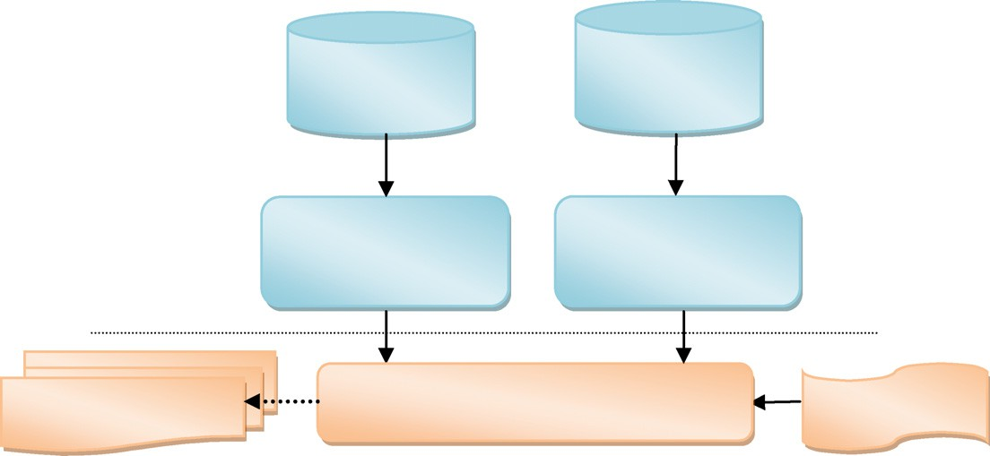

**Historical learners’ logs and rating**

**Historical learners’ rating**

**Preference matix building (explicit attribute modeling)**

**Implicit attribute weight extraction using GA (Implicit attribute modeling)**

**Offline**

**Online**

**Recommendation**

**Final rating prediction and generate recommendation using weighted hybrid method**

**Active learner logs**

Figure 1 System framework of the proposed material recommender system.

accuracy. When individual *wi* is applied to generate recom-

qPﬃﬃﬃﬃﬃﬃ*K*ﬃﬃﬃﬃﬃ*w*ﬃﬃﬃ2ﬃﬃ ·

mendation’s results for user *i*, the similarity between predic-

IAB

P*K wai* · *wbi*

*a*

*b*

tion rating with the actual rating values can express its

*sim*

(*L* , *L* )= *i*=1

prediction accuracy. It is the basis of fitness. So, the accu-

*i*=1 *ai*

*i*=1 *bi*

racy function is defined as follows:

The prediction rating of learning material *i* by *La* using im-

plicit attribute based method is *P*IAB(*La*, *i*) that is gained by the

*N*

X

*f*(*WU*, *WI*)= f(wi)=

*i*=1

*N* Mi *K*

*ik jk ij*

*w*

· *e*

— *r*

XX X

*i*=*N* j=1 *k*=1

(2)

rating of *La* neighborhood, *NIAB*(*La*), that have rated *i* before. The computation formula is as follows:

where *rij* is actual rating of item *j* by user *i*, *wik* and *ejk* are weight of attribute *k* for user *i* and item *j* respectively and Mi is number of rated items by user *i*. When *f*(*WU*, *WI*) is

lower, the accuracy prediction would be higher.

*PIAB*(*La*, *i*)= *RLa*

+ P*j*∈*NIAB* (*La* ) *simIAB*(*La*, *Lj*)× (*RLj* (*i*)— *RLj* ) (5)

P *sim* (*L* , *L* )

*j*∈*NIAB* (*La* )

*IAB*

*a*

*j*

*Selection operation*: The selecting of selection operators is

an important part in genetic algorithms. This part is inde- pendent of other parts in genetic algorithms and has no direct relation with the problem and with the fitness func- tion, crossover operator and mutation operator used in genetic algorithms [39]. In this research, a probabilistic selection is performed based upon the individual’s fitness such that the better individuals have an increased chance of being selected. Here, the universal sampling method is adopted for selecting the good strings and the probability of selecting each string is calculated by:

where *RLa* and *RLj* denote rating average of learning materials rated by active learner *La* and *Lj* respectively and *simIAB* (*La*, *Lj*) is the similarity between active learner *La* and *Lj* that is a member of *NIAB*(*La*). However, if a learner does not have enough similar learners, traditional algorithms will generate a lot of dissimilar learners which will definitely decrease the pre- diction accuracy of active learner. Thus, in order to enhance efficiency of calculation, learners set should be preliminarily fil-

tered via setting a similarity matching threshold s. The two learners are effective similar neighbor only if the similarity be-

tween them is at least s.

p (*W* , *W* )= 1 — fc(*WU*, *WI*)

(3)

c *U* *I*

X

*PS*

fc(*WU*, *WI*)

*C*=1

* 1. *Multidimensional information model based recommender*

In this section, learner interests are modeled as a multidimen-

where fc(*WU*, *WI*) denotes the value of fitness function for chromosome *c*, *PS* is number of individuals in the population or population size and pc(*WU*, *WI*) denotes the probability of selecting chromosome *c*. Because the sum of fitness in a popu- lation is constant, an individual with lower fitness)higher pre- diction accuracy) has larger probability to be chosen. We find that the universal sampling method scheme yields a good indi- vidual to be selected for the reproduction of the next popula- tion. We hope it would be helpful in improving the efficiency of our algorithm.

(4)

qPﬃﬃﬃﬃﬃﬃ*K*ﬃﬃﬃﬃﬃ*w*ﬃﬃﬃ2ﬃﬃ

*Crossover and mutation operation*: Crossover is a process of taking more than one parent solutions and producing a child solution from them. The crossover operator takes two chromosomes selected and tries to mate them generat- ing the individuals for the next generation. In this work, one-point crossover is used to produce offspring. Single crossover point on both parents’ strings is selected ran- domly. All gens beyond that point in either string is swapped between the two parent chromosomes.

Mutation operator is used to investigate some of the unvis- ited points in the search space, and also to avoid premature convergence of the entire feasible space caused by some super chromosomes. This operator makes random changes in one or more elements of the string. Mutation is done with a small probability, called mutation probability or rate. According to mutation rate, randomly selecting some elements of individual, and changing its value, new individual can be gained. It is a lo- cal random searching method to keep diversity of population.

*3.2.2. Recommendation*

After implicit attributes weight optimization, similarity degree between learners by implicit attribute based (IAB) method can be calculated by following formula that is a cosine similarity:

sional data structure according to explicit attributes of learning materials. Then, to generate recommendation, similarity be- tween learners is computed based on similarity between their multidimensional data structures.

* + 1. *Multidimensional information model*

Rating of a material that has certain explicit attribute values indicates the importance of these explicit attribute values for the learner; it can be considered as base for weighting of expli- cit attributes for the learner. Therefore, in order to consider learner’s preference accurately, attributes of learning materials should be taken into account. Therefore, the material attri- butes’ description model can be defined as a vector *C* = < *A*1, *A*2, .. . , *Am*) where *At* denotes the *t*th dimensional attribute’s name of material.

This research introduces a multidimensional attribute- based framework for recommendation that involves attributes of materials in the recommendation process, but selection of appropriate attributes may vary in the different systems. Sys- tem developer can use Learning Object Metadata (LOM) to se- lect suitable attributes. In this research, according to the simplicity and usefulness, we select four attributes including: subject, secondary subject, education type (Bachelor Degree (B.D.), Master Degree (M.D.), PhD Degree (PhD.D.)) and publisher of material. Based on this description model, a cer- tain material is defined as *MAj* = [(*AK*1, *AW*1), (*AK*2, *AW*2),

... , (*AKm*, *AWm*)], where *AKi* denotes *i*th dimension attri- bute’s keyword of material *Mj* and *AWi* denotes the appropri- ate weight value for *i*th attribute and *AW*1 P *AW*2 P

... P *AW* and P *WA* = 1. For example:

*m*

*m* *i*

*i*=1

*Mj* = [(*Mathematic*, 0.35), (Pr*obability*, 0.3), (*Master*

× deg *ree*, 0.2), (*Author*5, 0.15)].

we use the order of accessed material as useful information for learners’ dynamic interest modeling. The preference of a lear- ner’s recently accessed materials has an important role to the future interests. However, in the existing vector-space based preference modeling methods, the dynamic changes of lear- ner’s preference are neglected and always all accessed materials treat equally. Thus, by changing the learner’s interests and preferences with the passage of time, the recommender system cannot produce the accurate recommendations. Herein, Grad- ual Forgetting Function (GFF) concept is introduced in order to reflect dynamic interests and preference of a learner more accurately. In this research, we introduce a quadratic function, as follows:

*x*(*M* )— *x*  2!

*h*(*x*(*Mi*)) = 1 — *k* 1 —

*x*

*i*

min

min

max

— *x*

(6)

*MID*. For example in Fig. 3 material *M*1 is the first material that have been studied by *Li*, therefore *x*(*M*1) = 1 and *h*(1) = 0,02. Learner *Li* has rated this material four, therefore *RR* = 4.

Definition 2. The preference model of learner *Li* is defined as a matrix with *m* rows in which m denotes the number of attri- butes of materials. Each cell in this matrix is defined as a four-tuple (*KA*, *NH*, *RR*, *level*), where *KA* is the keyword of the *level*th attribute accessed materials by learner *Li* and *level* denotes the row number for this tuple.

Definition 3. *NH* of each tuple in PM is defined as the sum of the *NH* value of all materials in AM that their attributes’ key-

word is same with the attributes’ keyword of tuple.

*x*min < *x* < *x*max, 0 6 *k* 6 1, 0 < *h*(*x*(*Mi*)) < 1

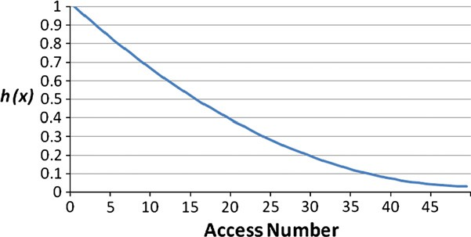

where *x* (*Mi*) is the order of *Mi* in the material access order by learner *Li*, *x*max is the order of the latest accessed material and *x*min is the order of the first accessed material. Therefore, the effect of *Mj* to *Li*’s future interest will becoming smaller with material access process going on and *h*(*x*) should be attenuated gradually. In *h*(*x*), *k* is an adjustable parameter used to de- scribe the change rate of learner’s preference, and the bigger of *k*, the quicker of the forgetting.

The *h*(*x*) attenuation with *k =* 0.95 is shown in Fig. 2. Based on Eq. (6), *h*(*x*) value of the latest accessed material is equal to 1, and with access going on, *h*(*x*) value of materials could be updated.

The central element of all recommender systems is the user model that contains knowledge about the individual prefer- ences which determine his or her behavior in a complex envi- ronment of web-based system. The attention-degree of learners is inferred by learners rating. In this paper, a multidi- mensional information model is introduced to combine attri- butes of accessed materials and learner’s rating information for making a preference model for learner. For each learner, we consider a set of accessed materials by the learner and a preference matrix that model learner ‘preference. Fig. 3 shows a preference matrix (PM) and a set of accessed materials (AM) by learner *Li*.

Definition 1. Each accessed material by learner *Li* is defined as a four-tuple (*MID* , *X*(*MID*), *NH*, *RR*), where MID denotes accessed material ID of learner *Li*, *x*(*MID*) denotes the order of MID in the material access order by learner *Li*, *NH* denotes the normalization value of *h*(*x*) function for accessed material *MID* by learner *Li* and *RR* denotes the rating of *Li* to material

Figure 2 Gradual forgetting function.

Definition 4. *RR* of each tuple in PM is defined as the average of the *RR* value of all materials in AM that their attributes’ keyword is same with the attributes’ keyword of tuple.

We make and update the preference matrix by the following strategy:

Search the keywords of the latest accessed material attri- butes (*MAj* = [*AKj*1, *AKj*2, ... , *AKjm*]) in *PM* from the upper row to the bottom row. If the keyword of *i*th attribute cannot be matched, a new column is created that the first *i* — 1 its rows give the corresponding matched attributes and the next *m* — *i* + 1 its rows give the latter *m* — *i* + 1 attributes of mate- rial. Then the *NHs* and *RRs* of matrix are updated according to Definitions 3 and 4.

PM can model preferences of a learner. System can transfer preference of a learner from accessed materials to high-level attributes and indicate importance each attribute for the lear- ner. In this matrix, each accessed material corresponds to a un- ique path from the first row to the last row, and the keywords of all tuples located in this path correspond to the relevant key- words of the material’s attributes.

* + 1. *Recommendation*

As a logical assumption, two learners with similar attribute keywords in their PM can be considered as similar neighbors. Based on this assumption, we can solve sparsity problem. For defining similarity degree, three rules are implemented:

* + - 1. The more similar attributes of learner *La* and learner *Lb*’s accessed materials, the larger similarity between them.
      2. The more similar the order of accessed materials of lear- ner *La* and learner *Lb*, the larger similarity between them.
      3. The more similar the rating data of learner *Lb* and lear- ner *Lb*, the larger similarity between them.

Therefore, the similarity degree between two learners can be calculated based on Attributes Intersection Vector (*AIV*) be- tween two their corresponding *PMs*. *AIV* between learner *La* and *Lb*, *AIV*(*La*, *Lb*), is defined as the maximum intersection between columns of *PMa* and *PMb* with same keyword in each row. After matching process, we have an *AIV* such as Fig. 4 shows.

The calculation of similarity between two learners can be divided into two aspects as: preference based similarity and

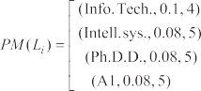 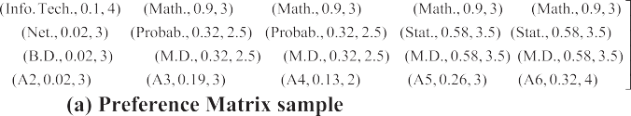





Figure 3 Components of multidimensional information model.

learner rating based similarity. The preference based similarity

*sim*PB can reflect the similarity between learners based on attri- butes. Inspired by Cosine similarity, the calculation of *simP- B*(*La*, *Lb*) can be defined as follows:

where *RLa* and *RLj* denote rating average of learning materials

rated by active learner *La* and *Lj* respectively and *sim*EAB (*La*, *Lb*) denote the similarity between active learner *La* and *Lj* that is a member of *NEAB*(*La*).

*sim*

(*L* , *L* )= P*i*∈*AIV*(*La* ,*Lb* )*AWi* · *NHai* · *NHbi*

* 1. *Final recommendation*

*PB a b*

*i*∈*PMa ai*

*i*∈*PMb bi*

qPﬃﬃﬃﬃﬃﬃﬃﬃﬃﬃﬃﬃﬃﬃﬃ*A*ﬃﬃﬃﬃ*W*ﬃﬃﬃﬃﬃ*i*ﬃﬃ·ﬃﬃ*N*ﬃﬃﬃﬃ*H*ﬃﬃﬃﬃ2ﬃﬃ ·

qPﬃﬃﬃﬃﬃﬃﬃﬃﬃﬃﬃﬃﬃﬃﬃ*A*ﬃﬃﬃﬃ*W*ﬃﬃﬃﬃﬃ*i*ﬃﬃ·ﬃﬃ*N*ﬃﬃﬃﬃ*H*ﬃﬃﬃﬃ2ﬃﬃ

The development of final recommendation is done in this stage. Truly, we proposed two methods for learning material

where *NHai* indicates the value of *NH* in the *i*-th row’s match-

(7)

ing for learner *a*. *AWi* indicates attribute weight that was de- fined before. For reflecting the similarity between the rating vectors of two learners, the learner rating based similarity can be applied to overcome sparsity rating problem. Inspired from Pearson, this similarity can be defined as follows:

recommendation: Explicit Attribute Based Collaborative Fil- tering (EAB-CF) and Implicit Attribute Based Collaborative Filtering (IAB-CF). These two methods can be combined for final recommendation. A linear combination of EAB-CF and IAB-CF is used for recommendation (EB-IB-CF). Therefore for rating prediction the following formula is used:

*sim*

(*L* , *L* )= P*i*∈*AIV*(*La* ,*Lb* ) |[*RRi*.*level* (*La* )— *RRAIV* (*La* )] · [*RRi*.*level* (*Lb* )— *RRAIV* (*Lb* )]|

*P* (*i*)= *a* · *P*

(*L* , *i*)+ (1 — *a*)· *P*

(*L* , *i*) (11)

RB *a b*

qPﬃﬃﬃﬃﬃﬃﬃﬃﬃﬃﬃﬃﬃﬃﬃﬃﬃﬃﬃﬃﬃﬃﬃﬃﬃﬃﬃﬃﬃﬃﬃﬃﬃﬃﬃﬃﬃﬃﬃﬃﬃﬃﬃﬃﬃﬃﬃﬃﬃﬃﬃﬃﬃﬃﬃﬃﬃﬃﬃﬃﬃﬃﬃﬃﬃﬃﬃﬃﬃﬃﬃﬃﬃﬃﬃﬃﬃﬃﬃﬃ2**ﬃ** qPﬃﬃﬃﬃﬃﬃﬃﬃﬃﬃﬃﬃﬃﬃﬃﬃﬃﬃﬃﬃﬃﬃﬃﬃﬃﬃﬃﬃﬃﬃﬃﬃﬃﬃﬃﬃﬃﬃﬃﬃﬃﬃﬃﬃﬃﬃﬃﬃﬃﬃﬃﬃﬃﬃﬃﬃﬃﬃﬃﬃﬃﬃﬃﬃﬃﬃﬃﬃﬃﬃﬃﬃﬃﬃﬃﬃﬃﬃﬃﬃ2**ﬃ** *La*

*IAB a*

*EAB a*

*i*∈*AIV*(*La* ,*Lb* ) (*RRi*.*level* (*La* )— *RRAIV* (*La* )) · *i*∈*AIV*(*La* ,*Lb* ) (*RRi*.*level* (*Lb* )— *RRAIV* (*Lb* ))

(8)

where *RRi*.*level*(*La*) indicates rating of user *La* in row *i* of *PMa* corresponding with row *i* of *AIV*. *RRASS*(*La*) indicates the mean value of *La*’s rating in rows of *PMa* corresponding with rows of *AIV*.

It must be noted, in the calculation of *sim*RB(*La*, *Lb*) that computes the similarity between *RR* value of rows on *PMa* and *PMb* which correspond to each row on *AIV*(*La*, *Lb*), does not need to have the identical accessed materials between two learners. By this definition of similarity, we can overcome spar- sity rating problem. Finally, Explicit Attribute Based (EAB) similarity between *La* and *Lb* can be calculated as follows:

*Sim*EAB(*La*, *Lb*)= *b* · *SimPB*(*La*, *Lb*)+ (1 — *b*)

· *SimRB*(*La*, *Lb*) (9)

The prediction rating of learning material *i* by *La* using im- plicit attribute based method is *PEAB*(*La*, *i*) that is gained by the rating of *La* neighborhood, *NEAB*(*La*), that have rated *i* be- fore. The computation formula is as the follows:

*PEAB*(*La*, *i*)= *RLa*

P *sim* (*L* , *L* )× (*R* (*i*)— *R* )

*j*∈*NEAB* (*La* ) EAB *a j Lj Lj*

contains 1148 learners and 12,000 materials.

where *PLa* (*i*) denotes final prediction rate for learning material *i* by *La*. Finally top N-learning materials with higher predicted rate are considered as recommendation results. Each of the ap-

proaches uses some of useful information in their recommen- dation process. Thus, hybrid approach can resolve their weak points and improve the accuracy and quality of recom- mendation results.

1. Experiments

We have conducted a set of experiments to set parameters and examine the effectiveness of our proposed recommender sys- tem in terms of recommendation accuracy and quality.

* 1. *Evaluation metrics and data set*

In order to check the performance of the proposed algorithm, a real-world dataset is applied in our simulations. MACE1 dataset that is pan-European initiative to interconnect and dis- seminate digital information about architecture is used for experiment. This dataset is issued from MACE project that is done from September 2006 to September 2010. This dataset

+ P *sim* (*L* , *L* )

*j*∈*NEAB* (*La* )

*EAB a j*

(10)

The precision and recall are most popular metrics that eval-

uate decision support accuracy. For the evaluation of recom- mender system, they have been used by various researchers [12,14]. The precision is a measure of exactness and recall is a measure of completeness. Several ways to evaluate precision and recall exists [40]. When referring to Recommender Systems the recall can be defined as follows:

Figure 4 Attributes intersection vector sample. 1 Metadata for Architectural Contents in Europe.

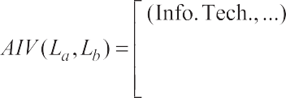

Recall = |*test* ∩ *top* — *N*|

|*test*|

(12)

* 1. *Parameters setting*

where *top* — *N* denotes the recommendation set and *test* de- notes the test set. The precision when referring to recom- mender systems can be defined as follows:

|*test* ∩ *top* — *N*|

In this section, first the impact of input parameters is analyzed on the recommendation performance.

* + 1. *Parameters of IAB-CF*

Precision =

*NR* (13)

The probabilities of Crossover and mutation operators have an important role in GA, so it is necessary to define proper

where *NR* denotes number of recommendations. Since increas-

ing the size of the recommendation set leads to an increase in recall but at the same time a decrease in precision, we can use *F*1 measure [41] that is a well-known combination metric with the following formula:

*F* = 2. Precision · Recall (14)

1 Precision + Recall

To evaluate prediction accuracy, we have used the Mean Absolute Error (*MAE*), a statistical accuracy metric, [40,42] is computed as

P*U*=*N*|*RU*(*i*)— *PU*(*i*)|

*MAE* = *U*=1

|*N*|

(15)

operator’s probability to achieve a better performance. How- ever, the optimal values of crossover and mutation probabili- ties are problem specific that often are obtained by trial and error. Therefore, we examine the impacts of various combina- tions of *PC* (probability of crossover) and *PM* (probability of mutation) on the recommendations quality of the proposed approach. According to the experiments, *PC = 0.83* and *PM* = 0.17 give good results for our problem. In order to choose the population size, we have considered the criterion of using a number of individuals in the population which is the double of the number of bits used to represent each indi- vidual [43]. Consequently, since we used *K* · 10 = 15 · 10 =

150 bits for each attributes weight vector, we select 300 as pop-

ulation size. The number of individuals keeps constant through

where *PU*(*i*) is the predicted rating for material *i* by learner *U*, *RU*(*i*) is the learner given rating for material *i* by learner *U*, and *N* is the total number learners. We have used the Rooted Mean Square (RMS) error, and 0/1 loss error also.

every generation. We only keep the 5% of the best individuals from each generation to obtain the next one (elitist selection). The genetic algorithm stops when there is an individual in the population with a fitness value lower than a constant c. We

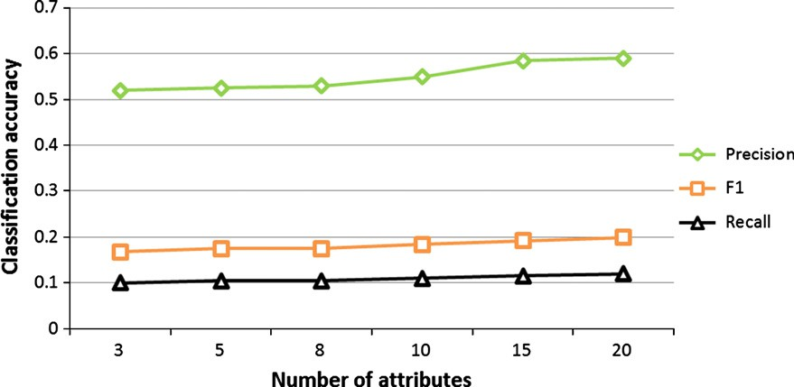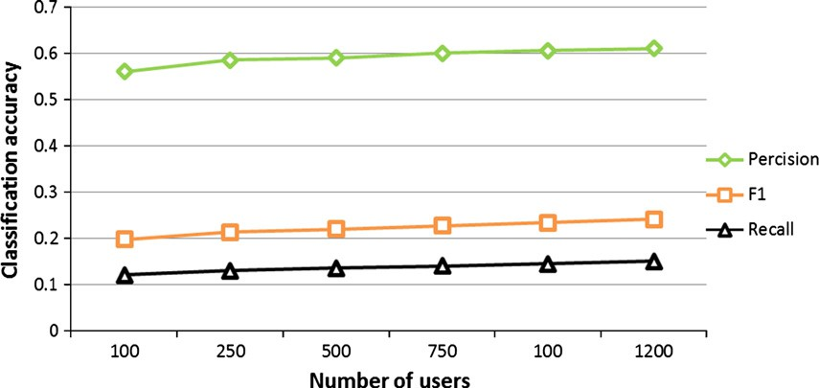

Figure 5 Performance of IAB-CF with respect of *K.*

Figure 6 Performance of IAB-CF with respect of the number of users.

Hybrid attribute-based recommender system for learning material 75

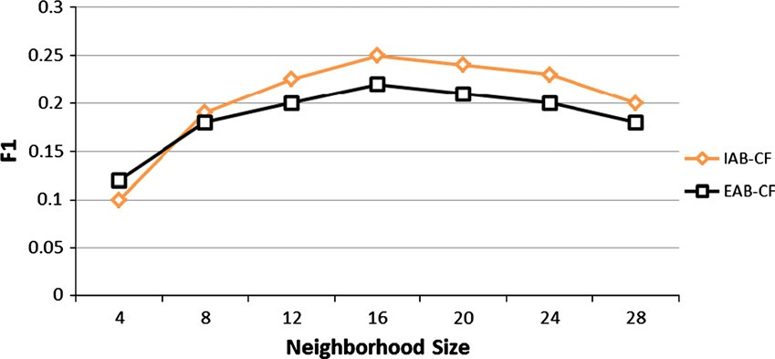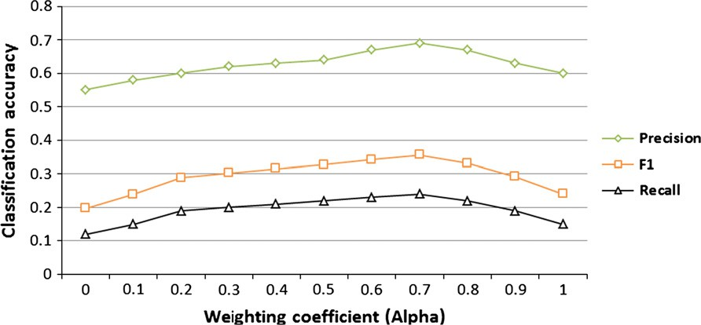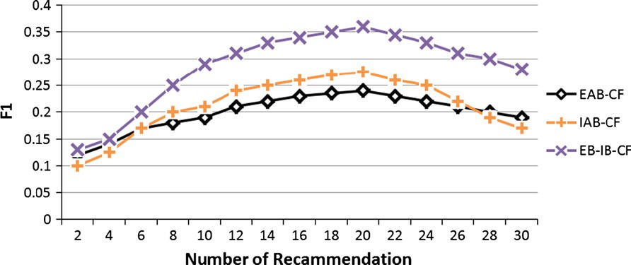

Figure 7 Performance results of proposed approaches with respect of neighborhood size.

Figure 8 Effect of *a* on precision, recall and F1 of *EB-IB-CF.*

Figure 9 Comparison of the proposed approaches with respect of number of recommendation.

select c according to the optimal values found in results of the other recommendation approaches.

|  |  |  |  |
| --- | --- | --- | --- |
| Table 1 A comparison of prediction accuracy of various methods. | | | |
| Method | Error |  |  |
|  | MAE | RMS | 0/1 loss |
| EB-IB-CF | 0.787 | 1.051 | 62.7 |
| EAB-CF | 0.891 | 1.181 | 65.2 |
| IAB-CF | 0.832 | 1.163 | 63.2 |
| User based | 0.873 | 1.172 | 64.7 |
| Mixture pLSA | 0.848 | 1.170 | 63.4 |
| CR [45] | 0.994 | – | – |
| BC [45] | 1.103 | – | – |
| BN [45] | 1.066 | – | – |
|  |  |  |  |

One of the parameters for the IAB-CF is number of attri- butes; *K*. The performance of method may vary with varying number of considered attributes for users. Fig. 5 shows the re- sults obtained for the proposed model with different number of attributes, where the minimum number of rating required for test users, *M*, was 30, the number of user, *N*, was 500. It can be seen that the performance improves steadily with the number of attributes increasing, but not very much.

Since number of attributes of user could be seen as the user communities, this number should be a relative small number according to experience. Fig. 6 shows the results obtained

76 M. Salehi et al.

Figure 10 The mean running times for single learner of algorithms with respect of *N*.

for the IAB-CF method, while parameters set as *M* = 30, *K* = 15, and the number of user was changed from 100 to 1200. According to Fig. 6, the performance of the method is good for different values of users. It means that the choosing the number of attributes, *K* is not strict.

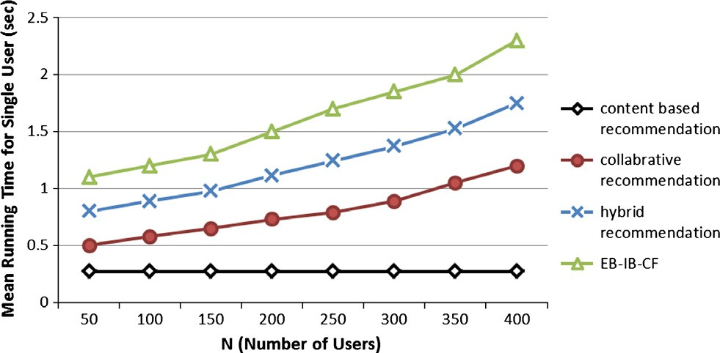

In addition, there are three other parameters including: number of neighborhoods, weighting coefficient in the combination of two type of similarity in EBA-CF (beta) and *EAB-CF* and *IAB-CF* (alpha) that must be adjust for better recommendation. According to previous experiments, EBA-CF for *b* = 0.35 gives the best prediction accuracy.

* + 1. *Neighborhood size*

Fig. 7 shows the influence of neighborhood size on the perfor- mance of EAB-CF and IAB-CF with F1 metric while *N = 500, M* = 50, *K* = 15. It was observed that the size of the neighborhood affects the quality of top-N recommenda- tions. Considering this diagram, we select 16 as the optimal choice of neighborhood size.

* + 1. *Weighting coefficient (a)*

Fig. 8 shows the impacts of a on the precision, recall and F1of EB-IB-CF while *N* = 500, *M* = 50 and *K* = 15. It indicates that taking into consideration a combination of EAB-CF and IAB-CF to predict rating will play a positive role in the recom- mendation process, but *a* does not acknowledge ‘the larger the better’ rule: the best precision can be obtained with *a* = 0.7.

* 1. *Performance comparison*

In experiments, the data is ordered by learners’ access time- stamp, and then is divided into a training set and a test set. In order to increase the number of records in test set as much as possible so as to eliminate the effect of accidental factor, the top 60% access records of each learner in ordered dataset are used as training set and the remnant 40% access records are used as test set. The algorithm is then trained on the training set and top N-learning materials are predicted from that learn- ers’ test set.

To evaluate the sensitivity of different algorithms on number of recommendation (NR), we compare proposed

approaches that is presented in Fig. 9 while *N* = 500, *K* = 15, and *M* = 50. As Fig. 9 shows combination of explicit based and implicit based collaborative filtering has the best performance. The relative performance of these methods for different number of recommendations is different but as in general we can say the best performance is from 18 to 22.

Although, this paper presents a recommender system for learning material, but the proposed approach can be used for some of other area of recommender system. Therefore, to compare our approach with other approach of recommender system, EachMovie dataset has been used. Table 1 presents the experimental results obtained by EB-IB-CF, EAB-CF, IAB-CF, a memory-based method using nearest-neighbor users to predict ratings, results of normalized Gaussian PLSA2 mixture method published in Hofmann [44] and results pub- lished in Breese et al. [45] including Bayesian clustering (BC), Bayesian networks (BN), Correlation(CR) for EachMovie dataset. Since the data set will influence the results of CF algo- rithm, comparing of different algorithms is difficult. For the mixture PLSA, results are chosen the best results in Hofmann [44]. The results of user-based and proposed method obtained from the same data set. Comparisons were produced for *N* = 500 users with the average number of ratings about 100, and *M* = 50. As can be seen, the proposed multi-attribute based method has better prediction accuracy of the memory- based, mixture PLSA method and other methods in terms of *MAE*.

In the final comparison experiment, the mean running times for single learner of EB-IB-CF algorithm, vector space model- based content-based recommendation algorithm [46], user and item combined collaborative-based recommendation algo- rithm and hybrid recommendation algorithm [47] is compared with respect to N or number of participated learner which are selected from MACE dataset while *K* = 15, *M* = 50 and *NR* = 20. As shown in Fig. 10 at all times, content-based algo- rithm is faster than any other algorithms. The running time of the proposed and improved hybrid recommendation algo- rithms are slightly larger than collaborative based algorithm. According these experiments, although the proposed recom- mendation will get higher precision in most case, it will cost

2 Probabilistic latent semantic analysis.

Hybrid attribute-based recommender system for learning material 77

the largest running time. Therefore, there is a trade-off be- tween algorithm running time and recommendation precision when choosing the proposed recommendation algorithm.

1. Conclusions

One of the most important applications of recommendation systems in e-learning environment is personalization and rec- ommendation of learning materials. However, since the repos- itory of learning materials is very massive and these materials have several attributes, there are several drawbacks such as sparsity when applying the existing recommendation algo- rithms. To address these problems and have a good recom- mendation for learner, this paper presents a novel personalized recommender system that utilizes explicit and im- plicit attributes of materials in the unified model. The experi- ment results show that the proposed approach performs better than the traditional approaches. The main contribution of this paper is improving the quality of recommendations and addressing sparsity problem using genetic algorithm and a multidimensional information model.

The learning processes (resource access processes) usually have some time-dependency relationship and are repeatable and periodic. Therefore, the time-dependency relationship be- tween learning resources in a learning process can reflect lear- ner’s resource access latent pattern and preference. For further research, to improve the recommendation process we can make a hybrid approach and mine learner’s historical access records for discovering the resource access sequential patterns. Then, using these sequential patterns, we can predict the most probable resource that a learner will access in near feature.

References

1. Greenhow C, Robelia B, Hughes JE. Learning, teaching, and scholarship in a digital age: Web 2.0 and classroom research: what path should we take now? Educat Res 2009;38(4):246–59.
2. Kardan AA, Abbaspour S, Hendijanifard F. A hybrid recom- mender system for e-learning environments based on concept maps and collaborative tagging. In: The 4th international confer- ence on virtual learning ICVL; 2009. p. 300–7.
3. Zaiane OR. Building a recommender agent for e-learning systems. In: Proceedings international conference on computers in educa- tion; 2002. p. 55–9.
4. Resnick P, Iacovou N, Suchak M, Bergstrom P, Riedl J. Grouplens: an open architecture for collaborative filtering of netnews. In: Proceedings of the 1994 ACM conference on computer supported cooperative work; 1994. p. 175–86.
5. Klasnja-Milicevic A, Vesin B, Ivanovic M, Budimac Z. E-learning personalization based on hybrid recommendation strategy and learning style identification. Comput Educat 2011;56(3):885–99.
6. Farzan R, Brusilovsky P. Social navigation support in a course recommendation system. In: Adaptive hypermedia and adaptive web-based systems; 2006. p. 91–100.
7. Burke R. Hybrid: recommender systems: survey and experiments. J User Model User-Adapted Interact 2002;12(4):331–70.
8. Mobasher B, Cooley R, Srivastava J. Automatic personalization based on Web usage mining. Commun ACM 2000;43(8):142–51.
9. Fayyad M, Piatetsky-Shapiro G, Smyth P, Uthurusamy R. Advances in knowledge discovery and data mining; 1996.
10. Schafer JB, Konstan JA, Riedl J. E-commerce recommendation applications. Data Mining Knowl Discov 2001;5(1):115–53.
11. Anderson CR, Domingos P, Weld DS. Relational Markov models and their application to adaptive web navigation. In: Proceedings

of the eighth ACM SIGKDD international conference on Knowledge discovery and data mining; 2002. p. 143–52.

1. Drachsler H, Hummel HGK, Koper R. Recommendations for learners are different: applying memory-based recommender system technique. In: Proceedings of the 1st workshop on social information retrieval for technology-enhanced learning and, exchange; 2007. p. 18–26.
2. Sarwar B. Application of dimensionality reduction in recom- mender system – a case study. In: ACM WEBKDD workshop, DTIC document; 2000.
3. Lee WS. Collaborative learning for recommender systems. In: Proceedings of the 18th international conference on machine learning; 2001. p. 314–21.
4. Sarwar B, Karypis G, Konstan J, Riedl J. Analysis of recom- mendation algorithms for e-commerce. In: Proceedings of the 2nd ACM conference on electronic commerce; 2000. p. 158–67.
5. Aggarwal CC, Wolf JL, Wu K-l, Yu PS. Horting hatches an egg: a new graph-theoretic approach to collaborative filtering. In: Proceedings of the fifth ACM SIGKDD international conference on knowledge discovery and data mining; 1999 p. 201–12.
6. Herlocker JL. Understanding and improving automated collab- orative filtering systems. Doctoral dissertation. Citeseer; 2000.
7. Tan H, Guo J, Li Y. e-Learning recommendation system. In: International conference on computer science and, software engineering; 2008. p. 430–3.
8. Santos OC, Boticario JG. Recommendation strategies for pro- moting eLearning performance factors for all. In: 6th Workshop on intelligent techniques for web personalization & recommender systems in conjunction with the 23nd AAAI conference on artificial intelligence; 2008.
9. Garcı´a E, Romero C, Ventura S, Castro C. An architecture for making recommendations to courseware authors using association rule mining and collaborative filtering. User Model User-Adapted Interact 2009;19(1):99–132.
10. Garcı´a E, Romero C, Ventura S, Castroa Cd. A collaborative educational association rule mining tool. Internet Higher Educat 2011;14(2):77–88.
11. Soonthornphisaj N, Rojsattarat E, Yim-ngam S. Smart e-learning using recommender system. In: ICIC’06 proceedings of the 2006 international conference on intelligent computing; 2006. p. 518–23.
12. Bobadilla J, Serradilla F, Hernando A. MovieLens, Collaborative filtering adapted to recommender systems of e-learning. Knowl- Based Syst 2009;22(4):261–5.
13. Khribi MK, Jemni M, Nasraoui O. Automatic recommendations for e-learning personalization based on web usage mining tech- niques and information retrieval. In: ICALT’08. Eighth IEEE international conference on advanced learning technologies; 2008.

p. 241–5.

1. Romero C, Ventura S, Zafra A, de Bra P. Applying Web usage mining for personalizing hyperlinks in Web-based adaptive educational systems. Comput Educat 2009;53:828–40.
2. Hammouda K, Kamel M Collaborative document clustering. In: Proceedings of the sixth SIAM international conference on data mining (SDM06); 2006. p. 453–63.
3. Lobo LM, Sunita RJ, Aher B. Mining association rule in classified data for course recommender system in e-learning. Int J Comput Appl 2012;39(7):1–7.
4. Chen MS, Han J, Yu PS. Data mining: an overview from a database perspective. IEEE Trans Knowl Data Eng 1996;8(6):866–83.
5. Mahdavi M, Shepherd J. Enabling dynamic content caching in Web portals. In: RIDE ‘04 Proceedings of the 14th international workshop on research issues on data engineering: web services for e-commerce and e-government applications (RIDE’04); 2004. p. 129–36.
6. Liang G, Weining K, Junzhou L. Courseware recommendation in e-learning system. In: Advances in web based, learning; 2006. p. 10–24.

78 M. Salehi et al.

1. Liu F, Shih B. Learning activity-based e-learning material recommendation system. In: Proceedings of the ninth IEEE international symposium on multimedia workshops; 2007. p. 343– 8.
2. Khribi MK, Jemni M, Nasraoui O. Automatic recommendations for e-learning personalization based on web usage mining tech- niques and information retrieval. Educat Technol Soc 2009;12(4):30–42.
3. Li Y, Niu Z, Chen W, Zhang W. Combining collaborative filtering and sequential pattern mining for recommendation in e-learning environment. Lecture Notes Comput Sci 2011;7048:305–13.
4. Benharzallah S, Kazar O, Caplat G. Intelligent query processing for semantic mediation of information systems. Egyptian Inform J 2011;12(3):151–63.
5. Claypool M, Gokhale A. Combining content-based and collab- orative filters in an online newspaper. In: SIGIR ’99 workshop on recommender systems: algorithms and evaluation; 1999. p. 195– 204.
6. salehi M, Nakhai Kamalabadi I. A hybrid attribute based recommender system for e-learning material recommendation. IERI Procedia 2012;2:565–70.
7. Zhong J, Li X. Unified collaborative filtering model based on combination of latent features. Expert Syst Appl 2010;37:5666–72.
8. salehi M, Nakhai Kamalabadi I, Ghaznavi ghoushci MB. A new recommendation approach based on implicit attributes of learning material. IERI Procedia 2012;2:571–6.
9. Salehi M, Tavakkoli-Moghaddam R. A genetic algorithm-based grouping method for a cell formation problem with the efficacy measure. Int J Ind Syst Eng 2010;6(3):340–59.
10. Herlocker JL, Konstan JA, Terveen LG, Riedl JT. Evaluating collaborative filtering recommender systems. ACM Trans Inform Syst (TOIS) 2004;22(1):5–53.
11. Shih YY, Liu DR. Product recommendation approaches: collab- orative filtering via customer lifetime value and customer demands. Expert Syst Appl 2008;35(1–2):350–60.
12. Zhao Z, Bing S. An adaptive algorithm for personal recommen- dation. J Changchun Univ 2005;1(1):22–9.
13. Alander JT. On optimal population size of genetic algorithms. Comput Syst Software Eng 1992:65–70.
14. Hafmann T. Latent semantic models for collaborative filtering. ACM Trans Inform Syst 2004;22:89–115.
15. Breese JS, Heckerman D, Kadie C. Empirical analysis of predictive algorithms for collaborative filtering. In: Proceedings of the 14th conference on uncertainty in artificial intelligence; 1998. p. 43–52.
16. Adomavicius G, Tuzhilin A. Toward the next generation of recommender systems: a survey of the state-of-the-art and possible extensions. IEEE Trans Knowl Data Eng 2005;17(6):734–49.
17. Baudisch P. Joining collaborative and content-based filtering. In: Proceedings of the conference on human factors in computing systems; 1999.