

[Egyptian Informatics Journal (2012) 13, 65–73](http://dx.doi.org/10.1016/j.eij.2012.04.002)

Cairo University

Egyptian Informatics Journal

[www.elsevier.com/locate/eij](http://www.elsevier.com/locate/eij) [www.sciencedirect.com](http://www.sciencedirect.com/science/journal/11108665)

ORIGINAL ARTICLE

Hybrid local search algorithm via evolutionary avalanches for spin glass based portfolio selection

Majid Vafaei Jahan a,*, Mohammad-R. Akbarzadeh-T b,c

a *Department of Computer Engineering, Islamic Azad University, Mashhad Branch, Mashhad, Iran*

b *Department of Electrical Engineering, Ferdowsi University of Mashhad, Iran*

c *Department of Computer Engineering, Ferdowsi University of Mashhad, Iran*

Received 29 December 2011; revised 23 March 2012; accepted 9 April 2012

Available online 15 May 2012

Abstract Nowadays, various imitations of natural processes are used to solve challenging optimi- zation problems faster and more accurately. Spin glass based optimization, specifically, has shown strong local search capability and parallel processing. However, generally, spin glasses have a low rate of convergence, since they use Monte Carlo simulation techniques such as *simulated annealing* (SA). Here, we investigate a new hybrid local search method based on *spin glass* (SG) for using adaptive distributed system capability, *extremal optimization* (EO) for using evolutionary local search algorithm and SA for escaping from local optimum states and trap to global ones. This algo- rithm improves the state of spins by selecting and changing the low ordered spins with higher prob- ability; after enough steps, the system reaches a high correlation where almost all spins have reached fitness above a certain threshold and ready to avalanche; this activity potentially makes any config- uration accessible. Therefore, avalanches allow escaping from local minima and efficiently exploring the configuration space.

As shown in this paper, this strategy can lead to faster rate of convergence and improved perfor- mance than conventional SA and EO algorithm. The resulting are then used to solve the portfolio selection multi-objective problem that is a non-deterministic polynomial complete (NPC) problem. This is confirmed by test results of five of the world’s major stock markets, reliability test and phase

KEYWORDS

Spin glass (SG);

Extremal optimization (EO); Simulated annealing (SA); Portfolio selection problem; Phase transition

* Corresponding author.

E-mail addresses: [VafaeiJahan@mshdiau.ac.ir](mailto:VafaeiJahan@mshdiau.ac.ir) (M.V. Jahan), Akbar [zadeh@ieee.org](mailto:zadeh@ieee.org) (Mohammad-R. Akbarzadeh-T).

1110-8665 *©* 2012 Faculty of Computers and Information, Cairo University. Production and hosting by Elsevier B.V. All rights reserved.

Peer review under responsibility of Faculty of Computers and Information, Cairo University. <http://dx.doi.org/10.1016/j.eij.2012.04.002>

Production and hosting by Elsevier

66 M.V. Jahan, M.-R. Akbarzadeh-T

transition diagram; and finally, the convergence speed is compared to other heuristic methods such as Neural Network (NN), Tabu Search (TS), and Genetic Algorithm (GA).

*©* 2012 Faculty of Computers and Information, Cairo University. Production and hosting by Elsevier B.V. All rights reserved.

1. Introduction

Similar to artificial neural networks, genetic algorithms, and ant colony systems, spin glass is a paradigm that is inspired from the governing laws of nature. However, as compared to many of its older counterparts, the main distinguishing feature of spin glasses is their unique distributed parameter optimiza- tion by emphasizing strong parameter interaction. More spe- cifically, spin glass model is a system of spins interacting with each other due to the existence of magnetic property among them. These spins change their quantity frequently to reach a lower energy level. When the system is at its minimum energy (or minimum temperature) state, there is no longer a visible change in spins’ states and the system is said to have reached its ground state [1]. In contrast to most other optimi- zation algorithms such as GA (Genetic Algorithm) where each chromosome represents a complete solution, every spin is only a *part* of an entire solution. The complete solution is found by the interaction of the many spins in the glass. The spin glass paradigm is therefore, a promising paradigm of adaptive dis- tributed systems. In addition, the spin glass model enjoys lots of properties, including limited interaction of each spin with neighboring spins [2], non-exponential growth of optimized (ground) states with the increase in spin glasses’ number of bonds [3], the effectiveness of environmental factors such as temperature on system behavior, and a continuing movement towards optimized states at different temperatures [4].

Considering these capabilities, many optimization problems can be solved using such distributed facility [2]. However, like many other heuristic methods, the rate of convergence of find- ing ground states is low when the problem dimension grows [5]. More specifically, this is reported to be a challenging aspect of the more conventional approaches such as the SA as re- ported earlier in [5,6].

To speed up the spin glass’s rate of convergence, it would be desirable to choose the ‘‘right’’ spin that promises the most improvements in terms of convergence rate and accuracy. This would be in contrast to the standard approach where spins are chosen arbitrarily. In this paper, we address this problem by combining SA with a local search strategy, specifically, EO [8]. In EO, on the other hand, the spin with lowest energy is chosen to change its state with a higher probability. This scheme works since changing each spin influences its other neighboring spins, and so they also change. If the total changes lead to a reduction in glass energy, the overall state of the glass improves and the correlation between spins increases. Hence, any change in each spin’s state would lead to rearrange major parts of the glass. In 2001, Boettcher and Percus likened this property to an avalanche that can lead to a faster survey of dif- ferent spin glasses’ states and an increased rate of convergence [8]. There is no need to tune control parameters with precise values; this is the great advantage of EO [9]; but this advantage is equal to deficiency: that is a trap in local optimum. Therefore, EO is fast but non-accurate. Instead, SA is slow but accurate.

Here, we investigate a new hybrid local search method based on *spin glass* for using adaptive distributed system capa- bility, *EO* for using evolutionary locally search algorithm and SA for escaping from local optimum states and trap to global ones. This algorithm that is named (EO–SA) needs a tune parameter such as temperature (from SA), spin selection meth- od such as aside from ranking (from EO) and locally interac- tion such as neighborhood spin interaction (from spin glass). Section 2 reviews the various applications of spin glasses in solving optimization problems. Section 3 provides a mathe- matical description of spin glasses. The portfolio selection problem is discussed in Section 4. This section also explains how this problem can be mapped onto a spin glass. The algo- rithm, EO–SA, is then presented in Section 5. In Section 6, the experimental results from applying the above algorithms to five of the world’s reputable stock markets are provided, and the convergence speed and accuracy are compared with other heuristic methods. The reliability test of algorithms and their performance validity is studied in Section 7. In Section 8, the resultant Pareto frontier is compared against the benchmark Pareto frontier; and finally in Section 9, phase transition anal-

ysis of the algorithms EO–SA and SA are presented.

1. Literature review

There is a wealth of existing literature on spin glasses in various domains in general, and physics, in particular. For the sake of brevity as well as the better focus, we are concerned here with that research related to engineering, and in particular, optimiza- tion, in which literature is relatively scarce. Minimum cost flow and matching problem are two examples of this kind [10]. In minimum cost flow problem, the ground state configuration of an Ising spin glass in a random environment, in which all ener- gies are non-negative, can be obtained with Dijkstra’s algorithm to find the shortest path in the directed network with non-nega- tive cost on the edges. In the matching problem, the ground state of a two dimensional spin glass model on a square lattice with nearest neighbor interaction with free boundaries can be mapped onto a matching problem of a general graph [2,10,11]. In 1999, Gabor and Kondor [12] used spin glasses for the first time in solving the portfolio selection problem with regard to its constraints. In their paper, they used a similar energy function to that of a Hopfield neural network [13]. In 2001, Nishimori [14,15] considered the application of spin glasses in transferring information in noisy channels. In 2004, Horiguchi et al. [16] pro- posed a spin glass-based routing algorithm for adaptive com- puter networks. Later in 2009, Vafaei and Akbarzadeh-T [6] introduced migration and elitism operators to find ground state of spin glasses with only a limited number of bonds, i.e. *short range* spin glasses. There [6], authors exploited *local* interaction among spins. In contrast, we consider here the *short range* effect

of spin interaction by investigating the use of EO.

The EO heuristic was first motivated by the Bak–Sneppen model of biological evolution [9] in 1993 for a lattice (glass)

Hybrid local search algorithm via evolutionary avalanches for spin glass based portfolio selection 67

of cooperating species (spins). Some applications of this meth- od were analyzed in solving optimization problems, including, solving the problem of the travel salesman problem [11], graph

Subject to

*N*

*i*=1

X

*xi* = 1 (4)

partitioning [17,18], graph coloring [19,20,31], social modeling [21,32], complex network analysis [22], and molecular dynam- ics’ simulation [23].

More specifically, EO is inspired by self-organized criticality (SOC), which is a statistic physics concept to describe a class of systems that have a critical point as an attractor [24]. In SOC,

there is no need to tune control parameters with precise values.

0 6 *xi* 6 1; *i* = 1; ... ; *N* (5)

where *N* is the number of different assets, *li* is the mean return of asset *i*, and *rij* is the covariance between returns of assets *i* and *j*. The decision variable *xi* represents the fraction of capital to be invested in asset *i.* Eqs. (2) and (3) are two cost functions that should be solved with constraints (4) and (5). *li* is the mean re-

*i*

*t*=1

*Wbi* (*t*)

Just inspired by this principle, EO drives the system far from

turn of asset *i* in *n* intervals of time, i.e. *l* = P*n*

*Wei* (*t*)—*Wbi* (*t*),

equilibrium: aside from ranking, there exists no adjustable

parameter, and new solutions are accepted indiscriminately [24].

1. Spin glass model

Spin glass is a model which can be used to investigate the col- lective properties of physical systems made from a large num- ber of simple elements. The important feature in this paradigm is that the interactions among these elementary components yield a collective phenomenon, such as stable magnetization orientation and the crystalline state of metal or alloy*.* In the Is- ing spin glass model [1,25], an Ising spin on a lattice point takes on one of two possible values (directions) (i.e., ±1 or up and down). By generalizing the Ising spin glass model to a XY spin glass model (hereafter referred to as spin glass mod-

where *Wbi* is the *i*th asset value at the beginning, and *Wei* is the

*i*th asset value at the end of each interval.

A feasible solution of the portfolio selection problem is an optimal solution if there is no other feasible solution improving one objective without deteriorating since the other. Usually, multiobjective optimization problems such as those in [28] have multiple non-dominant optimal solutions. This set of solutions form an *efficient frontier*. For the problem defined in Eqs. (2)–

(5) the efficient frontier is an increasing curve that gives the best tradeoff between mean return and variance (risk).

In this paper, we change the multi-objective problem into a multimodal problem with a single objective function as follows:

Minimize

X*N* X*N* X*N*

" # " #

el for short) [2,11], each spin can point to any direction in a plane instead of just two possible directions.

A suitable theoretical model describing spin glasses consists

*k* ·

*i*=1 *j*=1

*xirijxj*

*N*

X

+ (1 — *k*). —

*i*=1

*lixi*

(6)

of *N* spins placed on the regular sites of a *d*-dimensional lattice

with linear extension *L*, e.g., quadratic (*N* = *L*2) or cubic (*N* = *L*3). The spins interact ferromagnetically or antiferro- magnetically with their neighbors. The energy of such a net- work comes from two contributions [4,25] and can be

written as below:

Subject to *xi* = 1 (7)

*i*=1

0 6 *xi* 6 1; *i* = 1; ... ; *N* and 0 6 *k* 6 1 (8)

Here, *k* = 0.5, for the equal effect of risk and return.

" 1 X*N* X*m*

*E*({*xi*}) = — 2

*i*=1 *j*=1

# " X*N* #

*xiJijxj*

+ —

*hixi*

*i*=1

1. Solving portfolio selection problem using spin glass

(1)

To solve the portfolio selection problem, as studied in [6], each

where *E*({*xi*}) is the energy of all spins; the sum *i*, *j* runs over all

pairs of nearest neighbors; *m* is the number of nearest neighbors of each spin *i* (that can be *m* = 4 in Von Neumann cellular automata (CA), or *m* = 8 in Moore CA [26], or *m* = *N* for full connection); and *Jij* denotes the strength of the bond connecting spins *i* and *j*. *Jij* > 0 describes a ferromagnetic interaction, while *Jij* < 0 describes an antiferromagnetic interaction. The quan- tity *hi* is the external field acting on spin *i* and describes the en- ergy due to the spin’s orientation. Also, the factor 1 corrects for double counting of the interaction between every two neighbor- ing spins. Here the task is to find a spin configuration *xi* that

2

minimizes the energy of the spin glass, given {*J* } and {*h* }.

asset is supposed to be a spin having a value between 0 and 1. A glass (network) of such spins has an energy function as indi- cated in Eq. (1). To solve the portfolio selection problem in Eq. (6), the following relationship is observed:

*Jij* = —2*krij* (9)

*hi* = (1 — *k*)*li* (10)

Eqs. (9) and (10) refer to the *interaction* among spins and the *external field* energy of each spin, respectively. Search for opti- mal solutions begins with an initial assignment of each spin to

1 (or randomly assigned). Then, any of the various search

*N*

1. Portfolio selection problem

*ij* *i*

strategies can be used, in order to put the system in its mini-

mum energy. At any moment (spin flip or spin change), a spin is randomly selected and *e* is added to the spin’s value (*e* = 0.05, is a small fixed value). Then the values of neighbor-

Let us consider the Markowitz mean–variance model [27] for the portfolio selection problem as stated below:

*N N*

XX

Min *xirijxj* (2)

*i*=1 *j*=1

X*N*

Max

*lixi* (3)

*i*=1

ing spins change in such a way that they always meet con- straints (7) and (8).

* 1. *A hybrid evolutionary local search algorithm (EO–SA)*

In contrast to the above SA method that selects spins randomly in each flip, EO–SA gives the highest selection probability to a

spin that has lowest local energy (from Eq. (14)) hence avoiding

68 M.V. Jahan, M.-R. Akbarzadeh-T

locally optimal solutions. Here, spins are ordered based on their local energy. At each step, a ‘*superior*’ spin is selected based on its given probability in Eq. (14), with higher probability given to lower energy spins. After several iterations, because the glass moves toward lower energy and each spin affects its neighboring spins, many spins have lower energy than their initial values, i.e. the given value in Eq. (13) reduces. Hence, the system’s correla- tion increases, and the change in each spin leads to a change in many other spins which leads to SOC [7,9]. In this state, any small change leads to major changes in the system, so it is ex-

pected that most possible states are accessible. Therefore, one

In the above algorithm, *Eold* and *Enew* are glass’s energy before and after applying a change, and *T* is the system’s temperature at the time of applying the change. This SA-based algorithm ensures convergence to global solutions if *T* is reduced suffi- ciently slowly. However, this also means a slow rate of conver- gence. In the below two algorithms, we investigate two alternative heuristics that *choose* the next spin based on a given criterion, hence aiming for faster convergence.

Selecting every spin at each step depends on the following equation [2]:

can easily escape local optimal solutions and survey most possi- ble states for the system.

1—*s*

*k* = (1 + ÿ*n*1—*s* — 1 · *a*) 1

(14)

Algorithm (1) describes how the EO–SA method can be applied to spin glasses. Temperature and cooling schedule plays a central role in SA strategy [29]. The system’s tempera- ture is usually initialized to a high value to allow all possible states to be the initially producible, i.e. more global explora- tion. The system is then gradually cooled to allow better local search. To do so, the temperature of the glass is considered to be initially set to *T*0 = 1 (at high temperatures all states can occur). Each time the changes are applied. The temperature is decreased until it reaches near zero. Temperature variations are calculated as follows:

*T*(*n*)= *T*0 , *n* P 1 (11)

*n*2

In this algorithm, *ki* is local energy of each spin in Eq. (12).

Spin glasses’ total energy can then be obtained from a sum

where *k* refers to the selected spin’s number, whose set is or-

dered from low energy to high energy spins, and 0 6 *a* 6 1 is a random number. When *s* = 0, the algorithm acts like SA

and when *s →* ∞, *s* selects the spin with minimum energy.

Therefore it can be expected, that the above algorithm has the power law distribution equaling *Pk a k*—*s* in which 1 6 *k* 6 *n* [8].

* 1. *Problem constraints*

The two constraints in Eqs. (7) and (8) in portfolio selection problem must be considered in the algorithm. To maintain the first constraint, whenever *e* is added to each spin’s value, (*xi*:= *xi* + *e*), the value  *e* is reduced from each of the spin’s

ÿ *m*

*m* neighbors, *x* := *x* — . This ensures that the sum of all

*e*

*j j m*

*m*

*xj*: = 0 and the difference is added to *xi*. Considering the last

two cases, the second constraint (Eq. (8)) is also maintained.

of *ki*’s in Eq. (13).

(12)

!

1 X*m*

*ki* = *xi*

*Jij* · *xj* + *hi*

2

*j*=1

spin values remain at 1. If *xi* P 1, then *xi*: = 1 and its extra va- lue is reduced from *e*. Also if for each neighbor *xj* — *e* 6 0, then

*E*({*xi*}) = —

*n*

*i*=1

X

*ki* (13)

1. Experimental results and analysis

All *ki*’s are computed and ordered in rising order at each step

and selected based on the power law distribution in (Eq. (14)). The selected spin’s value is then changed. If this change leads

to the lower (better) glass energy, it is accepted; otherwise, it is accepted with a probability of *e*—D*E* .

*Algorithm 1: EO–SA spin glass*

*Begin*

1

2

*Initialize spin glass and set all spins to*  1

*N*

3

4

*Calculate ki for each spin and sort them with a*

*decreasing order.*

*Selected spins with power law distribution in*

Eq. (14) *based on calculated ki*

*Change the state of the selected spin i by*

*e (very small change) and change all the neighboring spins to satisfy* Eqs. (7) and (8)

5 *Calculate the energy of the changed spin and its*

*neighboring spins* (*E* = *E* )

*new*

P

*m*

*i*=1

*i*

6

7

8

9

*DE = Enew* — *Eold*

*If DE < 0 then accept this change, else*

*If DE > 0 then accept this change with probability e*

—

D*E T*

*Continue this process with decreasing temperature until*

*either DE remains near 0 for several iterations (i.e., the system has*

*reached the steady state, or T has reached near 0 (system has cooled)*

*End*

*T*

In order to verify the effectiveness of the above algorithms, the benchmarked ‘‘standard efficient frontier’’ (Pareto Front) is compared with the efficient frontier resulting from the pro- posed methods.

Experiments on the benchmark data were originally per- formed in [30]. These data are obtained from five major stock exchange markets, during the time period extending from March 1992 to September 1997. These five stock exchange markets include Hang Seng in Hong Kong (31 assets), Deut- scher Aktien Index (DAX100) in Germany (85 assets), Finan- cial Times London Stock Exchange (FTSE100) in Britain (89 assets), Standard & Poor’s (S&P100) in USA (98 assets), and Nikkei in Japan (225 assets). The efficient frontier for each of these five stock markets in the available time period is char- acterized by mean return as in Eq. (3) and variance of return as in Eq. (2). Fig. 1, illustrates this efficient frontier for the bench- mark data.

Three sets of tests are performed to analyze the spin glass behavior as follows. Firstly, spin glass’s accuracy and rate of convergence are compared for the proposed two approaches,

i.e. EO–SA, as well as the more conventional SA approach. Secondly, the resulting efficient frontier is compared with the benchmark’s efficient frontier. Thirdly, the reliability of pre- sented algorithms and phase transition analysis are tested and compared with those of SA. All the experiments were per- formed using Borland Delphi 6.0 running on a Pentium

Hybrid local search algorithm via evolutionary avalanches for spin glass based portfolio selection 69

Figure 2 Comparing SA, EO and EO–SA algorithms’ rate of convergence for S&P stock market.

Figure 1 Efficient frontier for benchmark data from five major stock markets as reported in [30].

2.0 GHz PC, under Windows XP operating system. It should be mentioned that each epoch equals 50 spin flips.

* 1. *Comparing SA, EO and EO–SA*

As seen in Fig. 2, all three spin glasses begin under similar ran- dom initial states and reach same final states using the two SA, EO–SA algorithms for the S&P stock market. However, they have significantly different rates of convergence. Based on the results seen in all studied stock markets, EO–SA method quickly approaches the final ground states, but fluctuates around the final states for much iteration before reaching it. Because, in each iteration the number of qualified spins in- creases, this cause increase the correlation between spins; therefore, changes in each spin leads to change in many other spins and cause fluctuates around the response range. In

contrast, the SA method has a simple random behavior and slowly moves to the ground state.

As illustrated in Fig. 2, Both SA and EO–SA algorithm reach near to the ground state. However, EO algorithm drops in the local optimum and fluctuates far from the response range.

Fig. 3 plots the final spin selection probability vs. spins that are ordered in descending selection probability levels. This conclusion is illustrated in an experiment carried out for S&P stock market, with *s* = 0.9 for EO–SA and *T*0 = 1 for SA. This state occurs when the glass has passed its transient state.

Table 1 shows a comparison between the computation time and the accuracy of reaching ground states in the three men- tioned methods. While both SA and EO–SA methods reach the ground state and have a generally comparable accuracy, EO–SA method has been more reliable than the other two methods in our experiments; however, the convergence time is more than EO.

* 1. *Comparison with other heuristics*

Now let us take a look at some numerical results in Table 2. This table is complementing Table 1 in paper [13] that shows

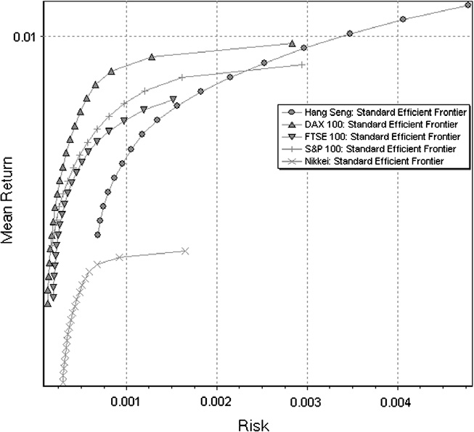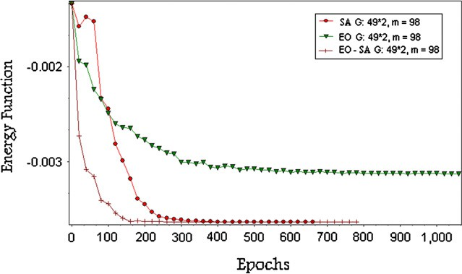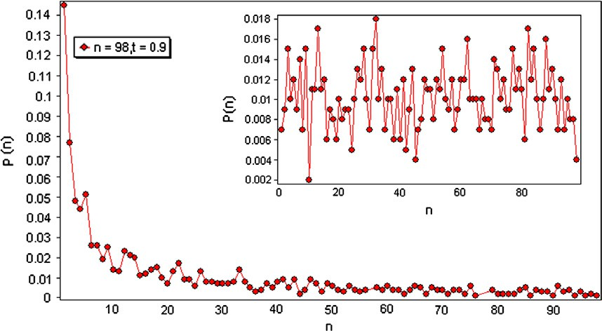

Figure 3 Comparing the distribution of spins’ selection resulting from EO–SA (external chart) and SA (internal chart), after reaching the final state for S&P stock market. *n* is the size of the portfolio.

70 M.V. Jahan, M.-R. Akbarzadeh-T

the comparison of Neural Network (NN) approach with GA, Tabu Search (TS) and SA. Table 2 allows some kind of com- parison between our spin glass (EO–SA) method results and those of paper [13]. In Table 2, Accuracy of the mentioned methods and their Run-Time are shown. Accuracy shows the degree of closeness of measurements of an objective function to its actual value that is shown as ‘‘Mean Absolute Error’’ (MAE) to actual objective function (actual cost function) va- lue. With regard to the computation times, EO–SA is the most efficient algorithm followed by TS, GA and finally NN. As compared EO–SA with other heuristic methods, EO–SA im- proves considerably MAE and run time for all different stock markets. This significantly increases the convergence speed ex- cept for the use of parallel facilities of spin glass that is com- pletely discussed in paper [6].

1. Reliability test

Table 1 Comparing the three algorithms (SA, EO and EO–SA) for accuracy and rate of convergence over 100 independent runs for each of the five World’s stock markets. Each approach is evaluated in terms of convergence time (shown in milliseconds), average minimum energy during the runs, and accuracy defined by the ratio of obtained minimum energy over actual minimal energy.

EO–SA

Convergence time (ms)

Average minimum energy

—0.00337

—0.00412

—0.00335

—0.00363

—0.00142

Accuracy (%)

1253

4091

6169

9048

98103

99.40

99.18

99.24

99.3

98.89

Test of reliability is performed by running the algorithm *n* times independently with the same data [10]. To pass the test, the test runs are expected to yield similar results with small variance. To do so, the reliability test of the three algorithms is carried out for the five benchmarks. For brevity, the analysis of S&P stock market is shown here. Results are shown in the form of the frequency chart in Figs. 4 and 5. It is done in such a way that spin glass’s minimum energy (*Egs*) in the ground state is counted and the probability to reach that state is also shown. The variance between the final energy states is given in Table 1.

EO

Convergence time (ms)

Average minimum energy

—0.0031

—0.0038

—0.0032

—0.0029

—0.00135

Accuracy (%)

92.26

92.23

95.52

79.94

95.07

Experimental results from 100 trials indicate that the algo- rithm’s final value has a small variance. In other words, final spin glass’s energy at each trial is in the range of best responses. Even though the movement towards this final response is random in the above algorithms, they consis- tently reach the ground state.

Accuracy (%)

833

6064

7741

2597

89761

1. Optimization frontier

99.20

99.10

99.20

99.36

98.91

The final Pareto front from EO–SA algorithm can be seen in Fig. 6 (The results are similar for SA). It shows the validity of energy reduction and avoiding local optimums for the five mentioned stock markets. The standard frontier for different *k*’s is also drawn. For having a Pareto frontier, *k* is consid- ered in the range of 0.05–0.95 with 0.05 differences. For any *k*, the spin glass’s optimization state was found and its risk and capital return values were defined with points. The validity of the presented algorithm in finding optimiza- tion response with different *k* was seen through comparing the resulting and standard (benchmark) Pareto fronts. Since the surface of whole optimization frontier is covered, one can draw that the presented method gives response for any *k*.

SA

Convergence time (ms)

Average minimum energy

—0.00336

—0.00412

—0.00335

—0.00363

—0.00142

HangSeng (31 Assets)

DAX (85 Assets)

FSTE (89 Assets)

S&P (98 Assets) Nikkei (225Assets)

2140

19111

25040

22828

214045

1. Phase transition analysis

Stock market

The temperature at phase transition is defined as the tempera- ture at which the likelihood of reaching the glass’s actual min- imum state suddenly decreases [11]. Fig. 7 illustrates the spin glass temperature at phase transition. As can be observed, be-

Hybrid local search algorithm via evolutionary avalanches for spin glass based portfolio selection 71

|  |  |  |  |  |  |
| --- | --- | --- | --- | --- | --- |
| Table 2 Comparison between proposed EO–SA spin glass, GA, TS and NN. The ground state of glass for each stock is calculated 100 times and the average of convergence time (Run-Time) and accuracy are listed. The experiment result numbers mentioned for GA, TS,  NN is extracted from paper [13]. | | | | | |
| Stock market |  | EO–SA | GA | TS | NN |
| Hang Seng (31 Assets) | MAE | 0.26 | 1.1321 | 1.1237 | 1.2316 |
|  | Run-Time (s) | 12 | 47 | 16 | 390 |
| DAX 100 (85 Assets) | MAE | 0.2784 | 2.4457 | 2.6668 | 1.5776 |
|  | Run-Time (s) | 21 | 162 | 45 | 1069 |
| FTSE (89 Assets) | MAE | 0.6619 | 0.7310 | 0.7357 | 1.2513 |
|  | Run-Time (s) | 27 | 160 | 51 | 1106 |
| S&P (98 Assets) | MAE | 0.571 | 1.3236 | 1.3130 | 1.7922 |
|  | Run-Time (s) | 31 | 178 | 50 | 1211 |
| Nikkei (225 Assets) | MAE | 0.9411 | 1.1415 | 0.5510 | 1.4737 |
|  | Run-Time (s) | 301 | 570 | 120 | 2827 |
|  |  |  |  |  |  |

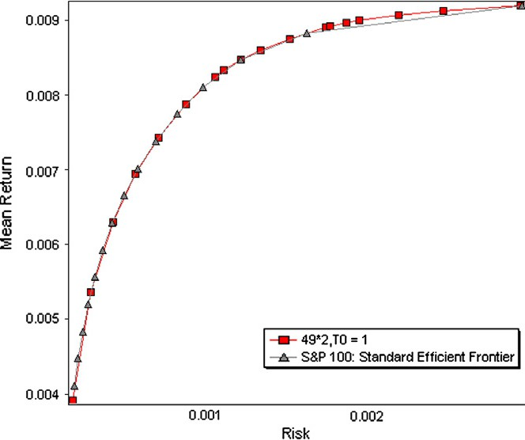Figure 4 The SA reliability test of the S&P stock market (where

*Egs* is glass energy at the ground state).

Figure 6 Efficient frontier obtained from EO–SA algorithm compared to standard efficient frontier from benchmark data [30] for stock market S&P.

Figure 5 The EO–SA reliability test with *s* = 0.9 of the S&P stock market (where *Egs* is glass energy at the ground state).

fore phase transition the probability of reaching the minimum state *Egs*  nears 1 (*E* is the ground state energy of glass, and

*E*min

*gs*

ture increases, this probability is expected to gradually de- crease, but this decrease does not occur until reaching near the temperature at phase transition, at which time, there is a sudden change in glass behavior. Here, phase transition is de-

fined to occur where the likelihood ratio *Egs* is decreased by

*E*

min

1%. As illustrated in Fig. 7, most of the benchmarks reach phase transition at 1.12 *·* 10—6 temperature (as indicated by a vertical line) for the SA algorithm. As Fig. 8 suggests, most

of the benchmarks with EO–SA find their minimum states even at higher temperatures (7.9 *·* 10—6) as compared with SA, prompting EO–SA as the algorithm that converges soon-

est. The above phase transition analysis also confirms the con- clusions of Table 1. Specifically, this experiment shows that, in EO–SA, the temperature of phase transition is higher than SA,

*E*min is the actual minimum of cost function). As the tempera- and accordingly better rate of convergence.

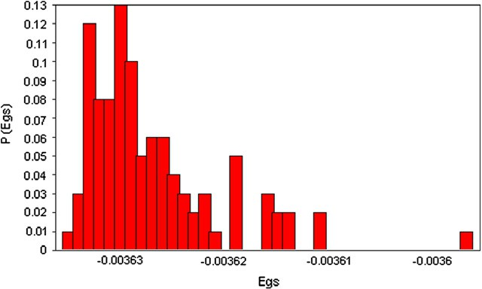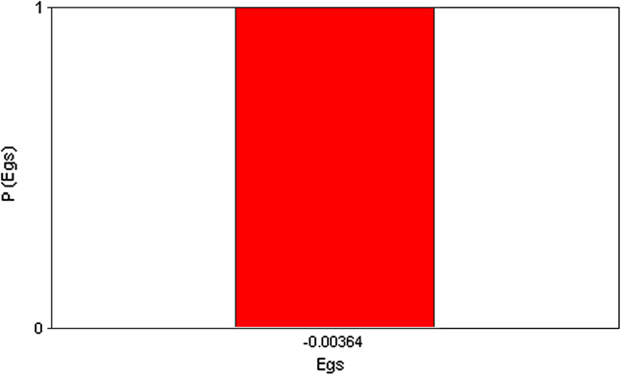

72 M.V. Jahan, M.-R. Akbarzadeh-T

A comparison of experiments shows the superiority of EO– SA to conventional EO and SA and other heuristic methods such as NN, TS and GA. And also, EO without SA has a fas- ter rate of convergence with not reliable accuracy; that is also confirmed by reliability test. In order to prove the capability of the algorithm, the efficient frontier from this algorithm is com- pared with the standard efficient frontier mentioned in bench- mark data of five major stock markets.

References

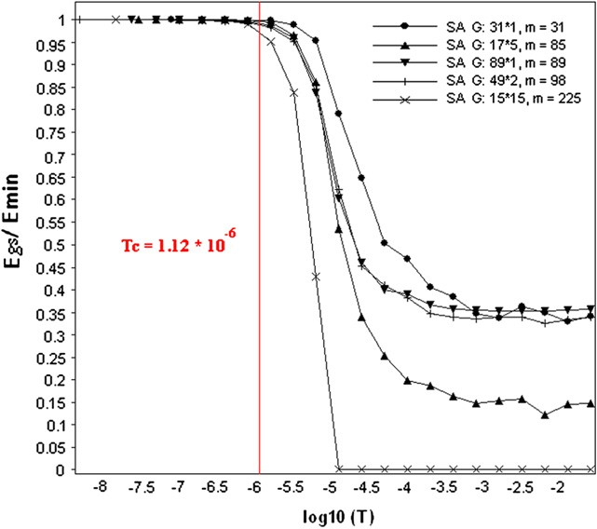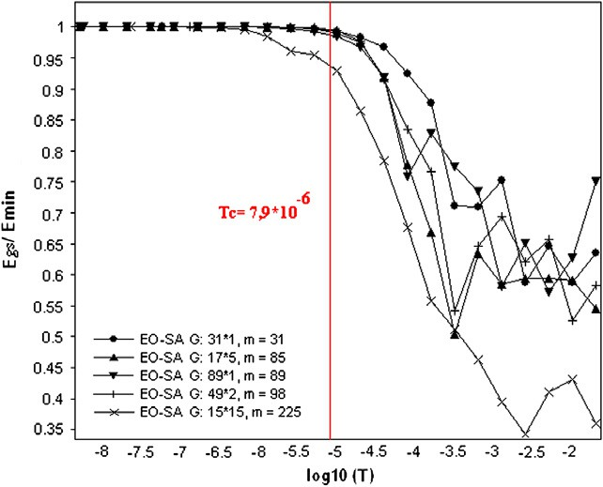

Figure 7 Portfolio selection phase transition phenomena based on SA for the five benchmark stock market data; transition

temperature is approximately 1.12 *·* 10—6.

Figure 8 Portfolio selection phase transition phenomena based on EO–SA for the five benchmark stock market data; transition

temperature is approximately 7.9 *·* 10—6.

1. Conclusion

In this paper, a hybrid approach is proposed for finding spin glass’s ground state based on EO–SA. The EO–SA method se- lects spins with minimum energy with a higher probability. So, a flip (change) in any spin leads to changes in its neighboring spins. If all of these changes reduce spin glass’s energy, more and more spins will be better qualified and the correlation be- tween spins increases. A process of self organizing criticality then occurs where the change in each spin leads to changes in many spins, allowing the glass to escape local optimums more easily.

As the experiments on phase transitions illustrate, the tem- perature at phase transition is elevated, hence the rate of con- vergence is improved.

1. Bolthausen E, Bovier A. Spin glasses. Berlin, Heidelberg: Springer-Verlag; 2007.
2. Hartmann AK, Rieger H. Optimization algorithms in physics. Wiley-VCH Verlag Co.; 2002.
3. Galluccio S, Bouchaud JP, Potters M. Rational decisions, random matrices and spin glasses. J Phys A 1998;259:449–56.
4. Kirkpatrick S, Swendsen RH. Statistical mechanics and disor- dered systems. J Commun ACM 1985;28(4).
5. Crama Y, Schyns M. Simulated annealing for complex portfolio selection problems. Eur J Oper Res 2003;150:546–71.
6. Vafaei Jahan M, Akbarzadeh-T MR. From local search to global conclusions: migrating spin glass-based distributed portfolio selection. J IEEE Trans Evol Comput 2010;14(4):591–601.
7. Narendra KS, Thathachar MAL. Learning automata: an intro- duction. Prentice Hall; 1989.
8. Boettcher S, Percus AG. Extremal optimization: an evolutionary local search algorithm. Neural, Parallel Sci Comput 2002;10(2):249–58.
9. Bak P, Sneppen K. Punctuated equilibrium and criticality in a simple model of evolution. Phys Rev Lett 1993;71:4083–6.
10. Hartmann AK, Rieger H. New optimization algorithms in physics. Wiley-VCH Verlag Co.; 2004.
11. Hartmann AK, Weigt M. Phase transitions in combinatorial optimization problems, basics, algorithms and statistical mechan- ics. Wiley-VCH Verlag Co.; 2005.
12. Gabor A, Kondor I. Portfolio with nonlinear constraints and spin glasses. Physica A 1999;274:222–8.
13. Fernandez A, Gomez S. Portfolio selection using neural networks. Comput Oper Res 2007;34:1177–91.
14. Nishimori H. Statistical physics of spin glasses and information processing: an introduction. Oxford: Clarendon Press; 2001.
15. Nishimori H. Spin glasses and information. Physica A 2007;384:94–9.
16. Horiguchi T, Takahashi H, Hayashi K, Yamaguchi C. Ising model for packet routing control. J Phys Lett A 2004;330:192–7.
17. Boettcher S, Percus AG. Extremal optimization for graph partitioning. Phys Rev E: Stat Nonlinear Soft Matter Phys 2001;64(2 Pt 2):026114 [Epub].
18. Boettcher S. Extremal optimization of graph partitioning at the percolation threshold. J Phys A: Math Gen 1999;32:5201–11.
19. Boettcher S. Extremal optimization at the phase transition of the 3-coloring problem. Phys Rev E: Stat Nonlinear Soft Matter Phys 2004;69(6 Pt 2):066703 [Epub].
20. Boettcher S, Percus AG. Optimization with extremal dynamics. Phys Rev Lett 2001;86(23):5211–4.
21. Duch J, Arenas A. Community detection in complex networks using extremal optimization. Phys Rev E 2005;72(2):1–4.
22. Garlaschelli D, Capocci A, Caldarelli G. Self-organized network evolution coupled to extremal dynamics. Nat Phys 2007;3:813–7.
23. Zhou T, Bai WJ, Cheng LJ. Continuous extremal optimization for Lennard-Jones clusters. Phys Rev E 2005;72(1):1–5.
24. Zeng GQ, Lu YZ. Survey on Computational Complexity with Phase Transitions and Extremal Optimization. In: Joint 48th IEEE conference on decision and control and 28th Chinese control conference, Shanghai, PR China; December 16–18, 2009.

Hybrid local search algorithm via evolutionary avalanches for spin glass based portfolio selection 73

1. Bar-Yam Yaneer. Dynamics of complex systems. Addison Wesley Longman, Inc.; 1997.
2. Sarkar P. A brief history of cellular automata. ACM Comput Surv 2000;32(1).
3. Markowitz H. Portfolio selection. J Finance 1952;7:77–91.
4. Coello Coello CA. An updated survey of GA-based multiobjective optimization techniques. ACM Comput Surv 2000;32(2).
5. Ingber L. Simulated annealing: practice versus theory. Math Comput Model 1993;18(11).
6. Portfolio selection benchmark data; 2000. <[http://people.brun-](http://people.brunel.ac.uk/~mastjjb/jeb/orlib/portinfo.html) [el.ac.uk/~mastjjb/jeb/orlib/portinfo.html](http://people.brunel.ac.uk/~mastjjb/jeb/orlib/portinfo.html)>.
7. Blum C, Aguilera MJ, Sampels ARM. Hybrid metaheuristics: an emerging approach to optimization. Springer-Verlag; 2008.
8. Yang XS. Introduction to mathematical optimization: from linear programming to metaheuristics. Cambridge International Science Publisher; 2008.