Full length article

Contents lists available at [ScienceDirect](http://www.sciencedirect.com/science/journal/11108665)

Egyptian Informatics Journal

journal homepage: [www.sciencedirect.com](http://www.sciencedirect.com/)

[](http://crossmark.crossref.org/dialog/?doi=10.1016/j.eij.2018.01.002&domain=pdf)Hybrid meta-heuristic optimization based energy efficient protocol for wireless sensor networks

Supreet Kaur a,⇑, Rajiv Mahajan b

a *Department of Computer Science and Engineering, Punjab Technical University, Punjab, India*

b *Golden Group of Institutes, Punjab, India*

# a r t i c l e i n f o

*Article history:*

Received 1 August 2017

Revised 11 December 2017

Accepted 5 January 2018

Available online 10 January 2018

*Keywords:*

Wireless sensor networks Ant colony optimization Energy efficient

Particle swarm optimization

# a b s t r a c t

Energy efficiency has recently turned out to be primary issue in wireless sensor networks. Sensor net- works are battery powered, therefore become dead after a certain period of time. Thus, improving the data dissipation in energy efficient way becomes more challenging problem in order to improve the life- time for sensor devices. The clustering and tree based data aggregation for sensor networks can enhance the network lifetime of wireless sensor networks. Hybrid Ant colony optimization (ACO) and particle swarm optimization (PSO) based energy efficient clustering and tree based routing protocol is proposed. Initially, clusters are formed on the basis of remaining energy, then, hybrid ACOPSO based data aggrega- tion will come in action to improve the inter-cluster data aggregation further. Extensive analysis demon- strates that proposed protocol considerably enhances network lifetime over other techniques.

© 2018 Production and hosting by Elsevier B.V. on behalf of Faculty of Computers and Information, Cairo

University. This is an open access article under the CC BY-NC-ND license ([http://creativecommons.org/](http://creativecommons.org/licenses/by-nc-nd/4.0/)

[licenses/by-nc-nd/4.0/](http://creativecommons.org/licenses/by-nc-nd/4.0/)).

1. Introduction

With the advent of Wireless Sensor Networks, inaccessible envi- ronments can be easily monitored. It is a powerful tool to gather data in many applications like military surveillance, battle-field, forestry, oceanography, temperature, pressure, humidity, etc. [1]. WSNs contain number of sensor nodes which are connected together and to a base station. WSNs include sensing of data through sensor nodes, processing of data, and transmission to base station. Charging and reinstallation of sensor nodes do not possible in difficult environments. So, energy conservation is a big challenge in WSNs. Recently, researchers gave a solution to this problem by organizing the nodes into clusters and enhance the life-time of WSNs [2]. Further, routing protocols are implemented in cluster WSNs to guide the selection of Cluster Heads (CHs) and discover best route to save the energy of nodes [3]. A typical cluster based wireless sensor network is shown in Fig. 1.

* Corresponding author.

*E-mail address:* [oberoisupreet9@gmail.com](mailto:oberoisupreet9@gmail.com) (S. Kaur).

Peer review under responsibility of Faculty of Computers and Information, Cairo University.

**Production and hosting by Elsevier**

Nayak and Anurag Devulapalli [4] utilized fuzzy logic based clustering technique to reduce the energy consumption rate fur- ther. In this method, size of cluster is optimized through Fuzzy inference engine (Mamdani’s rule). The appropriate selection of CHs reduces the energy consumption and enhances the life of net- work. Gong et al. [5] designed a routing protocol ETARP (i.e., Energy Efficient Trust-Aware Routing Protocol for Wireless Sensor Net- works) to reduce the energy consumption and increase the security during communication among nodes in WSNs. The selection of route between sensor nodes is based on utility theory. Shi et al.

[6] addressed the issue of mobile sinks like route maintenance in WSNs by introducing dynamic layered routing protocol. The distri- bution frequencies and scopes of routing updates are minimized using the combination of dynamic anchor selection and dynamic layered Voronoi scoping.

Leu et al. [7] utilized Regional Energy Aware Clustering with Iso- lated Nodes (REAC-IN) algorithm to select CHs based on weight. Weight is calculated considering each sensor’s residual energy and regional average energy of every sensor in all clusters. Shen et al. [8] solved the problem of delay in message transmission in underwater WSNs using Location-Aware Routing Protocol (LARP). In this method, position knowledge of sensor nodes is used to facil- itate message transmission. Bouyer et al. [9] used fuzzy C-means (FCM) algorithm to create optimum number of CHs in LEACH algo- rithm to reduce the energy and prolong the network life-time. Cai et al. [10] proposed Bee-Sensor-C routing protocol inspired from

<https://doi.org/10.1016/j.eij.2018.01.002>

1110-8665/© 2018 Production and hosting by Elsevier B.V. on behalf of Faculty of Computers and Information, Cairo University. This is an open access article under the CC BY-NC-ND license (<http://creativecommons.org/licenses/by-nc-nd/4.0/>).

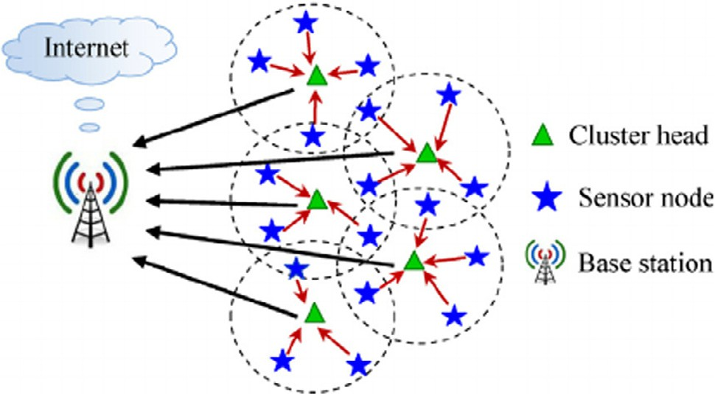

Fig. 1. Typical clustering environment of wireless sensor network.

BeeSensor (i.e. bee-inspired routing protocol) that can form clusters dynamically and transmit the data in parallel fashion.

Shankar et al. [11] used hybrid Particle Swarm Optimization (PSO) and Harmony Search Algorithm (HSA) to select CH efficiently utilizing minimum energy. Zahedi et al. [12] presented the problem of uneven distribution of CHs, unbalanced clustering, and their scope to limited applications of WSNs. They used fuzzy c-means clustering algorithm to create balanced clusters and Mamdani fuzzy inference system to select suitable CHs. Fuzzy rules are opti- mized through swarm intelligence algorithm based on firefly algorithm.

Sabet and Naji [13] implemented the multi-level route-aware clustering (MLRC) technique to save energy in decentralized clus- tering protocols. The main advantage of this protocol is that it cre- ates a cluster and routing tree, simultaneously, to reduce an unnecessary generation of routing control packets.

Naranjo et al. [14] presented Prolong- Stable Election Protocol (P-SEP) to elect the CHs among heterogeneous nodes in fog- supported WSNs to increase the life of network. Xenakis et al.

[15] utilized simulated annealing technique to control the topology by maximizing the network coverage and lifetime of WSNs as objective functions. Nayak and Vathasavai [16] utilized type-2 fuzzy logic in WSNs to make a decision for CH efficiency. Ouchi- tachen et al. [17] implemented IMOWCA (Improved Multi- Objective Weighted Clustering Algorithm) for the selection of CHs. Residual energy is used to select the best performing node for further communication with BS. Base Station Genetic Algorithm is utilized to balance the energy among different clusters.

Elshrkawey et al. [18] addressed the issues of LEACH protocol like improper selection of CH, formation of unbalanced clusters, and continuous transmission of updating data. They used threshold value to elect CHs, sensor nodes send their updated data in their allotted time, and modified TDMA scheduling is utilized to break steady state phase. Rani et al. [19] used E-CBCCP protocol to cache the data at CH and relay node to evade the communication of same data packets. Control packets are used to inform all sensor nodes that data packets are same and do not transmit the data packets. Laouid et al. [20] designed an approach to select the best route based on hop count and residual energy of each sensor node to maximize the life of network.

Ez-zazi et al. [21] utilized adaptive coding scheme considering channel state and distance between inter nodes to scrutinize the trade-off between energy efficiency and reliability. Huang et al.

[22] used public transportation vehicles as mobile sinks to gather data. To balance the energy consumption, an energy-aware routing and energy-aware unequal clustering algorithms are used.

In this paper, we have proposed a hybrid meta-heuristic opti- mization based energy efficient protocol. Because, GSTEB protocol routing tree is manufactured where tree centered routing is per- formed to transmit knowledge to the bottom section. In case, if

the parent node dies the topography must be repair again that’ll consume a lot of power and there might be loss of knowledge also. To prevail around the problem of sign delay and knowledge reduc- tion in the system because of the nodes disappointment in the root to sink, cluster based aggregation process can be utilized. In big sys- tem, well- organized sign of knowledge to the sink requires obtain- ing the maximum route according to how many trips; therefore, knowledge can be aggregated at cluster head which needs to be transmitted to the bottom station. The clustering strategy may minimize knowledge redundancy and reduce the congestive rout- ing traffic in knowledge transmission. Following the clustering tree centered routing at the cluster-heads it is required to obtain the shortest route between the source and the sink, but the smallest route issue is NP-Hard in nature [22].

Contribution: Following are our main contributions in this research paper:

1. First of all, we have evaluated the performance of some well- known existing energy efficient protocols for WSNs.
2. Based upon the comparative analysis we have found that effective inter-cluster data aggregation using metaheuristic techniques can improve the network lifetime further.
3. We have designed and implemented a well-known hybrid ACO-PSO based clustering GSTEB protocols to enhance the results further.
4. Extensive analysis has also been done to evaluate the effec- tiveness of the proposed technique.

Rest of the paper is organized as follows: In Section 2, network energy model is described for WSNs. Section 3, describes the pro- posed technique with suitable mathematical formulation. Experi- mental set-up and results are described in Section 4. Concluding remarks are discussed in Section 5.

1. Network energy model

In this research work, we have randomly deployed WSN with ‘‘N” sensor nodes in M⁄N network field. All nodes even including the sink are stationary in nature. Each node has its own unique identification number. Each node monitors the given environment and communicate data with sink. Whenever communication is done given node have to spent some energy based upon the dis- tance (D) with sink. All the communication links are symmetric in nature.

* 1. *Energy model*

Whenever a node sends or receives sensed information it has to spend some energy based upon two channel propagation models

called free space (D2 power loss) for the purpose of one-hop or direct transmission and the multipath fading channel (D4 power loss) for packet transmission via multihop. Therefore, energy con-

sumption model can be mathematically defined as follows:

( LEn(elec) + L*e*fres D2 , D < D0,

* + 1. The following set of the ants can now study on the phero- mone deposit feedback left by the formerly visited success- ful ants and will soon be guided to follow along with the quickest path.
    2. When ants walk from CHi to CHj where i – j, the chance in

the selection principle (so called pheromone) for a simple

## EnTrx(L, D)=

En(elec)

,j

+ L*e*mpat

D4 *D* P D0,

(1)

ant is computed as follows:

Here, L is the size of data packet. *e*fres represents free space energy

## Pi =

,

(si,j)*a* + (*g*i )*b*

## (5)

loss. *e*mpat is multipath energy loss. D0 is a threshold distance which controls states whether to use *e*fres or *e*mpat . D0 is computed as

,j R(s

i,j

)*a*(*g*i j)*b*

follows:

## sﬃ*e*ﬃﬃﬃﬃﬃﬃﬃﬃﬃ

Here, si,j represents the amount of pheromone deposit from

CHi to CHj. *g*i,j is the trail visibility function that is equiva-

## D0 =

fres

*e*mpat

(2)

lent to the reciprocal of the energy distance between CHi and CHj. a is the parameter to adjust the amount of phero- mone si,j.. *b* is a parameter to adjust the heuristic visibility

* 1. *Cluster head (CH) formation*

In this section, level-based clustering will be discussed. CHs are formed using energy aware threshold function. It states that nodes who have more energy will have more probability to become CHs. Each node generates a random value and try to become CH. If ran- dom value is less than the evaluated Threshold (T(i)), then it will become CH. T(i) is mathematically evaluated as follows:

)

+(

function *g*i,j.

1. if the link between two CHs exists, then Pi,jwill be updated

else

Pij = 0. end

1. Evaluate the Euclide an Distance (*DIS*) between the cluster head i and cluster head j as follows:

T(i)= Popt

1 — p

r.mod p1

opt

## Ei(r)

*

Eavg(r)

opt

## For all nodes if Ei(r) > 0

*DIS* = q(ﬃﬃ*C*ﬃﬃﬃ*H*ﬃﬃﬃﬃﬃﬃ·ﬃﬃ*x*ﬃﬃﬃ*d*ﬃﬃﬃ—ﬃﬃﬃﬃﬃ*C*ﬃﬃﬃ*H*ﬃﬃﬃﬃﬃﬃ·ﬃﬃ*x*ﬃﬃ*d*ﬃﬃﬃﬃﬃ2ﬃﬃﬃﬃﬃﬃﬃﬃﬃﬃ*C*ﬃﬃ*H*ﬃﬃﬃﬃﬃﬃ·ﬃﬃﬃ*y*ﬃﬃ*d*ﬃﬃﬃﬃ—ﬃﬃﬃﬃﬃ*C*ﬃﬃ*H*ﬃﬃﬃﬃﬃﬃ·ﬃﬃ*y*ﬃﬃﬃ*d*ﬃﬃﬃ)ﬃﬃ2ﬃ

## (6)

(3)

*i*

*j*

*i*

*j*

Here, r represents the current round in WSNs network lifetime, Ei(r) is the current energy of given node i.

Eavg represents average remaining energy which is evaluated as follows:

## P Ei(r)

Eavg =

N for every node i (4)

Here, *xd* and *yd* represent x and y coordinates of give *CH*.

1. P values will be updated by all the ants which have reached the BS successfully.
2. Pheromone evaporation (*q*) on the edge between

CHi and CHj is calculated using following formula:

sij ← (1 — *q*)sij (7)

Before adding the P, the evaporation action has to be per-

Here, N represents the total number of nodes.

1. Proposed technique

In this section, we propose an ACOPSO-GSTEB based routing technique to develop shortest path between available CHs and the sink. ACOPSO is a well-known metaheuristic technique which has ability to find optimal path between given set of nodes with sink as destination.

* 1. *Ant colony optimization (ACO) based path selection*

This section describes ACO based path selection technique. In this technique, a minimum cost based spanning tree (shortest path) is formed between CHs and the sink.

1. Initialize CHs as ants combined with sink as Destination.
2. Going of virtual ant depends on the amount of pheromone on the CH distances.
3. The first in ACO could be the trail collection between neigh- boring clusters, some synthetic ants (CHs) are simulated from the CHs to the sink.
4. The ahead ants are choosing the following CH randomly for

formed. The evaporation helps to find the shortest path and provide that no other path will be assessed as the short- est. This evaporation of pheromones has an intensity q.

1. CHs not chosen by artificial ants, the

*amount of P decreases exponentially*.

1. During every iteration (t) = {1, 2, 3, 4.. .n}, when all the ants reach to sink, then the value of the sij is calculated as follows:

sij(t + n)= *q* · sij(t)+ Dsij (8)

Here, Dsij represents the amount of pheromone being deposited.

1. If ant k has passed some edge between the CHs, it will leave P which is inversely proportional to the total length of all the edges ant k has passed from the starting CH to the BS by using the following formula:

m

*s*ij ← sij + XDs , 6(i, j)∈ L (9)

K

ij

K=1

Here, Dsijk is the amount of P ant k deposits on the edges visited. It is calculated by the following expression:

initially taking the data from the length matrix and the ants who are successful in achieving the sink are updating the pheromone deposit at the edges visited by them by an amount (CL), where M is the sum total journey period of

ij

DsK =

1/CK

0

(

//Where CKis the total length of all the edges

(10)

the ant and D a constant price that is adjusted in line with the fresh problems to the perfect value.

1. Now the path with best P value (minimum distance) is selected and assign as initial solution for
2. In the end Particl swarm opitmization (PSO) will comes in action to minimize the path cost fruther. The procedure of PSO is described in the following section.
   1. *Particle swarm optimization based path selection*

If newfv > oldfv oldfv = newfv;

else

old particle is forwarded to next iteration End

## (14)

PSO initializes itself with output of ACO solutions so called par- ticles. Each particle keeps the stored record for all its coordinates which are related to obtaining the optimal solution by following the current best particles. Objective function of every particle is evaluated and stored. The fitness value of the current optimum par- ticle is called pBest. When all the generated populations are consid- ered then the best value is chosen among the generated population and that particular best value is the best solution called gBest. In this paper minimum path cost is taken as objective function. PSO always try to change the velocity of every particle towards its pBest. The velocity is determined by random terminologies, which is having randomly generated numbers for velocity towards pBest. PSO always stores and maintains a record of results for three global variables such as target value or condition, gBest, and termi- nation value. Every evaluated particle of PSO comprises the follow-

ing information:

1. A data which can represent a global solution so called gBest.
2. Value for velocity which will indicate the amount of data to be changed.
3. pBest value.
4. First of all, we have assumed all CHs as particles which have two dimensions such as particle position and velocity.
5. Now initiate solutions based upon random distribution. Number of random solution are based upon the size of population.
6. Now estimation of fitness value will be done using fitness func- tion which is minimum path distance. The distance between two nodes will be calculate using Euclidian distance as:

Here, oldfv is old known best value so fart and newfv is new fitness value.

1. For every iteration, one best solution is selected as a pBest. The particle which has maximum fitness value in the current itera- tion is selected as pBest solution.
2. The pBest solutions from all iterations of the particle in which has maximum among all solutions are selected as a gBest solu- tion. Finally, the particle which has a gBest solution is elected as current inter cluster data aggregation path.
3. Experimental set-up and results

The MATLAB simulation tool is used for simulation purpose. It evaluates the performance of the proposed technique with existing technique i.e. GSTEB on the following metrics i.e. stability period, network lifetime, residual energy (average remaining energy), and throughput by taking 100 sensor nodes. Other parameters for sim- ulation are adapted from the GSTEB. The sensors have been dis- tributed arbitrarily in a 100 × 100 area with base station at (50 m, 150 m). Table 1 shows the various simulation parameters for comparative analysis.

Throughput represents number of packets which are success- fully transferred to the sink. Fig. 2 represents the comparison of the proposed technique with available one. The figure is cleary indi- cating that the throughput of the proposed technique is signifi- cantly improved. Therefore, compared to available protocols, it is found that the throughput of the proposed technique is signifi-

## D = qﬃ(ﬃxﬃﬃﬃ1ﬃﬃﬃ—ﬃﬃﬃﬃﬃxﬃﬃﬃ2ﬃﬃ)ﬃﬃ2ﬃﬃﬃ+ﬃﬃﬃﬃﬃ(ﬃyﬃﬃﬃ1ﬃﬃﬃ—ﬃﬃﬃﬃﬃyﬃﬃﬃ2ﬃﬃ)ﬃﬃ2ﬃ

cantly more than available well-known energy efficient protocols.

(11) Network lifetime of a network is the time when first and last ever node die in the network. Fig. 3 represents the comparison of

Here, (x1, y1) are position values of node 1 and (x1, y1) are

position values of node 2. After determining the aggregated distance cost for every solution which is fitness value. It is just required to evaluate gBest which is minimum aggregated dis- tance for every random solution.

1. Generation of new particles from the initial set of random solu- tions. Formation of new particles from the old one is a genera- tion of a new particle:
   1. Estimation of new velocity: the current velocity of a taken particle is considered to the rate at which the particle’s position is changed. New velocity is calculated as follows:

## newv = x * oldv + x1(lBestp — cBestp)+ x2 + w2(gBestp — cBestp)

(12)

Here, x represents the inertia weight. x1 and x2 are basic PSO tun- ing parameters. v represents the velocity and p determine the posi- tion value.

* 1. Estimation of new position of the particle is as follows:

## newp = oldp + newv (13)

Finally, the new particle (newv and newp) arrives.

1. Calculation of fitness value for newp is estimated by using the distance of the path.
2. Fitness value of old particle and new particle is compared and the best one is selected for the next iteration:

the proposed technique with available one. The figure is cleary indi- cating that the network lifetime of the proposed technique is signif- icantly improved. Compared to available protocols, it is found that the network lifetime of the proposed technique is quite more than available well-known protocols.

Residual energy of a network is the time when last ever node die in the network. Fig. 4 represents the comparison of the proposed technique with available one. The figure is cleary indicating that the Residual energy of the proposed technique is significantly improved. When compared with available protocols, it is found that the Residual energy of the proposed technique is consistent and maximized than available well-known protocols.

Table 1

WSNs set-up.

Parameter Value

Area (x, y) 100, 100

Base station (x, y) 50, 50 or 50, 150

Nodes (n) 100

Probability (p) 0.1

Initial energy 0.1

Transmiter_energy 50 * 10—9

Receiver_energy 50 * 10—9

Free space (amplifier) 10 * 10—13

Multipath (amplifier) 0.0013 * 10—13

Effective data aggregation 5 * 10—9

Maximum lifetime 2500

Data packet size 4000

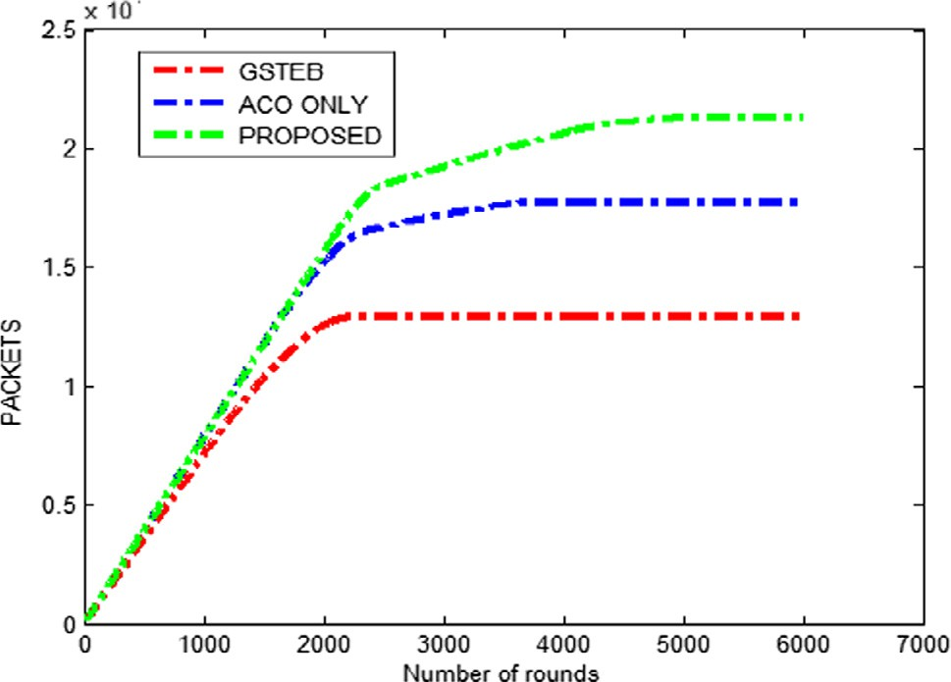

Fig. 2. Comparison of throughput anaysis.

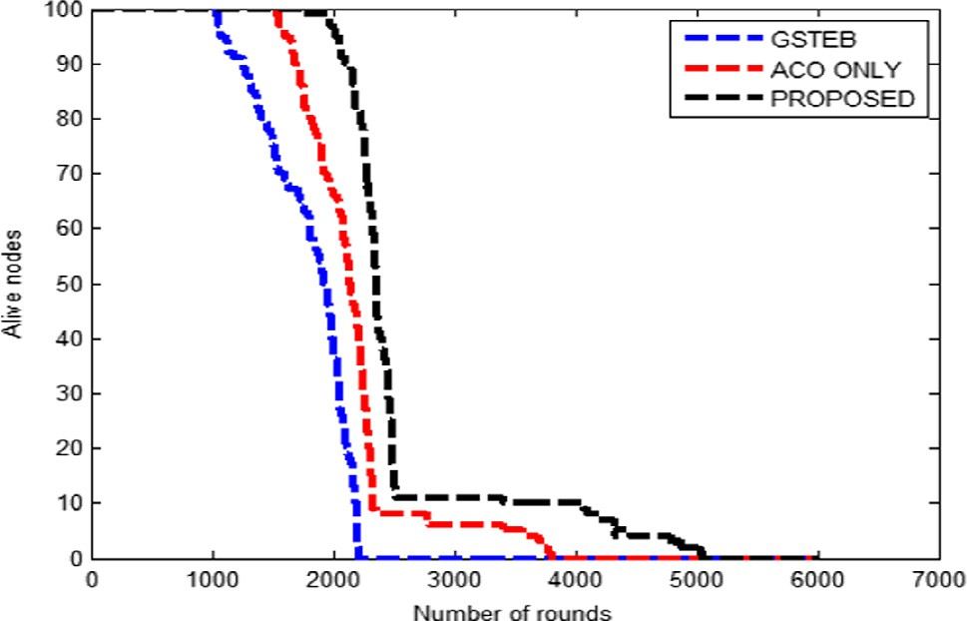

Fig. 3. Comparison of the network lifetime.

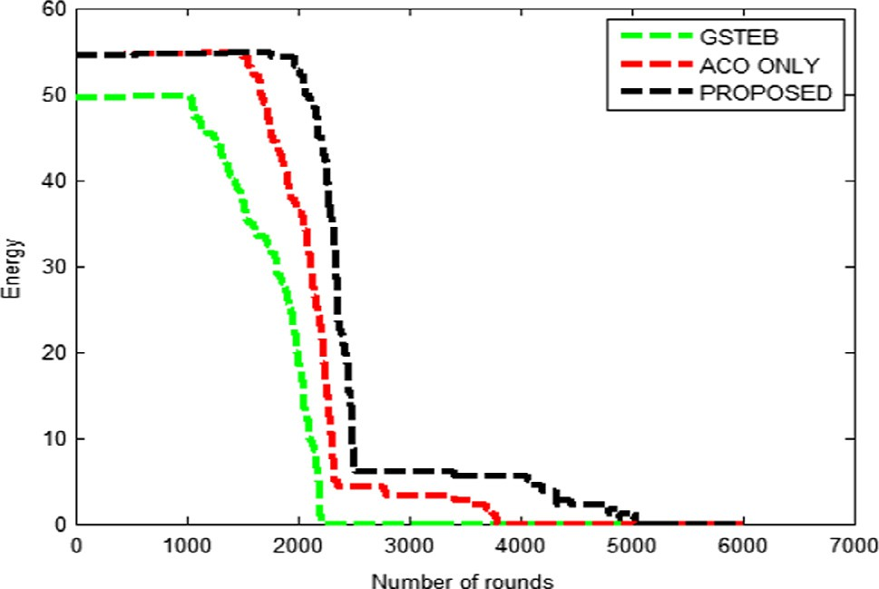

Fig. 4. Comparison of the residual energy.

To evaluate the effectiveness of the proposed technique, it has been compared with two well-known meta-heuristic based energy efficient protocols. These meta-heuristic techniques are Genetic algorithm and Artificial bee colony. To compare the proposed tech- nique with other techniques residual energy and throughput met- rices have been considered. Subsequent tables describe the evaluate values with respect to scale in number on nodes.

Table 2 demonstrates the effect of scale in number of nodes in case of existing and proposed techniques. It has been observed that

Table 2

Residual energy evaluation.

Nodes Genetic algorithm Artificial bee colony Proposed

|  |  |  |  |
| --- | --- | --- | --- |
| 100 | 0.41 ± 0.19 | 0.49 ± 0.20 | 0.51 ± 0.15 |
| 150 | 0.28 ± 0.23 | 0.27 ± 0.19 | 0.31 ± 0.28 |
| 200 | 0.40 ± 0.24 | 0.42 ± 0.14 | 0.43 ± 0.16 |
| 250 | 0.38 ± 0.20 | 0.37 ± 0.13 | 0.41 ± 0.19 |
| 300 | 0.26 ± 0.28 | 0.24 ± 0.18 | 0.29 ± 0.15 |
| 350 | 0.32 ± 0.21 | 0.33 ± 0.22 | 0.34 ± 0.19 |
| 400 | 0.44 ± 0.23 | 0.45 ± 0.17 | 0.47 ± 0.16 |

Table 3

Throughput analysis.

|  |  |  |  |
| --- | --- | --- | --- |
| Nodes | Genetic algorithm | Artificial bee colony | Proposed |
| 100 | 8.15 ± 2.4 | 9.25 ± 2.3 | 10.45 ± 3.8 |
| 150 | 11.36 ± 2.9 | 10.46 ± 1.9 | 12.60 ± 2.4 |
| 200 | 16.28 ± 2.8 | 17.62 ± 3.0 | 18.59 ± 2.6 |
| 250 | 21.92 ± 3.1 | 22.75 ± 2.8 | 23.98 ± 2.9 |
| 300 | 24.50 ± 3.4 | 23.33 ± 3.5 | 23.60 ± 3.4 |
| 350 | 27.34 ± 3.8 | 28.24 ± 2.9 | 29.14 ± 2.3 |
| 400 | 32.57 ± 2.9 | 33.60 ± 3.2 | 34.70 ± 2.7 |

proposed technique significantly improves the residual energy compared to each technique. Since, sensor networks have been deployed randomly, therefore, evaluated values have some fluctuations which have been shown using the variation with the help of .

Table 3 shows the comparison between existing and proposed techniques in terms of throughput analysis. It has been observed that the proposed technique has significantly improved the throughput (i.e. approximately 2.7897%) compared to existing pro- tocols. Therefore, proposed technique provides more efficient results compared to existing techniques.

1. Conclusions

This paper proposes a hybrid protocol which utilizes clustering, ACOPSO based clustering protocol for WSNs. It decomposes the sensor network into numerous segments thus called clusters and cluster heads are chosen in every cluster. Then, tree based data aggregation come in action and collects sensing information directly from cluster heads by utilizing short distance communica- tions. The ACOPSO optimization evaluates the shortest path among sink and cluster heads. The use of compressive sensing reduces the packet size which is going to be transmitted in the sensor network. The MATLAB simulation tool is used for simulation purpose. It eval- uates the performance of the proposed technique with existing technique i.e. GSTEB on the following metrics i.e. stability period, network lifetime, residual energy (average remaining energy), and throughput by taking 100 sensor nodes. Other parameters for sim- ulation are adapted from the GSTEB. The sensors distributed arbi- trarily in a 100 × 100 area with base station at (50 m, 50 m). Extensive analysis shows that the hybrid protocol considerably enhances network lifetime by conserving the energy in more effi- cient manner than other protocols at present deployed for sensor networks.

Conflict of interest

There is no conflict of interest regarding the publication of this paper.

References

1. [Arora, Kumar Vishal, Sharma Vishal, Sachdeva Monika. A survey on LEACH and](http://refhub.elsevier.com/S1110-8665(17)30065-8/h0005) [other’s routing protocols in wireless sensor network. Optik-Int J Light Electron](http://refhub.elsevier.com/S1110-8665(17)30065-8/h0005) [Opt 2016;127(16):6590–600](http://refhub.elsevier.com/S1110-8665(17)30065-8/h0005).
2. [Azharuddin Md, Kuila Pratyay, Jana Prasanta K. Energy efficient fault tolerant](http://refhub.elsevier.com/S1110-8665(17)30065-8/h0010) [clustering and routing algorithms for wireless sensor networks. Comput Electr](http://refhub.elsevier.com/S1110-8665(17)30065-8/h0010) [Eng. 2015;41:177–90](http://refhub.elsevier.com/S1110-8665(17)30065-8/h0010).
3. Luis Javier García Villalba, Sandoval Orozco Ana Lucila, Triviño Cabrera Alicia, Barenco Abbas Claudia Jacy. Routing protocols in wireless sensor networks. Sensors 9(11): 2009; 8399–8421.
4. [Nayak Padmalaya, Devulapalli Anurag. A fuzzy logic-based clustering algorithm](http://refhub.elsevier.com/S1110-8665(17)30065-8/h0020) [for wsn to extend the network lifetime. IEEE Sens J 2016;16(1):137–44](http://refhub.elsevier.com/S1110-8665(17)30065-8/h0020).
5. [Gong Pu, Chen Thomas M, Xu Quan. ETARP: an energy efficient trust-aware](http://refhub.elsevier.com/S1110-8665(17)30065-8/h0025) [routing protocol for wireless sensor networks. J Sens 2015;2015](http://refhub.elsevier.com/S1110-8665(17)30065-8/h0025).
6. [Shi Lei, Yao Zheng, Zhang Baoxian, Li Cheng, Ma Jian. An efficient distributed](http://refhub.elsevier.com/S1110-8665(17)30065-8/h0030) [routing protocol for wireless sensor networks with mobile sinks. Int J Commun](http://refhub.elsevier.com/S1110-8665(17)30065-8/h0030) [Syst 2015;28(11):1789–804](http://refhub.elsevier.com/S1110-8665(17)30065-8/h0030).
7. [Leu Je-Shiou, Chiang Tu-Hung, Min-Chieh Yu, Su Kuan-Wu. Energy efficient](http://refhub.elsevier.com/S1110-8665(17)30065-8/h0035) [clustering scheme for prolonging the lifetime of wireless sensor network with](http://refhub.elsevier.com/S1110-8665(17)30065-8/h0035) [isolated nodes. IEEE Commun Lett 2015;19(2):259–62](http://refhub.elsevier.com/S1110-8665(17)30065-8/h0035).
8. [Shen Jian, Tan Hao-Wen, Wang Jin, Wang Jin-Wei, Lee Su-Young. A novel](http://refhub.elsevier.com/S1110-8665(17)30065-8/h0040) [routing protocol providing good transmission reliability in underwater sensor](http://refhub.elsevier.com/S1110-8665(17)30065-8/h0040) [networks. Sensors 2015;16(1):171–8](http://refhub.elsevier.com/S1110-8665(17)30065-8/h0040).
9. [Bouyer Asgarali, Hatamlou Abdolreza, Masdari Mohammad. A new approach](http://refhub.elsevier.com/S1110-8665(17)30065-8/h0045) [for decreasing energy in wireless sensor networks with hybrid LEACH protocol](http://refhub.elsevier.com/S1110-8665(17)30065-8/h0045) [and fuzzy C-means algorithm. Int J Commun Networks Distrib Syst 2015;14](http://refhub.elsevier.com/S1110-8665(17)30065-8/h0045) [(4):400–12](http://refhub.elsevier.com/S1110-8665(17)30065-8/h0045).
10. [Cai Xuelian, Duan Yulong, He Ying, Yang Jin, Li Changle. Bee-sensor-C: an](http://refhub.elsevier.com/S1110-8665(17)30065-8/h0050) [energy-efficient and scalable multipath routing protocol for wireless sensor](http://refhub.elsevier.com/S1110-8665(17)30065-8/h0050) [networks. Int J Distrib Sens Netw 2015;11(3):976127](http://refhub.elsevier.com/S1110-8665(17)30065-8/h0050).
11. [Shankar T, Shanmugavel S, Rajesh A. Hybrid HSA and PSO algorithm for energy](http://refhub.elsevier.com/S1110-8665(17)30065-8/h0055) [efficient cluster head selection in wireless sensor networks. Swarm Evol](http://refhub.elsevier.com/S1110-8665(17)30065-8/h0055) [Comput 2016;30:1–10](http://refhub.elsevier.com/S1110-8665(17)30065-8/h0055).
12. [Zahedi Zeynab Molay, Akbari Reza, Shokouhifar Mohammad, Safaei Farshad,](http://refhub.elsevier.com/S1110-8665(17)30065-8/h0060) [Jalali Ali. Swarm intelligence based fuzzy routing protocol for clustered](http://refhub.elsevier.com/S1110-8665(17)30065-8/h0060) [wireless sensor networks. Expert Syst Appl 2016;55:313–28](http://refhub.elsevier.com/S1110-8665(17)30065-8/h0060).
13. [Sabet Maryam, Naji Hamidreza. An energy efficient multi-level route-aware](http://refhub.elsevier.com/S1110-8665(17)30065-8/h0065) [clustering algorithm for wireless sensor networks: a self-organized approach.](http://refhub.elsevier.com/S1110-8665(17)30065-8/h0065) [Comput Electr Eng 2016;56:399–417](http://refhub.elsevier.com/S1110-8665(17)30065-8/h0065).
14. [Naranjo Paola G Vinueza, Shojafar Mohammad, Mostafaei Habib, Pooranian](http://refhub.elsevier.com/S1110-8665(17)30065-8/h0070) [Zahra, Baccarelli Enzo. P-SEP: a prolong stable election routing algorithm for](http://refhub.elsevier.com/S1110-8665(17)30065-8/h0070) [energy-limited heterogeneous fog-supported wireless sensor networks. J](http://refhub.elsevier.com/S1110-8665(17)30065-8/h0070) [Supercomput 2017;73(2):733–55](http://refhub.elsevier.com/S1110-8665(17)30065-8/h0070).
15. Xenakis A, Foukalas F, Stamoulis G, Katsavounidis I. Topology control with coverage and lifetime optimization of wireless sensor networks with unequal energy distribution. Comput Electr Eng, June 2017.
16. [Nayak Padmalaya, Vathasavai Bhavani. Energy efficient clustering algorithm](http://refhub.elsevier.com/S1110-8665(17)30065-8/h0080) [for multi-hop wireless sensor network using type-2 fuzzy logic. IEEE Sens J](http://refhub.elsevier.com/S1110-8665(17)30065-8/h0080) [2017;17(14):4492–9](http://refhub.elsevier.com/S1110-8665(17)30065-8/h0080).
17. [Ouchitachen Hicham, Hair Abdellatif, Idrissi Najlae. Improved multi-objective](http://refhub.elsevier.com/S1110-8665(17)30065-8/h0085) [weighted clustering algorithm in Wireless Sensor Network. Egypt Inform J](http://refhub.elsevier.com/S1110-8665(17)30065-8/h0085) [2017;18(1):45–54](http://refhub.elsevier.com/S1110-8665(17)30065-8/h0085).
18. Elshrkawey Mohamed, Elsherif Samiha M., Wahed M. Elsayed. An enhancement approach for reducing the energy consumption in wireless sensor networks. J King Saud Univ – Comput Inform Sci, Available online 7 April 2017, ISSN 1319-1578.
19. Rani Shalli, Ahmed Syed Hassan, Malhotra Jyoteesh, Talwar Rajneesh. Energy efficient chain based routing protocol for underwater wireless sensor networks. J Network Comput Appl 92: 15 August 2017; 42–50, ISSN 1084-

8045.

1. [Laouid Abdelkader, Dahmani Abdelnasser, Bounceur Ahcène, Euler Reinhardt,](http://refhub.elsevier.com/S1110-8665(17)30065-8/h0100) [Lalem Farid, Tari Abdelkamel. A distributed multi-path routing algorithm to](http://refhub.elsevier.com/S1110-8665(17)30065-8/h0100) [balance energy consumption in wireless sensor networks. Ad Hoc Netw](http://refhub.elsevier.com/S1110-8665(17)30065-8/h0100) [2017;64:53–64](http://refhub.elsevier.com/S1110-8665(17)30065-8/h0100).
2. Ez-zazi Imad, Arioua Mounir, Oualkadi Ahmed El, Lorenz Pascal. On the performance of adaptive coding schemes for energy efficient and reliable clustered wireless sensor networks. Ad Hoc Networks, 64: September 2017; 99–111, ISSN 1570-8705.
3. Han Zhao, Wu Jie, Zhang Jie, Liu Liefeng, Tian Kaiyun. A general self-organized tree-based energy-balance routing protocol for wireless sensor network; 2014.

pp. 1–2.