[Egyptian Informatics Journal 22 (2021) 473–478](https://doi.org/10.1016/j.eij.2021.03.002)

Contents lists available at [ScienceDirect](http://www.sciencedirect.com/science/journal/11108665)

Egyptian Informatics Journal

journal homepage: [www.sciencedirect.com](http://www.sciencedirect.com/)

[](http://crossmark.crossref.org/dialog/?doi=10.1016/j.eij.2021.03.002&domain=pdf)Implementing MRCRLB technique on modulation schemes in wireless rechargeable sensor networks

Mohit Angurala a,⇑, Manju Bala b, Sukhvinder Singh Bamber c

a *Department of Computer Science & Engineering, Punjab Technical University, Kapurthala, Punjab, India*

b *Department of Computer Science & Engineering, Khalsa College of Engineering and Technology, Amritsar, Punjab, India*

c *Department of Computer Science & Engineering, University Institute of Engineering & Technology, Panjab University SSG Regional Centre, Hoshiarpur, Punjab, India*

# a r t i c l e i n f o

*Article history:*

Received 31 July 2020

Revised 3 January 2021

Accepted 23 March 2021

Available online 3 April 2021

*Keywords:*

Magnetic resonant coupling Modulation techniques Modified AODV

Recharging

Wireless sensor networks

# a b s t r a c t

As battery technology has not advanced as quickly as other technologies like semiconductor technology, energy efficiency is still one of the primary concerns in Wireless Sensor Networks (WSNs). One of the fin- est Wireless Energy Transfer (WET) technique is Magnetic Resonant Coupling (MRC) used to re-energize the nodes in WSNs. Recent advancements in MRC show that more than one node can be re-charged at the same time. This paper aims to exploit multiple nodes WET to overcome the issues pertaining to energy in Wireless Sensor Network (WSN). For transferring energy to various static sensor nodes deployed in a net- work, Unmanned Aerial Vehicle (UAV) is considered which travels inside a network and performs a pro- cess of re-charging. Further, WSNs being most acceptable face issues like: battery constraint, and congestion. Therefore, in order to address such issues, we have proposed MRCRLB (Magnetic Resonant Coupling Based Recharging and Load Balancing) scheme. Then, finally the proposed model is tested on various modulation schemes at the physical layer of WSNs to find out most appropriate modulation scheme type for lifetime extension model (MRCRLB).

© 2021 THE AUTHORS. Published by Elsevier BV. on behalf of Faculty of Computers and Artificial Intel-

ligence, Cairo University. This is an open access article under the CC BY-NC-ND license ([http://creative-](http://creativecommons.org/licenses/by-nc-nd/4.0/)

[commons.org/licenses/by-nc-nd/4.0/](http://creativecommons.org/licenses/by-nc-nd/4.0/)).

1. Introduction

WSNs are widely used in various applications types such as: medical treatment, battlefield, industrial monitoring, and threat detection. One of the major concerns in WSNs is the maintenance of sensor nodes, as most of them are battery operated. These sensor nodes are often positioned in harsh environments that are difficult to reach. Thus, short battery lifetime in WSNs is one of the major limitations of sensor node. Moreover, it is mandatory to deploy of large number of wireless sensing devices for various purposes like temperature sensing, humidity sensing and many more. Energy harvesting is a method to recharge the nodes, that is, it is

* Corresponding author.

*E-mail addresses:* [mohitpit@gmail.com](mailto:mohitpit@gmail.com) (M. Angurala), [drmanju571@gmail.com](mailto:drmanju571@gmail.com) (M. Bala), [ss.bamber@pu.ac.in](mailto:ss.bamber@pu.ac.in) (S. Singh Bamber).

Peer review under responsibility of Faculty of Computers and Artificial Intelligence, Cairo University.

**Production and hosting by Elsevier**

being used as a power source for sensor nodes. Thus, this elimi- nates the traditional way of periodic battery replacements. Gener- ally, for an energy harvesting process, an energy storage device is required because the harvested energy has an unstable nature. Besides this, small currents are required for energy storage devices to be charged without leakage in different environments. In WSNs, lifetime of a battery is the main parameter that is considered vital for ensuring long connectivity among the sensor nodes. Capacity of a battery has a strong impact on the size and cost of a device and is strongly dependent on the energy utilization of electronic equip- ments. While lifetime of sensor nodes can be increased by reducing the energy utilization of devices by using ultra low power compo- nents and accurate design, but these are expensive methods. Instead, the device can be equipped with rechargeable batteries that could be powered using harvesting mechanisms such as: solar, Radio Frequency (RF) and many more. Other ways to increase the lifetime of sensor nodes are using optimum topology and selecting proper modulation technique. One of our previous works [2] com- pared different modulation schemes based on the throughput anal- ysis. In this research paper a comparison was made based on throughput for Binary Phase-Shift Keying (BPSK), Quadrature Phase-Shift Keying (QPSK), 16 Quadrature Amplitude Modulation (16 QAM) and 64 Quadrature Amplitude Modulation (64 QAM).

<https://doi.org/10.1016/j.eij.2021.03.002>

1110-8665/© 2021 THE AUTHORS. Published by Elsevier BV. on behalf of Faculty of Computers and Artificial Intelligence, Cairo University. This is an open access article under the CC BY-NC-ND license (<http://creativecommons.org/licenses/by-nc-nd/4.0/>).

The study concluded that QPSK and 16QAM outperforms other modulation schemes and helps to extend lifetime of WSNs.

Many methods have been proved to be successful for extending the lifetime of sensors such as: routing data efficiently, switching off the sensors when not in use, clustering, data aggregation, and many more. The main aim of efficient routing is to decide appropri- ate routing protocol to deliver data to the destination efficiently. Clustering approach helps to maintain connectivity throughout the communication process. In clustering, the nodes are clustered into small groups of clusters. In each cluster there is a cluster head called coordination. Moreover, data aggregation assists in huge power savings by sending an alert to recharge the node having energy below a threshold. Nevertheless, selection of modulation scheme is always needed for transmitting the data at larger dis- tance in a network. There are different modulation schemes, for example, Phase modulation, Frequency modulation, Amplitude modulation. These modulations support the rechargeable sensor network in maintaining the connectivity for longer time period. Therefore, to provide better network lifetime, this paper aims to provide efficient solution by finding out appropriate modulation scheme for rechargeable networks based on delay and physical layer packet drops.

Rest of this paper is organized as follows:

Section 2 presents a literature survey based on lifetime exten- sion techniques and techniques to improve long distance charging in WSNs. Section 3 illustrate the design of MRC based drone model. Further, in Section 4, Introduction to MRCRLB architecture is repre- sented followed by its technical specifications. Section 5 represents the results and discussion after the implementation of proposed model on various modulation schemes. Finally, Section 6 concludes the paper.

1. Literature review

Several techniques have been proposed by various researchers to overcome energy constraints and long-distance problems in WSNs, but none tried to exploit modulation scheme to overcome issues. So, in this section, reviews on the existing methods to over- come the energy constraints and long-distance communications are explored.

Excellent works are being performed by various researchers to overcome the issue of limited energy in sensor nodes [1]. Proposed architecture of an Intermittent Energy Aware (IEA) EH-WSN plat- form with an intention of lowering the energy consumption [3,32] Proposed J- MERDG technique and CLB respectively, to recharge the nodes using SenCar when it is moved across various sensor nodes in a network [4]. Used Travelling Salesman Problem (TSP) to manage the demand of energy by utilizing clustering mechanism [5]. Proposed a limited knowledge charging approach which uses a virtual area using grid cells to create charging station. This helps to extend the network lifetime [6]. Used K-means algo- rithm to divide the entire network into numerous clusters. The authors also proposed semi-Markov model for energy prediction to update anchor points. Use of multiple charging vehicles helps to increase the lifespan of WSNs [7]. Proposed how UAVs can be used in medical applications [8]. Studied the limitations and advantages of both recharging and replacement techniques sepa- rately. They concluded that after analyzing the decision points the choice of replenishing or replacement can be made [9]. Reviewed three main features of WSNs including route methods, applications, and domains used for formulating the route [10]. Pro- posed a novel thought for magnetic sensors wireless charging on Mars that intends to efficiently transfer energy from Mars Rover to scattered magnetic sensors [11]. Demonstrated proficient non- radiative energy transmission where distance is more than 8 times

the radius of the coils and is capable of transmitting 60 W with approximately 40% efficiency when distance is more than 2 m [12]. Proposed a Genetic Algorithm Based Self-Organizing Network Clustering (GASONeC) technique, which provides an architecture to dynamically optimize clusters of WSN [13]. Proposed Radio Fre- quency based Medium Access Control (RF-MAC) protocol that opti- mizes power delivery to WSNs while reducing interruption during data transmission [14]. Proposed NETWRAP, an (Named Data Net- working) NDN based Real Time Wireless Recharging Protocol for charging the sensor nodes dynamically in WSNs [15]. Proposed an architecture of Joint Wireless Energy Replenishment and Anchor Point based Mobile Data Gathering approach by taking into account different power consumption sources in WSNs [16]. Pro- pose a physical layer-based technique to evaluate optimum modu- lation scheme for WSNs among Amplitude Shift Keying (ASK), BPSK and Offset Quadrature Phase Shift Keying (OQPSK). They evaluated the performance on the basis of total energy consumed and found the best modulation scheme [17]. Presented the Comparison based on Bit Error Rate (BER) of BPSK in Additive White Gaussian Noise (AWGN) by considering block codes and convolution codes and concluded that convolution coding performs better than the linear block codes [18]. Proposed a new scheme known as Weighted Compressive Data Aggregation (WCDA) that benefits by minimiz- ing the power consumption [19]. Developed Fuzzy Logic Inference technique and compared its performance in terms of WSNs life- time [20]. Proposed an unconstrained energy expenditure tech- nique that offers a lower bound on the power dissipation per information bit [21]. Surveyed numerous CMIMO techniques for various scenarios, including: multi-hop based, data aggregated, and clustered schemes [22]. Proposed distributed source coding based on virtual MIMO (Multiple Input and Multiple Output) [23]. Analyzed and implemented Discrete Cosine Transform (DCT) and Discrete Wavelet Transform (DWT) using TinyOS on hardware platform (TelosB) and based on parameters like: throughput, delay and battery lifetime, they proved that DCT pro- vides better compression ratio [24]. Developed novel complexity constrained distributed variable rate quantized CS method that reduces a weighted sum among an average encoding rate and mean square error signal reconstruction distortion [25]. Presented residual value coding algorithm for clustering WSNs that is based on distributed source encoding system [26]. Presented that link diversity improve the link quality in harsh industrial environments [27]. Discussed four key aspects of industrial WSN standards, namely: WIA-PA, WirelessHART, ISA100.11a, and ZigBee [28]. Used Maxwell software control variable method on mutual inductance coupling to improve the efficiency of wireless charging [29]. Pro- vided an overview of electromagnetic radiation followed by its effi- cient control in wireless networks [30]. Gave Joint Energy Replenishment and Load Balancing (J-ERLB) technique for improv- ing the packet delivery ratio and throughput which further amelio- rates the life span of sensor nodes [31]. Attempted to explore the characteristics, and issues of UAV based communication networks. Based on the literature work, we have summarized the profi- cient energy efficient schemes in Table 1 for extending lifetime of WSNs. These schemes are compared with a motive to extract the optimum scheme for our research work. Table 1 discusses the advantages and disadvantages of schemes and then based on the advantages and disadvantages, we have categorized into Effi- cient and In-Efficient. Finally, the best methods are merged to form an innovative mechanism which is then tested on various modula-

tion schemes.

After analyzing various techniques for increasing the lifetime of sensor nodes and charging mechanisms, we have selected the fol- lowing techniques for improving the energy efficiency of WSNs. Table 2 shows the selected techniques:

Table 1

Proposed scheme for improving overall lifetime of WSNs.

Name of Scheme Advantages Disadvantages Category

Electro Magnetic Induction Coupling

High power transfer efficiency, Non-radiative, simple Short transmission distance and inaccurate alignment

while charging.

In- efficient

Electromagnetic Radiation

Require tiny receiver in size and must be capable of maintaining the Radio Frequency to DC conversion efficiency

Only good for ultra-low powered sensor In- efficient

MRC Not affected by weather and is effective way to transfer power over several meters using omni-directional approach.

Becomes inefficient owing to orientation and axial mismatch between transmitter and receiver

Efficient

J-MERDG Provides recharging and data gathering Problem of own battery depletion of moving vehicle used for charging other nodes

Load Balancing Avoids congestion, automatically shifts the load Consumes more time in deciding new path for packet

delivery

Efficient Efficient

1. Components of proposed model

Now, before going into the proposed architecture of MRCRLB, it’s important to know about the components required to formu- late MRCRLB. The main components required to build the proposed model are:

in which anchor points acts as a point where UAV stops for limited time to recharge the nodes positioned that are within its transmis- sion range. Distance amid the nodes at time ‘t’ (specific time) is evaluated using (1):

## qﬃﬃﬃﬃﬃﬃﬃﬃﬃﬃﬃﬃﬃﬃﬃﬃﬃﬃﬃﬃﬃ2ﬃﬃﬃﬃﬃﬃﬃﬃﬃﬃﬃﬃﬃﬃﬃﬃﬃﬃﬃﬃﬃﬃﬃﬃﬃﬃﬃﬃﬃﬃ2ﬃﬃ

MRC

*Dis* =

## (X2 — x1)

+ (Y2 — Y1)

(1)

UAV

Load Balancing

* 1. *Introduction to magnetic resonant coupling*

MRC runs on the theory of Magnetic Resonant (MR) coils in which MR coils are strongly coupled on identical Resonance Fre- quency (RF) via non-radiative magnetic resonance. Energy is then transmitted from a sender coil to the receiver coil on the same RF with few losses in the direction of external off-resonance objects. In our proposed model these coils are made small enough so that they can exactly get fit into sensor nodes without affecting its efficiency. Some of the issues in MRC includes: interference and orientation if the sender and receiver coils are aligned coaxially. Further, if the rotation is at angle of 45 degrees for coaxial align- ment, mutual coupling between the receiver and other objects leads to interference. For power transfer from a single resonant transmitting coil to multiple resonant receivers two conditions are mandatory:

* + - Coils on the receiver must remain in the uniform magnetic field generated by the transmitting coil.
    - Receiving coils must be far enough from each other that their interactions with the transmitting coil are decoupled.

Designing WSNs that uses MRC is therefore a challenge and we have used MRC mechanism in UAV for recharging the sensor nodes placed at a specific distance.

* 1. *UAV support in MRC mechanism*

In order to recharge the sensor nodes deployed inside specific region of interest, it is vital to choose the pre-trajectory for UAV

Table 2

Selected techniques for extending lifetime of WSN.

In the above formula, Dis is the distance between the nodes, X1, X2, Y1 and Y2 are the coordinate values. We assume, here the cov- erage range of UAV is 100 m; however, it can be up to several meters depending upon the application type and transmitter to be used. Fig. 1 below shows the pre-defined trajectory for CLB:

Above shown is just an illustration, but for our experimentation, the anchor points are selected using X, Y coordinates in such a way that when UAV halts at certain point, it covers the maximum num- ber of sensor nodes during its visit. In Fig. 1, few sensor nodes are marked as anchor points where UAV halts to recharge sensors nearby dying sensor nodes. By dying sensor nodes, we mean that their energy value is less than threshold value (10 Joules) that is 25% of 40 Joules. The technical specifications of CLB model are listed in Table 3 below.

* 1. *Load Balancing*

The concept of load balancing is chosen for our proposed model because during routing process when sender sends data to the receiver, there may occurs traffic congestion on one particular node. This could lead to loss of packets or packet drops. Therefore, to avoid this, we introduced the Modified AODV (MAODV) that helps to avoid congestion. In this case, during the process of data transmission every sensor node keeps on checking the traffic rate

Serial No.

Selected Technique

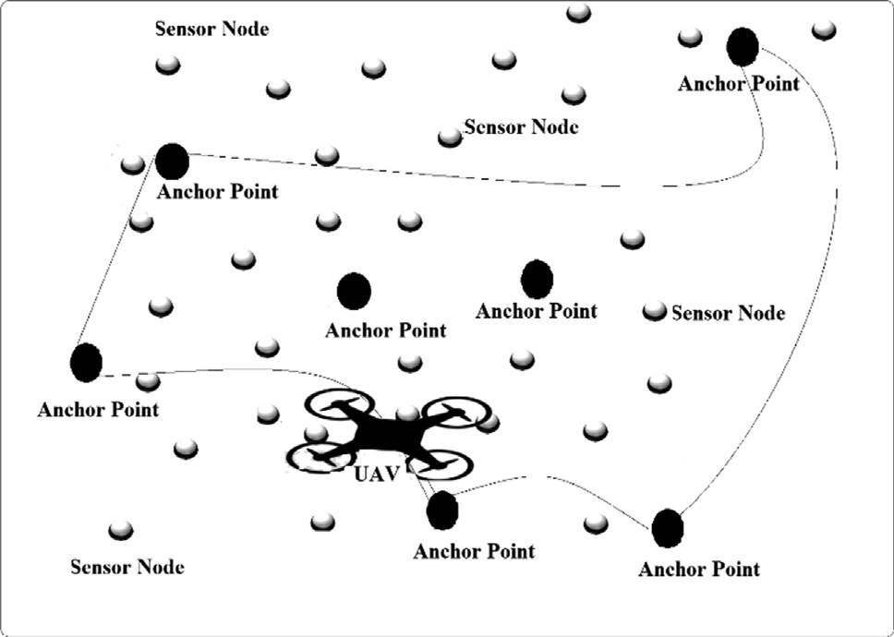Reason for selection

1. MRC Can recharge the batteries placed at larger meters

and are least affected by weather

1. UAV For implementing the mobile charging
2. Load

Balancing

To avoid congestion in a network

Fig. 1. Pre-defined route for UAV.

Table 3

Technical specifications of CLB model.

|  |  |  |
| --- | --- | --- |
| Serial No. | Parameter | Value |
| 1 | Antenna Type | Omni-Directional |
| 2 | Area | 1500 * 1500 m |
| 3 | Initial Energy of each node | 40 J |
| 4 | Initial Energy of Battery in UAV | 500 J |
| 5 | Protocol Type | MAODV |
| 6 | Number of mobile connections | 25 |
| 7 | Constant Bit Rate (CBR Rate) | Less than equal to 5.4 Mb/sec |

and updates its routing table. Whenever, the traffic rate on a par- ticular node becomes more than 75%, it immediately updates other nodes about the congestion. Thus, shifting the node to the next neighboring node helps to avoid the problem of traffic congestion thereby increasing the lifetime of WSNs.

1. MRCRLB and its working

MRCRLB is a combination of MRC, UAV and Load Balancing. The

routing is used for transmitting data packets. Besides this, UAV acts as a mobile transmitter that carried its own battery and a transmit- ter to transmit power to other static nodes. It follows a pre- trajectory in a network to provide the service of recharging. UAV starts from an initial point (init), visits (with speed of ‘V’ m/s to anchor point. At anchor point, it gathers the data (energy level of each sensor node) from nearby sensors which are within its sens- ing range. Then, it compares the energy level of each sensor nodes with a fixed threshold value of 25%. If value of any node is below 25%, it immediately transmits power to it. Therefore, in this way it keeps on revolving around pre-trajectory cycle, until the battery of UAV finishes. The range of charging is decided by having the rate of power received at a sensor node be at least over a threshold (de- noted as ‘*d*’). Ui is the power reception rate at a sensor node ‘i’. When a node is ‘D’ distance away from the UAV, we consider reception rate of energy to be very low which is insufficient to per- form MRC. ‘k’ is the range of UAV at a particular anchor point and this value keeps on incrementing as the UAV jumps to next anchor point.

To implement multi-hop routing of data, we denote fij as flow of data rate from node i to node j. Flow balance at each is written as:

architecture of MRCRLB along with its technical specifications is

*k*–*i*

*j*–*i*

shown in Fig. 2 and Table 3 respectively.

We consider a two-dimensional area of 1500*1500 m in NS2 simulator with ‘N’ number of nodes (where, N can be 25, 50, 75, 100, 125). Battery capacity of each node is considered to be Emax. Initially it is considered to be fully charged and green circle in Fig. 1 represents fully charged battery. Emin represents minimum energy of a node to perform any operation. In order to receive

X *f ki* + *Ri* = X *f ijwhere*; *i* ∈ *N* (2)

*keN j*∈*N*

Further, to transmit a rate of flow from node ‘i’ to node ‘j’, the

power transmission is Cij*fij, where Cij is the energy consumption rate while transmitting power from node ‘i’ to node ‘j’. is modeled as:

power wirelessly, the static sensor nodes are embedded with recei- ver coils Ri denotes the rate of data produced by each node ‘i’. Red

ij

C*ij* = *b*1 + *b*2D*a*

(3)

color and orange color in figure represent critical node and node having energy level between 25% and 75%. Critical node has energy level below 25% which is considered as minimum level and sensors stop working when its energy level falls below 25%. Multi-hop

Where, Dij id distance between ith node and jth node and ‘b' is the distance independent constant, while ‘b' and ‘a’is a coefficient of the distance- dependent term and path-loss index respectively.

The aggregate energy consumption rate for transmission at ‘i’ is:

1

2

*j*–*i*

X

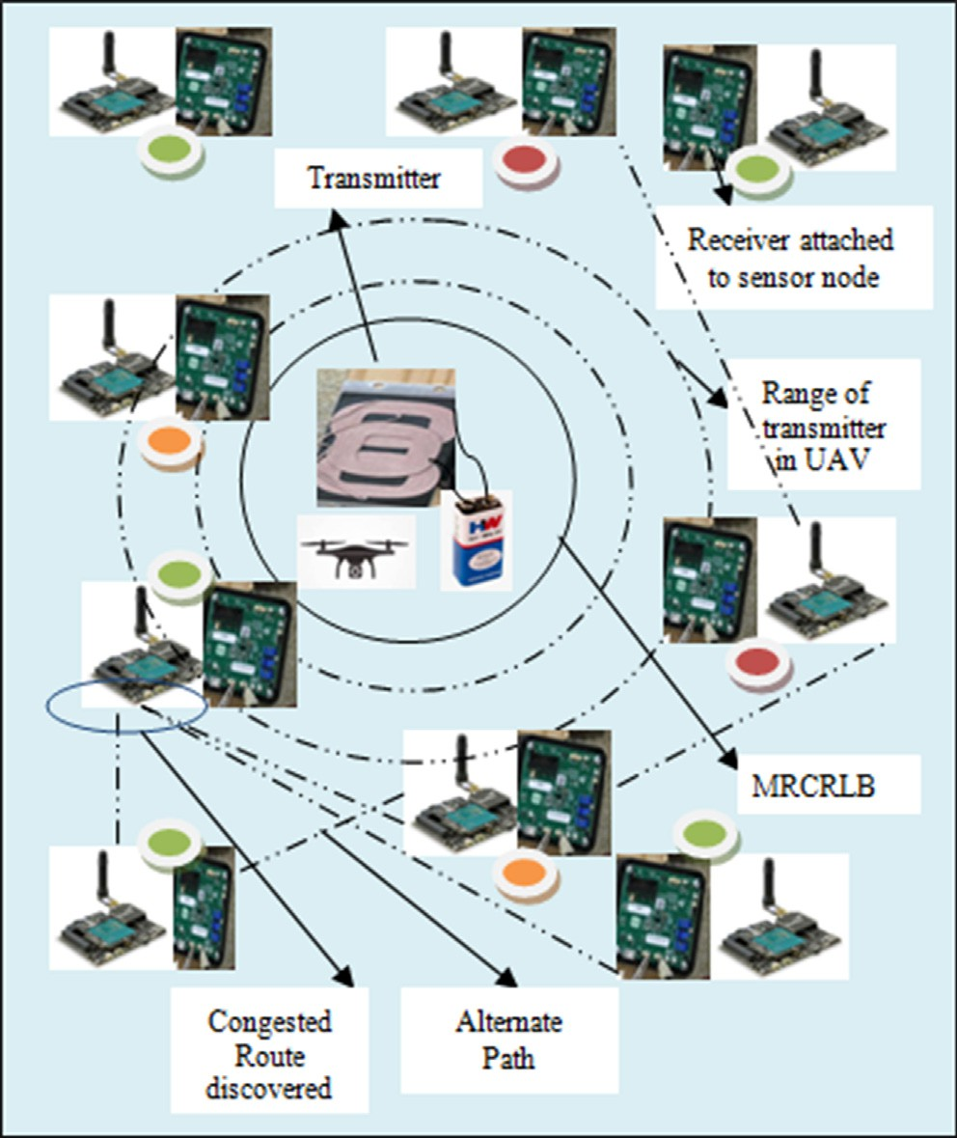*j*∈*N ij*

*C*

* *f ij*

(4)

Consumption of energy rate for reception at ‘i’ is modeled as

*q*P*j*–*i* , where ‘q’ is the energy consumption rate for receiving

*j*∈*N*

one data unit. Denote ‘Pi’ as the rate of energy consumption at ‘i’ that includes both the transmission energy and reception energy.

*k*–*i j*–*i*

*Pi* = *q* X *f ki* + X *Cijf ki*(*where i* ∈ *N*) (5)

*keN*

*j*∈*N*

The technical specifications for the above-mentioned model are shown in Table 3 below:

Several researches till date worked on wireless rechargeable sensor networks, but none of the researcher analyzed the effect of modulation schemes on rechargeable networks. Thus, after proposing an innovative solution (MRCRLB technique) for long range charging problems in WSNs, the analysis of our model is tested on various modulation schemes using Average End-to-End Delay and Physical Layer Packet Drops.

1. Results and discussions

Fig. 2. Architecture of MRCRLB.

Main objective of testing MRCRLB on various modulation schemes is to choose robust modulation for wireless rechargeable sensor networks. Therefore, BPSK, QPSK, 16 QAM and 64 QAM models are analyzed using Average End-to-End Delay (AVGd), Physical Layer Packet Drops (PLPDs) and throughput in NS2 simulator.

* 1. 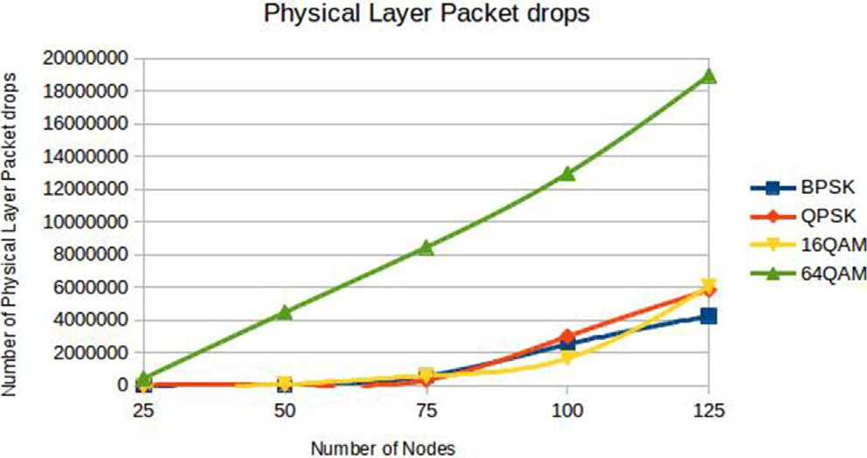*Average end-to-end delay (AVGd)*

Delay is defined time difference between the generated packet by sender and received packet by the receiver. AVGd is calculated by:

*AVGd* = RAllsampledelays

### *Numberofsamples*

Where, sample delay is delay linked with packet.

(6)

AVGd performs better for QPSK modulation scheme (See Fig. 3) as it experiences least delay when the number of nodes are less than or equal to 75. This is because, when MRCRLB is implemented in a network, the transmission errors can be corrected by QPSK in a better way and moreover, the bandwidth requirement is minimum in QPSK when the numbers of nodes are either less or equal to 75 in comparison to BPSK. But when the number of nodes becomes more than 75, BPSK and 16QAM becomes more efficient. This is because when number of nodes increases, the distance between the nodes decreases and hence it can efficiently deliver the packets quickly. BPSK has a property that it can be implemented in places where long distance communication is required. This is due to less AVGd, as packets take minimum time to transverse WSN. There- fore, BPSK and 16QAM performs better than other modulations when the numbers of nodes are higher.

* 1. *Physical layer packet drops (PLPDs)*

Packet drop at physical layer occurs when more than one packet of data traveling in WSN fails (Fig. 4).

The achieved throughput when the proposed MRCRLB model is implemented on different modulation techniques is shown in Fig. 5 above. Indeed, the throughput as outcome in case of BPSK is more than QPSK, 16 QAM and 64 QAM modulation schemes when MRCRLB is implemented. This happens due to decrease in Bit Error Ratio (BER) as the number of nodes increases which further yields high throughput. The minimum throughput value is achieved in case of 64 QAM because of increased number of bits per symbol which makes the channels noisier.

1. Conclusion

Extensive simulation results show that selection of appropriate modulation scheme depends upon the type of application and parameter in WSNs. Further, to regenerate the power in wireless sensor nodes, UAV is deployed which is based on magnetic coupling-based recharging and load balancing to enhance the life- time of sensor networks. Indeed, MRCRLB has the advantage of re- generating power along with the load balancing. In this paper, the proposed MRCRLB model when implemented on real-test beds can be used to increase the lifetime of WSNs, but to examine its feasi-

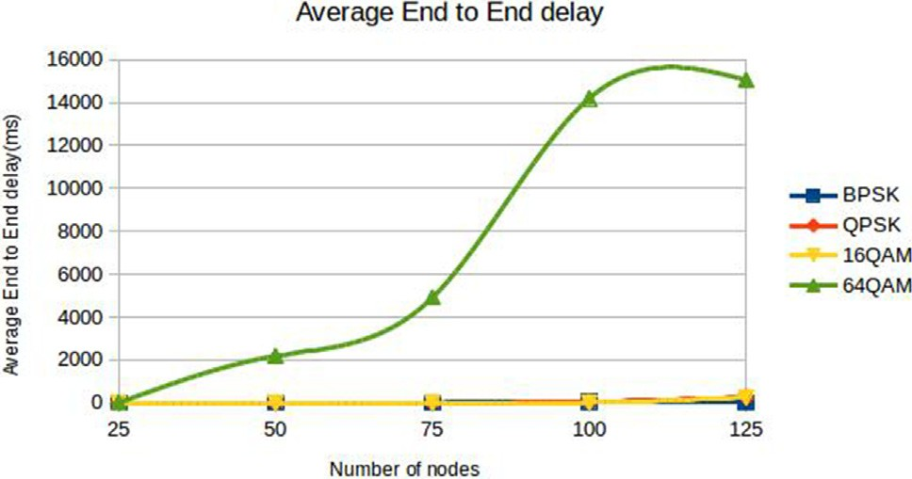

Fig. 3. Comparison of delay between modulation schemes.

Fig. 4. Comparison of physical layer packet drop parameter.

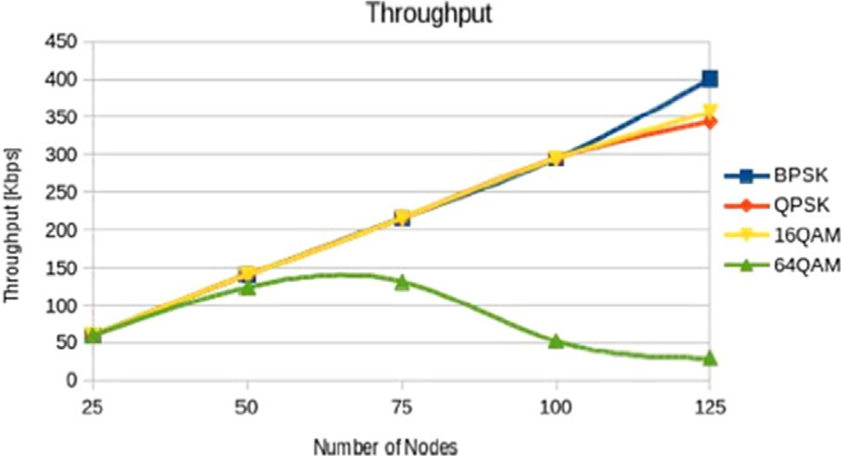

Fig. 5. Throughput comparison of modulation schemes.

bility with modulation scheme, BPSK, QPSK, 16QAM and 64QAM modulation schemes are tested in rechargeable scenario. The out- comes of simulations (in NS2) proved that 64QAM is inappropriate model for rechargeable sensor nodes, while QPSK is optimum solu- tion in terms of AVGd when the network size is small. However, when the network size grows, BPSK and 16QAM are more efficient. Besides this, BPSK modulation scheme best fits with rechargeable sensor networks if the considered parameter is number of packet drops. It works best for both small and large network size. There- fore, type of modulation scheme to be selected for wireless rechargeable sensor network totally depends on the size of net- work and the parameter to be considered.

1. Future work

Future work can be performed by implementing BPSK in WRSNs and performance evaluation metrics in terms of lifetime of sensor nodes, packet delivery ratio, throughput etc can be measured.

Ethical Statement

The research does not include animal participants and ethical process was provided for human participants.

Declaration of Competing Interest

The authors declare that they have no known competing finan- cial interests or personal relationships that could have appeared to influence the work reported in this paper.

References

1. [Zhang Y et al. An efficient EH-WSN energy management mechanism. Tsinghua](http://refhub.elsevier.com/S1110-8665(21)00022-0/h0005) [Sci Technol 2018;23(4):406–18](http://refhub.elsevier.com/S1110-8665(21)00022-0/h0005).
2. Angurala M, et al. Evaluating performance of different modulation schemes on modified cooperative AODV. In: International Interdisciplinary Conference on Science Technology Engineering Management Pharmacy and Humanities Held on 22nd–23rd, in Singapore, 2017. ISBN: 9780998900001
3. [Jan N, Javaid N, Javaid Q, Alrajeh N. A balanced energy consuming and hole](http://refhub.elsevier.com/S1110-8665(21)00022-0/h0015) [alleviating algorithm for wireless sensor networks. IEEE Access 2017](http://refhub.elsevier.com/S1110-8665(21)00022-0/h0015).
4. [Pal V, Singh G, Yadav R. Balanced cluster size solution to extend lifetime of](http://refhub.elsevier.com/S1110-8665(21)00022-0/h0020) [wireless sensor networks. IEEE Internet Things J 2015](http://refhub.elsevier.com/S1110-8665(21)00022-0/h0020).
5. [Sheikhi M, Kashi1 SS, Samaee Z. Energy provisioning in wireless rechargeable](http://refhub.elsevier.com/S1110-8665(21)00022-0/h0025) [sensor networks with limited knowledge. Wireless Netw 2019](http://refhub.elsevier.com/S1110-8665(21)00022-0/h0025).
6. [Han G, Yang X, Liu L, Zhang W. A joint energy replenishment and data](http://refhub.elsevier.com/S1110-8665(21)00022-0/h0030) [collection algorithm in wireless rechargeable sensor networks. IEEE Internet](http://refhub.elsevier.com/S1110-8665(21)00022-0/h0030) [Things J 2018](http://refhub.elsevier.com/S1110-8665(21)00022-0/h0030).
7. Angurala M, Bala M, Bamber SS, Kaur R, Singh P. An internet of things assisted drone based approach to reduce rapid spread of COVID-19. J Safety Sci Resilience. 2020;1(1):31–5. doi: <https://doi.org/10.1016/j.jnlssr.2020.06.011>.
8. Militano L, Erdelj M, Molinaro A, Mitton N, Iera A. Recharging versus replacing sensor nodes using mobile robots for network maintenance. Telecommun Syst 2016;63(4).
9. [Singh SK, Kumar P. SenCar: an energy efficient data gathering mechanism for](http://refhub.elsevier.com/S1110-8665(21)00022-0/h0045) [large scale multihop sensor networks. J Ambient Intell Human Comput 2019](http://refhub.elsevier.com/S1110-8665(21)00022-0/h0045).
10. [Liu C, Chau KT, Zhang Z, Qiu C, Lin F, Ching TW. Multiple-receptor wireless](http://refhub.elsevier.com/S1110-8665(21)00022-0/h0050) [power transfer for magnetic sensors charging on mars via magnetic resonant](http://refhub.elsevier.com/S1110-8665(21)00022-0/h0050) [coupling. J Appl Phys 2015;117(17):17E702](http://refhub.elsevier.com/S1110-8665(21)00022-0/h0050).
11. [Kurs A, Karalis A, Moffatt R, Joannopoulos JD, Fisher P, Soljacˇic´ M. Wireless](http://refhub.elsevier.com/S1110-8665(21)00022-0/h0055) [power transfer via strongly coupled magnetic resonances. Science 2007;317](http://refhub.elsevier.com/S1110-8665(21)00022-0/h0055) [(5834):83–6](http://refhub.elsevier.com/S1110-8665(21)00022-0/h0055).
12. [Yuan X, Elhoseny M, El-Minir HK, Riad AM. A genetic algorithm-based dynamic](http://refhub.elsevier.com/S1110-8665(21)00022-0/h0060) [clustering method towards improved wsn longevity. J Netw Syst Manage](http://refhub.elsevier.com/S1110-8665(21)00022-0/h0060) [2016:1–26](http://refhub.elsevier.com/S1110-8665(21)00022-0/h0060).
13. [Naderi MY, Nintanavongsa P, Chowdhury KR. RF-MAC: a medium access](http://refhub.elsevier.com/S1110-8665(21)00022-0/h0065) [control protocol for re-chargeable sensor networks powered by wireless](http://refhub.elsevier.com/S1110-8665(21)00022-0/h0065) [energy harvesting. IEEE Trans Wireless Commun Jul. 2014;13(7):3926–37](http://refhub.elsevier.com/S1110-8665(21)00022-0/h0065).
14. [Wang C, Li J, Ye F, Yang Y. NETWRAP: an NDN based real-time wireless](http://refhub.elsevier.com/S1110-8665(21)00022-0/h0070) [recharging framework for wireless sensor networks. IEEE Trans Mobile](http://refhub.elsevier.com/S1110-8665(21)00022-0/h0070) [Comput Jun. 2014;13(6):1283–97](http://refhub.elsevier.com/S1110-8665(21)00022-0/h0070).
15. [Guo S, Wang C, Yang Y. Joint mobile data gathering and energy provisioning in](http://refhub.elsevier.com/S1110-8665(21)00022-0/h0075) [wireless rechargeable sensor networks. IEEE Trans Mobile Comput 2014;13](http://refhub.elsevier.com/S1110-8665(21)00022-0/h0075) [(12):2836–52](http://refhub.elsevier.com/S1110-8665(21)00022-0/h0075).
16. Himanshu Sharma, Vibhav Kumar Sachan, Performance analysis of modulation techniques for energy efficient wireless sensor networks. In: International conference on communication and electronics (ICCE-2012), held at KIET, Ghaziabad,U.P., India, Proceedings vol. 1, p. 79, Oct. 2012.
17. [Pushpa V, Ranganathan H, Palanivelan M. BER analysis of BPSK for block codes](http://refhub.elsevier.com/S1110-8665(21)00022-0/h0085) [and convolution codes over AWGN channel. Int J Pure Appl Math 2017;114](http://refhub.elsevier.com/S1110-8665(21)00022-0/h0085) [(11):221–30](http://refhub.elsevier.com/S1110-8665(21)00022-0/h0085).
18. [Abbasi-Daresari S, Abouei J. Toward cluster-based weighted compressive data](http://refhub.elsevier.com/S1110-8665(21)00022-0/h0090) [aggregation in wireless sensor networks. J Adhoc Netw 2016;36(1):368–85](http://refhub.elsevier.com/S1110-8665(21)00022-0/h0090).
19. [Singh AK, Purohit N, Varma S. Analysis of lifetime of wireless sensor network](http://refhub.elsevier.com/S1110-8665(21)00022-0/h0095) [with base station moving on different paths. Int J Electron Taylor and Francis](http://refhub.elsevier.com/S1110-8665(21)00022-0/h0095) [2014 May;101(5):605–20](http://refhub.elsevier.com/S1110-8665(21)00022-0/h0095).
20. [Wang T, Heinzelman W, Seyedi A. Link energy minimization for wireless](http://refhub.elsevier.com/S1110-8665(21)00022-0/h0100) [networks. Ad Hoc Netw 2012;10:569–85](http://refhub.elsevier.com/S1110-8665(21)00022-0/h0100).
21. [Peng Y et al. Enhancing energy efficiency via cooperative MIMO in wireless](http://refhub.elsevier.com/S1110-8665(21)00022-0/h0105) [sensor networks: state of the art and future research directions. IEEE Commun](http://refhub.elsevier.com/S1110-8665(21)00022-0/h0105) [Mag 2017;55:47–53](http://refhub.elsevier.com/S1110-8665(21)00022-0/h0105).
22. Imam SA, et al. An energy-efficient data transmission scheme based on DSC- MIMO. In: Proc IEEE Int Conf Integr Circuits Microsyst (Nanjing, China), Nov. 2017, p. 309–12.
23. [Sheltami T, Musaddiq M, Shakshuki E. Data compression techniques in](http://refhub.elsevier.com/S1110-8665(21)00022-0/h0115) [Wireless Sensor Networks. Future Gener Comp Syst 2016;64:151–62](http://refhub.elsevier.com/S1110-8665(21)00022-0/h0115).
24. [Leinonen M, Codreanu M, Juntti M. Distributed distortion-rate optimized](http://refhub.elsevier.com/S1110-8665(21)00022-0/h0120) [compressed sensing in wireless sensor networks. IEEE Trans Commun 2018;66](http://refhub.elsevier.com/S1110-8665(21)00022-0/h0120) [(4):1609–23](http://refhub.elsevier.com/S1110-8665(21)00022-0/h0120).
25. Chen J, Han X. The distributed source coding method research based on clustering wireless sensor networks. Int J Sens Netw 2015;17(4).
26. [Cheffena M. Industrial wireless sensor networks: channel modeling and](http://refhub.elsevier.com/S1110-8665(21)00022-0/h0130) [performance evaluation. EURASIP J Wirel Commun Netw 2012;2012](http://refhub.elsevier.com/S1110-8665(21)00022-0/h0130).
27. [Wang Q, Jiang J. Comparative examination on architecture and protocol of](http://refhub.elsevier.com/S1110-8665(21)00022-0/h0135) [industrial wireless sensor network standards. IEEE Commun Surv Tutor](http://refhub.elsevier.com/S1110-8665(21)00022-0/h0135) [2016;18:2197–219](http://refhub.elsevier.com/S1110-8665(21)00022-0/h0135).
28. [NingNing C. Electromagnetic induction wireless power transmission efficiency](http://refhub.elsevier.com/S1110-8665(21)00022-0/h0140) [research. In: Proceedings of the information science and management](http://refhub.elsevier.com/S1110-8665(21)00022-0/h0140) [engineering III (ISME). p. 504–9](http://refhub.elsevier.com/S1110-8665(21)00022-0/h0140).
29. [Filios G, Madhja A, Nikoletseas S, Raptopoulos C. On electromagnetic radiation](http://refhub.elsevier.com/S1110-8665(21)00022-0/h0145) [control for wireless power transfer in adhoc communication networks: key](http://refhub.elsevier.com/S1110-8665(21)00022-0/h0145) [issues and challenges. IEEE Access 2019;7:3143–69](http://refhub.elsevier.com/S1110-8665(21)00022-0/h0145).
30. Angurala M, Bala M, Bamber SS. Performance analysis of modified AODV routing protocol with lifetime extension of wireless sensor networks. IEEE Access 2020;8:10606–13. doi: <https://doi.org/10.1109/ACCESS.2020.2965329>.
31. Nawaz H, Ali HM, Laghari AA. UAV communication networks issues: a review. Arch Computat Methods Eng 2020. doi: [https://doi.org/10.1007/s11831-020-](https://doi.org/10.1007/s11831-020-09418-0) [09418-0](https://doi.org/10.1007/s11831-020-09418-0).
32. Angurala M, Bala M, Bamber SS. Energy efficient CLB approach to find optimum modulation scheme in wireless rechargeable sensor networks. Int J Inf Technol 2020. doi: <https://doi.org/10.1007/s41870-020-00561-2>.