[Egyptian Journal of Basic and Applied Sciences 5 (2018) 265–279](https://doi.org/10.1016/j.ejbas.2018.10.002)

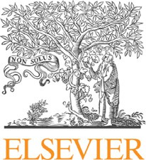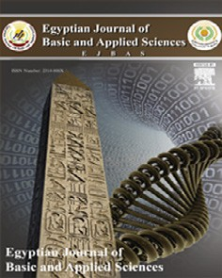

Contents lists available at [ScienceDirect](http://www.sciencedirect.com/science/journal/2314808X)

Egyptian Journal of Basic and Applied Sciences

journal homepage: [www.elsevier.com/locate/ejbas](http://www.elsevier.com/locate/ejbas)

[](http://crossmark.crossref.org/dialog/?doi=10.1016/j.ejbas.2018.10.002&domain=pdf)*In silico* prediction of anticarcinogenic bioactivities of traditional anti- inflammatory plants used by tribal healers in Sathyamangalam wildlife Sanctuary, India

Pavithra Chinnasamy, Rajendran Arumugam ⇑

*Department of Botany, Bharathiar University, Coimbatore, Tamil Nadu 641 046, India*

a r t i c l e i n f o

*Article history:*

Received 28 May 2018

Received in revised form 14 October 2018 Accepted 18 October 2018

Available online 26 October 2018

*Keywords:* Ethnomedicine Inflammation Anticancer

*In silico*

a b s t r a c t

The present study was designed to explore ethnopharmacological anti-inflammatory plants in the anti- cancer drug development. From the specialized local herbalists of the study area, who were treating tumors using anti-inflammatory plants by considering as a type of inflammation and explaining the potential of anti-inflammatory plants in prevalence of early stage’s cancer. Interaction results obtained from the herbalists, and *in silico* PASS and CLC-pred prediction results were greatly agreed with docu- mented data. Documentation was done through semi-structure standard designed proforma from the selected herbalist in study locality. A number of active compounds selected from recorded plants subse- quently analyzed by using computational *in silico* tools such as PASS, admetSAR, and CLC-pred to inves- tigate the antineoplastic capacity of anti-inflammatory plants. About 18 out of 20 plants said to be used in tumor-related affliction recognized for antineoplastic capacity using PASS database with high probability. Similarly, the selected compound’s absorption, metabolism, and toxicity also predicted using the admetSAR tool. CLC-pred Tools performed to examine the different cell line cytotoxicity of compounds with respective probabilities.

© 2018 Mansoura University. Production and hosting by Elsevier B.V. This is an open access article under

the CC BY-NC-ND license (<http://creativecommons.org/licenses/by-nc-nd/4.0/>).

1. Introduction

Ethnopharmacology becomes an important field to elucidate and justify the indigenous medicinal benefits bioactive of plant compounds through various biochemicals and experimental mod- els [1]. India is one among the country which has potent knowl- edge of ancient treatment of medicinal plants. Tribal people encompass vast recognition of treatment by plant therapy, and their historical knowledge has guaranteed results over novel experimental studies of plants secondary metabolites as a source to draw anti-inflammatory drugs [1–3]. Wound inflammation, especially chronic wound is considered as a freighting issue on physical welfare, which is tough one to cure. Plant based medica- ments are advised because of easy accessibility and better wound healing property of compounds [4,5]. India has documented 45,000 series of plants roughly 7500 species reputable as medicinal plants. Earlier system of Indian medicine ‘‘Ayurveda” describes healing properties as ‘Vranaropaka’ and treated with medicinal plants [6,7].

* Corresponding author.

*E-mail address:* [arajendran222@yahoo.com](mailto:arajendran222@yahoo.com) (R. Arumugam).

Cancer, a complicated disease holds the second position to cause death in all over the globe, and the incidences were discov- ered high in western countries comparatively than Asian countries. Ayurveda explains continuous irritation may lead to cancer under Granthi or Arbuda (inflammatory disease) that is a neoplasm will have the possibility to develop the malignancy and can treatable at early stage [8]. Due to the competence of preventing cancer, plants based compounds, which possess anti-inflammatory activ- ity, are also used in cancer treatment [9]. Probably customary medicines are worked based on the synergistic effect of whole plant extract while modern medicines isolate a single plant com- pound [10,11].

Computational tools have become very much important in medicinal chemistry to predict the bioactivities of particular com- pounds based on structure–activity relationships, which are signif- icantly correlated with experimental results [12]. The physical and chemical properties of plant based compounds were analyzed using *in silico* prediction models for their effective absorption metabolism and toxicity. These *in silico* techniques combined with pharmacology studies would greatly influence in discovery of novel drugs for ailments [13,14].

In the present study an attempt made to predict the anticar- cinogenic activity of compounds presented in plants with wound

<https://doi.org/10.1016/j.ejbas.2018.10.002>

2314-808X/© 2018 Mansoura University. Production and hosting by Elsevier B.V.

This is an open access article under the CC BY-NC-ND license (<http://creativecommons.org/licenses/by-nc-nd/4.0/>).

healing anti-inflammatory to explore the new plant compounds for anticancer activity through *in silico* studies. This also rationally proceeds towards interdisciplinary understanding of developing anticancer drugs from wound healing plants existed in traditional practices.

1. Materials and methods
   1. *Study area and tribal ethnography*

Sathyamangalam wildlife sanctuary lies between Tamil Nadu and Karnataka boundary regions with 77° 150 000 E longitude and 11° 310 1100 N latitude. Vegetation of the forest varies from tropical to temperate zones this forest extends east from Nilgiris. The thicket jungle is one of the piece elements of Western Ghats

enhanced with diverse species of plant and animal covers about 1411.6 km2 (545.0 sq mi) [15–17]. The moderate annual rainfall of the Sathyamangalam wildlife sanctuary is 824 mm, which located between the Western Ghats and the Eastern Ghats like a bridge. Wildlife Institute of India categorized the sanctuary as East- ern Ghats province in Biogeography classification (Fig. 1).

The forest is diversified with various tribal communities, including Irulas, Soligas, Kurumbas, Urali and also least distributed communities of Malayalee and Naickers. Urali is one of the domi- nants locale’s tribal groups migrated and largely settled in Sathya- mangalam forest with Urali language. The villager’s main job is to sell the forest products such as honey, fuel wood, resins and medic- inal herbs.

* 1. *Data collection*

The importance of each plant species among ethnic people was determined by use value (UV). The use value to a species (UV) is the summation over the number of use reports for the specific plant species (U) and is divided by the total number of informants

(N) interviewed. If the use value is high, it indicates the many use reports and importance to the plant, and low value indicates the less use reports. This was calculated as follows.

*UV* ¼ X *UR*/*N*

* 1. *Identification of plant specimens*

Identification of collected plant materials was performed by referring different regional floras and pertinent literature such as Flora of the Presidency of Madras, Flora of Tamil Nadu and Flora of the Tamilnadu Carnatic [18–20]. Then the plant materials were poisoned, pressed and preserved in a standard herbarium sheet. The collected specimens were compared and identified by the Madras herbarium (MH) Botanical Survey of India, Southern Regio- nal Centre, Coimbatore, India. Further the confirmation made using The Plant List and International Plant Name Index [21,22] and Fig. 2 provides the identified plants.

* 1. *In silico prediction using PASS and ADMET*

Computer-aided structure-activity based prediction studies in drug design helps to treat diseases with novel biomarkers. Predic- tion of activity spectra for substances (PASS) database comprised 46,000 biologically well-known active drugs and screening are per- formed before the establishment of an *in vitro* experiment. PASS gives the significant bioactivities of chemical compounds as Pa (Probable activity) and Pi (Probable inactivity) values to mention the compounds, whether they are active are inactive. The Pa values higher than 0.7 indicated this compound would be active in exper-

iment and Pi values indicate theirs inactivate possibilities. The admetSAR chemoinformatics based tool used to predict absorption, metabolism, excretion, and toxicity of the particular compound. Based on these criteria, the outcomes of an *in vitro* experiment will lower the risk of negative results [13,14].

* 1. *In silico prediction of cell line cytotoxicity with CLC-Pred tool*

CLC-Pred Tools performed to predict cytotoxicity of tumor cell lines, and it is based on structure-cell line cytotoxicity relation- ships designed by PASS special training sets with leave-one-out cross-validation procedure. The accuracy of *in silico* prediction results significantly 96% matches with the results of *in vivo* exper- imental. The efficiency of compounds against cancer could be found and optimized using this PASS based CLC-Pred database in the future to develop potential anti-cancer drugs. Predicted cyto- toxicity gives results against various human cell lines represented with Pa values if Pa value is >0.5 the probability of action is consid- erably high and whereas Pi value indicates inactivity [23].

1. Result and discussion
   1. *Demography and ethnography of informants*

Informant’s selection was done randomly of all communities from different tribal settlement areas. Among gathered peoples a total number of 35 informants selected after the primary group discussion in all settlement groups by their knowledge about the traditional treatments on wounds, inflammation, and cancer. The age of selected 35 informants varies from 45 to 65 years, including male (14) females (21). From the 35 informants, 10 healers were identified as herbalists among them 3 of were female and the rest were male (7) (Table 1). Between 10 herbalists, 8 herbalists (2 female; 6 males with >55 years old) were agreed to the statement that they are treating tumors with anti-inflammatory plants (Table 1). A formal questionnaire was prepared and orally asked to refer the definition of wounds and tumor, how the wounds and tumor will be treated; preparation method adopted, the proce- dure of administration, duration of administration, the local name of the tumor and wounds and types of tumor they experienced.

The interrogation confesses chronic inflammation wounds may develop into the tumor but in the early stage, this can be curable. They are terming cancer as Katti in local language and also inter- estingly the herbalists were treating tumors of specific organ includes uterine fibroids caused through heredity and irregular menstrual cycle, Gastric tumor caused by chronic inflammation and ulceration (Table 2). The understanding and informative views about cancer among tribal dwellers are greatly agreed to the liter- ature statement of causes of cancer, and also the chronic wounds were treated with herbalist prescription [5,24], among tribal inhabitants these complications were treated carefully in order to avoid forming tumor from chronic inflammation. Based on this, the entire primary ethno botanical investigation figured out locales having trivial knowledge about tumor treating plants, which are also used during the wound healing and inflammation activities.

* 1. *Anti-inflammatory plants in cancer*

The individual with most use-reports was considered as com- mon medicine for a particular ailment treatment. Based on the use-reports collected from ethnic people use value (UV) was calcu- lated to highlight the usage priority, importance, recommendation and sharing medicinal knowledge about the particular species among the informants. In this study *Abutilon indicum* (L.) Sweet*,*. (UV-0.60), *Lawsonia inermis* L.*, Lycopersicon esculentum* Mill

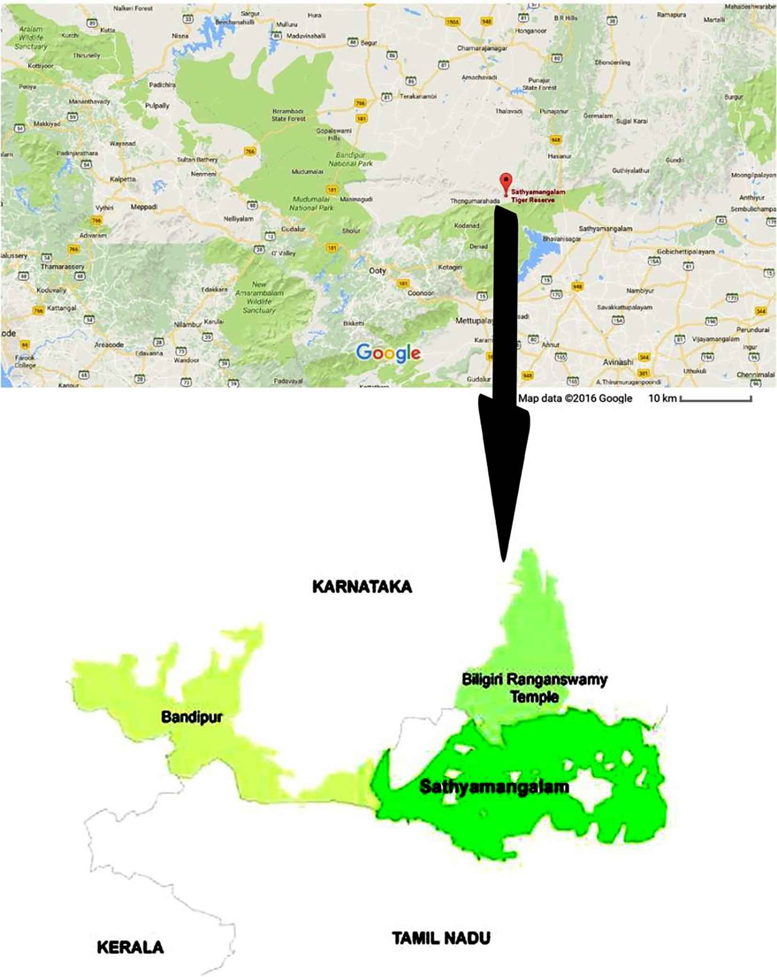

Fig. 1. Study area of the present study.

(UV-0.63), and *Madhuca indica* J.F.Gmel. (UV-0.66) showed com- mendable values this indicates the importance to the species among the studied area tribes (Table 3). However, least values indi- cate the limited knowledge of medicinal uses and may be due to its adverse effects of those plants.

Leaves are the dominant part used in the medicinal plant prepa- ration for treating inflammatory, wounds and cancer from the study area followed by bark, seed, tuber, and whole plant part (Table 3). Basically, leaves are the uncomplicated plant part in col- lection and in systematic perspective leaves are loaded with the huge amount of metabolites comparing to other parts through the plant [25]. Present investigation comes out with the usage of adjuvant among the tribal community with 9 plants followed by 11 plants individual consumption (Table 3). The practice of utiliz- ing adjuvants like honey, salt, milk and curd is a habit of Indian tri-

bal inhabitants already reported for Taungya, Terai and Kani tribals in India. Usong adjuvants are technically for higher bioavailability, which leads for synergistic effect to cure the disease better [25,26]. The preparation methods for anti-inflammatory activity were mostly in dry powder form to treat wounds and skin tumors [7]. The other methods, including paste and decoction were used to treat skin and stomach ailments were treated with juice (Table 3) and extraction methods considerably uncommon to treat stomach and bladder problems [24].

* 1. *In silico prediction results of PASS and admetSAR*

*In silico* tools used for pre-screening of compound activities and direct the studies towards the prior designing of particular work. PASS is a well-known tool used in almost all pharmaceutical

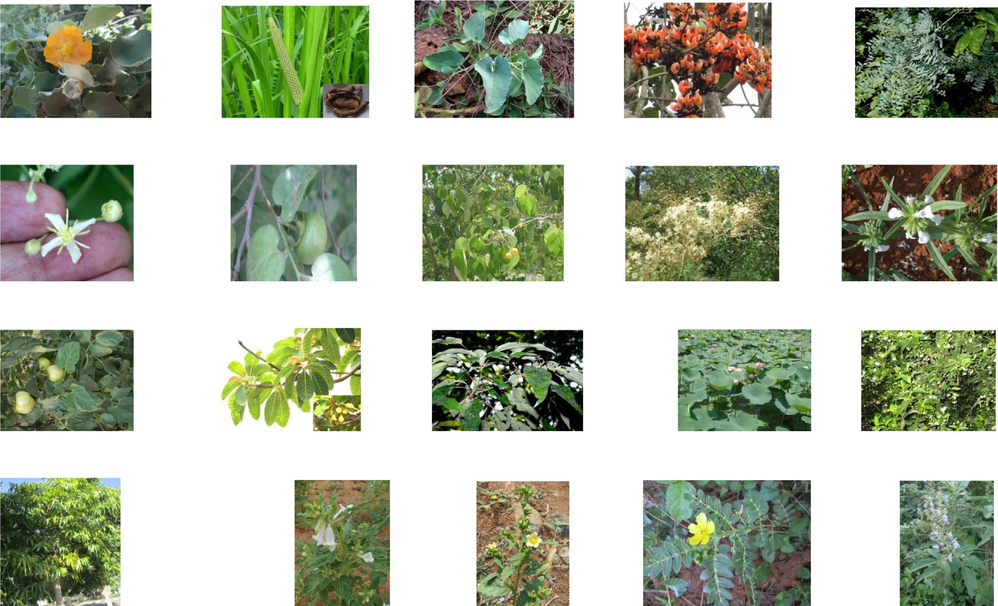



Fig. 2. Some identified plants from the present study area.

Table 1

Demographic representation of interviewed tribes by age group in the study area.

|  |  |  |  |  |  |  |
| --- | --- | --- | --- | --- | --- | --- |
| Age group of informants (In years) | Local people |  |  | Herbalist |  |  |
|  | Male (14) | Female (21) |  | Male | Female |
| 41–50 | 6 | 10 |  |  |  |  |
| 51–60 | 7 | 5 |  | 6 | 2 |  |
| 61–70 | 1 | 6 |  |  |  |  |

Table 2

List of biomedical terms used to identify the diseases with its corresponding local terms used by the tribes in the study area.

S. No Biomedical terms Local terms

1 Cancer Katti

2 Uterus tumor Karpa pai katti

3 Chronic inflammation Vayitrupun katti

4 Inflammation Udaleritchal

5 Burns Theekkaayam

6 Wounds Kaayam

1. Mouth ulcer Vaaippun
2. Stomach ache Vayitruvali
3. Stomach ulcer Vayitrupun

industries which based on structure–activity relationship’s analy- sis [27]. About 23 compounds corresponding to 20 plant species were selected and interpreted in PASS database to obtain the pre- diction of bioactivity. The collected 20 anti-inflammatory species which also observed to be used in tumor treatment by tribal inhab- itants were predicted by PASS and indicated the existence of antineoplastic activity in 18 reported plants. The compound aris- tolochic acid from *Aristolochia bracteolate* Lam. showed higher probabilities for the antiseptic (0.968/0.002), respiratory analeptic (0.828/0.007) and apoptosis agonist (0.821/0.007) in prediction

(Table 4) but various studies shows that aristolochic acid can be used on many types of cancer, including bladder cancer it closely resembles with the statement of usage of *Aristolochia bracteolate* Lam. in urinary track cancer and inflammation activity [26]. From the present study area, it’s clearly evidenced that the usage of aris- tolochic acid contained plants as a medicine existed previously in Indian subcontinent [28].

Congruently *Nelumbo nucifera* Gaertn also has shown activities like antineurotic (0.851/0.009), antitussive (0.836/0.003) and anti eczematic (0.851/0.010) and these also comparably to the herbalist information obtained from the study area, and the seeds are used in hepatocellular carcinoma [29]. These two inferences from *in sil- ico* prediction, documentation of study data and pertinent litera- ture briefly quoted the correlation between anti-inflammatory plants in cancer and apparently. It supports description in Ayur- veda, which cited 5000 years back as inflammation can lead to can- cer [10]. Comprehension of the total number of 19 species collected from the study location manifest various bioactivity in the PASS prediction indicated as apoptosis agonist, hepatoprotec- tant, and insulin promoter other than antineoplastic, which hold desired different probabilities (Table 4). The database of admetSAR is a mechanized free tool which predicts assimilation profiles of drugs as takes after intestinal ingestion, P-glycoprotein substrate and inhibitor, plasma protein restricting correspondingly unique

Table 3

Results obtained from herbalist belongs to the study area.

|  |  |  |  |  |  |  |  |  |  |  |
| --- | --- | --- | --- | --- | --- | --- | --- | --- | --- | --- |
| S.  No | Binomial name | Family/ vernacular name | Parts useda | Method of preparation | Ailments treated | Administration routeb | Administration duration | Time require for cure | Total number of citation | UV |
| 1 | *Abutilon indicum* | Malvaceae/ | L | Decoction | Ulcer and tumor in stomach | O | Once a day | 60 | 12 | 0.60 |
|  | (L.) Sweet | Thutthi |  | Paste | Inflammation and wounds | T | Once a day | 48 |  |  |
| 2  3 | *Acorus calamus* L.  *Aristolochia* | Acoraceae/ Vasampu  Aristolochiaceae/ | Tu  L | Paste  Juice | Inflammation, wounds, cuts and tumors in skin  Urinary bladder infections, | T  O | Once a day  Two days once | 36  58 | 9 | 0.40 |
|  | *bracteolata* Lam. | Aaduthinnapaalai |  |  | wounds, inflammations and |  |  |  |  |  |
| 4 | *Butea* | Fabaceae/Porasu | B | Powder | tumor  Wounds and inflammation | T | Two times a | 48 | 6 | 0.46 |
|  | *monosperma*  (Lam.) Taub. | maram |  |  | Mixed with milk for ulcer | O | day  Two times a | 60 |  |  |
| 5 | *Chloroxylon* | Rutaceae/Ven | L | Paste | and tumor in stomach  Inflammation, tumors and | T | day  Once a day | 48 | 4 | 0.40 |
|  | *swietenia* DC. | porinji maram |  |  | wounds |  |  |  |  |  |
| 6  7 | *Clematis gouriana* Roxb. ex DC.  *Diospyros* | Ranunculaceae/ Silankodi  Ebenaceae/ | L  B | Powder  Powder | Mixed with curd for inflammation and tumors  For inflammation of wounds | T  T | Twice aday  Once a day | 36  27 | 8  5 | 0.54  0.54 |
| 8 | *Montana* Roxb.  *Gmelina arborea* | Vakanathi  Verbenaceae/ | Wp | Paste | and tumors  For wounds, inflammation | T | Once a day | 36 | 3 | 0.49 |
| 9 | Roxb.  *Lawsonia inermis* | Kumali maram  Lythraceae/ | L | Powder | and tumors  For skin infections, | T | Twice a day | 48 | 16 | 0.63 |
| 10 | L.  *Leucas aspera* | Marudhani  Lamiaceae/ | L | Juice | inflammation, tumor and wounds  To treat stomach and | O | Twice a day | 48 | 15 | 0.60 |
|  | (Willd.) Link | Thumpai chedi | F | Juice | intestinal ulcers and tumors  Mixed with onion juice to |  | Twice a day | 60 |  |  |
| 11 | *Lycopersicon* | Solanaceae/ | L | Paste | treat severe ulceration in stomach  For inflammation, tumor, | T | Thrice a day | 60 | 18 | 0.63 |
|  | *esculentum* Mill. | Thakkali chedi | Se | Paste | burns and skin infections  Mixed with milk and |  | Twice a day | 48 |  |  |
| 12 | *Madhuca indica* J. | Sapotaceae/ | B | Decoction | applied over Skin tumor  Mixed with honey and used | O | Two days once | 36 | 11 | 0.66 |
|  | F.Gmel. | Iluppai | B & L | Paste | for stomach inflammation and tumor  For skin tumors | T | Once a day | 30 |  |  |
| 13  14 | *Mallotus philippensis* (Lam.) Müll.Arg.  *Nelumbo nucifera* | Euphorbiaceae/ Kurangu manjanathi  Nelumbonaceae/ | B  Se | Extract  Powder | For stomach ulceration, inflammation and tumor  Mixed with curd to cure | O  O | Two days once  Twice a day | 27  60 | 9  19 | 0.46  0.54 |
| 15 | Gaertn  *Nyctanthes* | Thamarai  Oleaceae/ | L | Extract | stomach ulcer and tumor  Mixed with salt for stomach | O | Once a day | 48 | 20 | 0.57 |
| 16 | *arbor-tristis* L.  *Polyalthia* | Pavilamalli  Annonaceae/ | B | Decoction | tumor and ulcer  For intestinal inflammation | O | Once a ay | 48 | 21 | 0.60 |
| 17 | *longifolia*(Sonn.) Thwaites  *Sesamum* | Nettilingam  Pedaliaceae/Ellu | Se | Powder | and tumor  Mixed with honey for colon | O | Twice a day | 48 | 19 | 0.54 |
| 18 | *indicum* L.  *Sida acuta* Burm. | chedi  Malvaceae/Vatta | L | Powder | infections and tumor  Mixed with curd to treat | T | Twice a day | 27 | 15 | 0.43 |
|  | f. | thirupi |  | Extract | skin inflammation  Stomach tumor | O | Once a day | 27 |  |  |
| 19 | *Tribulus terrestris* | Zygophyllaceae/ | Se | Decoction | Mixed with salt to cure | O | Twice a day | 48 | 16 | 0.46 |
| 20 | L.  *Vitex negundo* L. | Nerunchi  Lamiaceae | L | Decoction | stomach problems and tumor  Stomach inflammation and | O | Two days once | 27 | 14 | 0.40 |
|  |  | Nocchi |  |  | tumor |  |  |  |  |  |

a B-bark, L-leaf, Se-seed, Fl-flower, Wp-whole plant, Tu-Tuber.

b O-oral, T-topical.

kind of digestion as cytochrome substrate, inhibitor, activator and poisonous quality profiles like medication instigated liver damage, mutagenicity, cancer-causing agents [30]. As indicated by the results displayed in Table 4, all the compounds reported from listed plants, demonstrated low toxicity and low carcinogenicity. From the outcomes, all the reported compounds were considered as they can metabolize easily without causing much of problems, retained and transported through human intestinal.

* 1. *In silico CLC-Pred cell line cytotoxicity prediction results*

A CLC-Pred tool designed to predict the cell line toxicity and an active probability of compounds, a well-known tool in cheminfor- matics and medicinal chemistry to predict the cell line type and tissue to the respecting tumor type. The prediction was performed for all the 23 selected compounds, which cited as most active in the respective plant species (Table 5). The estimation of results

Table 4

*In silico* PASS and admetSAR prediction of compounds from documented plants from the study area.

|  |  |  |  |  |  |  |  |
| --- | --- | --- | --- | --- | --- | --- | --- |
| S.  no | Plant name | Reported compounds with details | PASS prediction | Pa | Pi | admetSAR prediction |  |
|  |  |  |  |  |  | A M T |
| 1 | *Abutilon indicum* | Abruslactone A | Antineoplastic | 0.928 | 0.005 | + + + |  |
|  | (L.) Sweet | Pubchem ID: 44575701 | Apoptosis agonist | 0.919 | 0.004 | + + + |  |
|  |  | Molecular weight: 454.695 g/mol | Insulin promoter | 0.842 | 0.003 |  |  |
|  |  | Molecular formula: C30H46O3 | Hepatoprotectant | 0.811 | 0.004 |  |  |
|  |  | SMILES:C[C@]12CC[C@H](C([C@@H]1CC[C@@]3([C@@H]2CC@C4[C@]3(CC[C@@] | Chemopreventive | 0.800 | 0.004 |  |  |
|  |  | 5([C@H]4C[C@]6(C[C@@H]5OC6@O)C)C)C)C)(C)C)O | Antineoplastic (lung | 0.774 | 0.005 |  |  |

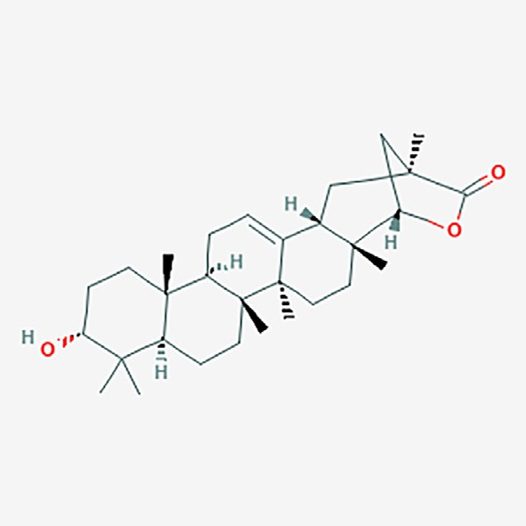cancer)

|  |  |  |  |  |  |  |  |  |
| --- | --- | --- | --- | --- | --- | --- | --- | --- |
| 2 | *Acorus calamus* L. | Beta-Asarone | Carminative | 0.905 | 0.008 | + | + | + |
|  |  | Pubchem ID: 5281758 | Apoptosis agonist | 0.802 | 0.008 | + | + | + |
|  |  | Molecular weight: 208.257 g/mol | Antineoplastic | 0.729 | 0.021 |  | + |  |
|  |  | Molecular formula: C12H16O3 SMILES:C/C@C\C1@CC(@C(C@C1OC)OC)OC |  |  |  |  |  |  |

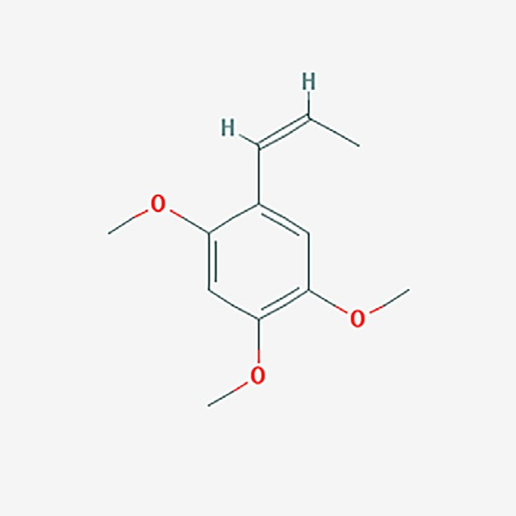

|  |  |  |  |  |  |  |  |  |
| --- | --- | --- | --- | --- | --- | --- | --- | --- |
| 3 | *Aristolochia* | Aristolochic acid | Antiseptic | 0.968 | 0.002 | + | + | + |
|  | *bracteolata*Lam. | Pubchem ID: 2236 | Respiratory analeptic | 0.828 | 0.007 | + | + | + |
|  |  | Molecular weight: 341.275 g/mol | Apoptosis agonist | 0.821 | 0.007 |  | + | + |
|  |  | Molecular formula: C17H11NO7 SMILES:COC1@CC@CC2@C3C(@C(C@C21)[N+]  (@O)[O-])C(@CC4@C3OCO4)C(@O)O |  |  |  |  |  |  |

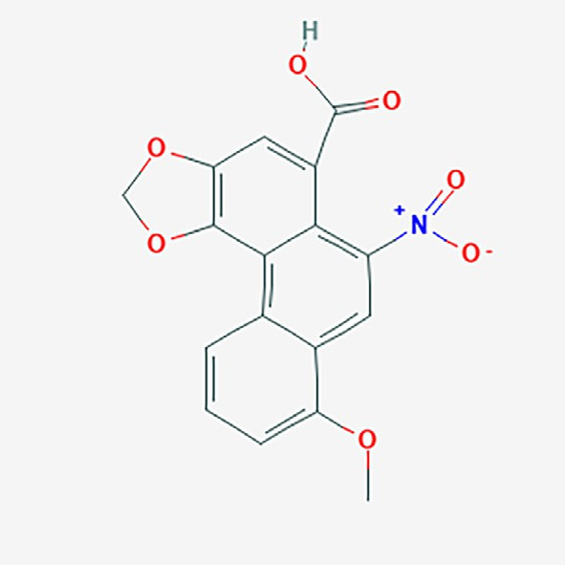

|  |  |  |  |  |  |  |  |
| --- | --- | --- | --- | --- | --- | --- | --- |
| S.  no | Plant name | Reported compounds with details | PASS prediction | Pa | Pi | admetSAR prediction |  |
|  |  |  |  |  |  | A M T |
| 4 | *Butea* | Butin | Membrane integrity | 0.953 | 0.003 | + + + |  |
|  | *monosperma* | Pubchem ID: 92775 | agonist |  |  | + + + |  |
|  | (Lam.) Taub. | Molecular weight: 272.256 g/mol | Antimutagenic | 0.848 | 0.003 | + |  |
|  |  | Molecular formula: C15H12O5 SMILES:C1[C@H](OC2@C(C1@O)C@CC(@C2)O)  C3@CC(@C(C@C3)O)O | Cytoprotectant | 0.796 | 0.002 |  |  |

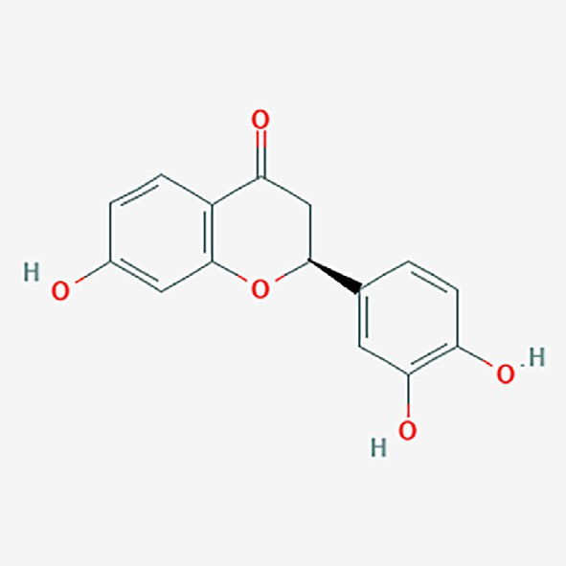

|  |  |  |  |  |  |  |  |  |
| --- | --- | --- | --- | --- | --- | --- | --- | --- |
| 5 | *Chloroxylon* | Skimmianine | Beta glucuronidase | 0.790 | 0.002 | + | + | + |
|  | *swietenia* DC. | Pubchem ID: 6760 | inhibitor |  |  | + | + | + |
|  |  | Molecular weight: 259.261 g/mol | Antineoplastic | 0.660 | 0.033 |  | + |  |
|  |  | Molecular formula: C14H13NO4 SMILES:COC1@C(C2@C(C@C1)C  (@C3C@COC3@N2)OC)OC |  |  |  |  |  |  |

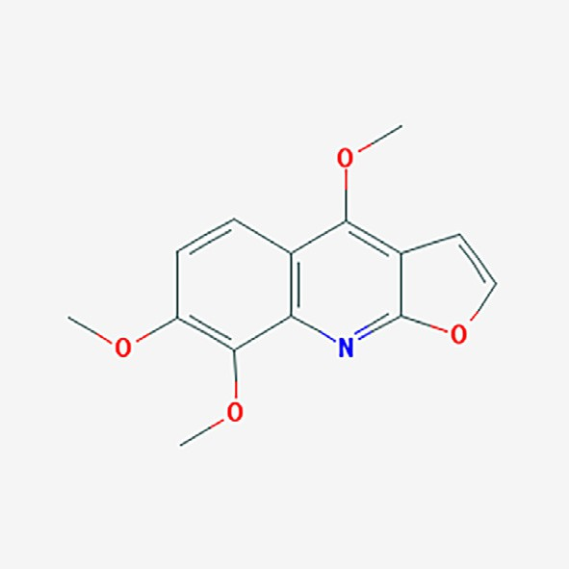

|  |  |  |  |  |  |  |
| --- | --- | --- | --- | --- | --- | --- |
| Swietenidin B | Aspulvinone | 0.816 | 0.028 | + | + | + |
| Pubchem ID: 442933 | dimethylallyltransferase |  |  | + | + | + |
| Molecular weight: 205.213 g/mol | inhibitor |  |  |  | + | + |
| Molecular formula: C11H11NO3 SMILES:COC1@C(C(@O)NC2@CC@CC@C21)OC |  |  |  |  |  |  |

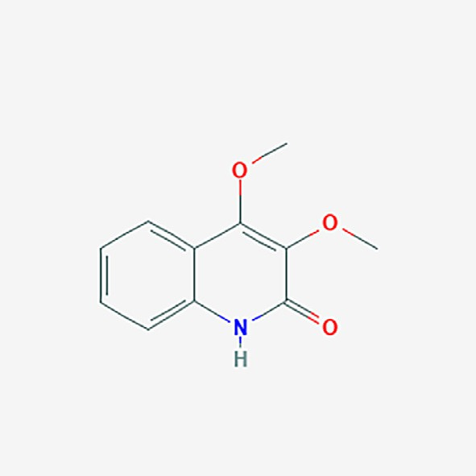

(*continued on next page*)

S. Plant name Reported compounds with details PASS prediction Pa Pi admetSAR no prediction

A M T

6 *Clematis gouriana*

Roxb. ex DC.

Protoanemonin Pubchem ID: 66948

Molecular weight: 96.085 g/mol Molecular formula: C5H4O2 SMILES:C@C1C@CC(@O)O1

Antileukemic 0.919 0.004 + + +

Antineoplastic 0.911 0.005 + + +

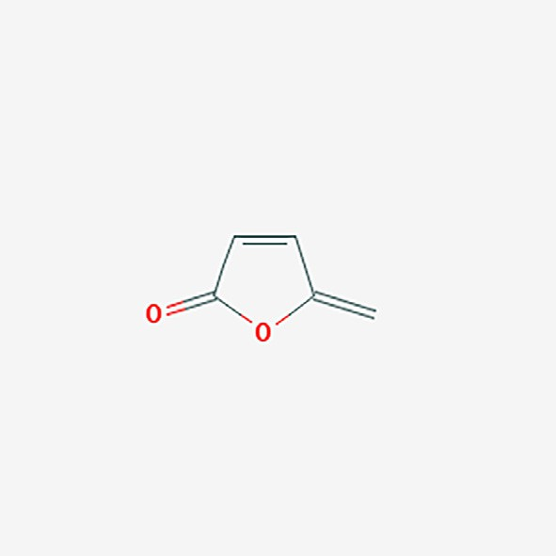

|  |  |  |  |  |  |  |  |  |
| --- | --- | --- | --- | --- | --- | --- | --- | --- |
| 7 | *Diospyros* | Diospyrin | Antiseptic | 0.860 | 0.004 | + | + | + |
|  | *montana* Roxb. | Pubchem ID: 308140 | Antineoplastic | 0.852 | 0.007 | + | + |  |
|  |  | Molecular weight: 374.348 g/mol | Antimutagenic | 0.783 | 0.004 | + | + |  |
|  |  | Molecular formula: C22H14O6  SMILES:CC1@CC(@C2C(@C1)C(@O)C(@CC2@O)C3@C(C@C4C(@O)C@CC(@O) |  |  |  |  |  |  |
|  |  | C4@C3O)C)O |  |  |  |  |  |  |

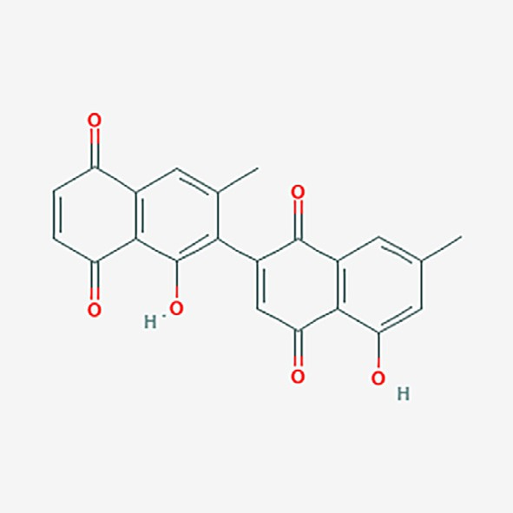

|  |  |  |  |  |  |  |  |  |
| --- | --- | --- | --- | --- | --- | --- | --- | --- |
| 8 | *Gmelina arborea* | Epieudesmin | Antineoplastic | 0.807 | 0.011 | + | + | + |
|  | Roxb. | Pubchem ID: 7000209 | Cardiovascular analeptic | 0.725 | 0.006 | + | + |  |
|  |  | Molecular weight: 386.444 g/mol |  |  |  | + |  |  |
|  |  | Molecular formula: C22H26O6 SMILES:COC1@C(C@C(C@C1)[C@H]2[C@H]3CO  [C@@H]([C@H]3CO2)C4@CC(@C(C@C4)OC)OC)OC |  |  |  |  |  |  |

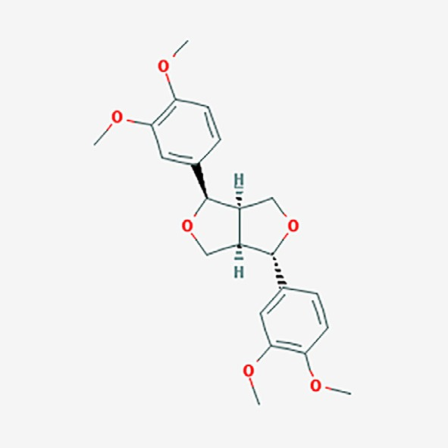

|  |  |  |  |  |  |  |  |
| --- | --- | --- | --- | --- | --- | --- | --- |
| S.  no | Plant name | Reported compounds with details | PASS prediction | Pa | Pi | admetSAR prediction |  |
|  |  |  |  |  |  | A M T |
| 9 | *Lawsonia inermis* | Lawsaritol | Antihypercholesterolemic | 0.971 | 0.002 | + + + |  |
|  | L. | Pubchem ID: 14890646 | Chemopreventive | 0.810 | 0.004 | + + |  |
|  |  | Molecular weight: 414.718 g/mol | Antieczematic | 0.806 | 0.017 |  |  |
|  |  | Molecular formula: C29H50O SMILES:CC[C@H](CC[C@@H](C)[C@H]1CC[C@@H]2  [C@@]1(CC[C@H]3[C@H]2CCC4@C[C@H](CC[C@]34C)O)C)C(C)C |  |  |  |  |  |

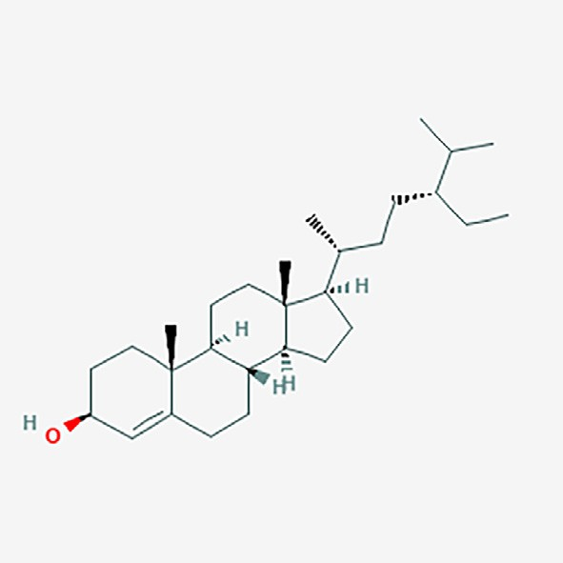

|  |  |  |  |  |  |  |
| --- | --- | --- | --- | --- | --- | --- |
| Lawsone | Vasoprotector | 0.821 | 0.004 | + | + | + |
| Pubchem ID: 6755 | Antimutagenic | 0.805 | 0.004 | + | + |  |
| Molecular weight: 174.155 g/mol | Antineoplastic | 0.777 | 0.015 | + |  |  |
| Molecular formula: C10H6O3 SMILES:C1@CC@C2C(@C1)C(@CC(@O)C2@O)O |  |  |  |  |  |  |

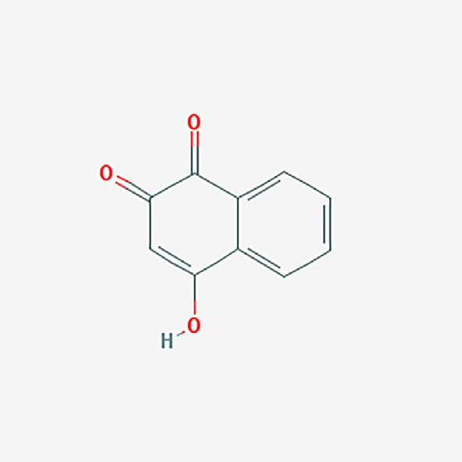

|  |  |  |  |  |  |  |  |  |
| --- | --- | --- | --- | --- | --- | --- | --- | --- |
| 10 | *Leucas aspera* | Oleanolic acid | Insulin promoter | 0.987 | 0.001 | + | + | + |
|  | (Willd.) Link | Pubchem ID: 10494 | Hepatoprotectant | 0.961 | 0.001 | + | + | + |
|  |  | Molecular weight: 456.711 g/mol | Chemopreventive | 0.937 | 0.002 |  | + |  |
|  |  | Molecular formula: C30H48O3 SMILES:C[C@]12CC[C@@H](C([C@@H]1CC[C@@]3 | Antinociceptive | 0.985 | 0.001 |  |  |  |
|  |  | ([C@@H]2CC@C4[C@]3(CC[C@@]5([C@H]4CC(CC5)(C)C)C(@O)O)C)C)(C)C)O | Antineoplastic | 0.877 | 0.005 |  |  |  |

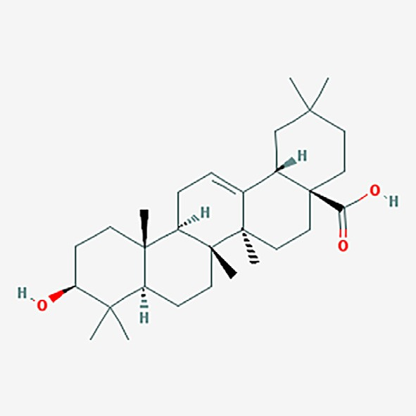

(*continued on next page*)

|  |  |  |  |  |  |  |  |
| --- | --- | --- | --- | --- | --- | --- | --- |
| S.  no | Plant name | Reported compounds with details | PASS prediction | Pa | Pi | admetSAR prediction |  |
|  |  |  |  |  |  | A M T |
|  |  | Ursolic Acid | Insulin promoter | 0.970 | 0.001 | + + + |  |
|  |  | Pubchem ID: 64945 | Hepatoprotectant | 0.961 | 0.001 | + + |  |
|  |  | Molecular weight: 456.711 g/mol | Chemopreventive | 0.929 | 0.002 | + |  |
|  |  | Molecular formula: C30H48O3 SMILES:C[C@@H]1CC[C@@]2(CC[C@@]3(C(@CC  [C@H]4[C@]3(CC[C@@H]5[C@@]4(CC[C@@H](C5(C)C)O)C)C)[C@@H]2[C@H]1C)C) | Antiprotozoal | 0.915 | 0.003 |  |  |
|  |  | C(@O)O |  |  |  |  |  |

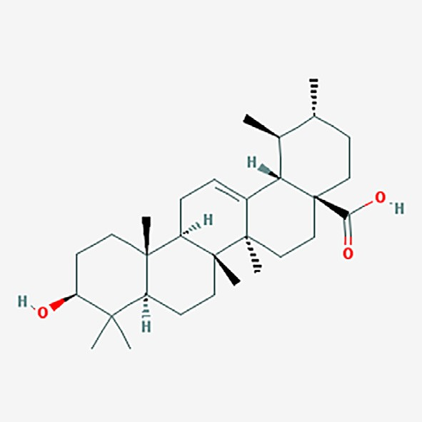

11 *Lycopersicon*

*esculentum* Mill.

Lycopene

Pubchem ID: 446925

Molecular weight: 536.888 g/mol

Molecular formula: C40H56 SMILES:CC(@CCC/C(@C/C@C/C(@C/C@C/C(@C/C@C/ C@C(/C@C/C@C(/C@C/C@C(/CCC@C(C)C)\C)\C)\C)/C)/C)/C)C

Apoptosis agonist 0.934 0.004 + + + Antineoplastic 0.905 0.005 + +

Antioxidant 0.848 0.003



|  |  |  |  |  |  |  |  |  |
| --- | --- | --- | --- | --- | --- | --- | --- | --- |
| 12 | *Madhuca indica* J. | Betulinic acid | Hepatoprotectant | 0.952 | 0.002 | + | + | + |
|  | F.Gmel. | Pubchem ID: 64971 | Antineoplastic | 0.925 | 0.005 | + | + |  |
|  |  | Molecular weight: 456.711 g/mol | Antiprotozoal | 0.923 | 0.003 |  |  |  |
|  |  | Molecular formula: C30H48O3 SMILES:CC(@C)[C@@H]1CC[C@]2([C@H]1[C@H]3CC | Chemopreventive | 0.835 | 0.003 |  |  |  |
|  |  | [C@@H]4[C@]5(CC[C@@H](C([C@@H]5CC[C@]4([C@@]3(CC2)C)C)(C)C)O)C)C(@O) | Antineoplastic | 0.825 | 0.003 |  |  |  |
|  |  | O | (melanoma) |  |  |  |  |  |

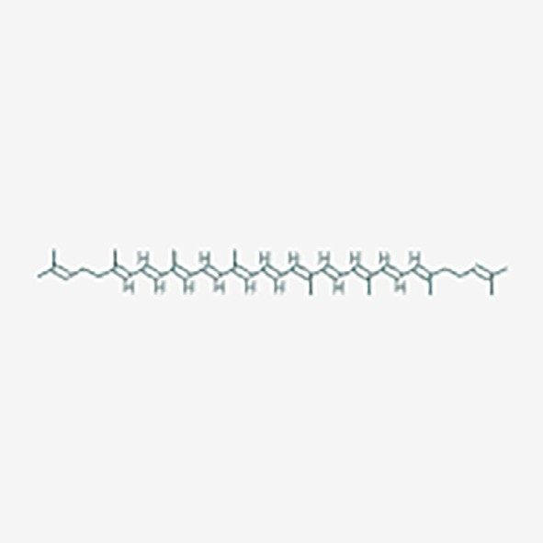

|  |  |  |  |  |  |  |  |
| --- | --- | --- | --- | --- | --- | --- | --- |
| S.  no | Plant name | Reported compounds with details | PASS prediction | Pa | Pi | admetSAR prediction |  |
|  |  |  |  |  |  | A M T |
| 13 | *Mallotus* | Friedelin | Apoptosis agonist | 0.871 | 0.005 | + + + |  |
|  | *philippensis* (Lam.) | Pubchem ID: 91472 | Antineoplastic | 0.850 | 0.007 | + + |  |
|  | Müll.Arg. | Molecular weight: 426.729 g/mol |  |  |  | + + |  |
|  |  | Molecular formula: C30H50O SMILES:C[C@H]1C(@O)CC[C@@H]2[C@@]1(CC[C@H]  3[C@]2(CC[C@@]4([C@@]3(CC[C@@]5([C@H]4CC(CC5)(C)C)C)C)C)C)C |  |  |  |  |  |

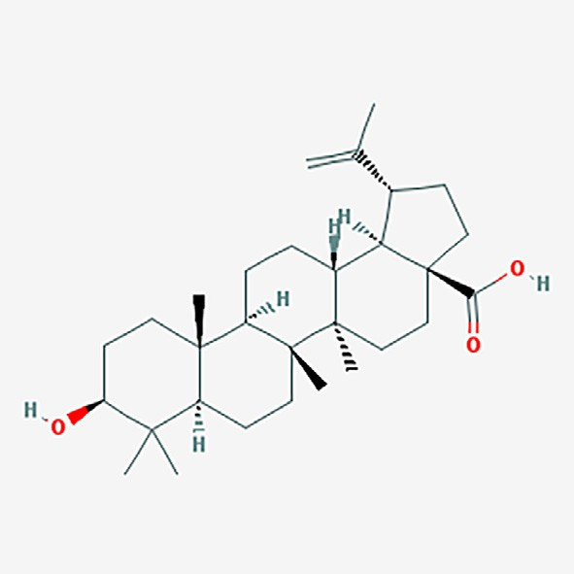

|  |  |  |  |  |  |  |  |  |
| --- | --- | --- | --- | --- | --- | --- | --- | --- |
| 14 | *Nelumbo nucifera* | Nuciferine | Antineurotic | 0.851 | 0.009 | + | + | + |
|  | Gaertn | Pubchem ID: 10146 | Antitussive | 0.836 | 0.003 | + | + |  |
|  |  | Molecular weight: 295.382 g/mol | Antieczematic | 0.851 | 0.010 | + | + |  |
|  |  | Molecular formula: C19H21NO2 SMILES:CN1CCC2@CC(@C(C3@C2[C@H]  1CC4@CC@CC@C43)OC)OC |  |  |  |  |  |  |

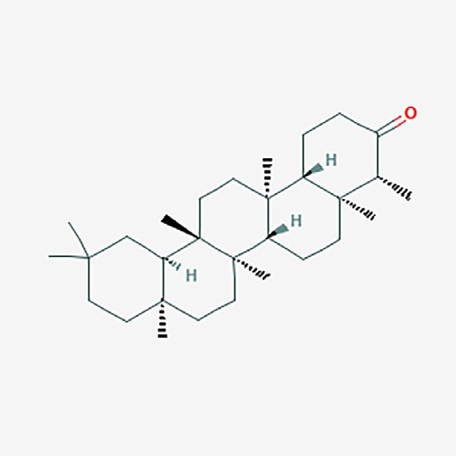

1. *Nyctanthes arbor- tristis* L.

Nyctanthic acid Pubchem ID: 12313631

Molecular weight: 440.712 g/mol

Molecular formula: C30H48O2 SMILES:CC(@C)[C@@H]1CC[C@@]2([C@@H]([C@@] 1(C)CCC(@O)O)CC@C3[C@]2(CC[C@@]4([C@H]3CC(CC4)(C)C)C)C)C

Hepatoprotectant 0.897 0.002 + + +

Insulin promoter 0.838 0.004 + +

Antineoplastic 0.826 0.009 +

Chemopreventive 0.814 0.004

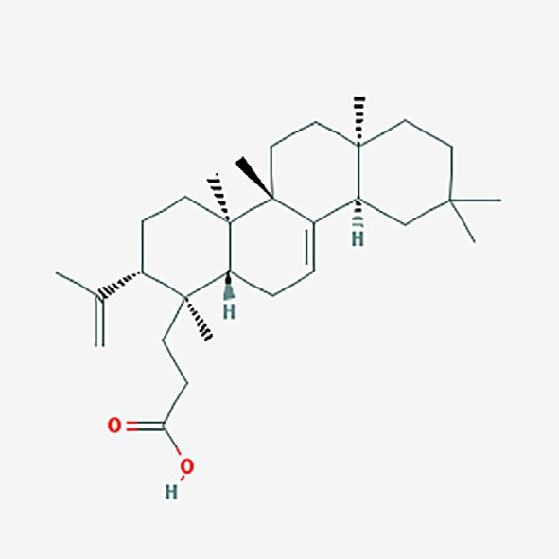

(*continued on next page*)

S. Plant name Reported compounds with details PASS prediction Pa Pi admetSAR no prediction

A M T

1. *Polyalthia*

*longifolia* (Sonn.)

Liriodenine Pubchem ID: 10144

Neurotransmitter uptake inhibitor

0.888 0.002 + + +

+ +

Thwaites

Molecular weight: 275.263 g/mol

Antineoplastic 0.786 0.014 +

Molecular formula: C17H9NO3 SMILES:C1OC2@C(O1)C3@C4C(@C2)C@CN@C4C (@O)C5@CC@CC@C53

Antineoplastic (colorectal cancer)

0.688 0.005

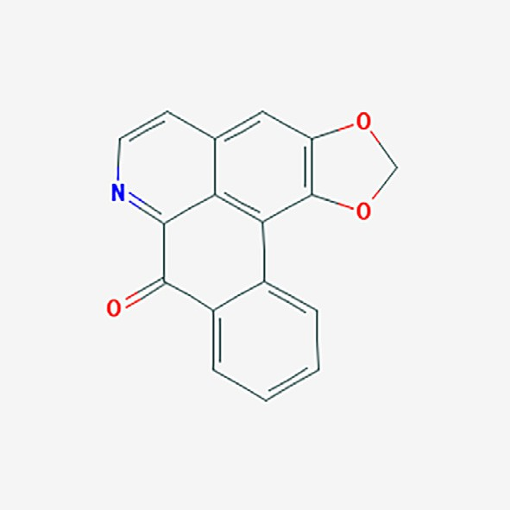

1. *Sesamum indicum*

L.

Sesamin

Pubchem ID: 72307

Membrane integrity agonist

0.931 0.005 + + +

+ +

Molecular weight: 354.358 g/mol

Molecular formula: C20H18O6 SMILES:C1[C@H]2[C@H](CO[C@@H]2C3@CC4@C (C@C3)OCO4)[C@H](O1)C5@CC6@C(C@C5)OCO6

Antineoplastic 0.797 0.012 +

Carminative 0.761 0.004

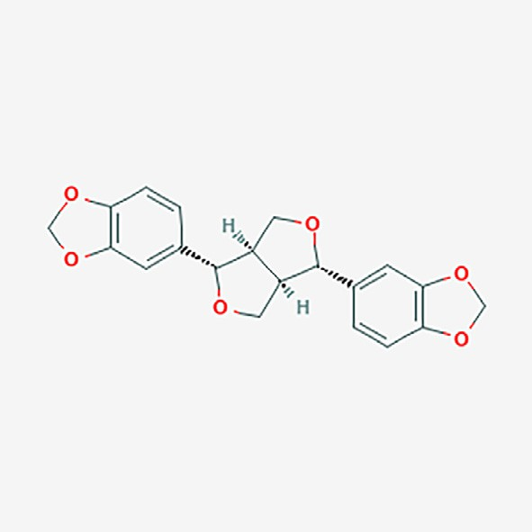

1. *Sida acuta* Burm.f. Vasicinone Antihypoxic 0.744 0.005 + + +

Pubchem ID: 442935

Molecular weight: 202.213 g/mol

Molecular formula: C11H10N2O2 SMILES:C1CN2C(@NC3@CC@CC@C3C2@O)[C@H] 1O

Antineoplastic (multiple myeloma)

0.564 0.005 + + +

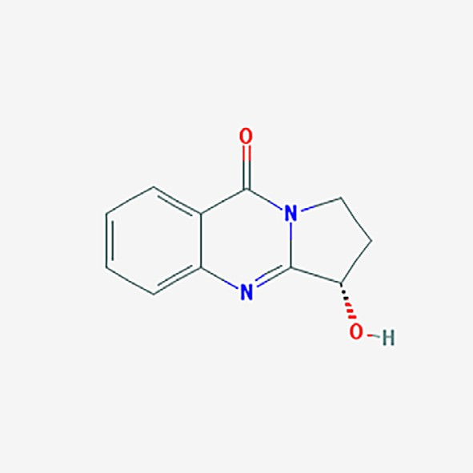

|  |  |  |  |  |  |  |  |
| --- | --- | --- | --- | --- | --- | --- | --- |
| S.  no | Plant name | Reported compounds with details | PASS prediction | Pa | Pi | admetSAR prediction |  |
|  |  |  |  |  |  | A M T |
| 19 | *Tribulus terrestris* | Harmine | Lysase inhibitor | 0.681 | 0.026 | + + + |  |
|  | L. | Pubchem ID: 5280953  Molecular weight: 212.252 g/mol  Molecular formula: C13H12N2O SMILES:CC1@NC@CC2@C1NC3@C2C@CC(@C3)OC | Preneoplastic conditions treatment | 0.628 | 0.019 | + + |  |

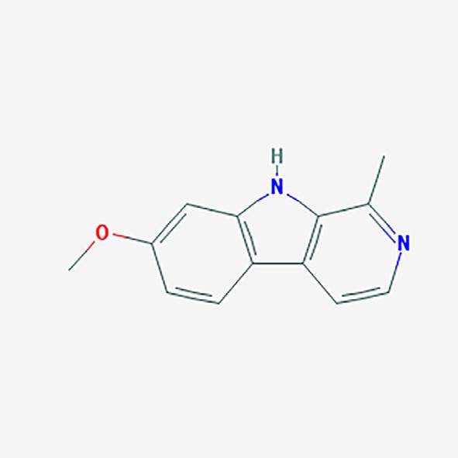

|  |  |  |  |  |  |  |  |  |
| --- | --- | --- | --- | --- | --- | --- | --- | --- |
| 20 | *Vitex negundo* L. | Vitexicarpin | Antimutagenic | 0.928 | 0.002 | + | + | + |
|  |  | Pubchem ID: 5315263 | Apoptosis agonist | 0.895 | 0.004 | + | + |  |
|  |  | Molecular weight: 374.345 g/mol | Antineoplastic | 0.832 | 0.008 |  |  |  |
|  |  | Molecular formula: C19H18O8 SMILES:COC1@C(C@C(C@C1)C2@C(C(@O)C3@C(C  (@C(C@C3O2)OC)OC)O)OC)O |  |  |  |  |  |  |

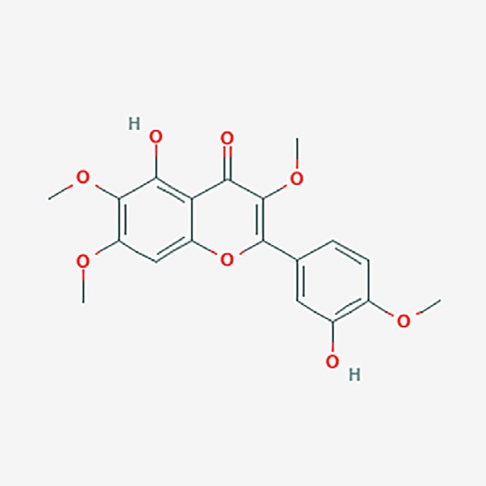

SMILES: Simplified molecular-input line-entry system; Pa: Probable activity, Pi: Probable inactivity; A: Adsorption; M: Metabolism; T: Toxicity.

presented in a Pa values, which is >0.5 are probably more active with the predicted cancer cell line. From the 20 plants 23 of com- pounds specifically selected and executed for cytotoxicity activity prediction in different cell lines by employing CLC-Pred tool. Almost all the plants showed aspirated outcome and barely three compounds displayed negative results those compounds are aris- tolochic acid (*Aristolochia bracteolata* Lam.), skimmianine (*Chlorox- ylon swietenia* DC.) and vitexicarpin (*Vitex negundo* L). The aristolochic acid CLC-Pred negative result greatly concurs in the result of PASS, but it is rationally used for tumor contradict vitexi- carpin showed positive correlation with both PASS prediction and study result (Tables 4 and 5).

The maximum number of different cell line prediction were col- lected and tabulated with respective cancer type, probability, and type of cell. The compounds oleanolic acid and ursolic acid from *Leucas aspera* (Willd.) Link showed significant cytotoxity against stomach adenocarcinoma (0.820/MKN-74), thyroid carcinoma (0.592/8505C), upper aero digestive tract carcinoma (0.505/FaDu), pancreas adenocarcinoma (0.504/ASPC-1), and stomach carcinoma (0.502/MKN-7) with significant Pa values (Table 5). Likewise, sesa- min of *Sesamum indicum* L. renders strong activity against lung car- cinoma (0.760/A549), central nervous system oligodendroglioma

(0.687/Hs683), central nervous system glioblastoma (0.522/SF- 295), colon adenocarcinoma (0.506/HCC2998) and stomach adeno- carcinoma (0.505/MKN-74) besides vasicinone from *Sida acuta* Burm.f. showed cytotoxicity against central nervous system oligo- dendroglioma (0.562/Hs683), Pleura mesothelioma (0.588/NCI- H2052) and lung carcinoma (0.530/PC-6). The other remaining compounds from the reported plants, *Madhuca indica* J.F.Gmel. (betulinic acid) (4), *Lawsonia inermis* L. (lawsaritol, Lawsone) (4), *Abutilon indicum* (L.) Sweet (Abruslactone A) (3), *Lycopersicon escu- lentum* Mill. (lycopene) (3), *Polyalthia longifolia* (Sonn.) Thwaites (liriodenine) (3), *Chloroxylon swietenia* DC (skimmianine, Swieteni- din B) (2), *Diospyros montana* Roxb. (Diospyrin) (2), *Gmelina arborea* Roxb. (epieudesmin) (2) and *Mallotus philippensis* (Lam.) Müll.Arg. (friedelin) (2) showed cytotoxicity against various cell lines respective of their affecting tissue. *Nyctanthes arbor-tristis* L. (nyctanthic acid) inversely *Butea monosperma* (butin), *Nelumbo nucifera* Gaertn (Nuciferine) *Tribulus terrestris* L. (harmine) pre- dicted with single cell lines cytotoxicity activity (Table 5).

*Tribulus terrestris* L. displayed only lung adenocarcinoma cyto- toxicity whereas present study and literature survey matches for hepatocellular carcinoma [31] comparatively *Nelumbo nucifera* Gaertn. mentioned to have traditionally used for inflammation

Table 5

*In silico* CLC-Pred cell line cytotoxicity prediction of documented plants from the study area.

|  |  |  |  |  |  |  |  |
| --- | --- | --- | --- | --- | --- | --- | --- |
| Plant name | Compoundsa | Cell line | Cell line model type | Affecting parts | Tumor type | Pa | Pi |
| *Abutilon indicum* (L.) | Abruslactone A | MKN-74 | Stomach adenocarcinoma cells | Stomach | Adenocarcinoma | 0.728 | 0.004 |
| Sweet |  | MKN-28 | Gastric epithelial carcinoma cells | Stomach | Carcinoma | 0.513 | 0.016 |
|  |  | MKN-7 | Gastric carcinoma cells | Stomach | Carcinoma | 0.522 | 0.034 |
| *Acorus calamus* L. | Beta-Asarone | TE-671 | Human Rhabdomyosarcoma cell line | Muscle | Sarcoma | 0.671 | 0.005 |
| *Butea monosperma* | Butin | PC-6 | Small cell lung carcinoma cells | Lung | Carcinoma | 0.519 | 0.023 |
| *Chloroxylon swietenia* DC | Skimmianine | TE-671 | Human Rhabdomyosarcoma cell line | Muscle | Sarcoma | 0.551 | 0.023 |
|  | Swietenidin B | HS 683 | Oligodendroglioma cells | Central nervous system | Oligodendroglioma | 0.505 | 0.014 |
| *Clematis gouriana* Roxb. | Protoanemonin | TE-671 | Human Rhabdomyosarcoma cell line | Muscle | Sarcoma | 0.682 | 0.005 |
| ex DC.  *Diospyros Montana* Roxb. | Diospyrin | NALM-6  HOP-18 | Adult B acute lymphoblastic leukemia cells  Non-small cell lung carcinoma cells | Haematopoietic and lymphoid tissue  Lung | Leukemia  Carcinoma | 0.545  0.627 | 0.003  0.003 |
| *Gmelina arborea* Roxb. | Epieudesmin | NC- H2052  A549 | Epithelioid mesothelioma cells  Lung carcinoma cells | Pleura  Lung | Mesothelioma  Carcinoma | 0.557  0.575 | 0.096  0.046 |
|  |  | PC-6 | Small cell lung carcinoma cells | Lung | Carcinoma | 0.534 | 0.022 |
| *Lawsonia inermis* L. | Lawsaritol | MKN-74 | Stomach adenocarcinoma cells | Stomach | Adenocarcinoma | 0.682 | 0.006 |
|  | Lawsone | MKN-7 | Gastric carcinoma cells | Stomach | Carcinoma | 0.548 | 0.023 |
|  |  | TE-671 | Human Rhabdomyosarcoma cell line | Muscle | Sarcoma | 0.634 | 0.009 |
| *Leucas aspera* (Willd.) | Oleanolic acid | NC- H2052  MKN-74 | Epithelioid mesothelioma cells  Stomach adenocarcinoma cells | Pleura  Stomach | Mesothelioma  Adenocarcinoma | 0.501  0.820 | 0.144  0.002 |
| Link | Ursolic acid | 8505C | Thyroid gland undifferentiated  (anaplastic) carcinoma cells | Thyroid | Carcinoma | 0.592 | 0.004 |
|  |  | FaDu  MKN-74 | Hypopharyngeal squamous carcinoma cells  Stomach adenocarcinoma cells | Upper aerodigestive tract  Stomach | Carcinoma  Adenocarcinoma | 0.505  0.756 | 0.007  0.003 |
|  |  | ASPC-1 | Pancreatic ductal adenocarcinoma cells | Pancreas | Adenocarcinoma | 0.504 | 0.004 |
|  |  | MKN-7 | Gastric carcinoma cells | Stomach | Carcinoma | 0.502 | 0.042 |
| *Lycopersicon esculentum* Lycopene | | TE-671 | Human Rhabdomyosarcoma cell line | Muscle | Sarcoma | 0.803 | 0.003 |
| Mill. | | LOX | Breast carcinoma cells | Breast | Carcinoma | 0.695 | 0.018 |
|  |  | IMVI | Melanoma cells | Skin | Melanoma | 0.529 | 0.015 |
|  |  | MKN-74 | Gastric carcinoma cells | Stomach | Carcinoma | 0.575 | 0.019 |
| *Madhuca indica* J.F.Gmel. | Betulinic acid | FaDu  8505C | Hypopharyngeal squamous carcinoma cells  Thyroid gland undifferentiated | Upper aerodigestive tract  Thyroid | Carcinoma  Carcinoma | 0.794  0.724 | 0.003  0.003 |
|  |  | MKN-74 | (anaplastic) carcinoma cells  Stomach adenocarcinoma cells | Stomach | Adenocarcinoma | 0.654 | 0.008 |
|  |  | SK- | Melanoma cells | Skin | Melanoma | 0.560 | 0.013 |
| *Mallotus philippensis* | Friedelin | MEL-2  MKN-74 | Stomach adenocarcinoma cells | Stomach | Adenocarcinoma | 0.614 | 0.013 |
| (Lam.) Müll.Arg.  *Nelumbo nucifera* Gaertn | Nuciferine | H9  A549 | T-lymphoid cells  Lung carcinoma cells | Haematopoietic and lymphoid tissue  Lung | Lymphoma  Carcinoma | 0.507  0.502 | 0.006  0.060 |
| *Nyctanthes arbor-tristis* L. | Nyctanthic | MKN-74 | Stomach adenocarcinoma cells | Stomach | Adenocarcinoma | 0.597 | 0.015 |
|  | acid | FaDu | Hypopharyngeal squamous carcinoma  cells | Upper aerodigestive tract | Carcinoma | 0.521 | 0.006 |
| *Polyalthia longifolia* | Liriodenine | A549 | Lung carcinoma cells | Lung | Carcinoma | 0.675 | 0.027 |
| (Sonn.) Thwaites |  | HCT-15 | Colon adenocarcinoma cells | Large intestine | Adenocarcinoma | 0.613 | 0.010 |
|  |  | SF-268 | Glioblastoma cells | Brain | Glioblastoma | 0.529 | 0.017 |
| *Sesamum indicum* L. | Sesamin | A549 | Lung carcinoma cells | Lung | Carcinoma | 0.760 | 0.016 |
|  |  | Hs 683 | Oligodendroglioma cells | Central nervous system | Oligodendroglioma | 0.687 | 0.004 |
|  |  | SF-295 | Glioblastoma cells | Central nervous system | Glioblastoma | 0.522 | 0.016 |
|  |  | HCC  2998 | Colon adenocarcinoma cells | Colon | Adenocarcinoma | 0.506 | 0.023 |
|  |  | MKN-74 | Stomach adenocarcinoma cells | Stomach | Adenocarcinoma | 0.505 | 0.036 |
| *Sida acuta* Burm.f. | Vasicinone | Hs 683 | Oligodendroglioma cells | Central nervous system | Oligodendroglioma | 0.562 | 0.008 |
|  |  | NCI- H2052  PC-6 | Epithelioid mesothelioma cells  Small cell lung carcinoma cells | Pleura  Lung | Mesothelioma  Carcinoma | 0.588  0.530 | 0.076  0.022 |
|  |  | MSTO-  211H | Pleural mesothelioma cells | Pleura | Mesothelioma | 0.501 | 0.114 |
| *Tribulus terrestris* L. | Harmine | SK-LU-1 | Lung adenocarcinoma | Lung | Adenocarcinoma | 0.508 | 0.069 |

a The compounds details were given in Table 4; Pa: Probable activity, Pi: Probable inactivity.

and cancer it greatly resembles with present study [32]. Likewise, *Butea monosperma* reported for its traditional usage as the anti- inflammatory and strong anti-cancer against hepatoma cells [33]. Above assertion grant adequate knowledge about the interconnec- tion between anti-inflammatory plants with anti- cancer proper- ties, and it authenticates undoubtedly Indian tradition of medicine have sufficient skills in treating cancer-related ailments and other disparate afflictions as evinced in ‘‘Ayurveda.”

1. Conclusion

Studies on ethno medicinal anti-inflammatory and wound heal- ing was abundant all over the world beyond particular attention paid to Indian ethnic societies, which have age-old therapeutic practices and guidelines for prescription medicaments by herbalist and traditional healers. The present study documented about 20 ethno medicinal plants that are utilized as anti-inflammatory,

wound healing agents and also in the treatment of cancer based on the traditional reports, particularly *Nyctanthes arbor-tristis*, *Butea monosperma; Tribulus terrestris* predicted cytotoxicity activity sig- nificantly correlated with the literature survey. The selected com- pounds from reported plants revealed significant anticancer activity in CLC-Pred prediction and PASS tools. This study entirely draws the appreciable output on the relationship of anti- inflammatory plants in cancer and moreover, the *in silico* studies assessed extremely the presence of anticancer activity. This study showed the possibility to correlate ethno pharmacological thera- pies to develop new pharmaceutical drugs thus can accelerate the interpretative analysis of the ethnic anti-inflammatory plants in the development of anti-cancerous drugs.

References

1. [Fabricant DS, Farnsworth NR. The value of plants used in traditional medicines](http://refhub.elsevier.com/S2314-808X(18)30257-4/h0005) [for drug discovery. Environ Health Perspect 2001;109():69–75](http://refhub.elsevier.com/S2314-808X(18)30257-4/h0005).
2. [Inngjerdingen K, Nergård CS, Diallo D, Mounkoro PP, Paulsen BS. An](http://refhub.elsevier.com/S2314-808X(18)30257-4/h0010) [ethnopharmacological survey of plants used for wound healing in](http://refhub.elsevier.com/S2314-808X(18)30257-4/h0010) [Dogonland, Mali, West Africa. J Ethnopharmacol 2004;92(2):233–44](http://refhub.elsevier.com/S2314-808X(18)30257-4/h0010).
3. [Wang R, Lechtenberg M, Sendker J, Petereit F, Deters A, Hensel A. Wound-](http://refhub.elsevier.com/S2314-808X(18)30257-4/h0015) [healing plants from TCM: *in vitro* investigations on selected TCM plants and](http://refhub.elsevier.com/S2314-808X(18)30257-4/h0015) [their influence on human dermal fibroblasts and keratinocytes. Fitoterapia](http://refhub.elsevier.com/S2314-808X(18)30257-4/h0015) [2013;84:308–17](http://refhub.elsevier.com/S2314-808X(18)30257-4/h0015).
4. [Harding KG, Morris HL, Patel GK. Healing chronic wounds. Brit Med J 2002;324](http://refhub.elsevier.com/S2314-808X(18)30257-4/h0020) [(7330):160](http://refhub.elsevier.com/S2314-808X(18)30257-4/h0020).
5. [Agyare C, Asase A, Lechtenberg M, Niehues M, Deters A, Hensel A. An](http://refhub.elsevier.com/S2314-808X(18)30257-4/h0025) [ethnopharmacological survey and *in vitro* confirmation of](http://refhub.elsevier.com/S2314-808X(18)30257-4/h0025) [ethnopharmacological use of medicinal plants used for wound healing in](http://refhub.elsevier.com/S2314-808X(18)30257-4/h0025) [Bosomtwi-Atwima-Kwanwoma area, Ghana. J Ethnopharmacol 2009;125](http://refhub.elsevier.com/S2314-808X(18)30257-4/h0025) [(3):393–403](http://refhub.elsevier.com/S2314-808X(18)30257-4/h0025).
6. [Kumar B, Vijayakumar M, Govindarajan R, Pushpangadan P.](http://refhub.elsevier.com/S2314-808X(18)30257-4/h0030) [Ethnopharmacological approaches to wound healing—exploring medicinal](http://refhub.elsevier.com/S2314-808X(18)30257-4/h0030) [plants of India. J Ethnopharmacol 2007;114(2):103–13](http://refhub.elsevier.com/S2314-808X(18)30257-4/h0030).
7. [Namsa ND, Tag H, Mandal M, Kalita P, Das AK. An ethnobotanical study of](http://refhub.elsevier.com/S2314-808X(18)30257-4/h0035) [traditional anti-inflammatory plants used by the Lohit community of](http://refhub.elsevier.com/S2314-808X(18)30257-4/h0035) [Arunachal Pradesh, India. J Ethnopharmacol 2009;125(2):234–45](http://refhub.elsevier.com/S2314-808X(18)30257-4/h0035).
8. [Jain S, Gill V, Vasudeva N, Singla N. Ayurvedic medicines in treatment of](http://refhub.elsevier.com/S2314-808X(18)30257-4/h0040) [cancer. J Chin Integr Med 2009;7(11):1096–9](http://refhub.elsevier.com/S2314-808X(18)30257-4/h0040).
9. Kazemi S, Shirzad H, Rafieian-Kopaei M. Recent findings in molecular basis of inflammation and anti-inflammatory plants. Curr Pharm Des 2018. [https://doi.](https://doi.org/10.2174/1381612824666180403122003) [org/10.2174/1381612824666180403122003](https://doi.org/10.2174/1381612824666180403122003) (in press).
10. [Garodia P, Ichikawa H, Malani N, Sethi G, Aggarwal BB. From ancient medicine](http://refhub.elsevier.com/S2314-808X(18)30257-4/h0050) [to modern medicine: ayurvedic concepts of health and their role in](http://refhub.elsevier.com/S2314-808X(18)30257-4/h0050) [inflammation and cancer. J Soc Integr Oncol 2007;5(1):25–37](http://refhub.elsevier.com/S2314-808X(18)30257-4/h0050).
11. [Aggarwal BB, Gehlot P. Inflammation and cancer: how friendly is the](http://refhub.elsevier.com/S2314-808X(18)30257-4/h0055) [relationship for cancer patients? Curr Opin Pharmacol 2009;9(4):351–69](http://refhub.elsevier.com/S2314-808X(18)30257-4/h0055).
12. [Saffari-Chaleshtori J, Heidari-Soreshjani E, Asadi-Samani M. Computational](http://refhub.elsevier.com/S2314-808X(18)30257-4/h0060) [study of quercetin effect on pre-apoptotic factors of Bad, Bak and Bim. J](http://refhub.elsevier.com/S2314-808X(18)30257-4/h0060) [Herbmed Pharmacol 2016;5(2):61–6](http://refhub.elsevier.com/S2314-808X(18)30257-4/h0060).
13. [Geronikaki A, Druzhilovsky D, Zakharov A, Poroikov VSAR. Computer-aided](http://refhub.elsevier.com/S2314-808X(18)30257-4/h0065) [prediction for medicinal chemistry via the Internet 1. SAR QSAR Environ Res](http://refhub.elsevier.com/S2314-808X(18)30257-4/h0065) [2008;19(1–2):27–38](http://refhub.elsevier.com/S2314-808X(18)30257-4/h0065).
14. [Martin YC. Computer-assisted rational drug design. Methods Enzymol](http://refhub.elsevier.com/S2314-808X(18)30257-4/h0070) [1991;203(29):587–613](http://refhub.elsevier.com/S2314-808X(18)30257-4/h0070).
15. [Revathi P, Parimelazhagan T, Manian S. Ethnomedicinal plants and novel](http://refhub.elsevier.com/S2314-808X(18)30257-4/h0075) [formulations used by Hooralis tribe in Sathyamangalam forests, Western](http://refhub.elsevier.com/S2314-808X(18)30257-4/h0075) [Ghats of Tamil Nadu, India. J Med Plant Res 2013;7(28):2083–97](http://refhub.elsevier.com/S2314-808X(18)30257-4/h0075).
16. [Poongodi A, Thilagavathi S, Aravindhan V, Rajendran A. Observations on some](http://refhub.elsevier.com/S2314-808X(18)30257-4/h0080) [ethnomedicinal plants in Sathyamangalam forests of Erode district, Tamil](http://refhub.elsevier.com/S2314-808X(18)30257-4/h0080) [Nadu, India. J Med Plant Res 2011;5(19):4709–14](http://refhub.elsevier.com/S2314-808X(18)30257-4/h0080).
17. Chinnasamy P, Arumugam R, Ariyan S. In silico validation of the indigenous knowledge of the herbal medicines among tribal communities in Sathyamangalam wildlife sanctuary, India. J Tradit Complement Med 2018. [https://doi.org/10.1016/ j.jtcme.2018.01.008](https://doi.org/10.1016/j.jtcme.2018.01.008) (in press).
18. [Gamble JS. Flora of the Presidency of Madras. Calcutta: Secretary of State for](http://refhub.elsevier.com/S2314-808X(18)30257-4/h0090) [India; 1915](http://refhub.elsevier.com/S2314-808X(18)30257-4/h0090).
19. [Nair NC, Henry AN. Flora of Tamil Nadu, India. Coimbatore: Botanical Survey of](http://refhub.elsevier.com/S2314-808X(18)30257-4/h0095) [India; 1983](http://refhub.elsevier.com/S2314-808X(18)30257-4/h0095).
20. [Matthew KM. Materials for a Flora of the Tamilnadu. Carnatic: Rapinat](http://refhub.elsevier.com/S2314-808X(18)30257-4/h0100) [Herbarium Tiruchirappalli; 1981](http://refhub.elsevier.com/S2314-808X(18)30257-4/h0100).
21. Web 1: <http://www.theplantlist.org/>.
22. Web 2: <http://www.ipni.org/>.
23. [Riju A, Sithara K, Suja SN, Shamina A, Eapen SJ. *In silico* screening major spice](http://refhub.elsevier.com/S2314-808X(18)30257-4/h0115) [phytochemicals for their novel biological activity and pharmacological fitness.](http://refhub.elsevier.com/S2314-808X(18)30257-4/h0115) [J Bioequiv Availb 2009;1:063–73](http://refhub.elsevier.com/S2314-808X(18)30257-4/h0115).
24. [Bianchini F, Kaaks R, Vainio H. Overweight, obesity, and cancer risk. Lancet](http://refhub.elsevier.com/S2314-808X(18)30257-4/h0120) [Oncol 2002;3(9):565–74](http://refhub.elsevier.com/S2314-808X(18)30257-4/h0120).
25. [Ayyanar M, Ignacimuthu S. Ethnobotanical survey of medicinal plants](http://refhub.elsevier.com/S2314-808X(18)30257-4/h0125) [commonly used by Kani tribals in Tirunelveli hills of Western Ghats, India. J](http://refhub.elsevier.com/S2314-808X(18)30257-4/h0125) [Ethnopharmacol 2011;134(3):851–64](http://refhub.elsevier.com/S2314-808X(18)30257-4/h0125).
26. [Poonam K, Singh GS. Ethnobotanical study of medicinal plants used by the](http://refhub.elsevier.com/S2314-808X(18)30257-4/h0130) [Taungya community in Terai Arc Landscape, India. J Ethnopharmacol](http://refhub.elsevier.com/S2314-808X(18)30257-4/h0130) [2009;123(1):167–76](http://refhub.elsevier.com/S2314-808X(18)30257-4/h0130).
27. [Hernández-Núñez E, Tlahuext H, Moo-Puc R, Torres-Gómez H, Reyes-Martínez](http://refhub.elsevier.com/S2314-808X(18)30257-4/h0135) [R, Cedillo-Rivera R, et al. Synthesis and *in vitro* trichomonicidal, giardicidal and](http://refhub.elsevier.com/S2314-808X(18)30257-4/h0135) [amebicidal activity of N-acetamide (sulfonamide)-2-methyl-4-nitro-1H-](http://refhub.elsevier.com/S2314-808X(18)30257-4/h0135) [imidazoles. Europ J Med Chem 2009;44(7):2975–84](http://refhub.elsevier.com/S2314-808X(18)30257-4/h0135).
28. [Poon SL, Huang MN, Choo Y, McPherson JR, Yu W, Heng HL, et al. Mutation](http://refhub.elsevier.com/S2314-808X(18)30257-4/h0140) [signatures implicate aristolochic acid in bladder cancer development. Genome](http://refhub.elsevier.com/S2314-808X(18)30257-4/h0140) [Med 2015;7(1):38](http://refhub.elsevier.com/S2314-808X(18)30257-4/h0140).
29. [Yoon JS, Kim HM, Yadunandam AK, Kim NH, Jung HA, Choi JS, et al. Neferine](http://refhub.elsevier.com/S2314-808X(18)30257-4/h0145) [isolated from *Nelumbo nucifera* enhances anti-cancer activities in Hep3B cells:](http://refhub.elsevier.com/S2314-808X(18)30257-4/h0145) [molecular mechanisms of cell cycle arrest, ER stress induced apoptosis and](http://refhub.elsevier.com/S2314-808X(18)30257-4/h0145) [anti-angiogenic response. Phytomedi 2013;20(11):1013–22](http://refhub.elsevier.com/S2314-808X(18)30257-4/h0145).
30. [Cheng F, Li W, Zhou Y, Shen J, Wu Z, Liu G, et al. admetSAR: a comprehensive](http://refhub.elsevier.com/S2314-808X(18)30257-4/h0150) [source and free tool for assessment of chemical ADMET properties. J Chem Inf](http://refhub.elsevier.com/S2314-808X(18)30257-4/h0150) [Model 2012;52(11):3099–105](http://refhub.elsevier.com/S2314-808X(18)30257-4/h0150).
31. [Kim HJ, Kim JC, Min JS, Kim MJ, Kim JA, Kor MH, et al. Aqueous extract of](http://refhub.elsevier.com/S2314-808X(18)30257-4/h0155)

[*Tribulus terrestris* Linn induces cell growth arrest and apoptosis by down-](http://refhub.elsevier.com/S2314-808X(18)30257-4/h0155) [regulating NF-jB signaling in liver cancer cells. J Ethnopharmacol 2011;136](http://refhub.elsevier.com/S2314-808X(18)30257-4/h0155) [(1):197–203](http://refhub.elsevier.com/S2314-808X(18)30257-4/h0155).

1. [Mukherjee PK, Mukherjee D, Maji AK, Rai S, Heinrich M. The sacred lotus](http://refhub.elsevier.com/S2314-808X(18)30257-4/h0160) [(*Nelumbo nucifera*)–phytochemical and therapeutic profile. J Pharmaceut](http://refhub.elsevier.com/S2314-808X(18)30257-4/h0160) [Pharmacol 2009;61(4):407–22](http://refhub.elsevier.com/S2314-808X(18)30257-4/h0160).
2. [Choedon T, Shukla SK, Kumar V. Chemopreventive and anti-cancer properties](http://refhub.elsevier.com/S2314-808X(18)30257-4/h0165) [of the aqueous extract of flowers of *Butea monosperma*. J Ethnopharmacol](http://refhub.elsevier.com/S2314-808X(18)30257-4/h0165) [2010;129(2):208–13](http://refhub.elsevier.com/S2314-808X(18)30257-4/h0165).