HOSTE D BY

Available online at [www.sciencedirect.com](http://www.sciencedirect.com/science/journal/2314808X)

**ScienceDirect**

journal homepage: [http://ees.elsevier.com/ejbas/default.asp](http://http//ees.elsevier.com/ejbas/default.asp)

egyptian journal of basic and applied sciences 3 (2016) 366–3 7 6



**Full Length Article**

**Investigating the optical properties and molecular structure of PEEK fiber**



***M.A. El-Bakary*** ***\****

*Physics Department, Faculty of Science, Mansoura University, Mansoura 35516, Egypt*

A R T I C L E I N F O A B S T R A C T

*Article history:*

Received 28 May 2016

Received in revised form 12 August 2016

Accepted 15 August 2016

Available online 22 August 2016

*Keywords:*

Poly(ether ether ketone) (PEEK) Birefringence

Optical constants Crystallinity Orientation VAWI-technique

The automatic variable wavelength interferometry, VAWI, technique is used to determine the optical properties of Poly(ether ether ketone), PEEK, highly oriented fiber. The main part of this technique is the Pluta polarizing interference microscope attached with the auto- matic moving interference filter via stepper motor. The VAWI technique depends on measuring the optical path length differences at certain positions in microinterferogram. These posi- tions are the coincidence and anti-coincidence of the fiber fringe with the free medium fringes. The measured refractive indices and birefringence values are utilized to calculate some optical constants of PEEK fiber using Cauchy and Sellmeier’s equations. Also using some struc- ture relationship, some molecular structure and orientation parameters of PEEK fiber as a function of the wavelength of the incident light are calculated. The method allows us to determine any molecular structure parameters of PEEK fiber at any wavelength in the visible spectrum. Microinterfrograms are given for illustration.

© 2016 Mansoura University. Production and hosting by Elsevier B.V. This is an open access article under the CC BY-NC-ND license (<http://creativecommons.org/licenses/by->

nc-nd/4.0/).

# Introduction

Poly(ether ether ketone), (PEEK) fiber is a semi-crystalline en- gineering polymer material; its scientific name is poly(oxy- 1,4-phenyene-oxy-1, 4-phenyene). The melting and glass

transition temperatures are (Tm = 340 °C, Tg = 143 °C) [1]. The ex- cellent mechanical properties of PEEK make it attractive for use

as a matrix material for high performance engineering ther- moplastic. PEEK fiber has a remarkable applications in many advanced industries, such as opto-electronics and aerospace systems, because of its chemical stability and high mechanical

strength [2,3]. In the melting state, PEEK is amorphous, it has its crystalline structure during the solidification process. The percentage of the crystalline and amorphous regions depends on the conditions of the solidification process. Thermal and crystallization behavior, processing, morphology, mechanical and structural properties of PEEK fiber were studied [3–8]. The chemical structure of PEEK fiber is:

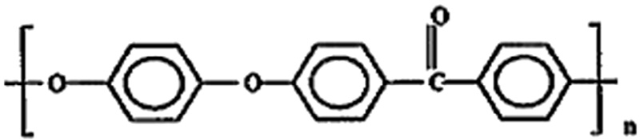

* *E-mail address:* [elbakary2@yahoo.com](mailto:elbakary2@yahoo.com). <http://dx.doi.org/10.1016/j.ejbas.2016.08.003>

2314-808X/© 2016 Mansoura University. Production and hosting by Elsevier B.V. This is an open access article under the CC BY-NC-ND license ([http://creativecommons.org/licenses/by-nc-nd/4.0/).](http://creativecommons.org/licenses/by-nc-nd/4.0/))

egyptian journal of basic and applied sciences 3 (2016) 366–3 7 6

**367**

The specific optical and dispersion properties give de- tailed information about the structure behavior of the fiber material. The refractive effects are a key information of mo- lecular orientation, crystalline and amorphous regions, and other structural properties of the synthetic fibers [9]. Also, the

The relation between the refractive index of the fiber material and the wavelength of monochromatic light used can be investigated from the well known Cauchy’s disper- sion relation [18]:

methods for characterizing its optical, mechanical and struc- tural parameters relationship are of considerable interest. Voice et al. [5] and Cakmak [10] studied the molecular orientation

**n** **   **A**   **B**

****2**

(4)

in uniaxially drawn PEEK from the X-ray, refractive index and intrinsic birefringence measurements.

Interferometric measurement techniques have been rec- ognized as a precise tool for studying the fibrous materials [11,12]. The VAWI-technique [11] is specially recommended for studying highly and partially oriented polymer fibers. The spec- tral dispersion properties and refractive index profile of some highly oriented fibers have been studied [13–16] using VAWI

where n(λ) is the refractive index at a given wavelength λ, A

and B are Cauchy’s constants. The values of these constants depend on the molecular structure behavior of the material. Another dispersion relation is between the transmitted photon energy E and the refractive index n of the fiber mate- rial. For a single oscillator, this relation is described by a

Sellmeier’s equation as follows [19]:

technique.

In this article, the VAWI-technique is used for studying Poly(ether ether ketone), PEEK, highly oriented fiber. The optical

**n2**  **1****1**  **Eo** 

**d**

**E**

**E2**

**EdEo**

(5)

properties of PEEK fibers are measured. The obtained results are utilized to calculate some molecular structure param- eters of the PEEK fiber such as the high frequency refractive

index n∞, the average oscillator wavelength λo and the oscil-

lator length strength So, polarizability per unit volume, density, the mass fraction of crystalline and amorphous regions, the optical stress coefficient, and molecular orientation behavior of PEEK fibers.

where Eo is the average excitation energy for the electronic tran-

sition or oscillation energy and Ed is the dispersion energy. The above equation can be calculated for the different polariza- tion states of the light vector. The resulting data can be analyzed to determine the long wavelength refractive index n∞, the os-

cillator length strength So and the average oscillator wave length

λo of the fiber material by using the single term Sellmeier’s oscillator [20].

**n2**  **1**

◎

 1  

****o**  **2**

(6)

# Theoretical considerations

**n2**  **1**

 ** 

where **n2**  1  **S** **2. By substituting in equation (6), one can

## *Optical and dispersion properties*

The refractive index and birefringence are considered as keys for determining the optical properties of the fiber material. Vari- able wavelength microinterferometry [11], VAWI, depends on measuring the optical path length difference, between the fiber

◎ **o o**

write:

2

**S** **

**n2**  **1**  **o o**

1  **2 **2

**o**

(7)

material and its surrounding medium, at different positions called coincidence position. The optical path length differs,

****s**, when the incident light vibrates parallel to the fiber axis can be measured by using the following equation [11]:

The values of the long wavelength refractive index n∞, the oscillator length strength So and the average oscillator wave length λo throw light on the optical transitions of the elec- tron in the energy gab of the fiber material.

## *Structure relationship and molecular orientation*

* *  **n**

**s s 1 s s**

− 1**t**  **m**

* **q**  * *

(1)

## *parameters*

The subscript s refers to the coincidence and/or anti- coincidence number, qs is the increase in the initial interference order m1 and t is the thickness of the fiber. When the light vector vibrates perpendicular to the fiber axis, a similar formula is

expressed. The above equation can be used to determine the

spectral dispersion curves of the refractive indices n|| and n⊥. The birefringence Δn is given by the following equation [11]:

The optical properties such as the refractive indices n||, n⊥, and niso, and the birefringence Δn of the fiber material throw light

on the structure of fiber material at the molecular level. These optical parameters are related to some physical structure pa- rameters by some structure relationship. The polarizabilities

Φ can be calculated by application the following Lorentz–

Lorenz equation [17]:

****s**  **nt**  **m1**  **qs**  ****s**

(2)

**n2**  **1**   (8)

**n2**  **2**

Using the values of the refractive indices n|| and n⊥, the iso- tropic refractive index, nios, can be calculated using the following equation [17]:

This relation can be used, when the light vector parallel and perpendicular to the fiber axis, for determining the polariz-

abilities Φ||, Φ⊥ and Φiso. The average density of the fiber material

**niso**

 **n**  **2n** (3)

**3**

can be calculated using the derived values of the refractive indices using the following formula [21]:

**368** egyptian journal of basic and applied sciences 3 (2016) 366–3 7 6

 **n2**  1  **n**2

* 2

polarizability constant. The refractive indices n|| and n⊥ of a

**  ****a** 

**n2**  2

 

**iso**

2

**n**

**iso**

− 1

(9)

polymer depend on the total polarizabilities of the molecules

α|| and α⊥ along and across such monomer unit, respectively.

where ρa is the density of amorphous regions of the fiber,

ρa = 1.264 gcm−3 [5] for PEEK fiber material and **n** is the average refractive index which can be calculated using the following

equation:

This leads to the Lorentz–Lorenz equations given by [22]:

3**M****  **n2**  1

*a*  **N**



**A****  **n 2**  2

(17)

**n**  1 **n**  **n** 

2

(10)

where α is caused by the deformation of the electron clouds in and between the molecules of the dielectric under the influence of the effective field. An analogous formula

The mass fraction crystallinity of semi-crystalline poly- mers depends on their densities. The amorphous regions are denser than fully crystalline regions in the fiber material. There- fore the data of the density can be used to calculate the mass

fraction crystallinity **χ**m using the following equation [21]:

can be used for the perpendicular direction of the light vector for determining α⊥, where ψ is the permittivity of

the free space = 8.85 × 10−12 Fm−1, NA is the Avogadro’s

number = 6.022 × 1023mol−1, M is the monomer unit molecu- lar weight, M for PEEK fiber = 1153.1 gmol−1 [5], and ρ is the bulk

polymer density.

**m  **c **  **a 

** **c  **a 

(11)

The optical stress coefficient, Cstress, is dependent on the chemical structure of the polymer. The value of this coeffi-

where ρ*c* and ρ*a* in equation (11) refer to the densities of the crystalline and amorphous regions, respectively, and ρ*c* = 1.311 g/cm3 for PEEK fibers [5]. There is a linear relation- ship between the crystalline and amorphous regions. So the

cient depends solely on the mean refractive index and the optical anisotropy of the random link as shown in the follow- ing equation:

3*p*  **n2**  22  

mass fraction of amorphous is given by the following relation:

**Cstress** 

45**KT** 

*a*  *a* 



**n** 

(18)

**1**  **m  1  **c **  **a 

** **c  **a 

(12)

where K is the Boltzmann’s constant and T is the absolute tem- perature. The difference between the polarizabilities along and

The mean square density fluctuation can be calculated, using the densities values ρ*a* and ρ*c*, by the following relation [22]:

across the axis of such monomer unit, Δα= α|| − α⊥, is called the

optical configuration parameter.

**2   ****c**  ****a** 2 ****m** **1**  ****m** 

(13)

The molecular orientation can be calculated by using the values of the measured refractive indices n|| and n⊥. The

Hermans orientation factor *f*Δ(θ) is then related to the refrac-

tive indices by the relation [23,24]:

# Experimental results and discussions

The variable wavelength interferometeric, VAWI, technique [26] was used with its image analysis software program to measure

*f* **  **n**  **n**

 

**o**

 **P2** **

(14)

the optical properties of PEEK fibers. This technique was ad- justed in the subtractive position [26] for measuring the diameter of PEEK fiber. The diameter is found to be 22.4 μm.

where Δo is the intrinsic birefringence which is measured when

all the molecules are perfectly aligned. This value for PEEK fiber was previously measured and equals 0.302 [5]. The optical ori- entation angle θ relates to the Hermans optical orientation

factor by the following equation [23,24]:

1

For measuring the refractive index, the microscope was ar-

ranged for obtaining duplicated images of PEEK fiber, one when the light vector vibrates parallel to the fiber axis and the other when the light vector vibrates in the perpendicular direction. The software program was adjusted for measuring the fiber refractive indices. All the measurements were done at a room temperature of 25 °C. Fig. 1(a, b) shows a microinterferogram

**  **sin****1**  2 1  *f* ** 2

(15)

 3  

where θ defines the angle between the polymer chain and the fiber axis. Cunningham et al. [25] derived the relation between the optical orientation factor and the polarizabilities Φ|| and Φ⊥ per unit volume by the relation:

of duplicated images of PEEK fiber. The upper image of the fiber is for measuring the refractive index n|| when light vibrates par- allel to the fiber axis. The lower image is for measuring the

refractive index n⊥ when light vibrates perpendicular to the

fiber axis. The microscope was rearranged in the position for obtaining a single image of PEEK fiber. Fig. 1(c) shows a microinterferogram of PEEK fiber for measuring the fiber

☞  

  *a*  **P** **

(16)

birefringence.

3*a***o** 



☞  2

**2**

The quantity [Δα/3αo] is a structure constant that depends on the molecular orientation factor called the electric

Fig. 2 shows a normal dispersion behavior of refractive

indices n||, n⊥ and niso, and birefringence Δn of PEEK highly ori- ented fiber over the visible range of spectrum. It is clear that

the PEEK fiber material has normal dispersion behavior. To

egyptian journal of basic and applied sciences 3 (2016) 366–3 7 6

**369**

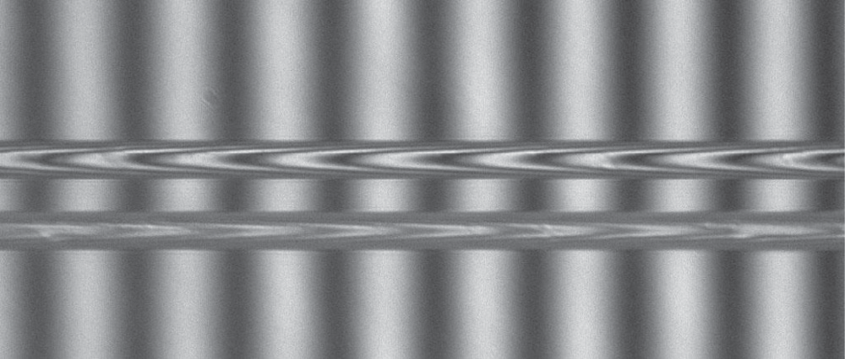

(a)

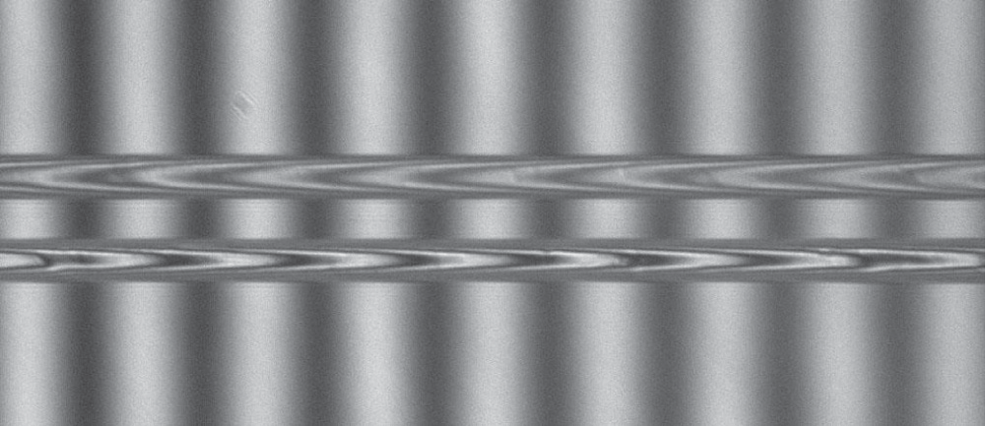

(b)

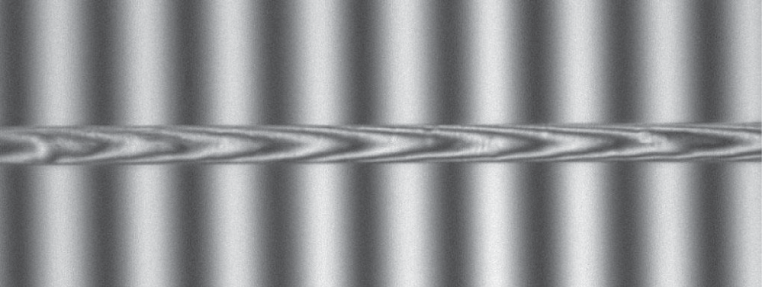

(c)

### Fig. 1 – (a, b, c) Microinterferograms of duplicated and non- duplicated images of PEEK fiber using automatic VAWI technique.

confirm this normal behavior, the Cauchy’s dispersion formula was used for PEEK fiber. To verify this equation, a relation between the refractive indices n|| and n⊥, and 1/λ2 was plotted. Fig. 3 gives the graphical representation of this relationship which takes a linear behavior. The constants A and B of Cauchy’s dispersion formula were determined. The results are given in Table 1. The values of A and B throw light on internal struc- ture of PEEK fiber. It is clear that the structure properties, on the molecular level, in the parallel direction are higher than the perpendicular direction. The accuracy in measuring the optical path length difference is about 0.05λ which leads to an accuracy in measuring the refractive index of 0.003 as given in Ref. [27].

The interaction of electromagnetic light wave with PEEK fiber material was interpreted by the refraction effects. These effects manifest through the frequency dependence on the refrac- tive index. Also, they related to the oscillation and dispersion of the bounded electrons of the PEEK fiber material. The os-

cillation and dispersion energies Eo and Ed can be determined by plotting a relation between (n2 − 1)−1 and the square of the photon energy E2. Fig. 4 shows the linear relationships from

which the oscillation and dispersion energies Eo and Ed were obtained. The dispersion properly normalizes the interaction potential describing the optical effects that are due to the re- lationship between electronic optical properties of the PEEK fiber material and its chemical bond [19]. The measured re- fractive indices can be analyzed to determine the high frequency

refractive index n∞ and the average oscillator wavelength λo

by plotting a linear relation between (n2 − 1)−1 verses λ−2 as

shown in Fig. 5. Using equations 6 and 7 and the slopes and intersect parts of the linear relation in Fig. 5, the high fre- quency refractive index n∞, the average oscillator wavelength

λo and the oscillator length strength So of PEEK fiber are cal-

culated and the results are given in Table 1.

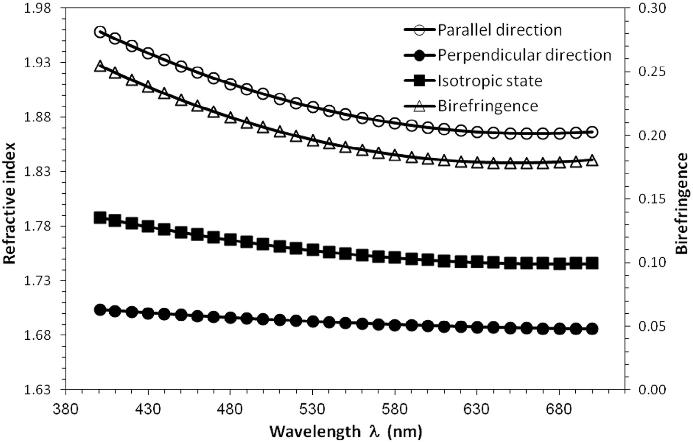

### Fig. 2 – The spectral dispersion curves of refractive indices n||, n⊥ and niso, and birefringence Δn of PEEK highly oriented fiber.

**370** egyptian journal of basic and applied sciences 3 (2016) 366–3 7 6

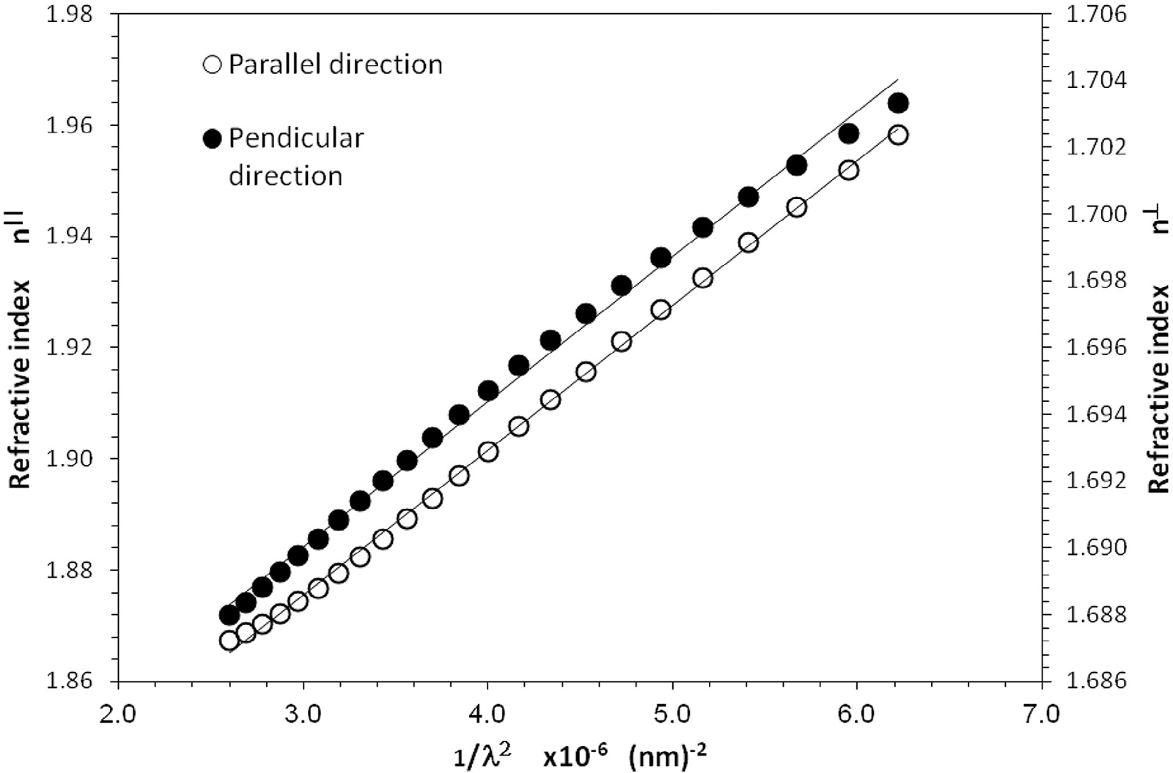

### Fig. 3 – The refractive indices n|| and n⊥ as functions of 1/λ2 to verify Cauchy’s dispersion relation for PEEK fiber.

According to Lorentz–Lorenz equation, there is a direct re- lationship between the refractive index and the polarizability per unit volume. Fig. 6 shows the dispersion curves of the po-

larizability per unit volume Φ||, Φ⊥ and Φiso when the incident

light beam in the visible range of spectrum.

The density of PEEK fibers is directly related to its refrac- tive index by equation (9). So that the density varies with the variation of the wavelength of the incident light as shown in Fig. 7. The decrease in the density of PEEK fiber material with increasing the wavelength gives evidence on the inter-chain interaction. It is reasonable that the density changes are similar to the dispersion curves of the refractive index of PEEK fiber.

PEEK fibers are semi crystalline polymer material. The degree of crystallinity can be calculated using the density values at different wavelengths in the visible spectrum. The variation of the degree crystallinity is due to the variation of the wave- lengths values. Using equations (11), (12) and (13), the mass

fraction of the crystalline regions **χ**m% percentage, the mass fraction of the amorphous regions (1 − **χ**m)% percentage, and

the mean square density fluctuation **2  were calculated at different wavelengths in the visible range of spectrum. Fig. 8 gives the graphical representation of the mass fraction of the

crystalline **χ**m% and amorphous (1 − **χ**m)% regions percent-

ages with different wavelengths in the visible range of spectrum. It is clear that the percentage of crystalline regions **χ**m%

decreases with increasing the wavelength from 400 nm to 700 nm while the percentage of amorphous regions (1 − **χ**m)%

is increased. The decrease and the increase of the percentage of the crystalline and amorphous regions when using light have wavelengths varying from 400 nm to 700 nm and are due to the refraction effects which depend mainly on the wave- length of light. The relationships of the mass fraction of the crystalline and amorphous regions and refractive index are qualitative relations because these structure parameters are intrinsic properties of the fiber material. The advantage of these measurements is that they give information at any wave- length all over the visible range of spectrum. The variation of the mean square density fluctuation **2 is presented in Fig. 7. The optical orientation factor and angles depend on the optical anisotropy of the fiber material, which is the birefrin- gence. Fig. 9 shows the behavior of optical orientation factor and angle with increase in the wavelength. It is clear that the optical orientation factor decreased and the orientation angle increased with increasing wavelength. Also, there is a rela-

tion between the optical orientation factor and the electric polarizabilities α|| and α⊥ of monomer unit of PEEK fibers. Fig. 10 gives a linear relationship between the optical orientation factor

P2(θ) and the value of [Φ|| − Φ⊥]/[ [Φ|| +2 Φ⊥]. The slope of this linear relation gives the constant [Δα/3αo] to be 0.0742. The value of the electric polarizability constant depends on the molecular

|  |  |  |  |  |  |
| --- | --- | --- | --- | --- | --- |
| **Table 1 – The optical and dispersion parameters of PEEK fiber using automatic VAWI technique.** | | | | | |
| Direction of the light vector | A | B × 103 nm2 | Optical and dispersion parameters  Ed (ev) Eo (ev) λ0 nm | n∞ | So × 10−5 nm−2 |
| **Parallel** | 1.798 | 26 | 17.674 6.736 174.18 | 1.8164 | 7.579 |
| **Perpendicular** | 1.677 | 4.3 | 25.443 14.037 87.896 | 1.6771 | 0.234 |

egyptian journal of basic and applied sciences 3 (2016) 366–3 7 6

**371**

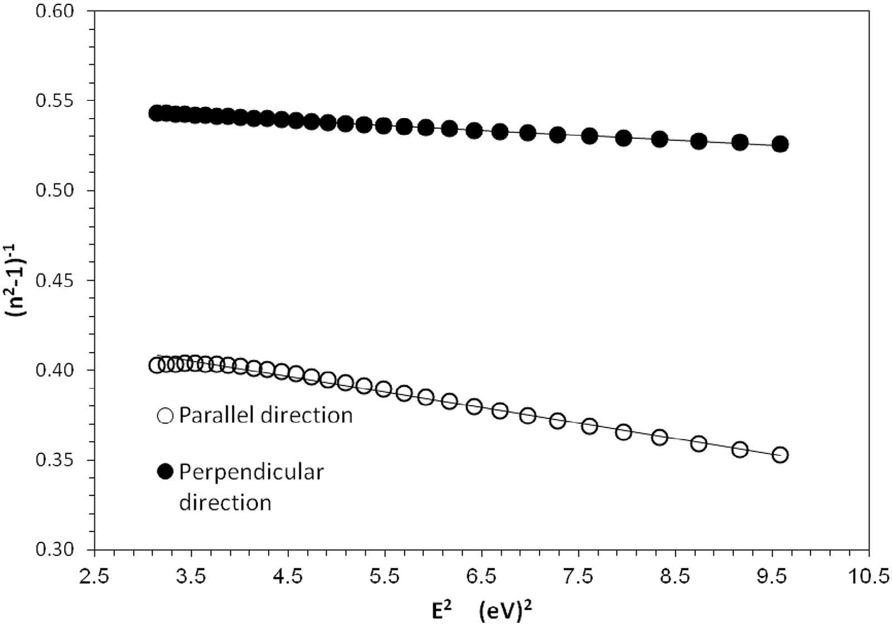

### Fig. 4 – The plot of (n2 − 1)−1 versus the square of photon energy E2 for PEEK fiber.

of PEEK fiber. The optical configuration parameter Δα is the dif- ference between α|| and α⊥. Fig. 11 shows the variation of the electric polarizability of monomer units α|| and α⊥ with the wave- length of the incident light vibrating parallel and perpendicular to the fiber axis. Fig. 12 describes the relationship between the

optical stress coefficient Cs and the wavelength λ. It is clear that the value of Cs decreased with increasing the wave- length taking the same behavior of the mean refractive index.

The interpretation of the changes of Cs with the wavelength of the photon energy throws light on the electrical properties

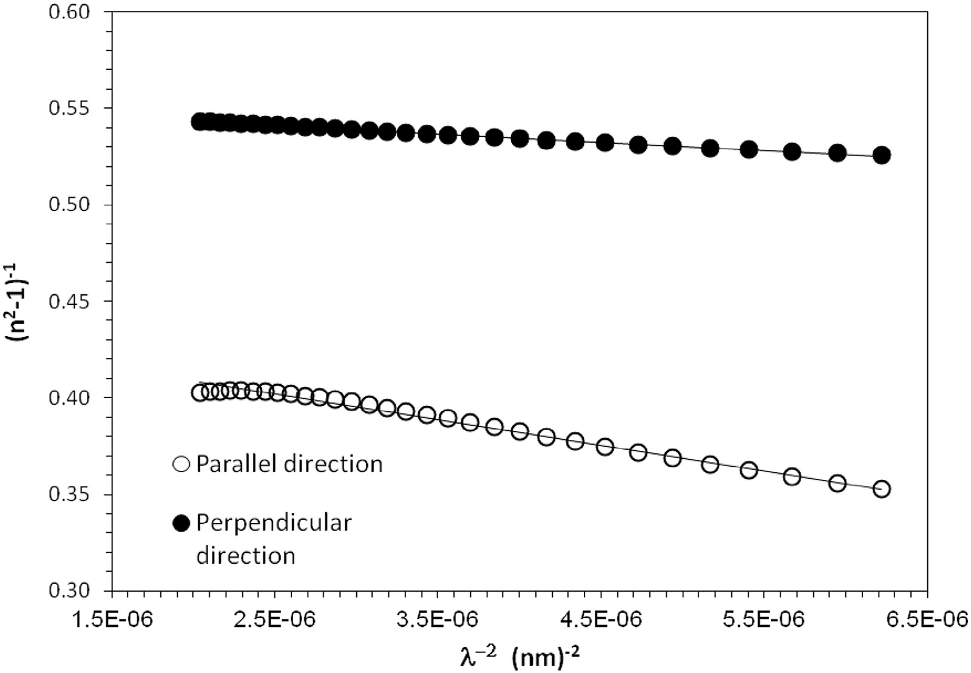

### Fig. 5 – The plot of (n2 − 1)−1 versus the inverse of the squared wavelength 1/λ2 for PEEK fiber.

**372** egyptian journal of basic and applied sciences 3 (2016) 366–3 7 6

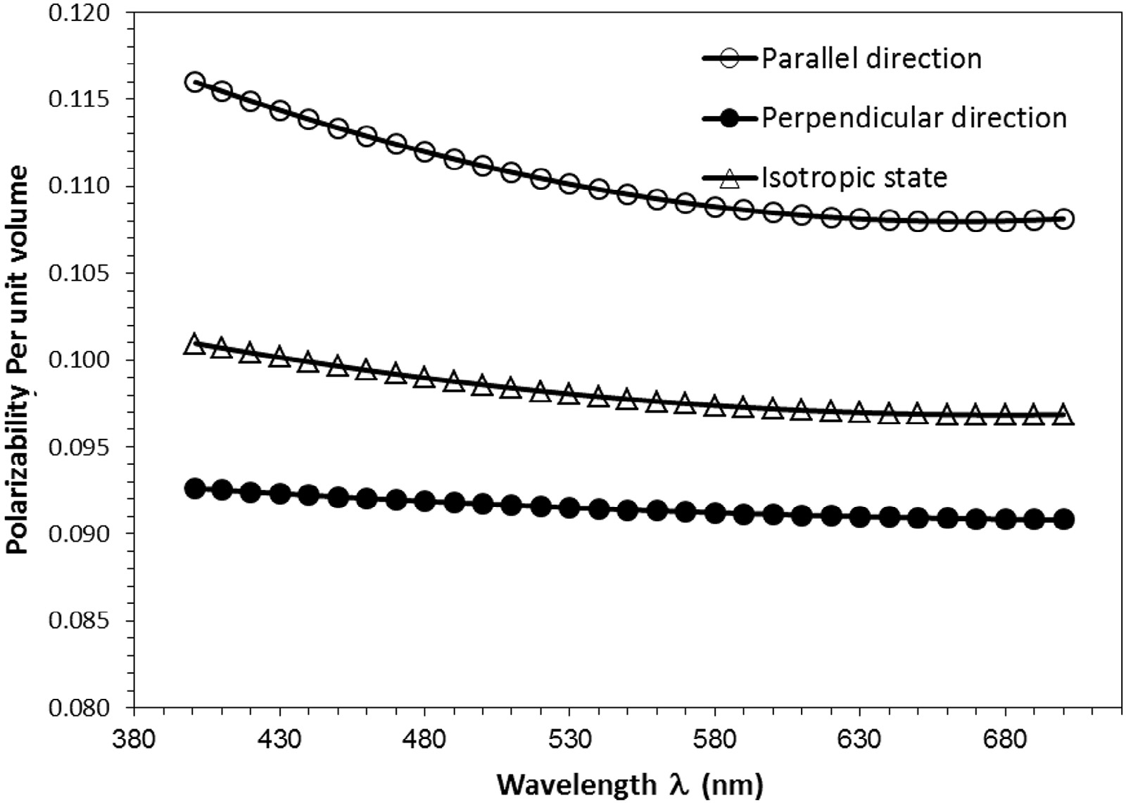

### Fig. 6 – The variation of the polarizability per unit volume Φ||, Φ⊥ and Φiso with the wavelength of the incident light.

arising from existing space changes in the PEEK fibers after production. It is important to note that Cs depends only on the mean refractive index and optical anisotropy of random link and independent of the degree of cross-linking of the network.

The variation of the optical properties and molecular structure of PEEK fiber material is due to the frequency de- pendence on its refractive index. The interaction of the photon energy with fiber material leads to the refraction effects which forced the cloud electrons of wavelength λo to vibrate by an

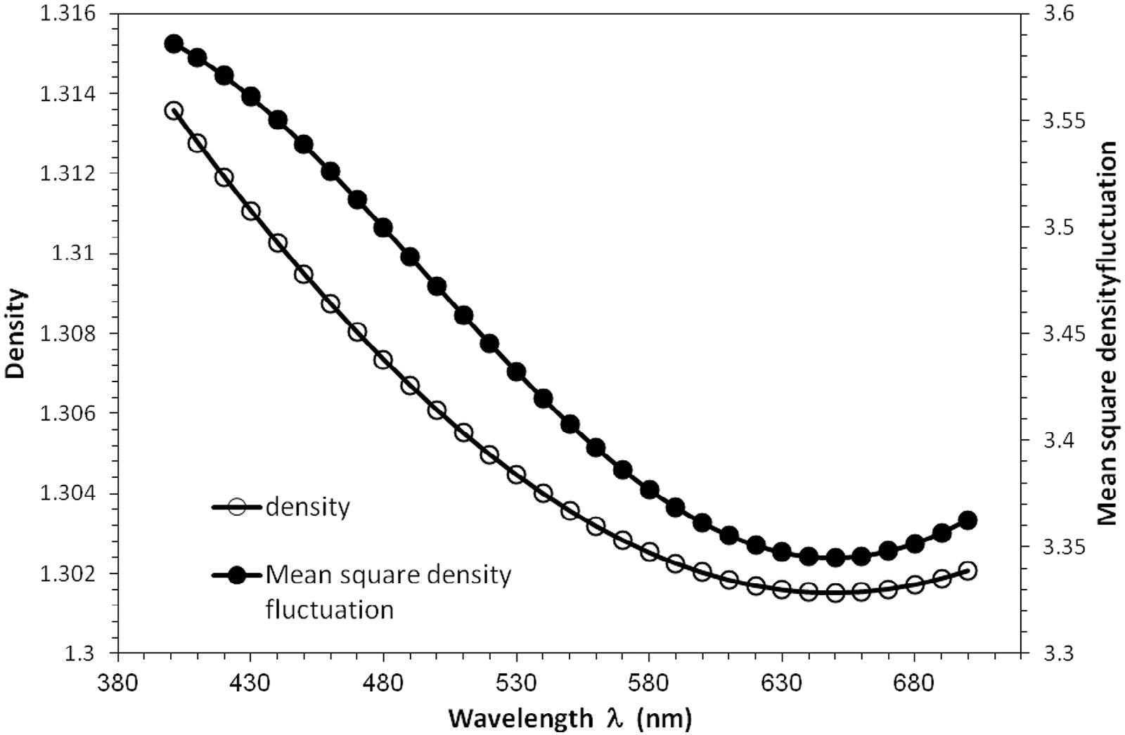

### Fig. 7 – The variation of the density and the mean square density fluctuation for PEEK fibers with the wavelength of the incident light.

egyptian journal of basic and applied sciences 3 (2016) 366–3 7 6

**373**

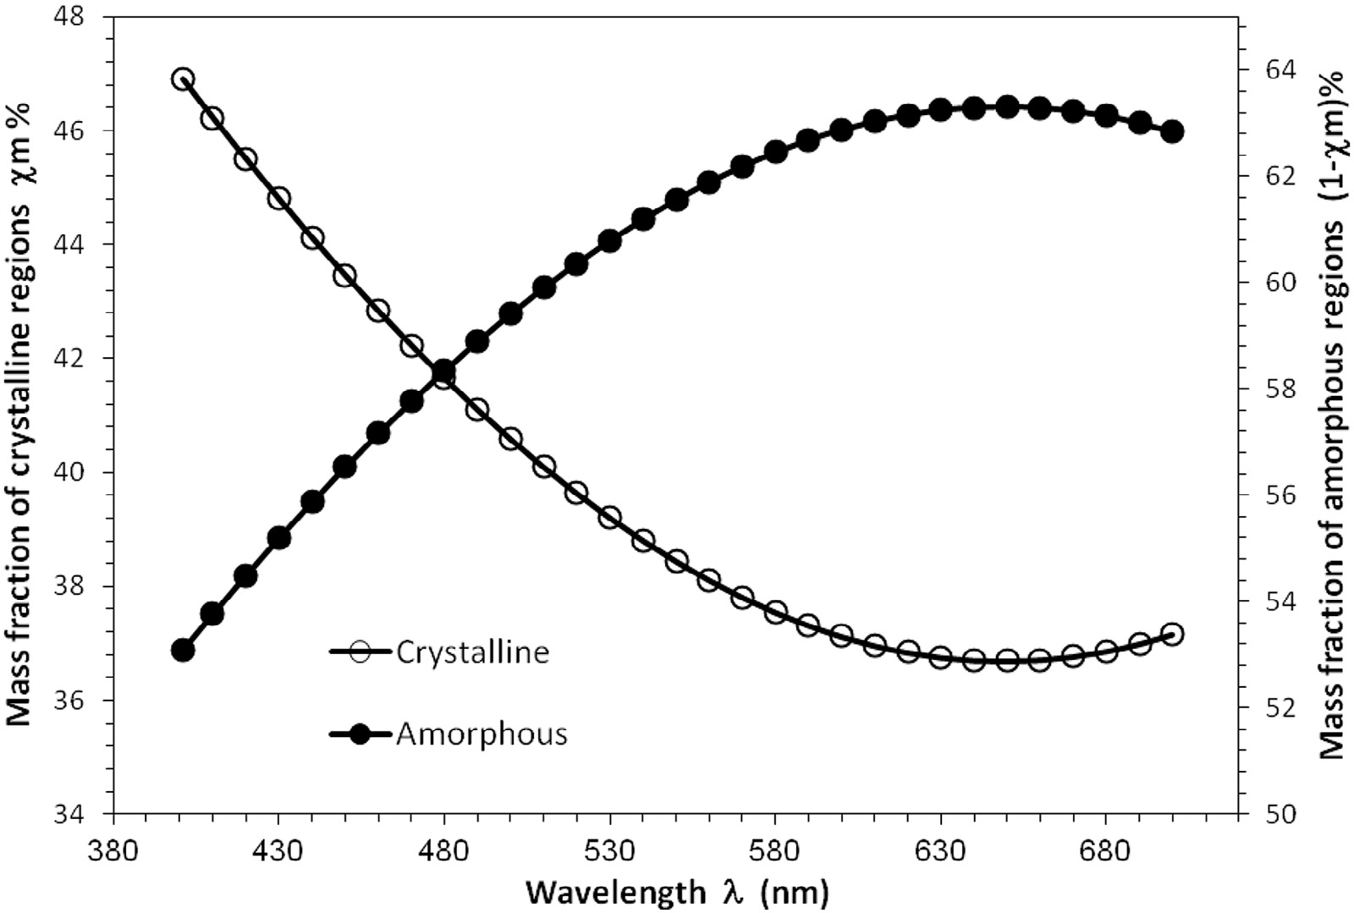

### Fig. 8 – The graphical representation of the mass fraction of the crystalline χm% and amorphous (1 − χm)% regions percentages of PEEK fiber with the wavelength of the incident light.

oscillatory electric field of wavelength λ. The relation between the refractive index and these molecular structure param- eters is a quantitative relation because these parameters are intrinsic properties of PEEK fiber material at a certain wavelength.

# Conclusions

The transmitted VAWI technique is suitable for determining the optical properties of PEEK fiber on the molecular level. This

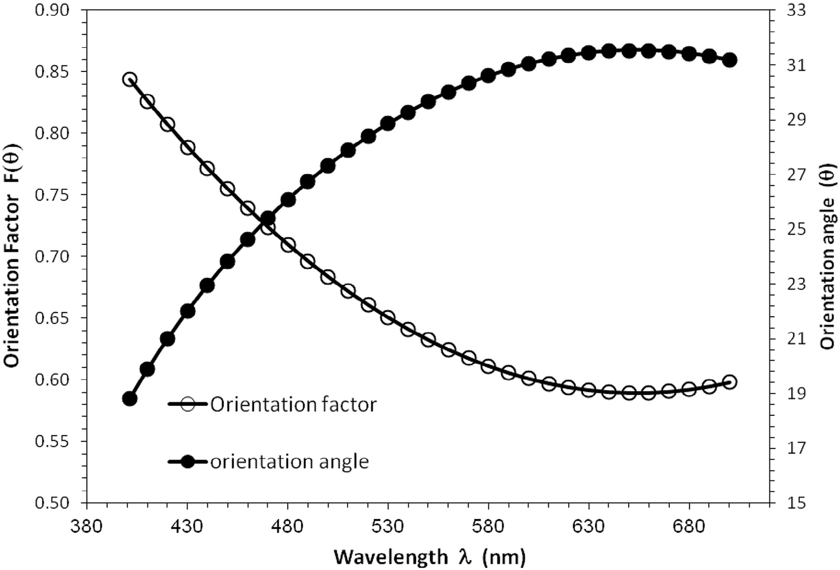

### Fig. 9 – The variation of the optical orientation factor and angle for PEEK fibers with the wavelength of the incident light.

**374** egyptian journal of basic and applied sciences 3 (2016) 366–3 7 6

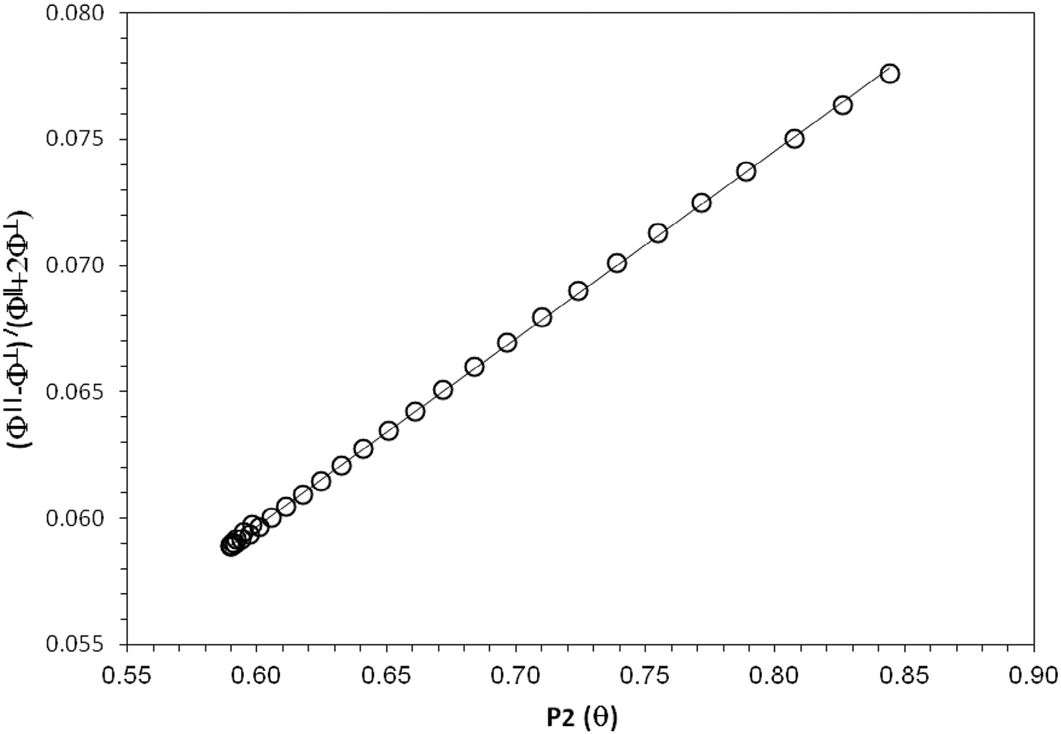

### Fig. 10 – The linear relationship between the optical orientation factor P2(θ) and the value of [Φ|| − Φ⊥]/[ [Φ|| +2 Φ⊥].

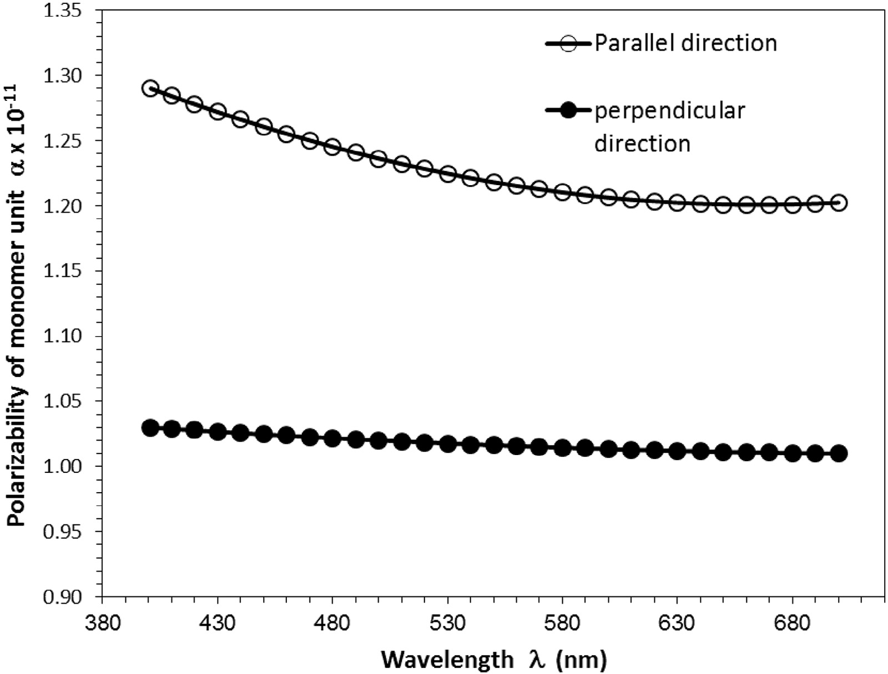

**Fig. 11 – The variation of the electric polarizability of monomer unit α|| and α⊥ for PEEK fibers with the wavelength of the incident light.**

egyptian journal of basic and applied sciences 3 (2016) 366–3 7 6

**375**

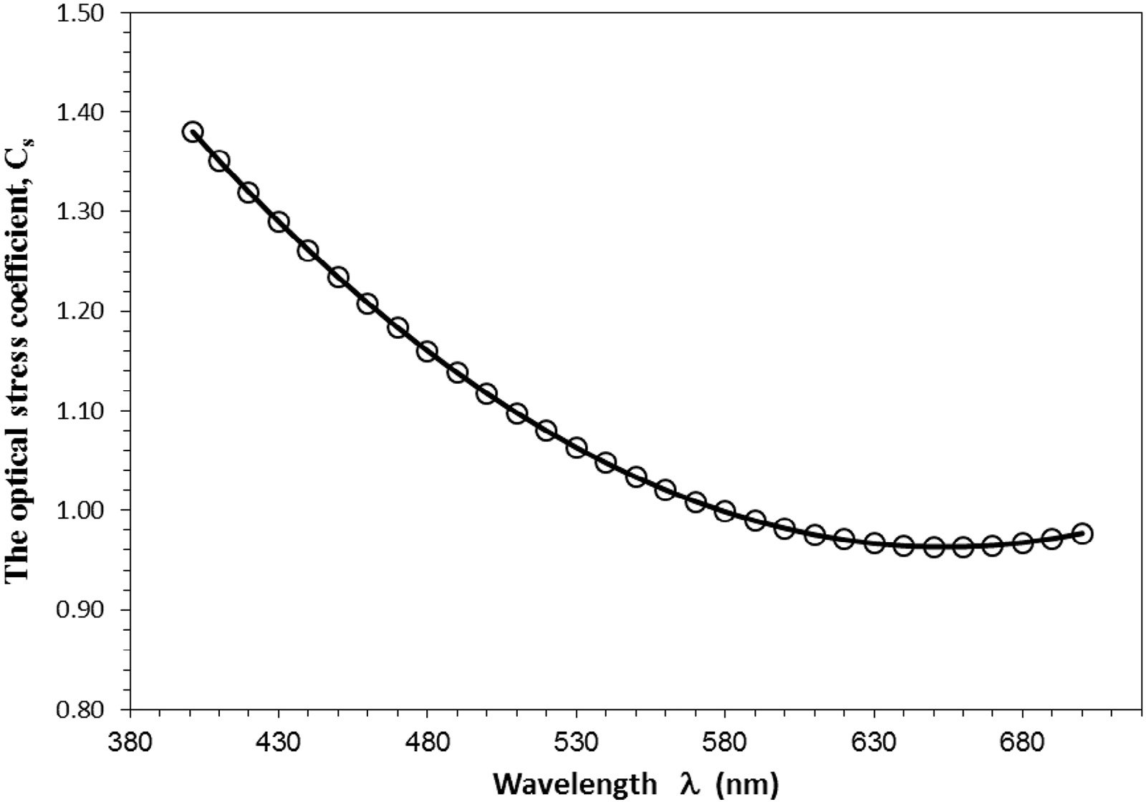

### Fig. 12 – The relationship between the optical stress coefficient Cs and the wavelength λ for PEEK fibers.

method enables us to determine that the molecular struc- ture parameters at any wavelength lies in the range of the visible spectrum. The variations of these structure param- eters with the wavelength are due to the variations of the transmitted light refraction effects.

From the measurements carried out, the following conclu- sions may be drawn:

1. PEEK fiber, which has a normal dispersion behavior, obeys the Cauchy’s and Sellmeier’s dispersion formulae.
2. The optical constants such that oscillation energy Eo, the

dispersion energy Ed, the high frequency refractive index n∞, the average oscillator wavelength λo and the oscillator length strength So of the PEEK fiber material are determined by plot- ting (n2 − 1)−1 versus the squared photon energy E2 and the inverse of the squared wavelength λ−2 according to equa- tions (5), (6) and (7). These constants relate the molecular

structure with the photon energy incident on the fiber ma- terial and may be very important in manufacturing optoelectronic devices.

1. Determining the molecular structure constants *f*Δ(θ), θ, Φ||, Φ⊥, Φiso, **χ**m%, (1 − **χ**m)%, **2 , [Δα/3αo], α||, α⊥, and Cstress gives a detailed information about the axial orientation of the mol-

ecules and hence the molecular structure order of PEEK fiber material.

# Acknowledgment

The author would like to acknowledge a debt of gratitude and appreciation to Prof. A.A. Hamza, Professor of Physics, Faculty

of Science, Mansoura University, and Ex-President of Mansoura University and British University in Egypt for his guidance, helpful advice and useful discussions.

R E F E R E N C E S

1. [Rae PJ, Brown EN, Orler EB. The mechanical properties of](http://refhub.elsevier.com/S2314-808X(16)30039-2/sr9010) [poly(ether-ether-ketone) (PEEK) with emphasis on the large](http://refhub.elsevier.com/S2314-808X(16)30039-2/sr9010) [compressive strain response. Polymer 2007;48:598–615.](http://refhub.elsevier.com/S2314-808X(16)30039-2/sr9010)
2. [Yuan M, Galloway JA, Hoffman RJ, Bhatt S. Influence of](http://refhub.elsevier.com/S2314-808X(16)30039-2/sr9015) [molecular weight on rheological, thermal, and mechanical](http://refhub.elsevier.com/S2314-808X(16)30039-2/sr9015) [properties of PEEK. Polym Eng Sci 2011;51(1):94–102.](http://refhub.elsevier.com/S2314-808X(16)30039-2/sr9015)
3. [White JL, Dong L, Han P, Laun HM. Rheological properties](http://refhub.elsevier.com/S2314-808X(16)30039-2/sr9020) [and associated structural characteristics of some aromatic](http://refhub.elsevier.com/S2314-808X(16)30039-2/sr9020) [polycondensates including liquid-crystalline polyesters](http://refhub.elsevier.com/S2314-808X(16)30039-2/sr9020) [and cellulose derivatives. Pure Appl Chem 2004;76(11):2027–](http://refhub.elsevier.com/S2314-808X(16)30039-2/sr9020) [49.](http://refhub.elsevier.com/S2314-808X(16)30039-2/sr9020)
4. [Kong Y, Hay JN. The measurement of the crystallinity of the](http://refhub.elsevier.com/S2314-808X(16)30039-2/sr9025) [polymers by DSC. Polymer 2002;43:3873–8.](http://refhub.elsevier.com/S2314-808X(16)30039-2/sr9025)
5. [Voice AM, Bower DI, Ward IM. Molecular orientation in](http://refhub.elsevier.com/S2314-808X(16)30039-2/sr9030) [uniaxially drawn poly (aryl ether ether ketone): 1. Refractive](http://refhub.elsevier.com/S2314-808X(16)30039-2/sr9030) [index and X-ray measurements. Polymer 1993;34(6):1154–](http://refhub.elsevier.com/S2314-808X(16)30039-2/sr9030) [63.](http://refhub.elsevier.com/S2314-808X(16)30039-2/sr9030)
6. [Wei CL, Chen M, Yu FF. Temperature modulated DSC and](http://refhub.elsevier.com/S2314-808X(16)30039-2/sr9035) [DSC studies on the origin of double melting peaks in](http://refhub.elsevier.com/S2314-808X(16)30039-2/sr9035) [poly(ether ether ketone). Polymer (Guildf) 2003;44:8185–93.](http://refhub.elsevier.com/S2314-808X(16)30039-2/sr9035)
7. [Jacob GC, Starbuck JM, Fellers JF, Simunovic S, Boeman RG.](http://refhub.elsevier.com/S2314-808X(16)30039-2/sr9040) [The effect of loading rate on the fracture toughness of fiber](http://refhub.elsevier.com/S2314-808X(16)30039-2/sr9040) [reinforced polymer composites. J Appl Polym Sci](http://refhub.elsevier.com/S2314-808X(16)30039-2/sr9040) [2005;96:899–904.](http://refhub.elsevier.com/S2314-808X(16)30039-2/sr9040)
8. [El-Bakary MA. Determination of radial structural properties](http://refhub.elsevier.com/S2314-808X(16)30039-2/sr9045) [and spectral dispersion curves of poly(aryl ether ether](http://refhub.elsevier.com/S2314-808X(16)30039-2/sr9045) [ketone) fibre. Polym Int 2004;53:48–55.](http://refhub.elsevier.com/S2314-808X(16)30039-2/sr9045)

**376** egyptian journal of basic and applied sciences 3 (2016) 366–3 7 6

1. [Ahdalli IH, El-Bakary MA. Interferometric determination of](http://refhub.elsevier.com/S2314-808X(16)30039-2/sr9050) [structural properties of PEN highly oriented fiber. Inter J](http://refhub.elsevier.com/S2314-808X(16)30039-2/sr9050) [Polym Mater 2006;55:733–45.](http://refhub.elsevier.com/S2314-808X(16)30039-2/sr9050)
2. [Cakmak M. Intrinsic birefringence of poly ether ether](http://refhub.elsevier.com/S2314-808X(16)30039-2/sr9055) [ketone. J Polym Sci Polym Lett 1989;27:119–21.](http://refhub.elsevier.com/S2314-808X(16)30039-2/sr9055)
3. [Pluta M. Advanced light microscopy, vol. 3. Warszawa: PWN;](http://refhub.elsevier.com/S2314-808X(16)30039-2/sr9060) [1993.](http://refhub.elsevier.com/S2314-808X(16)30039-2/sr9060)
4. [Barakat N, Hamza AA. Interferometry of fibrous material.](http://refhub.elsevier.com/S2314-808X(16)30039-2/sr9065) [Bristol: Adam Hilger; 1990.](http://refhub.elsevier.com/S2314-808X(16)30039-2/sr9065)
5. [Hamza AA, Fouda IM, Sokkar TZN, El-Bakary MA.](http://refhub.elsevier.com/S2314-808X(16)30039-2/sr9070) [Determination of spectral dispersion curves of](http://refhub.elsevier.com/S2314-808X(16)30039-2/sr9070) [polypropylene fibres. J Opt A Pure Appl Opt 1999;1:359–66.](http://refhub.elsevier.com/S2314-808X(16)30039-2/sr9070)
6. [Hamza AA, Fouda IM, Sokkar TZN, El-Bakary MA. The](http://refhub.elsevier.com/S2314-808X(16)30039-2/sr9075) [spectral dispersion curves in highly oriented fibres. Polym](http://refhub.elsevier.com/S2314-808X(16)30039-2/sr9075) [Test 2001;20:847–53.](http://refhub.elsevier.com/S2314-808X(16)30039-2/sr9075)
7. [Hamza AA, Sokkar TZN, El-Bakary MA. Interferometric](http://refhub.elsevier.com/S2314-808X(16)30039-2/sr9080) [determination of the birefringence of thermo-tropic](http://refhub.elsevier.com/S2314-808X(16)30039-2/sr9080) [polyester fibers and its copolymers of structure (PCPT. Co.](http://refhub.elsevier.com/S2314-808X(16)30039-2/sr9080) [CPO). J Appl Polym Sci 2012;125:1814–21.](http://refhub.elsevier.com/S2314-808X(16)30039-2/sr9080)
8. [Sokkar TZN, El-Bakary MA. The refractive index profile of](http://refhub.elsevier.com/S2314-808X(16)30039-2/sr9085) [highly oriented fibres. J Phys D Appl Phys 2001;34:373–8.](http://refhub.elsevier.com/S2314-808X(16)30039-2/sr9085)
9. [Samuels RJ. Structure polymer properties. New York: Jhon](http://refhub.elsevier.com/S2314-808X(16)30039-2/sr9090) [Wily; 1974. p. 54.](http://refhub.elsevier.com/S2314-808X(16)30039-2/sr9090)
10. [Pluta M. Advanced light microscopy, vol. 1. Warszawa: PWN;](http://refhub.elsevier.com/S2314-808X(16)30039-2/sr9095) [1989. p. 57.](http://refhub.elsevier.com/S2314-808X(16)30039-2/sr9095)
11. [Wemple SH. Material dispersion in optical fibers. Appl Opt](http://refhub.elsevier.com/S2314-808X(16)30039-2/sr9100) [1979;18:31–5.](http://refhub.elsevier.com/S2314-808X(16)30039-2/sr9100)
12. [Lee PA, Said G, Davis R, Lim TH. On the optical properties of](http://refhub.elsevier.com/S2314-808X(16)30039-2/sr9105) [some layer compounds. J Phys Chem Solids 1969;30(12):](http://refhub.elsevier.com/S2314-808X(16)30039-2/sr9105) [2719–29.](http://refhub.elsevier.com/S2314-808X(16)30039-2/sr9105)
13. [De Vries H, Bonnebat C, Beautemps J. Uni- and biaxial](http://refhub.elsevier.com/S2314-808X(16)30039-2/sr9110) [orientation of polymer films and sheets. J Polym Sci Symp](http://refhub.elsevier.com/S2314-808X(16)30039-2/sr9110) [1977;58:109–56.](http://refhub.elsevier.com/S2314-808X(16)30039-2/sr9110)
14. [De Vries H. A new approach to the continuum theory of](http://refhub.elsevier.com/S2314-808X(16)30039-2/sr9115) [birefringence of oriented polymers. Z Colloid Polym Sci](http://refhub.elsevier.com/S2314-808X(16)30039-2/sr9115) [1979;257:226–38.](http://refhub.elsevier.com/S2314-808X(16)30039-2/sr9115)
15. [Hermans PH. Contribution to the physics of cellulose fibers.](http://refhub.elsevier.com/S2314-808X(16)30039-2/sr9120) [Amsterdam; North Holland: 1946.](http://refhub.elsevier.com/S2314-808X(16)30039-2/sr9120)
16. [Sokkar TZN, El-Farahaty KA, El-Bakary MA. Determination of](http://refhub.elsevier.com/S2314-808X(16)30039-2/sr9125) [optical properties, dispersion, and structural parameters of](http://refhub.elsevier.com/S2314-808X(16)30039-2/sr9125) [Poly(ethylene terephthalate) fibers using automatic variable](http://refhub.elsevier.com/S2314-808X(16)30039-2/sr9125) [wavelength interferometry technique. J Appl Polym Sci](http://refhub.elsevier.com/S2314-808X(16)30039-2/sr9125) [2003;89:1737–42.](http://refhub.elsevier.com/S2314-808X(16)30039-2/sr9125)
17. [Cunningham A, Davies GR, Ward IM. Determination of](http://refhub.elsevier.com/S2314-808X(16)30039-2/sr9130) [molecular orientation by polarized infra-red radiation in an](http://refhub.elsevier.com/S2314-808X(16)30039-2/sr9130) [oriented polymer of high polarizability. Polymer](http://refhub.elsevier.com/S2314-808X(16)30039-2/sr9130) [1974;15:743–8.](http://refhub.elsevier.com/S2314-808X(16)30039-2/sr9130)
18. [Automatic Computer-Aided Microinterferometer for](http://refhub.elsevier.com/S2314-808X(16)30039-2/sr9135) [Measurements and Studies of Optical and Textile Fibers](http://refhub.elsevier.com/S2314-808X(16)30039-2/sr9135) [“Microinterferometer Operation Manual” Institute of Applied](http://refhub.elsevier.com/S2314-808X(16)30039-2/sr9135) [Optics, Warsaw, Poland: 1996.](http://refhub.elsevier.com/S2314-808X(16)30039-2/sr9135)
19. [Hamza AA, Sokkar TZN, El-Bakary MA, Ali AM. Variable](http://refhub.elsevier.com/S2314-808X(16)30039-2/sr9140) [wavelength microinterferometry applied for irregular fibres.](http://refhub.elsevier.com/S2314-808X(16)30039-2/sr9140) [J Opt A Pure Appl Opt 2002;4:371–6.](http://refhub.elsevier.com/S2314-808X(16)30039-2/sr9140)