HOSTE D BY

Available online at [www.sciencedirect.com](http://www.sciencedirect.com/science/journal/2314808X)

**ScienceDirect**

journal homepage: [http://ees.elsevier.com/ejbas/default.asp](http://http//ees.elsevier.com/ejbas/default.asp)

egyptian journal of basic and applied sciences 3 (2016) 232–240



**Full Length Article**

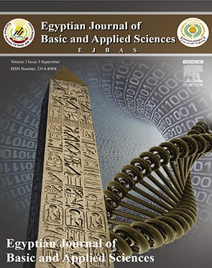**Isolation and characterization of the new indigenous Staphylococcus sp. DBOCP06 as a probiotic bacterium from traditionally fermented fish and meat products of Assam state**



***Debajit Borah*** ***a******,******\*******, Olee Gogoi*** ***a******, Chanakya Adhikari*** ***a******, B.B. Kakoti*** ***a******,******b***

a *Centre for Studies in Biotechnology, Dibrugarh University, 786004, India*

b *Department of Pharmaceutical Sciences, Dibrugarh University, 786004, India*

A R T I C L E I N F O A B S T R A C T

*Article history:*

Received 29 April 2016 Received in revised form 5 June 2016

Accepted 10 June 2016

Available online 17 June 2016

*Keywords:*

Probiotic strain *Staphylococcus* sp*.* DBOCP6 Antagonistic effect Gastrointestinal tract Commercial potentiality

Traditionally fermented fish and meat products are known for their probiotic values. An approach was made for the very first time to isolate and characterize novel indigenous probiotic bacterial strains from traditionally fermented fish and meat products of Assam, India, which is known as the biodiversity hotspot of the country with largely unexplored economically important microorganisms. The most potent probiotic isolate was identified as *Staphylococcus sp.* DBOCP6 (GenBank accession no. KR706310) on the basis of 16S rDNA sequencing technique. The new isolate was found to be non-hemolytic and nonpatho- genic on the basis of its susceptibility against broad and narrow spectrum antibiotics. It shows antagonistic effect against *E. coli* MTCC 40. Its viability in presence of lysozyme, bile salt (4%), and a pH range of 1–10 signifies its ability to survive throughout the gastrointestinal tract. It also shows significant value of hydrophobicity (33.1%) along with a higher value of auto-aggregation (71.43%) indicates its ability to adhere to the intestinal wall on the basis of its cell surface traits. The high thermal death point of the isolate (100 °C) indicates its suitability for further commercial exploitation. Based on the above observations, it could be concluded that the novel *Staphylococcus sp.* strain DBOCP6 can serve as a potential probiotic candidate for industrial exploitation.

© 2016 Mansoura University. Production and hosting by Elsevier B.V. This is an open

access article under the CC BY-NC-ND license (<http://creativecommons.org/licenses/by->

nc-nd/4.0/).

# Introduction

Assam, the state of North-East India is one of the richest site for fresh water fishes and largest dry fish production site in

Asia [1,2]. Moreover, the Northeast region of India is consid- ered as a biodiversity hotspot for flora and fauna, particularly of economically important microbes, that are yet to be ex- plored [3]. The fish and meat are the important source of food across the world. The ethnic people of Assam traditionally

* *Corresponding author.* Tel.: +91-9706394994.

*E-mail address:* [dborah89@gmail.com](mailto:dborah89@gmail.com) (D. Borah). <http://dx.doi.org/10.1016/j.ejbas.2016.06.001>

2314-808X/© 2016 Mansoura University. Production and hosting by Elsevier B.V. This is an open access article under the CC BY-NC-ND license ([http://creativecommons.org/licenses/by-nc-nd/4.0/).](http://creativecommons.org/licenses/by-nc-nd/4.0/))

egyptian journal of basic and applied sciences 3 (2016) 232–240

**233**

ferment and produce different preparations from the fish and meat such as xukati, hidal, and other dried fish and meat prod- ucts [4].

It is a well established fact that fermented foods are en- riched with health beneficial probiotic microbes. Probiotics have been defined as “a live microbial food supplement that ben- efits the host by improving the intestinal microbial balance,” and more broadly, as live microorganisms which exerts posi- tive health benefits [5,6]. Metchnikoff in 1907 who first implied that ingested bacteria in the form of fermented foods could

used as probiotic bacteria in procurement of yogurt and cheese [20]. The microbiota of fermented fish and meat, the ethnic food of Assam, India is almost next to untouched. Thus, an attempt was made to identify potent indigenous probiotic candidate in traditionally prepared fermented fish and meat products through a comprehensive approach which would originally con- sider the safety features of the strain and potential application of the isolated strain and finally its ability to survive through the entire GIT in order to deliver the health benefits.

beneficially affect the normal gut flora [7]. These properties

include the beneficial influences that probiotics apparently exert on the microbial ecology of the host [8,9]. The physicochemi- cal conditions that persuade the composition of the intestinal microbiota include intestinal motility, pH, redox potential, nu- trient materials, host secretions (e.g. digestive enzymes, hydrochloric acid, bile and mucus), and the presence of an intact ileocaecal valve [10]. Thus, the gastrointestinal (GI) tract harbors many distinct niches, with diverse microbial ecosystem that increases along the GI tract [11]. Apart from supporting the di- gestive functions, indigenous microbes also act as a main actor of the immune system by preventing the colonization by patho- genic microorganisms [11–13]. The European Parliament and the Council of the European Union also encourages develop- ment of suitable alternative to replace antibiotics [14,15]. The use of probiotics is an effective and safe alternative to anti- biotic implementation [14–17]. Since the beneficial effects of probiotic bacteria is mainly centralized in the GI tract, the probiotics should exhibit good surface hydrophobicity and ag- gregation properties to adhere and colonize in the GI tract [18,19].

Numerous studies from subsequent research programs have reported a considerable number of species belonging to *Lac- tobacillus*, *Bifidobacterium*, and *Enterococcus* that are being typically

# Experiment and method

## *Materials*

Chemicals and consumables used in the study were pur- chased from Merck India Pvt. Ltd., and all the microbiological media were purchased from HiMedia India Pvt. Ltd. Bacterial growth was monitored at 600 nm wave length using UV-Vis spectrophotometer (Shimadzu UV-1800, Japan). Centrifuga- tions were carried out in Sigma 3-30K centrifuge, Germany.

## *Collection of fermented fish and meat samples*

20 traditionally prepared fermented fish and meat samples were collected from different tribes, communities, and local markets of the state Assam, India. Details of the collected samples and their geographical distribution are shown in Table 1 and Fig. 1.

## *Isolation and screening of probiotic bacteria from the* collected samples

10% (*w/v*) of finely powdered each of the fish and meat samples were inoculated individually in 100 mL MRS (de Man Rogosa

|  |  |  |  |  |
| --- | --- | --- | --- | --- |
| **Table 1 – List of samples with the details of the collection sites.** | | | | |
| Local name of the preparation | Key mode of preparation | Name of the collection sites | Geographical position of the sample collection sites  Longitude Latitude | |
| Hukati | Smoke dried, crushed & fermented in bamboo tubes | Dibrugarh | 94° 54’E | 27° 29’N |
| Hukati | Sun dried | Sonapur | 91° 45’E | 26° 10’N |
| Hukati | Sun dried | Sonapur | 91° 45’E | 26° 10’N |
| Hukati | Sun dried | Sonapur | 91° 45’E | 26° 10’N |
| Hukati | Sun dried | Sonapur | 91° 45’E | 26° 10’N |
| Hukati | Sun dried | Sonapur | 91° 45’E | 26° 10’N |
| Hukati | Sun dried | Nagaon | 92° 41’E | 26° 21’N |
| Hukati | Sun dried | Nagaon | 92° 41’E | 26° 21’N |
| Hukati | Smoke dried, crushed & fermented in bamboo tubes | Jorhat | 94° 13’E | 26° 45’N |
| Hukati | Smoke dried, crushed & fermented in bamboo tubes | Lakhimpur | 94° 15’E | 27° 14’N |
| Hidal | Sun dried | Guwahati | 91° 44’E | 26° 11’N |
| Hidal | Sun dried | Guwahati | 91° 44’E | 26° 11’N |
| Hidal | Sun dried | Guwahati | 91° 44’E | 26° 11’N |
| Hidal | Pressed and fermented in earthen pots | Goalpara | 90° 37’E | 26° 10’N |
| Halis | Sun dried | Guwahati | 91° 44’E | 26° 11’N |
| Halis | Pressed and fermented in earthen pots | Goalpara | 90° 37’E | 26° 10’N |
| Wild chicken | Sun dried | North Lakhimpur | 94° 07’E | 27° 14’N |
| Halis | Sun dried | Dergaon | 93° 58’E | 26° 31’N |
| Mutton | Sun dried | Dhemaji | 94° 20’E | 27° 53’N |
| Pork | Sun dried | Tinsukia | 95° 22’E | 27° 30’N |

**234** egyptian journal of basic and applied sciences 3 (2016) 232–240

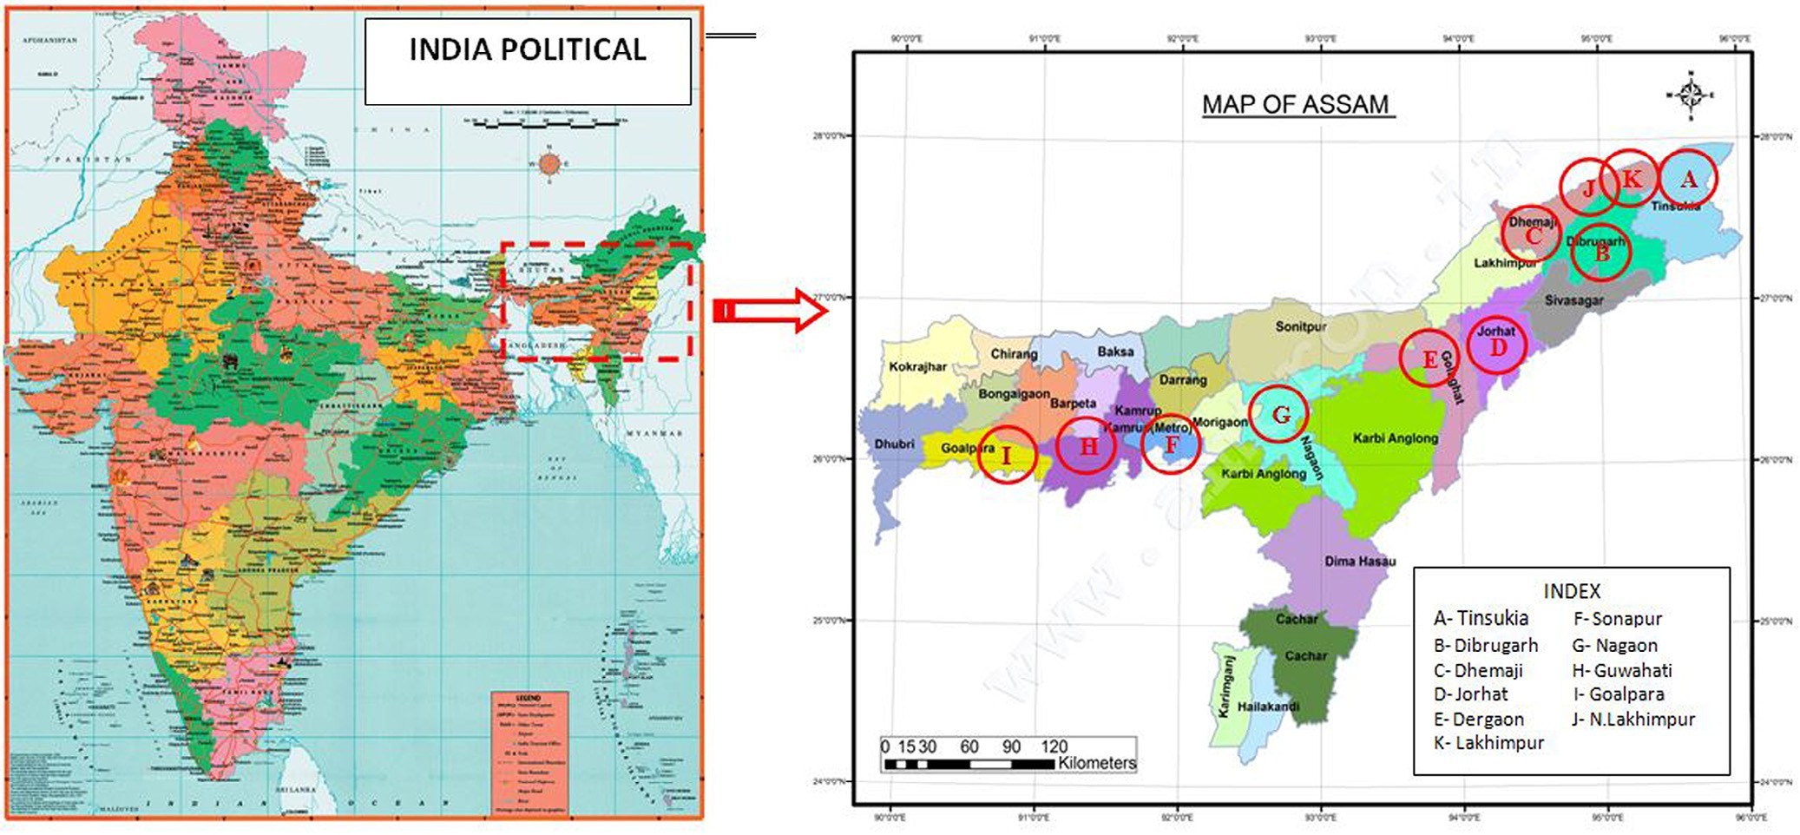

**Fig. 1 – Geographical location of the sample collection sites shown in the map.**

Sharpe) broth maintained at pH −3 and incubated at 37 ± 2 °C at 135 rpm for 24 hr (CERTOMAT®BS-1 shaker incubator, Sartorious Stedim Germany Ltd.). These were then inocu- lated on MRS agar (pH-3) plates to obtain acid tolerant bacterial strains. These were further screened by inoculated on bile esculin agar media. Nonpathogenic probiotic strains were screened by treating isolates with broad and narrow spec- trum commercially available antibiotic discs belonging to the clinically most relevant antibiotic classes, *viz*., ciprofloxacin (5 mcg), kanamycin (30 mcg), ampicillin (10 mcg), clindamycin

(2 mcg), vancomycin (30 mcg), erythromycin (15 mcg), genta- micin (10 mcg), and tetracycline (30 mcg) by Kirby Bauer’s disc diffusion method.

## *Viability in acidic and alkaline conditions*

The viability of the probiotic candidates were further evalu- ated in a pH range of 1–10 individually. The growth was measured at absorbance 600 nm at an interval of 1h, and the viability of the cells was confirmed by inoculating onto MRS agar plates by spread plate method.

## *Hemolysis assay*

Hemolytic activity of the isolates were evaluated using Blood agar base No.2 plates containing 5% (*v/v*) defibrinated sheep blood, and incubated at 37 °C for 24 h. The assay was per- formed in triplicate [21].

## *Test for the production of bacteriocin*

The most potent isolate was grown in MRS broth at 37 °C for 48 h and were harvested at 10,000 rpm for 5 min at 4 °C. The supernatant was heated to 70 °C (to inactivate proteases) and concentrated to 1/10th volume by rotary vacuum evaporator. This cell-free supernatant concentrate (CFSC), passed through

0.22 μm membrane filters (Millipore, Germany) and evaluated for its antimicrobial activities [22]. The antimicrobial activity was evaluated by agar-well diffusion assay. Briefly, the MH agar medium was poured onto the petri dishes and upon solidifi- cation the test organism *E. coli* MTCC 40 (0.5 McFarland standard dilution) was inoculated onto each plate. Wells with 8 mm di- ameter were made in the plates and filled with 50 μL of cell free content of the culture of the strain and left to diffuse for 18 hours at 37 ± 2 °C overnight and were examined for zone of inhibition around the wells.

## *Evaluation of antagonistic property in terms of* minimal inhibitory concentration (MIC) and minimum bactericidal concentration (MBC) the probiotic isolate against

**E. coli *(MTCC40)***

Aliquots of the overnight broth of the potential isolate (O.D. = 1.0) was inoculated (40, 80, 120, 160, and 200 μL) to a total volume of 10 mL overnight MRS broth of *E. coli* MTCC40 (as per 0.5 Mc- Farland standard dilution) individually at different test tubes maintained at 135 rpm at 37 °C for the determination of MIC and MBC values. The growth of the pathogen was monitored by measuring the OD at 600 nm at each interval of 2 h. The vi- ability of the test organism was further examined by inoculating on nutrient agar plates by spread plating method.

## *Molecular identification of the most potent isolate*

The potential probiotic isolate was identified on the basis of various techniques prescribed by Bergey’s Manual of System- atic Bacteriology and finally by 16S rDNA sequencing. 16S rDNA fragment of the isolate was amplified by using forward 704F (5′-GTA GCG GTG AAA TGC GTA GA-3′) and reverse 907R (5′-

CCG TCA ATT CMT TTG AGT TT-3′) primer, and a 909 bp long consensus sequence was generated using aligner software. The

16S rDNA sequence was used to carry out BLAST with the

egyptian journal of basic and applied sciences 3 (2016) 232–240

**235**

non-redundant 16S rRNA sequence (bacteria and archaea) da- tabase of NCBI GenBank. First ten sequences were selected on the basis of maximum identity scores and aligned using mul- tiple alignment software program ClustalWTM. The phylogenetic tree was constructed using MEGA6 software using the maximum likelihood method. The bootstrap value was set at 1000, and percentage values are given at the nodes [23–25]. The 16S rDNA sequence obtained was submitted to GenBank da- tabase. The evolutionary distances were computed using the Kimura 2-parameter method [26].

## In-vitro *determination of cell surface traits of the* most potent isolate

### *Hydrophobicity assay*

Bacterial cell surface hydrophobicity was measured by deter- mining the microbial adhesion to hydrocarbons using the protocol described by Crow et al. with minor modification [27]. Briefly, overnight bacterial culture was centrifuged at 10,000*X* g for 5 min. The pellet was washed twice in phosphate buffer saline (PBS) and suspended in 3 mL of 0.1M KNO3 solution. The absorbance was measured (A0) at 600 nm. 1 mL of toluene was added to the cell suspension in order to form a two-phase system. The two-phase system was vortex for 2 min after 10 min of pre-incubation at room temperature. After 30 min of incu- bation at room temperature, the water and toluene phases got separated. The aqueous phase was then carefully separated and the absorbance was measured at 600 nm (A1). The percentage of the cell surface hydrophobicity (H) was calculated using the following formula [28]:

H  1  A1  A0   100

### *Auto-aggregation assay of the potential probiotic* isolate with other pathogens

The specific cell–cell interactions were determined using auto- aggregation assay [18]. The bacterial cells were harvested at 5000X g for 10 min at 4 °C and washed with PBS and re- suspended in PBS to 108 cfu/mL. For the auto-aggregation assay, 3 mL of each bacterial suspension was vortex for 10 seconds and incubated at 37 °C for 2 h. The absorbance of the super- natant was measured at 600 nm using spectrophotometer. The auto-aggregation was calculated with the following [29]:

Auto-aggregation%  1  A2h A0h   100

Where, A2h  absorbance at 600 nm two hours of incubation and A0h  absorbance at 600 nm zero hour

### *Lysozyme susceptibility test*

Fresh 30 mL un-inoculated LB broth with 9 mL of egg white ly- sozyme was inoculated in 3 mL of overnight culture of the most potent isolate and incubated at 37 °C for 1 h. The survival of the isolate was tested by plating on nutrient agar plates [30]*.*

### *Determination of thermal death point of the potential* isolate

5 mL of overnight most potent bacterial isolate was treated at different temperatures for 10 min then streaked onto nutrient

agar plate and incubated overnight at 37 ± 2 °C overnight to see the temperature at which growth ceases [31].

## *Statistical analysis*

All the experiments were performed in triplicates and results were expressed in terms of mean ± SD. Student’s *t*-test was per- formed to see the significance of the results obtained.

# Results

A total of 120 probiotic bacterial candidates were isolated on MRS agar plates maintained at pH 3. The strains were further screened on the basis of their ability to grow on bile esculin agar (Fig. 2a). Only 12 strains were considered for further studies on the basis of their satisfactory growth on bile esculin agar. The tested strains displayed no hemolysis (γ-hemolysis) when challenged with human blood (Fig. 2b) indicate its nonpatho- genic character [32].

The isolates were screened for nonpathogenic strains on the basis of their susceptibility against standard clinically sig- nificant antibiotics. The most potent isolate was found to be sensitive against all the antibiotics used in the study. The can- didate probiotic strain was not found to be producing bacteriocin. As far as direct pathogen inhibition is apprehen- sive, many probiotic LAB have been observed to produce antimicrobial substances, and mainly organic acids, espe- cially lactic and acetic acids, etc. [29]. The antagonistic property of the potent probiotic candidate was checked against the most common GI tract bacterial species *E. coli* (MTCC40). The MIC and MBC values of the potent probiotic candidate were found

to be 120 and 200 μL/mL, respectively, against *E. coli* (MTCC40)

(Fig. 3).

It shows maximum viability at a pH of 2–8, however also shows its viability at pH 1 and 10 (Fig. 4). Here, the isolates were grown in bile esculine agar (4% Ox bile), where they hydro- lyse bile esculin producing dark brown to black coloration of the media (Fig. 2a). Isolates split the esculin molecules and use the liberated glucose to supply energy needs to release escu- letin into the medium where it reacts with ferric citrate to form a phenolic iron complex, which turns the agar medium from

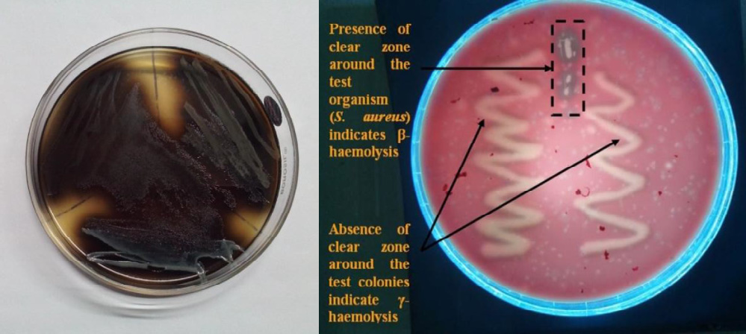

(a) (b)

**Fig. 2 – Appearance of black in bile esculin agar in**

**(a) indicates hydrolysis of esculin and (b) shows**

**γ-hemolysis by the potent isolate against a suitable reference strain.**

**236** egyptian journal of basic and applied sciences 3 (2016) 232–240

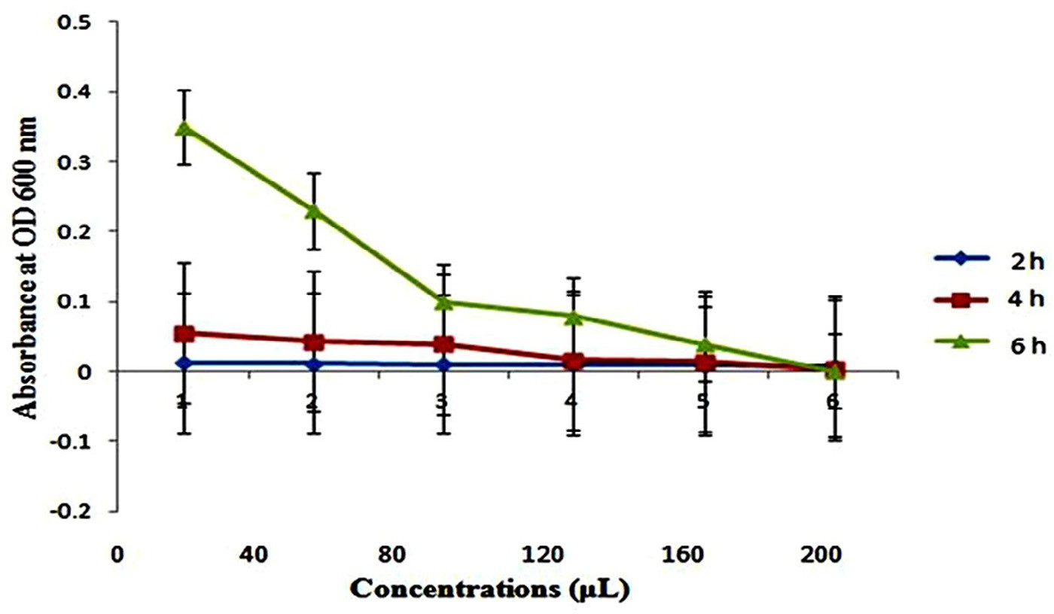

**Fig. 3 – Antagonistic effect of the potent isolate against *E. coli* (MTCC40) at different time interval.**

dark brown to black. The strain shows 33.1 ± 0.5% hydropho- bicity along with higher values of auto-aggregation (71.43 ± 0.2%) as compared to the test pathogen *E. coli* MTCC40 (55.5 ± 0.4%). The auto-aggregation value of the most potent strain ob- tained in our study is compared with some of the established probiotic isolates worldwide, *viz*, *Bifidobacterium longum* B6, *Lac- tobacillus acidophilus* ADH, *Lactobacillus paracasei* ATCC 25598, *Lact. rhamnosus* GG*, Lactobacillus brevis* (KACC 10553), *Lactobacillus casei* (KACC 12413), *Leuconostoc mesenteroides* (KACC 12312), *Pediococcus acidilactici* (KACC 12307), *L. monocytogenes* (KACC 12671); and also with some of the pathogens *viz*, *S. aureus* (KACC 10768), *Shi- gella boydii* (KACC 10792) and *Salmonella typhimurium* (KCCM 40253), *E. coli* MTCC40 (Fig. 5). The values used for compari- son were taken from documented literature [29].

The potent probiotic candidate was challenged with 400 μg lysozyme/mL for 60 minutes where it shows moderate

**Absorbance at 600 nm**

resistance to the enzyme (Fig. 6). This concentration was used in characterizing *Bifidobacterium* strains in simulated GI tract passage by *Rada* et al. [30]. On the basis of various staining techniques and their biochemical tests, the isolate 9F was found to be gram positive, catalase positive cocci. The most potent isolate 9F was identified to be novel species of *Staphylococcus sp.* DBOCP6 on the basis of 16S rDNA sequenc- ing. The evolutionary history was inferred using the maximum likelihood method [24]. The optimized phylogenetic tree shows maximum similarity score of 70% with *S. pasteuri* ATCC 51129 (GenBank Accession Number: NR 024669.1) by forcing *Lacto- bacillus paracasei* strain R094 (GenBank Accession Number: NR 025880.1) as outgroup with 1000 bootstrap value (Fig. 7). The GenBank accession number **KR706310** was received suc- cessfully for the novel probiotic isolate *Staphylococcus sp.* DBOCP6.

**Fig. 4 – Growth profile of the most potent isolate at different pH and time interval.**

**40**

**35**

**30**

**25**

**20**

**15**

**10**

1. **hr**
2. **hr**
3. **hr**
4. **hr**
5. **hr**
6. **hr**

**5**

**0**

**1**

**2**

**3**

**4**

**5**

**6**

**7**

**8**

**9**

**10**

**pH of the growth medium**

egyptian journal of basic and applied sciences 3 (2016) 232–240

**237**

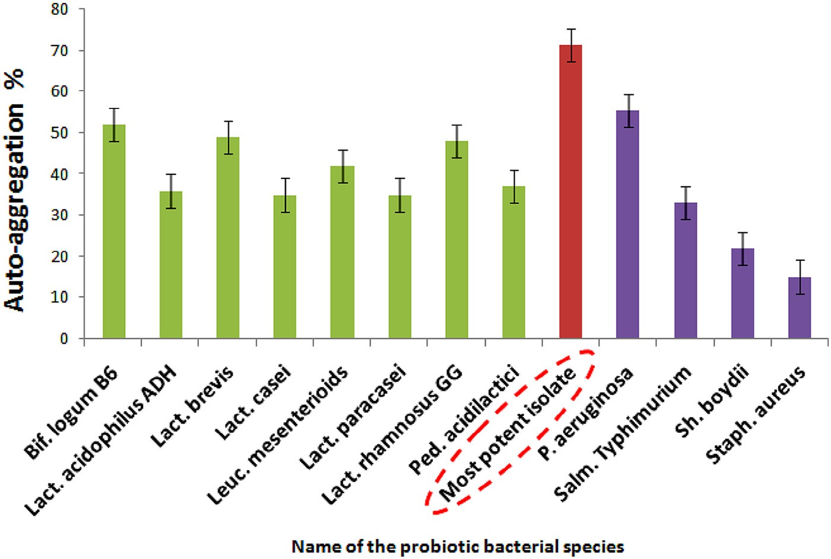

**Fig. 5 – Graph showing the comparison of auto-aggregation values by the most potent isolate in the current study with other known probiotic bacteria.**

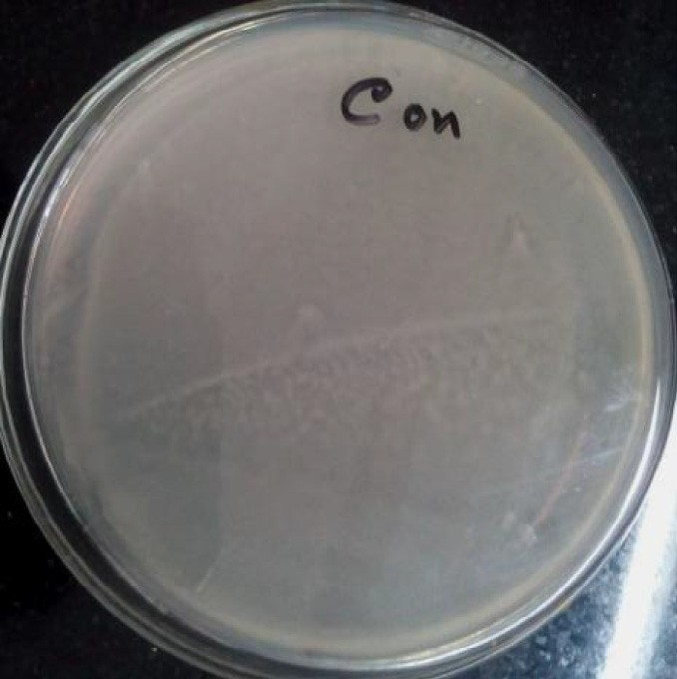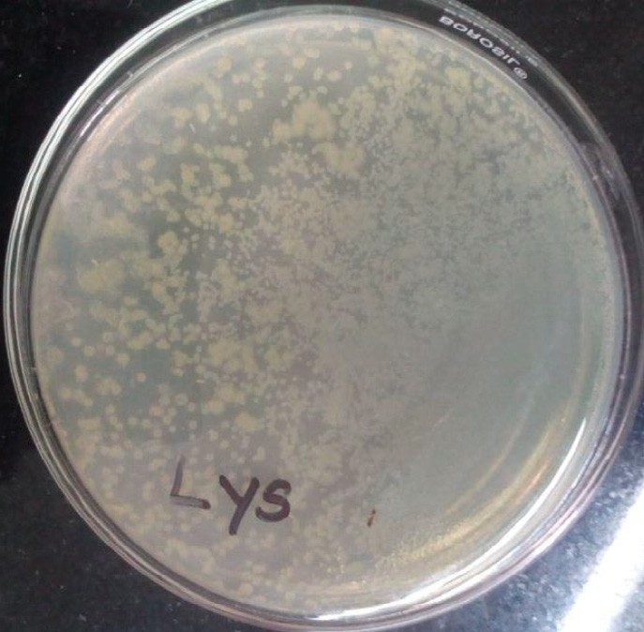

**Fig. 6 – Considerable growth (right image) of the isolate in presence of lysozyme as compared to the control plate (left image).**

# Discussion

A large number of authors reported the occurrence of food borne pathogens causing health hazards [33–35]. With the present status of escalating drug resistant microorganism and the side effects caused by these drugs, there is a fervent need for the development of unconventional natural food prod- ucts with health promoting properties [36,37]. Only one of the isolates was found to be susceptible to the entire broad and narrow spectrum antibiotics tested, which indicates that the isolate is nonpathogenic.

Bacteriocins actively produced *in vitro* may not necessarily be sufficiently high in quantities, or at all, within the GIT [28,38]. Therefore, the production of bacteriocins might not be consid- ered as a fundamental tract for a new probiotic candidates [20].

Gastric juice in stomach is a biological barrier where the pH is between 1.5 and 3.0 and the candidate isolate was able to survive and grow at pH range of 1–10 till 6 hr of incuba- tion, proving its capacity to transit through the acidic environment of stomach and also to survive in the alkaline conditions of GI tract [39]. Bile is another biological barrier encountered by the candidate microbe in the upper part of the small intestine. In the human body, the relevant physi- ological concentration of human bile ranges from 0.3 to 0.5% [38,40]. The inhibition of common intestinal bacteria had been related to the presence of deconjugated bile acids rather than conjugated ones [41]. The ability to hydrolyze bile salts can help the microorganism to sustain the balance of the gut microflora [42]. Bile salt hydrolase (BSH) activity is also correlated to a decrease in cholesterol level in humans [43,44].

**238** egyptian journal of basic and applied sciences 3 (2016) 232–240

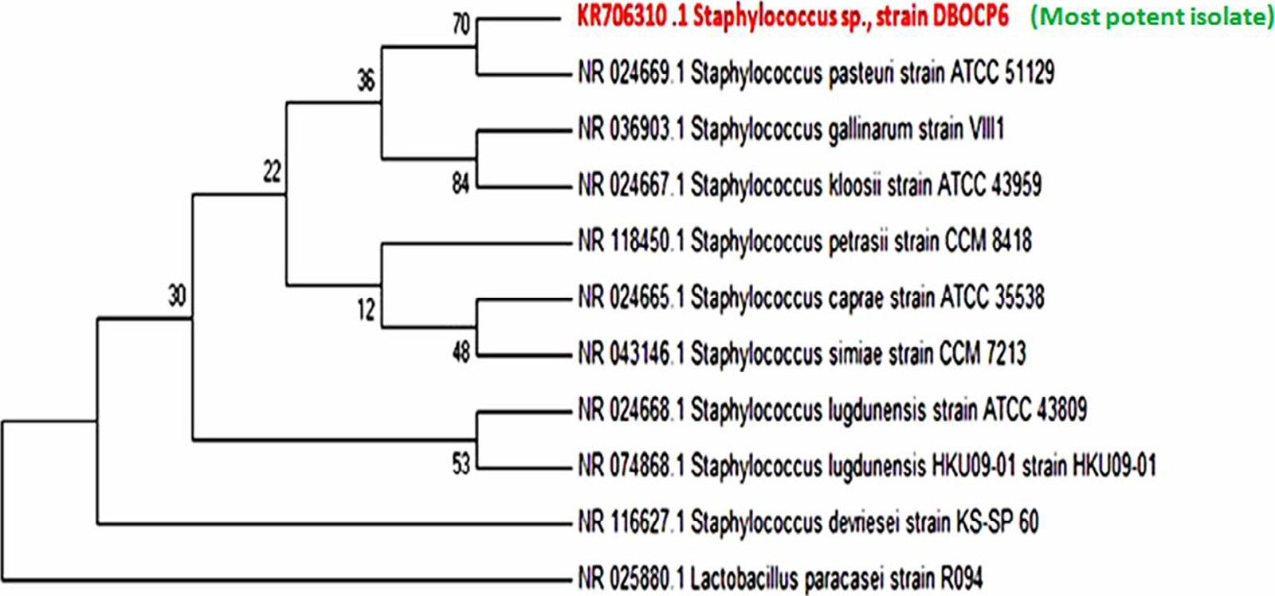

**Fig. 7 – Phylogenetic relationships of the new potent isolate *Staphylococcus* sp*.* DBOCP6 (GenBank accession no. KR706310) with ten other most closely related *Staphylococcus* species based on 16S rDNA sequencing. The data set resembled 1000 times using the bootstrap option, and percentage values are given at the nodes.**

The strain with promising probiotic characters was tested for its cell surface adhesion properties. It is globally recog- nized that probiotics must be able to colonize themselves inside digestive tract of the host [45,46]. Consequently, adhesion prop- erties have been anticipated as a crucial factor for the selection of new probiotics [28,47]. For probiotics to exert maximum effect on the host, it should have the aptitude to adhere and colo- nize the intestine apart from being resistant to GI conditions [36]. Toluene is used to assess the hydrophobic or hydrophilic characteristics of bacterial cell surface, which are attributed to carboxylic groups on the cell surface [29]. Functional effects of probiotic bacteria comprise adherence to the intestinal wall for colonization in the gastrointestinal tract with capacity to prevent pathogenic adherence or pathogen activation [48]. The hydrophobic and hydrophilic properties may result from pro- teins and polysaccharides on the bacterial cell surface [49]. Hydrophobicity is one of the physico-chemical properties that assist the first contact between the microorganisms and the host cells [36]. The high cell surface hydrophobicity of the strain could indicate its capability to attach to the epithelial cell lining of the intestine and resist the movement of digested food ma- terials [49]. The probiotic candidate showed reasonably higher auto-aggregation than the pathogens, suggesting the specific binding capabilities of probiotics in the GIT.

Lysozyme is the first biological barrier in the human di- gestive system encountered by the swallowed probiotic microbes [50]. Viability of the isolate indicates its ability to survive if it is administered orally.

# Conclusion

This study extensively documented the isolation and screen-

identified to be novel species of *Staphylococcus* species on the basis of *16S* rDNA sequencing technique. It shows satisfac- tory growth in presence of lysozyme, capable of surviving in a wide range pH range and also can hydrolyze bile esculin, in- dicating its potential to survive throughout the mammalian food tract. The isolated strain was also found to be nonpatho- genic on the basis of susceptibility to both the broad and narrow spectrum antibiotics and non-hemolytic property. It shows an- tagonistic activity against *E. coli.* It displayed good hydrophobicity values with a higher value of auto-aggregation. Even though the isolate was not found to be producing any antimicrobial bacteriocin, it is capable to withstand high temperature with thermal death point of 100 °C, indicating it encompasses the vulnerability of probiotic bacteria during the food processing techniques, making it suitable for industrial exploitation. Based on the above observations, it could be concluded that *Staphy- lococcus sp.* strain DBOCP6 can serve as a potential probiotic candidate for industrial exploitation.

# Acknowledgements

The author acknowledge DBT-MHRD, Govt. of India (Grant No. BT/04/NE/2009) and DBT-IBTHub projects (BT/04/NE.2009) for providing the funds and infrastructure to carry out the study at Centre for Studies in Biotechnology, Dibrugarh University. Authors also acknowledge Delcon facilities for providing access to more than 900 e-journals to Dibrugarh University, and Xcelris Labs. Pvt. Ltd., Ahmedabad for successfully performing 16S rDNA sequencing presented in the manuscript.

R E F E R E N C E S

ing of probiotic bacteria from traditionally prepared fermented fish and meat of Assam, India. The most potent isolate was

found to be a novel gram positive, cocci shaped, catalase posi- tive, non-hemolytic bacteria fulfilling all basic criteria to be considered as a potential probiotic candidate. The isolate was

1. [Goswami M, Sathiadhas R, Goswami UC. Market flow, price](http://refhub.elsevier.com/S2314-808X(16)30015-X/sr0010) [structure and fish marketing system in Assam – a case](http://refhub.elsevier.com/S2314-808X(16)30015-X/sr0010) [study. Ernakulam: CMFRI Publication; 2002. p. 146–55.](http://refhub.elsevier.com/S2314-808X(16)30015-X/sr0010)

egyptian journal of basic and applied sciences 3 (2016) 232–240

**239**

1. [Kashyap D, Bhattacharjya K. Costs, margins and price spread](http://refhub.elsevier.com/S2314-808X(16)30015-X/sr0015) [across the marketing channels of dry fish in jagiroad dry fish](http://refhub.elsevier.com/S2314-808X(16)30015-X/sr0015) [market of Morigaon district. Assam J Inland Fish Soc India](http://refhub.elsevier.com/S2314-808X(16)30015-X/sr0015) [2012;44(2):49–55.](http://refhub.elsevier.com/S2314-808X(16)30015-X/sr0015)
2. [Joshi SR, Banerjee S, Bhattacharjee K, Lyngwi NA, Koijam K,](http://refhub.elsevier.com/S2314-808X(16)30015-X/sr0020) [Khaund P, et al. Northeast Microbial Database: a web-based](http://refhub.elsevier.com/S2314-808X(16)30015-X/sr0020) [databank of culturable soil microbes from North East India.](http://refhub.elsevier.com/S2314-808X(16)30015-X/sr0020) [Curr Sci 2015;108(9):1702–6.](http://refhub.elsevier.com/S2314-808X(16)30015-X/sr0020)
3. [Tamang JP, Oki K, Rai AK, Sato S, Watanabe K. Lactic acid](http://refhub.elsevier.com/S2314-808X(16)30015-X/sr0025) [bacteria isolated from ethnic preserved meat products of](http://refhub.elsevier.com/S2314-808X(16)30015-X/sr0025) [the Western Himalayas. Food Microbiol 2011;28:1308–15.](http://refhub.elsevier.com/S2314-808X(16)30015-X/sr0025)
4. [Fuller R. A review: probiotics in man and animals. J Appl](http://refhub.elsevier.com/S2314-808X(16)30015-X/sr0030) [Bacteriol 1989;66:365–78.](http://refhub.elsevier.com/S2314-808X(16)30015-X/sr0030)
5. [FAO/WHO. Guidelines for the evaluation of probiotics in](http://refhub.elsevier.com/S2314-808X(16)30015-X/sr0035) [food. Working group report. Rome and Geneva: Food and](http://refhub.elsevier.com/S2314-808X(16)30015-X/sr0035) [Agricultural Organization of the United Nations/World](http://refhub.elsevier.com/S2314-808X(16)30015-X/sr0035) [Health Organization; 2002.](http://refhub.elsevier.com/S2314-808X(16)30015-X/sr0035)
6. [Metchnikoff E. The prolongation of life. Optimistic studies.](http://refhub.elsevier.com/S2314-808X(16)30015-X/sr0040) [2nd ed. London: William Heinemann; 1907.](http://refhub.elsevier.com/S2314-808X(16)30015-X/sr0040)
7. [Salminen S, Deighton MA, Benno Y, Gorbach SL. Lactic acid](http://refhub.elsevier.com/S2314-808X(16)30015-X/sr0045) [bacteria in health and disease: microbiology and functional](http://refhub.elsevier.com/S2314-808X(16)30015-X/sr0045) [aspects. 2nd ed. New York: Marcel Dekker Inc; 1998. p. 211–](http://refhub.elsevier.com/S2314-808X(16)30015-X/sr0045) [54.](http://refhub.elsevier.com/S2314-808X(16)30015-X/sr0045)
8. [Dunne C, O’Mahony L, Murphy L, Thornton G, Morrissey D,](http://refhub.elsevier.com/S2314-808X(16)30015-X/sr0050) [O’Halloran S, et al. *In vitro* selection criteria for probiotic](http://refhub.elsevier.com/S2314-808X(16)30015-X/sr0050) [bacteria of human origin: correlation with in vivo findings.](http://refhub.elsevier.com/S2314-808X(16)30015-X/sr0050) [Am J Clin Nutr 2001;73(Suppl.):386S–92S.](http://refhub.elsevier.com/S2314-808X(16)30015-X/sr0050)
9. [Booijink CC, Zoetendal EG, Kleerebezem M, De Vos WM.](http://refhub.elsevier.com/S2314-808X(16)30015-X/sr0055) [Microbial communities in the human small intestine:](http://refhub.elsevier.com/S2314-808X(16)30015-X/sr0055) [coupling diversity to metagenomics. Future Microbiol](http://refhub.elsevier.com/S2314-808X(16)30015-X/sr0055) [2007;2(3):285–95.](http://refhub.elsevier.com/S2314-808X(16)30015-X/sr0055)
10. [Gerritsen J, Smidt H, Vos WM, Rijkers GT. Intestinal](http://refhub.elsevier.com/S2314-808X(16)30015-X/sr0060) [microbiota in human health and disease: the impact of](http://refhub.elsevier.com/S2314-808X(16)30015-X/sr0060) [probiotics. Genes Nutr 2011;6:209–40.](http://refhub.elsevier.com/S2314-808X(16)30015-X/sr0060)
11. [Dethlefsen L, Eckburg PB, Bik EM, Relman DA. Assembly of](http://refhub.elsevier.com/S2314-808X(16)30015-X/sr0065) [the human intestinal microbiota. Trends Ecol Evol (Amst)](http://refhub.elsevier.com/S2314-808X(16)30015-X/sr0065) [2006;21(9):517–23.](http://refhub.elsevier.com/S2314-808X(16)30015-X/sr0065)
12. [Booijink CC, El-Aidy S, Rajilic´-Stojanovic M, Heilig HG, Troost](http://refhub.elsevier.com/S2314-808X(16)30015-X/sr0070) [FJ, Smidt H, et al. High temporal and inter-individual](http://refhub.elsevier.com/S2314-808X(16)30015-X/sr0070) [variation detected in the human ileal microbiota. Environ](http://refhub.elsevier.com/S2314-808X(16)30015-X/sr0070) [Microbiol 2010;12(12):3213–27.](http://refhub.elsevier.com/S2314-808X(16)30015-X/sr0070)
13. [Patterson J, Burkholder K, The European Parliament and the](http://refhub.elsevier.com/S2314-808X(16)30015-X/sr0075) [Council of the European Union 2003. Regulation (EC) No](http://refhub.elsevier.com/S2314-808X(16)30015-X/sr0075) [1831/2003 of the European Parliament and of the Council of](http://refhub.elsevier.com/S2314-808X(16)30015-X/sr0075) [22 September 2003 on additives for use in animal nutrition.](http://refhub.elsevier.com/S2314-808X(16)30015-X/sr0075) [Application of prebiotics and probiotics in poultry](http://refhub.elsevier.com/S2314-808X(16)30015-X/sr0075) [production. Poultry Sci 2003;82:627–31.](http://refhub.elsevier.com/S2314-808X(16)30015-X/sr0075)
14. [Santini C, Baffoni L, Gaggia F, Granata M, Gasbarri R, Di Gioia](http://refhub.elsevier.com/S2314-808X(16)30015-X/sr0080) [D, et al. Characterization of probiotic strains: an application](http://refhub.elsevier.com/S2314-808X(16)30015-X/sr0080) [as feed additives in poultry against *Campylobacter jejuni*. Int J](http://refhub.elsevier.com/S2314-808X(16)30015-X/sr0080) [Food Microbiol 2010;104:S98–108.](http://refhub.elsevier.com/S2314-808X(16)30015-X/sr0080)
15. [Chaiyawan N, Tayeeteptaikul P, Wannissorn B,](http://refhub.elsevier.com/S2314-808X(16)30015-X/sr0085) [Ruengsomwong S, Klungsupya P, Buaban W, et al.](http://refhub.elsevier.com/S2314-808X(16)30015-X/sr0085) [Characterization and probiotic properties of *Bacillus* strains](http://refhub.elsevier.com/S2314-808X(16)30015-X/sr0085) [isolated from broiler. Thai J Vet Med 2010;40:207–14.](http://refhub.elsevier.com/S2314-808X(16)30015-X/sr0085)
16. [Modesto M, D’Aimmo M, Stefanini I, Trevisi P, De Filippi S,](http://refhub.elsevier.com/S2314-808X(16)30015-X/sr0090) [Casini L, et al. A novel strategy to select *Bifidobacterium*](http://refhub.elsevier.com/S2314-808X(16)30015-X/sr0090)[strains and prebiotics as natural growth promoters in newly](http://refhub.elsevier.com/S2314-808X(16)30015-X/sr0090) [weaned pigs. Livest Sci 2009;122:248–58.](http://refhub.elsevier.com/S2314-808X(16)30015-X/sr0090)
17. [Del Re B, Sgorbati B, Miglioli M, Palenzona D. Adhesion,](http://refhub.elsevier.com/S2314-808X(16)30015-X/sr0095) [autoaggregation and hydrophobicity of 13 strains of](http://refhub.elsevier.com/S2314-808X(16)30015-X/sr0095) [*Bifidobacterium longum*. Lett Appl Microbiol 2000;31:438–](http://refhub.elsevier.com/S2314-808X(16)30015-X/sr0095) [42.](http://refhub.elsevier.com/S2314-808X(16)30015-X/sr0095)
18. [Collado MC, Isolauri E, Salminen S, Sanz Y. The impact of](http://refhub.elsevier.com/S2314-808X(16)30015-X/sr0100) [probiotic on gut health. Curr Drug Metab 2009;10:68–78.](http://refhub.elsevier.com/S2314-808X(16)30015-X/sr0100)
19. [Moreno MRF, Sarantinopoulos P, Tsakalidou E, De Vuyst L.](http://refhub.elsevier.com/S2314-808X(16)30015-X/sr0105) [The role and application of enterococci in food and health.](http://refhub.elsevier.com/S2314-808X(16)30015-X/sr0105) [Int J Food Microbiol 2006;106(1):1–24.](http://refhub.elsevier.com/S2314-808X(16)30015-X/sr0105)
20. [Thirabunyanon M, Boonprasom P, Niamsup P. Probiotic](http://refhub.elsevier.com/S2314-808X(16)30015-X/sr0110) [potential of lactic acid bacteria isolated from fermented](http://refhub.elsevier.com/S2314-808X(16)30015-X/sr0110) [dairy milks on anti-proliferation of colon cancer cells.](http://refhub.elsevier.com/S2314-808X(16)30015-X/sr0110) [Biotechnol Lett 2009;31:571–6.](http://refhub.elsevier.com/S2314-808X(16)30015-X/sr0110)
21. [Pal V, Pal A, Patil M, Ramana KV, Jeevaratnam K. *Bacteriocins*](http://refhub.elsevier.com/S2314-808X(16)30015-X/sr0115)[*from* Pediococcus pentosaceous. J Food Process Preserv](http://refhub.elsevier.com/S2314-808X(16)30015-X/sr0115) [2010;34:1064–79.](http://refhub.elsevier.com/S2314-808X(16)30015-X/sr0115)
22. [Kimura M. A simple method for estimating evolutionary](http://refhub.elsevier.com/S2314-808X(16)30015-X/sr0120) [rates of base substitutions through comparative studies of](http://refhub.elsevier.com/S2314-808X(16)30015-X/sr0120) [nucleotide sequences. J Mol Evol 1980;16:111–20.](http://refhub.elsevier.com/S2314-808X(16)30015-X/sr0120)
23. [Saitou N, Nei M. The neighbor-joining method: a new](http://refhub.elsevier.com/S2314-808X(16)30015-X/sr0125) [method for reconstructing phylogenetic trees. Mol Biol Evol](http://refhub.elsevier.com/S2314-808X(16)30015-X/sr0125) [1987;4:406–25.](http://refhub.elsevier.com/S2314-808X(16)30015-X/sr0125)
24. [Tamura K, Dudley J, Nei M, Kumar S. MEGA4: molecular](http://refhub.elsevier.com/S2314-808X(16)30015-X/sr0130) [evolutionary genetics analysis (MEGA) software version 4.0.](http://refhub.elsevier.com/S2314-808X(16)30015-X/sr0130) [Mol Biol Evol 2007;24:1596–9.](http://refhub.elsevier.com/S2314-808X(16)30015-X/sr0130)
25. [Felsenstein J. Confidence limits on phylogenies: an approach](http://refhub.elsevier.com/S2314-808X(16)30015-X/sr0135) [using the bootstrap. Evolution 1985;39:783–91.](http://refhub.elsevier.com/S2314-808X(16)30015-X/sr0135)
26. [Crow VL, Gopal PK, Wicken AJ. Cell-surface differences of](http://refhub.elsevier.com/S2314-808X(16)30015-X/sr0140)

[*Lactococcal* strains. Int Dairy J 1995;5:45–68.](http://refhub.elsevier.com/S2314-808X(16)30015-X/sr0140)

1. [Botta C, Langerholc T, Cencicˇ A, Cocolin L. *In vitro* selection](http://refhub.elsevier.com/S2314-808X(16)30015-X/sr0145) [and characterization of new probiotic candidates from table](http://refhub.elsevier.com/S2314-808X(16)30015-X/sr0145) [olive microbiota. PLoS ONE 2014;9(4):e94457.](http://refhub.elsevier.com/S2314-808X(16)30015-X/sr0145)
2. [Xu H, Jeong HS, Lee HY, Ahn J. Assessment of adhesion](http://refhub.elsevier.com/S2314-808X(16)30015-X/sr0150) [properties of probiotics. Lett Appl Microbiol 2009;49:434–42.](http://refhub.elsevier.com/S2314-808X(16)30015-X/sr0150)
3. [Rada V, Splichal I, Rockova S, Grmanova M, Vlkova E.](http://refhub.elsevier.com/S2314-808X(16)30015-X/sr0155) [Susceptibility of bifidobacteria to lysozyme as a possible](http://refhub.elsevier.com/S2314-808X(16)30015-X/sr0155) [selection criterion for probiotic *Bifidobacterial* strains.](http://refhub.elsevier.com/S2314-808X(16)30015-X/sr0155) [Biotechnol Lett 2010;32:451–5.](http://refhub.elsevier.com/S2314-808X(16)30015-X/sr0155)
4. [Aneja KR. Experiments in microbiology, plant pathology and](http://refhub.elsevier.com/S2314-808X(16)30015-X/sr0160) [biotechnology. 4th ed. India: New Age International](http://refhub.elsevier.com/S2314-808X(16)30015-X/sr0160) [Publishers; 2010.](http://refhub.elsevier.com/S2314-808X(16)30015-X/sr0160)
5. [Maragkoudakisa PA, Zoumpopouloua G, Miarisa C,](http://refhub.elsevier.com/S2314-808X(16)30015-X/sr0165) [Kalantzopoulosa G, Potb B, Tsakalidou E. Probiotic potential](http://refhub.elsevier.com/S2314-808X(16)30015-X/sr0165) [of *Lactobacillus* strains isolated from dairy products. Int Dairy](http://refhub.elsevier.com/S2314-808X(16)30015-X/sr0165) [J 2006;16:189–99.](http://refhub.elsevier.com/S2314-808X(16)30015-X/sr0165)
6. [Vescovo M, Torriani S, Orsi C, Macchiarolo F, Scolari G.](http://refhub.elsevier.com/S2314-808X(16)30015-X/sr0170) [Application of antimicrobial-producing lactic acid bacteria](http://refhub.elsevier.com/S2314-808X(16)30015-X/sr0170) [to control pathogens in ready-to-use vegetables. J Appl](http://refhub.elsevier.com/S2314-808X(16)30015-X/sr0170) [Microbiol 1996;81:113–19.](http://refhub.elsevier.com/S2314-808X(16)30015-X/sr0170)
7. [Kannappan S, Manja KS. Antagonistic efficacy of lactic acid](http://refhub.elsevier.com/S2314-808X(16)30015-X/sr0175) [bacteria against seafood borne bacteria. J Food Sci Tech Mys](http://refhub.elsevier.com/S2314-808X(16)30015-X/sr0175) [2004;41:50–9.](http://refhub.elsevier.com/S2314-808X(16)30015-X/sr0175)
8. [Wilderdyke MR, Smith DA, Brashears MM. Isolation,](http://refhub.elsevier.com/S2314-808X(16)30015-X/sr0180) [identification and selection of lactic acid bacteria from](http://refhub.elsevier.com/S2314-808X(16)30015-X/sr0180) [alfalfa sprouts for competitive inhibition of food borne](http://refhub.elsevier.com/S2314-808X(16)30015-X/sr0180) [pathogens. J Food Prot 2004;67:947–51.](http://refhub.elsevier.com/S2314-808X(16)30015-X/sr0180)
9. [Shobharani P, Agrawal R. A potent probiotic strain from](http://refhub.elsevier.com/S2314-808X(16)30015-X/sr0185) [cheddar cheese. Indian J Microbiol 2011;51(3):251–8.](http://refhub.elsevier.com/S2314-808X(16)30015-X/sr0185)
10. [Oyetayo VO, Adetuyi FC, Akinyosoye FA. Safety and](http://refhub.elsevier.com/S2314-808X(16)30015-X/sr0190) [protective effect of *Lactobacillus acidophilus* and *Lactobacillus*](http://refhub.elsevier.com/S2314-808X(16)30015-X/sr0190)[*casei* used as probiotic agent *in vivo*. Afr J Biotechnol](http://refhub.elsevier.com/S2314-808X(16)30015-X/sr0190) [2003;2(11):448–52.](http://refhub.elsevier.com/S2314-808X(16)30015-X/sr0190)
11. [Zavaglia AG, Kociubinsky G, Perez PD, Antoni G. Isolation](http://refhub.elsevier.com/S2314-808X(16)30015-X/sr0195) [and characterization of *Bifidobacterium* strains for probiotic](http://refhub.elsevier.com/S2314-808X(16)30015-X/sr0195) [formulation. J Food Prot 1998;61(7):865–73.](http://refhub.elsevier.com/S2314-808X(16)30015-X/sr0195)
12. [Corzo G, Gilliland SE. Bile salt hydrolase activity of three](http://refhub.elsevier.com/S2314-808X(16)30015-X/sr0200) [strains of *Lactobacillus acidophilus*. J Dairy Sci 1999;82:472–](http://refhub.elsevier.com/S2314-808X(16)30015-X/sr0200) [80.](http://refhub.elsevier.com/S2314-808X(16)30015-X/sr0200)
13. [Vlkovál E, Kalous L, Bunešová V, Rylková K, Sveˇtlíková R,](http://refhub.elsevier.com/S2314-808X(16)30015-X/sr0205) [Rada V. Occurrence of *Bifidobacteria* and *Lactobacilli* in](http://refhub.elsevier.com/S2314-808X(16)30015-X/sr0205) [digestive tract of some freshwater fishes. Biologia Sect Zool](http://refhub.elsevier.com/S2314-808X(16)30015-X/sr0205) [2012;67(2):411–16.](http://refhub.elsevier.com/S2314-808X(16)30015-X/sr0205)
14. [Grill JP, Cayuela C, Antoine JM, Schneider F. Isolation and](http://refhub.elsevier.com/S2314-808X(16)30015-X/sr0210) [characterization of a *Lactobacillus* amylovorus mutant](http://refhub.elsevier.com/S2314-808X(16)30015-X/sr0210) [depleted in conjugated bile salt hydrolase activity: relation](http://refhub.elsevier.com/S2314-808X(16)30015-X/sr0210) [between activity and bile salt resistance. J Appl Microbiol](http://refhub.elsevier.com/S2314-808X(16)30015-X/sr0210) [2000;89:553–63.](http://refhub.elsevier.com/S2314-808X(16)30015-X/sr0210)

**240** egyptian journal of basic and applied sciences 3 (2016) 232–240

1. [Taranto MP, de Ruiz HAP, de Valdez GF. Bile salt hydrolase](http://refhub.elsevier.com/S2314-808X(16)30015-X/sr0215) [activity in *Enterococcus faecium* strains. Microbiol Aliments](http://refhub.elsevier.com/S2314-808X(16)30015-X/sr0215) [Nutr 1995;13:375–9.](http://refhub.elsevier.com/S2314-808X(16)30015-X/sr0215)
2. [Argyri AA, Zoumpopoulou G, Karatzas KAG, Tsakalidou E,](http://refhub.elsevier.com/S2314-808X(16)30015-X/sr0220) [Nychas GJE. Selection of potential probiotic lactic acid](http://refhub.elsevier.com/S2314-808X(16)30015-X/sr0220) [bacteria from fermented olives by *in vitro* tests. Food](http://refhub.elsevier.com/S2314-808X(16)30015-X/sr0220) [Microbiol 2013;33:282–91.](http://refhub.elsevier.com/S2314-808X(16)30015-X/sr0220)
3. [Bautista-Gallego J, Arroyo-Lopez FN, Rantsiou K,](http://refhub.elsevier.com/S2314-808X(16)30015-X/sr0225) [Jimenez-Diaz R, Garrido-Fernandez A, Cocolin L.](http://refhub.elsevier.com/S2314-808X(16)30015-X/sr0225)

[Screening of lactic acid bacteria isolated from fermented](http://refhub.elsevier.com/S2314-808X(16)30015-X/sr0225) [table olives with probiotic potential. Food Res Int](http://refhub.elsevier.com/S2314-808X(16)30015-X/sr0225) [2013;50:135–42.](http://refhub.elsevier.com/S2314-808X(16)30015-X/sr0225)

1. [Ouwehand AC, Tolokko S, Kulmala J, Salminen S, Salmine E.](http://refhub.elsevier.com/S2314-808X(16)30015-X/sr0230) [Adhesion of inactivated probiotic strains to intestinal](http://refhub.elsevier.com/S2314-808X(16)30015-X/sr0230) [mucus. Lett Appl Microbiol 2000;31(1):82–6.](http://refhub.elsevier.com/S2314-808X(16)30015-X/sr0230)
2. [Rivera-Espinoza Y, Gallardo-Navarro Y. Non-dairy probiotic](http://refhub.elsevier.com/S2314-808X(16)30015-X/sr0235) [products. Food Microbiol 2010;27:1–11.](http://refhub.elsevier.com/S2314-808X(16)30015-X/sr0235)
3. [Lievin-Le Moal V, Servin AL. Pathogenesis of human](http://refhub.elsevier.com/S2314-808X(16)30015-X/sr0240) [enterovirulent bacteria: lessons from cultured, fully](http://refhub.elsevier.com/S2314-808X(16)30015-X/sr0240) [differentiated human colon cancer cell lines. Microbiol Mol](http://refhub.elsevier.com/S2314-808X(16)30015-X/sr0240) [Biol Rev 2013;77:380–439.](http://refhub.elsevier.com/S2314-808X(16)30015-X/sr0240)
4. [Salminen S, Isolauri E, Salminen E. Clinical uses of probiotics](http://refhub.elsevier.com/S2314-808X(16)30015-X/sr0245) [for stabilizing the gut mucosal barrier: successful strains for](http://refhub.elsevier.com/S2314-808X(16)30015-X/sr0245) [future challenges. Antonie Van Leeuwenhoek 1996;70:347–](http://refhub.elsevier.com/S2314-808X(16)30015-X/sr0245) [58.](http://refhub.elsevier.com/S2314-808X(16)30015-X/sr0245)
5. [Chauviere G, Coconnier MH, Kerneis S, Darfeuille-Michaud](http://refhub.elsevier.com/S2314-808X(16)30015-X/sr0250)

[A. Competitive exclusion of diarrheagenic *Escherichia coli*](http://refhub.elsevier.com/S2314-808X(16)30015-X/sr0250)[(ETEC) from human enterocyte-like Caco-2 cells by heat-](http://refhub.elsevier.com/S2314-808X(16)30015-X/sr0250) [killed *Lactobacillus*. FEMS Microbiol Lett 1992;70:213–17.](http://refhub.elsevier.com/S2314-808X(16)30015-X/sr0250)

1. [Turchi B, Mancini S, Fratini F, Pedonese F, Nuvoloni R,](http://refhub.elsevier.com/S2314-808X(16)30015-X/sr0255) [Bertelloni F, et al. Preliminary evaluation of probiotic](http://refhub.elsevier.com/S2314-808X(16)30015-X/sr0255) [potential of *Lactobacillus plantarum* strains isolated from](http://refhub.elsevier.com/S2314-808X(16)30015-X/sr0255) [Italian food products. World J Microbiol Biotechnol](http://refhub.elsevier.com/S2314-808X(16)30015-X/sr0255) [2013;29:1913–22.](http://refhub.elsevier.com/S2314-808X(16)30015-X/sr0255)