[Egyptian Journal of Basic and Applied Sciences 5 (2018) 289–297](https://doi.org/10.1016/j.ejbas.2018.09.001)

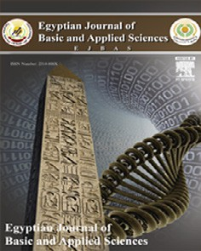

Contents lists available at [ScienceDirect](http://www.sciencedirect.com/science/journal/2314808X)

Egyptian Journal of Basic and Applied Sciences

journal homepage: [www.elsevier.com/locate/ejbas](http://www.elsevier.com/locate/ejbas)

Full Length Article

[](http://crossmark.crossref.org/dialog/?doi=10.1016/j.ejbas.2018.09.001&domain=pdf)Lipogenesis inhibition and adipogenesis regulation via PPARc pathway in 3T3-L1 cells by *Zingiber cassumunar* Roxb*.* rhizome extracts

Natthawut Wong-a-nan a, Kewalin Inthanon b, Aroonchai Saiai c, Angkhana Inta a, Wutigri Nimlamool d,

Siriwadee Chomdej a, Prasat Kittakoop e,f, Weerah Wongkham a,⇑

a *Department of Biology, Faculty of Science, Chiang Mai University, Chiang Mai 50200, Thailand*

b *Faculty of Science and Technology, Thammasat University, Lampang 52190, Thailand*

c *Department of Chemistry, Faculty of Science, Chiang Mai University, Chiang Mai 50200, Thailand*

d *Department of Pharmacology, Faculty of Medicine, Chiang Mai University, Chiang Mai 50200, Thailand*

e *Chulabhorn Graduate Institute, Chemical Biology Program, Chulabhorn Royal Academy, Kamphaeng Phet 6 Road, Laksi, Bangkok 10210, Thailand*

f *Chulabhorn Research Institute, Kamphaeng Phet 6 Road, Laksi, Bangkok 10210, Thailand*

# a r t i c l e i n f o

*Article history:*

Received 15 October 2017

Received in revised form 29 August 2018 Accepted 8 September 2018

Available online 22 September 2018

*Keywords:*

*Zingiber cassumunar Zingiber montanum* 3T3-L1

PPARc

Lipogenesis Adipogenesis Cassumunar ginger Obesity

# a b s t r a c t

*Zingiber cassumunar* (ZC) is used by tribal people in northern Thailand in traditional remedies for anti- obesity and in food recipes. Extracts from this plant have been studied for several pharmacological effects including anti-obesity, but with no clear evidence on cellular mechanism of activity. This study aim to investigate the lipolytic and anti-adipogenic activity of crude extracts from ZC on *in vitro* cultures of the mouse adipocyte cell-model, 3T3-L1. Dry rhizome powder was extracted with absolute ethanol and boiled-water. On the exposed pre-adipocytes to the extracts, cytotoxicity was not detected by using the 3-(4,5-dimethylthiazol-2-yl)-2,5-diphenyltetrazolium bromide (MTT) assay. Lipid content and glyc- erol release were assessed using Oil Red-O and a commercial Adipolysis Assay kits respectively. The extracts exhibited no significant lipolytic activity on the exposed mature-adipocytes, in serial dilutions ranging from 1 to 800 mg/ml. However, anti-lipogenic activity was presented. All extracts significantly

reduced the lipid content of exposed differentiating-adipocytes. This anti-lipogenic activity was con-

firmed by the expression of selected genes, determined by using real-time PCR techniques, in four groups namely: adipocyte differentiation genes, glucose uptake genes, lipid metabolism genes and fatty acid oxi- dation genes. 1H NMR spectrum of the extracts exhibited the prominent olefinic protons of phenylbu- tanoids, the group of compounds previously proved with several bioactivities. This study provided evidences of mechanisms that apparently verify the traditional use of ZC to prevent obesity.

© 2018 Mansoura University. Production and hosting by Elsevier B.V. This is an open access article under

the CC BY-NC-ND license (<http://creativecommons.org/licenses/by-nc-nd/4.0/>).

1. Introduction

The rhizome, young leaves and flowers of *Zingiber cassumunar* Roxb*.* (ZC) (Zingiberaceae) have long been used as a flavorings in Thai cuisine and as fresh ingredients in northern Thai salads. Syno- nyms of the scientific name include *Zingiber montanum* (J. Koenig) Link ex A. Dietr. (ZM) and *Z. purpureum* Roscoe. [1]. The Thai name of this monocotyledonous plant is Phlai or Plai [2,3] and the interna- tional common name is cassumunar ginger [4]. ZC has been investi- gated for several pharmacological properties, including antioxidant [5], anti-inflammation [6], anti-allergic [7], anti-proliferative [8], antiulcer [9] and insecticidal [10]. Anti-adipogenic activity of closely

* Corresponding author at: Department of Biology, Faculty of Science, Chiang Mai University, 239 Huay-Kaew Road, Tambol Su-Thep, Amphur Muang, Chiang Mai 50200, Thailand.

*E-mail address:* [weerah.w@cmu.ac.th](mailto:weerah.w@cmu.ac.th) (W. Wongkham).

related species has been mentioned in several publications (e.g. *Z. officinale* Roscoe (ginger) [11,12], *Z. zerumbet* Smith (bitter ginger)

[13] and *Z. mioga* Roscoe (mioga ginger) [14]), while for ZC only one reports have been published on the *in vitro* inhibitory effect on pancreatic lipase activity [15]. In northern Thailand, ZC is an ingredient in several pharmacological remedies to treat obesity among tribal people [16]. Consequently, this study investigated the potential and cellular mechanism of anti-adipogenic and lipoly- tic activity of crude extracts from ZC rhizomes on an *in vitro* culture system using the mouse adipocyte cell-model, 3T3-L1.

1. Methods and materials
   1. *Chemicals and reagents*

Dulbecco’s Modified Eagle Medium (DMEM), fetal bovine serum (FBS) and 100x antibiotics/antimycotic were purchased from GIBCO

<https://doi.org/10.1016/j.ejbas.2018.09.001>

2314-808X/© 2018 Mansoura University. Production and hosting by Elsevier B.V.

This is an open access article under the CC BY-NC-ND license (<http://creativecommons.org/licenses/by-nc-nd/4.0/>).

(Grand Island, NY, USA). Insulin, 3-isobutyl-1-methylxanthine (IBMX), dexamethasone (DEX), dimethyl sulfoxide (DMSO), iso- propanol, sodium dodecyl sulfate (SDS) and gelatin Type B from bovine skin from Sigma-Aldrich (St. Louis, MO, USA). Oil Red-O (ORO) from Bio Basic (Amherst, NY, USA). Absolute ethanol, hydrochloric acid and formaldehyde from RCI Labscan (Samut- sakorn, Thailand) and 3-(4,5-dimethylthiazol-2-yl)-2, 5diphenylte- trazolium bromide (MTT) from Invitrogen (Carlsbad, CA, USA).

* 1. *Plant materials*
     1. *Collection sites and type specimens*

Fresh rhizomes of ZC were purchased from a city market (orig- inally transported from suburban vegetable-garden) in Chiang Mai, Thailand. Ten pieces were sampled randomly from the pile and grown in a greenhouse at the Department of Biology, Faculty of Science, Chiang Mai University, to prepare herbarium specimens. Voucher specimens were deposited in the Herbarium Collection Section at the Human and Animal Cell Technology Research Unit, Faculty of Science, Chiang Mai University, Thailand with a voucher type specimens No. HC 255902-Z09.

* + 1. *ZC extraction*

The rhizomes were extracted with 2 types of solvents: absolute ethanol (ZCE) and distilled water (ZCW).

* + - 1. Absolute ethanol: The rhizomes were thinly sliced and oven- dried at 50 °C for 2 weeks, with dry-weight checking for stabiliza- tion. The dried material was pulverized into powder (500 g) and

soaked in 1.5 L of the absolute ethanol at ambient temperature (25–30 °C) for 3 days.

* + - 1. An aqueous extraction: Boil 60 g of the pulverized powdered ZC rhizome in 1 L of distilled water, under heat-reflux (100 °C) for 60 min, before cooling to room temperature.

At the end of each extraction, the mixture was taken to gauze filtration. The filtered solutions from each solvent were then re- filtered through WhatmanTM no.1 filter paper, using a vacuum pres- sure pump. Each of the final filtered solutions was concentrated with a rotary vacuum evaporator (Rotavapor R-114, Buchi,

Switzerland) to obtain a dark-brown, sticky, crude extract. Crude extracts were stored in brown bottles in darkness at 4 °C. The yield of each extraction process was calculated as a percent of the start- ing weight of the pulverized powder.

* + 1. *Serial dilutions of crude extracts*

Stock solutions (10 mg/ml) were prepared by dissolved each crude extract in DMSO. Serial dilutions, ranging from 0.25 to 1000 mg/ml were prepared by dissolving the stock solution in the completed media.

* 1. *Cell culture*
     1. *Pre-Adipocytes culture*

The mouse embryonic pre-adipocyte fibroblast, 3T3-L1 cell line, was purchased from American Type Culture Collection (ATCC, Manassas, VA, USA). Cells were cultured in 25 or 75 cm2 culture flasks with the completed media (DMEM supplemented with 10% (v/v) FBS and 1% (v/v) antibiotics/antimycotic) under standard cul-

ture conditions (37 °C in a 95% humidified atmosphere, with 5%

CO2). The media was changed every 2–3 days and sub-culturing was performed at 70% spatial confluency. In this paper, ‘‘pre- adipocyte fibroblast” is abbreviated to ‘‘PAs”, to avoid confusion with ‘‘mature adipocyte”, ‘‘MAs”. Also, cells differentiating from PAs into MAs (with or without chemical induction) are abbreviated as ‘‘DAs” (differentiating adipocytes).

* + 1. *Induction of adipogenesis*

The 96-well plates were pre-coated with 0.1% (w/v) gelatin and modified as described by ATCC® (PCS-999-027TM). Briefly, 0.1% gela- tin solution was prepared by dissolving gelatin type B, from bovine

skin, in deionized water and sterilized under a pressure-cooker (121 °C, 15 psi, 15 min). Add 60 ml of the solution into each well and incubated for 30 min in standard culture conditions. The solu-

tion was aspirated before adding 100 ml/well of serum free DMEM and incubated for at least 1 h to equilibrate the attach surface. The pre-coated plate was used within 3 days after preparation. The medium was discarded prior to the cell seeding.

Adipogenesis was induced in PAs (to finally result in MAs) using methods modified from those of Ambati, et al. [17]. Briefly, 3000 PA cells/well were plated in pre-coated 96-well plates and maintained for 2 days to achieve confluency. After confluency (day-0 of induc- tion), cells were exposed for 48 h to sequential inductive-media,

including initial media (mixtures of completed media, 0.5 mM IBMX, 1 mM DEX and 167 nM insulin). The cultures were then replaced every 2 days with insulin media (a mixture of completed media and 167 nM insulin), until day-14 to obtain MAs.

However, in this study, spontaneous adipogenesis of PAs, with- out any induction, occurred sparsely in a few cells at 14 days of culture, after the initial cell-seeding. Such cells are abbreviated as ‘‘SA”.

* 1. *Cellular quantitative assay*
     1. *MTT assay*

Numbers of viable-cells were counted by MTT assay. Any cell culture experiment, brought to the MTT assay, have been per- formed in a 96 well-plate. After each cell treatment, MTT stock solution (12 mM) was added into each well and incubated for 4 hrs, under standard culture conditions. Subsequently, formazan

crystal products were dissolved in 100 ml of 10% (w/v) SDS-

0.01 M HCl, incubated overnight and then the absorbance was read at 570 nm, using a microplate-reader (Rayto TR-2100C, Shenzhen, China). Relative viable-cell number was calculated in an untreated group control, as a reference.

* + 1. *Oil Red-O colorimetric assay*

The lipid content of MAs was quantified by ORO staining, as pre- viously described by Kinkel, et al. [18]. Briefly, cells in a pre-coated 96-well plate, were rinsed with phosphate buffer saline twice, fixed for 1 h in 10% (w/v) formaldehyde and then washed thoroughly with distilled water. Isopropanol (60% v/v) was added to wash and dehy- drate the wells and discarded afterward. Then the cells were air- dried and stained for 15 min with ORO solution (1.4 g ORO

+ 400 ml isopropanol + 144 ml distilled water) and completely rinsed 4 times with distilled water. In order to determine lipid con- tent, isopropanol was used to elute the ORO stain. Finally, absor- bance was monitored at 492 nm with a microplate-reader. Relative lipid content was calculated by comparison with untreated controls.

* 1. *Cytotoxic assay of pre-adipocyte*

PAs were seeded in 96-well plates at 5000 cells/well and incu- bated for 24 h, under standard culture conditions. Then the cultures were exposed to the crude extract solution at serial 10- dilutions (see above) and incubated for a further 72 h. Viable-cell numbers were detected by colorimetric MTT assay (described above). The inhibition concentration (IC) of the crude extract was evaluated by using the PriProbit Program ver. 1.63 [19]. The IC of 50% of the cell population in cultures (IC50) was used to assess the activity of cytotoxic assay. Non-toxic concentrations at IC10 to IC20, with values rounded to whole numbers, were obtained for use in the adipogenic assay.

* 1. *Adipogenic assay*
     1. *Lipolytic assay*

A sub-stock solution at IC10-IC20 (see above), of each extract, was freshly re-prepared by dissolving the designated concentra- tion of the stock solution in the completed media. A set of serial 5-dilutions was then prepared from the IC10-IC20 sub-stock solu- tion. The concentration of each crude extract in the 5-dilutions therefore differed among the extracts.

PAs were cultured in pre-coated 96-well plates and induced to differentiate into MAs, by the methods described above. The resul- tant MA cells were then exposed to the 5-dilutions of each extract on the last day of adipogenesis (i.e. day-14) for 3 days, under stan- dard culture conditions. The lipid content of the MAs was then detected by ORO colorimetric assay. The number of viable exposed MA cells was counted by colorimetric MTT assay on another similarly-treated plate, set up alongside. This 3-day treatment was set up to focus on the dose-dependent effect of each extract on the cells.

From the results of the 3-day treatment, the most effective lipolytic concentration of each extract was selected. This single concentration (S-Conc.) was re-prepared and applied for 6 days, to evaluate the time-dependent effect of the extracts. The proce- dure of exposure was similar to that of the 3-day experiments.

* + 1. *Glycerol release assay*

Glycerol release was assessed using the Adipolysis Assay Kit (Millipore, Billerica, MA, USA). The methodology was adapted from that provided in the company’s manual. Briefly, the induced MAs were exposed for 5 days to mixture-1 of each extract (DMEM

+ 10%FBS + S-Conc.). Subsequently, mixture-1 was replaced with mixture-2 of each extract (Kit’s Incubation Solution + 2% BSA + S- Conc.) and incubated for 24 h. Thereafter, the medium and the cells were collected separately. The quantity of glycerol released was determined with the Kit’s colorimetric assay protocol, i.e. 25 ml of

the medium was transferred into a new 96-well plate and 200 ml

of the Free Glycerol Assay Reagent was added to each well. Isopro- terenol, at 10 mM (provided with the Kit) was used as a positive control to determine lipolysis. After 15 min’s incubation at ambi-

ent temperature, the absorbance at 540 nm was determined using a microplate-reader. Lipid content of the cells was determined by the ORO colorimetric assay described above.

* + 1. *Anti-lipogenic assay*

An anti-lipogenic assay was performed, as described above, except that the IC10-IC20 of each extract was mixed with the initial media and with the insulin media before the cells were exposed to the extracts. Four cell-groups of PAs were set up: 1) the induction control group, exposed to the set of induction media, which became MAs, but not treated with any extract (MA/nt, 0 mg/ml);

1. the group with neither induction nor extract, which became

SAs under complete media only (SA/nt, 0 mg/ml) and 3–4) the three treatment groups which were exposed to IC10-IC20 of each extract during their differentiation, DA/ZCE and DA/ZCW. Lipid content

determination and the count of viable-cells were performed after the 14 days, as described above.

* 1. *Adipogenetic evaluation*

In this study, we focused on 4 groups of genes i.e. those

involved in the following processes: 1) adipocyte differentiation (*C/EBPa* (CCAAT/enhancer binding protein alpha), *PPARc* (Peroxi-

some proliferator-activated receptor gamma), *ADD-1* (Adipocyte determination and differentiation-dependent factor 1) and *Pref-1* (Pre-adipocyte factor 1)); 2) glucose uptake (*IRS-1* (Insulin receptor substrate 1), *GLUT4* (Glucose transporter type 4) and *Adiponectin*);

1. lipid metabolism (*FAS* (Fatty acid synthase) and *aP2* (Adipocyte protein 2)) and 4) fatty acid oxidation (*ATGL* (Adipose triglyceride lipase), *HSL* (Hormone sensitive lipase) and *PGC-1b* (PPARc coacti- vator 1 beta)). The relative mRNA expression of real-time PCR

products was evaluated. ZCE and ZCW extracts were chosen in this work, since other solvents pose human health hazards and are not used in traditional medicine.

Total RNA was isolated from cells, obtained after the anti- lipogenic assay, using a NucleoSpin® RNA isolation kit (Macherey- Nagel, Düren, Germany), according to the manufacturer’s instruc- tions. The mRNA was synthesized to cDNA, using ReverTra Ace® qPCR RT master mix (Toyobo Co., Osaka, Japan). Quantitative real- time PCR was conducted with a SensiFASTTM SYBER® No-ROX Kit

(Bioline, London, UK) in an EcoTM Real-Time PCR System (Illumina, Inc. SD, USA). The following primers were used: *C/EBPa* forward:

50-GGA TAC TCA AAA CTC GCT CC-30, reverse: 50-CTA AGT CCC TCC CCT CTA AA-30 ; *PPARc* forward: 50 -TTT TCA AGG GTG CCA GTT TC- 30 , reverse: 50 -AAT CCT TGG CCC TCT GAG AT-30 ; *ADD-1* forward:

50 -TGT TGG CAT CCT GCT ATC TG-30 , reverse: 50 -AGG GAA AGC TTT GGG GTC TA-30 ; *Pref-1* forward: 50 -CTA ACC CAT GCG AGA ACG AT-30 , reverse: 50 -GCT TGC ACA GAC ACT CGA AG-30 ; *IRS-1* forward: 50 -CAT GCA GAT AGG TTG TCC TC-30 , reverse: 50 -CAG CAA GGA AGA GTG AGT AG-30 ; *GLUT4* forward: 50 -ACC TCT ACA TCA TCC GGA AC-30 ,

reverse: 50 -TTG ATG CCT GAG AGC TGT TG-30 ; *Adiponectin* forward: 50 -GCA ACT ACT CAT AGC CCA TA-30 , reverse: 50 -CAT GTA AGA GTC GTG GAG AC-30 ; *FAS* forward: 50 -TTG CTG GCA CTA CAG AAT GC- 30 , reverse: 50 -AAC AGC CTC AGA GCG ACA AT-30 ; *aP2* forward: 50 - TCA CCT GGA AGA CAG CTC CT-30 , reverse: 50 -AAT CCC CAT TTA CGC TGA TG-30 ; *ATGL* forward: 50 -TAT TGA GGT GTC CAA GGA GG- 30 , reverse: 50 -GTA CAC CGG GAT AAA TGT GC-30 ; *HSL* forward: 50 - GAG GGA CAC ACA CAC ACC TG-30 , reverse 50 -CCC TTT CGC AGC

AAC TTT AG-30 ; *PGC-1b* forward: 50 -GGA AGA ACT TCA GAC GTG

AG-30 , reverse: 50 -CAC CTG GCA CTC TAC AAT CT-30 and *b-actin* for- ward: 50 -CCA CAG CTG AGA GGG AAA TC-30 , reverse 50 -AAG GAA

GGC TGG AAA AGA GC-30 . Initial denaturation of PCR mixtures was carried out at 94 °C for 3 min, followed by 40 thermal cycles: 40 s at 94 °C, 30 s at 60 °C and 30 s at 72 °C. The amounts of each gene were determined, relative to the housekeeping gene, *b-actin*, normalized as an internal control, using the 2—DDC method [20].

T

* 1. *1H NMR spectroscopy*

To evaluate the chemical composition of crude extracts, 10 mg of each, ZCE and ZCW, was dissolved in 0.7 ml of deuterated methanol (CD3OD) and in 0.7 ml of deuterium oxide (D2O) respec- tively. Each solution was then transferred into an NMR tube. 1H NMR spectra of the extracts were recorded on a Bruker Avance 300 spectrometer (1H at 300 MHz).

* 1. *Statistical analyses*

Results are presented as the mean ± standard error of the mean. Data were statistically evaluated by a One-way Analysis of Vari- ance. Determination of significant differences (*p* ≤ 0.05) between means was followed by Duncan’s multiple range test. Individual treatments was performed in triplicates, each with 5 wells of replication.

1. Results
   1. *ZC extraction*

The higher percentage yield was obtained with boiled water (ZCW, 14.7%), followed by the ethanol (ZCE, 1.7%).

* 1. *Cytotoxic assay of pre-adipocytes*

Considering the mean IC50 of the 2 types of extract (Table 1), ZCE appeared to be the more toxic to PA cells than ZCW with sig- nificant difference among the mean values.

* 1. *Lipolytic assay of mature adipocytes*

The extracts did not break down lipids. Neither dose-dependent nor time-dependent effects of the crude ZC extracts on lipolytic activity of MA cells were detected. At the concentration ranges used in the study, the lipolytic activity of the 2 extracts on MAs did not differ significantly over 3 day’s exposure (Fig. 1). The most concentrated solution of each extract was chosen to be the S-Conc,

i.e. 25 and 800 mg/ml for ZCE and ZCW, respectively. Exposure of MAs for 6 days to the S-Conc also had no effect on lipid content and glycerol release (see Supplement file, Fig. e-Sup 1).

Table 1

Mean values ± standard error of ICs (mg/ml) presenting the cytotoxic activity of the 2 crude extracts, ZCE and ZCW on Pas.

|  |  |  |
| --- | --- | --- |
|  | ZCE | ZCW |
| IC10 | 11.8 ± 3.2 | 560.4 ± 3.5 |
| IC20 | 25.8 ± 1.9 | 816.1 ± 2.1 |
| IC50 | 166.3 ± 2.4 | 1,674.8 ± 3.4 |

* 1. *Anti-lipogenic assay*

The extracts inhibited lipid accumulation. Although, the 2 ZC extracts (at non-toxic concentrations, IC10-IC20) did not inhibit dif- ferentiation of fat cells (adipogenesis), they did significantly reduce their fat content by significantly inhibiting lipogenesis in DA cells, compared with MA/nt (Fig. 2). ZCW and ZCE reduced lipid content in DA cells by 29 and 62% respectively, compared with the non- treated induced MA cells. Interestingly, the cells that underwent spontaneous adipogenesis (without induction), the non-treated SA/nt cells, contained the lowest lipid content, just 7% of that found in non-treated MA cells. Furthermore, 2 sub-populations of SA/nt were detected, spontaneous sensitive adipocyte (SSA) containing intracellular lipid droplets and spontaneous-insensitive adipocyte (SIA) with no visible lipid droplet. These sub-populations of cells with such biological properties have not previously been recorded among 3T3-L1 cultures. Nonetheless, how the extracts differently reacted to these cells was unclear in this experiment.

* 1. *Adipogenetic evaluation*

ZCE and ZCW significantly suppressed the expression of the adi- pocyte differentiation genes: *C/EBPa*, *PPARc* and *ADD-1* (Fig. 3A).

We also detected the expression of *Pref-1* gene and found that SA/nt cells have higher levels of gene expression than MA/nt cells.

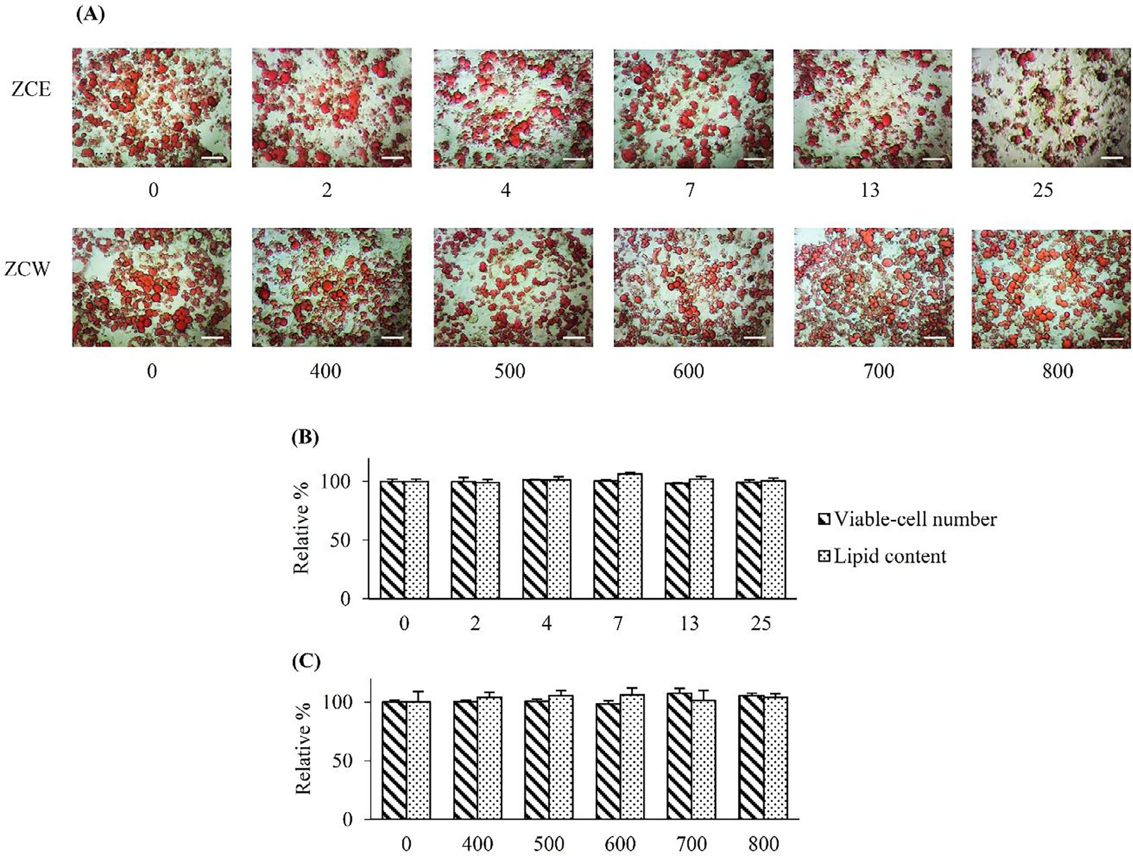

Fig. 1. Lipolytic activity of the crude extracts on MAs after 3 days of treatment. (A) – Image of lipid-droplets, stained with ORO, scale bar = 50 mm. Horizontal values indicated the 5-dilutions concentrations of the crude extracts in mg/ml. Relative percentage of lipid content by ORO colorimetric assay and relative percentage number of viable-cells, in comparison to those of the control group at 0 mg/ml, were presented on (B) – ZCE and (C) – ZCW in comparison to that of the media control (0 mg/ml). Differences among the means were not significant (*p* ≤ 0.05).

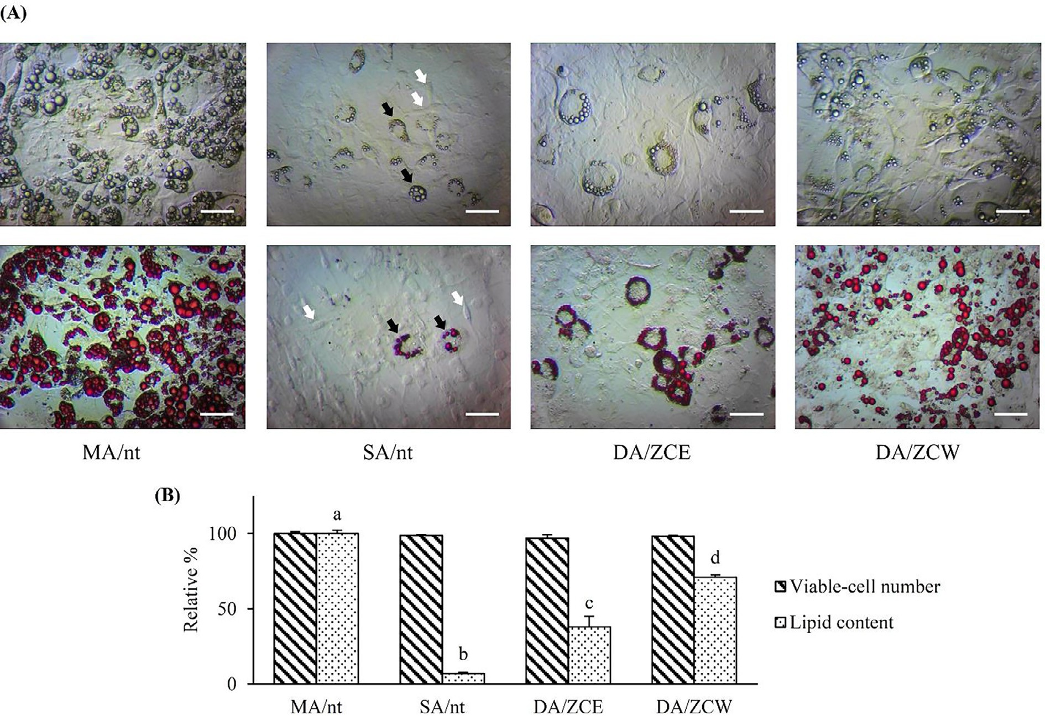

Fig. 2. Anti-adipogenic assay of the crude extracts on MAs after induction for 14-days. (A) – the fresh cells (upper row) and the cells with ORO staining (lower row) (scale bar = 50 mm). In SA/nt, black and white arrows indicated SSA and SIA cells respectively (see text). (B) – Relative number of viable-cells and the lipid content in compared with MA/nt. The exposed groups of DA/ZCE and DA/ZCW at 25 and 800 mg/ml respectively. The significant difference (*p* ≤ 0.05) of the means was shown as a, b, c and d on top of the histograms.

However, *Pref-1* expression was drastically reduced in the MA/nt cells and in DA/ZCE and DA/ZCW, compared with SA/nt cells. Regarding the glucose uptake genes (Fig. 3B), expression of both *GLUT4* and *Adiponectin* was significantly reduced, but not *IRS-1*. In view of the lipid metabolism genes, expression of *FAS* and *aP2* was significantly reduced in DA/ZCE and DA/ZCW compared with MA/nt (Fig. 3C). Considering the genes that regulate fatty acid oxi- dation, expression of *ATGL* and *HSL* was significantly down regu- lated in DA/ZCE and DA/ZCW, compared with MA/nt (Fig. 3D). However, we observed no significant change in the level of *PGC-*

*1b* expression in all experimental groups.

* 1. *NMR spectroscopy*

ZCE was analyzed by 1H NMR spectrum (Fig. 4). Signals of the anomeric protons of glucose were clearly observable at 5.4 ppm (a-form) and at 4.5 ppm (b-form), while protons attached to

hydroxyl groups of glucose had the resonances at 3.13–4.18 ppm. There were many signals of aromatic protons at 6.7–7.1 ppm indi- cating that the majority of the metabolites in the ethanol extract are natural products with aromatic rings. Signals of olefinic pro- tons at 6.0–6.5 ppm were observed in the 1H NMR spectrum and these signals were most likely to be of phenylbutanoids [21,22].

1H NMR spectrum of ZCW was also obtained and analyzed (Fig. 5). Glucose was presented in the water extract because of the appearance of its anomeric protons at 5.3 ppm (a-form) and at 4.5 ppm (b-form), as well as protons attached to hydroxyl

groups at 3.10–4.16 ppm. Two signals of aromatic protons at

6.85 ppm and 6.98 ppm and two signals of olefinic protons at

6.08 ppm and 6.32 ppm were observed in the spectrum. These sig- nals are characteristics for phenylbutanoids [21,22].

1. Discussion

With the synonym of scientific name to ZC, the review of ZM have been considered in parallel. Percentage yield of extractions from different works was found with result variations depended on the methodology of extraction and solvent [7,22]. In this work, the lesser-polar fractions, ZCE, exhibited with lesser % yield than the higher-polar fraction, ZCW.

Using the generally acceptable IC50 of between 20 and 40 mg/ml for crude extracts from herbal materials seems to be accepted in some cases as ‘high-toxic’ to either cancer cells [24,25] or normal cells [26], ZC appeared to show no cytotoxic activity (IC50 > 40 -

mg/ml). Methanol extracts of ZC were previously reported to be cytotoxic to 3T3-L1 with only 24% of cells surviving (i.e. IC76) at a concentration of 200 mg/ml [27]. However, that report focused

anti-oxidant activity, rather than anti-adipogenic activity. Essential

oils of ZC are not cytotoxic to human mouth epidermal carcinoma (KB) and murine leukemia (P388) cell lines at concentrations close to 100 mg/ml [8].

Considering adipogenic effects of active compound from herbs

that are closely related to ZC, gingerol (a phenolic compound from *Z. officinale*) enhances glucose uptake by increasing cell surface GLUT4 on L6 rat skeletal muscle cells *in vitro* [28]. The same com- pound from *Z. zerumbet* prevents adipocyte proliferation in a dose- and time-dependent manner and prominently inhibits adipogenic differentiation of 3T3-L1 cells [13]. Shogaol, another type of

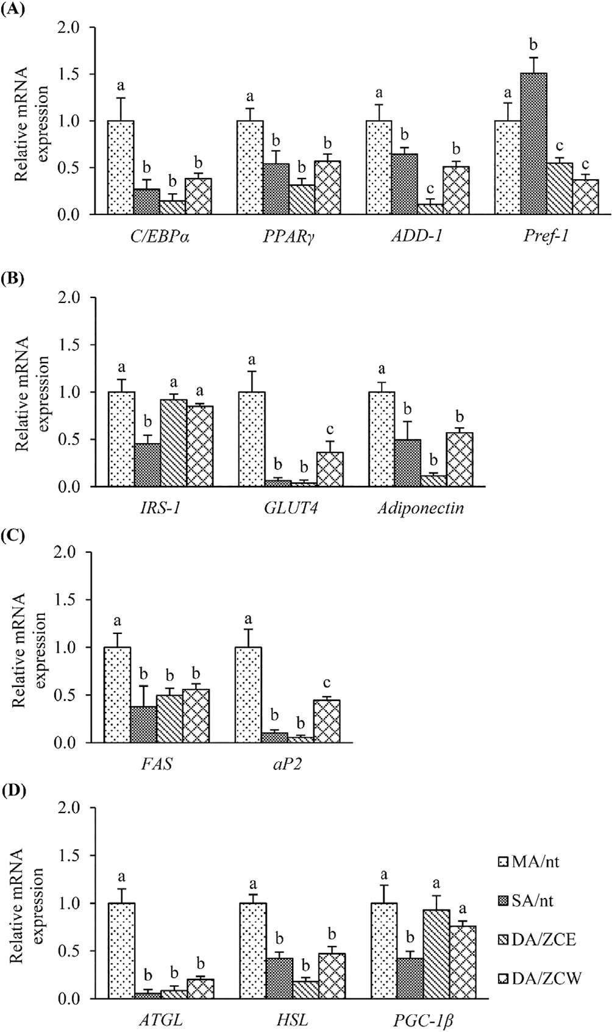

Fig. 3. Expression of adipogenic-related genes on the 4 cell-groups (abbreviation, see text). (A) –adipocyte differentiation genes, (B) – glucose uptake genes, (C) – lipid metabolism genes and (D) – fatty acid oxidation genes. The significant (*p* ≤ 0.05) of mRNA expression of each gene is shown in relation to MA/nt (control) cells.

phenolic compound and gingerol from *Z. officinale* possess lipolytic and anti-adipogenesis activity [12].

ZC yields a diverse range of polyphenols, steroids and terpenes [23,29,30]. Pure compounds of different types from ZC and *Z. offic- inale* have been identified elsewhere [31–34]. Previously, several phenylbutanoids were isolated from the rhizomes of ZC [21,22,35,36]. They were found to have anti-inflammatory activity by the inhibition of lipopolysaccharide (LPS)-induced nitric oxide production [22] and inhibition of cyclooxygenase-2 [35], anti- cancer activity [36], and inhibition of invasion of cancer cells [21]. Recently, the phenylbutanoid, *E*-4-(30 ,40 -dimethoxyphenyl)b ut-3-en-1-ol, from ZC showed anti-inflammatory activity in Wistar rats [37]. Isolated chemical compounds from ZC/ZM have never been tested for anti-adipogenesis or lipolysis. Since we now proved anti-lipogenesis activity of ZC crude extract, we recommend that similar trials are now performed on the main groups of chemical constituents or on individual compounds.

The effects of the extracts on gene regulation are shown in the Graphical Abstract. After induction of adipogenesis in PAs, *C/EBPa* and *PPARc*, are up-regulated [38]. *C/EBPa* then activates the expres-

sion of other adipocyte genes and thus stimulates differentiation.

*PPARc* regulates fatty acid storage, glucose metabolism and initi- ates lipid accumulation. *ADD-1* plays an important role in fat cell

gene expression and differentiation and enhances the regulatory pathway of *PPARc* [39]. Our study showed that ZCE and ZCW sup- press expression of *C/EBPa*, *PPARc* and *ADD-1*, *i.e*. the extracts sup-

press adipogenesis (Fig. 3A). *Pref-1* is a transmembrane protein that is highly expressed in PAs and it can be used as a marker for PA characteristics. Down-regulation of this gene is related to the end of the PA stage and is probably required for adipocyte differen- tiation [40]. Therefore, the reduction in *Pref-1* expression indicates that the PA stage is ending and the MA has been triggered. The high expression of *Pref-1* in SA/nt cells showed that most of the cells in that culture maintained their status as PAs, after 14 days of cultiva- tion (Fig. 3A).

Regarding the glucose-uptake genes (*IRS-1*, *GLUT4* and *Adipo- nectin*), differences in the level of *IRS-1* gene expression in DA/ ZCE and DA/ZCW were not significant, compared with the MA/nt group (Fig. 3B). The extracts, therefore, did not interfere with insu- lin signal transduction. Our observation that *GLUT4* was reduced, after the exposure to the extracts, strongly suggests that adi- pogenic suppression at least performed through down regulation of the insulin-regulated glucose transporter. Reduction in GLUT4 on the membrane led to a decrease in glucose transport from the extracellular environment into the cells. This may explain the smaller sizes of lipid droplets in DA/ZCE and DA/ZCW indicating lower lipid content (Fig. 2A). The mRNA expression level of *Adipo- nectin* was significantly decreased in DA/ZCE and DA/ZCW (Fig. 3B). Adiponectin is an adipokine, secreted predominantly by adipose cells, which regulates both metabolic and vascular homeostasis *in vivo*. Adiponectin also increases insulin’s ability to maximally stimulate glucose uptake through increasing expression of the *GLUT4* gene and increasing the recruitment of GLUT4 protein to the plasma membrane [41]. Suppression of *Adiponectin* by the extracts supports the idea that glucose transport through *GLUT4* is reduced. This may also be a major target pathway of the extracts for their mechanisms of action to prevent the accumulation of lipid content in the cells.

Focusing on the lipid metabolism genes, *FAS* regulates the syn- thesis of fatty acids from acetyl-CoA and malonyl-CoA via the tri- carboxylic acid cycle [42]. Therefore, reduction of *FAS*, by ZCE and ZCW extracts (Fig. 3C), could also explain how the extracts suppress lipid accumulation. *aP2* is a fatty acid binding protein, which reacts as a key factor in intracellular fatty acid transport

and lipid metabolism. This gene is activated in response to *PPARc*

regulation [43]. In our study the extracts reduced the mRNA level of *aP2*, suggesting that intracellular fatty acid transport and lipid metabolism are reduced due to low lipid accumulation.

Considering fatty acid oxidation genes, ATGL is a patatin- derived lipase, with differentiation-dependent up-regulation dur- ing adipogenesis of 3T3-L1 cultures [44]. ATGL selectively hydrol- yses triglycerides into diacylglycerol, where HSL (together with another enzyme, monoacylglycerol lipase) continues breaking down to glycerol and free fatty acids (FFA) [45]. FFAs are then taken into mitochondria to facilitate fatty acid oxidation. The extracts down regulated expression of *ATGL* and *HSL* genes (Fig. 3D). These results suggest that in addition to the suppression of the early responsive genes activation for initiation of the adipo- cyte differentiation, glucose uptake and synthesis-and-transport of fatty acid, the extracts can also suppress the processes of lipid break down. This phenomenon is not surprising, since cells have smaller lipid content due to inhibition of glucose uptake and lipid synthesis and thus there is no need for cells to induce the produc-

tion of lipases to break down lipid. Normally, up-regulation of *PGC- 1b* increases fatty acid oxidation in the mitochondrial pathway [46,47]. However, in this study when we measured the level of *PGC-1b*, there was no change in all experimental groups. PGC-1b

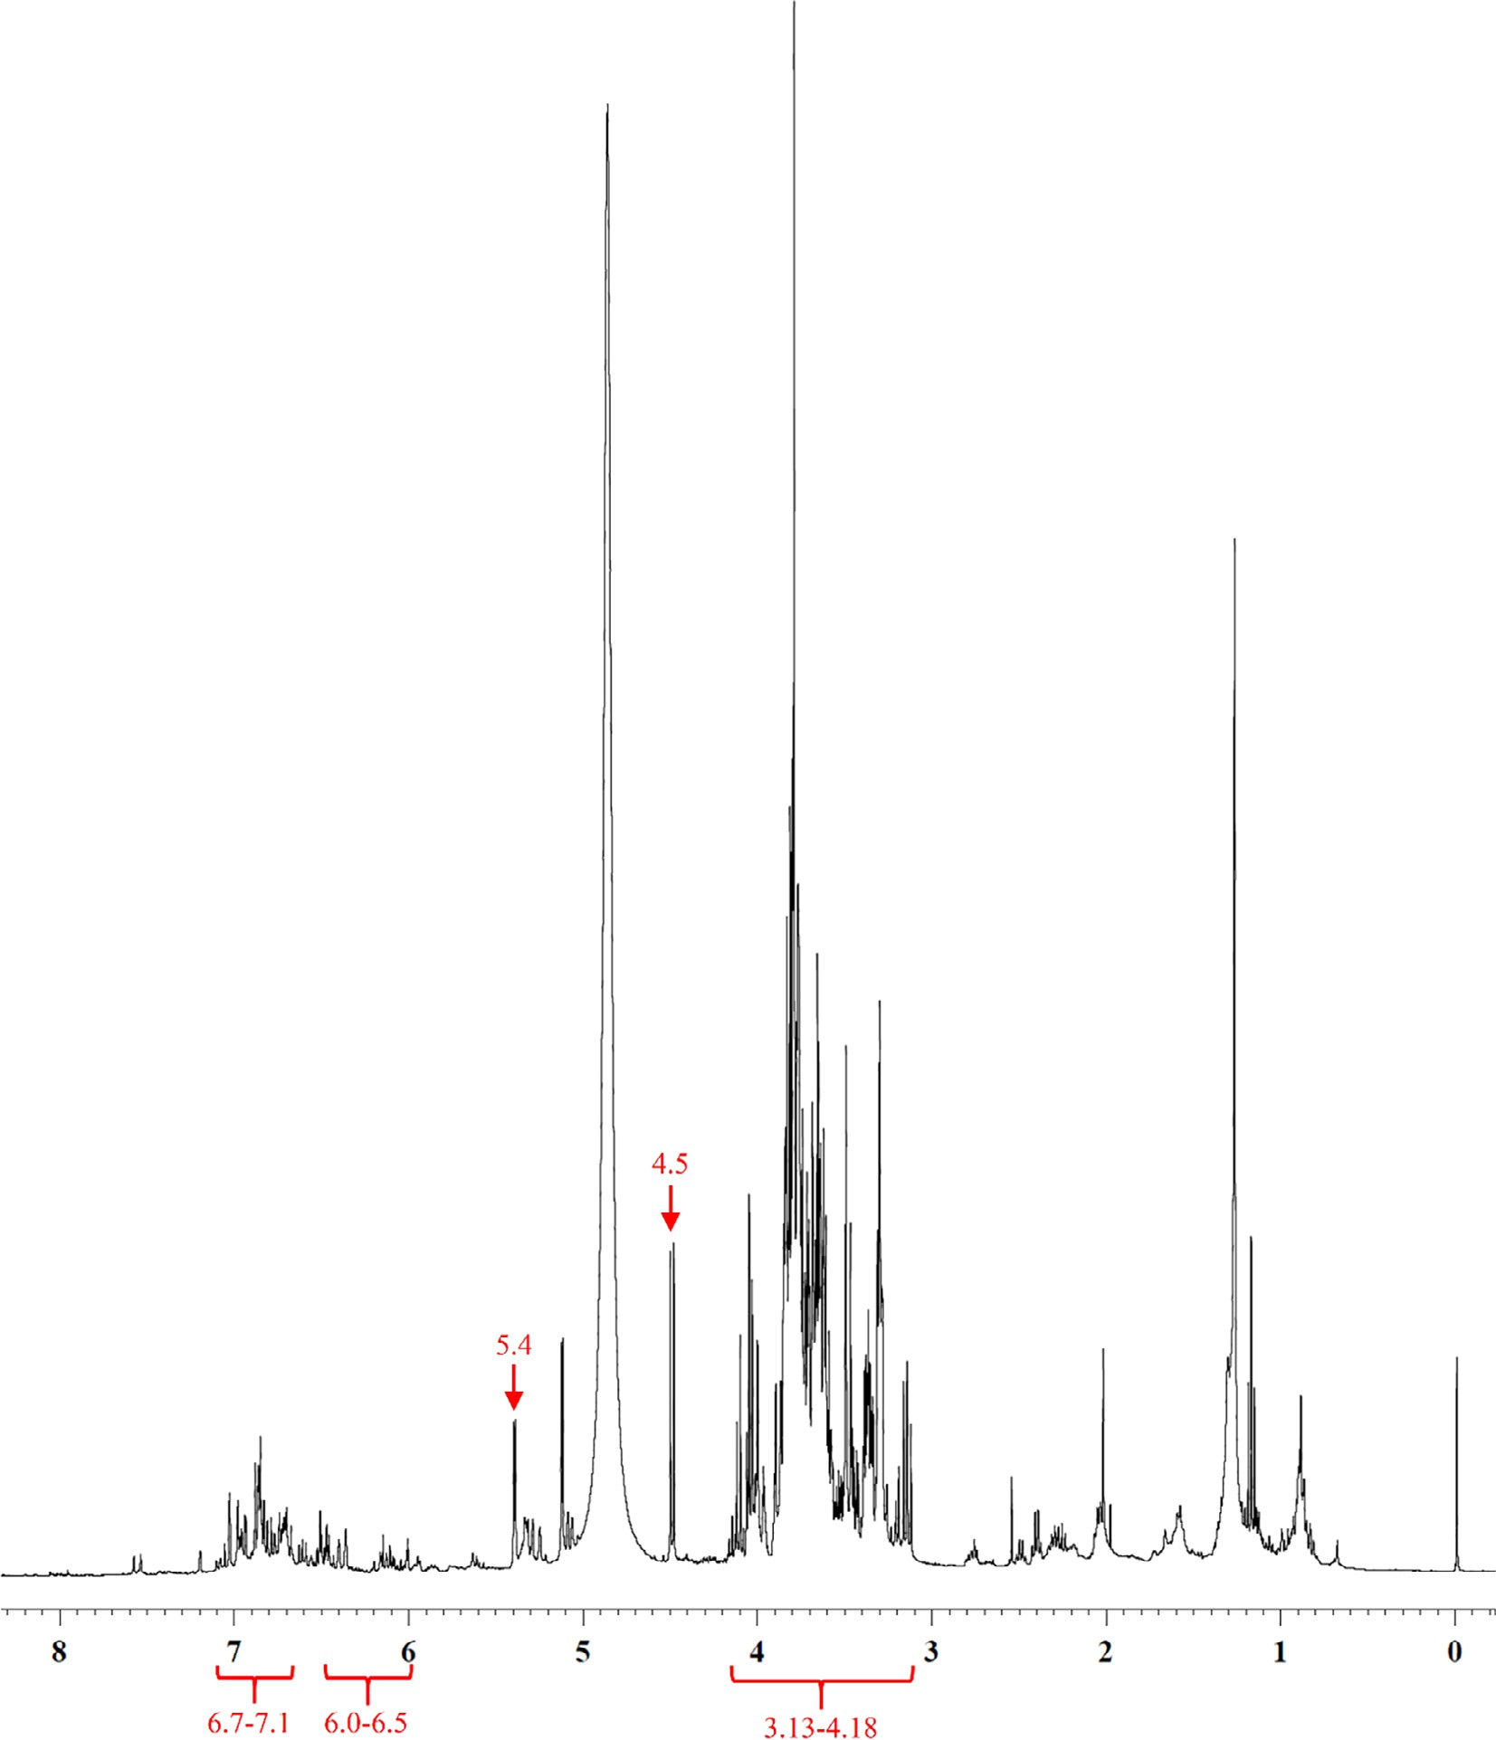

Fig. 4. 1H NMR spectrum (CD3OD) of the ethanol crude extract of ZCE. Anomeric protons peaks of glucose were shown at 5.4 and 4.5 ppm, with the resonances of hydroxyl groups’ protons at 3.13–4.18 ppm. Aromatic protons of metabolite majorities appeared at 6.7–7.1 ppm. Olefinic protons of phenylbutanoid compound were at 6.0–6.5 ppm.

works as a co-activator of PPARc in the transcriptional control of mitochondrial oxidative metabolism [48]. Therefore, ZCE and ZCW extracts did not suppress adipogenesis via down regulation

of *PGC-1b*.

Admitting ZC in this study showed the supported evidences of anti-obese activity, according to the Thai tribe traditional used, but precaution must be highlighted with over-dose consumption. Rats fed with single dose of ZC extracts at 5000 mg/kg.bw showed a remarkable decrease of body weights, but significant weight increase was detected in certain internal organs; spleen and epi- didymis in male, while lung and kidney in female [2].

1. Conclusion

Rhizome extracts of ZC have no effect on lipolysis, the break- down of fats in mature adipocytes, and also has no effect on adipo-

genesis, the differentiation of mature adipocyte from the pre- adipocyte. However, both ethanolic and aqueous extracts of ZC sim- ilarly reduced lipogenesis, the synthesis of lipids within the differ- entiated adipocytes, at the gene level, through inhibition of genes involved in adipocyte lipogenesis, glucose transport and fatty acid synthesis. Phenylbutanoid compounds in the extracts were believed to play an important role in such the activities. Whilst ZC is certainly not a cure for obesity, it may have applications in preventing the onset of obesity or preventing obese patients from becoming more obese. But before such recommendations can be considered, animal and human trials should be carried out to test the efficacy of the crude aqueous extract. If successful, further research, to determine which of the vast range of compounds pre- sent in the ZC extracts are responsible for inhibiting lipogenesis might yield more refined dietary supplements of medicines capable of controlling the onset or exacerbation of obesity.

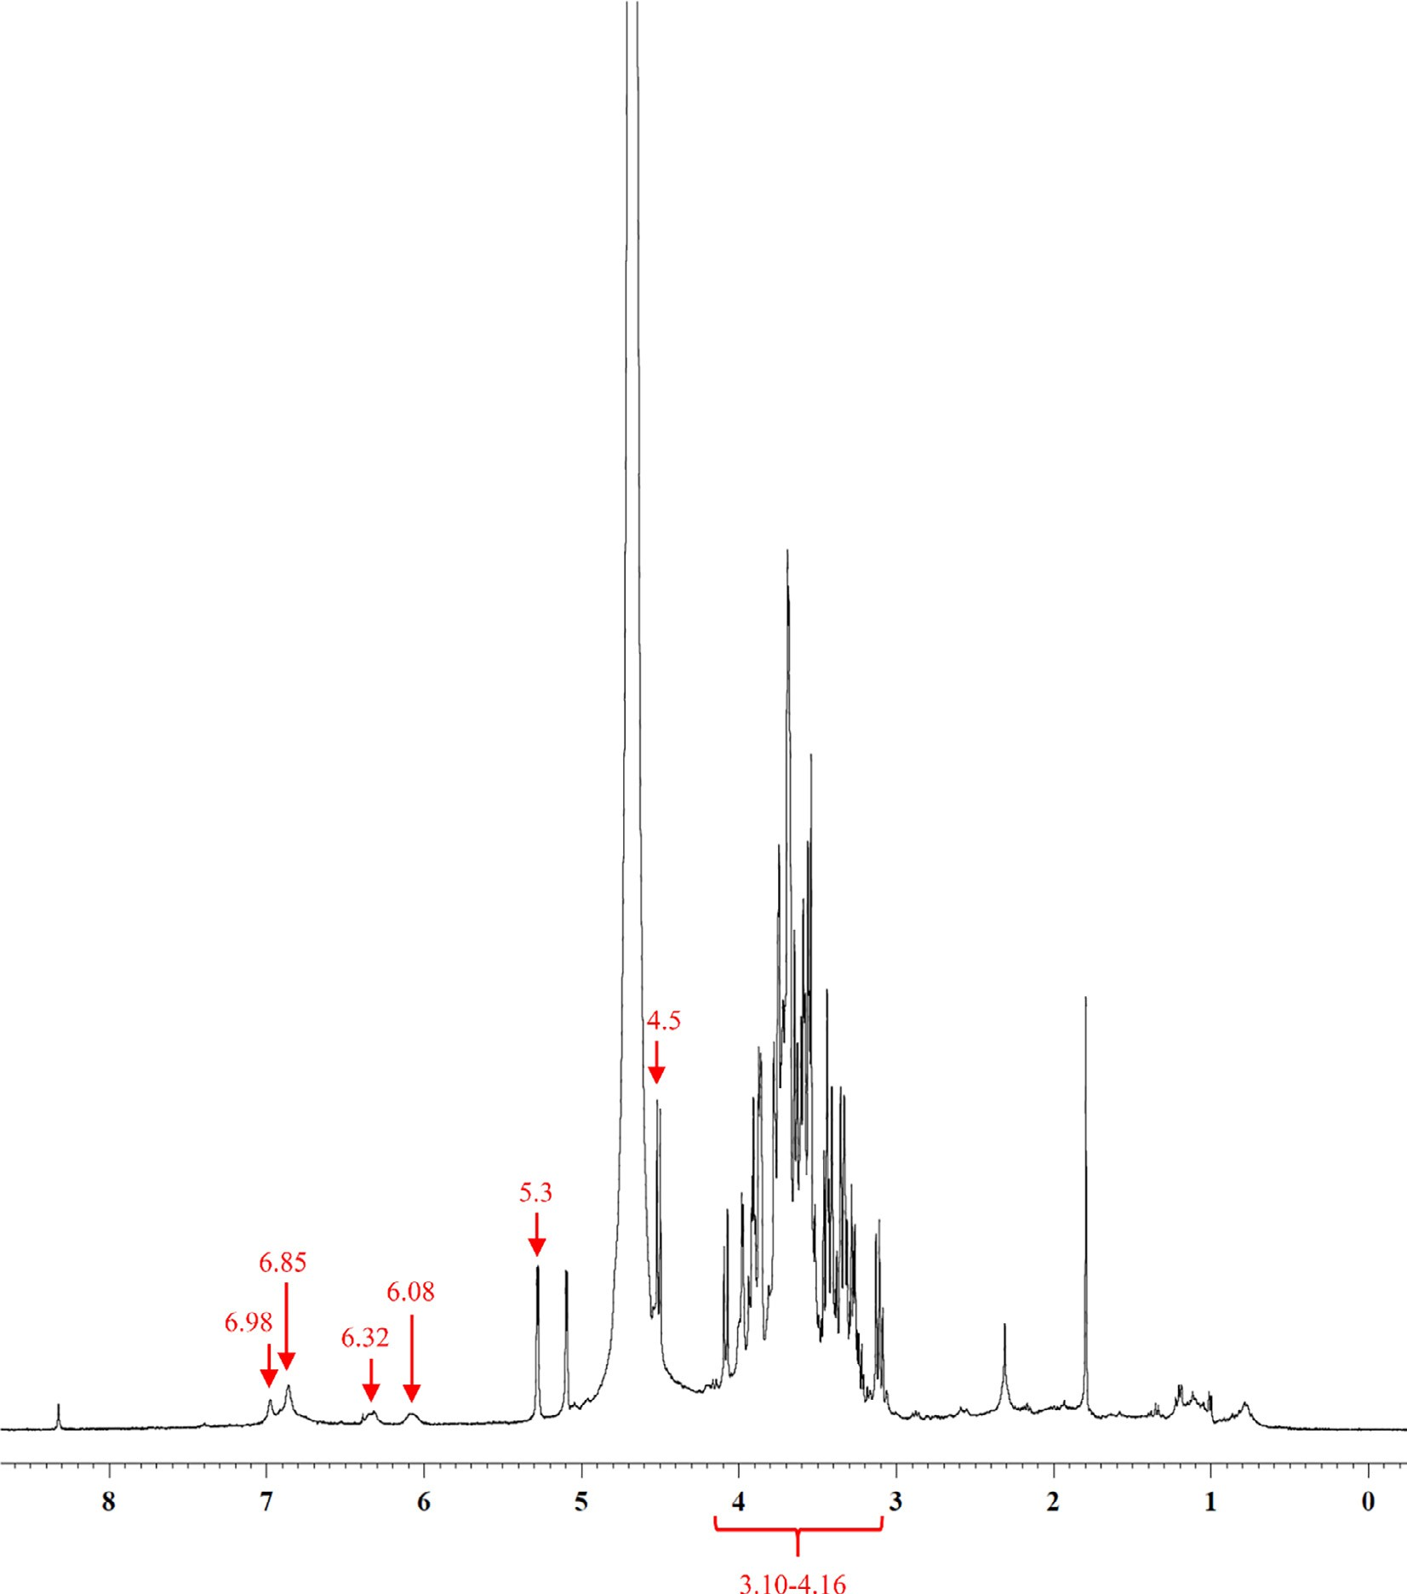

Fig. 5. 1H NMR spectrum (D2O) of ZCW. Anomeric protons peaks of glucose were shown at 5.3 and 4.5 ppm for a-form and b-form respectively, with the resonances of hydroxyl group protons at 3.10–4.16 ppm. Aromatic protons of metabolite majorities appeared at 6.85 and 6.98 ppm. Olefinic protons of phenylbutanoid compound were at

6.08 and 6.32 ppm.

Acknowledgements

We are very grateful to the National Research Council of Thailand (Project code: 130031-2556A10402008) for financial support of this study and to the Research Professional Development Project (under the Science Achievement Scholarship of Thailand (SAST)) for providing a Master degree scholarship to Mr. Natthawut Wong-a-nan. We also thank the Human and Animal Cell Technol- ogy Research Unit and Medicinal Plant and Reproductive Research Unit of the Department of Biology and the Department of Chem- istry both in the Faculty of Science, Chiang Mai University and also for institutional support. Appreciation of supports are also belong to Chulabhorn Graduate Institute, Chemical Biology Program, Chu- labhorn Royal Academy, and Chulabhorn Research Institute, Bang- kok. Finally, we thanks Dr. Stephen Elliott for his kindly revision on the first draft and for lots of useful comments.

Conflict of interest statement

We declare that we have no conflict of interest.

Appendix A. Supplementary data

Supplementary data to this article can be found online at <https://doi.org/10.1016/j.ejbas.2018.09.001>.

References

1. [Acevedo-Rodríguez P, Strong MT. Monocotyledons and gymnosperms of](http://refhub.elsevier.com/S2314-808X(17)30480-3/h0005) [Puerto Rico and the Virgin Islands. Contrib US Natl Herb 2005;52(1):1–415](http://refhub.elsevier.com/S2314-808X(17)30480-3/h0005).
2. [Koontongkaew S, Poachanukoon O, Sireeratawong S, Dechatiwongse Na](http://refhub.elsevier.com/S2314-808X(17)30480-3/h0010) [Ayudhya T, Khonsung P, Jaijoy K, et al. Safety evaluation of *Zingiber*](http://refhub.elsevier.com/S2314-808X(17)30480-3/h0010)[*cassumunar* Roxb. rhizome extract: acute and chronic toxicity studies in rats.](http://refhub.elsevier.com/S2314-808X(17)30480-3/h0010) [Int Sch Res Notices 2014, 2014,:1–14](http://refhub.elsevier.com/S2314-808X(17)30480-3/h0010).
3. [Pithayanukul P, Tubprasert J, Wuthi-Udomlert M. *In vitro* antimicrobial activity](http://refhub.elsevier.com/S2314-808X(17)30480-3/h0015) [of *Zingiber cassumunar* (Plai) oil and a 5% Plai oil gel. Phytother Res 2007;21](http://refhub.elsevier.com/S2314-808X(17)30480-3/h0015) [(2):164–9](http://refhub.elsevier.com/S2314-808X(17)30480-3/h0015).
4. [Manochai B, Paisooksantivatana Y, Choi H, Hong JH. Variation in DPPH](http://refhub.elsevier.com/S2314-808X(17)30480-3/h0020) [scavenging activity and major volatile oil components of cassumunar ginger,](http://refhub.elsevier.com/S2314-808X(17)30480-3/h0020) [*Zingiber montanum* (Koenig), in response to water deficit and light intensity.](http://refhub.elsevier.com/S2314-808X(17)30480-3/h0020) [Sci Hortic 2010;126(4):462–6](http://refhub.elsevier.com/S2314-808X(17)30480-3/h0020).
5. [Bua-in S, Paisooksantivatana Y. Essential oil and antioxidant activity of](http://refhub.elsevier.com/S2314-808X(17)30480-3/h0025) [cassumunar ginger (Zingiberaceae: *Zingiber montanum* (Koenig) Link ex](http://refhub.elsevier.com/S2314-808X(17)30480-3/h0025) [Dietr.) collected from various parts of. Thailand. Kasetsart J (Nat Sci)](http://refhub.elsevier.com/S2314-808X(17)30480-3/h0025) [2009;43:467–75](http://refhub.elsevier.com/S2314-808X(17)30480-3/h0025).
6. [Jeenapongsa R, Yoovathaworn K, Sriwatanakul KM, Pongprayoon U,](http://refhub.elsevier.com/S2314-808X(17)30480-3/h0030) [Sriwatanakul K. Anti-inflammatory activity of (*E*)-1-(3,4-dimethoxyphenyl)](http://refhub.elsevier.com/S2314-808X(17)30480-3/h0030) [butadiene from *Zingiber cassumunar* Roxb. J Ethnopharmacol 2003;87(2–](http://refhub.elsevier.com/S2314-808X(17)30480-3/h0030) [3):143–8](http://refhub.elsevier.com/S2314-808X(17)30480-3/h0030).
7. [Tewtrakul S, Subhadhirasakul S. Anti-allergic activity of some selected plants](http://refhub.elsevier.com/S2314-808X(17)30480-3/h0035) [in the Zingiberaceae family. J Ethnopharmacol 2007;109(3):535–8](http://refhub.elsevier.com/S2314-808X(17)30480-3/h0035).
8. [Manosroi J, Dhumtanom P, Manosroi A. Anti-proliferative activity of essential](http://refhub.elsevier.com/S2314-808X(17)30480-3/h0040) [oil extracted from Thai medicinal plants on KB and P388 cell lines. Cancer Lett](http://refhub.elsevier.com/S2314-808X(17)30480-3/h0040) [2006;235(1):114–20](http://refhub.elsevier.com/S2314-808X(17)30480-3/h0040).
9. [Al-Amin M, Sultana GN, Hossain CF. Antiulcer principle from *Zingiber*](http://refhub.elsevier.com/S2314-808X(17)30480-3/h0045)[*montanum*. J Ethnopharmacol 2012;141(1):57–60](http://refhub.elsevier.com/S2314-808X(17)30480-3/h0045).
10. [Phonsena P, Banchong Y, Rawanghet C. Efficacy of essential oils from Phlai](http://refhub.elsevier.com/S2314-808X(17)30480-3/h0050) [(*Zingiber montanum*), Turmeric (*Curcuma longa*) and Wan nang kham (*C.*](http://refhub.elsevier.com/S2314-808X(17)30480-3/h0050)[*aromatica*) against brown dog ticks. In: 44th Kasetsart University Annual](http://refhub.elsevier.com/S2314-808X(17)30480-3/h0050) [Conference: Animal, Veterinary Medicine. Bangkok: Kasetsart University;](http://refhub.elsevier.com/S2314-808X(17)30480-3/h0050) [2006. p. 539–43](http://refhub.elsevier.com/S2314-808X(17)30480-3/h0050).
11. [Ahn EK, Oh JS. Inhibitory effect of galanolactone isolated from *Zingiber*](http://refhub.elsevier.com/S2314-808X(17)30480-3/h0055)[*officinale* Roscoe extract on adipogenesis in 3T3-L1 cells. J Korean Soc Appl Biol](http://refhub.elsevier.com/S2314-808X(17)30480-3/h0055) [Chem 2012;55(1):63–8](http://refhub.elsevier.com/S2314-808X(17)30480-3/h0055).
12. [Suk S, Seo SG, Yu JG, Yang H, Jeong E, Jang YJ, et al. A bioactive constituent of](http://refhub.elsevier.com/S2314-808X(17)30480-3/h0060) [ginger, 6-shogaol, prevents adipogenesis and stimulates lipolysis in 3T3-L1](http://refhub.elsevier.com/S2314-808X(17)30480-3/h0060) [adipocytes. J Food Biochem 2016;40(1):84–90](http://refhub.elsevier.com/S2314-808X(17)30480-3/h0060).
13. [Tzeng TF, Liu IM. 6-gingerol prevents adipogenesis and the accumulation of](http://refhub.elsevier.com/S2314-808X(17)30480-3/h0065) [cytoplasmic lipid droplets in 3T3-L1 cells. Phytomedicine 2013;20](http://refhub.elsevier.com/S2314-808X(17)30480-3/h0065) [(6):481–7](http://refhub.elsevier.com/S2314-808X(17)30480-3/h0065).
14. [Iwashita K, Yamaki K, Tsushida T. Mioga (*Zingiber mioga* Rosc.) extract](http://refhub.elsevier.com/S2314-808X(17)30480-3/h0070) [prevents 3T3-L1 differentiation into adipocytes and obesity in mice. Food Sci](http://refhub.elsevier.com/S2314-808X(17)30480-3/h0070) [Technol Res 2001;7(2):164–70](http://refhub.elsevier.com/S2314-808X(17)30480-3/h0070).
15. [Iswantini D, Silitonga RF, Martatilofa E, Darusman LK. Zingiber cassumunar,](http://refhub.elsevier.com/S2314-808X(17)30480-3/h0075) [Guazuma ulmifolia, and Murraya paniculata extracts as antibesity: In vitro](http://refhub.elsevier.com/S2314-808X(17)30480-3/h0075) [inhibitory effect on pancreatic lipase activity. HAYATI J Biosci 2011;18](http://refhub.elsevier.com/S2314-808X(17)30480-3/h0075) [(1):6–10](http://refhub.elsevier.com/S2314-808X(17)30480-3/h0075).
16. [Traisrisilp S. Database records of Thai traditional herbal-medicine. Chiang Mai,](http://refhub.elsevier.com/S2314-808X(17)30480-3/h0080) [Thailand: Intellectual Development Institute; 2005](http://refhub.elsevier.com/S2314-808X(17)30480-3/h0080).
17. [Ambati S, Kim HK, Yang JY, Lin J, Della-Fera MA, Baile CA. Effects of leptin on](http://refhub.elsevier.com/S2314-808X(17)30480-3/h0085) [apoptosis and adipogenesis in 3T3-L1 adipocytes. Biochem Pharmacol 2007;73](http://refhub.elsevier.com/S2314-808X(17)30480-3/h0085) [(3):378–84](http://refhub.elsevier.com/S2314-808X(17)30480-3/h0085).
18. [Kinkel AD, Fernyhough ME, Helterline DL, Vierck JL, Oberg KS, Vance TJ, et al.](http://refhub.elsevier.com/S2314-808X(17)30480-3/h0090) [Oil red-O stains non-adipogenic cells: a precautionary note. Cytotechnology](http://refhub.elsevier.com/S2314-808X(17)30480-3/h0090) [2004;46(1):49–56](http://refhub.elsevier.com/S2314-808X(17)30480-3/h0090).
19. [Sakuma M. Probit analysis of preference data. Appl Entomol Zool 1998;33](http://refhub.elsevier.com/S2314-808X(17)30480-3/h0095) [(3):339–47](http://refhub.elsevier.com/S2314-808X(17)30480-3/h0095).
20. [Livak KJ, Schmittgen TD. Analysis of relative gene expression data using real-](http://refhub.elsevier.com/S2314-808X(17)30480-3/h0100) [time quantitative PCR and the 2](http://refhub.elsevier.com/S2314-808X(17)30480-3/h0100)-DDC [method. Methods 2001;25(4):402–8](http://refhub.elsevier.com/S2314-808X(17)30480-3/h0100).

[T](http://refhub.elsevier.com/S2314-808X(17)30480-3/h0100)

1. [Matsuda H, Nakamura S, Iwami J, Li X, Pongpiriyadacha Y, Nakai M, et al.](http://refhub.elsevier.com/S2314-808X(17)30480-3/h0105) [Invasion inhibitors of human fibrosarcoma HT 1080 cells from the rhizomes of](http://refhub.elsevier.com/S2314-808X(17)30480-3/h0105) [*Zingiber cassumunar*: structures of phenylbutanoids, cassumunols. Chem](http://refhub.elsevier.com/S2314-808X(17)30480-3/h0105) [Pharm Bull (Tokyo) 2011;59(3):365–70](http://refhub.elsevier.com/S2314-808X(17)30480-3/h0105).
2. [Nakamura S, Iwami J, Matsuda H, Wakayama H, Pongpiriyadacha Y, Yoshikawa](http://refhub.elsevier.com/S2314-808X(17)30480-3/h0110)

[M. Structures of new phenylbutanoids and nitric oxide production inhibitors](http://refhub.elsevier.com/S2314-808X(17)30480-3/h0110) [from the rhizomes of *Zingiber cassumunar*. Chem Pharm Bull (Tokyo) 2009;57](http://refhub.elsevier.com/S2314-808X(17)30480-3/h0110) [(11):1267–72](http://refhub.elsevier.com/S2314-808X(17)30480-3/h0110).

1. [Iswantini D, Silitonga RF, Martatilofa E, Darusman LK. *Zingiber cassumunar*,](http://refhub.elsevier.com/S2314-808X(17)30480-3/h0115) [*Guazuma ulmifolia*, and *Murraya paniculata* extracts as antiobesity: *in vitro*](http://refhub.elsevier.com/S2314-808X(17)30480-3/h0115)[inhibitory effect on pancreatic lipase activity. HAYATI J Biosci 2011;18](http://refhub.elsevier.com/S2314-808X(17)30480-3/h0115) [(1):6–10](http://refhub.elsevier.com/S2314-808X(17)30480-3/h0115).
2. [Gudarzi H, Salimi M, Irian S, Amanzadeh A, Mostafapour Kandelous H,](http://refhub.elsevier.com/S2314-808X(17)30480-3/h0120) [Azadmanesh K, et al. Ethanolic extract of *Ferula gummosa* is cytotoxic against](http://refhub.elsevier.com/S2314-808X(17)30480-3/h0120) [cancer cells by inducing apoptosis and cell cycle arrest. Nat Prod Res 2015;29](http://refhub.elsevier.com/S2314-808X(17)30480-3/h0120) [(6):546–50](http://refhub.elsevier.com/S2314-808X(17)30480-3/h0120).
3. [Srisawat T, Sukpondma Y, Graidist P, Chimplee S, Kanokwiroon K. The dose](http://refhub.elsevier.com/S2314-808X(17)30480-3/h0125) [dependent *in vitro* responses of MCF-7 and MDA-MB-231 cell lines to extracts](http://refhub.elsevier.com/S2314-808X(17)30480-3/h0125) [of *Vatica diospyroides* symington type SS fruit include effects on mode of cell](http://refhub.elsevier.com/S2314-808X(17)30480-3/h0125) [death. Pharmacogn Mag 2015;11(42):S148–55](http://refhub.elsevier.com/S2314-808X(17)30480-3/h0125).
4. [Vijayarathna S, Sasidharan S. Cytotoxicity of methanol extracts of *Elaeis*](http://refhub.elsevier.com/S2314-808X(17)30480-3/h0130)[*guineensis* on MCF-7 and Vero cell lines. Asian Pac J Trop Biomed 2012;2](http://refhub.elsevier.com/S2314-808X(17)30480-3/h0130) [(10):826–9](http://refhub.elsevier.com/S2314-808X(17)30480-3/h0130).
5. [Sharma GJ, Chirangini P, Mishra KP. Evaluation of antioxidant and cytotoxic](http://refhub.elsevier.com/S2314-808X(17)30480-3/h0135) [properties of tropical ginger, *Zingiber montanum* (J. Konig). A. Dietr. Gard Bull](http://refhub.elsevier.com/S2314-808X(17)30480-3/h0135) [(Singapore) 2007;59(1-2):189–202](http://refhub.elsevier.com/S2314-808X(17)30480-3/h0135).
6. [Li Y, Tran VH, Duke CC, Roufogalis BD. Gingerols of *Zingiber officinale* enhance](http://refhub.elsevier.com/S2314-808X(17)30480-3/h0140) [glucose uptake by increasing cell surface GLUT4 in cultured L6 myotubes.](http://refhub.elsevier.com/S2314-808X(17)30480-3/h0140) [Planta Med 2012;78(14):1549–55](http://refhub.elsevier.com/S2314-808X(17)30480-3/h0140).
7. [Ib Jantan, Yassin MSM, Chin CB, Chen LL, Sim NL. Antifungal activity of the](http://refhub.elsevier.com/S2314-808X(17)30480-3/h0145) [essential oils of nine Zingiberaceae species. Pharm Biol 2003;41(5):392–7](http://refhub.elsevier.com/S2314-808X(17)30480-3/h0145).
8. [Majaw S, Moirangthem J. Qualitative and quantitative analysis of *Clerodendron*](http://refhub.elsevier.com/S2314-808X(17)30480-3/h0150)[*colebrookianum* Walp. leaves and *Zingiber cassumunar* Roxb. rhizomes.](http://refhub.elsevier.com/S2314-808X(17)30480-3/h0150) [Ethnobot Leaflets 2009;2009(5):578–89](http://refhub.elsevier.com/S2314-808X(17)30480-3/h0150).
9. [Chairul Praptiwi, Chairul SM. Phagocytosis effectivity test of phenylbutenoid](http://refhub.elsevier.com/S2314-808X(17)30480-3/h0155) [compounds isolated from bangle (*Zingiber cassumunar* Roxb.) rhizome.](http://refhub.elsevier.com/S2314-808X(17)30480-3/h0155) [Biodiversitas 2009;10(1):40–3](http://refhub.elsevier.com/S2314-808X(17)30480-3/h0155).
10. [Gupta SK, Sharma A. Medicinal properties of ginger (*Zingiber officinale* Roscoe)](http://refhub.elsevier.com/S2314-808X(17)30480-3/h0160) [– a review. IOSR J Pharm Biol Sci 2014;9(5):124–9](http://refhub.elsevier.com/S2314-808X(17)30480-3/h0160).
11. [Sukatta U, Rugthaworn P, Chidchenchey S, Punjee P, Keeratinijakal V. Chemical](http://refhub.elsevier.com/S2314-808X(17)30480-3/h0165) [composition and physical properties of oil from plai (*Zingiber cassumunar*](http://refhub.elsevier.com/S2314-808X(17)30480-3/h0165)[Roxb.) obtained by hydro distillation and hexane extraction. Kasetsart J (Nat](http://refhub.elsevier.com/S2314-808X(17)30480-3/h0165) [Sci) 2009;43:212–7](http://refhub.elsevier.com/S2314-808X(17)30480-3/h0165).
12. [Tohma H, Gülçin](http://refhub.elsevier.com/S2314-808X(17)30480-3/h0170) I_[, Bursal E, Gören AC, Alwasel SH, Köksal E. Antioxidant](http://refhub.elsevier.com/S2314-808X(17)30480-3/h0170)

[activity and phenolic compounds of ginger (*Zingiber officinale* Rosc.)](http://refhub.elsevier.com/S2314-808X(17)30480-3/h0170) [determined by HPLC-MS/MS. J Food Meas Charact 2016:1–11](http://refhub.elsevier.com/S2314-808X(17)30480-3/h0170).

1. [Han AR, Kim MS, Jeong YH, Lee SK, Seo EK. Cyclooxygenase-2 inhibitory](http://refhub.elsevier.com/S2314-808X(17)30480-3/h0175) [phenylbutenoids from the rhizomes of *Zingiber cassumunar*. Chem Pharm Bull](http://refhub.elsevier.com/S2314-808X(17)30480-3/h0175) [(Tokyo) 2005;53(11):1466–8](http://refhub.elsevier.com/S2314-808X(17)30480-3/h0175).
2. [Lee JW, Min HY, Han AR, Chung HJ, Park EJ, Park HJ, et al. Growth inhibition](http://refhub.elsevier.com/S2314-808X(17)30480-3/h0180) [and induction of G1 phase cell cycle arrest in human lung cancer cells by a](http://refhub.elsevier.com/S2314-808X(17)30480-3/h0180) [phenylbutenoid dimer isolated from *Zingiber cassumunar*. Biol Pharm Bull](http://refhub.elsevier.com/S2314-808X(17)30480-3/h0180) [2007;30(8):1561–4](http://refhub.elsevier.com/S2314-808X(17)30480-3/h0180).
3. [Khemawoot P, Hunsakunachai N, Anukunwithaya T, Bangphumi K,](http://refhub.elsevier.com/S2314-808X(17)30480-3/h0185) [Ongpipattanakul B, Jiratchariyakul W, et al. Pharmacokinetics of compound](http://refhub.elsevier.com/S2314-808X(17)30480-3/h0185) [D, the major bioactive component of *Zingiber cassumunar*, in rats. Planta Med](http://refhub.elsevier.com/S2314-808X(17)30480-3/h0185) [2016;82(13):1186–91](http://refhub.elsevier.com/S2314-808X(17)30480-3/h0185).
4. [Niemelä S, Miettinen S, Sarkanen JR, Ashammakhi N. Adipose tissue and](http://refhub.elsevier.com/S2314-808X(17)30480-3/h0190) [adipocyte differentiation: molecular and cellular aspects and tissue](http://refhub.elsevier.com/S2314-808X(17)30480-3/h0190) [engineering applications. Top Tissue Eng 2008;4(1):1–26](http://refhub.elsevier.com/S2314-808X(17)30480-3/h0190).
5. [Kim JB, Spiegelman BM. ADD1/SREBP1 promotes adipocyte differentiation and](http://refhub.elsevier.com/S2314-808X(17)30480-3/h0195) [gene expression linked to fatty acid metabolism. Genes Dev 1996;10](http://refhub.elsevier.com/S2314-808X(17)30480-3/h0195) [(9):1096–107](http://refhub.elsevier.com/S2314-808X(17)30480-3/h0195).
6. [Smas CM, Kachinskas D, Liu CM, Xie X, Dircks LK, Sul HS. Transcriptional](http://refhub.elsevier.com/S2314-808X(17)30480-3/h0200) [control of the *pref-1* gene in 3T3-L1 adipocyte differentiation: sequence](http://refhub.elsevier.com/S2314-808X(17)30480-3/h0200) [requirement for differentiation-dependent suppression. J Biol Chem 1998;273](http://refhub.elsevier.com/S2314-808X(17)30480-3/h0200) [(48):31751–8](http://refhub.elsevier.com/S2314-808X(17)30480-3/h0200).
7. [Fu Y, Luo N, Klein RL, Garvey WT. Adiponectin promotes adipocyte](http://refhub.elsevier.com/S2314-808X(17)30480-3/h0205) [differentiation, insulin sensitivity, and lipid accumulation. J Lipid Res](http://refhub.elsevier.com/S2314-808X(17)30480-3/h0205) [2005;46(7):1369–79](http://refhub.elsevier.com/S2314-808X(17)30480-3/h0205).
8. [Lodhi IJ, Wei X, Semenkovich CF. Lipoexpediency: *de novo* lipogenesis as a](http://refhub.elsevier.com/S2314-808X(17)30480-3/h0210) [metabolic signal transmitter. Trends Endocrinol Metab 2011;22(1):1–8](http://refhub.elsevier.com/S2314-808X(17)30480-3/h0210).
9. [Makowski L, Brittingham KC, Reynolds JM, Suttles J, Hotamisligil GS. The fatty](http://refhub.elsevier.com/S2314-808X(17)30480-3/h0215) [acid-binding protein, aP2, coordinates macrophage cholesterol trafficking and](http://refhub.elsevier.com/S2314-808X(17)30480-3/h0215)

[inflammatory activity: macrophage expression of aP2 impacts peroxisome](http://refhub.elsevier.com/S2314-808X(17)30480-3/h0215) [proliferator-activated receptor c and IjB kinase activities. J Biol Chem](http://refhub.elsevier.com/S2314-808X(17)30480-3/h0215) [2005;280(13):12888–95](http://refhub.elsevier.com/S2314-808X(17)30480-3/h0215).

1. [Kim JY, Tillison K, Lee JH, Rearick DA, Smas CM. The adipose tissue triglyceride](http://refhub.elsevier.com/S2314-808X(17)30480-3/h0220) [lipase ATGL/PNPLA2 is downregulated by insulin and TNF-a in 3T3-L1](http://refhub.elsevier.com/S2314-808X(17)30480-3/h0220)

[adipocytes and is a target for transactivation by PPARc. Am J Physiol](http://refhub.elsevier.com/S2314-808X(17)30480-3/h0220) [Endocrinol Metabol 2006;291(1):E115–27](http://refhub.elsevier.com/S2314-808X(17)30480-3/h0220).

1. [Morak M, Schmidinger H, Riesenhuber G, Rechberger GN, Kollroser M,](http://refhub.elsevier.com/S2314-808X(17)30480-3/h0225) [Haemmerle G, et al. Adipose triglyceride lipase (ATGL) and hormone-](http://refhub.elsevier.com/S2314-808X(17)30480-3/h0225) [sensitive lipase (HSL) deficiencies affect expression of lipolytic activities in](http://refhub.elsevier.com/S2314-808X(17)30480-3/h0225) [mouse adipose tissues. Mol Cell Proteomics 2012;11(12):1777–89](http://refhub.elsevier.com/S2314-808X(17)30480-3/h0225).
2. [Chang WT, Wu CH, Hsu CL. Diallyl trisulphide inhibits adipogenesis in 3T3-L1](http://refhub.elsevier.com/S2314-808X(17)30480-3/h0230) [adipocytes through lipogenesis, fatty acid transport, and fatty acid oxidation](http://refhub.elsevier.com/S2314-808X(17)30480-3/h0230) [pathways. J Funct Foods 2015;16:414–22](http://refhub.elsevier.com/S2314-808X(17)30480-3/h0230).
3. [Vega RB, Huss JM, Kelly DP. The coactivator PGC-1 cooperates with peroxisome](http://refhub.elsevier.com/S2314-808X(17)30480-3/h0235) [proliferator-activated receptor a in transcriptional control of nuclear genes](http://refhub.elsevier.com/S2314-808X(17)30480-3/h0235) [encoding mitochondrial fatty acid oxidation enzymes. Mol Cell Biol 2000;20](http://refhub.elsevier.com/S2314-808X(17)30480-3/h0235)

[(5):1868–76](http://refhub.elsevier.com/S2314-808X(17)30480-3/h0235).

1. [Enguix N, Pardo R, González A, López VM, Simó R, Kralli A, et al. Mice lacking](http://refhub.elsevier.com/S2314-808X(17)30480-3/h0240) [PGC-1b in adipose tissues reveal a dissociation between mitochondrial](http://refhub.elsevier.com/S2314-808X(17)30480-3/h0240) [dysfunction and insulin resistance. Mol Metab 2013;2(3):215–26](http://refhub.elsevier.com/S2314-808X(17)30480-3/h0240).