[Egyptian Informatics Journal 24 (2023) 100389](https://doi.org/10.1016/j.eij.2023.100389)

Contents lists available at [ScienceDirect](http://www.sciencedirect.com/science/journal/11108665)

Egyptian Informatics Journal

journal homepage: [www.sciencedirect.com](http://www.sciencedirect.com/)

[](http://crossmark.crossref.org/dialog/?doi=10.1016/j.eij.2023.100389&domain=pdf)Machine learning algorithms in proactive decision making for handover management from 5G & beyond 5G

A. Priyanka a,⇑, P. Gauthamarayathirumal b, C. Chandrasekar a

a *Department of Computer Science, Periyar University, Salem, Tamil Nadu, India*

b *Department of Computer Science, Government Arts College, Dharmapuri, Tamil Nadu, India*

a r t i c l e i n f o

*Article history:*

Received 13 September 2022

Revised 27 June 2023

Accepted 4 July 2023

Available online 13 July 2023

*Keywords:*

Proactive decision making 5G

Handover

Handover control parameter Machine learning

a b s t r a c t

In recent years, heterogeneous networks (HetNets) have drawn a lot of attention to connecting devices that will enable everything to become smart, efficient, and fast. These networks are made up of many cell types, including macro, micro, pico, and femto that are added to suit customer demand. HetNets requires sophisticated mobility management to handle a variety of inter-frequency technologies. Mobility man- agement needs to be adequately addressed to prevent service degradation caused by high rates of unnec- essary handover attempts (HOA), handover ping-pong (HOPP), handover failure (HOF), radio link failure (RLF) and HO delay involved, which necessitates the user to execute the handover (HO) process while moving from one place to another. A well-suited HO management technique is proposed to resolve the issues observed when the user moves. The purpose of this study is to ascertain how the handover control parameter (HCP) involves the functionality of the 5G network. The novel approach taken into consider- ation in this work for cell selection is proactive decision-making (PDM). The performance of the proposed technique is evaluated through a simulation consisting of 5G Hetnets. Comparisons of evaluations were made in terms of HOA, HOPP, HOF, RLF and HO delay.

© 2023 THE AUTHORS. Published by Elsevier BV on behalf of Faculty of Computers and Artificial Intel-

ligence, Cairo University. This is an open access article under the CC BY-NC-ND license ([http://creative-](http://creativecommons.org/licenses/by-nc-nd/4.0/)

[commons.org/licenses/by-nc-nd/4.0/](http://creativecommons.org/licenses/by-nc-nd/4.0/)).

1. Introduction

Wireless communication technologies are experiencing remarkable growth by seamlessly interconnecting everything, enabling efficient and rapid innovations. The Internet of Things (IoT), augmented reality (AR), virtual reality (VR), automated driv- ing assistance systems (ADAS), high-definition video streaming, and emerging applications all contribute to the researchers’ efforts in constructing a smarter world to ensure uninterrupted device management and unbreakable connections. Among the various advancements in mobile technology, the most noteworthy advan- tage of 5G is its ability to deliver significantly faster speeds. This implies that 5G can greatly enhance the user experience in terms of file downloads and film streaming (Fig. 1).

As the world transitions towards a more connected future, the need for efficient and seamless communication networks becomes increasingly important. The 5th generation of mobile networks promises to revolutionize communication by enabling faster data transfer rates, lower latency, and better connectivity. Service provi-

* Corresponding author.

*E-mail address:* [venkatpriya57@gmail.com](mailto:venkatpriya57@gmail.com) (A. Priyanka).

ders and users are dealing with the management of HO in 5G tech- nologies and face several difficulties in implementing seamless connections. The first issue is inaccurate signal measurement, which is made more difficult by the high mmWave frequency and bandwidth needed to boost the network communication sys- tem’s capacity. Due to atmospheric factors, little diffraction around walls or other obstructions, and rain absorption, the signal path loss increases in the high-frequency bands. Furthermore, fading can readily affect signals operating in the high-frequency range, leading to errors that diminish the total switching rate of HO. Moreover, it will reduce the customer’s experience. However, as with any new technology, some challenges must be addressed to ensure its success. One such challenge is handover management, which refers to the process of transferring an ongoing communica- tion session from one base station to another as a user moves between coverage areas.

Traditionally, the measurement gap (MG) occurs when the end user (EU) measures the radio parameter of the target cell during the HO process [1]. The idea of continuous high-speed data transfer in next-generation mobile communications conflicts with the mea- surement gap (MG) because data transmission pauses and causes an undesired latency. MGs are critical periods where transmission

<https://doi.org/10.1016/j.eij.2023.100389>

1110-8665/© 2023 THE AUTHORS. Published by Elsevier BV on behalf of Faculty of Computers and Artificial Intelligence, Cairo University. This is an open access article under the CC BY-NC-ND license (<http://creativecommons.org/licenses/by-nc-nd/4.0/>).

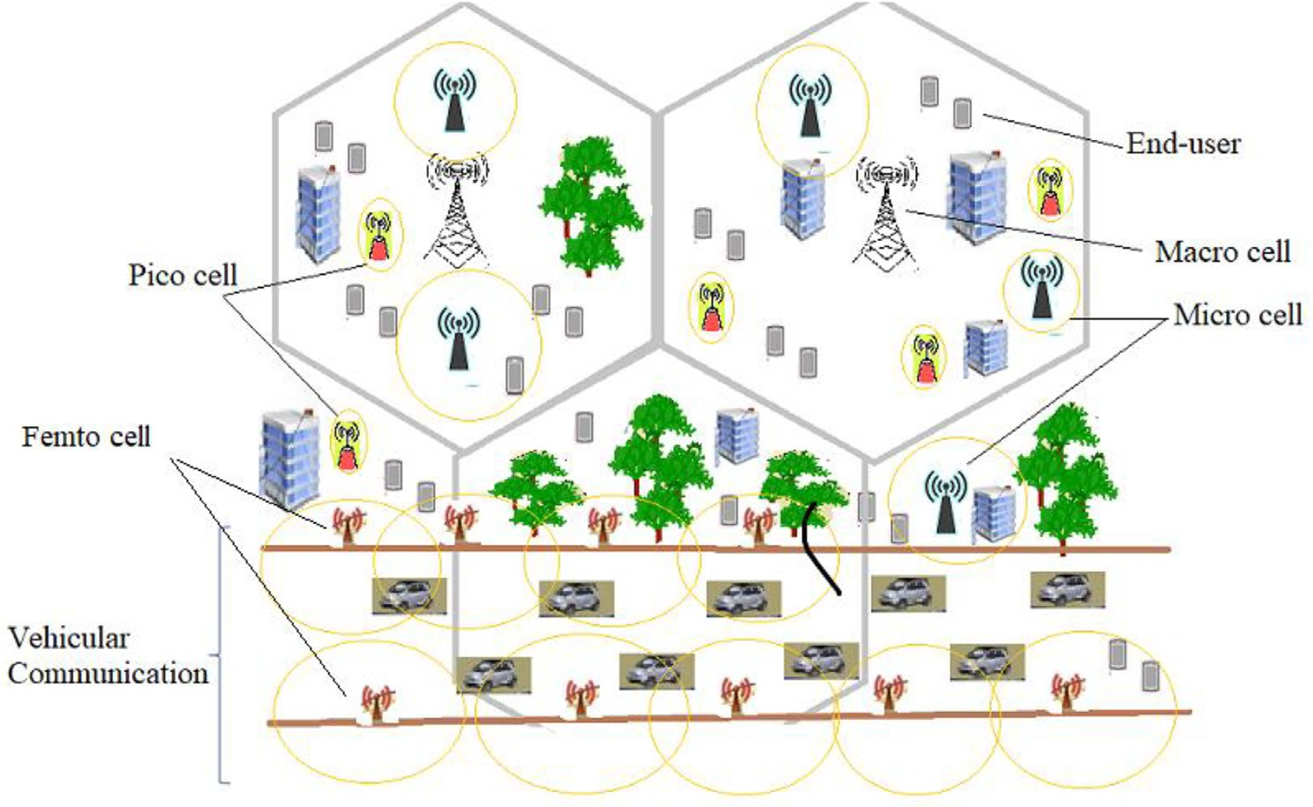

Fig. 1. HetNets Model.

temporarily stops and even call drops may occur. It might be diffi- cult to choose the best network from a heterogeneous network with the least amount of MG, yet doing so is essential to maintain- ing the quality of service in these networks. For a heterogeneous system, we suggested a network selection strategy in this study. The design objective is to offer its devoted customers the greatest network possible in terms of Quality of Service (QoS). Network selection is based on dependability, reputation, and network QoS parameters. A network’s dependability and reputation are crucial for the user experience. The next generation of heterogeneous wireless networks is user-centric and gives users the choice to switch service providers based on their quality of experience. The precise strategy considered in this work will characteristic nicely for cell selection. It is referred to as PDM. Proactive choice suggests that cell selection is not finished at the time of the HO cause. Instead, the counseled method will pick the suitable cell proac- tively and take that cell into account when HO commences. HCP plays a crucial role in ensuring smooth handover transitions and minimizing disruptions to communication. In this research article, we investigate the impact of handover control parameters on 5G handover management and propose strategies for optimizing their values to enhance the overall quality of service for 5G networks.

* 1. *Research objectives*

The countries are aiming to upgrade their telecommunications systems to 5G and beyond 5G (B5G) for technological advance- ment. One critical aspect of these systems is efficient Handover (HO) management to ensure uninterrupted communication. Previ- ous approaches utilizing novel weight-based network assessment methods have revealed unnecessary HO operations. The perfor- mance of each cell can vary significantly due to the nature of net- working technologies, leading to non-essential HO operations. To address this, a fresh weight consideration-based HO execution approach is proposed to minimize unnecessary operations. Out- dated techniques have exposed the MG issue, highlighting the need for a time-efficient schema in the context of 5G. However, measur- ing the parameter values to select an optimal cell requires addi- tional time, especially when considering multiple characteristics during the HO commencement. Network selection is a crucial

aspect when accessing programs available across different net- works. This task becomes more challenging in heterogeneous net- works due to fluctuating network traffic caused by real-time and general applications. To tackle this problem, the study proposes a machine-learning (ML) based plan that selects the best network among several coexisting networks at a specific location.

* + - The main objective is to develop an approach that intelligently predicts and selects the most suitable network for handover before it occurs. This aims to reduce time consumption during handover processes and improve user experience by seamlessly connecting to the optimal network.
    - The next goal is to establish a mathematical model that accu-

rately predicts the appropriate values of handover control parameters based on real-time network conditions. This opti- mization aims to minimize disruptions, improve network selec- tion decisions, and ensure smoother handover transitions.

* + - Another importance is to integrate edge-based data storage into

5G handover management. This involves leveraging the capabil- ities of edge computing to store and process data closer to the user, reducing latency and improving response times during handovers.

* 1. *Research contribution*

The research paper explores three significant contributions in the context of 5G handover management: Proactive Decision Mak- ing (PDM) to reduce time consumption, Handover Control Param- eter (HCP) for network selection, and the utilization of edge-based data storage.

* + - Firstly, the introduction of PDM aims to minimize time con- sumption during the handover process. PDM involves the intel- ligent prediction and selection of the most suitable network for seamless connectivity before the actual handover occurs. By proactively analyzing these two parameters for evaluation, like arbitrary strength unit (ASU) and network download rate (NDR), PDM enables faster and more efficient network selection, leading to reduced handover time and improved user experience.

|  |  |  |  |
| --- | --- | --- | --- |
| Table 2  Dataset. |  | | |
| S.No | ASU | RSRP (dBm) | NDR (Mbps) |
| 1 | 1 | —140 | 0–10 |
| 2 | 2 | —139 | 0–20 |
| . . . | . .. | .. . | . . . |
| 93 | 93 | —48 | 450–920 |
| 94 | 94 | —47 | 450–930 |
| 95 | 95 | —46 | 450–940 |
| 96 | 96 | —45 | 450–950 |

* + - * Secondly, the research paper proposes a novel approach for determining handover control parameter values by employing polynomial regression with the parameters of Received Signal Strength measured in ASU and NDR. Polynomial regression is utilized as a mathematical model to establish a relationship between the aforementioned parameters and the optimal han- dover control parameter values. By collecting and analyzing real-time data from multiple network handovers, the research applies polynomial regression techniques to derive a polyno- mial equation that accurately predicts the appropriate HCP val- ues based on the ASU and network download rate.

15

2021

U U

×

×

16

2021

U U

×

×

17

2021

U

×

×

×

18

2020

U U

×

×

19

2019

U U

×

×

20

2020

U U

×

×

21

2021

U

×

×

×

22

2020

U

×

×

×

23

2020

U

×

×

×

24

2022

×

×

×

×

* + - * Finally, the research paper explores the integration of edge-

based data storage in 5G handover management. With the emergence of edge computing capabilities, it becomes possible to store and process data closer to the edge of the network, reducing latency and improving response times. By leveraging edge-based data storage, the handover management system can efficiently offload and retrieve relevant data during the han- dover process, ensuring seamless connectivity and reducing the impact of latency-sensitive applications.

11

2012

×

×

×

×

12

2019

U

×

×

×

13

2019

U

×

×

×

14

2020

U U

×

×

These three contributions collectively contribute to advancing 5G handover management. By implementing proactive decision making, handover control parameters, and integrating edge- based data storage, the research aims to enhance the overall effi- ciency, reliability, and user experience of handover processes in 5G networks. Simulated trials are used to verify the efficiency of our suggested handoff technique. The numerical outcomes demon- strate that the suggested method can enable the EU to gain supe- rior transmission performance in comparison to the standard handoff technique in traditional networks.

7

2019

×

×

×

×

8

2020

U

×

×

×

9

2016

U

×

×

×

10

2018

U

×

×

×

1. Related work

6

2017

×

×

×

×

An overview of all the related work is discussed here to gain motivation for our research work (Table 1). To evaluate several strategies, XGBoost has been used as one of the ensemble methods [1]. The key contribution of this suggested method is the use of predictive-based HO management to address the MG issue. When the analysis was conducted, 70% of the samples were regarded as training samples, and the remaining 30% as test samples out of the total data collected. The sophisticated method reduces the delay and operates more quickly and precisely. The achieved han- dover success rate (HSR) for this approach is 100 percent. The speed, accuracy, and efficiency of these intelligent algorithms are dominating factors in this field. The percentage of training data and test data is challenging because the inequilibrium between both leads to either underfitting or overfitting of the model, which is highly undesirable.

Table 1

Overview of related papers.

Paper Year

5G & B5G focus ML focus

PDM focus

Edge based data process

1

2021

U U

×

×

2

2020

U U

×

×

3

2021

U U

×

×

4

2022

U U

×

×

5

2019

×

U

×

×

A novel vertical handover algorithm based on multi-attribute and neural network for heterogeneous integrated network is pro- posed in this paper. The method constructs the various network environments, including Universal Mobile Telecommunications Service (UMTS), General Packet Radio Service (GPRS), wireless

local-area network (WLAN), 4G, and 5G [2]. The network download rate is discovered from the heterogeneous platform as a final target output to choose the appropriate cell. The neural network tech- nique includes parameters such as user speed, maximum transmis- sion rate, minimum transmission delay, SINR, bit error rate, and packet loss rate. The collection of fresh weights for cell selection is maintained using this technique. According to HO management, choosing the wrong cell when using fresh weights might result in the poorest connection. Due to the EU’s observation of a fluctuating attitude, the weights are subject to alter at any time, allowing the technique to choose both the best and worst cells. Therefore, this method’s disadvantage is that it employs MG to choose the cell and fresh weights to determine the network download rate.

For generations like 5G and 6G, and so on, machine learning will be a flexible technology. The survey provides the convenience of managing a variety of well-liked and unique ML approaches to carry out the HO procedure [3,4]. The primary objective of many academics is to bring everything under the control of ML technol- ogy, and ML principles are now being supported globally. They pro- vide an extensive tutorial on HO management in 5G networks accompanied by a discussion on machine learning (ML) applica- tions to HO management. future directions and challenges for 5G UDSC networks were concisely addressed.

This work [5] uses the Recurrent Neural Network (RNN) approach to predict the access point’s reception signal strength. They propose a two-tier Machine Learning-based scheme for han- dover management in vehicular networks. They use a recurrent neural network model that forecasts an Access Point receiving sig- nal to derive a handover trigger decision. The Long-Short-Term Module (LSTM) method is processed from the hidden layer for data series prediction. Based on the anticipated series in the vehicular ad-hoc network, the new Received Signal Strength Indicator (RSSI) sequence is predicted, and the HO process is carried out.

The notion of adaptive pheromone evaporation is examined concerning ant colony optimization (ACO) for HO management [6]. The difficulty of this computation and implementation in the network selection procedure is a challenge. The primary driver behind the diverse study findings is the optimum cell selection procedure. The possibilities came when choosing an average per- former who will offer a medium-quality connection based on the optimal approach. The basic concept of an ACO-based vertical han- dover algorithm in heterogeneous wireless networks is used as in the new concept of adaptive pheromone evaporation rate.

Because conducting several computations during the handover process is a hindrance, the cell selection process will be concluded by absorbing the MG according to the Multiple Attribute Decision Making (MADM) techniques [7] based schema. The time complex- ity of every approach employed in the MADM was analyzed and EWSM yields reliable outcomes, according to the research findings. Additionally, relying on fresh weights may indicate a poor connec- tion. According to the study’s findings, the factors’ variations might lead to the worst connections being formed.

The recommended models will provide a measurement delay, just like fuzzy MADM approaches [8,11,13,24]. It may evaluate the weight range rather than taking into account the current weights. This method combines fuzzy logic and TOPSIS and uses FANP for weighting; it helps to avoid the impact of imprecision and vagueness in the metrics of the available networks. However, it will always take more time to look at the many cells all at once during the HO start. The probability of choosing an issuing cell with average performance is another issue with fuzzy-based approaches. To demonstrate, let’s look at an example. Take into account these two cells: C1 and C2. For both cells, the parameter value’s (data rate) range is 50–150 Mbps. The data points fall between the fixed range’s 100 fluctuating measured values since the range is fixed. Currently, C1 has 60% of its data points between

50 and 100 Mbps and 40% between 100 and 150 Mbps. Different from C1 is C2. 40% of the data points on C2 are between 50 and 100 Mbps, while 60% are between 100 and 150 Mbps. These two cells will have the same priority when we use fuzzy approaches for the cell selection process. Therefore, this incorrect prediction made by fuzzy-based approaches may result in improper cell selection.

This article provides a network choice and channel allocation technique that enables you to increase income by allowing for more users and responding to their preferences, while at the same time, following the policies of the top network operator. The amount that users must pay for accessing the top network is reduced by the formulation of an optimization problem to reduce the amount of cumulative interference caused by authenticated persons. The goal is to provide EUs with a certain QoS at a lower cost while still meeting the interference requirements of any net- work with open channels. Particle Swarm Optimization (PSO) and a modified Genetic Algorithm (GA) are used to solve the optimiza- tion problem, which is the network selection and channel alloca- tion process [9]. This approach requires fewer iterations to reach a higher fitness value. This won’t yield an exact solution, but it is close to an ideal one. This procedure will necessitate MG to com- plete the entire process.

A request-based handover strategy (RBHS) is presented to improve the user experience in performance and obtain the opti- mal allocation of resources, and a caching mechanism based on the users’ requests is introduced. Based on SINR, the RBHS is cre- ated, and the network is chosen [10]. The report gives an overview of how current research provides the most effective method for managing HO. To minimize the burden on the source cell, the notion of optimum resource allocation is suggested. The model will also lessen data traffic for connection management to get a better user experience in performance.

The networks have been clustered using hybrid clustering approaches. For the clustering procedure, K-means and genetic algorithms are explored [12]. It is recommended to use the Eucli- dean distance formula to calculate the distance between the mobile node and the access point. The two scanning techniques are break-before-make scanning between clusters and active back- ground scanning for the HO process. The work’s primary objective is to decrease HO failure and latency in IEEE 802.11 SDN-based dis- tributed mobility management.

The problem of traffic steering and network selection for 5 g is taken into consideration using the Reinforcement Learning Con- troller’s solution [14]. Using a cutting-edge state-space aggregation method, the entire process is described as a Markov Decision Pro- cess. In a typical telecommunication system, the load-balancing algorithm is taken into consideration while assigning network resources.

The network selection approach’s schema is given in [15] as the Multi-agent Cuckoo Search Optimization method. The record offers a top level view of the way contemporary studies offer the simplest method for coping with HO. The Cuckoo Search technique is then used to maximize the QoS guarantee to the users using the spec- trum from all of the networking channels to the users. Each cuckoo in this algorithm stands for an agent, and together, the agents make up a von-Neumann structure. They can continually increase energy and improve adaption through the neighboring competi- tion cooperation operator, mutation operator, self-learning opera- tor, and cuckoo algorithm’s evolution mechanism, and they can rapidly and precisely identify the problem’s ideal solution.

Reinforcement learning with a Markov Decision Process model is suggested [16] for the HO management problem of a slice- based mobile network. The EU is in charge of selecting the optimal slice of connectivity based on the number of slices. Experience replay training is a technique used by DQN to improve learning.

When training a neural network, it is critical that the data in the training set fulfill the independent and identical distribution. In contrast, there is a link between the training concentration data that the reinforcement learning sampling has found. If this data is exploited for consecutive training, the neural network might become unstable. DQN employs an experience replay technique to disrupt the correlation between the data to address this issue.

The Handover Control Parameter (HCP) parameters, which may be manually or automatically adjusted in [17], control the HO man- agement issue. In this study, the effect of various HCP settings on the functionality of 5G networks is examined. The report provides a comprehensive overview of how current research identifies the most straightforward approach to dealing with HO. The experi- ment’s results show that there are trade-offs between different systems’ results. When comparing lower HCP settings to higher HCP settings, Outage probability benefits are greatly increased. Simultaneously, lesser HCP settings have significant drawbacks in terms of high Ping-Pong handover probability for all scenarios of mobile speed when compared to higher HCP values. The simula- tion results indicate that if one of these systems is employed, mid- range HCP settings may be the best option. The best user experience-related strategy, according to this study, is the adop- tion of automatic self-optimisation (ASO) elements.

Several of the HO management strategies for 5G have been ad- dressed in [18–20]. In the survey, several HO decision-making algorithms, such as self-optimization, intelligent HO method, mobility prediction, user speed-based HO management, and others, were briefly discussed. Results of just using machine learn- ing techniques for HO decision issues in 5G UDSC are presented in the dispute. This article discusses the fundamental principles of radio access mobility in cellular networks, potential problems, and areas of current research interest.

The study summarizes how current research efforts approach the issues that characterize drones, with a special focus on the han- dover process. This work also provides a general concept of drone integration in heterogeneous networks and discusses specific solu- tions for addressing possible problems[21]. With a particular emphasis on the HO process, the report explains how current research efforts are defining drones. A brief discussion and recom- mendations for future research paths on connected drones in future heterogeneous networks are also provided by this survey.

In this observation, they included a velocity-based self- optimization approach to adjust the HO control parameters in 4G/5G networks [22]. The advised approach adjusts the HO margin and the time to trigger based totally on the users movement inside the network. The simulation consequences show that the proposed approach achieves a top notch discount inside the charge of ping- pong HOs and RLF whilst as compared to other existing algorithms, surpassing such algorithms by using a median of more than 70% for all HO performance parameters.

The auto-tuning optimization (ATO) technique for HO manage- ment is presented in this study and makes use of user speed and received signal reference power [23]. The goal of the suggested approach is to reduce the frequency of HOs and HOF ratios. They - provide a HO self-optimization approach for HetNets inside this research to enhance network performance. The suggested ATO algorithm modifies the values of HCPs on a regular basis based on EU speed and RSRP. Through a two-tier model simulation made up of 4G and 5G networks is assessed. The simulation findings reveal that the ATO algorithm enhances overall system perfor- mance and outperforms all other comparable methods. This sys- tem also decreases the overall rate of all performance measures by more than 80% when compared to other cutting-edge algo- rithms. Consequently, adapting HCPs to EU situations is a practical and efficient method for managing mobility.

1. Proposed model

The working model for simulation makes use of a HetNets de- sign that consists of several macro cells, micro cells, pico cells, and femtocells that are evenly distributed over the entire system following the needs of the user. EUs are generated at random throughout all locations, with random mobility models across all cells, and they are free to go anywhere in the geographic region throughout time t. We determine the EU as E = {e1, e2 ep}.

Meanwhile, E represents the set of EUs where e e E can travel in

a random direction He e [0, 2 p] and the average velocity of the

EU Ve e [vmin, vmax]. The description for the macro cell is given as M = {m1, m2.............mq} while the microcell is S = {s1, s2 sr}

and pico cell is P = {p1,p2.............pu} and femtocell is F = {f1,

f2 fv}.

If the EU switches from the serving cell to the destination cell, the HO operation might be completed in the same kind of cell or a new one. Based on the measurement data provided by the EU, the serving cell decides in this case about HO issues. Each cell pro- vides a trustworthy radio link to the EU within their particular broadcast area. With the value of Reference Signal Received Power (RSRP), the radio link’s quality is determined. The Network Down- load Rate (NDR) is manually set in each EU, according to the RSRP. All cells have their Handover Control Parameter (HCP) settings manually set up correctly and uniquely. Here, the quality of the network has been significantly impacted by HCP in all cells.

* 1. *Dataset description*

The data set generated in the simulation could be like an assumption state as for every RSRP value the random NDR value is choosen from a particular range of NDR. This means that if the RSRP value is —92 dBm, the NDR rate can be in the range of 200– 480 Mbps. So, for the simulation, for every RSRP value, a random NDR value is chosen in between the range according to the data set (Table 2).

* 1. *HO trigger*

The devices will reinforce the connection through the initiation of the HO process when they venture beyond the transmission range of the current cell. As the devices move away from the cur- rent cell, the detected signal strength may weaken, potentially impacting the ongoing data delivery process. In such cases, a stron- ger signal strength is necessary to ensure efficient data transfer. Thus, HO becomes essential to prevent a decline in performance. The threshold value acts as an indicator to anticipate a connection with lower quality. If the signal strength reading falls below the designated threshold, the device will promptly activate HO management.

By applying the requirements from the EU side, such as when the serving cell’s received radio link quality falls below the thresh- old value taken into consideration in this study, the HO process will be started.

* 1. *Problem formulation*

Devices require a wireless connection to provide services to cli- ents, and multiple cells are required to ensure this connectivity. The EU will assess the quality of the radio link based on the RSRP value. ASU represents an integer value that is inversely related to the RSRP measured by the mobile device. ASU serves as a measure- ment map for RSRP. The efficiency of the radio connection plays a crucial role in the EU’s success. To address handover management issues using HCP, quantitative counseling involves the utilization

of mathematical and statistical techniques to analyze and optimize the transition process. The following steps can be taken to imple- ment quantitative therapy in this scenario:

* + - Identify the Issue: The first stage is to identify the issue that needs to be resolved. This could include calculating the HCP value to minimize handover delays or maximize network bandwidth.
    - Data Collection: The next stage involves collecting data, which

includes ASU and NDR. This information can be obtained through the EU.

* + - Data Offloading to Edge: To leverage edge-based data storage,

the network selection algorithm can take into account the avail- ability of edge servers and their capacity for storing and pro- cessing data. When selecting a network, the algorithm can prioritize networks with nearby edge servers capable of offload- ing data from the EU. This can reduce latency and improve over- all network performance.

* + - Edge-Based Data Processing: Edge computing can also be uti-

lized for data processing tasks related to network selection. By performing calculations and analysis at the edge, the algorithm can make more informed decisions based on real-time network conditions and user requirements.

* + - Data Analysis: Following the collection of the data, statistical

techniques like polynomial regression can be used to analyze it. This can give insights into the connections between handover control settings and network performance and assist in identi- fying patterns and trends in the data. The dataset predicts that the NDR will determine network efficiency. Polynomial Regres- sion is the technique employed for the forecast procedure. The independent value is ASU, and the dependent value is NDR. The NDR will be predicted for all values of ASU. Finally, the average of the predicted NDR will be used as the HCP value, and the network selection procedure will be completed based on these values.

* + - Validation: Finally, the HCP can be validated using simulation to

ensure that it provides the promised network speed gains.

The cell reselection process is triggered when the EU changes its position. The neighboring cells of the EU can provide HCP values. Based on this value, the EU selects the best service provider as the target cell for handover management. Proactively, the EU chooses the top cell from all the available cells to establish han- dover management. According to the proposed strategy, the best cells are selected prior to the activation of handover. After han- dover triggers, the identified cell becomes the target cell, and han- dover management is conducted following the established procedures.

Table 3 below displays the HCP value that perhaps the EU received for the network reselection procedure in our simulation. Here, the EU considers five cells to be neighbours to choose the best cell again. The five cells’ measurement reports are evaluated, and the top-scoring cells are chosen for the HO procedure. The EU chooses F2 as its target cell since it is this situation’s best- performing cell.

When the simulation starts, the EU can rottenly change its posi- tion by applying a random mobility model. The EU can roam in the same cell or between different cells. The time duration is fixed for the minimum and maximum velocity of the EU. The RSRP mea-

surement of the source cell from the EU side is applied every sec- ond. Before the HO trigger occurs, the EU will collect the HCP values of all neighbours to choose the target cell. The top-scoring HCP provider will be selected by the EU, and it will be considered as the target cell when HO triggers.The information along with a measurement report regarding the target cell is forwarded to the source cell and the source can process the HO management.

Algorithm

1. begin
2. Setup the simulation
   1. EU *(E = {e1, e2* *ep})*
   2. macro cell *(M = {m1, m2* *mq})*
   3. micro cell *(S = {s1, s2* *sr})*
   4. pico cell *(P = {p1, p2* *pu})*
   5. femto cell *(F = {f1, f2* *fv})*
3. Start Simulation
   1. Simulation time(t)
4. Start mobility (EU)
   1. EU speed *Ve* s *[vmin, vmax]*
5. HCP of every cell can collect the ASU and NDR from the EU
   1. The user experienced data is collected
   2. Those are stored and processed in edge closer to the EU
   3. Apply polynomial regression to predict the NDR
   4. The predicted NDR is the final HCP value
6. EU – collects HCP(N)
   1. IF HCP(N1) > HCP(N2) 8 N
   2. N1 is considered as best cell by EU (PDM)
7. Apply RSRP measurement at EU side
8. if RSRP(S)<RSRP(d)
   1. HO trigger
   2. Update HOM
9. else (HO Decision – false)
   1. Keep a connection to SOURCE CELL
10. end
11. Simulation environment

The proposed technique is implemented in OMNET++. This research work is an extension of our previous work [24], and there are some drawbacks observed when we consider this model to 5G HetNets. The presented new model works well for future technolo- gies. 5G network simulations were used to assess and validate the proposed technique. The average values obtained from 300 EUs represent all outcomes included in the measurements throughout this work. Initially, each user had a different set of random coordi- nates in the cell. Although EU mobility is focused in one way, each EU used to have an exceptional path that became parallel to some other user’s degree. All mobile device users throughout the net- work who were only ever allowed to go in a random direction have already been encouraged to follow the random waypoint mobility model. As a consequence, since performance is assessed separately for each user throughout each simulation period, the findings will be more accurate. This is attained in 5 seconds by their movement within the cells, which matches the movement distance with the periodic interval. The expected average for all area residents mea-

Table 3

Handover Control Parameter values.

Cells M1 S2 S1 F2 P3

HCP value (Mbps) 43.78 64.82 189.76 211.84 198.58

Table 4

Simulation Parameters.

|  |  |  |  |  |
| --- | --- | --- | --- | --- |
| Parameter | Value |  | | |
|  | M | S | P | F |
| Number of cells | 20 | 50 | 75 | 100 |
| Cell radius (m) | 300 | 100 | 50 | 10 |
| Cell height (m) | 25 | 15 | 12 | 3.5 |
| Transmit Power (dBm)  Simulation area | 46  8 × 8 km2 | 26 | 23 | 15 |
| Number of EUs | 300 |  | | |
| EU height (m) | 1.5 |
| Mobility model | Random Waypoint Model |
| Simulation time (s) | 600 |
| EU speed (meter/second) | 20,40,60,80,100 |
| Thermal noise density (dbm/Hz) | —174 |
| Noise figure of EU (dB) | 9 |
| Time to trigger (ms) | Adaptive |
| Prediction models | polynomial regression |
| Parameters used for prediction | ASU, NDR |

sured in each simulation cycle was then calculated. Consequently, the findings for the average values of HOA, HOPP, RLF, HOF and HO delay were calculated for each simulation cycle.

1. Performance evaluation

To analyze the accomplishment of the proposed network selec-

necessary to prevent unnecessary signaling, reduce network load, and maintain optimal network performance. HOA is the measure- ment of how frequently HO happens between the source cell and the target cell. The probability of interchanging links between dif- ferent cells from all EUs is observed and the average HOA is taken for comparative analysis. Where p is the total number of users in the simulation.

tion process, the simulations are conducted by considering differ-

— P*p*

*HOA*

ent EU speeds. The performance of the proposed model is compared with that of MADM [7], Neural Network [2], and Fuzzy

*HOA* = *i*=1

# *p*

(1)

MADM [25] network selection methods. The combined simulation research findings are presented in this part, together with perfor- mance data for the recommended method. Five distinct mobile speed situations, HO levels, and TTT intervals were used to verify the investigated algorithm in order to completely explain how it performed under varied circumstances. The average values derived across all EUs in the cells throughout simulation periods with var- ious EU velocities are used to quantify performance in 5G net- works. After that, the recommended method was matched with other algorithms including MADM, Fuzzy MADM, and neural net- works. The simulations that were done for the average HOA, HOPP, RLF, HOF and HO delay were obtained by comparing the perfor- mance of the available approaches. The key parameters used in this simulation are shown in Table 4.

* 1. *HOA*

In mobile networking, an HOA is a process in which a mobile device switches from one base cell to another while maintaining an uninterrupted connection to the network. This process is neces- sary because as the mobile device moves, its signal strength and quality may degrade or change due to various factors such as dis- tance, obstacles, and interference, which can affect the quality of the communication. The HOA helps to ensure thate mobile devices always maintain the best possible connection to the network with- out any interruptions or dropped calls. But unnecessary HOAs on mobile networks can cause several issues, including:

* + - Reduced network performance
    - Increased battery consumption
    - Dropped calls and poor call quality
    - Increased network complexity

Therefore, it is important for mobile network operators to opti- mize handover procedures and ensure that they only occur when

The average HOA in proportion to the EU speeds during the course of the experiment is depicted in Fig. 2. The simulation results show that the proposed strategy produces a lower HOA rate than other strategies for all EU speeds. As a result, especially when the UE is moving swiftly, the high HOA rate leads to an increase in HOFs and HOPP.

* 1. *HOPP*

Reducing handover ping pong is important in mobile network- ing because it helps to optimize network performance, reduce sig- naling overhead, and improve user experience. Handover ping pong refers to the situation where a mobile device switches back and forth between two or more neighboring base stations fre- quently. HOPP is the representation of unnecessary HO happening between the source and target cell. When the EU disconnects its radio link from the source cell, establishes a new connection with another cell, and then bounces back to the previous source cell, it is considered HOPP. This can occur due to a variety of reasons, such as weak signal strength, interference, or incorrect configuration of handover parameters.

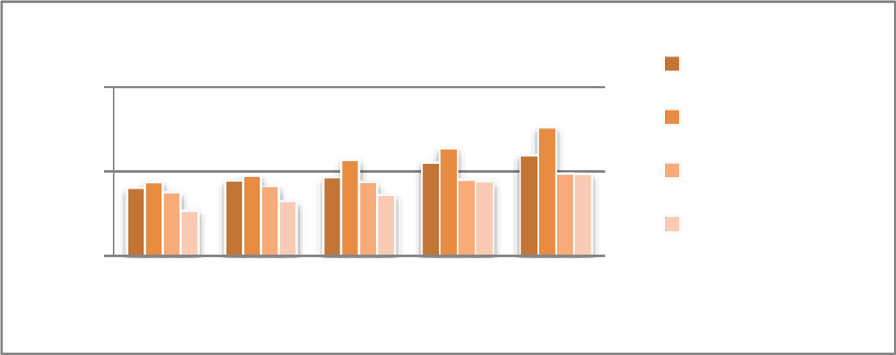

Fig. 2. Average HOA.

Fig. 4 shows the common RLF as opposed to different EU speeds accomplished from the simulation. The achieved outcomes of com- mon RLF from the endorsed version turn out to be less than the other models. The examined version notably reduces the common RLF under all speeds of the EU.

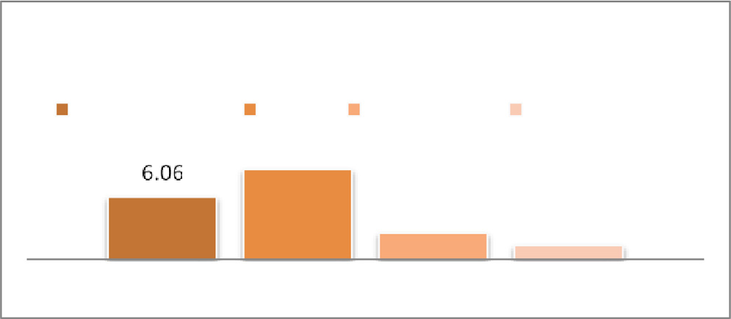

*5.4. HOF*

— *NHOPP*

Fig. 3. Average HOPP.

The lack of target resource availability is one of the reasons for HOF. When the HO process is initiated, the EU will search the neighbours for target cell selection. There can be a chance that insufficient resource availability will lead to the HOF. Another rea- son for HOF is that the EU can move out of the network coverage area of the target cell before completely establishing the HO pro-

*HOPP* = *NRHO* (2)

Where NHOPP is some occurred HOPP from the overall simula- tion and NRHO could be the number of HOs requested. The average HOPP in relation to the EU speeds during the length of the exper- iment is shown in Fig. 3. According to the simulation findings, the suggested approach achieves a lower HOPP rate than alterna- tive methods for all EU speeds. As a result, especially when the EU is moving quickly, the high HOPP rate leads to an increase in HOAs. Furthermore, a high HOA rate may lead to higher HOPP and HOF rates.

* 1. *RLF*

The connection loss of an EU from the source cell can occur due to low-quality links during the HO process. Failure of the radio link concurrently with the activity of the HO process, which disrupts the communication, is treated as RLF. Reducing radio link failure is important in mobile networking because it can impact network performance, the user experience, and network capacity. RLF refers to the situation where a mobile device is unable to maintain a stable connection with the network due to poor signal strength or quality. RLF can lead to reduced network capacity and perfor- mance due to increased signaling traffic and dropped calls. RLF can lead to unnecessary handover attempts, which can consume network resources and reduce capacity. To reduce RLF, mobile net- work operators can optimise network parameters such as antenna placement, transmit power, and handover thresholds. They can also deploy additional base stations or implement advanced tech- nologies such as beamforming and carrier aggregation to improve network coverage and capacity. By reducing RLF, mobile network operators can improve network performance, increase user satis- faction, and reduce operational costs. The average probability of RLF from all the EU is:

cess. Reducing handover failure is important in mobile networking because it can impact network performance, user experience, and network capacity. Handover failure refers to a situation where a mobile device fails to complete a handover to a neighboring cell, which can result in dropped calls, poor call quality, and reduced network capacity.

— *NHOF*

*HOF* = *NHOA* (4)

Where NHOF is the count of HOF and NHOA is the number of HO attempted. Fig. 5 shows the unusual HOF perceived from the sim- ulation. The complete consequences of commonplace HOF from the considered model are less than the alternative models. The examined model significantly reduces the common HOF.

* 1. *HO delay*

The length of time it takes to establish a connection between the old cell and the new cell is considered as a delay in the HO pro- cess. The process must only take a short amount of time to choose a cell, or else the delay will be huge. In comparison to the current work, the suggested technique performs the HO process in some kind of a relatively short amount of time. Handover delays can decrease network bandwidth and efficiency due to higher signaling

— P*p*

*RLF*

*RLF* = *i*=1

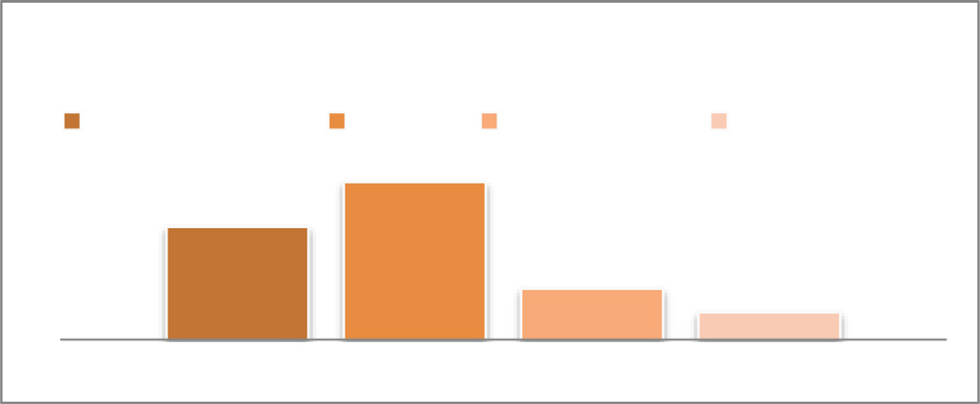

# *p*

(3)

Fig. 5. Average HOF.

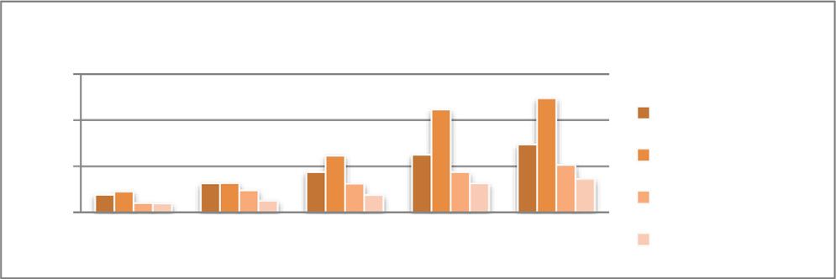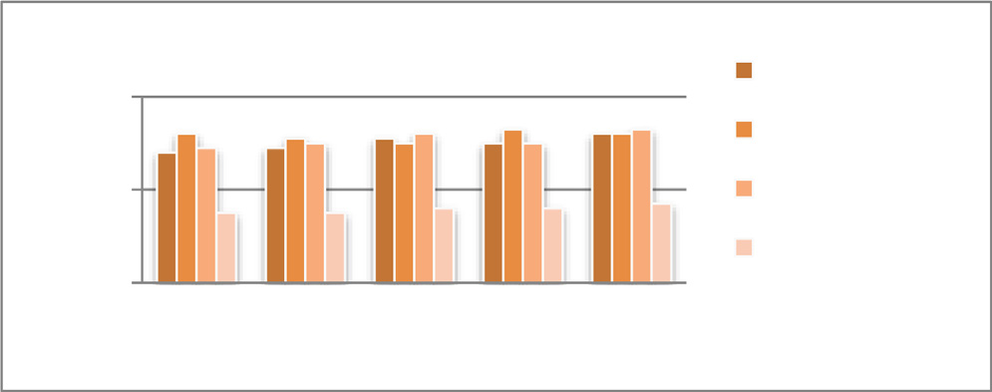

Fig. 4. Average RLF. Fig. 6. Average HO Delay.

traffic and dropped calls. Network providers can enhance network efficiency and ease congestion by cutting down on HO delays.

Fig. 6 shows the report’s quick summary and how significantly the suggested technique minimizing the time duration to change over the connection. The time of EU in the new cell (T-new cell) and the time of EU in the old cell (T-old cell) have been discovered to measure the handover delay.

*HO Delay* = *Tnewcell* — *Toldcell* (5)

* 1. *Limitations of the proposed methodology*
     + Inadequate network coverage: Handover choices based solely on download rate may fail to take the network’s coverage region into account. As a consequence, handovers may start even if the destination network has poor coverage in the user’s location, resulting in call drops.
     + Delayed handover initiation: Handover control settings that are

not changed regularly may cause delays in handover initiation. This can be a reason for poor user experience, particularly for apps requiring real-time data transmission.

* + - Frequent changes may lead to high signaling overhead after

each base station initializes the handover control parameters, which will clog the network and impair performance.

1. Conclusion

The importance of HO management is to maintain the QoS for the EU applications during their mobility. The 5G handover methodology is also expected to provide better coverage and capacity for mobile networks. This will improve the quality of ser- vice for mobile users and lead to happier customers. 5G and future technologies are rapidly advancing by outperforming older tech- nologies in terms of high-speed data rate and low latency. When devices move fast, mobility management is a meaningful task to strengthen the seamless data delivery process. And the whole pro- cess of mobility management should be done with minimal latency. From the existing three methodologies, we learn that the estimation of network performance or the score calculation task of the networks is handled at the moment of HO triggered by the EU. The time consumption to select the target cell by the existing methodology is higher than the proposed methodology. In this rec- ommended model, the role of HCP being all cells is the consider- able mechanism to execute the process with minimum latency. Cell selection was not carried out at the time of the HO trigger in this PDM based methodology. Instead, the recommended method will pick the right cell in advance and use that cell as the target cell when HO starts. The complex and dynamic nature of mobile net- works requires a proactive approach to handover management to ensure seamless connectivity and high-quality user experiences. PDM entails foreseeing problems and solving them before they arise. This entails examining network data to spot patterns and trends, spotting anomalies on the network, and taking remedial action to stop a service decline or interruption. Decision-making and increasing network efficiency also entails utilizing cutting- edge technologies like automation, machine learning, and artificial intelligence. Network operators can improve network performance and accessibility, lower running expenses, and increase client hap- piness by incorporating PDM into handover management. Addi- tionally, it permits them to fully utilize the benefits of 5G technology, including its extremely low delay, enormous machine-type interactions, and high data rates. In conclusion, PDM is essential for managing handoffs in 5G networks and can support network providers in achieving their organizational goals and providing top-notch user experiences.

Automation will probably become more prevalent in transfer administration in the future. With the use of AI and machine learn- ing, networks will be able to identify anomalies and possible issues autonomously and take corrective action without the need for human involvement. Developing more sophisticated ML models, such as deep learning or ensemble learning, to improve decision accuracy and adaptability and to address privacy and security con- cerns using techniques like privacy-preserving ML or secure feder- ated learning will be the scope.

Data availability statement

Data will be made available by sending a reasonable request to the first author. Communication can be done through email to the provided email address.

CRediT authorship contribution statement

A. Priyanka: Conceptualization, Methodology, Software, Inves- tigation, Resources, Data curation, Writing – original draft, Writing – review & editing, Visualization, Project administration, Funding acquisition. P. Gauthamarayathirumal: Formal analysis. C. Chan- drasekar: Validation, Supervision.

Declaration of Competing Interest

The authors declare that they have no known competing finan- cial interests or personal relationships that could have appeared to influence the work reported in this paper.

Acknowledgments

The first author sincerely acknowledges the financial support (University Research Fellowship) provided by the Department of Computer Science, Periyar University under the grant: PU/AD-3/ URF Selection Order/016175/2020.

References

1. [Majid SI, Shah SW, Marwat SNK, Hafeez A, Ali H, Jan N, et al. Using an efficient](http://refhub.elsevier.com/S1110-8665(23)00045-2/h0005) [technique based on dynamic learning period for improving delay in AI-based](http://refhub.elsevier.com/S1110-8665(23)00045-2/h0005) [handover. Mob Inf Syst 2021;2021:1–19](http://refhub.elsevier.com/S1110-8665(23)00045-2/h0005).
2. [Tan X, Chen G, Sun H. Vertical handover algorithm based on multi-attribute](http://refhub.elsevier.com/S1110-8665(23)00045-2/h0010) [and neural network in heterogeneous integrated network. EURASIP J Wirel](http://refhub.elsevier.com/S1110-8665(23)00045-2/h0010) [Commun Netw 2020;2020(1)](http://refhub.elsevier.com/S1110-8665(23)00045-2/h0010).
3. [Mollel MS, Abubakar AI, Ozturk M, Kaijage SF, Kisangiri M, Hussain S, et al. A](http://refhub.elsevier.com/S1110-8665(23)00045-2/h0015) [survey of machine learning applications to handover management in 5g and](http://refhub.elsevier.com/S1110-8665(23)00045-2/h0015) [beyond. IEEE Access 2021;9:45770–802](http://refhub.elsevier.com/S1110-8665(23)00045-2/h0015).
4. [Tanveer J, Haider A, Ali R, Kim A. An Overview of Reinforcement Learning](http://refhub.elsevier.com/S1110-8665(23)00045-2/h0020) [Algorithms for Handover Management in 5G Ultra-Dense Small Cell Networks.](http://refhub.elsevier.com/S1110-8665(23)00045-2/h0020) [Appl Sci Jan 3, 2022.;12(1):426](http://refhub.elsevier.com/S1110-8665(23)00045-2/h0020).
5. [Aljeri N, Boukerche A. A Two-Tier Machine Learning-Based Handover](http://refhub.elsevier.com/S1110-8665(23)00045-2/h0025) [Management Scheme for Intelligent Vehicular Networks. Ad Hoc Netw](http://refhub.elsevier.com/S1110-8665(23)00045-2/h0025) [2019;94:101930](http://refhub.elsevier.com/S1110-8665(23)00045-2/h0025).
6. [El Fachtali I, Saadane R, El Koutbi M. Improved vertical handover decision](http://refhub.elsevier.com/S1110-8665(23)00045-2/h0030) [algorithm using ants’ colonies with adaptive pheromone evaporation rate for](http://refhub.elsevier.com/S1110-8665(23)00045-2/h0030) [4th generation heterogeneous wireless networks. Int J Wirel Mob Comput](http://refhub.elsevier.com/S1110-8665(23)00045-2/h0030) [2017;12(2):pp](http://refhub.elsevier.com/S1110-8665(23)00045-2/h0030).
7. [Preethi GA, Gauthamarayathirumal P, Chandrasekar C. Vertical Handover](http://refhub.elsevier.com/S1110-8665(23)00045-2/h0035) [Analysis Using Modified MADM Method in LTE. Mobile Netw Appl 2019;24](http://refhub.elsevier.com/S1110-8665(23)00045-2/h0035) [(4):1139–51](http://refhub.elsevier.com/S1110-8665(23)00045-2/h0035).
8. [Mansouri M, Leghris C. A Use of Fuzzy TOPSIS to Improve the Network](http://refhub.elsevier.com/S1110-8665(23)00045-2/h0040) [Selection in Wireless Multi access Environments. J Comput Netw Commun](http://refhub.elsevier.com/S1110-8665(23)00045-2/h0040) [2020;2020:1–12](http://refhub.elsevier.com/S1110-8665(23)00045-2/h0040).
9. [Ul Hasan N, Ejaz W, Ejaz N, Kim HS, Anpalagan A, Jo M. ‘‘Network Selection and](http://refhub.elsevier.com/S1110-8665(23)00045-2/h0045) [Channel Allocation for Spectrum Sharing in 5G Heterogeneous Networks. IEEE](http://refhub.elsevier.com/S1110-8665(23)00045-2/h0045) [Access 2016;4:980–92](http://refhub.elsevier.com/S1110-8665(23)00045-2/h0045).
10. [Jia F, Zheng X. A request-based handover strategy using NDN for 5G. Wirel](http://refhub.elsevier.com/S1110-8665(23)00045-2/h0050) [Commun Mob Comput 2018;2018:1–9](http://refhub.elsevier.com/S1110-8665(23)00045-2/h0050).
11. [Chamodrakas I, Martakos D. A utility-based fuzzy TOPSIS method for energy](http://refhub.elsevier.com/S1110-8665(23)00045-2/h0055) [efficient network selection in heterogeneous wireless networks. Appl Soft](http://refhub.elsevier.com/S1110-8665(23)00045-2/h0055) [Comput 2011;11(4):3734–43](http://refhub.elsevier.com/S1110-8665(23)00045-2/h0055).
12. [Basloom S, Akkari N, Aldabbagh G. Reducing Handoff Delay in SDN-based 5G](http://refhub.elsevier.com/S1110-8665(23)00045-2/h0060) [Networks Using AP Clustering. Procedia Comput Sci 2019;163:198–208](http://refhub.elsevier.com/S1110-8665(23)00045-2/h0060).
13. [Priya B, Malhotra J. 5GAuNetS: an autonomous 5G network selection](http://refhub.elsevier.com/S1110-8665(23)00045-2/h0065) [framework for Industry 4.0. Soft Comput 2020;24(13):9507–23](http://refhub.elsevier.com/S1110-8665(23)00045-2/h0065).
14. Francesco Delli Priscoli, Alessandro Giuseppi, Francesco Liberati and Antonio Pietrabissa, ‘‘Traffic Steering and Network Selection in 5G Networks based on Reinforcement Learning”, 2020 European Control Conference (ECC), May 12- 15, 2020.
15. [Ai N, Bin Wu, Li B, Zhao Z. 5G heterogeneous network selection and resource](http://refhub.elsevier.com/S1110-8665(23)00045-2/h0075) [allocation optimization based on cuckoo search algorithm. Comput Commun](http://refhub.elsevier.com/S1110-8665(23)00045-2/h0075) [2021](http://refhub.elsevier.com/S1110-8665(23)00045-2/h0075).
16. [Wu Y, Zhao G, Ni D, Du J. Dynamic handoff policy for RAN slicing by exploiting](http://refhub.elsevier.com/S1110-8665(23)00045-2/h0080) [deep reinforcement learning. EURASIP J Wirel Commun Netw 2021;2021(1)](http://refhub.elsevier.com/S1110-8665(23)00045-2/h0080).
17. [Saad WK, Shayea I, Hamza BJ, Mohamad H, Daradkeh YI, Jabbar WA. Handover](http://refhub.elsevier.com/S1110-8665(23)00045-2/h0085) [Parameters Optimisation Techniques in 5G Networks. Sensors 2021](http://refhub.elsevier.com/S1110-8665(23)00045-2/h0085).
18. [Shayea I, Ergen M, Hadri Azmi M, Aldirmaz Colak S, Nordin R, Daradkeh YI.](http://refhub.elsevier.com/S1110-8665(23)00045-2/h0090) [‘‘Key Challenges, Drivers and Solutions for Mobility Management in 5G](http://refhub.elsevier.com/S1110-8665(23)00045-2/h0090) [Networks: A Survey. IEEE Access 2020;8:172534–52](http://refhub.elsevier.com/S1110-8665(23)00045-2/h0090).
19. [Tayyab M, Gelabert X, Jantti R. ‘‘A Survey on Handover Management: From LTE](http://refhub.elsevier.com/S1110-8665(23)00045-2/h0095) [to NR. IEEE Access 2019;7:118907–30](http://refhub.elsevier.com/S1110-8665(23)00045-2/h0095).
20. Rami Ahmad, Elankovan A, Sundararajan, Ala’ Khalifeh, ‘‘A Survey on Femtocell Handover Management in Dense Heterogeneous 5G Networks”, Telecommunication Systems, 2020.
21. [Angjo J, Shayea I, Ergen M, Mohamad H, Alhammadi A, Daradkeh YI. Handover](http://refhub.elsevier.com/S1110-8665(23)00045-2/h0105) [Management of Drones in Future Mobile Networks: 6G Technologies. IEEE](http://refhub.elsevier.com/S1110-8665(23)00045-2/h0105) [Access 2021;9:12803–23](http://refhub.elsevier.com/S1110-8665(23)00045-2/h0105).
22. Abdulraqeb Alhammadi, Mardeni Roslee, Mohamad Yusoff Alias, Ibraheem Shayea and Abdullah Alquhali, ‘‘Velocity-Aware Handover Self-Optimization Management for Next Generation Networks”, Applied Sciences, Feb 17, 2020.
23. [Alhammadi A, Roslee M, Alias MY, Shayea I, Alraih S, Mohamed KS. Auto](http://refhub.elsevier.com/S1110-8665(23)00045-2/h0115) [Tuning Self-Optimization Algorithm for Mobility Management in LTE-A and](http://refhub.elsevier.com/S1110-8665(23)00045-2/h0115) [5G HetNets. IEEE Access 2020;8:294–304](http://refhub.elsevier.com/S1110-8665(23)00045-2/h0115).
24. [Priyanka A, Jayachithra N, Dr Chandrasekar C. Implementing Fuzzy Logic to](http://refhub.elsevier.com/S1110-8665(23)00045-2/h0120) [Improve the Network Selection Process for Heterogeneous Handover.](http://refhub.elsevier.com/S1110-8665(23)00045-2/h0120) [Stochastic Model Appl Jun 8, 2022.;26](http://refhub.elsevier.com/S1110-8665(23)00045-2/h0120).