Available online at [www.sciencedirect.com](http://www.sciencedirect.com/)



[Electronic Notes in Theoretical Computer Science 277 (2011) 29–39](http://dx.doi.org/10.1016/j.entcs.2011.09.033)

[www.elsevier.com/locate/entcs](http://www.elsevier.com/locate/entcs)

Mathematical Approach to Predict the Drug Effects on Cancer Stem Cell Models

Chiara Fornari, Francesca Cordero1*,*2

*Department of Computer Science and Department of Clinical and Biological Science, University of Torino, Torino, Italy*

Daniele Manini, Gianfranco Balbo3*,*4

*Department of Computer Science University of Torino, Torino, Italy*

Raffaele A Calogero5

*Department of Clinical and Biological Science, University of Torino, Torino, Italy*

**Abstract**

The mechanism behind the growth and development of tumors is intensively studied using several mathe- matical approaches that rely on linear and non-linear techniques to model the cell population dynamics to better understand the development and progression of cancer. In this paper, we study the progression of a type of malignant tumors characterized by the stem-differentiation hierarchy. Two main issues are modeled and investigated: the differentiation phase and the phenotypic plasticity that suggests the existence of a dynamic interaction among Cancer Stem Cells and non-Cancer Stem Cells populations. Using these mod- els, we study several therapy effects on breast cancer in order to obtain the temporal behavior of the cell populations, taking into account different drug concentrations and oncoantigen-driven vaccinations.

*Keywords:* Prediction of Cancer Stem Cells behaviour, Mathemathical approach, Biological processes modelling.

# Introduction

Several mathematical models describing many aspects of tumor malignancy, as well as tumor growth, angiogenesis process, and drug response are published in the literature [2,5,14].

1 Email: [fornari@di.unito.it](mailto:fornari@di.unito.it)

2 Email: [fcordero@di.unito.it](mailto:fcordero@di.unito.it)

3 Email: [manini@di.unito.it](mailto:manini@di.unito.it)

4 Email: [balbo@unito.it](mailto:balbo@unito.it)

5 Email: [raffaele.calogero@unito.it](mailto:raffaele.calogero@unito.it)

1571-0661 © 2011 Elsevier B.V. Open access under [CC BY-NC-ND license](http://creativecommons.org/licenses/by-nc-nd/3.0/).

[doi:10.1016/j.entcs.2011.09.033](http://dx.doi.org/10.1016/j.entcs.2011.09.033)

Recent studies have changed the traditional view of tumor progression, showing that the growth and progression of many cancers are driven by small groups of Can- cer Stem Cells (CSCs) [3]. Given this evidence, Turner et al [15] and Zhu et al [17] developed two models that use systems of ordinary differential equations (ODEs) to describe this new theory of tumor development. The CSC tumor model presents a hierarchically structured organization similar to that found in normal tissues: CSCs are self-renewing, capable of tissue regeneration and of giving rise to non- CSCs, the latter being more differentiated and largely lacking in tissue-regeneration ability. Considering this hierarchical structure, the response to drug treatments on the several cell populations that compose the cancer, will produce different effects depending on the characteristics of the cancer subpopulation. For this reason, the CSCs are believed to be the cause of failure of conventional therapies, since effective drug treatments able to eliminate all the CSCs, hence to avoid relapses, are not easy to find [7].

Based upon the models presented in [17,15], we study the progression of malig- nant tumors characterized by the stem-differentiation hierarchy. In particular, we generalize their ODEs systems by taking into account all cancer types described by this hierarchical model. Two main issues are investigated: (i) the differentiation phase (in [17] the authors model only the proliferation phase of all subpopulations), and (ii) the phenotypic plasticity that suggests the existence of a dynamic interac- tion among CSCs and non-CSCs populations. In our ODEs system we also account for the drug effect on the cancer in order to simulate the behavior of the cells, considering different drug concentrations.

# Model structure

In the last 15 years major advances have been made in the understanding of tumor maintenance and initiation of relapse. These studies lead the researchers to move from a traditional view of cancer organization to a new heterogeneity concept. The traditional notion of cancer explains that the malignant tumor consists of a unique type of cell population characterized by the ability to divide without limit. This view has been overcome after the identification of the CSCs that can differentiate into heterogeneous cancer subpopulations.

In this section we describe the main biological features characterizing the tumor hierarchical organization based on CSC theory (Section 2.1) and how we translate these considerations into an ODEs model (Section 2.2).

* 1. *Stem-differentiation hierarchy model*

Several papers have been published, where the identification and characterization of CSCs has been reported [12,4]. The ability of CSCs to drive the growth and regeneration of tumors can be understood by considering their main properties:

(i) tumorigenic capacity and self-renewal, (ii) tissue regeneration and (iii) differen- tiation into non-stem cells. The CSCs abilities best characterize the cancer types described by the stem-differentiation hierarchy’s model. Indeed, in these tumors the

growth and the progression are driven by the CSCs subpopulations. Moreover, the hierarchical organization of the tumor is guaranteed from the CSC differentiation capacity. CSCs give rise to committed progenitor cells (PCs) which in their turn give rise to cells characterized by a rapid proliferation rate which then originate terminally differentiated cells (TCs).

A CSC is defined as a cell that can divide either symmetrically (originating two cells of the same CSC type) or asymmetrically (i.e., giving rise to a CSC cells and to a PC cell) upon the issuing of an appropriate external signal. Although it is still unknown what might be the mechanism for controlling whether a stem cell divides symmetrically or asymmetrically, empirical evidence shows that some envi- ronmental conditions could influence this phenomenon, so that, becomes crucial the micro-environment, also called *niches*, where the CSCs reside. Environmental pres- sures result in constantly adapting the cell physiology and gene expression for the appropriate stem cell state [8]: indeed, when moving from CSCs to TCs, it is possi- ble to observe the existence of different niche compositions leading to a progressive loss of proliferation ability, pluripotency and metastatic potential [1]. Moreover, in response to environment signals it is possible that during their early stage PCs can differentiate into CSCs. The possibility of bidirectional interconvertibility is due to some contextual signals that reprogrammed the non-CSCs into CSCs [6].

Due to this cancer structure, the stem-differentiation hierarchy model affects the design of cancer therapies. For instance, many papers [16,9] report the resistance of CSCs to many current cancer treatments including chemo and radiation ther- apy, while these therapies reveal a positive effect on TCs. Treatments designed to eliminate only TC subpopulation will likely be unsuccessful from the point of view of having a clinical impact on the whole tumor. Indeed, if the treatments fail in killing the CSCs, there is a large possibility to regenerate new tumors. Novel cancer therapies must consider these dynamics and must thus be designed to account for both genetic alterations and differentiation states of the CSCs in order to eradicate them.

* 1. *The cancer ordinary differential equations system*

As described in the previous section, the hierarchical model is composed of three cellular subpopulations: CSCs, PCs and TCs. The first two subpopulations are characterized by similar dynamics which are based on the succession of two phases: **proliferation** and **differentiation**, as shown in Figure 1 (A).

Proliferation rate is described by the parameter *ω* while differentiation rate is described by the parameter *η*. *γ* represents the parameter of the ability of progenitor cells to acquire CSC phenotype, also called dedifferentiation. All the subpopulations will die at a certain rate represented by the parameter *d*.

In Figure 1(B) is reported the detailed representation of the proliferation and differentiation mechanisms for each subpopulations. The CSCs can divide in both symmetrically or asymmetrically ways to generate two CSCs or one CSC and one *PC*1, respectively. On the other hand, the PCs subpopulation can evolve through several stages. At each stage the PC cells can proliferate in a symmetric manner

A B **Proliferation**



Death (d)

Proliferation

(U)

Differentation (ð, η)

Drug (#)

CSC  CSC + CSC

CSC  CSC + PC1

PCi

 PC + PC

i + 1 i + 1

i = 1...6

**Differentation**

CSC

PCi PC7

PCj

 PC1  PCi + 1

 TC CSC

i = 1...6

j = 1...3

Fig. 1. Cancer stem cells model. (A) CSCs and PCs cycle (B) Details of proliferation and differentiation rules

producing two PC cells belonging to the next stage. Following the assumptions made by Zhu [17], we set to seven the number of stages. For what concerns the differentiation, the CSC becomes *PC*1 while a subpopulation PC at stage *i* (*P Ci*), differentiates in the PC of the next stage (*PCi*+1). Finally, the last stage of PC, *PC*7, is differentiated in TC cells. As described in the previous section, we also model the bidirectional inter-convertibility among CSCs and *PCjs*. This plasticity involves the first three generation of PCs that are still similar to CSCs. Therefore we speculated that only some PC’s stages can undergo dedifferentiation to CSC, with a rate described by the parameter *γ* [15].

Finally, we also consider the effect that drug exposure may have on cancer. The drugs that we consider are either chemical compounds or current cancer treatments, including chemo and radiation therapies or vaccine administrations. Considering these different types of treatments we are confident to suppose that all the subpop- ulations are subject to at least one drug action. We model the drug effects as an increment of the cell differentiation rate, thereby accelerating the generation of the next subpopulation. The intensity of the drug exposure is captured in the model by the proper setting of parameter Θ.

Accounting for all these considerations, a model of the dynamics of these cancer cell populations is constructed by specifying the following system of linear and homogeneous ODEs:

*dNCSC*

*dt*

= *Psy*

*ωCSC*

*NCSC*

+ *γPC*

3

*N*

Σ

*j*=1

*P Cj*

* *η*1*N*

*CSC*

* Θ1*N*

*CSC*

* *d*1*N*

*CSC*

*dNP C*1

*dt*

= *Pasy*

*ωCSC*

*NCSC*

* *ωPCN*

*P C*1

* *γPCN*

*P C*1

+ *η*1*N*

*CSC*

* *η*2*N*

*P C*1 +

+ Θ1*NCSC −* Θ2*NP C*1 *− d*2*NP C*1

*dNP Cj*

*dt*

= 2*ω*

*PCN*

*P Cj−*1

* *ωPCN*

*P Cj*

* *γPCN*

*P Cj*

+ *η*2*N*

*P Cj−*1

* *η*2*N*

*P Cj* +

+ Θ2*NP Cj−*1 *−* Θ2*NP Cj − d*2*NP Cj j* = 2*...*3

(1)

*dNP Ci*

*dt*

= 2*ω*

*PCN*

*P Ci−*1

* *ωPCN*

*P Ci*

+ *η*2*N*

*P Ci−*1

* *η*2*N*

*P Ci*

+ Θ2*N*

*P Ci−*1 *−*

*—* Θ2*NP Ci − d*2*NP Ci i* = 4*...*6

*dNP C*7

*dt*

= 2*ω*

*PCN*

*P C*6

+ *η*2*N*

*P C*6

* *η*3*N*

*P C*7

+ Θ2*N*

*P C*6

* Θ2*N*

*P C*7

* *d*2*N*

*P C*7

*dNTC*

*dt*

= *η*3*N*

*P C*7

+ Θ2*N*

*P C*7

* Θ3*NTC*
* *d*3*NTC*

where *NCSC*, *NP Ci* and *NTC* are the numbers of cancer stem cells, progenitor cells, and terminal cells, respectively.

Notice that the terms characterizing these equations depend on 5 parameters:

* 1. *ωCSC, ωPC*: describes the proliferation rate of all the subpopulations, except for TCs. Note that all the PC subpopulations are modeled by a positive and negative term in order to describe their symmetric proliferation in the next stage of PCs. The proliferation rates of CSC and *PC*1 depend also on *Psy* and *Pasy* that are the probabilities of symmetric and asymmetric CSC division[17], respectively.
  2. *γPC*: represents the bidirectional inter-convertibility parameter that involves CSC, *PC*1, *PC*2 and *PC*3 subpopulations.
  3. *di*: indicates the death rate specific for each individual subpopulation *i*.
  4. *ηi*: describes the differentiation rates of each individual subpopulation *i*. Since the differentiation process involves all the subpopulations in the ordered chain of evolution, CSC *→ P Ci →* TC, in all the equations except those concerning CSCs and TCs, both positive and negative terms are included.
  5. Θ*i*: indicates the drug effects for each individual population *i*. As explained before, we model the effects of the drug therapy as increments of differentiation rates: indeed, the Θ-terms follow the same trend of *η*-terms. Moreover, a specific parameter Θ3 is defined for the TC subpopulation in order to describe the effect of treatments that work specifically on TCs.

# Equilibrium analysis

The overall behavior of the tumor progression discussed in this paper is studied by developing an analytic solution of the system of ODEs described in the previous section on the basis of different combinations of model parameters. Our first objec- tive is to determine which values lead to an equilibrium trend. For this purpose, the steady state analysis of the model can be exploited to identify key parameter groups and to establish which parameters affect most the dynamics of subpopulations.

* 1. *Basic Model Solution*

The linear system of ODEs (1) described in the previous section can be expressed in the following matrix form:

*Z′* = *AZ* (2)

where matrix *A* contains the coefficients of the biological system, while vector *Z* refers to the variables that represent the cell subpopulations. The solution of (2) is given by a linear combination of terms of the following form:

*Zi* = *Wieλit* (3)

where *Wi* is the *i − th* eigenvector of *A* and *λi* is its corresponding eigenvalue. The solution of the ODEs system is thus reduced to compute the eigenvectors and eigenvalues of matrix *A*, see [11] for more details. Following the analysis approach proposed by Zhu in his paper [17], we first concentrate on the study of the steady state behavior of this model. Our description of the dynamics of tumor progression builds on Zhu’s model accounting for differentiation, feedback (bidirectional inter- convertibility) and drug treatments. Neglecting all these aspects, the steady state analysis performed by Zhu shows that the equilibrium is obtained by setting:

*PsyωCSC* = *d*1 (4)

This result confirms the key role of CSCs in tumor growth: all cell populations reach a steady state if and only if the proliferation of CSCs is kept under control. In Zhu’s model this equilibrium condition is guaranteed when the rate of the symmetric division – that leads to an effective increment of the CSCs concentration – is set equal to the CSCs death rate; in real cases, instead, the control of the proliferation of CSCs depends also on differentiation, feedback, and drug treatments.

* 1. *Our model analysis*

For the above reasons, we propose a more detailed biological model that results in a system of linear ODEs whose analytical solution is harder to compute. The difficulty of this task is mainly caused by the presence of the feedback effect which can be however overcome by following a step-by-step procedure that we explain next. To make the analysis easier, we first study a simplified version of the model which neglects the feedback and then we extend the solution to the more general case. In details, we consider three variants of the model: (*var*1) corresponds to the system of ODEs with nine subpopulations (described in Section 2.2 ), but *without* the representation of the feedback; (*var*2) is the system of ODEs accounting only for the CSC and *PC*1 subpopulations, but *with* the representation of the feedback; (*var*3) is the whole system corresponding to Eq. (1).

The equilibrium of the *var*1 system is assured by the following condition:

*PsyωCSC* = *d*1 + *η*1 + Θ1 (5)

Indeed, this system is only a marginal generalization of Zhu’s model and the CSCs proliferation is controlled by the death, differentiation, and drug treatments rates. Considering the system *var*2, that takes into account the feedback action only on CSC and *PC*1 subpopulations, the steady state condition is computed solving a second degree polynomial. The equilibrium condition is given by:

*B*

*A* = *γ where C*

*A* = *PsyωCSC − d*1 *− η*1 *−* Θ1

*B* = *PasyωCSC* + *η*1 + Θ1

⎧⎪⎨

⎪⎩*C* = *−ωPC − η*2 *− γPC −* Θ2 *− d*2

From a biological point of view, this expression means that the decay of the CSC population is kept under control if the combined value of death, differentiation, and drug treatment rates exceeds the proliferation rate (the term denoted with *A*), as long as the feedback coming from the bidirectional inter-convertibility of *PC*1 (represented *B/C* and *γ*) compensates the difference. In the case of *var*2, the CSC variation is expressed by a group of parameters (*PsyωCSC*, *d*1, *η*1 and Θ1) and it has to be balanced by the CSC surrogate production given by the feedback action that is proportional to the concentration of *PC*1.

From a biological point of view, this expression means that the equilibrium of the system is reached if the CSCs ”cycle” – defined as proliferation, death, differen- tiation, drug effect, and denoted with *A*– is balanced with respect to the *P C*1 cycle and the feedback (represented by *B/C* and *γ* respectively). In the case of *var*2, the CSC variation is expressed by a group of parameters (*PsyωCSC*, *d*1, *η*1 and Θ1) and it has to be balanced by the CSC surrogate production given by the feedback effect that is proportional to the concentration of *PC*1.

Finally, the computation of the eigenvectors and eigenvalues of matrix *A* for the systems corresponding to *var*3 is more complicated since we must solve a **cubic polynomial**. The analytic solution of this polynomial is difficult to manage [10], hence we adopt a graphical approach to determine its roots. We estimate the equilibrium condition of *var*3 as the following:

*B*

*A ≈ γ* *C*

2

1+ *D − D C*

*C*

*where*

*A* = *PsyωCSC − d*1 *− η*1 *−* Θ1

*B* = *PasyωCSC* + *η*1 + Θ1

⎪

⎨

⎧

*C* = *−ωPC − η*2 *− γPC −* Θ2 *− d*2

⎪⎩*D* = 2*ωPC* + *η*2 + Θ2

In the complete ODEs system the first three generations of progenitor cells are able to dedifferentiate into CSCs cells. Hence, as explained for the *var*2 case, the CSCs variation must be balanced considering the *PC*1, *PC*2 and *PC*3 cycles.

# Results

In this section we first report the comparison between the results presented in Zhu’s paper [17] and those provided by our system (Eq.(1)) in order to verify that our model is able to replicate the system qualitative behavior by exploiting the same parameter set.

The model is subsequently applied to study the dynamics of a stem- differentiation hierarchy cancer, i.e. the breast cancer. The model parameters are tuned by using experimental data; the resulting model setting is used to investigate several drug effects and their combination. In all figures we show the temporal

behavior of three subpopulations: CSCs, TCs, and the sum of all the seven stages of progenitors indicated by *PCs*. Moreover, all numerical solutions (referred to as simulations) of the ODEs have been performed assuming the presence of a single CSC at time zero.

* 1. *Models comparison*

We run our model by using the same parameter set adopted by Zhu and coworkers that is based on experimental data or extracted from scientific literature. 6

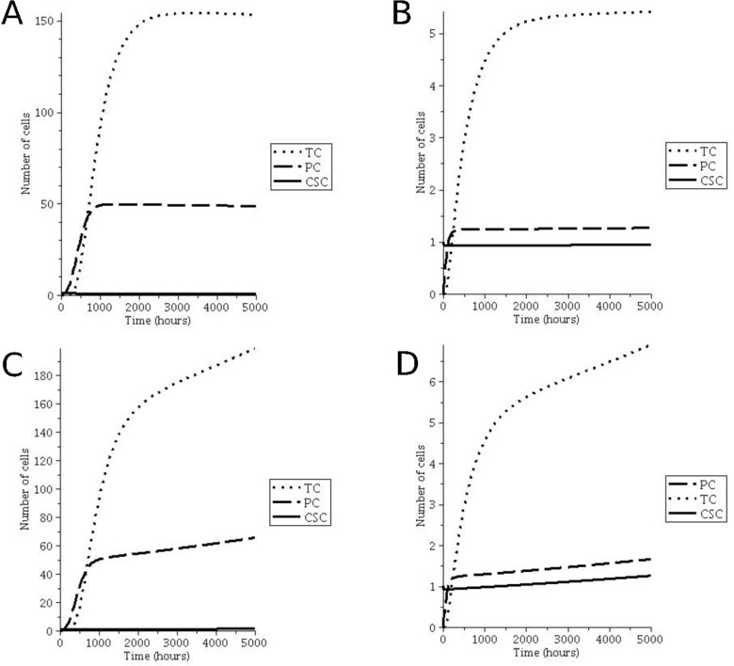

Fig. 2. Comparison of equilibrium conditions and expansion among Zhu’s model and our model. (A,B) Steady state condition of the tumor in which the number of CSCs, PCs, and TCs reach constant values. (C,D) Expansion of the three subpopulations over time.

Since we are interested to evaluate the level of similarity existing between the results published by Zhu and those derived by our model, we neglect in this phase, the drug effects. Figure 2 (A, C) show the dynamics of the three subpopulations using Zhu’s model, whereas Figure 2 (B, D) report the subpopulations trend ob- tained with our model. Panels A and B are obtained by setting the equilibrium conditions. Note that the qualitative behavior is similar, while the absolute values reached in equilibrium by the subpopulations are different. This difference is easy to explain since it is mainly due to the introduction of the feedback effect which is not represented in Zhu’s model.

6 Some of these parameters where reported with obvious typographical errors since they had in some cases wrong units of measurement. In Table at [http://compsysbio.di.unito.it/supplementary_material/](http://compsysbio.di.unito.it/supplementary_material/ODEModel.php) [ODEModel.php](http://compsysbio.di.unito.it/supplementary_material/ODEModel.php) we report the correct version of them.

On the other hand, in panels C and D are depicted the expansions of the three subpopulations obtained by relaxing the equilibrium conditions. The previous con- siderations concerning the qualitative and quantitative behaviors of the two models are valid also in this case. Indeed, decreasing the symmetric division probability value in Zhu’s model, it is possible to observe an expansion of CSCs population that leads to an increment of PCs and TCs. In our model, in order to observe a slow increment of all the three subpopulations, the self-renewal and feedback rates must be faster than those of death and dedifferentiation.

* 1. *Simulating the effect of atorvastatin on vaccination in breast cancer*

In this section we present the simulation results obtained when we take into ex- plicit consideration the drug effects. Note that, Zhu and coworkers perform some experiments in order to understand the tumor response to different treatments, but their preliminary approach consisted of the simulation of the drug effect by a rather simplistic increment of the death rates of PCs and TCs subpopulations.

Instead, we insert three specific parameters, one for each subpopulation, de- scribing a cancer therapy. We use our model to study the effect of the adjuvant treatment and the oncoantigen-driven vaccination on breast cancer.

The parameter set used in our model, without accounting for the drug effects, is retrieved by tuning the system to reach 35 TCs cells at 1000 hours. This value is derived by the tumor mass growth trend observed in mice after a subcutaneous injection of 100.000 cancer cells [Personal communication]. The resulting model calibration reveals a fast increment of TCs and PCs cells as reported in Figure 3 (A).

We use this model specification to simulate the vaccination effect on the tumor growth; note that the vaccination is performed at 2000 hours. **In particular, the** Θ3 **value is set in order to obtain a reduction of 50% of TCs in about 500 hours with respect to the normal tumor growth (see Figure** **3****, panel A). A mass reduction of 50% is resonable with respect to the decrement trend observed in vaccination experiments made on mice having tumors with 4 mm diameter**. Indeed, in Figure 3 (B) it is possible to observe a strong reduction in the number of TCs at 2000 hours. However, since the vaccination acts only on TCs, the CSCs follow the normal cancer growth and thus after 500 hours the increment of TCs increases again.

A different behavior is observable when we simulate the effect of atorvastatin on CSCs acting on the parameter Θ1 only. Atorvastatin is a cholesterol lowering drug with antileukemic effects [13]. *In vitro* experiment of atorvastatin effects suggests its role on the inhibition of CSCs functionalities. We set the value of Θ1 in order to obtain a reduction of 50% of CSCs which corresponds to the administration of 5*μ*M of drug. Panel 3(C) reports the atorvastatin effect given at 2000 hours: notice that the number of CSCs decreases and, as consequence, also the number of TCs, at 5000 hours, is less than 50% with respect to the normal condition of cancer growth. Finally, panel 3(D) reports the simulation of vaccine and atorvastatin treatment performed at the same time (2000 hours). Notice that in this case all the three

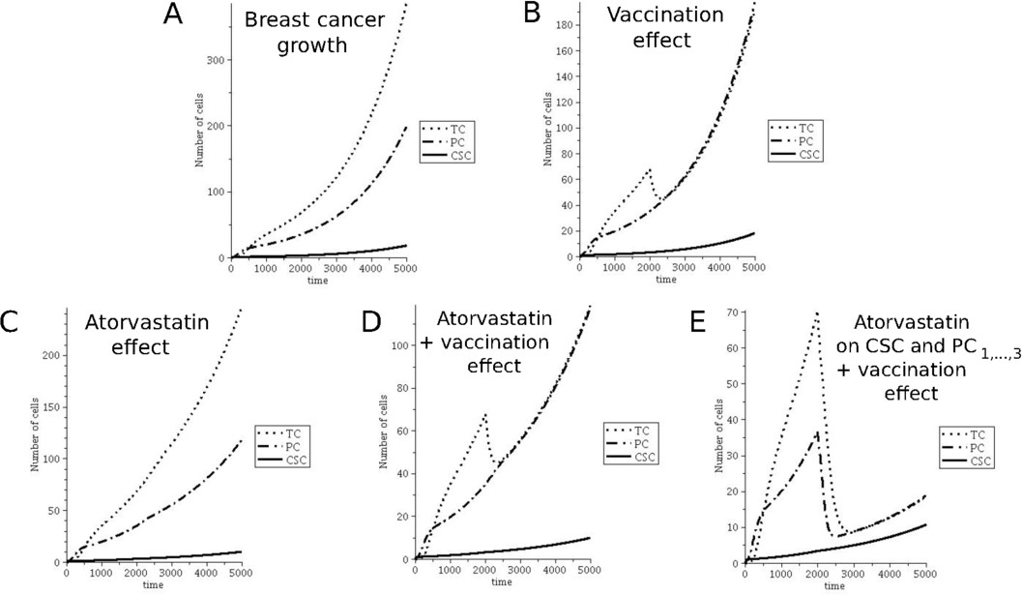

Fig. 3. Simulation of breast cancer growth without drugs (A), considering the ErbB2 vaccination effect (B), the effect of 5*μ*M of atorvastatin (C) and the combination of vaccination and atorvastatin (D); effect of atorvastatin on CSC and the first three generation of progenitor subpopulations in conjunction with vaccination(E)

subpopulations decrease: at 5000 hours the number of TCs is 44% and 68% less than vaccination only and atorvastatin therapy only, respectively.

Panel 3(E) reports the temporal behavior of the three subpopulations consider- ing the vaccination therapy and atorvastatin effect on both CSCs and PCs. Indeed, we add an additional effect of atorvastatin on the first three generations of PCs, which are able to generate CSCs by a feedback action. **We simulate this case** **properly setting** Θ2**, i.e. using** Θ2 */*=0 **for the first three PCs, and** Θ2 =0 **for the others** . It is worthwhile to note that if the atorvastatin effect involves also the first stages of PCs, the subpopulations increment after the administration is much slower with respect to the trend observed in plot D. These results are now under validation with in-vivo experiments concerning mice challenged with CSC and treated with vaccination and atorvastatin.

# Discussion and perspective

We present an ODEs system to describe the dynamics of the cancer cell subpopula- tions involved in the cancer type belonging to stem-differentiation hierarchy model. We first determine the values of the parameters that lead the system to an equilibrium behavior. Subsequently, we simulate the vaccination and drug therapy effects on the tumor growth. We plan to deeply study the effect of each parameter involved in the equilibrium of the system. Considering the key parameter groups defined in the paper, we would like to identify which parameters affect mostly the dynamics of subpopulations. We also plan to setup the vaccination protocol in

presence of increasing concentrations of Atorvastatin.

# References

1. Bomken, S., K. Fiser, O. Heidenreich and J. Vormoor, *Understanding the cancer stem cell*, British Journal of Cancer **103** (2010), pp. 439–445.
2. Chaplain, M., S. McDougall and A. Anderson, *Mathematical modeling of tumor-induced angiogenesis*, Annu.Rev.Biomed.Eng. **8** (2008), pp. 233–257.
3. Clarke, M., J. Dick, P. Dirks, C. Eaves, C. Jamieson, D. Jones, J. Visvader, I. Weissman and G. Wahl, *Cancer stem cells’ perspectives on current status and future directions: Aacr workshop on cancer stem cells.*, Cancer Res **66** (2006), pp. 9339–9344.
4. Dick, J. E., *Stem cell concepts renew cancer research*, Blood **112** (2008), pp. 4793–4807.
5. Frieboes, H., M. Edgerton, J. Fruehauf, F. Rose, L. Worrall, R. Gatenby, M. Ferrari and V. Cristini, *Prediction of drug response in breast cancer using integrative experimental/computational modeling.*, Cancer Res **60** (2009), pp. 4484–4492.
6. Gupta, P., C. Chaffer and R. Weinberg, *Cancer stem cells: mirage or reality?*, Nature Medicine **15**

(2009), pp. 1010–1012.

1. Gupta, P., T. Onder, G. Jiang, K. Tao, C. Kuperwasser, R. Weinberg and E. Lander, *Identification of selective inhibitors of cancer stem cells by high-throughput screening*, Cell **138** (2009), pp. 645–659.
2. Kang, K.-S. and J. E. Trosko, *Stem cells in toxicology: Fundamental biology and practical considerations*, Toxicological Sciences **120** (2010), pp. 269–289.
3. Li, X. and et al., *Intrinsic resistance of tumorigenic breast cancer cells to chemotherapy.*, J. Natl. Cancer Inst. **100** (2008), pp. 672–679.
4. Murray, J. D. T., “Mathematical Biology I: An Introduction.” Springer, 2002.
5. Pierre, N. V. T., “Dynamical Systems. An introduction with applications in Economics and Bilogy.” Springer-Verlag, 1992.
6. Reya, T., S. Morrison, M. Clarke and I. Weissman, *Stem cells, cancer, and cancer stem cells.*, Nature

**138** (2001), pp. 105–111.

1. Sassano, A., M. L. Iacono, G. Antico, A. Jordan, S. Uddin, R. Calogero and L. Platanias, *Regulation of leukemic cell differentiation and retinoid-induced gene expression by statins*, Molecular Cancer Therapy **8** (2009), pp. 615–625.
2. Sinek, J., S. Sanga, X. Zheng, H. Frieboes, M. Ferrari and V. Cristini, *Predicting drug pharmacokinetics and effect in vascularized tumors using computer simulation.*, J. Math. Biol. **58** (2009), pp. 485–510.
3. Turner, C. and M. Kohandel, *Investigating the link between epithelial-mesenchymal transition and the cancer stem cell phenotype: A mathematical approach*, Journal of Theoretical Biology **265** (2010),

pp. 329–335.

1. Woodward, W., M. Chen, F. Behbod, M. Alfaro, T. Buchholz and J. Rosen, *Wnt/beta-catenin mediates radiation resistance of mouse mammary progenitor cells*, Proc. Natl. Acad. Sci. **104** (2007), pp. 618– 623.
2. Zhu, X., X. Zhou, M. T. Lewis, L. Xia and S. Wong, *Cancer stem cell,niche and egfr decide tumor development and treatment response: A bio-computational simulation study*, Journal of Theoretical Biology **269** (2011), pp. 138–149.