HOSTE D BY

Available online at [www.sciencedirect.com](http://www.sciencedirect.com/science/journal/2314808X)

**ScienceDirect**

journal homepage: [http://ees.elsevier.com/ejbas/default.asp](http://http//ees.elsevier.com/ejbas/default.asp)

egyptian journal of basic and applied sciences 3 (2016) 94–10 5



**Full Length Article**

**Mathematical modeling of gas phase and biofilm phase biofilter performance**



***V. Meena*** ***a******, L. Rajendran*** ***b******,******\*******, Sunil Kumar*** ***c******, P.G. Jansi Rani*** ***b***

a *Department of Mathematics, Mangayarkarasi College of Engineering, Madurai 625018, Tamil Nadu, India*

b *Department of Mathematics, Sethu Institute of Technology, Virudhunagar 626115, Tamil Nadu, India*

c *Department of Mathematics, N I T, Jamshedpur 831001, Jharkhand, India*

A R T I C L E I N F O A B S T R A C T

*Article history:*

Received 24 May 2014 Received in revised form 28 September 2015

Accepted 29 September 2015

Available online 2 November 2015

*Keywords:*

Methanol Biofilters VOCs

Mathematical modeling

Non-linear differential equations Adomian decomposition method

In this paper, mathematical models of biofilteration of mixtures of hydrophilic (methanol) and hydrophobic (*α*-pinene) volatile organic compounds (VOC’s) biofilters were discussed. The model proposed here is based on the mass transfer in air–biofilm interface and chemi- cal oxidation in the air stream phase. An approximate analytical expression of concentration profiles of methanol and *α*-pinene in air stream and biofilm phase have been derived using the Adomian decomposition method (ADM) for all possible values of parameters. Further- more, in this work, the numerical simulation of the problem is also reported using the Matlab program to investigate the dynamics of the system. Graphical results are presented and dis- cussed quantitatively to illustrate the solution. Good agreement between the analytical and numerical data is noted.

© 2015 Mansoura University. Production and hosting by Elsevier B.V. This is an open access article under the CC BY-NC-ND license (<http://creativecommons.org/licenses/by->

nc-nd/4.0/).

# Introduction

Different cleaning technologies of gaseous effluents have been developed. Among these technologies, biological methods are increasingly applied for the treatment of air polluted by a wide variety of pollutants. Biofilteration is certainly the most com- monly used biological gas treatment technology. Biofilteration involves naturally occurring microorganisms immobilized in the form of biofilm on a porous medium such as peat, soil, compost, synthetic substances or their combination.

The medium provides to the microorganisms a hospitable environment in terms of oxygen, temperature, moisture, nu- trients and pH. As the polluted airstream passes through the filter-bed, pollutants are transferred from the vapor phase to the biofilm developing on the packing particles [1,2].

Recently Li et al. [3] as well as other research groups [4–10] have investigated emissions of VOCs into the atmosphere. Cur- rently, biological control processes have become an established technology for air pollution control. Biological control pro- cesses have many advantages over traditional methods such as lower operating fees and less secondary pollution, which

* *Corresponding author.* Tel.: +91 9442228951.

*E-mail address:* [raj_sms@rediffmail.com](mailto:raj_sms@rediffmail.com) (L. Rajendran).

<http://dx.doi.org/10.1016/j.ejbas.2015.09.007>

2314-808X/© 2015 Mansoura University. Production and hosting by Elsevier B.V. This is an open access article under the CC BY-NC-ND license ([http://creativecommons.org/licenses/by-nc-nd/4.0/).](http://creativecommons.org/licenses/by-nc-nd/4.0/))

egyptian journal of basic and applied sciences 3 (2016) 94–10 5 **95**

is rather true for the removal of readily biodegradable VOCs at low concentrations, so these processes are investigated largely and widely. Bioreactors for VOC removal can be classified as biofilters, bio scrubbers, biotrickling filters, or rotating drum biofilters, and choice of reactors should be based on many factors including the characteristics of the target VOCs [11–15]. In order to control the emission of volatile organic com- pounds (VOC) like methanol, *α*-pinene, etc. from industries, biofilters are being used nowadays instead of chemical complex absorption method [16–20]. Biofilters offer two major advan- tages to an energy-starved country like India. A mathematical model is describing the dynamic physical and biological pro- cesses occurring in a packed trickle-bed air biofilters to analyze the relationship between biofilter performance and biomass

accumulation in the reactor [4].

For the treatment of mixed VOCs [21–23], the presence of methanol and *α*-pinene in the air stream significantly influ- enced the removal of pollutants. The removal capacity for methanol and *α*-pinene per unit volume of the bed decreased linearly with increasing loading rates of methanol and *α*-pinene. The presence of this easily biodegradable compound sup- pressed the growth of the methanol and *α*-pinene degrading microbial community, thereby decreasing methanol and *α*-pinene removal capacity of the biofilters. Some researchers have studied the biofitration of pure methanol [24–26] and pure

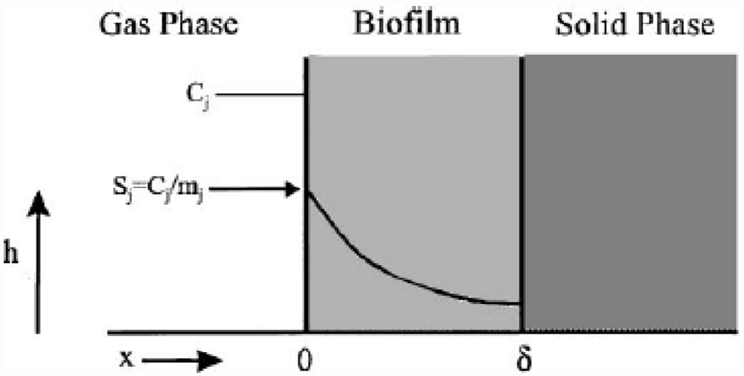

**Fig. 1 – Biophysical model for the biofilm structure on the biofilters packing materials and the concentration profiles across the biofilm.**

## *Mass balance in the biofilm phase*

The removal of methanol and *α*-pinene in the biofilm at steady state is described by the following system of non-linear dif- ferential equations (Mohseni and Allen [16]):

*D d*2*Sm*   *X *max*m**Sm*

*α*-pinene [27,28].

Recently, few researchers have studied the biofitration of

*em dx*2

*Ym K*

*m*  *Sm*

(1)

mixtures of pure methanol and pure *α*-pinene. Also a few re-

*D d*2*Sp*  **  *X *max *p**Sp*

(2)

searchers have tried to examine the treatment of mixtures of hydrophobic and hydrophilic VOCs and to understand the in-

*ep dx*2

*Yp K*

*p*  *Sp*

teractions between these compounds despite the fact that this situation exists in larger amount of air emissions. Mohseni and Allen [16] developed a mathematical model for methanol and *α*-pinene removal in VOC’s biofilteration. Lim et al. [29] devel- oped the steady state solution of biofilter model only for the limiting cases (first order and zero order kinetics). Also Lim et al. [30,31] obtained the non-steady solution of biofilter model using numerical methods. Recently some authors [32,33] solved the non-linear problems using fractional reduced differential trans- form method (FRDTM). To the best of our knowledge, to date,

where *Sm* and *Sp*represent the concentration of methanol and *α*-pinene respectively. **max, *K*, *Y*, *De* and *x* are maximum spe- cific growth rate, half saturation constant, yield coefficient, effective diffusion coefficient and the distance respectively. Sub- scripts *m* and *p* represent methanol and *α*-pinene respectively. The dry cell density in the biofilm *X* represents the overall popu- lation of microorganisms that consist of methanol and *α*-pinene degraders. The coefficient for the effect of methanol on *α*-pinene biodegradation is defined as follows:

a rigorous analytical expression of concentrations of sub- strate in the biofilm phase and air phase has been reported.

**  11  *Cm * *Ki* 2

(3)

The purpose of this communication is to derive approximate analytical expressions for the concentrations in both the phases using the Adomian decomposition method [34–40].

# Mathematical modeling of the boundary value problem

where *Ki* and *Cm* are the inhibition constant and the concen- tration of methanol in the air phase respectively. The boundary conditions are

*Sm*   *Cm*  *Sim* and *SP*   *CP*  *SiP* at *x*  0 (4)

*mm mP*

*dSm*  *dSP*  0 at *x*  ** (5)

The mathematical model relating the biofiltration of blends of hydrophilic and hydrophobic VOCs is based on the biophysi- cal model proposed by Mohseni and Allen [16]. It includes two main processes of diffusion of the compounds methanol and *α*-pinene through the biofilm and their degradation in the biofilm. Fig. 1 illustrates a schematic diagram of a single par- ticle, in the biofilter, covered with a uniform layer of biofilm in which the simultaneous biodegradation of methanol and

*dx dx*

## *Mass balance in gas phase*

The concentrations of methanol and *α*-pinene in the air, along the biofilter column, are described by

*α*-pinene takes place. The experimental setup for the biofilteration of this organic compound is given in Fig. 2.

*Ug dCm*  *AsDem*  *dSm* 

*dh*  *dx* *x*0

 

(6)

**96** egyptian journal of basic and applied sciences 3 (2016) 94–10 5

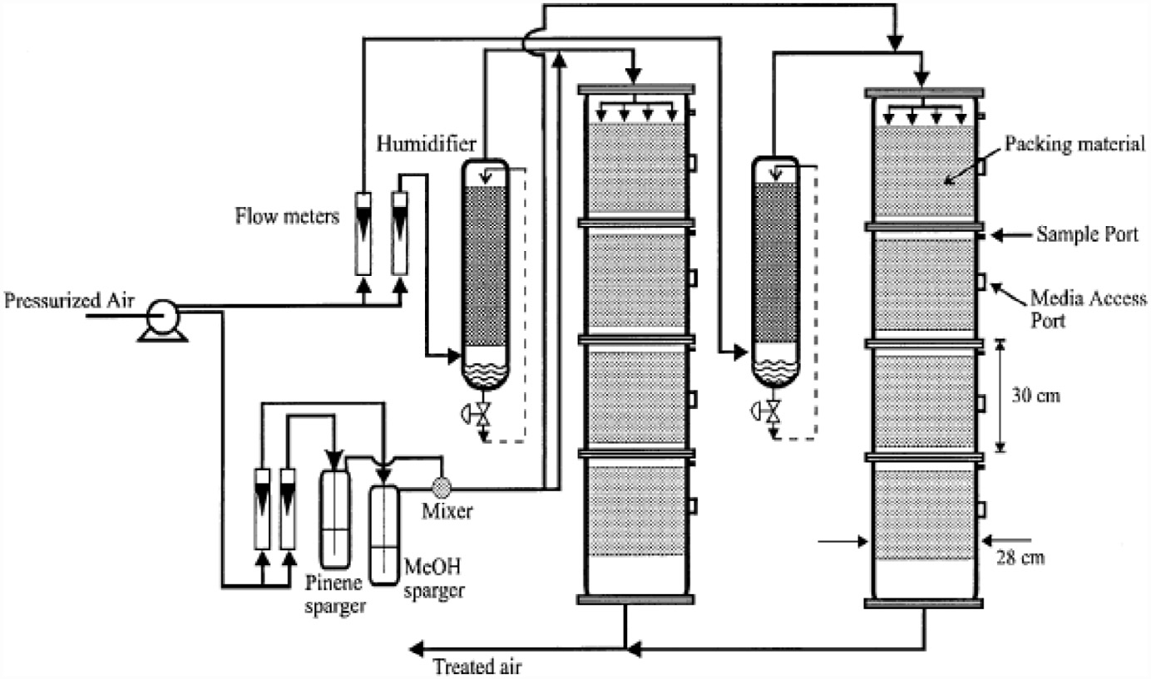

### Fig. 2 – Experimental setup for the bio filtration of methanol and *α*-pinene.

*Ug dCp*  *AsDep*  *dSmp* 

(7)

*Sm*\*  1, *Sp*\*  1 at *X*\*  0

(13)

*dh*

where *C*

 *dx* *x*0

*and C* represent the concentration of methanol and

*dSm*\*  *dSp*\*  0 at *X*\*  1 (14)

*m p dX*\*

*dX*\*

*α*- pinene in the air phase. *Ug*, *As*, *Dem*, *Dep* and *h* are the super- ficial gas velocity, biofilm surface area, effective diffusivity of methanol, effective diffusivity of *α*-pinene and position along the height of the biofilters respectively. The corresponding initial conditions are

*Cm*  *Cmi* and *Cp*  *Cpi* at *h*  0 (8)

*H C*

*p*

## *2.4. Dimensionless mass balance in the gas phase*

The differential Eqs. (6) and (7) are made dimensionless by de- fining the following parameters:

*A*  *HAsDemSim* , *A*

 *HAsDepSip* , *h*\*   *h* , *C*\*   *Cm* , *C*\*   *Cp*

where the subscript *i* represents the concentration of the VOCs at the biofilters inlet.

1

*Ug* *Cmi*

*Ug* *Cpi*

*m*

*mi*

*Cpmi* (15)

## *Dimensionless mass balance equation in the biofilm* phase

Using Eq. (15), Eqs. (6) and (7) can be expressed in the di- mensionless form as follows:

*dCm*\*  *dSm*\* 

The non-linear differential Eqs. (1) and (2) are made dimen- sionless by defining the following dimensionless parameters:

*dh*\*  *A*  *dX*\* 

*X* *0

 

(16)

*Sim*

*X *max*m* ** 2

*Sm*

*dCm*\* *p*

  *dS*\**p* 

**  , **1 

, *Sm*\* 

(9)

 ** *A*1  

(17)

*Km Ym*

*DemKm*

*Sim*

*dh*\*

 *dX*\* *X* *0

**  *Sip* , **

 *X *max *p* ** 2

, *S* *   *Sp*

The corresponding initial conditions for the above Eqs. (16)

*p Yp DepKp*

1

*K*

1

*p*

*Sip*

(10)

and (17) can be expressed as

Using the above dimensionless variables, Eqs. (1) and (2)

*Cm*\*   *Cm* and *C*\**p*  *Cmp* at *h*\*  0 (18)

reduce to the following dimensionless form:

*Cmi*

*Cpi*

*d*2*Sm*\*   *Sm*\* 

*dX*\*2  **  1  ** *S*\* 

(11)

 *m* 

*d*2*S*\**p*   *S*\**p* 

# Analytical expression for the concentration of methanol and *α*-pinene using the Adomian decomposition method (ADM)

2  **1  

(12)

*dX*\*

 1  **1*S*\**p* 

In recent years, many authors have applied the ADM [35–40]

The corresponding boundary conditions for the above Eqs.

(11) and (12) can be expressed as

to various problems and demonstrated the efficiency of the ADM for handling non-linear and solving various chemistry

egyptian journal of basic and applied sciences 3 (2016) 94–10 5 **97**

and engineering problems. Using ADM (refer to Appendix A),

*C*\* *h*\*  *Cm* *h*  1   *AsDemSim*

*X*max*m* tanh

*X*max*m* **

we can obtain the concentration of methanol and *α*-pinene in *m C*

*U Y D K*

*Y D K*

*mi g*

*m em m*

*m em m*

the biofilm phase (see Appendix B) as follows:

 1  *A * tanh

** *h*\* (27)

*S*\* *X*\*  *Sm* *x*  1 

*X*max*m*** 2

 *x*2

−  *x* 

*m S Y D* *K*  *S*   2** 2

** 

*Cp**h*

*A D S*

** *X* ** *X*

*im m em m im*

*C*\* *h*\* 

 1   *s ep ip*

max *p* tanh max *p* **

 1 

* * **  *X*\*2



− *X*\* 

*p*

(19)

*Cpi*

*Ug YpDepKp*

*YpDepKp*

1  **   2 



 1  *A*1

**1 tanh

**1 *h*\* (28)

*S*\* *X*\*  *Sp* *x*  1 

*X*max *p*** 2

 *x*2

−  *x* 

*p S Y D* *K*

*ip*

*p ep p ip*

 *S*   2** 2

**   

 1  * * **1  *X*\*2  *X*\* 

(20)

# Analytical solutions for the concentrations

1  **1   2 

Also solving Eqs. (6–7) and (16–17) using the analytical method, we can obtain the concentration of methanol and *α*-pinene in the air phase.

# of methanol and *α*-pinene for saturated (zero order) kinetics

Next we consider the limiting case where the substrate con- centrations of methanol and *α*-pinene in biofilm phase is

*C*\* *h*\*  *Cm* *h*

*m*

 1 

*AsX*max*m***

*h*  1 

*A*

*h*\* (21)

relatively high. In this case *Sm*  *Km* and *Sp*  *Kp* and Eqs. (1) and

1. reduce to the following form.

*Cmi*

*YmUgKm* 1  *Sim * *Km* 

1  ** 

*D d*2*Sm*   *X *

(29)

*C*\* *h*\*  *Cp* *h*  1  **  *AsX*max *p*** *h*  1  * * *A*1**1 *h*\* (22)

*em dx*2

*Y* max*m*

*Cpi*

*p*

*YpUgKp* 1  *Sip Kp* 

1  **1 

*m*

*D d*2*Sp*  **  *X *

(30)

*ep dx*2

*Y*

max *p*

*p*

# Analytical expression for the concentrations of methanol and *α*-pinene for

Then the analytical expressions for concentration of metha- nol and *α*-pinene in the biofilm phase are as follows:

# unsaturated (first order) kinetics

Now we consider the limiting case where the substrate con-

*Sm*\* *X*\* 

*Sm* *x* *Sim*

 1 

2*X*max*m* *x* 

*Ym DemSim*

*X*max*m* *x*2  1 

*Ym DemSim*

** *X*\*2  2*X*\*

(31)

**

centrations of methanol and *α*-pinene in biofilm phase are relatively low. In this case *Sm*  *Km* and *Sp*  *Kp*. Eqs. (1) and (2)

*S*\* *X*\*  *Sp* *x*

*S*

*p*

 1  2*X*max *p* *x*   *X*max *p* *x*2

*Y D S Y D S*

 1  **1 *X*\*2

**



− 2*X*\*

now reduce to the following form.

*ip p ep ip*

*p ep ip*

1

(32)

*D d*2*Sm*   *X*max*m* *S*

(23)

Using Eqs. (6–7) and (31–32), we obtain the analytical ex-

*em dx*2

*m*

*YmKm*

pression of the concentrations of methanol and *α*-pinene in the air phase.

*D d*2*Sp*  **  *X*max *p* *S*

(24)

*C* *h*

2*X* *A * *h*

2*A*

*ep dx*2

*p*

*YpKp*

*Cm*\* *h*\* 

*m*

*Cmi*

 1 

max*m* *s*

*YmUg*

 1 

** *h*\*

(33)

The analytical expression for concentrations of methanol and *α*-pinene in the biofilm phase becomes

*C*\**p* *h*\*  *Cp* *h*  1  2** *X*max*p**As* *h*  1  2** *A*1**1 *h*\*

(34)

*Sm* *x*

cosh





*X*

max*m*



*YmDemKm*

*x*  ** 







cosh





*X*max*m* 



*YmDemKm*

**





cosh ** *X*\*  1

*Cpi*

*YpUg *1

*Sm*\* *X*\* 



*Sim*

 ** *X*max



cosh



**



(25)

# Removal ratio of methanol and *α*-pinene

The percentage of the methanol removal ratio is

cosh 

 *p* *x*  ** 

*S*\* *X*\*  *Sp* *x*     *YpDepKp*   cosh **1 *X*\*  1



*C*\*  *C*\*

*p S* 

** *X* 

cosh **

*mi mf*

*ip* cosh 

max *p* ** 

1 methanol*R* 

*C*\*

 100 (35)

 *YpDepKp* 

(26) *mi*

Using Eqs. (6–7) and (25–26) we obtain the analytical ex- pression of the concentrations of methanol and *α*-pinene in the air phase.

where *Cm*\* *i* and *Cm*\* *f* are the initial (before treatment) and the final (after treatment) concentrations of methanol in the air phase, respectively. The percentage of the *α*-pinene removal ratio is

**98** egyptian journal of basic and applied sciences 3 (2016) 94–10 5

**  pinene*R*

 *C*\**pi*  *C*\**pf*  100 (36)

*C*\**pi*

Fig. 5a, b shows the dimensionless concentration of metha- nol *Cm*\* versus dimensionless height *h*\*. From Fig. 5a, it is described that the concentration of methanol slowly reaches

where *C*\**pi* and *C*\**pf* are the initial (before treatment) and the final (after treatment) concentrations of *α*-pinene in the air phase respectively.

# Numerical simulation

In order to investigate the accuracy of the ADM solution with a finite number of terms, the system of differential equa- tions was solved numerically. To show the efficiency of the present method, our analytical results are compared with nu- merical results graphically. The analytical solution of the concentrations of methanol and *α*-pinene in air phase and biofilm phase are compared with simulation results in Figs. 3–6. Upon comparison, it gives a satisfactory agreement for all values

of the dimensionless parameters *Sm*\*, *Sp*\*, *Cm*\* and *C*\**p*. The de- tailed Matlab program for numerical simulation is provided in Appendices C and D.

# Results and discussion

Eqs. (19–22) represent the simple and new analytical expres- sion of the concentrations of methanol and *α*-pinene in biofilm

the constant when the biofilm thickness or φ increases. In

Fig. 5b, it is labeled that the concentration of methanol de- creases when half saturation constant of methanol *β* decreases for the fixed value of other parameter.

Fig. 6a, b demonstrates the concentration of *α*-pinene *C*\**p* in the air phase versus dimensionless height *h*\*. From Fig. 6a, it is inferred that the concentration of *α*-pinene slowly reaches

a constant level when the diffusion coefficient φ1 increases for

the fixed value of other parameter. In Fig. 6b, it is labeled that the concentration of *α*-pinene attains the steady state values when the initial concentration of *α*-pinene  **1  increases.

Fig. 7 shows the profile of dimension concentration of methanol and *α*-pinene in the air phase versus height *h* for some fixed value of the parameters. From these figures it is inferred that the concentration is linearly proportional to the

height of the biofilter. And also the concentration of *Cm*\* and *C*\**p* decrease when the height of the biofilter increases. Fig. 8a, b illustrates the removal ratio of methanol and *α*-pinene in the

air phase. From this figure it is observed that the removal ratio

is directly proportional to the inlet loading. Our analytical results are compared with the experimental result and excellent agree- ment is noted.

phase *Sm*\*, *Sp*\* and in the air phase *Cm*\*, *Cp*\*respectively. The con-

centrations of methanol and *α*-pinene in the biofilm phase and the air phase depend upon the parameters *φ* and *β*. The varia- tion in the dimensionless variable *φ* can be achieved by varying either the thickness or dry cell density of the biofilm. The pa- rameter *β* depends upon the initial concentration and half saturation constant.

Fig. 3 represents the concentration of methanol *Sm*\* in the biofilm phase versus dimensionless distance *X*\* for different values of *φ* and *β*. From Fig. 3a, b, it is inferred that the con- centration of methanol increases when the initial concentration of methanol *β* increases for the fixed values of *φ*. For large value of dimensionless parameter *β*, the concentration of methanol remains constant. In Fig. 3c, d, we present the con- centration of methanol in the biofilm phase for various values of *φ* and for some fixed values of *β*. Maximum specific growth rate of methanol biodegradation *φ* decreases the concentra- tion of methanol slowly and reaches the constant level. The

minimum value of *Sm*\* *X*\* and *S*\**p* *X*\* are 1  ** 2 1  **  and

1  **1 2 1  **1  respectively.

Fig. 4 exhibits the concentration of *α*-pinene *Sp*\* in the biofilm phase versus dimensionless distance *X*\* for different values of **, **1 and **1. From Fig. 4a, b, it is inferred that the con- centration of *α*-pinene increases when the initial concentration of *α*-pinene  **1  increases for the fixed values of dry cell density *φ*1. For large value of *β*1, the concentration of *α*-pinene is uniform. In Fig. 4c, d, we show that the concentration of *α*-pinene in the biofilm phase for various values of cell density *φ*1 and for some fixed values of dimensionless parameter *β*1. From this figure, we conclude that the concentration of

*α*-pinene *Sp*\* increases when thickness of the film decreases. The concentration of *α*-pinene is equal to one *Sp*\*  1 when

# Conclusion

In this paper, the non-linear differential equations in biofiltration model have been solved analytically. Approxi- mate analytical expressions pertaining to the concentrations of methanol and *α*-pinene in the biofilm phase for all the values of parameters are obtained using the Adomian decomposi- tion method. This solution of the concentrations of methanol and *α*-pinene in the biofilm phase and air phase are com- pared with the numerical simulation results. This model is also validated using experimental results. These analytical results provide a good understanding of the system and the optimi- zation of the parameters in biofiltration model.

# Acknowledgements

This work was supported by the Department of Science and Technology (DST) (No. SB/S1/PC-50/2012). The authors are thank- ful to The Principal, The Madura College, Madurai and The Secretary, Madura College Board, Madurai for their encouragement.

# Appendix A: Basic concepts of the Adomian decomposition method (ADM)

Consider the non-linear differential equation

** 2 1  **   2 .

*y*  *N*  *y*  *g* *x*

#### (A.1)

egyptian journal of basic and applied sciences 3 (2016) 94–10 5 **99**

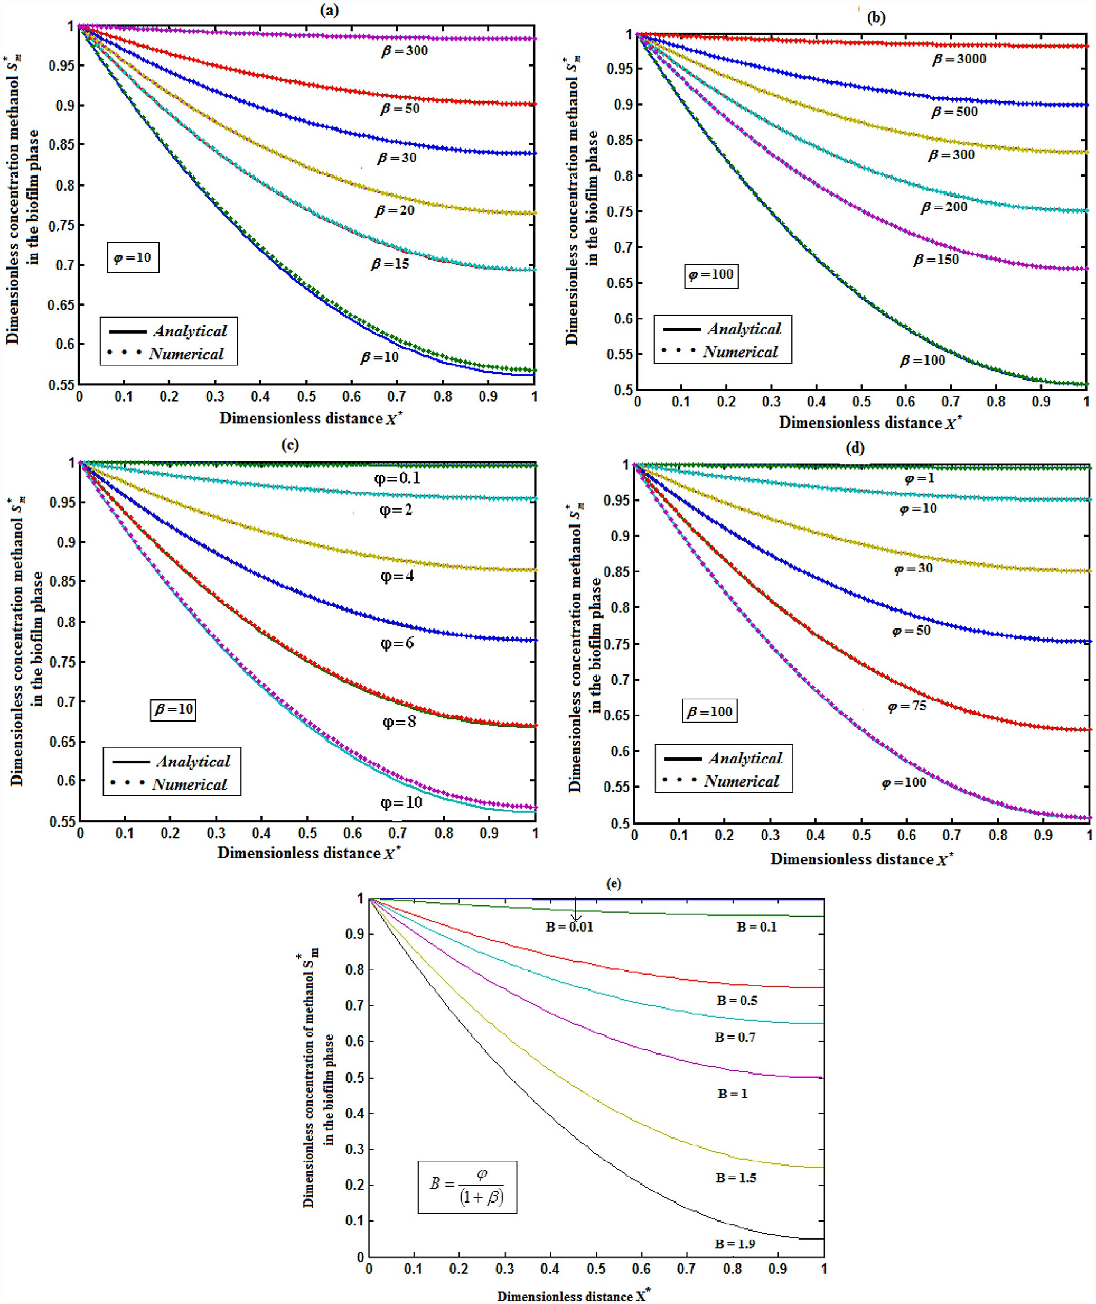

### Fig. 3 – Dimensionless methanol concentration *Sm*\* in the biofilm phase versus dimensionless distance *X*\* for the various values of the parameters *β* and *φ*. When (a) *φ* = 10, (b) *φ* = 100 for various values of the parameter *β* and (c) *β* = 10, (b) *β* = 100 for various values of the parameter *φ*. The key to the graph: solid line represents Eq. (19) and the dotted line represents the

**numerical simulation.**

**100** egyptian journal of basic and applied sciences 3 (2016) 94–10 5

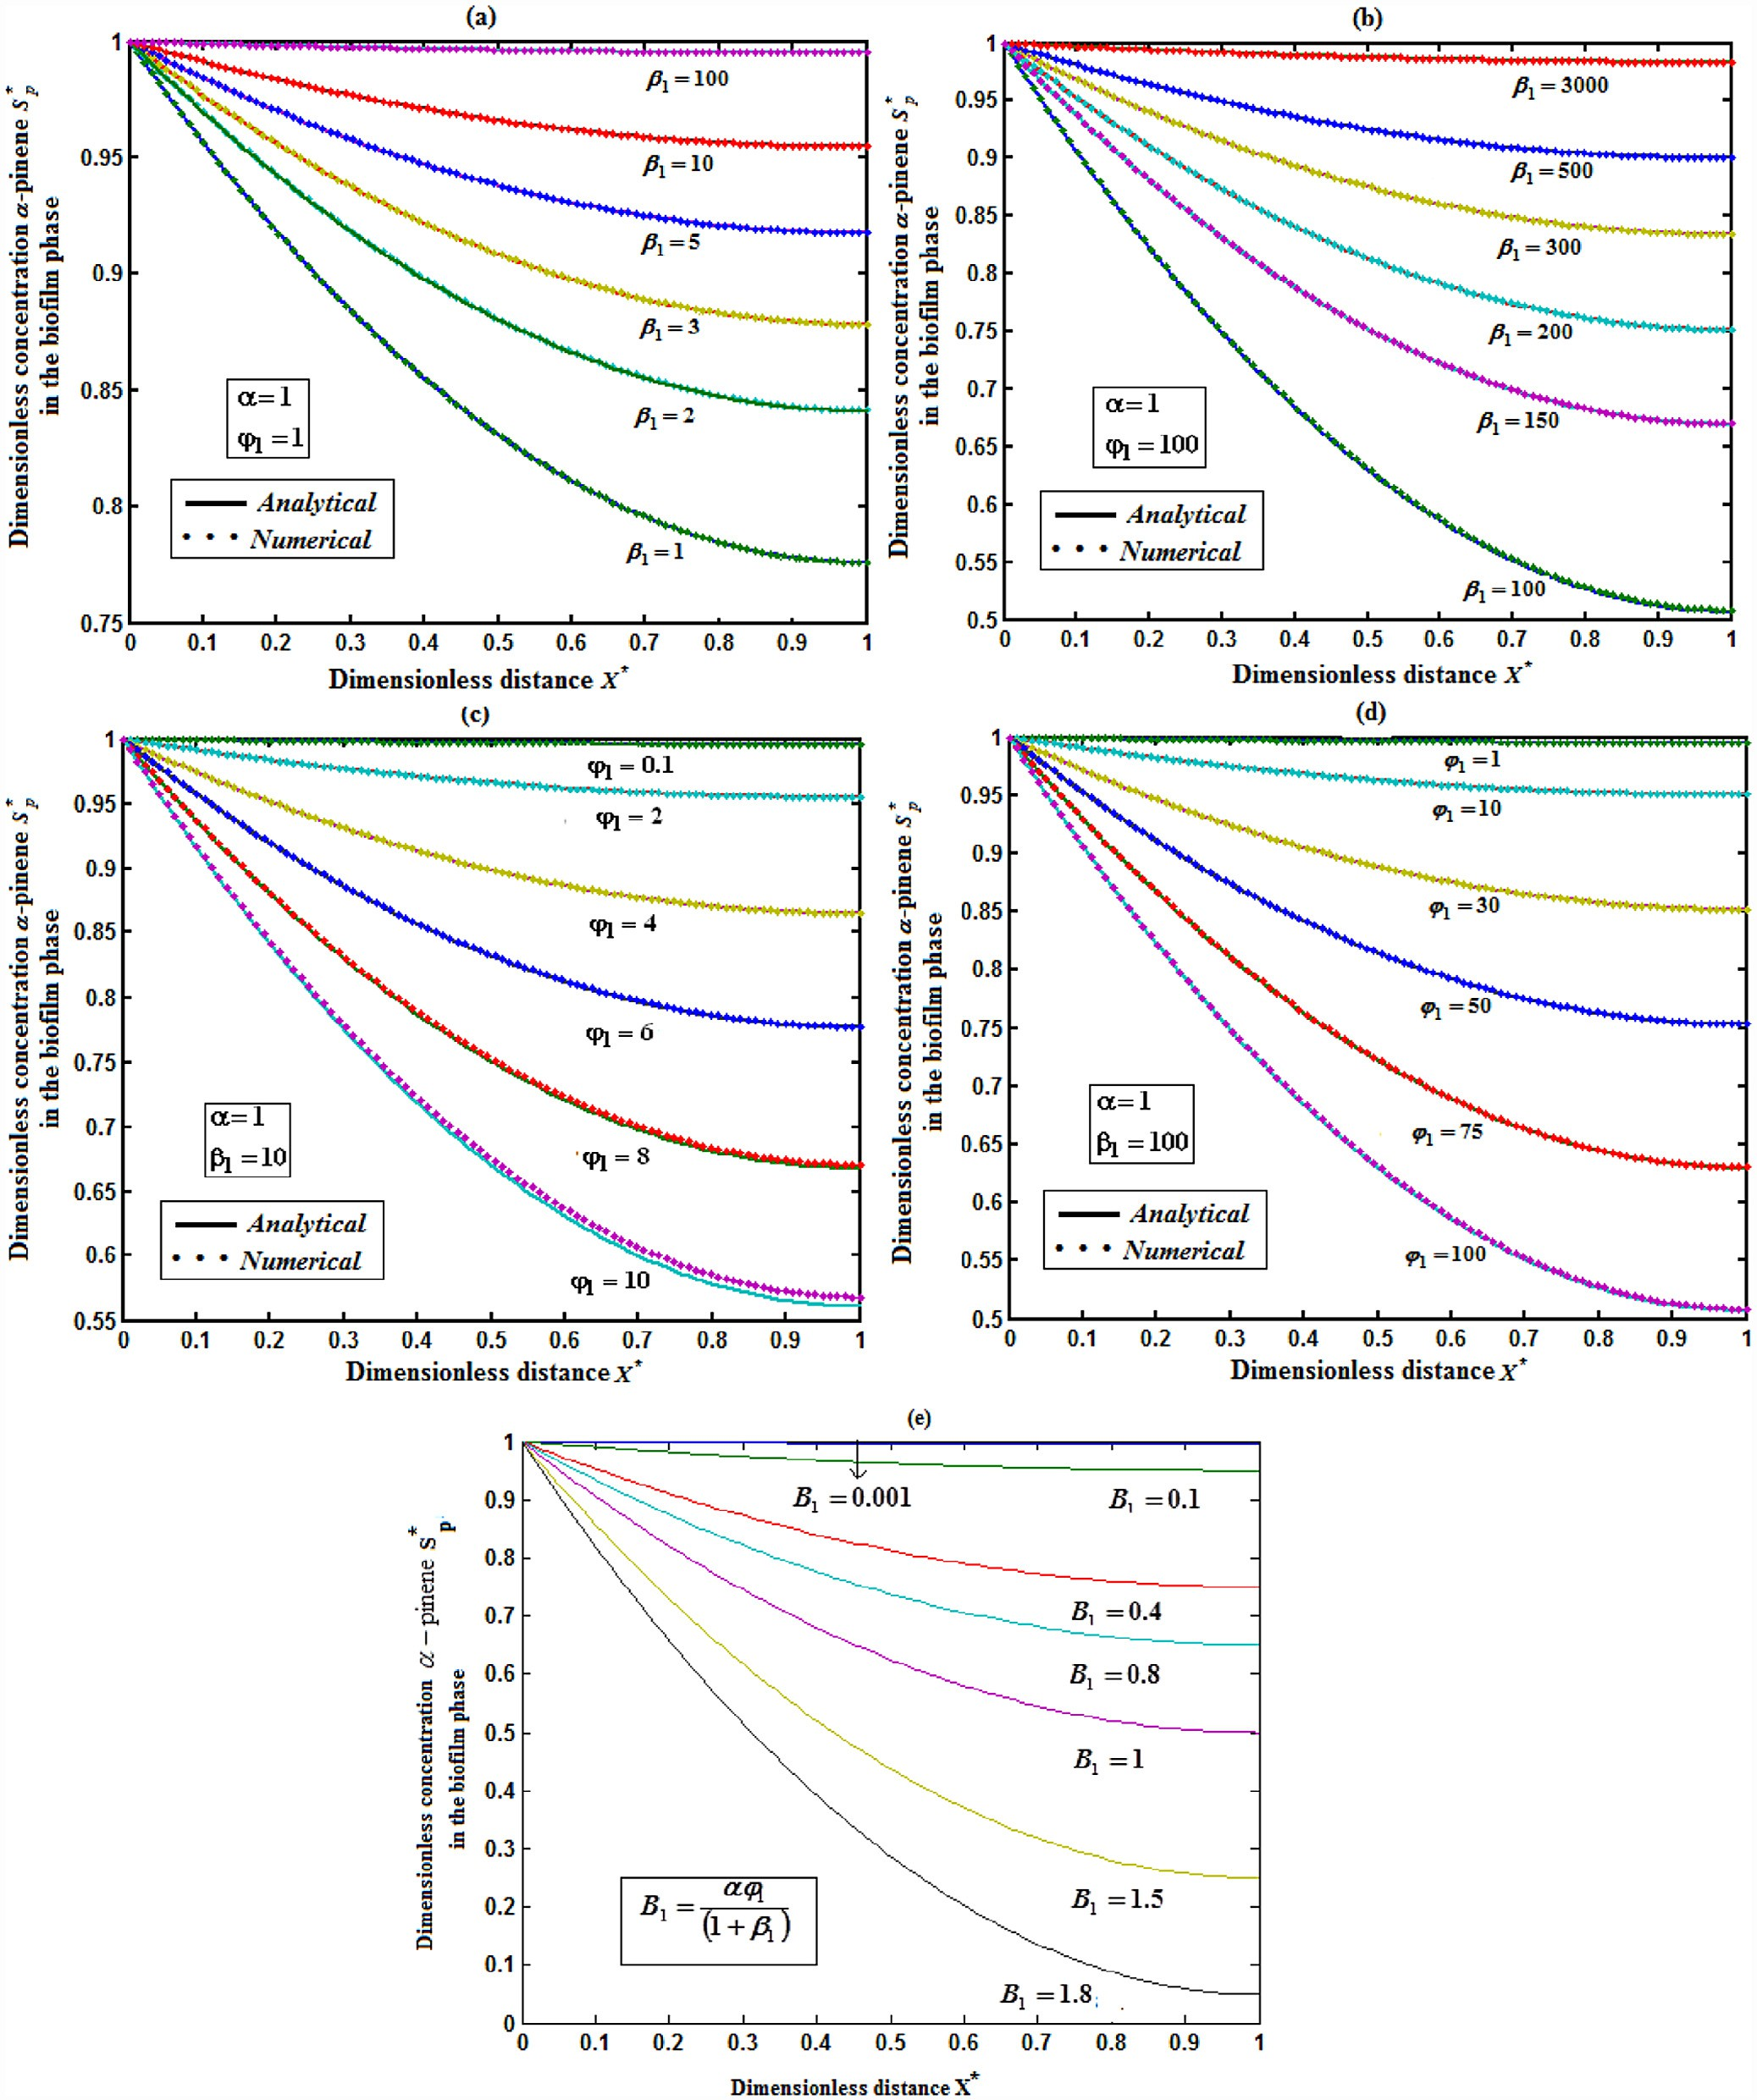

### Fig. 4 – Dimensionless *α*-pinene concentration *S*\**p* in the biofilm phase versus dimensionless distance *X*\* for the parameters

**, **1 and **1 **. The parameter *α* = 1 is fixed, when (a) *φ*1 = 1, (b) *φ*1 = 100 for various values of the parameter *β*1 and (c) *β*1 = 10, (b) *β*1 = 100 for various values of the parameter *φ*1.The key to the graph: solid line represents Eq.** **(20)** **and the dotted line represents the numerical simulation.**

egyptian journal of basic and applied sciences 3 (2016) 94–10 5

**101**

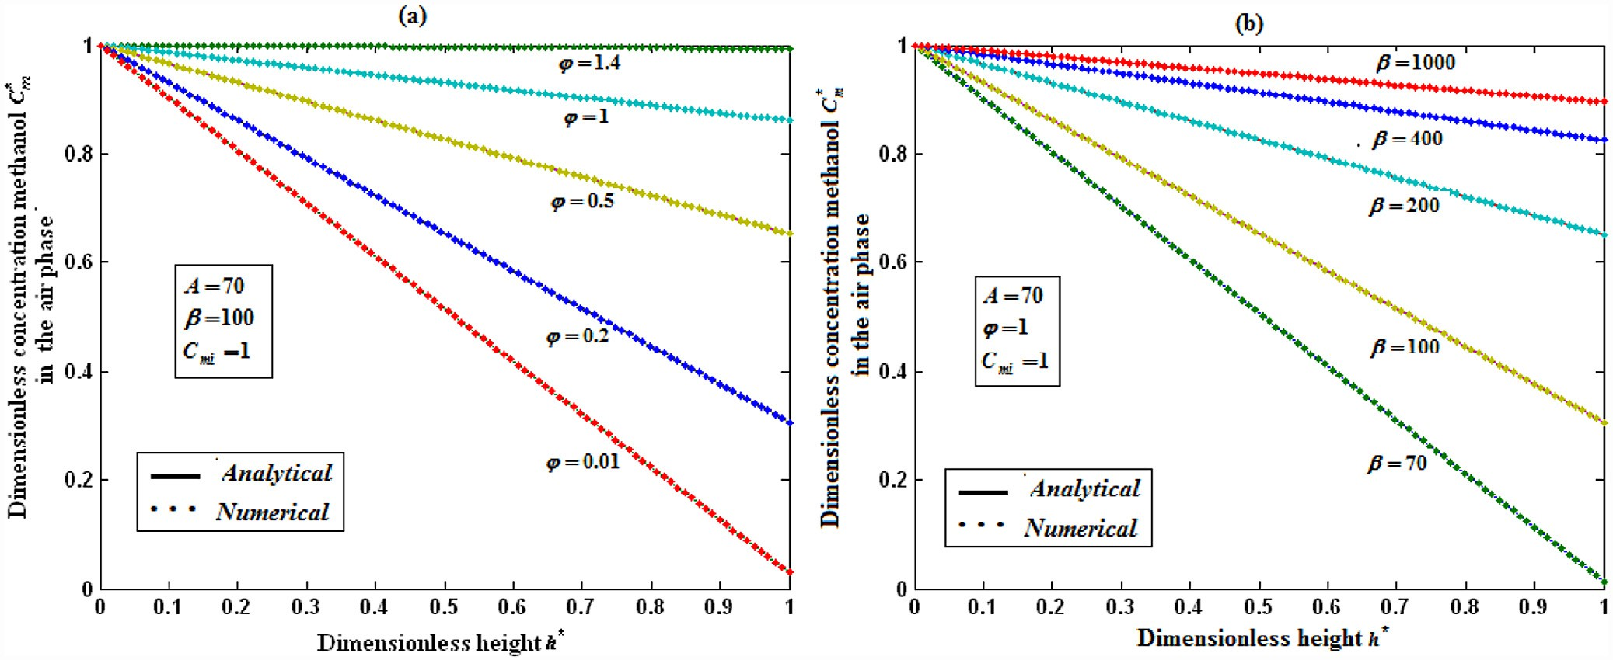

### Fig. 5 – Dimensionless methanol concentration *Cm*\* in the air phase *v*ersus dimensionless height *h*\* for some fixed values of the parameters *A*  70 and *Cmi*  1 . When (a) *β* = 100 for various values of the parameter *φ* and (b) *φ* = 1 for various values of the parameter *β*. The key to the graph: solid line represents Eq. (21) and the dotted line represents the numerical simulation.

with boundary conditions

*y* 0  *A*, *y* *b*  *B*

#### (A.2)

*L*  *y*  *g* *x*  *N*  *y* (A.4)

The inverse operator *L*1 is therefore considered as a two- fold integral operator (Duan and Rach [37]), as below

where *N*(*y*) is a non-linear function, *g*(*x*) is the given function

and *A*, *B* and *b* are given constants. We propose the new dif-  *x x*

ferential operator, as below

*L* 1 .   .*dxdx*

0 *b*

#### (A.5)

*L*  *d*2 *dx*2

So, Eq. (A.1) can be written as

#### (A.3)

Applying the inverse operator *L*1 on both sides of Eq. (A.4) yields

*y* *x*  *L*1 *g* *x*  *L*1 *N*  *y*  *y**b**x*  0  *y* 0, (A.6)

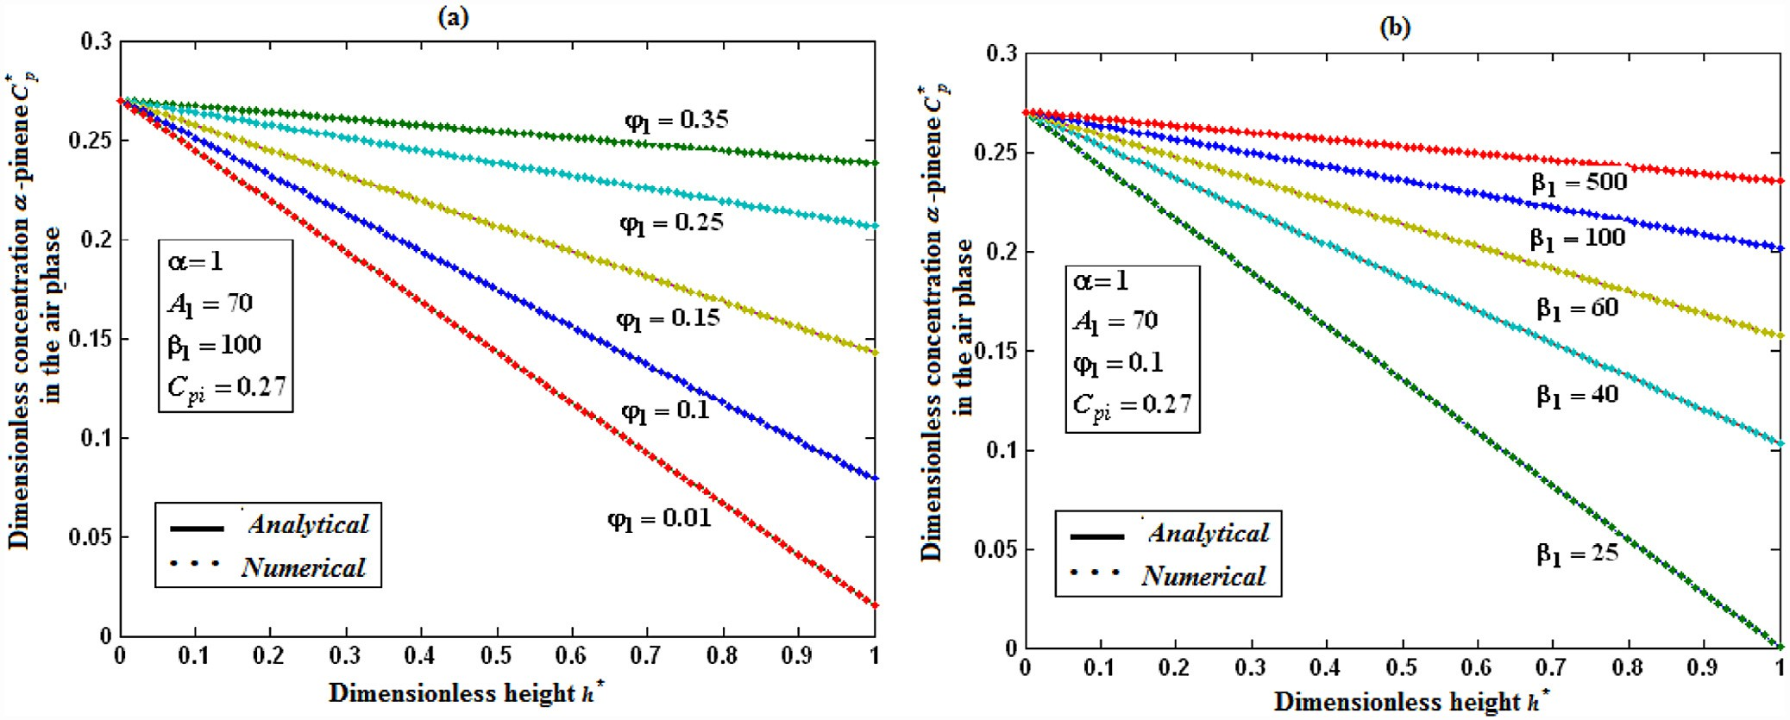

### Fig. 6 – Dimensionless *α*-pinene concentration *C*\**p* in the air phase versus dimensionless height *h*\* for some fixed values of the parameters **  1, *A*1  70, and *Cpi*  0.27. When (a) *β*1 = 10 for various values of the parameter *φ*1 and (b) *φ*1 = 0.1 for various values of the parameter *β*1.The key to the graph: solid line represents Eq. (22) and the dotted line represents the numerical

**simulation.**

**102** egyptian journal of basic and applied sciences 3 (2016) 94–10 5

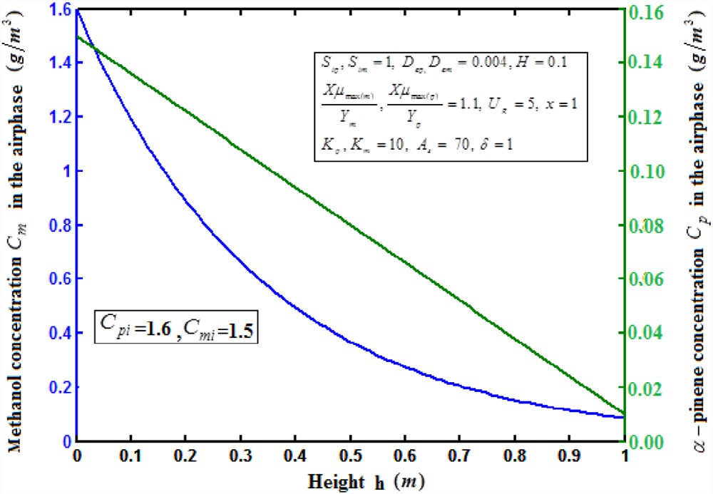where the components *yn*(*x*) of the solution *y*(*x*) will be deter- mined recurrently and the Adomian polynomials *An* of *N*(*y*) are evaluated using the formula

*A* *x*  1

*dn N*   *ny* 

#### (A.10)

*n n*! *dn*



 

*n*  0

*n* 

**  0

which gives

*A*0  *N*  *y*0 ,

*A*1  *N* *y*0  *y*1,

*A*2  *N* *y*0  *y*2  1 *N* *y*0  *y*2,

2 1

*A*3  *N* *y*0  *y*3  *N* *y*0  *y*1*y*2  1 *N* *y*0  *y*3,.

#### (A.11)

3! 1

⁝

### Fig. 7 – Dimension methanol and *α*-pinene concentrations

***Cm* and *Cp* in the air phase versus the height h using the values of the parameters** *Sim*, *Sip*  1, *Dem*, *Dep*  0.004, *Km*, *Kp*  10,

By substituting Eqs. (A.8) and (A.9) in Eq. (A.7) gives

◎ *y*  *L*1 *g* *x*  *L*1   *A*   *Ax*  *B*



### respectively. The solid line represents Eqs. (21–22).

 *n*

*n*  0

 

*n*  0

*n* 

#### (A.12)

Using the boundary conditions Eq. (A.2), Eq. (A.6) becomes

Then equating the terms in the linear system of Eq. (A.11) gives the recurrent relation

*y* *x*  *L*1 *g* *x*  *L*1 *N*  *y*  *Bx*  *A*

#### (A.7)

*y*0  *L*1 *g* *x*  *Bx*  *A*, *yn*1  *L*1  *An* , *n*  0

#### (A.13)

The Adomian decomposition method introduces the solu- tion *y*(*x*) and the non-linear function *N*(*y*) by infinite series

which gives

*y*0  *L*1 *g* *x*  *Ax*  *B*,

◎

*y* *x*  *y* *x*

#### (A.8)

*y*1  *L*1  *A*0 ,

and

 *n*

*n*  0

*y*2  *L*1  *A*1 ,

*y*3  *L*1  *A*2 ,.

⁝

#### (A.14)

◎

*N*  *y*   *An*

*n*  0

#### (A.9)

From Eqs. (A.11) and (A.14), we can determine the compo- nents *yn*(*x*), and hence the series solution of *yn*(*x*) in Eq. (A.7) can be immediately obtained.

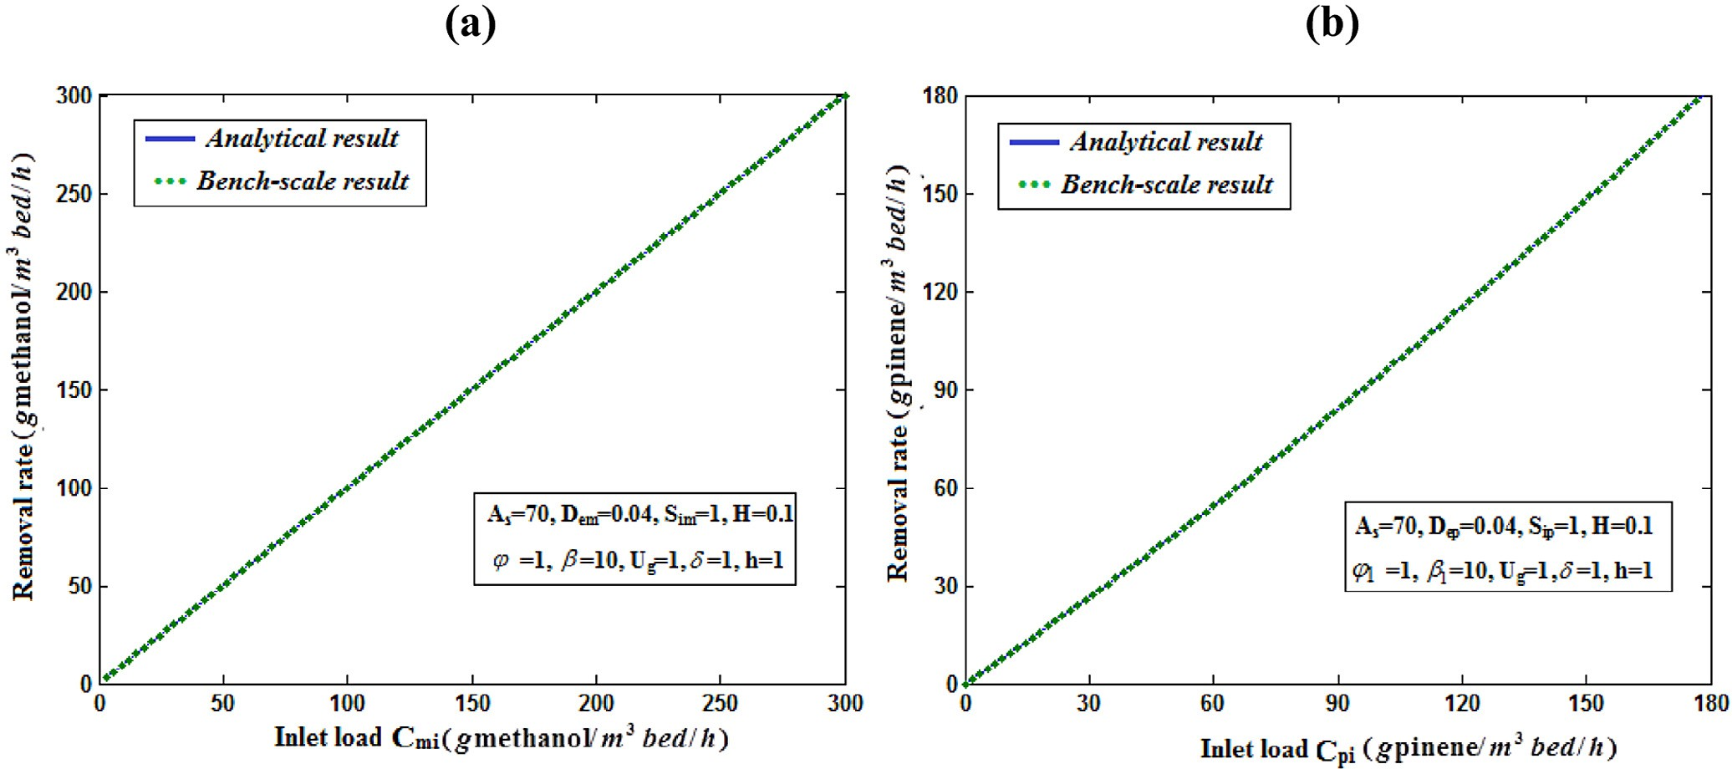

### Fig. 8 – (a) The methanol removal ratio methanol*R* versus inlet load *Cmi* for some fixed values of the parameters

*As*  70, *Dem*  0.04, *Sim*  1, *H*  0.1, **  1, **  10, *Ug*  1, **  1, , *h*  1 **. The graph is plotted using Eq.** **(35)****. (b) The *α*-pinene removal ratio** **  pineneR **versus inlet load** Cpi **for some fixed values of the parameters**

*As*  70, *Dem*  0.04, *Sim*  1, *H*  0.1, **1  1, **1  10, *Ug*  1, **  1, , *h*  1 **. The graph is plotted using Eqn.** **(36)****.**

egyptian journal of basic and applied sciences 3 (2016) 94–10 5

**103**

# Appendix B: Analytical solution of Eqs. (11) and (12)

In this appendix, we have derived the solution of Eqs. (11) and

(12) using the Adomian decomposition method. Eq. (11) can be written with the operator form

# Appendix C: Matlab program for the numerical solution of Eqs. (11) and (12)







*L*(*Sm*\* )  *N*(*Sm*\* )

#### (B.1)

wherethe differential operator *L*  *d*2 and *N*(*S*\* )   *Sm*\*

*m*

*dX*\*2 1  ** *Sm*\*

#### (B.2)

*x* * *x* *

Applying the inverse operator *L*1 .    .*dX*\**dX*\* on both 

0 1

sides of Eq. (B.1) yields

*S*\* *X*\*  *AX*\*  *B*  *L*1  *Sm*\* 

*m*









#### (B.3)

1  ** *Sm*\* 

Where *A*  *Sm*\* 1 and *B*  *Sm*\* 0. We let,

◎

*Sm*\* *X*\*  *Sm*\* *n* *X*\*

*n*0

*N*[*S*\* *X*\*]   *Sm*\*   *A*

*m*



#### (B.4)

(B.5)

1  ** *Sm*\*

*n*

*n*0

In view of Eqs. (B.4) and (B.5), Eq. (B.3) gives

◎

*Sm*\* *n*

*n*0

◎

*X*\*  *AX*\*  *B*  *L*1  *An*

*n*0

#### (B.6)

We identify the zeroth component as

*Sm*\* 0 *x*\*  *AX*\*  *B*

#### (B.7)

# Appendix D: Matlab program for the numerical solution of Eqs. (16) and (17)

and the remaining components as the recurrence relation

*Sm*\* *X*\*  *L*1*An*, *n*  0

*n*1

#### (B.8)



where *An* are the Adomian polynomials of *Sm*\* 1, *Sm*\* 2 ⋯ *Sm*\* *n*. We can find the first few *An* as follows:



*A*0  *N*(*Sm*\* 0 )   *Sm*\* 0

1  ** *Sm*\* 0

#### (B.9)

*A*1   *d* [*N*(*Sm*\* 0  *Sm*\* 1 )]

*d*

** 0

  *Sm*\* 1

1  ** 2

#### (B.10)



The remaining polynomials can be generated easily, and so, 

*Sm*\* 0 *X*\*  1

#### (B.11)

*S*\* *x*\*  * * **  *X*\*2  *X*\* 

*m*1 1  **   2 

#### (B.12)

Adding (B.11) and (B.12), we get Eq. (19) in the text. Simi-

larly, we can apply the above method to find the solution of  Eq. (12). Higher order iteration will be considered to improve

the accuracy of the results.

**104** egyptian journal of basic and applied sciences 3 (2016) 94–10 5

# Appendix E: Nomenclature

Symbols Definitions Units

*m*2 *m*3 *g m*3 *g m*3 *g m*3 *g m*3 *m*2 *h*

*m*2 *h*

As Biofilm surface area per unit volume of the biofilters

Cm Concentration of methanol in the air stream

*Cmi* Concentration of methanol in the inlet air stream

Cp Concentration of *α*-pinene in the air stream

*Cpi* Concentration of *α*-pinene in the inlet air stream

*Dem* Effective diffusivity of methanol in the biofilm

*Dep* Effective diffusivity of *α*-pinene in the biofilm

h Dimension along the height of the biofilters m

H Total height of the biofilters m

Ki Inhibition constant for *α*-pinene in the presence of methanol *g m*3

Km Half saturation constant of methanol in Monod kinetics obtained from differential biofilters experiments

*g m*3

Kp Half saturation constant of *α*-pinene in Monod kinetics *g m*3

mm Air/biofilm partition coefficient for methanol, dimensionless –

mp Air/biofilm partition coefficient for *α*-pinene, dimensionless -

Sm Concentration of methanol in the biofilm *g m*3

Sp Concentration of *α*-pinene in the biofilm *g m*3

Ug Superficial velocity of air through the biofilters m/s

X Dry cell density of the biofilm *kg m*3

Y Organic carbon content of the biofilm *g g*

Ym Biomass yield coefficient for methanol *kg cellkg* methanol

Yp Biomass yield coefficient for *α*-pinene kg/cell/kg *α*-pinene

*Sm*   *Cm*  *Sim mm*

*Sp*   *Cp*  *Sip mp*

Initial concentration of methanol in the biofilm *g m*3

Initial concentration of *α*-pinene in the biofilm *g m*3

L Linear operator

An Adomian polynomial

Greek letters

*α* Coefficient for the effect of methanol on *α*-pinene biodegradation, – dimensionless

δ Biofilm thickness m

**max*m* Maximum specific growth rate for methanol biodegradation *h*1

**max *p* Maximum specific growth rate for *α*-pinene biodegradation h−1

ρb Density of the biofilm kg/m3

Dimensionless Parameters:

**  *Sim*

*Km*

**  *X*max*m* ** 2

Dimensionless constant of methanol in Monod kinetics obtained from – differential biofilters experiments

*Ym*

*X*\*   *x*

**

*DemKm*

Dimensionless parameter –

Dimensionless coordinate in dry cell density of the biofilm –

*Sm*\*   *Sm*

*Sim*

Dimensionless concentration of methanol in the biofilm –

**1  *Sip*

*Kp*

**  ** *X*max*m* ** 2

Dimensionless constant of *α*-pinene in Monod kinetics obtained from – bench-scale biofiltration results

1

*Sp*\*   *Sp*

*Sip*

*Ym DemKm*

Dimensionless parameter –

Dimensionless concentration of *α*-pinene in the biofilm –

*A*  *HAsDemSim*

*Ug* *Cmi*

*A*1  *HAsDepSip*

*Ug* *Cpi*

Dimensionless parameter –

Dimensionless parameter –

*Cmi*

|  |  |  |
| --- | --- | --- |
| *Cm*\*   *Cm* | Dimensionless concentration of methanol in the air stream | – |
| *C*\**p*   *Cp* | Dimensionless concentration of *α*-pinene in the air stream | – |
| *Cm*\* *i Cpi* | Initial (before treatment) concentration of methanol | – |
| *Cm*\* *f* | Finial (before treatment) concentration of methanol | – |
| *C*\**pi* | Initial (before treatment) concentration of *α*-pinene | – |
| *C*\**pf* | Initial (before treatment) concentration of *α*-pinene | – |
| *h*\*   *h* | Dimensionless along the height of the biofilters | – |

*H*

egyptian journal of basic and applied sciences 3 (2016) 94–10 5

**105**

R E F E R E N C E S

1. [Ottengraf SPP. Biological system for waste gas elimination.](http://refhub.elsevier.com/S2314-808X(15)00069-X/sr0010) [Tibtech 1987;5:132–6.](http://refhub.elsevier.com/S2314-808X(15)00069-X/sr0010)
2. [Wani AH, Branion RMR, Lau AK. Biofiltration: a promising](http://refhub.elsevier.com/S2314-808X(15)00069-X/sr0015) [and cost effective control technology for odours VOC’s and](http://refhub.elsevier.com/S2314-808X(15)00069-X/sr0015) [air toxic. J Environ Sci Health A 1997;32:2027–55.](http://refhub.elsevier.com/S2314-808X(15)00069-X/sr0015)
3. [Li GW, Hu HY, Hao JM, Zhang HQ. Use of biological activated](http://refhub.elsevier.com/S2314-808X(15)00069-X/sr0020) [carbon to degrade benzene and toluene in a biofilter.](http://refhub.elsevier.com/S2314-808X(15)00069-X/sr0020) [Environ Sci 2002;23(5):13–18.](http://refhub.elsevier.com/S2314-808X(15)00069-X/sr0020)
4. [Sun YM, Quan X, Yang FL, Chen JW, Lin QY. Effect of organic](http://refhub.elsevier.com/S2314-808X(15)00069-X/sr0025) [gas components on biofitration and microbial density in](http://refhub.elsevier.com/S2314-808X(15)00069-X/sr0025) [biofilter. J Appl Environ Biol 2005;11(1):82–5.](http://refhub.elsevier.com/S2314-808X(15)00069-X/sr0025)
5. [Yang CP, Suidan MT, Zhu XQ, Kim BJ. Comparison of single-](http://refhub.elsevier.com/S2314-808X(15)00069-X/sr0030) [layer and multi-layer rotating drum biofilters for VOC](http://refhub.elsevier.com/S2314-808X(15)00069-X/sr0030) [removal. Environ Prog 2003;22(2):87–94.](http://refhub.elsevier.com/S2314-808X(15)00069-X/sr0030)
6. [Yang CP, Suidan MT, Zhu XQ, Kim BJ. Biomass accumulation](http://refhub.elsevier.com/S2314-808X(15)00069-X/sr0035) [patterns for removing volatile organic compounds in](http://refhub.elsevier.com/S2314-808X(15)00069-X/sr0035) [rotating drum biofilters. Wat Sci Technol 2003;48(8):89–96.](http://refhub.elsevier.com/S2314-808X(15)00069-X/sr0035)
7. [Yang CP, Suidan MT, Zhu XQ, Kim BJ. Removal of a volatile](http://refhub.elsevier.com/S2314-808X(15)00069-X/sr0040) [organic compound in a hybrid rotating drum biofilter. J](http://refhub.elsevier.com/S2314-808X(15)00069-X/sr0040) [Environ Eng 2004;130(3):282–91.](http://refhub.elsevier.com/S2314-808X(15)00069-X/sr0040)
8. [Yang CP, Chen H, Zeng G, Yu G, Luo S. Biomass accumulation](http://refhub.elsevier.com/S2314-808X(15)00069-X/sr0045) [and control strategies in gas biofitration. Biotechnol Adv](http://refhub.elsevier.com/S2314-808X(15)00069-X/sr0045) [2010;28:531–40.](http://refhub.elsevier.com/S2314-808X(15)00069-X/sr0045)
9. [Tonekaboni MM. Biofitration of hydrophilic and hydrophobic](http://refhub.elsevier.com/S2314-808X(15)00069-X/sr0050) [volatile organic compounds using wood-based media.](http://refhub.elsevier.com/S2314-808X(15)00069-X/sr0050) [Toronto: University of Toronto; 1998.](http://refhub.elsevier.com/S2314-808X(15)00069-X/sr0050)
10. [Kumar TP, Rahul, Kumar MA, Chandrajit B. Biofiltration of](http://refhub.elsevier.com/S2314-808X(15)00069-X/sr0055) [volatile organic compounds (VOCs) – an overview. Res J](http://refhub.elsevier.com/S2314-808X(15)00069-X/sr0055) [Chem Sci 2011;1(8):83–92.](http://refhub.elsevier.com/S2314-808X(15)00069-X/sr0055)
11. [Yang CP. Rotating drum biofitration. Cincinnati, OH:](http://refhub.elsevier.com/S2314-808X(15)00069-X/sr0060) [Department of Civil and Environmental Engineering,](http://refhub.elsevier.com/S2314-808X(15)00069-X/sr0060) [University of Cincinnati; 2004.](http://refhub.elsevier.com/S2314-808X(15)00069-X/sr0060)
12. [Yang CP, Chen H, Zeng GM, Qu W, Zhong YY, Zhu XQ, et al.](http://refhub.elsevier.com/S2314-808X(15)00069-X/sr0065) [Modeling biodegradation of toluene in rotating drum](http://refhub.elsevier.com/S2314-808X(15)00069-X/sr0065) [biofilters. Water Sci Technol 2006;54(9):137–44.](http://refhub.elsevier.com/S2314-808X(15)00069-X/sr0065)
13. [Yang CP, Chen H, Zeng GM, Zhu XQ, Suidan MT.](http://refhub.elsevier.com/S2314-808X(15)00069-X/sr0070) [Performances of rotating drum biofilter for VOC removal at](http://refhub.elsevier.com/S2314-808X(15)00069-X/sr0070) [high organic loadings. J Environ Sci 2008;20(3):285–90.](http://refhub.elsevier.com/S2314-808X(15)00069-X/sr0070)
14. [Yang CP, Suidan MT, Zhu XQ, Kim BJ, Zeng GM. Effect of gas](http://refhub.elsevier.com/S2314-808X(15)00069-X/sr0075) [empty bed contact time on performances of various types of](http://refhub.elsevier.com/S2314-808X(15)00069-X/sr0075) [rotating drum biofilters for removal of VOCs. Water Res](http://refhub.elsevier.com/S2314-808X(15)00069-X/sr0075) [2008;42(14):3641–50.](http://refhub.elsevier.com/S2314-808X(15)00069-X/sr0075)
15. [Zhu XQ, Suidan MT, Pruden AJ, Yang C, Alonso C, Kim BJ,](http://refhub.elsevier.com/S2314-808X(15)00069-X/sr0080) [et al. The effect of substrate Henry’s constant on biofilters](http://refhub.elsevier.com/S2314-808X(15)00069-X/sr0080) [performance. J Air Waste Manage Assoc 2004;54(4):409–18.](http://refhub.elsevier.com/S2314-808X(15)00069-X/sr0080)
16. [Mohseni M, Allen DG. Biofiltration of mixtures of hydrophilic](http://refhub.elsevier.com/S2314-808X(15)00069-X/sr0085) [and hydrophobic volatile organic compounds. Chem Eng Sci](http://refhub.elsevier.com/S2314-808X(15)00069-X/sr0085) [2000;55(9):1545–58.](http://refhub.elsevier.com/S2314-808X(15)00069-X/sr0085)
17. [Ramirez-Lopez EM, Corona-Hernandez J, Avelar-Gonzalez FJ,](http://refhub.elsevier.com/S2314-808X(15)00069-X/sr0090) [Omil F, Thalasso F. Biofiltration of methanol in an organic](http://refhub.elsevier.com/S2314-808X(15)00069-X/sr0090) [biofilter using peanut shells as medium. Bioresour Technol](http://refhub.elsevier.com/S2314-808X(15)00069-X/sr0090) [2010;101:87–91.](http://refhub.elsevier.com/S2314-808X(15)00069-X/sr0090)
18. [Rene ER, Lopez ME, Veiga MC, Kennes DC. Steady- and](http://refhub.elsevier.com/S2314-808X(15)00069-X/sr0095) [transient-state operation of a two-stage bioreactor for the](http://refhub.elsevier.com/S2314-808X(15)00069-X/sr0095) [treatment of a gaseous mixture of hydrogen sulphide,](http://refhub.elsevier.com/S2314-808X(15)00069-X/sr0095)

[methanol and α-pinene. J Chem Technol Biotechnol](http://refhub.elsevier.com/S2314-808X(15)00069-X/sr0095)

[2010;85(3):336–48.](http://refhub.elsevier.com/S2314-808X(15)00069-X/sr0095)

1. [Dhamwichukorn S, Klein Heinz GT, Bagley ST. Thermophilic](http://refhub.elsevier.com/S2314-808X(15)00069-X/sr0100) [biofiltration of methanol and alpha-pinene. J Ind Microbiol](http://refhub.elsevier.com/S2314-808X(15)00069-X/sr0100) [Biotechnol 2001;26(3):127–33.](http://refhub.elsevier.com/S2314-808X(15)00069-X/sr0100)
2. [Siddiqui AM, Hameed M, Siddiqui BM, Ghori QK. Use of](http://refhub.elsevier.com/S2314-808X(15)00069-X/sr0105) [Adomian decomposition method in the study of parallel](http://refhub.elsevier.com/S2314-808X(15)00069-X/sr0105) [plate flow of a third grade fluid. Commun Nonlinear Sci](http://refhub.elsevier.com/S2314-808X(15)00069-X/sr0105) [Numer Simul 2010;15:2388–99.](http://refhub.elsevier.com/S2314-808X(15)00069-X/sr0105)
3. [Rene ER, Jin Y, Veiga MC, Kennes C. Two-stage gas-phase](http://refhub.elsevier.com/S2314-808X(15)00069-X/sr0110) [bioreactor for the combined removal of hydrogen sulphide,](http://refhub.elsevier.com/S2314-808X(15)00069-X/sr0110)

[methanol and alpha-pinene. Environ Technol](http://refhub.elsevier.com/S2314-808X(15)00069-X/sr0110) [2009;30(12):1261–72.](http://refhub.elsevier.com/S2314-808X(15)00069-X/sr0110)

1. [Mohseni M, Allen DG. Transient performance of biofilters](http://refhub.elsevier.com/S2314-808X(15)00069-X/sr0115) [treating mixtures of hydrophilic and hydrophobic volatile](http://refhub.elsevier.com/S2314-808X(15)00069-X/sr0115) [organic compounds. J Air Waste Manag Assoc](http://refhub.elsevier.com/S2314-808X(15)00069-X/sr0115) [2011;49(12):1434–41.](http://refhub.elsevier.com/S2314-808X(15)00069-X/sr0115)
2. [Berenjian A, Chan N, Malmiri HJ. Volatile organic](http://refhub.elsevier.com/S2314-808X(15)00069-X/sr0120) [compounds removal methods: a review. Am J Biochem](http://refhub.elsevier.com/S2314-808X(15)00069-X/sr0120) [Biotechnol 2012;8(4):220–9.](http://refhub.elsevier.com/S2314-808X(15)00069-X/sr0120)
3. [Shareefdeen Z, Baltzis BC, Oh YS, Bartha R. Biofiltration of](http://refhub.elsevier.com/S2314-808X(15)00069-X/sr0125) [methanol vapor. Biotechnol Bioeng 1993;41:512–24.](http://refhub.elsevier.com/S2314-808X(15)00069-X/sr0125)
4. [Premkumar R, Krishnamohan N. Removal of methanol from](http://refhub.elsevier.com/S2314-808X(15)00069-X/sr0130) [waste gas using biofiltration. J Appl Sci Res 2010;6(11):1898–](http://refhub.elsevier.com/S2314-808X(15)00069-X/sr0130) [907.](http://refhub.elsevier.com/S2314-808X(15)00069-X/sr0130)
5. [Arriaga S, Serrano MA, Barba de la Rosa AP. Methanol vapor](http://refhub.elsevier.com/S2314-808X(15)00069-X/sr0135) [biofiltration coupled with continuous production of](http://refhub.elsevier.com/S2314-808X(15)00069-X/sr0135) [recombinant endochitinase Ech42 by Pichia Pastoris. Process](http://refhub.elsevier.com/S2314-808X(15)00069-X/sr0135) [Biochem 2012;47(12):2311–16.](http://refhub.elsevier.com/S2314-808X(15)00069-X/sr0135)
6. [Mohseni M. Biofiltration of alpha-pinene and its application](http://refhub.elsevier.com/S2314-808X(15)00069-X/sr0140) [to the treatment of pulp and paper air emissions. Tappi J](http://refhub.elsevier.com/S2314-808X(15)00069-X/sr0140) [1998;81(8):205–11.](http://refhub.elsevier.com/S2314-808X(15)00069-X/sr0140)
7. [Cabeza IO, Lopez R, Giraldez I, Stuetz RM, Díaz MJ.](http://refhub.elsevier.com/S2314-808X(15)00069-X/sr0145) [Biofiltration of α-pinene vapours using municipal solid](http://refhub.elsevier.com/S2314-808X(15)00069-X/sr0145) [waste (MSW) – pruning residues (P) composts as packing](http://refhub.elsevier.com/S2314-808X(15)00069-X/sr0145)

[materials. Chem Eng J 2013;233:149–58.](http://refhub.elsevier.com/S2314-808X(15)00069-X/sr0145)

1. [Lim KH. Waste air treatment with a biofilter for the case of](http://refhub.elsevier.com/S2314-808X(15)00069-X/sr0150) [excess adsorption capacity. J Chem Eng Jpn 2001;34(6):766–](http://refhub.elsevier.com/S2314-808X(15)00069-X/sr0150) [75.](http://refhub.elsevier.com/S2314-808X(15)00069-X/sr0150)
2. [Lim KH, Lee EJ. Biofilter modeling for waste air treatment:](http://refhub.elsevier.com/S2314-808X(15)00069-X/sr0155) [comparisons of inherent characteristics of biofilter models.](http://refhub.elsevier.com/S2314-808X(15)00069-X/sr0155) [Korean J Chem Eng 2003;20(2):315–27.](http://refhub.elsevier.com/S2314-808X(15)00069-X/sr0155)
3. [Lee EJ, Lim KH. A dynamic adsorption model for the gas-](http://refhub.elsevier.com/S2314-808X(15)00069-X/sr0160) [phase biofilters treating ethanol: prediction and validation.](http://refhub.elsevier.com/S2314-808X(15)00069-X/sr0160) [Korean J Chem Eng 2012;29(10):1373–81.](http://refhub.elsevier.com/S2314-808X(15)00069-X/sr0160)
4. [Srivastava VK, Kumar S, Awasthi MK, Singh BK. Two-](http://refhub.elsevier.com/S2314-808X(15)00069-X/sr0165) [dimensional time fractional-order biological population](http://refhub.elsevier.com/S2314-808X(15)00069-X/sr0165) [model and its analytical solution. Egypt J Basic Appl Sci](http://refhub.elsevier.com/S2314-808X(15)00069-X/sr0165) [2014;1:71–6.](http://refhub.elsevier.com/S2314-808X(15)00069-X/sr0165)
5. [Srivastava VK, Awasthi MK, Kumar S. Analytical](http://refhub.elsevier.com/S2314-808X(15)00069-X/sr0170) [approximations of two and three dimensional time](http://refhub.elsevier.com/S2314-808X(15)00069-X/sr0170) [fractional telegraphic equation by reduced differential](http://refhub.elsevier.com/S2314-808X(15)00069-X/sr0170) [transform method. Egypt J Basic Appl Sci 2014;1(1):60–66.](http://refhub.elsevier.com/S2314-808X(15)00069-X/sr0170)
6. [Biazar J, Babolian E, Islam R. Solution of the system of](http://refhub.elsevier.com/S2314-808X(15)00069-X/sr0175) [ordinary differential equations by Adomian decomposition](http://refhub.elsevier.com/S2314-808X(15)00069-X/sr0175) [method. Appl Math Comput 2004;147:713–19.](http://refhub.elsevier.com/S2314-808X(15)00069-X/sr0175)
7. [Amani AR, Sadeghi J. Adomian decomposition method and](http://refhub.elsevier.com/S2314-808X(15)00069-X/sr0180) [two coupled scalar fields. The International Conference](http://refhub.elsevier.com/S2314-808X(15)00069-X/sr0180) [Differential Geometry – Dynamical Systems Bucharest-](http://refhub.elsevier.com/S2314-808X(15)00069-X/sr0180) [Romania 2008; 11–18. Balkan Society of Geometers,](http://refhub.elsevier.com/S2314-808X(15)00069-X/sr0180) [Geometry Balkan Press 2008.](http://refhub.elsevier.com/S2314-808X(15)00069-X/sr0180)
8. [Adomian G, Rach R. Analytic solution of non-linear](http://refhub.elsevier.com/S2314-808X(15)00069-X/sr0185) [boundary-value problems in several dimensions by](http://refhub.elsevier.com/S2314-808X(15)00069-X/sr0185) [decomposition. J Math Anal Appl 1993;174:118–37.](http://refhub.elsevier.com/S2314-808X(15)00069-X/sr0185)
9. [Duan JS, Rach R. A new modification of the Adomian](http://refhub.elsevier.com/S2314-808X(15)00069-X/sr0190) [decomposition method for solving boundary value problems](http://refhub.elsevier.com/S2314-808X(15)00069-X/sr0190) [for higher order nonlinear differential equations. Appl Math](http://refhub.elsevier.com/S2314-808X(15)00069-X/sr0190) [Comput 2011;218:4090–118.](http://refhub.elsevier.com/S2314-808X(15)00069-X/sr0190)
10. [Muthuramalingam R, Kumar S, Lakshmanan R. Analytical](http://refhub.elsevier.com/S2314-808X(15)00069-X/sr0195) [expressions for the concentration of nitric oxide removal in](http://refhub.elsevier.com/S2314-808X(15)00069-X/sr0195) [the gas and biofilm phase in a biotrickling filter. J Assoc Arab](http://refhub.elsevier.com/S2314-808X(15)00069-X/sr0195) [Univ Basic Appl Sci 2015;18:19–28.](http://refhub.elsevier.com/S2314-808X(15)00069-X/sr0195)
11. [Rajendran L, Sivasankari M. Analytical expression of](http://refhub.elsevier.com/S2314-808X(15)00069-X/sr0200) [concentration of VOC and oxygen in steady state in](http://refhub.elsevier.com/S2314-808X(15)00069-X/sr0200) [biofiltration model. Appl Math 2012;4(1):12.](http://refhub.elsevier.com/S2314-808X(15)00069-X/sr0200)
12. [Muthukaruppan S, Senthamarai R, Rajendran L. Modeling of](http://refhub.elsevier.com/S2314-808X(15)00069-X/sr0205) [immobilized glucoamylase kinetics by flow calorimetry. Int J](http://refhub.elsevier.com/S2314-808X(15)00069-X/sr0205) [Electrochem Sci 2012;7:9122–37.](http://refhub.elsevier.com/S2314-808X(15)00069-X/sr0205)