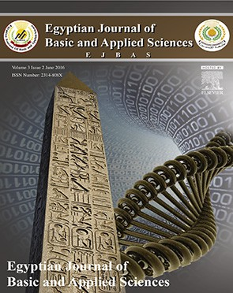 HOSTE D BY

Available online at [www.sciencedirect.com](http://www.sciencedirect.com/science/journal/2314808X)

**ScienceDirect**

journal homepage: [http://ees.elsevier.com/ejbas/default.asp](http://http//ees.elsevier.com/ejbas/default.asp)

**Full Length Article**

**Mitigating effect of *Avicenna marina* on indomethacin induced gastric ulcer in male albino rats**



***Magda M. El-Komy*** ***a******,******\*******, Foukia E. Mouafi*** ***b***

a *Zoology Department, Faculty of Science, University of Mansoura, Mansoura, Egypt*

b *Microbial Biotechnology Department, National Research Center, Dokki, Giza, Egypt*

A R T I C L E I N F O A B S T R A C T

*Article history:*

Received 9 September 2015 Received in revised form 27 January 2016

Accepted 29 January 2016

Available online 15 February 2016

*Keywords:*

Gastric ulcer Prostaglandin NSAIDs

Indomethacin

*Avicenna marina*

Polyphenols and tannins

The aqueous extract of *Avicenna marina* (AM) has been suggested to be useful in the treat- ment of various diseases. In this study, the protective effect of oral administration of *Avicenna marina* extract against oxidative gastric mucosal injury induced by nonsteroidal anti- inflammatory drugs (NSAIDs), indomethacin in rats was investigated. The aqueous extract of *Avicenna marina* was given by oral gavages (125 mg /kg) three times at 12 h intervals before administering indomethacin (20 mg/kg).The level of prostaglandin (PGE2) and pH gradient were markedly decreased following indomethacin treatment, with increase in acid volume. In ad-

dition, tumor necrosis factor (TNFα), transforming growth factor-β1 (TGF-β1) and the lipid

peroxidation products malondialdehyde (MDA) were significantly increased 6 h after oral ad- ministration of indomethacin in rats gastric mucosa indicating acute inflammatory injury.

Pretreatment with AM abolished indomethacin induced elevation of TNF-α, TGF-β1 and MAD

levels. In indomethacin-treated rats, the superoxide dismutase (SOD) and catalase (CAT) ac- tivities as well as reduced glutathione (GSH) content were significantly diminished in gastric mucosa. However, pre-administration with AM maintains the level of these parameters near to the control value. Thus, these results indicate the effective anti-peroxidative and preven- tive actions of AM against indomethacin-induced gastric mucosal damage.

Crown Copyright © 2016 Production and hosting by Elsevier B.V. on behalf of Mansoura University. This is an open access article under the CC BY-NC-ND license (http://

creativecommons.org/licenses/by-nc-nd/4.0/).

# Introduction

Harmful effects of toxic factors such as alcohol, bile salts, and hydrochloric acids are prevented by biological structures within

the stomach. This high resistance to injuries relies on a number of physiological responses evoked by the mucosal lining against potentially harmful luminal agents, as well as the ability of rapidly repairing the mucosal damage after it occurs [1]. On the other hand, these protective mechanisms might be

* *Corresponding author.* Tel.: +201006890251.

*E-mail address:* [magdaelkomy@yahoo.com](mailto:magdaelkomy@yahoo.com) (M.M. El-Komy).

*Abbreviations:* AM, *Avicenna marina*; PMN, Polymorphonuclear granules; CAT, Catalase; PGE2, Prostaglandin; GSH, Reduced glutathi- one; ROS, Reactive oxygen species; Indometh, Indomethacin; SOD, Superoxide dismutase; LPO, Lipid peroxidation; TGF-β1, Transforming growth factor β1; MDA, Malondialdehyde; TNF-α, Tumor necrosis factor α; NSAIDs, Nonsteroidal anti-inflammatory drugs

<http://dx.doi.org/10.1016/j.ejbas.2016.01.004>

2314-808X/Crown Copyright © 2016 Production and hosting by Elsevier B.V. on behalf of Mansoura University. This is an open access article under the CC BY-NC-ND license ([http://creativecommons.org/licenses/by-nc-nd/4.0/).](http://creativecommons.org/licenses/by-nc-nd/4.0/))

overcome by injurious factors and a gastric mucosal lesion may develop. Most of the deleterious effects on gastric mucosa are caused by nonsteroidal anti- inflammatory drugs (NSAIDs), which are considered one of the largely used pharmaceutical agents worldwide [2]. NSAIDs produce both helpful and an- tagonistic impacts fundamentally by hindering cyclooxygenase (COX) and subsequently diminishing the production of throm- boxanes and prostaglandins, which are the mediators that signal inflammation and pain as well as mediating the physiologi- cal functions [3].

Indomethacin, which is a part of the NSAIDs family, acti- vates polymorphonuclear granules and induce gastrointestinal damage in both animals and humans [4,5]. These kinds of pa- thologies are usually primarily due to damage of the mucosal cell membranes. Previously, reports have shown that the in- hibition of prostaglandin synthesis is not the only mechanism responsible for gastric damage induced by indomethacin [6]. Also, indomethacin might act like a pro-oxidant catalytic and also initiate LPO by producing ROS, thereby interfering with the endogenous antioxidant systems of any mucosal cells [7]. *Avicenna marina* is a mangrove plant known as gray man- grove tree belonging to the family of *Avicenniaceae* [8,9]*.* Phytochemical screening of *Avicenna marina* aqueous leaf extract revealed the presence of alkaloids, flavonoids, carbohydrates, glycosides, tannins, triterpenoids, and steroids [10,11]. It has been found to possess major therapeutic activity such as an- tibacterial, anti-helminthic [12], antimicrobial [13], antiviral [14], antihuman immunodeficiency virus, anti-inflammatory, and antitumor activity [15]. Mangrove extracts can be a possible source of mosquito larvicides. Mangrove plants are also re- ported for their antioxidant, anti-dyslipidemia, antidiarrheal, anti-filarial, anti-ulcer effect, cardiotonic properties, and an- tidiabetic effects [16]. Mangrove leaf extracts are nontoxic to humans and are environmentally friendly as they are less pol- lutant [17]. This study focused on the antiulcer activity of *Avicenna marina* aqueous leaf extract against indomethacin induced gastric ulceration. To the best of our knowledge, this is one of the first studies that reported the antiulcer effect of

AM leaves extract.

# Materials and methods

## *Experimental animals*

Healthy male Albino Wister rats of about 175 ± 5 g were used throughout the study. The animals were acclimated to labo- ratory conditions of 20–22 °C with a 12-h light/dark cycle for two weeks before experimentation. All rats were fed with a stan- dard pellet diet and water *ad libitum*. Care and use of animals were conducted under supervision of the animal Care Com- mittee of Mansoura University, Egypt.

## *Cold percolation extraction method*

*Avicenna marina* leaves were collected from (Makadi village, Hurghada region, Egypt) in August 2014. After drying the leaves, they were pulverized into fine powder using sterilized mortar and pestle. 200 g of crushed material was taken into 500 ml

of ethanol, kept on a rotary shaker at 120 rpm for 24 h. After shaking, it was filtered through layers of muslin cloth, centri- fuged at 1500 rpm for 20 min (Sigma, Laborzentifugen 2K15). Resultant extracts were evaporated and concentrated to dryness using the rotary evaporator at 45 °C. The powder was dis- solved in sterilized water and stored at 4 °C [18].

## *Experimental design*

The animals were deprived of food for 36 hours before the ex- periment but had free access to water. Then NSAIDs, indomethacin was used as the ulcerogenic agent by a single dose of 20 mg/kg of body weight [19]. Rats were divided into 4 groups, each of 8 animals. The first group did not receive any treatment and served as a control. The second group, animals were orally administered with aqueous extract of *Avicenna marina* with a dose of 125 mg/kg body weight thrice in 12 hours interval [20].The third group, animals received a single dose of indomethacin orally as 20 mg/kg of body weight. The fourth group, animals were orally administered with aqueous extract of *Avicenna marina* with a dose 125 mg/kg body weight thrice in 12 hours intervals; after one hour of last administration of AM, animals received a single dose of indomethacin orally as 20 mg/kg of body weight. After 6 hours of NSAID administra- tion, the animals were sacrificed by cervical dislocation. The animals were dissected and the stomach was taken out, the stomach was opened along the greater curvature and washed by saline solution. Then, the stomachs were photographed and the mucosa was exposed for evaluation.

## *Biochemical analysis*

Biochemical parameters, including malondialdehyde (MDA), reduced glutathione (GSH), superoxide dismutase (SOD) and catalase (CAT), were assayed using biodiagnostic kits, Dokki, Giza, Egypt. Tumor necrosis factor (TNF-α) level was esti- mated using an ELISA Kit (Diagnostic Products Corp., Los Angeles, CA, USA). Transforming growth factor β1 (TGF-β1) level was estimated by flow cytometric analysis. The prostaglan-

din E2 (PGE2) level was quantified with an immune-enzymatic dosage kit from R&D Systems (USA).

## *Animal handling*

The stomachs were removed and the gastric contents were col- lected and drained into a graduated centrifuge tube and centrifuged at 2000 x g for 15 min using Centurion Scientific Ltd centrifuge. The supernatant volume and pH were re- corded with digital pH meter (intelligent meter YK-2001 pH).

## *Histopathological study*

For histopathological examination, part of the gastric tissue was removed and was fixed in 10% formalin. After complete fixation, thin sections were prepared from tissues. Xylol and Hematoxylin-Eosin was used for clearing and staining, respec- tively. The slides were examined by microscope.

## *Statistical analysis*

All results obtained from the study were evaluated by one- way ANOVA test, and post-comparison was carried out with

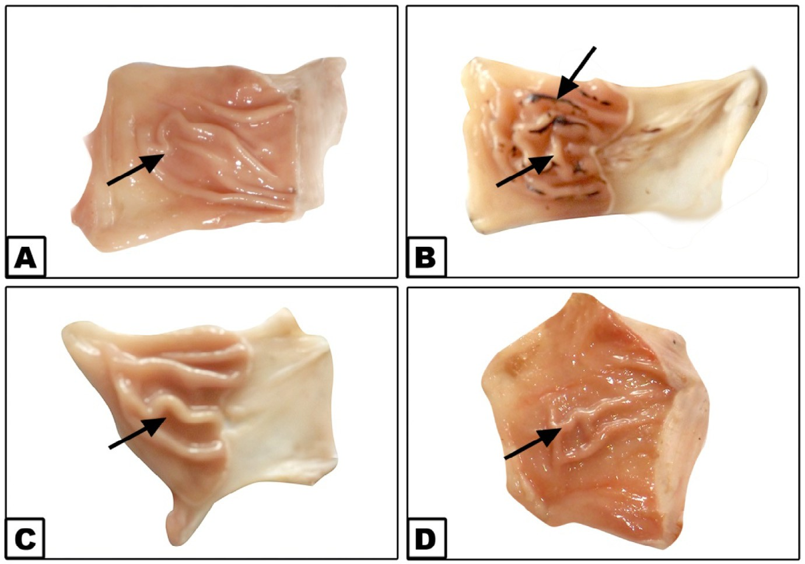

### Fig. 1 – Antiulcer activity of mangrove polyherbal formulation; (A) Stomach of control rat; (B) Stomach of rat showing mucosa with hemorrhagic erosion when treated with indomethacin (20 mg/kg); (C) Stomach of rat that received mangrove (125 mg/kg) showing normal mucosa; (D) Mangrove (125 mg/kg b.w.) + indomethacin (20 mg/kg) treated group showing normal mucosa.

Tukey-test. The values were expressed as means ± SE and values of P < 0.05 were considered statistically significant [21].

# Results

## *Morphological investigation*

Fig. 1(A–D) showed the antiulcer activity of AM. (A) Stomachs of controlled rats showing normal mucosa. (B) Stomachs of rats showing mucosa with hemorrhagic erosion when treated with indomethacin (20 mg/kg). (C) Stomachs of rats that received AM (125 mg/kg) showing normal mucosa. (D) AM and indo- methacin treated group showing nearly normal mucosa.

## *Biochemical investigation*

In this study, the oral administration of AM alone did not induce any obvious changes in the most biochemical parameters com- pared with the control group. Conversely, significant increases were demonstrated in the GSH level and CAT activity in the gastric mucosa. However, the result showed a significant de- crease in prostaglandin (PGE2) level and pH gradient accompanied with increase in acid volume in gastric mucosa in indomethacin treated rats. Meanwhile, pretreatment with AM recorded a suppression in these values as shown in Fig. 2 and Table 1.

Administration of indomethacin produced a significant in- crease in MAD content, an index of lipid peroxidation, in gastric mucosa. This was accompanied by marked inhibition of SOD and CAT activities in gastric mucosa in indomethacin treated rats. Oral administration of indomethacin also led to a sig- nificant decrease in GSH content (Table 1). The pretreatment

by AM prevented the increase of MDA levels and the de- crease in cellular antioxidants indicated by the activities of SOD and CAT and GSH concentration in the gastric tissue (Table 2). As shown in Figs. 3 and 4, the indomethacin treated rats had significantly higher levels of TNF-α and TGF-β1 com- pared to the controlled value. The oral pretreatment with plant extract of *Avicenna marina* normalized the increase in the levels

of these markers.

## *Histopathological investigation*

Fig 5. (A–F) Photomicrograph of stomach of rats H.E. staining. (A,B) Control group stomach showing normal gastric mucosa and sub-mucosa. Also normal acid producing cells were seen

(HE, A, 100x and B, 400x).

(C–F) Indomethacin treated stomachs showing necrosis of superficial layer of gastric mucosa (Star) (HE, C,D 100x).

Stomach showing necrosis and desquamation of superfi- cial layer of gastric mucosa (HE, E,F, 400x).

M, mucosa; SM, submucosa; MP, *Muscularis propria*; white arrow showing base of ulcer, black arrow showing fibrosis, arrow head showing leukocyte infiltration.

Fig 6. (A–D) Stomach of AM group showing normal gastric mucosa and submucosa (HE, A, 100x and B, 400x).

(C,D) Stomach of AM and indomethacin group, no ulcers were seen. Normal lining epithelium of gastric mucosa with mild congestion (HE, C, 100x and D, 400x).

# Discussion

NSAIDs are believed to be the most common causative factor in gastric mucosal injury [22]. On the other hand, the gastric

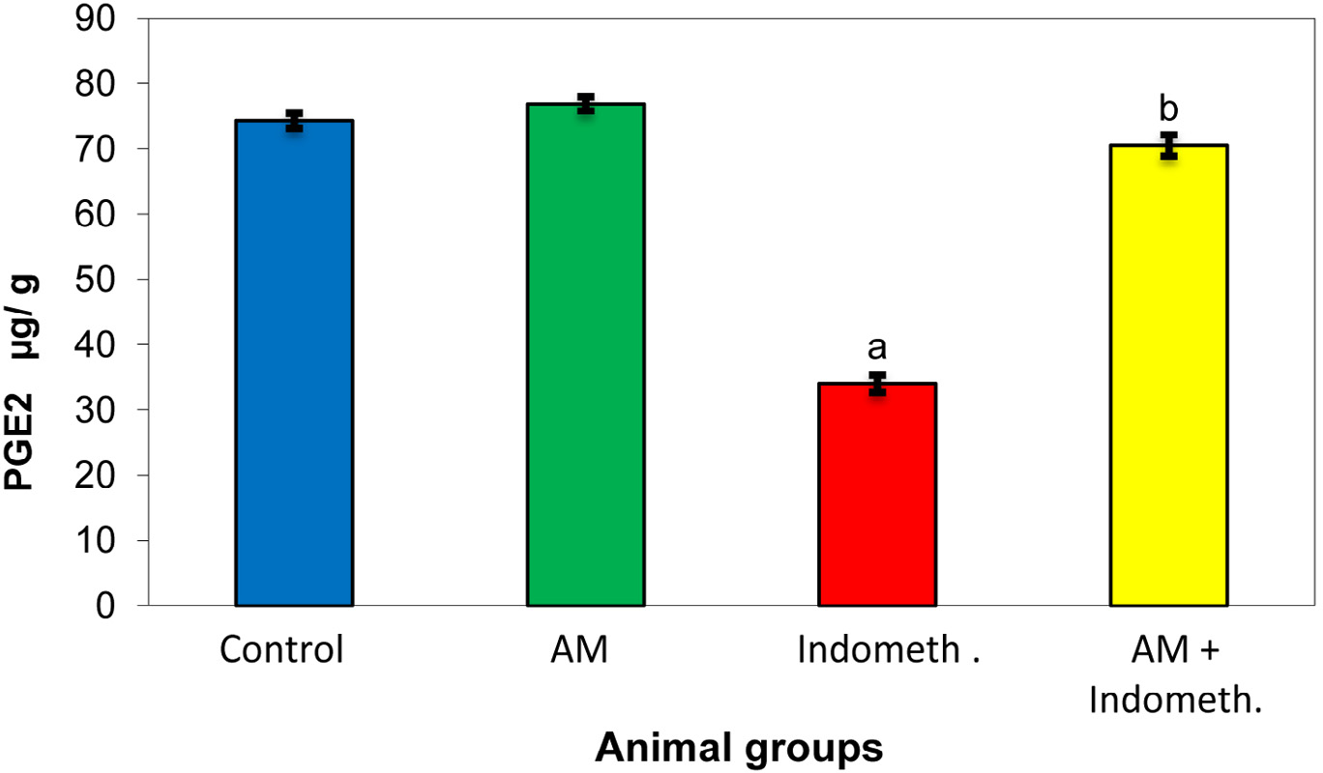

### Fig. 2 – Effect of *Avicenna marina* extract (125 mg/kg) on the levels of prostaglandin (PGE2; gg/g) in the stomach of different animal groups. The values are expressed as means ± SE (n = 8). Different superscript letters indicate significant difference at P Ç 0.05. a: Compared with control group; b: Compared with Indomethacin group. AM, aqueous extract of *Avicenna marina*. Indometh, indomethacin.

mucosal defense mechanisms include several protective factors which allow the mucosa to resist frequent exposure to dam- aging factors [1,23]. One of the most important gastric mucosal defense mechanisms is prostaglandin. The gastric mucosa rep- resents a source of continuous prostaglandin production, such

as PGE2 and PGI2, which are regarded as crucial factors for the maintenance of mucosal integrity and protection against in- jurious factors [24]. Prostaglandins can stimulate almost all of the mucosal defense mechanisms such as stimulating mucous and bicarbonate production, increasing mucosal blood flow,

|  |  |  |  |  |
| --- | --- | --- | --- | --- |
| **Table 1 – Effect of *Avicenna marina* extract (125 mg/kg) on the values of PH and acid volume in the stomach in different animal groups.** | | | | |
| Group parameters | Control | AM | Indometh. | AM + Indometh |
| pH (value)  Acid volume  (ml) | 6.49 ± 0.13  2.56 ± 0.09 | 6.64 ± 0.09  2.44 ± 0.13 | 3.03a ± 0.22  6.32a ± 0.17 | 5.92a,b ± 0.07  2.94b ± 0.08 |
| The values are expressed as the means ± SE (n = 8). Different superscript letters indicate a significant difference at P ≤ 0.05.  a Compared with control group.  b Compared with Indomethacin group.  AM ,aqueous extract of *Avicenna marina;* Indometh, indomethacin. | | | | |

|  |  |  |  |  |
| --- | --- | --- | --- | --- |
| **Table 2 – Effect of *Avicenna marina* extract (125 mg/kg) on the levels of lipid peroxidation product MDA (nmol/mg wet tissue), superoxide dismutase (SOD, u/g wet tissue), catalase (CAT, u/g wet tissue), and glutathione (GSH, mg/g wet tissue) in the stomach of different animal groups.** | | | | |
| Group parameters | Control | AM | Indometh. | AM + Indometh. |
| MDA | 9 | 33.97 ± 1.32 | 58.56a ± 1.13 | 32.54b ± 1.01 |
| (nmol/g) |  |  |  |  |
| SOD | 1179.16 ± 14.89 | 1207 ± 24.85 | 695.33a ± 22.93 | 1135.31b ± 37.66 |
| (U/g) |  |  |  |  |
| CAT | 0.025 ± 0.0013 | 0.030a ± 0.0009 | 0.019a ± 0.0011 | 0.026b ± 0.0007 |
| (U/g) |  |  |  |  |
| GSH | 0.30 ± 0.01 | 0.35a ± 0.01 | 0.25a ± 0.013 | 0.29 ± 0.009 |
| (mg/-g) |  |  |  |  |
| The values are expressed as the means ± SE (n = 8). Different superscript letters indicate a significant difference at P ≤ 0.05.  a Compared with control group.  b Compared with indomethacin group.  AM, aqueous extract of *Avicenna marina;* Indometh, indomethacin. | | | | |

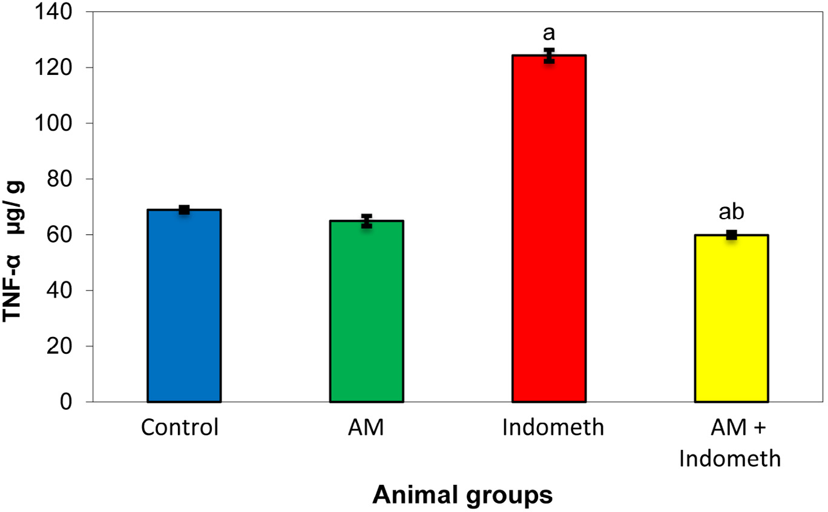

### Fig. 3 – Effect of *Avicenna marina* extract (125 mg/kg) on the levels of tumor necrosis factor (TNF-α gg/g) in the stomach of different animal groups. The values are expressed as means ± SE (n = 8). Different superscript letters indicate significant difference at P Ç 0.05. a: Compared with control group; b: Compared with indomethacin group. AM, aqueous extract of *Avicenna marina*. Indometh, indomethacin.

accelerating epithelial restitution and also mucosal healing in addition to reducing acid output [25]. Also, prostaglandins are known to inhibit mast cells activation as well as leukocytes and platelets adhesion to the vascular endothelium [26].

In the present study, the results recorded a significant de- crease in the level of PGE2 [Fig. 2] and pH gradient with increment in acid volume in indomethacin treated rats com- pared to the corresponding controls [Table 1]. These findings may be due to indomethacin which produces anti-inflammatory effects by inhibiting cyclooxygenase enzymes which by turn suppresses the formation of prostaglandins and throm-

boxane from arachidonic acid [27,28]. Moreover, prostaglandins reduce the activation of neutrophils and the local release of reactive oxygen species (ROS). In addition, the endothelium of mucosal microcirculation produces prostacyclin which will be highly relevant in ensuring the tonic inhibition of neutrophil adhesion [29,30]. Therefore, indomethacin can shift the mucosal balance toward the recruitment and endothelial adhesion of circulating neutrophils by the inhibition of prostaglandin bio- synthesis [28,31]. Neutrophils also clog the microvasculature causing a local drop in mucosal blood flow and a marked release of tissue damaging factors, like proteolytic enzymes and

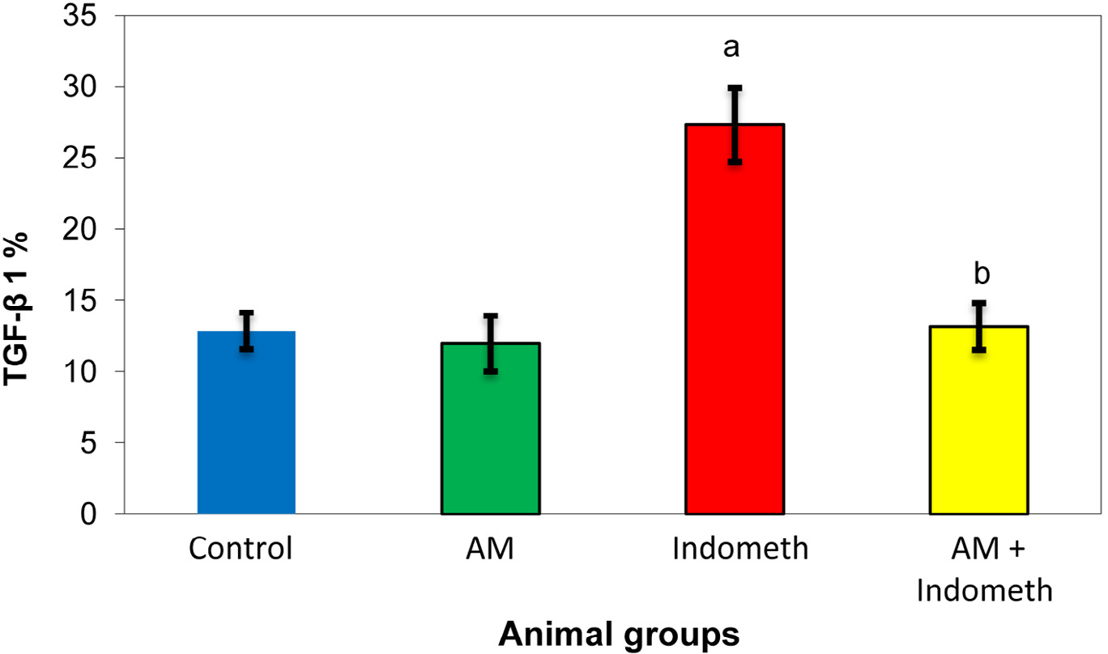

### Fig. 4 – Effect of *Avicenna marina* extract (125 mg/kg) on the percentage of transforming growth factor (TGF-β 1%) in the stomach of different animal groups. The values are expressed as means ± SE (n = 8). Different superscript letters indicate a significant difference at P Ç 0.05. a: Compared with control group; b: Compared with indomethacin group. AM, aqueous extract of *Avicenna marina*. Indometh, indomethacin.

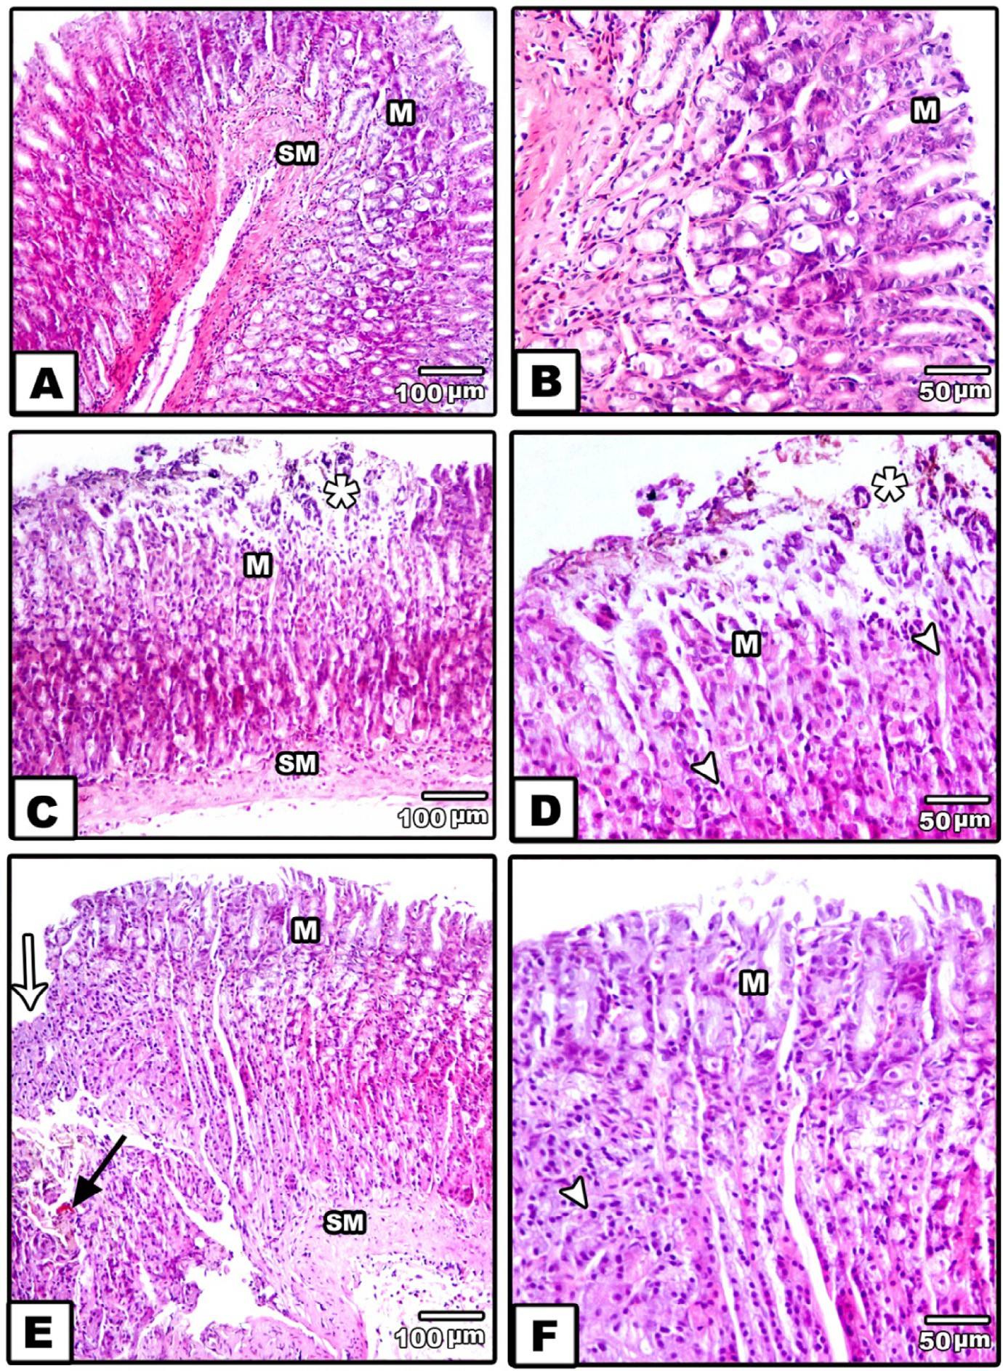

**Fig. 5 – (A–F) Photomicrograph of stomach of rats HE staining. (A,B) Control stomach showing normal gastric mucosa and submucosa. Also normal acid producing cells were seen (HE, A, 100x and B, 400x). (C–F) Treated stomach showing necrosis of superficial layer of gastric mucosa (Star). (HE, C,D, 100x) Stomach showing necrosis and desquamation of superficial layer of gastric mucosa (HE, E,F, 400x). M, mucosa; SM, submucosa; MP, *Muscularis properia*; white arrow showing base of ulcer, black arrow showing fibrosis, arrow head showing leukocyte infiltration.**

leukotrienes, which increase the vascular tone, exacerbate tissue ischemia, stimulate ROS production, and eventually promote the destruction of the intestinal matrix, leading to a severe degree of tissue necrosis, particularly in the presence of a low luminal pH [32,33]. Just as anticipated above, cyclooxygenase- dependent inhibition connected with bicarbonate secretion contributes also to the gastric mucosal injury elicited from NSAIDs [34].

The obtained gastric mucosal injury in indomethacin treated rats as shown in Fig. 1, may be due to the role of oxygen radi- cals, LPO and lowered antioxidants levels, this goes in accordance with Naito et al. [35], who suggested that LPO me- diated by oxygen radicals plays an important role in the

mechanism of ulcer aggravation induced by indomethacin. The lipid peroxidation product, MDA, is more cytotoxic to cells and affects the membrane structure and function [36]. In the present study, indomethacin produced a significant rise in MDA con- centration, accompanied by severe ulceration. In concomitant with increased LPO products, there was an inhibition in SOD and CAT activities as well as GSH content in indomethacin treated rats compared to the corresponding controls (Table 2). The decline in SOD, CAT activities and GSH level in the gastric mucosa of rats treated with indomethacin may lead to an in- crease in LPO and hence may render the gastric mucosa more susceptible to injury by indomethacin. Thus, the inhibition of antioxidants leads to the accumulation of ROS [19,37]. This study

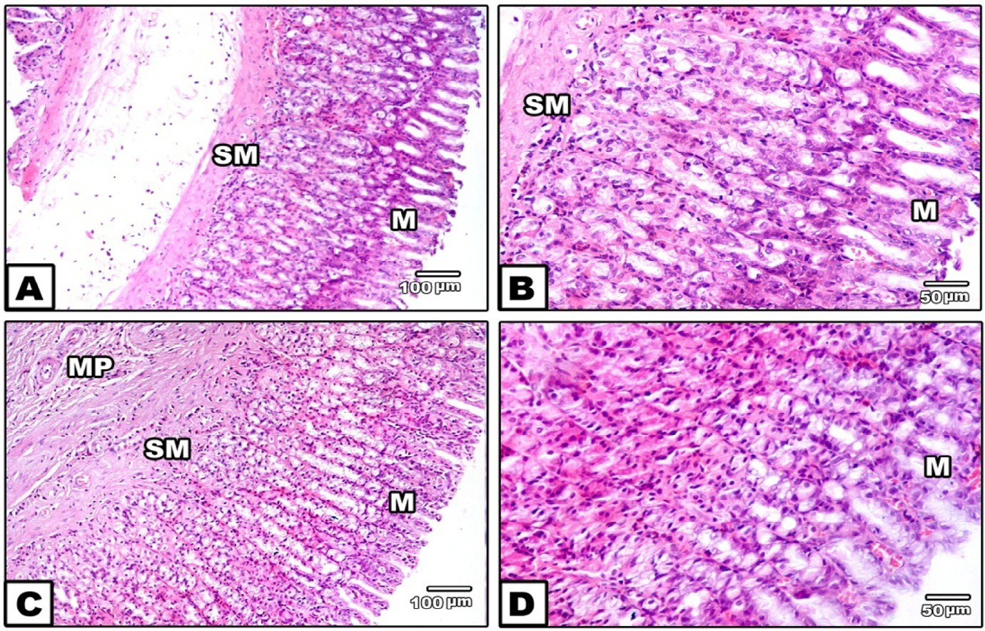

### Fig. 6 – (A–D) Stomach of mangrove group showing normal gastric mucosa and submucosa. (HE, A, 100x and B, 400x). (C,D) Stomach of AM and indomethacin group showing no ulcer were seen. Normal lining epithelium of gastric mucosa with mild congestion (HE, C, 100x and D, 400x).

proved that the level of GSH and CAT activity significantly in- creased in the AM treated group, and this may be due to its initiating effect on GSH and CAT synthesis.

Moreover, our results recorded a significant increase in tumor necrosis factor, alpha (TNF-α) in indomethacin treated rats as shown in Fig. 3. This result is in agreement with Whittle (2002)

[28], who recorded that, oxidative damage associated with in- domethacin treatment caused dramatic enhancement in gastric epithelial cell apoptosis triggered by increased expression of TNF-α. Also, the increase in mucosal blood flow is mediated by NO release, and there is experimental evidence demon- strating that NO protects the gastric mucosa against injury induced by indomethacin [38].

Transforming growth factor-β1 (TGF-β1) is usually a mul- tifunctional cytokine. It regulates cell growth, differentiation, and extracellular matrix production [39]. Also, TGF-β1 is con- sidered as a good inflammatory marker of the cells [40]. In the present study, TGF-β1 was significantly elevated in indometha- cin treated rats when compared with the corresponding controls

(Fig. 4). These results are usually attributed to the gastric injury relevant to indomethacin administration. Moreover, the integ- rity of gastric epithelium is actually maintained via a continuous process of cell renewal ensured by mucosal progenitor cells [41]. These cells are submitted to a continuous, well harmonized, and controlled growth, which ensures the replacement of damaged or aged cells on the epithelial surface. The cell turn- over process is controlled by growth factors [42]. In particular, a marked expression of epidermal growth factor receptor (EGF-R) has been detected in gastric progenitor cells. This receptor is activated via mitogenic growth factors, such as transforming growth factor-β (TGF-β1) and insulin-like growth factor-1 (IGF- 1) [43]. Also, PGE2 and gastrin are able to transactivate the EGF-R as well as promote the activation connected with mitogen- activated protein kinase pathway, with consistent stimulation associated with cell proliferation [44].

Unrefined extracts from some therapeutic tannin-rich plants are generally utilized worldwide to treat gastric ulcer [45]. Tannins are known to exist in mangrove species, which com- prises fundamentally of dense tannins or proanthocyanidins [46].

Pretreatment with the AM reflected a tendency to in- crease PGE2 production in spite of indomethacin-induced depletion. These results may be attributed to the polypheno- lic compounds found in AM [47]. Phenols stimulate PGE formation based on their action as co-substrates for the per- oxidase reaction [48]. Hence, the leaf extract of AM has the protective effect on the stomach against NSAIDs induced gastric ulcer, and this may be attributed to polyphenolic compounds [49].

In the present study, the gastroprotective properties of AM leaf extract may be attributed to the presence of several com- pounds. As, in a previous study of the author [10], the phytochemical screening of AM leaves extract revealed that the presence of phenolic-flavonoids; alkaloids; terpenoides; steroides; cardiac glycosides; tannins; flavonoids and saponines.The major active components of the AM are polyphenols, represented majorly by polymeric tannins (80%), hydrolysable tannins (20%) and catechin, chlorogenic, gallic and elagic acids as well as gallotannins, elagitannins, and condensed tannins. These sub- stances which are portrayed by their polyphenolic nature have indicated cytoprotective properties [48] and have been related to antiulcerogenic action in different plants [49,50]. On the other hand, tannins may counteract ulcer advancement because of their protein precipitating and vasoconstricting effects [49].Their astringent action can help precipitating microproteins on the ulcer site, thereby forming an impervious layer over the lining, which hinders gut secretions and protects the underlying mucosa from toxins and other irritants [51,52].

The results on histopathological investigation of the gastric mucosa of rats indicated that the pretreatment with AM

absolutely inhibited the indomethacin-induced congestion, hemorrhage, inflammations, erosions, and ulceration.

In conclusion, it appears that AM has an antiulcerogenic effect that will protect the gastric mucosa from damage induced by indomethacin. This protective action may be due to the in- hibition of basal gastric acid secretion and stimulation of mucus secretion. Also, the antiulcer effect of AM may be attributed to the presence of flavonoids in the aqueous extract, al- though the involvement of other chemical compounds in the plant cannot be ruled out. The data obtained so far do not in- dicate, however, which specific mechanism(s) is (are) responsible for the anti-secretory, antiulcer, and cytoprotective activities. Further studies are required to isolate the antiulcer com- pounds and to elucidate their mechanism of action.

# Acknowledgments

The author would like to express her gratitude to Prof. Dr. Amoura Abo El Naga, Professor of Embryology–Zoology Department, Faculty of Science, Mansoura University, for her advice and as- sistance with the histopathological examination of the sections.

R E F E R E N C E S

1. [Laine L, Takeuchi K, Tarnawski A. Gastric mucosal defense](http://refhub.elsevier.com/S2314-808X(16)00015-4/sr0010) [and cytoprotection: bench to bedside. Gastroenterology](http://refhub.elsevier.com/S2314-808X(16)00015-4/sr0010) [2008;135(1):41–60.](http://refhub.elsevier.com/S2314-808X(16)00015-4/sr0010)
2. [Ringim AH. Review evidence-based insights on non-](http://refhub.elsevier.com/S2314-808X(16)00015-4/sr0015) [steroidal antiinflammatory drugs. J Pharm Cosmet Sci](http://refhub.elsevier.com/S2314-808X(16)00015-4/sr0015) [2015;3(2):8–13.](http://refhub.elsevier.com/S2314-808X(16)00015-4/sr0015)
3. [Leslie JC. Use of NSAIDs in treating patients with arthritis.](http://refhub.elsevier.com/S2314-808X(16)00015-4/sr0020) [Arthritis Res Ther 2013;15(3).](http://refhub.elsevier.com/S2314-808X(16)00015-4/sr0020)
4. [Naito Y, Yoshikawa T, Yoshida N, Kondo M. Role of oxygen](http://refhub.elsevier.com/S2314-808X(16)00015-4/sr0025) [radical and lipid peroxidation in indomethacin-induced](http://refhub.elsevier.com/S2314-808X(16)00015-4/sr0025) [gastric mucosal injury. Dig Dis Sci 1998;43:30S–34S.](http://refhub.elsevier.com/S2314-808X(16)00015-4/sr0025)
5. [Sagar V, Ahamed RN. Gastric mucosal cellular changes](http://refhub.elsevier.com/S2314-808X(16)00015-4/sr0030) [induced by indomethacin (NSAID) in male albino rats.](http://refhub.elsevier.com/S2314-808X(16)00015-4/sr0030) [Indian J Exp Biol 1999;37:365–9.](http://refhub.elsevier.com/S2314-808X(16)00015-4/sr0030)
6. [Yoshikawa T, Naito Y, Kishi A, Tomii T, Kaneko T, Iinuma S,](http://refhub.elsevier.com/S2314-808X(16)00015-4/sr0035) [et al. Role of active oxygen, lipid peroxidation, and](http://refhub.elsevier.com/S2314-808X(16)00015-4/sr0035) [antioxidants in the pathogenesis of gastric mucosal injury](http://refhub.elsevier.com/S2314-808X(16)00015-4/sr0035) [induced by indomethacin in rats. Gut 1993;34:732–7.](http://refhub.elsevier.com/S2314-808X(16)00015-4/sr0035)
7. [Naito Y, Yoshikawa T, Matsuyama K, Yagi N, Arai M,](http://refhub.elsevier.com/S2314-808X(16)00015-4/sr0040) [Nakamura Y, et al. Neutrophils, lipid peroxidation, and nitric](http://refhub.elsevier.com/S2314-808X(16)00015-4/sr0040) [oxide in gastric reperfusion injury in rats. Free Radic Biol](http://refhub.elsevier.com/S2314-808X(16)00015-4/sr0040) [Med 1998;24:494–502.](http://refhub.elsevier.com/S2314-808X(16)00015-4/sr0040)
8. [Revathi P, Senthinath TJ, Thirumalaikolundusubramanian P,](http://refhub.elsevier.com/S2314-808X(16)00015-4/sr0045) [Prabhu N. Medicinal properties of mangrove plants – an](http://refhub.elsevier.com/S2314-808X(16)00015-4/sr0045) [overview. Int J Bio 2013;2(12):1597–600.](http://refhub.elsevier.com/S2314-808X(16)00015-4/sr0045)
9. [Zhu F, Chen X, Yuan Y, Huang M, Sun H, Xiang W. The](http://refhub.elsevier.com/S2314-808X(16)00015-4/sr0050) [chemical investigations of the mangrove plant *Avicennia*](http://refhub.elsevier.com/S2314-808X(16)00015-4/sr0050)[*marina* and its endophytes. Open Nat Prod J 2009;2:24–32.](http://refhub.elsevier.com/S2314-808X(16)00015-4/sr0050)
10. [Mouafi FI, Abdel-AzizS M, Bashir AA, Fyiad AA.](http://refhub.elsevier.com/S2314-808X(16)00015-4/sr0055) [Phytochemical analysis and antimicrobial activity of](http://refhub.elsevier.com/S2314-808X(16)00015-4/sr0055) [mangrove leaves (*Avicenna marina* and *Rhizophorastylosa*)](http://refhub.elsevier.com/S2314-808X(16)00015-4/sr0055) [against some pathogens. World Appl Sci J 2014;29(4):547–54.](http://refhub.elsevier.com/S2314-808X(16)00015-4/sr0055)
11. [Mahera SA, Saifullah SM, Ahmad VU, Mohammad FV,](http://refhub.elsevier.com/S2314-808X(16)00015-4/sr0060) [Ambreen K. Steroids and triterpenoids from grey mangrove](http://refhub.elsevier.com/S2314-808X(16)00015-4/sr0060) [*Avicennia marina*. Pak J Bot 2011;43(2):1417–2011.](http://refhub.elsevier.com/S2314-808X(16)00015-4/sr0060)
12. [Ravikumar S, Gnanadesigan M, Suganthi P, Ramalakshmi A.](http://refhub.elsevier.com/S2314-808X(16)00015-4/sr0065) [Antibacterial potential of chosen mangrove plants against](http://refhub.elsevier.com/S2314-808X(16)00015-4/sr0065)

[isolated urinary tract-infectious bacterial pathogens. Int J](http://refhub.elsevier.com/S2314-808X(16)00015-4/sr0065) [Med Sci 2010;2:94–9.](http://refhub.elsevier.com/S2314-808X(16)00015-4/sr0065)

1. [Gurudeeban S, Satyavani K, Ramanathan T,](http://refhub.elsevier.com/S2314-808X(16)00015-4/sr0070) [Balasubramanian T. Antidiabetic effect of a black mangrove](http://refhub.elsevier.com/S2314-808X(16)00015-4/sr0070) [species *Aegiceras corniculatum*in alloxan induced diabetic rat.](http://refhub.elsevier.com/S2314-808X(16)00015-4/sr0070) [J Adv Pharm Technol Res 2012;3:52–6.](http://refhub.elsevier.com/S2314-808X(16)00015-4/sr0070)
2. [Zandi K, Aherzadeh MT, Yaghoubi R, Tajbakhsh S, Rastian Z,](http://refhub.elsevier.com/S2314-808X(16)00015-4/sr0075) [Fouladvand M, et al. Antiviral activity of *Avicennia marina*](http://refhub.elsevier.com/S2314-808X(16)00015-4/sr0075)[against herpes simplex virus type 1 and vaccine strain of](http://refhub.elsevier.com/S2314-808X(16)00015-4/sr0075) [poliovirus. J Med Plants Res 2009;3:771–5.](http://refhub.elsevier.com/S2314-808X(16)00015-4/sr0075)
3. [Mani Senthil Kumar KT, Gorain B, Roy DK, Zothanpuia,](http://refhub.elsevier.com/S2314-808X(16)00015-4/sr0080) [Samanta SK, Pal M, et al. Anti-inflammatory activity of](http://refhub.elsevier.com/S2314-808X(16)00015-4/sr0080) [*Acanthus ilicifolius*. J Ethnopharmacol 2008;120:7–12.](http://refhub.elsevier.com/S2314-808X(16)00015-4/sr0080)
4. [Senthil Kumar KT, Puia Z, Samanta SK, Barik R, Dutta A,](http://refhub.elsevier.com/S2314-808X(16)00015-4/sr0085) [Gorain B, et al. The gastroprotective role of *Acanthus ilicifolius*](http://refhub.elsevier.com/S2314-808X(16)00015-4/sr0085)[– a study to unravel the underlying mechanism of anti-ulcer](http://refhub.elsevier.com/S2314-808X(16)00015-4/sr0085) [activity. Sci Pharm 2012;80:701–17.](http://refhub.elsevier.com/S2314-808X(16)00015-4/sr0085)
5. [Opra E, Wokocha R. Efficacy of some plant extracts on the *in*](http://refhub.elsevier.com/S2314-808X(16)00015-4/sr0090)[*vitro* and *in vivo* control of *Xanthomonas campestris* Pv.](http://refhub.elsevier.com/S2314-808X(16)00015-4/sr0090) [Vesicatoria. Agric J 2008;3:163–70.](http://refhub.elsevier.com/S2314-808X(16)00015-4/sr0090)
6. [Parekh J, Chanda S. *In vitro* antimicrobial activity of](http://refhub.elsevier.com/S2314-808X(16)00015-4/sr0095) [*Trapanatans* L. fruit rind extracted in different solvents. Afr J](http://refhub.elsevier.com/S2314-808X(16)00015-4/sr0095) [Biotechnol 2007;6:766–70.](http://refhub.elsevier.com/S2314-808X(16)00015-4/sr0095)
7. [Othman AI, El-Missiry MA, Amer MA. The protective action](http://refhub.elsevier.com/S2314-808X(16)00015-4/sr0100) [of melatonin on indomethacin-induced gastric and](http://refhub.elsevier.com/S2314-808X(16)00015-4/sr0100) [testicular oxidative stress in rats. Redox Rep 2001;6(3):1–5.](http://refhub.elsevier.com/S2314-808X(16)00015-4/sr0100)
8. [Thirunavukkarasu P, Ramkumar L, Ramanathan T. Anti-](http://refhub.elsevier.com/S2314-808X(16)00015-4/sr0105) [ulcer activity of Excoecaria agellocha bark on NSAID-](http://refhub.elsevier.com/S2314-808X(16)00015-4/sr0105) [induced gastric ulcer in albino rats. Glob J Pharmacol](http://refhub.elsevier.com/S2314-808X(16)00015-4/sr0105) [2009;3(3):123–6.](http://refhub.elsevier.com/S2314-808X(16)00015-4/sr0105)
9. [Snedecor GW, Cochran WG. Statistical methods. 7th ed.](http://refhub.elsevier.com/S2314-808X(16)00015-4/sr0110) [Iowa: The State University Press American; 1989.](http://refhub.elsevier.com/S2314-808X(16)00015-4/sr0110)
10. [Wallace J. Recent advances in gastric ulcer therapeutics.](http://refhub.elsevier.com/S2314-808X(16)00015-4/sr0115) [Curr Opin Pharmacol 2005;5(6):573–7.](http://refhub.elsevier.com/S2314-808X(16)00015-4/sr0115)
11. [Kay B, Paola P. New Insights into the use of currently](http://refhub.elsevier.com/S2314-808X(16)00015-4/sr0120) [available non-steroidal anti-inflammatory drugs. J Pain Res](http://refhub.elsevier.com/S2314-808X(16)00015-4/sr0120) [2015;8:105–18.](http://refhub.elsevier.com/S2314-808X(16)00015-4/sr0120)
12. [Halter F, Tarnawski AS, Schmassmann A, Peskar BM.](http://refhub.elsevier.com/S2314-808X(16)00015-4/sr0125) [Cyclooxygenase-2 implications on maintenance of gastric](http://refhub.elsevier.com/S2314-808X(16)00015-4/sr0125) [mucosal integrity and ulcer healing: controversial issues](http://refhub.elsevier.com/S2314-808X(16)00015-4/sr0125) [and perspectives. Gut 2001;49(3):443–53.](http://refhub.elsevier.com/S2314-808X(16)00015-4/sr0125)
13. [Brzozowski T, Konturek PC, Konturek SJ, Brzozowska I,](http://refhub.elsevier.com/S2314-808X(16)00015-4/sr0130) [Pawlik T. Role of prostaglandins in gastroprotection and](http://refhub.elsevier.com/S2314-808X(16)00015-4/sr0130) [gastric adaptation. J Physiol Pharmacol 2005;56(50):33–55.](http://refhub.elsevier.com/S2314-808X(16)00015-4/sr0130)
14. [Wallace J. COX-2: a pivotal enzyme in mucosal protection](http://refhub.elsevier.com/S2314-808X(16)00015-4/sr0135) [and resolution of inflammation. Sci World J 2006;6:577–88.](http://refhub.elsevier.com/S2314-808X(16)00015-4/sr0135)
15. [Vijaya JS, Sasi KM. Evidence based update on NSAIDs:](http://refhub.elsevier.com/S2314-808X(16)00015-4/sr0140) [overview. Int J Pharm Rev Res 2015;4(4):235–42.](http://refhub.elsevier.com/S2314-808X(16)00015-4/sr0140)
16. [Whittle BJ. Gastrointestinal effects of nonsteroidal anti-](http://refhub.elsevier.com/S2314-808X(16)00015-4/sr0145) [inflammatory drugs. Fundam Clin Pharmacol 2002;17(3):301–](http://refhub.elsevier.com/S2314-808X(16)00015-4/sr0145) [13.](http://refhub.elsevier.com/S2314-808X(16)00015-4/sr0145)
17. [Scarpignato C, Hunt RH. Nonsteroidal antiinflammatory](http://refhub.elsevier.com/S2314-808X(16)00015-4/sr0150) [drug-related injury to the gastrointestinal tract: clinical](http://refhub.elsevier.com/S2314-808X(16)00015-4/sr0150) [picture, pathogenesis, and prevention. Gastroenterol Clin](http://refhub.elsevier.com/S2314-808X(16)00015-4/sr0150) [North Am 2010;39(3):433–64.](http://refhub.elsevier.com/S2314-808X(16)00015-4/sr0150)
18. [Olsen P, Poulson K, Therkelsen A, Nexo E. Effect of](http://refhub.elsevier.com/S2314-808X(16)00015-4/sr0155) [sialoadenectomy and synthetic human urogastrone on](http://refhub.elsevier.com/S2314-808X(16)00015-4/sr0155) [healing chronic gastric ulcer in rats. Gut 1986;27:1443–9.](http://refhub.elsevier.com/S2314-808X(16)00015-4/sr0155)
19. [De-Faria FM, Almeida ACA, Ferreira AL, Dunder RJ, Takayama](http://refhub.elsevier.com/S2314-808X(16)00015-4/sr0160) [C, da Silva MS, et al. Mechanism of action underlying the](http://refhub.elsevier.com/S2314-808X(16)00015-4/sr0160) [gastric antiulcer activity of the Rhizophora mangle L. J](http://refhub.elsevier.com/S2314-808X(16)00015-4/sr0160) [Ethnopharmacol 2012;139:234–43.](http://refhub.elsevier.com/S2314-808X(16)00015-4/sr0160)
20. [Allen A, Flemström G. Gastroduodenal mucus bicarbonate](http://refhub.elsevier.com/S2314-808X(16)00015-4/sr0165) [barrier: protection against acid and pepsin. Am J Physiol Cell](http://refhub.elsevier.com/S2314-808X(16)00015-4/sr0165) [Physiol 2005;288(1):C1–19.](http://refhub.elsevier.com/S2314-808X(16)00015-4/sr0165)
21. [Jimènez MD, Martín MJ, Alarcón de la Lastra C, Bruseghini L,](http://refhub.elsevier.com/S2314-808X(16)00015-4/sr0170)

[Esteras A, Herrerías JM, et al. Role of L-arginine in](http://refhub.elsevier.com/S2314-808X(16)00015-4/sr0170) [ibuprofen-induced oxidative stress and neutrophil](http://refhub.elsevier.com/S2314-808X(16)00015-4/sr0170)

infiltration in gastric mucosa. Free Radic Res 2004;38(9):903– [11.](http://refhub.elsevier.com/S2314-808X(16)00015-4/sr0170)

1. [Musumba C, Pritchard DM, Pirmohamed M. Review article:](http://refhub.elsevier.com/S2314-808X(16)00015-4/sr0175) [cellular and molecular mechanisms of NSAID-induced](http://refhub.elsevier.com/S2314-808X(16)00015-4/sr0175) [peptic ulcer. Aliment Pharmacol Ther 2009;30(6):517–31.](http://refhub.elsevier.com/S2314-808X(16)00015-4/sr0175)
2. [Naito Y, Yoshikawa T, Matsuyama K, Nishimura S, Yagi N,](http://refhub.elsevier.com/S2314-808X(16)00015-4/sr0180) [Kondo M. Effects of free radical scavengers on](http://refhub.elsevier.com/S2314-808X(16)00015-4/sr0180) [indomethacin-induced aggravation of gastric ulcer in rats.](http://refhub.elsevier.com/S2314-808X(16)00015-4/sr0180) [Dig Dis Sci 1995;40:2019–21.](http://refhub.elsevier.com/S2314-808X(16)00015-4/sr0180)
3. [Takeuchi K, Ueshima K, Hironaka Y, Fujioka Y, Matsumoto J,](http://refhub.elsevier.com/S2314-808X(16)00015-4/sr0185) [Okabe S. Oxygen free radicals and lipid peroxidation in the](http://refhub.elsevier.com/S2314-808X(16)00015-4/sr0185) [pathogenesis of gastric mucosal lesions induced by](http://refhub.elsevier.com/S2314-808X(16)00015-4/sr0185) [indomethacin in rats. Relation to gastric hypermotility.](http://refhub.elsevier.com/S2314-808X(16)00015-4/sr0185) [Digestion 1991;49:175–84.](http://refhub.elsevier.com/S2314-808X(16)00015-4/sr0185)
4. [Ito M, Suzuki Y, Ishihara M, Suzuki Y. Anti-ulcer effects of](http://refhub.elsevier.com/S2314-808X(16)00015-4/sr0190) [antioxidants: effect of probucol. Eur J Pharmacol 1998;354.](http://refhub.elsevier.com/S2314-808X(16)00015-4/sr0190)
5. [Fiorucci S, Distrutti E, Cirino G, Wallace JL. The emerging](http://refhub.elsevier.com/S2314-808X(16)00015-4/sr0195) [roles of hydrogen sulfide in the gastrointestinal tract and](http://refhub.elsevier.com/S2314-808X(16)00015-4/sr0195) [liver. Gastroenterology 2006;131(1):259–71.](http://refhub.elsevier.com/S2314-808X(16)00015-4/sr0195)
6. [Eissa LA, Habib SA, Abdel Latif MM. Inhibitory effect of the](http://refhub.elsevier.com/S2314-808X(16)00015-4/sr0200) [partially purified protein from Raphnussativus roots and](http://refhub.elsevier.com/S2314-808X(16)00015-4/sr0200) [low-molecular-weight heparin on Ehrlich ascites carcinoma](http://refhub.elsevier.com/S2314-808X(16)00015-4/sr0200) [bearing mice. EJBAS 2014;1(2):88–96.](http://refhub.elsevier.com/S2314-808X(16)00015-4/sr0200)
7. [Lindholm C, Quiding-Järbrink M, Lönroth H, Hamlet A,](http://refhub.elsevier.com/S2314-808X(16)00015-4/sr0205) [Svennerholm A. Local cytokine response in Helicobacter](http://refhub.elsevier.com/S2314-808X(16)00015-4/sr0205) [pylori-infected subjects. Infect Immun 1998;66:5964–71.](http://refhub.elsevier.com/S2314-808X(16)00015-4/sr0205)
8. [Chiou S, Tanigawa T, Akahoshi T, Abdelkarim B, Jones MK,](http://refhub.elsevier.com/S2314-808X(16)00015-4/sr0210) [Tarnawski AS. Survivin: a novel target for indomethacin-](http://refhub.elsevier.com/S2314-808X(16)00015-4/sr0210) [induced gastric injury. Gastroenterology 2005;128(1):63–73.](http://refhub.elsevier.com/S2314-808X(16)00015-4/sr0210)
9. [Milani S, Calabrò A. Role of growth factors and their](http://refhub.elsevier.com/S2314-808X(16)00015-4/sr0215) [receptors in gastric ulcer healing. Microsc Res Tech](http://refhub.elsevier.com/S2314-808X(16)00015-4/sr0215) [2001;53(5):360–71.](http://refhub.elsevier.com/S2314-808X(16)00015-4/sr0215)
10. [Nguyen T, Chai J, Li A, Akahoshi T, Tanigawa T, Tarnawski](http://refhub.elsevier.com/S2314-808X(16)00015-4/sr0220) [AS. Novel roles of local IGF-1 activation in rat gastric ulcer](http://refhub.elsevier.com/S2314-808X(16)00015-4/sr0220)

[healing: promotes actin polymerization, cell proliferation,](http://refhub.elsevier.com/S2314-808X(16)00015-4/sr0220) [reepithelialization and induces COX-2 in a PI3K-dependent](http://refhub.elsevier.com/S2314-808X(16)00015-4/sr0220) [manner. Am J Pathol 2007;170(4):1219–28.](http://refhub.elsevier.com/S2314-808X(16)00015-4/sr0220)

1. [Pai R, Soreghan B, Szabo IL, Pavelka M, Baatar D, Tarnawski](http://refhub.elsevier.com/S2314-808X(16)00015-4/sr0225) [AS. Prostaglandin E2 transactivates EGF receptor: a novel](http://refhub.elsevier.com/S2314-808X(16)00015-4/sr0225) [mechanism for promoting colon cancer growth and](http://refhub.elsevier.com/S2314-808X(16)00015-4/sr0225) [gastrointestinal hypertrophy. Nat Med 2002;8(3):289–93.](http://refhub.elsevier.com/S2314-808X(16)00015-4/sr0225)
2. [Okuda T. Systematics and health effects of chemically](http://refhub.elsevier.com/S2314-808X(16)00015-4/sr0230) [distinct tannins in medicinal plants. Phytochemistry](http://refhub.elsevier.com/S2314-808X(16)00015-4/sr0230) [2005;66:2012–31.](http://refhub.elsevier.com/S2314-808X(16)00015-4/sr0230)
3. [Rahim AA, Rocca E, Steinmetz J, Kassim MJ, Ibrahim MS,](http://refhub.elsevier.com/S2314-808X(16)00015-4/sr0235) [Osman H. Antioxidant activities of mangrove](http://refhub.elsevier.com/S2314-808X(16)00015-4/sr0235) [Rhizophoraapiculata bark extracts. Food Chem](http://refhub.elsevier.com/S2314-808X(16)00015-4/sr0235) [2008;107:200–7.](http://refhub.elsevier.com/S2314-808X(16)00015-4/sr0235)
4. [Berenguer B, Sanchez LM, Quilea A, Lopez-Barreiro M, De](http://refhub.elsevier.com/S2314-808X(16)00015-4/sr0240) [Haro O, Galvez J, et al. Protective and antioxidant effects of](http://refhub.elsevier.com/S2314-808X(16)00015-4/sr0240) [Rhizophora mangle L. against NSAID-induced gastric ulcers.](http://refhub.elsevier.com/S2314-808X(16)00015-4/sr0240) [J Ethnopharmacol 2006;77:1–3.](http://refhub.elsevier.com/S2314-808X(16)00015-4/sr0240)
5. [Alanko J, Riutta A, Holm P, Mucha I, Vapatalo H, Metsa-](http://refhub.elsevier.com/S2314-808X(16)00015-4/sr0245) [Ketela T. Modulation of arachidonic acid metabolism by](http://refhub.elsevier.com/S2314-808X(16)00015-4/sr0245) [phenols: relation to their structure and antioxidant/](http://refhub.elsevier.com/S2314-808X(16)00015-4/sr0245) [prooxidant properties. Free Radic Biol Med 1999;26:193–](http://refhub.elsevier.com/S2314-808X(16)00015-4/sr0245) [201.](http://refhub.elsevier.com/S2314-808X(16)00015-4/sr0245)
6. [Perera LMS, Ruedas D, Gomez BC. Gastric antiulcer effects of](http://refhub.elsevier.com/S2314-808X(16)00015-4/sr0250) [Rhizophora mangle L. J Ethnopharmacol 2001;77:1–3.](http://refhub.elsevier.com/S2314-808X(16)00015-4/sr0250)
7. [Al-Rehailey AJ, Al-Howiriny TA, Al-Sohaibani MO, Rafatullah](http://refhub.elsevier.com/S2314-808X(16)00015-4/sr0255)

[S. Gastroprotective effects of ‘Amla’ Emblica officinalis on in](http://refhub.elsevier.com/S2314-808X(16)00015-4/sr0255) [vivo test models in rats. Phytomedicine 2002;9:515–22.](http://refhub.elsevier.com/S2314-808X(16)00015-4/sr0255)

1. [Gonzales E, Iglesias I, Carretero E, Villar A. Gastric](http://refhub.elsevier.com/S2314-808X(16)00015-4/sr0260) [cytoprotection of Bolivian medicinal plants. J](http://refhub.elsevier.com/S2314-808X(16)00015-4/sr0260) [Ethnopharmacol 2000;70:329–33.](http://refhub.elsevier.com/S2314-808X(16)00015-4/sr0260)
2. [Konig M, Scholz E, Hartmann R, Lehmann W, Rimpler H.](http://refhub.elsevier.com/S2314-808X(16)00015-4/sr0265) [Ellagitannins and complex tannins from Quercuspetraea](http://refhub.elsevier.com/S2314-808X(16)00015-4/sr0265) [bark. J Nat Prod 1993;57:1411–15.](http://refhub.elsevier.com/S2314-808X(16)00015-4/sr0265)