HOSTE D BY

Available online at [www.sciencedirect.com](http://www.sciencedirect.com/science/journal/2314808X)

ScienceDirect

journal homepage: <http://ees.elsevier.com/ejbas/default.asp>

[e gypti an j o ur nal o f b a sic and a p p l i ed sci e n c e s 2 ( 201 5 ) 132](http://dx.doi.org/10.1016/j.ejbas.2015.04.001) e[138](http://dx.doi.org/10.1016/j.ejbas.2015.04.001)



Full Length Article

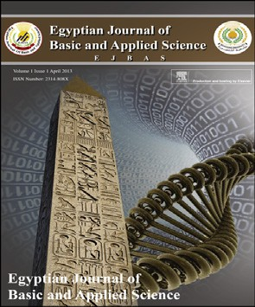Morphological studies of the pollen grains for some hydrophytes in coastal Mediterranean lakes, Egypt



*Y.A. El-Amier*\*

*Department of Botany, Faculty of Science, University of Mansoura, El-Mansoura, Egypt*

## a r t i c l e i n f o

*Article history:*

Received 3 March 2015 Received in revised form 5 April 2015

Accepted 7 April 2015

Available online 24 April 2015

*Keywords:* Palynology Northern lakes Hydrophytes Nile Delta

Key pollen

## a b s t r a c t

The pollen grains of forty species of the aquatic flowering plants (6 floating, 6 submerged and 28 emergent species) naturally growing in the four coastal Mediterranean lakes of Egypt were investigated during JanuaryeAugust 2012. These species belong to 17 families. Morphologically, the investigated pollen grains are mostly prolate-spheroidal, spheroidal or triangular, rarely prolate or elongated, tectum psilate, granulate, reticulate or micro- echinate. On the basis of aperture types pollen grains of most families are grouped under three distinct types, namely colporate, colpate and porate. On the other hand, pollen grains of some families e.g. Cyperaceae, Juncaceae, Potamogetonaceae and Ruppiaceae are ina- perturate. It is worth to stating that from a phylogenetic and evolutionary point of views, polarity, symmetry, apertural types and exine sculpturing are the most important char- acters to differentiate between the different pollen types. The identified pollen grains, conserved in the herbarium of Botany Department, Faculty of Science, Mansoura Univer- sity, Mansoura, Egypt, as reference key pollen in the northern lakes for palynologists, ecologists, taxonomists etc.

Copyright 2015, Mansoura University. Production and hosting by Elsevier B.V. This is an open access article under the CC BY-NC-ND license ([http://creativecommons.org/licenses/](http://creativecommons.org/licenses/by-nc-nd/4.„0/)

[by-nc-nd/4.0/](http://creativecommons.org/licenses/by-nc-nd/4.„0/)).

# Introduction

Through the palynology we can get tremendous knowledge from a little material in a short time [1]. Palynology is used in several applications such as a survey of atmospheric pollen, spore production and the archaeological excavation of ship- wrecks. The earliest investigation to use the morphological diversity of pollen directly concerned with the classification of plants [2]. Lindau [3] used a greater number of pollen

characters including shape and ornamentation as well as aperture number, to define a range of pollen types.

Morphology of pollen is involved in solving some taxo- nomic problems on the family, generic or specific level and has become part of the multidisciplinary and collaborative approach in plant systematic and evolution [4](#_bookmark6)e[6]. The sculp- turing of the exine and the constant features make pollen grains appreciably recognizable feature through which parent genera or even species can be recognized [7,8].

* Department of Botany, Faculty of Science, University of Mansoura, El-Gomhorya Street, El-Mansoura, Egypt. Tel.: +20 01017229120,

+20 01280288892, +2 050 2223786; fax: +2 050 2246781.

E-mail address: [yasran@mans.edu.eg](mailto:yasran@mans.edu.eg).

Peer review under responsibility of Mansoura University. <http://dx.doi.org/10.1016/j.ejbas.2015.04.001>

2314-808X/Copyright 2015, Mansoura University. Production and hosting by Elsevier B.V. This is an open access article under the CC BY- NC-ND license ([http://creativecommons.org/licenses/by-nc-nd/4.0/](http://creativecommons.org/licenses/by-nc-nd/4.„0/)).

[e g ypti an j o ur nal o f b a sic and a pp l i e d sci en c e s 2 ( 201 5 ) 132](http://dx.doi.org/10.1016/j.ejbas.2015.04.001) e[138](http://dx.doi.org/10.1016/j.ejbas.2015.04.001) 133

Several papers are published on pollen morphology of some dicots families from various parts of the world. Ana- cardiaceae, Bignoniaceae, Caricaceae, Myrtaceae, Mor- ingaceae, Meliaceae, Rhamnaceae and Zygophyllaceae have been studied by [9]. Palynology of families Apocynaceae has been investigated by Schill and Leuenberger [10] and Van Campo et al. [11]. The families Caesalpiniaceae and Mim- osaceae have been reported by Guinet [12] and Lock [13]. Morphology of pollen six aquatic angiosperms from Saudi Arabia has been studied by Perveen and Qaiser [14]. The main aims of this study are to contribute to our understanding the pollen morphology of aquatic plants naturally growing in four northern Mediterranean lakes of Egypt namely: Mariut, Idku, Burullus and Manzala by light microscopy and to be used as additional tool for plant taxonomy.

# Materials and methods

### *Study area*

The studied northern coastal Mediterranean lakes of Egypt are Lake Manzala, Lake Burullus, Lake Idku and Lake Mariut (Fig. 1). They are separated from the sea by strips of land that are very narrow in several places and are connected with the sea through narrow outlets (straits). Three lakes (Manzala, Burullus, Idku) receive the main bulk of the drainage water from the Nile Delta.

Lake Manzala (Long. 31◦ 500e32◦ 150 E and Lat. 31◦e31◦ 300 N)

is the largest of the northern deltaic lakes of Egypt. Its area is about 1400 km2 [15]. Lake Burullus lies on the eastern side of the Rosetta Branch of the River Nile occupying a central

position along the Mediterranean coast of the Nile Delta. It extends eastwards from Longitudes 30◦ 350 to 31◦ 80 E and northwards from Latitudes 31◦ 210 to 31◦ 370 N. It is the second largest natural lake in Egypt, with an area of about 410 km2 [16]. Lake Idku is situated west of the River Nile delta between Longitudes 30◦ 80 to 30◦ 280 E and Latitudes 31◦ 100 to 31◦ 80 N. Lake Mariut (Long. 29◦ 890 E and Lat. 31◦ 150 N) is the smallest of the northern Mediterranean lakes of Egypt.

Ayyad et al. [17] stated that, the Mediterranean coastal region of Egypt belongs to the dry arid climatic zone of

Koppen's [18] classification system. The study area lies in Meig's warm coastal deserts [19] in which summer is warm-

est month with mean monthly temperature less than 30 ◦C, and winter is coldest month with mean monthly temperature above 10 ◦C.

### *Pollen extraction*

Pollen grains were extracted from fresh flowers of thirty seven aquatic species collected from the northern Mediterranean lakes during MarcheAugust 2012. Extraction and chemical preparations procedures of the flowers and pollen used is that described by Moore et al. [20]. Also, original pollen grains sizes were the mean values of the longest axis of 15 measured grains. The herbarium specimens of the studied plants were kept and well preserved at the herbarium of the Faculty of Science, Mansoura University, Mansoura, Egypt. Material for LM was acetolysed according to Erdtman [21]. Before acetol- ysis the pollens were boiled in 10% KOH for about 8 min, causing the apertures to open and making them easier to investigate [22]. The acetolysed pollens were mounted in glycerin jelly on glass slides. The pollen was examined using a

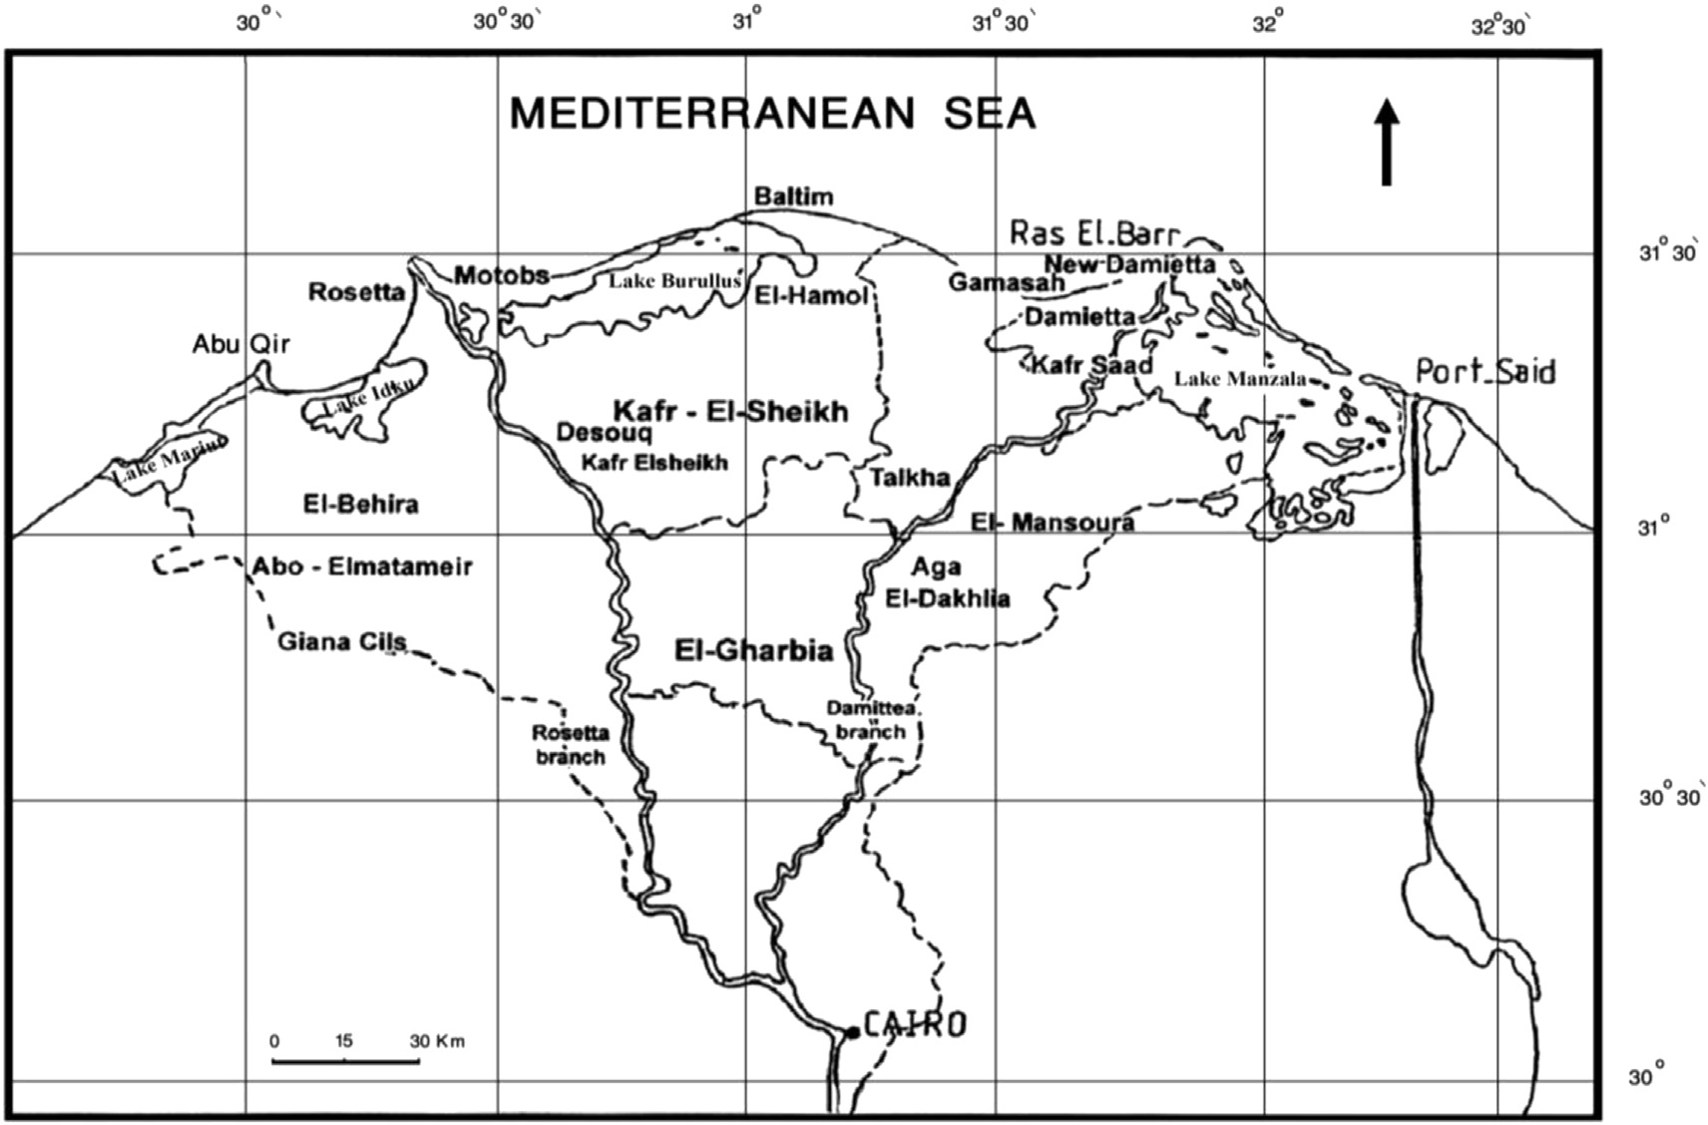

Fig. 1 e Map of the Nile Delta showing the coastal Mediterranean lakes of Egypt.

134 [e gypti an j o ur nal o f b a sic and a p p l i ed sci e n c e s 2 ( 201 5 ) 132](http://dx.doi.org/10.1016/j.ejbas.2015.04.001) e[138](http://dx.doi.org/10.1016/j.ejbas.2015.04.001)

Leitz Laborlux D microscope fitted with a 40× and 100× oil immersion objectives, using 10× eyepieces.

The pollen identification and description were according to Moore et al. [20], Faegri and Iversen [23]; Erdtman [9]; Reitsma

[24] and Punt et al. [25]. The terminology used is in accordance with Faegri and Iversen [26]; Kermp [27]; Walker and Doyle [1] and Solomon [28].

# Results and discussion

The pollen grains of thirty seven species of the four north- ern Mediterranean lakes were investigated. The studied

thirty seven species are classified into three groups namely: submerged, floating and emergent hydrophytes. The inves- tigated pollen morphological characters were: pollen unit, dimensions, shape class, polarity and symmetry, ap- ertures, sculptures and exine texture (Tables 1 and 2; Plates 1 and 2).

### *Pollen unit and dimensions*

The pollen grains at anthesis were found to be solitary (mo- nads) in all the studied taxa. The mean length of the polar axis varied from 24.3 mm in *Veronica anagallis-aquatica* to 106.4 mm in *Ludwigia stolonifera*. The mean of equatorial diameter varied

|  |  |  |  |  |  |  |  |  |  |
| --- | --- | --- | --- | --- | --- | --- | --- | --- | --- |
| Table 1 e Dimensions and shape classes variation in pollen grains of the hydrophytic taxa, of the Coastal Mediterranean lakes, Egypt. P/E ¼ Polar axis/Equatorial axis. | | | | | | | | | |
| No. | Pollen characters  Taxa | Po Mea | lar n | Dimensions (mm)  axis (P) Equatorial Range Mean | | | axis (E) Range | P/E | Shape class |
| *Floating* | *hydrophytes* |  | | | | |  |  |  |
| 1 | *Eichhornia crassipes* (Mart.) Solms | 74.3 | ± 4.7 | 50.0e87.5 | 58.6 ± | 3.7 | 47.5e75.0 | 1.31 | Prolate |
| 2 | *Lemna gibba* L. | 47.5 | ± 4.2 | 32.5e60.0 | 43.6 ± | 1.7 | 30.0e40.0 | 1.40 | Spheroidal |
| 3 | *L. minor* L. | 37.5 | ± 0.8 | 35.0e40.0 | 36.1 ± | 0.5 | 35.0e37.5 | 1.00 | Spheroidal |
| 4 | *L. perpusilla* Torr. | 40.5 | ± 0.9 | 36.5e45.0 | 39.0 ± | 1.2 | 36.0e42.0 | 1.04 | Spheroidal |
| 5 | *Ludwigia stolonifera* (Guill. & Perr.) Raven | 106.4 | ± 2.1 | 87.5e97.5 | 95.7 ± | 9.5 | 95.0e110.0 | 1.11 | Triangular |
| 6 | *Marsilea aegyptiaca* Willd. | 37.1 | ± 2.7 | 27.5e45.0 | 33.9 ± | 2.9 | 27.5e45.0 | 1.10 | Prolate spheroidal |
| *Submerged hydrophytes* | |  | | | | |  |  |  |
| 1 | *Ceratophyllum demersum* L. | 38.2 | ± 1.3 | 32.5e42.5 | 37.1 ± | 0.9 | 32.5e40.0 | 1.03 | Prolate spheroidal |
| 2 | *C. submersum* L. | 36.1 | ± 1.3 | 32.5e40.0 | 33.6 ± | 1.4 | 30.0e40.0 | 1.07 | Prolate spheroidal |
| 3 | *Myriophyllum spicatum* L. | 30.7 | ± 05 | 30.0e32.5 | 35.0 ± | 2.9 | 27.5e47.5 | 0.88 | Oblate spheroidal |
|  | |  | | | | |  |  | to Oblate |
| 4 | *Potamogeton crispus* L. | 38.2 | ± 1.5 | 35.0e45.0 | 32.9 ± | 1.5 | 30.0e37.5 | 1.16 | Spheroidal |
| 5 | *P. pectinatus* L. | 42.9 | ± 2.2 | 32.5e50.0 | 30.0 ± | 2.2 | 20.0e35.0 | 1.43 | Spheroidal |
| 6 | *Ruppia maritima* L. | 65.4 | ± 3.9 | 50.0e75.0 | 35.4 ± | 2.5 | 22.5e42.5 | 1.84 | Elongated |
| *Emergent hydrophytes* | |  | | | | |  |  |  |
| 1 | *Alternanthera sessilis* (L.) DC. | 17.9 | ± 1.2 | 15.0e22.5 | 18.6 ± | 1.0 | 15.0e22.5 | 1.00 | Spheroidal |
|  | |  | | | | |  |  | to Polyhedral |
| 2 | *Carex extensa* | 40.7 | ± 1.4 | 37.5e50.5 | 34.6 ± | 1.2 | 32.5e40.0 | 1.18 | Pear-shaped |
| 3 | *Cyperus alopecuroides* Rottb. | 31.4 | ± 0.8 | 30.0e35.0 | 25.4 ± | 0.7 | 22.5e27.5 | 1.24 | Pear-shaped |
| 4 | *C. articulatus* L. | 32.5 | ± 0.8 | 30.0e35.0 | 22.9 ± | 1.1 | 20.0e27.5 | 1.41 | Pear-shaped |
| 5 | *C. laevigatus* L. | 31.8 | ± 1.1 | 27.5e35.0 | 28.2 ± | 1.3 | 25.0e32.5 | 1.13 | Pear-shaped |
| 6 | *Echinochloa colona* (L.) Link | 35.5 | ± 0.8 | 32.5e37.5 | 30.4 ± | 1.0 | 27.5e32.5 | 1.15 | Prolate spheroidal |
| 7 | *E. crus-galli* (L.) P. Beauv. | 29.9 | ± 0.7 | 27.5e33.5 | 28.0 ± | 0.5 | 26.5e30.0 | 1.08 | Prolate spheroidal |
| 8 | *E. stagnina* (Retz.) P. Beauv. | 40.0 | ± 1.6 | 35.0e47.5 | 38.2 ± | 1.8 | 32.5e45.0 | 1.05 | Prolate spheroidal |
| 9 | *J. bufonius* L. | 42.5 | ± 0.8 | 39.5e45.0 | 40.5 ± | 0.5 | 38.5e43.5 | 1.05 | Prolate spheroidal |
| 10 | *J. subulatus* Forssk. | 39.3 | ± 2.1 | 35.0e50.0 | 37.5 ± | 2.5 | 30.0e47.5 | 1.05 | Prolate spheroidal |
| 11 | *Leersia hexandra* Swartz | 38.6 | ± 1.9 | 32.5e45.0 | 35.7 ± | 2.1 | 30.0e45.0 | 1.08 | Prolate spheroidal |
| 12 | *Leptochloa fusca* (L.) Kunth. | 35.4 | ± 1.1 | 32.5e40.0 | 33.2 ± | 1.3 | 27.5e37.5 | 1.06 | Prolate spheroidal |
| 13 | *Panicum repens* L. | 34.4 | ± 1.1 | 31.5e39.0 | 31.2 ± | 1.3 | 27.5e35.5 | 1.10 | Prolate spheroidal |
| 14 | *Paspalidium geminatum* (Forssk.) Staff in prain | 34.6 | ± 1.2 | 30.0e37.5 | 33.2 ± | 1.1 | 30.0e37.5 | 1.04 | Prolate spheroidal |
| 15 | *Paspalum distichum* L. | 37.9 | ± 0.9 | 35.0e40.0 | 36.1 ± | 1.3 | 32.5e40.0 | 1.05 | Prolate spheroidal |
| 16 | *Persicaria salicifolia* (willd.) Assenov | 55.4 | ± 1.6 | 50.0e62.5 | 55.0 ± | 1.8 | 47.5e60.0 | 1.01 | Prolate spheroidal |
| 17 | *P. lapathifolia* (L.) Gray | 54.6 | ± 1.8 | 50.0e62.5 | 53.6 ± | 1.3 | 50.0e57.5 | 1.02 | Prolate spheroidal |
| 18 | *Phragmites australis* (Cav.) Trin.ex Steud. | 28.9 | ± 0.8 | 27.5e32.5 | 28.6 ± | 0.5 | 27.5e30.0 | 1.01 | Prolate spheroidal |
| 19 | *Ranunculus sceleratus* L. | 26.4 | ± 1.0 | 22.5e30.0 | 23.2 ± | 0.8 | 20.0e25.0 | 1.14 | Subprolate |
| 20 | *Rorripa palustris* (L.)Besser. | 26.0 | ± 1.2 | 20.0e30.0 | 21.5 ± | 0.9 | 17.5e25.0 | 1.21 | Subprolate |
| 21 | *Saccharum spontaneum* L. | 45.0 | ± 2.0 | 40.0e50.0 | 42.5 ± | 2.0 | 37.5e50.0 | 1.06 | Prolate spheroidal |
| 22 | *Schoenoplectus maritimus* L. | 46.4 | ± 1.6 | 40.0e50.0 | 28.2 ± | 1.7 | 22.5e35.0 | 1.65 | Pear-shaped |
| 23 | *S. litoralis* (Schrad.) Palla | 28.6 | ± 1.4 | 22.5e32.5 | 23.2 ± | 1.3 | 22.5e27.5 | 1.23 | Pear-shaped |
| 24 | *Typha domingensis* (Pers.) Poir. ex Steud. | 28.9 | ± 0.8 | 27.5e32.5 | 28.6 ± | 0.5 | 27.5e30.0 | 1.01 | Spheroidal |
| 25 | *Veronica anagallis-aquatica* L. | 24.3 | ± 0.8 | 22.5e27.5 | 21.4 ± | 1.0 | 17.5e25.0 | 1.13 | Subprolate |

[e g ypti an j o ur nal o f b a sic and a pp l i e d sci en c e s 2 ( 201 5 ) 132](http://dx.doi.org/10.1016/j.ejbas.2015.04.001) e[138](http://dx.doi.org/10.1016/j.ejbas.2015.04.001) 135

|  |  |  |  |  |  |
| --- | --- | --- | --- | --- | --- |
| Table 2 e General pollen characters of hydrophytic taxa, of the coastal Mediterranean lakes, Egypt. | | | | | |
| No. Pollen characters  Taxa | Polarity | Symmetry | Apertures | Sculpture type | Exine texture |
| *Floating hydrophytes*   1. *Eichhornia crassipes* (Mart.) Solms 2. *Ludwigia stolonifera* (Guill. & Perr.) Raven 3. *Marsilea aegyptiaca* Willd. 4. *Lemna gibba* L. 5. *L. minor* L. 6. *L. perpusilla* Torr. | Isopolar Heteropolar Apolar Apolar Apolar Apolar | Bilateral symmetric Radiosymmetric Radiosymmetric Radiosymmetric Radiosymmetric Radiosymmetric | Monosulcate Trizonoporate Trizonocolpate Monoporate Monoporate Monoporate | Psilate-granulate Psilate  Psilate-granulate Psilate  Psilate Psilate | Thick Moderate Thick Thick Thick Thick |
| *Submerged hydrophytes*   1. *Ceratophyllum demersum* L. 2. *C. submersum* L. 3. *Myriophyllum spicatum* L. 4. *Potamogeton crispus* L. 5. *P. pectinatus* L. 6. *Ruppia maritima* L. | Apolar Apolar Isopolar Apolar Apolar Isopolar | Radiosymmetric Radiosymmetric Radiosymmetric Radiosymmetric Radiosymmetric Bilateral symmetric | Trizonoporate Trizonoporate Tetra-zonoporate Inaperturate Inaperturate Inaperturate | Psilate Psilate  Microechinate Reticulate Semitectate Reticulat e Psilate | Thick Thick Thick Thick Thick Thick |
| *Emergent hydrophytes*   1. *Alternanthera sessilis* (L.) DC. 2. *Carex extensa* 3. *Cyperus alopecuroides* Rottb. 4. *C. articulatus* L. 5. *C. laevigatus* L. 6. *Echinochloa colona* (L.) Link 7. *E. crus-galli* (L.) P. Beauv. 8. *E. stagnina* (Retz.) P. Beauv. 9. *J. bufonius* L. 10. *J. subulatus* Forssk. 11. *Leersia hexandra* Swartz 12. *Leptochloa fusca* (L.) Kunth. 13. *Panicum repens* L. 14. *Paspalidium geminatum* (Forssk.) Staff in prain 15. *Paspalum distichum* L. 16. *Persicaria salicifolia* (willd.) Assenov 17. *P. lapathifolia* (L.) Gray 18. *Phragmites australis* (Cav.)Trin.ex Steud. 19. *Ranunculus sceleratus* L. 20. *Rorripa palustris* (L.) Besser. 21. *Saccharum spontaneum* L. 22. *Schoenoplectus maritimus* L. 23. *S. litoralis* (Schrad.) Palla 24. *Typha domingensis* (Pers.) Poir. ex Steud. 25. *Veronica anagallis-aquatica* L. | Apolar Heteropolar Heteropolar Heteropolar Heteropolar Apolar Apolar Apolar Apolar Apolar Apolar Apolar Apolar Apolar Apolar Isopolar Isopolar Apolar Isopolar Isopolar Apolar Heteropolar Heteropolar Apolar  Isopolar | Radiosymmetric Radiosymmetric Radiosymmetric Radiosymmetric Radiosymmetric Radiosymmetric Radiosymmetric Radiosymmetric Radiosymmetric Radiosymmetric Radiosymmetric Radiosymmetric Radiosymmetric Radiosymmetric Radiosymmetric Radiosymmetric Radiosymmetric Radiosymmetric Radiosymmetric Radiosymmetric Radiosymmetric Radiosymmetric Radiosymmetric Radiosymmetric  Radiosymmetric | Polypantoporate Ulcerate Ulcerate Ulcerate Ulcerate Monoporate Monoporate Monoporate Inaperturate Inaperturate Monoporate Monoporate Monoporate Monoporate Monoporate Trizonocolporate Trizonocolporate Monoporate Trizonocolpate Trizonocolpate Monoporate Ulcerate Ulcerate Monoporate  Trizonocolporate | Microechinate Granulate Granulate Granulate Granulate Psilate  Psilate Psilate Psilate Psilate Psilate Psilate Psilate psilate Psilate Reticulate Reticulate Psilate Granulate Reticulate Psilate Granulate Granulate  Microreticulate  Perforate | Thick Thick Thick Thick Thick Thick Thick Thick Thin Thin Thick Thick Thick Thick Thick Thick Thick Thick Thick Thick Thick Thick Thick Thick  Thick |

from 18.6 mm in *Alternanthera sessilis* to 95.7 mm in *L. stolonifera*. Pollen grains can be categorized into small-sized (10e25 mm), medium-size (25e50 mm), large-size (50e100 mm) and very large-size (100e200 mm) [27]. In this connection Ramamoorthy

[29]; Ezcurra [30]; Bank et al. [31] and Ueckermann and Rooyer

[32] suggested that small-sized pollen enhances the insect pollination whereas large-sized pollen enables moth or bat pollination.

### *Shape class*

The morphology of a pollen grain was measured by the ratio of the length of the polar axis (an imaginary straight line con- necting the two poles) to the equatorial diameter (P/E) ac- cording to Erdtman [9]. Table 1 shows that the shapes of pollen grain are spheroidal (7 taxa), prolate-spheroidal (19 taxa) except in *Myriophyllum spicatum* is oblate-spheroidal,

triangular (8 taxa), subprolate (3 taxa), prolate in *Eichhornia crassipes* or elongated in *Ruppia maritima*.

### *Polarity and symmetry of pollen grains*

The pollen grains examined were usually radially symmetri- cal (except in *Eichhornia* and *Ruppia*, both with bilateral sym- metric), apolar, few taxa are isopolar and heteropolar (Plates 1 and 2). However, heteropolar grains were commonly found in monocotyledonous families (e.g. Cyperaceae) compared to dicot ones. Pollen grains of dicot families were usually apolar or isopolar. Pollen grains are usually categorized largely on the basis of their shape, size, apertural types, symmetry, polarity and exine sculpturing. However, from a phylogenetic and evolutionary point of view, polarity, symmetry, apertural types and exine sculpturing are the most important pollen characters [1].

136 [e gypti an j o ur nal o f b a sic and a p p l i ed sci e n c e s 2 ( 201 5 ) 132](http://dx.doi.org/10.1016/j.ejbas.2015.04.001) e[138](http://dx.doi.org/10.1016/j.ejbas.2015.04.001)

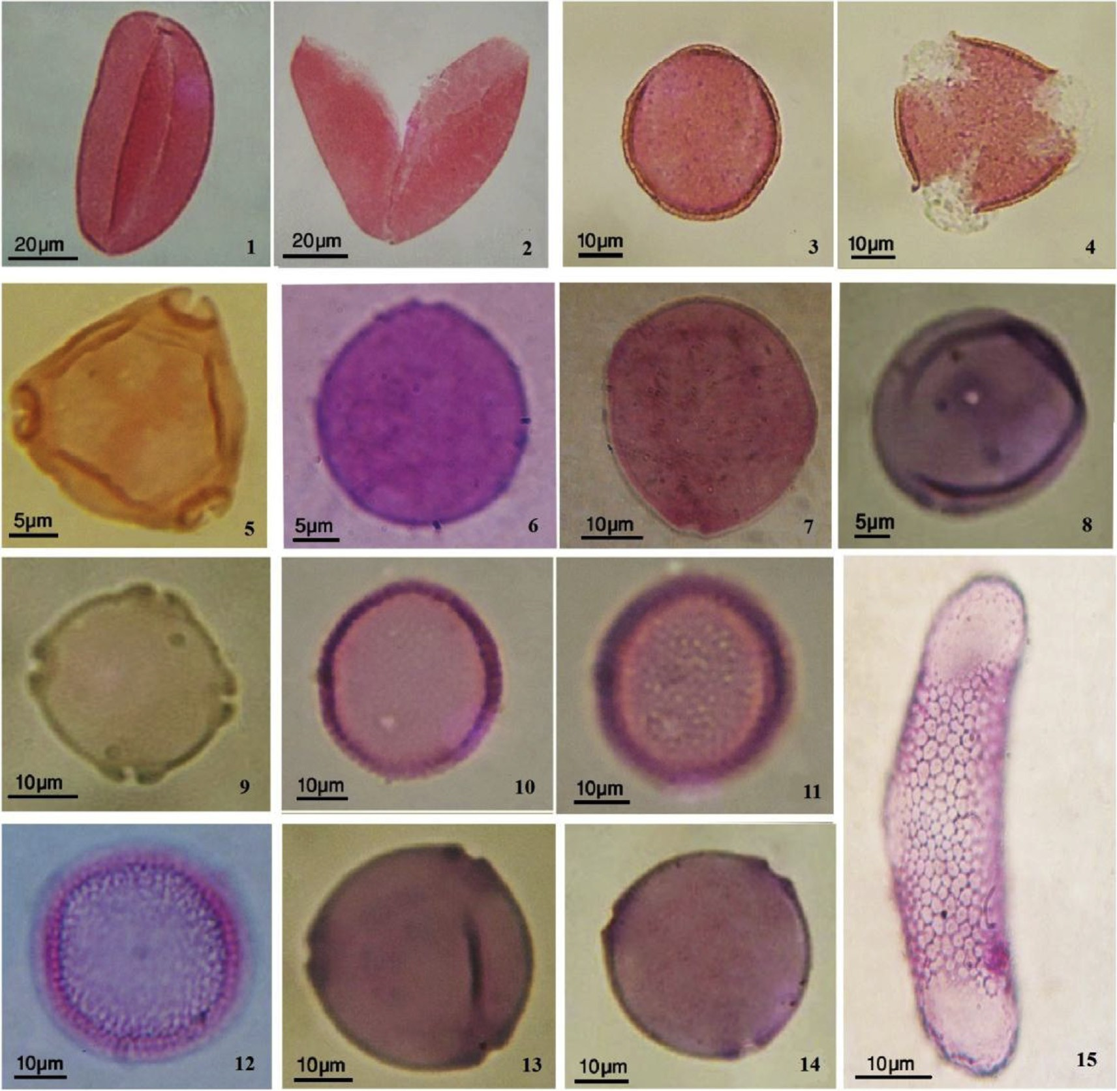

Plate 1 e Microphotographs showing the morphological shapes for pollen grains of submerged and floating hydrophytic taxa in the coastal Mediterranean lakes, Egypt. 1 and 2. *Eichhornia crassipes*, 3 and 4. *Marsilea aegyptiaca*, 5. *Ludwigia stolonifera*, 6. *Lemna gibba*, 7. *L. minor*, 8. *L. perpusilla*, 9. *Myriophyllum spicatum*, 10 and 11. *Potamogeton crispus*, 12. *P. pectinatus*, 13. *Ceratophyllum demersum*, 14. *Ceratophyllum submersum*, 15. *Ruppia maritima*.

### *Aperture characters*

In apertural types, the investigated pollens are mostly col- porate, colpate, porate rarely noneaperturate grains were observed. The colpate aperture is tricolpate with free apices in three taxa (*Marsilea aegyptiaca*, *Ranunculus sceleratus* and *Rorripa palustris*). The colporate aperture type is tricolporate in three taxa (*Persicaria* spp and *V. anagallis-aquatica*). The porate type is monoporate (14 taxa), triporate (3 taxa), tet- raporate as in *M. spicatum* and polyporate as in *A. sessilis.* The inaperturate pollen (14 taxa) as in Cyperaceae, Junca- ceae and *Potamogeton* spp. In *E. crassipes* the aperture is monosulcate.

Walker and Doyle [1] and Moore et al. [20] considered that the line of evolution in pollen class as from inaperturate pol- len (without aperture) vs aperturate pollen and the latter is from monoaperturate to polyaperturate. Thus, as the majority of the studied taxa have porate or inaperturate, rarely colpate

and colporate pollen grains, thus are considered the line of evolution between the primitive type and advanced pores. The pollen in monocots are less specialized than that of di- cots, particularly in their apertural types [33].

### *Pollen surface sculpture*

The pollen grains examined were usually thick in exine texture except these of family Juncaceae. The following pollen surface patterns were recorded; psilate (22 taxa), granulate (8 taxa), microechinate (*A. sessilis* and *M. spicatum*), reticulate (5 taxa), only that of *Typha domingensis* is microreticulate in pattern. *V. anagallis-aquatica* pollen are perforate sculpture but those of *R. maritima* have exine which is reticulate in pattern in the central portion of the grain and appears smooth at the extremities. Walker and Doyle [1] on angiosperms and Fur- ness [34] on Acanthaceae considered that the psilate pollen surface is the primitive case.

[e g ypti an j o ur nal o f b a sic and a pp l i e d sci en c e s 2 ( 201 5 ) 132](http://dx.doi.org/10.1016/j.ejbas.2015.04.001) e[138](http://dx.doi.org/10.1016/j.ejbas.2015.04.001) 137

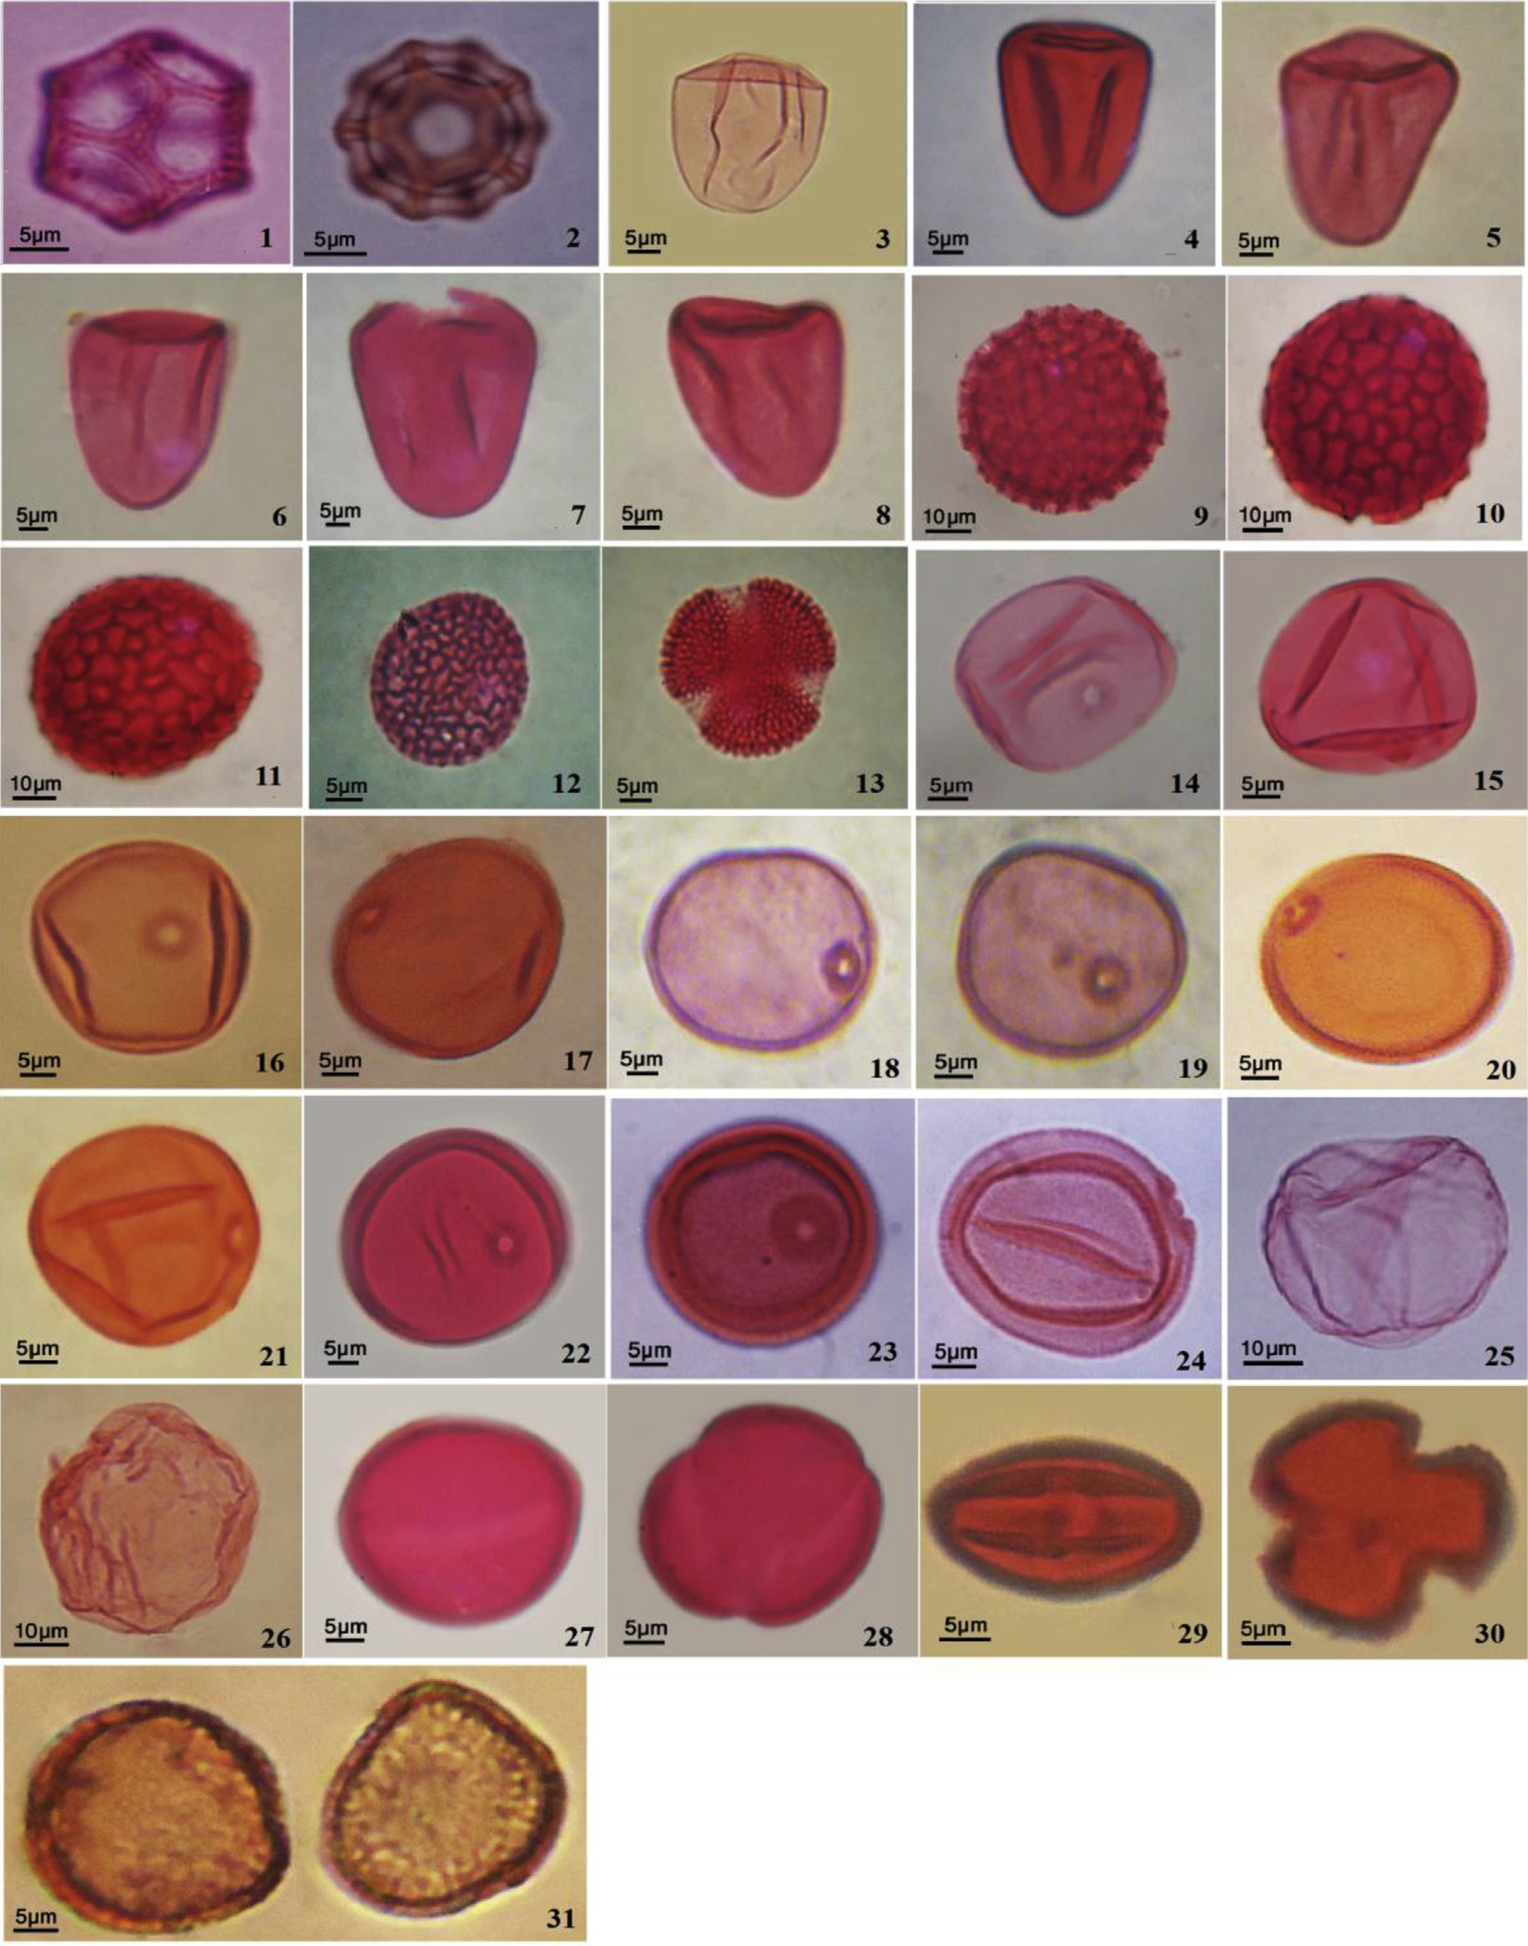

Plate 2 e Microphotographs showing the morphological shapes for pollen grains of emergent hydrophytic taxa in the coastal Mediterranean lakes, Egypt. 1 and 2. *Alternanthera sessilis,* 3. *Carex extensa*, 4. *Cyperus alopecuroides*, 5. *C. articulates*, 6.

*C. laevigatus*, 7. *Schoenoplectus maritimus, 8. S. litoralis*, 9 and 10. *Persicaria salicifolia*, 11. *P. lapathifolia*, 12 and 13. *Rorripa*

*palustris*, 14. *Echinochloa colona*, 15. *E. crus-galli*, 16. *E. stagnina*, 17. *Leersia hexandra*, 18. *Leptochloa fusca*, 19. *Panicum repens*,

20. *Paspalidium geminatum*, 21. *Paspalum distichum*, 22. *Saccharum spontaneum*, 23 and 24. *Phragmites australis*, 25. *J.*

*subulatus*, 26. *J. bufonius*, 27 and 28. *Ranunculus sceleratus*, 29 and 30. *Veronica anagallis-aquatica*, 31. *Typha domingensis*.

138 [e gypti an j o ur nal o f b a sic and a p p l i ed sci e n c e s 2 ( 201 5 ) 132](http://dx.doi.org/10.1016/j.ejbas.2015.04.001) e[138](http://dx.doi.org/10.1016/j.ejbas.2015.04.001)

# Acknowledgements

The author is deeply indebted to Prof. M.A. Zahran, Faculty of Science, Mansoura University for revising the manuscript and for his constructed advice.

## references

1. [Walker JW, Doyle JA. The basis of Angiosperm phylogeny:](http://refhub.elsevier.com/S2314-808X(15)00020-2/sref1) [palynology. Ann Bot Gard 1975;62:666](http://refhub.elsevier.com/S2314-808X(15)00020-2/sref1)e[723](http://refhub.elsevier.com/S2314-808X(15)00020-2/sref1).
2. [Brown R. Old pollen and spores flora, vol. 21. Oslo:](http://refhub.elsevier.com/S2314-808X(15)00020-2/sref2) [Scandinavian University Press; 1811](http://refhub.elsevier.com/S2314-808X(15)00020-2/sref2).
3. [Lindau G. In: Engler A, Prantl K, editors. Die Naturlichen](http://refhub.elsevier.com/S2314-808X(15)00020-2/sref3) [Pflanzenfamilien, vol. 4. Leipzig: W. Engelmann; 1893.](http://refhub.elsevier.com/S2314-808X(15)00020-2/sref3)

[p. 275](http://refhub.elsevier.com/S2314-808X(15)00020-2/sref3)e[354](http://refhub.elsevier.com/S2314-808X(15)00020-2/sref3).

1. [Carlo D, Paula R. New insights into pollen evolution. Int J](http://refhub.elsevier.com/S2314-808X(15)00020-2/sref4) [Plant Sci 2004;164:835](http://refhub.elsevier.com/S2314-808X(15)00020-2/sref4).
2. [Giveyrel L, Le Thomas A, Ferguson K, Chase MW. Critical](http://refhub.elsevier.com/S2314-808X(15)00020-2/sref5) [reexamination of palynological characters used to delimit](http://refhub.elsevier.com/S2314-808X(15)00020-2/sref5) [Asclepidaceae in comparison to the molecular phylogeny](http://refhub.elsevier.com/S2314-808X(15)00020-2/sref5) [obtained from plastid matk sequences. Mol Phylog Evol](http://refhub.elsevier.com/S2314-808X(15)00020-2/sref5) [2000;9:517](http://refhub.elsevier.com/S2314-808X(15)00020-2/sref5)e[27](http://refhub.elsevier.com/S2314-808X(15)00020-2/sref5).
3. [Persson V, Kanpps S, Blackmore S. Pollen morphology and](http://refhub.elsevier.com/S2314-808X(15)00020-2/sref6) [systematics of tribe juanulloeae A. T. Hunziker (Solanaceae).](http://refhub.elsevier.com/S2314-808X(15)00020-2/sref6) [Rev Palaeobot Palynol 1996;83:1](http://refhub.elsevier.com/S2314-808X(15)00020-2/sref6)e[30](http://refhub.elsevier.com/S2314-808X(15)00020-2/sref6).
4. [Harris WF. A manual of the spores of New Zealand](http://refhub.elsevier.com/S2314-808X(15)00020-2/sref7) [Pteridophyta. Bull NZ Sci Ind Res 1955;116](http://refhub.elsevier.com/S2314-808X(15)00020-2/sref7).
5. [Moore PD, Webb JA. An illustrated guide to pollen analysis.](http://refhub.elsevier.com/S2314-808X(15)00020-2/sref8) [London: Hodder and Stoughton; 1978](http://refhub.elsevier.com/S2314-808X(15)00020-2/sref8).
6. [Erdtman G. Pollen morphology and plant taxonomy;](http://refhub.elsevier.com/S2314-808X(15)00020-2/sref9) [angiosperms. Stockholm: Almqvist](http://refhub.elsevier.com/S2314-808X(15)00020-2/sref9) & [Wiksell; 1952](http://refhub.elsevier.com/S2314-808X(15)00020-2/sref9).
7. [Schill R, Leuenberger B. Pollen morpholigie and](http://refhub.elsevier.com/S2314-808X(15)00020-2/sref10) [cytotasonimie:der gattung pachypodium Lind L. Bot Jahrab](http://refhub.elsevier.com/S2314-808X(15)00020-2/sref10) [Syst 1972;92:169](http://refhub.elsevier.com/S2314-808X(15)00020-2/sref10)e[77](http://refhub.elsevier.com/S2314-808X(15)00020-2/sref10).
8. [Van Campo M, Nilsson S, Leeuwenberg AJM.](http://refhub.elsevier.com/S2314-808X(15)00020-2/sref11) [Palynotaxonomic studies in Tabernae Montana L. sensu lato](http://refhub.elsevier.com/S2314-808X(15)00020-2/sref11) [(Apocynaceae). Grana Palynol 1979;18:5](http://refhub.elsevier.com/S2314-808X(15)00020-2/sref11)e[14](http://refhub.elsevier.com/S2314-808X(15)00020-2/sref11).
9. [Guinet PH. Mimosoideae. In: Polhill RM, Raven PH, editors.](http://refhub.elsevier.com/S2314-808X(15)00020-2/sref12) [Advances in legumes, systematics; 1981. p. 191](http://refhub.elsevier.com/S2314-808X(15)00020-2/sref12)e[208. Botanic](http://refhub.elsevier.com/S2314-808X(15)00020-2/sref12) [Garden: Kew, England](http://refhub.elsevier.com/S2314-808X(15)00020-2/sref12).
10. [Lock JM. *Cassia*: Lat. (Leguminosae-Caesalpinioidae) in](http://refhub.elsevier.com/S2314-808X(15)00020-2/sref13) [Africa. Kew Bull 1988;43:333](http://refhub.elsevier.com/S2314-808X(15)00020-2/sref13)e[42](http://refhub.elsevier.com/S2314-808X(15)00020-2/sref13).
11. [Perveen A, Qaiser M. Pollen Flora of Pakistan: Malvaceae](http://refhub.elsevier.com/S2314-808X(15)00020-2/sref14) [Grewioideae - LII. Pak J Bot 2007;39:1](http://refhub.elsevier.com/S2314-808X(15)00020-2/sref14)e[7](http://refhub.elsevier.com/S2314-808X(15)00020-2/sref14).
12. [Zahran MA, Willis AJ. The vegetation of Egypt. 2nd ed.](http://refhub.elsevier.com/S2314-808X(15)00020-2/sref15) [Netherlands: Springer; 2009](http://refhub.elsevier.com/S2314-808X(15)00020-2/sref15).
13. [Shaltout KH, Khalil MT. Lake Burullus (Burullus protected](http://refhub.elsevier.com/S2314-808X(15)00020-2/sref16) [area). Cairo: National Biodiversity Unit, EEAA; 2005. p. 578.](http://refhub.elsevier.com/S2314-808X(15)00020-2/sref16) [13: 25](http://refhub.elsevier.com/S2314-808X(15)00020-2/sref16).
14. [Ayyad MA, Abdel Razik M, Mehanna A. Climate and](http://refhub.elsevier.com/S2314-808X(15)00020-2/sref17) [vegetation gradient in the mediterranean desert of Egypt. In:](http://refhub.elsevier.com/S2314-808X(15)00020-2/sref17) [Pre-report of the mediterranean biocleimatology](http://refhub.elsevier.com/S2314-808X(15)00020-2/sref17) [symposium, Montepellier, France; 1983](http://refhub.elsevier.com/S2314-808X(15)00020-2/sref17).
15. Koppen's W. Grundriss der Klimakunde, W. de Gruyter, Berlin; 1931.
16. [Meig P. World distribution of coastal desert. In: David HK,](http://refhub.elsevier.com/S2314-808X(15)00020-2/sref18) [Amiran, Andereu W, editors. Their natural and human](http://refhub.elsevier.com/S2314-808X(15)00020-2/sref18) [environments. Wiloon: Arizona Univ. Press; 1973](http://refhub.elsevier.com/S2314-808X(15)00020-2/sref18).
17. [Moore PD, Webb JA, Collinson ME. Pollen analysis. Oxford:](http://refhub.elsevier.com/S2314-808X(15)00020-2/sref19) [Blackwell; 1991](http://refhub.elsevier.com/S2314-808X(15)00020-2/sref19).
18. [Erdtman G. The acetolysis method: a revised description.](http://refhub.elsevier.com/S2314-808X(15)00020-2/sref20) [Svensk, Bot Tidskr54; 1960. p. 561](http://refhub.elsevier.com/S2314-808X(15)00020-2/sref20)e[4](http://refhub.elsevier.com/S2314-808X(15)00020-2/sref20).
19. [Reitsma T. Size modification of recent pollen grains under](http://refhub.elsevier.com/S2314-808X(15)00020-2/sref21) [different treatments. Rev Palaeobot Palynol 1969;9:175](http://refhub.elsevier.com/S2314-808X(15)00020-2/sref21)e[202](http://refhub.elsevier.com/S2314-808X(15)00020-2/sref21).
20. [Faegri K, Iversen J. Textbook of pollen analysis. 4th ed.](http://refhub.elsevier.com/S2314-808X(15)00020-2/sref22) [Chichster: John Wiley; 1989](http://refhub.elsevier.com/S2314-808X(15)00020-2/sref22).
21. [Reitsma TJ. Suggestions towards unification of descriptive](http://refhub.elsevier.com/S2314-808X(15)00020-2/sref23) [terminology of angiosperm pollen grains. Rev Palaeobot](http://refhub.elsevier.com/S2314-808X(15)00020-2/sref23) [Palynol 1970;10:39](http://refhub.elsevier.com/S2314-808X(15)00020-2/sref23)e[60](http://refhub.elsevier.com/S2314-808X(15)00020-2/sref23).
22. [Punt W, Hoen PP, Blackmore S, Nilsson S, Le Thomas A.](http://refhub.elsevier.com/S2314-808X(15)00020-2/sref24) [Glossary of pollen and spore terminology. Rev Palaeobot](http://refhub.elsevier.com/S2314-808X(15)00020-2/sref24) [Palynol 2007;143:1](http://refhub.elsevier.com/S2314-808X(15)00020-2/sref24)e[81](http://refhub.elsevier.com/S2314-808X(15)00020-2/sref24).
23. [Faegri K, Iversen J. Textbook of pollen analysis. Copenhagen:](http://refhub.elsevier.com/S2314-808X(15)00020-2/sref25) [Munksgaard; 1964](http://refhub.elsevier.com/S2314-808X(15)00020-2/sref25).
24. [Kermp GOW. Encyclopedia of pollen morphology. Tuscon,](http://refhub.elsevier.com/S2314-808X(15)00020-2/sref26) [U.S.A.: Univ. Arizona Press; 1965](http://refhub.elsevier.com/S2314-808X(15)00020-2/sref26).
25. [Solomon AM. Pollen morphology and plants taxonomy of](http://refhub.elsevier.com/S2314-808X(15)00020-2/sref27) [white oats in North America. Am J Bot 1983;70:481](http://refhub.elsevier.com/S2314-808X(15)00020-2/sref27)e[94](http://refhub.elsevier.com/S2314-808X(15)00020-2/sref27).
26. [Ramamoorthy TP. Ruellia section Chiropterophila](http://refhub.elsevier.com/S2314-808X(15)00020-2/sref28) [(Acanthaceae): a novelty from Mexico. Bot J Linn Soc](http://refhub.elsevier.com/S2314-808X(15)00020-2/sref28) [1991;107:79](http://refhub.elsevier.com/S2314-808X(15)00020-2/sref28)e[88](http://refhub.elsevier.com/S2314-808X(15)00020-2/sref28).
27. [Ezcurra C. Systematics of Ruellia (Acanthaceae) in southern](http://refhub.elsevier.com/S2314-808X(15)00020-2/sref29) [south America. Ann Mo Bot Gard 1993;8:787](http://refhub.elsevier.com/S2314-808X(15)00020-2/sref29)e[845](http://refhub.elsevier.com/S2314-808X(15)00020-2/sref29).
28. [Bank FH, Bank M, Balkwill MJ, Balkwill K. Electrophoretic](http://refhub.elsevier.com/S2314-808X(15)00020-2/sref30) [evidence for an undescribed species of Barleria L. S Afr J Bot](http://refhub.elsevier.com/S2314-808X(15)00020-2/sref30) [2000;66(1):22](http://refhub.elsevier.com/S2314-808X(15)00020-2/sref30)e[7](http://refhub.elsevier.com/S2314-808X(15)00020-2/sref30).
29. [Ueckermann C, Rooyer MW. Insect pollination and seed set](http://refhub.elsevier.com/S2314-808X(15)00020-2/sref31) [in four ephemeral plant species from Namaqualand. S Afr J](http://refhub.elsevier.com/S2314-808X(15)00020-2/sref31) [Bot 2000;66:28](http://refhub.elsevier.com/S2314-808X(15)00020-2/sref31)e[30](http://refhub.elsevier.com/S2314-808X(15)00020-2/sref31).
30. [Perveen A. Pollen characters and their evolutionary](http://refhub.elsevier.com/S2314-808X(15)00020-2/sref32) [significance with special reference to the Flora of Karachi.](http://refhub.elsevier.com/S2314-808X(15)00020-2/sref32) [Tur J Biol 2000;24:365](http://refhub.elsevier.com/S2314-808X(15)00020-2/sref32)e[77](http://refhub.elsevier.com/S2314-808X(15)00020-2/sref32).
31. [Furness CA. Pollen morphology of Acanthopsis Harvey,](http://refhub.elsevier.com/S2314-808X(15)00020-2/sref33) [*Acanthus* L. and *Blepharis Jussieu* (Acanthaceae: Acantheae).](http://refhub.elsevier.com/S2314-808X(15)00020-2/sref33) [Rev Palaeobot Palynol 1996;92:253](http://refhub.elsevier.com/S2314-808X(15)00020-2/sref33)e[68](http://refhub.elsevier.com/S2314-808X(15)00020-2/sref33).