[Egyptian Journal of Basic and Applied Sciences 4 (2017) 345–349](http://dx.doi.org/10.1016/j.ejbas.2017.07.001)

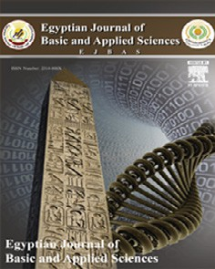

Contents lists available at [ScienceDirect](http://www.sciencedirect.com/science/journal/2314808X)

Egyptian Journal of Basic and Applied Sciences

journal homepage: [www.elsevier.com/locate/ejbas](http://www.elsevier.com/locate/ejbas)

Full Length Article

New, simple, sensitive and validated spectrophotometric method for the determination of salicylhydroxamic acid in capsules and raw material according to the ICH guidelines



Khaldun Mohammad Al Azzam a,⇑, Wafaa El Kassed b

a *Preparatory Year Department, Al-Ghad International Colleges for Applied Medical Sciences, 11451 Riyadh, Saudi Arabia*

b *Department of Pharmaceutical Chemistry, Pharmacy Program, Batterjee Medical College for Sciences and Technology (BMC), 21442 Jeddah, Saudi Arabia*

# a r t i c l e i n f o

*Article history:*

Received 12 May 2017

Received in revised form 19 June 2017 Accepted 2 July 2017

Available online 14 July 2017

*Keywords:* Salicylhydroxamic acid Spectrophotometric Linearity

Quality control Formulations

# a b s t r a c t

This work was aimed to develop a rapid, simple, selective, and precise spectrophotometric method for the estimation of salicylhydroxamic acid found in both capsules and raw materials. Spectrophotometric detection was conducted at maximum absorption of 294 nm with the aids of methanol: water (1:99, v/v) as solvent. The figures of merit of the newly developed method were validated for linearity, speci- ficity, accuracy, precision, robustness, ruggedness, limit of detection (LOD), and limit of quantification (LOQ). The detector response for the salicylhydroxamic acid was linear over the concentration range

studied 0.1–50 lg mL—1 with a correlation coefficient (R2) of 0.9999. Accuracy was between 99.0% and

101.7% with a mean value of 100.07%. The intra- and inter-day precisions, expressed as relative standard deviation (R.S.D.), were less than 0.0.322 and 0.421%, respectively. LOD and LOQ were 0.031 and

0.098 lg mL—1, respectively. Results confirmed that the excipients in the commercial capsules did not

interfere with the method and can be employed for routine quality control analysis of salicylhydroxamic acid whether in capsules or raw materials.

© 2017 Mansoura University. Production and hosting by Elsevier B.V. This is an open access article under

the CC BY-NC-ND license (<http://creativecommons.org/licenses/by-nc-nd/4.0/>).

1. Introduction

Salicylhydroxamic acid (SHAM) (C7H7NO3), which is a phenolic compound [1–3], is considered an intense and irreversible inhibi- tor used against bacteria. Additionally plant urease generally uti- lized for urinary tract diseases and known for its pharmaceutical applications (Fig. 1). This structure of SHAM is similar to urea, however, is not hydrolyzable by the urease [3–8]. It prevents the development/formation of calcium oxalate stones in kidneys [9,10]. At the point when administered orally, it is metablolized to salicylamide which applies pain relieving, antipyretic and anti- inflammatory effects. SHAM is additionally viewed as a typical ligand that utilized as a part of the combination of metal-crowns [4]. The mechanism of action of SHAM to stop the development of phosphate stones is by back off urease catalyst action [9]. The change procedure of urea to carbon dioxide and ammonia is then catalyzed by the impact of urease enzyme in the case of occurrence of urinary tract disease. When urease action is restrained, SHAM suppress ammonia formation and holds urea acidic [9]. Moreover,

* Corresponding author.

*E-mail address:* [azzamkha@yahoo.com](mailto:azzamkha@yahoo.com) (K.M. Al Azzam).

it diminishes serum uric acid and the rate of uric stones and ureate [11].

Literature search uncover that few methods for the estimation of SHAM have been accounted for whether the kinetics of the acid and base hydrolysis of SHAM and O-acetyl-salicylhydroxamic acid (OAc-SHAM) at various parameters, for example, time, tempera- ture and pH, utilizing reversed phase performance liquid chro- matography with UV detector (RP-HPLC/UV) [9], or for assessing SHAM in entire blood utilizing HPLC/UV [13].

SHAM was additionally evaluated by measuring the absorbance of its V(V) complex at 620 nm and limit of detection was 50 lM [14]. Moreover, potentiometric method for the estimation of SHAM in light of the inhibition of urease action was likewise conducted [15]. A linear calibration curve between 0.5 and 7 lg mL—1 with a

limit of detection of 0.1 lg mL—1 was achieved. Shetty et al. utilized

HPLC for measuring SHAM and its metabolites in the urine of rat [16]. Cu(II) can chelate some active ligands, for example, salicy- lamide, salicylhydroxamic and gallic acid which were likewise ana- lyzed by electron spin resonance (ESR) [17]. Besides, Capitan et al. have reported the utilization of SHAM in spectrophotometric methods for determination of Ti(IV) in aluminum alloys and mineral specimens as well. The complex Ti(IV)-SHAM and its blended ligand namely, Ti(IV)-SHAM – thiocyanate complex, were

<http://dx.doi.org/10.1016/j.ejbas.2017.07.001>

2314-808X/© 2017 Mansoura University. Production and hosting by Elsevier B.V.

This is an open access article under the CC BY-NC-ND license (<http://creativecommons.org/licenses/by-nc-nd/4.0/>).

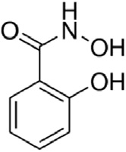

Fig. 1. The structure of salicylhydroxamic acid (p*K*a 7.40 and 9.70) [12].

estimated [18]. On the other hand, Salem created a few methods for the estimation of SHAM utilizing atomic absorption spec- trophotometry (AAS) and spectrophotometry methods. The AAS technique depends on precipitating the [Cu (NH3)4]2+-SHAM complex with the aid of excess of [Cu(NH3)4]2+ to SHAM solution. The Cu2+ ion in the supernatant layer was determined by AAS. The spectrophotometric technique is relies on upon measuring the green color produced by adding [Cu (NH3)4]2+ to SHAM solu- tion consisted of 50% dioxane: water solution [19].

Spectrophotometry is notable for its ease of use, minimal effort, low cost, and availability in all research centers. In addition, the pretreatment steps prior sample preparation is at times essential prior the application of such technique in order to overcome sam- ple interferences and to preconcentrate the analyte before sub- jected to analysis [19–21].

The target of the present work is to create simple, fast, specific and accurate UV spectrophotometric method for the estimation of SHAM in raw materials and capsules. This method was additionally validated for the accompanying parameters, for example, linearity, accuracy, precision, sensitivity, ruggedness, and robustness. The limits of detection (LOD), as well as quantification (LOQ), were also determined. Also, the experimental parameters for the developed method were validated in accordance with the International Con- ference on Harmonization (ICH) rules Q2 (R1) (ICH, 2005) [22]. The created method is consequently recommended for the normal routine analysis in the quality control unit.

1. Experimental
   1. *Materials and chemicals*

Salicylhydroxamic acid working standard (>99%) and SHAM (300 mg capsules) were a kind gift from El Nasr Pharmaceutical Chemicals Co. ‘‘ADWIC”. Salicylhydroxamic acid raw materials were purchased from Haoyuan Chemexpress Co. Ltd (MOLBASE, Shanghai, China) and Shangrao New Future Environment Protec- tion Technology Co., Ltd. (Shangrao, China). Methanol used in this work was of analytical grade which purchased from Sigma–Aldrich (St Louis, USA). All the other chemicals and reagents used were of analytical grade. Double distilled water was used for the prepara- tion of all solutions.

* 1. *Method development*
     1. *Instrumentation*

Spectroscopic analysis was carried out using Double beam Shi- madzu recording UV–Visible Spectrophotometer (Kyoto, Japan) model 1800 with 10 mm path length quartz cells. The solutions were made fresh on mass basis using a Mettler Toledo balance (Switzerland) model JB1603-C/FACT with a precision of ±0.01 mg. Double distilled water was produced in our laboratory using GFL- 2008 water (Burgwedel, Germany).

* + 1. *Preparation of standard solutions*

A stock solution of salicylhydroxamic acid working standard containing 1000 lg mL—1 was prepared in distilled water by trans- ferring the required amount of salicylhydroxamic acid in 500 mL

with the aid of 5 mL methanol. It was made up to mark using dis- tilled water. Then, a series of 100 mL volumetric flasks with vary- ing fractions were topped up to mark with distilled water in order to prepare different standard differing in concentration in the

range 0.1–50 lg mL—1. All other solutions were stored refrigerated

in the dark when not in use.

* + 1. *Preparation of sample (capsules and raw materials)*

Twenty capsules of SHAM (300 mg) were weighed. Equivalent to 100 mg salicylhydroxamic acid was quantitatively transferred into 500 mL volumetric flasks. Then it was dissolved using 5 mL of methanol. After that it was shaken for 5 min, 20 mL distilled water was added, shaken again for another 2 min, and finally topped up to the mark with distilled water to attain a final concen-

tration of 200 lg mL—1. The solution was filtered using Whatman

filter paper. The filtrate was diluted to obtain the desired concen- tration within the linearity range studied. The absorbance of sam- ple solutions was measured and the amount of salicylhydroxamic acid was determined using the calibration curve. In the same way, the raw materials were also prepared by transferring 100 mg each and transferred to 500 mL volumetric flask. After that, the same procedure in the preparation of capsules was followed.

* 1. *Method optimization*
     1. *Selection of* k*max wavelength*

The wavelength at which the maximum absorption (294 nm, Fig. 2) occurs is selected for further analysis. A definite concentra- tion of salicylhydroxamic acid solution was scanned in UV range of 200–800 nm. Methanol: water (1:99, v/v) was used as a blank. The absorbance of solutions was measured at 294 nm against blank and calibration curve of salicylhydroxamic acid was built up accordingly.

* 1. *Method validation*

The assay of salicylhydroxamic acid was validated taking into consideration linearity, LOD and LOQ, precision, accuracy, robust- ness, ruggedness and specificity. Validation of the parameters was carried in the light of the International Conference on Harmo- nization (ICH) guidelines Q2 (R1) (ICH, 2005) [22]. Below are the parameters that have been investigated.

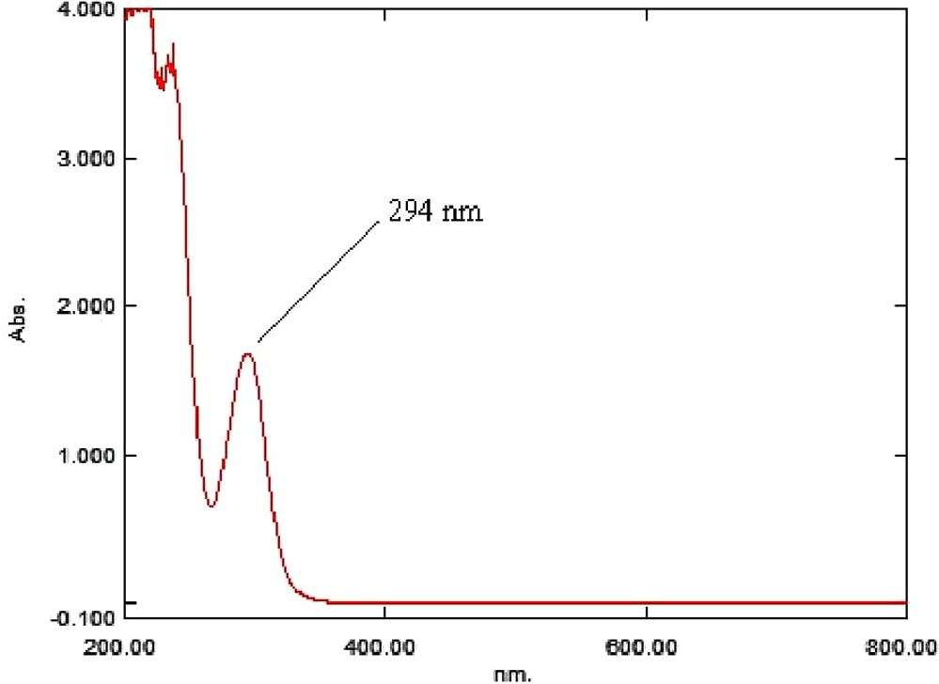

Fig. 2. UV spectra of salicylhydroxamic acid between 200 and 800 nm.

* + 1. *Sensitivity*

The sensitivity of the developed method was investigated by calculating the LOD, and LOQ. This was carried out by preparing a series of concentrations of the drug solutions. LOD and LOQ were carried out by a proper diluting known concentration of salicylhy- droxamic acid till the average responses attained were 3 or 10

times the standard deviation of the responses for six measure- ments [23,24]. LOD and LOQ values were 0.031, and 0.098 lg mL—1, respectively.

* + 1. *Specificity and selectivity*

SHAM capsules of label claim 300 mg containing salicylhydrox- amic acid of concentration 2 lg mL—1 was prepared in methanol: water (1:99, v/v). On the other hand 2 lg mL—1 of standard salicyl- hydroxamic acid, in addition, to sample solutions prepared were

Table 3

Table 2

Intra and inter-day precision for the determi- nation of salicylhydroxamic acid.

Amount (mg mL—1) RSD (%)

*Intra-day precision (n = 9)*

0.50 0.322

10 0.121

25 0.143

*Inter-day precision (n = 27)*

0.50 0.421

10 0.332

25 0.114

analyzed using the developed method. The expected amount of capsules was compared with that of the pure salicylhydroxamic acid solution of the same concentration.

* + 1. *Linearity and range*

Standard solutions containing salicylhydroxamic acid were pre- pared in a mixture of methanol: water (1:99, v/v) from a fresh stock solution (1000 lg mL—1) to construct the calibration curve. The least square regression analysis was carried out for the obtained data. Calibration curve consisted of ten different concen- trations in the range 0.1–50 lg mL—1 for salicylhydroxamic acid. Each concentration level was performed thrice. The equation of the calibration curve attained was y = 0.02x + 0.004. It was

obtained by plotting the absorbance (y) as a function of analyte concentration (x) in lg mL—1.

* + 1. *Accuracy*

An appropriate amount of SHAM capsules powder was weighed and then spiked with known amount of the standard compound. After that, each sample was analyzed thrice. In brief, three different concentration levels of SHAM capsules solution using methanol:

water (1:99, v/v) as solvent were prepared namely; 1, 5 & 10 lg

mL—1 and spiked with three different concentrations of salicylhy- droxamic acid standard solution which prepared using methanol: water (1:99, v/v) (2, 15 & 30 lg mL—1). Then the concentrations

(x) of the resulting solutions were calculated using the calibration curve. The accuracy was reported as% recovery ± standard devia- tion. Accuracy values obtained were in the range of 99.00– 101.70% as indicated in Table 1. The good accuracy results obtained reveal the potential of the developed method for the quantification of the analyte in capsules pharmaceutical formulation.

* + 1. *Precision*

Intra- and inter-day precision were used in order to investigate the precision of the developed method. It was done by analyzing three different concentration levels namely; 0.5, 10 and 25 lg mL—1 of standard solutions. The intra-day (repeatability) was esti- mated by analyzing the nine replicates on the same day. On the

other hand, inter-day variation (intermediate precision) was car- ried out over six consecutive days. Intra-day precision, expressed as the percentage relative standard deviation, RSD, was 0.121–

Robustness results of salicylhydroxamic acid in capsules and raw materials upon changing kmax 294 nm i.e., ±1.0 nm.

|  |  |  |
| --- | --- | --- |
| Trade name | (%)* ± SD (293 nm) | (%)* ± SD (295 nm) |
| SHAM | 91.10 ± 0.21 | 91.50 ± 0.29 |
| Raw material 1 | 52.80 ± 0.31 | 52.40 ± 0.46 |
| Raw material 2 | 102.40 ± 0.17 | 101.90 ± 0.18 |

*Average of three determinations.

0.322% (Table 2), while inter-day precision was 0.114–0.421%, indi- cating the good precision of the developed method. Reproducibility was also determined by analyzing three different concentrations of salicylhydroxamic acid namely; 0.5, 10 and 25 lg mL—1 on differ- ent Shimadzu UV spectrophotometers. The RSD values were less

than 0.110%.

* + 1. *Robustness*

Robustness of the developed method was also done by slight altering the kmax used in the analysis (kmax 294 nm) i.e., ± 1.0 nm (Table 3).

* + 1. *Ruggedness*

The ruggedness of the developed method was achieved by ana- lyzing salicylhydroxamic acid by different analysts using similar conditions. The%RSD value was found less than 1.5%.

* + 1. *Analysis of capsules and raw materials using the current method* The content of salicylhydroxamic acid in capsules with label claims 300 mg per capsule and in raw materials were quantified using the developed method. The content of twenty capsules was weighed and the average content per capsule was calculated. Then, equivalent to 100 mg of salicylhydroxamic acid was weighed. The same procedure under Section 2.2.3 was followed for both capsules and raw materials. The prepared solutions were assayed using the

proposed method. The% assay results were then reported.

1. Results and discussion

The maximum absorption of salicylhydroxamic acid was detected at 294 nm and overlay spectra of salicylhydroxamic acid

Table 1

Accuracy results for the determination salicylhydroxamic acid spiked in SHAM capsules.

|  |  |  |  |  |
| --- | --- | --- | --- | --- |
| Amount of sample taken (A) (lg mL—1) | Amount of standard added (B) (lg mL—1) | Total amount (A + B) (lg mL—1) | Total amount found (lg mL—1) | % Recovery* (Mean ± SD) |
| 1 | 2 | 3 | 3.05 | 101.7 ± 0.0039 |
| 5 | 15 | 20 | 19.8 | 99.00 ± 0.0041 |
| 10 | 30 | 40 | 39.8 | 99.50 ± 0.0029 |

*Indicates mean of six determinations (n = 6); SD: Standard deviation.

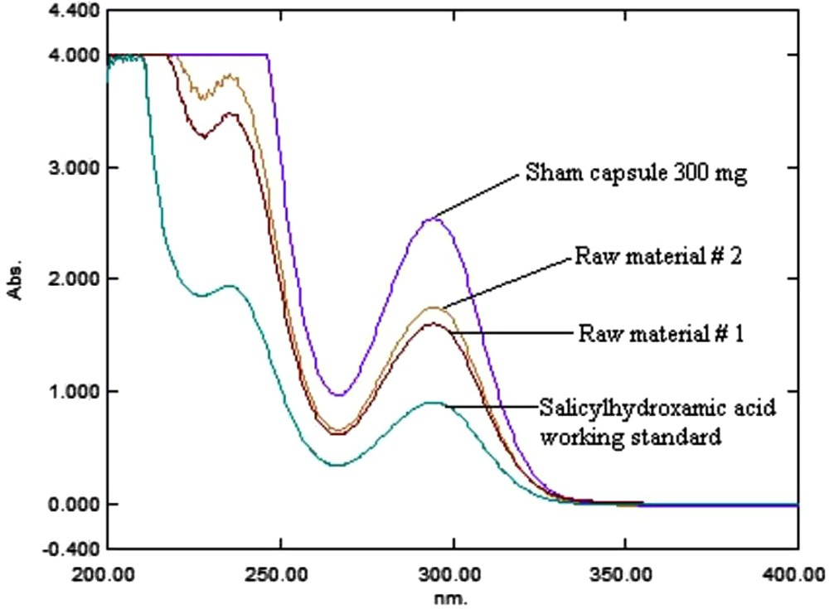

Fig. 3. Overlay spectrum of salicylhydroxamic acid working standard, raw mate- rials, and capsule 300 mg.

working standard, raw materials and capsule were recorded (Fig. 3).

The current method was found to be simple, sensitive, accurate, precise, economical and rapid for the routine analysis of salicylhy- droxamic acid not only in capsules but also in raw materials.

* 1. *Analytical method validation parameters*

The developed method was validated in accordance with the ICH guidelines (Q2) (R1) (ICH, 2005) [22].

* + 1. *Linearity and range*

The linearity of an analytical method is the figure of merits in method validation step. It is defined as the ability to get results that comply with Beer’s law [25]. The characteristic parameters of our newly method are slope 0.02, intercept 0.004, and the corre- lation coefficient of 0.9999 which show a good linearity of the cal- ibration curve (Table 3). Working solutions which contain the standard were prepared as prescribed earlier to draw the calibra- tion curve. Calibration curve contained ten different concentra-

Table 4

Results of validation parameters obtained by the newly developed method.

kmax 294 nm

Beer’s law range (lg mL—1) 0.1–50

Slope 0.02

Intercept 0.004

Correlation coefficient 0.9999

Accuracy 99.0–101.7%

Precision (%RSD) <0.421%

Robustness <0.46%

Ruggedness <1.5%

LOD (lg mL—1) 0.031

LOQ (lg mL—1) 0.098

tions (0.1–50 lg mL—1) for salicylhydroxamic acid and each concentration level was performed in a trice. Calibration curve with regression equation was y = 0.02x + 0.004 with good correla- tion coefficient (0.9999) between the standard concentration (x) and mean absorbance (n = 3) show a good linearity of standard curve (Table 4).

* + 1. *Precision*

The precision of an analytical method reflects the degree of scattering occurred between a series of measurements obtained under particular conditions [26]. Intra- and inter-day tests were used to prove the precision of the developed method. The later was conducted by analyzing three concentration levels namely;

0.5, 10 and 25 lg mL—1 of standard solutions. Specifically, intraday

precision (repeatability) can be defined as the use of analytical pro- cedure within a laboratory under a short period time through ana- lyzing nine replicates on the same day by the same analyst using the same equipment. On the other hand, inter-day precision (inter- mediate precision) implies the evaluation of variations in the anal- ysis when a method is used within a laboratory on different days (conducted over six consecutive days), by different analysts [24]. The %RSD for the intra-assay precision and intermediate precision for all the three concentration levels were below 0.322, and 0.421%, respectively (Table 2) indicating the good precision of the devel- oped method.

* + 1. *Accuracy*

The accuracy is defined as the closeness of results to accepted true value. It was determined by conducting recovery tests [27]. An appropriate amount of SHAM capsules powder was weighed and spiked with known amount of the standard compound, and each sample was analyzed in a trice. The results obtained were between 99.00% and 101.70% (Table 1). The obtained results sup- port the accuracy of the developed method.

* + 1. *Specificity*

The developed method was found selective and specific as there is no interferences occurred as reflected by the accuracy results.

* + 1. *LOD/LOQ*

Standard solutions showed good linearity (r2 > 0.9999) over the concentration range tested. The sensitivity of the current method is higher compared with the reported spectrophotometric one (Salem, 2003; [11] the LOQ was 1.53 lg mL—1) or even the poten- tiometric one reported by Hassan et al., 1997 (the LOD was 0.1 lg mL—1) [15]. The LOD for SHAM was 0.031 lg mL—1, while the LOQ was 0.098 lg mL—1. LOD and LOQ were calculated using the following formulas (LOD = 3.3 r/S), and (LOQ = 10 r/S), respectively.

* + 1. *Robustness*

The slight variation in the kmax (±1.0 nm) gave% assay results as indicated in Table 3, indicating the robustness of the current method.

Table 5

Assay results of salicylhydroxamic acid in capsules and raw materials.

|  |  |  |  |  |
| --- | --- | --- | --- | --- |
| Trade name | Manufacturer | Generic Name | Label claim (mg) | (%)* ± SD |
| SHAM | ADWIC | Salicylhydroxamic acid | 300 | 90.88 ± 0.17 |
| Raw material 1 | MOLBASE | Salicylhydroxamic acid | NA | 51.00 ± 1.06 |
| Raw material 2 | SHANGRAO | Salicylhydroxamic acid | NA | 100.13 ± 0.18 |

*Average of three determinations.

* + 1. *Application of the newly UV-Spectrophotometer method*

The developed method has been successfully applied for the determination of SHAM capsules and raw materials (two different suppliers). In agreement with ICH guidelines the assay values for all formulations studied i.e., capsules and raw materials (1 & 2) were found 90.88, 51.00, and 100.13%, respectively (Table 5). Results indicate good agreement between the current method and the manufacturer’s claimed values were found (Table 5).

1. Conclusion

A simple, reliable, accurate and reproducible spectrophotomet- ric method for the determination of salicylhydroxamic acid (SHAM) in capsules and raw materials was successfully developed as per the ICH guidelines. The good analytical performance with regards to validation parameters was achieved. All the validated data attained are in agreement with the ICH guidelines Q2 (R1) (ICH, 2005) [22]. Once compared with the reported spectrophoto-

metric method (Salem, 2003) [11], the developed method exhibits higher sensitivity. The LOD and LOQ were 0.031 lg mL—1 and

0.098 lg mL—1, respectively. Good recoveries of SHAM were obtained in the range of 99.00–101.70% (Table 1) in different sam- ples confirming the accuracy of developed method. The developed method is thus recommended to be implemented as a quality con- trol protocol in pharmaceutical industries.

Conflict of interest statement

Khaldun Mohammad Al Azzam declares that he has no conflict of interest.

Wafaa El Kassed declares that she has no conflict of interest.

References

1. [Gharobi B, Zanjan MG, Asli DE, Jafari MJ. Effect of salicylhydroxamic acid](http://refhub.elsevier.com/S2314-808X(17)30217-8/h0005) [(SHAM) on yield and yield components of safflower (Carthamustinctirius L.).](http://refhub.elsevier.com/S2314-808X(17)30217-8/h0005) [Ann Biol Res 2013;4:73–7](http://refhub.elsevier.com/S2314-808X(17)30217-8/h0005).
2. [Lu G-B, Zhang C-X, Chen W-H, Chen L-P, Zhou Y-S. Thermal hazards and kinetic](http://refhub.elsevier.com/S2314-808X(17)30217-8/h0010) [analysis of salicyl hydroxamic acid under isothermal and adiabatic conditions.](http://refhub.elsevier.com/S2314-808X(17)30217-8/h0010) [Thermochim Acta 2016;623:43–9](http://refhub.elsevier.com/S2314-808X(17)30217-8/h0010).
3. [Algadi DM, Seif A, Algielani A. Synthesis, characterization and biocidal Studies](http://refhub.elsevier.com/S2314-808X(17)30217-8/h0015) [of salicylhydroxamic acid and phathalic salicylhydroxamic acid. Eur J Acad](http://refhub.elsevier.com/S2314-808X(17)30217-8/h0015) [Essays 2017;4:138–40](http://refhub.elsevier.com/S2314-808X(17)30217-8/h0015).
4. [Ibrahim IT, Hamed M, Abou ELZahab M. Synthesis of 125I-salicyl hydroxamic](http://refhub.elsevier.com/S2314-808X(17)30217-8/h0020) [acid for urinary bladder imaging. Arab J Nucl Sci Appl 2015;48:90–8](http://refhub.elsevier.com/S2314-808X(17)30217-8/h0020).
5. Hashem El-Sayed N, SALAMA EE. Electrochemical oxidation of salicylhydroxamic acid on Pt electrode. Ovidius Univ Annals Chem. 2016; 27: 53–57.
6. Pang S-YM, Tristram S, Brown S. Salicylhydroxamic acid inhibits the growth of candida albicans. Int J Biol Biom Agri Food Biotechnol Eng. 2011; 5: 187–193.
7. [Mohamed TY, Atwa ST. Spectrophotometric microdetermination of Fe(III) and](http://refhub.elsevier.com/S2314-808X(17)30217-8/h0035) [V(V) using schiff base derived from salicylhydroxamic acid. Int J Res Stud](http://refhub.elsevier.com/S2314-808X(17)30217-8/h0035) [Biosci 2013;1:8–13](http://refhub.elsevier.com/S2314-808X(17)30217-8/h0035).
8. [Adiguzel E, Yilmaz F, Emirik M, Ozil M. Synthesis and characterization of two](http://refhub.elsevier.com/S2314-808X(17)30217-8/h0040) [new hydroxamic acids derivatives and their metal complexes. An investigation](http://refhub.elsevier.com/S2314-808X(17)30217-8/h0040) [on the keto/enol, E/Z and hydroxamate/hydroximate forms. J Mol Struct](http://refhub.elsevier.com/S2314-808X(17)30217-8/h0040) [2017;1127:403–12](http://refhub.elsevier.com/S2314-808X(17)30217-8/h0040).
9. [AlShamaileh E, Alawi M, Dahdal Y, Saadeh H. Kinetic stability study of selected](http://refhub.elsevier.com/S2314-808X(17)30217-8/h0045) [hydroxamic acids using HPLC/UV. Jordan J Pharma Sci 2008;1:55–64](http://refhub.elsevier.com/S2314-808X(17)30217-8/h0045).
10. [Foye WO, Hong HS, Kim CM, Prien EL. Degree of sulfation in](http://refhub.elsevier.com/S2314-808X(17)30217-8/h0050) [mucopolysaccharide sulfates in normal and stone-forming urines. Invest](http://refhub.elsevier.com/S2314-808X(17)30217-8/h0050) [Urol 1976;14:33–7](http://refhub.elsevier.com/S2314-808X(17)30217-8/h0050).
11. [Salem AA, Omar MM. Atomic absorption and spectrophotometeric](http://refhub.elsevier.com/S2314-808X(17)30217-8/h0055) [determinations of salicylhydroxamic acid in its pure and pharmaceutical](http://refhub.elsevier.com/S2314-808X(17)30217-8/h0055) [dosage forms. Turk J Chem 2002;27:383–93](http://refhub.elsevier.com/S2314-808X(17)30217-8/h0055).
12. [Fazary AE. Metal complexes of salicylhydroxamic acid and 1,10-](http://refhub.elsevier.com/S2314-808X(17)30217-8/h0060) [phenanthroline; equilibrium and antimicrobial activity studies. Bull Chem](http://refhub.elsevier.com/S2314-808X(17)30217-8/h0060) [Soc Ethiop 2014;28:393–402](http://refhub.elsevier.com/S2314-808X(17)30217-8/h0060).
13. Barnicoat AJ, Van T.Hoff WG, Morrison PJ, Bradbrook ID. Determination of salicylhydroxamic acid, a trypanocidal agent, by reversed phase high- performance liquid chromatography. J Chromatogr 1981; 225: 236-239.
14. Kanabus-Kaminska J, Urbanski T. Bull Acad Pol Sci Ser Sci Chem. 1979; 27: 891–893 Anal. Abst. 1E48, 41 (1981).
15. [Hassan SSM, El-Bahnasawy RM, Rizk NM. Potentiometric determination of](http://refhub.elsevier.com/S2314-808X(17)30217-8/h0075) [salicylhydroxamic acid (urinary struvite stone inhibitor) based on the](http://refhub.elsevier.com/S2314-808X(17)30217-8/h0075) [inhibition of urease activity. Anal Chim Acta 1997;351:91–6](http://refhub.elsevier.com/S2314-808X(17)30217-8/h0075).
16. [Shetty BV, Melethil S. High pressure liquid chromatographic assay for salicylic](http://refhub.elsevier.com/S2314-808X(17)30217-8/h0080) [acid and its metabolites in rat urine. Anal Lett 1988;21:395–410](http://refhub.elsevier.com/S2314-808X(17)30217-8/h0080).
17. [Khadikar PV, Pol B, Joshi S, Bharti S. Pol J Chem 1987;61:833–8](http://refhub.elsevier.com/S2314-808X(17)30217-8/h0085).
18. [Capitan-Vallvey LF, Molina-Diaz A, Fernandez de Cordova ML, Pascual-Reguera](http://refhub.elsevier.com/S2314-808X(17)30217-8/h0090) [MI. Microchim Acta 1990;1:305–11](http://refhub.elsevier.com/S2314-808X(17)30217-8/h0090).
19. [Salem AEAA. Atomic absorption and spectrophotometeric determinations of](http://refhub.elsevier.com/S2314-808X(17)30217-8/h0095) [salicylhydroxamic acid in its pure and pharmaceutical dosage forms. Turk J](http://refhub.elsevier.com/S2314-808X(17)30217-8/h0095) [Chem 2003;27:383–93](http://refhub.elsevier.com/S2314-808X(17)30217-8/h0095).
20. [Al-Saidi HM, Abdel-Fadeel MA, El-Sonbati AZ, El-Bindary AA. Determination of](http://refhub.elsevier.com/S2314-808X(17)30217-8/h0100) [bismuth in different samples by dispersive liquid–liquid microextraction](http://refhub.elsevier.com/S2314-808X(17)30217-8/h0100) [coupled with microvolume b-correction spectrophotometry. J Mol Liq](http://refhub.elsevier.com/S2314-808X(17)30217-8/h0100) [2015;212:635–40](http://refhub.elsevier.com/S2314-808X(17)30217-8/h0100).
21. Xiao N, Deng J, Huang K, Ju S, Hu C, Liang J. Application of derivative and derivative ratio spectrophotometry to simultaneous trace determination of rhodamine B and rhodamine 6G after dispersive liquid–liquid microextraction. Spectrochim. Acta A Mol Biomol Spectrosc. 2014; 128 312–318.
22. ICH Guideline Q2(R1), Validation of analytical procedures: text and methodology, November 2005.
23. [Carr GP. A parallel approach to method validation in pharmaceutical analysis. J](http://refhub.elsevier.com/S2314-808X(17)30217-8/h0115) [Pharm Biomed Anal 1990;8:613–8](http://refhub.elsevier.com/S2314-808X(17)30217-8/h0115).
24. [Sharma K, Agrawal SS, Gupta M. Development and validation of UV](http://refhub.elsevier.com/S2314-808X(17)30217-8/h0120) [spectrophotometric method for the estimation of Curcumin in bulk drug and](http://refhub.elsevier.com/S2314-808X(17)30217-8/h0120) [pharmaceutical dosage forms. Int J Drug Dev Res 2012;4:375–80](http://refhub.elsevier.com/S2314-808X(17)30217-8/h0120).
25. [Chapman KG. Validation terminology. In: Reddy IR, Nash RA, editors.](http://refhub.elsevier.com/S2314-808X(17)30217-8/h0125) [Pharmaceutical process validation. New York: Maecel Dekker; 1993. p.](http://refhub.elsevier.com/S2314-808X(17)30217-8/h0125) [587–96](http://refhub.elsevier.com/S2314-808X(17)30217-8/h0125).
26. [Al Azzam KM, Saad B, Aboul-Enein HY. Simultaneous determination of](http://refhub.elsevier.com/S2314-808X(17)30217-8/h0130) [atenolol, chlorthalidone and amiloride in pharmaceutical preparations by](http://refhub.elsevier.com/S2314-808X(17)30217-8/h0130) [capillary zone electrophoresis with ultraviolet detection. Biomed Chromatogr](http://refhub.elsevier.com/S2314-808X(17)30217-8/h0130) [2010;24:977–81](http://refhub.elsevier.com/S2314-808X(17)30217-8/h0130).
27. [Snyder LR, Kirkland JJ, Glajch JL. Completing the method: validation and](http://refhub.elsevier.com/S2314-808X(17)30217-8/h0135) [transfer. In: Snyder LR, Kirkland JJ, Glajch JL, editors. Practical HPLC method](http://refhub.elsevier.com/S2314-808X(17)30217-8/h0135) [development. New York: John Wiley & Sons Inc; 1997. p. 233–312](http://refhub.elsevier.com/S2314-808X(17)30217-8/h0135).